Policy | Canberra Health Services
Risk Management
CHS24/589

Policy statement
Risk management is a critical part of clinical and corporate governance across the Canberra Health Services (CHS) Network. It is an essential process to maintain an appropriate balance between realising opportunities for improvement and addressing the uncertainty of not achieving what we intend to.
Risk management processes assist us to make the best decision possible, in a timely manner, to reduce the consequence and likelihood of risk exposure. For example, unintended harm to CHS Network team members, patients, and visitors, and damage to property.
Risk management enables us to do our jobs, to the best of our ability, each day, to meet the organisation’s strategic and operational objectives and deliver exceptional health care.
CHS Network is committed to establishing a risk culture that supports the provision of exceptional care, and demonstrates the principles of risk management through:
- open communication and consultation about risk among all team members
- proactive, timely identification, escalation and reporting on risks by all team members
- responsive development, implementation and monitoring of risk treatment action plans by management.
CHS Network has a risk appetite of medium using the CHS Risk Matrix found on the Risk Management HealthHub page. Our risk appetite is supported by our tolerance to risk. We recognise it is not possible, or necessarily desirable, to eliminate all the risks inherent in our work. Accepting some degree of risk in our business practices promotes efficiency and innovation. The risk appetite may vary on a case-by-case basis on assessment of each risk.
CHS Network has a higher risk tolerance when the negative consequences of risk treatment outweigh the benefits. In doing so, we must be able to demonstrate we have made informed, evidence and risk-based decisions.
Under the Insurance Act 2005, the ACT Insurance Authority (ACTIA) is delegated with responsibility for driving best practice risk management across the ACT Government.
CHS completes an annual declaration to ACTIA to provide assurance that risk management is built into annual corporate planning, operational activities, planning (including business continuity planning) and reporting processes. The declaration also provides assurance over risk management culture, the presence of risk management oversight bodies and the presence and implementation of our Risk Management Policy.

Purpose
This policy outlines CHS Network approach to risk management and outlines the roles and responsibilities of all CHS team members. It is aligned to the requirements of the ACT Government Risk Management Policy, the International Risk Management Standard ISO AS/NZS 31000:2018 – Risk Management Guidelines, and 1.10 Clinical Governance – Risk Management within the National Safety and Quality in Health Service Standards.

Scope
This policy applies to all team members across the CHS Network. The CHS Network includes the inpatient facilities at Canberra Hospital, Clare Holland House (CHH), North Canberra Hospital (NCH), University of Canberra Hospital (UCH) and community-based services.

Roles and responsibilities

Risk Management Governance
Risk management governance is aligned with the CHS organisational governance structure. Risk management is integrated into corporate and business planning processes. Refer to Attachment1 for the CHS Risk Management Governance Structure which provides direction and oversight of risk management activities.
Risks are monitored across multiple levels of the organisation as outlined below:
- risk management system oversight – is the responsibility of CHS Network Executive
- risk oversight – is the responsibility of CHS Network Operations Executive and the peak governance committee for each health service operational area
- risk management – is everyone’s responsibility
- risk assurance – is the responsibility of the Internal Audit function within the Strategy and Governance Branch with oversight by the Audit and Risk Management Committee (ARMC), and other executive and specialist committees as appropriate.

Risk Management Strategy
Risk Management is not a standalone process. It’s most effective when integrated with existing organisational business processes. Key processes for risk management integration are:
- Strategic/business planning – Organisational and operational business planning processes both inform and are informed by risk management processes. The planning process provides an opportunity to reflect on achievements, identify and prioritise future focus areas, strategic priorities and objectives, identify and respond to risks and areas for quality and safety improvement.
- Internal audit – The internal audit program and processes assess the effectiveness of risk management controls. The internal audit program uses a risk management-based approach to prioritise the internal audit plan.
- External audits – An additional assurance mechanism to determine the performance and effectiveness of our risk management system e.g. accreditation against the Australian Commission on Safety and Quality in Health Care’s National Safety and Quality Health Service Standards.
- Performance management – Risk management responsibilities are included, where relevant, in individual performance plans.
- Business continuity management – Business continuity management is a risk management process that identifies potential impacts of events that can disrupt business processes. Business continuity plans detail how essential services are to be maintained with minimal disruption, so the delivery of critical high level and business unit functions can continue or be resumed as soon as possible.
- Clinical governance and clinical risk management - Clinical risk management is an approach to improving the quality and safe delivery of health care by identifying circumstances that put patients at risk of harm and acting to prevent or control those risks. Clinical risk management is part of a broader organisational risk management system at CHS which uses a range of strategies to identify, mitigate and manage risk, and improve the quality of clinical care. Further information is provided in our CHS Exceptional Care Framework.
- Performance reporting and monitoring – Performance reporting and monitoring processes provide opportunity for risk identification across and at all levels within the organisation. Performance against key indicators (e.g. clinical, financial, environmental, social and governance responsibility indicators) measures our risk control effectiveness.
- Legislative compliance – Monitoring of legislative compliance enables CHS to identify areas of risk exposure, inform policy review or development to strengthen or gain greater control and prioritise other required improvement actions.

Risk Management Principles
Table one outlines how we adopt the principles of risk management into everyday work practices.
- CHS Risk Management Principles
Principle | Description
There is a mandate and commitment from the CHS executive and senior management for risk management.  (Principle in the RM Standard: Human and Cultural Factors) | This is demonstrated by strong leadership in risk management, an ability to articulate governance processes and the availability of support and training opportunities within areas of responsibility.
There is linkage between risk management and the achievement of CHS priorities outlined in our Strategic and Corporate Plans.  (Principle in the RM Standard: Customised) | Risks are linked to strategic objectives; risk management information is used to support decision making and strategic audits are focused on identified areas of risk.
There are clear roles and responsibilities for risk management throughout CHS.  (Principle in the RM Standard: Inclusive) | There is a clear governance structure for risk management. Executives are identified as strategic risk leaders who are responsible for the management of risk within their realm of responsibility.
There is integration of risk management into decision making processes.  (Principle in the RM Standard: Integrated) | Risk management information is used to inform decision making within legislative and regulatory frameworks.
There is a structured approach to the robust assessment of risk which considers best available information from relevant data and stakeholders.  (Principles in the RM Standard: Structured and Comprehensive, Best available information, Inclusive) | There is a structured and consistent approach to risk assessment which uses CHS approved tools and templates. Risk assessments consider relevant information sources such as historical data, expert stakeholder experience and opinions and direct observation.
There is responsiveness to change when internal or external factors impact on risk management and/or the management of risks.  (Principle in the RM Standard: Dynamic) | Risk management is a part of everyday business processes. Risk assessments are considered in a timely way to address uncertainty. There is ongoing review of our CHS Risk Management policy, processes and supporting documentation.
There is continual improvement to risk management and the management of risk, and conversely risk management facilitates improvements within CHS.  (Principle in the RM Standard: Continual Improvement) | Risks are discussed and communicated as opportunities for improvement. Risk treatment actions plans are considered improvement initiatives and are recorded as quality improvement activities as appropriate.

Risk Management process
For risk management to be truly effective, it must be an integral part of our culture and systems. Every staff member has an important role to play in supporting the organisation to manage risk to achieve strategic and operational priorities and keeping themselves, other staff, and consumers from harm.
To provide support to staff, a risk management toolkit has been created and contains practical information about implementing the CHS Risk Management Policy. It provides fact sheets, tips and templates for each phase of the risk management process and is available on the Risk Management HealthHub page.

‘Three lines’ model for managing risk
The ‘Three lines’ model is a hierarchical model that assists in describing roles and responsibilities of CHS Network team members and how different parts of the organisation work collaboratively to communicate about and manage risk. It also provides a basis for assurance that risk treatment controls and actions are effectively managing identified risks, and appropriate arrangements are in place for effective communication across the CHS Network for active management of risks.
This model aims to prevent gaps in risk management activities and/or control measures being identified by different functions, so a catastrophic event does not occur and result in the organisation not achieving its objectives.
The tables below also outline Key Performance Indicators (KPIs) so the effectiveness of the implementation of these actions can be monitored and refers to risk escalation process/es which can be found in Attachment 2 and 3.
- First line - operational level (function that owns and manages the risk)
The following table (Table two) outlines the roles and responsibilities that CHS team members must fulfil at the ‘first line’ for managing risk. It focuses on the day-to-day decisions made at the operational level and is the level that typically has the greatest understanding of risks relevant to operational processes and procedures.
  - Managers are required to fulfil the responsibilities for All Team Members in addition to those outlined for Managers, within their area of responsibility.
  - Executives are required to fulfil the responsibilities for Managers (and meet KPIs) in addition to those outlined for Executives, within their area of responsibility.

- First line – Function that owns and manages the risk. Roles and responsibilities
Role | Responsibilities
Executive Management  (Includes: Executive Directors, Executive Group/Branch Managers, General Managers, CEO, Deputy CEO, COO)  Executive Management (cont.) | Culture  Lead and promote a culture of risk awareness and risk management, including the implementation of risk management principles, across CHS Network.  Governance  Develop and maintain governance mechanisms to effectively monitor risks and their management, including escalation of risk as required.  Ensure risk management activities are aligned to CHS strategic objectives.  Regularly review risk registers to ensure that risks identified are rated, that risk owners are appointed, that risk controls are identified and assigned, that additional treatment actions are identified where appropriate and that timeframes for actions are clearly shown together with progress in achieving those.  Manage and escalate risk in accordance with the CHS priority for action table available with the risk matrix on the Risk Management HealthHub page.  Include risk management as a standing agenda item for meetings.  Ensure business plans clearly articulate and take into consideration risk management activities, key risks and opportunities for improvement.  Ensure regular assessments, where appropriate, are conducted on the effectiveness of risk controls identified on enterprise and operational level risk registers.  Process  Implement CHS Exceptional Care Framework and Risk Management Policy.  Monitor compliance with the Risk Management Policy.  Identify, assess and evaluate risks, and implement risk treatment action plans.  Integrate and embed risk management into business operations, including business planning activities and day to day operations.  Conduct reviews of internal controls, as appropriate, to ensure they effectively manage the identified risks and contribute to achieving operational and strategic objectives.  Review and monitor risk management activity and incorporate recommendations provided by internal and independent assurance functions (i.e. audits) when making organisational decisions.  Training  Ensure team members understand and fulfil their risk management responsibilities.  Ensure managers and team members receive support, tools, resources and training to fulfil their risk management responsibilities.  Improvement  Contribute to regular review of the Risk Management Policy and Toolkit and participate in annual Risk Management Maturity Self-Assessment.  Key Performance Indicators for Executive Management  All occupants of Executive Management positions have completed Risk Management training.  Risk management is a standing agenda item on all Peak Health Service Operational Area/Divisional Executive/Governance/Quality and Safety/WHS meetings i.e. enabling review of Operational Risks and providing opportunity for risk escalation.  All Enterprise and Operational risks documented in the RiskMan Risk Register are reviewed at least quarterly, evidenced by progress updates.  - All newly identified high and extreme risks follow the risk escalation process outlined in the Risk Management Toolkit on the Risk Management HealthHub page.
Management  (Includes: All staff with supervisory or management delegation, Directors/Assistant Directors, Program managers, Team Leaders, ADONs/DONs, Clinical Directors)  Management (cont.) | Culture  Promote the CHS Risk Management Policy and Toolkit and support timely and effective risk management practices.  Maintain and support a ‘no blame’ risk management culture and environment in which managing risk is embedded and integrated within operational business processes and team members are empowered to escalate risks as required.  Governance  Promote/communicate the risk escalation process to staff within their area of responsibility.  Provide regular reporting to Executive on risks within their area of responsibility and communicate/escalate unacceptable/intolerable levels of risk.  Include risk management as a standard agenda item within team meetings within their level of responsibility and business operations.  Process  Develop, maintain and regularly review Program/Team/Business Unit Risk Registers, as guided by Executive, systematically identifying, analysing, evaluating and reporting on risks that might impact on the objectives of the Program/Team/Business Unit.  Develop and implement timely and effective risk treatment action plans within their level of responsibility and business operations.  Monitor risk treatment action plan progression, including documentation completion, and escalate significant increase to risk rating and/or changes to management of risk in line with the risk escalation process outlined in the Risk Management Toolkit on the Risk Management HealthHub page.  Conduct reviews of internal controls to ensure they effectively manage the identified risks and contribute to achieving operational and strategic objectives.  Training  Support team members to actively develop risk management skills e.g. through training and/or coaching. Note: Training options outlined on Risk Management HealthHub page.  Improvement  Identify opportunities to improve operational effectiveness and efficiencies.  Key performance Indicators for Managers  Risk management is a standing agenda item for team meetings.  All risks are reviewed at least quarterly with progress updates documented according to local risk procedures.  - All high and extreme risks follow the risk escalation process on the Risk Management HealthHub page.
All Team Members  (Includes: contractors, agency staff, VMOs, volunteers, students) | Culture  Understand and comply with the CHS Exceptional Care Framework, Risk Management Policy and practices.  Comply with legislation, regulations and CHS policy and procedures.  Governance  Understand the process for communicating/escalating intolerable levels of risk.  Process  Maintain an awareness of risks that relate to their work area.  Actively assist in the risk management process. This includes contributing to risk assessment, implementation of treatment action plans and monitoring the adequacy of controls and risk treatment actions that might impact on objectives within their level of decision-making responsibility.  Training  Complete risk management education and/or training to gain an understanding of CHS Risk Management Policy, process and practices, including roles and responsibilities.  Improvement  Identify opportunities to improve operational effectiveness and efficiencies.

- Second line (function that oversees the management of risk)
The ‘second line’ provides assurance that the ‘first line’ controls are working as intended to manage the risk.
The areas within CHS identified in table three below support and collaborate with team members in operational roles (first line) to ensure controls are appropriate within policies and procedures, and provide assurance that risks are being managed effectively.
- Second line – Function that oversees the management of risk. Roles and responsibilities
Role | Responsibilities
Strategy and Governance; Quality, Safety, Innovation and Improvement | Risk Management Team  Facilitate and guide best practice risk management across CHS.  Provide tools/templates, procedures and training for best practice risk management across CHS Network.  Develop and maintain the CHS Risk Management Policy and Toolkit.  Develop and maintain the CHS Enterprise Risk Register.  Analyse information within risk registers to determine common themes or patterns in risk across CHS Network.  Report on common themes or patterns of risk to the CHS Network Operations Executive, CHS Network Executive and Audit and Risk Management Committees.  Incorporate lessons learnt from events and audit recommendations into the review of the CHS Risk Management Policy and Toolkit.  Coordinate annual self-assessment of CHS risk management maturity.  Policy Team  Coordinate regular self-assessment of legislative compliance across the organisation to prevent policy gap and minimise risk exposure and legal penalty.  Clinical Incident Management teams  Lead the implementation and embedding of CHS Incident Management – Clinical Policy, CHS Incident Management - Clinical Procedure and NCH Incident Management Procedure which enables team members to identify, report, investigate, learn, improve and manage risks in relation to clinical incidents.
Office of the Deputy Chief Executive Officer | Senior Executive Responsible for Business Integrity and Risk (SERBIR)  Develop and maintain a CHS fraud and corruption control plan.  Investigate allegations of suspected fraud and corruption and misconduct within the organisation.  Incorporate lessons learned from confirmed cases to enhance prevention and control activity around fraud and corruption.  Report regularly on fraud prevention and control activity to the Audit and Risk Management Committee.
Office of the Chief Operating Officer (COO) | Develop, maintain and test the CHS Business Continuity Framework (and plans).  Develop, maintain and test the CHS Emergency Management Plan and CHS site-specific Emergency Plans.
Work Health and Safety, People and Culture and Work Health and Safety, NCH | Support the workforce to comply with the Work Health and Safety Act 2011 and WorkSafe ACT regulations.  Undertake activities to implement the ACTPS Work Health, Safety and Wellbeing Strategy.  Maintain the CHS Work Health and Safety Management System.  Support the identification of sub-divisional risks, and the promotion of the risk management governance structure and risk escalation process within Divisions.
Facilities Management, Canberra Hospital | Support the workforce to comply with the CHS Protective Security Policy (CHS PSP).  Maintain the CHS PSP which provides the necessary governance to assist CHS to meet mandatory governance requirements detailed in the ACT Government Protective Security Policy Framework e.g. complete the CHS Enterprise Security Risk Assessment every two years, complete annual reporting on the CHS Critical Infrastructure Risk Management Plan.  Undertake an annual compliance check aligned to the CHS PSP.
Specialist committees  (e.g. Work Health and Safety Committees, subordinate specialist Committees reporting to CHS Network Operations Executive or the peak health service operational area governance committee) | Undertake risk identification activities.  Coordinate and manage information related to risks, as appropriate and guided by the Accountable risk lead.  Coordinate risk treatment action plan activities.  Provide expert advice for certain types of risk.  Note: Risk management responsibilities are to be outlined in committees’ Terms of Reference.
- Third line (provides independent assurance)
The ‘third line’ assures that CHS Risk management activities described in Table four below are comprehensive, implemented effectively and help to achieve CHS objectives. The CHS internal audit function is coordinated by Strategy and Governance Branch.
- Third line – Provides independent assurance. Roles and responsibilities
Role | Responsibilities
Strategy and Governance | Internal Audit  Develop and maintain the CHS Internal Audit Plan.  Coordinate independent audits on the control effectiveness of key risks (enterprise and operational) identified within risk registers and/or as highlighted by Divisions, the management function or the Audit and Risk Management Committee.  Provide assurance of consistent application of the risk management process.  Engage external subject matter experts as required.  Liaise with ACT Audit Office.  Manage and maintain audit recommendations register.  Support CHS management-initiated audits.  Communicate the findings from audits across CHS, to the risk management function, the Audit and Risk Management Committee and the Chief Executive Officer.  Conduct compliance assurance testing in relation to the ACT Government’s legislative and statutory requirements and CHS’ policies and procedures.

Governing bodies
The risk management roles and responsibilities of select governing bodies are outlined in Table five below and incorporated into the Terms of Reference for each committee.
- Governing bodies. Roles and responsibilities
Role | Responsibilities
CHS Network Operations Committee | Promote the CHS Risk Management Policy for awareness among senior and middle management, Executive Directors/Executive Group/Branch/General Managers.  Support the application of best practice risk management across CHS functions and processes to embed a robust culture, to foster effective implementation of risk management activity.  Provide oversight of CHS Operational level risks and review CHS risk management performance to monitor progress and ensure organisational accountability and focus on continuous improvement.  Discuss risk assessments escalated to the CHS Network Operations Executive Committee and determine best approach for future monitoring and review, in line with the risk escalation process outlined in the Risk Management Toolkit on the Risk Management HealthHub page.  Communicate risk management related decisions to facilities/clinical divisions.  Review risk reports from subordinate Committees and/or Divisions regularly and communicate decisions stemming from risk reporting to subordinate Committees and/or other destinations as relevant.
CHS Audit and Risk Management Committee (ARMC) | Review whether CHS has a current and comprehensive CHS Risk Management Policy and associated procedures and resources in place.  Review and give advice on effective management of business and financial risks.  Oversee independent assurance processes and provide reporting to the Chief Executive Officer on risk management, internal controls, governance and accountability.  Review the process for developing and implementing the fraud control plan to satisfy that CHS has appropriate processes and systems in place to record and effectively investigate fraud related information.  Review reports on fraud from the CHS SERBIR that outline any identified allegations of fraud, the status of any ongoing investigations and any changes to identified fraud risk.  Note: Audit and Risk Management Committee responsibilities are set out in the CHS Audit and Risk Management Committee Charter.
CHS Network Executive Committee | Ensuring alignment with risk management standards AS/NZS ISO 31000:2018 and the ACT Insurance Authority (ACTIA) Risk Management Policy where applicable.  Providing strategic direction for risk management activity across the organisation.  Providing oversight of risk and incident management systems to ensure consistent application, reporting, escalation, management and review.  Providing advice and decisions on unresolved issues and emerging risks, escalated from sub-ordinate Committees reporting to CHS Network Executive.  Ensure risk management non-compliance is managed.

Training
It is highly recommended that all CHS team members undertake Risk Management e-learning through the Human Resources Information Management System (HRIMS) within two months of their appointment.
Any person having responsibility for advising on, or actively promoting risk management will arrange to complete appropriate training in collaboration with their manager and the Director, Risk Management within two months of their appointment.

Measuring our progress and performance
Monitoring performance is one of the most important steps in the risk management process. It ensures initiatives implemented for treating and controlling risks are working as planned and expected.
All risk treatment action plans for:
- CHS operational risks
  - reviewed and updated on RiskMan (or on sub-divisional registers) at least quarterly
  - monitored at CHS Network Operations Committee, peak health service operational area, peak divisional and peak sub-facility governance committees and/or relevant specialist committees.
- high and extreme Enterprise level risks
  - have the risk rating and progress towards risk treatment action plan implementation reviewed and updated on RiskMan at least quarterly
  - monitored at the CHS Network Operations Committee and/or the CHS Network Executive Committee quarterly.
The effectiveness of risk controls is monitored and reported through mechanisms such as incident monitoring, consumer feedback monitoring and internal and external audit activities.
The CHS risk management approach is formally reviewed through annual risk management maturity self-assessment to ensure it remains contemporary.
A risk maturity self-assessment, where CHS assesses risk management maturity at the basic, developing, established, integrated, or optimised level also occurs annually. A goal is set for the next year with an action plan developed to move us closer towards our target.

Evaluation

Outcome
Identified risks are managed as per this policy.

Measures
Implementation of this policy will be evaluated annually through the ACTIA developed risk maturity self-assessment tool used across ACT Government, which measures risk management maturity of the following attributes:
- Risk Management Culture
- Policy and Framework
- Risk Identification and Analysis
- Risk Evaluation and Treatment
- Monitoring and Review.
Achievement of target maturity will be assessed.
Evaluation will include review against KPIs outlined in the Roles and Responsibilities Section for achievement through an annual desktop activity.

Related policies, procedures, guidelines and legislation

Policies
- ACT Government Risk Management Policy 2021
- CHS Protective Security
- CHS Work Health Safety Management System
- Incident Management – Clinical

Procedures
- Incident Management – Clinical
- NCH Incident Management

Frameworks and Strategies
- CHS Exceptional Care Framework
- CHS Internal Audit Charter 2024

Standards
- AS/NZS ISO 31000:2018 Risk Management Guidelines
- National Safety and Quality in Health Service Standards – Standard 1 – Clinical Governance

Legislation
- Work Health and Safety Act 2011
- Security of Critical Infrastructure Act 2018
- Health Records (Access and Privacy) Act 1997
- Human Rights Act 2004

Other
- Australian Charter of Healthcare Rights

Definition of terms
Peak Health Service Operational area – the highest level of governance within a CHS facility or service delivery area e.g. Canberra Hospital, North Canberra Hospital, Mental Health, Justice Health, Alcohol and Drug Services, Community based services, Corporate/support services.
Risk culture – the culture of CHS that supports successful implementation of the Exceptional Care Framework and Risk Management Policy, including risk management principles and their role and responsibilities in managing risk
Risk appetite – defines the amount and type of risk that CHS is willing to accept to achieve its strategic objectives
Risk tolerance – the maximum level of acceptable risk that CHS will bear after risk treatment without affecting the achievement of strategic and operational objectives
Facility – Hospital/inpatient services led by a General Manager
Divisional – Business area led by an Executive Director/ Executive Group Manager
Sub-Divisional – Business area reporting to an Executive Director/Executive Group Manager

Search terms
Risk Management, Risk, Management, First Line, Second Line and Third Line

Attachments

Attachment 1- Risk Management Governance Structure

Attachment 2- Risk escalation- Operational to Enterprise

Attachment 3 – Risk escalation to CHS Peak Health Service Operational Area risk register

For Policy Team to complete:
Date amended | Section amended | Divisional approval | Final approval
04/12/2024 | New Document Added | Josephine Smith, EBM, Strategy & Governance | Policy Document Review Panel
This document supersedes the following:
Document number | Document name
CHS22/393 | Risk Management Policy

Disclaimer
This document has been developed by Canberra Health Services specifically for its own use. Use of this document and any reliance on the information contained therein by any third party is at his or her own risk and Canberra Health Services assumes no responsibility whatsoever.
Acknowledgement of Country  Canberra Health Services acknowledges the Ngunnawal people as traditional custodians of the ACT and recognises any other people or families with connection to the lands of the ACT and region. We acknowledge and respect their continuing culture and contribution to the life of this region.  © Australian Capital Territory, Canberra 2024 | Accessibility  call (02) 5124 0000   Interpreter call 131 450  canberrahealthservices.act.gov.au/accessibility  

Attachment 1 – Risk Management Governance Structure
A full resolution version of the Risk Management Governance Structure is available on the Risk Management page of the Healthhub.
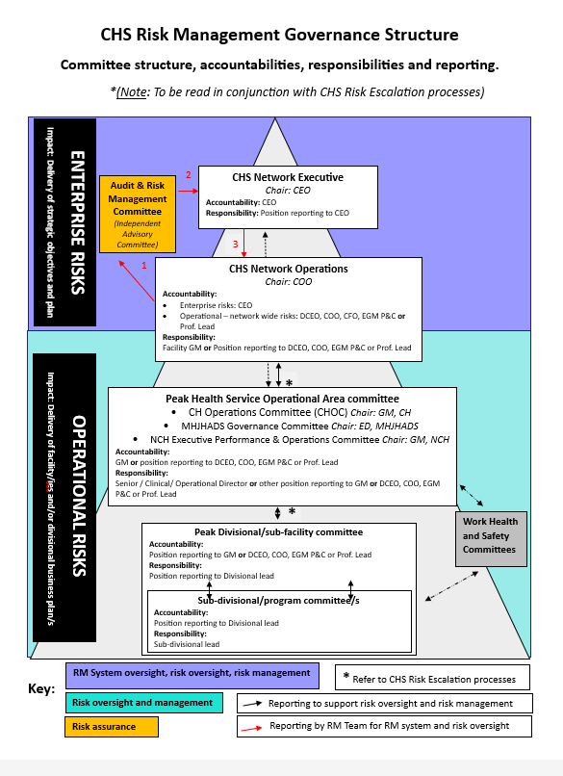

Attachment 2 – Risk escalation – Operational to Enterprise
A full resolution version of the Risk escalation – Operational to Enterprise is available on the Risk Management page of the Healthhub.
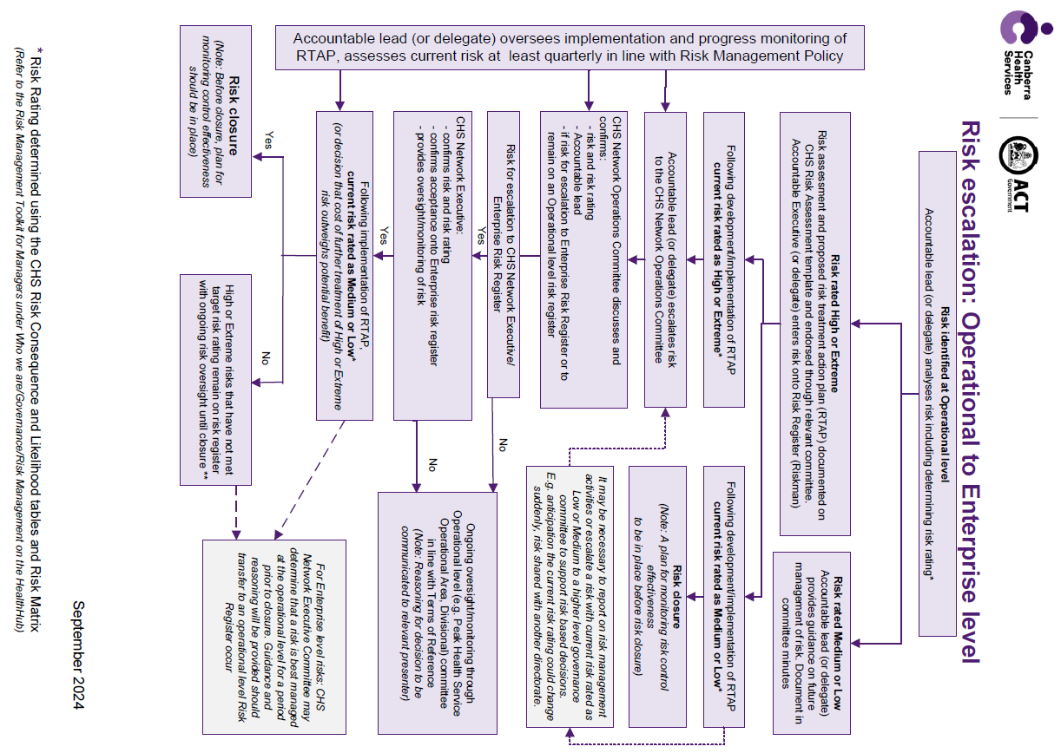

Attachment 3 – Risk escalation to CHS Peak Health Service Operational Area risk register
A full resolution version of the Risk escalation to CHS Peak Health Service Operational Area risk register is available on the Risk Management page of the Healthhub.
