Canberra Health Services
Guideline
Maternity Level of Care (Traffic Light) System

Contents

Contents 1
Guideline Statement 2
Scope 3
Section 1 – Levels of Care (Traffic Light) System and Responsibility of Leading Care 3
Section 2 – Green Light – Midwifery Led Care 4
Section 3 – Yellow Light – Midwifery / Obstetric Led Care 4
Section 4 – Red Light – Obstetric Led Care 5
Evaluation 5
Related Policies, Procedures, Guidelines and Legislation 5
References 6
Definition of Terms 8
Search Terms 8
Attachments 8

Guideline Statement

Background
This document has been developed to provide a framework for a ‘Way of Working’ for all obstetric and midwifery staff to promote autonomy, responsibility, and respectful practice, by developing trusting working relationships built on clear communication principles. It will guide staff working in Maternity Unit to ensure appropriate care for the clinical situation and that the expertise of maternity caregivers is used most effectively (Attachment 3).

Key Objective
By following this guideline, the care of women and babies in the maternity unit will be provided by the most appropriate clinician dependent on the clinical need. The guideline provides a structure to ensure an appropriate management plan with the aim of providing the highest level of safe and quality care is instigated for the woman and her baby. By following the guideline, care of all women in the maternity unit will be prioritised to ensure timely review, transfer, or discharge, reduce waiting times, and improve capacity and patient flow within the unit.

This guideline is strongly aligned with the National Safety and Quality Health Services (NSQHS) Standard Communicating for Safety Standard: Leaders of a health service organisation set up and maintain systems and processes to support effective communication with patients, carers and families; between multidisciplinary teams and clinicians; and across health service organisations. The workforce uses these systems to effectively communicate to ensure safety^{1, 2}.

This document is to be used to aid the management of relevant patient and clinical circumstances. The guideline should be interpreted and applied in practice after considering the clinical circumstances, the management options available and the professional judgements, knowledge and expertise of relevant/available clinicians.

Alerts
Allocation to a category is at the midwife’s or obstetric teams’ professional judgement. The allocation of a category in consultation with the obstetric team is negotiable, based on clinical and professional judgement, keeping the woman at the centre of her care. Should rationale be applied that deviates from this guideline, documentation must be made in the medical record to explain the deviation from recommended practice.

Re-categorisation of the level of care using the traffic light system may be required at any time as the woman’s labour and birth progresses. In the event the clinical situation crosses two level of care systems, the higher level should be chosen to ensure safety and quality of care is always provided.

Back to Table of Contents

Scope

This document applies to medical, midwifery and nursing staff under the clinical governance of the Canberra Health Services (CHS) Women, Youth and Children Division.

For the purposes of this document, the term Maternity refers to all women accessing hospital-based care throughout pregnancy, labour and birth and postpartum period as well as the unborn fetus and/or the newborn.

Back to Table of Contents

Section 1 – Levels of Care (Traffic Light) System and Responsibility of Leading Care

This system has been instigated to ensure women receive the most appropriate care led by the most appropriate clinician for their clinical situation, and that the expertise of maternity caregivers is used most effectively.

Women will be assessed, ongoing throughout the care journey, to ensure the most appropriate level of care system is applied to their situation.

The primary midwife providing care will use their own clinical judgement to assess the woman continuously throughout labour, birth and the postnatal period. The primary midwife is responsible for determining and discussing the initial assessment of the clinical situation and allocation of level of care with the appropriate members of the multidisciplinary team. Any midwife who is unsure of their assessment should discuss the situation with the team leader.

The primary midwife is also responsible for determining and documenting an initial management plan in the clinical record, with the aim of providing the highest level of safe and quality care. Ongoing assessment and developments in the management plan will be in consultation with the determined clinical lead for the situation and documented in the clinical record.

In the event the clinical situation crosses two level of care systems, the higher level should be chosen to ensure safety and quality of care.

Clinical handover between clinicians, either on a temporary or permanent basis will be as per current CHS policy, following the ISBAR (introduction, situation, background, assessment, recommendation/read back) format. See Clinical Handover Procedure for more detail.

Deviations in care from this guideline must be documented in the patient’s medical record.

Levels of Care – Traffic Light System

Level of Care | Responsibility of Leading Care
Green Light | Midwifery Led Care
Yellow Light | Midwifery Led care with Obstetric team input
Red Light | Obstetric Led Care

Back to Table of Contents

Section 2 – Green Light – Midwifery Led Care

Women in this category have had a Midwifery Admission completed and meet the criteria for midwifery led care (Attachment 1).

The midwife providing care will take the lead in facilitating the woman’s labour and birth in partnership with them.

The midwife will use their own judgement to assess the woman and her progress in labour. The midwife will consult and refer to the obstetric team when clinically indicated. Any midwife who is unsure of whether the woman meets the criteria for midwifery led care should discuss the situation with the team leader. Assessment is an ongoing process and should occur throughout labour and birth.

Obstetric staff are not required to routinely meet, review, or receive progress updates for women who meet the low risk (green light) criteria and are receiving midwifery led care. If the labouring woman continues to meet the green light criteria, clinical handover will be provided by midwifery staff. It is expected that midwives will inform obstetric staff promptly if these criteria are no longer met.

Consultation and referral will be in accordance with relevant CHS policies and clinical guidance documents and the Australian College of Midwives (ACM) National Maternity Guidelines for Consultation and Referral.

Back to Table of Contents

Section 3 – Yellow Light – Midwifery / Obstetric Led Care

Women in this category have a clinical indication that requires the primary midwife to consult and collaborate regarding care and decision making with the Obstetric Team. Upon consultation with the Obstetric Team, the clinical situation will determine if ongoing care responsibility remains with the primary midwife with ongoing consultation, or is referred to the Obstetric Team.

Consultation and referral will be in accordance with CHS policies and clinical guidance documents and the ACM National Maternity Guidelines for Consultation and Referral.

Back to Table of Contents

Section 4 – Red Light – Obstetric Led Care

Women in this category have a clinical indication that determines their care is to be led by the Obstetric Team. A midwife will provide care, with a clear management plan and regular ongoing review and input from the obstetric team.

Consultation and referral will be in accordance with CHS policies and clinical guidance documents and the ACM National Maternity Guidelines for Consultation and Referral.

Back to Table of Contents

Evaluation

Outcome
- All staff will be able to appropriately determine level of care throughout the woman’s journey using this document and demonstrate by escalation and clinical handover.
- Women will be cared for by the appropriate clinician.
- Escalation of level of care is actioned responsive to clinical scenario.

Measures
- Concerns related to appropriateness of category allocation and reallocation will be reviewed by Clinical Midwifery Manager (CMM) of Birth Suite. Cases will be identified from Riskman incidents and staff notifications of concern.
- Adverse birthing outcomes related to inappropriate allocation or reallocation will be reviewed by Maternity Morbidity and Mortality (M&M) subcommittee as identified, cases with higher harm scores will be escalated to monthly Maternity M&M committee for review.
- Clinical and quality outcomes are evaluated through patient experience questionnaires and consumer feedback data.

Back to Table of Contents

Related Policies, Procedures, Guidelines and Legislation

Policies
- Nursing and Midwifery Board of Australia (NMBA) Requirements for Practice
- Informed Consent - Clinical

Procedures
- Labour and Birth Care including First, Second, Third and Fourth Stage
- Early onset Group B Streptococcus disease (EOGBSD) – Maternity
- Water Immersion in Labour and Birth

Guidelines
- Fetal Surveillance
- Diabetes in pregnancy - includes pre-existing and gestational diabetes
- Vaginal Birth After Caesarean (VBAC) Management
- Prelabour Rupture of Membranes (PROM) Management at Term
- Preterm Prelabour Rupture of Membranes (PPROM)
- Termination of Pregnancy (TOP), Miscarriage or Fetal
- Induction of Labour
- Obstetric Emergencies

Legislation
- Health Records (Privacy and Access) Act 1997
- Human Rights Act 2004
- Work Health and Safety Act 2011

National Policies & Guidelines
- National Safety and Quality Health Service (NSQHS) Standards
- ACM Consultation and Referral Guidelines
- RCOG Green Top Guidelines
- RANZCOG Guidelines
- NICE Guidelines
- Queensland Clinical Guideline: Normal birth
- Nursing and Midwifery Board Framework: Decision making framework for nursing and midwifery

Other
• Australian Charter of Healthcare Rights

Back to Table of Contents

References

- Australian College of Midwives: Consultation and Referral Guidelines. 3rd edition. Issue 2. https://www.midwives.org.au/resources/national-midwifery-guidelines-consultation-and-referral-3rd-edition-issue-2-2014
- Australian Medical Association (AMA). Safe handover: safe patients. Guidance on clinical handover for clinicians and managers. The Australian Medical Association Limited. Canberra, Australia. 2006.
2. Beckmann M, Cooper C, Pocock D. INFORMed choices: Facilitating shared decision-making in health care. Australian and New Zealand Journal of Obstetrics and Gynaecology. 2015;55(3):294-7.
3. Burvill S. Midwifery diagnosis of labour onset. British Journal of Midwifery. 2002;10(10):600-5.
4. Carrigan C. Collaborative arrangements. Australian Nursing Journal. 2011;18(10):24-7.
5. Chaboyer W, McMurray A, Johnson J, Hardy L, Wallis M, Chu FYS. Bedside handover: quality improvement strategy to “transform care at the bedside”. Journal of nursing care quality. 2009;24(2):136-42.
6. Chin GSM, Warren N, Kornman L, Cameron P. Transferring responsibility and accountability in maternity care: clinicians defining their boundaries of practice in relation to clinical handover. BMJ Open. 2012;2(5):e000734.
7. Eastern Health Guidelines for Consultation and Collaborative Maternity Care Planning. Available at: http://www.easternhealthfoundation.org.au
8. Garner J, Murray S, Parisaei M. Prioritisation on labour ward. Obstetrics, Gynaecology & Reproductive Medicine. 2019;29(10):292-7.
9. Merten H, Van Galen LS, Wagner C. Safe handover. BMJ. 2017;359.
10. Moudi A, Iravani M, Najafian M, Zareiyan A, Forouzan A, Mirghafourvand M. Exploring the concept and structure of obstetric triage: A qualitative content analysis. BMC Emergency Medicine. 2020;20(1).
11. Pregnancy, childbirth, postpartum and newborn care - A guide for essential practice. World Health Organization, Department of Making Pregnancy Safer. 2006.Available at: http://www.who.int/maternal_child_adolescent/documents/imca-essential-practice-guide/en/
12. Risk assessment for care in labour. Available at: http://www.royalberkshire.nhs.uk
13. Siassakos D, Fox R, Bristowe K, Angouri J, Hambly H, Robson L, et al. What makes maternity teams effective and safe? Lessons from a series of research on teamwork, leadership and team training. Acta Obstetricia et Gynecologica Scandinavica. 2013;92(11):1239-43.
14. The Shrewsbury and Telford Hospital: Your risks in pregnancy: Deciding the right place for you to give birth. Available at: https://sath.nhs.uk
15. Veit‐Rubin N, Brossard P, Gayet‐Ageron A, Montandon CY, Simon J, Irion O, et al. Validation of an emergency triage scale for obstetrics and gynaecology: a prospective study. BJOG: An International Journal of Obstetrics & Gynaecology. 2017;124(12):1867-73.
16. World Health Organisation (WHO) Care in normal birth: A practical guide. Report of a technical working party. 1996 Geneva: Publication no WHO/FRH/MSN/96.24. King Edward Memorial Hospital (KEMH) Obstetric Clinical Care Unit: Management of normal labour. 2002.

Back to Table of Contents

Definition of Terms

Back to Table of Contents

Search Terms

Traffic light system, Maternity, Level of care, Green light, Yellow light, Red light, Labour, Birth, Triage, Lead care, Admission assessment, Red, Yellow, Green, Midwife, Obstetric.

Back to Table of Contents

Attachments

Attachment 1: Maternity Level of Care (Traffic light system for labour and birth) flowchart
Attachment 2: Maternity Level of Care (Traffic Light System) Patient Record Sticker
Attachment 3: Initial Midwifery Admission Assessment

Disclaimer: This document has been developed by Canberra Health Services specifically for its own use. Use of this document and any reliance on the information contained t
herein by any third party is at his or her own risk and Canberra Health Services assumes no responsibility whatsoever.

Policy Team ONLY to complete the following:
Date Amended | Section Amended | Divisional Approval | Final Approval
12/10/2023 | Complete review | Suzanne Pilkington, ED WY&C | CHS Policy Committee

This document supersedes the following:
Document Number | Document Name
CHS22/212 | Maternity Level of Care (Traffic Light) System

Attachment 1: Maternity Level of Care (Traffic light system for labour and birth) flowchart

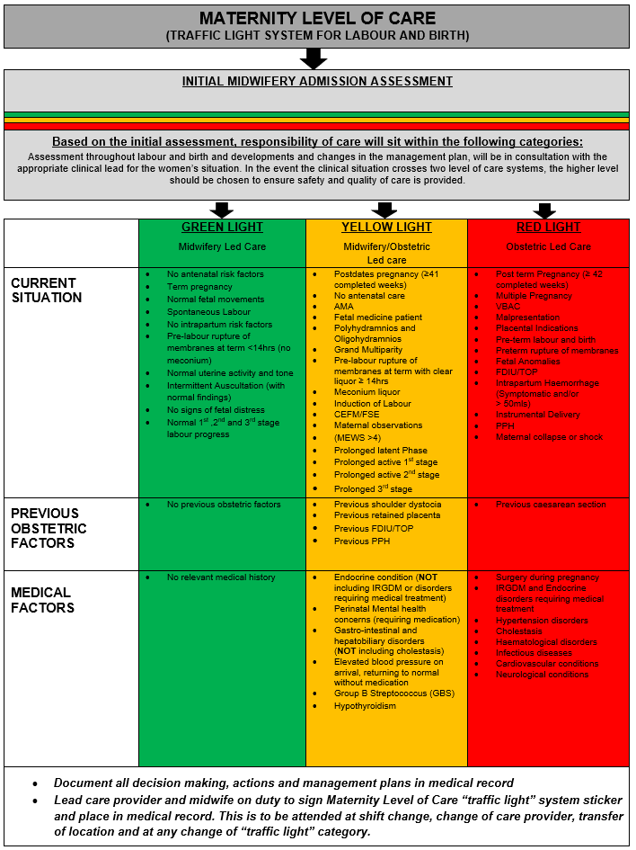

Attachment 2: Maternity Level of Care (Traffic Light System) Patient Record Sticker

MATERNITY LEVEL OF CARE (TRAFFIC LIGHT SYSTEM) |  |  | DATE: |  | TIME:
GREEN LIGHT  Midwifery Led Care | YELLOW LIGHT  Midwifery/Obstetric  Led Care |  |  | RED LIGHT  Obstetric Led Care
Document all actions and management plans in medical record

I, the lead care provider agree with the above Level of care:  Signature:  Print name: Designation: |  | I, agree with the above Level of care:  Signature:  Print name: Designation:
MATERNITY ON DUTY TEAM LEADER INFORMED OF LEVEL OF CARE, BY LEAD CARE PROVIDER

Attachment 3: Initial Midwifery Admission Assessment
INITIAL MIDWIFERY ADMISSION ASSESSMENT

Care is patient centred and includes informed choice, consent, privacy and respectful communication.

Initial contact
• Reason for presentation/contact
• Preferences for labour and birth
• Emotional and psychological needs

Review history
• Verbal
• Pregnancy Health Record
• Obstetric, gynaecological, medical, surgical,
social
• Investigations and results
• Medications and allergies
• Pregnancy complications
• Psychosocial, cultural and spiritual

Contractions
• Time commenced
• Duration, strength, frequency and resting tone

Maternal observations
• Temperature, pulse, respiratory rate, BP, Sp02
• Urinalysis
• Nutritional and hydration status
• General appearance

Abdominal assessment
• Observation and palpation
• Fundal height, lie, presentation, position, engagement/descent, liquor volume

Fetal wellbeing
• Fetal movements
• Auscultate FHR towards the end of contraction and continue for at least 30‒60 seconds after contraction finished
• Differentiate fetal heartbeat from maternal pulse

Vaginal loss
• Nil, discharge, liquor, blood
• Note colour, odour, amount, and consistency

Vaginal examination
• If stage of labour uncertain, may assist decision making
• Consider speculum examination if SROM

Discomfort and pain
• Reassure, promote, reinforce coping strategies
• Assess response to contractions
• Review birth plan and note preferences
• Discuss advantages/disadvantages of options

BP: blood pressure, FHR: fetal heart rate, VE: vaginal examination, SROM: spontaneous rupture of membranes Sp02: Oxygen saturations #Australian College of Midwives: National midwifery guidelines for consultation and referral. 3rd Edition, Issue 2. 2015

TRIAGE TRAFFIC LIGHT CATEGORY
Triage stage of labour and /or risk factors?
NOT IN LABOUR/EARLY LABOUR
Antenatal Assessment and document plan
IN LABOUR
Refer to Labour and birth: care during First, Second, Third and Fourth stage
MATERNITY LEVEL OF CARE
(TRAFFIC LIGHT SYSTEM FOR LABOUR AND BIRTH)
GREEN
LIGHT

Midwifery Led Care
YELLOW LIGHT
Midwifery/
Obstetric Led Care
RED
LIGHT

Obstetric Led Care
- Discuss with appropriate Led Care Provider surrounding assessment and inform Team Leader of plan
- Document all decision making, actions, management plans in medical record and complete traffic light sticker in notes

