Canberra Health Services
Procedure
Residential Aged Care Facility Placement from Hospital

Contents

Contents 1
Purpose 2
Alerts 3
Scope 3
Section 1 – Roles and Responsibilities 4
Section 2 – Process for patients requiring Residential Aged Care Placement 4
Section 3 – Process for discharge of a person to RACF 7
Section 4 – Declining Placement 7
Section 5 – Nursing Home Type Patient (NHTP) Fees 9
Section 6 – Respite Beds 9
Evaluation 10
Related Policies, Procedures, Guidelines and Legislation 10
References 11
Definition of Terms 12
Search Terms 13
Attachments 13
Attachment 1: Nursing Home Type Patient Information 15
Attachment 2: Flowchart for a patient to be considered as waiting for Residential Aged Care Placement 17
Attachment 3: RACLN Bookmark – Navigating the Residential Aged Care Process 18
Attachment 4: Residential Aged Care Placement - Process Flow 19
Attachment 5: Letter 1A – The Residential Aged Care Application Confirmation Letter 20
Attachment 6: Letter 1B - Residential Aged Care Application Confirmation Form 21
Attachment 7: Letter 2 – Residential Aged Care Application Confirmation Follow-up Letter 22

Purpose

The purpose of this procedure is to ensure that a standardised approach is adopted across Canberra Health Services (CHS) Network to support inpatients who require discharge directly from hospital to a permanent placement in a Residential Aged Care Facility (RACF).

This procedure outlines the process for facilitating the early identification of older persons who are likely to require placement in a RACF, outlining processes and information to guide the management of efficient and timely residential aged care placement (RACP).

Throughout this process, a collaborative approach will be taken in consultation with the individual and/or substitute decision makers. This will include:
- treating people with dignity and respect
- empowering people to participate in decisions about their health and wellbeing
- obtaining informed consent and providing adequate and accurate information to support informed decision making
- providing access to advocacy processes.

This procedure is applicable in circumstances where the treating team recommend placement to a RACF to be the most appropriate place to best meet the individual’s current care needs. Long term inpatient admission in a hospital setting is not considered appropriate for ongoing care because of the risks this presents to older persons.

Benefits that can be gained from facilitating timely transfer to a RACF include:
- a model of care and support that specifically caters for the needs of the person.
- decreased vulnerability to hospital acquired infections.
- a structured environment that is conducive to meet the long-term needs of the person.
- staff appropriately skilled in the provision of long-term care.
- increased interaction, socialisation, and improvement in personal wellbeing.
- appropriate care with ongoing options/choice to transfer between residential care facilities, if desired and where available.
- promoting timely flow through the health services therefore providing effective and efficient use of health resources.

Back to Table of Contents

Scope

Alerts

Fees
The Medical Officer (MO) or Visiting Medical Officer (VMO) must inform the person or substitute decision maker of the decision to change the level of care of the person to Maintenance Care (also known as non-acute care – NAC) with accommodation reason Nursing Home Care – NHC (also known as Nursing Home Type Patient – NHTP). The financial implications are discussed when providing this advice and can be informed by the Information Sheet “Nursing Home Type Patient Information” (Attachment 1).

If feasible this discussion should be done during a family meeting, or at a family bedside meeting, and is to be documented in the person’s clinical record.

Orders
Where patients are currently under any orders (e.g., Psychiatric treatment orders, Guardianship and Management of Property orders) these must be considered.

Back to Table of Contents

Scope

This procedure relates to the management of older person inpatients, who, after being clinically stabilised:
- are unable to be safely discharged back to their pre-admission environment.
- have been approved or waiting for approval by the Aged Care Assessment Team (ACAT) as being eligible for residential aged care placement.

This procedure is applicable to all staff of CHS Network who participate in the care and discharge of people transferring from hospital to a RACF.

The CHS Network includes inpatient facilities at The Canberra Hospital, and University of Canberra Hospital (UCH).

Note: For RACF placement at North Canberra Hospital (NCH) please refer to NCH Residential Aged Care Facility Placement procedure.

During this process, there is a need to consider Aboriginal and Torres Strait Islander older persons, to ensure appropriate care is provided, through the provision of information and access to relevant services. A referral to the Aboriginal and Torres Strait Islander Liaison Service (ALO Service) can be made through the Digital Health Record (DHR).

Back to Table of Contents

Section 1 – Roles and Responsibilities

All patients who require a RACP will be referred to the Residential Aged Care Liaison Nurse (RACLN). A referral on the patient’s clinical records can be made via DHR by the Social Worker (SW), Clinical Nurse Consultant (CNC) or Team Leader (TL). The RACLN is responsible for the initial support to the person/substitute decision maker to help navigate the aged care system and consult with residential aged care facilities on the availability of permanent beds.

Note: If the patient identifies as Aboriginal and Torres Strait Islander, it is important to include the ALO Service to ensure cultural protocols are followed and that the correct decision maker is determined.

It is the responsibility of MO/VMO to inform the person, or substitute decision maker (at a formal family meeting or consultation) of the decision to change the care type to reflect waiting for RACF placement and to advise them of the financial implications. SW can assist the family with financial implications. A record of this conversation should include possible incurred financial implications and should be documented in the individual clinical record. An Information Sheet is available to assist with this discussion (Attachment 1).

Further clarification if required, can be sought from the Patient Accounts Team via Canberra Hospital Switch. The role of the Patient Accounts Team is to provide supporting documentation and information to the person or substitute decision maker. This information will include details of any charges that may be incurred following a level of care change authorised by a Medical Officer. This is outlined as patient contributions under the disallowable instrument Health (Fees) Determination under the Health Act 1993. The Social Worker can assist with financial hardship paperwork and linking into Centrelink if applicable. The Social Worker and RACLN will work together to assist the person/substitute decision maker with RACF placement.

It is expected that the person or substitute decision maker will work in partnership with all members of the multidisciplinary team, led by the MO/VMO with the assistance of the Social Worker and the RACLN, and where appropriate the ALO. The substitute decision maker is responsible for acting in the best interest of the person requiring placement in a RACF. These responsibilities are described in the Enduring Power of Attorney documents and the ACT Public Trustee and Guardian Factsheet for Private Guardians.

Back to Table of Contents

Section 2 – Process for patients requiring Residential Aged Care Placement

Family Meeting
A family meeting will be conducted once a person is clinically stable, and the treating team has recommended that the individual will require ongoing care and is unlikely to be managed safely in the community. The person should be invited to participate in the family meeting, regardless of their decision-making capacity and presence of a substitute decision maker. If a family meeting is not feasible a consultation between the treating team and family member/EPOA/substitute decision maker should be arranged.

It is essential that the capacity of the person to make decisions (medical, accommodation, or financial) is determined. If it is determined that the capacity of the person requires a substitute decision maker, this must be arranged, and the substitute decision maker must be involved with the family meeting (i.e., in person or via teleconference). Medical, Nursing and Allied Health representatives will also be present. Use of Translating and Interpreting Services (TIS) should be offered if the patient is from a culturally or linguistically diverse background.

At the family meeting, the person or substitute decision maker will be informed of the team’s assessment of the person. A recommendation will be provided that the person requires ongoing care to meet their needs, which may not be possible in the community. Appropriate consideration should be given to transfer the person to a respite bed or discharge the person home with community supports while they wait for placement.
The person or substitute decision maker is required to decide as soon as possible and not more than 48hrs on how they wish to proceed.

At the family meeting, the MO/VMO should clearly inform the person or substitute decision maker of the change in level of care coding to reflect waiting for Nursing Home Care and the financial implications of this. Outcomes of the family meeting are to be clearly documented in the clinical record. The Sub and Non-Acute Patient Team (SNAP)Team should be notified via secure chat in the DHR.

Patient/Carer preference to return home.
After weighing up the advice provided at the family meeting, if a person or substitute decision maker opts for discharge home rather than to a RACF this will be clearly documented. At the family meeting, the person or substitute decision maker must be reminded of the risks identified and recommendation made by the multi-disciplinary team. The person or substitute decision maker’s acknowledgement must be documented in the person’s clinical record.

Information around support services will be provided, and where possible, appropriate referrals made. All discussions and decisions should be recorded in the person’s clinical record. The person will then be discharged from CHS.

Change of Level of Care
For a person to have level of care changed to Maintenance Care, accommodation reason NHC/NAC, all the following questions require a YES answer (see Attachment 2):
- Is the person clinically stable?
- Has the treating team recommended ongoing care that is not available in the community?
- Has the person or substitute decision maker been consulted in a family meeting about the requirement for 24-hour care and RACP? And the risks involved in a discharge to the community?
- Does the person have a current ACAT approval for residential aged care (permanent or respite)?
- Has the person or substitute decision maker been informed of potential billing charges when the level of care is changed, and has this conversation been documented in the progress notes?
- Is the person still clinically stable and ready for immediate transfer to an appropriate RACF?

Application for Residential Aged Care

A referral is made through the My Aged Care website for an in hospital Aged Care Assessment once the referral is made for an ACAT assessment, the person or substitute decision maker will be given the ‘Residential Aged Care Placement Pack’ by the unit Social Worker. The Social Worker will make a referral via the person’s clinical record to the RACLN. The referral and consent provided by the person or substitute decision maker will be documented in the clinical notes. The referral will include the reason for RACP (i.e., functional decline, cognitive impairment, or other relevant information).

The person/substitute decision maker will be requested to complete and submit the ‘Combined Assets and Income Assessment’ to Centrelink. The person or substitute decision maker may decide, in some circumstances, not to complete this form. The Social Worker or RACLN will advise that if they choose not to complete the form, they may be charged the full cost from the facility.
The RACLN will:
- Once a referral is received the RACLN will make contact with the person/substitute decision maker within 24hrs to start the process of securing a RACP.
- RACLN will communicate to person/substitute decision maker the names of the RACF that have available beds.
- If there are significant difficulties completing the application, the RACLN or Social Worker provide assistance.
- Record all discussions and updates from the RACF and substitute decision maker in the person’s clinical record.

Navigating the Residential Aged Care Process Bookmark is available at Attachment 3.

Some people/substitute decision makers may choose to manage this process independently without the involvement of the RACLN, however they are still required to meet the criteria detailed in this procedure.

If the Social Worker or RACLN become aware of any potential barriers to transfer to RACF, these should be communicated to the Clinical Nurse Consultant (CNC) who will discuss with the divisional Assistant Director of Nursing (ADON) at their weekly flow meeting. If the person is still an impatient after 28 days of been made NHTP they will be placed on the divisional Multi-Agency Discharge Events (MADE).

Further reading
- Navigating the Residential Aged Care Process Bookmark is available at Attachment 3.

Back to Table of Contents

Section 3 – Process for discharge of a person to RACF

Process for discharge of a person to RACF (New Resident)
Preparing the transfer of a person to residential aged care should be part of the standard discharge planning process. Once a place is secured the discharge to the RACF will be managed by the Discharge Liaison Nurse (DLN) or Rehabilitation Care Coordinator (RCC) they will act as the communication link between the RACF and the person or substitute decision maker.

Influenza, pneumococcal and COVID-19 immunisation status will be checked, and if appropriate, offered by the discharging ward prior to being discharged to the RACF.

The details for the process for discharge of people to a RACF are outlined in further detail at Attachment 4 - Discharge of Patient to RACF - Process Flow

Back to Table of Contents

Section 4 – Declining Placement

Declining Placement
While it is acknowledged that a person or substitute decision maker may have a preferred facility for RACP, it is a requirement that a person or substitute decision maker will accept a RACF that supports the clinical, social, and cultural needs of the individual. Offering a place at this RACF is consistent with meeting the person's rights under the Human Rights Act 2004 and the Charter of Rights (Aged Care Act 1997).

Where a person or substitute decision maker fails to apply to RACFs or does not accept a bed when offered by one of the facilities, the hospital will request the person or substitute decision maker consider other discharge options and the matter will be escalated through the Divisional ADON to the Divisional Director of Nursing (DON).

The risk associated with refusal of an available RACF bed is that:
- People who remain in hospital for an extended period of time are at risk of functional decline and/or hospital acquired infection.
- Inpatient beds are occupied with people who no longer require acute/sub-acute care while those who need such care are delayed due to limited capacity; and
- Inefficient and ineffective use of inpatient hospital resources.

If issues emerge that extend the length of stay beyond 28 days the person will be referred to the divisional MADE. Documentation in the person’s clinical record is required and should include the discussions, events and actions undertaken, including escalation pathways.

Early Recognition of Barriers to Transfer to RACF:
Early recognition triggers for potential barriers to transfer to RACF/refusal may include:
- Inability to contact family.
- No family/substitute decision maker available.
- Family/substitute decision maker not attending scheduled meetings or unresponsive to contact(s).
- Frequent changes to discharge plan by family/substitute decision maker or RACFs.
- Lack of flexibility with RACF preferences.
- Lack of available RACFs due to complex needs of patient or culturally sensitive requirements.
- No agreed discharge destination at day 10 of admission or approaching estimated discharge date with no agreed discharge plan in place.
- Difficulty accessing equipment or special services.
- Delay in accessing guardianship where required.
- Citizenship or residency issues
- Delay in submission of the Combined Assets and Income Assessment and response from Centrelink.
- Cultural expectations about family responsibility to care and stigma around RACF placement.
- History of trauma and institutional abuse. This is particularly relevant for Aboriginal and Torres Strait Islanders, culturally and linguistically diverse (CALD) communities, Forgotten Australians, Care leavers and members of the lesbian, gay, bisexual, transgender, intersex, queer or questioning (LGBTIQ+) community.
- Financial hardship or financial concerns about selling a home/ homelessness of a carer.

The person or substitute decision maker can access Advocacy groups for advice /support. Advocacy groups include but are not limited to the following:

- ACT Disability, Aged and Carer Advocacy Service (ADACAS)
- Council on the Ageing (COTA)
- Human Rights Commission (HRC)
- Older Persons ACT Legal Services (OPALS)
- Aged Care Navigators
- Private Aged Care Placement Services.

Escalation Plan:
If the treating team believe the substitute decision maker is not acting in the best interests of the person, then:

- A family meeting will be held led by the Medical Team and will include the Social Worker, RACLN, CNC and Divisional ADON, and will be attended by the person or substitute decision maker. This may also include independent support or advocacy agencies.
- The substitute decision maker should be given the opportunity to explain their perceived barriers to placement.
- The substitute decision maker is informed that the individual will not be able to stay in hospital and that RACF placement is appropriate for their care needs.
- A list of RACF options will be provided to the substitute decision maker along with a summary of what care has been requested and offered to date.
- The person should be referred to the Divisional MADE.

Where no progress can be made, an application to the ACT Civil and Administration Tribunal will be considered as the last resort following advice from the ACT Government Solicitor’s Office (ACTGS). All relevant documentation and information will be sent to the ACTGS for advice (as per the Request for Legal Advice Procedure on the CHS Policy Register).

Please note: The Tribunal is a legal process and is between the substitute decision maker and CHS (not an individual staff member working for CHS).

Note: If the substitute decision maker cannot be contacted, the escalation process should be initiated. In this case, ACTGS advice should be sought before consulting with the ACT Civil and Administrative Tribunal to raise concerns if no one is acting as a patient advocate.

Back to Table of Contents

Section 5 – Nursing Home Type Patient (NHTP) Fees

It should be noted that fees may apply to people in hospital who require ongoing supported care. These people will be assigned a level of care of Maintenance Care with accommodation reason NHC. No fees are payable for the days the patient reverts to an acute, sub-acute, or non-billable maintenance level of care. If the person has elected to use private health insurance, their Acute Care Certificate needs to indicate that they no longer require acute clinical care.

People classified and coded as Maintenance Care NHC who are in receipt of a pension from Centrelink or Veterans Affairs may be eligible for payments/entitlements from these services. Upon the reclassification the Social Worker can assist in providing information to individuals and their families/substitute decision maker on potential entitlements.

Back to Table of Contents

Section 6 – Respite Beds

Patients who are ready for discharge from hospital but awaiting a permanent residential aged care bed may be suitable for commonwealth funded residential respite care in a RACF as a transition between their hospital stay and finding a permanent placement. An ACAT assessment will need to occur for those identified for respite care to determine eligibility. Residential respite is available for up to 63 days of subsidised care in a financial year. This includes both planned and emergency residential respite care.
It is possible to extend this by 21 days at a time, with further approval from the aged care assessor.

The RACLN will work with the person or supported-decision maker and the RACF to arrange for the transition to respite care on discharge from CHS. Those in residential respite are entitled to the same care and support services as permanent residents of the aged care facility.

Due to bed pressures in the ACT, there is no guarantee that a respite bed is available.

Back to Table of Contents

Evaluation

Outcome
That a standardised approach is adopted across CHS when supporting inpatients who require discharge directly from hospital to a permanent placement in a Residential Aged Care Facility (RACF).

That inpatients (older persons) who are likely to require permanent placement in a RACF, are identified early (as per this procedure) to ensure efficient and timely residential aged care placement (RACP).

Measures:
Length of stay (LOS) of inpatients remaining in hospital once identified by the team as being suitable for discharge to a RACF/when the level of care coding changes to reflect same.

Regular Audit of DHR notes regarding compliance with the procedure.

Back to Table of Contents

Related Policies, Procedures, Guidelines and Legislation

Policies
- Informed Consent - Clinical

Procedures
- Admission to Discharge – Canberra Hospital
- Discharge Summary Completion inpatients
- Request for Legal Advice Procedure

Guidelines
- Discharge Liaison Nurse Guidelines

Legislation
- Human Rights Act 2004
- Commonwealth Aged Care Act 1997
- Health Insurance Act 1973 (Commonwealth)
- Health Act 1993 (ACT)
- Charter of Aged Care Rights 2019
- Health (Fees) Determination Disallowable instrument – updated annually
- Aged Care Quality and Safety Commission Act 2018

Other
- Australian Charter of Healthcare Rights

Back to Table of Contents

References

- National Immunisation Program Schedule, 1 November 2005 (Australian Government Department of Health & Ageing)
- Residential Aged Care Placement Policy Directive, SA Health July 2015
- Immunisation Strategy 2007 – 2010
- Opportunistic Influenza Immunisation for Aged Care Rehabilitation Services (ACRS) Inpatients, April 2010
- Northern Sydney Central Coast NSW Health Residential Aged Care Placement Policy 2010
- Melbourne Health Discharge of Patient to Residential Care Facility Policy 2011
www.myagedcare.gov.au
- 5 Steps to Entry into Residential Aged Care
http://www.health.gov.au
- Northern Sydney Central Coast NSW Health Residential Aged Care Placement Policy 2010
- Melbourne Health Discharge of Patient to Residential Care Facility Policy 2011
- Aged Care Act 1997 Date accessed November 2017
- Health Insurance Act 1973 Date accessed November 2017
- Human Rights Act 2004 (ACT) Date accessed November 2017
- ACT Civil and Administrative Tribunal Act 2008 (ACT) https://www.act.gov.au/. Date accessed November 2017
- Guardianship and Management of Property Act 1991 (ACT) Date accessed November 2017
- Powers of Attorney Act 2006 (ACT) Date accessed November 2017
- www.myagedcare.gov.au Date accessed November 2017
- Legal Aid - http://legalaidact.org.au/whatwedo/cu/ Date accessed November 2017

Back to Table of Contents

Definition of Terms

Discharge Liaison Nurse (DLN) - act as the communication link relating to the discharge process between relevant internal and external stakeholders and the patient and their family/carer.

Multi-Agency Discharge Event (MADE) - brings together the multi-disciplinary team to support improved patient flow across the system, recognise and unblock delays, and challenge, improve and simplify complex discharge processes.

Nursing Home Care (NHC) – Accommodation reason used for patients who are waiting for residential aged care facility placement. This classification can be applied to patients with a hospital length of stay of less than 35 days, and in those cases will not attract a fee.

Nursing Home Type Patient (NHTP) - A patient who has been in one or more approved hospitals (public or private) for a continuous period of more than 35 days, with a maximum break of seven days, and who is not deemed to be receiving acute care; but does not include a compensable patient or a non-eligible person. This term is not included in the Digital Health Record. (Source: authorised by the ACT Parliamentary Counsel-also accessible at www.legislation.act.gov.au)

Older person or eligible for RACF/P = people aged 65 yrs and Aboriginal and Torres Strait Islander people over the age of 55 yrs who require care are that can no longer be met in the community.

Rehabilitation Care Coordinator (RCC) –Coordinate the transition of patients accepted into the Rehabilitation Service and assists in the overall discharge process for rehabilitation patients by attending Goal Setting meetings, facilitating Case Conferences, attending Family meetings and Discharge Planning meetings, supporting the MDT to improve performance against expected date of discharge, providing support and updates to patients, families and staff through the rehabilitation and discharge planning process and ensuring appropriate referrals are actioned in a timely manner.
Residential Aged Care Liaison Nurse (RACLN) - provides support to person/substitute decision as you move from hospital into a residential aged care facility.

Residential Aged Care Facility (RACF) - In this document the term RACF refers to a special-purpose facility which provides accommodation and other types of support, including assistance with day-to-day living, intensive forms of care, and assistance towards independent living, to frail and aged residents. Facilities are accredited by the Aged Care Standards and Accreditation Agency Ltd to receive funding from the Australian Government through residential aged care subsidies. (Definition sourced from AIHW)

Residential Respite Care - Resident respite care takes place in an aged care home. It is best suited to people who need carer support for most tasks and can be for a few days through to a few weeks at a time. Respite Care provides you the same care and support services as permanent residents of the aged care home. For example, you will be given a room and hotel-type services such as meals, laundry, and social activities, as well as services to meet your personal and care needs.

Substitute Decision Maker - is a nominated person who acts for a protected person and is permitted under the law to make decisions on behalf of another person who is unable to make independent decisions for themselves. These decisions may be about financial, medical, and personal matters and to act for a protected person and to ensure their needs and interests are met.

Back to Table of Contents

Search Terms

Discharge, Transfer, Residential Aged Care, Long stay, Residential Aged Care Facility, Nursing Home, Substitute Decision Maker, Placement

Back to Table of Contents

Attachments

Attachment 1: Information Sheet – Nursing Home Type Patient Information
Attachment 2: Flowchart for a patient to be considered as waiting for Residential Aged Care Placement (RACP)
Attachment 3: RACLN Bookmark – Navigating the Residential Aged Care Process
Attachment 4: Discharge of Patient to Residential Care Facility - Process Flow
Attachment 5: Letter 1A – The Residential Aged Care Application Confirmation Letter
Attachment 6: Letter 1B -Residential Aged Care Appliciton Confirmation Form
Attachment 7: Letter 2 -Residential Aged Care Application Confirmation Follow-up Letter

Disclaimer: This document has been developed by Canberra Health Services specifically for its own use. Use of this document and any reliance on the information contained therein by any third party is at his or her own risk and Canberra Health Services assumes no responsibility whatsoever.

Policy Team ONLY to complete the following:
Date Amended | Section Amended | Divisional Approval | Final Approval
16/07/2024 | Complete Review | ED, RACS | Policy Document Review Panel

This document supersedes the following:
Document Number | Document Name
CHHS16/080 | Residential Aged Care Facility Placement
CHS20/141 | Residential Aged Care Facility Placement

Attachment 1: Nursing Home Type Patient Information

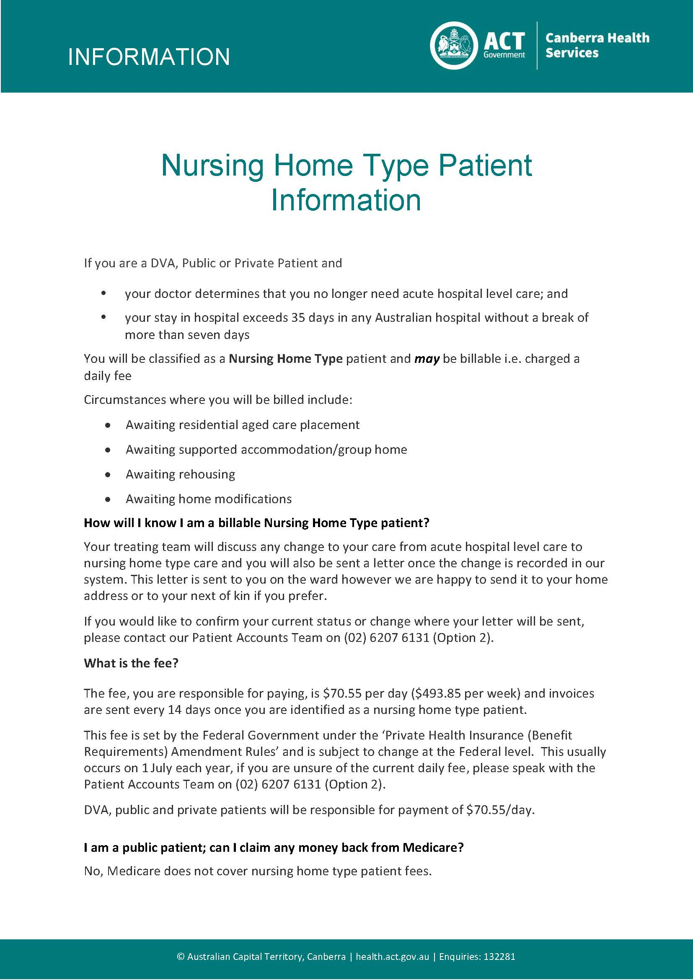

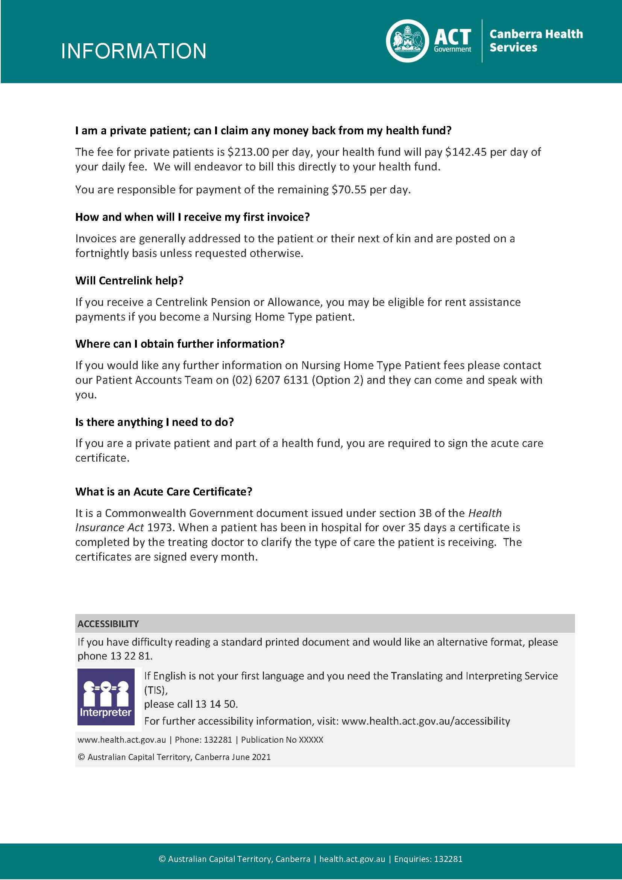

Attachment 2: Flowchart for a patient to be considered as waiting for Residential Aged Care Placement (RACP)

All questions require a YES answer

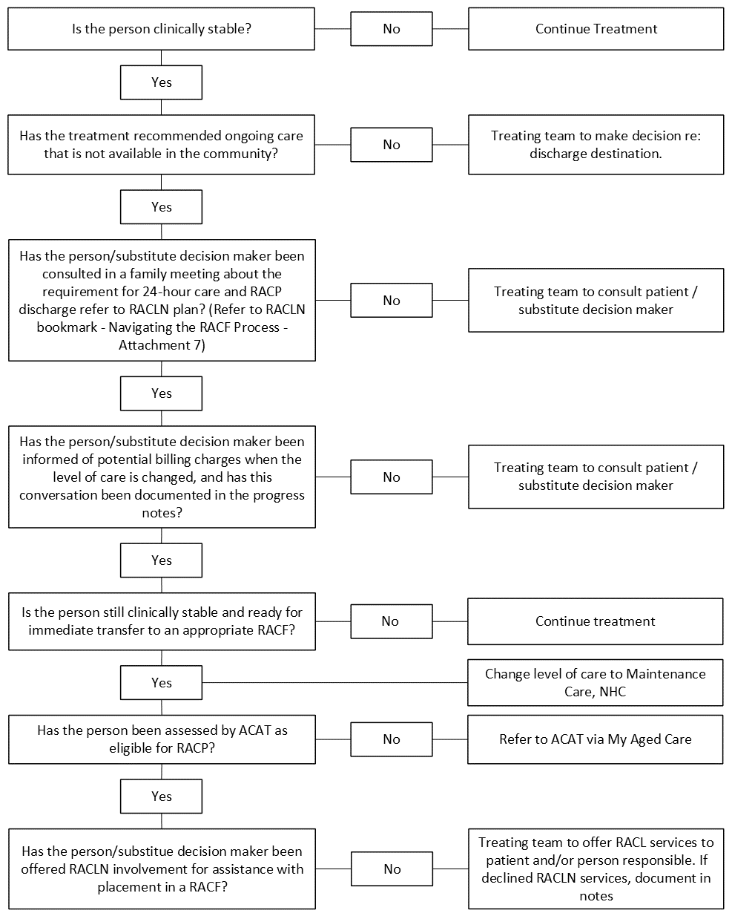

Attachment 3: RACLN Bookmark – Navigating the Residential Aged Care Process
(Available from the RACLN)
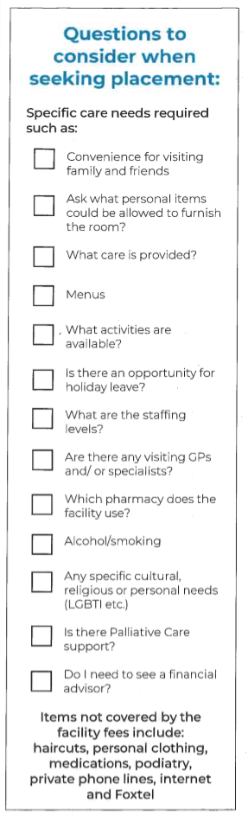
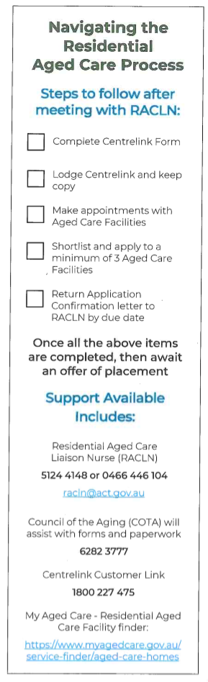

Attachment 4: Residential Aged Care Placement - Process Flow
Treating Team recommends Level of Care change to Maintenance Care - NHC awaiting RACP

Family meeting organised and Person/Substitute decision maker or other support personnel (i.e., Aboriginal Liaison Officer) consulted by the Medical and Multidisciplinary Team regarding ongoing care requirements and recommendations for RACP discharge plan.
Person/ Substitute decision maker consents to placement in a RACF
Social Worker meets with person/substitute decision maker to:
1. To explain the process and ensure that the person/ substitute decision maker is aware of the steps and requirements and is resourced with relevant residential care information.
2. Person assessed and approved by ACAT as eligible for RACF placement.
3. Ensure that a referral is made, with consent, to a RACLN to assist the person/substitute decision maker in the process of finding a suitable RACF placement. The RACLN will assist by liaising with appropriate RACF’s.

Once placement date is offered, person or substitute decision maker, RACF and Hospital facilitate discharge.
Letter 1A (The Residential Aged Care Application Letter) and Letter 1B (Residential Aged Care Application Confirmation Form) is provided and explained to the person/ substitute decision maker by RACLN.
The person/ substitute decision maker will be requested to complete and submit the “Combined Assets and Income Assessment” to Centrelink as well as lodging written applications to a minimum of three (3) RACFs within 14 business days. Documentation of the process and communication is to be recorded in the person’s clinical record.
Placement becomes available in a nominated and suitable RACF and accepted by person or substitute decision. This is to be documented in the patient’s clinical record.
If Letter 1B has not been returned to the RACLN, Letter 2 (Residential Aged Care Application Confirmation Follow-up Letter) is to be issued to the person/substitute decision maker and returned by the nominated due date.
The Discharge Liaison Nurse or Rehabilitation Care Coordination is to facilitate the person’s discharge to a RACF in a timely and safe manner. Valuables, belongings, medications, and transfer/ discharge letters are to accompany the person on discharge to RACF in accordance with the CHS discharge processes. Prescriptions can be faxed to community pharmacy for dispensing/ delivery direct to the RACF if required.

Attachment 5: Letter 1A – The Residential Aged Care Application Confirmation Letter

Name:

Address:

Dear _____________________________,

We acknowledge that the decision for residential care means a significant life change and we will endeavour to help you through this process.

To assist in this process the Residential Aged Care Liaison Nurse (RACLN) will advise you on bed availability in the Residential Aged Care Facilities. We request that you submit applications to a minimum of three appropriate facilities within fourteen days (14) days from the date of consent to be placed in a residential aged care facility. It is important only to submit applications to facilities for which you are prepared to accept a vacancy as Canberra Health Services requires that you take the first vacancy offered.

Please complete and return the Residential Aged Care Application Confirmation section below and return this form to the RACLN by ___________ (insert date).

If you have any questions or need assistance with your application for RACF placement, please contact the RACLN on 5124 64355 or mobile 0466 446 104 or email RACLN@act.gov.au as they may be able to assist.

Yours sincerely

Chief Operating Officer
Canberra Health Services

Date

Attachment 6: Letter 1B - Residential Aged Care Application Confirmation Form

I _____________________ (patient/family member/Substitute Decision Maker) advise that.

_______________________________________________ (insert patient’s name)

Has submitted applications to the following facilities:

No | Name of Facility | Suburb
1
2
3

I understand that Canberra Health Services requires that
_______________________________ (insert patient’s name) will take the first available vacancy offered from this list. If there are no vacancies at any of the nominated facilities foreseeable for the next two (2) weeks, additional facilities need to be considered.

Signed: __________________________Print Name: _________________________

Relationship to Patient_________________________________________________

Please return by: ___________ (insert date) to the Residential Aged Care Liaison Nurse.

Attachment 7: Letter 2 – Residential Aged Care Application Confirmation Follow-up Letter

Name:

Address:

Dear _____________________________,

We wrote to you on ________________ (insert date) about the need for

________________________ (insert patient’s name) to seek appropriate Residential Aged Care Facility placement.

We also asked for a Residential Aged Care Application Confirmation Form to be completed and returned to the Residential Aged Liaison Nurse (RACLN) by__________________ (insert due date) but as of this date, we have not received notification that you have applied to three Residential Aged Care Facilities.

If you are having difficulty and need assistance with your application for RACF placement, please contact the RACLN on 5124 64355 or mobile 0466 446 104 or email RACLN@act.gov.au as they may be able to assist.

We look forward to receiving your Residential Aged Care Application Confirmation Form by no later than ____________________ (insert date).

Yours sincerely

Chief Operating Officer
Canberra Health Services

