Canberra Health Services
Procedure
Pressure Injury Prevention and Management – Adults, Children and Neonates

Contents

Contents 1
Purpose 2
Scope 2
Section 1 - Services and systems to prevent and manage pressure injuries 2
Section 2 - Neonates and Children 7
Section 3 - Comprehensive skin inspections 8
Section 4 - Preventing and Managing Pressure Injuries 9
Section 5 - Patient/carer/family education and information 12
Section 6 - Equipment/resources/supplies 13
Section 7 - Staff education on pressure injury prevention and management 14
Evaluation 14
Related Policies, Procedures, Guidelines and Legislation 14
References 15
Definition of Terms 16
Search Terms 18
Attachments 18
Attachment 1: Waterlow Risk Assessment Tool (WRAT) - for adults 20
Attachment 2: Braden Q Risk Assessment Scale - for children (age <15years) 21
Attachment 3: Neonatal Skin Risk Assessment and Management Scale - Neonatal Intensive Care Unit (NICU) and Special Care Nursery (SCN) 22
Attachment 4: Modified version Waterlow tool (2005) in Maternity 24
Attachment 5: Braden Risk Assessment Scale within the community (Allied Health) 25
Attachment 6: Pressure Injury Prevention and Management Clinical Interventions Guideline 26
Attachment 7: Pressure injury Classification tool/photos 27
Attachment 8: GLOBIAD Ghent Global Incontinence Associated Dermatitis Categorisation Tool 28

Purpose

To provide a comprehensive, coordinated, and systematic approach for pressure injury prevention, assessment, and management across Canberra Health Services (CHS) that includes governance, systems and processes based on international best practice guidelines.

Pressure Injuries can occur at any age. This document provides clinicians and senior managers with direction and resources to recognise risk factors and plan for comprehensive care of adults, children, and neonates.

This clinical procedure is consistent with the National Safety and Quality Health Service Standards and should be used in conjunction with the Comprehensive Care Standard.

Back to Table of Contents

Scope

This procedure applies to the CHS Network, which includes the inpatient facilities at Canberra Hospital, Clare Holland House, North Canberra Hospital, and University of Canberra and community based services. CHS staff are responsible for the safe and effective prevention and management of pressure injuries for adults, children, and neonates across CHS.

This document applies to the following CHS staff working within their scope of practice:
- Medical Officers
- Nurses and Midwives
- Allied Health professionals
- Students under direct supervision
Back to Table of Contents

Section 1 - Services and systems to prevent and manage pressure injuries

Governance and reporting
CHS has organisation wide systems for pressure injury prevention, assessment and wound management that are consistent with best practice guidelines. CHS systems are based on the Prevention and Treatment of Pressure ulcers/injuries: Clinical Practice Guideline. The International Guideline. 2019².

Governance of pressure injury prevention and management is led by the Comprehensive Care Executive Committee and Pressure Injury Working Group.

Comprehensive Care Standard - Pressure Injury Working Group and North Canberra Hospital Falls and Pressure Injury Working Group
The intention of the Comprehensive Care standard is to minimise patient harm. CHS has targeted best practice strategies to prevent and care for patients at risk of or presenting with a pressure injury.

The role of the Pressure Injury Working Group is to provide expert advice to the Comprehensive Care Executive Committee on evidenced based organisation wide processes and systems to prevent and manage pressure injuries. The membership of the working party includes interdisciplinary key experts.

CHS reporting systems - Reporting a pressure injury
There are several mechanisms for reporting pressure injuries within CHS. Clinical incidents are reported via the clinical incident system RiskMan which is accessible to all staff via the intranet. A wound extension module (WEM) appears within a RiskMan incident report when an incident is identified as a pressure injury. The module improves reporting of the pressure injury by including specific information according to best practice guidelines, including whether the injury was present on admission.

RiskMan reports include key identifiers for each injury:
- Stage of pressure injury
- Anatomical location of pressure injury
- Facility or non-facility acquired
- Pressure injury prevention and management interventions.

RiskMan reports are received by the Tissue Viability Unit at The Canberra Hospital, the CNCs at the University of Canberra Hospital and the Wound Management Service in the Community Care Program. The patients are reviewed, and further documentation is added and/or adjusted within the Riskman report and patient clinical record, including the development of an individualised comprehensive care plan.

Governance under the Comprehensive Care Standard
A data set is generated by the Canberra Hospital Quality Safety Innovation and Improvement branch and Clinical Governance and Quality Unit at North Canberra Hospital synthesising data from multiple sources (below) and outcomes are forwarded back for correction by clinical experts to check accuracy of data and identify trends in pressure injury data across CHS, targeting interventions in areas with high pressure injury rates.

Hospital Acquired Complications (HAC) data
Four key descriptors of pressure injuries are required to be collected from the coded data within the clinical record on patient discharge.
- Facility acquired
- Stage of the injury - Stage 3, Stage 4, Suspected Deep Tissue Injury SDTI or Unstageable
- Unspecified (when a pressure injury has been documented, but not staged). (Stage 1 and Stage 2 are not reportable).
- Anatomical location

Health Round Table – Hospital Acquired Complications (HAC) Summary data
- Facility acquired
- Stage 3, Stage 4, (Stage 1 and Stage 2, SDTI and Unstageable are currently not reported)
- Unspecified (when a pressure injury has been documented, but not staged)
This information is generated at time of discharge and collated by ICD-11- Australian Modified (AM) clinical coders.
Risk Screening and Risk Assessment
- A pressure injury risk screening assessment aims to identify patients who are at risk of pressure injuries and informs the development and implementation of an individualised comprehensive care plan to mitigate risk factors.
- When conducting pressure injury risk screening, follow a structured approach that considers risk factors for pressure injury development.
- Risk screening is a snapshot of the patient’s current risk status on arrival to a health service.

Individuals who are a high risk are those characterised by multiple risk factors that effect:
- Exposure to damaging mechanical boundary conditions (MBC) i.e. type, magnitude, time, and duration of the mechanical load
- The susceptibility and tolerance of the individual (ST) i.e. mechanical properties geometry, physiology and repair and transport and thermal properties of the skin and tissue

Populations potentially characterised by multiple risk factors include:
- Acutely ill and or in critical care
- Sustained a fractured hip
- Spinal cord injury (SCI)
- Chronic neurological conditions
- Diabetes mellitus
- Sixty-five years of age or older and 45 years or older for Aboriginal & Torres Strait Islander
- Neonates and children
- Individuals in community, aged care, and rehabilitation settings
- Experiencing trauma
- Patients in the operating rooms -prolonged surgery
- Receiving palliative care
- Individuals with obesity
- Individuals in transit

Risk factors for developing pressure injuries
- Activity and mobility limitations
- Skin status
- Perfusion, circulation, and oxygenation factors
- Nutrition indicators
- Moisture at skin surface
- Body temperature
- Older age
- Sensory perception limitations
- Blood markers (For e.g. low haemoglobin, increase C- reactive protein, low albumin)
- General and mental health status

Patients with additional risk factors are:
- Patients in the operating rooms
- Critically ill patients
- Neonates and children

Risk assessment is central component of clinical practice and a necessary first step aimed at identifying individuals who are susceptible to pressure injuries.

Assessment of pressure injury risk should inform the second step – the development and implementation of an individualised management plan to mitigate modifiable risk factors and prevent pressure injury development.

Both modifiable and non-modifiable risk factors should be included in an overall assessment of pressure injury risk, however pressure injury prevention focuses on modifiable risk.

Risk assessment tools are used in both screening and assessment and inform the development and implementation of a risk plan.

The following validated risk assessment tools are endorsed across CHS:
- Waterlow Risk Assessment Tool (WRAT) - for adults (Attachment 1)
- Braden Q Risk Assessment Scale - for children (age less than 15years) (Attachment 2)
- Neonatal Skin Risk Assessment and Management Scale - Neonatal Intensive Care Unit (NICU) and Special Care Nursery (SCN) (Attachment 3)
- Modified version Waterlow tool (2005) in Maternity (Attachment 4)
- Braden Risk Assessment Scale within the community (Allied Health) (Attachment 5)

Other assessment tools
- Pressure Injury Prevention and Management Clinical Interventions Guideline (Attachment 6)
- Pressure injury Classification tool/photos (Attachment 7)
- Incontinence Associated Dermatitis Categorisation Tool (Attachment 8)
- Wound Management and assessment (refer to Wound Prevention and Management Procedure)
- Pain tool (refer to pain policy)

Risk screening and assessment by patient group

- Adults:
CHS has a Risk Assessment Tool for adults - Waterlow Risk Assessment Tool (Attachment 1). This is part of the screening and assessment process for pressure injuries.

Pressure injury risk screening and Waterlow score is conducted:
- At the Canberra Hospital, North Canberra Hospital and University of Canberra Hospital inpatient areas – within 8 hours of admission. Ongoing risk screening is attended daily and more frequently if there is a significant change in condition, in conjunction with a full skin assessment.
- Skin assessment and risk screening for pressure injuries is to be documented in the patient’s Digital Health Record.
- In the community (i.e. outpatient clinics, ambulatory care clinics, home visits and Walk in Centres) - at the initial home or clinic visit.
- Ongoing risk screening is attended at each home visit/clinic appointment for patients identified at risk or when there is a significant change in condition.
- On presentation to the Emergency Department, or as soon as possible for patients undergoing resuscitation or other priority interventions.
- After a prolonged procedure where the patient has been immobile or had surgery.
- Prior to discharge from the care service or transfer to other wards or facilities.

- Children < 15 years of age
- The Braden Q Risk Assessment Scale is used for screening and assessment of children under 15 years of age (Attachment 2). The screening and assessment are conducted:
- At Canberra Hospital inpatient areas - as soon as possible (i.e. at first contact with the health professional and documented in the patient clinical record within 8 hours of the decision to admit). Ongoing risk screening is attended daily and more frequently if there is a significant change in condition.
- In the community (i.e. outpatient clinics, ambulatory care clinics, home visits and Walk in Centres) - at the initial home or clinic visit.
- Ongoing risk screening is attended at each home visit/clinic appointment for patients identified at risk or when there is a significant change in condition.
- On presentation to the Emergency Department, or as soon as possible for patients undergoing resuscitation or other priority interventions.
- After a prolonged procedure where the patient has been immobile or had surgery.
- Prior to discharge from the care service or transfer to other wards or facilities.

- Neonates (see section 2 for more information)
- Neonatal skin assessment is attended in Neonatal Intensive Care Unit (NICU) and Special Care Nursery (SCN) on admission (Attachment 3) and documented within the patient’s clinical record within 8 hours.
- Dependant on the neonate’s risk score staff are required to reassess each neonate’s skin and update their risk of injury 2-24 hourly.
- Neonates scored as extreme risk require 2-4 hourly skin assessment.

- Maternity Services
- Modified version Waterlow tool (2005) is used in Maternity Services (Attachment 4)
- Is conducted at the Canberra Hospital inpatient areas and North Canberra Hospital maternity inpatient services - as soon as possible (i.e. at first contact with the health professional and documented in the patient’s clinical record within 8 hours of decision to admit). Ongoing risk screening is attended daily and more frequently if there is a significant change in condition.
- In the community (i.e. outpatient clinics, ambulatory care clinics, home visits) - at the initial home or clinic visit.
- Ongoing risk screening is attended at each home visit/clinic appointment for patients identified at risk or when there is a significant change in condition.

- Allied Health
- Braden Risk Assessment Scale is used by Allied Health (Attachment 5)
- Is conducted at Canberra Hospital, North Canberra Hospital and University of Canberra inpatient areas - as soon as possible (i.e. at first contact with the health professional).
- In the community (i.e. outpatient clinics, ambulatory care clinics, home visits) - at the initial home or clinic visit.
- Ongoing risk screening is attended at each home visit/clinic appointment for patients identified at risk or when there is a significant change in condition.

Patients at risk of developing a pressure injury
- Staff will use the risk assessment tool to implement evidence-based interventions and plan for comprehensive care, which include ongoing skin and tissue assessment.:
- Waterlow Risk Assessment Tool (WRAT) - for adults (Attachment 1) is used at the Canberra Health Services, North Canberra Hospital and the University Hospital
- Braden Q Risk Assessment Scale - for children (age less than 15years) )Attachment 2) is used at the Canberra Health Services and the University Hospital
- Neonatal Skin Risk Assessment and Management Scale - Neonatal Intensive Care Unit (NICU) and Special Care Nursery (SCN) is used at the Canberra Health Services
- Modified version Waterlow tool (2005) in Maternity is used at the Canberra Health Services
- Braden Risk Assessment Scale within the community (Allied Health) is used at the Canberra Health Services and the University Hospital
- HHS Pressure Injury Prevention and Management Clinical Interventions Guideline is used at the Canberra Health Services and the University Hospital

Note: All staff at North Canberra Hospital (inclusive of nursing personnel and Allied Health) use the Waterlow Risk Assessment Tool when complying with this procedure. The Braden scale is not currently in use.

- Staff will conduct ongoing risk assessments for pressure injury and ensure all documentation is complete, including prevention/management plans, treatments and interventions provided
- The risk assessments are found in flowsheets in the Clinical Record System Care plans for skin integrity in Clinical Record System are required to be completed.
- Staff will document education provided to the patient and significant others and complete the education section in the Clinical Record System
- Staff should be guided by Pressure Injury Prevention and Management Clinical Interventions Guideline (Attachment 6) in the prevention and management of pressure injuries
- If the patient has a pressure injury, staff will monitor wound healing and document the assessment and management of the wound on the CHS Wound Assessment and Management Form:
- Complete the wound assessment and management on the Clinical Record System Avatar.
- If dressing in place, to complete a dressing assessment in the patients clinical record every shift.
- Ensure the wound order is used and updated when required in the patients clinical record
- Staff will document stage of pressure injury using the Pressure Injury Classification Tool/images/definitions (Attachment 7)
- Staff will alert the Medical teams of the patient’s risk status and of the presence of pressure injuries, clearly communicating stage of pressure injury, anatomical location of pressure injury and facility or non-facility acquired
Back to Table of Contents

Section 2 - Neonates and Children

Due to the immaturity of Neonates and children’s skin, they are at high risk of pressure injuries. Pressure injury prevalence rates have been reported to be as high as 27 per cent in paediatric intensive care units (PICUs) and 23 per cent in neonatal intensive care units (NICUs). The main risk factors at neonatal age are the use of therapeutic and diagnostic devices (50–90 per cent of the pressure injuries in neonates), presence of endotracheal tube, use of non-invasive mechanical ventilation, hypotension and hypoxemia, prolonged stay in the NICU, low birth weight (less than 2500 g) and prematurity (less than 37 weeks of GA). The highest period of risk is day 1 to 3 of admission.

Over 90 per cent of pressure injuries in the NICU are related to medical devices (non-invasive mechanical ventilation. Strategies to prevent pressure injuries are essential in reducing the incidence and severity of injuries. Preventive interventions in the neonatal population are based on four aspects: risk assessment, skin care, nutrition, and pressure management.

If a neonate is noted to have a hospital acquired nasal pressure injury, staff will implement a Nasal Injury Care Plan.

The Nasal Injury Care Plan provides staff guidelines for continuing care:
1. Hourly checks to ensure prongs are away from the septum
2. 3 to 4 Hourly Nasal Cares
3. To be reviewed by Level 2 each shift
4. Two staff to attend to cares
5. Remove Hydrocolloid (Duoderm) Nose using Adhesive remover (Niltac)
6. Apply small amount of Skin barrier (Cavillon barrier film)
7. Ensure Duoderm Nose is custom made for infant.

- Staff will document and report the injury to senior staff.
- Post assessment by a senior staff member, staff will contact the Tissue Viability Unit and complete a Riskman report.
- When next visiting their infant, parents should be informed of the injury.

Back to Table of Contents

Section 3 - Comprehensive skin inspections

Skin and tissue assessment should be conducted and documented as part of every risk assessment. It is a key component of pressure injury prevention and an opportunity for early identification and treatment of skin and tissue damage.

This assessment is conducted using a structured approach to risk assessment, informed by knowledge of relevant risk factors and clinical judgement.

A routine skin and tissue assessment involve:
- A visual inspection in conjunction with touch and palpation for differences in temperature and tissue consistency
- A head to toe assessment of skin with focus over bony prominences
- Observing for signs of maceration, especially between skin folds]
- Inspecting skin, tissue, and mucous membrane under and around medical devices
- Inspecting the skin for blanchable and non-blanchable erythema noting that darkly pigmented skin may not have visible blanching
- Inspecting the skin under prophylactic dressings
- Assessing for localised pain
- Assessing of pressure points to determine the effectiveness of a repositioning regime
Back to Table of Contents

Section 4 - Preventing and Managing Pressure Injuries

What causes pressure injury development?
The type, magnitude, time, and duration of mechanical load (mechanical boundary conditions) on soft tissue and the susceptibility and tolerance (susceptibility and tolerance of the individual) of the patient are risk factors in the development of a pressure injury.
- Pressure with shear applied to soft tissues over time can result in ischemia, inflammation, and possible cell death
- Direct and sustained deformation injury of soft tissue cells, which irreversibility damages the cell membrane and support structure of the cell
- Microclimate (moisture and heat) increases the metabolic demand on cells and weakens the intercellular connections reducing the tolerance of superficial skin structures to pressure and shear.

Preventive interventions
Skin hygiene
Maintaining skin integrity and good skin hygiene is essential in the prevention and management of pressure injuries.
Implement a skin care regime that includes:
- Keeping the skin clean, dry, and hydrated
- Moisturising the skin
- Cleansing the skin promptly with a pH friendly cleanser after episodes of incontinence
- Avoiding use of alkaline soaps and cleansers
- Protecting the skin from moisture with a barrier product
- Avoiding vigorously rubbing skin that is at risk of pressure injuries
- High absorbency incontinent products to protect the skin from moisture associated skin damage such as incontinence associated dermatitis (IAD)
- Document category of IAD (Attachment 8). In the Clinical Record System when “Wound” is added to the Avatar, in the properties section of the wound, IAD can be selected and the GLOBIAD scale shows in the information column to the right (click arrow to unhide column if required).
- Applying a silicone multilayered foam dressing to protect skin for patients at risk of pressure injuries
- Inspecting skin under the foam dressing at each shift at the Canberra Hospital, North Canberra Hospital and University of Canberra Hospital and at every home visit or clinic appointment in the community setting.

Nutrition and hydration
- Nutrition and hydration play a vital role in the prevention and treatment of pressure injuries. A nutrition screening and assessment should be conducted for patients at risk of a pressure injury and for those with a pressure injury
- The nutrition screening and assessment can be found in Flowsheets
- An individualised nutrition care plan should be developed and implemented for patients at risk of a pressure injury who are malnourished or at risk of malnutrition
- After an assessment by a Dietitian, a high calorie, high protein nutritional supplement may be prescribed
- Provide and encourage water/fluids intake for patients with or at risk of a pressure injury when compatible with goals of care and clinical condition.

Repositioning and early mobilisation
Repositioning and early mobilisation is an important component in the prevention of pressure injuries. The aim is to optimise offloading of all bony prominences and maximise redistribution of pressure.
- Patients must have a repositioning schedule even if they are on a support surface
- Patients with or at risk of pressure injuries should have an individualised repositioning schedule developed unless contraindicated
- Determine repositioning frequency with consideration to the patient and level of activity, ability to reposition independently and skin and tissue tolerance
- Consider patient’s general medical condition, comfort, and pain
- Ensure that repositioning is effective in offloading bony prominences
- Recognise that some patients may be damaging skin with excessive movement and dragging, particularly patients with agitation, exposing the skin and tissue to shear forces
- Reposition the patient using manual handling techniques and equipment that reduce friction and shear, e.g. slide sheets for each patient
- Promote sitting out of bed in an appropriate chair or wheelchair with a support cushion or pressure redistribution cushion for limited periods of time
- Conduct regular risk and skin assessments to determine the most appropriate duration of seating sessions
- Consider pressure mapping to identity pressure points using dynamic weight shifting to evaluate the repositioning regime and the skin and tissues response to pressure
- Consider a Return to Seating Protocol for patients who have a sacral or ischial tuberosity pressure injury or undergone debridement or reconstruction surgery.
- If a patient has a pressure injury limit, restrict time positioned directly on the wound. Position patient so they are not increasing pressure to the wound area.

Managing a pressure injury and monitoring of healing
- Staff should be guided by Pressure Injury Prevention and Management Clinical Interventions Guideline – (Attachment 6) in the prevention and management of pressure injuries
- Wound assessment and management plans are to be completed at each dressing change when a pressure injury is identified. Refer to the Wound Management Procedure
- Refer to other health professionals and services, including:
- Tissue Viability Unit – Canberra Hospital, North Canberra Hospital and University of Canberra Hospital
- Wound Management Service – Community Care Program
- Occupational therapy
- Podiatry
- Medical teams
- Nutrition
- Social Worker
- Physiotherapy
- Seating/wheelchair specialists
- Community nursing
- GP
- Monitor wound healing by measuring wound dimensions and photography – Document verbal consent gained for Clinical Record System photography using a Rover. Assessment includes the colour of wound bed and exudate, undermining, tissue loss and exposed underlying structures (bone, muscle, tendon)
- Assess utilising the T.I.M.E. wound assessment principle
- Tissue
- Inflammation/Infection
- Moisture
- Edges
- Apply evidence based wound products and technologies
- Document in the patient’s clinical file, care plan and in a RiskMan report:
- stage of the pressure injury
- anatomical location
- facility or non-facility acquired
- pressure injury prevention and management interventions.

Device related pressure injury
Pressure injuries may develop as a result of prolonged and unrelieved pressure from a medical device. Often the devices are essential for treatment and management of a patient’s medical needs. Device related pressure injuries other than mucosal injuries require a staging classification/anatomical location and facility acquired or non-facility acquired as documented.

Mucous pressure injuries are found on mucous membranes. The mucous membrane is the moist lining of body cavities and line the tongue, oral mucosa, gastrointestinal tract, nasal passages, urinary tract, tracheal lining, and vaginal tract. Pressure applied to this tissue can cause sustained deformation leading to ischaemia. Mucosal tissue is particularly vulnerable to medical devices such as oxygen tubing, naso-gastric tube, endotracheal tube, and urinary catheters. Some devices are essential for the patient’s recovery and unable to be removed. Interventions to prevent pressure should be implemented.

Staff should note the following when caring for a patient who has a medical device:
- Tubes should be repositioned in the mouth/nose every 4hours/PRN
- Use a prophylactic dressing beneath a medical device
- Increase frequency of skin and tissue assessment
- Monitor the tension of medical device securement
- Seek the patient’s assessment of comfort
- Neonates are assessed as part of routine care for pressure injuries from any medical devices and tapes. The Neonatal Skin Risk Assessment score is recorded, and action taken is documented
- Use an endotracheal attachment device for a patient who will be intubated for more than 24 hours. Cotton tape should be replaced every 24hours/PRN
- When using prone positioning, ensure correct positioning of medical devices and use prophylactic dressings to offload bony prominences. Minimum 2 hourly – position head, nose bridge, chin, arms, ears, and shoulders. Minimum 6 hourly Jordon Frame for body
- Miami J/hard collars used in spinal precautions should be removed every 4 hours/PRN to inspect the underlying skin and tissue and change padding when soiled
- A clearly documented order from the Medical Officer should determine when splints or back slabs can be removed. At this time a skin and tissue assessment should be completed
- If splints cannot be removed for medical reasons, document this in the patient’s clinical record
- Ensure splints and back slabs are well padded. Ask patients to report any areas that are uncomfortable or painful, particularly over bony prominences
Note: that patients who have peripheral neuropathy and spinal injury may have altered sensation.

At North Canberra Hospital, prone patients are managed in the following fashion within Operating Theatres:
- Multiple pillows across body to offload bony prominences
- Segmental gel pads and towels are applied as a further layer in addition to pillows
- A specific foam pillow is provided which has a outlet/channel for the ETT
Eyes are protected in consultation with anaesthetists, which include soft eye pads, the eyes being taped.
Back to Table of Contents

Section 5 - Patient/carer/family education and information

Patient/carer/family education
- On presentation to CHS and throughout the patient’s admission, staff will provide education about pressure injury risks, prevention interventions and management if a pressure injury is identified
- The education will be provided at point of care (bed side, clinic visit, home setting) through face to face discussion
- The patient, carer and their family will be provided with the CHS Pressure Injury Prevention information brochure
- Staff will develop an individualised comprehensive pressure injury plan in partnership with the patient, carer, and family and document in the patients clinical record

Discharge from hospital to home
Planning for the patient’s discharge should commence on admission at the time the risk assessment is conducted. Staff should consider the following:
- Contacting the multidisciplinary team who are an integral part of the discharge plan, to enable ongoing care of the pressure injury or risk, such as arranging equipment in the home
- Attending a risk assessment in the patient’s home prior to discharge
- Referring to appropriate services such as community nurse, dietitian, or occupational therapist
- Note patients with a pressure injury may require follow up appointments with the medical team
- Applying preventative dressings to bony prominences if patients are travelling e.g. air or road ambulance.

Clinical handover
The patient’s pressure injury risk assessment and skin and tissue assessment should be communicated at changeover of shift and when patients are:
- Transferred to a different ward or unit at Canberra hospital, North Canberra Hospital and University of Canberra Hospital
- Transferred to a ward from Critical Care areas or the Operating Theatre
- Discharged to the community based services
- Discharged from the health service or transferred to another health facility.
Back to Table of Contents

Section 6 - Equipment/resources/supplies

CHS have equipment, resources, evidence based wound products and advanced technologies available for preventing and managing pressure injuries. Wound products and skin care creams are ordered through stores.

At Canberra Hospital and University of Canberra Hospital the standard hospital mattress is a High Specification Reactive Foam Mattress (see Glossary for definition).

Equipment can be ordered for inpatients through Canberra Equipment Store at Canberra Hospital and hired for community patients from ACT Equipment Loan Scheme ELS (Monday – Friday during business hours). The University of Canberra Hospital staff call the local contractor – BGIS help desk extension 47000 and orders a mattress and it is delivered to the ward.
Equipment available:
- Support surfaces – active/reactive (alternating and overlays) mattresses, support/alternating cushions
- Heel troughs
- Manual handling equipment - slide sheets, slings/lifters
- Specialty support surfaces - hover mats and Skin IQ

Products available as stock items
- Silicone multilayered foams - sacral/heel and different sizes
- Skin care moisturisers, pH cleansers and barrier creams.

At North Canberra Hospital the standard mattress is an Invacare Soft form Premier Active. This is a hybrid active/reactive support system that can be toggled between each setting by adding or removing an air pump based on clinical need:
- At North Canberra Hospital standard mattresses and /or pumps are requested via referral to ward support officers in Clinical Record System.
- At North Canberra Hospital specialised mattresses are requested via Clinical Records System orders sent to Ward Support Officers, the Occupational Therapy Team & the Supply team.
- CNC’s for the ward are required to complete and sign a mattress order form that is sent to the Supply Department if the required mattress can’t be sourced internally hospital store. This is to ensure there is some oversight from a cost centre manager when mattresses are ordered, managed and financed as special orders.
Specialised mattresses can be ordered over weekends, public holidays and evenings by contacting the hospital “After Hours Manager.”
Back to Table of Contents

Section 7 - Staff education on pressure injury prevention and management

Staff education on pressure injury prevention and management is provided through a variety of forums
- Face to face one day modules in Staff Development Unit - booked through Capabiliti
- Orientation programme for new staff
- Education to Medical Officers
- eLearning – Pressure Injury Prevention and Management
- Face to face education in the Community Care program
- Wound journals and books located in the Canberra Hospital and North Canberra Hospital library
- Local professional conferences and symposiums
Online webinars and educational presentations
Back to Table of Contents

Evaluation

Outcome
Patients have risk assessment completed for risk of pressure injury within 8 hours of the decision to admit for inpatients and on first contact in the community and recorded in the patients clinical record
Patients at risk of developing a pressure injury have appropriate interventions put in place.
Patients who develop a pressure injury are managed according to this procedure.

Measure
- Review of incident reports related to pressure injuries.
- Review of Healthcare Associated Complications data.
- Review of Bedside Audit data related to pressure injury management.

Back to Table of Contents

Related Policies, Procedures, Guidelines and Legislation

Policies
- Nursing and Midwifery Continuing Competence
- Informed Consent
- Waste Management
- Restraint of a Person
- ICU Proning Checklist located in ICU

Procedures
- Wound Prevention and Management
- Infection Prevention and Control -Healthcare Associated Infections
- Nursing and Midwifery Continuing Competence
- Photos Video and Audio Capture, Storage, Disposal and Use
- Aseptic Technique
- Guideline Care of the extremely preterm and low birth weight bay-The golden hour
- Catheter Insertion and Management for Adults
- Ventilation-Invasive & Non-Invasive (neonates and infants)
- Tube feeding for infants, Children and Adolescents (Nasogastric, Orogastric and Nasojejunal)
- Clinical Handover
- Active Management of Larger (Bariatric) Adult Patients

Consumer handouts
- Preventing Pressure Injuries Information for Patients and Carers
- Nutrition and Wound Healing
- Hip Fracture Care, Clinical Care Standard –Adults only Procedure

Guidelines
- International guidelines for prevention and treatment of pressure injuries 2019

Legislation
- Health Records (Privacy and Access) Act 1997
- Human Rights Act 2004
- Work Health and Safety Act 2011

Back to Table of Contents

References

- Australian Commission on Safety and Quality in Health Care Standards
- National Pressure Ulcer Advisory Panel, European Pressure Ulcer Advisory Panel and Pan Pacific Pressure Injury Alliance. Prevention and Treatment of Pressure Ulcers/Injuries: Emily Haesler (Ed.). Cambridge Media: Perth, Australia; 2019.
- Australian Wound Management Association Inc, AWMA Position Document: Bacterial impact on wound healing: From contamination to infection. 2009 AWMA. http://www.awma.com.au/awma/index.php
- Dunk AM, Carville K. The international clinical practice guideline for prevention and treatment of pressure ulcers/injuries. Journal of Advance Nursing. 2015; 243.
- Wounds Australia Standards for Wound Management 2016 http://www.awma.com.au
- Carville, K. Wound Care Manual 6th Edition, Silver Chain Nursing Association WA (2016)
- Dealey, Carol. The care of wounds: a guide for nurses, 2013 Wiley-Blackwell, UK
- Flanagan, M, Wound Healing and Skin Integrity, Principles and Practice, 2013 Wiley & Sons.
- B Stevenson R, Collinson M, et al. The prevalence of pressure ulcers in community settings: An observational study. Int J Nurs Stud, 2013
- A Houghton PE, Campbell KE . CPG Canadian Guidelines for the prevention and management of pressure ulcers in people with spinal cord injury. A resource handbook for clinicians 2013 Ontario Neurotrauma Foundation: hhtp://www.onf.org.
- E Bogaisky M Dezieck L. Hospital readmission of nursing home residents and community dwelling elderly adults discharged from the geriatrics service of an urban teaching hospital: Patterns and risk factors. Jam Geriatric Soc, 2015 63(3): 548 – 552.
- F Van Der Wielen H. Post MWM et al Hospital acquired pressure injuries in SCI patients: time to occur, time until closure, and risk factors. Spinal Cord 2016 54(9) 726 – 731
- Giesbrecht EM, Ethan KD et al. Measuring the effect of incremental angles of wheelchair tilt on interface pressure among individuals with SCI. Spinal Cord. 2011;49 (7): 827 – 831.
- Baharestani MM, Ratliff CR. Pressure ulcers in neonates and children: an NPUAP white paper. Adv Skin Wound Care. 2007;20(4):208, 210, 212,214,216,218-220.
- García-Molina P et al. “Neonatal Pressure Ulcers: Prevention and Treatment.” Research and Reports in Neonatology 7 (2017): 29–39. Web.
- Kottner J, Wilborn D, Dassen T. Frequency of pressure ulcers in the paediatric population: a literature review and new empirical data. Int J Nurs Stud. 2010;47(10):1330-1340.
- Campbell J, Barakat-Johnson M, Hogan M, Maddison K, McLean J, Rando T, Samolyk M, Sage S, Weger K, Dunk AM. A clinical guide to pelvic skin assessment. Wounds International. 2020: 11; (1);10-15
- García-Molina P et al. “Neonatal Pressure Ulcers: Prevention and Treatment.” Research and Reports in Neonatology 7 (2017): 29–39. Web.
- Murray JS, Noonan C, Quigley S, Curley MA. Medical device-related hospital-acquired pressure ulcers in children: an integrative review. J Pediatr Nurs. 2013;28(6):585-595.
- Scheans P. Neonatal pressure injury prevention. J N.A. Nurs. 2015;34(2):127–132.
- Visscher M, Taylor T. Pressure ulcers in the hospitalized neonate: rates and risk factors. Sci Rep. 2014;4(7429):1–6. http:// dx. doi. org/ 10. 1038/ srep07429

Back to Table of Contents

Definition of Terms

Definition of terms come from the National Pressure Ulcer Advisory Panel, European Pressure Ulcer Advisory Panel and Pan Pacific Pressure Injury Alliance. Prevention and Treatment of Pressure Ulcers: Emily Haesler (Ed.). Cambridge Media: Perth, Australia; 2019.

Clinical judgement
An overarching concept integrating all reasoning tasks and actions performed by health professionals to describe and assess a health condition of interest. It describes the sum of cognitive action carried out by health professional to interpret and synthesize information to derive a diagnosis and management plan for an individual.

Erythema
Redness of the skin due to dilation of blood vessels.
- Blanchable erythema: An area of reddened skin that temporarily turns white or pale when light pressure is applied to the skin and reddens when pressure is relieved. Over a pressure site, this is due to a normal hyperaemic response.
- Non-blanchable erythema: Skin redness that persists following the application of pressure, usually over a bony prominence. This is a sign of a category/stage 1 pressure injury. Darkly pigmented skin may not have visible blanching.

High Specification Reactive Foam Mattress
Is one with superior qualities of immersion, envelopment, and microclimate control. Characteristics of reactive foam mattresses that relate to the qualities of immersion, envelopment and microclimate control include foam type, density, hardness, support factor, thickness, and water vapor permeability.

Device related pressure injuries
Result from medical device, equipment, furniture, and everyday objects that had applied pressure to the skin, either as an unintended consequence of their therapeutic use or inadvertently due to unintended skin contact. The term device related describes the aetiology of the pressure injury rather than its severity of or extent of tissue loss. They should be staged using a recognised classification system. They should conform to the pattern or shape of the device. Example of a device, plaster cast, back slabs, and splints.
Also known as medical device related pressure injury (MDRPI).

Mucosal membrane pressure injuries
They are recognised as moist membranes that line the respirator, gastrointestinal and genitourinary tracts. Often caused by primarily by medical devices (generally by tubing and stabilising equipment) exerting sustained compressive and shear forces on the mucosa.
In the mucosa of the respiratory tract (i.e. lips, mouth, nasal passages) often caused by ventilation or feeding tubes and /or their stabilisation equipment. The gastrointestinal tract (i.e. penile, ureteral) often caused feeding tubes, ostomy appliances and catheters.

Microclimate of skin
Temperature, humidity, and air flow next to skin surface.

Pressure injury
Localised damage to the skin and/ or underlying tissue, as a result of pressure or pressure in combination with shear. Pressure injuries usually occur over a bony prominence but may also be related to a medical device or other object.

Support Surface
A specialised device for pressure redistribution designed for management of tissue load, microclimate, and/or therapeutic functions. Support surfaces include mattresses, integrated bed systems, mattress replacements or overlays, seat cushions, or seat cushion overlays.
- Active Support Surface: A powered support surface, with the capability to change its load distribution properties, with or without applied load.
- Reactive Support Surface: A powered or non-powered support surface with the capability to change its load distribution properties only in response to applied load.

Risk Factors for Pressure Injuries inclusive of mechanical boundary conditions and the susceptibility and tolerance of the individual to injury

Risk factors categories | Mechanical Boundary conditions (MBC) | Susceptibility and tolerance of the individual (ST)
Activity and mobility limitations | X
Skin status |  | X
Perfusion, circulation, and oxygenation factors |  | X
Nutrition indicators |  | X
Moisture | X | X
Body temperature |  | X
Older age | X | X
Sensory perception limitations | X
Blood markers |  | X
General and mental health status | X | X
Additional risk factors for specific populations | MBC | ST
Individuals in the operating room | X | X
Critically ill individuals | X | X
Neonates and children | X | X

Back to Table of Contents

Search Terms

Pressure injury, Friction, Pressure, Shear, Microclimate, Alternating air mattress/cushion, ACT Equipment scheme, Central Equipment Service, Equipment, Reactive, Active, Support surfaces, Staging of pressure injuries, classification of pressure injury, Wound, Wound extension module, Incontinence associated dermatitis, Risk assessment tool, Skin integrity, Waterlow risk assessment tool, Braden Q, Neonatal skin assessment tool

Back to Table of Contents

Attachments

Attachment 1: Waterlow Risk Assessment Tool (WRAT) - for adults
Attachment 2: Braden Q Risk Assessment Scale - for children (age less than 15years)
Attachment 3: Neonatal Skin Risk Assessment and Management Scale - Neonatal Intensive Care Unit (NICU) and Special Care Nursery (SCN)
Attachment 4: Modified version Waterlow tool (2005) in Maternity
Attachment 5: Braden Risk Assessment Scale within the community (Allied Health)
Attachment 6: CHHS Pressure Injury Prevention and Management Clinical Interventions Guideline
Attachment 7: Pressure injury Classification tool/photos
Attachment 8: GLOBAD Ghent Global Incontinence Associated Dermatitis Categorisation Tool

Disclaimer: This document has been developed by Canberra Health Services specifically for its own use. Use of this document and any reliance on the information contained therein by any third party is at his or her own risk and Canberra Health Services assumes no responsibility whatsoever.

Policy Team ONLY to complete the following:
Date Amended | Section Amended | Divisional Approval | Final Approval
20/11/2020 | Complete Review | Daniel Wood, NMPSS | CHS Policy Committee
22/02/2024 | Document updated to include NCH | CHS Policy Team | CHS Policy Team
05/11/2024 | Amendments made to align with DHR processes | CHS Policy Team | CHS Policy Team
22/11/2024 | Review date extended to 6 months till June 2025. | CHS Policy Team | CHS Policy Team
07/01/2025 | Amendments made to reflect changes in risk screening and assessment timings | Ann Marie Dunk, CNC Tissue Viability Unit | CHS Policy Team
08/07/2025 | Additional information included to Pressure injury risk screening and Waterlow score is conducted. Review date extended for 6 months till December 2025. | Leanne Muir, ADON Clinical Support Servcies | CHS Policy Team

This document supersedes the following:
Document Number | Document Name
CHHS17/008 | Pressure Injury Prevention and Management – Adults, Children and Neonates

Attachment 1: Waterlow Risk Assessment Tool (WRAT) - for adults
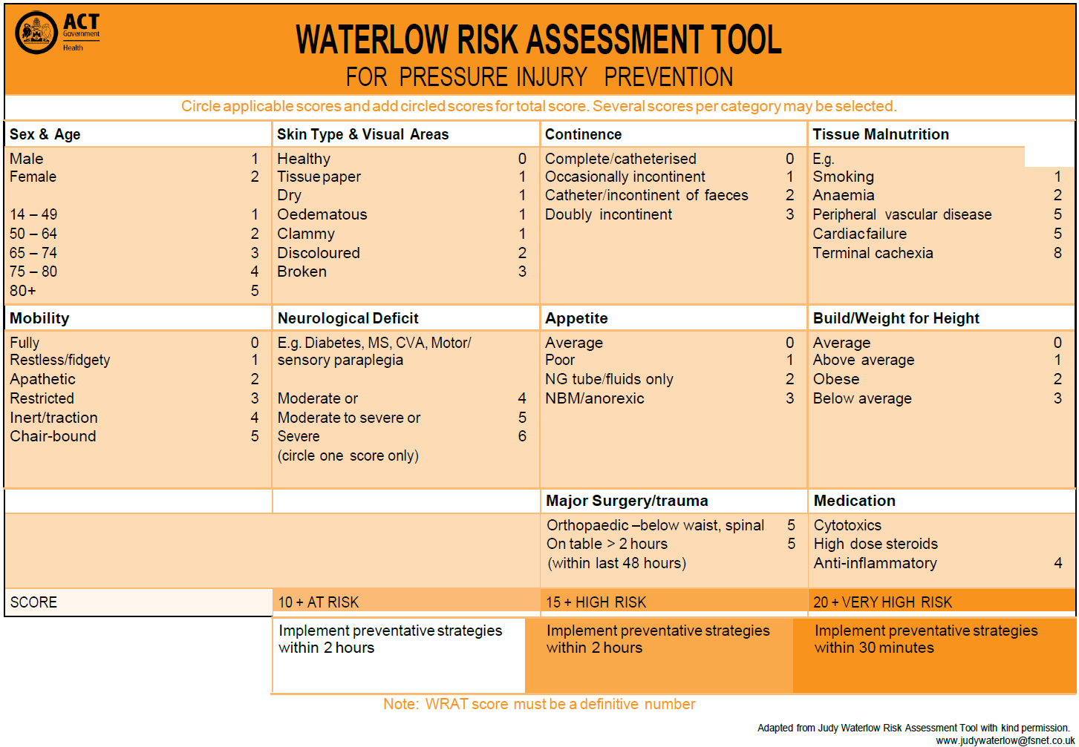

Attachment 2: Braden Q Risk Assessment Scale - for children (age less than 15years)
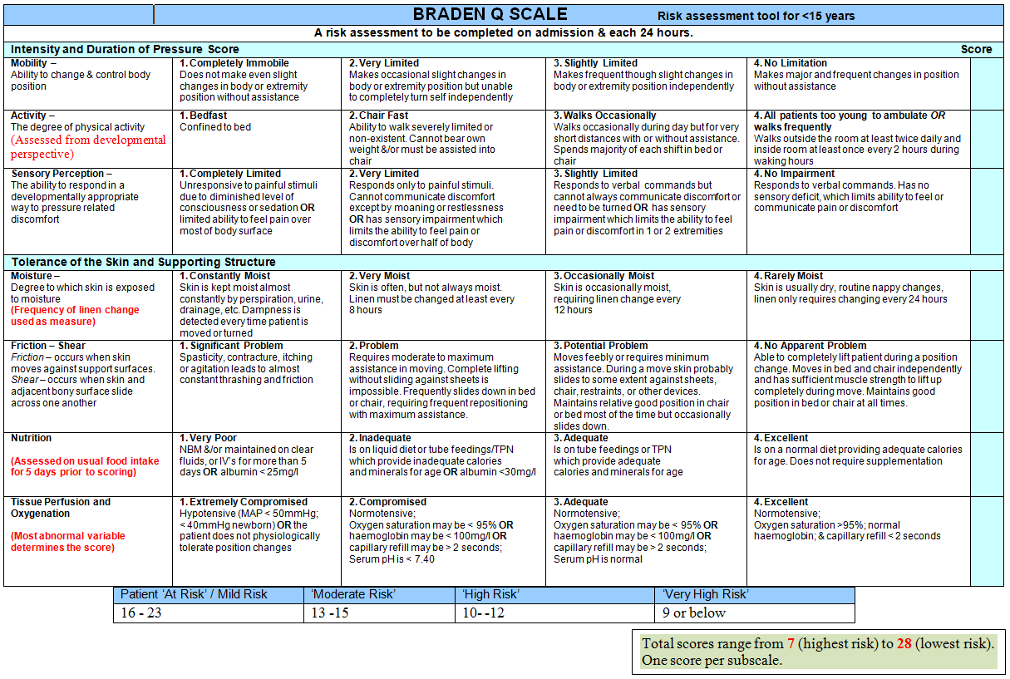

Attachment 3: Neonatal Skin Risk Assessment and Management Scale - Neonatal Intensive Care Unit (NICU) and Special Care Nursery (SCN)
Page 1 of 2
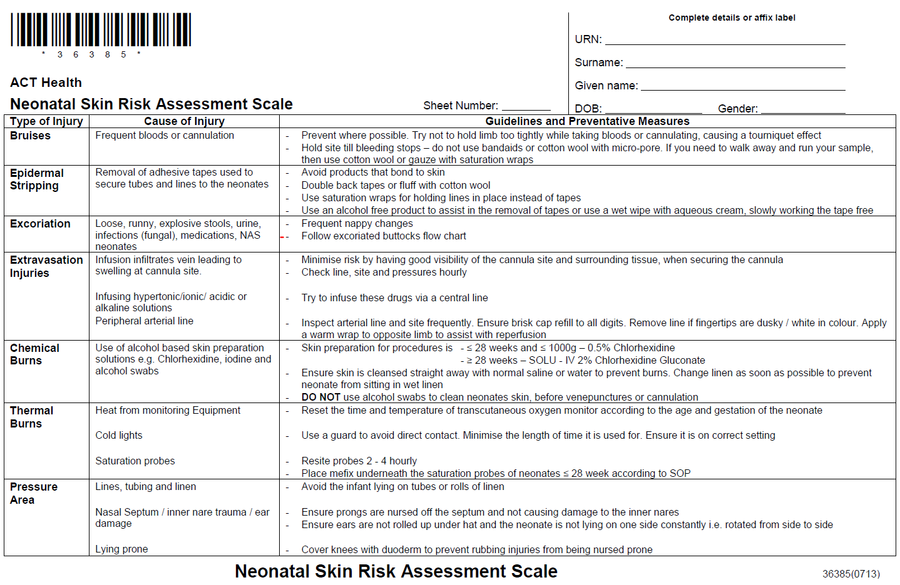
Sample
Attachment 3: Continued Neonatal Skin Risk Assessment and Management Scale - Neonatal Intensive Care Unit (NICU) and Special Care Nursery (SCN) Page 2 of 2
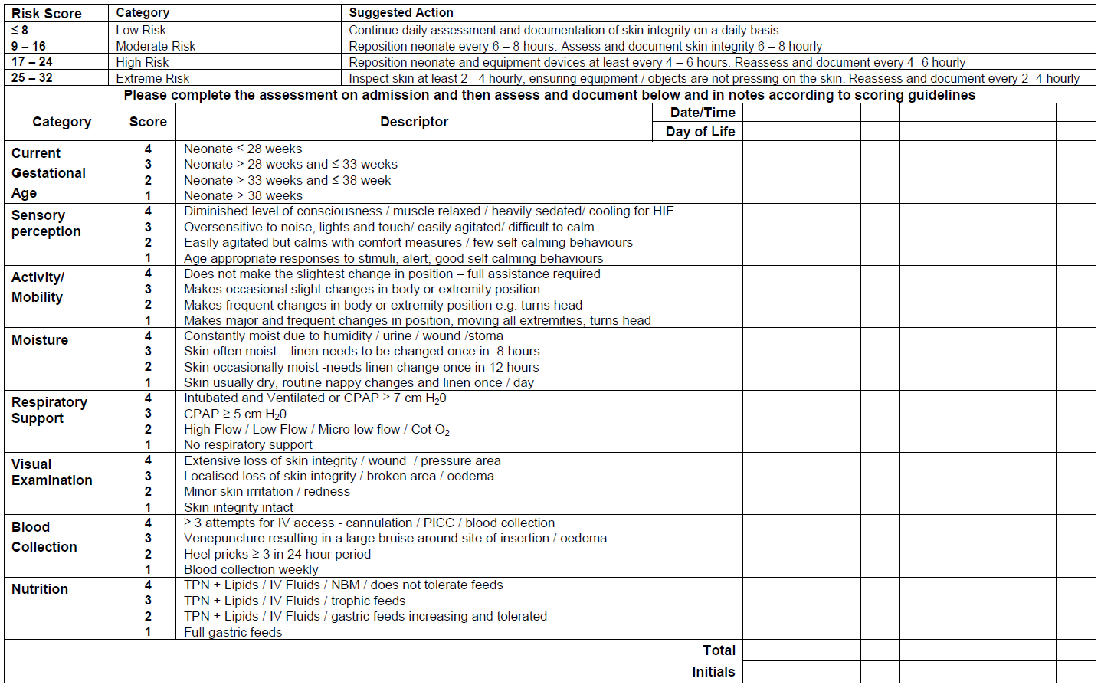
Sample

Attachment 4: Modified version Waterlow tool (2005) in Maternity
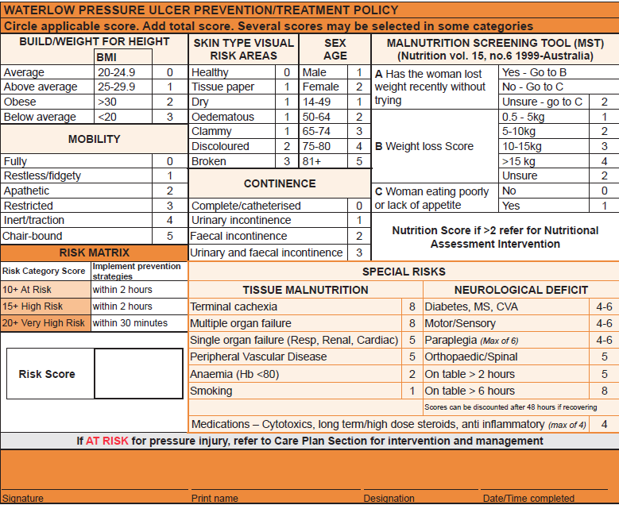

Attachment 5: Braden Risk Assessment Scale within the community (Allied Health)
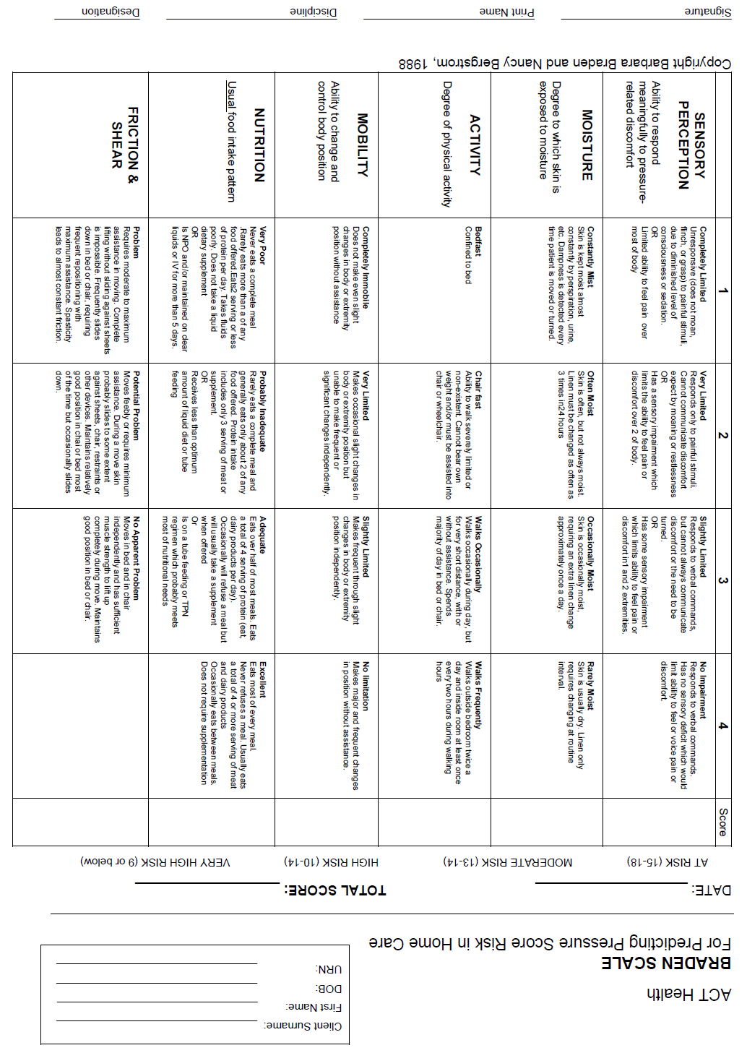
Sample

Attachment 6: Pressure Injury Prevention and Management Clinical Interventions Guideline
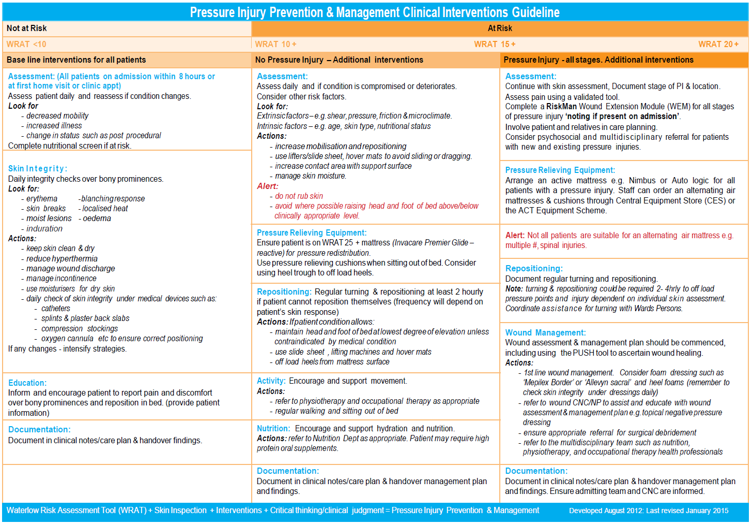

Attachment 7: Pressure injury Classification tool/photos
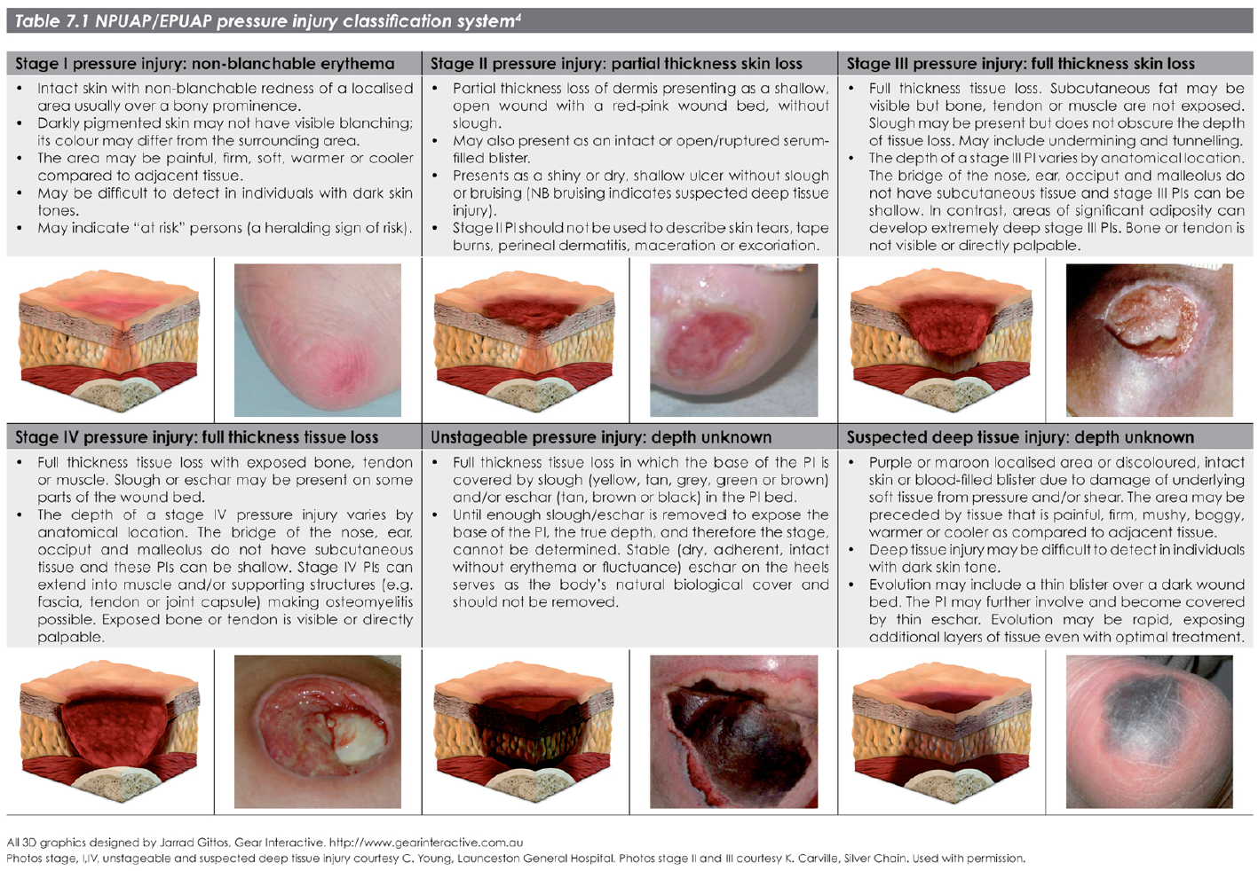

Attachment 8: GLOBIAD Ghent Global Incontinence Associated Dermatitis Categorisation Tool
