Guideline | Canberra Health Services
Neonatal Nutrition Guide
CHS25/152

Contents
Guideline statement 2
Scope 3
Section 1 Feeding Guideline 3
1.2 Enteral Feeding Methods 4
1.3 Nil By Mouth (NBM) Criteria 6
1.4 Initiation of Feeds 6
1.5 Feed Initiation and Advancement 7
1.6 Daily Total Fluid Intake 7
1.7 Standard Feeding Schedules 8
1.8 Pump and Gravity Feeding Duration and Criteria 10
1.9 Gastric Residuals, and Feed Intolerance & Management 11
1.10 Fortifying feeds 13
1.11 Vitamin and Mineral Supplementation 14
1.12 Fluid, Energy, Protein, and Biochemical Monitoring Requirements based on European Society for Paediatric Gastroenterology Hepatology and Nutrition (ESPGHAN) nutrition recommendation 15
1.13 Growth Monitoring and Growth failure 16
1.14 Inpatient and Discharge Dietician Referral Criteria 17
1.15 Discharge Fortification 18
Section 2 Pasteurised Donor Human Milk 19
2.1 Eligibility & Cessation Criteria for PDHM 19
2.2 Consent and Medical Prescription Procedure 20
2.3 Supply, Documentation, and Preparation 20
2.4 Accidental administration of PDHM without Parental Consent/Medical Prescription 22
Section 3 Osteopenia or Metabolic Bone Disease of Prematurity 23
3.1 Pathophysiology and Risk Factors 23
3.2 Screening and Interpretation 24
3.3 Management 26
Evaluation 28
Related policies, procedures, guidelines and legislation 28
References 29
Definition of terms 32
Search terms 33
Attachments 33
Attachment 1 - Insertion of Nasogastric/Orogastric Feeding Tube (Neonates/Infants)………37
Attachment 2 – Enteral Tube Feeding Procedure 42
Attachment 3 – Department of Neonatology Nutrition Guide 45
Attachment 4 – Standard Feeding Schedules 46
Attachment 5 – Feeding Intolerance Algorithm 50
Attachment 6 – Medela Calesca Milk Warmer 51
Attachment 7 – ESPGHAN Nutrition Recommendations Table 54

Guideline statement

Background
Premature infants have greater nutritional needs in the neonatal period. Undernutrition during this critical period negatively impacts short and long-term growth and neurological development. This document provides feeding guidelines for neonates in scope to ensure their nutritional needs are met.
Key Objective
The goal of nutrition is to achieve as near to normal in-utero growth rate as possible. According to the World Health Organisation (WHO) in-utero data, estimated average fetal weight gain is:
- 20 to 23 g/kg/d (12 to16 g/d) from 23 to 25 weeks postmenstrual age (PMA)
- 17 to 20 g/kg/d (17 to 23 g/d) from 26 to 29 weeks
- 13 to 17 g/kg/d (24 to 30 g/d) from 30 to 34 weeks and
- 10 to 13 g/kg/d (30 to 32 g/d) from 35 to 37 weeks PMA
The aim should be to introduce enteral milk feeds as early as possible. The recommended nutritional practice for very low birthweight infants is to provide mother’s own milk (MOM). along with a human milk fortifier (HMF) to avoid protein and nutrient deficiencies.
Key Points
- Standardised feeding protocols improve clinical outcomes.
- Mothers’ own breastmilk (MOM) – also referred to as Expressed Breast Milk (EBM) is always the preferred feed.
- Pasteurised Donor Human Milk (PDHM) is available to eligible infants.
- Early commencement of enteral feeds with 18 to 30 ml/kg/day advancements does not increase the risk of Necrotising Enterocolitis (NEC).
Back to Contents

Scope
This document provides feeding guidelines for neonates admitted to Canberra Health Services (CHS) specifically Department of Neonatology at the Centenary Hospital for Women, Youth, and Children and North Canberra Hospital.
This document applies to the following CHS staff working within their scope of practice:
- Medical Officers
- Nurses and Midwives
- Allied Health Professionals
- Nutrition Room Technician
- Student under direct supervision.
Back to Contents

Section 1 Feeding Guideline
Alert:
All preterm neonates are to ideally receive breastmilk, preferably in the order in which it was expressed. This ensures that all infants receive the nutritional and immunological benefits of colostrum and early milk.
Mothers/birth parent are encouraged to express within 2 hours post-birth.
When approaching 12 hours, and if no MOM available, PDHM should be considered for eligible infants.
Refer to the CHS Breastfeeding Guideline available on the CHS Policy and Guidance Documents Register, for further information on breastmilk expression.
Initiation of “Ready to Use” breast milk substitute/formula and bottle feeding requires parental consent before initiation. This is to be documented in the patient’s medical records.

1.1 Enteral Feed Choice
- Mothers Own Milk (MOM) or Expressed Breast Milk (EBM) (preferred feed choice).
- Pasteurised Donor Human Milk (PDHM).
  - Available to eligible inpatients less than 32 weeks and/or less than 1500 grams (refer to Section 2 - Pasteurised Donor Human Milk (PDHM)).
- “Ready To Use” breast milk substitute / formula (used when infant is unable to receive breastmilk).
  - Preterm Formula (PTF)
  - Term Formula

1.2 Enteral Feeding Methods
There are 3 methods of enteral feeding commonly used in the Neonatal Intensive Care Unit (NICU) and Special Care Nursery (SCN). These include:
- enteral tube feeding
- breastfeeding
- paced bottle feeding
It is important to coordinate feeding sessions and to promote kangaroo cuddles for when parents are available, to help promote infant-parental bonding and developmental care.

Enteral Tube Feeding
Note:
For infants on long term low flow nasal cannula oxygen and trying to establish suck feeds, it may be appropriate to use a NGT instead of an OGT. Seek advice from the Neonatologist before proceeding with NGT.
For insertion for enteral tube, refer to Attachment 1 - Insertion of Nasogastric/Orogastric Feeding Tube (Neonates/Infants).
- Orogastric (OGT) and nasogastric (NGT) tubes are frequently used for the management of infants who require nutritional support, decompression of the gastrointestinal tract (GIT), diagnosis and assessment, and/or medication administration.
- NGT is preferred as evidence suggests that infants receiving nasogastric tube feeds achieve full enteral feeding sooner than those receiving OGT feeds, with a lower incidence of aspiration or tube displacement.
- OGT are to be used for the following infants:
  - Requiring respiratory support i.e., Continuous Positive Airway Pressure (CPAP), ventilation.
  - Showing signs of respiratory distress.
  - Diagnosed with choanal atresia or complete bilateral cleft palate.
- Transpyloric Tube (TPT)
  - Occasionally, infants may require the insertion of a transpyloric tube – e.g., Duodenal atresia – post-operatively.
  - TPTs are inserted by a medical officer (MO) and placement is confirmed by x-ray due to the difficulty with tube placement and risk of perforation of gut.

Breastfeeding
- Infants greater than or equal to 34 weeks corrected gestational age (CGA), who are medically stable are encouraged to commence suck feeding if they are showing signs of feeding readiness such as:
  - Rooting
  - Waking for feeds
  - Sucking on dummy
  - Other hunger cues
- Kangaroo cuddles or skin-to-skin contact with the mother can help promote breastfeeding.
- Mothers/birth parent should be encouraged to have breast cuddles with their neonate to encourage familiarity and confidence on the breast for both mother/birth parent and neonate.
- If required, referral to be sent to a Lactation Consultant.
- Refer to Breastfeeding Guideline available on the CHS Policy and Guidance Documents Register.

Pace Bottle Feeding
- Infants greater than or equal to 34 weeks corrected gestational age (CGA) are encouraged to commence suck feeding if they are showing signs of feeding readiness such as:
  - Rooting
  - Waking for feeds
  - Sucking on dummy
  - Other hunger cues.
- Parents must provide informed consent before bottle feeding is commenced. Consent (verbal) must be documented in the infant’s medical records.
- The bedside nurse can clinically assess the suitability of the flow rate for the teat.
- Consider referring infant to Speech Pathology for the following at risk criteria:
  - Infants born less than 28 weeks GA
  - Infants with Chronic Lung Disease (requiring oxygen therapy after 37-week CGA)
  - Neurological conditions
  - Genetic disorders affecting airway/digestive tract such as Tracheoesophageal fistulas (TOF).

Note:
For further information on breastfeeding recommendations and techniques, refer to the Breastfeeding Guideline available on the CHS Policy and Guidance Documents Register.
For further information on feeding cues, developmental care, and oral aversion, refer to the Developmental Care in the Neonatal Intensive Care Unit and Special Care Nursery also available on the CHS Policy and Guidance Documents Register.

1.3 Nil By Mouth (NBM) Criteria
There are very specific groups of infants with clinical conditions who may require NBM for limited periods of time. The clinical conditions include:
- Shock – infants may require NBM in the initial phase of illness. Infants with early onset sepsis, or early phase of hypoxic ischemic encephalopathy (HIE) and those with clinically poor perfusion may remain NBM and commence minimal enteral feeds as soon as stable.
- Exchange transfusion – infants should remain NBM for duration of procedure.
- Suspected or proven inborn error of metabolism – Galactosemia or phenylketonuria being most common, these infants should remain NBM while investigations such as ammonia levels and urinary ketones are underway.
- Suspected or proven gastrointestinal obstruction or abnormality – until diagnosis or repair
- Post surgery – some infants may remain NBM for a period of time following surgical repair of gastroschisis, omphalocele, diaphragmatic hernia etc. Oral care with MOM and initiation of feeding is discussed by surgical and neonatal team.

1.4 Initiation of Feeds
Early Minimal Enteral Feeds (MEF) or Trophic Feeds help maintain gut integrity and are encouraged for all neonates when MOM or PDHM is available. Minimal Enteral Feeds are defined as nutritional insignificant small volumes of milk (typically 12 to 24 mL/kg/d) without advancing the feed volumes for a period of 3 to 7 days.
Enteral feeding should start as early after birth as possible. Refer to Attachment 3 - Department of Neonatology Nutrition Guide.
- MOM should be given soon after birth, ideally:
  - 2 hours for normal vaginal delivery (NVD)
  - 4 hours for lower segment caesarean section (LSCS)
- For infants less than 1000g, MEF may be considered for a set period (no longer than 48hrs) as extra, based on clinical condition and Neonatologist advice.
- If approaching 12 hours, and no MOM available, consent for PDHM must be actively considered.
- If no MOM available, and no consent for PDHM given, it is appropriate to wait up to 48hrs before administering infant formula and where an infant is receiving intravenous (IV) fluids.

1.5 Feed Initiation and Advancement
- Start Early MEF or Trophic Feeds as soon as possible after birth and advance feeds as clinically tolerated. Refer to Attachment 3 - Department of Neonatology Nutrition Guide.
- For neonates less than or equal to 32 weeks GA and/or less than or equal to 1800g, advancement of feeds is directed by the Section 1.7 - Standard Feeding Schedules (SFS) and Attachment 4 – Standard Feeding Schedules. It is initiated by the medical officer and/or the clinical bedside nurse and feed tolerance is assessed before every feed. Any signs of feed intolerance will require immediate medical review. Refer to Attachment 5 – Feed Intolerance Algorithm.
- Once an infant is tolerating 80 to 90ml/kg/day, all IV medications should change to oral where possible (except if the neonate has IV antibiotics in some circumstances), and fortifier may be added.
- Once the infant is tolerating 120ml/kg/day of enteral feeds, removal of vascular devices should occur. If devices are not removed, reasons must be documented in the patient clinical record.

1.6 Daily Total Fluid Intake
- The daily total fluid intake (TFI) for infants is calculated as ml/kg/day.
- The dosing weight or weight used to calculate the TFI is usually the neonate’s highest weight or unless directed by the Neonatologist.
- For neonates who require IV therapy at birth, IV fluid intake is titrated based on the recommended daily total fluid intake (See Table 1 – Daily Total Fluid Intake) and enteral fluid intake.
- For infants commencing on enteral feeds without IV therapy (e.g., greater than or equal to 33 weeks GA and/or greater than 1800g), feeds should be commenced and advanced based on the daily total fluid intake (See Table 1 – Daily Total Fluid Intake).

Table 1 – Daily Fluid Intake
Day of Life | Total Daily Fluid Intake | Additional Information
1 | 60 to 80 ml/kg/day | Extremely Low Birth Weight (ELBW) infants especially no/partially steroid covered infants may need higher intake initially due to insensible water loss.
2 | 80 to 100 ml/kg/day
3 | 100 to 120 ml/kg/day
4 | 120 to 140 ml/kg/day
5 | 140 to 160 ml/kg/day
6 | 160 ml/kg/day
- Feeds can be increased further depending on weight gain or at the recommendation of a MO. Most stable growing infants will require fluid intakes of 150 to 180 mL/kg/d to achieve appropriate nutrient intakes.
- If nutritional needs can be met, fluid intake as low as 135 mL/kg/d may be considered safe to maintain body homeostasis and avoid renal compromise.
- In individual infants born preterm, enteral fluid intakes up to 200 mL/kg/d may be appropriate and safe depending on current clinical status.

1.7 Standard Feeding Schedules
Alert:
Grading up feeds may need to be slow or altered (e.g., hourly bolus feeds, pump feeds over longer period, continuous feeds, transpyloric feeds) in special circumstances, such as:
- Growth restriction
- Abnormal umbilical Dopplers
- Feed intolerance
- NEC and other medical or surgical gastrointestinal conditions
- Haemodynamically significant patent ductus arteriosus (PDA) (particularly infants on ibuprofen)
- Infants on inotropic support and/or muscle relaxants.
The Standard Feeding Schedule applies to neonates born less than or equal to 32 weeks GA and less than or equal to 1800g. Most preterm neonates will have IV therapy commenced at birth and for those neonates, select the Standardised Feeding Schedule according to the neonate’s birthweight. This can be found in Attachment 4 – Standard Feeding Schedules.

Procedure
- Commence appropriate fluid/feed regimen based on gestation and birth weight following admission and stabilisation (Refer to Attachment 3 – Department of Neonatology Nutrition Guide).
- Medical Officer to order fluids/feeds on the Digital Health Record (DHR).
- Bedside nurse to commence enteral feeds as soon as possible unless NBM orders from medical staff. Refer to Section 1.4 – Initiation of Feeds.
- For neonates less than or equal 32 weeks GA and/or less than or equal to 1800g, select Bedside Standard Feeding Schedule (SFS) Protocol Card based on neonate’s birthweight which can be found in the NICU workroom. See Image 1 – Bedside SFS Protocol Card Template.
  - Staff to document patient’s specific protocol number, feed day, and feed number into the patient’s medical records.
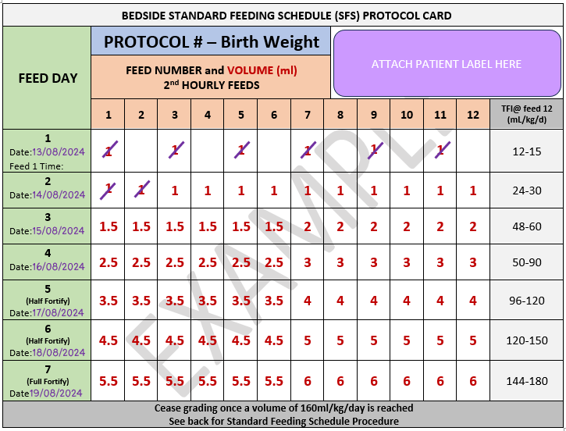
- Beside nurse to attach small patient label (e.g., linear patient label) and document dates for Feed Days using whiteboard marker (Refer to Image 1 – Bedside SFS Protocol Card Template). The Bedside SFS Card to be attached on neonate’s pendant for easy reference.
  - Feed Day- refers to the day feeding is occurring, NOT the day of life.
  - Feed Number - is determined by frequency of feed (e.g., 2nd hourly has a total of 12 feed numbers or 3rd hourly has 8).
- Commence standard feeding schedule protocol by giving feed number volume (e.g., Protocol #, Feed Day 3, and Feed Number 6 is a 1.5ml). Nurse to give feed via enteral tube feeding and to cross off each feed volume once given (Refer to Image 1).
  - Advance feed as per SFS Protocol and the increase is approximately 20 to 30ml/kg/day.
- Bedside nurse to assess feed intolerance before every feed. Refer to Attachment 5 – Feeding Intolerance Algorithm, for management of feed intolerance.
  - If feeds are paused due to medical assessment for feed intolerance or blood transfusion, bedside nurse to continue from last feed given unless directed by medical team
- Once neonate reaches 80 to 100ml/kg/day enteral feeds:
  - Commence fortification of MOM and/or PDHM. Commence with half strength for 2 days then full strength. Refer to Section 1.10 – Fortifying Feeds. Medical officer to order fortification.
  - All IV medications should change to oral where possible (except if the neonate has IV antibiotics in some circumstances).
- Once the neonate is tolerating 120ml/kg/day of enteral feeds, removal of vascular devices should occur.
- By Feed Day 7, full enteral feeds should be ideally achieved which will be a Total Fluid Intake (TFI) of 160ml/kg/day.
- Bedside nurse to document feeds and observation/assessments via DHR.

1.8 Pump and Gravity Feeding Duration and Criteria
Note:
For enteral feeding procedure refer to Attachment 2 – Enteral Tube Feeding Procedure.

Pump Feeds
Neonates less than or equal to 32 weeks GA and/or less than or equal to 1800g are to commence on pump feeds.
Table 2 – Pump Feed Duration Based on Volume
Volume | Pump Duration
Less than 5 milliliters (mls) | Manual Push/Bolus (1 to 2 minutes)
5 to 20mls | 10 minutes
Greater than 20mls | 20 minutes
Once a neonate reaches greater than 34 weeks CGA, they can be transitioned to gravity feeds.

Gravity Feeds
Neonates greater than 32 weeks GA and/or greater than 1800g are to commence on gravity feeds. Feed to be administered over 15-20 minutes by allowing milk to free flow via gravity.

1.9 Gastric Residuals, and Feed Intolerance & Management

Gastric Residuals
Routine monitoring of gastric residuals (GR) in the clinically stable infant is not recommended.
Assessment of GR should be performed only when other clinical signs associated with feeding intolerance or NEC are present such as extreme abdominal distension, tenderness, emesis, bloody stools, apnoea, and temperature instability. Refer to Attachment 5 – Feeding Intolerance Algorithm.

Feed Intolerance Clinical Signs
Significant clinical changes to vital signs such as frequent apnoeic and bradycardic episodes, and thermal instability.
- Vomiting may be the result of an over distended stomach, poorly positioned feeding tube, reflux, or may be more serious such as infection, obstruction, or other disorders.
- Aspirate colour
  - If for clinical reasons a gastric aspirate has been obtained, green-coloured aspirates (Box 1 – 6 in Figure 1 – Gastric Aspirate Colour and pH Chart) are not associated with any increase in NEC in the absence of any other clinical manifestation and should generally not drive the decision to withhold feeds.
  - Bile in the aspirate can be a sign of a poorly positioned feeding tube, an ileus or obstruction and therefore should be evaluated. Heavily bile-stained aspirate, such as in Box 7 or 8 in Figure 1 above, warrants medical assessment.
  - For heavily bile-stained vomiting, feeds must be stopped for 24 hours, and should this worsen, there may be further investigations required. The decision whether the feeds could be continued but not upgraded will be at the discretion of the MO.

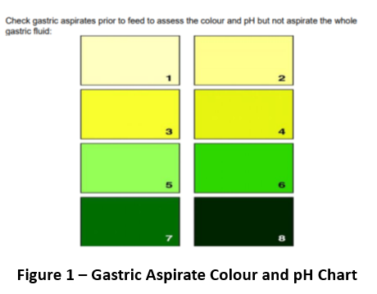

- Abdominal distension
  - Distension with or without visible loops of bowel can be due to poor gastric motility, ileus, constipation or ‘gas’. If the abdomen remains soft / nontender it may resolve with prone positioning. Consider a lower flow rate if the infant requires CPAP support.
  - A tense abdomen with or without visible loops of bowel is abnormal and requires investigation for obstruction, infection, or NEC.

Feed Intolerance Management
Deciding whether feeds should be continued, reduced, or stopped should be according to the Attachment 5 – Feeding Intolerance Algorithm.
- Feeds are usually stopped if there is frequent vomiting and/or abdominal distension and/or blood in the stools.
- Investigations are carried out and an assessment is made after 12 to 24 hours.
- Feeds can generally be restarted when the infant has stabilised and has had a 12-to-24-hour absence of any significant clinical signs of feed intolerance and after consultation with the MO.

1.10 Fortifying feeds
Despite the immunological and other advantages of human milk, MOM does not provide sufficient nutrients to sustain in utero growth rates and does not meet the recommended nutrients and energy intake of preterm infants with a birth weight less than 1800g. Additionally, preterm neonates have low nutrient stores because they were born before the transplacental acquisition in the last trimester of pregnancy. Fortification of MOM with multi-component fortifier leads to improved short term in-hospital growth which in turn improves long term neurodevelopmental outcome.
The criteria for fortification are:
- Neonates less than or equal to 32 weeks GA and/or less than or equal to 1800g.
- Infants with postnatal growth failure at the time of discharge or those with increased nutritional requirements.
Feeds are fortified in the Department of Neonatology as per instructions below:
- Fortify at 80 to 100 mL/kg/day.
  - Start with 75 kilo Calories (kCal)/100mL for 2 days (half).
  - Increase to 82 kcal/100mL (full) once tolerated
  - Cease fortification at 36 weeks and weight 2.2kg, if appropriate growth.
  - For discharge fortification, refer to Section 1.15 – Discharge Fortification.
- The various enteral feed choices available in the Department of Neonatology, their caloric composition per 100ml, and fortification instructions are listed below:

Alert:
- When fortifying feeds, staff are required to maintain medication safety, work, health, and safety, and hand hygiene practices and protocols.
- Breastmilk and fortifier to be checked and co-signed by 2 nurses.
- Handling of breastmilk and fortifier requires a clean work surface and careful management to reduce risk of contaminating milk.
- Staff to maintain hand hygiene and wear appropriate personal protective equipment when handling breastmilk.

Table 3 – Fortification and Calories of Enteral Feeding Choices
Enteral Feeding Choice | Calories/100mL | Fortification Instructions/Additional Information
MOM/EBM/PDHM | ~66 kcal
Term formula | 67 kcal
Preterm formula | 80 kcal
MOM fortified – half strength | ~75 kcal | 1 x 1g sachet of Nutricia HMF + 50ml of EBM
MOM fortified – full strength | ~82 kcal | 1x 1g sachet Nutricia HMF + 25ml EBM
PDHM fortified – half strength | ~75 kcal | 1 x 1g sachet Nutricia HMF + 50ml PDHM
PDHM fortified – full strength | ~82 kcal | 1x 1g sachet Nutricia HMF + 25ml EBM + 0.15g beneprotein
Infatrini | 100 kcal | - Infants greater than 1800g requiring reduced volume (e.g., cardiac patients)  - Not recommended for preterm infants due to reduced micronutrient content  - Dietitian referral required
Elecare/PeptiJunior | 67 kcal/80kcal | - Malabsorption/allergy  - Consider dietitian referral for commencement of these products – fortification only with dietitian referral
S26 Formula Lactose Free | 67 kcal

1.11 Vitamin and Mineral Supplementation
Preterm infants are at high risk of micronutrient deficiencies due to maternal deficiencies, low body stores at birth, and low nutritional intakes. Most preterm infants require vitamin supplementations sometime after birth. Except for iron (Nutricia HMF) and vitamin D, the intake of most micronutrients is met by fortified breast milk and preterm infant formula feeds at enteral feed volumes greater than 150 ml/kg/day.
As individual requirements may vary significantly depending on gestational ages, stores at birth, and clinical factors, we recommend commencing Pentavite, Folic Acid, Iron and zinc in preterm infants less than or equal to 32 weeks and/or less than or equal to 1800g in the Department of Neonatology. All supplementations should be continued up to 3 to 6 months of age. Refer to Table 4 – Supplement Prescription Guide
Table 4 – Supplement Prescription Guide
Supplement | Procedure | Additional Information
Pentavite | Commence Pentavite for all neonates less than or equal to 32 weeks and/or less than or equal to 1800g once they reach full feeds. | Pentavite is a neonatal multivitamin preparation containing vitamins A, D, C, B1, B2, B6, pantothenic acid and niacin
Folic Acid | Commence Folic acid in all neonates less than or equal to 32 weeks and/or less than or equal to 1800g once they reach full feeds | There is no folic acid in Pentavite and Brauer Baby & Toddler Liquid Multivitamin, two commonly used multivitamin preparations in Australian Capital Territory (ACT). Current guidelines recommend routine supplementation of folic acid to prevent development of folic acid deficiency in preterm infants.
Iron | Commence Iron supplements in all neonates less than or equal to 32 weeks and/or less than or equal to 1800g at 2 weeks of age once they reach full feeds. | Iron intakes of less than 2mg/kg/day are likely to result in iron deficiency in preterm infants especially in those with birth weights of less than 1800g.
Zinc | Commence Zinc supplements in all neonates less than or equal to 32 weeks and/or less than or equal to 1800g at 2 weeks of age once they reach full feeds. | Routine zinc supplementation may improve short term weight gain and linear growth

1.12 Fluid, Energy, Protein, and Biochemical Monitoring Requirements based on European Society for Paediatric Gastroenterology Hepatology and Nutrition (ESPGHAN) nutrition recommendation
Note:
Updated (2022) recommendations for enteral nutrient intake are provided in Attachment 7 – ESPGHAN Nutrition Recommendations Table.
Fluid
Most stable growing infants will require fluid intakes of 150 to 180ml/kg to achieve appropriate nutrient intakes. ESPGHAN suggests a minimum of 135ml/kg (if nutrition needs can be met) to avoid renal compromise and up to 200ml/kg may be safe depending on the clinical status of the neonate.

Energy
A reasonable range of total energy intake for most healthy growing preterm infants is 115 to 140 kcal/kg/d. Energy intakes greater than 140 kcal/kg/d may be needed where growth is below the recommended range but should not be provided until protein and other nutrient sufficiency has been ensured and should not exceed 160 kcal/kg/d.

Protein
Very preterm infants should be given at least 3.5 to 4.0 g protein/kg/d together with sufficient other macro- and micronutrients. Protein intake may be further increased up to 4.5 g/kg/d where growth is slow, provided protein quality is good, concomitant energy and other micronutrient intakes are optimal, and there are no other causes for suboptimal growth.

Biochemical Monitoring (Blood Urea level)
The evidence for cut-off values of plasma urea concentrations to guide protein intake is very limited and concentrations may be affected by immature glomerular filtration rate as well. Yet, elevated urea concentrations in the absence of fluid or renal derangements indicate that proteins are not fully used for protein synthesis but are oxidized instead. This thus hints at either optimizing concomitant nutritional intakes or decreasing protein intake. Plasma urea should be monitored at regular intervals. Low urea concentrations (less than 3 mmol/L) after the first few weeks of life may indicate enteral protein intakes can be increased up to 4.5 g/kg/d. If urea concentrations are above 5.7 mmol/L in the absence of fluid or renal derangements, while providing sufficient concomitant energy, lowering of protein intake should be considered.

1.13 Growth Monitoring and Growth failure
- Growth is evaluated by measuring gain in weight, length, and head circumference (HC) but also using measures of body composition. (Refer to Section 2 – Growth Measurements in the Neonatal Routine Care Clinical Guideline).
- For neonates less than or equal to 32 weeks and/or less than or equal to 1800g, measure weight at least once or twice daily during the first 1 to 2 weeks of life, followed by 2 to 3 times per week in the stable growing phase.
- Length and HC should be measured once weekly in all infants.
- Weight loss up to 7 to 10 percent is acceptable in the first 3 to 4 days after birth in average gestational age (AGA) neonates. Small for gestational age (SGA) neonates often lose less (4 percent to 7 percent).
- Growth velocity in g/kg/day is measured over 7 days (1 week) by using average weight for that week. For example, if the neonate weighed 1kg on day 1 of the week and 1.2 kg on Day 7, average weight for the week is (1+1.2) ÷2=1.1kg. Growth velocity is calculated as 200/ (7x1.1) = 26g/kg/day.
- Using fetal ultrasound estimates, an average fetal weight gain of 20 to 23 g/kg/d during 23 to 25 weeks of gestation, 17 to 20 g/kg/d during weeks 26 to 29, 13 to17 g/kg/d during weeks 30 to 34, and 10 to 13 g/kg/d during weeks 35 to 37 is considered appropriate as per World Health Organization (WHO).
  - These growth targets showed better weight, length, and HC at 18 to 22 months CGA. These growth targets also matched with intrauterine growth and maintain the birth percentile in extra uterine life.
- Fenton’s chart is the reference growth chart used in Department of Neonatology (which can be found on the DHR) and is based on in-utero fetal growth.
- The optimal growth velocity that optimises outcomes in preterm infants remains unclear. We recommend a pragmatic approach with an aim of not losing more than 1 Standard Deviation Score (SDS) in weight, length, and HC from 1 to 2 weeks of age (age infant regained birth weight) to discharge.
- Growth failure (GF) or postnatal growth retardation describes an infant whose growth slows such that they do not follow a certain centile during the period of established growth (and is not defined as any anthropometric measurement below the 10th percentile).

1.14 Inpatient and Discharge Dietician Referral Criteria

Inpatient Dietician Referral Criteria
- Restricted fluid intake less than or equal to 160 mL/kg/day – at greater than 2 weeks of age.
- Less than 15 g/kg/day weight gain (less than 35/40 CGA) or less than 10 g/kg/day (35 to 37/40 weeks CGA).
- Growth faltering/crossing centiles/ greater than -1 SDS from time regained birth weight on Fenton’s Z score calculator.
- Greater than 200mL/kg/day of preterm formula or fortified breast milk intake.
- Short bowel syndrome/NEC/ where use of elemental formula is considered.
- Gastrointestinal anomaly.
- Chylothorax.
- Significant obstructive jaundice.
- Less than 75 percent of prescribed quota of nutritional fluids for more than 2 weeks
- Not regained birthweight by 14 days.
- Intolerance to preterm formula of breast milk fortifier.
- Chronic Lung Disease (CLD) where growth impairment is likely.
- Malabsorption.
- Congenital heart disease where growth impairment is likely.
- Renal failure.
- Metabolic disorder.

Outpatient Dietician Referral Criteria
- Weight or Length greater than -1 SDS at discharge from time regained birth weight on Fenton’s Z score calculator.
- Home oxygen.
- Exclusive nasogastric feeding.
- Infants with ongoing gastrointestinal issues – stoma.
- Infants with ongoing cardiac failure requiring restricted fluids.

1.15 Discharge Fortification
- Infants with postnatal growth failure at the time of discharge, or those with increased nutritional requirements (e.g., CLD, Cardiac failure) may need ongoing fortification prior to being discharged home to support "catch-up growth."
- Fortification could be achieved by concentrating term formula for those on formula or by adding formula powder, polyjoule or MCT oil to MOM for those on breast milk
- The dietician should always be consulted to provide a recipe prior to discharge.
  - These infants will need ongoing follow-up in the nutrition clinic post discharge for monitoring growth and weaning of fortification.
Back to Contents

Section 2 Pasteurised Donor Human Milk
Necrotising Enterocolitis (NEC) is one of the most common gastrointestinal emergencies in infants. Risk factors being preterm birth (particularly less than 32 weeks CGA) and very low birth weight (less than 1500g). NEC has considerable morbidity and mortality implications.
Alert:
MOM takes precedence over PDHM. Encouragement and support for mothers to express and increase milk supply should be the primary focus. This can be achieved by referring mother to Lactation Consultant and/or delaying consent for PDHM for 12. to 24 hours.
Human milk feeding has been shown to decrease the risk of NEC, and the WHO recommends that low birth weight infants, who cannot be fed their MOM should be fed donor human milk.
This guideline outlines best practice for the safe preparation in the Nutrition Milk Room (found in the Centenary Hospital for Women and Children) and handling of Pasteurised Donor Human Milk (PDHM) by staff within the Department of Neonatology. It also is to be used in conjunction with the Pasteurised Donor Human Milk (PDHM) for Vulnerable Infants - NSW Health and Australian Red Cross Blood Service Partnership Service Protocol.
Note:
For mothers/birth parent who want to donate their excess milk, EBM can be donated to Mothers’ Milk Bank Charity. Process for donation can be found on the Mothers Milk Bank Charity website.

If PDHM supply issues occur, the Nutrition Department and Department of Neonatology will be informed, and alternative supply/processes will be decided.

2.1 Eligibility & Cessation Criteria for PDHM

Eligibility Criteria
- Infants less than 32 weeks gestation.
- Infants greater than 32 weeks gestation and less than 1500g.
- Infants treated and recovering from NEC.
- Feed intolerance to PTF.
- Medically indicated as per Neonatologist.
- Infants transferred with PDHM from other hospitals.

Cessation of PDHM
When infants reach 34 weeks CGA, PDHM will be ceased unless clinically indicated.

2.2 Consent and Medical Prescription Procedure

Equipment
- PDHM
- PDHM Distribution Record (Nutrition Room)
- CHS Informed Consent Form
- Fluid Order.

Procedure
- Medical staff or a Neonatal International Board-Certified Lactation Consultant (IBCLC) must obtain signed written consent from the parent/guardian for infant to receive PDHM using the Informed Consent form (Form No. 15270) .
  - Written consent must be obtained before PDHM can be ordered/prescribed.
  - The signed consent form must be filed in the infant’s clinical record on DHR.
  - PDHM must be ordered by a medical officer.
- Once consent has been obtained and PDHM order completed, Nutrition Room Technician will receive order and dispense milk accordingly.
  - If the infant has a combination of different enteral milk orders (e.g. MOM and PDHM), MOM should be given before PDHM.

2.3 Supply, Documentation, and Preparation
Alert:
- Breastmilk and fortifier to be checked and co-signed by 2 nurses/nutrition room technicians
- Handling of breastmilk requires a clean work surface and careful management to reduce risk of contaminating milk
- Staff to maintain hand hygiene and wear appropriate personal protective equipment when handling breastmilk.

Supply
A partnership service with the Australian Red Cross Blood Service (ARCBS) has been developed to provide PDHM to infants at high risk of NEC in New South Wales (NSW) and Australian Capital Territory (ACT) when maternal supply is not sufficient to meet the nutritional needs of the infant. The use of PDHM may be effective in protecting against other high-risk conditions in vulnerable infants, such as late-onset sepsis.
Donor human milk from the ARCBS is pasteurised and transported to the Centenary Hospital for Women and Children and is available for eligible infants with insufficient expressed breast milk.

Documentation, and Preparation
- Nutrition Room Technician will monitor any data loggers to ensure the cold chain has been maintained during transport for each delivery of PDHM. The Nutrition Room Technician should note the condition of the milk on arrival following transport (hard frozen) and the expiry date.
  - If there is any concern, the PDHM is discarded.
- Once the milk has been prepared, the Distribution Record Form from must be completed by the Nutrition Room Technician.
- The required volume of PDHM will be thawed, allocated, labelled with the patient’s identifiers, and delivered to the individual infant and placed in the patient room refrigerator.
  - This process is to be checked by a second Nutrition Room Technician, Allied Health Staff, or nurse.
  - After hours: Any PDHM taken from the freezer in the above circumstances should be clearly identified with the infant’s medical record number, the date thawed and the expiry date.
- Additives including HMF will be added to PDHM by the Nutrition Room staff as per MO’s order or Standard Feeding Schedule prior to dispensing to the infant.
- Nutrition Room Technician will document:
  - Each bottle of PDHM used in the patient’s clinical record
    - The batch numbers
    - Date administered
  - In the data registry:
    - The infant name
    - Date of birth
    - Hospital identifier
    - Batch/bottle number
    - Date administered.

Note:
Thawing of frozen PDHM:
- Use the oldest milk first.
- Ideally breastmilk should be thawed in the fridge. It can also be placed the container in a pan or jug of warm water.
- Thawed milk should be refrigerated, if not used immediately.
- Shake the container to evenly distribute the fat.
- Discard any thawed milk within 24 hours.

- Once the PDHM is decanted from its original bottle into individual patient bottles, the new bottles will be clearly labelled:
  - “Pasteurised Donor Human Milk”.
  - Patient Label with identifiers that is Name, Date of Birth, and MRN.
  - Batch number.
  - Any additives (e.g., Human Milk Fortifier (HMF).
  - Caloric value (e.g., 85kcal).
  - Date removed from the freezer.
  - Date dispensed.
  - Use-by Date.

2.4 Accidental administration of PDHM without Parental Consent/Medical Prescription
Note:
Refer to Expressed Breastmilk Incident Guide Clinical Guideline (available on the CHS Policy and Guidance Documents Register) for further follow up processes offered to parents/guardians and governance following incorrect breastmilk incidents.
- If the infant has an enteral feeding tube insitu, aspirate the ingested PDHM as soon as possible. The feed may be aspirated up to 30 minutes after feeding.
- Report incident to the MO, Nurse Team Leader, and Nutrition Room Manager immediately.
- Ensure open disclosure to the parents/guardian, informing them that the risk of transmission and possible acquisition of infection is negligible due to donor screening and the pasteurisation process.
  - Screening of the mother or infant is unlikely to be necessary unless requested by the Neonatologist following a risk assessment and discussion with the parents.
  - If screening is to be performed ensure pre-test counselling by MO.
- Complete a formal incident report via RiskMan immediately.
- Inform the ARCBS (or Mothers Milk Bank) and ask them to provide the original infection screen from the source mother and infection screen of the PDHM and document in recipient infant’s medical record.
Back to Contents

Section 3 Osteopenia or Metabolic Bone Disease of Prematurity

Background
Metabolic bone disease of prematurity (MBD) is the under-mineralisation of the preterm infant’s skeleton because of inadequate calcium (Ca) and phosphate (P) mineral, both prenatally and postnatally.
- Bone mineralisation is maximal during the third trimester (80 percent). Very preterm infants miss the accretion process.
- Postnatally, it is difficult to maintain a comparable intake of minerals (risk of Ca and P precipitation in Total Parenteral Nutrition (TPN), feed intolerance in high-risk preterm infants, medications, renal immaturity).
- A Ca intake of 3.0 to 5.0 mmol (120 to 200 mg)/kg/d and a P intake of 2.2 to 3.7 mmol (70 to 115 mg P)/kg/d of P are recommended.
- The recommended molar calcium to phosphate ratio to ensure adequate Ca retention is less than or equal to 1.4 (less than or equal to 1.8 in mass).

3.1 Pathophysiology and Risk Factors

Pathophysiology

Calcium Deficiency
- Immediate drop in Ca at birth with the lowest value by 24 to 30 hours.
- Stimulates parathyroid hormone (PTH) release (action on bones and kidneys).
- Net effect through action on kidneys-normo or hypercalcemia and hypophosphatemia.
- Insufficient calcium intake over time, long term medications like frusemide causes persistent hyperparathyroidism leading to persistent biochemical changes causing metabolic bone disease.
- Calcium is an extracellular ion and greater than 95 percent calcium is stored in bones.

Phosphate Deficiency
- In contrast, phosphate is an intracellular ion with only 60 to 70 percent stored in bones. The rest is used for metabolic pathways and organ/soft tissue growth.
- Unlike calcium, there is no robust mechanism to maintain serum phosphate concentration hence phosphate deficiency is the most common biochemical change of osteopenia of prematurity (as early as 7 to 14 days).
- Hypophosphatemia suppresses PTH leading to low or normal PTH levels.
- Hypophosphatemia also activates the synthesis of active Vit D, which increases Ca and P absorption leading to hypercalcemia and hypercalciuria.
- Hypophosphatemia causes the kidneys to respond by increasing P reabsorption which increases TRP (Tubular reabsorption of phosphate).
- To calculate the TRP, use calculation below:
  - TRP = [1-(urinary phosphorus/urinary creatinine × serum creatinine/serum phosphorus)] × 100

Vitamin D Deficiency
- MBD occurs due to substrate deficiency (Ca, P) rather than Vit D deficiency.
- With routine Vitamin D supplementation (400IU per day in Pentavite), deficiency is rare.
- Consider Vitamin D levels in select cases like known maternal Vit D deficiency, short gut syndrome, cholestasis.

Alkaline Phosphatase (ALKP)
- Marker of bone turnover or resorption.
- Physiologically increase in the first few weeks of life and plateaus around 5 to 6 weeks.
- Persistent increase in ALKP or rising ALKP beyond 5 to 6 weeks may be suggestive of impaired bone homeostasis and mineralisation.

Risk factors
- Prematurity less than 28 weeks gestation
- Very Low Birth Weight less than 1500 grams
- NEC
- Short gut syndrome
- Prolonged TPN greater than 4 weeks
- Postnatal Steroids
- Loop diuretics
- Renal or Liver disease
- Unable to fortify breast milk.

3.2 Screening and Interpretation

Screening
Table 5 – Screening for MBD
Test | Level of Interest | Key Points
Alkaline Phosphatase (ALP) | Less than 500  (N less than 500) | High values associated with MBD  Low in Zn deficiency or steroid exposure
Calcium corrected | Less than 2.1 or greater than 2.6 mmol/L | Often NORMAL (compensation)
Tubular Reabsorption of Phosphorus (TRP) | Greater than 95 percent in the setting of low phosphate  (N 78 to 91percent) | HIGH equals low urinary phosphate wasting: PO4 deficient
Urine Calcium Creatinine Ratio (Ca: Cr) | Greater than 2.3 mmol/mmol  (N Preterm: less than 2.3) | Screen for hypercalciuria (excess Ca, loop diuretic, methylxanthine)
Parathyroid Hormone (PTH) | Greater than 10 pmol/L  (N 1.1-7.4) | Elevated in subclinical hypocalcemia
Vitamin D | Less than 75 nmol/L | Less than 50 nmol/L s/o deficiency
Phosphate | Less than 1.8 mmol/L  (N 1.8-2.3) | Low levels correlate with MBD

Interpretation
Table 6 – Interpretation of MBD screening
Phosphate Deficiency  (Most Common) | Calcium Deficiency | Calcium And Phosphate Deficiency
- Low Phosphate  - Increased ALKP  - Increased TRP  - Normal or Decreased PTH  - Increased urine Ca/Creat  - Normal or Increased Ca | - Normal of decreased Ca  - Increased ALKP  - Decreased TRP  - Increased PTH  - Normal of decreased urinary Ca/Creat  - Normal or high Phosphate | - Normal of decreased Ca  - Increased ALKP  - Decreased TRP  - Increased PTH  - Normal of decreased urinary Ca/Creat  - Low Phosphate

3.3 Management
Note:
Refer to the Neonatal Intensive Care Medication Guidance: Australian Neonatal Medicines Formulary (ANMF) Guideline (available on the CHS Policy and Guidance Documents Register) for dosing of supplements.

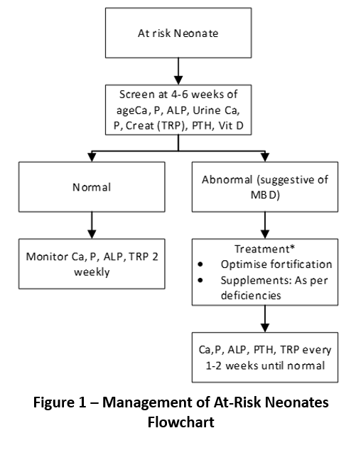
- Add fortifier as soon as possible after commencing feeds (per protocol)
- For specific dosing, administration, precautions, and instructions for Calcium and Phosphate supplements, refer to Neonatal Intensive Care Medication Guidance: Australian Neonatal Medicines Formulary (ANMF) Guideline (available on the CHS Policy and Guidance Documents Register).
- The method described to optimise mineral intake is to supplement calcium and phosphate with the goal of achieving a slight surplus of supply (SSS). In infants not on diuretics or methylxanthines, this is achieved by regular adjustments to mineral intake with a goal of achieving a slight excess of urinary mineral excretion (urine concentrations of 1 to 2 mmo/L).
- Poor linear growth in an otherwise well-nourished ex-preterm infant may indicate ongoing Ca and P deficiency.
- Hypercalcaemia (Ca greater than 2.8 mmol/L) is rarely a sign of excessive Ca intake; therefore, decreasing fortifier concentration will not help improve hypercalcaemia (and will deprive the patient of all other extra nutrients).
- The most common cause for hypercalcemia is hypophosphatemia and thiazide diuretics. Excess Vitamin D supplements can also cause hypercalcemia. For persistent hypercalcemia, check TRP, Vit D and PTH levels. Add more P supplements in suggestive circumstances, stop diuretics, and/or screen for nephrocalcinosis by renal ultrasound.
- Refer infant to Endocrinologist if:
  - Clinically complex
  - Failure to respond despite supplementation
  - NBM, intolerant to supplements and high PTH (Considering calcitriol)
  - Monitor urine Ca/Creatine if on calcium or calcitriol
- There is limited research and date on supplementation cessation. Continue supplements until 4 to 6 months if ongoing biochemical abnormalities and poor linear growth. Several high-risk infants continue to show bone mineral deficit up to 1 year of age.
Back to Contents

Evaluation

Outcomes
- Nursing and medical staff are guided in nutrition management for optimal growth and development for infants in the Department of Neonatology.
- Improved nutritional outcomes for infants requiring nutritional management in the Department of Neonatology.

Measures
- Review conducted by MO yearly on 20 percent neonates less than 28 weeks gestation (approximately 5 neonates/year) to assess if adherence to guideline with regards to Standardised Feeding Schedules and presented at departmental Policy and Guidelines meeting.
- Review conducted by MO yearly on 20 percent neonates less than 28 weeks gestation (approximately 5 neonates/year) to assess of incidence of postnatal growth failure at discharge.
- Monitoring NEC and central line data through departmental Morbidity and Mortality meeting 3 monthly.

Back to Contents

Related policies, procedures, guidelines and legislation

Policies
- Medication Safety
- Medication Handling
- Preventing and Controlling Healthcare Associated Infections

Guideline
- Consent for Healthcare Treatment
- Expressed Breast Milk Incident Guide
- Developmental Care in the Neonatal Intensive Care Unit and Special Care Nursery
- Breastfeeding
- Neonatal Surgery
- Total Parenteral Nutrition and Lipids (Neonates)
- Neonatal Routine Care
- Neonatal Intensive Care Medication Guidance: Australian Neonatal Medicines Formulary (ANMF)
- Healthcare Associated Infection Surveillance Guideline (for adults and children)
- Respiratory Support – Invasive and Non-Invasive (Neonates and Infants)

Procedures
- Infection Prevention and Control
- Patient Identification and Health Care Activity Matching
- Venous and Arterial Access: Management in the Department of Neonatology

Legislation
- Health Records (Privacy and Access) Act 1997
- Human Rights Act 2004
- Work Health and Safety Act 2011

Forms
- Informed Consent (Form No. 15270)

Other
- Australian Charter of Healthcare Rights
Back to Contents

References
- Embleton ND, Jennifer Moltu S, Lapillonne A, van den Akker CHP, Carnielli V, Fusch C, Gerasimidis K, van Goudoever JB, Haiden N, Iacobelli S, Johnson MJ, Meyer S, Mihatsch W, de Pipaon MS, Rigo J, Zachariassen G, Bronsky J, Indrio F, Köglmeier J, de Koning B, Norsa L, Verduci E, Domellöf M. Enteral Nutrition in Preterm Infants (2022): A Position Paper From the ESPGHAN Committee on Nutrition and Invited Experts. J Pediatr Gastroenterol Nutr. 2023 Feb 1;76(2):248-268. doi: 10.1097/MPG.0000000000003642. Epub 2022 Oct 28. PMID: 36705703.
- Oddie SJ, Young L, McGuire W. Slow advancement of enteral feed volumes to prevent necrotising enterocolitis in very low birth weight infants. Cochrane Database Syst Rev 2017;8:CD001241.
- Dorling J, Abbott J, Berrington J, et al. Controlled trial of two incremental milk-feeding rates in preterm infants. N Engl J Med 2019;381:1434–43.
- Abdelrahman,K; Jarjour,J; Hagan,J et al. Optimizing Delivery of Breast Milk for Premature Infants: Comparison of Current Enteral Feeding Systems. (2020) Nutrition in Clinical Practice. Vol.35
- Alizadeh, T; Sajjadian, N; Asgharyan, F and Shariat, M. Is early breastmilk fortification more effective in preterm infants? A clinical trial. (2017) J Perinat Med Vol 45
- Badran, A; Hashish, M; Ali, A; Shokeir, M and Shabaan, A. Nasogastric versus Orogastric Bolus Tube Feeding in Preterm Infants: Pilot Randomized Clinical Trial. (2020) American Journal of Perinatology.
- California Perinatal Quality Care Collaborative. Nutritional Support of the Very Low Birth Weight Infant: A Quality Improvement Toolkit (2018)
- Chu, S., Procaskey, A., Tripp, S., Naples, M., White, H., & Rhein, L. Quality improvement initiative to decrease time to full feeds and central line utilization among infants born less than or equal to 32 weeks through compliance with standardized feeding guidelines. (2019) Journal of Perinatology : Official journal of the California Perinatal Association Vol. 39, No.8
- D’Costa, R; Gallipoli, A; Fucile, S; Dickson, B & Dow, K. A standardised daily feeding protocol improves nutrition and overall health in premature low birth weight infants. (2019) Paediatrics & Child Health. Vol. 24
- De Waard,M; Li,Y; Zhu,Y et al. Time to Full Enteral Feeding for Very Low Birth Weight Infants Varies Markedly Among Hospitals Worldwide But May Not Be Associated With Incidence of Necrotizing Enterocolitis: The NEOMUNE-NeoNutriNet Cohort Study. (2019) Journal of Parenteral and Enteral Nutrition. Vol. 43, No.5
- Fenin, A; Newman, J and Taylor, S. Very low birth weight infants receive full enteral nutrition within 2 postnatal weeks. (2020) Journal of Perinatology.
- Donor breastmilk banks: the operation of donor breastmilk bank services. National Institute for Health and Clinical Excellence (2010)
- Best Practice for Expressing, Storing and Handling Human Milk in hospitals, homes, and Child Care Settings. Frances Jones and Mary Rose Tully 2nd Edition © HMBANA 2006
- Effect of Holder Pasteurization and Frozen Storage on Macronutrients and Energy Content of Breastmilk, Journal of Paediatric Gastroenterology & Nutrition, September 2013 - Volume 57 - Issue 3 - p 377–382
- Department of Health and Aged Care Donor human milk banking in Australia - issues and background paper, Australian Government - Department of Health and Aged Care. (2014) Available at: https://www.health.gov.au/sites/default/files/documents/2022/02/donor-human-milk-banking-in-australia-issues-and-background-paper.pdf (Accessed: 05 December 2024).
- Rustico SE, Calabria AC, Garber SJ. Metabolic bone disease of prematurity. J Clin Transl Endocrinol. 2014 Jul 4;1(3):85-91. doi: 10.1016/j.jcte.2014.06.004. PMID: 29159088; PMCID: PMC5684970.
- Faienza MF, D'Amato E, Natale MP, et al. Metabolic Bone Disease of Prematurity: Diagnosis and Management. Front Pediatr. 2019;7:143. Published 2019 Apr 12. doi:10.3389/fped.2019.00143
- Dawson, J. A., Summan, R., Badawi, N., & Foster, J. P. (2021). Push versus gravity for intermittent bolus gavage tube feeding of preterm and low birth weight infants. Cochrane Database of Systematic Reviews, 2021(8). https://doi.org/10.1002/14651858.cd005249.pub3
- Kohler,J; Fowler,J; Moore,R et al. Improved Use of Human Milk, Growth and Central Line Utilization with Standard Feeding Roadmap in an Academic NICU Nutrition in Clinical Practice: Official Publication of the American Society for Parenteral and Enteral Nutrition. Vol.35, No.4
- Lubbe, W. Clinicians guide for cue-based transition to oral feeding in preterm infants: An easy-to-use clinical guide. (2018) J Eval Clin Pract
- Ma, X; Fan, W. Earlier Nutrient Fortification of Breastmilk Fed LBW Infants Improves Jaundice Related Outcomes. (2020) Nutrients Vol.12, No.7
- Morton, S; Belfort,M; Kahlon, P; Barfjani,S; Rudie,C; Hashim,E; Hansen,A & Huh,S. Reducing time to initiation and advancement of enteral feeding in an all-referral neonatal intensive care unit. (2018) Journal of Perinatology Vol.38
- Oliver, C; Watson, C; Crowley,E; Gilroy,M; Page,D; Weber,K; Messina,D & Cormack,B. Vitamin and Mineral Supplementation Practices in Preterm Infants: A survey of Australian and New Zealand Neonatal Intensive and Special Care Units. (2019) Nutrients. 12 (1)
- Parker, L; Torrazza, R; Li, Y; Talaga, E; Shuster, J and Neu, J. Aspiration and evaluation of gastric residuals in the neonatal intensive care unit: state of the science. (2015) Journal of Perinatal & Neonatal Nursing. Vol.29 No.1
- Pereira-da-Silva, L & Virella, D. Is intrauterine growth appropriate to monitor postnatal growth of preterm neonates? (2014) BMC Pediatrics Vol 14
- Purohit, G; Mehkarkar, P; Athalye-Jape, G; Natahn, E & Patole, S. Association of gastric volumes with necrotising enterocolitis in extremely preterm infants- a case-control study. (2021) European Journal of Pediatrics.
- Torazza, R; Parker, L; Li, Y; Shuster, J and Neu, J. The value of routine evaluation of gastric residuals in very low birth weight infants. (2015) Journal of Perinatology. Vol.35, No.1
- Ehrenkranz RA, Dusick AM, Vohr BR, Wright LL, Wrage LA, Poole WK, National Institutes of Child Health and Human Development Neonatal Research Network. Growth in the neonatal intensive care unit influences neurodevelopmental and growth outcomes of extremely low birth weight infants. Pediatrics. 2006 Apr 1;117(4):1253-61
- Olsen IE, Groveman SA, Lawson ML, Clark RH, Zemel BS. New intrauterine growth curves based on United States data. Pediatrics. 2010 Feb 1; 125(2): e214-24.
- Winnipeg Regional Health Authority. Enteral Feeding and Nutrition for the Preterm and High Risk Neonate. Clinical Practice Guideline. June 2020.
- Royal Hospital for Women Neonatal Enteral Nutrition Guide. Available online at https://www.seslhd.health.nsw.gov.au/royal-hospital-for-women/services-clinics/directory/newborn-care-centre-nicu/neonatal-medical-guidelines. Accessed 29-5-24
- John Hunter Childrens Hospital Neonatal Enteral Nutrition guide. Available online at https://www.hnekidshealth.nsw.gov.au/__data/assets/pdf_file/0018/423108/Enteral_Feeding_September_2018.pdf. Accessed 29-5-24
- Health and Social Policy. Pasteurised Donor Human Milk For Vulnerable Infants [Internet]. Pasteurised Donor Human Milk for Vulnerable Infants. NSW Government Health; 2018 Nov [cited 2025 Jan 22]. Available from: https://www1.health.nsw.gov.au/pds/ActivePDSDocuments/PD2018_043.pdf
- Medela . Calesca Warming and Thawing Device [Internet]. [cited 2025 Jan 22]. Available from: https://www.medela.com/en/breastfeeding-pumping/products/nicu/calesca-warming-and-thawing-device?productId=4487
Back to Contents

Definition of terms
Accretion process – Mineral accretion in the fetus refers to the process of accumulating minerals, particularly calcium and phosphorus, in the developing fetus during pregnancy. This process is crucial for proper fetal bone development and overall growth.
Neonate – a child under 28 days old
Infant – a child under 1 year old
Preterm neonate – a neonate born before 37 weeks gestational age
Mothers own Milk (MOM) or Expressed Breast Milk (EBM) – Expressed milk from the mother
Suck feeding – is the mode of feeding when an infant breastfeeds or bottle feeds.
Gestational age (GA) – is the length of pregnancy based in weeks and in terms of neonates it is the gestational age which the child is born
Corrected gestational age (CGA) – is the current gestational age of child after he/she is born. For example, a neonate born at 32 weeks GA at 9 in the morning has a CGA of 32+3 weeks at Day 4 of life.
Osteopenia - a condition in which bone mineral density is lower than normal.
Pasteurised Donor Human Milk (PDHM) - Human breastmilk heated to 62.5 degrees Celsius for 30 minutes then passed as sterile by microbiology
Back to Contents

Search terms
NICU, SCN, Breastmilk, Pasteurised Donor Breastmilk, PDBM, PDHM, Infant feeding room, naso-gastric tube, nutrition, feeding, trophic feed, Osteopenia, Osteopenia and Metabolic Bone Disorder Prematurity, Metabolic Bone Disorder of Prematurity, Calcium Deficiency, Phosphate Deficiency, Vitamin D Deficiency, Alkaline Phosphatase, Calcium and Phosphate Deficiency, Nasogastric Tube, Orogastric Tube, Enteral feeding, insertion of nasogastric tube, insertion of orogastric tube, tube feeding, gravity feeds, pump feeding, neonate, neonates, neonatal, baby, infant, infants, nutrition guide, standard feeding schedule, standard feeding regime, feed intolerance, green aspirates, bile aspirates, orogastric tube, NGT, OGT, fortification
Back to Contents

Attachments

Attachment 1 – Insertion of Nasogastric/Orogastric Feeding Tube (Neonates/Infants)

Attachment 2 – Enteral Tube Feeding Procedure

Attachment 3 – Department of Neonatology Nutrition Guide

Attachment 4 – Standard Feeding Schedules

Attachment 5 – Feeding Intolerance Algorithm

Attachment 6 – Medela Calesca Milk Warmer

Attachment 7 – ESPGHAN Nutrition Recommendations Table

For Policy Team to complete:
Date amended | Section amended | Divisional approval | Final approval
09/04/2025 | Complete review | Katherine Wakefield, ED WY&C | Policy Document Review Panel
30/05/2025 | Minor amendments made throughout including Attachments. | Dr Tejasvi Chaudhari, Neonatology Staff Specialist & Hazel Carlisle Neonatology Clinical Director | CHS Policy Team
This document supersedes the following:
Document number | Document name
CHS19/157 | Neonatal Nutrition Guide

Disclaimer
This document has been developed by Canberra Health Services specifically for its own use. Use of this document and any reliance on the information contained therein by any third party is at his or her own risk and Canberra Health Services assumes no responsibility whatsoever.
Back to Contents

Acknowledgement of Country  Canberra Health Services acknowledges the Ngunnawal people as traditional custodians of the ACT and recognises any other people or families with connection to the lands of the ACT and region. We acknowledge and respect their continuing culture and contribution to the life of this region.  © Australian Capital Territory, Canberra 2024 | Accessibility  call (02) 5124 0000   Interpreter call 131 450  canberrahealthservices.act.gov.au/accessibility  

Attachment 1 – Insertion of Nasogastric/Orogastric Feeding Tube (Neonates/Infants)
Alert:
- Apnoea, bradycardia, desaturation may occur following stimulation of the vagal nerve. Ensure infant is monitored throughout procedure. If infant does have a vagal response, either remove tube or give infant time to recover.
- The feeding tube should never be forced during insertion due to risk of perforation of the oesophagus, stomach or duodenum.
- Aspiration of feed due to feeding tube being placed into trachea. Always verify tube placement thoroughly, upon insertion, once a shift, or when in doubt.

Equipment
- Alcohol based hand rub (ABHR)
- Enteral feeding tube
Table 7 – Enteral Feeding Tube Sizing Guide
French Catheter Size (Fr) 5 | Fr 6-6.5 | Fr 8
Less than 1000 grams | Greater than or equal to 1000 grams | Gastrointestinal Surgery
- 3, 5 or 10 mL oral syringe
- pH indicator strip
- Duoderm
- Neoplast brown tape
- Scissors
- Additional: MOM, swaddling wrap, dummy, and/or sucrose
Note:
- Nasogastric tube is preferred for enteral feeding for its reduced risk of displacement and its promotion of suck feeding (e.g., greater than 34-week CGA infants, High Flow or Low Flow Nasal Oxygen Therapy).
- For infants on non-invasive respiratory support (e.g., Bubble CPAP) or issues with nasal blockage an orogastric tube is recommended.
- For surgical infants with trans anastomotic tubes (which will be inserted nasally), an orogastric tube may be requested for gastric drainage by paediatric surgical team.
- Sizing up on enteral tube may also be considered in consultation with the MO.

Procedure
- Attend to hand hygiene and patient identification
- Gather equipment
- Determine appropriate route: nasogastric or orogastric
  - Nasogastric tubes are preferable for infants greater than 1kg, infants with a strong gag reflex, and those starting suck feeding.
  - Orogastric tubes are appropriate for infants on nasal bubble CPAP, those that have high oxygen requirements, infants less than 1kg, and those with excoriated nares.
- Determine depth of insertion of feeding tube (See Image 1 – Feeding Insertion Landmarks/Depth below).
  - Nasogastric (NGT) – measure from nose to ear lobe, down to halfway between xiphoid process and umbilicus.
  - Orogastric (OGT) – measure from centre of mouth to ear lobe, down to halfway between xiphoid process and umbilicus.
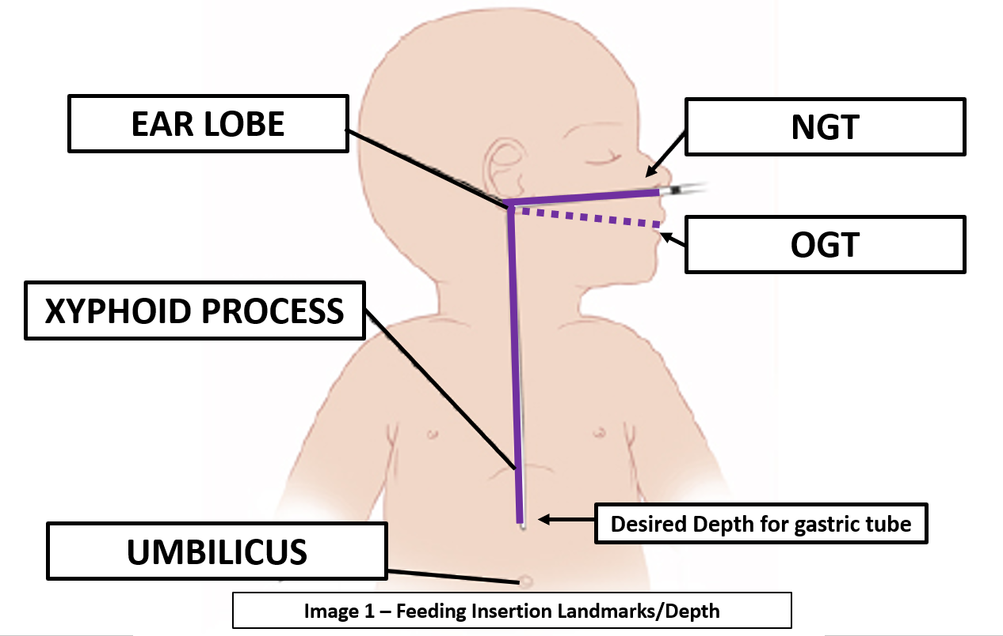
- Encourage non-nutritive sucking and administer MOM or sucrose to the infant two minutes prior to insertion of feeding tube for analgesia.
- Position infant supine and swaddle with arms tucked inside wrap.
- Moisten tip of tube with infant’s saliva and gently insert into nose (NGT) or mouth (OGT) to desired depth.
- Taping of:
  - NGT insertion
    - Cut Duoderm® to appropriate size and neoplast brown tape to single trouser leg shape as is shown in Image 2 – Taping of Nasogastric Tube.
    - Place duoderm on side of face, abutting the nose.
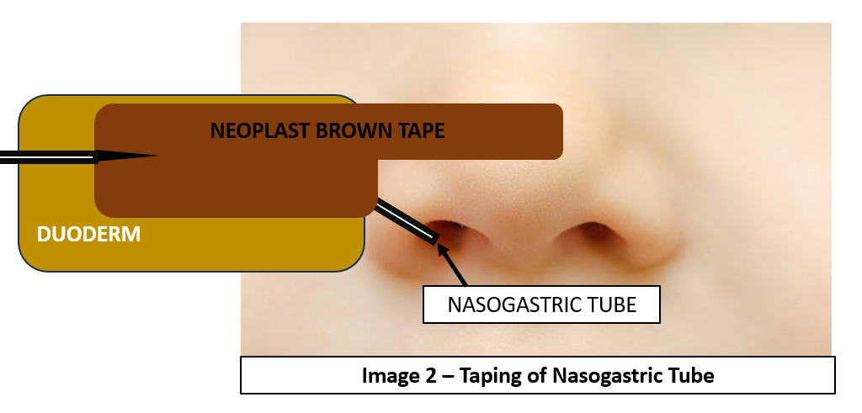
    - Secure NGT by applying neoplast brown tape over with single trouser leg over bridge of nose and wide portion over NGT and duoderm. See Image 2 – Taping of Nasogastric Tube below for reference.
  - OGT insertion:
    - Cut Duoderm® to appropriate size and place on infant’s chin.
    - Cut neoplast brown tape into a trouser leg shape (Step 1- Image 3 – Taping of Orogastric Tube below). Wrap one trouser leg over gastric tube and other leg around feeding tube to ensure non-slippage (Step 2 – Image 3 – Taping of Orogastric Tube).
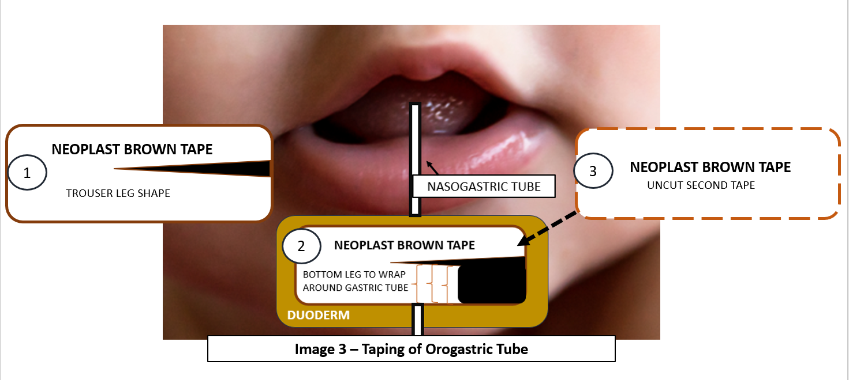
    - Place a second piece of neoplast brown tape over the top to ensure extra security (Step 3 – Image 3 – Taping of Orogastric Tube).

Alert:
- The “Whoosh” test i.e. injecting air down the gastric tube and listening with a stethoscope is no longer recommended as a method to confirm tube placement.
- Visible presence of gastric aspirate in tube is also unreliable.
- Nurse to check position of NGT/OGT via testing the pH of gastric aspirate.
  - Using a 3ml or 5ml oral syringe aspirate 0.5 to 1ml of gastric contents and use this aspirate to test acidity using pH strips. The tested aspirate must be less than pH 5.5. Discard aspirated milk.
  - If unable to aspirate any gastric contents:
    - When appropriate, turn infant to left side-lying with tube secure and retry aspiration.
    - If unsuccessful again, consider repositioning tube by remeasuring tube depth, adjusting tube position and re-aspirate.
    - After this, if still aspirate is unattainable, remove gastric tube and consult with MO.
    - Confirmation via x-ray maybe necessary.
    - If pH is greater than 6, consider possible causes such as presence of amniotic fluid (if neonate is less than 48 hours old), continuous enteral feeding, medications, and presence of milk or blood in tube.
- Attach patient label with patient identifiers on distal end of gastric tube.
- Document feeding tube insertion with relevant information in infant’s medical records such as date of insertion, tube length/depth, inserting clinician’s name in patient clinical records and patient label attached to gastric tube.
Back to Contents

Attachment 2 – Enteral Tube Feeding Procedure
Alert:
- All enteral milk choices given to infants must be checked by 2 clinical staff members (e.g., nursing, medical, and/or allied health staff) and must be documented in the infant’s clinical record.
- If incorrect breast milk given to infant, refer to Expressed Breastmilk Incident Guide Clinical Guideline (available on the CHS Policy and Guidance Documents Register).
- Breastmilk and fortifier to be checked and co-signed by 2 nurses/nutrition room technicians
- Handling of breastmilk requires a clean work service and careful management to reduce risk of contaminating milk
- Staff to maintain hand hygiene and wear appropriate personal protective equipment when handling breastmilk.
Note:
- If the infant requires a naso/orogastric tube, refer to Attachment 1 – Insertion of a Nasogastric/Orogastric Tube (Neonates/Infants).
- For the fluid, nutritional and gastrointestinal management of surgical patients, please refer to the Neonatal Surgery Guideline (available on the CHS Policy and Guidance Documents Register).
- Please refer to the Developmental Care in the Neonatal Intensive Care Unit and Special Care Nursery Guideline (available on the CHS Policy and Guidance Documents Register) for a guide on incorporating developmental care practices to infants feeding and nutrition (e.g. non-nutritive sucking, kangaroo care, immune-supportive oral care etc.).

Equipment
- Alcohol based hand rub (ABHR)
- Prescribed Enteral Milk Feed
- 3ml/5ml oral syringe for pH test
- Appropriate oral syringe for feeding
- pH test strips
- Enteral Feeding Pump for less than or equal to 32 weeks GA and/or less than or equal to 1800g
- Appropriately sized oral syringe
- Optional: Sterile Water for Injection (WFI), milk bottle

Procedure
- Attend hand hygiene and identify correct patient.
- Check infant’s abdomen for bowel sounds, signs of distension, colour and/or visible loops of bowel. Refer to Attachment 5 – Feeding Intolerance Algorithm. If there are concerns, immediately consult with MO before giving feed.
- Bedside nurse to retrieve patient’s enteral milk feed as per fluid order from the patient room refrigerator, checking patient identification, type of milk feed, and use-by date.
- Place milk feed in milk warmer.
Note:
Medela Calesca Milk Warmer is used in the Department of Neonatology and is a waterless thawing and warming device that warms milk to body temperature. It uses a 24-hour use disposable insert. Refer to Attachment 6 - Medela Calesca Milk Warmer.
- Apply developmental care practice prior to giving enteral feed through kangaroo care, non-nutritive sucking, and/or immuno-supportive oral care depending on the developmental care (gestational) needs of the infant.
- Nurse to check position NGT/OGT via:
  - pH test: to be attended once a shift. Refer to Attachment 1 – Insertion of Nasogastric/Orogastric Feeding Tube (Neonates/Infants) on how to test pH. Gastric aspirate pH should be less than 5.5
  - Visual check: to be attended before every feed. Bedside nurse to check correct tube length and dressing integrity. If in doubt, attend to pH test.
Alert:
Do not routinely aspirate the entire gastric residuals.

The “Whoosh” test i.e. injecting air down the gastric tube and listening with a stethoscope is
no longer recommended as a method to confirm tube placement.

Visible presence of gastric aspirate in tube is also unreliable.
- Once position of tube confirmed, bedside nurse to retrieve warmed milk and to check that the correct milk is to be given to the correct patient via patient identifiers on milk container and patient label. Both nurses to co-sign in patient clinical record.
- Bedside nurse to shake milk container before commencing feeds (to mix fat, additives, etc. thoroughly in milk).
- Commence feed by either:
  - Pump feed (for infants less than or equal to 32 weeks GA and/or less than or equal to 1800g).
- Pour enteral milk feed into an oral syringe, attach and prime long feeding line, then attach to patient’s gastric tube.
- Place oral syringe into enteral feeding pump and set infusion rate depending to prescribed infusion time. See Table 2 for pump duration:
- See table below for pump duration as per volume. Consider transitioning to gravity feeds once the baby is greater than 34 weeks CGA.

Table 2 – Pump Feed Duration Based on Volume
Volume | Pump Duration
Less than 5mls | Manual Push/Bolus (1-2 minutes)
5 – 20mls | 10 minutes
Greater than 20mls | 20 minutes

  - Gravity Feed (for infants greater than 32weeks GA and/or greater than 1800 g)
    - Attach filled oral syringe to infant’s gastric tube and use plunger to initiate feed through tube and allow milk to free flow via gravity.
    - The time/flow in which a feed is given via gravity depends on the height of the syringe. Lowering the syringe slows the milk flow and raising it makes it faster. The aim is 15 to 20 minutes.
- If apnoea and bradycardias occur during feeding, cease feed, check tube placement, give the infant time to recover and continue to feed slowly.
- Once feed is given, disconnect syringe and clear gastric tube by flushing line with 0.5ml of air or sterile (WFI), and close gastric tube.
Note:
For management of the gastric tube for infants on non-invasive respiratory support, refer to the Respiratory Support – Invasive and Non-Invasive (Neonates and Infants) Guideline (available on the CHS Policy and Guidance Documents Register).
- Document the milk feed given in patient clinical record and feeding tube properties

Back to Contents

Attachment 3 – Department of Neonatology Nutrition Guide
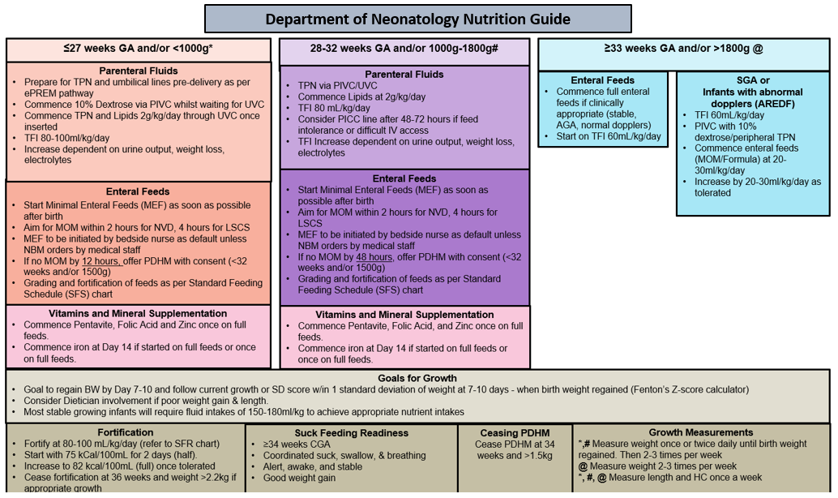
Back to Contents

Attachment 4 – Standard Feeding Schedules

Key points:
- For infants less than 1000g, minimal enteral feeds may be considered for a set period (no longer than 48hrs) as extra based on clinical condition and Neonatologist advice.
- ‘Feed day’ refers to the day feeding is occurring, NOT the day of life.
- Grading up feeds may need to be slow or altered (e.g., hourly bolus feeds, pump feeds over longer period, continuous feeds, transpyloric feeds) in special circumstances, such as:
- Growth restriction
- Abnormal umbilical Doppler’s
- Feed intolerance
- Necrotising enterocolitis and other medical or surgical gastrointestinal conditions
- Hemodynamically significant Patent Ductus Arteriosus (PDA) (particularly infants on ibuprofen)
- Infants on inotropic support and/or muscle relaxants

PROTOCOL 1 – 400-499g
FEED DAY | FEED NUMBER and VOLUME (ml) 2nd HOURLY FEEDS  *Cease grading once a volume of 160mL/kg/d is reached
FEED DAY | 1 | 2 | 3 | 4 | 5 | 6 | 7 | 8 | 9 | 10 | 11 | 12 | TFI@ feed12  (mL/kg/d)
1 | 1 |  | 1 |  | 1 |  | 1 |  | 1 |  | 1 |  | 12-15
2 | 1 | 1 | 1 | 1 | 1 | 1 | 1 | 1 | 1 | 1 | 1 | 1 | 24-30
3 | 1.5 | 1.5 | 1.5 | 1.5 | 1.5 | 1.5 | 2 | 2 | 2 | 2 | 2 | 2 | 48-60
4 | 2.5 | 2.5 | 2.5 | 2.5 | 2.5 | 2.5 | 3 | 3 | 3 | 3 | 3 | 3 | 72-90
5 (half Fortify) | 3.5 | 3.5 | 3.5 | 3.5 | 3.5 | 3.5 | 4 | 4 | 4 | 4 | 4 | 4 | 96-120
6 (half Fortify) | 4.5 | 4.5 | 4.5 | 4.5 | 4.5 | 4.5 | 5 | 5 | 5 | 5 | 5 | 5 | 120-150
7 (fully fortify) | 5.5 | 5.5 | 5.5 | 5.5 | 5.5 | 5.5 | 6 | 6 | 6 | 6 | 6 | 6 | 144-180

PROTOCOL 2 - 500-599g
FEED DAY | FEED NUMBER and VOLUME (ml) 2nd HOURLY FEEDS  *Cease grading once a volume of 160mL/kg/d is reached
FEED DAY | 1 | 2 | 3 | 4 | 5 | 6 | 7 | 8 | 9 | 10 | 11 | 12 | TFI@ feed12  (mL/kg/d)
1 | 1 | 1 | 1 | 1 | 1 | 1 | 1 | 1 | 1 | 1 | 1 | 1 | 20-24
2 | 2 | 2 | 2 | 2 | 2 | 2 | 2 | 2 | 2 | 2 | 2 | 2 | 40-48
3 | 3 | 3 | 3 | 3 | 3 | 3 | 3 | 3 | 3 | 3 | 3 | 3 | 60-72
4 (half Fortify) | 4 | 4 | 4 | 4 | 4 | 4 | 4 | 4 | 4 | 4 | 4 | 4 | 80-96
5 (half Fortify) | 5 | 5 | 5 | 5 | 5 | 5 | 5.5 | 5.5 | 5.5 | 5.5 | 5.5 | 5.5 | 110-132
6 (fully fortify) | 6.5 | 6.5 | 6.5 | 6.5 | 6.5 | 6.5 | 7 | 7 | 7 | 7 | 7 | 7 | 140-168
7 | 8 | 8 | 8 | 8 | 8 | 8 | 8 | 8 | 8 | 8 | 8 | 8 | 160-192

PROTOCOL 3 - 600-699g
FEED DAY | FEED NUMBER and VOLUME (ml) 2nd HOURLY FEEDS  *Cease grading once a volume of 160mL/kg/d is reached
FEED DAY | 1 | 2 | 3 | 4 | 5 | 6 | 7 | 8 | 9 | 10 | 11 | 12 | TFI@ feed12  (mL/kg/d)
1 | 1 | 1 | 1 | 1 | 1 | 1 | 1 | 1 | 1 | 1 | 1 | 1 | 17-20
2 | 2 | 2 | 2 | 2 | 2 | 2 | 2.5 | 2.5 | 2.5 | 2.5 | 2.5 | 2.5 | 42-50
3 | 3.5 | 3.5 | 3.5 | 3.5 | 3.5 | 3.5 | 4 | 4 | 4 | 4 | 4 | 4 | 68-80
4 (half Fortify) | 5 | 5 | 5 | 5 | 5 | 5 | 5.5 | 5.5 | 5.5 | 5.5 | 5.5 | 5.5 | 94-110
5 (half Fortify) | 6.5 | 6.5 | 6.5 | 6.5 | 7 | 7 | 7 | 7 | 7.5 | 7.5 | 7.5 | 7.5 | 128-150
6 (fully fortify) | 8.5 | 8.5 | 8.5 | 8.5 | 9 | 9 | 9 | 9 | 9.5 | 9.5 | 9.5 | 9.5 | 162-190

PROTOCOL 4 - 700-799g
FEED DAY | FEED NUMBER and VOLUME (ml) 2nd HOURLY FEEDS  *Cease grading once a volume of 160mL/kg/d is reached
FEED DAY | 1 | 2 | 3 | 4 | 5 | 6 | 7 | 8 | 9 | 10 | 11 | 12 | TFI@ feed12  (mL/kg/d)
1 | 1 | 1 | 1 | 1 | 1 | 1 | 1.5 | 1.5 | 1.5 | 1.5 | 1.5 | 1.5 | 22-25
2 | 2.5 | 2.5 | 2.5 | 2.5 | 2.5 | 2.5 | 3.5 | 3.5 | 3.5 | 3.5 | 3.5 | 3.5 | 52-60
3 (half Fortify) | 4.5 | 4.5 | 4.5 | 4.5 | 4.5 | 4.5 | 5.5 | 5.5 | 5.5 | 5.5 | 5.5 | 5.5 | 82-94
4 (half Fortify) | 6.5 | 6.5 | 6.5 | 6.5 | 6.5 | 6.5 | 7.5 | 7.5 | 7.5 | 7.5 | 7.5 | 7.5 | 112-128
5 (fully fortify) | 8.5 | 8.5 | 8.5 | 8.5 | 8.5 | 8.5 | 9.5 | 9.5 | 9.5 | 9.5 | 9.5 | 9.5 | 142-162
6 | 10.5 | 10.5 | 10.5 | 10.5 | 10.5 | 10.5 | 11 | 11 | 11 | 11 | 11 | 11 | 165-188

PROTOCOL 5 - 800-999g
FEED DAY | FEED NUMBER and VOLUME (ml) 2nd HOURLY FEEDS  *Cease grading once a volume of 160mL/kg/d is reached
FEED DAY | 1 | 2 | 3 | 4 | 5 | 6 | 7 | 8 | 9 | 10 | 11 | 12 | TFI@ feed12  (mL/kg/d)
1 | 1 | 1 | 1 | 1 | 1 | 1 | 2 | 2 | 2 | 2 | 2 | 2 | 25-30
2 | 3 | 3 | 3 | 3.5 | 3.5 | 3.5 | 4 | 4 | 4 | 4.5 | 4.5 | 4.5 | 54-67.5
3 (half Fortify) | 5.5 | 5.5 | 5.5 | 6 | 6 | 6 | 6.5 | 6.5 | 6.5 | 7 | 7 | 7 | 84-105
4 (half Fortify) | 8 | 8 | 8 | 8.5 | 8.5 | 8.5 | 9 | 9 | 9 | 10 | 10 | 10 | 120-150
5 (fully fortify) | 11 | 11 | 11 | 11.5 | 11.5 | 11.5 | 12 | 12 | 12 | 12.5 | 12.5 | 12.5 | 150-188
6 | 13 | 13 | 13 | 13 | 13 | 13 | 13 | 13 | 13 | 13 | 13 | 13 | 156-195

PROTOCOL 6 - 1000-1249g
FEED DAY | FEED NUMBER and VOLUME (ml) 2nd HOURLY FEEDS  *Cease grading once a volume of 160mL/kg/d is reached
FEED DAY | 1 | 2 | 3 | 4 | 5 | 6 | 7 | 8 | 9 | 10 | 11 | 12 | TFI@ feed12  (mL/kg/d)
1 | 1 | 1 | 1 | 1 | 2 | 2 | 2 | 2 | 3 | 3 | 3 | 3 | 25-30
2 | 4 | 4 | 4 | 4 | 5 | 5 | 5 | 5 | 6 | 6 | 6 | 6 | 50-60
3 (half Fortify) | 7 | 7 | 7 | 7 | 8 | 8 | 8 | 8 | 9 | 9 | 9 | 9 | 75-90
4 (half Fortify) | 10 | 10 | 10 | 11 | 11 | 11 | 12 | 12 | 12 | 13 | 13 | 13 | 125-156
5 (fully fortify) | 13 | 13 | 13 | 13 | 14 | 14 | 14 | 14 | 15 | 15 | 15 | 15 | 144-180
6 | 15 | 15 | 15 | 15 | 15 | 15 | 16 | 16 | 16 | 16 | 16 | 16 | 154-192

PROTOCOL 7 - 1250-1499g
FEED DAY | FEED NUMBER and VOLUME (ml) 2nd HOURLY FEEDS  *Cease grading once a volume of 160mL/kg/d is reached
FEED DAY | 1 | 2 | 3 | 4 | 5 | 6 | 7 | 8 | 9 | 10 | 11 | 12 | TFI@ feed12  (mL/kg/d)
1 | 2 | 2 | 2 | 2 | 3 | 3 | 3 | 3 | 4 | 4 | 4 | 4 | 32-38
2 | 6 | 6 | 6 | 6 | 7 | 7 | 7 | 7 | 8 | 8 | 8 | 8 | 64-76
3 (half Fortify) | 10 | 10 | 10 | 10 | 11 | 11 | 11 | 11 | 12 | 12 | 12 | 12 | 96-115
4 (half Fortify) | 14 | 14 | 14 | 14 | 15 | 15 | 15 | 15 | 16 | 16 | 16 | 16 | 128-154
5 (fully fortify) | 18 | 18 | 18 | 18 | 19 | 19 | 19 | 19 | 20 | 20 | 20 | 20 | 160-192

PROTOCOL 8 - 1500-1799g
FEED DAY | FEED NUMBER and VOLUME (ml) 3RD HOURLY FEEDS  *Cease grading once a volume of 160mL/kg/d is reached
FEED DAY | 1 | 2 | 3 | 4 | 5 | 6 | 7 | 8 | TFI@ feed 12 (mL/kg/d)
1 | 2 | 2 | 4 | 4 | 6 | 6 | 10 | 10 | 44-53
2 | 12 | 12 | 14 | 14 | 16 | 16 | 18 | 18 | 80-96
3 (half Fortify) | 21 | 21 | 23 | 23 | 25 | 25 | 27 | 27 | 120-144
4 (fully Fortify) | 30 | 30 | 32 | 32 | 34 | 34 | 36 | 36 | 160-192
Back to Contents

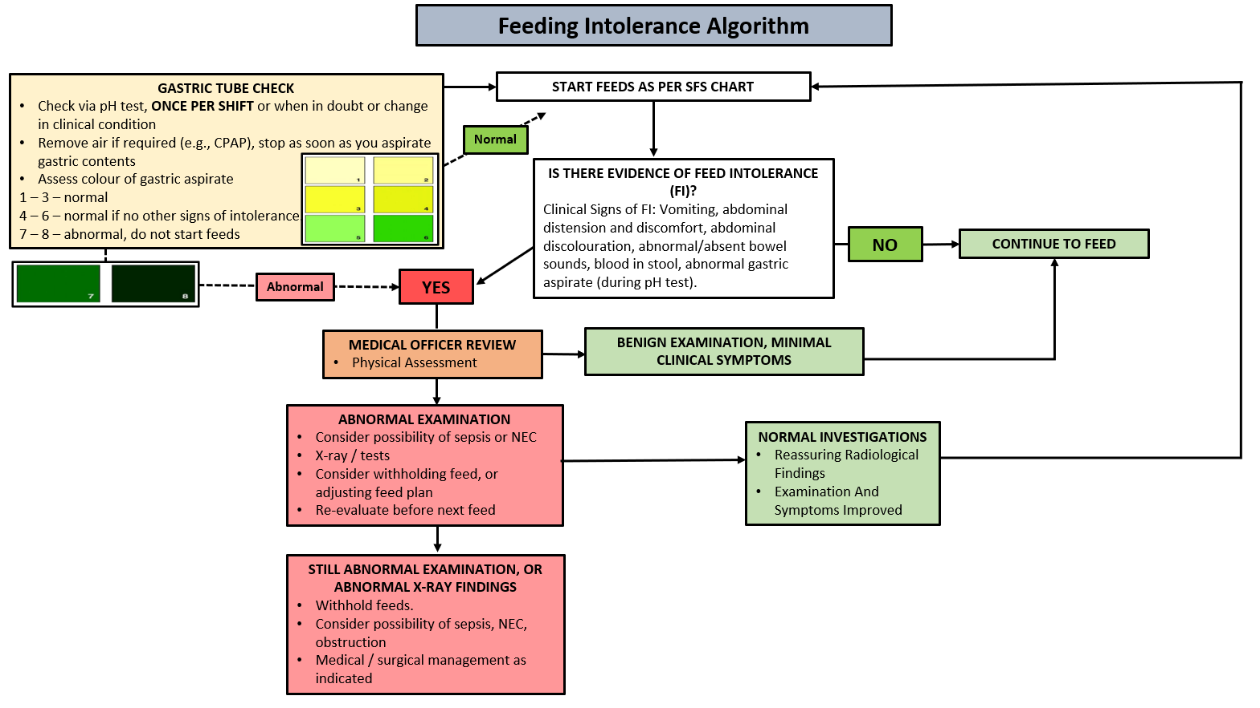
Attachment 5 – Feeding Intolerance Algorithm

Back to Contents

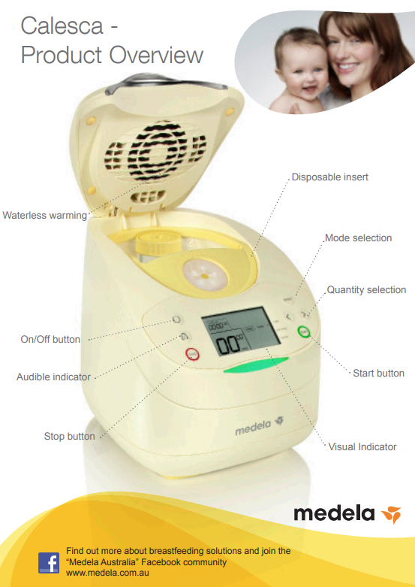
Attachment 6 – Medela Calesca Milk Warmer

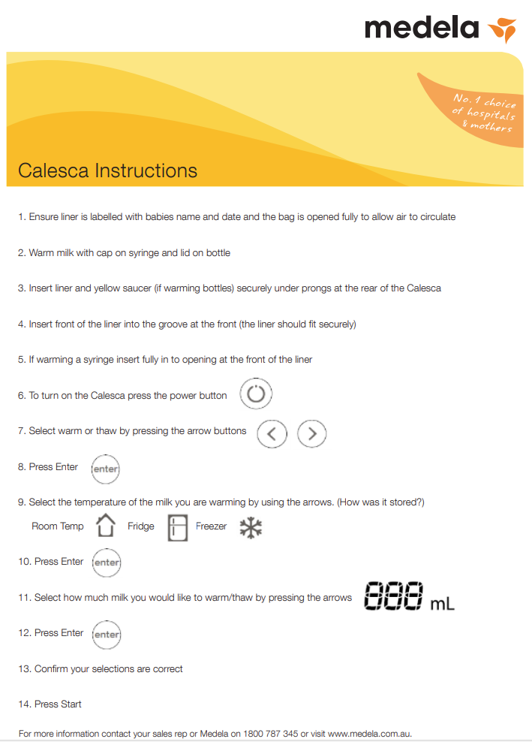
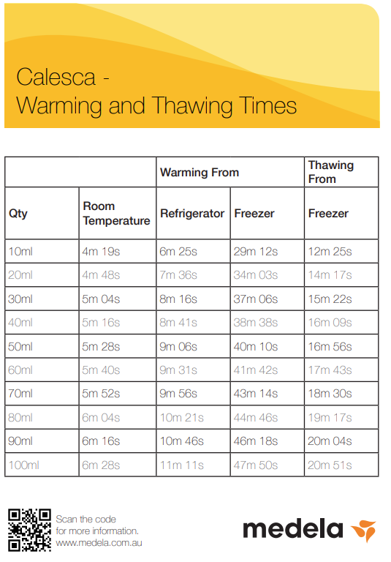

Back to Contents

Attachment 7 – ESPGHAN Nutrition Recommendations Table
Fluid, Electrolytes and Nutrient | ESPGHAN 2022 recommendation
Fluid, mL/kg/d | 150–180 (135–200)
Energy, kcal/kg/d | 115–140 (−160)
Protein, g/kg/d | 3.5–4.0 (−4.5)
Fat, g/kg/d | 4.8–8.1
Carbohydrate, g/kg/d | 11–15 (−17)
Sodium, mmol/kg/d | 3.0–5.0 (−8.0)
Chloride, mmol/kg/d | 3.0–5.0 (−8.0)
Potassium, mmol/kg/d | 2.3–4.6
Calcium, mmol/kg/d | 3.0–5.0
Phosphorus, mmol/kg/d | 2.2–3.7
Magnesium, mmol/kg/d | 0.4–0.5
Iron, mg/kg/d | 2.0–3.0 (−6.0)
Zinc, mg/kg/d | 2.0–3.0
Folic acid, μg/kg/d | 23–100
Vitamin A, IU/kg/d | 1333–3300 (400–1000 μg retinol ester/kg/d)
Vitamin D, IU/kg/d | 400–700 IU/kg/d (<1000)
Vitamin E, mg/kg/d | 2.2–11
Vitamin K, μg/kg/d | 4.4–28
Back to Contents

