Canberra Health Services

Procedure
Malignant Hyperthermia -Management

Contents

Contents 1
Purpose 3
Alerts 3
Scope 3
Section 1- Background 4
Section 2- Signs and Symptoms 4
Section 3- Preparation and Flushing of the GE AISYS CS²® Anaesthetic Machine for Known or Suspected Malignant Hyperthermia Susceptible Patients 5
Section 4- Preparation and Flushing of the GE Carestation 650 Anaesthetic Machine for Known or Suspected Malignant Hyperthermia Susceptible Patients 6
Section 5- Preparation and Flushing of the GE Datex-Ohmeda Aestiva 5/MRI Anaesthetic Machine for Known or Suspected Malignant Hyperthermia Susceptible Patients 6
Section 6- Quick flush technique for emergency malignant hyperthermia susceptible patients using Vapor-clean® charcoal filters 7
Section 7 – Management of Adult or Paediatric Patients in Malignant Hyperthermia Crisis 9
Evaluation 12
Related Policies, Procedures, Guidelines and Legislation 12
References 13
Definition of Terms 14
Search Terms 14
Attachments 14
Attachment 1: Malignant Hyperthermia Alert Notice for standard machine preparation 16
Attachment 2: Malignant Hyperthermia Flushing Notice 17
Attachment 3: Malignant Hyperthermia Alert Notice for standard machine preparation using Vapor-clean filters® 18
Attachment 4: Australian and New Zealand Malignant Hyperthermia Group Malignant Hyperthermia Initial Management 19
Attachment 5.1: Australian and New Zealand Malignant Hyperthermia Group Malignant Hyperthermia Crisis Task Cards – Resuscitation 20
Attachment 5.2: Australian and New Zealand Malignant Hyperthermia Group Malignant Hyperthermia Crisis Task Cards – Lines & Investigations 21
Attachment 5.3 Australian and New Zealand Malignant Hyperthermia Group Malignant Hyperthermia Crisis Task Cards- Nursing 22
Attachment 5.4: Australian and New Zealand Malignant Hyperthermia Group Malignant Hyperthermia Crisis Task Cards – Dantrolene Reconstitution 23
Attachment 5.5: Australian and New Zealand Malignant Hyperthermia Group Malignant Hyperthermia Crisis Task Cards - Cooling 24
Attachment 5.6: Australian and New Zealand Malignant Hyperthermia Group Malignant Hyperthermia Crisis Task Cards - Logistics 25
Attachment 5.7: Australian and New Zealand Malignant Hyperthermia Group Malignant Hyperthermia Crisis Task Cards – Surgical Team 26
Attachment 6: Dantrolene Dosage Quick Reference Guide 27

Purpose

This procedure provides Canberra Health Services (CHS) Network clinicians with best practice for preparing the operating theatre to receive a patient with known or suspected Malignant Hyperthermia susceptibility, and guidance for the clinical management of a Malignant Hyperthermia crisis through instituting a structured approach to patient management and delegation of staffing responsibilities.

Back to Table of Contents

This Standard Operating Procedure (SOP) describes for staff the process to

Scope

Alerts

In the event of a Malignant Hyperthermia crisis, a coordinated approach to care is crucial to ensuring optimal patient outcomes⁵. Early notification and involvement of the pharmacy department and critical care services is important to ensure prompt responses to a developing crisis.

Procurement of additional offsite dantrolene stocks from other hospitals will require the assistance of the pharmacy department or on-call Pharmacist who can be contacted during business hours on extension 45303 or after hours through the after-hours Clinical Nurse Consultant (CNC) extension 42410 or pager 50479.

Back to Table of Contents

Scope

This procedure applies to CHS Network including the inpatient facilities at Canberra Hospital, Clare Holland House, North Canberra Hospital, and University of Canberra and community based services; staff who may be required to:
- Care for a patient during a Malignant Hyperthermia crisis
- Care for any patient with a known or suspected Malignant Hyperthermia susceptibility
- Prepare an anaesthetic machine for a patient with known or suspected Malignant Hyperthermia susceptibility.

This document applies to the following CHS staff working within their scope of practice:
- Medical Officers
- Registered Nurses and Midwives
- Enrolled Nurses
- Wardspersons
- Students working under supervision.

This document must be used in conjunction with Australian and New Zealand College of Anaesthetist (ANZCA) Professional Standard 31⁴, 55² and the anaesthetic machine manufacturer’s guidelines.
Back to Table of Contents

Section 1- Background

Malignant Hyperthermia is a rare pharmacogenetic hypermetabolic disorder characterised by muscle rigidity, inappropriate tachycardia, increased oxygen consumption, elevated end tidal carbon dioxide concentrations and extreme pyrexia upon exposure to volatile anaesthetic agents including: Enflurane, Halothane, Isoflurane, Sevoflurane or Desflurane, or Suxamethonium in susceptible patients⁵.

Malignant Hyperthermia reactions are potentially fatal if prompt appropriate treatment is not instituted. Avoiding exposure to all trigger agents remains the safest way to care for patients with known or suspected Malignant Hyperthermia susceptibility. This should involve removal of trigger agents from the patient’s vicinity, appropriate use of the hospital allergy/alert system and preparation of the anaesthetic machine for all patients who are requiring anaesthesia.

Malignant hyperthermia is more likely in patients with:
- Diagnosed malignant hyperthermia susceptibility after halothane/caffeine contracture test on biopsied muscle tissue
- Malignant hyperthermia susceptible relatives
- Significantly and consistently raised resting serum Creatinine Phosphokinase (CK)
- Several very rare muscle disorders

Back to Table of Contents

Section 2- Signs and Symptoms

Exposure to trigger agents induce the release of stored calcium ions within the muscle cells, precipitating unregulated muscle contraction, marked hypermetabolism and a variety of clinical symptoms:
- Early: Prolonged masseter spasm after Suxamethonium , inappropriately raised end tidal carbon dioxide or tachypnoea during spontaneous respiration, inappropriate tachycardia and cardiac arrhythmias, particularly ventricular ectopic beats⁵ ⁷

- Developing: Rapid rise in temperature (0.5ºC per 15 minutes), progressive respiratory and later metabolic acidosis, hyperkalaemia, profuse sweating, cardiovascular instability, decreased peripheral capillary oxygen saturation (SpO2) or mottling of skin, generalised muscular rigidity⁵ ⁷

- Late: “Cola” coloured urine due to myoglobinuria, generalised muscle ache (in an awake patient), grossly raised serum Creatine Kinase (CK), coagulopathy, cardiac arrest⁵ ⁷

Back to Table of Contents

Section 3- Preparation and Flushing of the GE AISYS CS²® Anaesthetic Machine for Known or Suspected Malignant Hyperthermia Susceptible Patients

To prepare the Operating Room for a Malignant Hyperthermia case:
- Remove any volatile anaesthetic vaporisers from the anaesthetic machine and operating room
- Remove Suxamethonium from drug trolley and operating room
- To prepare anaesthetic machine follow directions below and at Attachment 1
ALERT: Affix laminated Malignant Hyperthermia (MH) Flushing Notice to anaesthetic machine (see Attachment 2).

To prepare the GE AISYS CS² anaesthetic machine:
- Change the carbon dioxide (CO₂) sample line
- Replace the disposable breathing circuit with new breathing circuit
- Replace the patient electrostatic Heat and Moisture Exchange (HME) filter
- Replace the bacterial/viral filter
- Connect patient end of anaesthetic breathing circuit to a new or re-processed 2 litre reservoir bag
- Replace the Soda-Lime absorber with a new absorber unit
- Select Volume Mode (volume control ventilation – VCV mode)
- Set oxygen concentration to 100%
- Set oxygen flow to 15L/minute
- Set VT (tidal volume) to 700mL
- Set respiratory rate to 12 breaths per minute (bpm)
- Always confirm selection by pressing rotary knob
- Complete the Malignant Hyperthermia Anaesthetic Flushing Notice (see Attachment2) and affix to anaesthetic machine
- Allow machine to flush for 30 minutes^{5,7}
- Perform a full test including a ventilator check of the anaesthesia delivery system as per ANZCA PS 31⁴ prior to commencement of an anaesthetic session
- Wherever possible maintain fresh gas flows at 15L/min for the duration of the case⁵.

Back to Table of Contents

Section 4- Preparation and Flushing of the GE Carestation 650 Anaesthetic Machine for Known or Suspected Malignant Hyperthermia Susceptible Patients

To prepare the Operating Room for a Malignant Hyperthermia case:
- Remove any volatile anaesthetic vaporisers from the anaesthetic machine and operating room
- Remove Suxamethonium from drug trolley and operating room
- To prepare anaesthetic machine follow directions below and at Attachment 1

ALERT: Affix laminated Malignant Hyperthermia (MH) Flushing Notice to anaesthetic machine (see Attachment 2).

To prepare the GE Carestation 650 anaesthetic machine:
- Change the carbon dioxide (CO₂) sample line
- Replace the disposable breathing circuit with new breathing circuit
- Replace the patient electrostatic HME filer
- Replace the bacterial/viral filter
- Connect patient end of anaesthetic breathing circuit to a new or reprocessed 2 litre reservoir bag
- Replace the Soda-Lime absorber with a new absorber unit
- Select Volume Mode (volume control ventilation - VCV mode)
- Set oxygen concentration to 100%
- Set oxygen flow to 15L/minute
- Set VT (tidal volume) to 700mL
- Set respiratory rate to 12 bpm
- Always confirm selection by pressing rotary knob
- Complete the Malignant Hyperthermia Flushing Notice (see Attachment 2) and affix to anaesthetic machine
- Allow machine to flush for 25 minutes⁷
- Perform a full test including a ventilator check of the anaesthesia delivery system as per ANZCA PS 31⁴ prior to commencement of an anaesthetic session
- Wherever possible maintain fresh gas flows at 15L/min for the duration of the case^{5, 7, and 10}.

Back to Table of Contents

Section 5- Preparation and Flushing of the GE Datex-Ohmeda Aestiva 5/MRI Anaesthetic Machine for Known or Suspected Malignant Hyperthermia Susceptible Patients

To prepare the Operating Room for a Malignant Hyperthermia case:
- Remove any volatile anaesthetic vaporisers from the anaesthetic machine and operating room
- Remove Suxamethonium from drug trolley and operating room
- To prepare anaesthetic machine follow directions below and at Attachment 1

Alert: Affix laminated Malignant Hyperthermia Flushing Notice to anaesthetic machine (see Attachment 2).

To prepare the GE Datex-Ohmeda Aestiva 5/MRI anaesthetic machine:
- Change the carbon dioxide sample line
- Replace the disposable breathing circuit with new breathing circuit
- Replace the patient electrostatic HME filer
- Replace the bacterial/viral filter
- Connect patient end of anaesthetic breathing circuit to a new or re-processed 2 litre reservoir bag
- Replace the Soda-Lime absorber with a new absorber unit
- Select Vol. Mode (volume control ventilation mode)
- Set oxygen concentration to 100%
- Set oxygen flow to 15L/minute
- Set VT (tidal volume) to 700mL
- Set respiratory rate to 12 bpm
- Always confirm selection by pressing rotary knob
- Complete the Malignant Hyperthermia Flushing Notice (see Attachment 2) and affix to anaesthetic machine
- Allow machine to flush for 35 minutes⁹
- Perform a full test including a ventilator check of the anaesthesia delivery system as per ANZCA PS 31⁴ prior to commencement of an anaesthetic session
- Wherever possible maintain fresh gas flows at 15L/min for the duration of the case^{5, 7, and 9}.
Back to Table of Contents

Section 6- Quick flush technique for emergency malignant hyperthermia susceptible patients using Vapor-clean® charcoal filters

To prepare the Operating Room for a Malignant Hyperthermia case:
- Remove any volatile anaesthetic vaporisers from the anaesthetic machine and operating room
- Remove Suxamethonium from drug trolley and operating room
- To prepare anaesthetic machine follow directions below and at Attachment 3

Alert: Affix laminated Malignant Hyperthermia Flushing Notice to anaesthetic machine (see Attachment 2).

To prepare any anaesthetic machine:
- Leave existing circuit in place
- Set oxygen concentration to 100%
- Increase fresh gas flow to 15L/min
- Select volume control ventilation mode
- Set tidal volume to 700mL
- Set respiratory rate to 15bpm
- Place freshly autoclaved or new breathing bag on the patient end of the breathing circuit and start ventilator
- With the old circuit still attached allow to flush for 90 seconds and continue flushing during circuit change
- Remove circuit tubing and place the “INSP” canister on the inspired port of the anaesthesia machine and the “EXP” canister on the expired port of the anaesthesia machine.
- Replace the entire breathing circuit including:
- Circuit tubing
- CO₂ sample line
- Soda-lime absorber
- Patient HME filter
- Do not use an expiratory blue ‘bacterial/viral’ filter
- Perform a full test including a ventilator check of the anaesthesia delivery system as per ANZCA PS31⁴ prior to commencement of an anaesthetic session
- Maintain fresh gas flow at 10L/minute or greater for the duration of the case⁶.

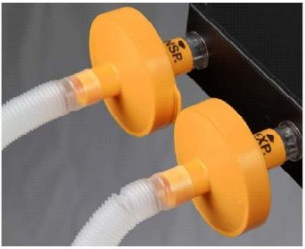
Figure 1: Correctly applied Vapor-Clean® filters⁴

Additional considerations for using Vapor-Clean® filters:
- Vapor-clean is latex free⁶
- Changing of internal valves is not required with Vapo-clean® filters⁶
- Vapor-clean activated charcoal filters must be changed after 12 hours of continuous use⁶
- Filters are a single use product
- Product is compatible with a nitrous oxide (N2O) anaesthetic
- In the event of a Malignant Hyperthermia crisis Vapo-clean® filters must be changed hourly to prevent saturation of the charcoal filters⁶
- Product is compatible with all anaesthetic machines.
Back to Table of Contents

Section 7 – Management of Adult or Paediatric Patients in Malignant Hyperthermia Crisis

A Malignant Hyperthermia crisis is extremely rare, and many clinicians will not experience one in their practising career. In responding to a developing Malignant Hyperthermia crisis there are many high priority tasks that must be attended to simultaneously.

Malignant Hyperthermia reactions are potentially fatal if prompt appropriate treatment is not instituted. In the event of a Malignant Hyperthermia crisis, the most senior Anaesthetist or Intensivist present should declare an anaesthetic emergency, send for help and coordinate crisis management^{5,7} (see Attachments 4 & 5.1-5.7). The red Malignant Hyperthermia trolley should be collected from operating theatres in the anaesthetic storage area beneath the Albumex cupboard, and senior staff should be mobilised to help with the developing crisis. The senior Anaesthetist should also consider informing the Intensive Care Unit of the patient’s status.

The Anaesthetist should distribute the Malignant Hyperthermia task cards (see Attachment 5.1-5.7) stored in the Malignant Hyperthermia trolley to the most appropriate staff members^{5,7}. Malignant Hyperthermia task cards are a simple and reliable way to delegate multiple high priority tasks to available theatre staff. Note that more staff may be required to complete more than one task card. Typical distribution of task cards in the perioperative environment may include:
- Malignant Hyperthermia Crisis Initial Management- The most senior Anaesthetist
- Logistics - The patient flow manager between 07:00 and 21:00 or the theatre team leader after hours
- Anaesthetist 1 - The most senior Anaesthetist
- Anaesthetist 2 - A consultant Anaesthetist or Anaesthetic Registrar
- Anaesthetic Nurse - An experienced Anaesthetic Nurse
- Surgical team - All members of the surgical team, including Surgeons, Instrument and Circulating nurses
- Cooling - A Theatre Wardsperson or any other available theatre staff
- Dantrolene reconstitution - Anaesthetic Registrars, additional Instrument, Circulating, Anaesthetic and Recovery (PACU) nurses

Equipment considerations
For patients who develop suspected Malignant Hyperthermia intraoperatively, Vapor-Clean® activated charcoal filters should be installed on the inspiratory and expiratory limbs of the breathing circuit, and the patient hyperventilated with 100% oxygen at flows of 10L/min to flush volatile anaesthetics and lower end tidal carbon dioxide concentration (ETCO₂). The Vapor-Clean® filter may become saturated after one hour, therefore, a replacement set of filters should be substituted after the first hour of use⁶.
Dantrolene stock levels
During a Malignant Hyperthermia, crisis mobilisation of off-site dantrolene stocks may be required. Additional dantrolene may be acquired, as per the below section, from:
- Calvary John James Hospital: 2 boxes of 6 vials (12 total).
- National Capital Private Hospital: 4 Boxes of 6 vials (24 total).
- Calvary Bruce Public: 6 boxes of 6 vials (36 total).
- The Canberra Hospital:
- 6 boxes of 6 vials (36 total) in Theatre Malignant Hyperthermia trolley.
- 2 boxes of 6 vials (12 total) in Pharmacy

Dantrolene acquisition
Literature confirms⁵ that the administration of Dantrolene is of the highest importance during a Malignant Hyperthermia crisis. The dose required by individual patients will vary depending on patient’s weight and may exceed the stock level kept on site. In the event of a Malignant Hyperthermia crisis, further stock may be procured by the pharmacy department or the on-call Pharmacist from:
- The Canberra Hospital Pharmacy Department during business hours (02) 5124 5303
- The Canberra Hospital After Hours CNC on extension 42410 or pager 50479
- Calvary Bruce Hospital (02) 6201 6111
- National Capital Private Hospital: Team Leader/Floor Manager (02) 62226757
Theatre Manager (02) 62226638
- Calvary John James Hospital (02) 6281 8100

To facilitate the urgent transfer of additional stocks, the Pharmacy Department or on-call Pharmacist may consider the use of ambulance or police escort. Upon receipt of additional dantrolene, the Pharmacist involved is required to document the transfer of the offsite dantrolene stocks by recording the volume of stock transferred, the batch and expiry dates. As up to 25% of Malignant Hyperthermia patients relapse within the first 24 hours⁵ the perioperative Malignant Hyperthermia trolley and additional stock must accompany the patient for the first 24 hours following a Malignant Hyperthermia crisis. Transferred stock may be returned 24 hours after the last Malignant Hyperthermia episode, at the discretion of the senior Anaesthetist or Intensivist, through the pharmacy department.

Out of hours considerations
The initial management of a Malignant Hyperthermia crisis requires a large number of staff and may require additional staff during out-of-hours times.

If a Malignant Hyperthermia crisis occurs during anaesthesia or in the immediate recovery period, the logistics coordinator can be the Operating Room Coordinator. The logistics coordinator should consider calling in additional senior nursing and medical staff^{5,7}. This could include calling in a senior surgeon if required to complete surgery more quickly, calling in the cardiac Anaesthetist on call, and calling in additional perioperative nursing staff⁵. The logistics coordinator may also consider utilising recovery room staff in theatre or vice versa. Furthermore, the logistics coordinator may consider utilising external staff through activating a code blue/ medical emergency code.

Out of areas considerations
In the event of a Malignant Hyperthermia crisis occurring in a remote or non-acute area of the hospital, early notification to the Operating Room coordinator and Intensive Care Unit coordinator is vital to ensure an appropriate level of monitoring and care for the patient. Generally, if the patient is outside the operating theatre unit and/or Post Anaesthetic Care Unit, the Intensive Care Unit Coordinator can be assigned the role of logistics co-ordinator.

The first priority is immediate transfer of the patient to a critical care environment (ICU or operating theatres) and administration of dantrolene. The crisis should be attended by the logistics coordinator and specialist support staff should be deployed ASAP. The logistics coordinator must also ensure immediate dispatch of total intravenous anaesthesia (TIVA) equipment and anaesthetic drugs (propofol).

Intensive care management
In the event of a Malignant Hyperthermia crisis developing in the Intensive Care Unit once the patient is administered Suxamethonium, contact the Operating Theatre Patient Flow Manager between the hours of 0700-2100 (0402893457) or the Theatre Team Leader between the hours of 2100-0700 (X42765) to organise the Malignant Hyperthermia trolley being moved to Intensive Care Unit.

ALERT:
The Canberra Hospital Malignant Hyperthermia trolley is located in the Operating Theatre department, beneath the Albumex cupboard in the sterile stock room. The trolley should stay with the patient for 24 hours due to the risk of a relapse.
the NCH Malignant Hyperthermia trolley is located in either Operating Theatre 3 and 4. The trolley should stay with the patient for 24 hours due to the risk of a relapse.

For Canberra Hospital - the Malignant Hyperthermia trolley contains sufficient Dantrolene stocks (36 vials) for an initial dose for patients up to 285kg in weight as well as sterile water diluent, ice packs and medication for supportive therapy. (For how to mix up and give Dantrolene see Attachment 5.4 and 6).

For NCH - the Malignant Hyperthermia trolley contains sufficient Dantrolene stocks (36 X 20mg vials) for an initial dose for patients up to 72kg in weight for 1 hour or 144kg in weight for 30min, as well as sterile water diluent, ‘snap’ instant ice packs and medication for supportive therapy. (For how to mix up and give Dantrolene see Attachment 5.4 and 6).
Note: Ice can be found in freezer located in Anaesthetic Bay 1.

In the event of a Malignant Hyperthermia crisis in the Intensive care unit, patient care should be coordinated by the most senior medical specialist, and the Intensive Care Consultant should be notified immediately. The intensive care team leader should assume the role of the logistics coordinator and should distribute task cards (Attachments 4 and 5.1-5.7) as appropriate. In the event of a Malignant Hyperthermia crisis, the logistics coordinator should consider calling in additional senior nursing and medical staff^{5,7} in consultation with the most senior intensivist.

Post crisis management
After a Malignant Hyperthermia crisis, it is essential that all patients with a known or suspected Malignant Hyperthermia susceptibility receive appropriate notification, counselling and testing^{5, 7}. As Malignant Hyperthermia is inherited in an autosomal dominant fashion, diagnostic testing should be extended to the patient’s family. This should include a referral for DNA and invitro contracture testing through:

- New South Wales: Department of Anaesthesia, Westmead Children’s Hospital (02) 98450000

- Victoria: Department of Anaesthesia, Royal Melbourne Hospital (03) 93427000

- Western Australia: Department of Anaesthesia, Royal Perth Hospital (08) 92441038

Back to Table of Contents

Evaluation
Outcome
Patients identified as susceptible or with a history of malignant hyperthermia are managed as per this procedure.

Measure
- Review of all clinical incident reports related to malignant hyperthermia
Back to Table of Contents

Related Policies, Procedures, Guidelines and Legislation
Policies
- Medication Handling
- Informed Consent (Clinical)

Procedures
- Vital Signs and Early Warning Scores
- Infection Prevention and Control
- Peripheral Intravenous Cannula, Adults and Children (not Neonates)
- Central Venous Access Device (CVAD) Management – Children, Adolescents and Adults (NOT Neonates)
- Patient Identification and Procedure Matching
- Code Blue (Medical Emergency) – ACT Health Emergency Management Plans

Standards
- Australian College of Perioperative Nurses Standards for Perioperative Nursing in Australia
- Australian and New Zealand College of Anaesthetists Professional Standards
Legislation
- Health Practitioner Regulation National Law (ACT) Act 2010
- Health Records (Privacy and Access) Act 1997
- Human Rights Act 2004
- Privacy Act 1988
- Medical Treatment (Health Directions) Act 2006
- Medicines, Poisons and Therapeutic Goods Regulation 2008.

Other
- Australian Charter of Healthcare Rights

Back to Table of Contents

References

- ACORN. Standards for Perioperative Nursing in Australia [14th edition] Adelaide: Australian College of Operating Room Nurses Ltd; 2016
- ANZCA [Internet]. Melbourne: Australian and New Zealand College of Anaesthetists; 2021. PS 55 (A) Position statement on minimum facilities for safe administration of anaesthesia in operating suites and other anaesthetising locations. Available from: https://www.anzca.edu.au/getattachment/7ee1b267-8c29-414e-86c2-6d0e50933d43/PS55(A)-Position-statement-on-minimum-facilities-for-safe-administration-of-anaesthesia
- ANZCA [Internet]. Melbourne: Australian and New Zealand College of Anaesthetists; 2021. PS 55 (A) BP Position statement on minimum facilities for safe administration of anaesthesia in operating suites and other anaesthetising locations Background Paper. Available from: https://www.anzca.edu.au/getattachment/9ee023d4-e323-4396-acc6-8b5554273f9d/PS55(A)BP-Position-statement-on-minimum-facilities-for-safe-administration-of-anaesthesia-in-operating-suites-and-other-anaesthetising-locations-Background-Paper-(PS55BP)#page=
- ANZCA [Internet]. Melbourne: Australian and New Zealand College of Anaesthetists; September 2014. PS 31 (A) Guidelines on Checking Anaesthesia Delivery Systems revised 2016 January 27 [cited October 2016]; [9 pages]. Available from: http://www.anzca.edu.au/resources/professional-documents/documents/professional-standards/pdf-files/PS31.PDF
- ANZCA [internet]. Melbourne: Australian and New Zealand College of Anaesthetists; March 2014: ANZCA Bulletin; [cited 6 June 2017]; [2 pages]. Available from http://www.anaesthesia.mh.org.au/anzca-bulletin-march/w1/i1023221/
- Dynasthetics. Vapour-Clean: Use Instructions [Internet]. Salt Lake City (UT): Dynasthetics; [Date Unknown]. Available from: http://www.dynasthetics.com/Vapor-Clean/Vapor-Clean-IFU.pdf
- mhanz [Internet] Malignant Hyperthermia Australia & New Zealand; 2018. Malignant Hyperthermia Information for Anaesthetists. Available from: https://malignanthyperthermia.org.au/mh-for-Anaesthetists/
- Giles R, Street N, Pollock N, Waddington N, Perry M, Nelson P, Langton E, Whitta R, Stowell K, Davis M, Bjorksten A, Flanagan B. MH Resource Kit [internet] 2009. Available from http://www.anaesthesia.mh.org.au/mh-resource-kit/w1/i1002692/
- MIMS Online [Internet]. St Leonards (NSW): MIMS Australia Pty Ltd.; 2020. Available from:
https://www.mimsonline.com.au/Search/FullPI.aspx?ModuleName=Product%20Info&searchKeyword=dantrolene&PreviousPage=~/Search/QuickSearch.aspx&SearchType=&ID=5960001_2
- mhanz [internet] Malignant Hyperthermia (MH) Resource Kit 2018. Available from http://malignanthyperthermia.org.au/resource-kit/

Back to Table of Contents

Definition of Terms

Dantrium: The trade name for the drug ‘dantrolene’, which is indicated, along with supportive measures, for the management of the fulminant hypermetabolism of skeletal muscle characteristic of malignant hyperthermia crisis⁶.

Malignant hyperthermia: Malignant Hyperthermia (MH) is a rare pharmacogenetic disorder characterised by muscle rigidity, inappropriately elevated end-tidal carbon dioxide, tachycardia and extreme pyrexia upon exposure to volatile anaesthetic agents or Suxamethonium in susceptible patients⁵.

Vapor-clean® filters: The trade name for activated charcoal filters designed to remove unwanted residual anaesthetic gas particles from the breathing circuit of an anaesthetic machine.
Back to Table of Contents

Search Terms

Malignant Hyperthermia, MH, Vapor-clean®, Dantrolene, Dantrium Sodium, Anaesthetic Machine, Flushing, Hyperpyrexia, crisis

Back to Table of Contents

Attachments

Attachment 1: Malignant Hyperthermia standard machine preparation instructions
Attachment 2: Malignant Hyperthermia Flushing Notice
Attachment 3: Malignant Hyperthermia standard machine preparation using Vapor-clean® Filters instructions
Attachment 4: Australian and New Zealand Malignant Hyperthermia Group Malignant Hyperthermia Crisis Initial Management⁵
Attachment 5.1-5.7: Australian and New Zealand Malignant Hyperthermia Group Malignant Hyperthermia Crisis Task Cards⁵
Attachment 6: Dantrolene Dosage Quick Reference Guide

Disclaimer: This document has been developed by Canberra Health Services specifically for its own use. Use of this document and any reliance on the information contained therein by any third party is at his or her own risk and Canberra Health Services assumes no responsibility whatsoever.

Policy Team ONLY to complete the following:
Date Amended | Section Amended | Divisional Approval | Final Approval
29/08/2022 | Full review | Lisa Gilmore, ED Surgery | CHS Policy Committee

This document supersedes the following:
Document Number | Document Name
CHS19/078 | Malignant Hyperthermia

Attachment 1: Malignant Hyperthermia Alert Notice for standard machine preparation

Suspected Malignant Hyperthermia Patients
GE Healthcare recommendations for preparing
ASYS CS²/CARESTATION 650/AESTIVA

Preparing machine and environment
- Remove all vaporiser cassettes from the workstation and the theatre
- Remove Suxamethonium from the theatre
- Attach a new breathing circuit, patient filter, expiratory filter, CO₂ line, Soda Lime, to the anaesthesia machine.
- Connect the new disposable 2L reservoir bag from the MH trolley on patient Y piece
Flushing ASYS CS²/CARESTATION 650/AESTIVA machine
- Using Oxygen
- ‘VCV’ ventilation mode
- Fresh gas flow 15 litres per minute
- 700ml tidal volume (TV)
- Respiratory rate 12
- PEEP off
- 1:2 ratio of inspiratory to expiratory

- Flush the machine for:
  - ASYS CS² - 30 minutes
  - CARESTATION 650 - 30 minutes
  - AESTIVA – 35 minutes

- Leave Flushing Notice on the Workstation

Attachment 2: Malignant Hyperthermia Flushing Notice
FLUSHING NOTICE
Malignant Hyperthermia
ASYS CS²/CARESTATION 650/AESTIVA

Flushing time start …………………………………
Flushing time end …………………………………..
Machine Set up by …………………………………………………………
Minimum flush time required (with notice)
  - ASYS CS²- 30 minutes
  - CARESTATION 650 - 30 minutes
  - AESTIVA – 35 minutes
Minimum flush time required (Vapor-Clean)
  - ASYS CS²- 90 seconds
  - CARESTATION 650 – 90 seconds
  - AESTIVA – 90 seconds

During Case: Regular flush has been completed
- Before connecting breathing circuit to patient, activate O₂ flush for 10 seconds
- Set total fresh gas flow rate at 10 litres per minute for the duration of the case

During Case: Vapor-Clean charcoal filters being used
- Set total fresh gas flow rate at least 10 litres per minute for the duration of the case

Attachment 3: Malignant Hyperthermia Alert Notice for standard machine preparation using Vapor-clean filters®

Suspected Malignant Hyperthermia Patients
ASYS CS²/CARESTATION 650/AESTIVA
Preparing with Vapor-Clean: Charcoal Filters

Preparing machine and environment
- Remove all vaporisers from the workstation
- Remove Suxamethonium from the theatre
- Use the existing circuit
- Connect the new disposable 2L reservoir bag from the MH trolley on patient Y piece
Flushing machine
- 100% Oxygen
- ‘VCV’ ventilation mode
- Fresh gas flow 15 litres per minute
- 700ml tidal volume
- Respiratory rate 15

- Flush the machine for at least:
  - ASYS CS²- 90 seconds
  - CARESTATION 650 - 90 seconds
  - AESTIVA – 90 seconds

Replace breathing circuit
- Whilst changing circuit, continue the machine flush
- Place Vapo-Clean Charcoal filters on designated inspiratory and expiratory ports as marked
- Replace the breathing circuit, patient filter, CO₂ line, absorber
- Complete ‘Full Test’

- Leave ‘Flushing Notice’ on the Workstation

Attachment 4: Australian and New Zealand Malignant Hyperthermia Group Malignant Hyperthermia Initial Management

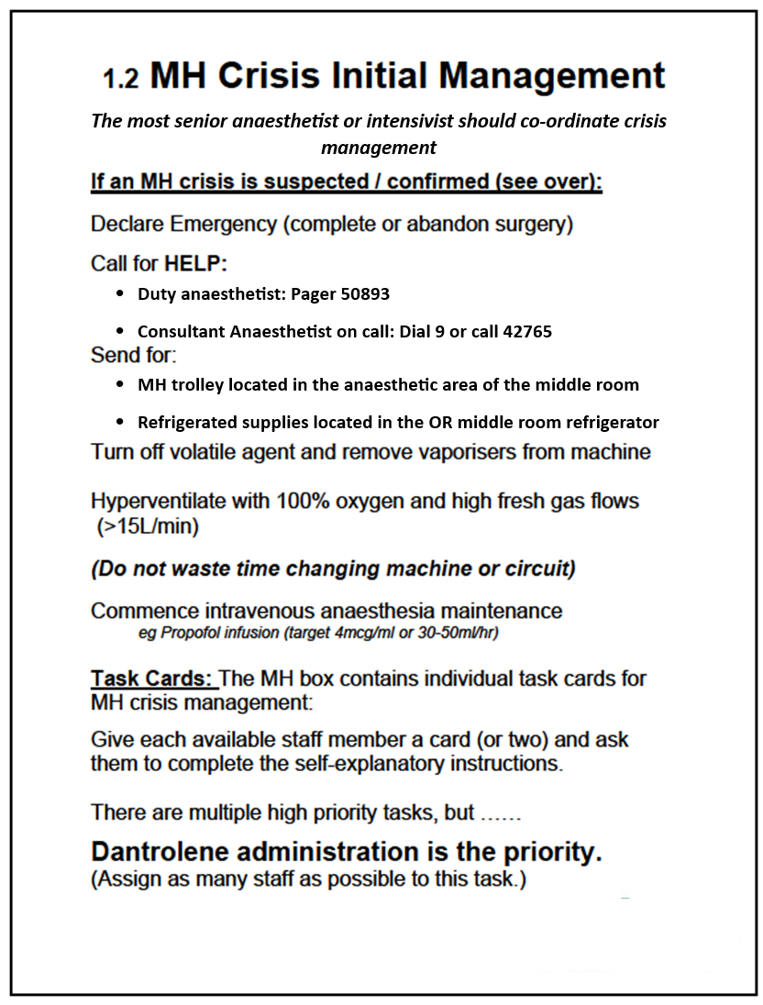

Attachment 5.1: Australian and New Zealand Malignant Hyperthermia Group Malignant Hyperthermia Crisis Task Cards – Resuscitation
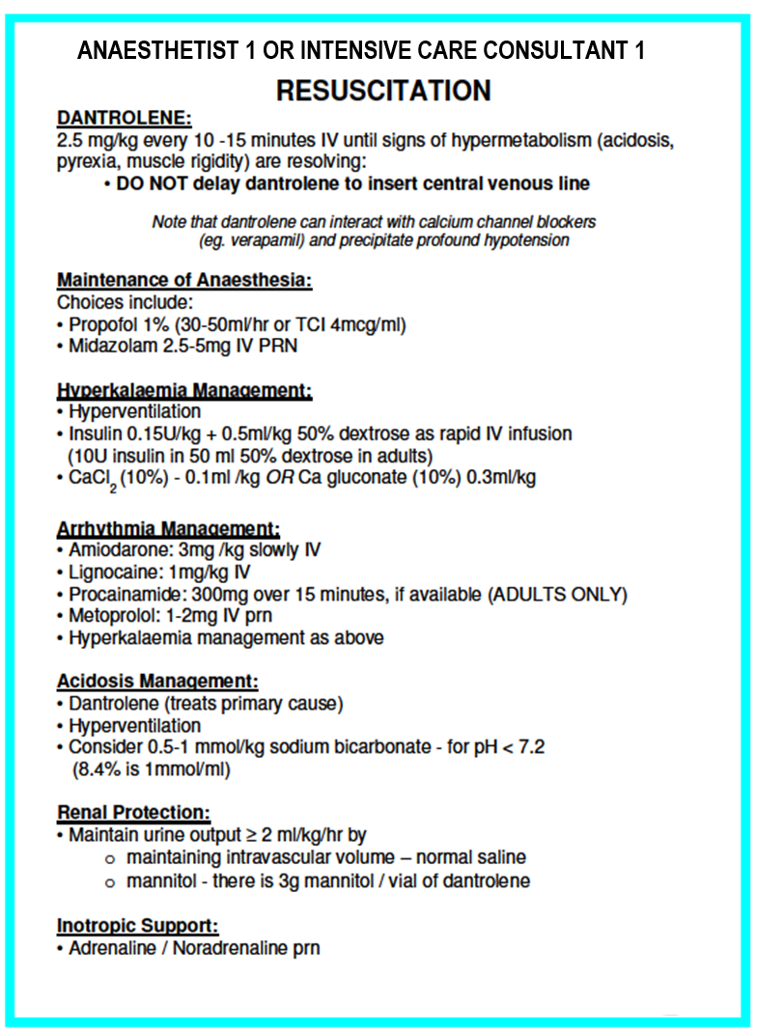

Attachment 5.2: Australian and New Zealand Malignant Hyperthermia Group Malignant Hyperthermia Crisis Task Cards – Lines & Investigations
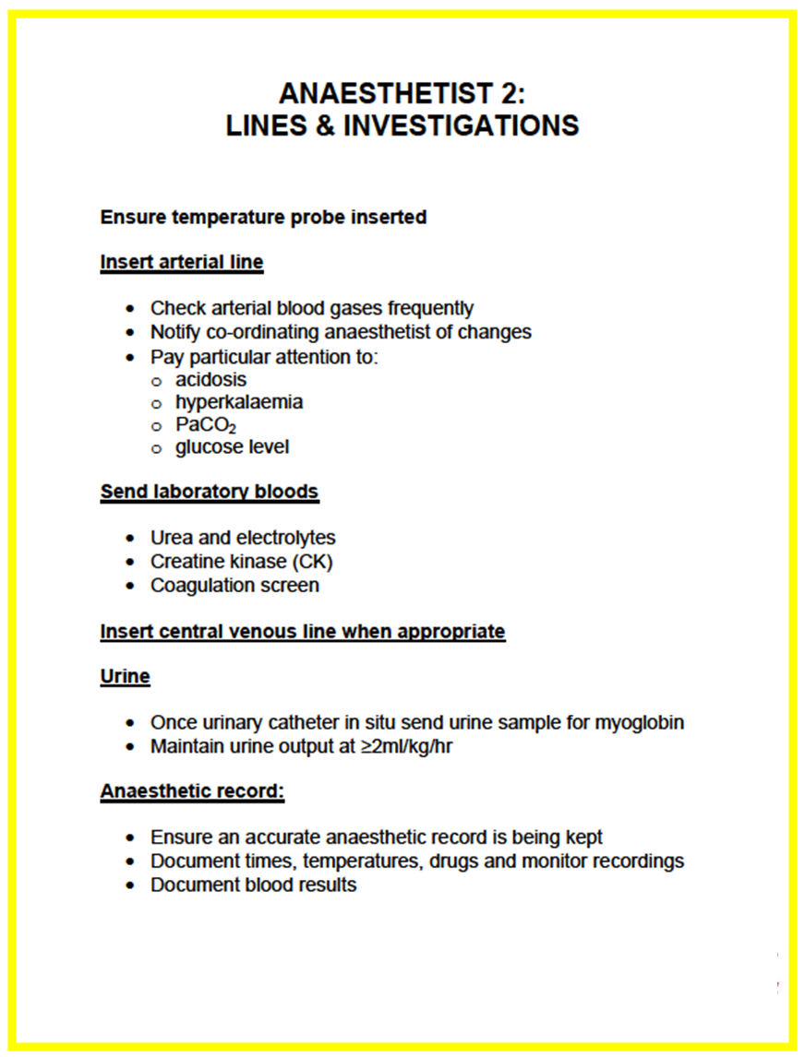

Attachment 5.3 Australian and New Zealand Malignant Hyperthermia Group Malignant Hyperthermia Crisis Task Cards- Nursing

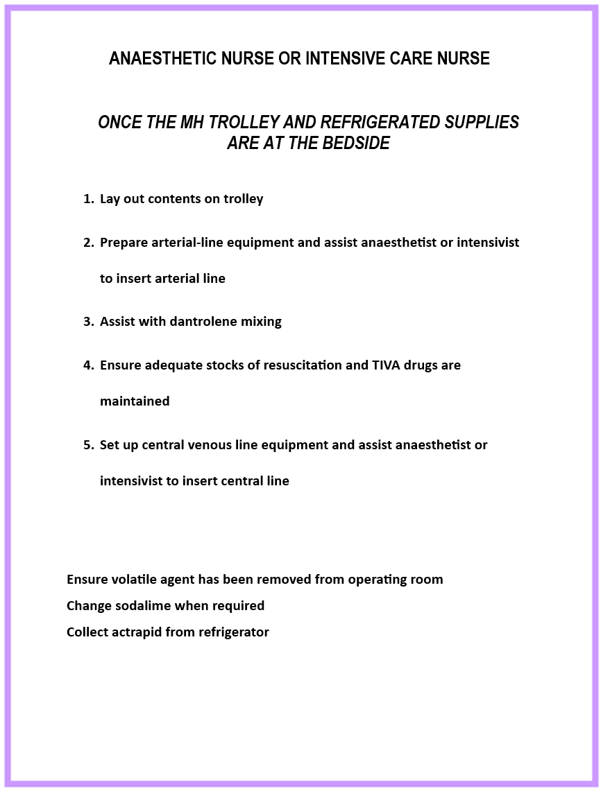

Attachment 5.4: Australian and New Zealand Malignant Hyperthermia Group Malignant Hyperthermia Crisis Task Cards – Dantrolene Reconstitution
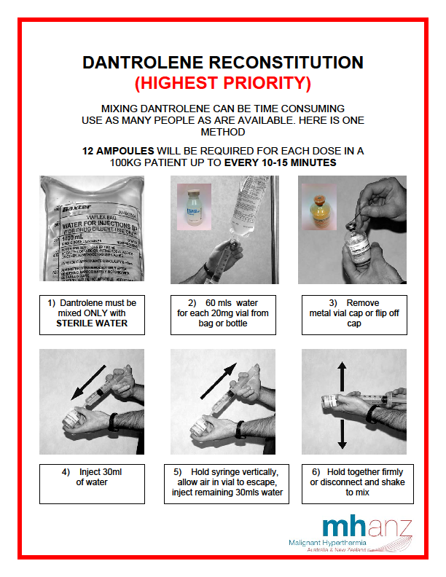

Attachment 5.5: Australian and New Zealand Malignant Hyperthermia Group Malignant Hyperthermia Crisis Task Cards - Cooling

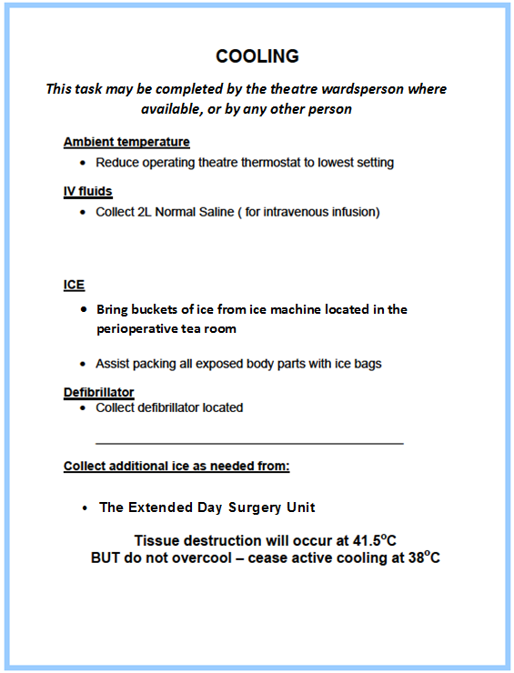

Attachment 5.6: Australian and New Zealand Malignant Hyperthermia Group Malignant Hyperthermia Crisis Task Cards - Logistics

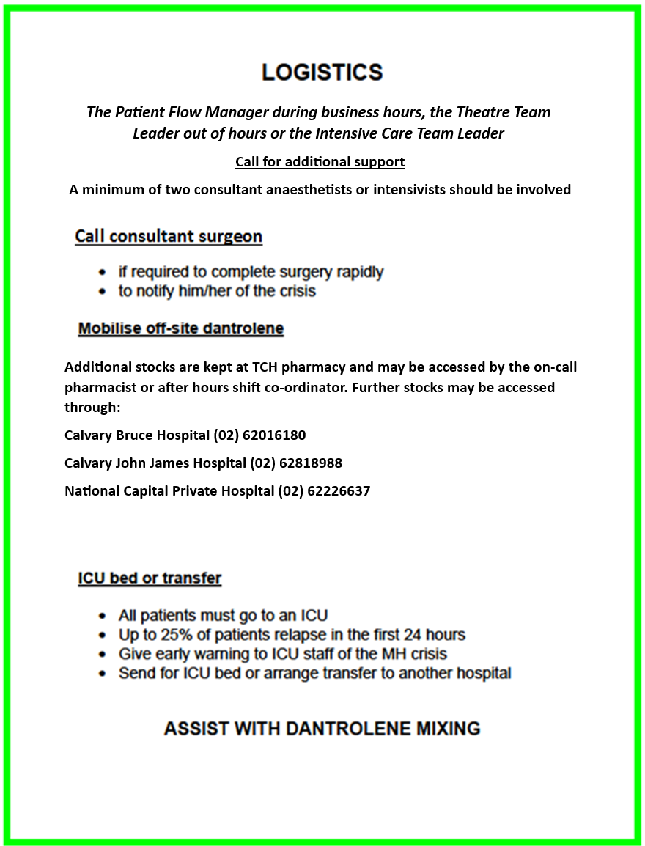

Attachment 5.7: Australian and New Zealand Malignant Hyperthermia Group Malignant Hyperthermia Crisis Task Cards – Surgical Team

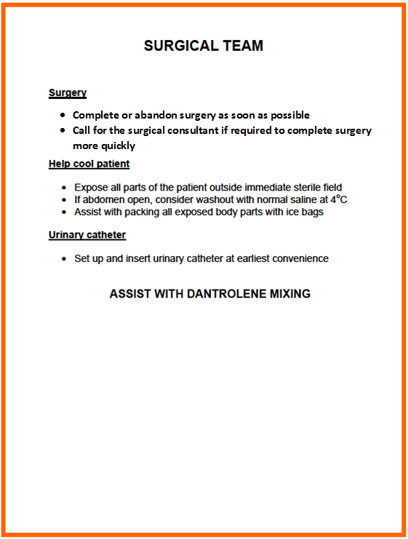

Attachment 6: Dantrolene Dosage Quick Reference Guide

Dantrolene is presented as 20mg lyophilised powder. Mix with 60 mL water for injection. Shake until solution is clear. Continuous rapid intravenous push.
Final concentration ~ 0.33 mg/mL, pH 9.5.

Dantrolene Dosage
Dose 2.5 mg/kg – MHANZ recommendation⁷
Patient weight | 10KG | 20KG | 30KG | 40KG | 50KG | 60KG | 70KG | 80KG | 90KG | 100KG
Dosage in number of 20 mg vials | 2 | 3 | 4 | 5 | 7 | 8 | 9 | 10 | 12 | 13

Note: The following Ryanodex is for Canberra Hospital only, NCH do not stock this product.

Ryanodex® is dantrolene presented as sterile 250 mg lyophilised powder. Mix Ryanodex® with 5 ml of sterile water for injection.
Final concentration 50 mg/ml, pH 10.3.

Ryanodex® Dosage
Dose 2.5 mg/kg – MHANZ recommendation⁷
Patient weight | 10KG | 20KG | 30KG | 40KG | 50KG | 60KG | 70KG | 80KG | 90KG | 100KG
Dosage in number of 20 mg vials | 1 | 1 | 1 | 1 | 1 | 1 | 1 | 1 | 1 | 1

