Canberra Health Services
Procedure
Inpatient Revenue Collection, Admission & Billing Logs

Contents

Contents 1
Purpose 3
Scope 3
Background 3
Roles and Responsibilities 4
Administrative Staff 4
Patient Liaison and Admissions Team, Ward Services Administration and other Administrative Officers in areas involved in private patient election 4
Patient Liaison and Admissions Team 5
Revenue Data, Patient Billing and Debt Recovery Team 5
Staff Specialists 5
Section 1 – Patient Classifications 6
What items and services are billed? 7
Section 2 – Admission Process 7
Demographic Entry/Updates 8
Admitting Staff Responsibilities 8
Deferred patient elections (including post anaesthetic elections) 8
Data Validation Reports 9
Section 3 – Medicare Eligible Patient Criteria 10
Eligibility 10
Medicare Cards 10
Reciprocal Health Care Agreements 11
Period of cover 11
Students 11
Entitlements 11
RHCA entitlement for holders of Retirement Visas class 405 or 410 12
What services are NOT covered under RHCAs? 12
Use of Medicare’s Health Professional Online Search (PKI) 13
Section 4 – Admission Requirements per Classification 13
Public Admissions 13
Private Admissions 14
Reciprocal Health Care Agreement Admissions 15
Veterans Affairs or DVA Admissions 15
Non-Eligible Admissions 16
Defence Force Admissions 17
Correctional Facility Admissions 18
Compensable Admission 18
Asylum Seeker with ACT Access Card Admissions 18
Asylum Seeker in Community Detention Admissions 19
Nursing Home Type Patients 19
Section 5 – What to do when a patient transfers between NOOPEX and non NOOPEX specialists 20
Section 6 – Contacting patients substitute decision maker 20
Section 7 – Processing admission forms remotely 20
Section 8 – When a patient is discharged prior to gaining required information for funding 21
Section 9 – When to contact the Patient Liaison and Admission Team 21
Section 10 – When can the patient make an election 21
Section 11 – Billing Process 22
Accommodation Charges 22
Doctors Billing 22
Inpatient Billing Log / Tick & Flick Billing Forms 22
Section 12 – Debt Recovery Process 22
Evaluation 23
Related Policies, Procedures, Guidelines and Legislation 24
References 25
Definition of Terms 25
Search Terms 26
Attachments 26
Attachment 1 – Inpatient Billing Log (General) 27
Attachment 2 – ICU & HDU Billing Log (Tick and Flick) 28
Attachment 3 – The Canberra Hospital Emergency Billing Form – Compensable/Non Eligible 32

Purpose

To outline admission procedures related to patient billing, provide guidance for how inpatient billing logs and billing tick & flick sheets are managed and to ensure correct and complete data collection to ensure correct billing processes for all billable inpatients of CHS.

Back to Table of Contents

Scope

This document applies to all:
- Admitting staff including (but not limited to):
- Patient Liaison and Admission Team (PLAT)
- Emergency Department Administrative Staff,
- Ward Clerks,
- Revenue Data Patient Billing and Debt Recovery Office,
- Outpatient/Ambulatory Administrative Staff and
- Administrative staff responsible for admissions in the Adult Mental Health Unit.
- University of Canberra Public Hospital (UCPH) Administrative staff
- Women, Youth and Children Division Administrative Staff
- Staff Specialist Medical Staff
- Completion of the billing logs and/or billing tick & flick sheets is the responsibility of Staff Specialists employed by CHS.
- Administrative, Nursing, Medical (non staff specialist) and Allied Health Staff.

Back to Table of Contents

Background

Billing in a public health institution is governed by the following:
- The National Health Care Agreement 2012 (NHCA) http://www.federalfinancialrelations.gov.au/content/npa/health/_archive/healthcare_national-agreement.pdf
- The National Health Reform Agreement (NHRA) http://www.federalfinancialrelations.gov.au/content/npa/health/_archive/national-agreement.pdf
- The Medicare Benefits Schedule (MBS) http://www.mbsonline.gov.au/internet/mbsonline/publishing.nsf/Content/Home
- The Health Insurance Act 1973 (HIA) https://www.legislation.gov.au/Series/C2004A00101
- Health (fees) Determination http://www.legislation.act.gov.au/di/2014-320/default.asp

The Health Insurance Act 1973 and the National Health Reform Agreement outline the admission requirements that must be met for all eligible patients admitted to public hospitals in Australia.

This procedure has been created to ensure that all staff involved in the admission and billing processes are aware of the requirements and follow consistent practices.

Back to Table of Contents

Roles and Responsibilities

Administrative Staff
It is the responsibility of the administrative staff member admitting the patient to capture all relevant patient information required by the hospital and by law to enable revenue collection, this includes (but is not limited to):
- The Patient Liaison and Admission Team
- Emergency Department Administrative Staff
- Ward Clerks
- Outpatient/Ambulatory Administrative Staff
- Administrative staff responsible for admissions in the Adult Mental Health Unit (AMHU)
- UCPH Administrative staff
- Women, Youth and Children Division Administrative Staff

It is the responsibility of the administrative admitting staff to:
- Ensure patients are aware of all election options for admission
- Provide the patient with relevant information related to election to ensure informed consent is obtained and therefore a valid election is made
- Obtain all information relevant to the election and ensure information is entered into ACTPAS and/or EDIS. This includes (but is not limited to)
- Medicare number,
- Private health insurance details,
- Department of Veterans Affairs reference number,
- Compensable details, and/or
- National Disability Insurance Scheme Identification Number
- Action inpatient data validation reports as appropriate (edit reports)

*The complete list of required information per financial classification can be found in Section 4 – Admission Requirements per Classification.

Patient Liaison and Admissions Team, Ward Services Administration and other Administrative Officers in areas involved in private patient election
- In conjunction with area managers provide training for administration staff involved in the admission process. Training will include admission paperwork and “No out of Pocket expenses” (NOOPEX) admission information.
- Maintain, update and monitor frequent admissions process for dialysis and the independent living unit patients

Patient Liaison and Admissions Team
- Report on private patient uptake

Revenue Data, Patient Billing and Debt Recovery Team
- Report errors and issues to relevant admissions to Patient Liaison and Admissions Team and/or other Administrative Offices in areas involved in patient elections for follow-up.

Staff Specialists
Staff specialists are responsible for completion of the billing log or billing tick & flick sheets with a minimum of:
- Date and time of service,
- Item number (or service description including tests or procedures performed), and
- Legible name and signature EACH time the patient is reviewed.

This should be completed as soon as practical after the service provision.
If the service is provided remotely e.g. a procedure performed by an Allied Health Professional and later reported by the Specialist (e.g. EEG) the Specialist should document this service on the green sheet or tick & flick sheet as soon as practical after the report is provided.

Dependent on the clinical area different billing logs or billing tick & flick sheets apply as listed below:
- General Ward Inpatient (TCH and UCH) – Inpatient Billing Log, see Attachment 1
- Intensive Care Unit – Canberra Hospital ICU & HDU Private Practice Billing Form, see attachment 2
- Emergency Department – Canberra Hospital Emergency Department Billing Form – Compensable/Non-Eligible, see attachment 3

The staff specialist is to notify the ward clerk if billing log or billing tick and flick sheet is full or missing from the patients file.

Substitute Decision Maker
Where it has been identified that an adult does not have the decision-making capacity to provide consent to treatment or procedures themselves, the following substitute decision makers can provide consent in specific situations:
- an Attorney under an Enduring Power of Attorney
- a Guardian, when appointed
- a Health Attorney
- the Public Advocate of the ACT when appointed guardian, and the
- the Chief Psychiatrist or Community Care Coordinator (where there are issues relating to mental health or mental dysfunction and the consumer is under a Mental Health Order).
For additional information in relation to list, staff should refer the the Consent and Treatment procedure. https://actgovernment.sharepoint.com/:w:/r/sites/intranet-health/PPR/_layouts/15/Doc.aspx?sourcedoc=%7B4b7d6323-0c56-46bf-abc2-35a6180c4ce3%7D
Back to Table of Contents

Section 1 – Patient Classifications

The below table lists the different patient election classifications, a brief description and billing status.
Description | Use for: | Billable
Asylum Seeker –  ACT Access Card | Asylum Seeker living in the ACT Community with a Protection Visa Acknowledgement (PVA) letter from the Department of Immigration and Border Protection | NO
Asylum Seekers –  SRSS Recipients | Status Resolution Support Service (SRSS) Recipients | YES
Asylum Seekers –  Community Detention | Asylum Seekers in Community Detention | YES
Correctional Facility | Patients currently incarcerated/held in a correctional facility | NO
Defence | Active Defence Force Member | YES
Department of Veterans Affairs | Eligible veteran (previous defence force member) or  their eligible family members | YES
Lifetime Care & Support Scheme | Patients who have been accepted as participants in the Lifetime Care and Support Scheme | YES
Nursing Home Type Patient | Patients requiring nursing care and accommodation after the 35th day of stay in hospital provided they no longer need hospital level treatment. | LIMITED
National Disability Insurance Scheme | Patients with active NDIS plans are chargeable for some services that are deemed reasonable and necessary. These would only be in a non-acute setting. | LIMITED
Non-Eligible Patient | Patients who are not eligible for Medicare and not covered by a Reciprocal Health Care Agreement | YES
Private Patients | Eligible patients who elect to be treated as a private patients | YES
Public Patient | Eligible patients who elect to be treated as a public patient | NO
Public Liability | Patients who is or may be entitled to recover, by way of public liability insurance, the cost of the service provided | YES
Reciprocal Health Care Agreement | An eligible patient from a country with a reciprocal healthcare agreement. | LIMITED
Third Party | Patient who is or may be entitled to recover, by way of third party insurance, the cost of the service provided | YES
Workers Comp | Patient who is or may be entitled to recover, by way of public liability insurance, the cost of the service provided | YES

What items and services are billed?
Where the patient is admitted as a billable patient (refer to table above) the primary charges are:
- Accommodation Charges
- Doctors billing e.g. consultations, procedures, surgery etc
- Pathology
- Medical Imaging
- Prosthesis and surgical supplies.

For a complete list of chargeable items and services refer to the Health (fees) Determination.

Back to Table of Contents

Section 2 – Admission Process

Note:
All eligible persons have the choice to be treated as either a public or private patient regardless of their Private Health Insurance status.

Elections must be obtained in writing using an Inpatient Election Form.

An election must be made before, at the time of, or as soon as possible after admission.

If a patient is unable to sign admission paperwork or does not have the information required to complete the admission paperwork the sustitute decision maker is to be contacted by the admitting clerk (emergency administrative staff/ward clerk/other admission staff) to complete and/or sign the admission paperwork on behalf of the patient. If the substitute decision maker completes the form remotely e.g. by fax, this should be noted in the ‘Declaration by Hospital Employee as Witness’ section.

If a patient is discharged prior to gaining the required information for funding, the ward clerk from the discharging ward may call to the patient at home .

Any verbal advice provided to patients or their substitute decision maker that refers to the admitted patient election process must be consistent with the information provided in the admitted patient election form.

Translation/interpreting services should be arranged for non-english speaking patients or their substitute decision maker to ensure they are not disadvantaged in the election process.
If an interpreter required, please call the Translating and Interpreting Service (TIS) on 13 14 50

Where a patient elects to be treated as a public patient:
- All components of the public hospital service (such as pathology and diagnostic imaging) will be regarded as a part of the patient’s treatment and will be provided free of charge and;
- Where care is directly related to the episode of admitted patient care, it will be provided free of charge as a public hospital service regardless of whether it is provided at the hospital or in private rooms.

An eligible patient presenting at a public hospital emergency department will be treated as a public patient, before any clinical decision to admit. On admission, the patient will be given the choice to elect to be a public or private patient. The election will be made before, at the time of, or as soon as possible after admission.

Demographic Entry/Updates
At each admission, all patient demographic information must be entered/updated in ACTPAS and/or EDIS.

Admitting Staff Responsibilities
The admitting staff will inform the patient or substitute decision maker of their admission options and complete the required forms as listed in Section 4 per category.

The admitting staff member must ensure they explain:
- Each form completed by the patient or substitute decision maker,
- Any and all charges that will be raised, this includes nursing home type patient charges; and
- That care is provided by a team under a supervision of a/their specialist.

If the patient or substitute decision maker raises any questions or concerns regarding election that you cannot answer you should contact the Private Patient Liaison Team (02) 5124 3336 or their area manager.

Copies of the following forms must be forwarded to the patient accounts team for archiving;
- Admission Form Front Sheet
- Inpatient Election Form
- Simplified Billing Form
- National Private Patient Hospital Claim Form
- Two Way Claim Form/Medicare Claim Forms where applicable (NIB patients only).

Original copies of the Inpatient Election Form, are to be sent to Health Information Services. All other copies of the other documents are to be sent to the patient accounts team in hard copy for archiving.

Deferred patient elections (including post anaesthetic elections)
All patients should complete an election form prior to, at or as soon as possible after admission. Exceptions may arise in the following circumstances:
- emergency admissions after hours where staff are not available to organise the completion of the election form until the following working day
- where the patient is experiencing some or all the following:
- Culturally and linguistically diverse peoples and those with special needs
- lacks decision making capacity for an election decision and the substitute decision maker is not present or available (after reasonable attempts to contact them) to make the decision on the patient’s behalf
- post anaesthetics
- unconsciousness
- severe pain
- shock
- dementia; or
- cognitive disability

In such cases an election may be deferred until the patient is able, or the substitute decision maker can complete the election process.

In circumstances where a patient cannot speak English, hospital staff may facilitate interpreter assistance.

If there is reason to believe that the patient may not be able to make a valid election, staff should be guided by the patient’s treating Medical Team regarding assessment of the patient’s capacity to make a valid election, their medical team should ensure the patient:
- understands and retains the information,
- believes the information (i.e. is not divorced from reality or is unable to comprehend what is being said),
- understands that a choice can be made; and
- can reason, make a choice, and convey their decision.

The assessment by the health practitioner must be documented in the clinical notes.

If an admitted patient or their Substitute Decision Maker does not make an election, these patients will be treated as public patients and the hospital will choose the doctor until such time as an election is made.

When a valid election is made that election is to be considered for the whole episode of care, commencing from admission unless the patient or their substitute decision maker can make a revised election by completing a new election form. Where a new valid election is made it will take effect from the date on which it is made, not for the entire election.

Data Validation Reports
ACTPAS ‘Edit Admit’ validation reports are checked daily. These edit reports provide warnings for a range of issues and errors including (but not limited to):
- Missing demographic information
- Financial status (Admin Category) unverified
- Invalid Financial Classification
- Medicare Number/DVA Reference Missing (Where appropriate)
- Private patient without funding source recorded
- Admin category and ward mismatch

Administrative staff must follow-up and action errors as indicated on the report.
Any errors unable to be actioned should be escalated to the staff members direct manager for resolution.

Unverified Reports will be sent out weekly from the Patient Accounts office identifying any admissions with ‘Unverified’ financial classifications. These should be actioned within 48 hours of receipt.

Back to Table of Contents

Section 3 – Medicare Eligible Patient Criteria

Eligibility
Everyone who lives in Australia are eligible for Medicare if;
- They hold Australian citizenship,
- They have been issued with a permanent visa,
- They have applied for a permanent visa,
- They are an asylum seeker with a Protection Visa Acknowledgement (PVA) letter from the Department of Immigration and Border Protection.

Visitors to Australia from a country that has a Reciprocal Health Care Agreement (RHCA) with Australia are also eligible for medically necessary treatment, further information is provided in Section 4, Reciprocal Health Care Agreement Admissions below.

Medicare Cards
Below are examples of the three different Medicare cards which signify that the client is eligible under Medicare guidelines:
- The Green Medicare card is for people permanently in Australia. Cards may be issued for individuals or families.
- The Blue Medicare card bearing the words "INTERIM CARD" is for people who have applied for permanent residence.
- The Yellow Medicare card is for people from countries with Reciprocal Health Care agreements with Australia, more information on Reciprocal health Care agreements is provided in Section 4.

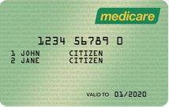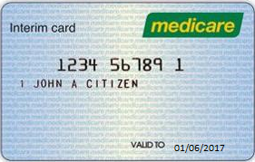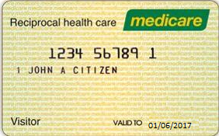
Green Card Blue Card Yellow Card

Reciprocal Health Care Agreements
The Australian Government has signed Reciprocal Health Care Agreements (RHCAs) with United Kingdom, the Republic of Ireland, New Zealand, Sweden, the Netherlands, Finland, Belgium, Norway, Slovenia, Malta, Italy

RHCAs cover treatment that is medically necessary. This means any ill-health or injury which occurs while you are in Australia and requires treatment before you return home.

Period of cover
Residents of New Zealand, the United Kingdom, the Republic of Ireland, Sweden, Finland and Norway are covered for the length of their stay in Australia.

Residents from Belgium, the Netherlands or Slovenia are covered for the length of stay in Australia or until the expiry date on their Reciprocal Health Care card, whichever date is earlier. An example of a reciprocal health care agreement Medicare card can be found above.

Visitors from Malta or Italy are covered for a period of six months from the date of arrival in Australia.

Students
Visitors in Australia on a student visa from the United Kingdom, Sweden, the Netherlands, Belgium, Slovenia, Italy or New Zealand, are covered by the agreements with these countries.

Students from Norway, Finland, Malta and the Republic of Ireland are not covered by the agreements with those countries and must be classified as Non-Eligible patients.

The patient should be asked what Visa type they have, and this should be noted on the election form if provided.

Entitlements
Residents from the United Kingdom, Sweden, the Netherlands, Finland, Belgium, Norway, Slovenia, Malta and Italy are entitled to the following:
- free treatment as a public in-patient or out-patient in a public hospital
- subsidised medicine under the Pharmaceutical Benefits Scheme (PBS)
- Medicare benefits for out-of-hospital treatment provided by a doctor

Residents of the Republic of Ireland and New Zealand are entitled to:
- services as a public patient in a public hospital (including outpatient services) for medically necessary treatment
- medicines available on prescription which are subsidised under the Pharmaceutical Benefits Scheme (PBS).

Note:
A passport or reciprocal health Medicare card can be used to verify eligibility.
If a passport is used to verify eligibility a copy of the passport must be obtained and kept on the patient’s medical record. If the patient refuses to allow a copy of their passport to be kept please note this in the patients record.

Note:
The patient Visa class should be noted on the election form if provided.

If there is any question regarding the eligibility of the patient with reciprocal health care rights in regard to:
- the service being medically necessary prior to returning to their country of residence or
- travel to Australia was for the intention of Medical care

This should be directed to the unit’s clinical director or Clinical Nurse Consultant (CNC)

RHCA entitlement for holders of Retirement Visas class 405 or 410
Ordinarily holders of these visas are not eligible under the RHCA unless exceptional circumstances can be shown. The criteria used when making an assessment regarding exceptional circumstances is
- Proof of residence in country of origin
- Determination of temporary residence in Australia
- Established life style factors
- intention to spend more than six of the next twelve months in Australia
- visits to Australia form a pattern of regular and significant visits over a number of years
- own property in Australia
- lease or rent property in Australia
- have a spouse, parent/s or child/ren residing in Australia
- employed in Australia
- have an Australian bank account
- have a motor vehicle registered in Australia
- have formed any ties to the community in Australia, such as membership of a club or other organised group

What services are NOT covered under RHCAs?
- medicine not subsidised under the PBS
- treatment arranged prior to arrival in Australia
- accommodation and medical treatment as a private patient in a public hospital
- ambulance services
- dental examinations and treatment
- physiotherapy, occupational therapy, speech therapy, eye therapy, chiropractic services, podiatry or psychology
- acupuncture (unless part of a doctor's consultation)
- glasses and contact lenses
- hearing aids and other appliances
- the cost of prostheses
- medical costs for which someone else is responsible (for example a compensation insurer, an employer, a government or government authority)
- medical services which are not clinically necessary
- surgery solely for cosmetic reasons
- examinations for life insurance, superannuation or membership of a friendly society
- eye therapy
- home nursing

Use of Medicare’s Health Professional Online Search (PKI)
All staff are responsible for ensuring patient demographics are up-to-date.

Administrative staff have access to search for and or validate a patients Medicare numbers via the Department of Human Services Health Professional Online Services (HPOS).

By accessing the HPOS service, you are confirming that you have obtained the patient's consent to search for or confirm their Medicare card details. Before searching for the patient, you must obtain consent to do so.

The patient can provide this consent via the General Conditions of Admission form or you may notate the consent on the inpatient election form.

Back to Table of Contents

Section 4 – Admission Requirements per Classification

Public Admissions
Where an eligible patient elects to be treated as a public patient the following forms are required:
- General Conditions of Admission Form
- Admission Form Front Sheet
- Inpatient Election Form A - completed by the patient or substitute decision maker.
You must explain ‘Nursing Home Type Patient’ charges to all public patients AND note the charges for Nursing Home Type care on the election form before the patient or substitute decision maker signs. Also ensure the patient substitute decision maker have indicated if they have been admitted to any hospital in the past 7 days.

Private Admissions
Where an eligible patient elects to be treated as a private patient the following forms are required:
- General Conditions of Admission Form
- Admission Form Front Sheet
Inpatient Election Form A - completed by the patient or substitute decision maker Bed charges are to be explained and documented on the election forms including charges for Nursing home Type Care. You must explain Nursing Home Type Patient charges to all public patients AND note the charges for Nursing Home Type care on the election form before the patient or substitute decision maker signs. Also ensure the patient or substitute decision maker have indicated if they have been admitted to any hospital in the past 7 days.
- A private patient can request a single room as part of their election and this must also be documented on the election form, please circle the patient’s choice on the election form. If the patient answers NO but later changes their mind, a new election form should be completed, ensure the new election form is dated.
- National Private Patient Hospital Claim Form (HC21)
- Medicare Simplified Billing Form
- NIB Patient Only - Medicare Claim Form
- NIB Patient Only - Two Way Claim Form

The inpatient billing log is to be placed in the patients file.

Private Patient Admission Types
Canberra Health Service has three internal private patient classifications
- True Private Patient
These patients either:
- have an existing agreement with their own specialist (can be a VMO) to be admitted as a private patient; or
- have requested to be a private patient on admission and their nominated specialist has agreed to accept the patient as their private patient.
In these circumstances the patient is responsible for payment of any out of pocket costs incurred during the admission.
- No Out of Pocket Expense (NOOPEX) Private Patient:
These patients have been offered the option to use their private health insurance under the Canberra Health Services No Out of Pocket Expense Scheme (NOOPEX).
This offer can only be made when the patient is admitted under the care of a specialist who has agreed to participate in the NOOPEX scheme. These doctors are listed in the procedures and training manual for the admitting clerks and ward clerks. Updated lists can be obtained from the patient accounts office.
- Uninsured Private Patient
A patient may elect to be treated as a private patient but is uninsured. These patients are billed as private patients. In these circumstances the patient is responsible for payment of all costs incurred during the admission.

Reciprocal Health Care Agreement Admissions
Where patient is eligible under a reciprocal health care agreement the following forms are required
- General Conditions of Admission Form to be completed.
- Admission Form Front Sheet
- Inpatient Election Form 2 - completed by the patient or substitute decision maker

Where a passport is used to verify the patient’s eligibility a copy must be taken and kept on the patient’s Medical Record. If the patient refuses to allow a copy of their passport to be kept please note this in the patients record.

If there the patient does not have a passport on admission they should be asked to provide one as soon as practical. Until the passport has been provided the patient will be classified as a non-eligible patient and will be invoiced as such until such time as their passport is provided.

Patient with reciprocal health care rights can elect to be treated as private patients and will be charged for medical treatment and accommodation. These fees can't be claimed from Medicare. If the patient chooses to be admitted as a private patient an Inpatient Election Form A and the National Private Patient Hospital Claim Form (HC21) must also be completed.

Veterans Affairs or DVA Admissions
Department of Veterans Affairs or DVA Repatriation Healthcare Cards are issued to veterans, their widows/widowers and dependants.

There are three DVA cards with different levels of cover:
- Gold Card – DVA accepts financial responsibility for all services
- White Card – The White Card entitles the veteran to treatment for that veteran’s accepted war or service related condition, and for treatment related to the following conditions service related or not:
- Cancer (malignant neoplasia)
- pulmonary tuberculosis
- any mental health condition
- Orange Card – The Orange Card entitles the veteran to pharmaceutical items only

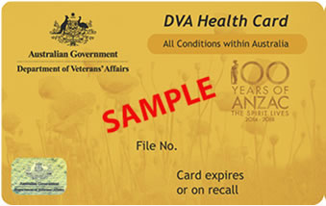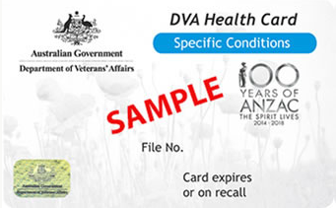

Where an eligible patient elects to be treated as a DVA patient the following forms are required:
- General Conditions of Admission Form
- Admission Form Front Sheet
- Inpatient Election Form 1 - completed by the patient or substitute decision maker.
You must
- You must explain ‘Nursing Home Type Patient’ charges to all public patients AND note the charges for Nursing Home Type care on the election form before the patient or substitute decision maker signs
- record DVA card number and category on election form
- ensure the patient indicates their election choice of private or public in the event their DVA claim is unsuccessful; NOTE if private is chosen as back up, depending on admitting Doctor, patient must be made aware they may be out of pocket.
- Department of Veterans’ Affairs Hospital Admission Voucher - attach to election form

The inpatient billing log is to be placed in the patients file.

If there is any question as to the eligibility of the patient or the condition being treated this should be referred to the veteran’s liaison office.

Non-Eligible Admissions
Non-Eligible (or ineligible) patients are unable to receive free public hospital services and are therefore liable to meet the full costs of their hospital treatment.

These people are temporary entrants to Australia from a country that does not have a reciprocal health care agreement or where the reciprocal health care agreement period of cover has expired or does not cover the person. This includes tourists/visitors, overseas students and people granted temporary resident status.

These patients may have health insurance or travel insurance; in these circumstances CHS will bill the insurance company on behalf of the patient where possible however the debt remains the responsibility of the patient or their guarantor (where identified on the election form). The patient is responsible to pay any gap between the hospital charges and insurance company payments.

When a patient is admitted as non-eligible it is the responsibility of the admitting clerk to obtain all of the following information and update ACTPAS and/or EDIS:
- Home address (overseas)
- Visiting address (address where staying in Australia) or Temporary address
- Phone contact number/s
- Email address
- substitute decision maker and/or if substitute decision maker resides overseas another local contact person
- Copy of passport
- Any insurance details
- Contact name and number of any other person responsible for payment (guarantor).

Where patient is non-eligible the following admission forms are required:
- General Conditions of Admission
- Admission Form Front Sheet
- Inpatient Election Form 2 - completed by the patient or substitute decision maker
Where possible a guarantor should be nominated on the election form.

Patients with current health insurance (e.g. Medibank Private or BUPA) should also complete the National Private Patient Hospital Claim Form (HC21).

The inpatient billing log is to be placed in the patients file.

Patient Accounts is responsible for following up on payments for Non-Eligible patients. This office is aware of any patients that have been admitted as Non-Eligible and requires the above information to be recorded in ACTPAS and/or EDIS. Patient Accounts are not responsible for the signing of any admission paperwork. More information on the debt recovery process can be found in the CHS Debt Recovery Standard Operating Procedure, a copy of this document can be requested by emailing CHHSBilling@act.gov.au.

Medically necessary care will NOT be denied based on the patient’s financial status.
If requested an application for write-off of fees due to financial hardship can be completed by the patient. Information on this process can be found in the CHS Debt Recovery Operating Procedure, a copy of this document can be requested by emailing CHHSBilling@act.gov.au.

Note:
If a child is admitted that has been accepted into the Rotary Oceanic Medical Aid for Children (ROMAC) Program the admitting clerk is to notify the Patient Accounts Office at CHHSBilling@act.gov.au Confirmation should be sought from the Executive Officer Division of Women, Youth and Children.

Defence Force Admissions
Any person who is an active member of an Australian Defence Force is to be admitted with an Administrative Category of Defence. Mandatory additional information required includes Rank and Serial number.

Required forms are
- General Conditions of Admission Form.
- Admission Form front sheet
- Inpatient Election Form 1 - complete the correct section.
Rank and Serial Number must be recorded.

The inpatient billing log is to be placed in the patients file.

Correctional Facility Admissions
Any person who is currently incarcerated is to be treated like a public patient and no charges are raised for services provided, regardless of Medicare eligibility. There is no requirement to obtain an election form for these patients.

The address for the patient must be updated to the name of the Correctional Facility
substitute decision maker is also to be the name of the Correctional Facility.

A new General Practitioner should also be added to the patient demographics in ACTPAS, please use the practitioner referring from the correctional facility.

Compensable Admission
In relation to a health service, compensable means a patient of the health service who has or may have a right to recover from any other person by way of compensation or damages including the cost of the service provided in respect of the injury, illness or disease for which he/she received care and treatment or where the patient is an approved participant in the lifetime care and support scheme.

Note:
The Minister for Health has exercised discretion under sub section 19(3) of the Health Insurance Act 1973 and any person that is employed to play sport are entitled to Medicare benefits for injuries incurred while playing sport. It should not be assumed that a sporting injury would be considered a compensable (workers compensation) unless the patient expressly elects to be admitted under a compensable category.

Required Forms are
- General Conditions of Admission Form
- Admission Form Front Sheet
- Inpatient Election Form 1 – completed by the patient or substitute decision maker
The compensable section must be completed including selection of the compensable type by ticking the relevant box (note – life time care and support scheme participants should tick other). Bed charges must be documented on the form and choice for private or public if the claim is unsuccessful.

You must obtain, if possible, any insurance company details including claim number or Solicitors details. Where insurance details (including claim number) are not supplied invoices cannot be sent to the insurance company. Patient must be advised they may receive invoices in the mail which they can then submit to their insurance company or solicitor.

The inpatient billing log is to be placed in the patients file.

Asylum Seeker with ACT Access Card Admissions
Asylum seekers with a Protection Visa Acknowledgement (PVA) letter from the Department of Immigration and Border Protection are given an ACT Services Access Card.

This card entitles the asylum seeker to free public health care including pathology, diagnostic imaging, pharmaceutical and outpatient services in ACT public hospitals.

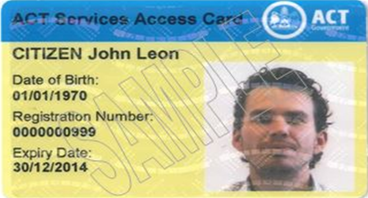

The patient’s access card registration number must be recorded in ACTPAS and/or EDIS in the funding source tab.

Required Forms are
- General Conditions of Admission Form
- Admission Form Front Sheet
- Inpatient Election Form 2 - completed by the patient or substitute decision maker.

You must explain and note the charges for Nursing Home Type care on the election form.
Ensure they have indicated if they have been admitted to any hospital in the past 7 days.
You must note on the election form that the patient is an ACT Access Card holder.

Asylum Seeker in Community Detention Admissions
There is an agreement in place between the Department of Home Affairs and the ACT Government to ensure the appropriate delivery of health services to people in community detention as required.

Canberra Health Service invoices the Department of Home Affairs for services provided to these patients. The patient will NOT be invoiced for the service.

Required Forms are:
- General Conditions of Admission Form
- Admission Form Front Sheet
- Inpatient Election Form 2 - completed by the patient or substitute decision maker

Nursing Home Type Patients
A patient is classified as Nursing Home Type Patient (NHTP) where they have been in hospital for a continuous period of more than 35 days, is not receiving acute care, and is being provided with accommodation and nursing care as an end in itself.

A continuous period of hospitalisation includes any periods during which a patient was, or is, receiving hospital treatment, whether the same hospital, where the periods are separated from each other by not more than 7 days. 35 days of hospitalisation is accrued across hospitals when a patient is transferred or readmitted within 7 days. For example, a patient receives admitted patient care in hospital A for 20 days and is then transferred to hospital B. On the 16th day of the second admission the patient becomes a NHTP if acute care certification (ACC) does not exist.

If a NHTP is out of any hospital (other than for contracted services) for more than seven consecutive days, the 35 day count begins again.

Once the patient reaches the 35 days in the admission an Acute Care Certificate is automatically generated by the patient billing system which are sent to the Medical Officers for completion. If the patients care type is to be changed the ward clerk will be provided with a Care Type Change form and must update the required fields in ACTPAS.

Back to Table of Contents

Section 5 – What to do when a patient transfers between NOOPEX and non NOOPEX specialists

If a patient has signed a private election under a NOOPEX specialist and transfers to the care of a non NOOPEX specialist (via a ward transfer or for any other reason) the patient must re-elect as either a ‘true private’ and will potentially have out-of-pocket costs for the admission or re-elect as public. A patient cannot be reverted to an ‘Unverified’ classification after making their initial election.

Back to Table of Contents

Section 6 – Contacting patients substitute decision maker

If a patient is unable to sign admission paperwork or does not have the information required to complete the admission paperwork their substitute decision maker is to be contacted by the admitting clerk (emergency administrative staff/ward clerk/other admission staff) to complete and/or sign the admission paperwork on behalf of the patient.

Back to Table of Contents

Section 7 – Processing admission forms remotely

If the substitute decision maker completes on election form remotely e.g. by fax or email, this should be noted in the ‘Declaration by Hospital Employee as Witness’ section.

Back to Table of Contents

Section 8 – When a patient is discharged prior to gaining required information for funding

If a patient is discharged prior to gaining the required information for funding the ward clerk, from the discharging ward, should contact the patient at home.

Any verbal advice provided to patients or their substitute decision maker that refers to the admitted patient election process must be consistent with the information provided in the admitted patient election form.

Every effort will be made to obtain a written valid election for every admission, however, if a patient is discharged, transferred or passes away prior to making a valid election:
- Medicare Eligible patients will be updated to public financial classification.
- Non-Eligible patients will be updated to the relevant non-eligible financial classification.

Back to Table of Contents

Section 9 – When to contact the Patient Liaison and Admission Team

The Patient Liaison and Admissions Team (PLAT) should be engaged when a patient is identified as chargeable or potentially chargeable, this includes patients who:
- Hold private health insurance (including active defence members)
- Identifies as compensable
- Identified as Medicare ineligible

PLAT will process admission for all chargeable and potentially chargeable patients.

Back to Table of Contents

Section 10 – When can the patient make an election

Elections must be made before, at the time of, or as soon as possible after admission.

Any decision regarding the patient’s mental capacity, infection status or being too unwell too make an election must be directed to the patients treating team. If the treating team advises the patient is not able to make an election at the time the patients’ ability to elect should be reviewed by the admitting officer with the treating team every 24 hours until such time that the patient is able to elect.

If the patient is discharged, transferred or passes away prior to making a valid election;
- Medicare Eligible patients will be updated to public financial classification.
- Non-Eligible patients will be updated to the relevant non-eligible financial classification

Back to Table of Contents

Section 11 – Billing Process

Accommodation Charges
At various intervals, dependant on the length of the patients stay, invoices are generated on the patient billing system for accommodation charges and these are sent to the appropriate health fund or other debtor for the episode.

Doctors Billing

Inpatient Billing Log / Tick & Flick Billing Forms
The Inpatient Billing Log or tick & flick billing sheets must be placed in the file for all billable and unverified patients on admission by the admitting clerk.

The PLAT team/ward clerk/administrative staff are to ensure each billable patient’s clinical record has:
- at least 2 billing logs/tick & flick sheets in it,
- has current patient labels (current election status), and
- patient health fund, compensable details or other relevant billing information (e.g. Defence ID) is up-to-date and in ACTPAS

The PLAT team/ward clerk/administrative staff are to monitor the clinical record and replace the billing log and ‘tick & flick’ sheet as required. The top section of the form (patient information) must be completed by the PLAT team/ward clerk/administrative staff before placing in the file.

When the billing log/tick & flick sheet is full, or the patient is discharged the PLAT team/ward clerk/administrative staff are to;
- file in EMU for collection or
- send them to the Patient Accounts office in the internal mail.

Back to Table of Contents

Section 12 – Debt Recovery Process

For Information on debt recovery processes please contact the Patient Accounts Office at CHHSBilling@act.gov.au.

Back to Table of Contents

Evaluation

Accurate Data Entry of Admission Details into ACTPAS
Method:
The accuracy of admission data input to ACTPAS will be measured by the level of errors on the inpatient edit reports.

Accountability:
Admitting administrative staff and relevant area managers, Patient Accounts Office

Input and monitoring:
- Patient Accounts Office will report errors to area managers real time
- Edit Admit Reports are automatically generated on a daily basis.
- Edit Admit Reports will be run weekly and collated for end of month reporting by Patient Accounts Office Manager to divisional Operations Managers for action and escalation to the Canberra Health Service Executive Committee where appropriate.

Correct completion of election forms of all patients by admitting staff
Method:
Audits of election forms to be conducted at a minimum of twice per annum by the Patient Accounts Office Revenue Data Audit and Training team and reported to the Chief Finance Officer for action and escalation to the Canberra Health Service Executive Committee where appropriate.

Accountability:
Admitting administrative staff and relevant area managers, Patient Accounts Office.

Input and monitoring:
Patient Accounts Office to report audit findings to Chief Finance Officer for action and escalation to the Canberra Health Service Executive Committee where appropriate.

Correct billing of all billable patients
Method:
Accommodation revenue and activity reports generated monthly.

Accountability:
Patient Accounts Office, Patient Liaison and Admission Team Manager.

Input and monitoring:
Report to Chief Finance Officer for action and escalation to the Canberra Health Service Executive Committee where appropriate.

Consistent levels of staff specialist inpatient item billing (in line with service level variations)
Method:
Reporting on facility fee levels for inpatient services and level (number) of inpatient items billed per month per specialist.

Accountability:
Clinical staff, Patient Accounts Office.

Input and monitoring:
Report to Chief Finance Officer for action and escalation to the Canberra Health Service Executive Committee where appropriate.

Back to Table of Contents

Related Policies, Procedures, Guidelines and Legislation

Policies
- Allocation of single rooms
- Public health services to Medicare ineligible asylum seekers policy
- ACT Health Directorate Essential Education Policy
- Consent and Treatment Policy

Guidelines
- Health Directorate Admitted Patient Activity Data Standards
- ACT Client Registration Data Standards (Currently in DRAFT)
- Commonwealth Medicare Benefits Schedule http://www.mbsonline.gov.au/internet/mbsonline/publishing.nsf/Content/Home
- Mandatory: Privacy and Confidentiality (eLearning on Capabiliti).
- Mandatory: ACTPAS Training referencing the ACTPAS User Guide
- Admission to Discharge – Canberra Hospital and Health Services

Legislation
- Health Insurance Act 1973 – www.comlaw.gov.au/Details/C2012C00184
- ACT Health Act 1993(www.legislation.act.gov.au)
- ACT Consolidated Acts - Health Records (Privacy and Access) Act 1997 – Schedule 1 (www.legislation.act.gov.au)
- The Medicare Benefits Schedule (MBS) http://www.mbsonline.gov.au/internet/mbsonline/publishing.nsf/Content/Home
- The National Health Care Agreement 2012 (NHCA) http://www.federalfinancialrelations.gov.au/content/npa/health/_archive/healthcare_national-agreement.pdf
- The National Health Reform Agreement (NHRA) http://www.federalfinancialrelations.gov.au/content/npa/health/_archive/national-agreement.pdf
- The Health Insurance Act 1973 (HIA) http://www.comlaw.gov.au/Series/C2004A00101
- Health (Fees) Determination https://www.legislation.act.gov.au/di/2019-261
- Health Rights Act 2004 - http://www.legislation.act.gov.au/a/2004-5/current/pdf/2004-5.pdf
- Charter of Health Care Rights - https://www.safetyandquality.gov.au/australian-charter-healthcare-rights
- Mental Health Act 2015 - http://www.legislation.act.gov.au/a/2015-38/current/pdf/2015-38.pdf

Back to Table of Contents

References

- Health Insurance Act 1973
- National Health Care Agreement
- National Health Reform Agreement
- Health (Fees) Determination 2013 (no4)
- Commonwealth Medicare Benefits Schedule

Back to Table of Contents

Definition of Terms

ACTPAS – the ACT Patient Administration System.

Admitting Officer – Staff member employed by the Health Directorate whose duties include the admission of patients to the hospital. This includes;
- Admission Office staff,
- Ward Clerks, and
- Emergency Department Administrative Staff

Eligible Person – An Australian resident or an eligible overseas representative. (As defined in subsection 3(1) (6) (6A) and (7) of the Health Insurance Act 1973.

Public Patient – An eligible person who receives or elects to receive a public hospital service with no costs incurred.

Private Patient – An eligible person who elects to be admitted as a private patient and elects to be responsible for paying fees for hospital services as determined by the Australian Capital Territory (Health (Fees) Determination).

Third Party – Any party other than the Commonwealth (including Department of Veterans Affairs) and the State Department administering the Agreement that enters into an arrangement for the purchase of public hospital services.

Tick & Flick Sheet – List of billable items known as a ‘Tick and Flick’ sheet, the clinician ‘ticks’ services provided and ‘flicks’ the sheet to the billing office for processing.

Back to Table of Contents

Search Terms

Billing, Claims, Financial Information, Financial Systems, Rate Setting, Medicare, Insurance, Revenue, Admission, Inpatient Billing, Billing Log

Back to Table of Contents

Attachments

Attachment 1 – Inpatient Billing Log (General)
Attachment 2 – ICU & HDU Billing Log
Attachment 3 – The Canberra Hospital Emergency Billing Form – Compensable/Non Eligible

Disclaimer: This document has been developed by Canberra Health Services specifically for its own use. Use of this document and any reliance on the information contained therein by any third party is at his or her own risk and Canberra Health Services assumes no responsibility whatsoever.

Policy Team ONLY to complete the following:
Date Amended | Section Amended | Divisional Approval | Final Approval
17/06/2020 | New Document | Andrew Gay, CFO | CHS Policy Committee

This document supersedes the following:
Document Number | Document Name

Attachment 1 – Inpatient Billing Log (General)

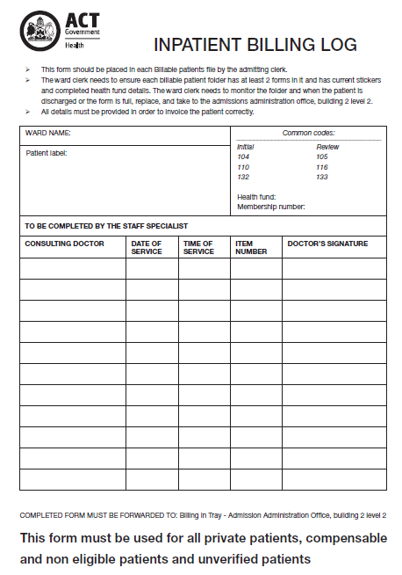

Attachment 2 – ICU & HDU Billing Log (Tick and Flick)

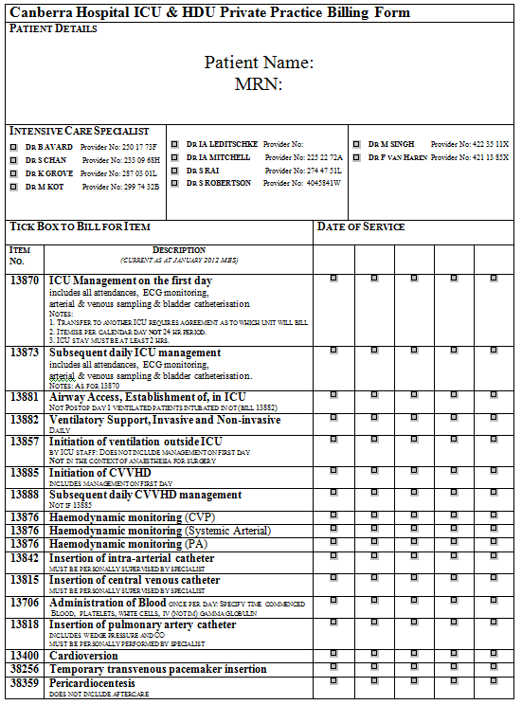

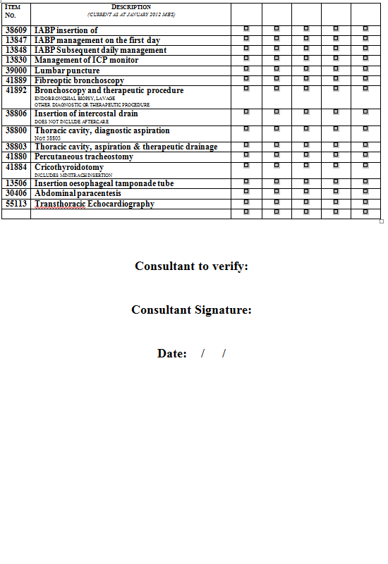
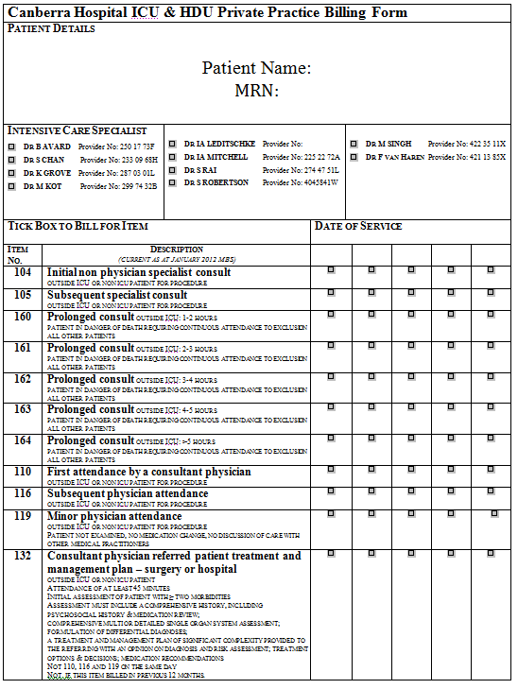
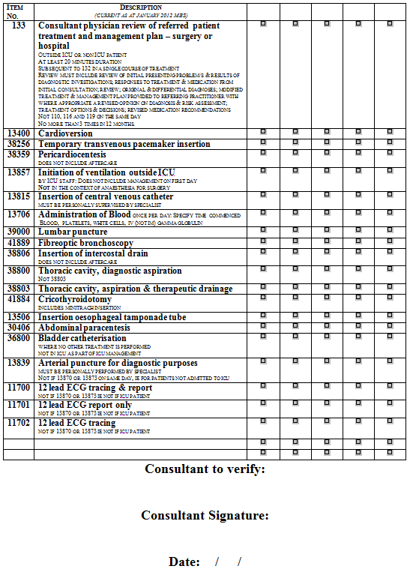

Attachment 3 – The Canberra Hospital Emergency Billing Form – Compensable/Non Eligible

