Canberra Health Services
Procedure
Incident Management - Clinical

Contents

Contents 1
Purpose 2
Scope 2
Section 1 – The Incident Management Process 2
Section 2 – Identification and Immediate Response 3
Section 3 – Notification 4
Verbal notification 4
Section 4 – Prioritisation 5
Section 5 – Classification (Incident Type) 6
Section 6 – Open Disclosure and Consumer involvement 6
Section 7 – Investigation and Review 7
Section 8 – Quality Assurance Committees (QACs) 13
Section 9 – Recommendations and Actions 13
Section 10 – Feedback and Learning 14
Section 11 – Incident data and reporting 15
Section 12 – Interjurisdictional incident management 15
Evaluation 15
Related Policies, Procedures, Guidelines and Legislation 16
References 17
Definition of Terms 17
Search Terms 18
Attachments 18
Attachment A – Manager Responsibility and staff following an incident 20
Attachment B – Incident Management Process Summary 21
Attachment C – Clinical Incident Management Harm Score Table 22
Attachment D – Incident Management Summary Table 24

Purpose

The purpose of this procedure is to inform staff of the process for managing a clinical incident.

All CHS staff apply a consistent process to clinical incident management (including timely identifying, reporting, and managing all clinical incidents) to support patient safety and to reduce the risk of patient harm.

The incident management procedure provides a guide that all staff members must follow when an incident occurs. All staff are expected to participate in the incident management process and undertake training relevant to their position. This procedure recognises open disclosure as an integral part of the incident management process.

All incidents, including near misses, are to be recorded in the RiskMan Clinical Incident Notification System and managed in accordance with the CHS Clinical Incident Management Policy.

Back to Table of Contents

Scope

This procedure applies to all CHS staff and students.

For the purposes of this procedure:
an ‘incident’ only relates to ‘Clinical Incidents’
consumer means ‘patient, client, consumer, person’.

A clinical incident is an event or circumstance that did result in unintended harm or could have resulted in unintended harm (near miss) to a patient/client/consumer resulting from, or contributed to, by health care provided by Canberra Health Services and outside the natural disease process. The resultant harm differed from the expected outcome of patient/client/consumer management.

Excluded are:
Information related incidents
Staff incidents - refer to CHS Work Health Safety Management System (WHSMS) Section 11 – Incident/Hazard Reporting and Investigation
Notifications via RiskMan to Child and Youth Protection Services.

Back to Table of Contents

Section 1 – The Incident Management Process

The principles of transparency, accountability, obligation to act, consumer focused, open ‘just’ culture and prioritisation are to be applied throughout the incident management process to ensure the safety and quality of care to consumers.

An incident may have a significant impact on staff. Staff must be provided with support following an incident.

Attachment A - Fact Sheet ‘Manager Responsibilities’ Refer to CHS Guideline – Psychological Support for Staff – A Manager’s Guide

The incident management process incorporates:
- incident identification and immediate response
- notification
- prioritisation and escalation
- classification (incident type)
- open disclosure and consumer involvement
- investigation and review
- recommended actions
- documentation
- feedback and learning
- improvement.

Attachment B – Clinical Incident Management Process

Back to Table of Contents

Section 2 – Identification and Immediate Response

All staff have responsibility for identifying clinical incidents (including near miss incidents) and to respond appropriately to ensure safety of consumers.

Alert:
All incidents including near misses are to be reported in the RiskMan Clinical Incident Notification System.

Staff providing care to patients/clients/consumers must be aware of what defines a clinical incident and know the required response including their reporting responsibilities. Refer to CHS Incident Management Policy, Roles and Responsibilities.

Any staff member, student, patient, consumer or family/carer, contractor or volunteer can identify that an incident has occurred either at the time of the incident or when an unexpected outcome is identified.

Incidents are also identified through team discussions, audits, morbidity and mortality activities and committees and through the consumer feedback.

The immediate action is to ensure safety including:
- Providing immediate care to the individuals involved (patients, staff or members of the public as relevant to the situation)
- Ensuring the patient/client/consumer, staff and visitors are safe, supported and action is taken to prevent further injury/harm
- Isolating any related device or equipment that contributed to the incident
- Informing the immediate supervisor/responsible manager
- Apologising to the consumer involved if appropriate.

Refer to CHS Open Disclosure Procedure.

Back to Table of Contents

Section 3 – Notification

The staff/area that identifies the incident has responsibility to ensure the incident is reported in the RiskMan incident notification system as soon as possible and before the end of the workday.

The level of response and responsibility following an incident notification in RiskMan is dependent on the Harm Score (HS1-HS4) or the potential for serious harm.

Verbal notification
The incident is to be verbally reported to the immediate supervisor when the incident is identified and escalated according to level of harm.

The supervisor/responsible manager must escalate any Harm Score 1 (HS1) or Harm Score 2 (HS2) incidents during and after hours as soon as possible.

RiskMan incident notification

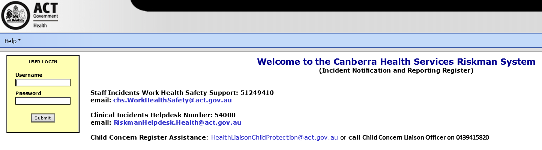
Use ACTGOV login

A member of the patient/client/consumer’s treating team must ensure all incidents that reached the person are also documented in the clinical record as soon as possible and before the end of the workday.

Documentation related to an incident must not apportion blame or provide opinions outside of the reporter’s expertise.
The reporter must complete all required fields in the RiskMan incident notification.
Field tips are included within the RiskMan template to assist with field entry.
The reporter will select the harm score based on the level of harm to the patient/client/consumer/person (See Attachment C CHS Clinical Incident Harm Score Table):
- Harm Score 1 – Death related to a clinical incident and National Sentinel Events
- Harm Score 2 - Major Harm
- Harm Score 3 - Minor Harm
- Harm Score 4 - No Harm / Near Miss.

Back to Table of Contents

Section 4 – Prioritisation

While all incidents are a quality and safety priority there is a requirement to prioritise incidents in relation to the Harm Score.

The incident Harm Score guides the prioritisation, escalation, type of investigation, timeframes, and responsibility and accountability for managing the incident. The Harm Score is determined by the seriousness of an incident in relation to the actual harm to the consumer involved in the incident. Noting that a Harm Score of 3 or 4 may require priority action and escalation by the manager/supervisor/division dependant on the risk of recurrence and potential for serious harm.

Attachment C – CHS Clinical Incident Harm Score Table

Harm Score 1 (HS1) or Harm Score 2 (HS2)
Clinical incidents meeting the definition of a Harm Score 1 (HS1) or Harm Score 2 (HS2), must be verbally notified to the supervisor/manager and escalated to executive leaders as soon as possible. A RiskMan notification must be completed before the end of the working day.

The responsible manager will:
- clarify the details of the incident
- escalate to the relevant Executive Director
- follow up and offer support to the consumer/carer as appropriate (refer to CHS Open Disclosure Procedure)
- follow up and provide support to staff involved
- update the RiskMan incident notification, including confirmation of the Harm Score.

The Executive Director will:
- escalate to the Chief Operating Officer (COO) and
- ensure a Rapid Incident Assessment (RIA) is completed (refer to Section 7).

Harm Score 3 (HS3) or Harm Score 4 (HS4)
All HS3 and HS4 incidents are to be verbally notified to the supervisor/manager and a RiskMan notification completed before the end of the working day.

The responsible supervisor/manager will:
- manage any immediate/potential risk of further harm
- follow up the well being of the consumer and staff involved
- escalate serious risks and system issue concerns to the relevant executive director and the Quality Safety Innovation and Improvement (QSII) Clinical Incident Management Team
- view all incident notifications submitted by staff who report to them and confirm the harm score within 5 calendar days
- update the RiskMan incident notification, including confirmation of Harm Score, completing investigation and review sections and distributing the notification as appropriate.

Back to Table of Contents

Section 5 – Classification (Incident Type)

The selection of an incident type enables the capturing of like incidents into categories to support reporting and identify trends, risks and initiate, monitor and/or evaluate system improvements. There are primary category types with subcategories.

Example of Categories and sub categories
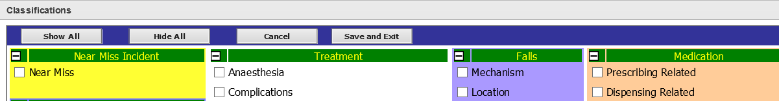

The Clinical Incident Management Team (who review all notifications to post and distribute) will select the relevant classification based on the details of the incident documented within the notification.

Back to Table of Contents

Section 6 – Open Disclosure and Consumer involvement

Open disclosure must occur whenever an incident has reached the patient/client/consumer. It involves an open conversation between CHS staff and a consumer and/or carer relating to an incident.

The Open Disclosure process happens in parallel with the Incident Management process. Information about the investigation that will occur should be given to the consumer/carer at the time of the initial Open Disclosure.

Clinician Open Disclosure
This process involves an initial discussion with the consumer and/or their carer following an incident. All incidents, require at a minimum, an acknowledgement of the incident and an apology or expression of regret. This discussion should commence as soon as possible and a record of the conversation should be noted in the consumer’s clinical record.

Formal Open Disclosure
Formal Open Disclosure is a structured process which follows on from Clinician Open Disclosure. For incidents with a HS1 or HS2, a formal Open Disclosure meeting will occur with the consumer/carer and senior clinician and executive staff. In addition a written response, is required to be offered to the consumer and/or carer.

Refer to the CHS Open Disclosure Procedure

Open disclosure discussions are also an opportunity for the consumer/carer to provide feedback about their experience. Where possible the consumer/carer perspective and questions should be incorporated into the incident investigation/review. This information can be obtained during the initial open disclosure conversation and provided by the manager to the investigation team.

Alert: Information, findings and recommendations are not able to be provided to the consumer/carer, if the investigation was undertaken by an approved Quality Assurance Committee (QAC). The Clinical Review Committee is a QAC.
Refer to Section 8 or the Health Act 1993 www.legislation.act.gov.au/a/1993-13/current/pdf/1993-13.pdf

Membership of CHS Governance, Our Care Committee (OCC), Clinical Review Committee (CRC) and Divisional Quality and Safety, and Morbidity and Mortality Committees should include a consumer representative.

Back to Table of Contents

Section 7 – Investigation and Review

All incidents require an investigation or review. This should be commenced as soon as possible following an incident. Evidence that an investigation/review has been completed is to be documented in the RiskMan Clinical Incident Register.

The primary goal of incident investigation and review is to learn and improve, by understanding what happened, why it happened and how to reduce the possibility of a recurrence to improve the quality and safety of health care.

Investigations/reviews should be timely, objective, without bias, factual and with a focus on systems not individuals. Information should be managed with consideration of confidentiality.

Investigations may be conducted by or on behalf of Quality Assurance Committee (QAC).

Investigations and reviews conducted by a QAC must comply with the provisions set out in the Health Act 1993.

Refer to Health Act 1993 ACT (Part 4 and Part 8) www.legislation.act.gov.au/a/1993-13/current/pdf/1993-13.pdf

Following completion of the Rapid Incident Assessment, all remaining HS1 and HS2 incidents will be referred to the CHS Clinical Review Committee (CRC) for consideration of the appropriate method of investigation. The Clinical Review Committee is a QAC.

Alert: Regardless of the Harm Score a Service/Unit Level Review should be conducted on all incidents as soon as possible.

Attachment D – Clinical Incident Management Summary Table

Rapid Incident Assessment (RIA)
A RIA is required for all suspected HS1 and HS2 incidents. The assessment is to be completed by at least 2 clinicians/staff selected by the Executive Director of the relevant division based on expertise. One team member will be identified as the lead.

The RIA is to be completed within 72 hours of the incident being identified. On reporting of a suspected Harm Score 1 or 2 clincial incident via the RiskMan clinical incident register, the Director, Clinical Incident Management will request a Rapid Incident Assessment from the Executive Director.

Once the RIA has been completed by the Division, it is returned to the Director, Clinical Incident Management. The decision recgarding the Harm Score is made by the Director on the basis of the report. The completed RIA report is emailed to the COO and the DCEO by the Director.

The purpose of a RIA is to:
- establish what happened
- confirm the Harm Score
- assess any immediate risks for the incident to happen again
- identify actions that need to be implemented immediately in the clinical area
- identify that open disclosure processes have been activated
- confirm staff involved in the incident have been provided with appropriate support.

If required, the Director, Clinical Incident Management will update the Harm Score in the RiskMan incident notification once the RIA report is finalised.

Alert: Information from the RIA can be referenced in the initial open disclosure conversation.

Types of investigations
There are four types of investigation methods which are applied depending on the seriousness, type and complexity of the incident.
- Comprehensive Investigation
- Concise Investigation
- Service/Unit level review
- Multi-Incident analysis.

Attachment D - Clinical Incident Management Summary Table

Regardless of the type of incident investigation, the purpose is to answer the following questions:
- What happened?
- Why and how it happened?
- What action can be taken to prevent it happening again?

Alert: The focus of an incident investigation is on system vulnerabilities not individual performance.

Alert: At completion of all investigations the RiskMan incident notification is to be updated including updating the harm score and classification if required.

If a staff performance issue is identified, this should be referred to the manager of the staff member.

Refer to CHS Policy – Underperformance, or CHS procedure – Reviewing the Clinical Competence of a doctor or dentist following the receipt of a complaint or concern.

Harm Score 1 (HS1) and Harm Score 2 (HS2) incident investigations
All HS1 and HS2 incidents require a RIA and a referral to the Clinical Review Committee (CRC). The CRC will determine the most appropriate investigation.

Harm Score 3 (HS3) incident investigations
A HS3 requires the use of either the Concise Investigation methodology or a Service/Unit Level review. However, another type of investigation may be recommended based on identified system risks and process concerns.

Harm Score 4 (HS4) incident investigations
HS4 incidents require a Service/Unit level review at a minimum, usually led by the responsible supervisor/manager. However, the Manager may recommend another type of investigation pending identified system risks and process concerns.

- Comprehensive incident Investigation
A Comprehensive Investigation is undertaken when death or major harm has occurred (or a significant risk thereof) or where the incident is complicated or complex.

A significant amount of time and human resources are required to conduct this type of investigation.

The steps involved in this process include identifying the sequence of events and contributory factors, recommendation development and a formal written report.

The characteristics of a Comprehensive Investigation include:
- a structured methodology (such as Root Cause Analysis methodology (RCA))
- a specifically selected multidisciplinary team of three to four
- documentation review, staff interviews, the consumer/carer perspective, literature review, and may include site visits and additional expert opinion
- drill down to identify the contributory factors and use of cause and effect diagrams
- statement/s of findings
- recommendations and actions
- a formal report.

The investigation report with the team recommendations is to be available within 60 calendar days from the decision to conduct a Comprehensive investigation.

2. Concise incident Investigation
A Concise incident Investigation is a succinct, yet systematic way to review an incident. This type of investigation is primarily for Harm Score 3 incidents. However there may be circumstances where this type of investigation is initiated for some Harm Score 1 or 2 incidents. For example where within a short period a similar incident has occurred that has had a Comprehensive Investigation completed. There may also be cases where a Harm Score 4 incident may benefit from a Concise incident investigation.

Characteristics of a Concise Investigation include:
- a structured methodology for gathering information and identifying contributory factors
- a specifically selected team of two staff
- documentation review, supplemented by a small number of staff interviews and the consumer/carer perspective
- identifying the contributory factors
- formulating recommendations and actions
- a report including contributory factors, recommendations and actions.

The investigation is to be completed (including documentation) within 45 calendar days from the date the incident was identified.

3. Service/Unit Level review
A Service/Unit Level Review should be conducted on all incidents as soon as possible regardless of the harm score.

A Service/Unit Level Review is a succinct review of an incident to identify any ongoing risks or concerns and to implement actions to support improvement and prevent a recurrence of the incident.

This type of review may be undertaken by the supervisor/manager or by a Morbidity and Mortality Committee. It usually includes speaking with staff involved to clarify the incident and understand what happened and why.
Controls/actions/improvements must be put in place to manage any contributory factors.

Supervisor/Manager reviews (medical, nursing, midwifery, allied health, administrative and operational)
The RiskMan incident notification must be updated with evidence of a supervisor/manager review being completed within 28 calendar days including documentation of any systemic contributory factors and the actions.

Morbidity and Mortality Committee Reviews
The primary purpose of a Morbidity and Mortality Committee (M&M) is to examine and discuss clinical services relevant to the committee’s health care activities. The aim is to facilitate improvement in the safety and quality of health services. Refer to the CHS Mobidity and Mortality Committees Guideline.

Members should be focused on learning and improvement and the meeting participants should feel comfortable to participate in an open and honest discussion.

Systemic issues/trends and actions/recommendations are provided to the divisional quality and safety committee.

If through an M&M activity an incident is identified that may not already have been reported in RiskMan then a notification should be completed in the clinical incident register. If a serious incident is identified that may require a more comprehensive investigation then escalation is required as soon as possible.

Alert: It is not a CHS requirement that an M&M committee is also a Quality Assurance Committee (QAC).
However, if an M&M committee is a QAC (Section 8), the committee must comply with the stringent secrecy provisions of the Health Act 1993. Refer to Health Act 1993 ACT (Section 4 and Section 8) www.legislation.act.gov.au/a/1993-13/current/pdf/1993-13.pdf
Please refer to the CHS Quality Assurance Committee Procedure.

4. Multi-incident analysis
Multi-incident analysis is a method for analysing several incidents at once instead of one by one, by grouping them in themes (in terms of composition or origin). Multi-incident analysis can be used for incidents that resulted in no or minimal harm as well as near misses that took place at any location in the organisation (possibly in a short interval of time). It can also be used to analyse a group of comprehensive and/or concise investigations. This method of analysis can generate valuable organisational and/or sector-wide learning that cannot be obtained through the other methods⁵.

An Executive Director, governance committee or the QSII Director, Clinical Incident Management can commission a multi-incident analysis based on data and trends. A terms of reference for the analysis is completed that identifies the team to conduct the analysis, the scope, timeframe and reporting requirements.

Considerations for a Multi-incident analysis include:
- a group of individual patient safety incidents, similar in composition and/or origin, that caused minor, or no, or varying degrees of harm
- a group of patients who are impacted by similar contributing factor/s, and who experienced the same clinical incident (to greater or lesser degrees).
- a group of completed investigations with similar contributory factors.

Characteristics of a Multi-incident analysis include:
- a pre-defined theme or scope
- involvement of a multidisciplinary team including frontline clinicians and where relevant a consumer representative
- use of quantitative and qualitative methodologies⁵.

Back to Table of Contents

Section 8 – Quality Assurance Committees (QACs)

QACs are established under Part 4 of the Health Act 1993 and are subject to very strict confidentiality requirements, with severe penalties for breaches of the Act.

Formal approval of a QAC is by the Minister for Health and is formalised by a Notifiable Instrument. Legislative requirements include approval of members by the CEO, limitations on what the committee should discuss and what information and/or documents can be shared outside of the committee.

All members of, or persons assisting a QAC, will become information holders. It is a breach of the Act, and a criminal offence, to share Protected and Sensitive Information. The Health Act describes sensitive information as including any information:
- that identifies a person who received a health service or
- that identifies a health service provider or
- that identifies a person who provided information to a QAC or
- would allow the identity of the person to be worked out.

It is important that information holders familiarise themselves with Section 4 and 8 of the Act to reduce the possibility of committing a criminal offence if disclosure was made in the absence of a lawful exception. Refer to Health Act 1993 www.legislation.act.gov.au/a/1993-13/current/pdf/1993-13.pdf

Back to Table of Contents

Section 9 – Recommendations and Actions

The investigation/review team will develop recommended actions against the finding statements and/or identified contributory factors that enabled the incident to occur. The team (or reviewer) develops recommended actions in order of priority, proposal of timeframes, responsibility and the proposed evidence for completion.

Recommendation development endorsement and monitoring
For Harm Score 1 and 2 incident investigations the investigation team consult with the relevant divisional executive and/or leaders on the purposed recommendations. The CRC will endorse final recommendations. The endorsed recommendations are placed on the Reccomendations Register.

The Recommendation Review Panel monitor and manage outstanding recommendations. The division allocated ownership of the recommendation must complete a Recommendation Review Panel Submission to the secretariat of the Recommendation Review Panel. The submission should outline what activity has occurred to implement the recommendation and copies of relevant evidence. The Recommendation Review Panel is responsible for agreeing or not agreeing that the evidence submitted demonstrates adequate implementation/completion of the recommendation.

The recommendation endorsement process is to be completed within 60 Days from the completion of the investigation.

Harm Score 3 and 4 investigation/review recommended actions are to be managed through the divisional Quality and Safety processes for endorsement, monitoring and completion of evidence.

Harm Score 3 and 4 investigation/review endorsed recommendations/actions are to be documented on the relevant divisional Quality and Safety Committee register and within the RiskMan incident register incident notification.

Back to Table of Contents

Section 10 – Feedback and Learning

Investigation/review feedback and the sharing of learnings are important to close the loop for staff and consumer/carers involved in an incident. This feedback is also important and necessary for improving healthcare and to engage staff in change and improvement activities.

Feedback of the system issues identified and the recommendations from the investigation/review/analysis must be provided to staff involved in the incident.

Feedback on the lessons learnt and proposed changes are communicated more broadly with clinicians, managers and staff.

Completing documentation within the relevant RiskMan incident notification supports the feedback to staff and is essential for data and improvement reporting.

Feedback to the consumer/carer is managed by the relevant divisional executive and leaders.

Alert: Information from investigations and reviews conducted by a Quality Assurance Committee (QAC) must be managed in line with the Health Act 1993. Refer to Section 8 – Quality Assurance Committees (QACs).

Back to Table of Contents

Section 11 – Incident data and reporting

The incident management process supports the provision of safe, high quality health care. Outcomes from incident management guide changes that will result in health care improvement.

Incident data and reporting will be directed through governance processes including divisional Quality and Safety Committees and the Our Care Committee.

Reporting includes:
- Sentinel events
- HS1 and HS2 incidents
- General incident data including number of incidents, types of incidents and trends
- Divisional safety and quality reports.

This information will also be used to the review the clinical incident management system to improve the effectiveness of the system in improving patient safety and quality of care.

Back to Table of Contents

Section 12 – Interjurisdictional incident management

If there is a requirement to undertake an interjurisdictional investigation, the relevant Executive Director and CEO will be required to approve the decision, agree on the jurisdiction to coordinate the investigation and the investigation team representatives from CHS.

Back to Table of Contents

Evaluation

Outcome
- Staff understand and comply with the clinical incident management process within their roles and responsibilities for incident management.
- Staff investigate Clinical incidents within required timeframes.
- Staff select appropriate Harm Scores to clinical incidents.
- Staff understand the recognition, notification and investigation processes of Clinical Incidents and act in a timely and appropriate manner.
- There is evidence of action and improvement from high level clinical incidents.

Measures
- Post training and education feedback is sought from staff involved in the incident management process. Opportunities for improvement are identified.
- Audit reports from the clinical incident register to determine timeframes from incident notification to manager completion of the investigation.
- Staff access the policy documents to support the provision of safe, high quality health care
- Annual review of all Harm Score 1 and 2 notifications posted to confirm appropriate escalation and investigation occurred.
- Clinical Incident Management Team annually review a selection of incident notifications to confirm appropriate Harm Scores allocated and investigation occurred.
- Clinical Incident Management Team audit and report annually on recommendation endorsement and completion process, including timeframes.
Back to Table of Contents

Related Policies, Procedures, Guidelines and Legislation

Policies
- CHS Clinical Incident Management Policy
- Consumer Feedback Management Policy
- CHS Work Health Safety Management System (WHSMS)
- CHS Work Health Safety (WHS) Policy
- Clinical Records Management Policy
- Administrative Records Management Policy
- CHS Policy – Information Privacy
- CHS – Policy – Consumer Privacy

Procedures
- Consumer Feedback Management Procedure
- CHS Operational Procedure – Open Disclosure
- Canberra Health Services – Procedure – Clinical Record Management
- Consumer Compensation Claims Procedure

Guidelines
- Morbidity and Mortality Guidelines
- CHS – Guidelines, Psychological Support for Staff – A Managers Guide
- Australian Commission on Safety and Quality in Healthcare – National Safety and Quality Health Service Standards
- Partnering with Consumers Framework
- Exceptional Care Framework
- Clinical Governance Framework

Legislation
- Health Act 1993 (ACT)
- Information Privacy Act 2014
- Health Records (Privacy and Access) Act 1997
- Australian Charter of Healthcare Rights

Back to Table of Contents

References

- Australian Commission on Safety and Quality in Health Care. National Safety and Quality Health Service Standards.
- Australian Commission on Safety and Quality in Health Care, Australian Sentinel Events (version 2), Publication Year 2020.
- NSW Government, Incident Management Policy and Procedure, Issue date December 2020.
- NSW Government, Clinical Excellence Commission, Incident Management Policy Resources, www.cec.health.nsw.gov.au.
- Best Practice Guide to Clinical Incident Management, State of Queensland (Queensland Health), First Addition 2014.
- Victorian sentinel event guide, State of Victoria, Safer Care Victoria, June 2019.
- Canadian Incident Analysis Framework, Canadian Patient Safety Institute, 2012.

Back to Table of Contents

Definition of Terms

Adverse event | an incident
Australian Sentinel Event  (ASE) | An ASE is a wholly preventable patient safety incident resulting in death or serious patient harm. It is a category of incident defined by the Australian Commission on Safety and Quality in Health Care and approved by the Health Ministers. The ASE list is at Attachment A.
Harm | Patient/client/consumer/person harm is any unintended and unnecessary harm resulting from, or contributed to, by health care.
Harm Score | A score from 1 to 4 applied to clinical incidents based on the outcome and additional treatment and/or resources required as defined in Attachment A.  Clinical Harm Score 1 (HS1)- death related to a clinical incident or an Australian Sentinel Event  Harm Score 2 – Major harm  Harm Score 3 – Minor harm  Harm Score 4 – No harm or near miss.
Incident (Clinical) | A clinical incident is an event or circumstance that did result in unintended harm or could have resulted in unintended harm (near miss) to a patient/client/consumer resulting from, or contributed to, by health care provided by Canberra Health Services and outside the natural disease process.  The resultant harm differed from the expected outcome of patient/client/consumer management.
Incident Management | Actions and processes for immediate and ongoing activities following an incident.
Just Culture | Supports a learning environment and recognises that individual practitioners should not be held accountable for system failings over which they have no control.  A culture in which frontline personnel feel comfortable disclosing errors - including their own - while maintaining professional accountability.
Manager/Supervisor | A designated senior staff member who manages and mentors another staff member and who will assist in the management of an incident.
Near miss | An incident that could have caused harm but did not or an incident that was intercepted before reaching the patient/client/consumer.
Notice | A notification submitted in the RiskMan Incident Register that does not meet the definition of an incident.
Notification | The process of entering or documenting data about an incident or near miss into the RiskMan Incident Management System.
Open disclosure | Open Disclosure is an open conversation between CHS staff and a consumer and/or carer relating to an incident that could have resulted, or did result, in harm whilst receiving healthcare.
RiskMan incident module | An online web based system used to report incidents within CHS.

Back to Table of Contents

Search Terms

Incident, open disclosure, Harm Score, investigation, RiskMan, Quality Assurance Committee, Clinical Review Committee
Back to Table of Contents

Attachments

Attachment A – Fact Sheet ‘Manager Responsibilities’ to staff
Attachment B – Clinical Incident Management Process diagram
Attachment C – Clinical Incident Management Harm Score Table
Attachment D – Clinical Incident Management Summary Table

Disclaimer: This document has been developed by Canberra Health Services specifically for its own use. Use of this document and any reliance on the information contained therein by any third party is at his or her own risk and Canberra Health Services assumes no responsibility whatsoever.

Policy Team ONLY to complete the following:
Date Amended | Section Amended | Divisional Approval | Final Approval
9 June 2021 | Complete Review | Kellie Lang, A/g EBM, QSII | CHS Policy Committee
28/06/2022 | Updated to reflect current reporting structure | Jenny Broome Director Clinical Incident Management | CHS Policy Team
29/08/2023 | Document amended to reflect current practise | Helen Milne, A/g EBM, QSII | CHS Policy Team
07/09/2023 | Document amended to reference Our Care Committee and updated Attachment B | Jenny Broome, Director of Incident Management, QSII | CHS Policy Team

This document supersedes the following:
Document Number | Document Name
DGD18-016 | Incident Management Procedure

Attachment A – Manager Responsibility and staff following an incident

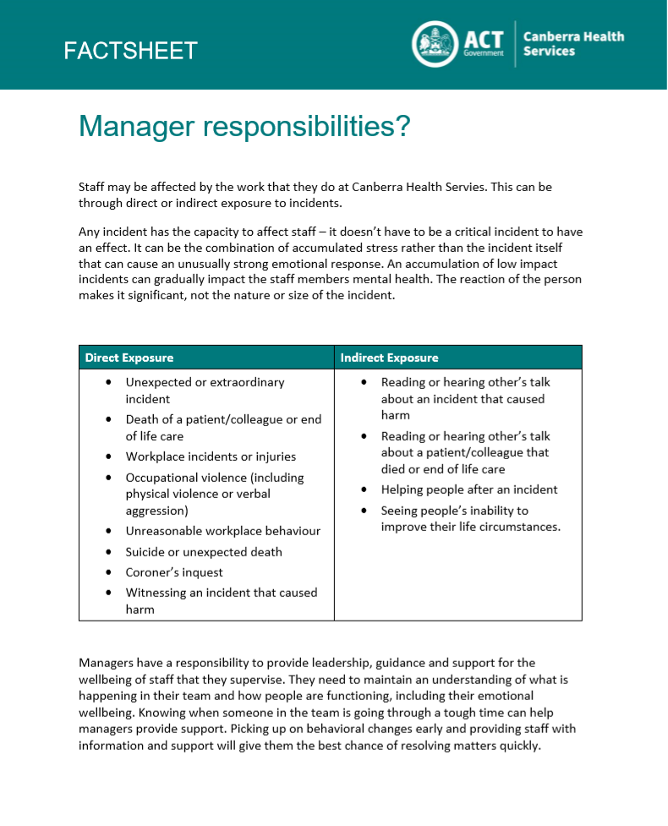

Attachment B – Incident Management Process Summary

Attachment C – Clinical Incident Management Harm Score Table

Clinical Incident: an event or circumstance that did result in unintended harm or could have resulted in unintended harm (near miss) to a patient/client/consumer resulting from, or contributed to, by health care provided by Canberra Health Services and outside the natural disease process. The resultant harm differed from the expected outcome of patient/client/consumer management.

HARM SCORE 1 - Death and Sentinel Events
- Death of a Patient/client/consumer/person as the result of a clinical incident.
- Suicide or suspected suicide of a Mental Health consumer discharged from a CHS inpatient facility within the previous seven days.
- Suicide of a current inpatient of Canberra Health Services.
- Sentinel Event:
- Surgery or other invasive procedure performed on the wrong site resulting in serious harm or death
- Surgery or other invasive procedure performed on the wrong patient resulting in serious harm or death
- Wrong surgical or other invasive procedure performed on a patient resulting in serious harm or death
- Unintended retention of a foreign object in a patient after surgery or other invasive procedure resulting in serious harm or death
- Haemolytic blood transfusion reaction resulting from ABO incompatibility resulting in serious harm or death
- Suspected suicide of a patient in an acute psychiatric unit or acute psychiatric ward
- Medication error resulting in serious harm or death
- Use of physical or mechanical restraint resulting in serious harm or death
- Discharge or release of an infant or child to an unauthorised person
- Use of an incorrectly positioned oro- or naso- gastric tube resulting in serious harm or death.
HARM SCORE 2 - Major Harm
- Major Harm to a Patient/client/consumer/person as the result of an incident:
- requiring life saving surgical or medical intervention or
- shortened life expectancy or
- permanent or long-term physical harm or long-term loss of function.
- Attempted Suicide of a Mental Health consumer discharged from a CHS inpatient facility within the previous seven days.
- requiring life saving surgical or medical intervention or
- shortened life expectancy or
- permanent or long-term physical harm or long-term loss of function.
Note: If the incident meets the definition of a Sentinel Event it is a Harm Score 1
HARM SCORE 3 – Minor Harm
- Minor Harm to a Patient/client/consumer as the result of an incident:
- resulting in transfer to a higher level of care or
- surgical or medical intervention or
- increased level of care.
Note: An assessment is not an increased level of care
HARM SCORE 4 – No Harm / Near Miss
- No harm acquired as the result of an incident and includes a near miss event
- The event reached the patient/consumer/client but did not result in harm (the person did not require a higher level of care or surgical/medical intervention) OR
- The event was intercepted before reaching the patient/consumer/client
NOTICE - No incident identified
- Does not meet the definition of a clinical incident
Note: an intervention such as a MET or seclusion/restraint is a response, not an incident.

Attachment D – Incident Management Summary Table
Clinical Incident | HS 1 | HS 2 | HS 3 | HS 4
Description | Unexpected Death or Sentinel Event | Major Harm | Minor Harm | No Harm (reached the person) or  Near Miss (intercepted)
1. Identify Incident and ensure safety
Patient/staff/visitors | Yes | Yes | Yes | Yes
Environment | Yes | Yes | Yes | Yes
Support patient/carers/families | Yes | Yes | Yes | Yes
Support staff | Yes | Yes | Yes | Yes
2. Clinician disclosure
Within 24 hours and complete clinician disclosure section in clinical records before end of workday | Yes | Yes | Yes | No Harm – Yes  Near miss – No
3. Notify
Report in the RiskMan Clinical Incident Register before end of workday | Yes | Yes | Yes | Yes
Document incident and clinician disclosure in clinical records before end of workday | Yes | Yes | Yes | No Harm – Yes  Near miss – No
4. Escalate
Staff to supervisor/manager to Senior manager/leader | Yes | Yes | Yes | No Harm – Yes  Near miss – Generally, No
Manager to executive as soon as possible and ≤ 12 hours | Yes | Yes | Case by case | Generally, No
Clinical Incident | HS 1 | HS 2 | HS 3 | HS 4
Description | Unexpected Death or Sentinel Event | Major Harm | Minor Harm | No Harm (reached the person) or  Near Miss (intercepted)
5. Investigation/Review
RIA completed ≤ 72 hours | Yes | Yes | No | No
Comprehensive investigation completed ≤ 60 calendar days | Yes | Yes | Generally, No | Generally, No
Concise Investigation ≤ 45 calendar days | Generally, No | Generally, No | Yes | No
Service/Unit Level Review ≤ 28 calendar days | Yes | Yes | Yes | Yes
Multi-incident Analysis | Possibly | Possibly | Possibly | Possibly
6. Recommendations/Actions
Formulated by investigation team/reviewer/s | Yes | Yes | Yes | Yes
Endorsement by the Clinical Review Committee | Yes | Yes | Generally, No | Generally, No
Monitored by the Recommendations Review Panel | Yes | Yes | No | No
Endorsement by the Divisional Quality and Safety Committee | No | No | Yes | Possibly
Monitored by the Divisional Quality and Safety Committee | Yes | Yes | Yes | Possibly
7. Feedback
Feedback to staff | Yes | Yes | Yes | Yes
Feedback to consumer/carer | Yes, per Open Disclosure process | Yes, per Open Disclosure process | Yes, per Open Disclosure process | Generally, No

