Canberra Health Services
Procedure
Clinical Records Management

Contents

Contents 1
Purpose 2
Scope 2
Section 1 – Legislative and Policy context for Clinical Record Management 2
Section 2 – Creation of Clinical Records 4
Section 3 – Access to Clinical Records 6
Section 4 – Privacy Audits 8
Section 5 – Digitisation of Clinical Records 10
Section 6 – Clinical Record Documentation 11
Section 7 – Clinical Record Forms 23
Section 8 – Discharge Documentation 29
Section 9 – Transporting clinical record documents 30
Section 10 – Release of Information (ROI) and Sharing of Clinical Records 33
Section 11 – Storage and Security of clinical records 45
Section 12 – Disposal of Clinical Records 47
Evaluation 48
Related Policies, Procedures, Guidelines and Legislation 48
References 50
Definition of Terms 50
Search Terms 54
Attachments 54
Attachment 1 – Record access audit sample communication with line manager 55
Attachment 2 – Tracking records in ACTPAS 56
Attachment 3 – Tracking records for destruction 62
Attachment 4 – Physical storage requirements for clinical records 65

Purpose

Effective clinical record keeping practices are vital for Canberra Health Services (CHS) to support the delivery of high-quality patient care, operational efficiency, accountability, and transparency. They are also essential for demonstrating compliance with the National Safety and Quality Health Service (NSQHS) Standards and must be available to clinicians at the point of care.

The purpose of this procedure is to outline the required processes for all CHS staff to ensure consistent, effective, and appropriate clinical record and health information management across CHS.

This procedure, in conjunction with the CHS Clinical Records Management Policy, and the CHS Clinical Record Management Program ensure that CHS meets its responsibilities under Section 16 (2) of the Territory Records Act 2002.

Back to Table of Contents

Scope

This procedure applies to all CHS staff involved in the creation, use or management of clinical records and personal health information. Corporate records are out of scope.

Back to Table of Contents

Section 1 – Legislative and Policy context for Clinical Record Management

Territory Records Office record management principles
The Territory Records Office (TRO) Standard for Records, Information and Data Management outlines seven principles of record management for ACT Government agencies: Strategy, Capability, Assess, Describe, Protect, Retain and Access.

The Records Management Program for Clinical Records and the Clinical Records Management policy details how CHS implements these principles.

The Australian Charter of Health Care Rights
The importance of privacy is enshrined in the Australian Charter of Health Care Rights (the Charter), which commits to both the consumer’s right to access to information, including medical records, as well as to the security and confidentiality of personal health information. Specifically, under the Charter, consumers have the right to:

“access [my] health information” and
“have information about me and my health kept secure and confidential”.

The National Safety and Quality Health Service (NSQHS) Standards
Record keeping and timely access to information are important features of safe health care. Actions 1.16 to 1.18 under Standard 1 (Clinical Governance – Patient Safety and Quality Systems) specifically address record keeping and state:

  - The health service organisation has healthcare records systems that:
- Make the healthcare record available to clinicians at the point of care
- Support the workforce to maintain accurate and complete healthcare records
- Comply with security and privacy regulations
- Support systematic audit of clinical information e. Integrate multiple information systems, where they are used

  - The health service organisation works towards implementing systems that can provide clinical information into the My Health Record system that:

- Are designed to optimise the safety and quality of health care for patients
- Use national patient and provider identifiers
- Use standard national terminologies

  - The health service organisation providing clinical information into the My Health Record system has processes that:

- Describe access to the system by the workforce, to comply with legislative requirements
- Maintain the accuracy and completeness of the clinical information the organisation uploads into the system

The intent of the actions under this Standard is that health record keeping supports safe health care for consumers through clear, accurate, accessible and secure information.

Strategic Commitment to Digital Health Records
Other strategic work in the ACT that relates to clinical record management includes:
- the ACT Digital Health Strategy;
- the ACT Health Quality Strategy; and
- the current development of the ACT Digital Health Record.

The ACT Digital Health Strategy has committed to:
- Implementation of the Epic Digital Health Record (DHR) across the ACT public health system including all CHS facilities, Calvary Public Hospital Bruce and the Tresillian QEII Family centre. The DHR:
- will be a fully electronic medical record solution. Clinicians will enter clinical information directly into the DHR using a variety of electronic devices.
- is scheduled to go live in November 2022 and will replace over 30 specialised Clinical Information Systems (CIS).
- will be a major step towards achieving a fully centralised, single electronic clinical record for the ACT.
Back to Table of Contents

Section 2 – Creation of Clinical Records

Creation of the clinical record occurs on registration of a patient with the health service and allocation of the CHS Patient Identifier, also known as the URN – Unit Record Number or MRN - Medical Record Number.

The existence and location of clinical records should be identified and tracked within the the ACT Health Patient Administration System (ACTPAS). Records are currently tracked in ACTPAS and tracking information will be migrated into the DHR when it is implemented in late 2022. CHS staff must take all reasonable steps to ensure that clinical records are accurate, complete, and up to date.

Clinical Record Folders
Where the storage of records is intended to be temporary, prior to scanning into the clinical record solution (e.g., records of current inpatients held on the ward) they need not be filed into formal Clinical Record file covers but can be stored in temporary folders (e.g., green ring binders for current inpatients used on wards, plain manila folders or in plastic sleeves).

Where the records need to be retained in hard copy in the long term or stored as decentralised records, formal CHS clinical record covers (as shown below) should be used to assist in safely preserving the record content and to facilitate terminal digit filing.

Write the patient’s SURNAME/Family name in upper case letters on the cover as shown below, and then their First and Middle names in lower case using a black marking pen.
Again with black marker, write the URN across the top right hand edge of the file cover in the boxes provided.
Also write it down the right hand side as shown

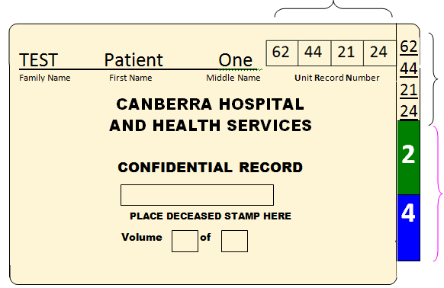

Apply the colour coded TDO stickers matching the last two Primary digits:
2 and 4 in this example
to assist with Terminal Digit Filing

All Community Clinical Record file covers require ACTPAS document tracking labels to be affixed to the front cover, and inside cover of the file. ACTPAS document tracking is used to identify the type of clinical record, the volume of the record and capture clinical record movement between sites where CHS staff deliver care e.g. Community Health Centres or the patient’s home. When an electronic document is created in ACTPAS the user will be prompted to print document labels. The labels will print on an A4 page of stickers.
Document Type
URN
Volume
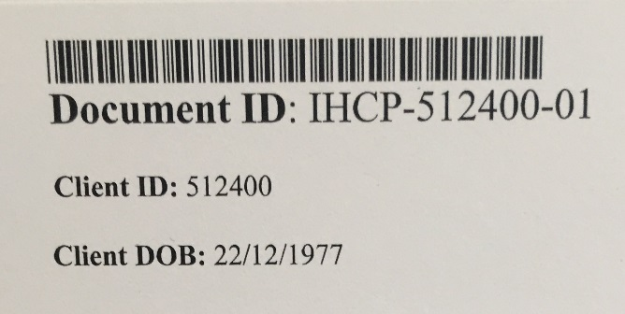
Document ID Label
The top two labels on the sheet are de-identified Document ID labels and one should be placed on the outside front cover of the file.

This is the barcode that is scanned when sending and receiving documents between the Community Clinical Records Unit and various CHS sites.

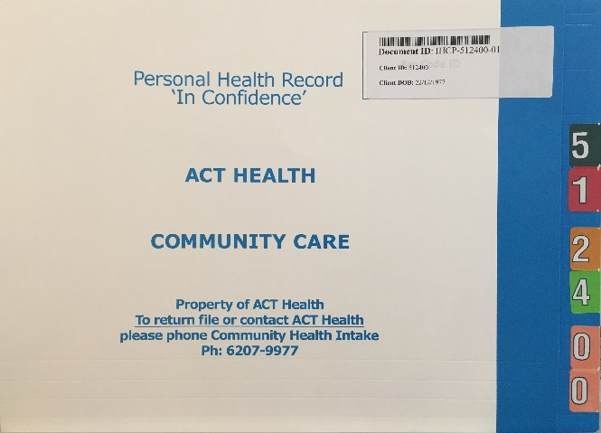
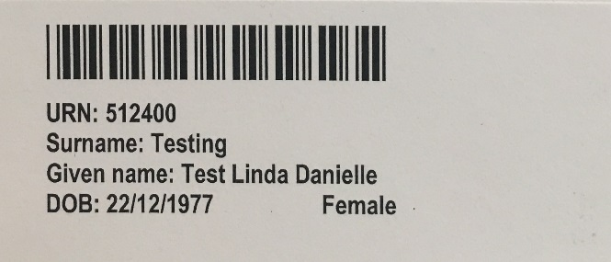
Patient ID Label
The remaining labels are Patient Identification labels and include the patient’s URN, Surname/Family Name , Given Name, DOB and Sex.

A Patient ID label should be placed on the inside cover of the file. The remaining Patient Identification labels are to be placed inside the file to be used by clinicians to affix to clinical record forms.

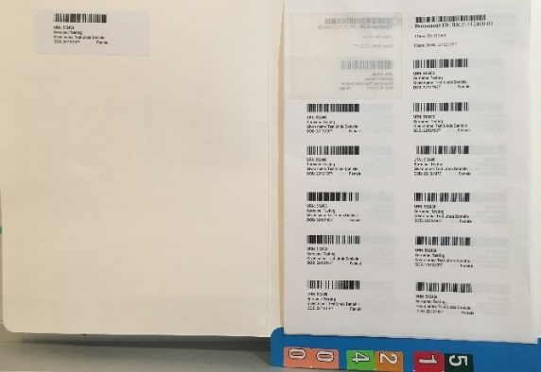

Back to Table of Contents

Section 3 – Access to Clinical Records

CHS utilises a hybrid system for the management of clinical record information. At the point of care in most inpatient wards and outpatient/non-admitted areas clinicians will capture/document clinical information on paper clinical record forms. On discharge or following treatment, these paper documents are sent to Health Information Services (HIS) for scanning into the CHS scanned clinical record solution: the Clinical Patient Folder (CPF) for long term storage and future access.

CHS is required to protect patient’s privacy under the Health Records (Privacy and Access) Act 1997. Reasonable steps should be taken to protect patient information on display in public or communal areas. Hard copy clinical files, for example (green folders and bedside folders) must be stored in a designated area. To ensure a consistent process for patient safety on hard-copy clinical files, all areas are to ensure the hard copy clinical files are labelled with patient’s first and surname/family name, and doctor’s surname/family name.

Security of clinical records within CPF
All clinical records are confidential. All confidential records stored within CPF are protected by the ACT Government network firewalls, built-in system security measures and dual factor user authentication.

A small selection of specific clinical documents have been deemed by CHS Executive and the Health Records Advisory Committee to be highly sensitive requiring additional security measures. This is facilitated in CPF through document level security by use of Add-on-roles. These Add-on-roles are applied to specific document types and then allocated to specific users. A user without the necessary Add-on-role will not be able to view a document secured under that specific Add-on-role.

The following CPF Add-on-roles have been approved to provide additional document level security at CHS:

Add-on-role Applicable records
Neuropsychology Psychological and Neuropsychological tests
Confidential Domestic violence documents and sensitive counselling records
CARHU Sensitive child at risk reports

Access to CPF and other clinical systems listed below can be requested via the Identity Access Management (IAM) system. Most users will require either Clinical or Clerical access to CPF. A limited number of users will require additional Add-on-roles depending on their role within CHS e.g. Print, Neuropsychology, Confidentiality etc. Requests for access to these additional Add-on-roles will require manager and HIS approval.

Some systems will require completion of eLearning prior to access provision.

Other core CHS Clinical Information Systems (in alphabetical order) include:
Area | System | Interface with CPF
Breast Screen ACT | BIS | Not currently
Cardiology | Cardiobase | Some reports
Cardiology | Synapse – ECGs | Not currently
Dental | Titanium | Not currently
Electronic Discharge Summaries | EDS – Clinical Portal | EDS documents
Emergency Department | EDIS | ED Discharge Letters
Equipment Loan Service | MESaLS | ELS loan agreements
e-referrals | Clinical Portal | Referral documents
Fetal Medicine | ViewPoint | Not currently
Gastroenterology | Provation MD | Procedure Reports
Intensive Care Unit | Metavision | Discharge summaries, and other salient documents
Maternity | BOS | Not currently
Medical Imaging | RISPACs | Reports
Medical Oncology | CHARM | CHARM clinical documents
Medications | EMM – MedChart | Medication Charts
Mental Health | MAJICeR | MAJICeR progress notes
Nursing Observations | Patient Track | Electronic observations
Pathology | Kestral | Reports
Patient demographics | ACTPAS | Patient demographics and visit/episode information
Patient Digital Journey Board |  | Not currently
Radiation Oncology | ARIA | Documents
Renal Medicine | CV5 | Not currently
Walk-In-Centres | WIC ECR – Clinical Portal | WIC event summaries

The Digital Health Record (DHR)
When the DHR is implemented, it will replace many of the specialised systems above. The core function of the DHR is direct digital/electronic capture of clinical data. While it will have capacity for accepting some scanned documents, it is not designed or intended to be a scanned document repository so only limited/critical Point of Care (POC) scanning into DHR will occur post go live.

CPF will remain in use as the primary storage solution for scanned clinical record documents and will interface with the DHR providing the treating team with seamless access to the patient’s full historic CHS clinical record, including scanned records dating back to 1994.

Back to Table of Contents

Section 4 – Privacy Audits

CHS is required to maintain the confidentiality and privacy of patient information it collects and maintains and will conduct regular audits to ensure access to health records is authorised, appropriate and in accordance with privacy and health record legislation and CHS policies.

HIS is responsible for monitoring and auditing access to the electronic clinical records stored within CPF, for potential breaches and inappropriate access.

In accordance with the Health Records (Privacy & Access) Act 1997, health records should only be accessed, used, and disclosed for the purpose for which the information was collected. For CHS staff, that means to provide clinical care to patients or to support the provision of patient care and management of the health service, including funding and quality improvement activities. Staff must only access patient records when required as part of their role following the “need to know” principle.

Alert: Where it appears that there may have been inappropriate patient record access, it is the manager’s and/or HIS’ responsibility (see Proactive Audits below) to conduct a Preliminary Assessment (refer People & Culture Information Guideline No. 1 - Dealing With Misconduct: A Manager’s Guide, and People & Culture Information Guideline No. 3 – Preliminary Assessments: A Manager’s Guide) for more information.

Having conducted a Preliminary Assessment and if it is found that there may have been inappropriate patient record access, the matter will be passed onto People & Culture (Human Resources) and may result in disciplinary action being taken against staff member(s) involved, where misconduct has been identified.

To provide assurance that access to personal health information is appropriate and that patient privacy is protected, HIS routinely monitors record access and undertakes either proactive or reactive audits.

Proactive audits
HIS conducts routine audits of individual patient records and/or individual staff members in order to confirm that record access was appropriate. These audit activities will be completed by a Health Information Manager or delegate and will include audits of:
- Random patient records.;
- Random staff logins;
- Access by users to patient records with the same surname/family name; and
- High-profile patients.

Proactive audit process
HIS staff will run random access audit reports on a monthly basis. The audit reports will be analysed and if irregularities or potential breaches in access to health information are identified, the HIS staff member will escalate to a HIS manager for further assessment.
The HIS manager will review and refer any potential breaches to the staff member’s direct line manager, who may carry out a Preliminary Assessment (see Attachment 1 for an example of communication to the manager). If a Preliminary Assessment is required it will be conducted in accordance with Preliminary Assessments: A Manager’s Guide (People & Culture Information Guideline No. 3), can be found on the Sharepoint (HR/Employee Services/HR fact sheets/ Employee Relations). Managers or Delegates are encouraged to contact Workforce Relations, the Business Partner for their Division or HR Advisors in HR Advisory and Business Partnerships on (02) 5124 9610 or via email at CHS.WR@act.gov.au if contemplating conducting a Preliminary Assessment.
The staff member’s direct line manager will inform HIS of the outcome of their enquiries.
If a breach is suspected/confirmed HIS will report the matter to People & Culture. People & Culture will review the details and proceed with further investigation or disciplinary action if deemed appropriate. People & Culture will advise if the breach requires full disclosure to the patient or if notification to an internal or external body is required.

No further action will be required where a privacy/policy breach is not confirmed. The results of proactive audits will be captured in the HIS Access Audit Register and reported to the Health Records Advisory Committee.

Reactive audits are based on requests
HIS will receive requests to undertake an access audit from, but not limited to:
- Consumer Feedback and Engagement
- Clinical Incident or Complaint
- People & Culture
- Quality and Patient Safety
- Staff, managers or Executive Directors of Clinical Divisions
- Anonymous reports
- Digital Solutions Division (Emergency Access to the My Health Record by CHS staff).
A request to audit clinical record systems must include reasonable justification for the audit, specific timeframe and relevant details i.e., staff member details and/or patient details (patient name and URN). These audits are resource-intensive and must only be used for genuine concerns to ensure appropriate access/use of personal health information and HIS resources.

Reactive audit process
HIS will run relevant audit reports as required. The audit reports are transactional logs from the system audit trail. These metadata audit logs will be analysed for irregularities and compared to entries within the clinical record to determine who was directly involved in the care of the patient at the time of the access, and to establish whether these staff members would have a legitimate reason to access the record.

The auditor may also use other CIS, e.g., ACTPAS to determine other legitimate reasons for access such as wait list management or appointment re-scheduling etc.

If the reason for the access is not linked to a patient encounter, other checks may also occur, including:
- Quality/audit activities
- Billing activities
- Record management (e.g., tracking, prepping or scanning the record)
- Clinical Coding activities
- Release of information (ROI) or medico-legal activities
- Clinical incident or complaint investigation
- Case Conference
- Discuss with Unit Manager/Supervisor to identify any other endorsed activity.

If the above process has not identified an appropriate reason for the access to the record, the access will be flagged as a potential data breach and the manager should then contact Workforce Relations, People & Culture on (02) 5124 9610 or via email at CHS.WR@act.gov.au for further information and advice.

The results of potential privacy breach investigations and the outcome will be captured in the HIS Complaints Register and a summary report of de-identified audit results will be reported to the Health Records Advisory Committee. HIS will provide feedback of the investigation to the complainant/notifier where required/appropriate.
Back to Table of Contents

Section 5 – Digitisation of Clinical Records

CHS utilises a scanned Clinical Record solution (Clinical Patient Folder – CPF) for the storage and management of the centralised CHS clinical records and some community-based services.

Note: CPF will continue to be utilised as the scanned record solution after implementation of the DHR as the Epic system is not designed or intended to be a scanned document repository and does not support the type of high speed scanned document capture that CPF provides.

Active hard copy clinical records are converted to digital storage via the scanning process, on discharge or as soon as practicable after the attendance/event, as per the HIS Digitisation Plan. The hard copy records of discharged patients or Emergency Department attendances should be sent to HIS for scanning within 48 hours of discharge. Hard copy records relating to ambulatory care (non-admitted outpatient attendances) should be sent to HIS for scanning at the end of the outpatient clinic (see Section 9 Transporting Clinical Record Documents for more information).

The digitisation process involves the scanning of paper clinical records or importing clinical information from other electronic CIS. Canberra Hospital commenced scanning active clinical records in 1994 with records being scanned into the Patient Record System (PRS). All data and images have been progressively migrated at each upgrade to the newer system, that is from PRS to CRIS in 2003 and then to CPF (the current system) in 2019 to ensure that all scanned records since 1994 remain accessible for patient care.

Only original clinical record documents approved by the Clinical Forms Review Panel (CFRP), not photocopies, should be used to facilitate optimal image quality. Barcoded Patient Identification labels produced by ACTPAS or Emergency Department Information System (EDIS) should be used on all clinical record forms for compliance with NSQHS Standards and to facilitate accurate and efficient scanning.

Following rigorous quality checks and verification procedures, the source records (paper version) are destroyed, in accordance with the TRO - Records Disposal Schedule for Source Records, and the digitised version of the record, stored within the CPF, is recognised as the official CHS clinical record.

Access to the CPF scanned clinical record solution can be requested through the IAM system. Further information can be obtained from HIS at Canberra Hospital or the Community-Based Clinical Records Unit located at 1 Moore Street, Civic, Canberra.

Back to Table of Contents

Section 6 – Clinical Record Documentation

The following documentation rules are displayed alphabetically and not by order of priority or importance and apply to both handwritten and electronic clinical record entries.

Abbreviations
Only approved abbreviations, symbols and acronyms may be used in the clinical record. Refer to the Approved Abbreviations List on the Clinical Record Forms Register and the Placeholder available on the Policy and Guidance Documents Register.

Advance Charting of Clinical Care
Clinical care must not be documented in the clinical record prior to the care being given.

Adverse Drug Reactions and Allergies
Known drug reactions and allergies must be clearly annotated and prominently displayed on the appropriate clinical record forms (e.g., Medication Charts, Patient Assessment Forms, Request for Admission forms, Report of Suspected Adverse Substance Reaction Forms, etc) and captured in any relevant CIS.
Allied Health Professional Entries
Clinical record entries made by allied health professionals should:
Be recorded sequentially in chronological order with date and time for every entry;
Utilise ISOAP or ISBAR method of handover (refer to the CHS Clinical Handover Procedure);
Be recorded as close to real time as possible and not in advance;
Include the date and time that the entry was made;
Include the reason for the referral (when relevant), assessment detail and treatment plan, regular notation of patient’s progress against the treatment plan;
Identify any unresolved problems and recommendations for follow-up;
Be recorded sequentially in date/time chronological order; and
Be signed, with the author’s printed name and designation
Babies for Adoption
For record management purposes and because of the complex and specific regulations under the Adoption Act 1993, surrounding eligibility for access to identifying data by an adoptee, adoptive parents and birth parents, standard practice at Canberra Hospital in adoption cases is not to have the birth mother’s identifying details (e.g., name, addressor DOB) visible on the baby’s record and not to use the linked baby registration facility in ACTPAS.

Carbon Copy (cc) copies of letters
Letters generated in the Winscribe system are automatically distributed electronically to CPF for storage in the centralised CHS clinical record, as well as to the nominated recipients/addressees. To avoid multiple copies of the same letter being scanned into the CPF record multiple times, letter authors are asked not to request cc copies to internal members of the treating team or to “Medical Records” as this occurs automatically.

Centralised Clinical Records (See Integrated Clinical Records)

Clinical Record Forms
For inclusion in the CHS clinical record:
Use only approved bar-coded CHS Clinical Record Forms;
Use only original forms, not photocopies, as photocopying compromises the barcode and hinders the scanning process;
Write within the borders and do not encroach on the margins as the edges of the forms may be cropped during scanning;
Unapproved forms will be scanned as “unapproved forms” and will be returned to the ward or originating area/form creator for follow up; and
Draft forms being trialled should be approved by the CFRP prior to commencement of the trial.
For more information refer to Section 7 CHS Clinical Record Forms.

Coloured Pens
Coloured pens should be avoided in favour of black ballpoint pens. Fountain pens, or other coloured pens should not be used when writing clinical notes. The use of highlighter pens, felt tipped pens, whiteout and pencils is prohibited.

Consent
Consent should be documented in the clinical record as per the Consent and Treatment Policy found on the CHS Policy Register.

Correction of Documentation Errors – See Errors

Correspondence
Copies of records or reports from private specialists’ rooms will only be included in the CHS clinical record if the report is addressed to CHS or indicated in the “CC copy” section of the report.

Creation of Clinical Records
Creation of the clinical record commences on registration of a patient in ACTPAS. A clinical record must be created and maintained for every patient accessing a CHS service, with evidence of service delivery recorded for every patient attendance/event.

CPF – Clinical Patient Folder
CPF is the current clinical record scanning solution. All hard copy clinical record forms relating to active patients should be sent to HIS for digitisation (scanning) into the CPF system as soon as practical after creation.

Date and Time of Entries
All entries in the clinical record must include date and time to avoid confusion if documents become separated and to allow the chronological order of events to be preserved. All entries should be documented within the sequential multidisciplinary progress notes. The date/time format should be dd/mm/yy and 24 hour clock (hh:mm) or 12 hour clock (hh:mm) with am or pm specified. Where a single entry flows onto the next page, the date and time should be included on each new page.

Decentralised Records
CHS actively discourages the maintenance of decentralised records and is progressing towards a single, integrated clinical record, where all clinicians record and access a single, centralised clinical record.

Where centralised storage or digitisation of some parts of the hard copy record is not yet feasible due to clinical or resourcing requirements, these volumes may be managed as decentralised records, if approved by the Chief Executive Officer (CEO). All clinical records, including decentralised records, must be identified, and tracked within the document tracking module of ACTPAS.

Approved decentralised records are currently maintained for the following patient groups/clinical areas:
Canberra Sexual Health Centre
Child at Risk Health Unit
Chronic Care Program
Clinical Genetics
Clinical Forensic Medicine Services
Some Community-Based services (those previously under the Community Health Division)
Women’s Health Service (some records are exempt from scanning due to Protected Confidence legislation)

The implementation of the DHR will see a significant reduction in decentralised record keeping with most of the above services being in-scope for implementation of the DHR.

Digitisation of Clinical Records
Hard copy clinical record documents should be sent to the HIS for scanning/digitisation into the Clinical Record scanning solution on discharge or within 48 hours of the attendance/episode of care.

Discharge Medications
Where a paper medication chart is used, e.g., for areas not using the EMM system, the Discharge Prescription must be completed by the Medical Officer with reference to the current medication chart and Medication Reconciliation Form. The discharge medications section of the Electronic Discharge Summary (EDS) should be used for this process with the prescription being printed and then forwarded to the Canberra Hospital Pharmacy. For planned discharges, the Discharge Prescription should be forwarded to Pharmacy by 3pm on the day before discharge. For unplanned same day discharges, the Discharge Prescription must be forwarded to the Canberra Hospital Pharmacy at least two hours for uncomplicated prescriptions or four hours for complicated prescriptions (e.g., those requiring Webster packs to be arranged) prior to the intended discharge time.

If amendments or corrections are required after sending the EDS Discharge Prescription to the Canberra Hospital Pharmacy, the Medical Officer who completed the EDS Discharge Prescription should make the amendments as soon as possible to ensure the General Practitioner (GP) receives accurate information regarding their patient’s medications at discharge.

Discharge Summaries
An accurate Discharge Summary, or synopsis of the inpatient episode, must be completed for all inpatient separations, regardless of length of stay or discharge outcome. The Discharge Summary or discharge documentation should be completed:
electronically (using the Electronic Discharge Summary application via the Clinical Portal, or other approved CIS); and
on discharge/transfer, or within 48 hours of discharge, to facilitate a smooth transition of care to the GP and / or facility and to finalise the inpatient clinical record documentation requirements.

For more information refer to Section 8 Discharge Documentation or the Discharge Summary completion procedure.

Documentation Queries
Once documentation queries from the Clinical Coding and or Clinical Documentation Improvement Team are completed by clinicians, these must be scanned or uploaded to CPF to ensure they are included in the CHS clinical record to provide evidence that clarification of the documentation was received prior to emending the clinical coding.

Draft Forms
Draft forms being trialled should be approved by the CFRP prior to trial commencement as per Section 7 CHS Clinical Record Forms.

Electronic Clinical Record Entries
Where clinical record information is captured electronically or directly entered into a CIS, a minimum of unique two-stage user authentication (e.g., unique username and a unique password) is required to meet legal electronic signature requirements. General clinical record documentation principles still apply. These include:
take care to ensure the entry is being made in the correct patient’s record;
entries should be sequential and be able to be viewed/displayed sequentially;
entries should be real time or as close to real time as possible to avoid the need for retrospective entries;
only use approved abbreviations; and
the date and time and author (including name and designation) of the entry must be recorded and visible in the displayed record.

Electronic Signatures or Authorisation
Documents electronically authorised, that is, where the author’s identity can be verified via a two-stage user authentication process, system audit trails or other electronic means, will be accepted as meeting clinical record signature requirements.

Email communication
The ACT Government’s Digital, Data and Technology Information unit has advised that information sent by email to any email address, including those outside of the ACTGOV network, will only be encrypted if the following Information Management Markers are applied:
- OFFICIAL: Sensitive
- OFFICIAL: Sensitive – Personal privacy
- OFFICIAL: Sensitive – Legal Privilege
- OFFICIAL: Sensitive – Legislative Secrecy

Where appropriate, consent for email communication with a patient or carer should be recorded in ACTPAS. Where ACTPAS is not the primary booking system in use by the clinical area, the patient’s consent to use email (can be obtained by phone or in person) should be documented in the initial email e.g., “You are receiving an email from CHS because you have provided your email address and consented for us to email you”.

Note:
Consumer consent for receiving communication from CHS via email should be obtained prior to sending the email. As added security, where possible encourage the consumer to initiate the email conversation to allow the CHS staff member to “Reply” to their email and avoid mistyping the consumer’s email address. Where this is not possible, extreme caution must be applied when selecting or typing the recipients email address.

Email correspondence of a clinical nature or capturing consultations between a clinician and a patient or carer, or another member of the treating team, or where clinical information is provided or management strategies discussed, must be included in the patient’s clinical record. These can either be:
- printed, with patient details (URN, name and DOB) noted on document or a barcoded patient label attached and sent to HIS for scanning into CPF; or
- saved as a PDF and emailed to CHS.HIS.CPFScanning@act.gov.au with the patients URN in the subject field.

Email correspondence for inclusion in the record must include adequate patient identification e.g., the patient’s full name, URN, and DOB as well as the name and designation of the clinician.

eForms
An eForm is an electronic record entry or notation typed directly into pre-configured electronic templates in a digital record system such as CPF or the DHR (e.g., an electronic progress note). Requests for amendments to existing eForms or creation of new eForms should be submitted via email to CHS.CHSHIS.ClinicalForms@act.gov.au for consideration by the CFRP.

Entries by non-CHS Personnel
Entries can be made in the clinical record by non-CHS staff, when relevant to the episode of care such as: intervention by the Community Advocate, Interpreters, student health professional, external health professionals (e.g., GPs), spiritual care and the patient, if required. The date and time of the entry, and the author must be clearly identified. Written directives or written statements (e.g., concerning amendments) by the patient can also be added to the clinical record.

Errors in a written entry
To correct a retrospective error in a clinical record the clinician should:
- Draw a single line through the erroneous entry.
- Sign (or initials if insufficient space) and include designation.
- Include the date of correction, if different to the date and time of the entry.

Where an error is made concurrently, while writing the entry, simply draw a line through the error and initial the correction, then print and sign your name and add designation at the end of the entry.

Erroneous entries must not be totally obliterated, and the use of liquid paper is prohibited. Principle 7 of The Health Records (Privacy and Access) Act 1997 stipulates that information in a health record cannot be deleted even where it is later found or claimed to be inaccurate. Written statements dated and signed by the clinician or patient concerning correction or addition of information can also be added to the clinical record if necessary.

Errors in the scanned record
Where a user identifies an error in the scanned record such as:
- The document has been scanned into
  - the wrong patient’s record
  - the wrong episode
  - under the wrong title/document name
  - with the wrong date
- The eForm has been completed
  - on the wrong patient
  - against the wrong episode
  - under the wrong title/document name

The user should contact HIS to report the error by phone on (02) 5124 2124 or via email to CHS.HIS@act.gov.au.

Information Given in Confidence
To prevent subsequent disclosure of sensitive information that was provided “in confidence” to the treating team, when there is a request to access the record by the patient or delegate at a later date, the recorder must make a notation stating that “this information was given in confidence”, at the time of writing the entry. E.g., if a member of the patient’s immediate family provided information to the Social Worker about the patient’s emotionally abusive relationship with another family member which they believe may have a bearing on the patient’s current mental state and asks the Social Worker not to divulge the disclosure or the source of the information to the patient, the Social Worker should mark the entry as “information given in confidence” to prevent subsequent disclosure.

Integrated Clinical Records
CHS is progressing towards a single, integrated clinical record, where all clinicians utilise a single, centralised clinical record. All new hard copy clinical record documentation should be sent to the HIS or CRU for digitisation on discharge so it can be stored centrally within the CPF Clinical Record scanning solution.

ISBAR
This is a structured handover method used at CHS for verbal or written clinical handovers.
- Introduction
- Situation
- Background
- Assessment
- Recommendation/read back

ISOAP
This is a structured handover method used at CHS for written clinical handovers.
- Identification
- Subjective information
- Objective information
- Analysis/action/advice
- Plan

Medical Staff Documentation Requirements
Clinical documentation by medical staff must be:
- Recorded sequentially in chronological order with date and time noted for every entry;
- Recorded as close to real time as possible and not in advance;
- Utilise ISOAP or ISBAR method of handover (refer to the CHS Clinical Handover Procedure); and
- Signed, with the author’s printed name and designation.

Clinical documentation by medical staff must include:
An initial assessment including;
- Reason for the referral (when relevant)
- The provisional diagnosis
- Relevant medical, family and social history
- Evidence of a physical examination completed within the relevant timeframe (e.g., within 24 hours of admission and prior to a procedure for inpatients)
- Any known allergies or adverse drug reactions
- Assessment detail and treatment plan
Regular notation of the patient’s progress against the treatment plan recorded sequentially and in date/time chronological order;
Entries made as close to real time as possible;
Evidence of informed consent to treatment or denial of consent;
The date and time the entry was made and the author’s signature, printed name, and designation;
Evidence of planned, coordinated patient care;
Reasons for changes in treatment and responses to treatment;
Discharge planning and follow-up arrangements;
Reasons for referral to other practitioners; and
Comprehensive discharge documentation or a Discharge Summary including a discharge diagnosis and follow up plan, completed within 48 hours of discharge.
Medications
MedChart is the electronic Medication Management solution in use at CHS. Where MedChart is not available, medication and therapeutic orders must be clearly written, dated, timed and signed by a medical officer on an approved Medication Chart or entered into an approved CIS. The bracketing (for single signature) of more than one drug on handwritten Medication Charts is not permitted. The MedChart application interfaces with CPF to send Medication Charts on discharge so there is no requirement for wards to print electronic Medication Charts.

Nursing/midwifery Documentation Requirements
Clinical documentation by nursing/midwifery staff must be:
Recorded sequentially in chronological order with date and time noted for every entry;
Recorded as close to real time as possible and not in advance;
Utilise ISOAP or ISBAR method of handover (refer to Clinical Handover Procedure); and
Signed, with the author’s printed name and designation

Clinical record entries by nursing/midwifery staff should include:
A Patient Assessment completed within the relevant timeframe for the service (e.g., within 24 hours of admission for inpatients);
Evidence of planned nursing care;
Evidence of discharge planning;
Observation and response to treatment and/or changes in the patient’s condition
Regular notation of the patient’s progress recorded sequentially and in date/time chronological order;
Entries made as close to real time as possible and not charted in advance; and
Any event/s that may contribute to injury or harm to the patient (in addition to completion of a patient accident/incident (Riskman) form).

Operation reports
Operation reports should be completed on one of the following:
- Operating Theatres: Operation Record; or
- Day Surgery: Day Surgery Operation Report and Discharge Summary.

The reports must include the following information:
Date of operation / procedure;
Pre-operative diagnosis / indication for operation / procedure;
Documentation of compliance of surgical safety checklist;
Surgical operation / procedure performed;
Personnel involved in performing the operation / procedure;
Method of surgery / procedure;
Changes to the planned operation / procedure, including any adverse events;
Operative / procedural findings;
Tissue removed/Pathology ordered on specimens;
Post-operative orders; and
Wound classification/drains.

The following forms must also be completed for any operation:
- Implants and Single Use Items form if relevant.
- Nursing theatre report; and
- Anaesthetic Record.

Outpatient documentation
Documented evidence of care provided is required for every presentation at CHS including a patient’s attendance at an outpatient clinic or telehealth consultation. All outpatient entries should include the date and time of the entry as well as the printed name, signature, and designation of the clinician/author.

Documentation for the initial appointment should as a minimum also include the reason for the referral, current status, recommended treatment plan/goals follow-up requirements. Clinical record entries for subsequent appointments should detail the patient’s current status/progress against treatment plan/goals, any recommended changes to the treatment plan and follow-up.

As per the Transcription Framework, clinical handover by way of a dictated letter from the Winscribe system (with the exclusion of allied health services) to the referrer and primary health provider is not required following every appointment but is required:
After initial appointment;
When there is change in care/treatment; and
At transfer of care/discharge to the primary health provider.

Original Documents for Scanning
Original clinical record documents, rather than copies, need to be sent for scanning purposes to ensure that optimal image quality is achieved through the scanning/digitisation process. These should be sent for scanning as soon as the outpatient clinic is finished or within 48 hours of discharge for inpatient records.

Patient Identification
The patient must be clearly identified on all clinical record forms.
- Bar-coded patient identification labels from ACTPAS/EDIS or the DHR should be placed on the top right-hand corner of all clinical record forms.
- Where labels are not available, the following three elements of patient identification should be documented on the top right-hand corner of the form, the patients:
  - full name;
  - DOB; and
  - URN (Unit Record Number or Patient Identifier).
- DO NOT recycle unused clinical record forms by fixing another patient’s ID label over the top of the original form. Unused labelled forms should be discarded in classified waste.

Patient Written Entries or Correspondence
In accordance with Principle 7 of The Health Records (Privacy and Access) Act 1997, where it is deemed necessary to preserve the accuracy and currency of the clinical record a patient can request to add a written statement to the record. The written statement must be signed by the author (including printed name) and should indicate the date and time of the entries believed to be inaccurate.

Photos or images
Wound photos or other images taken to assist in the care of the patient are part of the clinical record and should be included in the centralised CHS Clinical Record. These can be uploaded to CPF by the user via the Photographs eForm. The photos or images must be taken only with appropriate consent as per the Photo, Video and Audio: Capture, Storage, Disposal and Use Procedure located on the Policy and Guidance Documents Register.

Photocopies of Records from other Hospitals/Services
Photocopies of entire records from other hospitals/services will not be retained in the CHS clinical record with the exception of Discharge Summaries or referral correspondence. Where necessary, relevant facts should be gleaned from the photocopies and documented in the CHS patient progress notes including details of the source of the information.

Progress Notes
CHS progress notes are multidisciplinary and will contain sequential entries from all medical, nursing, and allied health staff on the treating team, to facilitate a coordinated approach to patient care. Every progress note entry:
Must include date (dd/mm/yy format) and time using 24-hour clock (hh:mm);
Should be recorded sequentially in date/time chronological order;
Should be completed at the time of the event or as soon as practicable after
Should not be documented in advance;
Must include the author’s full details (Signature, Printed name, and Designation);
Should not be made on behalf of another person; and
Should follow the ISBAR or ISOAP format.

Retrospective Entries
Where it is not possible or practical to make the clinical record entry when the event occurred, the retrospective entry, made out of sequence, must state “Written in Retrospect”, and clearly identify the date and time that the entry was made, and the date and time of the event being described. If based on working notes and written on the same day, then the “written in retrospect” comment is not required.

Riskman Incident Reports
The information contained within the RiskMan incident reporting module is also part of the patient’s Clinical Record. For information relating to the release of RiskMan reports to patients, please refer to the “Release of RiskMan Incident Reports” operating procedure located on the policy register.

Signatures, Printed Name and Designation/Role
Every patient progress entry in the clinical record must include the signature, printed name and the designation/role of the person making the entry. The “treating team” encompasses a wide variety of health professionals and it is imperative that the identity and authority of those making entries in the clinical record can be easily determined. The use of stickers to indicate designation e.g., Physiotherapy, are acceptable but must be approved by the CFRP. Electronic documents directly imported into the Clinical Record scanning solution e.g., Pathology and Medical Imaging reports, should have adequate user authentication procedures in place to allow the identity of the author to be verified.

Specialised Clinical Information Systems
Specialised CIS or Electronic Medical Record systems utilised by some Clinical Units, should interface with CPF. The interface should export relevant clinical information or summaries into the centralised CHS Clinical Record Solution to ensure that the centralised record remains the source of truth for patient information for ongoing care and clinical coding.

Storage of Clinical Records
CPF is the current approved CIS for the storage of the centralised CHS clinical record. Clinical Records should not be stored in unsecured network drives, personal files, desktops, or stand-alone specialised IT systems. Care should be taken to ensure the security of paper clinical records is protected in clinical areas prior to scanning.

Student Entries and Access to Clinical Records
Medical, nursing, and allied health students are considered to be part of the “treating team” while on placement at CHS facilities and may access clinical records (including obtaining logins to electronic clinical record systems) and make entries in clinical records for the purpose of providing patient care. Student entries should be countersigned by a supervising clinician who should also include their name and designation.

Telemedicine or Telephone Consultations
Video, telemedicine or telephone consultations between a clinician and a patient or carer, or another member of the treating team should be included in the patient’s clinical record. Evidence of these consultations can be recorded on progress notes, e-forms or a relevant approved clinical record form and should be included in the Clinical Record.

Tracking of Clinical Records
The existence and location of clinical records should be identified and tracked within ACTPAS.

Unapproved Forms
The use of unapproved forms is actively discouraged. These forms will be scanned into the clinical record scanning solution under the document type “Unapproved forms” and will be returned to the ward or originating area for follow up. Unapproved forms should be submitted to the CFRP as per Section 7 Clinical Record Forms.

Working Notes
The Health Records (Privacy and Access) Act 1997 does not make a distinction between “working notes” and the permanent “legal” record. For practical application of the law, working or draft notes used as the basis for final clinical documentation, e.g., rough notes prior to final report, should be securely destroyed after completion of the final reports or immediately following the episode of care.

Back to Table of Contents

Section 7 – Clinical Record Forms

- Forms Design
CHS maintains strict control over the creation or amendment of clinical record forms. All forms used to capture or record clinical information in CHS Clinical Records must be supported by the Divisional Executive Director and approved by the CFRP:
- to ensure a consistent approach to the design of forms;
- to facilitate accurate and comprehensive clinical record documentation;
- to support the provision of high quality, integrated, multidisciplinary patient care;
- to ensure compliance with legislative requirements and where possible compliance with Australian Standard 2828.1 Health Records Part 1: Paper based health records and Australian Standard 2828.2 Health Records Part 2: Digitized health records; and
- to support the efficient capture of clinical information and high legibility through the digitisation (scanning) process.

The CFRP is responsible for authorising the use of clinical record forms, stickers and stamps. Approval must be obtained prior to any trial or printing. Forms generated by electronic systems for inclusion in CPF should also conform to forms design guidelines and be approved by the CFRP.

- Applying for a New Form
- Applications should be submitted online via the Clinical Record Forms Register
SharePoint page. For assistance contact CHS.CHSHIS.ClinicalForms@act.gov.au

  - Is the New Clinical Form Essential?
Consider the points below:
- Check the clinical forms register for an existing form
Is there a similar approved form, sticker, stamp, or label that may meet their needs?
- Consult within your team and seek executive approval
Consultation needs to occur prior to submission to the CFRP for approval.
- Form generated by an approved electronic clinical information system
Where a form is to be approved in preparation for inclusion in an electronic clinical record system, evidence of endorsement from the relevant electronic clinical system project, advisory group, system owner or system administrator is required.
- Paper-based form or an electronic form
Consider the clinical workflow to determine if a paper-based form is required or if an electronic form would be more practical. Clinicians will need ready access to PCs, tablets, or other devices for an electronic form to be feasible.

  - Will this Form Impact a CHS Policy or Procedure?
The CHS Policy Team (policyathealth@act.gov.au) must be consulted if a new or amended form will impact on an existing CHS policy or procedure, prior to submission to the CFRP.
- Standardised tool
If a form is using a standardised published tool, the applicant is responsible for seeking approval/endorsement to use or modify the tool.
- Copyright
To avoid any copyright infringement, the applicant is responsible for seeking approval/endorsement to use forms developed by other sites.

- NSQHS Standards
To support effective and high-quality patient care, clinical record forms must be designed in compliance with the NSQHS Standards specifically:

Standard 2 – Partnering with Consumers:
If the form requires a patient or representative to read, complete or acknowledge understanding of the information on the form, evidence of consumer engagement in the form development process is required.
Standard 4 - Medication Safety
Any forms that refer to or capture a patient’s medications require endorsement from the Medication Safety committee prior to submission to the CFRP.
Standard 8 - Recognising and Responding to Acute Deterioration
If the form refers to or captures a patient’s vital signs, evidence of engagement with the Early Recognition of the Deteriorating Patient Program is required during the development of the form and prior to submission to the CRFP.

- Form Specifications

  - Templates
Form Design templates are available on the Clinical Forms Register: http://inhealth/acthmr/Form%20Templates/Forms/AllItems.aspx
  - Forms Design Standards
The design of clinical record forms within CHS will conform as closely as possible to Australian Standard 2828 – Health Records.
Forms Design Element | Standard
Logos | CHS logo is used on all Clinical Forms. Exceptions will need approval from the CFRP.
Paper Size | A4 - for ease of filing, handling and uniformity. Where a larger sheet is necessary (A3), it should be A4 in depth (297mm) and folded to A4 width with allowance for a 20mm binding margin.
Font | Sans Serif font family, Arial. Minimum size is 8pt
Tick Boxes | Placed to the left of the descriptor
Abbreviations | Must be on the approved abbreviations list on SharePoint
Form Orientation | Portrait orientation is preferred however, landscape orientation can be used if it is more suitable for data capture/workflow.
Patient Identification | Forms must accommodate Patient ID labels on top right-hand corner and must include, surname, given names, date of birth (DOB), sex and URN. Patient ID must be repeated on every odd numbered page.
Form Name/Title | Form name should be on the top left-hand corner of the form and in the right-hand margin. See form template examples in Section 7.4.1.
Form Barcode | The document barcode allocated by HIS when form is approved will be included in the binding margin as per templates in Section 7.4.1.
Forms from Clinical Information / EMR Systems | Forms printed or generated from Clinical Information / EMR systems should also include adequate patient identification and details of the source system and page numbering in the footer of the form/report.
Clinical Images | HIS maintains an image library of clinical diagrams for use within clinical record forms. Diagrams used in clinical record forms that are not sourced from this library must have copyright approval.
Ink/text Colour | Black
Paper colour | White
Coloured forms | Forms and labels of similar categories may adopt a standard colour for ease of identification either of the form or categories within the form such as those used on MEWS/PEWS Observation Charts.  Different text colours may also be considered but will need testing to ensure scanning compatibility prior to printing.  Colours should be selected from the Pantone® solid coated colour (PMS) range for forms that adopt up to 2 colours to ensure consistent commercial standard quality of printed forms. Forms that require more than 2 colours, colours should be selected from the CMYK (Cyan, Magenta, Yellow, and Key) colour model to reduce printing costs.  Special consideration must be given for forms produced in colour that are not intended for commercial print stock. Control of printing non-stock forms cannot be guaranteed in most circumstances. Consult the Clinical Record Forms team within HIS for assistance.

- The Form Approval Process

  - Developing the draft form
After considering all of the above, if a new form, sticker, stamp or label is deemed necessary, the requesting area should follow the steps below:
- Review the Clinical Record Forms Register to determine if any existing form meets the needs or can be modified to meet the required need.
- Obtain approval from the appropriate manager and Executive Director, or delegate, prior to development of the draft.
- Access the forms design resources on the Clinical Record Forms Register and obtain the relevant draft clinical record form template.
- Develop the draft form in compliance with the forms design standards.
- Complete the online application for a new clinical record form via the Clinical Record Forms Register page on the Intranet.
- Attach an MS Word draft version of the form, sticker, stamp or label.
- The Clinical Record Forms Officer will review the draft, and the information provided in the application to ensure that appropriate areas have been consulted. Artwork will then be developed, and a draft will be returned to the business area for review in preparation for submission to the CFRP.

Assistance in developing the draft form or navigating the application process can be obtained by contacting the Clinical Record Forms Officer via email at CHS.CHSHIS.ClinicalForms@act.gov.au or on (02) 512 42245

  - Forms Generated from Electronic Clinical Information Systems
The CFRP must be consulted regarding formatting and approval where a form:
- will be generated by an electronic system for inclusion in the CPF scanned clinical record solution.
- is completed in hard copy before information is transferred into an electronic system.
- is printed or exported from a system and may be required in order to comply with a subpoena for the production of ALL CHS clinical records on a particular patient.

The printed or exported output from the system must comply with CHS forms design standards in terms of adequate patient identification, displaying the date, time and author of each entry and should contain a footnote specifying details of source system.

  - Unapproved Forms and Photocopied Forms
To ensure high quality clinical documentation and legibility of documents stored within the clinical record, only CHS forms that have been approved by a CFRP should be used to capture/record clinical information. All forms intended for inclusion in the clinical record should be printed directly from the Clinical Record Forms Register or ordered/purchased from the approved stationery supplier rather than photocopied. Continued photocopying leads to degradation in the quality of the printed content on the form and can make the barcodes un-readable by the document scanners. Photocopies of approved forms are NOT ACCEPTABLE, and therefore NOT permitted.

  - Amending Approved Forms
Any amendments to existing forms should be directed to the Clinical Record Forms Officer to ensure the version stored in the forms register remains current by phoning HIS or emailing CHS.CHSHIS.ClinicalForms@act.gov.au Staff should not amend existing forms without prior approval.

  - Document Barcodes
Document Barcodes are directly linked to the form name/title that is displayed in the Document list view of the scanned record solution. Document type barcodes can only be allocated by HIS. Document type barcodes are essential to the scanning and document identification process and dictate the default display order of the forms and document filtering functions in the scanned clinical record. Approved document barcodes are not to be copied onto draft forms.

  - Abbreviations
The use of abbreviations on clinical record forms should be avoided unless space limitations on the form prevent displaying the full text of the term/description. Refer to the Approved Abbreviations list available on the Forms Register SharePoint page. Requests to add new abbreviations to the approved list must be submitted to the CFRP.

  - Submission To the Clinical Forms Review Panel (CFRP)
Forms will be added to the relevant CFRP agenda in order of receipt with a maximum of ten forms tabled at each meeting. Where the maximum number has been reached, forms will be tabled at the relevant panel meeting in the following month or considered for out of session approval.

Applicants or a delegate, are required to attend the relevant forms panel meeting in support of their application to ensure an efficient approval process. If there is no delegate present at the meeting, consideration of the draft form will be held over till the next meeting.

Following approval by the relevant forms panel, any required changes will be made by the Clinical Record Forms Officer and a final draft will be returned to the applicant. Upon final agreement from the applicant, the Clinical Record Forms Officer will upload the form, sticker, stamp, or label to the Clinical Record Forms Register and organise external printing if required.

- The Clinical Forms Review Panel (CFRP)
- The CFRP is a multidisciplinary group responsible for overseeing and approving new and amended clinical record forms.
- CFRP meetings are held monthly.
- Applications for consideration at the relevant panel meeting must be submitted no later than one week prior to the meeting. Applications received after this time will be automatically tabled for the following month.
- A minimum of two months lead time is recommended for most forms.

- Stock Control

  - Printing And Artwork
Revision of artwork for clinical record forms/stickers is coordinated through HIS as the authorised contact with the stationery supplier. The date of artwork review is printed on the form. No clinical record form sticker will be printed by the stationery supplier without the approval of the CFRP.

  - Cost Of Printing/ Artwork
CHS operates largely under a user-pays framework with the costs of forms and stationery being devolved to the individual business unit. Where possible, the artwork for a form is completed in-house by HIS at no cost to the requesting area. If external professional artwork is required, the cost will be borne by the requesting area. A cost centre code and approval from the financial delegate of the requesting area is required on the application prior to drafting of artwork. Printing and any external artwork costs for forms/stickers are incorporated in the per-item cost of the form and shared amongst those areas ordering the form. Where the requestor of a new form requires current stocks to be destroyed to expedite circulation of the new form, the cost of purchasing existing stocks will be borne by the requesting area.

  - Slow Moving Products
The stationery supplier provides form owners and HIS with a report identifying slow moving products. That is, where the stock levels held by the stationery supplier are estimated as being more than three months usage, based on a rolling average usage as calculated by the supplier.

Once a form/label is deemed to be a slow-moving product, it may incur slow moving product charges as advised by the supplier. Within 30 days the form owner must choose one of the following options, and advise the Clinical Record Forms Officer:
- The form owner will purchase all slow-moving products and accept delivery for use or destruction;
- The form owner will purchase all slow-moving products for destruction by the print supplier. A destruction fee may apply; or
- The print supplier may offer to apply a slow-moving product charge to hold the product in stock for warehousing.

All costs will be charged to the cost centre code supplied by the form owner on the original new form application. Any new form application without a cost centre code will not be accepted.

  - Archiving Of Forms
All obsolete forms will be moved from the Clinical Record Forms Register to a SharePoint archive library to prevent continued usage, following appropriate authorisation by the form owner. A list of archived forms will be tabled at each forms panel meeting and Health Records Advisory Committee.

Back to Table of Contents

Section 8 – Discharge Documentation

Inpatients
All Canberra Hospital inpatient episodes, regardless of length of stay or discharge outcome, require a Discharge Summary, or an acceptable alternate discharge document, with the exception of day-only dialysis admissions. The Discharge Summary or discharge documentation should be completed on transfer/discharge, or within 48 hours of discharge, to facilitate a smooth transition of care to the GP or other facility and to finalise the inpatient clinical record documentation requirements.

Ultimate responsibility for completing the Discharge Summary or discharge documentation lies with the discharging consultant and/or discharging clinical unit and is usually delegated to a Junior Medical Officer (JMO). All inpatient Discharge Summaries are to be completed before HIS will sign the Medical Officers Staff Clearance forms.

Note: For further information please refer to the Discharge Summary Completion Procedure on the Policy and Guidance Documents Register.

Community Based Services
For community-based services, discharge documentation such as a Case Closure Summary, Discharge Letter, or an equivalent should be completed within 48 hours of discharge and faxed/despatched to the GP and/or other health professionals involved in the patient’s ongoing care. Further information is available in the Discharge Summary Completion Procedure available on the policy register.

Outpatient services
Written clinical handover should be provided to the referrer and primary health provider on discharge from the outpatient service and transfer of care to the primary health provider. This could be via a handwritten or typed discharge letter.

Back to Table of Contents

Section 9 – Transporting clinical record documents
When transporting hard copy clinical records within the facility, it’s important to ensure that patient confidentiality is maintained, and patient details are covered during bed transfers.

The following guidelines should be followed for clinical record transport:
Within the one facility - use sealed envelopes or coloured satchels,
- with no patient details or labels showing; and
- only one inpatient record per envelope, except for day/cases.
External to Canberra Hospital, such as between Health Centres or to the Community-Based Clinical Records Unit or from UCPH to Canberra Hospital,
- use locked cases or satchels for transport.
To External recipients (by HIS staff only),
- e.g., posting a copy of the record to the patient following a patient access request, use Registered Post to ensure patient confidentiality is maintained.

Dispatching clinical record document to HIS or CRU
The CHS courier from the mail room will collect and deliver mail, including records in envelopes and satchels, from various wards and clinical locations within CHS and external sites such as Community Health Centres and deliver to HIS and CRU. An external courier is contracted to deliver mail from UCH to CRU and CHS.

Records must be placed in envelopes or satchels to protect patient privacy and are not to remain in the mail room overnight. Where standard courier times are unacceptable records may be hand delivered to HIS or collected by HIS staff if required.

Tracking file movements in ACTPAS
All file movements, including files received in CRU via the internal mail and those dispatched by CRU to other areas within CHS must be recorded in the Document Tracking Module of ACTPAS (refer to Attachment 2 for more information).

Clinical Records transported through the internal mail courier are collected from the Mail Room (Ground floor, 1 Moore Street), tracked as “received” in ACTPAS and filed in the CRU compactus using the Terminal Digit Filing method.

Clinical Records requested from CRU must be dispatched within 24 hours (one business day) of receipt of the request. CRU staff will retrieve the records from the filing area, track them as “dispatched” in the Document Tracking module of ACTPAS, secure in a locked clinical record transport case, label the case with the relevant destination and deliver the transport case to the mail room for physical dispatch.

Care must be taken to ensure that:
loose documentation is secured into the file prior to dispatch;
the patient URN is clearly visible on any loose pages;
the destination label on each case accurately reflects the intended destination; and
both locks on the clinical record transport cases are turned to disguise the security code.

Refer to the Community Based Clinical Records procedure for more information on tracking archived Community clinical records. Refer to the ACTPAS Patient Document Tracking User Guide or contact HIS or Digital Solutions for more information on Document Tracking.

Timeframes
The timeframes for the return/despatch of active records for scanning/filing is as follows:
- Canberra Hospital clinical records are to be dispatched to HIS, at Canberra Hospital, within 48 hours of the patient’s discharge or attendance:
- Inpatient notes – within 48 hours of discharge
- Outpatient notes – immediately following the clinic or the next business day
- Emergency Department notes – within 48 hours of presentation at Emergency.
- Community Based clinical records despatched from the Clinical Records Unit (CRU) should be returned to CRU as soon as practicable after the patient’s care is completed.
- University of Canberra Public Hospital (UCPH) clinical records
Hard copy clinical record documentation from UCPH will be transferred to CRU for scanning. A dedicated courier picks up records from UCH and delivers daily (Monday to Friday) to CRU. When an inpatient is transported from Canberra Hospital to UCPH (discharged or transferred to UCPH) and for ongoing rehabilitation, the Canberra Hospital inpatient notes will not be transferred with the patient but will instead be urgently despatched to HIS for urgent scanning so they can be accessed online at UCPH.
- Dhulwa Secure Mental Health Facility clinical records
As a CHS facility Dhulwa has been set up in ACTPAS as an off-site inpatient unit. Hard copy clinical record forms are sent to HIS at Canberra Hospital each week, and on final discharge from the facility for digitisation into the CPF for long term storage.
- Calvary John James Hospital clinical records
Where the Territory Wide Surgical Services (TWSS) arranges for elective surgery of Canberra Hospital patients to be conducted at Calvary John James Hospital, the operation report and discharge summary will be emailed to CHS.HIS.CPFScanning@act.gov.au for uploading into the CPF scanned record solution.
Deficiency Tracking /HIS Mail process
The receipt of all hard copy Inpatient records by HIS will be tracked within the ACTPAS Deficiency Module to facilitate monitoring of record return rates and ensure the provision of records for on-going patient care and clinical coding.

Any Clinical Units/Programs creating and managing decentralised clinical records are responsible for their safe and secure storage and must ensure that all policies and standards for Clinical Record management are adhered to.

Coloured satchels for record transport
Type of record | Type of envelope/satchel | Scanning priority
Alcohol & Drug | Yellow satchel | Urgent (within 24 hours)
Day-cases | One patient per envelope | Urgent (within 24 hours)
Dhulwa records | CHS Courier | Urgent (within 24 hours)
Inpatient | One patient per envelope | Semi-urgent (within two days)
MDU Day Cases | Several patients per envelope | Urgent (within 24 hours)
Outpatient clinics | Different coloured satchels | Semi-urgent (within two business days)
UCPH records | Delivered to CRU daily (M-F) by external courier | Urgent (within 24 hours)
WYC discharges to Midcall | CHS Courier | Urgent (within 24 hours)

Emailing documents to HIS or CRU
Clinical record documents be scanned to PDF and emailed to HIS or CRU for uploading into CPF to avoid the delays of using the courier. Requirements for emailing documents to HIS or CRU for upload to CPF include:
- Scan as a PDF file type only;
- Scan in colour and duplex (if double sided);
- The email itself will not be uploaded, only the attachment is uploaded ;
- Send a separate email for each patient;
- Include the URN in the subject field in the following format URN = 512400;
- Ensure the patient’s URN, Name and DOB are clearly visible on the first page of each attachment;
- Don’t scan results or documents for multiple patients into one PDF; and
- Don’t attach PDFs for different patients on the one email (one patient per email)

Email PDF document to:
- CPFscanning@act.gov.au
  - For documents relating to Canberra Hospital hospital inpatients or outpatient clinics
- CRUscanning@act.gov.au
  - For documents relating to UCH or Community based services

For more information refer to the Digital Solutions Division (DSD) Quick Reference - CPF Email Capture

Back to Table of Contents

Section 10 – Release of Information (ROI) and Sharing of Clinical Records

Access to clinical records and the release of personal health information is governed by the Health Records (Privacy and Access) Act 1997. CHS staff should understand their responsibilities in relation to protecting the privacy of patients and maintaining patient confidentiality.

- Sharing of Personal Health Information
Under the Health Records (Privacy and Access) Act 1997, the treating team is defined as including anyone who is involved in the provision of health services to a patient. This would include a variety of health professionals; students on placements in CHS; and external healthcare providers who have referred the patient for treatment or have been identified by the patient as being involved in their care.

  - The sharing of personal health information is permitted with:
- members of the treating team, referring doctors/health professionals and GPs;
- health professionals providing follow-up care;
- other community support services, if the patient is aware of the referral and has consented to the referral and release of information; and
- the consumer by email if the consumer has consented to email communication. Extreme care should be taken when selecting or entering email addresses.

Patient consent is not expressly required for the sharing of clinical and personal health information between members of the treating team involved in the care of a patient for a particular episode of care, if it is likely that the patient would be aware of the members of the treating team.

Staff employed by or under contract to CHS, are considered to be part of the treating team, regardless of where the actual service provision takes place. e.g., NSW Radiologists under contract to CHS to report on Breast Screen ACT mammograms, would be considered to be part of the treating team, even if they read and report on the mammogram in NSW, so consent for disclosure is not required.

While some support services within the community may meet these definitions, best practice would be to include the patient in the discussion and obtain consent where possible. Consent can be documented within the patient notes or on the Consent to Release and/or Share Personal Information form available on the Clinical Forms Register.

Mental Health, Justice Health and Alcohol and Drug Services (MHJHADS) involvement of others in a patient’s care
In MHJHADS informed consent is to be obtained prior to involving others in the care of a patient. The staff member should explain why they are seeking the involvement of others or information about the person from others and then, in consultation with the person, complete the Consent for Exchange/Release of Information Outside of the Treating Team form on MAJICER.

Note: In situations where there is a risk of harm to themselves or others, consent is not required for sharing of information to relevant parties and involvement of others in care delivery.

When a patient is subject to the provisions of the Guardianship and Management of Property Act 1991, clinicians must involve the guardian or manager in decisions as appropriate under the Act. (e.g., medication changes, discharge planning, treatment decisions).

When a patient has identified a nominated person or has completed an Advance Consent Direction, any person/s nominated can receive information and be involved and consulted with regarding decisions relating to a person’s treatment, care, and support. Refer to Advance Agreements, Advance Consent Directions, and Nominated Persons under the Mental Health Act 2015 Procedure.

During initial assessment and following assessment of risk factors, patients will be invited to involve others in their meeting with MHJHADS. During ongoing treatment and support others may be involved in the person’s care by sharing information, making/receiving referrals or providing documentation. Consent for this will be documented in the recovery plan.

  - The sharing of personal health information is not permitted in the following scenarios:
- If the patient has refused or withdrawn consent to release or share their personal health information.
- If it relates to a report under the Children and Young People Act 2008 and/or if it would cause significant risk to the health or life of a patient of another person.
- If the information is being captured or stored on a personal digital device such as mobile phones or iPads unless prior approval has been granted by CHS. Personal digital devices are NOT permitted to be used for the reproduction and/or sharing of the clinical record or personal health information unless in strict compliance with the Mobile Communication Devices Management and Use Policy and the Photos Video and Audio Capture Storage Disposal and Use Procedure found on the CHS Policy Register.
- By capturing screen dumps of CIS or using mobile phones or other portable devices to take digital photos of clinical record documents.

- Release of Clinical Records and Personal Health Information

  - Telephone Requests
Personal health information should not be released over the phone without verifying the identity of the caller and confirming that the release of information is permitted and complies with policy and legislation. Refer to Consumer Privacy Policy.

- For routine enquiries from friends or relatives regarding the patient’s condition, ward staff should check with their Clinical Nurse Consultant (CNC) or supervisor and ACTPAS for any restrictions on the release of information. If the release is permitted provide a one-word general condition statement e.g., satisfactory, stable, serious, or critical unless a patient has requested that NO information be released. Hospital Enquiries staff and Ward Clerks should refer to their detailed internal procedures and Consumer Privacy Policy.
- For requests or enquiries from the patient’s GP seeking information in relation to one of their patients, staff should direct the call to the most appropriate member of the treating team available at the time.
- When a third party urgently requests patient information for continuity of care or in an acute emergency, the following process applies. Information may be given if it is required for the treatment of the person or in an acute emergency involving the person. The identity of the recipient of the information is to be established prior to any information being provided and is to be done by checking the recipient’s name and telephone number and the authority to receive the information. This is done by returning the person’s call before any information is provided.

To assist in understanding the purpose for the request for information the caller must be asked:
- Is this information required urgently to allow you to provide treatment and care for the person?; and
- Is this information required to prevent or lessen a serious and imminent risk or harm to the person about whom the information is sought or someone else?

  - Request for clinical/confidential information to be provided via Email or Facsimile
Email communication is protected via encryption if any of the following Information Management Markers are selected:
- OFFICIAL: Sensitive
- OFFICIAL: Sensitive - Personal privacy
- OFFICIAL: Sensitive - Legal Privilege
- OFFICIAL: Sensitive - Legislative Secrecy

Care should be taken when entering the recipient email address to avoid emails inadvertently being sent to the wrong recipient. For further detail refer to Email Communication in Section 6 Clinical Record Documentation.

Clinical information that includes personal details or identifying information should not be sent by facsimile unless it is urgent, required for the continuity of the person’s treatment or is a referral.

When a request is received to fax clinical information urgently required for the treatment of a person, staff must ensure the following:
- The recipient's name, telephone and fax number and authority to receive the information are confirmed by telephone prior to emailing or faxing the information. (Note: The ACT Civil and Administrative Tribunal and the ACT Public Advocate have secure fax lines and do not require contacting prior to faxing or to confirm receipt).
- All faxes should be sent with a Facsimile Transmission Advice form (cover sheet) which includes the standard CHS confidentiality disclaimer.

Faxes relating to clinical information from MHJHADS staff need to confirm:
- That the receiver is at the other end waiting and acknowledges the arrival of the fax.
- Transmission has been successful.

  - Requests for access to clinical records or personal health information
Requests for access to clinical records or personal health information should be referred to HIS during office hours or to the Hospital Shift Coordinator or Emergency Department medical staff after hours.

- Submission of requests
Requests for access to clinical records or personal health information can be made by the patient, a parent or guardian of a child, a third party or delegate on behalf of the patient (with the patient’s written consent dated within the last three months) or by other lawful authority e.g., by Order of a Court or with legislated authorisation.

Requests should be made in writing using the application form published on the ACT Health website (Request for record access - application form) or including the following elements:
- Patient details (full name, DOB and address)
- Valid consent
  - Signed by the patient for patient’s 15 years or older;
  - Signed by the parent or legal guardian for patients under 15 years; or
  - Dated within the last three months
- Details of records/information required (e.g., dates, type of treatment etc).

Requests should be forwarded as follows:
Hospital Records/Health Information | Health Information Services  Mezzanine Level, Building 12  Canberra Hospital  Yamba Drive, Garran  or  PO Box 11  Woden ACT 2606  or  CHS.HIS.ROI@act.gov.au
Community records/health Information | Community-Based Clinical Records Unit  1 Moore St, Civic  Or  CHS.HIS.CRU@act.gov.au
MHJHADS | Executive Officer  PO BOX 825  Canberra City ACT 2601  or  ROIMHJHADS@act.gov.au

Some parts of the information contained within the RiskMan incident reporting module forms part of the patient’s clinical record. For information relating to the release of RiskMan incident reports to patients, please refer to the “Release of RiskMan Incident Reports” procedure on the CHS Policy Register.

- Processing of Requests
Requests for access to clinical records or personal health information:
- Will be registered in the HIS ROI database.
- Will incur a fee as per the Health Records (Fees) Determination by the Minister for Health. Documents will not be dispatched until payment is received. Where access to the record with explanation of the contents is provided, a health professional can charge the standard consultation rates for the provision of the service in addition to the standard access fee.
- Must undergo record review prior to release to determine if the information is available and to ensure that no exemptions which may prevent the release, apply.
- Should be actioned within the following timeframes:
- one week (seven days) after the day the fee is paid; or
- 30 days after the request was received.

Note: MHJHADS clinical records are reviewed by Operational Director/Director/Senior Manager for clearance for release. When providing access to a MHJHADS clinical record consideration should be given to provide support to the person viewing the record in case they experience a negative reaction.

Further information can be found on the Health Records (Accessing your medical records) page on the ACT Health website.

Admitted Inpatients and Other Current Patients
Clinicians may discuss and explain their own clinical entries at the time-of-service provision, if requested by patients.

Requests to access the full clinical record or past history by admitted inpatients should be directed to the senior treating Medical Officer or the relevant Executive Director. These requests can be actioned in the clinical area, providing the circumstances for exemption do not apply. Circumstances for exemption are summarised below and are detailed in the Health Records (Privacy and Access) Act 1997 . HIS on (02) 5124 2124 or via email at CHS.HIS.ROI@act.gov.au should be advised as soon as possible to provide a form to the requestor and to capture the details of the request in ROI database. HIS can also provide advice or assistance if required.

Patient access to health records in clinical areas should always be supervised by a health professional.

Requests to access the full clinical record or past history by current outpatients or community-based clients should be forwarded to HIS on (02) 5124H 2124 or via email at CHS.HIS.ROI@act.gov.au

Access to personal health information can be given to a carer, or nominated person of the patient in the following circumstances:
- If the patient can give consent and does so;
- If the patient is incapable of giving consent and there is a medical emergency;
- To prevent or lessen a serious or imminent risk;
- For compassionate reasons (such as when the patient is dying);
- Where the person requesting the information is the legal guardian;
- The carer needs to have this information to provide appropriate care as part of a discharge plan determined by the health professional and /or as part of a discharge plan agreed to by the patient and the health professional; or
- As requested by the nominated person to undertake their function as the nominated person. Refer to Advance Agreements, Advance Consent Directions, and Nominated Persons under the Mental Health Act 2015 Procedure.

Note: In all circumstances, when releasing information, consider the best interests of the patient.

Child or young person
Guidelines on the Privacy Act released in July 2019 by the Office of the Australian Information Commissioner indicate that an individual aged under 15 is presumed not to have capacity to consent.

Where the patient is classified as a “Young Person” (under 15 years) or otherwise subject to a guardianship order, consent from the child’s parent or legal guardian is required.

Where a patient is less than 15 years of age, the patient may be provided with access without parental consent if the patient is assessed as being capable of providing informed consent. If a “Young Person” has sufficient understanding and is deemed capable of giving consent to his or her own medical treatment, the young person is able to consent to access their own record without parental consent. The treating health professional must make the assessment of the patient’s capability.

Note: Where a parent requests copies of the record of a patient aged between 15 and 18 the patient’s consent is also required.

Deceased Patients
Where the patient is deceased, authority from the patient’s legal representative is required e.g., Executor of the patient’s will or Administrator of the patient’s estate. In circumstances where there is no legal representative, an immediate family member who is the nominated next of kin in ACTPAS may be granted access to personal health information of a deceased patient for compassionate reasons where such disclosure would have been expected by the patient and is not contrary to any wishes expressed by the patient (Health Records (Privacy and Access) Act 1997 - Section 13b (3)(c) ii B).

ACT Government Solicitor access
When the ACT Government Solicitor is acting on behalf of CHS, Privacy Principle 9(e) and 10(e) of the Health Records (Privacy & Access) Act 1997 allows for the disclosure of personal health information:
- if the disclosure is necessary for the management, funding, or quality of the health service provided or;
- the disclosure is required or allowed under:
- a law of the Territory (including this Act); or
- a law of the Commonwealth; or
- an order of a court

Release of information should be made through HIS. Requests from the ACT Government Solicitor, when acting on behalf of an ACT Government Department other than CHS, will be treated as routine third party requests and therefore require patient consent. These requests will incur the standard third-party request fee.

Medical Reports
HIS will provide copies of clinical notes in response to requests for Medical Reports. All such requests should be forwarded to HIS. HIS will record the details of the request in the ROI database, verify the patient’s authorisation, copy appropriate documents, and charge the required fee. Documents will not be dispatched until payment is received.

Exemptions - grounds for non-production or refusing access
The requestor must be notified in writing of any decision to exempt (redact) all or part of the record from disclosure and be advised of the reason for the exemption i.e., the s
Section of the Health Records (Privacy & Access) Act 1997 that applies. Any such decision regarding exemption can be the subject of review by the Health Services Commissioner at the request of the patient. The Commissioner’s decision can also be subject to review by the ACT Magistrate’s Court. Current exemptions under the Act are:
- Record relates to complaint under the Children and Young People Act 2008
Access cannot be given to a health record or part of a health record if the record (or part of the record) relates to such a report made under the Children and Young People Act 2008, Section 354 or 356, or if the identity of the person who made the report can be determined from information in the record.
- Risk to the life or health of the patient or another person
Section 15 of the Health Records (Privacy and Access) Act 1997 prevents access to records where provision of the information would constitute a significant risk to the life or the physical, mental or emotional health of:
- The patient; or
- Any other person
Where the health service provider considers that provision of the information would constitute a significant risk to the life or the physical, mental or emotional health of the patient, they can offer to discuss the health record with the patient (Section 16 of the Health Records (Privacy and Access) Act 1997)
- Record contains information specified as “Given in Confidence”
Access may not be granted where all or part of the record consists of material or information given in confidence, to the person writing the record, and the entry is marked as “given in confidence” at the time the entry was made. (Section 17 of the Health Records (Privacy and Access) Act 1997)
- Counselling records regarding sexual assault
Division 4.2.5 of the Evidence (Miscellaneous Provisions) Act 1991, Sections 55 and 56 provides for counselling 'communication' regarding sexual assault to be deemed to have protected confidence. Sections 57 and 58 provide immunity from disclosure under subpoena for documents recording a protected confidence in both criminal proceedings and preliminary criminal proceedings.

Release of Psychology Test Files
Under the Australian Psychological Society Ethical Guidelines for Psychological Assessment and the Use of Psychological Tests (2014), testing documents may be deemed exempt documents on the grounds that disclosure would be contrary to the public interest, where disclosure would:
- Invalidate the utility of the test or tests in the practice of psychology;
- Impair the ability of psychologists to perform their duties properly; or
- Constitute a breach of the contractual arrangements under which psychologists are supplied with test materials.

Psychology files are not routinely released. The summary report (on the client’s file) is usually sufficient for the purposes of a release of information (ROI) request. The release of psychology files must be explicitly requested and be authorised by the divisional Senior Psychologist or the Lead Psychologist, particularly if the request is a result of subpoena or legal warrant. Requests for information contained in psychology files must be made via the usual CHS processes:
- For MHJHADS Division: the MHJHADS RIO Officer via email at
ROIMHJHADS@act.gov.au or on (02) 5124 1578.
- For all other CHS Divisions: the CHS Health Information Service Medicolegal Team via email at CHS.HIS.ROI@act.gov.au or on (02) 5124 2124.

The CHS HIS or MHJHADS ROI Officer will then consult with the relevant divisional Senior Psychologist regarding the appropriate release of test data. Non-psychologists are not authorised to release information contained within a psychology file without oversight from a Senior Psychologist.

In the event the psychology file is to be released, it will only be released to a psychologist who holds general registration with the Psychology Board of Australia (or equivalent in the case of international request) in accordance with professional standards and copyright.

Amendments to Clinical Records
If there is information in a person’s health record that they believe is incorrect, or not accurate, the Health Records (Privacy & Access) Act 1997 allows the person to request to have the information amended, or to add a written statement to the record outlining their concerns.

Note: The Health Records (Privacy and Access) Act 1997 does not permit the deletion of information from the health record. If it is found that the information is inaccurate, and an addendum can be added to the person’s clinical record.

For MHJHADS clinical records
This process is managed through the Release of Information process for MHJHADS by the Executive Officer and in consultation with the relevant Team Manager or Operational Director.

Once the request has been reviewed, the Electronic Clinical Record (ECR) Team will respond to a request from the Executive Officer to open the relevant clinical records on the record so that an annotation can be added.

Once completed, the records will be closed off by the ECR Team, and a copy of the relevant clinical entries with the annotations will be provided to the person.

A file note will be added to the clinical record to reflect that a request has been received and actioned and the original documentation filed for administrative purposes.

  - Access authorised by Court Order
Subpoena / Summons / Coroner’s Directions
A subpoena is an order from the ACT Supreme Court. A summons is an order from the ACT Magistrate’s Court and Coroner’s Directions is an order received from the Coroner’s Court. Subpoenas can also be issued by the Federal Court, the Federal Circuit and Family Court of Australia (for example in workers compensation (ComCare) or family law matters).
Any subpoena or summons served on CHS for health records or health information is to be addressed to CHS and sent to the CEO where they will be registered centrally and then distributed to the relevant areas of CHS for action (e.g., administrative records (Payroll or Employment records), MHJHADS, Pathology).
These areas will action the subpoena and raise the appropriate fee, as per below

Subpoena Fees (per patient) | Cost
Subpoena Production | $85.00 (No GST)
Subpoena Production < 5 Days’ Notice | $125.00 (No GST)
Notice of Non-Party Production | $85.00 (No GST)

If subpoenas are received by Visiting Medical Officers (VMOs) at their private rooms requesting CHS clinical records, the VMO must advise HIS at CHS upon receipt of the subpoena.
Having received a subpoena from the CEOs office, the relevant Service Unit or Executive Unit of CHS will coordinate the release of information with HIS at Canberra Hospital. All records and medical images specified in the schedule of the subpoena must be sent to HIS for despatch to the Clerk of the relevant Court.
Under Section 43 of the Coroners Act 1997, the Coroner may issue a Coroner’s Direction requiring CHS to produce document(s), including a health record, to the Coroner’s Court. This Coroner’s Direction must be complied with in the same manner as a subpoena or summons generally. Further, under Section 21 of the Coroners Act 1997, the Coroner may order CHS to provide the health records for the assistance of a post-mortem examination. Coroner’s Directions are issued directly to HIS and actioned by HIS staff.
Any Personal Injury Claim Notification or Statement of Claim where CHS or an employee of CHS is named as a party should be immediately forwarded to the Medico Legal Coordination Team of the Clinical Safety and Quality Unit.

For additional advice or assistance, contact HIS on (02) 5124 2124 during business hours.

Search Warrants
ACT Law requires compliance with a search warrant and record keepers are advised that they should inform their immediate supervisor of any official demand for access to records and/or data.

Notice of Non-party Production
The Court Procedures Act 2004, states that a party to an action can apply to the Registrar of the Supreme Court to issue a Notice requiring CHS to produce documents for inspection to the Applicant or the Applicant’s solicitor within 14 days (or longer if specified in the notice). The same fee for production of records under subpoena will apply.

All other parties to the action are served with a copy of the Notice of Non-Party Production. Any other party can inspect the documents for the purpose of deciding whether or not to make a claim to the Court for privilege or objection in relation to certain documents before the Applicant inspects them.

  - Access authorised by Statute
Where access to health records or provision of access is required or authorised by a law of the Territory, a law of the Commonwealth or an order from a court of competent jurisdiction, patient consent is not required.

Under Section 6 of the Health Records (Privacy and Access) Act 1997, the Privacy Principles can be disregarded if, to adhere to them would contravene a law of the Territory, Commonwealth or an order of a court of competent jurisdiction.
Requests must be in writing and include details of the relevant legislation and section that authorises the access. The fact that a law authorises disclosure may not be sufficient to require disclosure in every case.

The following list includes some of the applicable legislation. Each request should be assessed on merit and if in doubt of the validity of such a request, confirmation from the ACT Government Solicitor should be obtained:
- Adoption Act 1993
Requests by an adopted person for information from their mother’s record (without the mother’s written consent) must be refused under the Health Records (Privacy and Access) Act 1997. However, in some circumstances, release of information may be authorised under the Adoption Act 1993 (Part 5). The request must be in writing, provide specific details of the section authorising access, and sufficient information to meet the necessary requirements of the Adoption Act 1993.
- Children and Young People Act 2008
Section 862 of this Act permits release of personal health information without patient consent, to Care and Protection Services, in some circumstances. The requests must be in writing and provide specific details of the section authorising access.
- Privacy Act 1988 (Commonwealth)
In circumstances where the Health Records (Privacy and Access) Act 1997 is silent regarding the disclosure of personal information, Australian Privacy Principle (APP) 11—security of personal information of the Privacy Act 1988 can be relied on. This principle limits the disclosure of personal information in the following circumstances where:
- “an APP entity holds personal information about an individual;
- the entity no longer needs the information for any purpose for which the information may be used or disclosed by the entity under this Schedule;
- the information is not contained in a Commonwealth record;
- the entity is not required by or under an Australian law, or a court/tribunal order, to retain the information; and
- the entity must take such steps as are reasonable in the circumstances to destroy the information or to ensure that the information is de-identified.”
- Social Security Administration Act 1999 (Commonwealth)
Section 196 of this Act permits release of personal health information to Centrelink, without patient consent, in some circumstances. The requests must be in writing and provide specific details of the section authorising access.

  - Access for Research or Quality Assurance Purposes
Access to clinical records and personal health information for research purposes must be in accordance with Privacy Principles, 2, 9 and 10 of the Health Records (Privacy and Access) Act 1997, which limits the use and disclosure of personal health information. Researchers are bound by the confidentiality provisions of these Principles and will be required to sign a statement restricting the use of information to that approved in the research

Patient Identifiable Data
Requests for information required for research activities, using patient data from a health record or secondary data, such as morbidity data or statistics generated from these, should be made to the appropriate data custodian. CHS data custodians are:
- The Chief Executive Officer (CEO);
- The Chief Information Officer (CIO);
- The Chief Health Officer (CHO); and/or
- Their approved delegates.

Applications must be in writing and should be submitted to the Research Manager, Health Information Services (contact CHS.HIS@act.gov.au for access to the request form) and should include details of:
- the requestor’s name and position in the organisation;
- approval from their supervisor;
- a detailed explanation of the purpose of the study; and
- details of how the results will be used (internal or external and or planned publication).

If the results are to be presented within CHS, no further approval is required. Where there is the potential for publication, the data/information request needs to be approved by the ACT Health Human Research Ethics Committee.

The Ethics Committee meets monthly and reviews copies of Ethics applications for consideration and/or approval. A list of projects that are for possible publication is maintained by the Research Office.

Statistical information and case studies, which do not identify the patient and are for use only within CHS, may be approved immediately by the relevant delegate.

Requests by External Agencies
Requests by external agencies must be made in writing and are to be approved by CHS custodians e.g., Research Manager in HIS and ACT Health Human Research Ethics Committee where appropriate.

Aggregated and/or Non-Patient Identifiable Data
Requests for information for research purposes using de-identified and/or aggregated data should be made in writing and directed to the appropriate data custodian e.g., Research Manager in HIS.

Quality Improvement Activities
Approval to collect data for quality improvement projects being undertaken by CHS staff in their own areas is required if record access is being sought as the access is not for direct patient care.

Projects overlapping into other areas require the approval of the relevant Unit/Manager or should be submitted through channels as outlined above.

- Requests by the Media
No information about any patient should be released without the patient’s or guardian’s (where appropriate) express permission.

Enquires should be referred to the CEO, the Chief Operating Officer (COO), Executive Director or the Senior Manager. For Media – refer to CHS Health Media Policy on the CHS Policy Register.

Back to Table of Contents

Section 11 – Storage and Security of clinical records

Managing records in clinical areas
CHS is required to protect patient’s privacy under the Health Records (Privacy and Access) Act 1997. Reasonable steps should be taken to protect patient information on display in public or communal areas. Hard copy clinical files, for example (green folders and bedside folders) must be stored in a designated area. To ensure a consistent process for patient safety on hard-copy clinical files, all areas are to ensure the hard copy clinical files are labelled with Patient’s first and last name, and Doctor’s surname.
Patient’s first and last name, and Doctor surname

Centralised records
All active centralised CHS clinical records are stored electronically within the CPF clinical record storage solution. The storage of clinical records on the Q drive, within personal files or in unapproved stand-alone CIS is not permitted.

The following hard copy Clinical Record storage facilities are currently in use for CHS clinical records:
- Health Information Services
- Canberra Hospital - Building 12 – Lower level of HIS (below the Mezzanine Level)
- Warehouse - 2/68 Sheppard Street Hume
- The Community-Based Clinical Records Unit
- 1 Moore Street Canberra – Basement Level
- Warehouse – Essington Street Mitchell
- Breast Screen ACT
- 1 Moore Street Canberra – Basement Level
- Radiation Oncology
- Canberra Hospital - Building 3 - Level 1
- Canberra Hospital - Building 19 – Level 1
- Sexual Health
- Canberra Hospital – Building 8
- Community Health Centres – various locations.

Decentralised records
Any Clinical Units/Programs creating and managing decentralised records, including paper-based records, are responsible for their safe and secure storage and must ensure that all policies and standards for Clinical Record management are adhered to.

Tracking of records
All file movements should be recorded in the Document Tracking Module of ACTPAS.

Prior to carrying out any record tracking, a hob will need to be logged with DSD to confirm that the workstation to be used for record tracking has access to the ACTPAS Document Tracking module. For further information on ACTPAS document tracking please refer to Attachment 2.

Physical storage requirements for clinical records
In order to preserve paper-based healthcare records, they should be stored at a temperature of 23 ±2°C and 60 ±5% relative humidity in well-lit areas, having sufficient space for their storage and retrieval. Storage areas should be free of chemical contamination, dust-free, vermin-free and protected against fire and flood. With carbonless and thermal paper, care should be taken to avoid direct exposure to sunlight or light of similar spectral nature,
or polyvinyl chloride (PVC) for prolonged periods of time. For further details regarding the requirements of physical storage locations please refer to Attachment 4.

Back to Table of Contents

Section 12 – Disposal of Clinical Records

Clinical records created or generated at or by any CHS facility are Territory Records and remain the property of the ACT Government and cannot be destroyed without prior approval from HIS and the TRO. Clinical records must be retained and managed in accordance with legislative guidelines and the approved Records Disposal Schedules listed below:

Schedule name | Date Effective | Notifiable Instrument No
Records Disposal Schedule for CHS Clinical Records (Policy and Guidance Documents Register) | 15 March 2018 | N/A
Territory Records (Records Disposal Schedule - Health Treatment and Care Records Approval 2017 (No 1) (ACT Legislation Register) | 7 December 2017 | NI2017-629
Territory Records (Records Disposal Schedule – Converted or Digitised Source Records) Approval 2020 (No 1) (ACT Legislation Register) | 20 July 2020 | NI2020-435

Records can only be destroyed in accordance with one of these schedules or CHS’s accepted normal administrative practice as defined in the Records Disposal Schedule for CHS Clinical Records (Policy and Guidance Documents Register).

Additional arrangements, such as capturing indigenous status in the Patient Administration System, are in place to protect records, information and data that may allow people to establish links with their Aboriginal or Torres Strait Islander heritage and ensure appropriate retention for cultural and historical purposes.

Records Disposal Register
HIS maintain a register of all TRO approved CHS record destruction activities. This is in addition to the destruction of each record being recorded in the control record system e.g., ACTPAS document tracking for each individual patient record. The CHS Records Disposal Register included Record Type, Facility, Number of records destroyed, Disposal Class number (from the TRO Notifiable Instrument), Date of first entry in the record/s, Date of last entry in the record/s, Date of TRO approval for destruction and Date of Destruction.

For more information or advice around clinical record management, retention or seeking approval to destroy please contact HIS via email at CHS.HIS@act.gov.au.

Back to Table of Contents

Evaluation

Outcome
- CHS clinical records will be created and managed in accordance with relevant legislation, record management principles and standards and relevant policies and procedures.
- Duplicate records/patient registrations will be investigated and resolved as appropriate.
- Clinical records will be available to clinicians at the point of care when required.
- Clinical records and personal health information will be protected and only accessed or shared in accordance with legislation.

Measures
- Ongoing monitoring by HIS staff of record creation and review for completeness and accuracy .
- Ongoing monitoring of duplicate patient registration management will be reported to the Health Records Advisory Committee .
- Evidence of appropriately tracked records through file audits.
- Ongoing monitoring of compliance with the two day Scanning Key Performance Indicators and routine scanning quality assurance activities.
- Evidence of compliance with documentation standards through Clinical Record Documentation audits .
- Evidence of compliance with privacy legislation through routine record access audits.
- Evidence of compliance with legislation around the sharing and release of information through routine ROI audits.

Back to Table of Contents

Related Policies, Procedures, Guidelines and Legislation

Policies
- Clinical Handover
- Clinical Records Management Policy
- Consumer Privacy
- Infromed Consent- Clinical
- Information Privacy
- Your Privacy at Canberra Health Services

Procedures
- Approved Abbreviations and Symbols
- Community Based Clinical Records

Legislation
- Adoption Act 1993
- Children and Young People Act 2008
- Coroners Act 1997
- Crimes Act 1900
- Electronic Transactions Act 2001
- Evidence Act 1971
- Financial Management Act 1996
- Freedom of Information (FOI) Act 1989
- Health Records (Privacy and Access) Act 1997
- Human Rights Act 2004
- Information Privacy Act 2014
- Mental Health Act 2015
- Ombudsman Act 1989
- Privacy Act 1988 (Commonwealth)
- Public Sector Management Act 1994
- Territory Records Act 2002
- Transcription Framework (still in draft as at Dec 2017)
- Work Health and Safety Act 2011
- Working with Vulnerable People (Background Checking) Act 2011

Other
- ACT Government’s Code of Conduct
- ACT Government’s Code of Ethics
- Australian Standard (AS2828.1) Health records Paper-based health records
- Australian Standard (AS2828.2) Health records Digitized (scanned) health records
- Territory Records Office Standard for Records, Information and Data
- Australian Commission on Safety and Quality in Health Care (ACSQHC) National Safety and Quality Health Service (NSQHS) Standard 1 – Clinical governance
- Digitisation Plan for CHS Clinical Records
- Records Management Program for Clinical Records
- People and Culture Information Guideline No 3 (Preliminary Assessments: A Manager’s Guide)

Back to Table of Contents

References

¹ ACT Government, Children and Young People Act 2008, accessed at: https://www.legislation.act.gov.au/View/a/2008-19/current/html/2008-19.html Accessed on: 20/04/2022

² ACT Government, Guardianship and Management of Property Act 1991, accessed at: https://www.legislation.act.gov.au/View/a/1991-62/current/html/1991-62.html Accessed on 20/04/2022

³ Health Records (Privacy and Access) Act 1997
http://www.legislation.act.gov.au/a/1997-125/current/pdf/1997-125.pdf

⁴ Australian Commission on Safety and Quality in Health Care. National Safety and Quality Health Service Standards guide for hospitals. Sydney: ACSQHC; 2017.

Back to Table of Contents

Definition of Terms

ACTPAS
ACT Health Patient Administration System

Carer
A carer is an individual who provides personal care, support and assistance to another individual who needs it because that other individual:
- Has a disability, or
- Has a medical condition (including terminal or chronic illness); or
- Has a mental illness;a or
- Is frail or aged.

Clinical Documentation Improvement (CDI) Team
The CDI team are a small team of registered nurses whose activities are focused on improving the level of detail included in targeted clinical documentation scenarios with the specific aim to improve the specificity and accuracy of clinical coding to ensure that the inpatient episodes is assigned to the appropriate Diagnosis Related Group (DRG).

Clinical Record
Also referred to as “Health Record”
Confidentiality
The assurance that written and spoken information is protected from access and use by unauthorised persons. With respect to confidentiality, CHS staff members are to refer to the Public Sector Management Act 1994 and are to note that disclosure or misuse of confidential information held in official records is illegal.

CPFS
The acronym for the scanned clinical record solution in use by CHS for the management and storage of the centralised clinical record. The Clinical Patient Folder System was implemented in June 2019.

CRU
The Clinical Records Unit (CRU) is a subunit of the Health Information Service and is located at 1 Moore St in the City. The unit is responsible for managing clinical records for UCPH, community-based and ambulatory services across several divisions.

Guardian ^{1,2}
Under Children and Young People Act 2008 a guardian is defined as:
- for a young person—a parent, a legally appointed guardian of the young person or someone else with parental responsibility for the young person under the Children and Young People Act 2008, division 1.3.2; or
- for a legally incompetent person—
- a person who is—
- a legally appointed guardian of the legally incompetent person; or
- an attorney, appointed under an enduring power of attorney that has become operative, of the legally incompetent person; and
- who has power to make decisions about the medical treatment or health care of the legally incompetent person.

Under Guardianship and Management of Property Act 1991 a guardian is appointed for:
- someone has impaired decision-making ability in relation to a matter relating to the person’s health or welfare; and
- while the person has the impaired decision-making ability—
  - there is, or is likely to be, a need for a decision in relation to the matter; or
  - the person is likely to do something in relation to the matter that involves, or is likely to involve, unreasonable risk to the person’s health, welfare or property; and
- if a guardian is not appointed—
  - the person’s needs will not be met; or
  - the person’s interests will be significantly adversely affected.

Under Guardianship and Management of Property Act 1991 a guardian may be given powers:
- to decide where, and with whom, the person is to live;
- to decide what education or training the person is to receive;
- to decide whether the person is to be allowed to work;
- if the person is to be allowed to work—to decide the nature of the work, the place of employment and the employer;
- to give, for the person, a consent required for a medical procedure or other treatment (including medical research or low-risk research but not including a prescribed medical procedure or medical treatment mentioned in paragraph (f));
- to give, for the person, a consent required for medical treatment involving treatment, care or support under the Mental Health Act 2015 (other than a prescribed medical procedure); and
- to bring or continue legal proceedings for or in the name of the person.

HIS
Health Information Services is a unit of the Finance and Business Intelligence (FBI) Branch.

Health Record³
Any record, or any part of a record:
- held by a health service provider and containing personal information; or
- containing personal health information.

Health Service³
- any activity that is intended or claimed (expressly or by implication), by the person providing it, to assess, record, improve or maintain the physical, mental or emotional health of a consumer or to diagnose or treat an illness or disability of a consumer; or
- a disability, palliative care or aged care service that involves the making or keeping of personal health information; and
- but does not include any service declared by regulation to be an exempt service.

Health Service Provider³
An entity that provides a health service.

ISBAR
Is a structured handover method used at CHS for verbal or written clinical handovers.
- Introduction
- Situation
- Background
- Assessment
- Recommendation/read back

ISOAP
Is a structured handover method used at CHS for written clinical handovers
- Identification
- Subjective information
- Objective information
- Analysis/action/advice
- Plan
Nominated Person
A person with a mental disorder or mental illness, who has decision-making capacity, may, in writing nominate someone else to be the person’s nominated person. Examples a close relative or close friend, a carer, the person’s neighbour.

Note If a person makes an advance agreement, the agreement may set out contact details for a nominated person.

Patient
In this document the term ‘patient’ refers to patients, consumers, and clients under the care of CHS.

PMI
Patient Master Index.

Point of Care⁴
The time and location of an interaction between a patient and a clinician for the purpose of delivering care

Privacy
The freedom from intrusion and public attention.

Record³
A record in documentary or electronic form that consists of or includes personal health information in relation to a consumer (other than research material that does not disclose the identity of the consumer), and includes;
- a photograph or other pictorial or digital representation of any part of the consumer;
- test results, medical imaging materials and reports, and clinical notes, relating to the consumer;
- any part of a record; and
- a copy of a record or any part of a record.

Recordkeeping
The making and maintaining of complete, accurate and reliable evidence of business transactions in the form of recorded information.

Records Management
The organisational function of managing records to meet operational business needs, accountability requirements and community expectations. Records Management covers but is not limited to the creation, keeping, protecting, preservation, storage, and disposal of, and access to records of the agency.

Requests for access to clinical records or personal health information
Includes requests for reports.

ROI
Release of Information

SNAP
Sub-acute and non-acute patients.

Treating Team³
In relation to a consumer, means health service providers involved in diagnosis, care, or treatment for the purpose of improving or maintaining the consumer’s health for a particular episode of care, and includes —
- if the consumer named another health service provider as his or her current treating practitioner—that other health service provider; and
- if another health service provider referred the consumer to the treating team for that episode of care—that other health service provider.

Back to Table of Contents

Search Terms

clinical record, CPF, Health record, Patient record, medical record, Record, record management, Discharge Summary, Record Disposal, Digitisation, MHJHADS, Access, confidentiality, privacy

Back to Table of Contents

Attachments

Attachment 1 – Record access audit sample communication with line manager
Attachment 2 – Tracking records in ACTPAS
Attachment 3 – Tracking records for destruction
Attachment 4 – Physical storage requirements for clinical records

Disclaimer: This document has been developed by Canberra Health Services specifically for its own use. Use of this document and any reliance on the information contained therein by any third party is at his or her own risk and Canberra Health Services assumes no responsibility whatsoever.

Policy Team ONLY to complete the following:
Date Amended | Section Amended | Divisional Approval | Final Approval
26 June 2022 | Complete Review | Paul Ogden, Chief Financial Officer | CHS Policy Committee

This document supersedes the following:
Document Number | Document Name
CHHS18/085 | Clinical Records Management Procedure

Attachment 1 – Record access audit sample communication with line manager
Below is an example of a communication between HIS and the staff member’s line manager.

Note: Confirm the line manager’s identity prior to referring the issue, as Outlook Active Directory is not always accurate.
Private and Confidential
Dear <insert name of line manager>
In accordance with privacy legislation and CHS policies and procedures, personal health information is to be managed securely and only accessed by staff, when needed to perform the role they are employed to do. HIS conducts regular audits to monitor staff usage of CPF and these audits may require staff to clarify the reason they accessed personal health information when that reason is not able to be determined as part of the audit process.

An audit conducted on <date> for the period <date> to <date> identified that staff member <name of staff member> accessed the following patient information in CPF (electronic health record):
- Their own record
<patient name – MRN: MRN> on the following dates/times:
- The record of a patient with the same surname (potential family member)
<patient name – MRN: MRN> on the following dates/times:
- The record of a patient with no recent CHS activity
<patient name – MRN: MRN> on the following dates/times:
<Insert list of dates/times of access by staff member or attach report>
As <name of staff member>’s direct line manager, could you please meet with this staff member to ascertain the reason they accessed this information, to determine whether there was a legitimate work-related reason for the access?
Please advise if:
- The meeting confirms that there was legitimate access to the health record
    - no further action will be taken or required
- The meeting confirms a privacy/policy breach in accessing the information. Please consider the following actions:
  - Warning issued to staff member with a reminder of privacy and record access responsibilities
  - Staff member required to complete Privacy and Confidentiality eLearning
  - Refer the matter to People and Culture for further action and advice.
If you require assistance or guidance in completing this process, please contact your Human Resources Business Partner or Workforce Relations on Ph.: (02) 5124 9610 or email: CHS.WR@act.gov.au. If you have any further questions or issues regarding the audit results, please contact me directly.

Yours sincerely
<insert signature block>

Back to Table of Contents

Attachment 2 – Tracking records in ACTPAS
All hard copy file movements should be recorded in the Document Tracking Module of ACTPAS. Prior to tracking, a request will need to be logged with DSD for the ACTPAS tracking function to be activated on the computer will be used for the tracking, as the access is computer based, not user-based. Once DSD have actioned the request, records can be created and tracked within ACTPAS.

- Open ACTPAS
Click on Document Tracking Icon ( ) in toolbar, Enter URN in Patient id box
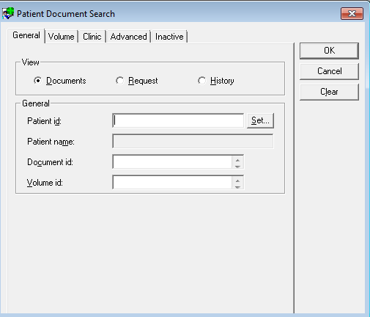
Type Patient URN
- You will see a variety of Locations
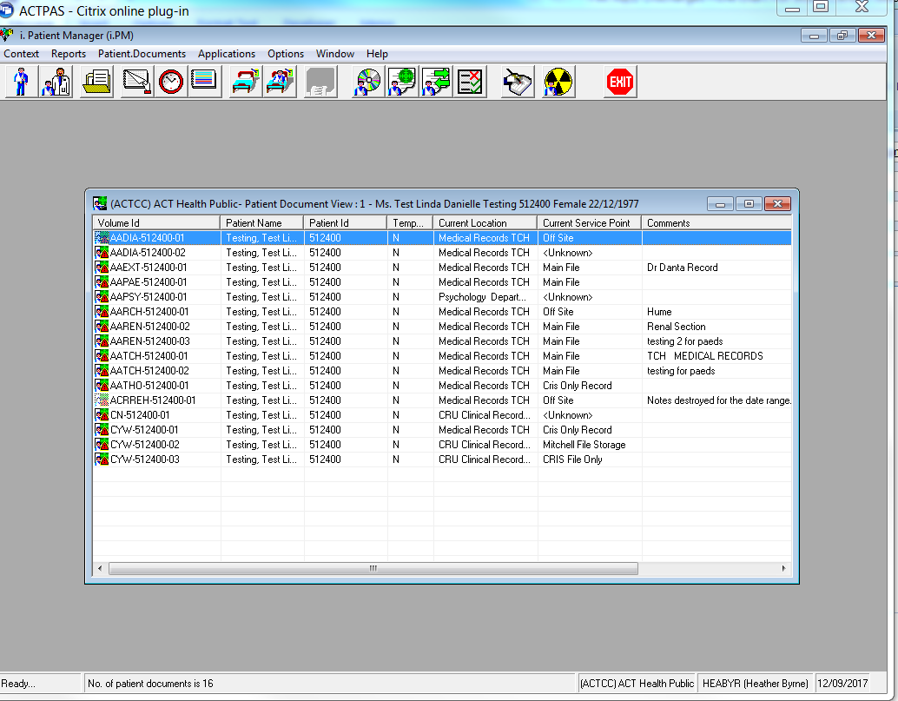

- Right click on one of the documents, select Patient Document, then select New
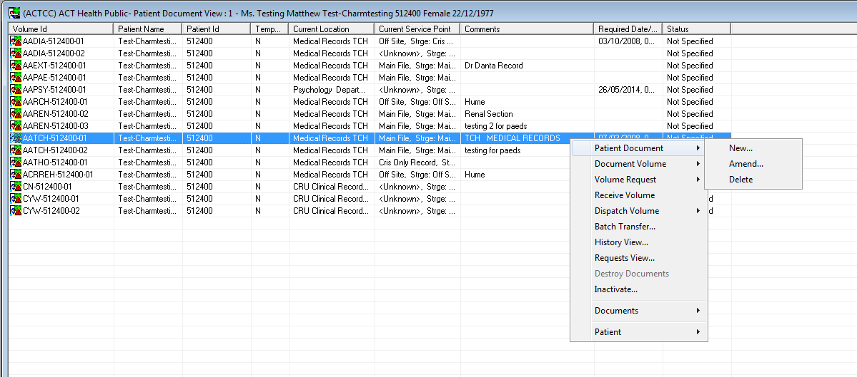

- Change the Document type to relevant document type for the document. If the document type already exists on ACTPAS, you may use this. If there has never been a document created for the relevant area in the past, a job will have to be logged with ICT to create a new document type on ACTPAS. You will need to specify in the job what you want the document to be called in ACTPAS.

Choose the relevant storage location, and as above if it is not listed, you will need to log a job with ICT to create a new storage location.
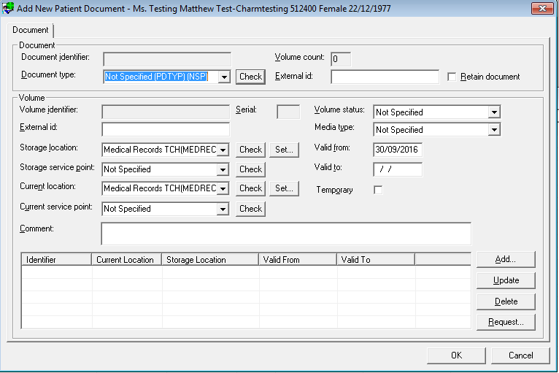
Document Type
Storage Location

Change the Storage service point to the relevant storage service point, for example New Main File
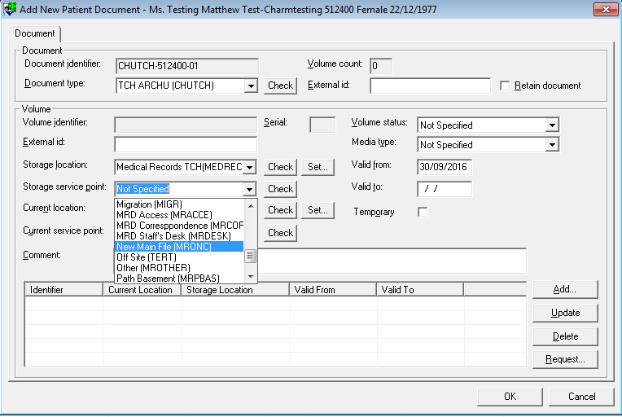
Service Point

- Add comment in Comments field if required, for example it could be a box number
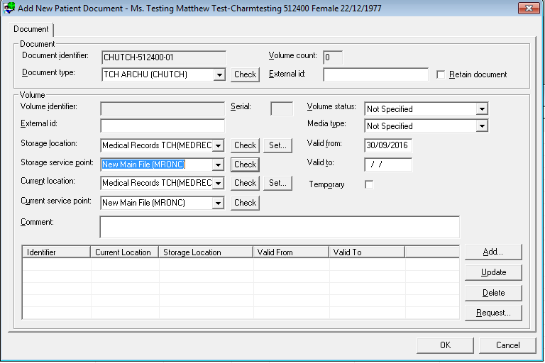
Add Box Number for example

- Click Add
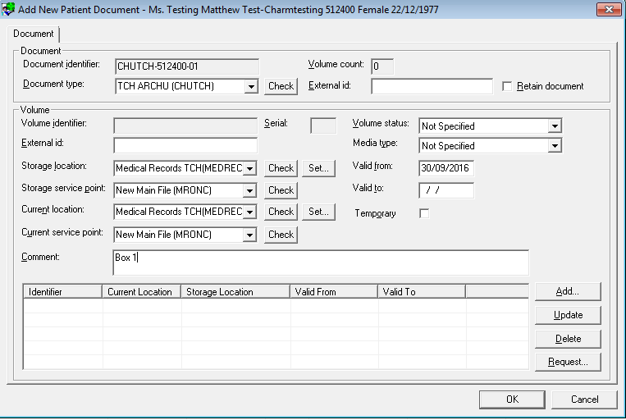

- You will be asked if you want to print a document volume label, click No
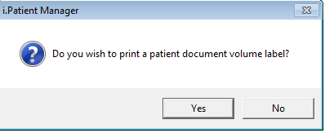

- Document is created
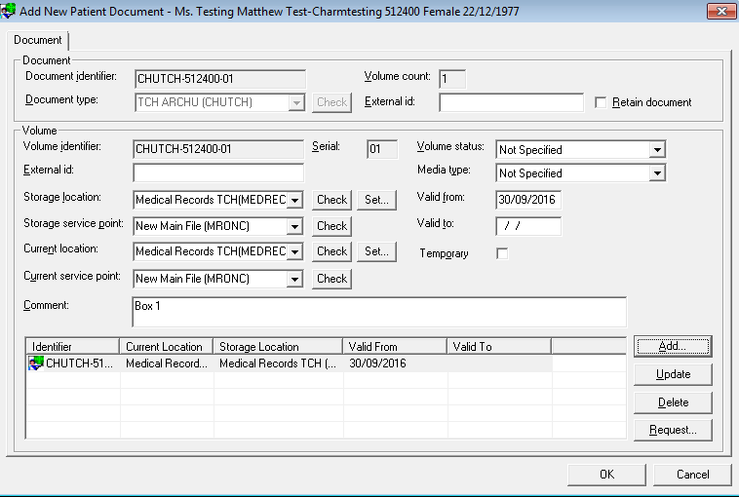

- Click OK to complete the process

- Completed Creation and Tracking should look like this.
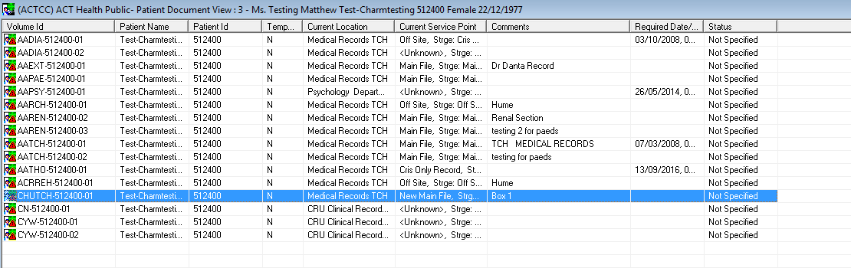

- To dispatch a Volume, right click on relevant document, move mouse over Dispatch volume, then select New
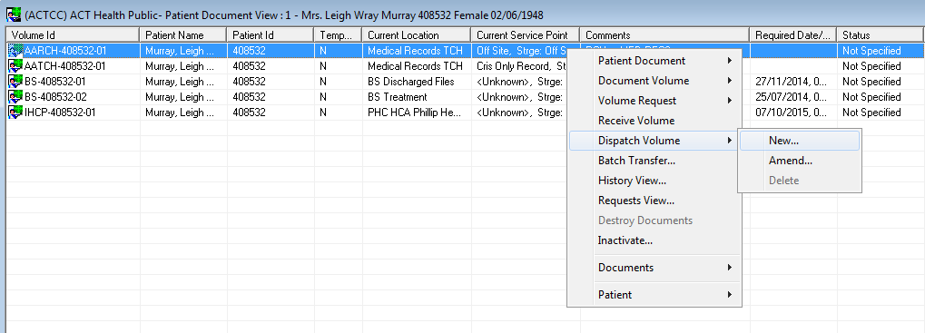
Click on NEW

- Change the Service point to relevant Service Point, Enter in Comments if required
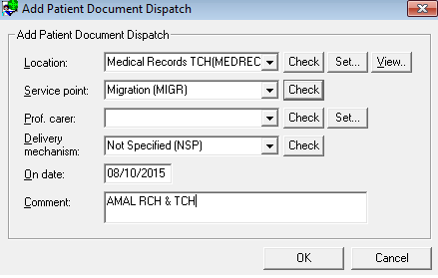
Service Point

- Click OK and Document is successfully dispatched.
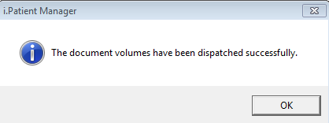

Back to Table of Contents

Attachment 3 – Tracking records for destruction
Once records have been approved for destruction by HIS and TRO, details of the records and the planned destruction need to be recorded and maintained as a “control” record or index of the record location. For most CHS records the ACTPAS Document Tracking module can be used for this purpose as per the process below.

Where tracking in ACTPAS is not possible, (e.g. where the patients are not already registered in ACTPAS), an excel file or list containing the details of each record should be created and sent to HIS. The list will need to include the URN, patient demographics, description of the record (record type), date created, date last actioned, destruction date.-

The Tracking process:
- Search for the patient using the PMI Active Search function and right click to select Patient Documents
OR
- Select the Document Tracking icon and enter the patients URN.

- From the Patient Document View screen select the required Document/Volume and double click.

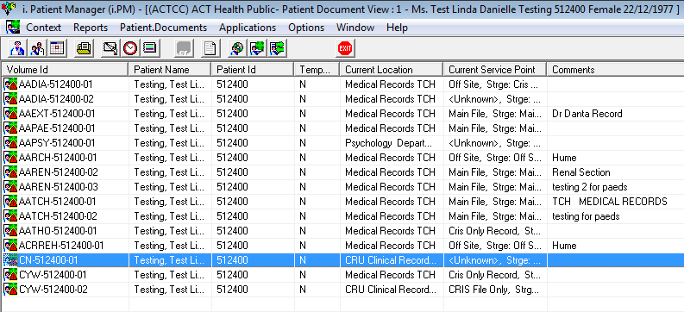
- Select the appropriate Storage service point from the drop-down box.
- Destroyed – Medical Records
- BS-Destroyed
- CRU-Destroyed

Note:
- ‘Destroyed Medical Records’ can only be used for Canberra Hospital document types with the Storage Location of Medical Records TCH.
- ‘BS – Destroyed’ can only be used for Breast Screen documents with a Storage Location of BS 1 Moore St.
- ‘CRU-Destroyed’ can only be used for Community document types with a Storage Location of CRU Clinical Records.

Contact Digital Solutions to add other document types and Storage Locations after consultation with HIS.

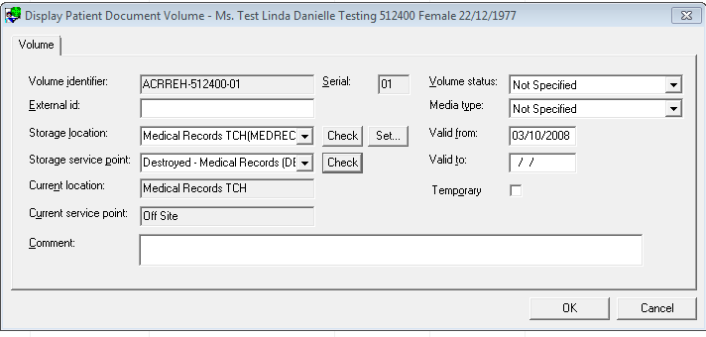
- Change the Volume Status to Closed and change the Valid to date to the date of destruction.
- Enter the date range of the notes in the Comment field.
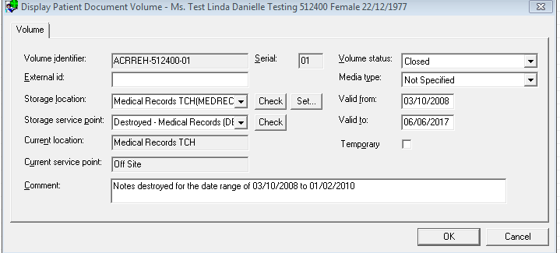

- Select ok. The Patient Document View displays the Current Service Point as Destroyed and the date range of the notes is visible in the Comments field.

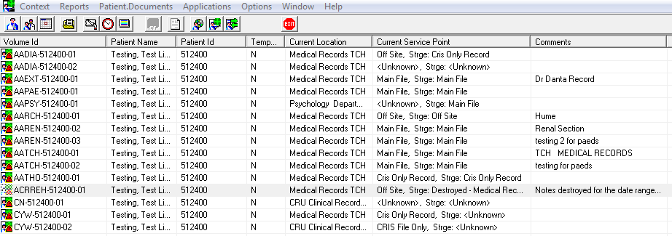
Back to Table of Contents

Attachment 4 – Physical storage requirements for clinical records
Building environment
The building and surrounds include the following characteristics: Free of potential external hazards, such as risk of fire, explosion, or impact; Appropriate location, that is, not within an area prone to flood, earthquake, a flight path, or close to heavy industry pollutants; an area with adequate storm water drainage; an area which is accessible to records users such as the public (for example using public transport).

The building must:
- Be a dedicated building or area within a building used solely for records storage. This reduces the risk of fire damage by eliminating volatile items, and exposure of records to items that may be detrimental to their preservation;
- Comply with Australian building standards and codes (the building and its services;)
- Be constructed of appropriate low maintenance, non-flammable construction materials, including steel, reinforced concrete, or concrete block;
- Have separation of storage areas from office areas/ facilities e.g., toilets and kitchens;
- Have sufficient space for appropriate storage and growth in volume;
- Have sufficient space to enable delivery of all services required by the controlling agency;
- Be secure, including site security, perimeter security ;
- Have adequate floor loading, in particular for in-house storage area;s
- Have adequate fire protection for the site and the building; and
- Have an enclosed loading dock.
Internal environment
Records must not be stored on the floor of the storage area, principally to minimise potential damage from any flooding. Occupational health and safety conditions for staff working in storage facilities must be maintained at all times. One aspect of this is the need to use correct equipment for retrieving records from high shelves.

The internal environment includes the following characteristics:
- Storage areas are isolated from internal hazards such as electrical plants or exposed plumbing;
- Appropriate and stable temperature/humidity levels;
- Appropriate energy management, air quality and lighting with minimisation of other sources of light (especially direct sunlight) and heat;
- Appropriate fire protection and safety facilities;
- Security, including access status and monitoring, controlled access to storage areas within the building, unauthorised entry detection system;
- Dirt and dust control;
- Pest and vermin control;
- Appropriate power supply; and
- Meeting occupational health and safety provisions.

Back to Table of Contents

