Canberra Health Services
Procedure
Blood Collection using Heel Lance Device (Neonates)

Contents

Contents 1
Purpose 2
Scope 2
Alert 2
Section 1 – Heel Lance Procedure 2
Evaluation 5
Related Policies, Procedures, Guidelines and Legislation 5
References 5
Search Terms 6

Purpose

The purpose of this procedure is to assist clinicians in collecting blood samples from neonates using a heel lance device.

Scope

This document applies to neonates/newborns at the following Canberra Health Services (CHS) Network facilities:
- Canberra Hospital
- Centenary Hospital for women and Children
- North Canberra Hospital.

This document applies to the following staff who are working within their scope of practice:
- Medical Officers
- Nurses and Midwives
- Students working under direct supervision.
Back to Table of Contents

Alert

The heel lance technique should not be performed on newborn babies (neonates) with:
- Oedematous feet
- Injured feet
- Infected feet
- Abnormalities that preclude putting pressure on the foot
- If a patient requires large volume of blood to be taken (>1mL) , sampling by venepuncture is preferred
- If blood is taken for a Full Blood Count and Coagulation Study, venepuncture is preferred to minimise risk of the blood clotting within the blood tube
- If capillary blood flow is inadequate after 2-3 attempts of heel lance, staff are to seek help from a senior clinician or consider venepuncture to minimise patient stress
- When taking blood from a neonate, staff should consider the developmental care needs around timing of and postioning during the procedure.

Back to Table of Contents

Section 1 – Heel Lance Procedure

Equipment
- Alcohol-based Hand Rub
- Gloves
- Sterile cotton wool balls
- Heel warming equipment (e.g., warm sheet, Infant Heel Warmer)
- Heel lance device
- Pathology request
- Appropriate pathology container (e.g., pathology tubes, newborn bloodspot screening card)
- Analgesia: expressed breast milk (EBM), wrap for swaddling, sucrose, dummy (if parental consent obtained)

Alert:
Do not use Infant Heel Warmers on neonates <35 weeks or <2 kgs as it may cause burns

Procedure
- Attend to hand hygiene (HH)
- Identify the infant as per Patient Identification and Procedure Matching Procedure
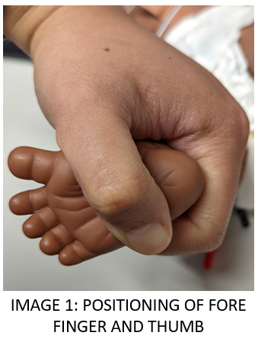
- Provide parents with information about the need for the collection of blood and obtain verbal consent
  - If attending to Newborn Bloodspot Screening Test (NBST), obtain parent/guardian consent prior to procedure. Refer to Newborn Bloodspot Screening Test Procedure
- Gather equipment
- If required, pre-warm the heel by applying a warm cloth/foot warmer for 3-5 minutes

Note:
The Clinical and Laboratory Standards Institute recommends the following order of draw when collecting capillary blood (skin puncture):
- Blood Gases
- Ethylenediaminetetraacetic acid (EDTA) tubes
- Other additive tubes
- Serum tubes
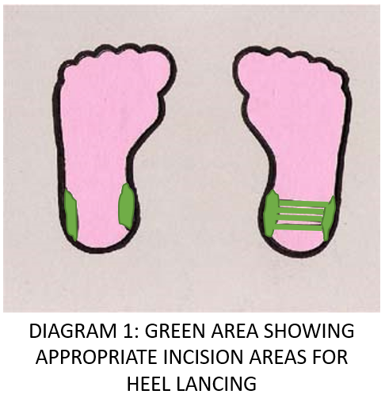
- Provide analgesia
  - If mother present, offer breastfeed
  - Offer EBM if present
  - If parental/guardian consent obtained, offer sucrose 2 minutes prior to procedure
- Apply gloves
- Dorsiflex the foot between the thumb and fore finger and grasp firmly. Refer to Image 1
- Place heel lance device with the flat blade opening surface flush on the incision area as demonstrated in Diagram 1 without exerting pressure
- Once area is ascertained, depress trigger
- After incising the heel, wipe away the first drop of blood to discard cellular debris that can contaminate the sample

Note:
- Safe incision areas are the sides of the heels on the plantar aspect of the foot. Research indicates that the plantar surface between those areas can be incised safely using a controlled-depth device if frequent sampling from the sides has rendered them unusable.
- Never incise the end of the heel.

- Apply gentle pressure to flexed heel to allow large drops of blood to freely form for collection. Avoid scraping or scooping.
- Release pressure to allow capillaries to refill and repeat
  - If blood stops flowing, wipe site with a gauze swab to remove clot, ensure time for capillary refill then reposition your hand and reapply pressure.
  - If blood does not flow, choose another incision site and repeat procedure.

Note:
- When collecting sample for NBST, make sure that infant’s skin does not touch the NBST card and that the entire test area (front and back) is covered
- Avoid excessive heel squeezing to prevent unnecessary pain and sample compromise
- Sample compromise can occur from fluid leakage, haemolysis and bruising

- After completing collection of blood sample, apply pressure to the incision site with cotton wool. Avoid using adhesive dressings
- Remove gloves and attend to HH
- Settle infant as per developmental care needs. Refer to Developmental Care in the Neonatal Intensive Care Unit and Special Care Nursery Guideline.
- Discard equipment appropriately as per standard Work Health and Safety procedures.
- Attend to HH
- Label pathology specimen containers and send to ACT Pathology
- Document procedure attended in patient’s clinical records.

Back to Table of Contents

Evaluation

Outcome
- Staff to follow this process for heel lancing for blood collection
- Blood collection through heel lance is done safely.
Measures
- Incidents in pathology specimen contamination
- Incidents relating to skin injury arising from NBST results recorded via Risk Management System
- Skin injuries measured and reported at neonatal QS meeting.

Back to Table of Contents

Related Policies, Procedures, Guidelines and Legislation

Policies
- Nursing and Midwifery Board of Australia (NMBA)nursing Requirements for Practice
- Informed Consent - Clinical

Procedures
- Infection Prevention and Control Procedure
- Patient Identification and Procedure Matching Procedure
- Patient Identification – Pathology Specimen Labelling Procedure
- Venepuncture Blood Specimen Collection Procedure
- Newborn Bloodspot Screening Test Procedure
- Venous & Arterial Access Management in the Department of Neonatology Procedure
- Pathology Specimen Handling and Transportation Procedure

Guideline
- Developmental Care in the Neonatal Intensive Care and Special Care Nursery

Legislation
- Health Records (Privacy and Access) Act 1997
- Human Rights Act 2004
- Work Health and Safety Act 2011

Other
- Australian Charter of Healthcare Rights
Back to Table of Contents

References
- Lippincott. Heelstick, neonatal [Internet]. Lippincott Procedures. 2021 [cited 25 May 2022]. Available from: https://procedures.lww.com/lnp/view.do?pId=6692488&hits=heel,heels,lancing&a=true&ad=false&q=heel%20lance
- Vedder T, Nimavat J (2015) Heel sticks. Medscape
https://www.schn.health.nsw.gov.au/files/attachments/newborn_screening_guidlines_2015.pdf
- Public Health England (2016) Guidelines for Newborn Blood Spot Sampling. Available from: https://assets.publishing.service.gov.uk/government/uploads/system/uploads/attachment_data/file/511688/Guidelines_for_Newborn_Blood_Spot_Sampling_January_2016.pdf
- Shah, V. & Ohlsson, A. (2011) Venepuncture versus heel lance for blood sampling in term neonates, Available from:
https://www.cochranelibrary.com/cdsr/doi/10.1002/14651858.CD001452.pub4/full
- World Health Organization (2010) WHO guidelines on drawing blood: Best practices in phlebotomy. Geneva: WHO; 2010. Available from: http://www.ncbi.nlm.nih.gov/books/NBK138650/

Back to Table of Contents

Search Terms

Heel prick, Heel lance, Heel stick, Blood collection, Blood spot, Heel lancing, Neonates, Neonatal, Infant, Infants, Newborn, Blood collection, NBST, sucrose
Back to Table of Contents

Disclaimer: This document has been developed by Canberra Health Services specifically for its own use. Use of this document and any reliance on the information contained therein by any third party is at his or her own risk and Canberra Health Services assumes no responsibility whatsoever.

Policy Team ONLY to complete the following:
Date Amended | Section Amended | Divisional Approval | Final Approval
31/08/2022 | Full review | Susan Freiburg, ED WYC | CHS Policy Committee
10/01/2024 | Related Policies, Procedures, Guidelines and Legislation | CHS Policy Team | CHS Policy Team
18/04/2024 | Updated to include NCH | CHS Policy Team | CHS Policy Team

This document supersedes the following:
Document Number | Document Name

