Procedure | Canberra Health Services

Eligibility for pregnancy ultrasound examinations and use of bedside ultrasound (maternity only) - North Canberra Hospital (NCH)
CHS25/004
Contents
Purpose 2
Alerts 2
Scope 2
Section 1 – First Trimester Eligibility 2
Section 2 – Second Trimester Eligibility 3
Section 3 – Third Trimester Eligibility 4
Section 4 – External Referrals 4
Section 5 – Use of Bedside Ultrasound in the Maternity Unit 5
Evaluation 6
Related policies, procedures, guidelines and legislation 7
References 8
Definition of terms 9
Search terms 9
Attachments 10
Attachment 1 - CHS Preterm Birth Prevention - Management of Moderate-Risk Patients Pathway 11
Attachment 2 - Fetal Growth Restriction (FGR) care pathway for singleton pregnancies 12

Purpose
The availability of pregnancy ultrasound examinations at North Canberra Hospital (NCH) is limited due to the medical imaging department’s responsibility to provide both inpatient and outpatient imaging and sonography services. This procedure will guide internal referrers with appropriate referrals for this publicly funded service.
This procedure also advises Midwives and Medical Officers on the use of the ultrasound in the NCH Maternity Unit.
Back to Contents

Alerts
All women with a body mass index (BMI) ≥50 are recommended to attend an ultrasound provider who provides tertiary level imaging services. Safe working limits of beds in the medical imaging department is 200kg although they are narrow in dimension so clinical judgement is needed.
NCH does not provide tertiary level ultrasound services such as fetal echocardiogram or ultrasound guided prenatal procedures. The Maternal Fetal Medicine Unit (MFMU) at the Centenary Hospital for Women and Children (CHWC) is to be referred to if these are required and the woman prefers it to be publicly funded.
Back to Contents

Scope
This document applies to the following staff working within their scope of practice at NCH:
- Medical Officers
- Nurses and Midwives
- Medical Imaging staff
Back to Contents

Section 1 – First Trimester Eligibility
Pregnancy ultrasound referrals to medical imaging at NCH are to be ordered in the Digital Health Record (DHR) as an Outpatient work order. Women that hold a GP referral letter may call medical imaging directly and make an appointment (if they fit the eligibility criteria).
The eligibility for pregnancy ultrasound services must be documented in the order or the referral may be declined by Medical Imaging services.
Frequency of required ultrasounds is as per the relevant guideline or clinical pathway.

Eligibility for early pregnancy ultrasounds (<18 weeks)
- Confirmation of pregnancy viability potentially requiring medical and/or surgical management
- Any emergency department presentation for early pregnancy concerns (i.e. per vaginal bleeding, severe pain or trauma)
- Confirmation of pregnancy location and ongoing management of ectopic and/or molar pregnancies.

Eligibility for Routine Fetal Anatomy Surveillance (Morphology 18 – 21+6 week ultrasound)
- All women who hold a Pension, Asylum Seeker or Health Care Card
- Women who are financially disadvantaged (decision to be made in conjunction with social work)
- Women who require an interpreter
- Women who identify as Aboriginal and/or Torres Strait Islander
- Women who are incarcerated, homeless or living in a refuge or safe house.
- Women who have been identified as part of a vulnerable group and are unlikely to engage in a service outside of the hospital
- Women with urgent obstetric or medical concerns
- Women with a moderate or high risk combined Nuchal Translucency result and who have not attended non-invasive prenatal testing (NIPT).
Back to Contents

Section 2 – Second Trimester Eligibility

Eligibility for Second trimester growth and fetal wellbeing ultrasounds (22-27⁺⁶ weeks)
- Women with urgent obstetric or medical concerns
- Women with previous early onset ≤32 weeks fetal growth restriction (birth weight [BW] < 10th percentile)
- Women on the moderate risk preterm birth prevention pathway (refer to Attachment 1 - CHS Preterm Birth Prevention-Management of Moderate-Risk Women Pathway). Women at high risk are to be referred to MFMU.
- Women who present at this gestation with no prior antenatal care
- Dichorionic Diamniotic (DCDA) twin pregnancy
- Previous Fetal Death in Utero (FDIU) or neonatal death.
Back to Contents

Section 3 – Third Trimester Eligibility

Eligibility for Third Trimester growth and fetal wellbeing ultrasounds (28-42 weeks)
- All eligibility the same as Second trimester plus:
- Women with previous fetal growth restriction born at any gestation
- Women who present at this gestation with limited or no prior antenatal care
- Placenta praevia
- Low lying placenta anteriorly with previous caesarean section
- Low lying placenta confirmed by ultrasound ≥ 32/40
- Women with Gestational Diabetes Mellitus (GDM) requiring insulin/metformin only
- Women who use illicit substances and/or regular alcohol and/or tobacco products
- Women with antiphospholipid antibodies, thrombophilia or Rhesus antibodies
- Women on medication for hypertension and/or neurological conditions (e.g., epilepsy)
- Women with suspected fetal growth restriction to be confirmed by ultrasound (estimated fetal weight [EFW] or abdominal circumference (AC) <10th percentile)
- Women with suspected accelerated fetal growth and other risk factors (confirmed by ultrasound EFW or AC >95%ile
- Level 3 in the Fetal Growth Restriction (FGR) Care Pathway (refer to Attachment 2 – Fetal Growth Restriction (FGR) Care Pathway for Singleton Pregnancies)
- ≥ 2 or more presentations for decreased fetal movements with normal cardiotocograph (CTG), or ≥ 1 presentation with abnormal features on CTG
- Suspected poly/oligohydramnios
- Breech presentation at term for vaginal breech/External Cephalic Version (ECV) assessment
- Women declining birth prior to 42+1 weeks (short notice ultrasound may be required. Please refer to Section 5 regarding eligibility for bedside ultrasound).
Back to Contents

Section 4 – External Referrals

Common indications that require referral to an external provider
- BMI ≥ 40 or ≤ 18
- Symphysiofundal height (SFH) ≥ 3cm above or below gestation
- Papp A (pregnancy associated plasma protein-A ) < 0.4 MoM
- Placental location
- Continuing suspicion of FGR with unchanged clinical assessment and a normal growth and fetal wellbeing ultrasound (EFW and AC >10%ile & normal dopplers)
- First presentation of decreased fetal movement with normal CTG
- Invitro Fertilisation/Assisted Reproductive Technologies pregnancy
- Diet-controlled GDM
- Marginal cord insertion
- Maternal age ≥ 40 years or ≤ 20 years
- Recent common maternal illness (i.e. COVID, influenza, gastroenteritis)
- Uterine fibroids
- Thyroid conditions
- Vaginal Birth After Caesarean (VBAC) assessment and planning
- Suspected SGA or LGA without other considerable risk factors

Exceptions that may qualify woman for internal ultrasound referral (at any gestation)
Unless the woman meets any of the following criteria, they are to be referred to private imaging provider:
- Health Care/Pension/Asylum Seeker Card holder
- Financially/socially disadvantaged
- Geographically isolated and attending multiple appointments at NCH.
- Identifies as Aboriginal and/or Torres Strait Islander
- Incarcerated, homeless or residing in a refuge or safe house
- Require an interpreter
- Diagnosed mental health condition requiring multiple medications and/or admission in pregnancy
- Diagnosed intellectual disability/deficit.
Back to Contents

Section 5 – Use of Bedside Ultrasound in the Maternity Unit
Bedside ultrasounds are to be performed by Obstetricians, Obstetric Registrars or Midwives who have formally recognised ultrasound training. Bedside ultrasound examinations can be used to assist with immediate obstetric decision making. Such examinations are complementary to, and do not replace, the services provided by an Accredited Medical Sonographer (AMS), particularly where the Obstetric Registrar is not experienced in obstetric ultrasound.

Indications for the use of ultrasound
- Limited obstetric ultrasound may include assessment of:
  - fetal heart sounds if the use of a sonicaid has proven unsuccessful
  - fetal position
  - fetal number, presentation and position
  - confirmation of fetal heart rate
  - amniotic fluid assessment
  - placental site
  - Doppler flow.
Alert
Transvaginal (TV) ultrasound is not performed within the Women and Children’s division. Transvaginal probes must not be used anywhere but in the Medical Imaging Department.

Equipment
Ultrasound machine.

Process
- Attend moments of hand hygiene as appropriate throughout the procedure (refer to the Infection Prevention and Control - North Canberra Hospital (NCH) procedure, available on the Policy and Guidance Documents register).
- Identify the correct patient (refer to the Patient Identification and Procedure Matching
procedure, available on the Policy and Guidance Documents register).
- When using the utrasound machine, only M-Mode (motion modulation) should be used to measure fetal heart, not the pulsed doppler.
- Operator to explain the procedure to the woman
- Ensure the woman is comfortable
- Gather all the required equipment (the ultrasound machine is kept in Birth Suite)
- Clean the probe and transducer with wipes before the scan
- Attend the scan
- After the scan the operator is required to clean the probe, transducer, control panel and keyboard with disinfectant wipes
- Return the equipment to Birth Suite
- The following must be document in the woman’s DHR
  - the indication for the ultrasound examination
  - findings and interpretation
  - recommendations
  - name of doctor or other practitioner performing the scan
  - plan for definitive scan if appropriate.
Back to Contents

Evaluation
Outcome
- Ultrasounds are conducted in a timely manner
- Ultrasound appointments will be available to women as required by this procedure

Measures
- Ultrasound availability will be monitored to ensure that women with identified needs are able to access services as required by this procedure.
- Clinical and quality outcomes are evaluated through patient experience questionnaires and consumer feedback data.
- Regular monitoring through the Maternity Quality and Safety Committee, to ensure any issues arising are addressed.
Back to Contents

Related policies, procedures, guidelines and legislation

Policies
- Nursing and Midwifery Board of Australia (NMBA) Requirements for Practice

Procedures
- External ultrasound probe use and reprocessing requirements – North Canberra Hospital (NCH)
- Indigenous Status Data Collection – North Canberra Hospital (NCH)
- Infection Prevention and Control – North Canberra Hospital (NCH)
- Patient Identification and Procedure Matching

Guidelines
- Antepartum Haemorrhage (APH) including Placenta Praevia, Placental Abruption and Vasa Praevia
- Birth After Previous Caesarean Section – North Canberra Hospital (NCH)
- Consent for Healthcare Treatment
- Obesity – Pregnancy, Labour, Birth and Postnatal care
- Obstetric Emergencies
- Pregnancy Care
- Preterm Birth Screening and Prevention

Legislation
- Health Records (Privacy and Access) Act 1997
- Human Rights Act 2004
- Work Health and Safety Act 2011
- Carers Recognition Act 2021
- Multiculturalism Act 2023

Other
- Australian Charter of Healthcare Rights
Back to Contents

References
- Alfirevic Z, Stampalija T, Dowswell T. Fetal and umbilical Doppler ultrasound in high‐risk pregnancies. Cochrane Database of Systematic Reviews 2017, Issue 6. Art. No.: CD007529. DOI: 10.1002/14651858.CD007529.pub4.
- Alfirevic Z, Stampalija T, Medley N. Fetal and umbilical Doppler ultrasound in normal pregnancy. Cochrane Database of Systematic Reviews 2015, Issue 4.
- American Institute of Ultrasound Medicine, 2019. Practice Parameter for the Performance of Detailed Second- and Third-Trimester Diagnostic Obstetric Ultrasound Examinations. J Ultrasound Med, 38: 3093-3100.
- Australian Government Department of Health and Aged Care. (2020). Clinical Practice Guidelines: Pregnancy Care. https://www.health.gov.au/resources/pregnancy-care-guidelines?utm_source=health.gov.au&utm_medium=redirect&utm_campaign=digital_transformation&utm_content=antenatal (Accessed 30/09/2022).
- Australian Government Department of Health, 2021. Pregnancy Care Guidelines clinical assessments.
- Bricker L, Medley N, Pratt JJ. Routine ultrasound in late pregnancy (after 24 weeks' gestation). Cochrane Database of Systematic Reviews 2015, Issue 6. Art. No.: CD001451. DOI: 10.1002/14651858.CD001451.pub4.
- Gomez Acevedo H, Rahman MH, Moreno MA, 2023 Sonography 3rd Trimester and Placenta Assessment, Protocols, and Interpretation. Statpearls Publishing.
- Kaelin Agten A, Xia J, Servante JA, Thornton JG, Jones NW. Routine ultrasound for fetal assessment before 24 weeks' gestation. Cochrane Database of Systematic Reviews 2021
- Lees CC, Stampalija T, Baschat AA, da Silva Costa F, Ferrazzi E, Figueras F, Hecher K, Kingdom J, Poon LC, Salomon LJ, Unterscheider J. ISUOG Practice Guidelines: diagnosis and management of small-for-gestational-age fetus and fetal growth restriction. Ultrasound Obstet Gynecol 2020; 56: 298–312
- Lowe SA, Bowyer L, Lust K, McMahon L, Morton M, North RA, Paech M. Said J. Guidelines for the management of hypertensive disorders of pregnancy, 2014. Society of Obstetric Medicine for Australia and New Zealand
- National Institute for Health and Care Excellence, 2020. NICE Guideline NG3 - Diabetes in pregnancy: management from preconception to the postnatal period.
- Rao U, de Vries B, Ross GP, Gordon A. Fetal biometry for guiding the medical management of women with gestational diabetes mellitus for improving maternal and perinatal health. Cochrane Database of Systematic Reviews 2019, Issue 9. Art. No.: CD012544. DOI: 10.1002/14651858.CD012544.pub2.
- Royal Australian and New Zealand College of Obstetrics & Gynaecology, Guideline: Prenatal assessment of fetal structural conditions, 2021.
- Royal College of Obstetricians & Gynaecologists, 2013. Small for Gestational Age Fetus, Investigation and Management (Green-top Guideline No. 31).
- Shipp TD, Simpson LL, Levine, D, Barss VA. UpToDate Overview of ultrasound examination in obstetrics and gynaecology, 2023
- Woolcock JG, Grivell RM, Dodd JM. Regimens of ultrasound surveillance for twin pregnancies for improving outcomes. Cochrane Database of Systematic Reviews 2017, Issue 11. Art. No.: CD011371. DOI: 10.1002/14651858.CD011371.pub2.
Back to Contents

Definition of terms
Non-eligible: non-residents of Australia who are not eligible for Medicare funding
Dichorionic Diamniotic (DCDA) twins: twin pregnancy with two separate gestational sacs and two placentas
Ectopic: a pregnancy occurring in an abnormal location (non-viable pregnancy)
Molar: a tumor that develops in uterus due to a non-viable pregnancy
Fetal Growth Restriction (FGR): suspected = EFW (estimated fetal weight) or AC (abdominal circumference) <10th percentile or confirmed = BW (birth weight) <10th percentile.
Threatened Preterm Labour (TPL): suspected labour <36 weeks
Papp A: Pregnancy associated plasma protein-A (a placenta mediated protein). Test result can be expressed as an MoM (multiple of the median).
Placenta Praevia: Placenta in contact with or covering internal os (≥ 20/40)
Low lying placenta (LLP): lower placental edge within 20mm of internal os (≥ 20/40)
LLETZ: large loop excision of the transformation zone (of the cervix)
LGA: Large for Gestation age (suspected = EFW or AC >95%ile or confirmed = BW >90%ile)
Non-invasive prenatal testing (NIPT): testing of fetal cells in maternal blood for chromosomal abnormalities
Symphysiofundal height (SFH): measurement of pregnant abdomen from symphysis pubis to fundus
External Cephalic Version (ECV): attempted external turning of malpresentation
Back to Contents

Search terms
Ultrasound, medical imaging, early pregnancy, trimester, first, second, third, emergency, maternity, bedside, POCUS, point of care, birth suite, midwife, north.
Back to Contents

Attachments

Attachment 1: CHS Preterm Birth Prevention-Management of moderate-risk women Pathway

Attachment 2: Fetal Growth Restriction (FGR) Care Pathway for singleton pregnancies
Back to Contents

For Policy Team to complete:
Date amended | Section amended | Divisional approval | Final approval
07/01/2025 | New Document Added | Michelle Thinius, ED, Women & Children – NCH | Policy Document Review Panel
This document supersedes the following:
Document number | Document name
CHS24/187 | Use of Ultrasound in Maternity Unit
Disclaimer
This document has been developed by Canberra Health Services specifically for its own use. Use of this document and any reliance on the information contained therein by any third party is at his or her own risk and Canberra Health Services assumes no responsibility whatsoever.
Back to Contents

Acknowledgement of Country  Canberra Health Services acknowledges the Ngunnawal people as traditional custodians of the ACT and recognises any other people or families with connection to the lands of the ACT and region. We acknowledge and respect their continuing culture and contribution to the life of this region.  © Australian Capital Territory, Canberra 2024 | Accessibility  call (02) 5124 0000   Interpreter call 131 450  canberrahealthservices.act.gov.au/accessibility  

Attachment 1 - CHS Preterm Birth Prevention - Management of Moderate-Risk Patients Pathway

Source: Preterm Birth Prevention Guidelines, Kind Edward Memorial Hospital for Women, Perth Western Australia
Back to Contents

Attachment 2 - Fetal Growth Restriction (FGR) care pathway for singleton pregnancies
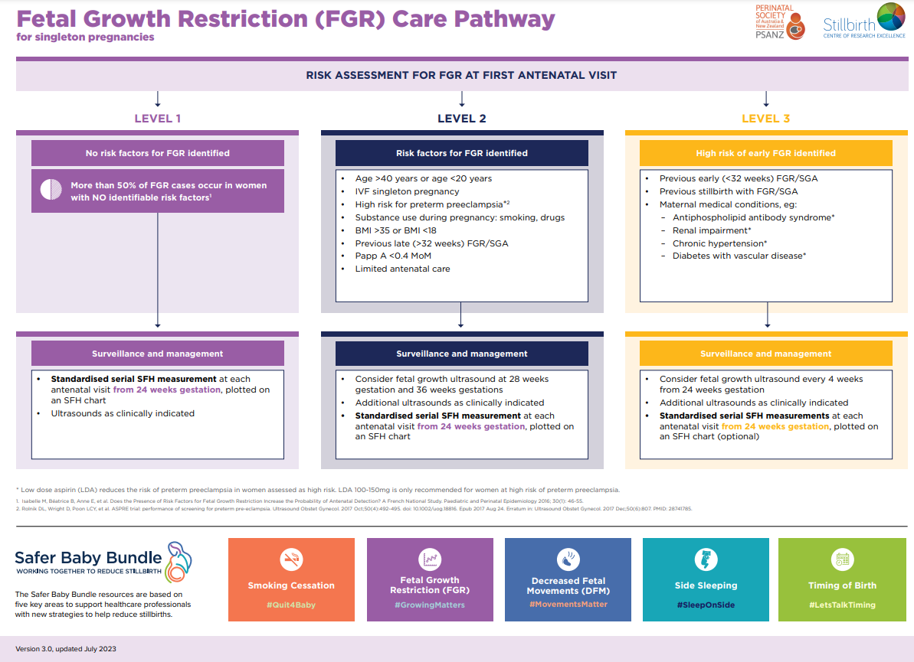
Source: Stillbirth Centre of Research Excellence (available at: https://learn.stillbirthcre.org.au/wp-content/uploads/2023/05/FGR-Care-Pathway-V2.0.pdf)
Back to Contents

