Guideline | Canberra Health Services
Nurse Initiated Treatment for Lacerations in the Canberra Hospital Emergency Department- Adults and Paediatrics aged more than 1 year
CHS24/410

Contents
Guideline statement 2
Scope 2
Section 1 – Laceration criteria 2
Section 2 – Management/Treatment 4
Evaluation 12
Related policies, procedures, guidelines and legislation 12
References 13
Search terms 13

Guideline statement
This guideline aims to ensure appropriate treatment for minor wounds in adult and paediatric patients (less than 16 years) in the Canberra Hospital Emergency Department (ED).
The primary goals are to:
- Prevent wound infection
- Closure of a wound
- Suspend bleeding
- Minimise pain/discomfort
- Facilitate healing
- Minimise scar formation.
Back to Contents

Scope
This guideline applies to adult and paediatric patients (less than 16 years) presenting to the Canberra Hospital Emergency Department with minor wounds.
This guideline applies to the following staff working within their scope of practice:
- Nurses working in the ED
- Nursing students under direct supervision.
This guideline applies to registered and enrolled nurses who have successfully:
- Completed the five wound modules on HRIMS.
Clinicians should seek guidance from experienced senior medical and/or nursing staff when appropriate or refer to specialty teams as necessitated by the specific injury.
Back to Contents

Section 1 – Laceration criteria
A laceration is a breach in the skin that can involve one or more of the epidermis, dermis, subcutaneous layer, and deep fascia.
Inclusion criteria:
- Adult and paediatric patients (aged more than 1 year)
- Lacerations that are single layered
- Single laceration less than or equal to 5cm in length
- Edges easily approximated
- Wound less than 12 hours old
- Superficial debris easily removed
- Wound bed visualised and no underlying structures involved.
Redirect to medical officer if:
- Contaminated wounds
- Signs of infection
- Infants less than 12months of age or suspected non-accidental injury
- Wound greater than 12 hours old
- Multiple lacerations, total length greater than 20cm
- Concerned about ability to close wound with good cosmetic outcome
- Single laceration greater than 5cm in length
- Puncture wounds e.g. Human/animal bites
- Other co-morbidities e.g. bleeding disorders, immunodeficiency
- Concern about ability to close laceration to hand, scalp, structures surrounding eyes, lips, nose, neck, ears or genitals.
- Any signs of neurovascular compromise
- Can visualise or are suspicious of any injury to tendon or ligament
- Associated injuries (e.g. head or cervical spine in falls, eye in facial trauma, teeth with mouth injuries)
- Injury to deeper structures (e.g. Tendons, joints, muscles or nerves)
- Wounds at risk of or containing a foreign body
- Impairment of blood supply to surrounding tissue
- Areas with end-arterial supply (extremities such as tip of the nose, fingertips, ear lobes).
- Uncontrolled pain from lacerations
Differentials
Not applicable.
Back to Contents

Section 2 – Management/Treatment
Work-up and Pre-Treatment measures:
Complete the following assessment of the patient with their parent/carer (as appropriate) and document in DHR:
- Primary assessment of airway, breathing and circulation, inclusive of neurological assessment if indicated.
- Pain assessment appropriate to age and development i.e. numerical pain scale, Wong-Baker FACES scale, Face, Legs, Activity, Cry, Consolability (FLACC) scale. If pain is identified, then pre-procedural pain relief is provided.
  - For adult and paediatric patients refer to heading Medication Standing Orders or ask a senior ED Medical Officer (EDMO) to chart appropriate analgesia.
- Injury details including time, place, mechanism and risk assessment for non-accidental injury, and last oral intake.
- Immunisation status including previous medical history.
- Allergies e.g. local anaesthetics, latex.
- Motor and vascular function should be assessed prior to any intervention.
- Clarification of the mechanism of injury to identify high risk wound e.g. bite, puncture wound, power tool, burns.
- Wound assessment including depth, shape, length, possible foreign bodies or involvement of underlying structures.
- All children aged 1-12 years presenting with a laceration to be assessed for application of Laceraine.
- For adults and older children consider referral to an EDMO for regional anaesthetic if pain is significant and unable to be managed with medication standing orders.

Treatment:
- All lacerations are to be irrigated/cleaned with 0.9% sodium chloride to ensure they are clean and all foreign material is removed
- Base of wound to be visualised to exclude injury to underlying structures/ presence of foreign body.
Laceraine®:
Inclusion: children aged between 1-12 years with a laceration under 5cm in length:
Gel Laceraine® application:
- The procedure should be explained to the client/parent/carer and consent gained to apply gel Laceraine®.
- Consider distraction therapy to assist with compliance in paediatric patients or neurodivergent children. If willing, parents can continue to provide comfort to the child. Communicate all steps involved in children who can comprehend the procedure to reduce anxiety. If anxiety is too elevated, then refer to EDMO for potential need for anxiolytics or sedation to reduce trauma.
- Consider getting assistance with wound closure prior to beginning procedure. Assistance should be sought if appropriate positioning is required to achieve proper application of Laceraine®.
- Clean wound to remove debris and clotted blood.
- Wearing gloves, apply gel to wound bed.
- Use gauze to create a barrier around periwound, leaving wound bed open for visualisation.
- Draw up 0.1ml/kg of Laceraine® up to a:
- Maximum of 2ml for children aged 1-3 years
- Maximum of 3ml for children aged 3 years to adults
- Place Laceraine gel onto wound and cover wound and area around wound with an occlusive dressing. The hollow centre should be visible to track Laceraine® effectiveness – see image below.
- Leave dressing in situ for 20-30 minutes (maximum 60 minutes); test sensation prior to treatment
Alert: Care should be taken to ensure the product is not inadvertently transferred to the eyes, mouth and other mucous membranes

- Provide the parent/carer with the Laceraine® fact sheet and return the client and their parent/carer to the waiting room to enable Laceraine® to take effect.
- If any adverse or systemic events are identified then the occlusive dressing should be immediately removed, wound irrigated and urgent clinical review obtained.
- Refer to Emergency Department Medication Standing Order for Laceraine for indications, contraindications, exclusions and dosing guides.
- The dressing and residual product must be removed after 60 minutes to avoid excess absorption

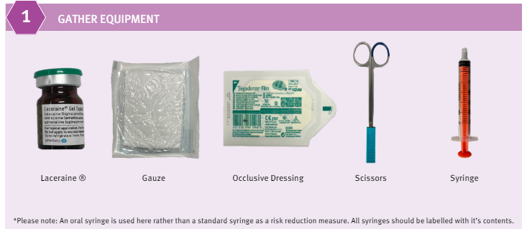
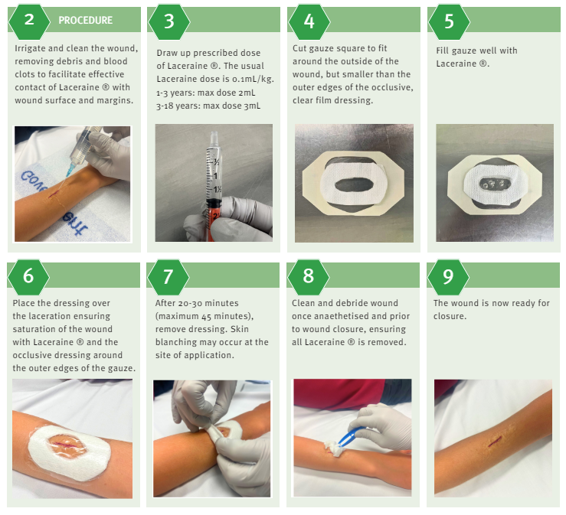
Gel Laceraine application (Children’s Health Queensland Hospital and Health Service)

Liquid Laceraine® application:
- The procedure should be explained to the client/parent/carer and consent gained to apply liquid Laceraine®.
- Consider distraction therapy to assist with compliance in paediatric patients or neurodivergent children. If willing, parents can continue to provide comfort to the child. Communicate all steps involved in children who can comprehend the procedure to reduce anxiety. If anxiety is too elevated, then refer to EDMO for potential need for anxiolytics or sedation to reduce trauma.
- Consider getting assistance with wound closure prior to beginning procedure. Assistance should be sought if appropriate positioning is required to achieve proper application of Laceraine®.
- Clean wound to remove debris and clotted blood
- Draw up 0.1ml/kg of Laceraine® up to a:
- Maximum of 2ml for children aged 1-3 years
- Maximum of 3ml for children aged 3 years to adults
- Wearing gloves, soak gauze with Laceraine® and apply to wound
- Cover wound and area around wound with an occlusive dressing
- Leave dressing insitu for 20-30 minutes (maximum 60 minutes); test sensation prior to further treatment
Alert: Care should be taken to ensure the product is not inadvertently transferred to the eyes, mouth and other mucous membranes
- Provide the parent/carer with the Laceraine® fact sheet and return the client and their parent/carer to the waiting room to enable Laceraine® to take effect.
- If any adverse or systemic events are identified then the occlusive dressing should be immediately removed, wound irrigated and urgent clinical review obtained.
- Refer to Emergency Department Medication Standing Order for Laceraine for indications, contraindications, exclusions, and dosing guides.
- The dressing and residual product must be removed after 60 minutes to avoid excess absorption.

Skin Adhesive
Inclusion: if the wound is on a non-functional/low tension, dry area of the body, less than 5cms, not contaminated or infected, less than 12 hours since injury then a skin adhesive may be considered.
Skin adhesive application:
- The procedure should be explained to the client/parent/carer and consent gained to close wound with glue.
- Consider distraction therapy to assist with compliance in paediatric patients or neurodivergent children. If willing, parents can continue to provide comfort to the child. Communicate all steps involved in children who can comprehend the procedure to reduce anxiety. If anxiety is too elevated, then refer to EDMO for potential need for anxiolytics or sedation to reduce trauma.
- Consider getting assistance with wound closure prior to beginning procedure. Assistance should be sought if appropriate positioning is required to achieve proper alignment and wound closure.
- The wound should be cleaned, and haemostasis achieved prior to closure. Do not trim or shave hair. Do not use on mucosal surfaces.
- The glue vial should be prepared according to the manufacture’s recommendations.
- Oppose the edges of wound by using longitudinal traction and/or lateral pressure from both sides of the wound and apply very small amount of glue to surface, holding edges together for 30 seconds. Do not allow glue to enter wound itself as it is not absorbable (acts as foreign body) and may result in wound dehiscence.
- Follow product instructions, i.e. if Dermabond wait 30 seconds prior to applying subsequent layers and apply second and third layers over the length of the laceration slightly increasing in width with each application.
- Apply an eye pad or clean gauze to protect the eye if the wound is in the vicinity of the eye or on the forehead; to avoid glue dripping into the eye or eyelashes.
- If gloved fingers adhere to the patient’s skin, remove contact immediately. If this fails, use warm soapy water to release the contact or trim the adherent portion of glove which will lift or fall off over the next week. Explain same to parent/carer.
- Advise parents skin adhesive will come off after 5-10 days and should not be removed manually.

Adhesive Strips
Inclusion: if the wound is on a non-functional, dry area of the body and is shallow then adhesive strips may be considered:
- The procedure should be explained to the client/parent/carer and consent gained.
- Clean wound
- Ensure surrounding skin is clean and dry. Apply protective barrier wipe to surrounding skin to increase adhesiveness of strips.
- Ensure haemostasis prior to or upon application.
- Consider distraction therapy to assist with compliance in paediatric patients or neurodivergent children. If willing, parents can continue to provide comfort to the child. Communicate all steps involved in children who can comprehend the procedure to reduce anxiety. If anxiety is too elevated, then refer to EDMO for potential need for anxiolytics or sedation to reduce trauma.
- Carefully approximate wound edges. Apply first strip to middle of wound, place half of one strip on one side and then gently bring edges of wound together and pass strip over to adhere to other side.
- Place strips alternately to each side to keep skin tension equal. Also place strips with sufficient space between each to allow drainage of fluid from the wound to avoid infection.
- Consider anchoring rows of strips with two strips across the distal end of rows.
- Avoid circumferential application of adhesive strips or rigid tapes around digits in order to prevent constriction of circulation and potential secondary ischaemic injury
- Adhesion of skin closures will be enhanced if you gently but firmly press or stroke the skin closure strip during application. Skin adhesive glue may be used to stick steri-strips down parallel to the wound but NOT over the wound.
- Advise client/parents/carers adhesive strips:
- Are usually worn until they fall off, approximately 5-7 days - wear time depends on area of the body, friction and skin type.
- Edges of strips can be trimmed to extend duration of adherence.
- Keep dry for 24 hours after application, then can be pat dry after shower - limit exposure to water to increase duration of adherence.

On completion of all wound closure:
- Motor, neurological, and vascular function should be reassessed to ensure no new deficit has arisen during closure.
- Choose appropriate non-adherent dressing. Mepilex borders should be avoided as it can cause the adhesive to peel off.
- Document details, including any complications of procedure in DHR.
Advice for client/parent/carer
- Elevate to reduce swelling and pain. Recommend simple analgesia as required.
- Offer Adult Diptheria & Tetanus (ADT) if appropriate or consider tetanus immunoglobulin if unknown previous tetanus cover.
- Avoid further trauma to the area and seek medical review should the wound break open or become infected.
- Refer parents to The Royal Children’s Hospital (RCH) Kids Health Info app for more information on home care.
- Advise parents that wounds heal quickly in children and that there will be some scar formation, no matter which method is used to close the wound.
- Scar minimisation advice:
- Refer to ‘Massaging your scar’ document on CHS intranet
- Avoid repeated trauma to the area;
- Avoid sun exposure (consider protective clothing whilst in sun)
Medication Standing Orders
- Paracetamol CHS24 228 Medication Standing Order
- Ibuprofen Registered Nurse and Registered Midwife Initiation Medication Orders
- Panadeine Forte – for adults
- Oxycodone – for adults
- Laceraine®
Back to Contents

Evaluation
Outcome
- Reduction in wait time for adult and paediatric patients presenting to Emergency Department
- Improvement in patient and parent/carer satisfaction.
- Avoiding representation in patients with lacerations that can be managed by nursing staff.
- Improving wound care skills in the emergency department through the upskilling of staff
Measures
- Regular review and reporting to relevant managers of clinical activity, referrals received, and waitlist times.
- Reviewing wound management, specifically lacerations that fit the criteria in this policy, to ensure efficiency and effectiveness of treatment.
- Reviewing wait times pre implementation of this treatment guideline and post implementation for adult and paediatric patients.
Back to Contents

Related policies, procedures, guidelines and legislation

Policies
- Nursing and Midwifery Requirements for Practice

Procedures
- Infection Prevention and Control
- Patient Identification and Procedure Matching
- Wound Prevention and Management
- Paracetamol CHS24 228 Medication Standing Order
- Ibuprofen – Registered Nurse and Registered Midwife MSO
- Panadeine Forte – for adults ED MSO
- Oxycodone – for adults ED MSO
- Laceraine®- ED MSO

Guidelines
- Consent for Healthcare Treatment

Legislation
- Health Records (Privacy and Access) Act 1997
- Human Rights Act 2004
- Work Health and Safety Act 2011
- Carers Recognition Act 2021

Other
- Australian Charter of Healthcare Rights
Back to Contents

References
- Australian Medicines Handbook, (2019). Lidocaine (anaesthesia). Retrieved from: https://amhonline.amh.net.au/chapters/chap-02/anaesthesia-local-drugs/anaesthetics-local/lignocaine-01
- DeLemos D. (2017). Closure of minor skin wounds with sutures. In A.M. Stack, A. B. Wolfson & J. F. Wiley (Eds.). UpToDate. Retrieved from: https://www.uptodate.com/contents/closure-of-minor-skin-wounds-with-sutures?source=search_result&search=laceration&selectedTitle=1~51
- Marshall G, (2013). Skin glues for wound closure. NPS Medicine Wise. http://www.nps.org.au/australian-prescriber/articles/skin-glues-for-wound-closure#b1
- Royal Children’s Hospital Melbourne, (2022). Lacerations. Retrieved from: Clinical Practice Guidelines : Lacerations (rch.org.au)
- Sydney Children’s Hospital (2021). Laceration management in the emergency department. Retrieved from: https://resources.schn.health.nsw.gov.au/policies/policies/pdf/2009-0011.pdf
- Children’s Health Queensland Hospital and Health Service (n.d.). Laceraine application. Retrieved from: https://www.childrens.health.qld.gov.au/__data/assets/pdf_file/0029/219728/Laceraine-R-application-skill-sheet.pdf.pdf

Back to Contents

Search terms
Laceration, skin, glue, adhesion, strips, laceraine, paediatric, emergency department
Back to Contents

For Policy Team to complete:
Date amended | Section amended | Divisional approval | Final approval
10/09/2024 | New document | Andrew Slattery, ED, Medicine | PDRP
This document supersedes the following:
Document number | Document name

Disclaimer
This document has been developed by Canberra Health Services specifically for its own use. Use of this document and any reliance on the information contained therein by any third party is at his or her own risk and Canberra Health Services assumes no responsibility whatsoever.
Back to Contents

Acknowledgement of Country  Canberra Health Services acknowledges the Ngunnawal people as traditional custodians of the ACT and recognises any other people or families with connection to the lands of the ACT and region. We acknowledge and respect their continuing culture and contribution to the life of this region.  © Australian Capital Territory, Canberra 2024 | Accessibility  call (02) 5124 0000   Interpreter call 131 450  canberrahealthservices.act.gov.au/accessibility  

