Canberra Health Services
Procedure
North Canberra Hospital (NCH) - Falls Risk Minimisation and Management Procedure

Contents

Contents 1
Purpose 2
Scope 2
Section 1 – Equipment 2
Section 2 – Falls risk screen and assessment 3
Section 3 – Falls prevention interventions and management 4
Section 4 – Falls reporting an management post-fall in an inpatient setting 6
Section 5 – Management of the recurrent faller 12
Related Policies, Procedures, Guidelines and Legislation 13
References 13
Definition of Terms 14
Search Terms 14
Attachments 14
Attachment 1 – Instrinsic and extrinsic risk factors and falls prevention interventions 15
Attachment 2 – Riskman clinical incident notification 19
Attachment 3 – Fit to transfer test 21
Attachment 4 – Use of Bedrails Matrix 22

Purpose

This document provides a procedure that will aim to enhance patient safety by effectively identifying inpatients who are at risk of falls, minimising patient falls, and reducing adverse outcomes from falls. It also provides guidance for the management of patients that have sustained a fall whilst in hospital. It is acknowledged, however, that there may be non-preventable falls risks due to a medical condition, cognitive and other disability. This procedure aims to minimise the impact of falls to the patient and their family.

The purpose of this procedure is to:
- Provide direction to all clinical staff to improve the safety and quality care of patients by identifying their falls risk through screening and assessment and implementing appropriate falls prevention interventions.
- Establish a consistent approach to the prevention and management of falls (including post fall “huddles”) that is in accordance with Australian best practice guidelines.
- Increase awareness of the importance of being proactive in the prevention of falls and falls related injury.
- Establish a consistent approach to the safe use of bed rails in accordance with best practice evidence.
- Clarify the governance infrastructure in place that outlines responsibilities in relation to the prevention and management of falls and falls injury.
- Provide direction to all staff to maintain a safe and clean environment.

Back to Table of Contents

Scope

This procedure applies to all patients who present or are admitted to North Canberra Hospital (NCH) and Clare Holland House (CHH) and staff and students providing care at both NCH and CHH.

This procedure applies to the following NCH and CHH staff working within their scope of practice:
- Medical Officer
- Nursing and Midwifery staff
- Allied health Professionals
- Support Service Staff.
Back to Table of Contents

Section 1 – Equipment

Patients’ equipment needs are based on the Multi-Disciplinary Team (MDT) risk assessment AND clinical judgement of the treating clinicians at the time of care provision.
The following necessary equipment is available on the ward to minimise patient falls.
Equipment includes, but may not be limited to:

- manual handling equipment
- bathroom aids
- mobility aids
- hi lo beds
- bed rails
- nurse Call bells
- bed/chair alarms
- non slip socks
- ezi reachers.
Back to Table of Contents

Section 2 – Falls risk screen and assessment

- All patients will have a Falls Screen and, if indicated, a Falls Risk Assessment Tool completed in the Digital Health Record (DHR) under Risk Screenings. The falls prevention action plan must be implemented and documented immediately after completion of the FRAT for all patients identified as having a ‘high risk’ of falls.
- Timely referrals are made to allied health professionals according to risk factors, for further assessment and provision of falls risk mitigation strategies.
- For inpatients identified at “High Risk” of falls on completion of the screening tool, a medication review is required by a medical officer (MO) or pharmacist.
- A documented Falls Risk Screen and FRAT (if indicated) should be completed:
- On arrival to the hospital (within 4 hours of admission).
- As soon as possible following a fall.
- When a patient’s environment changes including transfer to a new ward or room.
- When a patient’s condition (health or functional status) changes.
- Prior to transfer to another healthcare facility
- Prior to discharge.
- Every 7 days for acute and subacute patients.
- Once completed, the FRAT for each patient must be handed over at each shift and reassessed immediately according to the above.
- Some inpatient areas such as the Adult Mental Health Unit may have patients who are ambulant and mostly independent, and therefore may be excluded from the weekly falls risk reassessment. However, reassessment must be completed if their condition changes.
Maternity Services
- In Maternity, falls screening and if indicated, a falls assessment of all women should occur within 4 hours of admission to identify any underlying medical conditions that may increase the risk of falls such as epilepsy, diabetes, disability, medications, anaemia, high BMI, substance use and language barriers. The risk assessment must be completed after delivery with updates if risk factors change. All identified risk factors will be clearly documented in DHR and communicated at each handover of care. All new mothers should be informed of the risk of falls for newborns and provided with information on how to lower the risk whilst in hospital.
- All neonates are at risk of falls whilst in a hospital setting. Increased risk factors include:
- Co-bedding/co-sleeping while feeding
- Impaired awareness of mother (e.g. fatigue/sedation /dim lighting)
- Impaired mobility of mother (e.g. epidural, post-surgery, disability)
- Primiparous mother
- Underlying maternal medical conditions
- Social issues (e.g. maternal age and mothers with poor support structures)
- Time of day (e.g. night-time, limited family support outside visiting hours)

Surgical Services
- Patients presenting for surgery will have a falls risk screen attended, if appropriate, during their pre admission clinic visit or whilst in the surgical admission lounge prior to surgery.

Back to Table of Contents

Section 3 – Falls prevention interventions and management

Staff Education
NCH Clinical Staff have access to a self-directed HRIMS e-learning module ‘Preventing Falls & Harm from Falls’. This package will assist staff to increase their knowledge in relation to falls and the falls minimisation program. The package is required training for completion by all nursing, midwifery and allied health staff working in the targeted clinical areas. It is the responsibility of the ward Clinical Nurse/Midwifery Consultant, Clinical Nurse/Midwifery Educator or Department Manager to ensure that all staff are adequately trained in falls minimisation and management.

Patient Education
- After screening and/or assessment, a targeted and individual falls prevention action plan will be developed and appropriate interventions will be implemented once the patient’s falls risk level has been determined. This will be in consultation with the patient, their family or carer and the multi-disciplinary team and will be initiated by the patients’ nurse/midwife.
- Information regarding falls risks, prevention and interventions should be discussed with patient and family and/or the carer:
- Level of falls risk.
- Orientate to surroundings.
- Non-slip footwear.
- Mobility aids if required.
- Call bell within reach.
- Assistance for toileting.
- Falls risk volunteer (as appropriate for higher risk patients).
- Patients will receive a brochure titled “Staying Safe From Falls in Hospital”. This is to be documented in the patient’s clinical records.
- If it is deemed safer for the patient to use a walking aid, the appropriate health professional will educate the patient, family and/or carer as to why the equipment is needed and how to use it correctly. If identified as “at risk” then explain the need for referral to other health professionals, as required.
- Maintain appropriate levels of mobility.
- Ensure the patient/carer understands the reasons for using the “Falls Risk” identification placed in the patient’s bed space.
- Involve the patient/carer in the bedside handover.
- In Maternity education for parents should include:
- mothers and newborns should not sleep in the same bed together
- the height on the mothers be should be lowered to the lowest level possible before bringing a newborn into bed with its mother
- if the mother has limited mobility, she should call for assistance when moving the newborn to and from the cot
- the safest position to breastfeed the newborn in bed is on the mothers side facing the newborn
- bed side rails should be raised when the newborn is in the bed with its mother
- if the mother is so tired that she may fall asleep whilst the newborn is in bed with her, a mother should move newborn to the cot or call for help if she cannot do so safely
- parents and visitors should not carry newborn between postnatal area and other areas without using a cot
- parents must not carry newborns while also carrying hot drinks/water.

Falls Prevention Interventions and Management
- A multifactorial and team approach is needed to achieve significant reduction in falls and falls related injury.
- Based on the outcome of the FRAT, patients will have a ‘falls risk rating’ determined. High risk falls patients are identified in the DHR and displayed on ward digital track board.
- The patient’s falls risk rating will be identified using the ‘traffic light system’:
- Red = high falls risk
- Orange = moderate falls risk
- Green = low falls risk
The risk rating will be communicated to the patient and family/carer, to other health staff via appropriate referrals, ward meetings, clinical notes and patient handover.
- Interventions should address both the intrinsic (individual) and extrinsic (environmental) risk factors as indicated from the FRAT (see Attachment 1).
- Specific strategies are used to identify patients who are at risk of falling.
- Appropriate coloured symbols in the patients bed space to reflect falls risk.
- Patients will have their level of assistance required for safe mobilisation documented in the notes and on the patient’s white board.
- A thorough patient and environmental risk assessment, particularly prior to patient mobilisation.
- Individual programs and interventions should be flexible enough to accommodate the patient’s needs and circumstances.
- The falls risk level and management plan must be documented and handed over to other care providers for ongoing care at transfer and/or discharge.
- Falls injuries can include fractures. Management of osteoporosis should be addressed in those who are at risk of fractures.

Managing falling patients
- If a patient starts to lose balance, open handed prompting to guide/assist/steady the patient is recommended.
- Whilst mobilising a patient, standing to the side and slightly behind the patient puts the carer in the best position for steadying assistance or to assist a controlled lowering to the floor (without taking the patients full weight).
- “Catching” a falling patient involves high risk of injury for staff and the broad approach is to avoid “catching” a falling patient. Assist as able and control lowering to the floor if possible.
Back to Table of Contents

Section 4 – Falls Reporting and Management Post-Fall in an Inpatient Setting

Immediate Care
If a patient falls, the following must occur:
- Basic Life Support.
- Conduct baseline vital signs (full MEWS) and reassure the patient. Complete a GCS assessment.
- If the patient meets the MET criteria, dial 2222.
- If the patient is unconscious, or conscious with a GCS < 13, or there is any evidence of bleeding or clear fluid leaking from the ears or nose, call a MET.
- Do not move the patient initially – call for assistance.
- If there has been a head strike and the patient is conscious with a GCS ≥ 13, with no signs of bleeding or clear fluid leaking from the ears or nose, notify the MO for immediate medical review.
- Check if patient has unequal or increased pupil size and /or decreased reaction to light
- Assess for injury, control any blood loss and manage wound, if sustained.
- Do not move the patient if there is indication of injury to the cervical spine. There may not be an indication of a cervical spine injury especially if the patient is unconscious, confused, etc. The elderly are most at risk and may not complain of neck pain particularly if they have a peg fracture, all patients should be treated with spinal precautions. Signs of injury may include: bruising, lacerations, swelling, redness and abrasions in the head and neck region.
- Inform the CNC/Team leader and MO. After hours, inform the After Hours Nurse Coordinator/Team Leader and MO.
- Ensure an appropriate risk assessment is performed to ensure patient and staff safety when moving a patient from the floor.
- Ensure appropriate equipment is utilised to assist in moving the patient from the floor to support patient safety and appropriate Work, Health and Safety procedures.
- Stabilise the patient before moving. Immobilise the spine if head and neck pain is reported.
- Observe for any changes in condition (increased pain, reduced mobility or change in vital signs).
- Clean and dress any wounds as per the Wound Assessment and Management Procedure.
- If the fall was unwitnessed, consider further imaging if clinically indicated.
- Document GCS observations on the neurological flowsheet in DHR according to Recognition and Response to Deterioration Policy.

For Newborns
- Immediate action includes a physical examination and ongoing assessment for possible traumatic brain injury and includes:
- assessment of airway, breathing and circulation
- evaluation of level of consciousness
- assessment of local traumatic injuries
- full set of observations.
- All newborns that have had a fall should be carefully moved to a surface with adequate lighting and heat source such as the neonatal resuscitaire for assessment. It is important to check if the newborn had received Vitamin K after birth.
- Call a MET if the newborn is unresponsive, having seizures or there is obvious signs of external injury (any new swelling over scalp/ new bruise/ suspected limb fracture/ clear fluid draining from the nose or ear.
- If newborn is responsive, active, crying with no obvious signs of external injury a paediatrician should be notified and a full set of observations performed. Ongoing observations as per the observation schedule for all other patients listed below.

NOTE:
It is vital that communication with parents is maintained and updates provided as soon as practical.

Notification
- Call a “huddle”, a multidisciplinary meeting immediately following the fall to discuss what had happened and how it can be prevented in the future.
- Contact the MO for review. The MO will assess and treat any clinical issues that arise.
- Notify the registrar/consultant (as required).
- Notify the CNC/Team Leader and JMO.
- Inform the patient’s family/carer of the fall and, where appropriate, discuss an ongoing management plan. Document interactions with the family/carer. This Open Disclosure communication with the patient’s family/carer should be conducted as per the Open Disclosure Procedure
- Other notifications:
- If incident during Business Hours: TL or CNC to notify Nursing Director and ADON. Depending upon severity of fall incident, escalation of notification to Executive may be required.
- If incident occurs After Hours: notify AHHM. Depending upon severity of fall incident, escalation of incident may need to be notified by AHHM to the Executive On-Call.
- Notification in Riskman incident system as soon as possible – see attachment 2.

Observation
- Monitor GCS and vital sign observations as follows:
- Q15 mins for 1st hour
- Q30 mins for 2nd hour
- Hourly for the next 2 hours
- Then 4/24 for 24hrs if the GCS remains >14.
- Record vital signs (full MEWS) as above then review and continue as per medical orders. Use the Glasgow Coma Scale if head injury is suspected.
- Notify the MO immediately if any changes in the patient observations or condition
- Observe for signs of bleeding if on anticoagulants.
- Continue GCS monitoring daily for 7 days or until discharge (whichever occurs first) or until the patient is medically cleared. Provide a head injury information sheet eg. What to do after mild traumatic brain injury (adult) handout to any patient discharged within 7 days of a sustained or suspected head injury.

Check for any of the following indications of deteriorations throughout the observation period.
Immediate medical review is indicated for:
- Fall in GCS by two or more Points (MET call)
- Patient has a delayed or focal seizure (MET call)
- Increasing confusion (assess for delirium)
- Patient develops unequal or increased pupil size and/or decreased reaction to light (MET call)
- Persistent vomiting (2 or more occasions)
- Persistent severe headache
- Persistent abnormal alertness/behaviour/cognition (assess for delirium)
- Patient on anticoagulant and antiplatelet medication

Ongoing care
- Review the environment (for example: hi-lo bed, position of furniture in the room or patient belongings, call bell, mobility aids).
- Review of clothing to ensure long gown, socks and footwear are not contributing to the falls
- Nursing staff to review patient vital signs and conduct Fit to Transfer assessment prior to mobilising post fall (see Attachment 3)
- Reassess the patient and arrange any additional multidisciplinary interventions that may be required. This may include :
- medication review
- geriatrics/rehabilitation review
- nutrition review
- physiotherapy review
- occupational therapy review
- social worker review
- optometrist, podiatry, Vision Australia or other specialist on discharge.
- Community Falls Clinic on discharge.
- Pastoral Care
- Aboriginal Liaison Officer (ALO)

Additional indications for CT scan post head strike:
- GCS < 15 at 2 hrs post injury.
- Deterioration in GCS.
- Focal neurological de0ficit.
- Clinical suspicion of skull fracture.
- Vomiting (especially if recurrent or projectile).
- Age > 65 years.
- Seizure.
- Prolonged loss of consciousness (>5 minutes).
- Persistent post traumatic amnesia (Abbreviated Westmead Post Traumatic Amnesia Scale (A-WPTAS < 18/18 4 hrs post injury).
- Clinical symptoms NOT IMPROVING at 4-6 hrs post time of injury.
- Clinical deterioration or clinical symptoms not improving during observation period.

Documentation and reporting
- The fall will be documented in the patient’s clinical record and include any injuries, observation, an updated Falls Risk Assessment and MDT management plan.
- Complete an incident (RiskMan) notification, including the falls extension, record RiskMan incident number in the patient’s clinical record – see Attachment 2.
- The Manager is required to confirm the outcome of the fall (any injuries sustained by the patient) and complete the investigations and controls implemented and Manager Responsibilities sections of the incident report.
- Handover appropriate information to all staff caring for the patient.
- The patient’s family/carer must be notified after any fall.

For Newborns
Clearly document the circumstances of the fall in the clinical record. This includes
- Who was caring for baby at time of fall?
- What happened?
- When was baby last known to be safe and well?
- Who found baby after fall?
- What was estimated height from where baby fell to floor?
- What was height of bed from floor?
- Were the side rails raised?
- Type of surface baby was found on?
- Had parents received information about preventing falls on admission to ward?
- What and when was the last risk assessment of mother undertaken?
- What and when were the last observations of mother undertaken?

Discharge Planning
- Patients who have an identified falls risk will have a post discharge falls prevention plan developed prior to their hospital discharge by the multidisciplinary team. Planning should commence at admission.
- Include specific falls information in all discharge, transfer and referral information for all patients at risk of falls or who have fallen.
- Post discharge risks are to be identified as early as possible and risk management strategies should be developed in consultation with the patient, carer, Community Services and the patient’s GP.
- Physiotherapist and Occupational Therapist assessment should be considered to enable safe discharge.
- An assessment of risk in the environment to which high risk patients will be discharged may need to be arranged with Occupational Therapy.
- Allow adequate time for equipment availability and education of patient and carer to prevent any delays in discharge from inpatient settings.
- Consider referral where appropriate to the Falls Prevention Clinic and other community services. Referrals can be made via DHR Future Outpatient Orders.

Considerations for discharge post head strike:
- GCS 15/15.
- No persistent post traumatic amnesia.
- Alertness/ behaviour/ cognition returned to normal state.
- Clinically improving after observation.
- Normal CT or no indication for CT scan.
- Clinical judgement required regarding discharge and follow up of elderly patients or patients with known coagulopathy or bleeding disorder due to increased risk of delayed subdural haematoma.
- Responsible person available to take home and observe.
- Return to Emergency Department if deterioration occurs.
- Discharge advice understood by patient and/or carers and documented in Discharge Tab on DHR.

Discharge for home observation if the above criteria met:
- Provide written patient advice eg. After Visit Summary
- Provide discharge summary to General Practitioner (GP)
- Advice to see GP for follow up if they are not feeling back to normal within two days
- Routine GP follow up for any patient with:
- minor CT abnormalities
- significant clinical symptoms or
- prolonged post traumatic amnesia.

Safe use of Bed Rails
Bed rails may be used to reduce the risk of a patient accidentally slipping, sliding, falling or rolling out of bed. Bed rails will not prevent a patient from leaving their bed and falling elsewhere and should not be used for this purpose (restraint). A patient falls risk screen and/or FRAT must be carried out and the result documented in the clinical record. The decision to use/not use bed rails must be documented. The decision will be reviewed in line with changes to patient condition.
- On all occasions, the default position is bed rails DOWN, unless clinically indicated through risk assessment.
- All patients will be assessed using the Bed Rail Risk Assessment outlined in the Use of Bed Rails Procedure (see copy of matrix Attachment 4).
- The decision to use or not use bed rails will be documented in the clinical record.
- All patients will be assessed for the appropriateness of use of bedrails on admission and reviewed in response to changes in their condition.
- Whenever possible the decision to use or not use bedrails will be communicated to all staff/carers responsible for the care of the patient.

Use of bed and chair alarms
Bed and chair alarms are commonly used in falls prevention in hospitals and aged care facilities.
- Each alarm consists of a chair or bed pad with an alarm box attached. The alarm will sound when the pressure is taken off the pad (i.e. when someone stands up or gets themselves out of bed/sitting on the edge of the bed).
- Any clinical staff member can install a chair alarm to minimise the risk of falls in the ward environment.
- For further information about installation, please review the Use of Bed and Chair Alarm Procedure.
- If there are any concerns about the suitability of chair or bed alarms, please consult with a Falls Committee Member, Ward Physiotherapist or Occupational Therapist.

Measuring Orthostatic Blood Pressure
Postural hypotension or orthostatic hypotension is defined as the “reduction in systolic blood pressure of >20mmHg or a reduction in diastolic blood pressure of >10 mmHg during the first 3 minutes of standing from lying down”. This is typically associated with autonomic failure and can be multi-factorial. This is a common cause of patients falling and needs to be included in the risk assessment for a patient who has sustained a fall as multiple strategies can be employed to reduce the subsequent risk of falls and related injury to these patient.
Postprandial hypotension is defined as a reduction of systolic blood pressure of >20mmHg 1 hour after a meal.

Back to Table of Contents

Section 5 – Management of the recurrent faller

Once detected, a specific falls prevention case meeting should be held within 24 hours of the fall occurring between the treating nurse, physiotherapist and ward CNC/TL. The goals of the meeting are to:
- analyse falls and determine whether the falls were preventable
- collaboratively review and reassess the FRAT
- holistically review the history, presentation, diagnosis medications and pathology to exclude any reversible causes
- discuss and implement appropriate falls prevention strategies
- assign tasks to members of the MDT to implement falls prevention strategies.

Appropriate strategies may include but are not limited to:
- use of Hi-Lo beds
- use of Chair/Bed Alarms
- patient positioned closer to the nurses station
- patient moved into 2 or 4 bed room if in a single room (as allowed with regards to infection control strategies)
- consider increased supervision of patient (TL to request via Patient Flow Unit)
- nursing staff to conduct Fit to Transfer assessment prior to mobilising post fall.
- physiotherapy review of mobility status, suitability of walking aids and transfer method
- occupational therapy review to provide aids to assist in Activities of Daily Living (ADL)
- ensure environment is free form clutter and mess, and is set up to meet the patient’s needs and risks. Consider placement or removal of bedside table, placement of walking aid and height of chair
- educate the patient and the family regarding falls risk and include them in care planning as able
- request assistance with supervision from family.

Strategies that are deemed appropriate should be implemented by the MDT within two hours of the case meeting and the strategy clearly documented in the clinical notes. These strategies should be reviewed regularly to ensure efficacy in safely preventing falls. The CNC/team leader should ensure that family are aware of strategies and implications for patient care as per open disclosure policy and notification section above.
Please note:
- a FRAT must be repeated as per this procedure.
- falls prevention strategies should be reviewed within 48 hours to determine if further changes are necessary
- falls prevention strategies will be handed over between clinical staff using the ISBAR communication tool and the patient communication boards.

Back to Table of Contents

Related Policies, Procedures, Guidelines and Legislation

Policies
- NCH Recognising and Responding to Deterioration

Procedures
- Open Disclosure Procedure
- Wound Prevention and Management
- NCH Clinical Handover

Legislation
- Human Rights Act 2004
- Carers Recognition Act 2021
- Work Health and Safety Act 2011
- Health Records (Access and Privacy) Act 1997

Other
- Preventing falls and harm from falls brochure
- Australian Charter of Healthcare Rights
Back to Table of Contents

References

- Australian Commission on Safety and Quality in Health Care. (2009). Preventing falls and harm from falls in older people: Best practice guidelines for Australian Hospitals. Sydney: ACSQHC. Retrieved from: https://www.safetyandquality.gov.au/wp-content/uploads/2012/01/Guidelines-COMM.pdf [27th Oct 2023].
- Australian Commission on Safety and Quality in Health Care. (2017). National Safety and Quality Health Service Standards (second edition). Sydney: ACSQHC.
- Australian Government, Department of Health and Ageing. (2011). Don’t fall for it. Falls can be prevented! A guide to preventing falls for older people. Retrieved from: http://www.health.gov.au/internet/main/publishing.nsf/content/E23F5F7BF8F07264CA257BF0002043F5/$File/Don%27t%20fall%20for%20it.pdf [19th March, 2019].
- ACT Health. (2018). Canberra Health Services Clinical Procedure – Falls prevention and management (including safe use of bed rails). Canberra. Australian Government.
- British Association of Perinatal Medicine. (2020). The Prevention, Assessment and Management of in-Hospital Newborn Falls and Drops: A Framework for Practice For Consultation. BRITISH ASSOCIATION FOR PERINATAL MEDICINE (amazonaws.com).
- Cameron, I, D., Gillespie, L, D., Robertson M, C., Murray G, R., Hill K, D., Cumming, R, G., et al. (2012) Interventions for preventing falls in older people in care facilities and hospitals. Cochrane Database of Systematic Reviews; 12.
- Emergency Care Institute. (2022) Abbreviated Westmead Post Traumatic Amnesia Scale (A-WPTAS) information page: https://aci.health.nsw.gov.au/networks/eci/clinical/clinical-tools/head-injuries
- Taylor, E., Hignett, S. (2016). The SCOPE of Hospital Falls: A Systematic Mixed Studies Review. Health Environments Research and Design Journal, 9 (4): 86-109.
- The Royal Australian College of General Practitioners & Osteoporosis Australia. (2017). Osteoporosis prevention, diagnosis and management in postmenopausal women and men over 50 years of age (Second Edition). RACGP; East Melbourne, Vic.

Back to Table of Contents

Definition of Terms

CNC – Clinical Nurse Consultant
FRAT – Falls Risk Assessment Tool
NCH – North Canberra Hospital
TL – Team Leader

Back to Table of Contents

Search Terms

Falls Prevention and Management, Falls and Falls Injury Prevention, Falls Screen, Falls Assessment, Bed Rails, Bed rails risk matrix, Restraint, Falls prevention interventions

Back to Table of Contents

Attachments

Attachment 1 – Intrinsic and extrinsic risk factors and falls prevention interventions
Attachment 2 – Riskman clinical incident notification
Attachment 3 – Fit to transfer test
Attachment 4 – Use of Bedrails Matrix

Disclaimer: This document has been developed by Canberra Health Services specifically for its own use. Use of this document and any reliance on the information contained therein by any third party is at his or her own risk and Canberra Health Services assumes no responsibility whatsoever.

Policy Team ONLY to complete the following:
Date Amended | Section Amended | Divisional Approval | Final Approval
26/02/2024 | NCH Transition Document | CHS Policy Team | CHS Policy Team

This document supersedes the following:
Document Number | Document Name
 | Falls risk minimisation procedure

Attachment 1 – Intrinsic and extrinsic risk factors and falls prevention interventions

Intrinsic (Individual) Factors | Possible Interventions
History of falls both recent and old | - Alert all staff of increased risks  - Consider use of hip protectors  - Consider use of bed and chair alarms  - Place patient under close supervision
Patient’s age | - Increased awareness
Medications  Any agent which can cause increased falls risk  for example: Cardiovascular agents, benzodiazepines, opioids, bladder relaxants/anticholinergic agents, insulin, sedatives/hypnotics, antispasmodics/muscle relaxants, antipsychotics, anticonvulsants, antidepressants | - Collaborate with the pharmacist and initiate a medication review
Recent change in medications | - Counselling and education
Polypharmacy = >4 medications | - Collaborate with medical staff and pharmacist to initiate a medication review
Osteoporosis and use of vitamin D/Calcium | - Consider vitamin D, calcium and anti-osteoporotic medications (bisphosphonate or denosumab) if clinically indicated  - Long stay patients – time in sunshine where possible
Cognitive impairment  For example: confusion, dementia, delirium, and depression | - Awareness and appropriate review to identify cause and/or triggers  - Address reversible causes of acute or progressive cognitive decline  - Treat orthostatic hypotension (common in patients with dementia)  - Closer observation, supervision and assistance  - Medication review to identify contributing medications  - Modify environment  - Exercise programs to improve gait, balance, mobility and flexibility  - Consider hip protectors  - Lower beds  - Use fall alarm devices
Impulsiveness | - Education of staff  - Close observation and supervision  - Medication review
Lack of insight/capacity | - Education of carers  - Closer observation  - Consider chair/bed alarms  - Falls risk “Special” (usually an AIN)  - Hourly rounding
Fear of falling | - Patient education  - Balance/exercise classes  - Psychologist referral/disability counsellor
Withdrawal from any substances | - Utilise relevant withdrawal chart  - Refer drug and alcohol service  - Patient education  - Medication review
The need for oxygen – hypoxic agitation | - Ensure appropriate and safe oxygen use
Hypotension | - Measure postural blood pressure  - Education  - Medication review  - Investigate other causes of syncope  - Ensure good hydration  - Encourage patient to take their time when moving from a lying position
Incontinence – bladder and bowel | - Screen for UTI  - Use incontinence aids for catheters (IDC/SPC) consider a leg bag  - Regular toileting  - Continence health professional referral  - Medication review  - Minimise environmental risk factors (eg clutter free pathway to toilet, easy to undo clothing, hand rails, leave toilet light on)
Sensory loss  - Vision impairment  - Somatosensory loss (from peripheral neuropathy)  - Hearing loss  - Vestibular system (inner ear) | - Optometrist referral (on discharge)  - Ensure patient has spectacles/hearing aids with them  - Educate patient re: bifocals and multifocal risk when walking  - Adequate lighting  - Medical review (eg. cataracts present)  - Assist with mobility and walking aids  - Medication review  - Vestibular health professional referral  - Audiologist review  - Diagnose and treat benign paroxysmal positional vertigo (BPPV)  - Nutritionist/dietitian referral  - Assist with nutritional intake
Recent lower limb surgery  Knee replacement | - Physiotherapist and occupational therapist referral  - Appropriate equipment and aids available
Musculoskeletal pain – increased risk if in two sites | - Assist with mobility  - Medication review  - Medical review
Muscle strength | - Encourage functional activity and exercise  - Physiotherapist and occupational therapist referral (as appropriate)
Gait and balance disorders | - Walking aids  - Assist with mobility as required  - Medical review  - Medication review
Foot pain/deformities | - Appropriate review by medical and referral to podiatry on discharge

Extrinsic (environmental) Factors | P Possible interventions
Restraint – physical or chemical | - Avoid use of restraint  - Investigate possible causes for “risky behaviour” such as agitation and implement appropriate strategies:  - “Special” (usually an AIN) or sitters/companionship/carer  - Diversionary activity  - Low beds  - Decreasing environmental noise and activity  - Meeting a patient’s physical and comfort needs  - Complete bed rail risk matrix before use
Unsafe environment  slippery floor, spills, floor mats | - Ensure environment is safe:  - Clean spills promptly  - Ensure flooring is non-slip  - Signage for steps/cords
Poor lighting | - Consider night lighting particularly in toilets
Excess furniture | - Declutter environment
Furniture | - Use low bed  - Brakes on bed  - Consider use of cot sides  - Have seating at correct height  - Report environmental safety issues to Work Health and Safety Representative/Manager and RiskMan
Failure of walking aids | - Inspection to ensure safe (eg. rubber stoppers on walking sticks)  - Ensure correct use of walking aids
Inappropriate footwear | - Educate patient  - Ensure correct footwear is available  - Discourage patient from walking in socks or bare feet
Walking aids/personal belongings not in reach | - Ensure call bells, walking aids and belongings are within easy reach
Sleep deprivation | - Refer to appropriate health professional  - Normalise diurnal cycle
Patients require assistance with transfers and mobility | - Educate patient to call for assistance  - Regular toileting
Issues with language and understanding | - Use interpreter family/carer  - Use communication strategies (refer as appropriate to Speech Pathology)

Back to Table of Contents

Attachment 2 – Riskman clinical incident notification
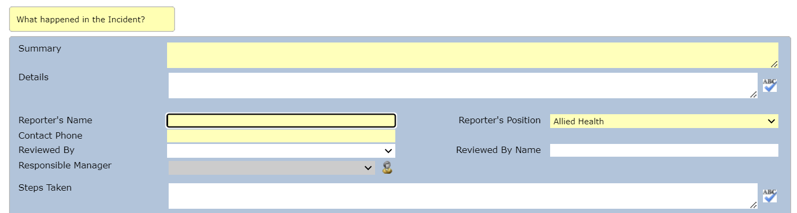
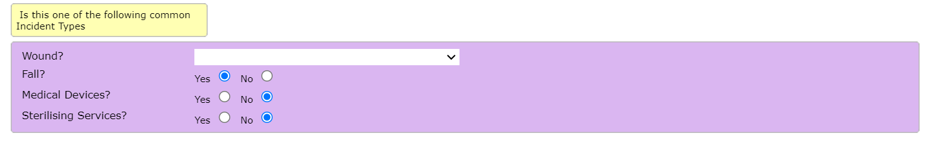
Falls extension
Complete all sections of the falls extension (located in the blue box).
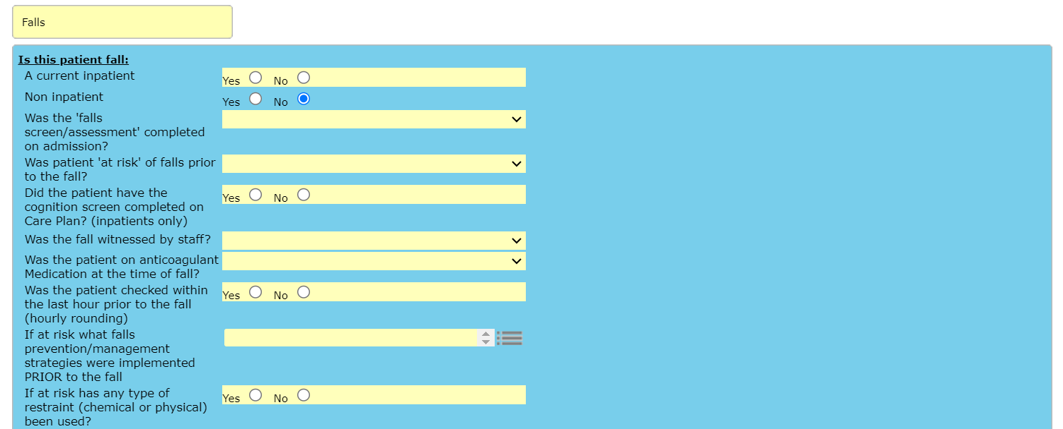
Manager Responsibilities
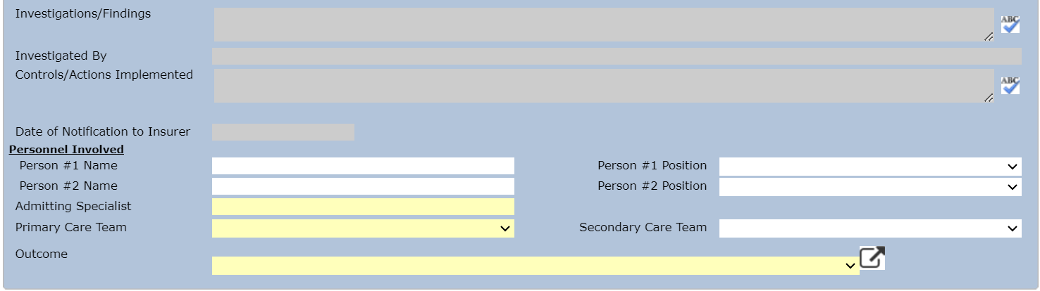
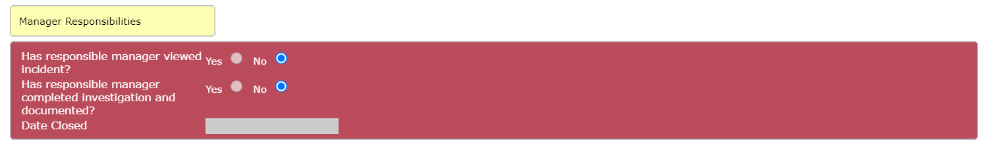
Back to Table of Contents

Attachment 3 – Fit to transfer test

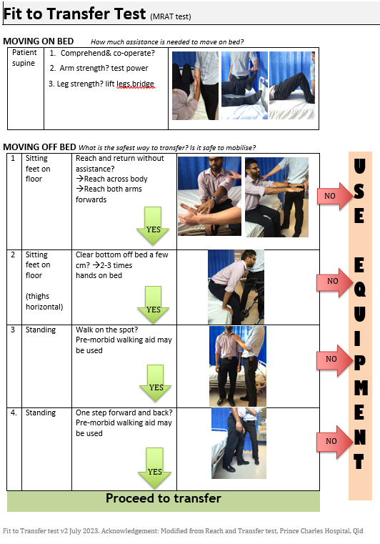
Back to Table of Contents

Attachment 4 – Use of Bedrails Matrix

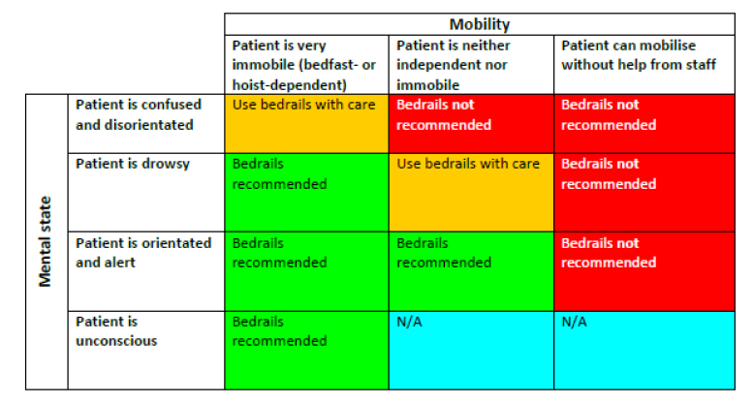
Adopted from NHS Foundation Trust ‘Bed Rail Policy’ ratified by Quality Safety Governance Committee on 13th March 2018. www.dtgp.cpft.nhs.uk/FileHandler.ashx?id=1347)

Use this risk matrix in combination with your clinical judgement remembering the following:
- Patients with capacity can make decisions about bed rail use.
- Patients with visual impairment may be more vulnerable to falling from bed.
- Patients with involuntary movements (e.g. spasms) may be more vulnerable to falling from bed.
- Patients with a cognitive impairment are at high risk of falls.

Instructions for use:
Determine patient mental state, then determine mobility. Follow the matrix across until both mental state and mobility meet.
Use of bedrails must be reassessed when patients condition changes.

