Canberra Health Services
Procedure
North Canberra Hospital (NCH) - Moving Patient Beds/Stretchers Procedure

Contents

Contents 1
Purpose 2
Scope 2
Section 1 – Overview 2
Section 2 – Moving Bariatric Beds 2
Section 3 – Moving High Low Beds 3
Section 4 – Moving Hospital Beds or Trolleys 3
Section 5 – Patient transports to Bruce Private Hospital 4
Related Policies, Procedures, Guidelines and Legislation 5
References 5
Definition of Terms 5
Search Terms 5

Purpose

To document safe operating procedure for moving hospital beds or patient trolleys at North Canberra Hospital (NCH).
Back to Table of Contents

Scope

This document applies to the following NCH staff working within their scope of practice at NCH:
- Medical Officers
- Nurses and Midwives
- Student Nurses under direct supervision.
- Ward Services Officers
- Facilities staff

Back to Table of Contents

Section 1 – Overview

- Standard beds and trolleys may be pushed by either one or two staff depending on staff risk assessment and capacity. Two staff are preferred for occupied beds with patients weighing >100kg in a standard bed and >130kg in a stretcher.
- If one staff member is moving a bed they should be positioned at foot end of the bed facing the head end. For two handlers the main pusher should be at the foot end of the bed, and the assistant handler standing on one side of the head end (either right or left) to assist.
- Pushing beds is preferred to pulling to reduce injury risk.
- Where appropriate and space allows (noting space limitations of the lifts), the bed mover is available for bed transports particularly for bariatric bed transport, pushing beds over long distances or on carpeted areas.
- Beds should not be pushed for any distance sideways, but only for manoeuvring into patient bed spaces or other tight spaces such as storage areas.

Back to Table of Contents

Section 2 – Moving Bariatric Beds

- Minimum of two staff must be used at all times to push patients in Bariatric beds.
- Patients being nursed in a Bariatric bed who need to be transported in the lifts should be transferred to a suitably weight rated wheelchair, trolley or standard bed for transport. Alternatively the bariatric recliner chair with the bed mover may be used.
- Medicraft Bariatric beds require removal of the bed rails to fit into the lift and to enter some rooms. To complete this assistance of 2 staff are recommended (due to weight of side rails) and required tool is attached to each side rail. To ensure patient safety, patients should not be transported in a bed without side rails.

Back to Table of Contents

Section 3 – Moving High Low Beds

- High low beds are not to be used for transporting patients between wards, to Medical Imaging or around the hospital.

Note: High Low beds have small wheels and do not have a steering lock which increases manual handling risks.

- If a patient nursed in a high low bed requires transport out of the wheelchair, a transport trolley or a standard hospital bed is to be used.
- Two staff must assist at all times to manoeuvre high low beds. When manoeuvring around corners move close to the front or back end of the bed and use body weight to assist direction changes.
- Requirement to move these beds within and between wards should be kept to a minimum with other bed allocation and bed management strategies.

Back to Table of Contents

Section 4 – Moving Hospital Beds or Trolleys

- Prepare patient prior to transport
- Raise side rails
- Secure any attached equipment – IV pole, oxygen cylinder
- Ensure that the bed and any medical equipment is unplugged from the wall, and cords secured for transport.

- Prepare bed for transport
- Release brakes
- Adjust bed height to just below waist height of the main pusher so that with hands on bed end elbows are at 90° and forearms parallel to the floor
- Check wheels are in line with direction of travel. If they are not, adjust the wheel position using body weight
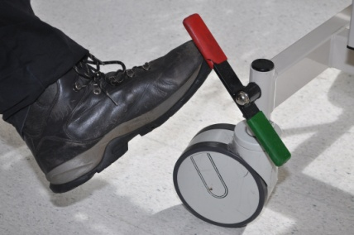
- Engage the steering wheel lock for greater control and to stop bed drifting in transit.

- Pushing bed
- Beds should be pushed rather than pulled for bed transports. Primary force should not be provided by pulling for any more than very short distances
- To initiate bed movement use a lunge stand at end of the bed, brace core muscles and lift foot closest to the bed. Do not start suddenly, rather build up the force gradually
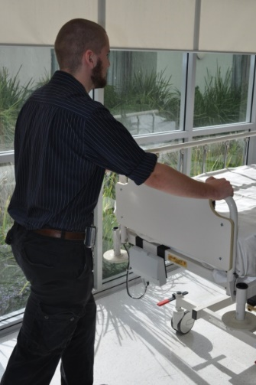
- Push through the lower palm of hand, wrists in neutral, keeping body close to the bed
- Push at a steady even pace. High force is needed to stop or start bed movement suddenly and is a high injury risk
- Avoid jerky or explosive movements
- Use the steering lock for straight travel to reduce push forces.

- Manoeuvring/Cornering
- Gradually slow pace as corners are approached. Use ceiling mounted mirrors where available to identify hazards in preparation for cornering
- Do not twist body
- To push bed sideways: release steering wheel lock, push from the side of the bed.

- Stopping
- Lean backwards and use body weight to slow bed movement
- Ensure brakes are engaged when bed is stationary
- Plug in electric beds and any electrical equipment.

Back to Table of Contents

Section 5 – Patient transports to Bruce Private Hospital

For bed transports between NCH and Bruce Private hospital via the link bridge, a bed mover must be used.

Back to Table of Contents

Related Policies, Procedures, Guidelines and Legislation

Procedures
- Patient Identification and Procedure Matching
- Manual Handling Procedure

Legislation
- Health Records (Privacy and Access) Act 1997
- Human Rights Act 2004
- Work Health and Safety Act 2011

Other
• Australian Charter of Healthcare Rights
Back to Table of Contents

References

- Work Health and Safety Act 2011 (ACT)
- Hazardous Manual Tasks Code of Practice 2011AORN Ergonomic Tool 7: Pushing, Pulling, and Moving Equipment on Wheels, AORN Journal Volume 94, issue 3, 2011.

Back to Table of Contents

Definition of Terms

Steering wheel lock: Locks front wheels into place enabling safe and easier steering
Lunge stand: One foot is a step ahead of the other, toes and body facing forwards
Stretcher: Narrower patient bed. May also be known as a patient trolley
High Low bed: A bed which lowers to floor level to reduce patient injury from falling out of bed, with small castors (usually 125mm or less)
Core muscles: Muscles which stabilize the trunk to reduce injury risk from shearing forces.
Bariatric bed: Beds with a safe working load of >300kg and a wider sleep deck
Bed mover: Powered machine that attaches to beds, trolleys and recliners or compatible wheel base dimensions to allow a single operator to transport equipment with minimal force required.
Back to Table of Contents

Search Terms
Transport, Moving beds, Patient Transport,

Back to Table of Contents

Disclaimer: This document has been developed by Canberra Health Services specifically for its own use. Use of this document and any reliance on the information contained therein by any third party is at his or her own risk and Canberra Health Services assumes no responsibility whatsoever.

Policy Team ONLY to complete the following:
Date Amended | Section Amended | Divisional Approval | Final Approval
24/05/2024 | New Document | People and Culture | CHS Policy Team

This document supersedes the following:
Document Number | Document Name

