Canberra Health Services
Procedure
Community Duress Device

Contents

Contents 1
Purpose 2
Alerts 2
Scope 2
Section 1 – Responsibilities and Governance 3
Section 2 –Training 5
Section 3 – Consent Process for use of a Community Duress Device 6
Section 4 – Operational use of the Community Duress Device 8
Section 5 – Community Duress Device Activation and Types of Alerts 9
Section 6 – Testing of Community Duress Device 13
Section 7 – Lost, Stolen, or Damaged Community Duress Device 13
Section 8 – Privacy and Security of Data 14
Section 9 – Staff Incident Reporting 15
Section 10 – Key Support and Contact Information 15
Evaluation 15
Related Policies, Procedures, Guidelines and Legislation 16
Definition of Terms 17
Search Terms 18
Attachments 18
Attachment 1 - SafeTcard Personal Duress Alarm Flyer 19
Attachment 2 – Community Duress Device - Information for Designated CHS Contacts…… …22
Attachment 3 – Community Duress Device – Quick Reference Guide………………………………….27
Attachment 4 – Community Duress Device – False Alarms………………………………………………….29

Purpose

The purpose of this procedure is to detail the responsibilities and requirements relating to the use of community duress devices (CDDs) by Canberra Health Services (CHS) staff, students and volunteers.

Back to Table of Contents

Alerts

The use of a listening device is prohibited under the Listening Devices Act 1992 unless consent has been provided. Any device which can listen to and/or record a conversation is considered a ‘listening device’ under the Listening Devices Act 1992. This includes the CDDs referred to in this procedure. For further details on consent and the Listening Devices Act 1992 refer to Section 3 – Consent Process for use of a Community Duress Device.

The user of the CDD must complete the required training prior to wearing, using and potentially activating the CDD and remain aware of the requirements of this procedure. For further details on training requirements refer to Section 2 – Training.

Back to Table of Contents

Scope

This procedure applies to all CHS staff who engage with consumers and members of the public in the course of their duties and require the use of a CDD to ensure their safety in the following settings:

- Non-CHS owned or operated locations Community based settings including but not limited to:
- consumer homes
- schools
- public spaces (including other ACT Government facilities not operated by CHS)
- private business facilities
- non-government organisation facilities.

- CHS owned and operated settings where staff may not have the ability to raise the alarm with standard CHS duress technology (for example Code Black) or be assisted with fixed and portable duress technology in hospital settings when
  - transferring a consumer between services at the Canberra Hospital
  - between CHS campuses
  - away from a CHS setting including escorting consumers for approved leave.

Back to Table of Contents

Section 1 – Responsibilities and Governance

CHS staff who provide services in community settings experience increased risk of occupational violence and potential harm. This is mainly due to their isolation and limitations in raising alarm and seeking assistance when under threat compared to the support readily available at CHS sites such as fixed/portable duress and Code Black response teams.

Under the Work Health and Safety Act 2011 (ACT), all reasonably practicable steps must be taken to protect workers through the elimination or minimisation of Work Health Safety (WHS) risks.

A reasonably practicable step to minimise risk of serious harm to CHS staff working in isolation is to provide the ability to discreetly and rapidly raise the alarm, and have a response provided in the event of a personal threat.

The CDD provided to CHS staff is the SafeTcard ID Series supplied and monitored by the third-party vendor SafeTcard Australia Pty Ltd (SafeTcard).

Responsibilities
Executive Director/Executive Group Manager

The Executive Director has overall responsibility for ensuring that:
- Staff complete mandatory training in the use of CDD as outlined in Section 2 of this procedure.
- Escalation pathways and contact information are in place and current for duress response.
- Any potential breaches of consent or privacy are appropriately investigated.

Responsible Manager
The responsible manager is to ensure that:
- All staff requiring CDDs have a CDD available to them.
- Staff complete training as outlined in Section 2 – Training, and are provided adequate time during work hours to complete the required training prior to wearing the CDD.
- Contact details for the designated contact, including for operations outside of business hours, remain current and any changes to contact details are communicated to the Work Health and Safety (WHS) team.
- Use of a CDD is embedded into the workflow and procedures of the unit or service, including consideration to minimising staff travel requirements where appropriate.
- Appropriate storage and charging facilities are available for the CDD.
- Testing of CDD occurs as specified in this procedure to ensure the integrity and functionality of the CDD.
- Any potential breaches of consent or privacy are appropriately investigated as per ACT Government and CHS privacy policies and procedures.
- Processes are in place to check staff have safely completed their home visits/shift by an expected time in accordance with the Home Visiting procedure accessible from the Policy and Guidance Document Register.

Designated Contact
The designated contact is the work unit contact provided to the Alarm Receiving Centre (ARC). For more information about ARC see the Definitions section within this procedure. The ARC will inform the designated contact in the event a CDD is activated by a staff member in their work area. Following being notified of CDD activation the designated contact is to ensure that:
- Appropriate response and support is provided to ensure the safety of the staff member, including contacting police if required.
- Next of kin for the affected staff member are contacted where it cannot be confirmed that the staff member is safe or where it is confirmed that the staff member has been injured (also refer to the Manager’s Occupational Violence Incident Response Toolkit accessible from the ACT Health Policy Register.
- Ensuring that the staff member completes a staff incident report in clinical incident management system reporting the activation of the CDD for investigation and action according to the Work Health and Safety Management System.

Staff Member (allocated a Community Duress Device)
The staff member using the CDD, under the requirements of this procedure, is to ensure that they:
- Remain familiar with, and follow, all requirements under this procedure.
- Complete the required training outlined in Section 2 at the earliest opportunity prior to wearing the CDD.
- Wear the CDD at all times when working in isolation, and comply with identified storage and charging processes.
- Check consent is provided prior to delivery of a health service with a CDD.
- Report any potential breaches of privacy to their manager in accordance with the Consumer Privacy Policy accessible on the CHS Policy and Guidance Register.
- Report any identified issues with the CDD such as damage, failed testing, or loss of CDD to their manager.

Work Health Safety
The WHS team is responsible for supporting the local work areas to effectively implement the CDD including:
- Procurement of CDDs and distribution to work areas.
- Ensuring availability of training to staff on HRIMS Learning (Course Title: CHS-Community Duress Device (SafetTcard) eLearning; Course ID: CHS_el_STC_d).
- Liaising between work areas allocated CDDs and the third-party vendor related to CDD faults, and organising replacement for lost, stolen, or damaged CDDs (at cost to the local area).
- Communicating storage and charging station requirements to the local work area.

Security
Security Operations staff are available as an alternative point of contact for the ARC in the event a designated contact and/or After-Hours Contact is unable to be contacted by the ARC. If contacted by the ARC, Security Operations are responsible for:
- As necessary based on risk, escalating relevant concerns to management and/or Executive of the staff member involved, according to the escalation pathway.
- Providing/arranging optimal assistance to the staff member, having regard to relevant resources available.
- Maintaining liaison as necessary with the staff member’s management/Executive to provide updates and support.

Back to Table of Contents

Section 2 –Training

Training for use of Community Duress Devices
Training for staff to use the SafeTcard is available on HRIMS Learning and titled CHS Community Duress Device (SafeTcard) eLearning. Staff must complete the provided training prior to wearing, using and activating the CDD while providing healthcare services as specified in this procedure. Adequate work time is to be provided to allow completion of the training.

Regular refresher training is not mandatory, however:
- A staff member must complete the training again if directed to do so by their manager/supervisor.
- A staff member may, at any time complete the training again for their own learning and refresh of information.

Staff who are new to a role with community based duties are to complete CHS Community Duress Device (SafeTcard) eLearning during orientation to the service.

Note: During the Community Duress Device (SafeTcard) eLearning training staff will be required to activate the CDD and are required to contact the ARC to inform them that a training alarm will be activated. Staff undertaking the eLearning training should follow the instructions in the eLearning to contact the ARC, and to activate the CDD.

Back to Table of Contents

Section 3 – Consent Process for use of a Community Duress Device

Consent
The use of a listening device is prohibited under the Listening Devices Act 1992 unless consent has been provided. Any device which can listen to and/or record a conversation is considered a ‘listening device’ under the Listening Devices Act 1992. This includes the CDD referred to in this procedure.

To support staff safety and enable the use of the CDD all reasonable efforts are to be made to gain informed consent from consumers in accordance with the Informed Consent – Clinical Policy accessible on the CHS Policy and Guidance Register.

To enable legal use of CDD consent must be obtained from the consumer or their guardian by one of the following methods.

- Home Visit Pre-Assessment The Home Visit Pre-Assessment is a clinical form available from the Clinical Forms Register or within the clinical record system which identifies potential WHS risk factors including occupational violence.
- A component of the Home Visit Pre-Assessment informs consumers that CHS staff will have a CDD on their person which can record conversation if activated. The consumer is then requested at this stage to provide consent for the CDD to be used in the event the staff member feels their safety is at risk.
- In order to enable the activation of CDD during community visits it must be confirmed that consent has been provided by the consumer on the Home Visit Pre-Assessment prior to staff activating the CDD as described under this procedure.

Verbal consent
- Where the Home Visit Pre-Assessment is not able to be utilised, such as when the consumer is uncontactable prior to a home visit, or the staff member is entering a school where prior consent from each student is not practicable, then staff must attempt to obtain verbal consent from the consumer or their guardian/nominated person at the first reasonable opportunity to enable the activation of CDD in case staff later become under threat.
- To gain this consent the staff member is to ask the following question:
“I need to advise you that during a home visit, if a staff member feels there is a threat to their personal safety, the staff member may activate a duress device which can record conversation for the purpose of seeking assistance. Do you/the carer consent to this?”

- If the consumer gives their verbal consent the staff member must document the consent on the Home Visit Pre-Assessment clinical form.

The consent is documented in the patient’s clinical record.

If no consent has been provided, or there may not be an opportunity to obtain informed consent prior to a community visit. then staff are to perform a dynamic risk assessment.

Examples of no consent include but are not limited to:
- A consumer verbally or in writing refuses to provide consent.
- There is no opportunity to contact and gain consent prior to community visit such as the Home Assessment and Acute Response Team (HAART) review of patient who is not contactable however a visit is required by clinical staff to check on welfare.
- Consent prior to community visit is not practicable due to number of persons present and set up of community facility such as a drop-in clinic at women’s refuge; school vaccination visit; or a sexual health visit to sex work establishment.

When consent has not been provided for any reason, staff are to perform a dynamic risk assessment based on the circumstances relating to the consumer, the healthcare activity and controls available. Staff may utilise resources available to them to assist in the risk assessment including colleagues, supervisors, managers, and/or WHS advisors.

Based on the risk assessment conducted, an agreed course of action is to be implemented which may include:
- Proceeding with the service activity without wearing the CDD.
- Proceeding with the service activity wearing the CDD and remaining aware that activation of the CDD may breach the Listening Devices Act 1992. For clarity, the CDD may be worn where no consent has been provided, but may not be activated until consent is gained.
- Modifying or ceasing the service activity such as:
- having an additional staff member present during interactions
- deciding that no community visits with interactions are to occur only at a CHS facility such as an outpatient clinic, Community Health Centre, or other on-campus arrangement
- ensuring the service is delivered during business hours hours only
- ceasing or withdrawing service. A lack of consumer consent may indicate that providing a specific service is too high a risk to staff, and the consumer is to be informed of alternative care arrangements such as remain as an inpatient rather than accepted for home visiting services.

Note: for further information on risk assessment practices and principles for Community Based Staff see the Home Visiting Operational Procedure and the Work Health Safety Management System available from the Work Health Safety intranet page.

Back to Table of Contents

Section 4 – Operational use of the Community Duress Device

Storage and Charging of the Device
Storage and charging of CDDs is to meet the requirements of the manufacturer as outlined in the product manual. The product manual is provided to the work area on issuing of the CDD and a copy of the product manual may be requested from WHS as required.

Allocation of CDDs to approved staff
A CDD is to be allocated to all staff exposed to occupational violence risks, who work in community settings as identified in this procedure.

Maintenance of CDDs
- A CDD that is allocated must be worn by staff who are exposed to occupational violence risks as identified in the scope of this procedure.
- At the time a CDD is collected the CHS staff member is to confirm the CDD has adequate battery life, is operational (by turning the CDD on), check for obvious signs of damage, and confirm a mobile network connection.

Wearing the CDD
- The CDD is to be worn with consideration to infection control, and in a location where it is easily accessed in the event of a personal threat so that the activation of the CDD is practical and prompt.
- When a staff member is not wearing the CDD it should be stored in a location where it will not likely be subject to excess wear and tear. Inappropriate storage includes resting on the vehicle dashboard where the CDD may be exposed to direct sunlight or otherwise subject to damage when the vehicle is in motion.

Checking Consent Prior to Consumer Visits
- Prior to consumer visits the CHS staff member is to check for evidence of consent to use the CDD. Consent for use of a CDD is documented on the Home Visit Pre-Assessment clinical form in the clinical record system or Clinical Work Device “Rover” software device. See Section 3 above, Consent Process for use of a Community Duress Device for further information on the consent process.
- If a consumer has provided consent, then the CDD can only be activated as specified under this procedure.
- If a consumer has not provided consent then the CDD is not able to be activated while attending to the consumer.

Where a consumer has not granted consent to use CDD, staff must use a risk-based approach to determine appropriate risk control measures in respect of the visit. Refer to Section 3 – Consent Process for use of a Community Duress Device for further information.

On Leaving a Consumer Home or Facility
On completion of visit to a consumer’s home or a community facility, ensure infection control practices are followed by cleaning the CDD with a sanitising wipe.

Returning CDD to a CHS Facility
On return to the CHS facility where the CDD is usually stored, the CHS staff member is to ensure that:
- The CDD is stored in the allocated area and charging when not in use.
- Any issues with the CDD such as damage or failure to charge are to be escalated to the responsible manager at the earliest opportunity and to WHS on 512 49410 or CHS.WorkHealthSafety@act.gov.au.

If the CDD is taken to a location outside of work duties then the staff member is to:
- Alert the responsible manager at the earliest opportunity.
- Turn the CDD off to prevent inadvertent activation in a non-work-related setting.
- Arrange return of the CDD to the work area as soon as practical.

Taking the CDD Home at End of Shift
For some areas it may be operationally possible and appropriate for staff to take the CDD home with them at end of shift. Work areas may incorporate this practice into to their workflow with approval from their manager ensuring:
- CDD availability to staff on duty is not impacted and CDDs available are appropriately charged.
- Device is turned off outside of work hours to prevent accidental activation.
- Device is stored in a safe location.

Back to Table of Contents

Section 5 – Community Duress Device Activation and Types of Alerts

When a CDD may be Activated
A CDD can legally be activated in the event a CHS staff member:
- Feels their safety is under threat.
- Prior consent has been obtained for the use of a “listening device” (as defined in the Listening Devices Act 1992) as outlined in Section 3 – Consent Process for use of a Community Duress Device.

Activation of the Community Duress Device
- The CDDs used at CHS are supplied and monitored by SafeTcard. SafeTcard use an Alarm Receiving Centre (ARC) as a 24/7 monitoring centre, where operators are always on duty to monitor and respond to duress alerts.
- On activation of a duress the CDD immediately transmits the Global Navigation Satellite System (GNSS) location of the device and calls the 24/7 ARC.
- The ARC operator can listen to what is happening within the vicinity of the CDD, but the user will not be able to hear the ARC operator. The operator can see on their screen any information associated with the CDD such as user details; employer details; escalations contacts; and operator instructions.
- The ARC operator uses the audio to assess and triage the situation and coordinates an appropriate response including dispatching emergency services if required.

Note: The CDD does not continually record or relay audio recording to the ARC, nor continually relay the CDD’s GNSS location to the ARC or in any way to CHS. The audio recording and GNSS location are only provided to the ARC on activation of the CDD as outlined in this section.

Types of Alerts
- Red Alert
- A Red Alert immediately transmits live audio and CDD GNSS location to the ARC. If a Yellow Alert (see below) has previously been activated, then this will also be transmitted to the ARC on activation of a Red Alert.
- A Red Alert is activated by pressing and holding the Red Alert button on the CDD until one vibration is felt (see Attachment 1). ‘SOS’ will be on the CDD’s display screen.
- To deactivate a Red Alert, press and hold the Red Alert button until you feel one vibration. ‘SOS cancelled’ will be on the CDD’s display screen. A Red Alert may also be activated by pulling the magnetic pin (rip alert) at one of the lanyard connection points on the CDD (see Attachment 1). On activation of the rip alert the CDD will vibrate once to indicate an Alert has been activated. ‘SOS’ will be on the CDD’s display screen.
- To deactivate a rip alert, reinsert the magnetic pin to its usual location. ‘SOS cancelled’ will be on the CDD’s display screen.

- Falls Alert
- The ‘man-down’ functionality of the SafeTcard ID Series is based on the detection of a sudden drop or fall. If a sudden drop or fall is detected, then the ARC will be alerted by the CDD as per the Red Alert activation. The CDD will beep once and ‘MDOWN’ will be on the CDD’s display screen to indicate a “Man Down” has been activated. In the event of a “Man Down”, 2-way audio is enabled, and the ARC will be able to communicate directly with the user and coordinate a response if required
- The “Man Down” is not activated on sensing a tilt for a defined period.
- To deactivate a “Man Down”, press and hold the Red Alert button until you feel one vibration, and ‘MDOWN cancelled’ will be on the CDD’s display screen.

- Yellow Alert
- A Yellow Alert is a voice recording made by the user prior to entering an area where GNSS positioning may be unreliable or insufficient to locate the user (for example, an indoor location, or a higher-density residential area such as a multi-storey building). In this situation staff must activate a Yellow Alert and provide relevant information to be transmitted in the event of duress activation.
- The voice recording is dated and timestamped on the ARC software and is only accessed by the ARC operator(s) when a Red Alert is activated
- To activate a Yellow Alert, press and hold the Yellow Alert button on the CDD until you hear one beep (see Attachment 1), then scroll through the menu options and select to ‘Voice Record’. When the light clears, the recording is completed.

False Alarm
- Accidental/unintentional activation by staff member - e.g. pressing on button.
- Duress button (SOS button) activated when device not being worn - e.g. item such as laptop left on device in vehicle with pressure on the duress button.
- Device safety feature triggered - e.g. device is left in a position that triggers the “Man Down” alert or device is dropped accidentally causing duress activation, or the magnetic pin is removed by accident activating the “Rip Alert”.

Attachment 3 – Community Duress – Quick reference guide - provides a quick reference to Activation types and actions following activation.

Business Hours Activation of the Community Duress Device
Activation of the CDD opens an audio channel and transmits the CDD’s GNSS location to the ARC. The ARC will assess the audio and triage to arrange an appropriate response as per the following categories where CDD is activated:

- Potential immediate risk
The incident involves immediate risk to staff safety and requires an urgent response as determined by ARC. The ARC will organise dispatch of emergency services to provide an immediate response. The ARC will then inform the designated contact of the nature and response to the duress activation.
- Unconfirmed risk
ARC unable to determine level of threat or otherwise. ARC will triage the event and seek further information to enable assessment. Designated Contact will be contacted to provide updates.
- Potential threat now resolved
Incident identified as no ongoing threat or resolved incident:
- CDD activated in caution. No threat eventuated as determined by ARC.
- CDD activated. Threat was apparent but resolved and no further threat as determined by ARC.
The ARC will notify the designated contact of CDD activation, however no response will be actioned by the ARC. The ARC will continue monitoring the audio until contact is made to the user by the designated contact and escalate a response if required.
- Confirmed False Alarm
Incident identified as a false alarm by the ARC. The ARC will inform the relevant designated contact for the CDD that a false alarm activation has occurred. The designated contact is to then inform the relevant CDD user of the false alarm activation for action as soon as practicable.

Actions by the designated contact when contacted by the ARC:
- Follow instruction(s) of the ARC
- Provide relevant information to the ARC (for example, appointment schedule and locations of the staff member, description of staff member) if required
- Depending on the known situation and the assessed level of risk, follow local practices for escalation of safety concerns to police (if required), and local and divisional management
- Contact the next of kin for the affected staff member if it cannot be confirmed that the staff member is safe, or where it is confirmed that the staff member has been injured Also refer to the Managers Occupational Violence Incident Response Toolkit.
- Ensuring that the staff member completes a staff incident report in the clinical incident management system regarding the activation of the CDD for investigation and action in accordance with the Work Health and Safety Management System.
- For further resources refer to the Managers Occupational Violence Incident Response Toolkit and Psychological Support for Staff: a Manager's Guide.

After Hours Activation of the Community Duress Device
In the event of activation outside of usual business hours the ARC will follow the same process in triaging the alarm as occurs within business hours (as above).

An after hours contact will be arranged by the work area in collaboration with the designated after-hours contact. The after-hours contact will perform the duties of the designated contact as outlined in the Responsibilities section above, and handover any ongoing or outstanding actions to the local work area as appropriate.

Note: Change of designated contact details such as change in role or phone number, are to be communicated to the WHS team at CHS.WorkHealthSafety@act.gov.au

Accidental Activation
In the event of accidental activation of the CDD, or on first becoming aware of accidental activation of the CDD the staff member with the CDD is to:
- Immediately deactivate the Alert by holding the Alert activation button until a vibration is felt, and the relevant alert ‘cancelled’ is on the display screen.
- Inform the responsible manager of the accidental activation.
- Lodge a staff incident report in the clinical incident management system to record the accidental activation of the CDD.

The responsible manager is to review reports of accidental activation for potential trends and implement controls to reduce accidental Alert activation where appropriate.

Failed Activation or Failure of Community Duress Device to Gain Signal
In the event that a staff member attempts to activate the CDD and for any reason the CDD fails to activate, the staff member is to raise the alarm and ensure their own safety as best as possible, including withdrawing from the area and retreating to any safe location. Based on the incident the staff member is to request immediate assistance from:
- police – phone 000
- their manager, and/or
- member of the public if appropriate.

On resolution of the incident and when the staff member’s safety is ensured, the staff member is to complete a staff incident report in the clinical incident management system, or a manager may complete one on behalf of the staff member if they are unable to for any reason.

If a consumer’s location is discovered to be a black spot for cellular signal, then an Alert is to be added to the consumer’s record. See Alerts Management Procedure for further information on adding alerts.

Back to Table of Contents

Section 6 – Testing of Community Duress Device

- The responsible manager is to ensure that testing of all CDDs occurs at least monthly.
- For information on CDD testing refer to the product manual. The product manual is provided to the work area on issuing of the CDD and a copy of the product manual may also be requested from WHS as required.
- The responsible manager is to ensure testing of the CDD is incorporated into the workflow of the unit.

Back to Table of Contents

Section 7 – Lost, Stolen, or Damaged Community Duress Device

In the event a CDD is not functioning appropriately or is determined to be lost, the staff member is to notify their manager.Once notified the manager is to contact WHS as soon as possible to arrange a replacement. WHS can be contacted on 512 49410 or CHS.WorkHealthSafety@act.gov.au

The manager is to ensure that the staff member lodges a staff incident report on the clinical incident management system detailing the loss of the CDD and the circumstances in which the CDD was lost. Replacement of the CDD if required will be at the cost of the work area concerned.

Responsible managers are to ensure there are appropriate arrangements within the work unit to minimise risk of CDDs being lost, stolen or damaged by:
- arranging appropriate secure storage when not in use/charging
- arranging a check-out/check-in process for staff using the CDD
- ensuring availability of the provided protective case and arrange replacement if required.

Staff members are to minimise the risk of CDDs being lost, stolen or damaged by:
- using appropriate secure storage when CDD is not in use/charging
- following a check-out/check-in process when using/returning the CDD
- using the provided protective case and report any wear and tear issues
- minimising CDD exposure to sun and/or water.
Back to Table of Contents

Section 8 – Privacy and Security of Data

Privacy
The sole purpose of the CDD is to enable staff to raise an alarm in the event their safety is threatened as outlined in Section 5 – Community Duress Device Activation and Types of Alerts. At no time should a CDD be used to:
- record conversation with an individual or group where there is no immediate threat to safety.
- record conversation for the purpose of record keeping or obtaining evidence outside of the requirements of this procedure.
- determine an individual’s whereabouts unless there is reasonable concern for that person’s safety such as a manager requesting GNSS data to determine a staff member’s movements during work.

Any potential breaches of privacy are to be reported by the staff member as soon as they become aware of the breach to their manager. The manager is to investigate the potential breach of privacy as per ACT Government privacy policies and procedures.

Consumer Complaints Regarding use of Community Duress Device
Consumers who feel unsafe or aggrieved for any reason in relation to staff use of the CDD have the right to provide feedback or make a complaint in accordance with the Consumer Feedback Management Policy and Procedure.

Any staff member who activates a CDD in the presence of a consumer is to provide the consumer with the Consumer Feedback and Engagement Team contact information, email HealthFeedback@act.gov.au and phone 5124 5932

Security of Data
Recordings obtained through intentional and unintentional activation of a CDD will be stored in accordance with relevant legislation under the Privacy Act 1988 and Information Privacy Act 2014.

Note: Audio captured from CDD use (intentional or unintentional) does not form part of the patient’s clinical record, or part of the staff member’s personnal file. Any recordings are maintained strictly for confidentiality by the provider SafeTcard.

Retention and retrieval of recordings by a third party alarm system monitoring centre is to comply with the requirements of a Grade A1 facility as per the Australian Standard for Intruder alarm systems - Monitoring centres (AS 2201.2:2022).

Requests to access recordings stored and maintained by the ARC are to be directed to WHS on 512 49410, or email CHS.WorkHealthSafety@act.gov.au

Back to Table of Contents

Section 9 – Staff Incident Reporting

Staff incident reporting
In the event of activation of a CDD whether intentional or not, a staff incident report is to be completed in the clinical incident management system. Refer to Staff Incident Reporting intranet page (SharePoint) for resources and factsheets for completing a Staff Incident Report.

Reports from SafeTcard
SafeTcard will provide regular reports on activation of CDDs to CHS Work Health Safety (WHS). Report data will be disseminated to the CHS Peak WHS Committee by the WHS team. For requests to access to reports or summarised data contact WHS on 512 49410, or email CHS.WorkHealthSafety@act.gov.au.

Back to Table of Contents

Section 10 – Key Support and Contact Information

WHS
Phone: 512 49410
Email: CHS.WorkHealthSafety@act.gov.au

SafeTcard
Phone: (07) 4037 4800

Security Operations
Phone: 512 45145
Back to Table of Contents

Evaluation

Outcome
- Staff are familiar with and follow all requirements in this procedure.
- Staff are allocated and have access to a CDD as specified under this procedure.
- Staff are trained in use of CDDs.
- Consumer consent is documented for the use of the CDD
- CDDs are only used when prior consent is provided by the consumer..
- Use of the CDD is incorporated into workflow of community based CHS staff when working off-site of a CHS facility.

Measures
- Staff Incident Reports are reviewed by managers and any issues relating to the CDD are escalated through WHS Committees and to the WHS team and resolved.
- Review of compliance with mandatory staff training in HRIMS Learning.
- Complaints from consumers regarding use of the CDD without consent.

Back to Table of Contents

Related Policies, Procedures, Guidelines and Legislation

Strategies
- Occupational Violence Strategy 2020-2022
- ACT Government Public Sector Work Health, Safety and Wellbeing Strategy 2019-2022
- Staff Health and Wellbeing Strategy 2020-2023
- Work Health Safety Strategy 2018 – 2022

Frameworks
- ACT Government Respect, Equity and Diversity Framework (2010)

Policies
- Occupational Violence
- Work Health and Safety
- Incident Management - Clinical
- Protective Security
- Risk Management
- Family Violence
- Security Services – Use of Force
- Consumer Feedback Management
- Consumer Privacy

Procedures
- Occuational Violence
- Incident Management - Clinical
- Restrictive Practices for people NOT detained under the Mental Health Act 2015
- Education and Training – Governance Processes and Staff Requirements
- Alert Management
- Risk Management
- Security Services – Use of Force
- Consumer Feedback Management
- Safety Huddle to Identify, Mitigate and Manage safety issues within the Secure Mental Health Services
- Identifying and Responding to Family Violence
- Home Visiting
- Security Services – Use of Force

Guidelines
- Psychological Support for Staff – A Managers Guide
- Multi-agency Response Guide (MARG) Mental Health, Justice Health and Alcohol & Drug Services (MHJHADS)
- Challenging Behaviour Guideline Placeholder
- ACT Health Directorate Isolated or Remote Worker Guideline for ACT Health Services
- ACT Health Directorate Manager’s Occupational Violence Incident Response Toolkit

Standards
Australian Standard for Intruder alarm systems - Monitoring centres (AS 2201.2:2022).

Legislation
- Crimes Act 1900 (ACT)
- Discrimination Act 1991 (ACT)
- Health Records (Privacy and Access) Act 1997
- Human Rights Act 2004 (ACT)
- Mental Health Act 2015 (ACT)
- Personal Violence Act 2016 (ACT)
- Victims of Crime Act 1994 (ACT)
- Work Health & Safety Act 2011 (ACT)
- Work Health and Safety Regulations 2011 (ACT)
- Crimes (Health Directorate) Authorisation 2018 (No.1)
- Public Sector Management Act 1994
- Healthcare Charter of Rights
- Privacy Act 1988
- Information Privacy Act 2014
- Listening Devices Act 1992

Other
- Reporting Occupational Violence Factsheet
- Managers Response to Occupational Violence Factsheet

Back to Table of Contents

Definition of Terms

Alarm Receiving Centre (ARC) – 24/7 alarm monitoring centre which receives, triages, and organises response to alarms from CDDs. For clarity, the ARC is operated by a third-party vendor (SafeTcard) and is not responsible for Fixed or Portable Duress response on the Canberra Hospital and University of Canberra Hospital campuses, or Community Health Centres.

Community Duress Device (CDD) – a device used to raise a duress alarm in a community setting

Designated Contact – the contact provided by the work unit or service area to the ARC to act as a first point of contact for the ARC in the event of a CDD activation. The designated contact may be updated in the event of service changes, organisation restructuring, etc.

Global Navigation Satellite System (GNSS) - a group of synchronized satellites working in concert (collectively called constellations) used for Position Navigation and Time (PNT) solutions on a global basis.

Listening Device – any instrument, apparatus, equipment, or device capable of being used to listen to or to record a private conversation but does not include a hearing aid. The SafeTcard CDD is a listening device per this definition.

Responsible Manager – the responsible manager is the manager of staff who deliver services in the community.

SafeTcard Australia Pty Ltd – third party vendor supplying the CDD and providing a 24/7 monitoring and response service for CDD activation.

Staff Member - any CHS staff member who has been allocated a CDD for use as part of delivering health services.
Back to Table of Contents

Search Terms

Community, Community Duress, Community Duress Device, CDD, Duress, Duress Device, Home, Home Visit, Listening Device, Lone Worker, SafeTcard

Back to Table of Contents

Attachments

Attachment 1 - SafeTcard Personal Duress Alarm Flyer
Attachment 2 - Community Duress Device – Information for Designated CHS Contacts
Attachment 3 – Community Duress Device – Quick Reference Guide
Attachment 4 - Community Duress Device – False Alarms

Disclaimer: This document has been developed by Canberra Health Services specifically for its own use. Use of this document and any reliance on the information contained therein by any third party is at his or her own risk and Canberra Health Services assumes no responsibility whatsoever.

Policy Team ONLY to complete the following:
Date Amended | Section Amended | Divisional Approval | Final Approval
31/01/2023 | New Document | Kalena Smitham, Executive Group Manager People and Culture | CHS Pollicy Commitee
16/06/2023 | Addition of Attachments 2, 3 and 4. | Kerry CarMichael, Director Employee Services, P&C | CHS Policy Team

This document supersedes the following:
Document Number | Document Name
CHS21/589 | Community Duress Device Procedure
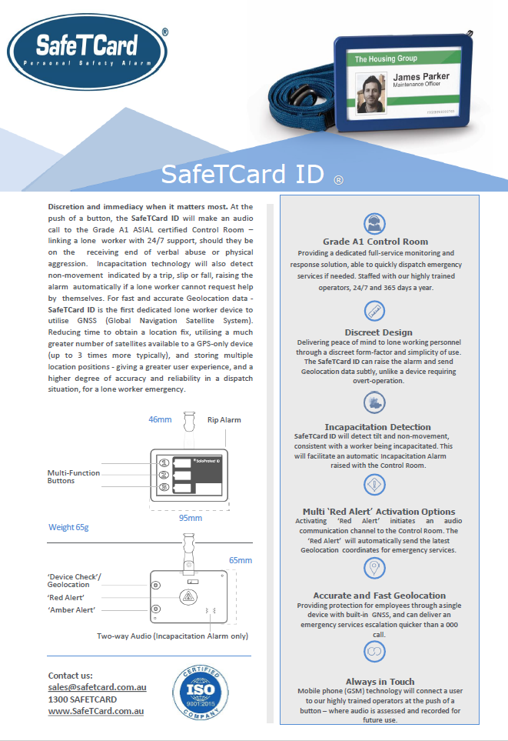

Attachment 1 - SafeTcard Personal Duress Alarm Flyer

Attachment 2 – Community Duress Device - Information for Designated CHS Contacts

Community Duress Device (CDD) – Information for Designated CHS Contacts
This factsheet details information on the Canberra Health Services (CHS) community duress device (CDD) for designated CHS contacts. This includes the following information:
What is the CDD (SafeTCard) and who monitors it?
Types of CDD duress activations - How, when, and why?
What happens when the CDD’S duress is activated?
When does the Alarm Receiving Centre (ARC) contact CHS?
Designated CHS contacts - Actions when contacted by the ARC?

What is the CDD (SafeTCard) and who monitors it?
The CDD is a duress device provided to community-based staff to improve safety particularly for lone worker who may discreetly activate duress when their safety is under threat e.g. lone worker under threat of occupational violence (OV). This protection occurs through:
- Staff activation of duress – e.g. pressing the duress button to raise the alarm when they feel their personal safety is under threat e.g. OV in the home of client
- Device safety features – e.g. the device can detect indicators of OV to staff including falls alert, device being ripped from lanyard. These safety features may also indicate potential medical events e.g. lone worker who passes out, has stroke
- 24 hour monitoring of duress activation - by the SafeTCard Alarm Receiving Centre (ARC) located in Cairns, Queensland
- The ARC triages all duress activations - working in conjunction with CHS Management to coordinate appropriate responses to support staff whose safety may be under threat.
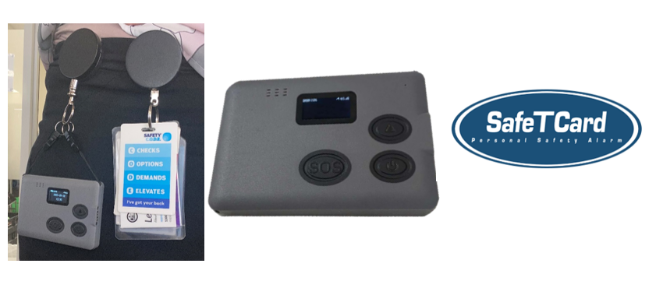

Types of CDD activations - How, when, and why?
A CDD duress activation occurs by staff activation or by the triggering of a device safety feature. A description of the types of activations and how, when and why they occur are detailed below.

RED ALERT  (Including RIP ALERT) | - Staff member deliberately activates duress – e.g. duress button pressed when under personal threat e.g. staff anticipates OV or OV is in progress  - RIP Alert - e.g. device ‘ripped’ from lanyard e.g. by client in OV incident causing the trigger of a device safety feature and automatic duress activation.
FALLS ALERT  (‘Man-down’) | - Device detects sudden drop or fall that may indicate harm or danger to staff – e.g OV assault where staff member hits the ground or potentially a medical event e.g. staff member passing out or stroke.
FALSE ALARM | - Accidental activation by staff member - e.g. pressing on button.  - Duress button activated when device not being worn - e.g. item such as laptop left on device in vehicle with pressure on the duress button.  - Device safety feature triggered - e.g. device is left in a position that triggers the falls alert or device is dropped accidentally causing duress activation.

What happens when the CDD’s duress is activated?
Following an activation of the device the ARC will triage the situation, and if necessary, coordinate an appropriate response to support staff. This may involve the ARC operator:
- Listening to the audio around the CDD - after duress activation to determine if the staff member is in danger, and if so, what level of assistance is required
- Phoning the staff member using the CDD - to confirm their safety, the level of risk, what assistance is required, or confirming with if it was a false alarm
- Coordinating an appropriate response if required - e.g. contacting Police for immediate attendance where an urgent response is identified as being required
- Phoning CHS designated contact/s - e.g. to seek further information and assistance to verify status of incident e.g. staff member movements, alternate personal contacts.


SafeTCard and the ARC have a copy of this factsheet to refer to if you are contacted regarding a duress activation.

When does the ARC contact CHS?
CHS has provided SafeTcard (the ARC) with the contact details of specific CHS Managers relevant to the work unit that each CDD belongs to e.g. 1st contact = Team Leader …. 2nd Contact = Manager.
Additional contacts are also provided to give the ARC further options should they not be able to reach the 1st or 2nd contacts e.g. 3rd or 4th contact as CHS Security or A/H Hospital Manager.

The ARC may phone CHS designated contacts after a duress to provide information, seek further information, or liaise to determine next steps e.g. response required. Examples may include when:
- A staff member has been harmed or is in danger – e.g. OV in the home of client confirmed by ARC in phone call to staff member or other method.
- The safety of the staff member cannot be determined – e.g. ARC attempts to contact staff member have been unsuccessful, therefore the status post activation is unknown. members safety as their status is not known.
- Attempts to phone other CHS contact/s have been unsuccessful – e.g. unable to reach 1st contact so phones the 2nd contact and if necessary, 3rd or 4th contact in the escalation pathway.

Note:
The ARC does not contact CHS for false alarms or accidental activations.

The ARC will contact CHS staff according to the order of contacts specified in the escalation pathway provided by CHS. The ARC will initially try to reach Contact 1, and if unable to reach them, will continue to the next level contact as per below etc.

Designated CHS contacts - Actions when contacted by the ARC?
Type of CDD Activation | Actions required by CHS Contact e.g. Manager | Actions required by CHS Security | Action required by A/H Hospital Manager
- Staff member deliberately activates duress – e.g. duress button pressed when under personal threat e.g. staff anticipates OV or OV is in progress.  - RIP Alert - e.g. device ‘ripped’ from lanyard e.g. by client in OV incident causing the trigger of a device safety feature and automatic duress activation.  - Device detects sudden drop or fall that may indicate harm or danger to staff – e.g. OV assault where staff member hits the ground or potentially a medical event e.g. staff passing out.  FALSE ALARM Activations below:  - Accidental activation by staff member - e.g. pressing on button.  - Duress button activated when device not being worn - e.g. item left on device with pressure on the duress button.  - Device safety feature triggered - e.g. device is left in a position that triggers the falls alert or device is dropped accidentally causing duress activation. | The ARC may contact you to assist with the response.  - Document the incident details as provided by the ARC – refer to Attachment 1 – ARC contact event notes to record relevant information.  - Depending on the situation and the assessed level of risk – the ARC will coordinate a response if required e.g. contact police.  - If staff member status is unknown e.g. OV incident unable to be confirmed or potential false activation:  - coordinate attempts to make contact with the staff member by other methods to determine their welfare e.g. personal mobile or colleague who may know of their where abouts  - Check on expected location at time of alarm activation e.g. appointment list/home visited.  - Escalate to higher Management as necessary depending on the situation to keep them updated and request support if required.  - For post incident support refer to the Manager response to OV Factsheet.docx and the Psychological Support for Staff - A Manager’s Guide .docx  - Ensure a Staff Incident Report in RiskMan is completed. | The ARC may contact you to assist with the response.  - Document the incident details as provided by the ARC – refer to Attachment 1 – ARC contact event notes to record relevant information.  - Depending on the situation and the assessed level of risk – the ARC will coordinate a response if required e.g. contact police.  - Send pre-scripted email to relevant executive divisional office.  - Escalate to higher Management as necessary depending on the situation to keep them updated and request support if required.  - For post incident support refer to the Manager response to OV Factsheet.docx and the Psychological Support for Staff - A Manager’s Guide .docx  - Ensure a Staff Incident Report in RiskMan is completed. | The ARC may contact you to assist with the response.  - Document the incident details as provided by the ARC – refer to Attachment 1 – ARC contact event notes to record relevant information.  - Depending on the situation and the assessed level of risk – the ARC will coordinate a response if required e.g. contact police.  - Escalate to higher Management as necessary depending on the situation to keep them updated and request support if required.  - For post incident support refer to the Manager response to OV Factsheet.docx and the Psychological Support for Staff - A Manager’s Guide .docx  - Ensure a Staff Incident Report in RiskMan is completed.
Note:
The ARC Phone Number is 07 4037 4888 (this will be the number that will appear on your phone).

Email CHS.Workhealthsafety@act.gov.au or call Work Health Safety Support Line on 5124 9410.

Attachment 3 – Community Duress Device – Quick Reference Guide
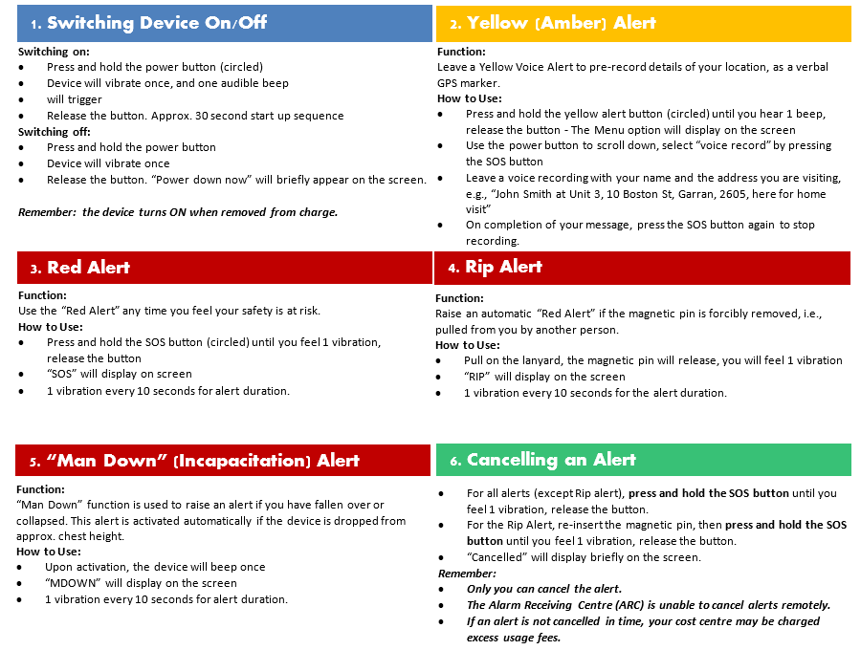

reventing and Reducing False Alarms
PREVENTING AND REDUCING FALSE ALARMS

To prevent a false alarm, e.g., an accidental or unintentional activation:
- Avoid unnecessary knocks or dropping of the device
- When you are not wearing the device – put it on charge or turn it off
- If the device is taken home, turn it off and keep it away from children and pets to avoid accidental activation
- Remember: alerts can still be activated when the device is charging
- Store the device in a secured area with no public access.

In the event of a false alarm:
- Speak through the device and say “your name, Canberra Health Services, false alarm & I am ok”
- Cancel the alert immediately – Press and Hold the “SOS” button.

Attachment 4 – Community Duress Device – False Alarms
This factsheet is relevant to Canberra Health Services (CHS) staff who use Community Duress Devices (CDD) supplied and monitored by SafeTcard Australia Pty Ltd (SafeTcard).
Below are some useful tips to prevent false alarm activations from occurring, to avoid potential excess usage fees to your cost centre and to ensure that the device is available to be activated during personal threat situations.
How Will I Know If a False Alarm Is Activated?
The device will trigger the same alert as a deliberate duress activation, therefore, if you detect 1 vibration from the device every 10 seconds, this means a false alarm has activated and the Alarm Receiving Centre (ARC) can hear you.
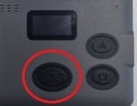

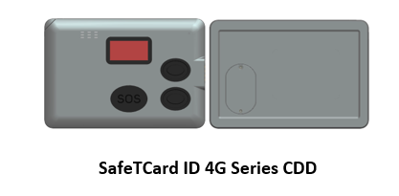

What Should I Do in the Event of a False Alarm?
If a false alarm is triggered, remain calm and complete the steps below:
STEP 3: Inform your manager
Inform your responsible manager of the accidental activation
STEP 2: Cancel the alert - Press and hold the “SOS” button
Press and hold the SOS button (circled) until you feel 1 vibration and
“Cancelled” is displayed on the screen
Please note: Only you can cancel the alert (ARC operators are not able to)

STEP 1: Let the Alarm Receiving Centre (ARC) know that it’s a false alarm
Speak through the device and say your name, your organisation, “false alarm” and “I am ok”
This saves ARC operators following up on alerts received with only a few seconds of audio
available that does not give a clear indication of the situation

STEP 4: Report it in Riskman
Lodge a Staff Incident Report in Riskman to record the accidental activation of the CDD

Tips for Preventing False Alarms:
- Avoid unnecessary knocks or dropping of the device - it could trigger the man down/incapacitation alert
- When the device is not being worn, place it away from other items or equipment, such as laptops or mobile phones, to avoid pressure on the duress button
- Store the device in a secured area with no public access. When the devices are not in use, put devices on charge or turn off the devices
- The device is on when removed or unplugged directly from charger. If the device is not to be used after charging, please switch it off in order to avoid unintentional activation
- Alerts can still be activated while the device is charging. Please secure the device properly and separate from other devices when it is on charge
- Label each device clearly to ensure the correct allocated device for a staff member or vehicle is worn, in order to avoid mix up
- If staff take the device home, turn it off and keep it away from others i. e. children and pets to prevent inadvertent activation in a non-work-related setting
- Familiarize yourself with the types of alerts and how to cancel them. Rehearse the process regularly. If in doubt, take the refresher training

Is Your Contact Information Current?
The ARC will attempt to verify alarm activation by contacting the device user and the escalation contacts prior to further action. It is important that your contacts are up to date and reachable in the event of an alarm activation. When changes are required for Designated Contact details such as changes in roles or phone numbers, please direct the request to the WHS team at CHS.WorkHealthSafety@act.gov.au.
Important: If an alert is set off without you knowing, the ARC operator will call you to make sure that everything is ok. Ensure you answer any calls from the ARC 07 4037 4888 (Valour Security Services). This will be the number that appears on your phone. It’s good practice to save this number in your phone and the designated emergency contacts’ phone so that it won’t be misinterpreted as a scam call.

