Canberra Health Services
Guideline
Tube feeding for Infants, Children and Adolescents (Nasogastric, Orogastric, and Nasojejunal)

Purpose

The Sydney Children’s Hospital Network Practice Guideline ‘Enteral Feeding Tubes and the Administration of Enteral Nutrition’ was developed by an expert multidisciplinary group of clinicians, informed by contemporary evidence.

The guideline reflects what is currently regarded as a safe and appropriate approach to the insertion and management of feeding tubes in children. This document should be used as a guide and does not replace the need for the application of clinical judgment to each individual presentation. This document is endorsed for use at Canberra Health Services Network (CHS). CHS Network includes the inpatient facilities at Canberra Hospital, Clare Holland House, North Canberra Hospital (NCH), and the University of Canberra and community based services. Staff at CHS should document insertion, assessment and ongoing management of feeding tubes in the digital health record (DHR) on the Avatar and/or Fluid Balance Flowsheet, and document family education on the ‘NICU/Paed Gavage Feeding and Medication’ Education title.

Families may be offered Nasogastric Tube home insertion training if the child is under the care of a paediatrician with admitting rights to The Canberra Hospital. Suitability of families offered this training should be discussed with the child’s treating team, and the paediatric Clinical Development Nurse (CDN) before training is offered.

Children being discharged from CHS with a feeding tube should be referred to the Paediatric Outpatient Department for ongoing support, however the child must be under the care of a Paediatrician with admitting rights. Families should be provided with the Health Information Sheet Paediatric Nasogastric Tube feeding, guide for parents and carers located on the Policy and Guidance Documents Register. Children with feeding tubes who attend public schools or pre-schools should also be referred to the Healthcare Access At School (HAAS) team as early as practicable.

At NCH – any infants being discharged home with a nasogastric tube insitu will also be referred to the Newborn and Parent Support Service (NAPSS).

See Attachment 1 for Insertion of nasojejunal tubes at CHS.

Scope

These guidelines apply to infants, children and adolescents
These guidelines apply to all CHS Network clinicians working within their scope of practice caring for paediatric patients including:
- Medical Officers
- Nurses and Midwives
- Allied Health Professionals
- Students working under direct supervision.

Exception: Tube feeding and related procedures that occur in Medical Imaging and infants under the care of Neonatology or Maternity.

Which area in Canberra Health Services can I contact for more information?

Paediatric Clinical Support Nurse (Monday – Friday)
Phone 0481 396 197 or 0403 194 726

For NCH:
• Special Care Nursery Clinical Development Nurse (Tuesday – Thursday)
Phone 6201 6036
• Special Care Nursery Clinical Nurse Consultant (Monday – Friday)
Phone 6201 6038

How can I access the document?
The guideline can be accessed at:
Enteral Feeding Tubes and the Administration of Enteral Nutrition (nsw.gov.au)

The procedure for inserting a nasogastric tube can be accessed at:
Appendix 2: Procedure for inserting a NGT (nsw.gov.au)

The definition of terms used in the guideline can be accessed at:
Appendix 8: Definition of terms (nsw.gov.au)

Search Terms

NGT, OGT, NJT, TPT, nasogastric, orogastric, nasojejunal, tube, feed, paediatric, paed, transpyloric, jejunal, gavage, gastric.

Attachments
Attachment 1: Nasojejnual tube insertion

Disclaimer: This document has been developed by Canberra Health Services specifically for its own use. Use of this document and any reliance on the information contained therein by any third party is at his or her own risk and Canberra Health Services assumes no responsibility whatsoever.

Policy Team ONLY to complete the following:
Date Amended | Section Amended | Divisional Approval | Final Approval
14/07/2023 | Complete Review | Suzanne Pilkington, A/g ED of WY&C | Chair, CHS Policy Committee
22/03/2024 | Updated to include NCH in scope, links updated | CHS Policy Team | CHS Policy Team
05/08/2024 | Minor Amendments made | Libby Coonan, A/g ADON, Paediatrics | CHS Policy Team

This document supersedes the following:
Document Number | Document Name
CHS19/159 | Tube feeding for Infants, Children and Adolescents (Nasogastric, Orogastric, and Nasojejunal)

Attachment 1: Nasojejnual tube insertion

At CHS, nasojejunal tubes should be inserted as below:

Location of procedure
If the child has altered anatomy (e.g. craniofacial abnormality) that makes it unsuitable to insert the tube at the bedside, or if there have been multiple failed attempts, the nasojejunal tube should be inserted in the medical imaging department with the assistance of fluoroscopy.

Measuring for a nasojejunal tube
Prior to inserting the nasojejunal tube, two measurements must be obtained: distance A, the length to the stomach; and distance B, the length to the jejunum. Distance A is measured by placing the tip of the tube at the child’s nostril and running the tube along the cheek to the tragus of the ear, then down from the tragus to the mid-point between the xiphisternum and umbilicus. Distance B is then measured by continuing the tube from the mid-point between the xiphisternum and umbilicus down to the right iliac crest (see diagram below).

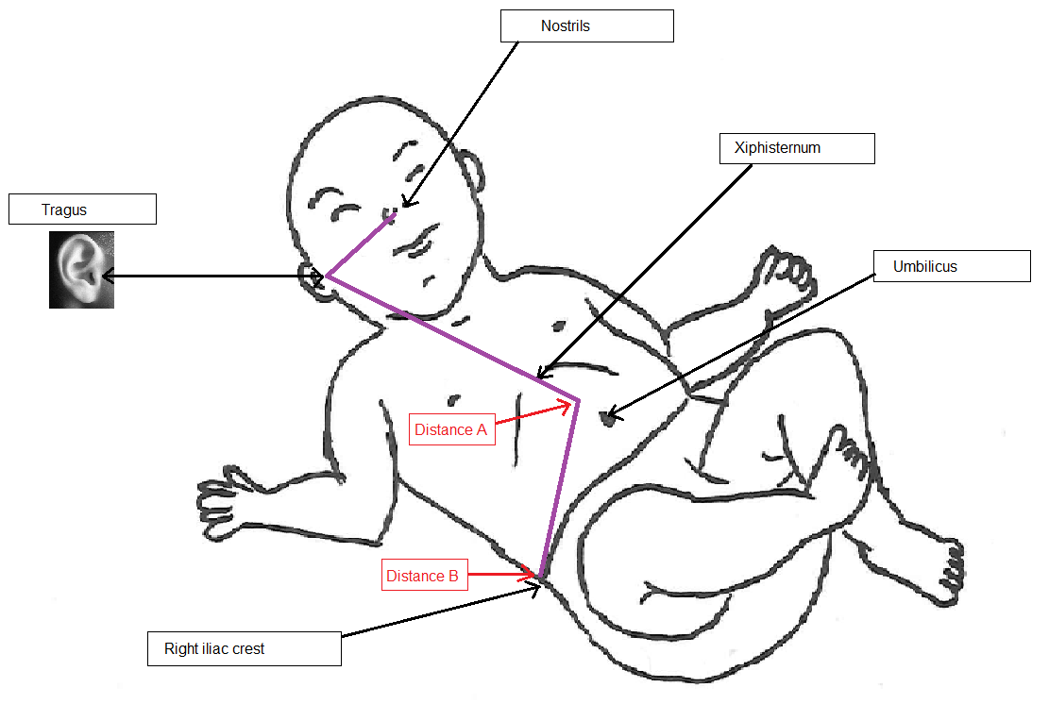
Image credit: Norrie, S. 2018.

Insertion procedure
- Follow procedure for insertion of nasogastric tube as per Sydney Children’s Hospital Network Practice Guideline Appendix 2 to step 13, using distance A.
- Position the child lying on their right side. If possible, elevate the head of the child’s bed to a 30-degree angle to aid peristalsis. Aim to keep the child in this position for the duration of the insertion process to encourage peristalsis and aid passage of the tube.
- Confirm correct placement for a nasogastric tube, then flush the tube with 2mL of water to encourage peristalsis. Begin advancing the tube (by 2-4cm for infants and smaller children, or 4-6cm for bigger children and adolescents) every 5-10 minutes, flushing with 2mL of water prior to each advancement. Continue this process until distance B has been reached. Secure the tube well with tape.

Alert:
NEVER push the tube against resistance, due to the risk of perforation. If any resistance is felt, an additional flush with water may help aid passage of the tube. If resistance is still felt after additional flushing, withdraw the tube slightly then attempt to readvance gently.

- Confirm correct tube placement with X-ray prior to use. Allow approximately 60 minutes after tube insertion prior to X-ray confirmation, to allow adequate time for peristalsis to move the tube through the pylorus. If possible, keep the child on their right side until X-ray confirmation has been obtained.
- Once the correct tube position has been confirmed, mark the tube at the nostril with permanent marker for future reference.
- Document the procedure and position of the nasogastric tube in the child’s clinical record on the DHR Avatar.

