Canberra Health Services
Guideline
Telehealth Consultation

Contents

Contents 1
Guideline Statement 4
Background 4
Key Objective 4
Scope 4
Section 1 – Benefits of Telehealth 5
Section 2 – Governance and Monitoring 5
Section 3 – Assessing Telehealth Suitability 5
Accessibility 6
Risk of harm to self and/or others 6
Specific Assessments and Interventions 7
Psychological Intervention 7
Section 4 – Privacy and Security 7
Consent 7
Section 5 – Telehealth Consultations: General Information 7
Booking Appointments 7
Spaces to do telephone and telehealth consultations 7
Staff and Patient Access to Telehealth Video 8
Recording Patient email and Consent 8
Alexander Maconochie Centre/Prison/Detention Centre Appointments 9
Using Interpreters 9
Telephone Consultation 9
Video Consultation 9
Involving Carers, Nursing teams and GPs during telehealth Consultations 9
Section 5 – Telephone Consultations 9
Administrative Duties 10
Clinical Duties 10
Section 6 – Video Consultations 11
Administrative Duties 12
Clinical Duties 13
Education sessions 14
Section 7 – Conducting a Telehealth Consultation 15
Developing the therapeutic relationship 15
Be aware of the effectiveness of teleconferencing services 15
Be clear about the purpose, goals and limitations of treatment 15
Optimising the visual and audio experience 16
Working with Children and Young People 16
Children 16
Young People 17
Developing Cultural Competence 17
Working with Culturally and Linguistically Diverse People 17
Managing Patient in Distress or Deterioration 17
Managing patients within Mental Health, Justice Health and Alcohol & Drug Services 18
Data Entry and Reporting 18
Working from Home/ Remote Working 18
Section 8 –Patient unable to connect to Telehealth 18
Evaluation 19
Related Policies, Procedures, Guidelines and Legislation 19
Search Terms 20
Attachments 20
Attachment 1 - Client Information Sheet on participating in a Telehealth session 22
Telephone Consultation 23
Attachment 2 - Telephone and Video Booking Instructions 24
Attachment 3 - Email Template to Confirm Appointment 25
Attachment 4 - ACTPAS instructions: Recording Patient/Patient Consent and Email Addresses 27
Attachment 5 - Using Interpreters for Video Consultations 28
Attachment 6 - Guide to Booking Video Consultations with Interpreters 33
Attachment 7 - Telehealth: Administrative Workflow 35
Attachment 8 - Telehealth: Clinical Workflow 36
Attachment 9 - Recording of COVID-19 adjusted activity 37
Attachment 10 - COVID-19 Medicare Billing Cheat Sheet 49
Attachment 11 - Medicare Non-Eligible or Ineligible Patient Service Fees 54
Attachment 12 - Letter to ACT Practitioners – Telehealth Prescribing 55
Attachment 13 - Use of Telehealth in Mental Health, Justice Health and Alcohol and Drug Services 57

Guideline Statement

This guideline provides the foundations to build a dynamic and adaptive workforce that can confidently integrate technology to assist all facets of service delivery.

The decision on whether a patient would benefit from a telephone consult, or a video consult is a clinical decision. Patients are given a choice and administration teams will support implementation of the collaborative clinical and patient decision. Telehealth phone or video consultations will only go ahead if the patient’s consent is obtained.

The determination of whether a telehealth model of care is entirely substituted for face-to-face services or complimentary to face-to-face services should be determined on a case-by-case basis by the clinician and depend on acceptance by the patient.

This guideline is to be used in conjunction with the Ambulatory Care Operations Manual.

Background
The objectives of using telehealth are to:
- improve patient outcomes via timely integrated access;
- drive greater efficiency in the way health care is delivered;
- support the delivery of quality health care; and
- make telehealth a viable alternative to the way some health care is traditionally delivered.

Key Objective
To inform staff on the best practice use of telehealth services in relation to:
- a patient’s suitability;
- risk assessment and management in the context of telehealth services;
- clinical practice considerations; and
- consent, record keeping and privacy.

The modes of telehealth that have been chosen by Canberra Health Services (CHS) are telephone and video consultation.

Back to Table of Contents

Scope

This guideline applies to all staff across CHS using telehealth services.

Back to Table of Contents

Section 1 – Benefits of Telehealth

- Where clinically appropriate and acceptable to patients, telehealth is a safe, effective and valuable method to support patient and family-centred care and care closer to home.
- Telehealth provides the opportunity for clinical teams to integrate services from geographically dispersed providers at the one time.
- Telehealth can provide an equitable service delivery mechanism for people in the ACT to access quality healthcare, reducing the need to travel to appointments.
- Telehealth provides more opportunities to support flexible workplaces and ensure health providers are well connected and supported in their roles.
- Telehealth can link in with carers of family who can’t be present.

Back to Table of Contents

Section 2 – Governance and Monitoring

- Governance and monitoring of telephone and video consultations will be through Divisional Quality and Safety meetings.
- Models of care are monitored and evaluated on an ongoing basis to support continuous improvement.
Back to Table of Contents

Section 3 – Assessing Telehealth Suitability

Telehealth can be used to support wellness, prevention, health management, and performance improvement. Staff should consider an individual’s health needs to determine if telehealth is appropriate.

While the barriers listed above are factors that can be used to assess and consider suitability for telehealth they do not necessarily preclude the use of telehealth. Staff should also consider the consequence for individuals and their families/carers if they choose not to access the telehealth service.

Patients who are reluctant, do not want to access telehealth services or are unsuitable for telehealth services should be offered a face-to-face appointment.

Staff should also review the suitability of telehealth over time. If the patient’s presentation or circumstances change, telehealth may no longer be a suitable option.

The decision whether an appointment is suitable for telephone or video will be made by the clinician and will consider clinical, patient and logistical factors.

Models of care using telehealth may require consideration of inclusion and exclusion criteria.

The following factors should be considered:
- Level of physical assessment required;
- Availability of support at the patient site;
- Availability and access to appropriate devices including video conferencing units/systems;
- Ability of the client to participate, including consideration of physical, mental, social, language and cognitive barriers;
- Distance between provider and client locations;
- Local availability of associated imaging and lab tests;
- Availability of technology;
- Patient familiarity and competence to use technology independently or with appropriate help;
- Patient desire to participate in a telehealth consultation; and
- Ability to schedule a telehealth session within the timeframes for the service or program’s standard of practice guidelines.

Accessibility
Staff need to consider potential barriers to effective service provision. For instance, the patient’s capacity to access services such as whether the patient has the required hardware or devices, a reliable internet connection, technical skills, and access to IT support. This may also mean considering if the financial cost to the patient for accessing a telehealth service is prohibitive (e.g., hardware, software, data usage).

Consideration must also be given to the patient’s ability to participate, such as physical, mental, and cognitive barriers. Staff should be aware of existing barriers and work with patients/carers to minimise them. A telehealth service may be inappropriate for people with vision or hearing impairments. Interpreters can be arranged when using telehealth.

Risk of harm to self and/or others
When a health service is delivered face-to-face, staff can respond to any concern about risk of harm to self and/or others while the patient is present whereas in a telehealth service, the patient’s location may be unknown or unable to be reached.

This means that staff will need to consider their capacity to provide a safe service if the patient presents with acute risk of harm to self (e.g., suicidal ideation) or potential for harm to others. The presence of this risk does not preclude the patient from receiving the service, particularly if staff have developed in collaboration with the patient an individualised safety plan that considers skills and supports.

Further information relating to Telehealth and patients from Mental Health, Justice Health and Alcohol & Drug Services is at Attachment 13.

Specific Assessments and Interventions

Psychological Intervention
Some types of psychological interventions will be more suitable than others. Factors to consider include the strength of the existing therapeutic relationship between staff and the patient and the current stage of psychological therapy. Consideration also needs to be given to post-therapy support, given people may remain in a heightened emotional state within their home.
In general, the following are examples of suitable and unsuitable telehealth psychological interventions:
- Suitable: Skills-based therapies, coaching, psychoeducation, health promotion, supportive counselling, psychological first aid. This will depend on staff training and skills.
- Not suitable: Second stage of trauma therapy (e.g reprocessing), people with acute psychosis or mania, or acute suicide risk

Back to Table of Contents

Section 4 – Privacy and Security

Staff are required to use the telehealth platform provided by ACT Health Digital Solutions and not a platform of their own choosing. This ensures that the platform is compatible with CHS technology and meets Australian legislative requirements for privacy and security.

Consent
Staff should include as part of the routine informed consent process information on privacy and security, the limits to privacy in online communication, and the use of session materials. Staff should refer to Informed Consent (Clinical) policy.

Clients and/or their carer’s will be sent a telehealth information brochure prior to their telehealth session outlining their rights and responsibilities. A copy of this is at
Attachment 1.

Back to Table of Contents

Section 5 – Telehealth Consultations: General Information

Booking Appointments
- Administration teams should use the instructions provided in Attachment 2 to book patients into both phone and video telehealth appointments.

Spaces to do telephone and telehealth consultations
- Existing spaces used to provide clinical services, including hospital and community settings, can be used to implement telephone/telehealth services using existing fitted or mobile technology or with the provision of new equipment.
- Office settings or meeting rooms may also be suitable if they provide privacy.

Staff and Patient Access to Telehealth Video
- Staff should contact Digital Solutions Division and request access to ‘Telehealth-video’ consultation.
- Once staff have signed into Telehealth for the first time and set up a password, they will have access to their assigned waiting room(s). It is recommended that staff save the below Telehealth log in page link to their google chrome browser:
https://vcc.healthdirect.org.au/login
- Patients with booked Telehealth appointments must be emailed the details of the appointment and how to log on at least one day before their scheduled appointment utilising the template in Attachment 3.
- Advice should be given to patients to test their equipment using the ‘Test Call’ function and take the opportunity to browse the support topics and resources available at www.health.act.gov.au.
- Patients should also be reminded that telehealth is not supported by Microsoft Edge, therefore a different browser, such as Google Chrome must be used.

Recording Patient email and Consent
Prior to emailing a patient, verbal consent must be obtained from the patient for Canberra Health Services to contact them by email. This is consistent with the Informed Consent (Clinical) policy. The following information must be recorded within ACTPAS:
- Consent to receive messages
- A valid and current email address.

Attachment 4 provides a guide to recording patient consent and email addresses in ACTPAS.

The CHS rules and governance around sending administrative emails to patients includes the following:
- Emails should only contain administrative details, such as the link for patients to login to telehealth.
- Email can contain patient identifying information such as first and last name and URN but NO further details.
- Emails should not have any patient related treatment plans or clinical information related to the patient’s care.
- Emails can include appointment date, appointment time and service information.
- Emails to clients can only be sent from approved email accounts that will be nominated by service managers. In the Adult Community Mental Health Service (ACMHS), each team will used their generic email to liaise with patient/people.
- Emails relating to client communication cannot be deleted and any such incident will require a Riskman report to be recorded.
- Records should be kept in line with the CHS Informed Consent (Clinical) Policy and the CHS Records management policy.

Alexander Maconochie Centre/Prison/Detention Centre Appointments
- Appointments for patients from prison or detention centres will have the prefix of ‘AMC’ before their first name so that administration teams can identify the patient.
- Administration teams are advised to book appointments for these patients either at the beginning of clinic start time or the end so that these patients are not kept waiting.
- Once a mode of appointment delivery is confirmed, it cannot be changed by the clinician as special permissions and set up is required. An appointment can only be changed where there is prior notice.
- Further information relating to telehealth and Justice Health patients is contained in Attachment 13.

Using Interpreters

Telephone Consultation
- While using telephone service for your consultation, if you need an interpreter, please call the Translating and Interpreting Service (TIS) on 13 14 50
- For more information, please see the HealthHUB - https://healthhub.act.gov.au/node/471

Video Consultation
- An ONCALL interpreter service can support the need of an interpreter service while using the Health Direct Platform.
- The patient and the interpreter are greeted by the administration team and both calls are joined/merged before the patient’s appointment and the interpreter is placed in the waiting room for the clinician.
- An Administration guide to connect patient and interpreter is available at Attachment 5.
- The user guide to book the ONCALL interpreter is available at Attachment 6.

Involving Carers, Nursing teams and GPs during telehealth Consultations
- Telehealth video consultations can add both GPs and carers.
- Carers or family members who are not able to be physically present can be sent a link directly to attend the consultation. Prior to sending any links to families or carers the patient must give consent for their medical information to be shared, as per the Informed Consent –(Clinical) Policy.
- Shared care and Early Transition to GP care may use telehealth-video consultations as a tool to support their model of care.

Back to Table of Contents

Section 5 – Telephone Consultations

- Telephones are often used to provide results, monitor patient progress including following discharge.
- Telephone consultation may be used where internet may not be suitable for video.
- Access to a land line phone connection or a de-identified mobile number is essential for clinicians.
- Patient is required to have access to a phone (land line or mobile)

Administrative Duties
- Refer to Attachment 7 for the Telehealth -Administrative Workflow
- Ensure clear communication with patient regarding the mode of their appointment.
- Communication can be supported by letters, emails (see Attachment 3) and SMS function where available.
- Clearly communicate to the patient that they should not call back on the number the clinician uses for their telephone appointment. Where possible, clinicians should use phones with a blocked number when calling a patient.
- If the patient does not consent to a telephone consultation, other options such as video or face-to-face should be offered while booking an appointment.
- Agree on a preferred number for the clinician to call for their consultation.
- Communicate to the patient that they should be in a safe, quiet location with a good network connection (if using a mobile number) for their telephone consult to take place.
- Patients should be asked to be flexible as the clinician may be running late and the appointment may not start on time and to ensure their phone/ tablet/computer is well charged and/or they have access to a charging point during consultation.
- Administrative staff should use agreed fields within their Patient Management Systems to record the consultation as a ‘telephone appointment’ e.g. Dependent Resource tab for ACTPAS.
- Administrative staff are to print out clinic lists for clinicians on the day so that the clinician is aware which patients are booked for telehealth appointments e.g. Patient 1 - face to face appointment; Patient 2 - video appointment; Patient 3 - telephone appointment. Where systems are integrated with Q Flow, using the system should be the standard operating procedure. Q Flow is a tool that is used to see patients in a Waiting Room.
- Administrative staff will support clinicians to “arrive” and “depart" patients on Patient Management Systems as required and set this up in local processes.
- Administrative staff are to follow-up on any actions from the telephone consultation. These may be actioned on the electronic systems (Flow Manager) or via various agreed local processes.
- Administrative staff are to undertake billing where appropriate. Attachments 10 and 11 provide further information and guidance on billing processes.

Clinical Duties
- Refer to Attachment 8 for the Telehealth: Clinical Workflow
- Clinicians will clearly identify patient or patients that would benefit from a telehealth consultation and communicate this to the administrative staff (bookings team).
- Clinicians are to verify and identify the patient using 3 unique identifiers, as per the Patient Identification Procedure Matching Procedure, available on the Policy and Guidance Documents Register (https://actgovernment.sharepoint.com/sites/intranet-health/PPR/default.aspx) including the physical location of a consumer
- Clinicians are to confirm patient is in a safe, secure and quiet location to begin their telehealth consult.
- Clinicians are to confirm who is with the clinician and confirm who is with the patient during the consultation.
- Once the telephone consultation is complete, the clinician is to let the patient know the outcome of their appointment e.g. is the patient being discharged from the service, does the patient need a follow up appointment and what mode of appointment they require, does the patient need further investigations, and/or does the patient require a new prescription.
- The clinician should document progress notes of the telephone consultation in Clinical Patient Folder (CPF) or appropriate medical records systems.
- Outcomes from telephone consultations should be recorded in electronic systems (Flow Manager) or agreed local processes.
- Outcomes from the telephone consultations should be given to the administrative staff to action in a timely manner.

Back to Table of Contents

Section 6 – Video Consultations

- Health Direct is the platform procured by CHS for telehealth (video) consultations.
- The Health Direct platform is a standalone platform which enables a patient and clinician to have a video consultation. It does not integrate with any CHS systems.
- Please use Google Chrome V72+; Apple Safari V12+ or Firefox V68+to connect to the Health Direct link. Please do not use Microsoft Edge as this is not supported by the current version at CHS.
- A quality internet connection with sufficient bandwidth is required at both ends of the consultation or problems may impact on the quality of the consultation. For clinical video consultations, the recommended bandwidth is 350Kbps per video stream
- A poor connection can result in audio dropouts, freeze frames, lip sync problems and pixelation.
- The audio-visual quality of a video conference is directly related to the speed at which data is transmitted through the internet connection.
- Through consultation, CHS has agreed to a Super Clinic structure to support demand with the capacity.
- Super Clinics are either grouped according to speciality or location of outpatient appointments to ease Patient participation. These are:
- Canberra Hospital
- University of Canberra Hospital (UCH)
- Community
- Cancer
- Sexual Health
- Mental Health & Drug and Alcohol
- Women, Youth and Children
- Dental Services
- There are 3 levels of access for the Telehealth System:
- Service Referrer – Admin teams who manage all outpatient clinics
- Team Member – All Doctors, Nurses, Allied Health and reception staff who will connect with a video call with the patient
- Organisation Administration – Digital Solutions Division staff who manage the configuration of the system.
- The CHS HealthHUB Technology section provides videos and training material created by the Digital Solutions team. These include and are not limited to:
- How to join telehealth calls for clinicians, administration staff and patients
- Video: How to join a video call and see your patient– 5-minute video for clinicians and reception staff
- Proposed Telehealth Workflow
- Video: How to reset your password – 49 second video
- COVID-19 Medicare Telehealth/Phone billing
- Pathology request instructions
- Capital Pathology Online request form
- Capital Pathology Contact List
- Prescribing medications instructions
- ACT Pharmacies Contact list
- eForm for CPF

Other help sheets:
- Telehealth Troubleshooting guide
- Call screen infographic
- Web Cam set-up instructions
- Comparison of video conferencing applications for Patient or patient content

Administrative Duties
- Refer to Attachment 7 for the Telehealth -Administrative Workflow
- Clearly communicate with patients about the mode of their consultation.
- Communication can be supported by letters, administrative emails and SMS function where available.
- If a patient does not agree to have a telehealth consultation, other options for their consultation should be offered when booking.
- Check that they have: the equipment necessary for a video call; a reliable internet connection; a safe, secure and quiet space to do the consultation; and that they have help available if they need it.
- Give the patient the link to the ACT Health homepage: https://health.act.gov.au/ and instructions to select ‘Telehealth’ service button from the four buttons on the top of the page (See Attachment 7).
- Advise the patient to access the link and try a test call prior to their appointment. This link will also be sent to the patient by letter or email.
- Patients should be asked to be flexible about their appointment start time as the clinician’s previous consult may over-run and to ensure their phone/ tablet/computer is well charged and or they have access to a charging point during consultation.
- Administrative staff should use agreed fields within their patient Management Systems to record the consult as a ‘telehealth-video appointment’ e.g. Dependent Resource tab for ACTPAS. This may differ with other patient administration systems.
- Administrative staff are to print out clinic lists for clinicians on the day so that clinician is aware of the format for each consultation e.g. Patient 1- face-to-face appointment, Patient 2- telehealth video appointment; Patient 3- telephone appointment. Where systems are integrated with Q Flow, using the system should be the standard operating procedure.
- Administrative staff are to support clinicians to “arrive” and “depart” patients on Patient Management systems as required and outlined in local processes.
- When a patient arrives for their telehealth consultation, administrative staff will do the demographic check and update details that require updating.
- Administrative staff will check the Patient Management systems (ACTPAS or other) and identify which clinic/ session the patient is attending.
- Administrative staff are to move patient into the waiting room for the session/clinic via the telehealth-video Health Direct software.
- Administrative staff are to action outcomes from the telehealth -video consultation. These may be actioned on electronic systems (Flow Manager) or via local processes.
- Administrative staff are to undertake billing where appropriate.

Clinical Duties
- Refer to Attachment 8 for the Telehealth: Clinical Workflow
- Clinicians will clearly identify patients that would benefit from a telehealth consult and communicate this to the administrative staff (bookings team).
- Clinicians can access the Telehealth-Video login page using the Quick Links - Telehealth on the CHS intranet hub
- Clinicians are to verify and identify the patient using the 3-point identification check including the physical location of the consumer
- Clinicians are to confirm the patient is a safe, secure and quiet location to begin their telehealth consult.
- Clinicians are to confirm who is with the clinician and confirm who is with the patient during the consultation.
- Introduce yourself and anyone with you to the patient and their family members and establish eye contact by keeping the eyes at the level of the camera.
- The clinician should agree with the patient on how they would reconnect if their video consultation is interrupted or disconnected for any reason.
- This can be done via a phone call to the patient but must be agreed earlier in the consultation.
- The clinician will request client’s consent to Medicare Telehealth billing and record their response in the clinical notes.
- Speak slowly and use non-technical language.
- Use visual aids to explain the situation. This may include online whiteboards, writing on paper and sharing of screens to show medical imaging and pathology where appropriate.
- Summarise the consultation and check that they have understood the information. Where possible, consider sending a copy of the consultation summary to the patient as well as the GP.
- Before completing the consultation, provide opportunities to the patient and family members for addressing current and future concerns by encouraging questions and offering contact details.
- Once the telehealth consultation is complete, the clinician is to let the patient know the outcome of their appointment e.g. is the patient being discharged from the service, does the patient need a follow up appointment (clarify the type of appointment), does the patient need further investigations or tests, and does the patient require a new prescription.
- Progress notes of the telehealth consult should be documented in the Clinical Patient Folder (CPF) or appropriate medical records systems.
- Outcomes from telehealth consults should be recorded in electronic systems (Flow Manager) or specific local processes.
- Outcomes from the telehealth consult should be given to the administrative staff to action in a timely manner.

Education sessions
- Healthdirect Video Call is a clinical tool, so only up to 5 participants can be in a Video Call consult or meeting room.
- For more than 5 participants in a session, a video conferencing tool such as Cisco Webex or Microsoft Teams can be used.
- These platforms are supported by Shared Services and are secure to use if individual patient details are not being exchanged.
- Webex Meeting can easily cater for 15 to 20 people and is a highly interactive tool.
- Webex Event can cater for more than 100 participants and is a less interactive tool.
- Microsoft Teams is like Webex Meeting with slightly different display functionality.
- For more information, please visit the Intranet Hub- Technology

Back to Table of Contents

Section 7 – Conducting a Telehealth Consultation

The following clinical practice considerations are for staff intending to engage in ongoing health interventions, with specific reference to psychological and psychosocial interventions.

Developing the therapeutic relationship
The therapeutic relationship underpins all psychological services and consideration must be given to establishing this alliance in the context of electronic communication.

Staff can improve the capacity for a healthy and strong therapeutic alliance by considering the following adjustments to their practice when delivering a service via videoconference:

Be aware of the effectiveness of teleconferencing services
Research has shown that the quality of the therapeutic alliance using telehealth is comparable to face-to-face.

Adjustments can include:
- Emphasising verbal and non-verbal gestures
Videoconferencing generally limits the amount of non-verbal information exchanged between the staff member and the patient. As a result, staff will need to emphasise both verbal (e.g. expressions of unconditional positive regard, acceptance and caring) and non-verbal gestures to facilitate rapport building. Skills that may need to be used more often include active listening, taking turns, paraphrasing, using shorter sentences, as well as slowing down the interaction and paying more attention to social cues and emotional expressions. Staff will also need to be more overt and deliberate with their non-verbal communications (e.g., inflection, tone, gestures and mannerisms) compared with what is typical during face-to-face sessions.
- More frequently clarifying the meaning of patients’ facial expressions and body language.
- Approaching the session with friendliness and warmth.
Compared with people using face-to-face services, people engaging in a telehealth session are generally more sensitive to the level of friendliness and warmth expressed by the provider. Staff who adjust their communication style to convey a friendly and warm approach will assist the patient to feel comfortable and at ease with the videoconference environment.
- Checking with the patient about their experience of the therapeutic alliance.
- It can be helpful to check in with the patient about their experience of the therapeutic alliance/bond and/or use validated measures to gauge the quality of the alliance.

Be clear about the purpose, goals and limitations of treatment
Staff can enhance the therapeutic relationship by clarifying the purpose of therapy, the goals for treatment and agreeing on the tasks required to achieve the desired outcomes. Such discussions are standard practice at the beginning of any psychological intervention, but in a telehealth service is it important that the discussion also focuses on the patient’s expectations for treatment delivered via videoconference. Staff should also be open with people about the benefits and limitations of telehealth and work with the patient to overcome any limitations. Staff are encouraged to regularly check-in with the patient to review how the telehealth modality is working for them.

Optimising the visual and audio experience
There are a number of considerations when setting up videoconferencing technology that impact on the experience for both the patient and the provider. For example, positioning the camera only on the patient’s face limits the capacity of the staff member to gather non-verbal cues. It is important that staff consider these factors when setting up the teleconference session so they can advise the patient to make appropriate adjustments. Some aspects found to enhance the videoconferencing experience include:
- Adequate eye-contact with the patient established by:
- Ensuring the staff member and patient are seated squarely in front of the camera lens
- The staff member adjusting their view of the patient and assisting the patient to adjust their view of the staff member so that you can both see each other’s face clearly
- The staff member regularly alternating their gaze between the monitor and the lens of the camera when speaking and/or listening
- Limiting the taking of written notes as this averts the staff member’s gaze
- Removing any accessories or obstacles that obscure visibility of facial expressions
- Good lighting for both the patient and the staff member
- Privacy (no interruptions) for both the patient and the staff member
- Maintaining a video link throughout the session even if during times of discomfort, some people wish to switch the camera off or engage in more subtle behaviours such as moving out of the view of the camera.

Working with Children and Young People
Children and young people with regular access to technology may prefer the use of telehealth services, particularly young people who may dislike traditional modes of therapy. Engagement is of paramount importance; staff need to translate engagement and play activities into the online space.

Staff should also consider how they will communicate with parents/carers, such as an agreement that they will be present at the start and/or end of the session. Discussion with the parent/carer should include a mutual plan if the child or young patient becomes distressed in session.

Children
For younger children, staff should consider commencing sessions by gaining the attention of the child by playing a game requiring them to engage, like counting fingers, singing a song, or showing where they are/touring the home (the child or young patient introducing the staff member to pets or sentimental objects in the home can generate good conversation). Other activities include therapeutic story telling (reading a book together, either one the child or staff member has or online), joint-drawing (using the telehealth whiteboard function), or games. The following link has a list of online games that can be played using telehealth: https://freeappsforme.com/games-to-play-over-skype/

Staff should have on hand their usual therapy-aid tools, such as feeling bear cards, that can be shown on screen to the child. Given limits to attention, staff may consider shorter sessions with children.

Young People
Young people generally require more time to engage with health services. Similar to the activities mentioned above for children, staff can use online activities and games to help with engagement. Staff can use the telehealth chat box function to send links to resources, such as worksheets. Where telehealth allows, staff can share their screen if required as part of an engagement activity.

Consideration needs to be given to the young patient’s home environment, and capacity to maintain privacy and confidentiality. The staff member should discuss these factors with the young patient before engaging in telehealth.

Developing Cultural Competence
Staff delivering any telehealth service must work within the boundaries of their competence. Cultural competency is the ability of providers to effectively deliver services tailored to meet the social, cultural and linguistic needs of a client.

Working with Aboriginal and Torres Strait Islander Peoples
It is likely that some people seeking health services will be Aboriginal and/or Torres Strait Islander people. Staff will therefore need to reflect on how they will identify if a patient is Aboriginal and/or Torres Strait Islander if they are conducting an initial intake or assessment. The only effective and accurate way to identify someone of Aboriginal and/or Torres Strait Islander origin is to ask, “Are you of Aboriginal and/or Torres Strait Islander origin?”

Delivering a service that is culturally inappropriate has the potential to do more harm than good. Staff should consider seeking the services of the CHS Aboriginal and Torres Strait Islander Health and Wellbeing Team when working with Aboriginal and Torres Strait Islander people and seek cultural supervision and support for the use of telehealth.

Working with Culturally and Linguistically Diverse People
In addition to considerations noted above, staff should consider the best practice of service delivery for culturally and linguistically diverse people that are relevant to the use of telehealth. Staff should not use family or friends to interpret. Where needed, staff should use the Translating and Interpreting Service (TIS).

Managing Patient in Distress or Deterioration
During telehealth-video or telephone consultation if a patient becomes distressed or deteriorates:
- Consider another contact method.
- Call an ambulance and inform next of kin.
- Hand over care to carer if one is present and check in later.

Managing patients within Mental Health, Justice Health and Alcohol & Drug Services
See Attachment 13.

Data Entry and Reporting
- Follow ACTPAS guidelines for the recording of all COVID-19 adjusted activity (see Attachment 9)
- Non-ACTPAS services, please email Digital Solutions Support to determine best reporting arrangements.

Working from Home/ Remote Working
- If a clinician is self-isolating, or working remotely, processes need to be agreed with your service’s Leadership team, Operations, and Administration Managers on how telehealth could be supported.
- Teams may agree to email clinicians their clinic list and the clinician can communicate via email, Microsoft Teams or by returning the clinic list with patient outcomes.
- Provided the clinician has access to the stationery and script pads, post consult follow up activity such as medication scripts, pathology forms, etc can be done when doing telehealth or telephone appointments remotely and scanned back to teams.
Telehealth Prescribing
- Prescribing for Telehealth appointments is available to clinicians. Further information on the process is outlined in Attachment 12.

Back to Table of Contents

Section 8 –Patient unable to connect to Telehealth

- Patients are advised to do a test call prior to their appointment.
- If they need help, patients can call Digital Solutions Support to assist them with troubleshooting their technical issues. This number will be displayed on the ACT Health homepage and telehealth webpage.
- On the day of the appointment, DSS will support the patient to connect to their appointment if they have trouble.
- If the appointment time is not going to be met, DSS will email the Bookings Team linked to the Super Clinic with details of the patient so that the appointment is not recorded as a DNA.
- This also provides an opportunity to reschedule the appointment.

Back to Table of Contents

Evaluation

Outcome

- No scheduled appointments were adversely affected by technological failure.
- Positive feedback received from patients who have accessed the telehealth consultation service.
- Improved outcomes for patients seen via telehealth compared to face-to-face consultation

Measures

- A 12 monthly audit of telehealth appointments data by administrative staff to identify number of appointments cancelled due to technology problems and results reported to the Our Care Committee.

- Collect 12 monthly quantitative and qualitative data from patients focussing on their telehealth experiences, what is currently working, what is not working and opportunities for improvement by the relevant area and report results to the Our Care Committee

- Analysis of patient records by relevant staff responsible for conducting telehealth consultation, for indication of consultation; the actions taken resulting from the consultation and further care provided in the next 30 days in relation to the telehealth consultation (e.g. treatment room tests, ED presentations, further telehealth consultations, etc) and results reported to the Our Care Committee.

Back to Table of Contents

Related Policies, Procedures, Guidelines and Legislation

Policies
- Nursing and Midwifery Board of Australia Requirements for Practice Policy
- Informed Consent (Clinical)

Procedures
- Infection Prevention and Control – Healthcare Associated Infections
- Patient Identification and Procedure Matching

Guidelines
- Fasting Guidelines for Patients Undergoing Procedures Requiring Sedation or Anaesthesia

Manuals
- Ambulatory Care Operations Manual

Legislation
- Health Records (Privacy and Access) Act 1997
- Human Rights Act 2004
- Work Health and Safety Act 2011

Other
Australian Charter of Healthcare Rights

Back to Table of Contents

Search Terms

Telehealth, appointments, video, telephone, consultations, accessibility, ACTPAS, billing, Medicare, COVID-19, prescribing, consent, Q Flow

Back to Table of Contents

Attachments

Attachment 1 - Client Information Sheet on participating in a Telehealth session
Attachment 2 – Telephone and Video Booking Instructions
Attachment 3 – Email Template to Confirm Appointment
Attachment 4 - ACTPAS instructions: Recording Patient/Patient Consent and Email Addresses
Attachment 5 - Using Interpreters for Video Consultations
Attachment 6 - Guide to Booking Video Consultations with Interpreters
Attachment 7 - Telehealth: Administrative Workflow
Attachment 8 - Telehealth: Clinical Workflow
Attachment 9 - Recording of COVID-19 adjusted activity
Attachment 10 – COVID-19 Medicare Billing Cheat Sheet
Attachment 11 – COVID-19 Non-Eligible patient or patient billing cheat sheet
Attachment 12 – Letter to ACT Practitioners – Telehealth Prescribing
Attachment 13 – Use of Telehealth in MHJHADS

Disclaimer: This document has been developed by Canberra Health Services specifically for its own use. Use of this document and any reliance on the information contained therein by any third party is at his or her own risk and Canberra Health Services assumes no responsibility whatsoever.

Policy Team ONLY to complete the following:
Date Amended | Section Amended | Divisional Approval | Final Approval
27/04/2022 | Complete Review | Cathie O’Neil- COO | CHS Policy Committee

This document supersedes the following:
Document Number | Document Name
CHS 21/499 | Telehealth consultation guideline

Attachment 1 - Client Information Sheet on participating in a Telehealth session

What is a Telehealth session?
A Telehealth session is a consultation where you and a Canberra Health Services clinician are not in the same room as each other and use technology to be able to see and hear each other.

Why use Telehealth?
A Telehealth session reduces the need for you to travel to receive a consultation. During the current COVID-19 global pandemic telehealth has been implemented in rapid response to meet the healthcare needs of clients.

How will I see the clinician if we are not in the same room?
The most common piece of technology used to deliver telehealth consultations is videoconferencing. It is similar to a normal telephone call, with the added benefit of being able to see the participants at the other end.

Can a family member attend the session with me?
You can choose if a family member, your carer or other support patient attends the appointment with you.

Who will be part of the session?
At the time of consultation, you will see your treating clinician through a screen. Your clinician will be in a quiet, office space during the consultation.

Consent for the session
Verbal consent is required at the beginning of your consultation. All staff who are part of the consultation will be introduced at the beginning of the session. You will also be asked to identify any other individuals present in the consultation.

Your follow up appointment
A follow up appointment will be made if required.

Can I ask questions during the session?
You and your carer should feel free to ask any questions you have both before, during and after the consultation.

What if I don’t want to be part of a Telehealth session?
You may choose not to participate in a telehealth consultation if you are uncomfortable.

What if I am uncomfortable during the session?
If you are uncomfortable, please speak with your treating clinician and they will try to resolve any concerns you may have alternatively you can ask to finish the consultation.

Maintaining your privacy and confidentiality
All sessions done via Telehealth are private and secure and will not be recorded. Documentation will be taken during the consultation by the clinician and will then be entered into your medical record, as would normally happen if you saw your clinician face-to-face.

Using Interpreters

Telephone Consultation
- While using telephone service for your consultation, if you need an interpreter, please call the Translating and Interpreting Service (TIS) on 13 14 50
- For more information, please see the HealthHUB - https://healthhub.act.gov.au/node/471

Attachment 2 - Telephone and Video Booking Instructions

https://actgovernment.sharepoint.com/:x:/r/sites/intranet-health/CAS/achs/_layouts/15/Doc.aspx?sourcedoc=%7BC15CACAA-E611-4875-B7FE-971135545A5E%7D&file=Bookings%20Admin%20Flipchart%20February%202021.xlsx&action=default&mobileredirect=true&DefaultItemOpen=1

Attachment 3 - Email Template to Confirm Appointment

Dear <<first name last name>>

Canberra Health Services is currently reducing non-essential, non-urgent activity across all our services in efforts to relieve pressure on the health system and to reduce the spread of COVID-19.

Your consultation for <<service>> is going to be via a Telehealth- video call. You do not need to come to a Canberra Health Services location for this consultation.

Your Telehealth- video call appointment has been made for
Date: <<DATE>>
Time: <<TIME>>

On the day of appointment: Enter health.act.gov.au link in your web browser. Please click the ‘Telehealth button’ on the home screen and this will take you to the video consultation.
Before your appointment: Visit health.act.gov.au and click on the ‘Telehealth button’ and attempt a ‘Test call’ to check your device and internet connection. The webpage will also provide you with information on attending a telehealth appointment.

If you have technical issues when connecting to your telehealth appointment, please call ACT Health Digital Solutions on 02 5124 5000.

Please be patient as with normal appointments, your doctor may be running late, and the appointment may not start on time.

As you enter the Video Clinic, reception staff will greet you and confirm your identity and appointment details. At the start of your appointment your doctor will ask questions to identify you. You may also be asked to give verbal consent to have your appointment bulk-billed to Medicare if eligible.
If your condition gets worse before your appointment, please visit your GP, a Walk in Centre or if very unwell, the Emergency Department. If you do have to visit the Canberra Hospital, please note that you will need to comply with visitor restrictions.

Please phone us on the contact number below if:
- you no longer need this appointment
- you are not able to attend your appointment
- your contact details have recently changed

Canberra Health Services apologises for any inconvenience this has caused you, and we thank you for your patience and understanding.

Yours sincerely,
<< Service details/ Bookings team >>

You are receiving this email as you have verbally consented for Canberra Health Services to contact you by email. Please DO NOT respond to this email as this mailbox is not monitored.

Attachment 4 - ACTPAS instructions: Recording Patient/Patient Consent and Email Addresses

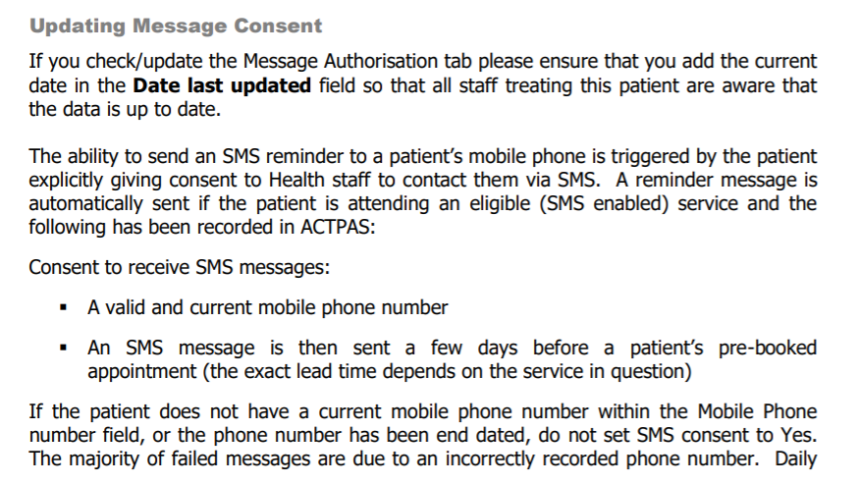

Full instructions regarding Registration and Alerts for ACTPAS are available in the ACTPAS User Guide Module 2.

Attachment 5 - Using Interpreters for Video Consultations
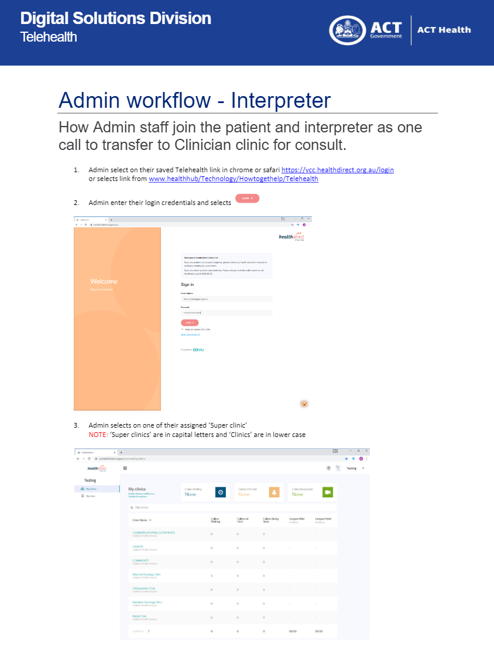
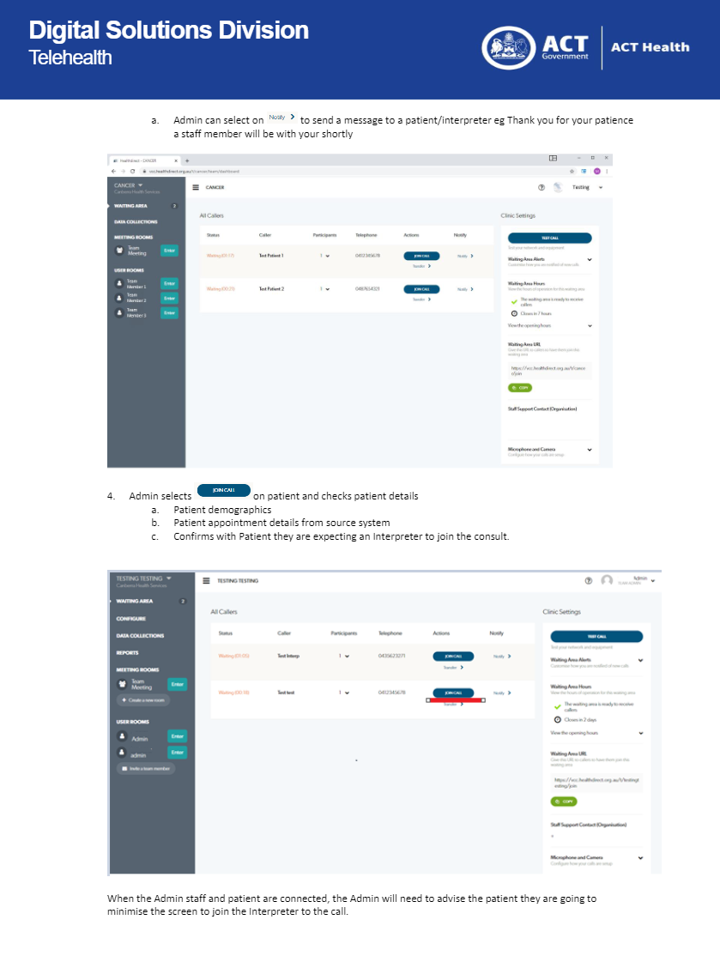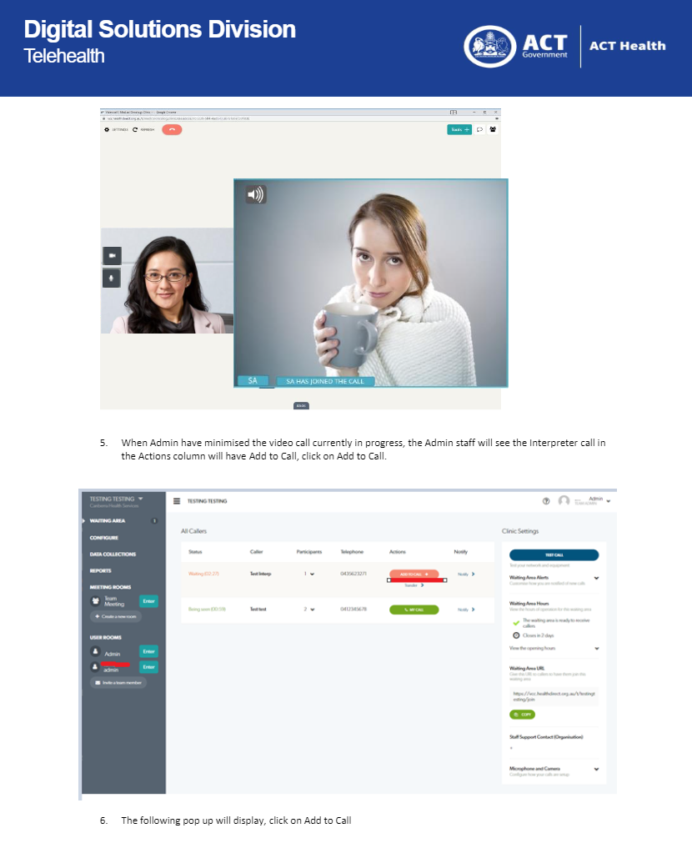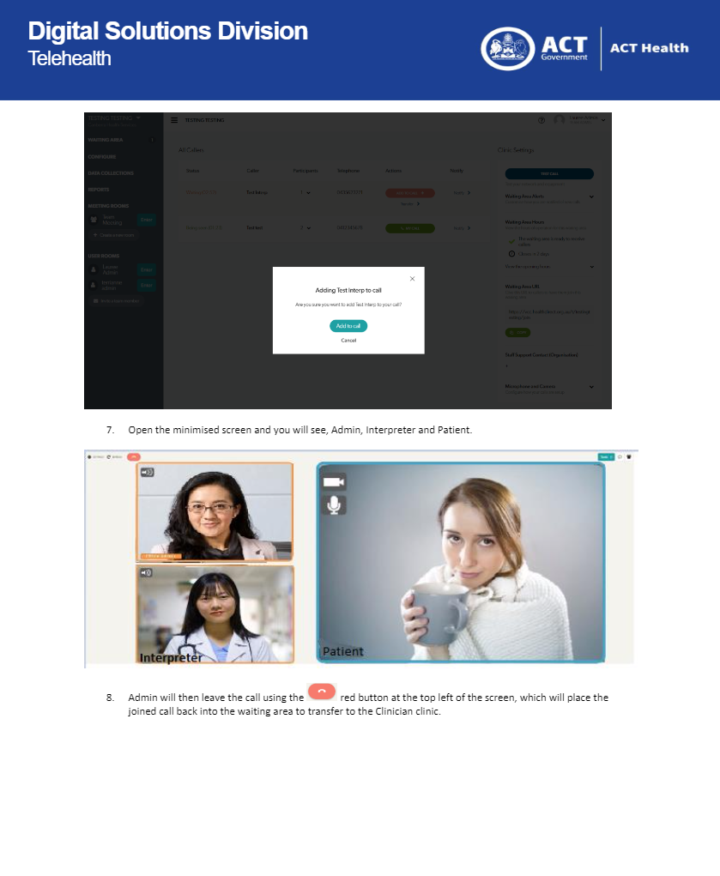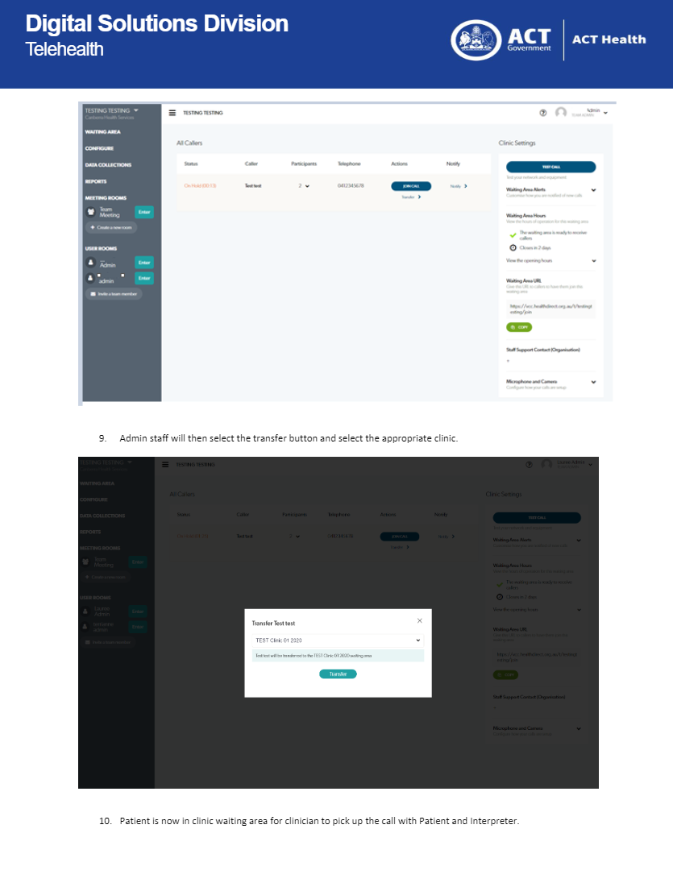

Attachment 6 - Guide to Booking Video Consultations with Interpreters

Interpreters and Telehealth
During the transition to Telehealth using the Health Direct platform it was discovered that TIS are unable to provide interpreting services into our telehealth appointments, though TIS can do teleconferences. Other facilities in the ACT have used TIS using the interpreter phone call on speaker phone with the clinician however they are unable to video in.
An alternative provider of interpreter services, OnCall Interpreters has been identified that can work within the Health Direct platform.

Making a booking with OnCall for Telehealth
Bookings can be made through bookings.nsw@oncallinterpreters.com or by calling 02 8986 4100. CHS client code is 23215 and the information required at the time of booking includes:
- Use the generic email login that you use for TIS bookings
- patient name
- MRN (use reference number field if it isn’t labelled MRN or URN)
- Client Code – these are the same as TIS
- Name of the super clinic
- requester name and profession

At the time of the appointment
- Patient logs on, for example, the Cancer clinic as normally happens
- Interpreter logs in as First Name: Tamil Interpreter, Last Name: Patient Name, and Patient URN
- Both patient and interpreter are connected by the admin supporting the super clinic and transferred from Cancer super clinic to Drs clinic.

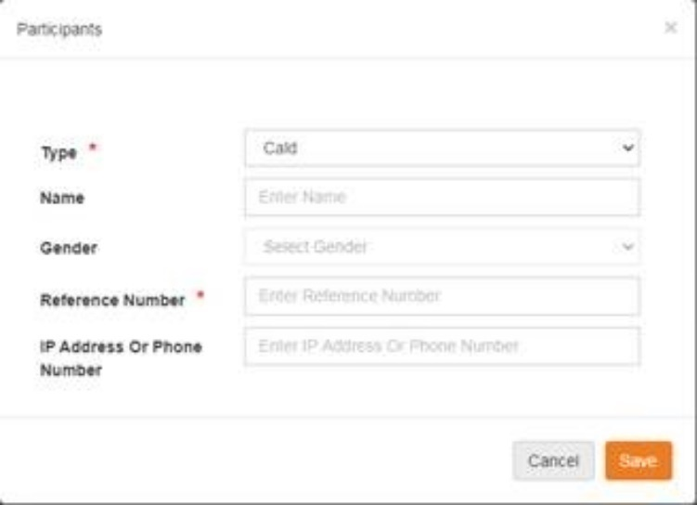

When provided a Telehealth link: you will be directed to the ACT Telehealth site (Health.act.gov.au) which displays Super clinics for telehealth- video appointments at the hospital
- You are required to select the correct Super clinic (found on the booking confirmation email)
- You will be taken to the HealthDirect page
- Follow the HealthDirect instructions below

When provided a direct HealthDirect link, perform the following steps:
- Test device settings by pressing “Run a Test Call” and follow the prompts
This will open in a new window. Once test complete, go back to original window
- If required: Select the specialist clinic (found in the booking confirmation email)
- Select “Start video call”
- Under “First name” and “Surname”, enter the following:
First Name: Interpreter + (your language “-” and your full name)
Surname: For + (CALD name)
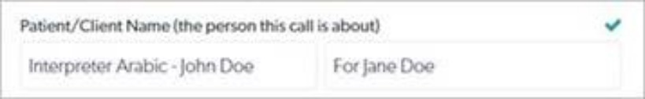
- Phone Number: Enter ONCALL phone number
- Press “Continue”

You will be placed into the waiting area and the meeting will begin

Note: If prompted to enter details for additional fields (i.e. Date of birth, address, medicare card number etc), enter zero (0) to continue.

Reference : Agency for Clinical Innovation: Telehealth in Practice https://www.aci.health.nsw.gov.au/__data/assets/pdf_file/0008/509480/ACI_0261_Telehealth_guidelines.pdf

Attachment 7 - Telehealth: Administrative Workflow

Attachment 8 - Telehealth: Clinical Workflow

Attachment 9 - Recording of COVID-19 adjusted activity

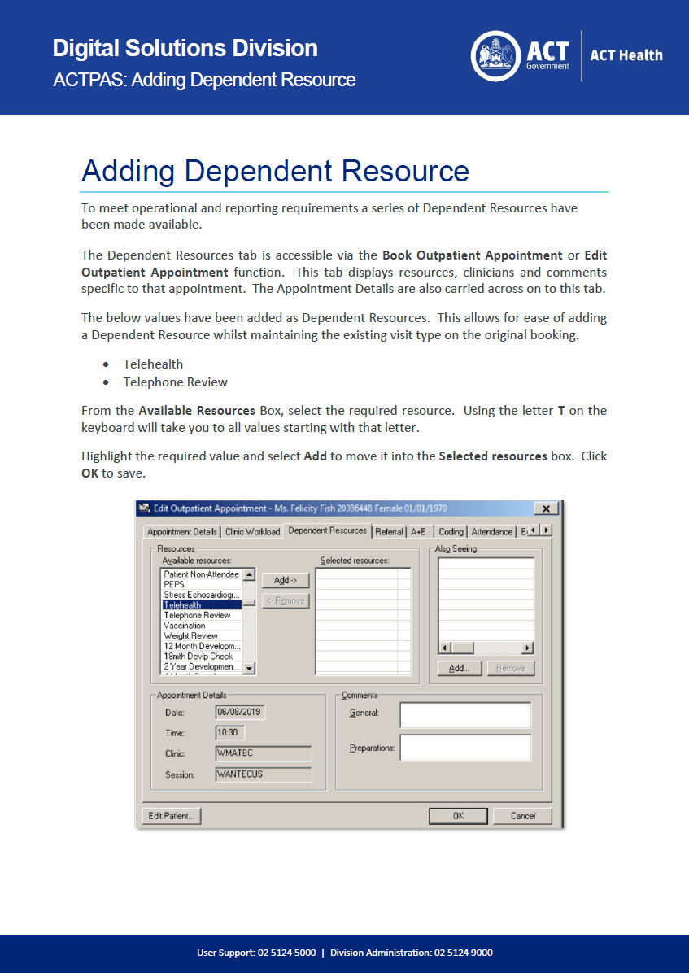y
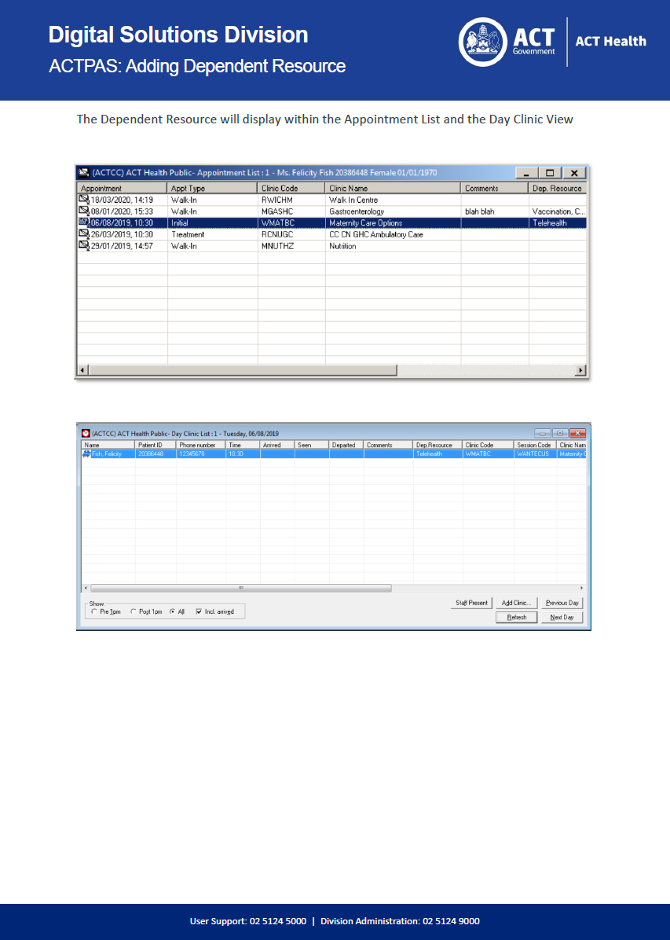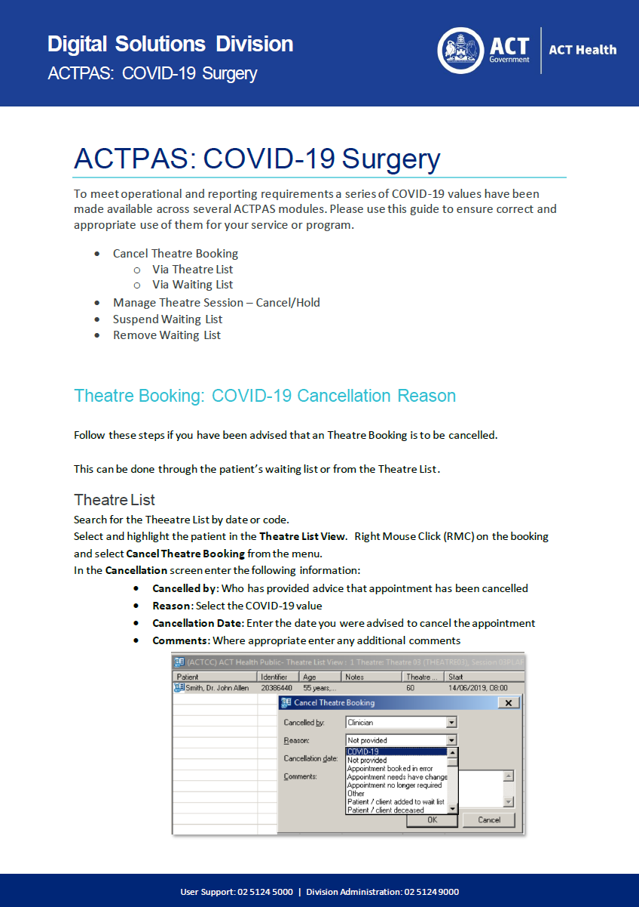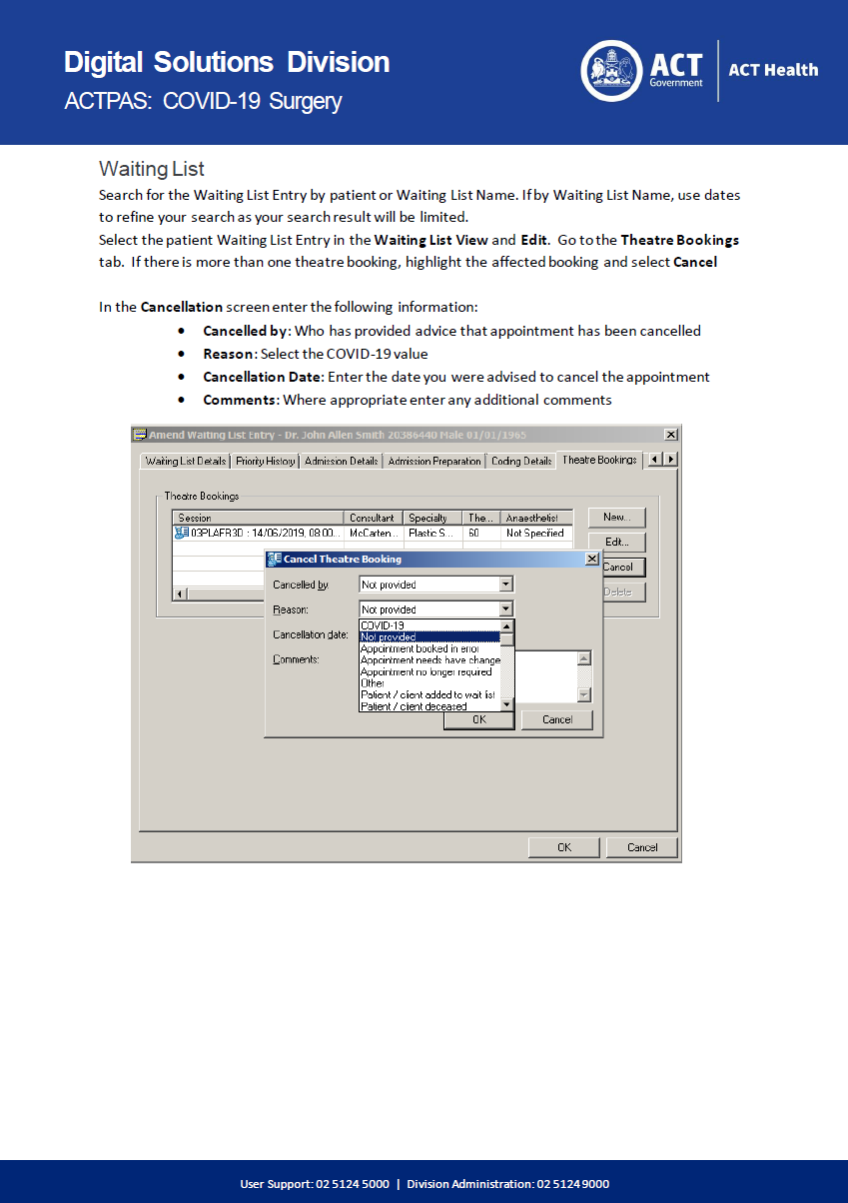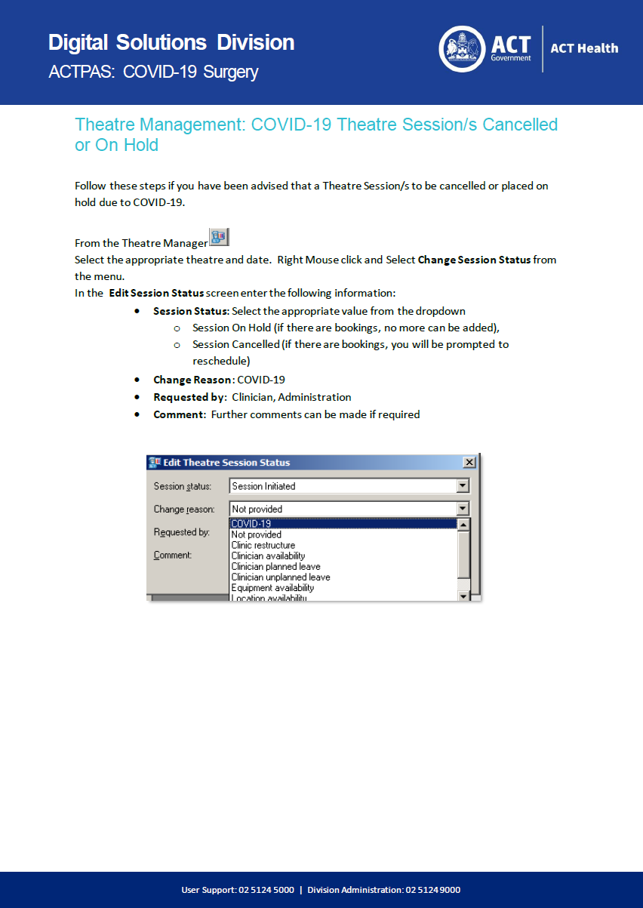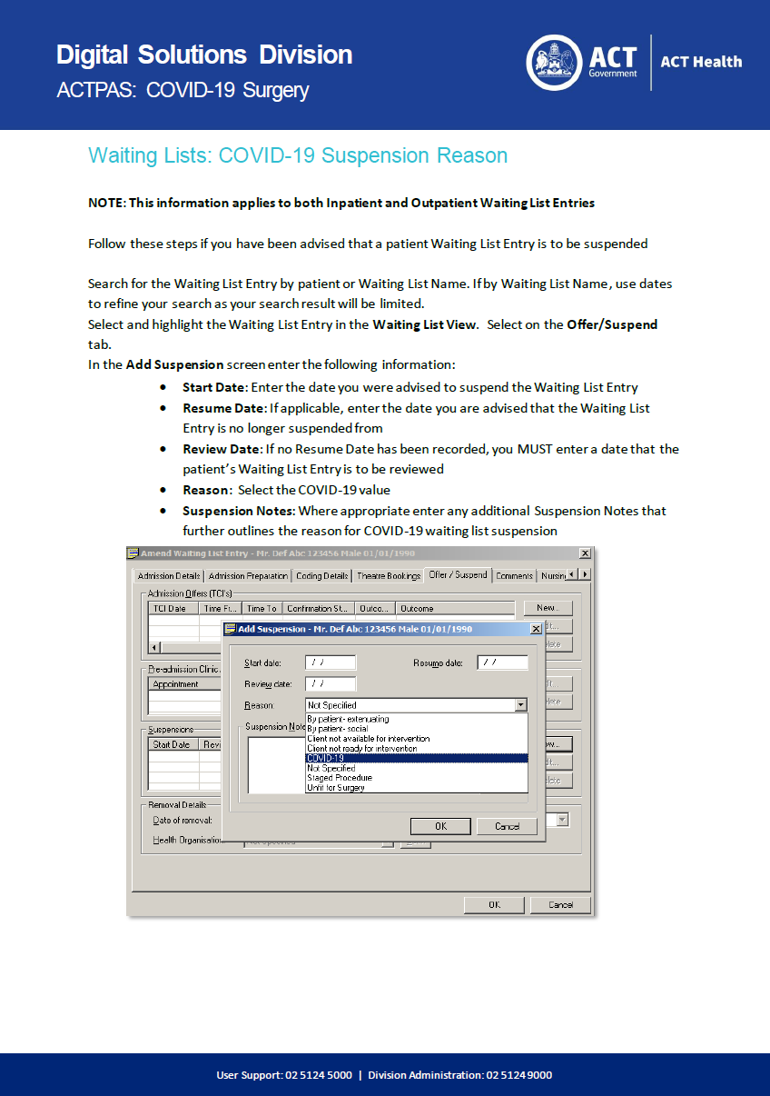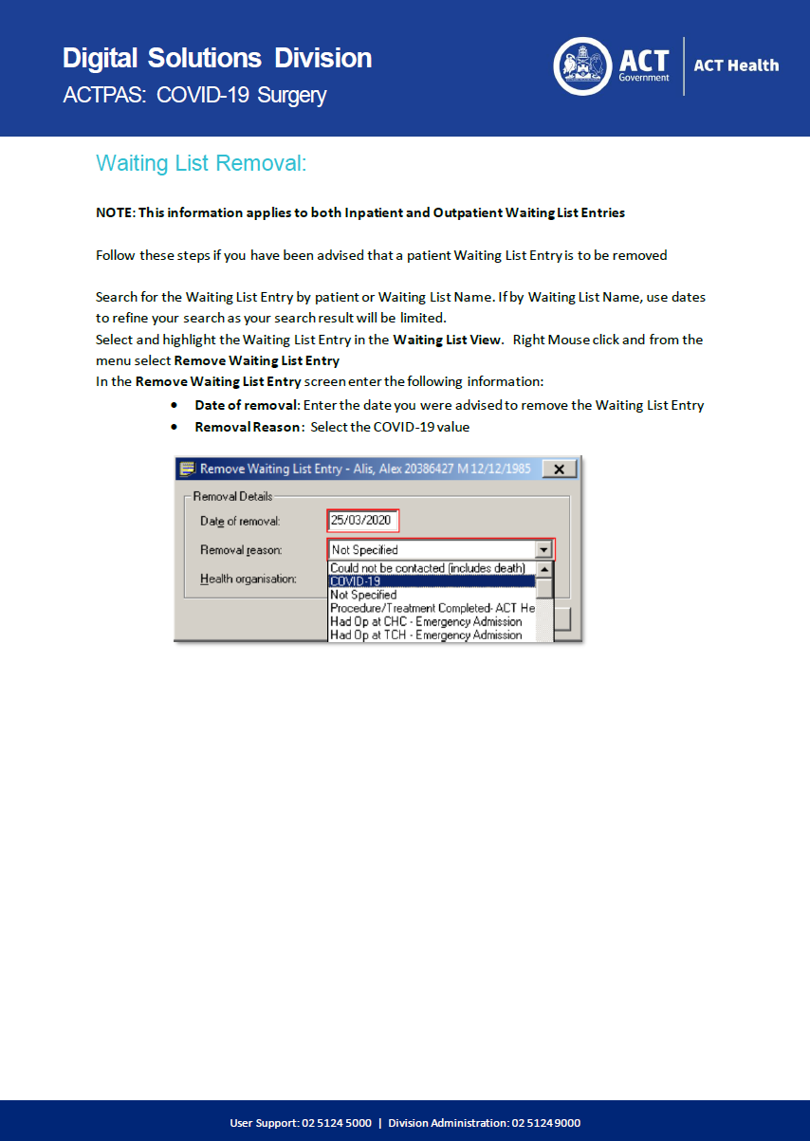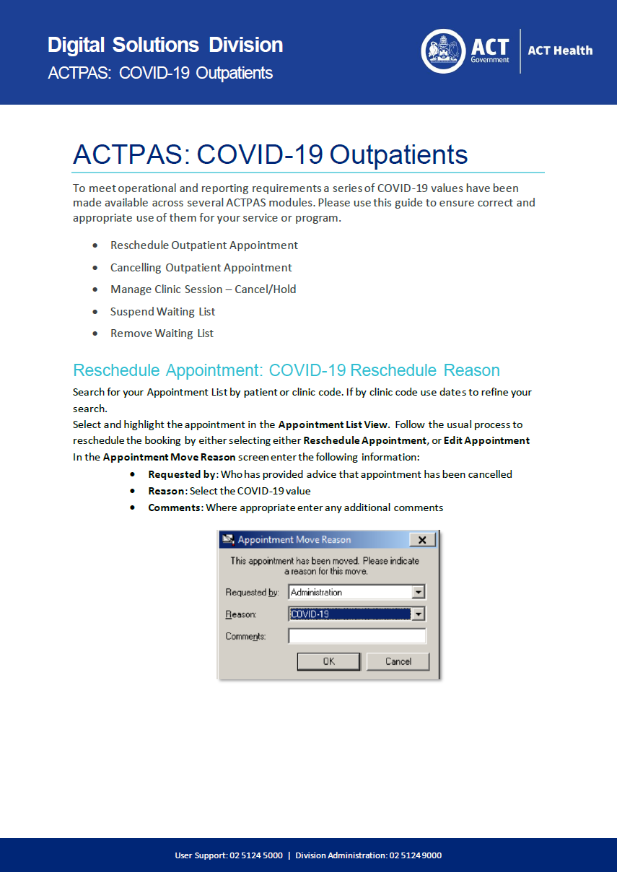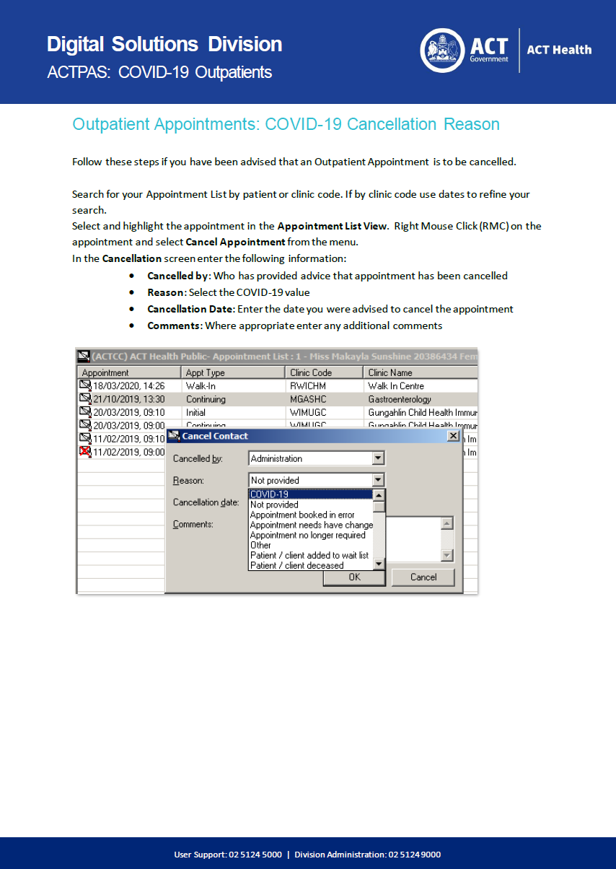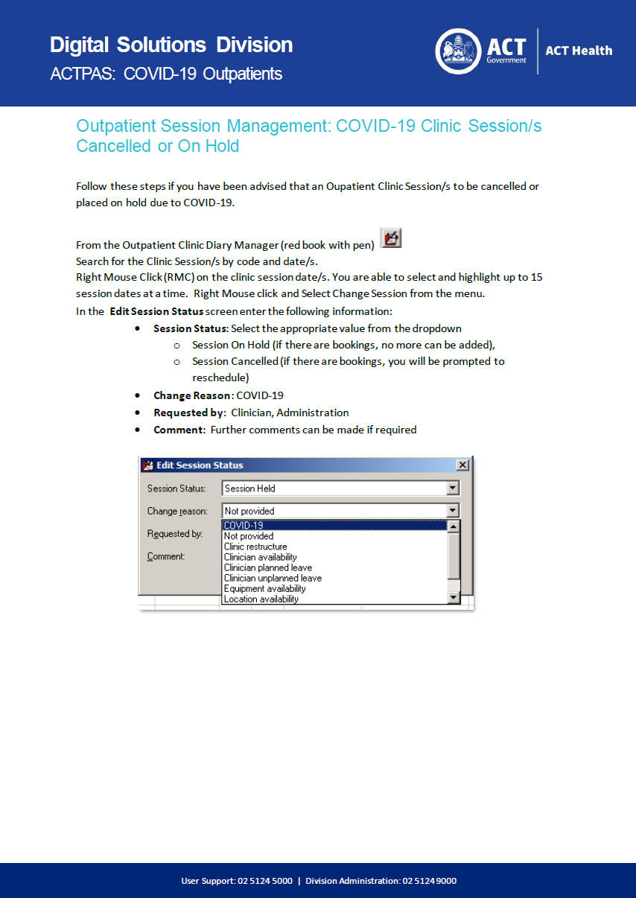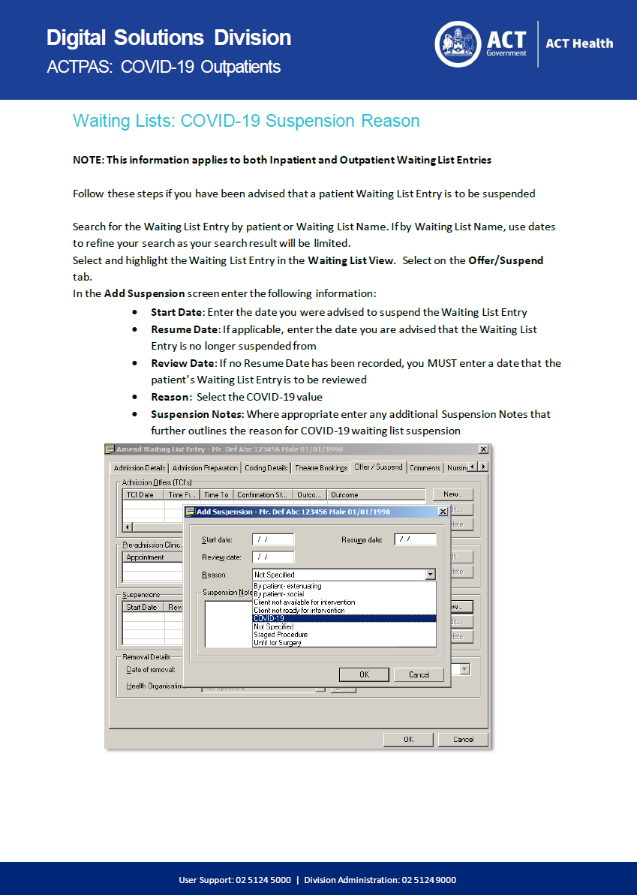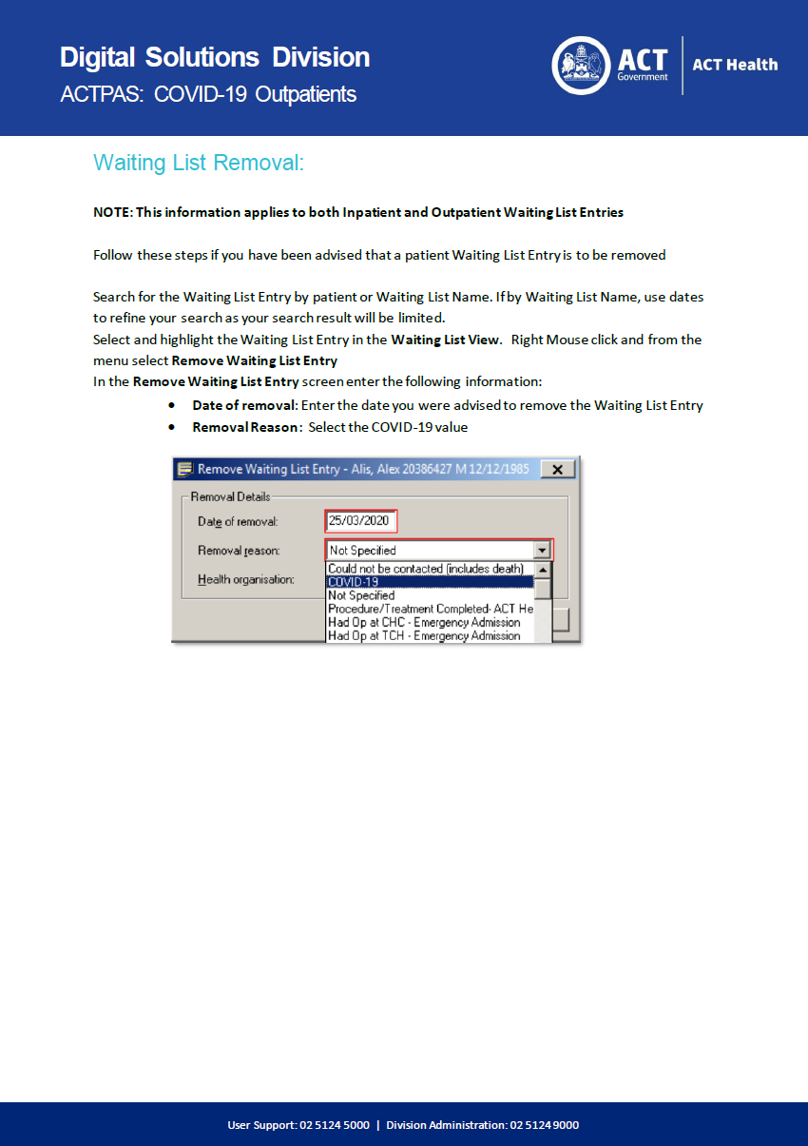

Attachment 10 - COVID-19 Medicare Billing Cheat Sheet

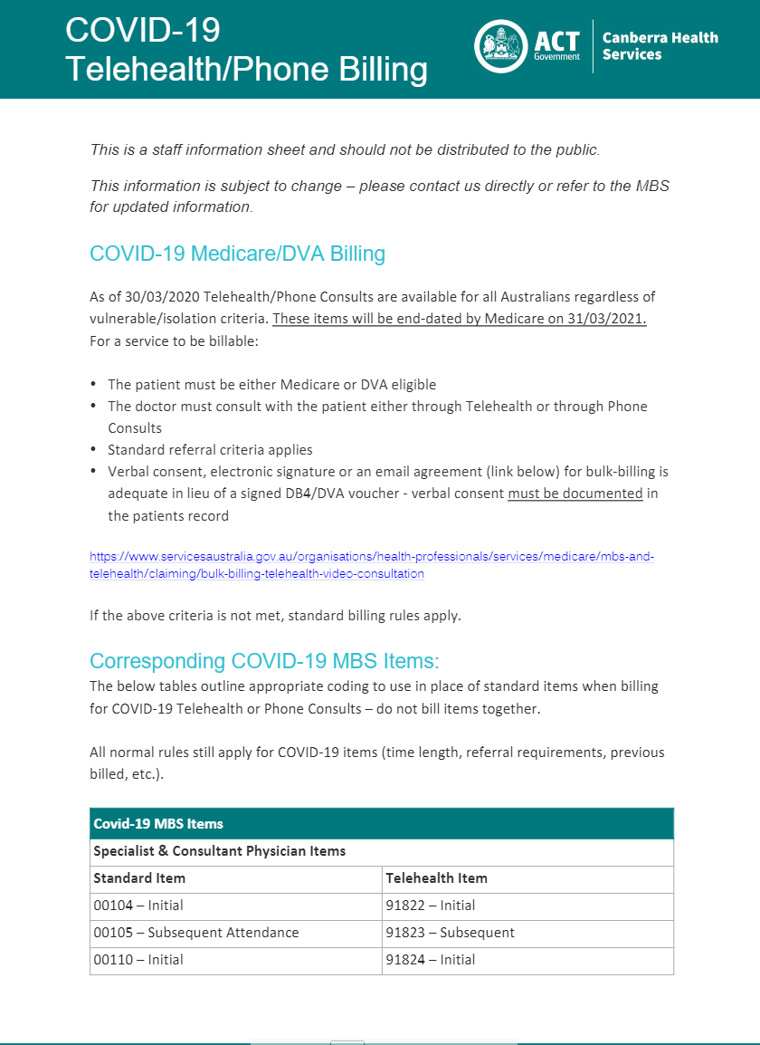
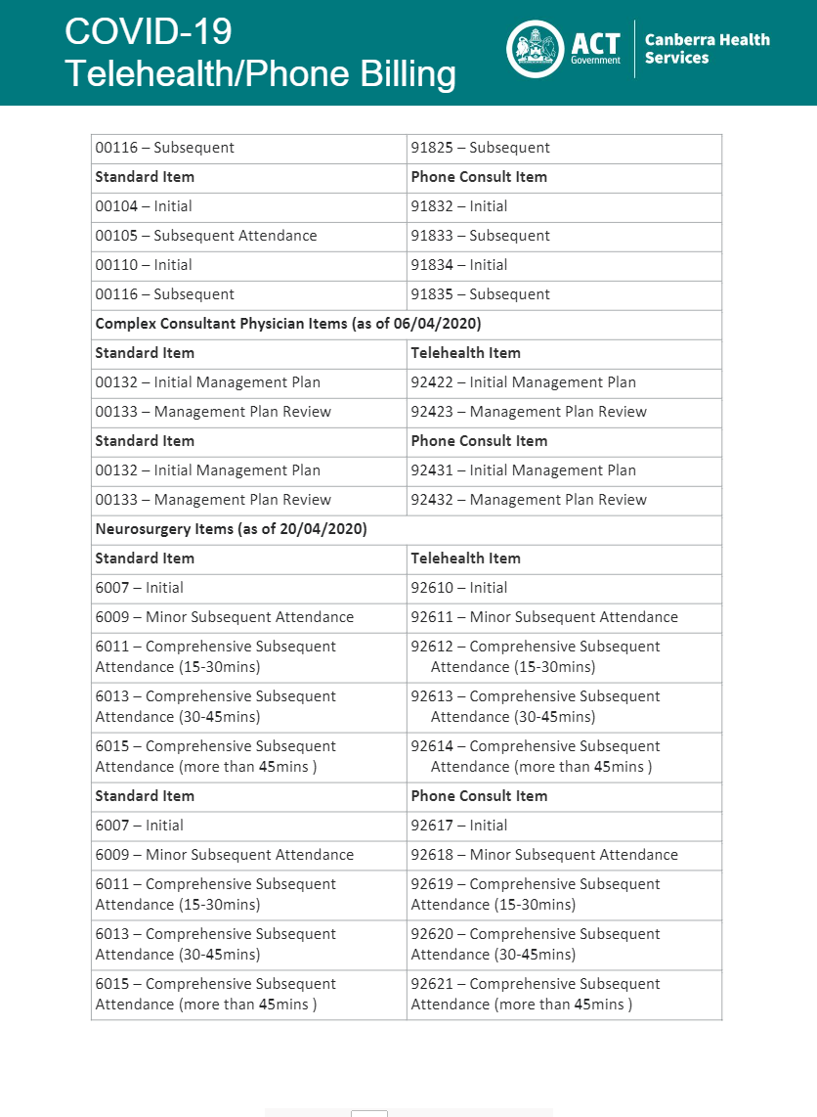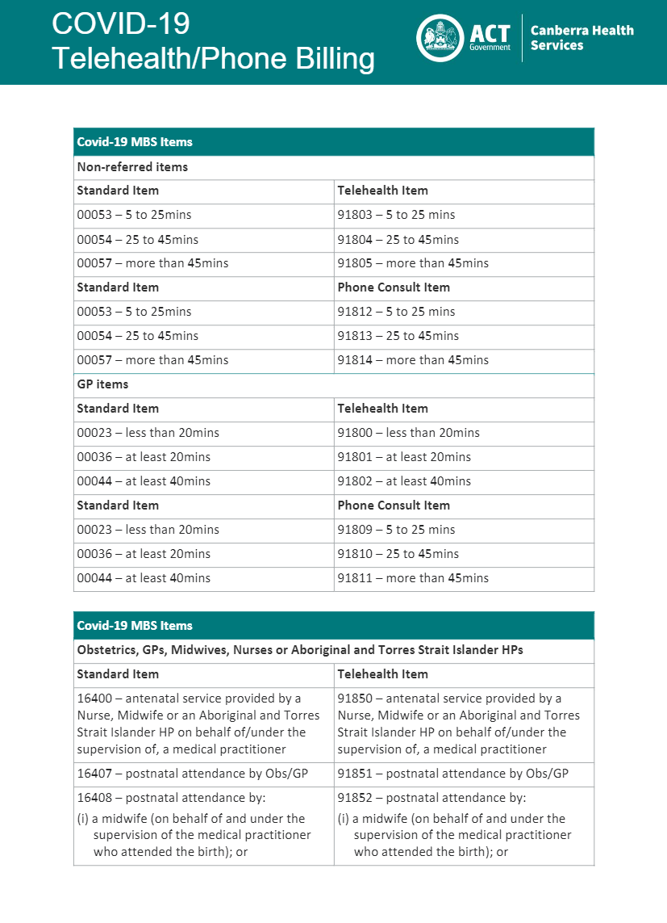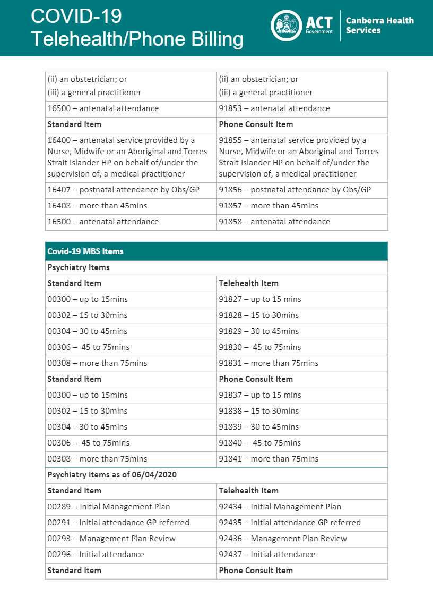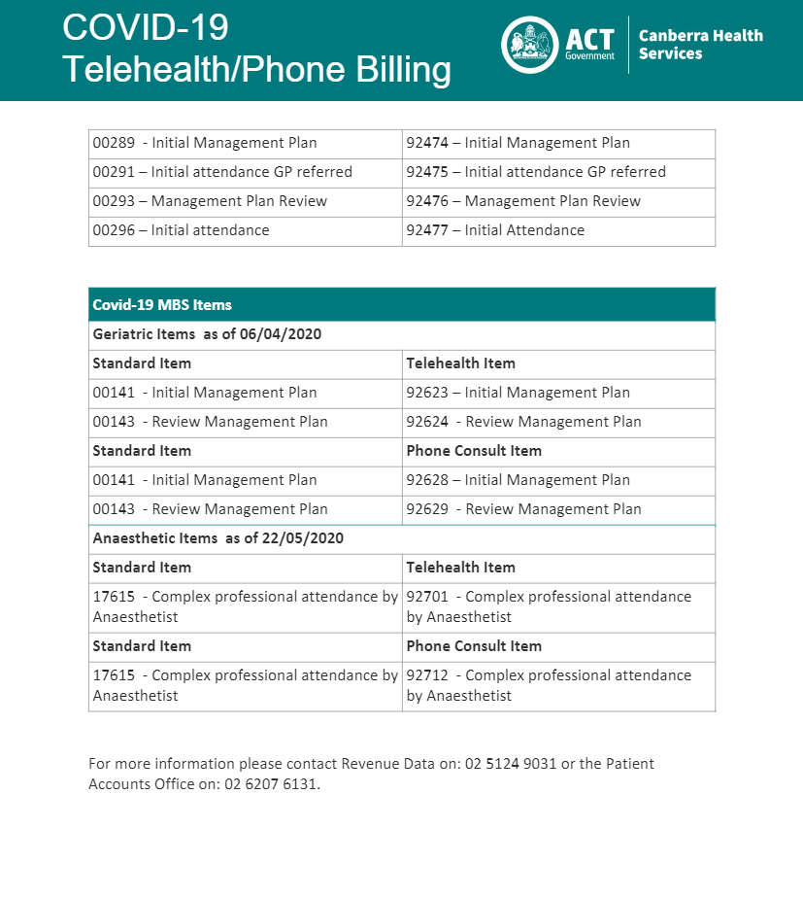

Attachment 11 - Medicare Non-Eligible or Ineligible Patient Service Fees

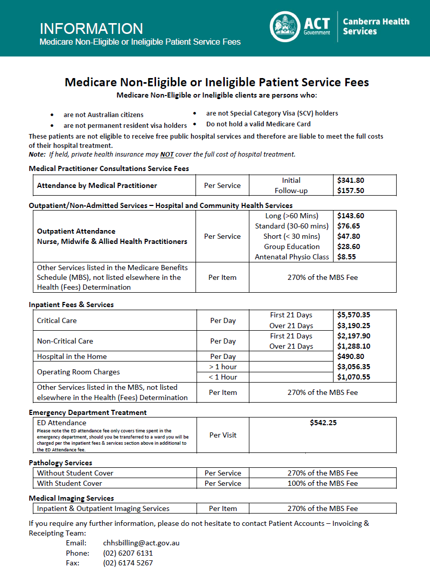

Attachment 12 - Letter to ACT Practitioners – Telehealth Prescribing
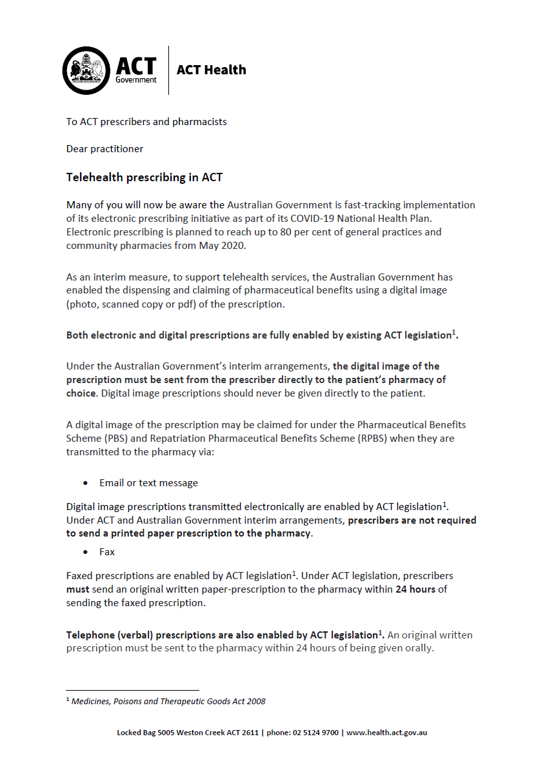
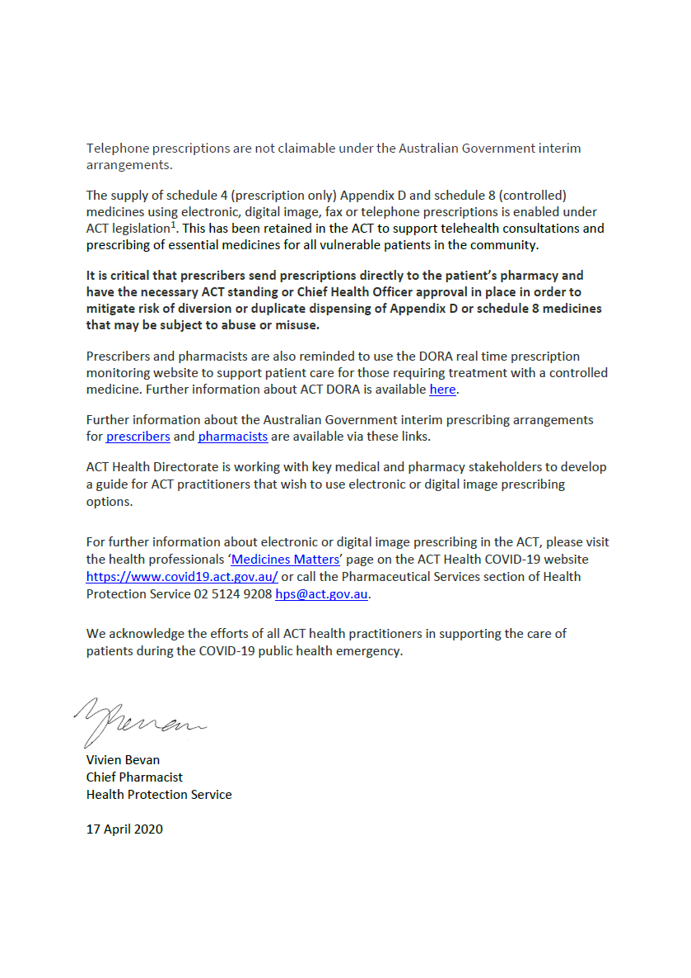

Attachment 13 - Use of Telehealth in Mental Health, Justice Health and Alcohol and Drug Services

Specific Assessments and Interventions
Mental Health & Drug and Alcohol Assessments (including routine Risk Assessments)
Any presentation that has been triaged as Category A-C must be seen face-to-face. Ideally Category D presentations would also be seen face-to-face, though some consideration can be given for Telehealth. Category E and below are suitable for telehealth.

Staff need to consider risk of deterioration, the need for an observable mental state examination, and the patient’s recent mental health history (e.g. hospitalisations, functioning, stability in mental state, and supports).

Psychological Assessments
Psychological and neuropsychological testing may be suitable for telehealth. As a general rule of thumb, psychological assessments require different types of information as parts of a thorough assessment which is then integrated using the psychologist’s clinical skill to formulate. Before using telehealth for psychological or neuropsychological assessment, psychologists should:
- Consider those components of assessment that can include a telephone or telehealth component (e.g. interview and feedback). The clinical record and other background information (e.g. collateral information for developmental history or school reports) should be reviewed, collected, and included in the report.
- Consider the tests currently available online (e.g. Q Global) to be considered as part of the assessment (e.g. questionnaires).
- Not assess via telehealth using tests that the psychologist has not been trained in or has received supervision on in relation to administering in this way which may lead to incomplete test administration. For instance, commencing a WAIS-IV via telehealth but not being able to complete Block Design.

Psychosocial Assessment
Psychosocial assessments are considered appropriate to undertake via telehealth. Refer to subsection 2.4.1 for more information on what staff need to consider.

Psychological Intervention
Some types of psychological interventions will be more suitable than others. Other factors to consider include the strength of the existing therapeutic relationship between staff and the patient and the current stage of psychological therapy. Consideration also needs to be given to post-therapy support, given people may remain in a heightened emotional state within their home.

In general, the following are examples of suitable and unsuitable telehealth psychological interventions:
- Suitable: Skills-based therapies, coaching, psychoeducation, health promotion, supportive counselling, psychological first aid.
- Not suitable: Second stage of trauma therapy (i.e. reprocessing), people with acute psychosis or mania, or acute suicide risk.

Occupational Assessments and Interventions
Occupational functional assessment and some interventions are not suitable for telehealth. Occupational Therapists can use telehealth to develop therapeutic rapport, provide education and advice, health promotion, develop an occupational formulation and a plan based on self-report.

Peer Interventions
Telehealth can be used to facilitate supportive one-on-one peer interventions, as well as deliver peer-led educational and support groups, such as PeerZone.

Physical Health Interventions
Telehealth can be used to support wellness, prevention, health management, and performance improvement. Dietitians, Exercise Physiologists, and Nurses may use telehealth to undertake physical health and lifestyle screening, for health promotion, education and advice, and to prescribe relevant interventions. Staff should consider an individual’s health needs to determine if telehealth is appropriate.

Establish a Risk Contingency Plan
At the initial telehealth session with the patient (and including family/carers/parents/guardians, where relevant), staff should develop with the patient an individualised contingency and safety plan for managing any risk-related situations and that may arise during the course of treatment. The plan could include the following steps:
- Request the contact details for at least two people known to the patient. This could include the work/home telephone, email and address for patient’s next of kin, GP, other health care worker. If the patient does not consent to provide identifying information or contact details of people known to them, consider whether the risks are acceptable and seek supervision, if necessary. If you accept the patient, work with the patient to develop a reasonable and viable safety plan if risk does arise.
- Request the patient provide their location at the commencement of each telehealth session.
- Talk to the patient about when, how and with whom a safety plan may be activated.
- Establish what will happen if the patient does not appropriately participate in or respond to questions about risk, or the internet or mobile connection fails during the assessment and management of risk situations. For example, the staff member may need to telephone the patient’s nominated contact/s.
- Document the plan in the patient’s electronic clinical record.

