Clinical Procedure | Canberra Health Services

Snake Bite Management- Adults and Paediatrics
CHS25/150
Contents
Purpose 2
Alerts 2
Scope 2
Section 1 – NSW Health Clinical Management Guideline 2
Section 2 – Equipment and Patient Assessment 3
Section 3 – Pathology Investigations 4
Section 4 – Disposition 5
Section 5 – Antivenom Administration 6
Evaluation 7
Related policies, procedures, guidelines and legislation 7
References 8
Definition of terms 8
Search terms 9
Attachments 9
Attachment 1 – Clinical Pathway Flowchart 10
Attachment 2 – Pressure Bandage with Immobilisation 12
Attachment 3 – Other Useful Resources 13

Purpose
This document provides direction for nursing, medical staff, pharmacy staff and students in relation to the assessment, investigation, treatment and disposition of adult and paediatric patients presenting to a Canberra Health Services (CHS) Emergency Department (ED) with snake bite.
Envenoming refers to venom being injected into a patient as a result of a bite/sting. Envenoming from snake bite is rare, and when it occurs, early signs and symptoms may be subtle or absent. It is important for ED staff to thoroughly assess every bite for potential envenoming in a timely manner via the procedure described in this document.
Early identification of the envenomed patient is very important to help guide appropriate and timely early management.
Back to Contents

Alerts
To help guide treatment, all cases of suspected or confirmed envenoming must be discussed with a clinical toxicologist as early as possible, usually via the NSW Poisons Information Centre (PIC) - Phone 13 11 26.
Back to Contents

Scope
This document applies to all patients presenting to the ED at Canberra Hospital or North Canberra Hospital (NCH) with history suggestive of snake bite, with or without evidence of envenoming.

This document applies to the following staff working within their scope of practice:
- Medical Officers
- Nurses
- Pharmacists
- Students under direct supervision.
Back to Contents

Section 1 – NSW Health Clinical Management Guideline
This procedure draws extensively from the NSW Health Snake and Spider Bites Clinical Management Guideline. Refer to this guideline for more detailed information on the management of snakebite. The Guideline can be accessed on the NSW Health website at: https://www1.health.nsw.gov.au/pds/ActivePDSDocuments/GL2024_007.pdf
Back to Contents

Section 2 – Equipment and Patient Assessment

Equipment
- Pressure Bandage with Immobilisation (PBI) should be applied immediately on arrival, if not applied pre-hospital (refer to Attachment 1 - Clinical Pathway Flowchart and Attachment 2 - Pressure Bandage with Immobilisation). First apply a folded pad over bitten area, then apply a broad (15cm) elasticised bandage (not crepe) starting directly over the bitten area and then applied distally then proximally with pressure similar to that used for a sprained ankle. If applying to torso, take care not to impede the patient’s chest expansion. Immobilisation of both affected limb and entire patient is essential. Use of the PBI more than four hours after bite is unlikely to be effective.
- Antivenom as required. CHS stocks antivenom for:
  - polyvalent antivenom (contains antibodies to five snake groups—black snake, taipan, death adder, tiger snake and brown snake)
  - brown snake monovalent antivenom
  - tiger snake monovalent antivenom.
At the Canberra Hospital, antivenom is stored in the refrigerated Pod 4 (Resus) automated dispensing cabinet (ADC). At NCH antivenom is refrigerated in the Pharmacy After Hours Cupboard (AHC).
In the event of stock unavailability in the ADC/AHC:
- secondary stock holdings are maintained in the Canberra Hospital pharmacy department
- after-hours supply can be obtained by contacting the on-call pharmacist (via the afterhours clinical nurse coordinator [AHCNC]).

Patient Assessment

Setting:
- All patients reporting that they have been bitten by a snake should be rapidly assessed in a monitored bed, with at least one large bore intravenous (IV) line placed in a non-affected limb. A second large-bore cannula should be inserted if the decision is made to administer antivenom, but should not delay the administration. The treating team must be prepared for anaphylaxis & resuscitation.

History:
- Staff should document in the patient’s clinical record when the patient was bitten, location of bite, type of snake (if known) and timing of PBI application.
- Ask the patient specifically about any prehospital collapse, headache, visual changes, muscle weakness, or bleeding of any kind.
- Patients may exhibit nonspecific systemic symptoms, such as nausea, vomiting, headache, abdominal pain, diarrhoea and sweating, and these should be carefully noted and documented in the patient’s clinical record.

Examination
- Neurological examination of the patient for descending flaccid paralysis which may begin with very subtle eye or face symptoms (ptosis, diplopia, blurred vision, later progressing to bulbar, respiratory and limb weakness). Subtle early ptosis may be apparent as fatiguability or eyelid droop from failure to maintain an upward gaze on exam.
- Evidence of bleeding: check for oozing from the bite site, cannula site or occult sites of bleeding such as gastrointestinal, urinary, or intracranial.
- Examination of the bite site, looking for definite evidence of skin breach, bruising or local necrosis and draining lymph nodes for tenderness.
Alert: Do not remove the PBI on initial examination; cut a hole over the bite site to examine it.

Back to Contents

Section 3 – Pathology Investigations
Pathology investigations must be completed as documented below, until either:
- evidence of envenomation is found, prompting antivenom administration, or
- all tests have been completed and are normal at 12 hours post bite time.
- Initial tests are performed on patient arrival, with request clearly indicating “snake bite query envenomation” and urgent:
  - full blood count (FBC)
  - urea, electrolytes and creatinine (UEC)
  - creatinine kinase (CK)
  - International Normalised Ratio (INR) and activated Partial Thromboplastin Time (aPTT)
  - fibrinogen
  - D-dimer
  - liver function tests (LFT)
  - lactate dehydrogenase (LDH).
Expectation is that Pathology will give verbal phone notification of abnormal results to ED, which frequently consist of non-clotting blood on coagulation studies, a strong indicator of envenomation rather than a lab/machine error.

- If above results are within normal limits:
  - remove the PBI
  - commence a 12-hour regime of repeat bloodwork as below:
    - At one hour post PBI removal and six- and twelve-hours post-bite repeat INR, aPTT, fibrinogen, d-dimer and CK
  - If the results of these tests are abnormal at any stage, contact NSW Poisons Information Centre (Phone 13 11 26) to consider the use of antivenom.
- If signs of envenomation, the above blood tests should be repeated serially at 6 hours, 12 hours and 24 hours post bite. D-dimer should only be used in the first 6 hours, or for the first 2 tests only. Lactate dehydrogenase (LDH) and blood film should be tested at 6 hours or 12 hours post snake bite if evidence of venom-induced consumption coagulopathy (VICC).
Back to Contents

Section 4 – Disposition

Disposition of the envenomed patient
- Criteria for admission to hospital includes any abnormal exam findings (see Assessment, Section 2 above), abnormal blood investigations, or antivenom given in ED. Admission should always be to the Intensive Care Unit (ICU) for cardiac monitoring and continued close observation. In addition to administration of antivenom, the management of patients experiencing systemic envenomation is to include supportive treatment of associated signs and symptoms (which may include pain relief, clotting factor replacement, fluid therapy, haemodialysis and oxygen therapy).

Disposition of the non-envenomed patient
- Patients who have no clinical signs or symptoms of envenomation should be educated around the need to stay in hospital to complete the 12-hour regime in Section 3 above. This is the minimum time to definitively exclude envenomation. Any patient wishing to leave prior to the 12 hours and against advice must be discussed with the ED Consultant on duty. In the event of the patient discharging themselves against advice, the patient is to be given verbal and written advice around risk of discharge against advice, including death. The advice given to the patient is to be documented in the patient’s clinical record.
- If all the patient's test results are within normal limits at 12 hours post bite, and the patient has no concerning signs or symptoms the patient may be discharged home during daylight hours with appropriate follow up. Any abnormal exam findings should be discussed with NSW Poisons Information Centre prior to discharge, even if all blood investigations are normal.
- Snake bites are classified as a tetanus-prone wound. Check the patient’s tetanus immunisation status prior to discharge (immunisation status may be obtained in the Digital Health Record (DHR) via the My Health Record portal immunisation register).
  - Adult patients: administer ADT booster (diphtheria-tetanus combination vaccine) if recommended by The Australian Immunisation Handbook (AIH); Table. Guide to tetanus prophylaxis in wound management.
  - Paediatric patients: administer age-based formulation in accordance with AIH tetanus-prone wound recommendations for paediatric patients.
  - This should only be done after completion of the 12-hour workup as above and once haemostasis is achieved.
Back to Contents

Section 5 – Antivenom Administration
- Indications for antivenom administration are obvious clinical evidence of envenomation (cardiac arrest, shock state, bleeding, or neurologic abnormality) or pathology abnormalities even in the absence of clinical findings. Standard treatment for patients bitten within the catchment area for CHS is 1 ampule of tiger snake and 1 ampule of brown snake antivenom. However, in most cases, every effort must be made to obtain clear advice on choice of antivenom from a clinical toxicologist as early as possible.
  - The earlier the antivenom is administered (preferably within 2 hours of the snake bite), the more effective the therapy. The risk of adverse effects outweighs the benefits of antivenom at more than 12 hours post snake bite.
- Advice will vary depending on clinical presentation, and may require two different monovalent antivenoms, but each antivenom dose will be one vial, given once only. In the context of cardiac arrest, further administration of ampules of antivenom may be considered in consultation with the Toxicologist.
- Given the potential for the patient to have anaphylaxis to antivenom (severe anaphylaxis occurs in 1% for monovalent and 5% for polyvalent), the antivenom should be administered to the patient in a resuscitation bed with close haemodynamic monitoring (blood pressure, heart rate, continuous cardiac monitoring, oxygen saturation).
  - Temporarily suspend antivenom infusion if anaphylaxis occurs and treat in accordance with Australasian Society of Clinical Immunology and Allergy (ASCIA) anaphylaxis guidelines.
  - Contact NSW PIC to obtain advice on reinitiating antivenom infusion at a slower rate or with concurrent adrenaline infusion (following consultation with an ED staff specialist).
  - All patients who receive antivenom should be counselled about serum sickness – a self-limiting complication affecting approximately one-third of patients. Symptoms including skin rash, fever, myalgia and arthralgia may develop 4-14 days following antivenom treatment. Treatment of serum sickness is with oral prednisolone if it occurs but there is no role for prophylactic steroids.
- Antivenom is to be administered to the patient as per the Australian Injectable Drugs Handbook.
  - Each antivenom vial contains a different volume. Practitioners must administer the entire contents of a single vial and measure the total volume before reconstitution to ensure appropriate dilution.
  - Dilute antivenom before use in a 1:10 dilution of sodium chloride 0.9% or Hartmann’s solution over 20 minutes (a 1:5 dilution may be used for children or patients with fluid restrictions).
  - In life-threatening emergency situations antivenom can be given undiluted as a rapid injection.
Antivenom | Units of antivenom per vial | Volume range per vial (batch dependent) | Final volume 1:10 dilution (adults)
Polyvalent | 40 000 units | 28 – 50mL | 500 mL
Monovalent: Brown Snake | 1 000 units | 4 - 9 mL | 100 mL
Monovalent: Tiger Snake | 3 000 units | 9 – 12 mL | 250 mL

- Even with adequate antivenom administration, it may take 10-20 hours for coagulation studies to improve with patients with VICC, and longer still to return to normal (up to 24-36 hours). The resolution of VICC is dependent on synthesis of new clotting factors. It is reasonable to administer fresh frozen plasma (FFP) following antivenom administration to patients who have active and potentially life-threatening bleeding.

Evaluation

Outcome
Patients presenting to the Canberra Hospital or NCH ED reporting a snake bite, or possible snake bite, are managed as per this procedure.

Measures
ED will complete an audit/review of the assessment and management, as recorded in the clinical record, of patients with snake bites notes to ensure compliance with this procedure.
Back to Contents

Related policies, procedures, guidelines and legislation

Policies
- Medication Handling

Procedures
- Infection Prevention and Control
- Infection Prevention and Control - North Canberra Hospital (NCH)
- Medication Handling – North Canberra Hospital (NCH)
- Patient Identification and Health Care Activity Matching
- Wound Assessment, Prevention and Treatment
- Pathology Specimen Management
- Peripheral Intravenous Cannula (PIVC) and Midline Catheters – the Insertion and Management of - Adults and Children not Neonates
- Vital Signs and Early Warning Scores – the Canberra Hospital
- Vital Signs and Early Warning Scores – North Canberra Hospital (NCH)
- Venepuncture Blood Specimen Collection
- Vaccine Cold Chain Management

Guidelines
- Consent for Healthcare Treatment

Legislation
- Health Records (Privacy and Access) Act 1997
- Human Rights Act 2004
- Work Health and Safety Act 2011
- Carers Recognition Act 2021

Other
- Australian Charter of Healthcare Rights
Back to Contents

References

- Agency for Clinical Innovation, NSW Health. Snake and Spider Bites Clinical Management 21 June 2024 Published online: https://www1.health.nsw.gov.au/pds/ActivePDSDocuments/GL2024_007.pdf

Back to Contents

Definition of terms
Anaphylaxis: The most severe type of allergic reaction. It should always be treated as a medical emergency. Anaphylaxis is:
- any acute onset illness with typical skin features (urticarial rash or erythema/flushing, and/or angioedema) plus involvement of respiratory and/or cardiovascular and/or persistent severe gastrointestinal symptoms or
- any acute onset of hypotension or bronchospasm or upper airway obstruction where anaphylaxis is considered possible, even if typical skin features are not present.
Antivenom: This is the cornerstone of treatment for any person experiencing systemic envenomation following a snake or spider bite. It acts by binding to and neutralising venom. It does not reverse already established clinical manifestations of venom.
Envenomation: When a snake or spider bite injects sufficient venom to cause clinical effects. Envenomation can cause local effects (like pain or swelling), systemic effects (like nausea, headache or diarrhoea), collapse or other toxin syndromes.
Monovalent antivenom: Antivenom that contains antibodies intended for one specific snake or spider group.
Polyvalent antivenom: Antivenom that contains antibodies to five snake groups − black snake, taipan, death adder, tiger snake and brown snake. This covers most of the clinically important snake groups in Australia and Papua New Guinea. Polyvalent antivenom is a much larger volume (50 mL).
Back to Contents

Search terms
snake bite, antivenom, venom, pressure bandage with immobilisation, PBI, north
Back to Contents

Attachments
Attachment 1: Clinical Pathway Flowchart
Attachment 2: Pressure Bandage with Immobilisation
Attachment 3: Other Useful Resources

Attachment 1 – Clinical Pathway Flowchart
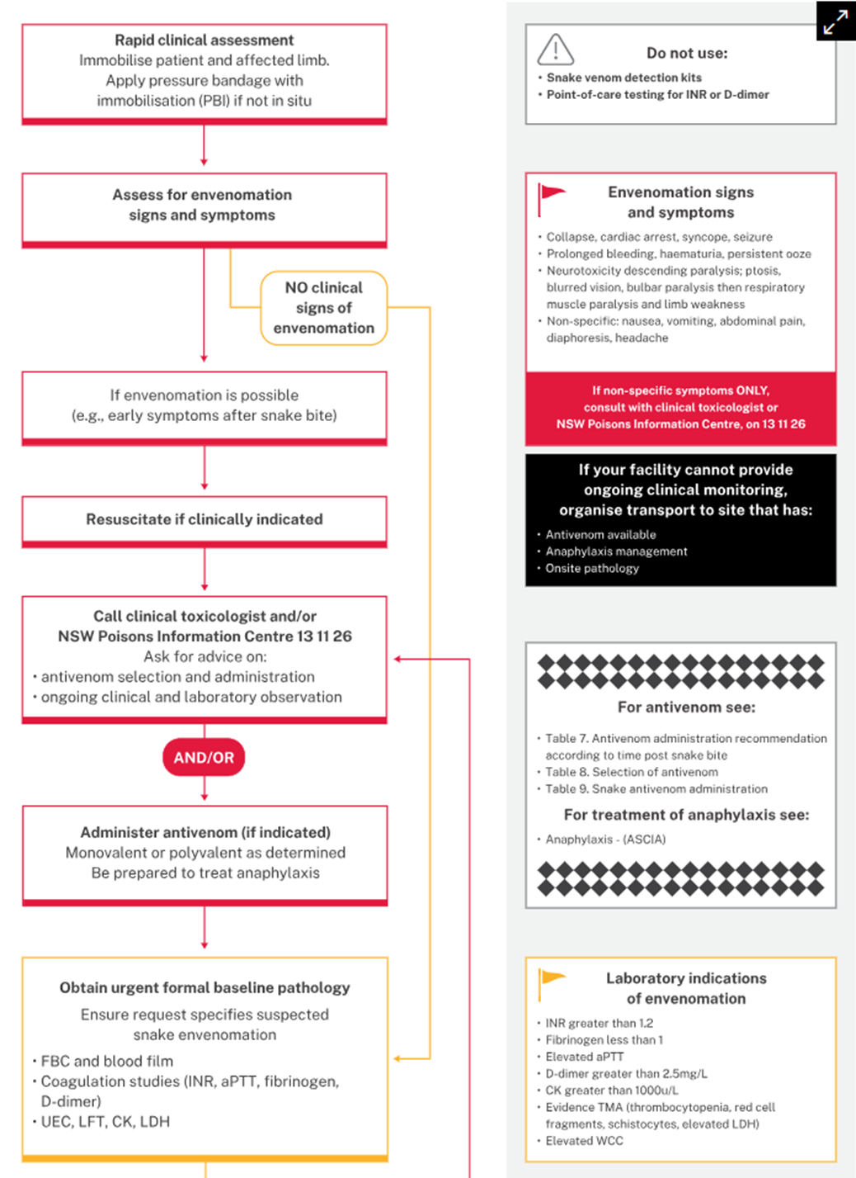
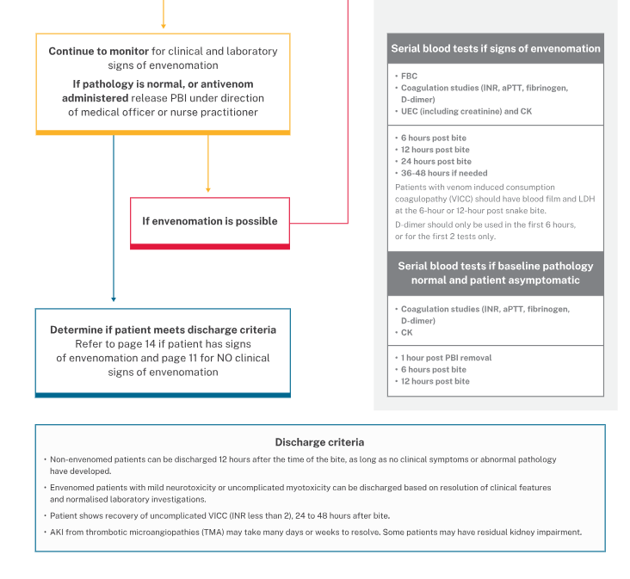Source: NSW Health Snake and Spider Bites Clinical Management Guideline.

Attachment 2 – Pressure Bandage with Immobilisation
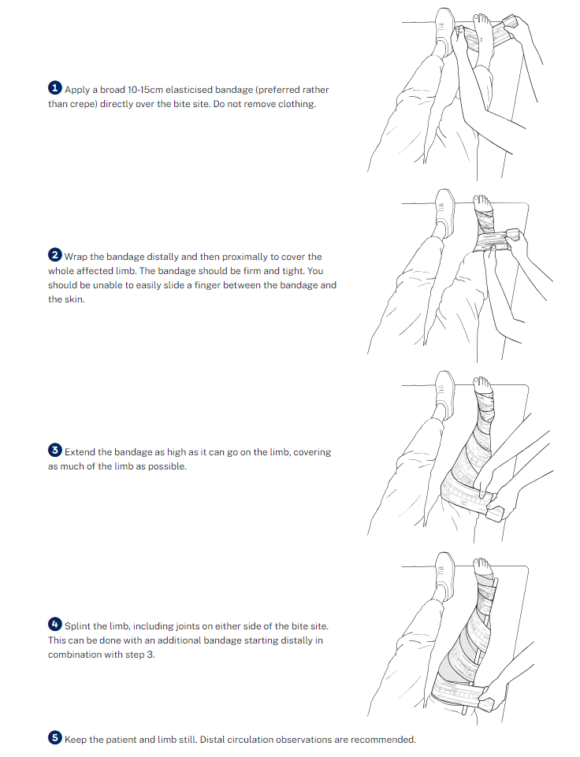

Attachment 3 – Other Useful Resources

NSW Poisons Information Centre website: https://www.poisonsinfo.nsw.gov.au/
Life Saving Drugs Register (Clinical Excellence Commission): https://lsdr.cec.health.nsw.gov.au/
Toxicology and Toxinology Therapeutic Guidelines: https://app.tg.org.au/
Acute management of anaphylaxis (ASCIA): https://www.allergy.org.au/hp/papers/acute-management-of-anaphylaxis-guidelines
Australian Immunisation Handbook: https://immunisationhandbook.health.gov.au/

Back to Contents

For Policy Team to complete:
Date amended | Section amended | Divisional approval | Final approval
04/04/2025 | Complete review | Rebekah Ogilvie, ED Medicine | Policy Document Review Panel
This document supersedes the following:
Document number | Document name
CHS21/336 | Snake Bite Management - Adults and Paediatrics
Disclaimer
This document has been developed by Canberra Health Services specifically for its own use. Use of this document and any reliance on the information contained therein by any third party is at his or her own risk and Canberra Health Services assumes no responsibility whatsoever.
Back to Contents

Acknowledgement of Country  Canberra Health Services acknowledges the Ngunnawal people as traditional custodians of the ACT and recognises any other people or families with connection to the lands of the ACT and region. We acknowledge and respect their continuing culture and contribution to the life of this region.  © Australian Capital Territory, Canberra 2024 | Accessibility  call (02) 5124 0000   Interpreter call 131 450  canberrahealthservices.act.gov.au/accessibility  

