Canberra Health Services
Procedure
Pulmonary Rehabilitation Program (Adult)

Contents

Canberra Health Services 1
Contents 1
Purpose 2
Scope 2
Section 1 – Referrals 3
Section 2 – Assessment 4
Section 3 – Group Exercise Session 5
Section 4 – Information Session 6
Section 5 – Managing unwell patients 6
Section 6 – Non-attendance 6
Evaluation 7
Related Policies, Procedures, Guidelines and Legislation 7
References 8
Definition of Terms 8
Search Terms 8
Attachments 8
Attachment 1: Pulmonary Rehabilitation Referral Form 10
Attachment 2: Pulmonary Rehabilitation Administrative Processes 11
Attachment 3: Alternative Pulmonary Rehabilitation or Exercise Programs 12
Attachment 4: Pulmonary Rehabilitation Assessment Form 13
Attachment 5: Six Minute Walk Test 15
Attachment 6: Chronic Respiratory Disease Questionnaire Response 17
Attachment 7: Pulmonary Rehabilitation Discharge Report 19

Purpose

Pulmonary Rehabilitation (PR) is an essential component in the holistic management of adults with chronic respiratory diseases. This procedure provides a framework for health professionals within Canberra Health Services (CHS) to provide and administer a patient centred, multidisciplinary and evidence based Pulmonary Rehabilitation Program.

Background
“Pulmonary Rehabilitation is a comprehensive intervention based on a thorough patient assessment followed by patient tailored therapies that include, but are not limited to, exercise training, education, and behaviour change, designed to improve the physical and psychological condition of people with chronic respiratory disease and to promote the long-term adherence to health-enhancing behaviours.” ¹

CHS PR program provides a comprehensive individualised assessment, followed by an 8 week group program with two sessions per week. The program involves completion of an individualised exercise program for one hour twice a week, with the addition of an information session once a week conducted by one of the multidisciplinary team members.

Key Objectives
- To deliver timely, equitable and accessible PR for people with chronic respiratory disease.
- To ensure continuity of care in delivery of PR program.
- To guide the operational requirements of PR to ensure evidence based practice.

Back to Table of Contents

Scope

This document applies to all CHS staff involved in the administration and delivery of the PR program to adult ACT residents with chronic respiratory diseases.

This document applies to the following staff working within their scope of practice:
- Physiotherapists
- Allied Health Assistants (AHA)
- Physiotherapy and AHA students under direct supervision
- Other health professionals including nurses and medical officers
- Administration staff.

Back to Table of Contents

Section 1 – Referrals

Referrers
Referrals are accepted from respiratory physicians, physiotherapists or Chronic Obstructive Pulmonary Disease (COPD) Clinical Nurse Consultant (CNC). Referrals are currently not accepted from General Practitioners (GP) and patients are required to have a respiratory physician.

Referrals are completed using the barcoded Pulmonary Rehabilitation Referral Form (see Attachment 1, also available on the Clinical Forms Register on SharePoint) and faxed/mailed/emailed according to the form. Fax and email details are noted in the form. Referrals will be triaged and processed as per the Pulmonary Rehabilitation Administrative Processes document (Attachment 2). Patients will receive a welcome letter and information regarding the PR program on receipt of appropriate referral.

Eligibility Criteria²
Patients are eligible if they have a confirmed diagnosis of a chronic respiratory disease including:
- Chronic Obstructive Pulmonary Disease (COPD)
- Interstitial Lung Disease
- Bronchiectasis
- Asthma
- Pulmonary Hypertension
- Pre and Post Lung transplant
- Post respiratory exacerbation, with background of respiratory illness as above.

Patients requiring oxygen or current smokers are eligible and encouraged to attend.

Note: Patients with lung cancer in absence of other chronic respiratory condition will be considered on a case by case basis, pending disease severity, treatment regime and eligibility for other exercise programs (refer to Attachment 3 for more information on other programs).

Exclusion Criteria²
- Unstable cardiovascular disease (e.g. unstable angina, uncontrolled arrhythmias, severe aortic stenosis, uncontrolled symptomatic heart failure, unstable pulmonary hypertension)
- Uncontrolled metabolic disease
- Acute systemic infective disease process
- Musculoskeletal or neurological disorders impacting on function
- Severe cognitive impairments affecting the ability of the patient to participate in exercise
- Unwilling to participate in a group program
- Meet criteria for one of the alternative Pulmonary Rehabilitation or exercise programs listed in Attachment 3.

Triaging of Referrals
Referrals will be prioritised and triaged by a senior physiotherapist as below:
- Category 1
- Assessment or intervention will prevent a hospital admission or rapid deterioration in health status
- Category 2
- Pre or post Lung transplant
- Post hospitalisation for acute respiratory exacerbation resulting in a significant change in function or symptoms
- New respiratory diagnosis with significant change in function or symptoms
- Severe disease with specialised needs
- Category 3
- All referrals unless specified above.

Re-referral
The program will accept re-referrals if patients are showing a decline in health status, physical function or quality of life since completion of the initial program. Patients who do not demonstrate a deterioration should consider alternate exercise programs prior to being re-referred.

Back to Table of Contents

Section 2 – Assessment

Initial Assessment
- Patients will attend initial appointment with a physiotherapist to complete an assessment and establish suitability for the program.
- Patients will be referred to more appropriate programs as required (Attachment 3).
- This assessment will include screening for precautions or contraindications, with particular attention to cardiac conditions and diabetes.
- Assessment forms utilised are available on the Clinical Forms Register on SharePoint or can be completed electronically using Clinical Patient Folder (CPF, located in Ambulatory Tab) and include the:
- Pulmonary Rehabilitation Assessment Form (Attachment 4)
- Six Minute Walk Test (Attachment 5)
- Chronic Respiratory Disease Questionnaire Response Form (called Chronic Respiratory Questionnaire on CPF). (Attachment 6)
- COPD Assessment Test (CAT)⁴

Alert: Six Minute Walk Tests will be conducted according to published guidelines³

Discharge Assessment
On completion of the program:
- Initial outcome measures will be repeated.
- Ongoing exercise plans are discussed and confirmed with the patient, and referrals made as required.
- A Pulmonary Rehabilitation Discharge report (Attachment 7, also available on the Clinical Forms Register on Sharepoint or can be completed electronically using CPF) is completed and a letter is sent to the patient’s referrers and treating team.

Back to Table of Contents

Section 3 – Group Exercise Session

PR group exercise classes require a minimum of 2 staff members and a staff to patient ratio of 1:4 to 1:8². If required, the staff ratio can be increased to reflect the complexity and acuity of the group.

Initial exercise session will include orientation to the environment, principles of safe exercise and symptoms that require staff to be notified. On arrival and completion of exercise, patients will have the following assessments completed and recorded in the Pulmonary Rehabilitation Exercise Record:
- General health and any changes from previous assessment
- Oxygen saturation (SpO2), heart rate and BORG
- Blood Pressure or Blood Glucose Levels as indicated.

Patients are encouraged to undertake regular hand hygiene and to wipe down equipment after use.

Individualised exercise programs will be prescribed, progressed and monitored by a health professional in accordance with the principles described in American Thoracic Society Guidelines¹ and the Australian Pulmonary Rehabilitation Toolkit².

Supplemental oxygen will be provided and administered during exercise as prescribed by the treating respiratory physician. This may be communicated in the Pulmonary Rehabilitation Referral form or in consultation with physicians post initial assessment. A written prescription is required.

The following safety equipment will be available at all times:
- Oxygen cylinders
- Nasal prongs and Hudson mask
- Forehead oxygen saturation probe and pulse oximeter
- Jellybeans and/or orange juice
- Hypoglycaemic kit
- MET trolley and Automated External Defibrillator AED
Back to Table of Contents

Section 4 – Information Session

A multidisciplinary information session focusing on self-management strategies will be delivered once a week in conjunction with the exercise session. Information sessions are based on the recommendations in the Australian Pulmonary Rehabilitation Toolkit².

At least one staff member will remain available to supervise the education sessions and support patients on oxygen at the end of the exercise session.

Back to Table of Contents

Section 5 – Managing unwell patients

Patients who present or become medically unwell during the program will be reviewed by the physiotherapist and the following strategies implemented as deemed appropriate:
- Patients with hypoglycaemia will be managed as per the Exercise Therapy – Management of Hypoglycaemia and Hyperglycaemia for Patients with Diabetes Procedure. Patients can continue to exercise with modified program with increased observation.
- Patients to be advised not to exercise and review with GP/specialist.
- Patients to be escorted by physiotherapy staff to emergency for medical management.
- MET Call activated.

Alert: Patients’ Blood Glucose Level is required to be >5mmols/L to be able to drive^{5,6}.

A minimum of 2 staff (at least one physiotherapist or exercise physiologist) must be present to start or continue the class. If this is not possible other patients will be asked to cease exercise until staffing levels can be re-established.

Back to Table of Contents

Section 6 – Non-attendance

Non-attendance will be managed as follows:
- Patients not attending an initial appointment will be contacted by phone.
- Patients will be discharged from the program if they do not attend two consecutive initial assessments or three exercise sessions without prior notice or medical reason.
- If patients are unable to be contacted on more than three occasions, they will receive a letter to contact the program. If no contact is made within the specified timeframe, the patient will be discharged from the program.
- Referrers and respiratory specialist will receive correspondence regarding the patient’s discharge.
- Inability to attend appointments or exercise sessions due to medical concern or hospitalisation will be considered by the program organiser and timing of participation in the program will be reviewed. Additional sessions may be added to the program.
- Discharge from the program for the above reasons will not affect future participation in the program.

Back to Table of Contents

Evaluation

Outcome
Pulmonary Rehabilitation Program will be delivered and administered as documented in this procedure.

Measures
- Regular reporting to Physiotherapy managers of clinical activity, referrals received, and waitlist times.
- Annual review of patient experience data related to Pulmonary Rehabilitation Program.

Back to Table of Contents

Related Policies, Procedures, Guidelines and Legislation

Policies
- Informed Consent (Clinical)

Procedures
- Infection Prevention and Control Healthcare Associated Infections Clinical
- Exercise Therapy – Management of Hypoglycaemia and Hyperglycaemia for Patients with Diabetes
- Credentialing and Defining Scope of Clinical Practice for Allied Health
- Clinical Supervision for Allied Health Clinicians

Legislation
- Health Records (Privacy and Access) Act 1997
- Human Rights Act 2004
- Work Health and Safety Act 2011

Other
- Australian Charter of Health Care Rights

Back to Table of Contents

References

- Spruit M et al. An Official American Thoracic Society/European Respiratory Society Statement: Key concepts and advances in pulmonary rehabilitation. Am J Respir Crit Care Med. 2013;188:e13–e64. Available at http://www.atsjournals.org/
- Pulmonary Rehabilitation Toolkit. Lung Foundation Australia. Available at http://pulmonaryrehab.com.au
- Holland AE, Spruit MA, Troosters T et al. An official European Respiratory Society/American Thoracic Society technical standard: field walking tests in chronic respiratory disease. European Respiratory Journal 2014:44, 1428-1446
- COPD Assessment Test. GlaxoSmithKline Services Unlimited. 2018. Available at https://www.catestonline.org
- Diabetes and Driving, Version 4. National Diabetes Services Scheme, Diabetes Australia; 2020. Available at: https://www.ndss.com.au
- Assessing Fitness to Drive 2016 as amended up to August 2017. Austroads; Austroads Publication Number AP-G56-17; 2017. Available from: https://austroads.com.au/

Back to Table of Contents

Definition of Terms

- ACTPAS – ACT Patient Administration System is a computerised Patient Management System.
- CPF – Clinical Patient Folder is an electronic document storage and retrieval system, it provides online access to scanned clinical records for authorised users.

Back to Table of Contents

Search Terms

Adult, Chronic Obstructive Pulmonary Disease, COPD, emphysema, Exercise, Physical activity, Pulmonary Rehabilitation, Pulmonary Rehab, Respiratory, Respiratory Outpatients, PR, Physio,

Back to Table of Contents

Attachments

Attachment 1: Pulmonary Rehabilitation Referral Form
Attachment 2: Pulmonary Rehabilitation Administrative Processes
Attachment 3: Alternative Pulmonary Rehabilitation or Exercise Programs
Attachment 4: Pulmonary Rehabilitation Assessment Form
Attachment 5: Six Minute Walk Test
Attachment 6: Chronic Respiratory Disease Questionnaire
Attachment 7: Pulmonary Rehabilitation Discharge Report

Disclaimer: This document has been developed by Canberra Health Services specifically for its own use. Use of this document and any reliance on the information contained therein by any third party is at his or her own risk and Canberra Health Services assumes no responsibility whatsoever.

Policy Team ONLY to complete the following:
Date Amended | Section Amended | Divisional Approval | Final Approval
17/02/2022 | Review complete | Jo Morris ED Allied Health | CHS Policy Committee

This document supersedes the following:
Document Number | Document Name
CHHS 18/039 | Pulmonary Rehabilitation Program (Adult)

Attachment 1: Pulmonary Rehabilitation Referral Form

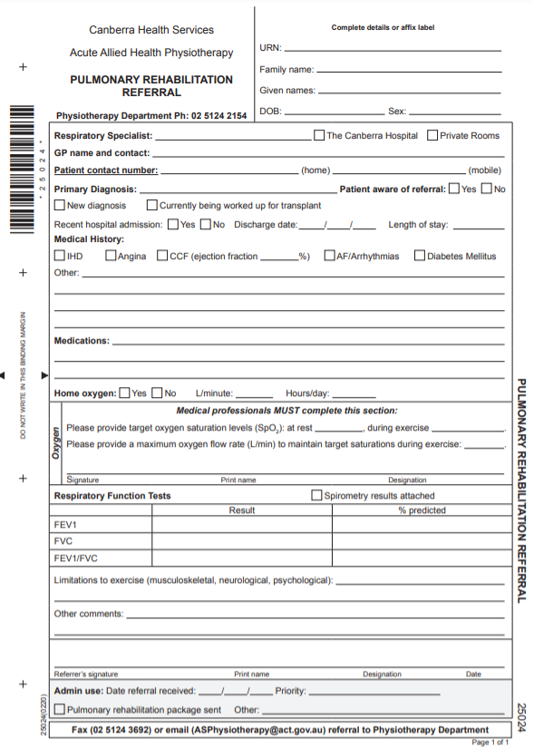
Sample

Attachment 2: Pulmonary Rehabilitation Administrative Processes
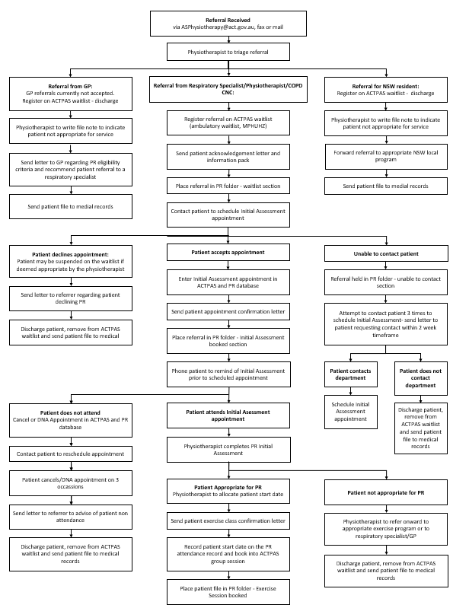

Attachment 3: Alternative Pulmonary Rehabilitation or Exercise Programs

NSW Pulmonary Rehabilitation Programs
Location |  | Phone |  | Fax
Moruya |  | 02 4474 1984 |  | 4474 1970
Batemans Bay |  | 02 4475 1603 |  | 4475 1662
Cooma |  | 02 6455 3281 |  | 6455 3360
Goulburn |  | 02 4827 3256 |  | 1300 797 331
Queanbeyan |  | 02 61507245 |  | 02 61507236
Young- Mercy Care |  | 02 6382 8444 |  | 02 6382 8400
Yass |  | 02 6220 2017 |  | 02 6226 2944
NSW Central Intake | Fax: 1300 797 331 |  | Email: snswlhdcommunityintake@health.nsw.gov.au

Alternative Exercise Programs
Exercise Program | Phone | Email
Lungs in Action – CIT Bruce | 02 6207 4309 | FitandWell@cit.edu.au
Lungs in Action – UC Health Clinic | 02 6201 5843 | healthclinic@canberra.edu.au
Exercise Physiology | 02 5124 2573 | chiintake@act.gov.au
Cardiac/Heart Function Rehabilitation | 02 5124 3733 | CHS.cardiacrehab@act.gov.au

Attachment 4: Pulmonary Rehabilitation Assessment Form
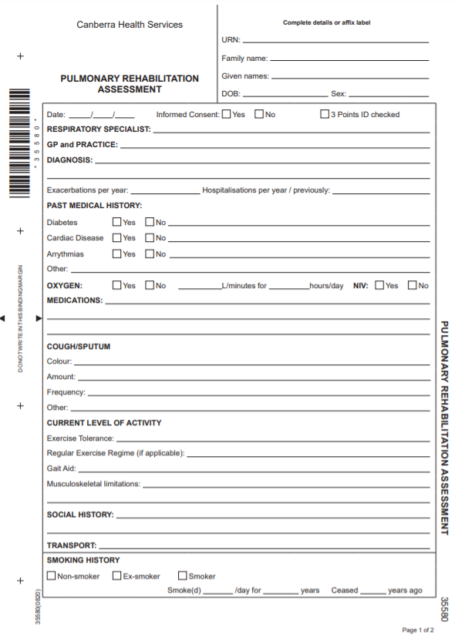
Sample

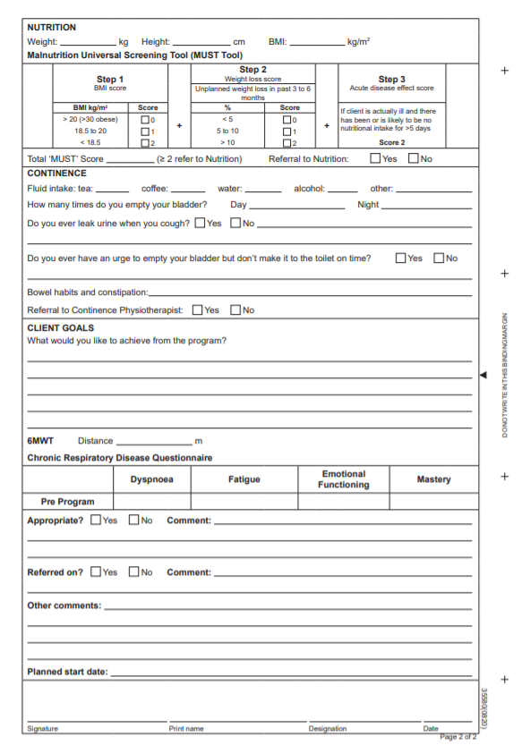
Sample

Attachment 5: Six Minute Walk Test
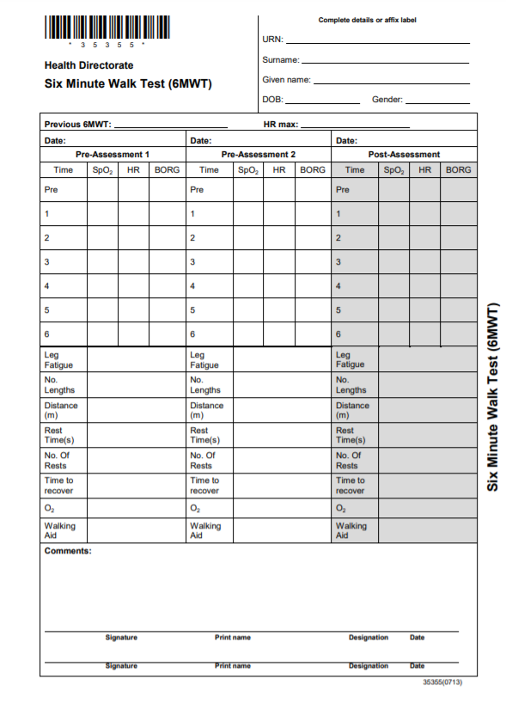
Sample

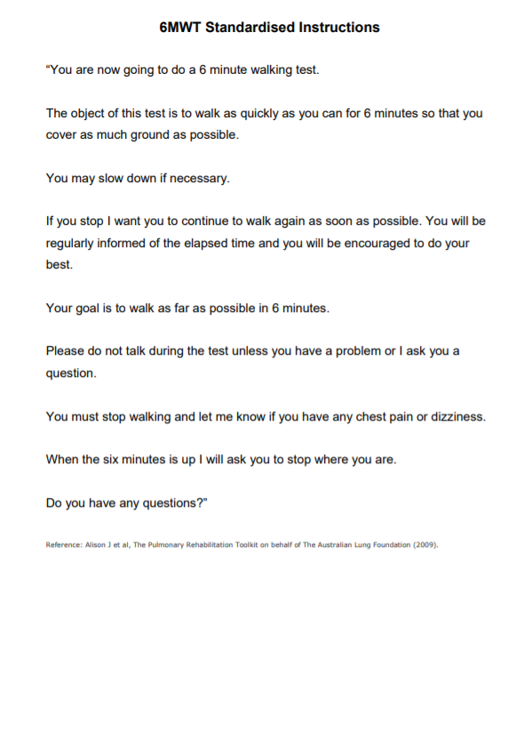

Attachment 6: Chronic Respiratory Disease Questionnaire Response
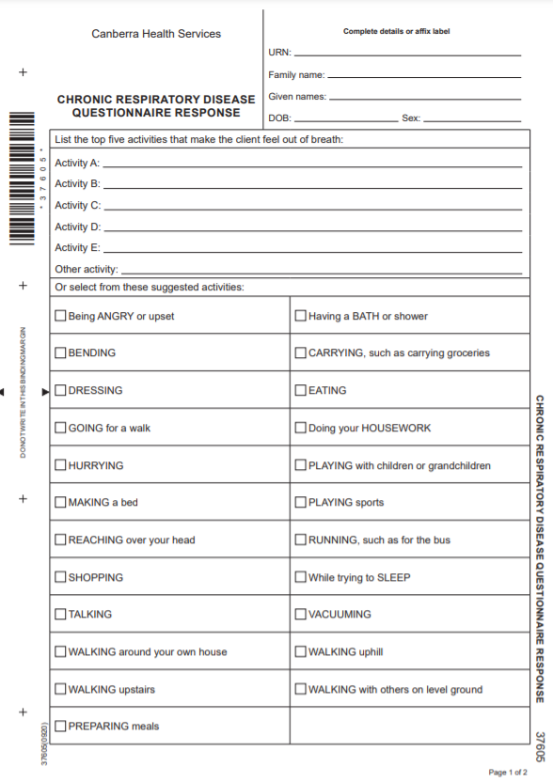
Sample

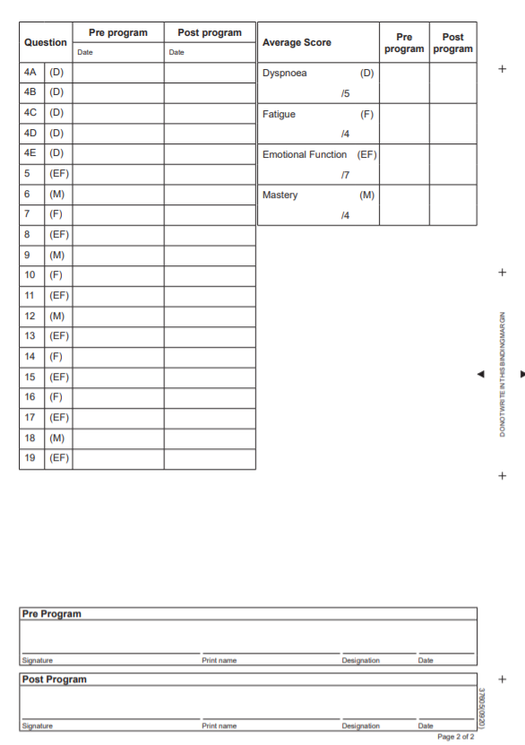
Sample

Attachment 7: Pulmonary Rehabilitation Discharge Report
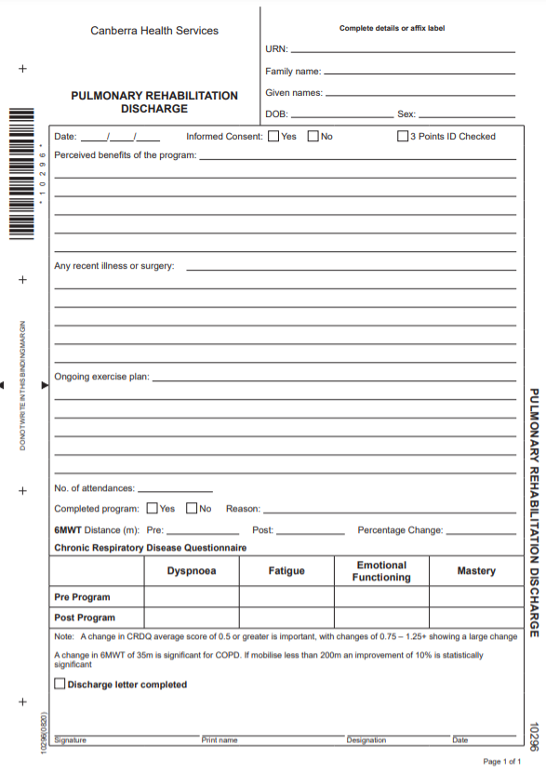
Sample

