Canberra Health Services
Clinical Guideline
Physiotherapy Treatment Pathways for Musculoskeletal Pain and Injury Management in the Walk in Centre (Adults and Children)

Contents

Contents 1
Guideline Statement 2
Scope 3
Section 1 – Role of the Primary Contact Physiotherapist in the Walk in Centre 3
Section 2 – Patient Flow for Patients with Musculoskeletal Pain and Injury within the Walk in Centre 4
Section 3 – Lower Back 4
Section 4 – Wrist and Hand 6
Section 5 – Ankle and Foot 7
Section 6 – Elbow Pain 8
Section 7 – Neck Pain 9
Section 8 – Shoulder 10
Section 9 – Knee 11
Section 10 – Hip 12
Section 11 – Rib 13
Section 12 – Thoracic Spine 14
Implementation 15
Related Policies, Procedures, Guidelines and Legislation 15
Search Terms 15

Guideline Statement

This Guideline outlines clinical treatment pathways for Primary Contact Physiotherapists working within the Walk in Centres (WiC) at Canberra Health Services (CHS), in the management of musculoskeletal pain and injury management.

Background
Physiotherapists have been working in advanced and extended roles within the Emergency and Orthopaedic Outpatient Departments of Canberra Hospital since 2010. These roles have been extensively reviewed and refined through research projects including the ACT Health Extended Scope of Practice Initiative and the Health Workforce Australia Expanded Scope of Practice – Physiotherapists in Emergency Department project. Both research projects demonstrated physiotherapists provide safe, efficient and cost effective care for patients presenting with musculoskeletal conditions and are well accepted by staff and patients within the department. In November 2018 a similar primary contact physiotherapy role was introduced into the WiC.

A Tier One: Primary Contact Physiotherapist (PCP) will work within the WiC. PCPs are experienced musculoskeletal physiotherapists who have achieved competency against the CHS Primary Contact Physiotherapy Standard. They are employed in both the Emergency Department and WiC and work within a traditional physiotherapy role, with advanced clinical reasoning supported by medical staff and WiC nursing staff. The role of the PCP is outlined in Section 1 of this guideline.

Key Objectives
To outline the management of musculoskeletal pain and injury management for PCPs within the WiC. PCPs will:
- Manage the treatment of patients presenting to the WiC with musculoskeletal injury as their primary complaint
- Provide mobility and other appropriate assessments on a referral basis from the WiC nurses.

Alerts
- Identify the potential for serious illness or risk and refer the patient to the Emergency Department with an event summary.

- The PCP can conduct a thorough assessment unless the patient displays a symptom listed under the exclusion/red flag section within each injury category. Consultation with WiC Nursing staff should be undertaken if analgesia is required or for the management of open wounds.

Back to Table of Contents

Scope

This guideline relates to PCPs within the WiC under the clinical governance of CHS and applies to both Adults and Children.

Patients must meet the patient selection criteria outlined in the Exclusions/Red Flags for the WiC in addition to the following:

- Patients aged 65 and over must have few co-morbidities
- Spinal pain is only included where there is mild to moderate pain
- Patients between ages 2 and 18 must be presenting with a simple musculoskeletal injury.

Back to Table of Contents

Section 1 – Role of the Primary Contact Physiotherapist in the Walk in Centre

The PCPs in the WiC are responsible for assessing, diagnosing, requesting imaging, where indicated, and comprehensively managing patients according to their needs. This may include referring patients to inpatient and outpatient specialist medical services and community-based healthcare providers.

WiC PCPs are authorised as the primary contact to:
- Initiate care
- Perform assessments
- Order radiology on isolated limb injury as per the appropriate pathway as per the Physiotherapists ordering medical imaging within Canberra Hospital and the Walk in Centre guideline
- Perform initial management
- Education and advice
- Liaise with WiC nursing staff regarding wound management and/or medication requirements as appropriate
- Discharge the patient with written management and follow up advice
- Document the episode of care in the Clinical Portal and ACTPAS as per the WiC clinical record.

Back to Table of Contents

Section 2 – Patient Flow for Patients with Musculoskeletal Pain and Injury within the Walk in Centre

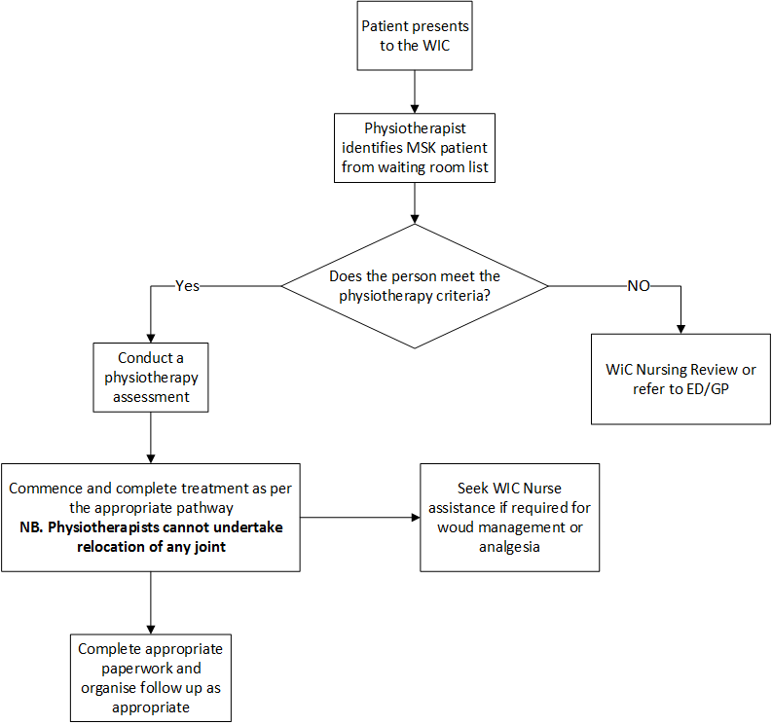

Back to Table of Contents

Section 3 – Lower Back

Exclusions/Red Flags:
- Diplopia, Dysphagia, Dysarthria, Drop attacks or Dizziness
- Blackouts/Loss of consciousness (LOC)
- Hemiparesis
- Fall from a height > 1 metre
- Suspected spinal fracture
- Malignancy
- History of Osteoporosis
- Absent reflexes AND decreased muscle strength.

Symptomatic Treatment:
The following treatment pathway prescribes the examination, treatment and follow up pathway that the PCPs in the WiC are to follow for people with lower back pain/injury where no red flags have been identified.

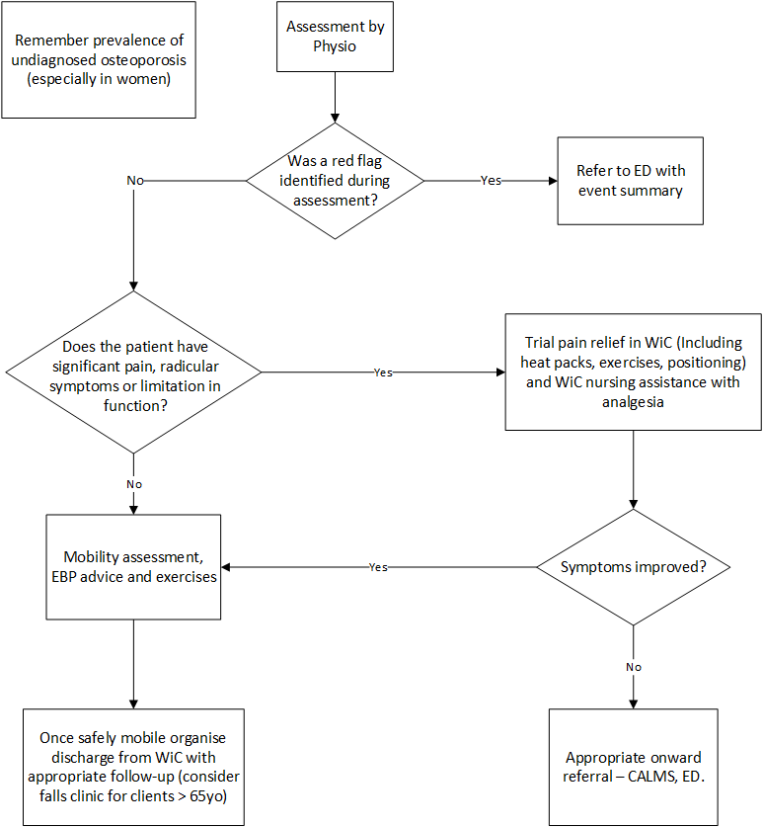

Back to Table of Contents

Section 4 – Wrist and Hand

Exclusions/Red Flags

- Malignancy
- Suspected joint infection
- Dislocation
- Gross deformity
- Neurovascular compromise.

Symptomatic treatment:
The following treatment pathway prescribes the examination, treatment and follow up pathway PCPs in the WiC should follow for people with wrist and hand pain/injury where no red flags have been identified.

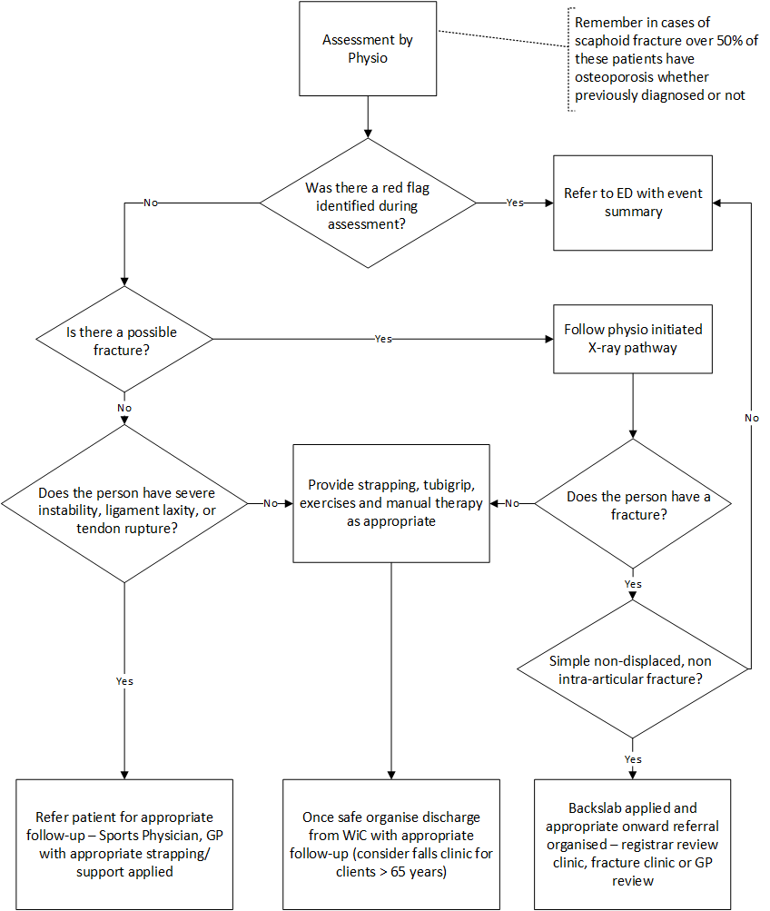

Back to Table of Contents

Section 5 – Ankle and Foot

Exclusions/Red Flags:

- Malignancy
- Gross deformity
- Dislocation
- Neurovascular compromise
- Suspected infection

Symptomatic Treatment
The following treatment pathway prescribes the examination, treatment and follow up pathway PCPs in the WiC are to follow for people with ankle and foot pain/injury where no red flags have been identified.

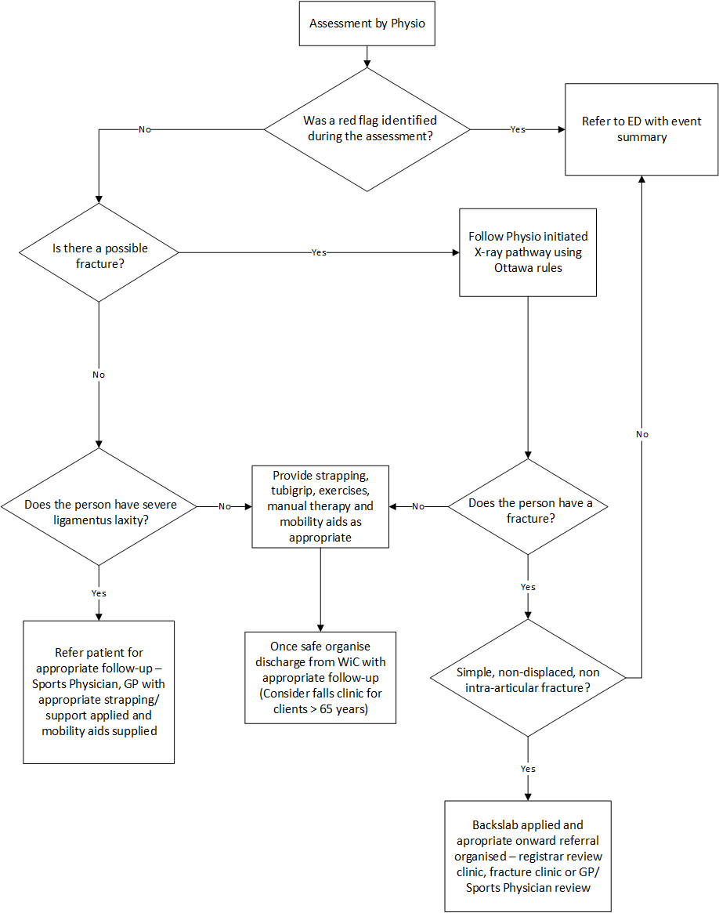

Back to Table of Contents

Section 6 – Elbow Pain

Exclusions/Red Flags:

- Malignancy
- Suspected infection
- Gross deformity
- Compound injury
- Neurovascular compromise

Symptomatic Treatment:
The following treatment pathway prescribes the examination, treatment and follow up pathway PCPs in the WiC are to follow for people with elbow pain/injury where no red flags have been identified.
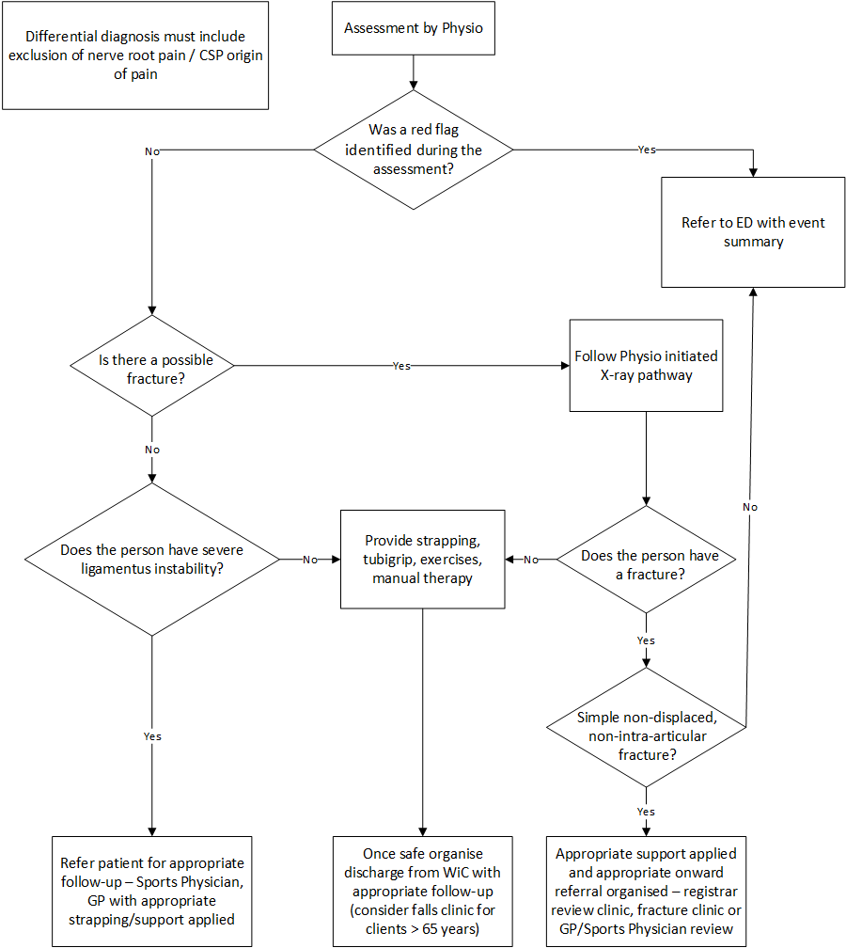

Back to Table of Contents

Section 7 – Neck Pain

Exclusions/Red Flags:

- Malignancy
- LOC
- Episodes of recent fitting
- Suspected infection
- Dysphasia, diplopia, dysarthria, drop attacks or dizziness
- Sudden unexplained swelling in limbs
- Patient wearing a hard collar
- Hemiparesis
- Fall from a height > 1 metre
- Suspected fracture
- Osteoporosis
- Absent reflexes
- Decreased muscle strength

Symptomatic Treatment:
The following treatment pathway prescribes the examination, treatment and follow up pathway PCPs in the WiC are to follow for people with neck pain/injury where no red flags have been identified.
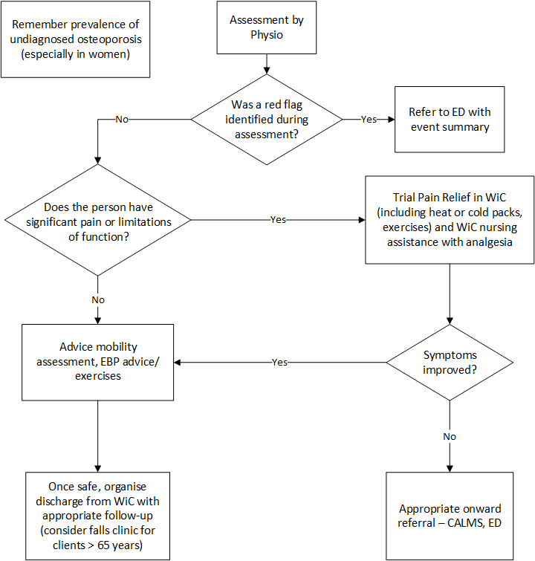

Back to Table of Contents

Section 8 – Shoulder

Exclusions/Red Flags
- Malignancy
- Dislocation
- Neurovascular compromise
- Gross deformity
- Suspected infection

Symptomatic Treatment:
The following treatment pathway prescribes the examination, treatment and follow up pathway PCPs in the WiC are to follow for people with shoulder pain/injury where no red flags have been identified.
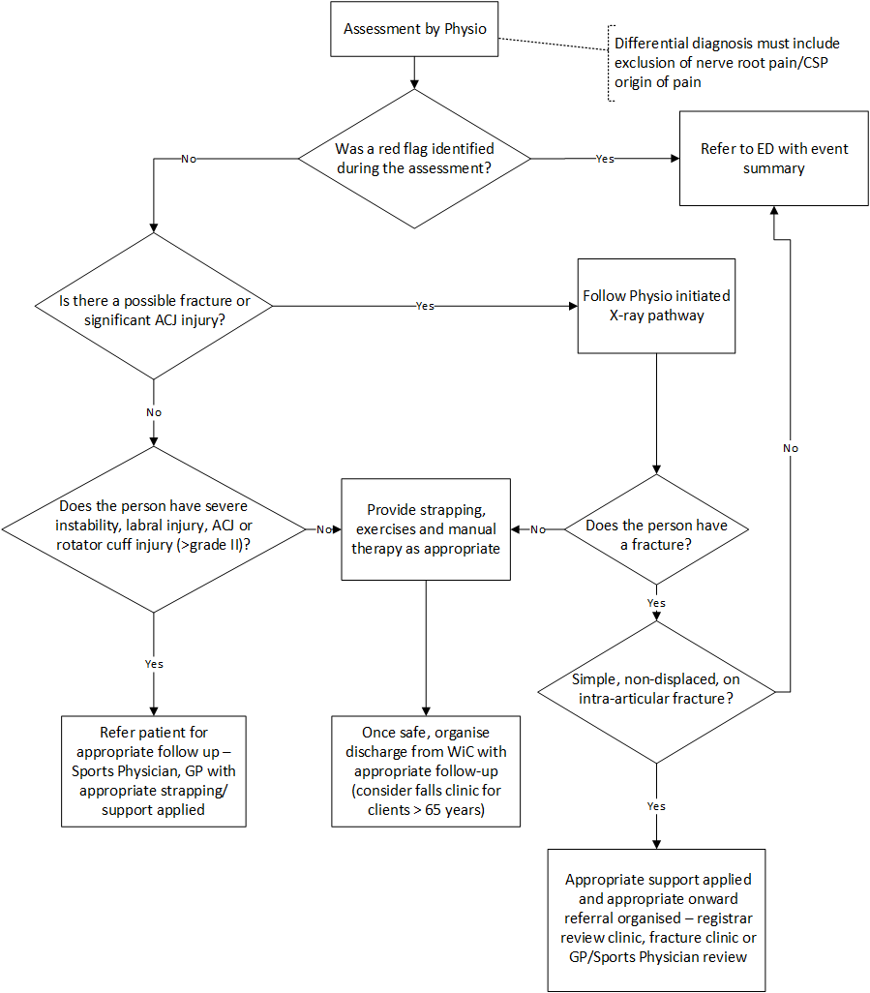

Back to Table of Contents

Section 9 – Knee

Exclusions/Red Flags
- Malignancy
- Suspected infection
- Gross deformity
- Neurovascular compromise
- Dislocation

Symptomatic Treatment
The following treatment pathway prescribes the examination, treatment and follow up pathway PCPs in the WiC are to follow for people with knee pain/injury where no red flags have been identified.

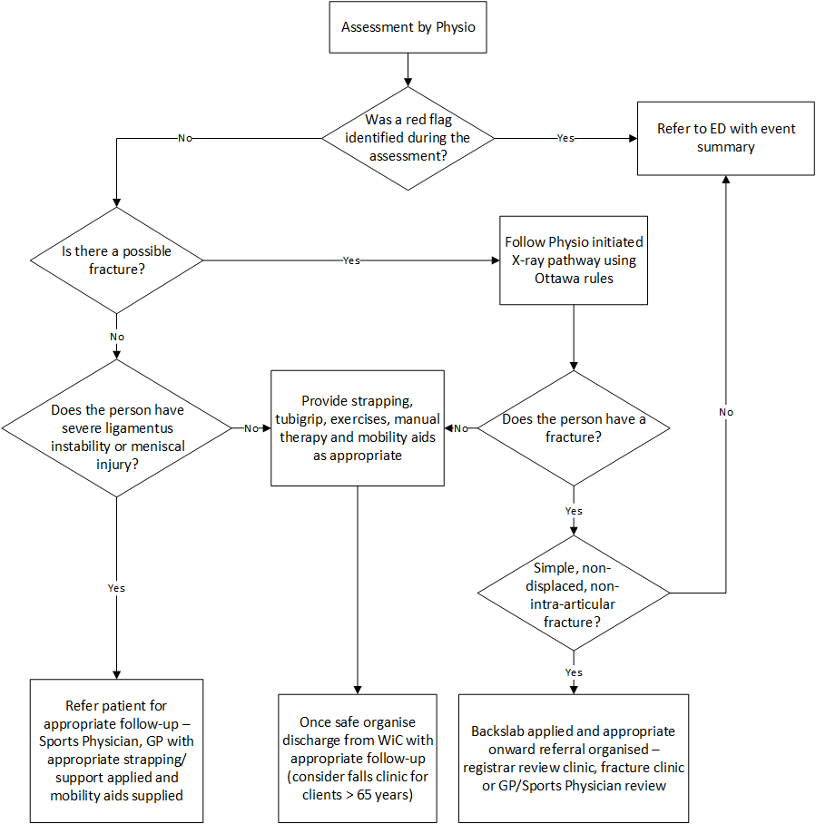

Section 10 – Hip

Exclusions / Red Flags:

- Malignancy
- Suspected infection
- Sudden unexplained swelling in limbs
- Hemiparesis
- Suspected fracture (leg shortened and externally rotated)
- Osteoporosis
- Absent reflexes
- Decreased muscle strength

Symptomatic Treatment
The following treatment pathway prescribes the examination, treatment and follow up pathway PCPs in fast track are to follow for people with hip pain/injury where no red flags have been identified.

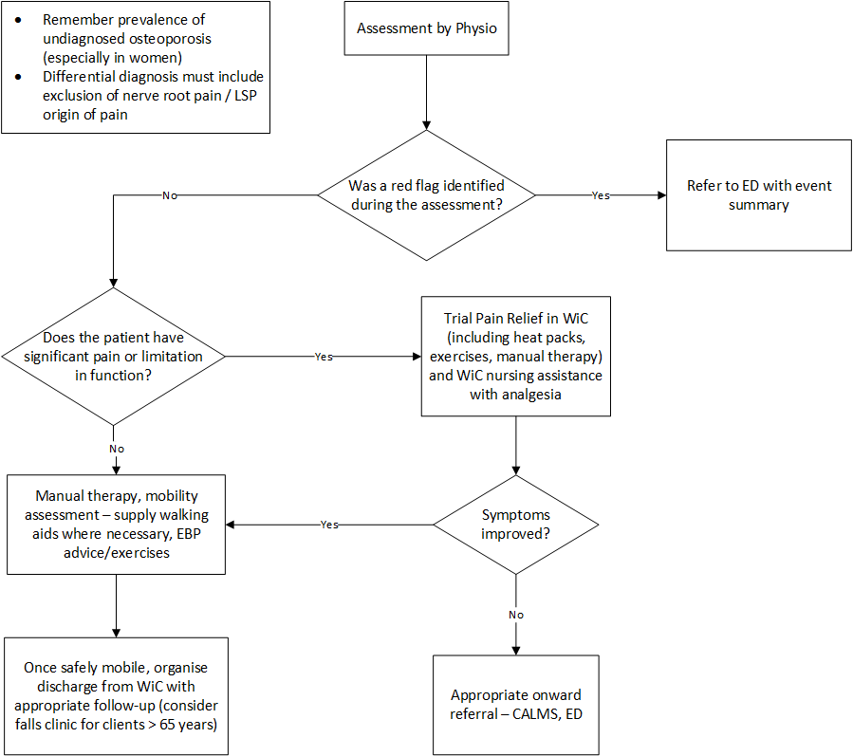

Back to Table of Contents

Section 11 – Rib

Exclusions/Red Flags:

- Non-musculoskeletal pain (e.g. chest pain)
- Respiratory changes (e.g. shortness of breath)
- Saturations of less than 95% on room air
- Pneumothorax
- Underlying chronic respiratory conditions
- Obvious flail segment
- Blackouts / LOC
- Malignancy
- History of Osteoporosis
- Absent reflexes and decreased muscle strength
- Reported Haemoptysis

Symptomatic Treatment
The following treatment pathway prescribes the examination, treatment and follow up pathway PCPs in walk in clinic are to follow for people with rib pain/injury where no red flags have been identified.

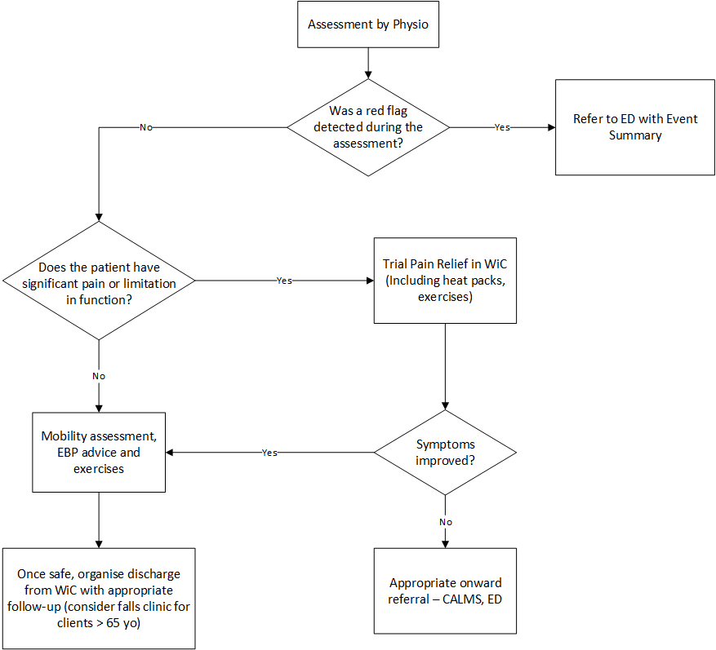
Back to Table of Contents

Section 12 – Thoracic Spine

Exclusions / Red Flags

- Diplopia, dysphagia, dysarthria, drop attacks or dizziness
- Blackouts / LOC
- Hemiparesis
- Malignancy
- History of Osteoporosis
- Absent reflexes and decreased muscle strength
- Fall from a height > 1 metre
- First presentation following motor vehicle accident
- Possible fracture

Symptomatic Treatment
The following treatment pathway prescribes the examination, treatment and follow up pathway PCPs in WiC are to follow for people with thoracic back pain/injury where no red flags have been identified.

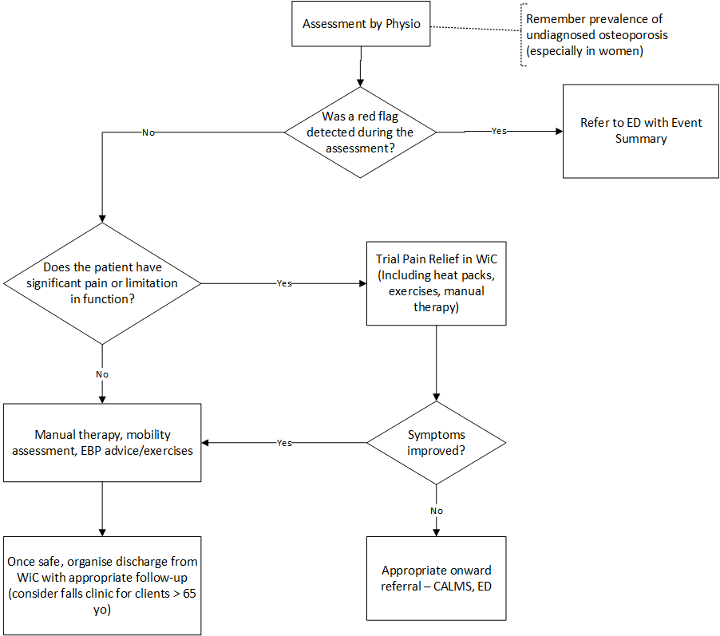

Implementation

This guideline will be implemented and communicated to staff and incorporated into existing training programs, orientation plans, staff meetings, peer review sessions and available on the CHS Policy Register.

Back to Table of Contents

Related Policies, Procedures, Guidelines and Legislation

Policies
- Consent and Treatment

Procedures
- CHHS Healthcare Associated Infections Clinical Procedure
- CHHS Patient Identification and Procedure Matching Policy

Guidelines
- Physiotherapists ordering medical imaging within Canberra Hospital and the Walk in Centre

Legislation
- Health Records (Privacy and Access) Act 1997
- Human Rights Act 2004
- Work Health and Safety Act 2011

Back to Table of Contents

Search Terms

Walk in Centre, Physiotherapy, Musculoskeletal

Disclaimer: This document has been developed by Canberra Health Services specifically for its own use. Use of this document and any reliance on the information contained therein by any third party is at his or her own risk and Canberra Health Services assumes no responsibility whatsoever.

Policy Team ONLY to complete the following:
Date Amended | Section Amended | Divisional Approval | Final Approval
17/07/2019 | New Document | Cathie O’Neill, ED CAS | CHS Policy Committee

This document supersedes the following:
Document Number | Document Name

