Guideline | Canberra Health Services

Perinatal and Infant Mental Health Wellbeing
CHS25/153
Contents
Guideline Statement 3
Background 3
Scope 5
Section 1 – Perinatal Mental Health Concerns and Clinical Considerations 5
Section 2 – Infant Mental Health 14
Section 3 – Assessment and Screening Tools 14
Section 4 – Clinical Management 17
Section 5 – Perinatal Mental Health Crisis Management at North Canberra Hospital 19
Section 6 – Perinatal Mental Health Crisis Management at Canberra Hospital 20
Section 7 – Perinatal Mental Health Crisis Management within Community Services 21
Section 8 – Education and Support for Staff 22
Section 9 – Resources 23
Evaluation 27
Related policies, procedures, guidelines and legislation 28
References 30
Search terms 31
Attachments 31
Attachment 1: Perinatal Psychosocial Assessment (PPSA) (Figure 1 and 2) 33
Attachment 2: Edinburgh Postnatal Depression Scale (EPDS) (Figure 3 and 4) 36
Attachment 3 : PPSA Scoring Guide 40
Attachment 4: EPDS Scoring Guide 41
Attachment 5: Edinburgh Postnatal Depression Score Clinical Management Response Flowchart: Adapted from COPE 2024 42
Attachment 6: Assessment of Suicide Risk and Risk of Harm to Self/others Flowsheet: Adapted from COPE 2024 43
Attachment 7: Safety Plan- Can be used with Assessment of Suicide Risk and Risk of Self/Others Harm and EPDS Management Flowsheets- Adapted from COPE 2024 44
Attachment 8: Psychiatric Support at North Canberra Hospital Flowchart 45

Guideline Statement
The purpose of this document is to provide evidence-based practice guidelines for Canberra Health Services (CHS) clinicians, relating to perinatal mental health and care provided, alongside infant mental health. The focus on early identification, prevention and support to women, partners, and their families who are at risk of, or have, perinatal depression/anxiety or other perinatal mental health concerns is a priority. The impact of these mental health concerns for the infant is recognised and explained, reinforcing the vital need for consistency and assessment at frequent points on the perinatal continuum.
Perinatal period refers to the time from pregnancy to the first 12 months after childbirth¹⁷, and infant mental health will refer to the importance of the first thousand days in life¹⁹. These periods are recognised as a time of vulnerability and change for the family unit^{17,18}.
This guideline is underpinned by the Centre of Perinatal Excellence (COPE); Mental Health Care in the Perinatal Period: Australian Clinical Practice Guideline 2023, the Australian Pregnancy Care Guidelines 2024, and Best Start for Canberra’s Children: The First 1000 Days Strategy 2022. Clinicians can use these documents as current guiding care for the perinatal period and optimal infant mental health outcomes, alongside this guideline. Recognised within this guide is every clinical situation is individual and may require collaborative clinical judgement with a multi-disciplinary team.
Clinicians working in CHS that provide clinical care for families in the perinatal period will routinely screen women for any concerns relating to perinatal mental health using the following screening tools outlined in section 3: the Perinatal Psychosocial Assessment (PPSA) (Attachment 1) and the Edinburgh Postnatal Depression Scale (EPDS) (Attachment 2). The Kimberley Mum’s Mood Scale is the validated tool for Aboriginal and Torres Strait Islander woman to support clinicians to provide culturally appropriate care¹⁵. The use of these evidence-based validated screening tools facilitates the identification of early signs and symptoms of maternal anxiety and/or depression and risk factors that can contribute to mental health issues. These tools can also be used for screening men within the perinatal period that are experiencing mental health issues¹⁷.
Translated EPDS are available for clinicians to use for non-English speaking (NESB) clients¹⁴. It is CHS policy to use an interpreter to support clients’ understanding of information for their safety and care if they do not speak or understand English. If a client declines the use of a professional interpreter, this must be documented in their clinical record. Refer to Language Services – Interpreters and Translated Materials for adults and children Procedure available on the CHS Policy and Guidance Documents Register for further detail.

Background
The importance of healthy families to our community has far reaching effects on our health resources and societal functioning. The perinatal period is a well-known time of vulnerability and change for families. These changes can be positive, but they can also negatively affect the family ⁶. The prevalence of mental illness in Australia, within the perinatal period, highlights one in ten women will experience depression during pregnancy and one in seven will experience postnatal depression. One in five women are affected by anxiety in both the antenatal and postnatal periods. Suicide is one of the leading causes of maternal death in Australia ¹⁰. Men are less likely to seek help for mental illness, however, experience postnatal depression and anxiety. One in ten fathers experience depression postnatally, and one in six experience postnatal anxiety. There is a correlation between maternal and paternal depression ⁷.
The National Perinatal Mental Health Initiative (NPMHI) is an intergovernmental agreement across maternal, adult, child, and mental health services. It aims to improve prevention and early detection of perinatal depression and provide better support and treatment for expectant and new mothers experiencing depression and or anxiety. As a result of this initiative Australia developed their Clinical Practice Guidelines (Centre of Perinatal Excellence (COPE); Mental Health Care in the Perinatal Period: Australian Clinical Practice Guideline 2023), to increase clinician’s knowledge, client screening and early intervention for woman in the perinatal period with mental health concerns. Furthermore, it has incorporated the family, including reference to fathers/non-birthing parents’ mental health needs. More severe mental health issues experienced in the perinatal period are associated with impaired functioning, and decreased care and attachment to the infant. This can lead to poorer health outcomes for the infant/child throughout their lifespan. The NPMHI aims to increase collaboration between services to improve families’ emotional and mental health, pregnancy and parenting experiences, infant mental health, and safety, resulting in increased parenting capacity, breastfeeding rates, and positive experiences. Building strong, connected families, builds strong, connected communities^{13,17}.
Clinicians working with families during the perinatal period are uniquely placed to build trust, provide consistent care, and identify early deterioration in mental state. Through therapeutic engagement, they can refer families to appropriate services, promoting positive mental health outcomes¹⁷.

Ways to achieve the therapeutic relationship
Working in a partnership
Utilisation of the Family Partnership Model (FPM) supports families to recognise their strengths and develop strategies to problem solve long term. The family and clinician develop relationships that are empowering and supportive, actively collaborating to gain positive and meaningful health outcomes ¹⁰.
Continuity of care
This is a philosophy that involves shared understanding of care pathways by all clinicians involved in a woman’s and family’s care, with the aim of reducing fragmentation of care and conflicting advice. The clinician providing the continuity of care can develop meaningful relationships based on trust, provide consistent information, and recognise/assess any changes or deterioration with the client. This also provides safety for clients to not have to retell their story multiple times within the health system^{12,16}.
Trauma Informed Care
Trauma Informed Care is a framework for service delivery that is based on knowledge and understanding of how trauma affects people’s lives and their service needs. This requires consideration of a person’s environment beyond the immediate service being provided and how their presentation may be seen as responses/adaptations to past trauma/s. Trauma informed services aim to do no further harm, providing safety within the services to explore health needs⁸.

Alert
As mandated reporters CHS clinicians must report any pregnancy, infant, or child concerns to Child Youth and Families (CYF) as per CHS Child Protection Policy and Identifying and Responding to Harm, Abuse and Neglect of Children Guideline.
Back to Contents

Scope
This guideline relates to CHS staff working within their clinical scope of practice who see women, infants, and their families in the perinatal period. This includes:
- Canberra Hospital
- North Canberra Hospital (NCH)
- Community Services - Women, Youth and Children Community Health Programs (WYCCHP) including Maternal, Child and Family Health (MACH) and Enhanced Health Service (EHS) Early Family Support Service (EFSS).
- Medical Officers
- Allied Health Professionals (e.g. physiotherapists, dietitians, counsellors, psychologists, psychiatrists, social workers).
- Nurses and Midwives
- Student nurses and midwives, and medical and allied health students under direct supervision.
Back to Contents

Section 1 – Perinatal Mental Health Concerns and Clinical Considerations
Perinatal mental health includes all adult mental health disorders as well as specific perinatal period illnesses such as postpartum psychosis. Outlined below are mental health concerns the clinician may encounter within their practice. Management, support, referrals and follow up care of these concerns will be addressed within the following sections of the document and outline acute and community responses.

History Taking
Client health history can outline factors that are associated with an increased risk of perinatal mental illnesses, these include:
- personal or family history of mental health illness/es
- current personal mental health illness/es
- current alcohol and/or drug problems
- current or history of abuse and/or trauma (e.g. physical, sexual, psychological)
- negative or stressful life events (e.g. previous loss of baby, stillbirth, loss of job, relationship issues, moving to a new house, isolated from family/friends).
Factors that can further impact client’s mental health include:
- a stressful or unplanned pregnancy
- past obstetric complications e.g. fertility issues, IVF
- a very long labour
- a premature baby or a baby with health issues e.g. in special care nursery or neonatal intensive care
- difficulty breastfeeding
- an unsettled baby
- prolonged lack of sleep
- being a single parent
- being a young parent e.g. teenager
- multiple births
- financial stress
- relationship difficulties.
Undertaking a comprehensive health history assessment is a vital first step within consultations to gain an understanding of risks and implement early mitigation of risks¹⁷.
Alert: A collaborative mental health birth plan is recommended for clients with mental health conditions, referring/liaising with Perinatal Infant Mental Health Consultation Service (PIMHCS), to develop this plan is vital support for clients.

Baby Blues
In the early days following birth, women may experience a temporary condition commonly known as ‘the baby blues’. The baby blues usually occur between the third to the fifth day after having a baby. Due to the sudden change in hormone levels following birth, women describe feeling very teary, distressed, emotional or sometimes irritable. These overwhelming feelings are completely normal and natural. Baby blues doesn’t usually require any treatment other than the client talking to a family member or friend, resting at every opportunity and eating well. Baby blues will subside within the first two weeks. If these symptoms continue, it may be a sign of other postnatal mental health conditions like postnatal depression and/or anxiety^{7,17}.

Perinatal Anxiety
There can be several common anxiety disorders that present or are exacerbated in the perinatal period. These include:
Generalized Anxiety Disorder (GAD) | Feeling worried about issues on most days over a prolonged period (six months). Common worries may include:  - the infant’s wellbeing e.g. miscarriage, disability, the birth, SIDS, illness  - not being organised with life administration and chores e.g. getting ready for the birth, housework, shopping  - inability to cope with infant e.g. lack of sleep, change to family  - feeding worries e.g. not enough milk supply  - pressure of work and family  - caring for multiple children e.g. having enough love to give.
Panic Disorder | Frequent attacks of overwhelming fear/anxiousness that cannot be controlled.  These may occur:  - when thinking about the birth, or on-tests/investigations  - when thinking about or trying to leave the house e.g. attending appointments or playgroups  - when thinking about sleep and settling e.g. how to cope with the next time baby is awake and unsettled, or if unable to settle the infant  - with development changes/progressions with infant e.g. starting solids  - when left alone with infant.
Social Phobia | Intense fear of being judged, embarrassed or criticised.  This may include:  - people invading their personal space, or touching their infant  - worry about judgement of parenting decisions from family and friends  - infant crying in public and drawing attention to them and their parenting.
Obsessive Compulsive Disorder (OCD) | Characterised by repeated unwanted thoughts/feelings/sensations (obsessive); and acting on these thoughts in response (compulsion). Clients will undertake compulsions to try and alleviate the obsessive thoughts, aiming to decrease distress. Obsessive behaviour can vary widely e.g. may be focused on germs/cleanliness, safety/rechecking rituals, organisation/structured lifestyle.
Post-Traumatic Stress Disorder (PTSD) | Develops from a traumatic event characterised by intrusive thoughts about the incident, recurring distress and worry, flashbacks, and avoidance of situations.  This may have occurred from:  - a potential life-threatening incident  - witnessing a life-threatening incident e.g. being the first responder to an emergency  - previous pregnancy issues, birth trauma, or neonatal death  - an assault/abuse of physical/sexual nature.
Specific Phobia | Fearful feelings about objects or situations. This commonly includes birth, vomiting or faeces, or body changes (eating disorders).
Symptoms clients may share with the clinician include (noting these are experienced longer than two weeks):
- feelings of fear and worry which begin to ‘take over’ thinking
- feeling irritable, restless, tense or constantly ‘on edge’
- racing heart/strong palpitations – sometimes panic attacks and being unable to function
- reoccurring worrying thoughts e.g. that you are not doing things correctly and/or that something terrible will happen
- unable to sleep – even when you have the opportunity
- avoiding situations for fear something bad will happen¹⁷.
Assessing the answers to questions 2, 3, 4, 7 and 11 on the PPSA can outline possible perinatal anxiety.
Assessing the answers to questions 3, 4 and 5 on the EPDS can outline possible perinatal anxiety.
Refer to Section 3 - Assessment and Screening Tools to assess for possible perinatal anxiety.

Perinatal Depression
Depression during this period can develop within a short time frame or gradually. It is the same as having depression at any time of life but the incidence of developing depression in this period is higher.
Depression has significant effects on health and wellbeing of the developing foetus, breastfeeding journey, and the entire family dyad. It is complex and can be masked by thinking it is normal adjustment to change, or from being tired or experiencing hormonal imbalances. This can lead to delayed assessment and treatment and can have devastating effects for the family.
Symptoms clients may share with the clinician include (noting these are experienced longer than two weeks):
- low mood and or feeling numb
- loss of interest in things you would normally enjoy
- feeling inadequate, like a failure, guilty, worthless, sad
- feeling unmotivated and unable to cope with daily life
- not being able to sleep or sleeping excessive
- feeling close to crying all the time
- thoughts of self-harm and or suicide¹⁷.
Refer to Section 3 - Assessment and Screening Tools to assess for possible perinatal depression.

Postnatal Psychosis
This is a rare but severe mental illness experienced after having a baby. The onset is rapid, usually occurring within 48 hours to two weeks postnatal, however, may still present up to 12 weeks postnatally. It is characterised by significant changes in mood, perceptions, and behaviour. Cause is unknown, however there is an increased risk if the client experiences Bipolar Disorder. Medical issues such as infection, endocrinological and thromboembolic issues must also be considered.
Alert: Postnatal Psychosis is a psychiatric emergency. Immediate safety of the mother and baby is paramount. Please refer the woman to an approved mental health facility via the emergency department immediately. If you have concerns for the immediate safety of the women or others, please call 000.
Symptoms clients may experience can be related to a mania or depressive phase:

Mania Phase:
- lack of need for sleep, increased energy, feeling powerful and strong, hearing voices, or seeing things that aren’t there (hallucinations), delusional thoughts, disorganised, talking fast, large mood fluctuations, overspending, making unrealistic plans, can have sexual indiscretions/increased libido.

Depressive Phase:
- no energy, unable to sleep/eat, or excessive sleeping, wanting to die, harmful thoughts, hearing voices that may be critical - saying they are a bad person, unable to care for self or baby, withdrawn, hopeless, helpless, worthless feelings, low mood.
Due to the high risk of suicide and or infanticide this is a medical emergency and needs ongoing treatment within an acute facility. This can be frightening for the client and family. A point to consider; when a client needs to be admitted to a specialised psychiatric facility it is important, when/if safe to do so, to advocate to keep the mother and infant together to help establish good attachment relationships and breastfeeding. However, the safety of the infant is of the highest importance and in the early phase of treatment while the mother remains acutely unwell, caring of her infant may be very difficult. Continuing to breastfeed may be manageable but can sometimes be difficult. Consultation with a lactation consultant and the treating psychiatric team regarding this is advised¹⁷.
Refer to Sections 5, 6 and 7 regarding the relevant CHS services available in the management of postnatal psychosis.

Schizophrenia
A serious mental illness that affects how a client thinks, feels, and behaves. Characteristics include experiencing psychotic episodes e.g. hallucinating, delusions, thought disordered, decreased motivation/withdrawal and difficulty with concentration and memory. The treatment of psychotic symptoms in schizophrenia during the perinatal period requires a comprehensive, multidisciplinary approach due to the risks of relapse, the severity of the symptoms, and the need for medication adjustments^{8,17}.

Bipolar Disorder
A serious mental health disorder characterised by intense mood shifts between manic and depressive. Requires a multidisciplinary approach and specialist perinatal mental health services due to risk of relapse during pregnancy and early parenting, severity of condition and medication review^{8,17}.

Borderline Personality Disorder (BPD)
A mental health disorder characterised by a severe inability to regulate emotions. This can increase impulsivity, has an effect on self, and can negatively impact relationships. Emotional deregulation, being the poor ability to emotionally respond appropriately, is a core feature of BDP. BPD is associated with a history of childhood trauma, poor attachment and parenting dysfunction^{8,17}.

Pregnancy loss/miscarriage, still birth and newborn loss
The death of a baby at any stage of pregnancy, birth or as a newborn is tragic. Each year in Australia approximately 150,000 woman and their families experience loss of a developing or new baby. 147,000 due to miscarriage (less than 20 weeks gestation), 1,750 are stillborn (died after 20 weeks gestation) and 850 in the first 28 days of life. The impact on the mental health of the client and family is significant, and experiencing this profound grief can lead to mental health conditions of depression and anxiety. Subsequent pregnancies can also pose a higher risk of having anxiety and or depression due to the past traumatic experience. Sensitive and specialist care is needed for families in these situations ^{4,17}.

Birth Trauma
Birth related trauma is a woman’s experience of interactions and or events related to pregnancy, labour and/or childbirth that causes overwhelming distressing emotions and reactions, leading to short- or long-term negative impacts on a woman’s health and wellbeing^{5,17}.
Clients may experience birth trauma physically; including injuries, tears, muscle damage, bladder damage, infection, wound issues, haemorrhages, nerve damage and/or psychologically; this can be if the birth doesn’t go to plan, feeling like they have no control or clear communication, feeling disappointed or frightened, or affected by past experiences. Some clients experience severe emotional distress after a traumatic birth, which can present as depression, anxiety, OCD or PTSD. This can be experienced by both the woman giving birth and their non birthing partner ^{5,17}.

Self-Harming Behaviours
- people who self-harm often do so as a way of coping
- they may self-harm to relieve distressing thoughts, feelings, or memories
- self-harm may be used as a way to express how they are feeling
- they may self-harm to control their thoughts and feelings or because they feel alone
- some people self-harm to punish themselves due to feelings of guilt or shame.
The relief that people feel after self-harming is short-term and their difficult feelings will often return. When these feelings return, people often feel the urge to self-harm again which creates a cycle that can be difficult to break ^{3,9}.

Suicidal Ideation
Suicidal ideation occurs when an individual thinks, plans or focuses on ending their life. Many individuals who complete suicide may provide some kind of warning signs that are out of character for the person, however in some instances there are no warning signs.
It can be difficult and confronting to know that someone is feeling suicidal and wants to end their life. Suicidal behaviour is complex with many influencing factors. People who are suicidal are experiencing intense emotional pain and may view suicide as the only option to end their pain ^{3,9}.

Risk factors
Risk factors are behaviours or aspects of lifestyle, environmental exposures or inherited characteristics that interact to influence people’s risk of suicidal behaviours.
It is important to remember that the presence of one or more risk factors cannot predict or explain suicide or intentional self-harm as each person’s experience is unique.
Experiencing a particular risk factor does not necessarily mean a person has, or ever will, attempt suicide. However, establishing whether a person has risk factors can help determine whether they are at increased risk and can highlight areas of a person’s life experience that may need additional attention to provide effective suicide prevention interventions ^{3,9}.
Some risk factors for suicide are:
Individual: male, history of suicidal behaviour, history of self-harm, major physical or chronic illness, mental illness, alcohol or substance misuse, history of trauma, abuse or neglect, low socio-economic status, family history of suicide.
Situational: job and financial losses, long-term unemployment, stressful life events including natural disasters, breakdown of relationships, bereavement or the loss of a loved one, contact with the criminal justice system, transition from school, hospital or correctional facilities, homelessness, easy access to lethal means.
Social/Cultural: social isolation, lack of social support, discrimination, victimisation, bullying and stigma, exposure to suicidal behaviours, barriers to accessing healthcare, cultural alienation ^{3, 9}.
Some warning signs may include and present as:
Thoughts: suicidal ideation, hopelessness and helplessness, unable to focus on the present or future, self-blame and low self-esteem, poor motivation and concentration, paranoid or persecutory thoughts, delusions and hallucinations, ruminative or obsessive thoughts
Verbalisations: talking about being a burden, expressing hopelessness, talking about feeling trapped or in unbearable pain, e.g. "You won't have to worry about me for much longer", "You'll be sorry when I'm gone", "Everyone would be better off if I was gone", "It's too much, I can't deal with it anymore”.
Behaviours: talking or writing about suicide, self-harm behaviours, looking for a way to access lethal means, increased anger or rage, withdrawing from family and friends, increased substance use, extreme mood swings, sleeping too much or too little, isolating themselves, giving away possessions, changes in appetite, loss of interest in personal appearance and hygiene ^{3,9.}

Protective factors:
- connectedness to family, friends and schools
- responsibility for children or family
- presence of a significant other, child, partner, adult
- personal resilience and problem-solving skills
- good physical and mental health
- economic security, particularly in older age
- strong spiritual or religious faith
- community and social integration
- early identification and treatment of psychiatric illness
- belief that suicide is wrong
- lack of access to guns or other means^{3,9}.
Assessing clients suicide risk will be from talking to women and undertaking an EPDS. A positive response to question 10 on the EPDS, prompt clinicians to ask further about clients’ suicidal thoughts and self-harm. Clinicians need to feel secure in knowing this does not encourage suicide, rather provides the opportunity to explore the clients mental health, ensure safety of mother and infant and arrange appropriate care for the individual situation. See Attachment 6 for Assessment of Suicide Risk and Risk of Harm to Self/Others. Refer to Initial management , assessment and intervention for people vulnerable to suicide procedure.

Fathers mental health
Research is continuing to explore fathers’ mental health during the perinatal period. Clinicians must include the fathers within the family ecological lens, considering their mental health history and assessment due to the impact on the infant and mother. Depression and anxiety are prevalent within fathers during this period, due to lack of awareness, financial strains, adjustment and change and relationship stress. The EPDS can be used to assess fathers, however further validation needs to be undertaken as men exhibit varying symptoms of mental health conditions to women¹⁷.

Higher risk groups for mental health adverse experiences
Some community groups experience a higher risk of adverse mental health disorders due to their experience of increase stressors, trauma and lack of support or isolation.
This includes:
Aboriginal and Torres Strait Islander People - can experience perinatal depression and or anxiety at double the rate of non-indigenous people; due to racism, colonisation, trauma, and poorer health outcomes ^{7,11,17} .
People from Multicultural communities - can experience higher rates of mental health conditions due to severe isolation, trauma, language, and cultural barriers^{7,17}.
Lesbian, gay, bisexual, trans, intersex and/or queer (LGBTIQ+) people - further research is needed to support vulnerabilities, however, can experience fertility/IVF and or donor egg stressors, and gender bias due to discrimination and adverse experiences within health care facilities^{7,17}.
People with a disability - can experience accessibility issues, negative bias due to their condition, questioning of their abilities to be pregnant and parent ^{7,17}.
People experiencing intimate partner violence - experience higher scores on the EPDS and higher reports of self-harm, anxiety, and depression^{7,17}.

Medications in perinatal period
It is important for the clinician to encourage clients to consult with their General Practitioner (GP)/Obstetrician or Psychiatrist regarding their care needs and medications for their mental health conditions during the perinatal period¹⁷.
There are resources that can be accessed for further information regarding medications and their effects, risks, and benefits.
These include:
- Pregnancy and Breastfeeding Medicines Guide (PBMG)
- LactMed
- Hale's Medication and Mother's Milk
Back to Contents

Section 2 – Infant Mental Health
Research has highlighted the importance of infant mental health, not merely from birth, but from conception. The challenges faced in adulthood are now being linked to the foundational first 1000 days of life, being from conception to 2 years. This includes links to health issues such as obesity, heart disease, and mental health issues^{1,2,6,17,18,19}. The United Nations Convention on the Rights of the Child recognises children have the right to a high standard of health and well-being (1990)²⁰. Our children are our prime focus for healthy community development. The developing brain architecture between conception to around 2 years is at its most crucial. It is this period that has the most potential to affect health and wellbeing over the lifespan^{6,17,18}.
Infant mental health refers to the developing capacity of the infant and young child to experience, express and regulate emotions, form close and secure relationships, and explore the environment and learn, all in the context of cultural expectations. For infants to grow and thrive, the relationship between the parents/caregivers and their children is of primary importance. The quality of the attachment relationship between parents and children is a critical mediator of infant mental health^{1,2,17,18,19}.
Children who have parents with a diagnosed mental illness or disorder are at a higher risk within the family unit. These at-risk children have a higher chance of developing a mental health illness/disorder themselves, in comparison to other children in the general population. The risk is associated with the reduced emotional availability of the parent, altered perception of the child and the impaired capacity to nourish child development, due to the parent’s mental health conditions^{1,2,19}.
It is important to note that interventions early in life can address risk factors effectively and reduce negative symptoms, to improve outcomes for children and reduce adverse impact on development. Supporting perinatal, infant, and early childhood mental health is a crucial component of assessment focus across the multidisciplinary team that come into contact with families^{1,17,19}.
Alert: Protecting the vulnerable infant/child from harm is at the forefront of clinical care. Clinicians mandated reporting ensures the safety of the infant from situations during this time of change and stress. Situations to highlight for the clinician’s awareness include education and strategies for families on shaken baby syndrome, support for drug use, awareness of relationships that are negative or volatile, or parents or caregiver’s with limited means and self-regulation. These are not purely mental health illnesses/disorders, however, impact the safety and positive infant mental health outcomes. Clinicians are to report child concerns to Child Youth and Families (CYF) as per CHS Child Protection Policy.
Back to Contents

Section 3 – Assessment and Screening Tools

Perinatal Psychosocial Assessment (PPSA)
CHS use the evidence based validated tool PPSA to screen woman for psychosocial risk factors that may affect their pregnancy, birth, and parenting. PPSA has 13 questions (refer to Attachment 1 - Figure 1 and 2). The PPSA addresses key areas that have been aligned with an increased risk within the perinatal period.
These increased risk factors include:
- level of practical and emotional support surrounding the client
- anxious, worrying thoughts, or lower moods
- mental health history of both parents and immediate family members - including drug and alcohol abuse
- history of abuse or neglect
- stressors faced in the last year (moved, financial worries, death of someone close, pregnancy loss, relationship issues, been unwell, difficult pregnancy)
- feeling unsafe in their home - domestic violence
- birth and parenting experience being negative or disappointing¹⁷.
The PPSA does not result in a score, it highlights areas of risk or vulnerability through a positive answer to the questions. This provides an opportunity for the clinician to offer support and referral within these areas (refer to Attachment 3 - PPSA Scoring Guide). The PPSA is to be used in conjunction with the clinician’s clinical assessment and further exploration of issues, support, and referral may be required.
The PPSA screening at CHS occurs via:
- CHS maternity services administer the PPSA routinely to all women in pregnancy.
- CHS MACH and EFSS teams administer the PPSA at the initial first home visit postnatally. Repeating the PPSA postnatally includes two questions, that can be used to start a conversation focusing on the key issues post birth and provides an opportunity for woman to seek further support, if needed.

Edinburgh Postnatal Depression Scale (EPDS)
CHS use the EPDS to screen women for possible anxiety, depression, or self-harm/suicidal conditions throughout the perinatal period (refer to Attachment 2).
Accurately identifying women experiencing symptoms of depression, anxiety, self-harm and or suicide enables:
- the safety and better outcomes for the family unit
- the delivery of prompt care
- alignment with an early intervention focus; and
- a referral to specialist mental health services with appropriate follow-up management¹⁷.
It is important to remember that the EPDS is a screening tool and is not used for diagnosis.
The EPDS screening at CHS occurs via:
- CHS maternity services screen women during pregnancy at the first antenatal visit (around 12-16 weeks) and again at 26 weeks.
- CHS MACH and EFSS teams screen women at 6-12 weeks postnatally and repeat screening at least once in the first postnatal year.

For women that score between 10 and 12, a repeat EPDS is to be completed in 2-4 weeks. The EPDS may be repeated at any time during the pregnancy or postnatally if clinically indicated.
Consideration for maternal emotional wellbeing, even after the 12-month postnatal period, should be routinely addressed at each child’s development health check as evidence indicates depression can be experienced amongst women with children of all ages¹⁷.

Scoring and responding to the EPDS - (refer also to Section 4- Clinical Management)
The EPDS consists of 10 questions that relate to experiencing anxious thoughts/feelings, low mood and/or self-harm/suicidal ideations or thoughts. Refer to Attachment 2 - Figure 3 and 4.
The EPDS sits alongside a Scoring Guide (refer to Attachment 4), and a EPDS Clinical Management Response Flowchart (refer to Attachment 5). Clinicians follow the guide and flowchart to review the score and share information about on-going mental health care needs and support.
Each question attracts a score and is calculated to gain a total out of 30. A total score of 13 or more is considered an indication for the clinician to provide follow-up care for depression and or anxiety. For scores of 1, 2 or 3 on Question 10, which relates to self-harm, the safety of the woman and children in her care should be assessed and, according to clinical judgment, advice sought and/or mental health assessment arranged. Refer to Attachment 6 for Assessing risk of suicide and self/other harm. This risk assessment can be used in conjunction with Safety Plan, refer to Attachment 7.
EPDS important clinician considerations
- The screening tool is to be completed by the client in the presence of the clinician.
- Explain the screening tool, providing clear instructions, and that it relates to how client has been feeling in the last 7 days.
- Answer any questions the woman may have, making no assumptions about their literacy or ability to complete the form on their own.
- If the woman wants the clinician to go through the screening form with them, staff can read out the questions for the client in order. Do not change or reword the questions.
- Consider if an interpreter is required to help complete the screening tools for clients of NESB.
- Use culturally validated EPDS that are available in different languages for clients of NESB - see link for EPDS translated in 20 languages EPDS Translated 20 languages.¹⁴
- Use the Kimberley Mum’s Mood Scale for our Aboriginal and Torres Strait Islander People. This tool is in two parts, a 10 questions visual scale, and a tell me your story yarning. See training manual and tool link Kimberley Mum's Mood Scale training Manual and Tool .¹⁰
- Score the questionnaire using the relevant scoring template (EPDS automatically calculated when entered through Digital Health Record (DHR)).
- In discussing and communicating the outcome of the tool, try to keep any discussion until after the woman has finished the screening tool.
- Avoid using statements that may create a negative or fearful reaction in women.
- Always inform the woman of their score and discuss any issues the screening tool has highlighted.
- The woman’s overall EPDS score may be below a total score of 13, however woman may have concerns or feelings they would like to explore and seek services for support.
- EPDS can be used for fathers/non birthing partners to screen for depression within the perinatal period.
Back to Contents

Section 4 – Clinical Management
The management of mental health concerns and support from undertaking the PPSA and EPDS for perinatal psychosocial risk factors, anxiety, depression, birth trauma and loss is outlined in this section. Clinical management for families experiencing a mental health crisis, postnatal psychosis and or/ suicidal/experiencing harmful thoughts, is outlined in Section 5, 6 and 7 (dependent on acute or community services crisis responses). Refer to Attachments 5, 6 and 7 as clinical guides/flowsheets.

Management of Perinatal Psychological risk factors:
- Complete the PPSA - refer to Attachment 3 PPSA Scoring Guide
- Any woman who has a history of mental health concerns would be offered an extended stay in hospital postnatally to monitor medication and undertake mental health review.
- Discuss risk factors identified with the client.
- Consider support services and resources specific to risk factors identified- these can be found in Section 9 – Resources. Refer as per service and resource referral requirements.
- Ensure comprehensive discharge planning is a priority
- Arrange any follow up appointments as required.
- Discuss any concerns with your clinical manager.

Management of Perinatal Anxiety and or Depression:
- Complete the EPDS - refer to Attachment 5 - Scoring the EPDS.
- Any woman who has a history of mental health concerns would be offered an extended stay in hospital postnatally to monitor medication and undertake mental health review.
- Discuss score with the client.
- Assessing the answers to questions 3,4 and 5 on the EPDS can outline possible perinatal anxiety.
- A score over 13 on the EPDS can indicate depression.
- Follow, using clinical judgement, Attachment 6 - Edinburgh Postnatal Depression Score Clinical Management Response Flowchart.
- Note - any yes on question 10 needs immediate further assessment. Refer to Attachment 1 and 6.
- Safety of the infant is a priority.
- Consider support services and resources specific to score and risk factors identified. These can be found in Section 9 – Resources. Refer as per service and resource referral requirements.
- Ensure comprehensive discharge planning is a priority.
- Discuss any concerns with your clinical manager.

Management of Perinatal Loss:
Acute Services:
Procedures for the care of families experiencing perinatal loss within acute services (NCH and Canberra Hospital):
North Canberra Hospital (NCH):
- Care of Families Experiencing Perinatal Loss at Less Than 20 Weeks Procedure available on the CHS Policy and Guidance Documents Register.
- Care of Families Experiencing Perinatal Loss at Greater Than 20 weeks Procedure available on the CHS Policy and Guidance Documents Register.
Canberra Hospital:
- Termination of Pregnancy (TOP), Miscarriage or Fetal Death Management Clinical Guideline available on the CHS Policy and Guidance Documents Register.
Community Services:
If clients have experienced a previous perinatal loss that is impacting their current parenting post birth, there are services to offer for support:
- Refer to the Early Family Support Service Counselling Team - via DHR/or self-refer via Community Health Intake (CHI) 5124 9977.
- Client can call Red Nose Grief and Loss Support Services - via 1300 308 307 - 24/7.
- See their GP for review and support.
- Offer on-going MACH follow-up and support within clinics and or self-managed clinician time.

Management of Birth Trauma:
Birth trauma can have significant effects on the mental health of the family, breastfeeding journey, and parenting experience/attachment to baby. It is vital to explore any concerns raised after a traumatic birth and within the postnatal period^{4,5,16}. The PPSA Question 12 can highlight a client’s or family’s experience of birth trauma.
Acute Services:
- Offer a debrief session and outline of the birth for the family with postnatal clinical manager and or obstetric team involved at birthing hospital.
- Refer client and or family to social work services or counselling services.
- Offer resources to client and or family for support (refer to Section 9 – Resources).

Community Services:
- Encourage the family to call the birthing hospital for a debrief session and outline of the birth with postnatal clinical manager and or obstetric team.
- Refer client to counselling services- see Section 9 - Resources
- Offer further resources to client- see Section 9 - Resources
- offer on-going MACH follow-up and support within clinics and or self-managed clinician time
- see GP for review and support.
Back to Contents

Section 5 – Perinatal Mental Health Crisis Management at North Canberra Hospital
North Canberra Hospital (NCH) clinicians work with clients in community clinics and acute services at the hospital. Outlined below is the immediate response for clinicians to maintain client safety and care when a client is experiencing a mental health crisis (suicidal) or postnatal psychosis, as this is a medical emergency.

Community NCH antenatal clinic options include:
- Discuss concerns with client, and family if present.
- Refer client to the closest Emergency Department (ED) or dial 000 for an ambulance. The clinician may instigate this in recognition that it is an emergency.
- You can call the Access Mental Health Team (AMHT) on 1800 629 354 for support.
- Remain with the client until assistance arrives, call their family to make aware if they were alone at appointment
- Document your consultation in client’s clinical record, and inform your manager of incident, and to debrief.
- AMHT and/or ED may liaise and refer follow up care to the Perinatal Infant and Mental Health Consultation Service (PIMHCS).

Acute Services as an NCH inpatient include:
- Inform the Team Leader/Clinical Midwife Consultant (CMC)/Clinical Flow Manager (CFM) on the ward.
- Request immediate review by the obstetric team (midwives are to ensure the obstetric team undertake a full clinical assessment prior to seeking consultation with the psychiatric team).
- Call the NCH Mental Health Liaison Consultation (MHCL) Team on 62648366 (for after hours and weekends), and also refer to Attachment 8: Psychiatric Support at North Canberra Hospital.
If the patient is not admitted (including a parent of a NICU or SCN infant), but is in the hospital:
- Consider calling the Medical Emergency Team (MET) by dialling 2222.
- Accompany the woman to the ED, if possible.
- Phone the AMHT on 1800 629 354 for support.
- AMHT and or ED may liaise and refer follow up care to the PIMHCS.
Back to Contents

Section 6 – Perinatal Mental Health Crisis Management at Canberra Hospital
Canberra Hospital clinicians work with clients in community clinics and acute services at the hospital. Outlined below is the immediate response for clinicians to maintain client safety and care when client is having a mental health crisis (suicidal) or postnatal psychosis, as this is a medical emergency.

Community Canberra Hospital antenatal clinic options include:
- Discuss concerns with woman, and family if present.
- Refer client to the closest ED or dial 000 for an ambulance. The clinician may instigate this in recognition that it is an emergency.
- You can call the AMHT on 1800 629 354 for support.
- Remain with the client until assistance arrives, call their family to make aware if they were alone at appointment.
- Document your consultation in client’s clinical record, and inform your manager of incident, and to debrief.
- AMHT and or ED may liaise, and referral follow up care to the PIMHCS.

Acute Services as a Canberra Hospital inpatient include:
- Inform the Team Leader/Clinical Midwife Consultant (CMC)/Clinical Flow Manager (CFM) on the ward.
- Inform the on duty Medical Officer.
- Request immediate review by the obstetric team (midwives are to ensure the obstetric team undertake a full clinical assessment prior to seeking consultation with the psychiatric team).
- Call the Canberra Hospital Consultation Psychiatry Service Liaison Service on 5124 3204.

If the patient is not admitted (including a parent of a NICU or SCN infant), but is in the hospital:
- Consider calling the MET by dialling 2222.
- Accompany the woman to the emergency department, if possible.
- Phone the AMHT on 1800 629 354 for support.
- Document your consultation in client’s clinical record, and inform your manager of incident, and to debrief.
- AMHT and or ED may liaise and refer follow up care to the PIMHCS.
Back to Contents

Section 7 – Perinatal Mental Health Crisis Management within Community Services
Community Services (MACH and EFSS) clinicians work with clients through home visiting and community clinics. Outlined below is the immediate response for clinicians to maintain client safety and care when client is having a mental health crisis (suicidal) or postnatal psychosis, as this is a medical emergency.
- Discuss concerns with the woman, and family if present. Refer to Attachment 5 - Edinburgh Postnatal Depression Score Clinical Management Response Flowchart, Attachment 6- Assessing Risk of Suicide and Self/Other Harm, and Attachment 7- Safety Plan (if appropriate).
- Consider the safety of the infant as a priority.
- You can call the Access Mental Health Team (AMHT) on 1800 629 354 for support.
- Refer client to the closest ED if support person can safely drive or dial 000 for an ambulance if needing immediate assistance.
- Remain with the client until assistance arrives. Call their family to make them aware if the client attended the appointment alone.
- Call clinical manager for support to manage situation as needed and operational organisation/support.
- Document your consultation in client’s clinical record.
- If not already done so, call and inform your clinical manager of incident for debrief.
- AMHT and or ED may liaise and refer follow up care to the PIMHCS.
- Maintain contact with client/family to offer follow-up support when discharged from acute psychiatric services with clinics or clinician self-managed time.
Back to Contents

Section 8 – Education and Support for Staff
Caring for clients and families within a mental health crisis and/or experiencing a deterioration in mental health can be stressful and carry a high level of risk. It is vital to debrief and explore these situations with your manager and if required, seek further support as needed¹⁵. Outlined below is education and support available to CHS staff.

Essential Education to be completed by CHS clinicians:
- Perinatal & Infant Mental Health Wellbeing e-learning via Human Resource Information Management System (HRIMS).
- Strengthening Health Responses to Family Violence Training (face-to-face) booked via HRIMS.
- Aboriginal and Torres Strait Islander Awareness e-learning via HRIMS.
- Cultural Diversity and Inclusion e-learning via HRIMS.
- Understanding Sex and Gender Diversity e-learning via HRIMS.
- Working with Interpreters e-learning via HRIMS.

Recommended Education - speak to your clinical manager:
- Accidental Counsellor Course available via HRIMS.
- Psychological First Aid- available via HRIMS.
- COPE Basic Skills in Perinatal Mental Health free via Basic Skills in Perinatal Mental Health - COPE.
- Kimberley Mum’s Mood Scale Training Course https://www.amsed.com.au/kmms-module.
- Emerging Minds- Advancing Australian Children’s mental health education via Online training courses - Emerging Minds.
- Domestic Violence training- free frontline worker e-learning DV-alert e-learning
- 1800RESPECT- 1800RESPECT.
- Head to Health- Suicide Prevention Training- free online Suicide Prevention Online skills training | Head to Health.
- Birth Trauma information- Australasian birth trauma association Downloadable Guides – Birth Trauma.
- Beyond Blue- Learn about mental health - Beyond Blue - Beyond Blue.
- Beyond Blue- A guide to what works for depression - Depression.
- Beyond Blue- A guide to what works for anxiety - Anxiety.
- Australian Association for Infant Mental Health - AAIMH - Australian Association for Infant Mental Health.

Support for CHS staff:
- Speak with your clinical manager for support.
- Attend Compassion Fatigue course available via HRIMS - speak to your clinical manager.
- CHS outline of extensive staff supports available, for immediate support, 24/7 counselling, debriefing can be found on SharePoint, CHS HealthHub under ‘Emergency and Safety’, and then ‘Support for Staff’: Staff Wellbeing.
- RU OK at Work? Workplace Resources for asking "Are you OK?" | R U OK?
Back to Contents

Section 9 – Resources
Clinicians use clinical judgement regarding referral and/or support required in conjunction with the woman and family. Referrals to services and supports should align with responses to the PPSA, the score from the EPDS, as well as medical or social history that may impact the woman’s perinatal mental health. This promotes exceptional care, early intervention, and promotes continuity as women and families may access several health professionals during pregnancy and early parenthood to optimise their perinatal mental health journey. A multidisciplinary approach for perinatal mental health care is necessary. This could include support from a wide range of the following practitioners and services depending on the families experiences and needs. Access the links to read about each service for your clients.

Crisis Support
If you need immediate help:
- call 000, ambulance and/ or police
- call Access Mental Health (AMH) on 1800 629 354 (ACT)
- call Mental Health Access Line 1800 011 511 (NSW)
- Lifeline 13 11 14
- Suicide Callback Service 1300 659 467 24/7 Phone and Online Counselling | Suicide Call Back Service

Community Services for on-going support, counselling, sustained home visiting and mental health review
- Maternal Child and Family Health Nurse/Midwife (MACH): Call Central Health Intake (CHI) 5124 9977- must be discharged from acute hospital services before community referral processed.
- Early Parenting Support Line: Monday to Friday 08.30AM-5:00PM (02) 5124 1775 (part of MACH Services).
- Early Family Support Service Counselling Team: Via DHR referral or client can self-refer by calling CHI on (02) 5124 9977.
- Early Family Support Service Nursing Team (EFSS): Vulnerable Families Sustained home visiting program. Referral via DHR- prenatal or postnatal dependant on vulnerabilities identified.
- General Practitioner- (GP): Clinician can refer/write review outline for the GP, or client can self-refer.
- Psychologist/Psychiatrist: Referral from GP
- Social worker: Through switchboard at Canberra Hospital/NCH
- Parent Enhancement Program Antenatal Nurses: At Canberra Hospital and NCH.
- Perinatal Infant Mental Health Consultation Service: E-mail the Perinatal and Infant Mental Health Consultation Service Referral Form to: ACTHealthPerinatalMHCS@act.gov.au 02 5124 8809. If you are unsure about whether to refer, please contact the Perinatal and Infant Mental Health Consultation Service on 5124 3133. PIMHCS Referral Form- Found on CHS HUB.
- ForWhen: Call 1300 242 322 Monday to Friday 09:00AM- 4:30PM Perinatal Mental Health Service to support navigation of mental health services in the community.
- Tresillian Day Stay or Residential Parenting: For support call 1300 272 736, 07:00AM -11:00PM, 7 days Parenting Guides, Advice & Support | Tresillian Family Care Centres.
- The Child and Family Centres: Gungahlin: (02) 6207 0120 Tuggeranong: (02) 6207 8228 West Belconnen: (02) 6205 2904. Clinician can contact intake worker with consent or the client can access.
- Child Protection Services: Call 1300 556 728 Child Concern report via RISKMAN ACT Child and Youth Protection Services - ACT Government.
- Fetal Medicine Unit FMU: Via 5124 7461. Care in a high risk/complex pregnancy Fetal Medicine Unit (FMU) - Canberra Health Services.
- Maternity Assessment Unit: Via 5124 7444. Assessment and monitoring of pregnancy 19+6 weeks and support for those who have birthed within 14 days Maternity Assessment Unit - Canberra Health Services.
- Adult Mental Health Units in Canberra- Public: Adult Inpatient Mental Health Units - Canberra Health Services (act.gov.au) Private Deakin Private Hospital Mental Health | Deakin Private Hospital.

Universal Supports and Websites
- How You Feel Matters: CHS brochure available on CHS Policy and Guidance Documents Register.
- Perinatal Wellbeing Centre: (02) 6288 1936 www.perinatalwellbeingcentre.org.au.
- PANDA National Helpline: Monday to Saturday 9am-7.30pm 1300 726306.
- Centre for Perinatal Excellence (COPE): www.cope.org.au.
- Ready to COPE: Free pregnancy and parenthood ap to inform parents Free pregnancy app and app for new parents - Ready to COPE.
- MumSpace: Online support for mental health conditions MumSpace: Antenatal & Postnatal Depression Support Australia.
- Black Dog Institute: www.blackdoginstitute.org.au.
- Beyondblue: 1300 22 4636 www.beyondblue.org.au.
- Beyond Blue: Emotional health and wellbeing: A guide for pregnant women, new mums and other carers.
- Gidget Foundation: 1300 851 758 Perinatal Mental Health Support Gidget Foundation.
- Head to Health: 1800 595 212 Mental health guidance and Support Home | Head to Health.
- SANE: SANE Australia Support Line 1800 187 263.
- Pregnancy, Birth and Baby: 7am to midnight 7 days a week 1800 882 436.
- Healthdirect: 1800 022 222, 24/7 Trusted Health Advice | Healthdirect.
- Relationships Australia 1300 364 277 Services - Relationships Australia Canberra & Region (racr.org.au).
- Family Relationships Advice Line: 1800 050 321 family relationships advice line.
- Playgroups ACT: 1800 171 882 Community playgroups - ACT Playgroups Association (playgroupact.org.au).
- Australian Digital Mental Health Resources: Comprehensive List eMHPrac-Resource-Guide.
- Raising Children: Parenting information Raising Children Network.
- Australian Breastfeeding Association: 1800 mum 2 mum 1800 686 268 Australian Breastfeeding Association.
- Health Information Sheets for Woman: A-Z fact sheets | The Royal Women's Hospital.
- Emerging Minds - Advancing Australian children's mental health: Resources for children of parents with a mental illness (COPMI) and their parents.

Father’s Support
- Fathers Matter: CHS brochure available on CHS Policy and Guidance Documents Register.
- Everyman Australia (Canberra): (02) 6230 6999 www.everyman.org.au.
- Info for Dads on the go: www.sms4dads.com.
- MensLine: 24/7 telephone and online support service 1300 789 978.
- Beyond Blue: Emotional health and wellbeing. A guide for new dads, partners and other carers.
- Healthy Male: Health topics | Healthy Male.

Aboriginal and Torres Strait Islander Support
- Aboriginal and Torres Strait Islander Liaison Service: Supporting Aboriginal and Torres Strait Islander patients - Canberra Health Services (act.gov.au).
- Youth Centres: Gugan Gulwan Southside 6296 8900.
- Winnunga Nimmityjah Health Service: 6284 6222 Winnunga Nimmityjah – Winnunga Nimmityjah.
- Yerrabi Child and family Aboriginal Corporation: Yerrabi – Child & Family Aboriginal Corporation – Empowering Generations of Culturally Strong, Thriving Aboriginal Children, Families and Communities.
- Aboriginal Legal Services: 1800 765 767 Aboriginal Legal Service (NSW/ACT).
- 13 Yarn 13 92 76 13YARN 24 /7 Crisis support for Aboriginal and Torres Strait Islanders.

Culturally Diverse Support
- Theo Notaras Multicultural Centre: Help settling into Canberra, Multicultural Hub Canberra Contact Us.
- Companion House: Refuge Services and Support 6251 4550 Companion House.
- Migrant and Refugee services (MARSS): Settlement, housing, education and training, English lessons Migrant and Refugee Settlement Services.
- Health Translations Victoria: Translated Information for Postnatal Health Translations Pregnancy Health Translations Mental Health Translations What is family violence? Health Translations.

LGBTIQ+ Support
- A Gender Agenda: (Ph) 6162 1924 A Gender Agenda | Trans, Intersex & Gender Diverse services ACT.
- Q Life: Ph 1800 184 527 QLife - Support and Referrals.
- Diversity ACT: (Ph) 0467 243 281 Our community: Diversity ACT.
- Rainbow Families: (Ph) 0481 565 958 Rainbow Families.

Young parents
- Canberra College Cares: Education for pregnant and parenting youth - 14 to 25years; Ph 6142 3464
- Youth Centres: Woden (Ph) 6282 3037, Belconnen (Ph) 6264 0200, The Junction (Ph) 6232 2423, Headspace (Ph) 6113 5700, Mura Lanyon (Ph) 6185 2090.
- Youth Law Centre: (Ph) 6173 5410
- Child and Adolescent Mental Health (CAMHS): Northside (Ph) 5124 1407 Southside (Ph) 5124 3133

Vulnerable Families
- Volunteering ACT: Guides for homelessness, emergency and crisis support, free meal/showers, food relief - Info Guides - Volunteering ACT.
- Karinya House: Providing safety and shelter to a woman who is pregnant or parenting Home - Karinya House.
- Karralika: Supporting families through a range of drug and alcohol programs Karralika Programs Inc - Alcohol and Drug Services In Canberra.
- Gambling Help: 1800 858 858 Gambling Help Online | Gambling Help Online.
- Alcohol and Drug Hotline: 1800 250 015 24/7.
- Alcoholics Anonymous: 1300 222 222 Alcoholics Anonymous.
- Family Drug Support: 1300 368 186 24/7 Family Drug Support - Family Drug Support Australia.
- Health Justice Partnership: Health justice partnership - Health Justice Australia.
- Women’s Legal Centre ACT: 1800 634 669 or 02 6257 4377 Get Help - Women’s Legal Centre (wlc.org.au).
- One Link: Housing support 1800 176 468 OneLink | Information and Connections | 1800 176 468 - OneLink.
- Housing ACT: Applications for public housing, 1800 950 255, Housing ACT - ACT Government.
- Care Financial Counselling Services: 1800 007 007 free support for financial counselling with your situation Financial Counselling & Capability | Care (carefcs.org).
- Women’s Health Service- CHS: 02 5124 1787, Health Care Support for vulnerable woman- Women's Health Service - Canberra Health Services (act.gov.au).
- Marymead Family Support Services: Marymead CatholicCare.
- Roundabout: Roundabout Canberra.
- Community Options: Woman and Newborn Community Support Program 02 6295 8800.

Trauma and Grief
- Trauma and Grief Network: Trauma & Grief Network.
- Red Nose: Grief and Loss: 1300 308 307 Guiding Light - Red Nose Grief and Loss.
- Australasian Birth Trauma Association: Birth Trauma – Australasian Birth Trauma Association.
- The Pink Elephants Support Network - Home: Pregnancy loss & fertility support.

Premature Babies (NICU/SCN- sick or unwell)
- Paediatric Liaison and Navigation Services (PLaNS): Support to navigate the health system- call 02 5124 9977.
- Life’s Little Treasures Foundation: Supporting families of Premature and Sick Babies, 1300 697 736 Home - Life's Little Treasures (lifeslittletreasures.org.au).
- Miracle babies: Supporting families impacted by prematurity and illness at birth, 1300 622 243 Home - Miracle Babies.

Family Violence
- e-safety commission: Support for online abuse Online safety | eSafety Commissioner
- Domestic Violence Crisis Service: 24/7: (02) 6280 0900 Home - DVCS | Domestic Violence Crisis Service in Canberra
- 1800RESPECT: www.1800respect.org.au.
Back to Contents

Evaluation
The Perinatal and Infant Mental Health Wellbeing Guideline evaluation will be undertaken yearly by WYC to ensure the information provided aligns with the current evidence and clinical practice guidelines.

Outcome
- CHS clinicians working with clients in the perinatal period will provide consistent clinical care as outlined in this guideline.
- CHS clinicians will routinely screen women/birth parent for any concerns relating to perinatal mental health (using the PPSA and the EPDS) when providing clinical care for clients and families during the perinatal period.
- Clinicians providing care for clients during the perinatal period will feel confident in identifying and managing concerns relating to perinatal mental health as per this guideline.
- Clients and their families will feel supported, cared for and report positive mental health outcomes during the perinatal period.
- Reduction in consumer complaints regarding services experienced in the perinatal period.
- Referrals processed to provide appropriate, safe care, aligned with available community services and clients/families care needs.

Measures
- Regular review and reporting to relevant managers of clinical activity, referrals received, and waitlist times.
- Assess data from DHR to review number of EPDS and PPSA’s completed by clinician’s to align with consumers utilising service/birth numbers within the perinatal period.
- Clinical and quality outcomes are evaluated through patient experience questionnaires and consumer feedback data.
- Clinical and quality outcomes are evaluated by clinician feedback data.
Back to Contents

Related policies, procedures, guidelines and legislation

Policies
- Nursing and Midwifery Board of Australia (NMBA) Requirements for Practice
- Child Protection
- Work Health and Safety
- Comprehensive Care
- Family Violence
- Annual Renewal of Health Practitioner Registration
- Consumer Privacy

Procedures
- North Canberra Hospital - Care of Families experiencing perinatal loss less than 20 weeks
- North Canberra Hospital - Care of Families experiencing perinatal loss at greater than 20 weeks
- Initial Management, Assessment and Intervention for People Vulnerable to Suicide
- Language Services- Interpreters and translated Materials
- Aboriginal and Torres Strait Islander Impact Statement and Declaration
- Maternal Child and Family Health Procedures in the ACT
- Clinical Handover
- Patient Identification and Health Care Activity Matching
- Identifying and Responding to Family Violence

Guidelines
- Identifying and responding to harm, abuse and neglect of children
- Child and Youth Protection Services working within Canberra Health Services – Collaborative Care
- Consent for Healthcare Treatment
- Termination of Pregnancy (TOP), Miscarriage or Fetal Death Management
- Maternal, Child and Family Health Services in the ACT
- Psychological Support for Staff - A Manager's Guide
- Centre of Perinatal Excellence (COPE); Mental Health Care in the Perinatal Period; Australian Clinical Practice Guideline 2023
- Australian Pregnancy Care Guidelines 2023
- Continuing Competence Assessment and Management of Perinatal Mental Health

Legislation
- Children and Young People Act 2008
- Crimes Act 1900
- Family Violence Act 2016
- Health Practitioner Regulation National Law (ACT) Act (2010)
- Human Rights Act 2004
- ACT Mental Health Act 2004
- Health Records (Privacy and Access) Act 1997
- Human Rights Act 2004
- Work Health and Safety Act 2011
- Carers Recognition Act 2021
- Multiculturalism Act 2023

Other
- Australian Charter of Healthcare Rights
- United Nations Convention on the Rights of the Child
- The ACT Charter of Rights for People Who Experience Mental Health Issues
- CHS Statement of Commitment
- Best Start for Canberra’s Children: The First 1000 Days Strategy 2022.

Back to Contents

References
- Advancing Australian Children’s Mental Health (2024) Emerging Minds. Available at: https://emergingminds.com.au/ (Accessed: 30 May 2024).
- Australian Association for Infant Mental Health, AAIMH. Available at: https://www.aaimh.org.au/ (Accessed: 30 May 2024).
- Australian Institute of Health and Welfare (2022) https://www.aihw.gov.au/suicide-self-harm-monitoring/data/suicide-self-harm-monitoring-data (Accessed: 17 December 2024).
- Australian Pregnancy Care Guidelines (2024), https://app.magicapp.org/#/guideline/jm83RE (Accessed 30 May 2024).
- Australasian Birth Trauma Association. (2024). Retrieved fromhttps://birthtrauma.org.au/
- Best Start for Canberra’s Children: The First 1000 Days .Available at: https://www.act.gov.au/__data/assets/pdf_file/0004/2401177/Best-Start-for-Canberras-Children-The-First-1000-Days-Strategy.pdf (Accessed: 30 May 2024).
- Beyond Blue | 24/7 Support for Anxiety, Depression and Suicide Prevention - Beyond Blue. Available at: https://www.beyondblue.org.au/ (Accessed: 30 May 2024).
- Blue Knot Foundation (2024). Available at: https://blueknot.org.au/ (Accessed: 30 July 2024).
- Centers for Disease Control and Prevention (CDC), 2022. https://www.cdc.gov/suicide/factors/index.html (Accessed: 17 December 2024).
- Centre of Perinatal Excellence (2023) COPE. Available at: https://www.cope.org.au/ (Accessed: 30 April 2024).
- Close the Gap. Available at: https://closethegap.org.au/ (Accessed: 30 June 2024).
- Cummins, A. et al. (2023) ‘Does midwifery continuity of care make a difference to women with perinatal mental health conditions: A cohort study, from Australia’, Women and Birth, 36(2). doi:10.1016/j.wombi.2022.08.002.
- Data Opportunities in Perinatal Mental Health Screening; What is Perinatal Mental Health and Psychosocial Screening and Why is it Important? (2021) Australian Institute of Health and Welfare. Available at: https://www.aihw.gov.au/reports/mothers-babies/data-opportunities-in-perinatal-mental-health-scre/contents/what-is-perinatal-mental-health-and-psychosocial-s (Accessed: 30 May 2024).
- Department of Health. Victoria, A. (2024) Health translations, Department of Health. Victoria, Australia. Available at: https://www.healthtranslations.vic.gov.au/ (Accessed: 30 July 2024).
- Marley, J.V. et al. (2017) Validity and acceptability of Kimberley mum’s mood scale to screen for perinatal anxiety and depression in remote Aboriginal Health Care Settings. Available at: https://www.ncbi.nlm.nih.gov/pmc/articles/PMC5279756/ (Accessed: 30 June 2024).
- Maternity in Focus : The ACT Public Maternity System Plan 2022-2032. (no date) Trove. Available at: https://nla.gov.au/nla.obj-3084016725/view (Accessed: 30 May 2024).
- Perinatal Mental Health Guideline (2023) COPE. Available at: https://www.cope.org.au/health-professionals/review-of-new-perinatal-mental-health-guidelines/ (Accessed: 30 May 2024).
- Safe and Supported: The National Framework for Protecting Australia’s Children 2021 - 2031 (2023) Department of Social Services, Australian Government. Available at: https://www.dss.gov.au/our-responsibilities/families-and-children/programs-services/protecting-australias-children (Accessed: 30 May 2024).
- The First Thousand Days: An evidence paper. Available at: https://www.researchgate.net/publication/320057527_The_First_Thousand_Days_An_Evidence_Paper (Accessed: 30 June 2024).
- UN Convention on the Rights of the Child (1990) Save the Children UK. Available at: https://www.savethechildren.org.uk/what-we-do/childrens-rights/united-nations-convention-of-the-rights-of-the-child (Accessed: 30 May 2024).
Back to Contents

Search terms
Perinatal and Infant Mental Health Wellbeing
Back to Contents

Attachments

Attachment 1: Perinatal Psychosocial Assessment (PPSA) (Figure 1 and 2)

Attachment 2: Edinburgh Postnatal Depression Scale (EPDS) (Figure 3 and 4)

Attachment 3 : PPSA Scoring Guide

Attachment 4: EPDS Scoring Guide

Attachment 5: Edinburgh Postnatal Depression Score Clinical Management Response Flowchart: Adapted from COPE 2024

Attachment 6: : Assessment of Suicide Risk and Risk of Harm to Self/others Flowsheet: Adapted from COPE 2024

Attachment 7: Safety Plan- Can be used with Assessment of Suicide Risk and Risk of Self/Others Harm and EPDS Management Flowsheets- Adapted from COPE 2024

Attachment 8: Psychiatric Support at North Canberra Hospital Flowchart
Back to Contents
For Policy Team to complete:
Date amended | Section amended | Divisional approval | Final approval
09/04/2025 | Complete review | Katherine Wakefield, ED WY&C | Policy Document Review Panel
This document supersedes the following:
Document number | Document name
CHS20/135 | Perinatal Mental Health Wellbeing
Disclaimer
This document has been developed by Canberra Health Services specifically for its own use. Use of this document and any reliance on the information contained therein by any third party is at his or her own risk and Canberra Health Services assumes no responsibility whatsoever.
Back to Contents
Acknowledgement of Country  Canberra Health Services acknowledges the Ngunnawal people as traditional custodians of the ACT and recognises any other people or families with connection to the lands of the ACT and region. We acknowledge and respect their continuing culture and contribution to the life of this region.  © Australian Capital Territory, Canberra 2024 | Accessibility  call (02) 5124 0000   Interpreter call 131 450  canberrahealthservices.act.gov.au/accessibility  

Attachment 1: Perinatal Psychosocial Assessment (PPSA) (Figure 1 and 2)
Figure1: PPSA in Clinical Forms Register on HUB- (printed and have in clinic or at home visit)
Sample

Figure 2: PPSA in Digital Health Record- (client can fill in using rover or desktop)
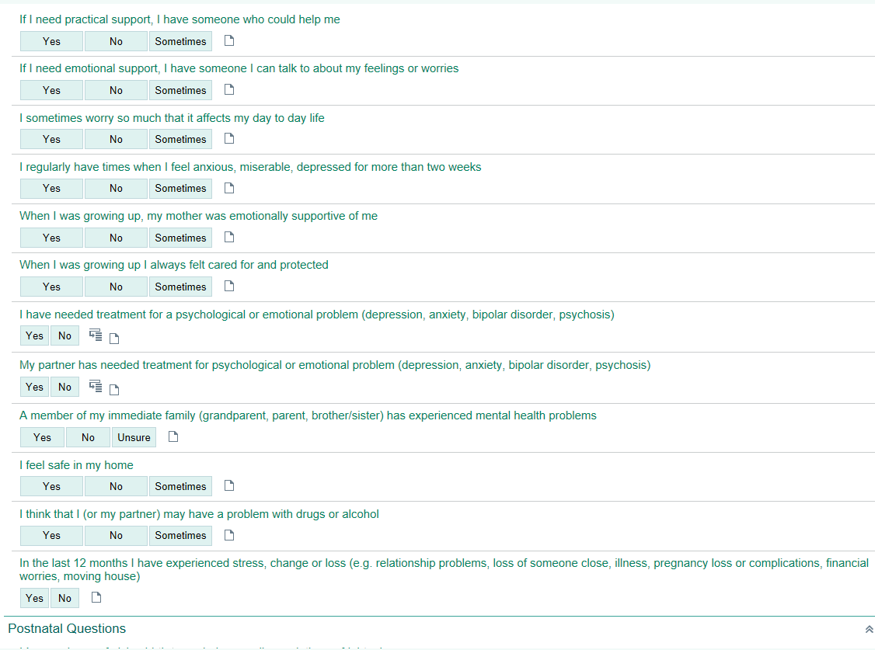

Attachment 2: Edinburgh Postnatal Depression Scale (EPDS) (Figure 3 and 4)
Figure 3: EPDS in Clinical Forms Register on HUB- (printed and have in clinic)
Sample

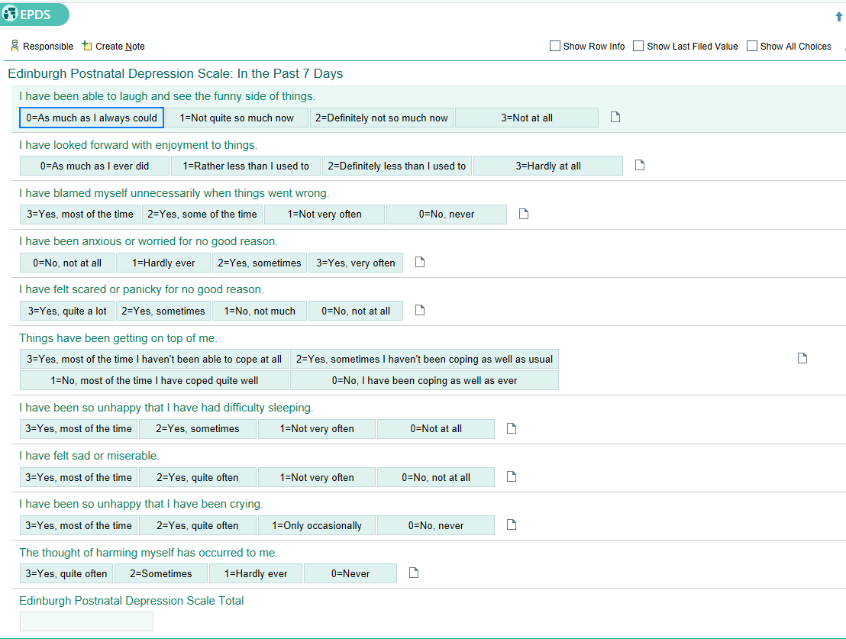
Figure 4: EPDS in Digital Health Record- (client can fill in desktop and scores are totalled)

Attachment 3 : PPSA Scoring Guide

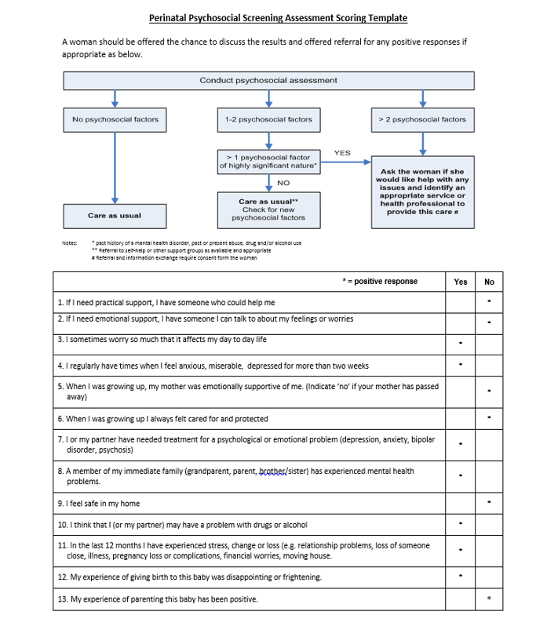

Attachment 4: EPDS Scoring Guide
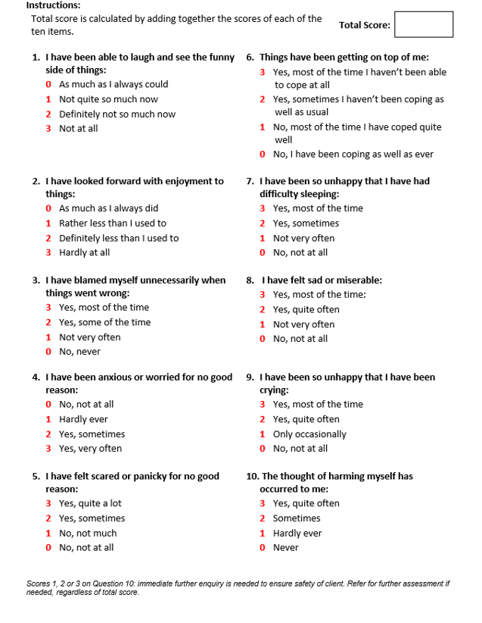

Attachment 5: Edinburgh Postnatal Depression Score Clinical Management Response Flowchart: Adapted from COPE 2024
See Resources- Section 9 for health promotion/wellbeing information to share with client
Call For When: to navigate mental health services 1300 242 322
- Provide health promotional information for wellbeing, groups and community supports

- Discuss any support the woman may require

- Engage with Midwifery and MACH Services

- Discuss score

- Provide usual care provided to all

- Likelihood of depression low

EPDS Score 10-12
EPDS Score 13-18
EPDS Score 19-30
EPDS Score 0 - 9
Usual Care- Provide to all women

Pro

- Discuss score
- Monitor and repeat EPDS in 2 weeks
- Provide usual care provided to all
- GP review
- Explore support systems/networks
- Identify any psychosocial factors (PPSA and EPDS)
- Consumer led self-help and parenting services/counselling
- Continue regular support/contact
- Possibility of depression
- As for score of 10-12
- Discuss case with clinical manager
- Using clinical judgement- refer to:
- Social worker
- Counsellor
- Perinatal Mental Health Consultation Service (PNMHCS)
- Psychology/Psychiatry (acute or private)
- Likelihood of depression high

- As for 13 +
- Consider safety of mother and infant
- Contact their nominated support person if alone at appointment
- Call the Access Mental Health 24 hrs, 7 days:
- ACT: 1800 629 354
- NSW:1800 011 511
- Lifeline 13 11 14
- Call 000 for immediate support
- Complete a Safety Plan with the client/support person- See Attachment 7

Score 1,2,or 3 on Question 10- “The thought of harming myself has occurred to me”
- These thoughts/feelings must be explored and assessed within the consultation
- Assess safety of client and infant- see Assessment of Suicide Risk and Risk of Harm- Attachment 6
- Care as for EPDS score of 19-30
- Call Access Mental Health, or 000 for immediate support, call nominated support person if alone at appointment
- Call clinical manager for support

For perinatal safety concerns for foetus/infant contact:
CYF 24hr mandated reporter line 1300 556 729

Attachment 6: Assessment of Suicide Risk and Risk of Harm to Self/others Flowsheet: Adapted from COPE 2024
If a mother scores on Question 10 of the EPDS an assessment of her suicide risk or harm to self and her infant is paramount before she leaves the service. If you have immediate concerns:1. call an ambulance and/or the police on 000 2. Call clinical manager for support.
ASK Questions about:
● Suicidal/harmful thoughts to self ● Plan ● Lethality ● Means ● Harm to infant

Fleeting thoughts of self-harm/suicide, no current plan or means, no harm to infant |  | Suicidal thoughts and intent but no current plan or immediate means, no harm to infant |  | Continual/specific suicidal thoughts, intent, plan and means, thoughts of harm to infant

Lower Risk  - Ensure safety of client and infant  - Discuss availability of support and treatment options- engage with GP  - Arrange follow-up consultation (timing of this will be based on clinical judgement)  - Identify relevant community resources and provide contact details  - Discuss with clinical manager |  | Medium Risk  - Ensure safety of client and infant  - Discuss availability of support and treatment options- engage with GP  - Organise re-assessment within one week  - Have contingency plan in place for rapid re-assessment if distress or symptoms escalate  - Develop a safety plan with the woman/support person (see attachment 7)  - Discuss with clinical manager |  | High Risk  - Ensure that the woman and infant is in an appropriately safe and secure environment with safe support person  - call AMHT 1800 629 354 or 000  - Organise re-assessment within 24 hours if appropriate (as may be in acute care setting)  - Follow-up outcome of assessment offering on-going support  - Discuss with clinical manager

Attachment 7: Safety Plan- Can be used with Assessment of Suicide Risk and Risk of Self/Others Harm and EPDS Management Flowsheets- Adapted from COPE 2024
SAFETY PLAN call 000 if immediate care needed
WARNING SIGNS:
What are some of the warning signs that you may be at risk of harming yourself (e.g feeling trapped, worthless, hopeless)
WARNING SIGNS YOU MAY FEEL/NOTICE:
- …………………………………………………………………………………………………..
- …………………………………………………………………………………………………..
- …………………………………………………………………………………………………..
PROTECTIVE ACTIONS YOU CAN DO:
- …………………………………………………………………………………………………..
- …………………………………………………………………………………………………..
- …………………………………………………………………………………………………..
COPING STRATEGIES:
What are some of the coping strategies that help you and decrease your level of risk?
- …………………………………………………………………………………………………..
- …………………………………………………………………………………………………..
- …………………………………………………………………………………………………..
SUPPORT NETWORK:
Who can you turn to, people that can assist you in times of need?
- ……………………………………………………………………………………………………
- ……………………………………………………………………………………………………
- ……………………………………………………………………………………………………
PROFESSIONAL HELP:
Which health professionals and agencies can be contacted for help?
- ……………………………………………………………………………………………………
- ……………………………………………………………………………………………………
- ……………………………………………………………………………………………………

Back to Contents

Attachment 8: Psychiatric Support at North Canberra Hospital Flowchart
Psychiatric Support at North Canberra Hospital
Obstetric team to undertake a full clinical assessment prior to seeking consultation with the psychiatric team.

NCH Mental Health Liaison Consultation (MHCL) Team:
Dr Lai-Ling Lee
Dr Carrie Flynn
2 X Psychiatry Registrars
Nurse Practitioner
RN 3 Clinicians
MHCL Contact Numbers:
MHCL Clinician – 8366 (DECT)
Office desk phone – 6264 7020 / 7023
MHCL Registrar – 8403 (DECT)
Inpatient referral on DHR via orders in ‘inpatient consult to NCH consultation liaison’ 706

Back to Contents

Consultant Psychiatrist
On call, available 24 hours
Contact through The Canberra Hospital switchboard
5124 0000
After hours care
Coordinated by Obstetric team by phoning psychiatric consultant at Canberra Hospital
Contact through The Canberra Hospital switchboard
5124 0000
Weekend Psychiatry Registrar
On duty for face-to-face assessments at NCH
Saturday 08:00 - 17:00
Sunday 08:00 - 17:00
Contact through switch ‘9’ or 6201 6111
Hours of operation for MHCL Team
Monday to Friday 07:00 - 21:30
Saturday 08:00 - 16:30
Sunday 08:00 - 16:30

