Guideline | Canberra Health Services

Low Dose Aspirin in Pregnancy
CHS24/549
Contents
Guideline Statement 2
Scope 2
Section 1 Risk factors for developing pre-eclampsia in pregnancy 3
Section 2 – Recommended Aspirin Use 4
Evaluation 5
Related policies, procedures, guidelines and legislation 6
References 6
Definition of Terms 7
Search Terms 7
Attachments 7
Attachment 1 Somanz Consumer Information Sheet: Use of aspirin in preventing preeclampsia 9

Guideline Statement
This document provides recommendations regarding the use of Aspirin as prophylaxis for preterm preeclampsia prevention. Clinicians should refer to The Society of Obstetric Medicine Australia and New Zealand (SOMANZ) 2023 Hypertension in Pregnancy Guideline for other recommendations. The complete guideline can be accessed at SOMANZ Hypertension in Pregnancy Guideline 2023 - Society of Obstetric Medicine Australian and NZ

Background
Preeclampsia is a syndrome characterised by the new onset of hypertension plus proteinuria, end organ dysfunction, or both after 20 weeks of gestation in a previously normotensive individual. It is a leading cause of maternal and neonatal morbidity and mortality. Women who develop preeclampsia have increased risks of stroke and cardiovascular disease and babies from a pre-eclamptic pregnancy have increased risks of preterm birth, neurodevelopmental challenges and perinatal death^{1,6}.
Low-dose aspirin has be shown to significantly reduce the frequency of preterm preeclampsia when commenced before 16 weeks of pregnancy ^{3,7}. The exact mechanism by which aspirin prevents preeclampsia remains unclear but is thought to have both anti-platelet and anti-inflammatory effects on placental development ^{2,3,6,7}. The ASPRE trial demonstrated that administration of aspirin, compared to placebo, resulted in a 62% reduction in the incidence of preterm-preeclampsia but had no significant effect on the incidence of term-preeclampsia⁷.

Key Objective
This document recommends:
- Use of a combined first trimester screen (maternal features, biomarkers, and sonography) to identify women at risk of developing preeclampsia.
- Where combined first trimester screen is not available, preeclampsia risk stratification should be based on maternal risk factors (maternal characteristics, medical and obstetric history)
- Women at high risk of developing preterm preeclampsia, should commence Aspirin prior to 16 weeks gestation, at a dose of 150 mg once per day.

Alerts
Contraindications to aspirin use include an allergy to aspirin or Non-Steroidal Anti-Inflammatory Drugs (NSAIDS) and aspirin sensitive asthma. Relative contraindications include a history of a previous gastrointestinal tract (GIT) bleed, severe hepatic dysfunction and peptic ulcer disease.
Back to Contents

Scope
This document applies to the following Canberra Health Services (CHS) Network inpatient facilities:
- Canberra Hospital
- Centenary Hospital for Women and Children (CHWC)
- North Canberra Hospital (NCH).
This document applies to the following CHS staff working within their scope of practice:
- Medical Officers
- Registered Nurses and Registered Midwives
- Students working under direct supervision
- Pharmacists.
Back to Contents

Section 1 Risk factors for developing pre-eclampsia in pregnancy
Given the ability to reduce a woman’s risk of developing preeclampsia, SOMANZ strongly recommends screening all pregnant women for their risk of developing preeclampsia early in their pregnancy to provide an opportunity for timely prophylactic intervention ^{2,3}.
The use of a combined first trimester screen (combined maternal risk factors, serum-based biomarkers, and sonography results) has been shown to improve accuracy in identifying women at risk of developing pre-term preeclampsia³.
Where combined first trimester risk screening is not available, risk stratification for developing pre-term preeclampsia should be completed based on maternal risk factors (maternal characteristics, medical and obstetric history) ³.
If a woman is <16 weeks pregnant, has not commenced prophylactic low dose aspirin and has risk factors for developing pre-term preeclampsia, input should be sought regarding commencement of prophylactic low dose aspirin.
If a woman has commenced prophylactic low dose aspirin before attending pre-admission booking appointment, and indications do not meet recommendations as per this guideline, input should be sought from senior midwifery or medical team member prior to discussing cessation of low dose aspirin with the woman.
Table 1 summarises clinical risk factors that help identify women at risk of developing preeclampsia. Where one or more ‘high-risk’ factors are present or two or more ‘moderate risk ‘factors are present in early pregnancy, consideration should be given to ways in which women’s risk of preeclampsia can be minimised.

Table 1 Clinical factors identified as high or moderate risk in identifying women at risk of developing preeclampsia
Factors identified as ‘High Risk’ for developing preeclampsia
One or more risk factors | Previous hypertensive disorder during prior pregnancy
One or more risk factors | Chronic kidney disease or kidney impairment
One or more risk factors | Multi-fetal gestation
One or more risk factors | Pre-existing chronic hypertension
One or more risk factors | Pre-existing Type 1 or Type 2 diabetes mellitus
One or more risk factors | Autoimmune disorders e.g., systemic lupus erythematous, anti-phospholipid syndrome
Factors identified as ‘Moderate Risk’ for developing preeclampsia
Two or more risk factors | Advanced maternal age (>40)
Two or more risk factors | Obesity (BMI ≥35)
Two or more risk factors | Nulliparity
Two or more risk factors | Family history of preeclampsia
Two or more risk factors | Interpregnancy interval of 10 or more years
Two or more risk factors | Assisted reproduction technologies
Two or more risk factors | Systolic blood pressure >130mmHg and/or diastolic blood pressure >80
Source: SOMANZ Hypertension in pregnancy guideline 2023.
Back to Contents

Section 2 – Recommended Aspirin Use
Canberra Health Services follows the recommendations, as below, for the use of low dose aspirin as a preventative strategy for preterm preeclampsia. Recommendations are per the SOMANZ 2023 Hypertension in Pregnancy Guidelines.
Recommendations for low dose aspirin prophylaxis to prevent pre-term preeclampsia
- Initiation of aspirin < 16 weeks gestation. Based on the evidence of benefit, trivial risk of harm and accessibility to treatment, initiation of aspirin at < 16 weeks gestation is strongly recommended in women at high risk of developing preeclampsia.
- 150mg once per day of Aspirin is recommended for all women who have one or more high risk factors for developing preeclampsia in pregnancy or who are deemed high risk for developing pre-term eclampsia on first trimester screening.
- 150mg once per day of Aspirin is recommended for all women with two or more moderate risk factors for developing preeclampsia or pre-term preeclampsia on combined risk screening.
  - 150mg of Aspirin was not associated with an increased risk of maternal or neonatal harm. Based on the evidence of benefit, low risk of harm and ability to achieve the desired dose, a preferred dose of 150mg of aspirin is strongly recommended3.
- Evening ingestion of aspirin is recommended. Evidence favours the use of bedtime aspirin in risk reduction for early-onset preeclampsia. Due to limited sample size, evening ingestion of aspirin is conditionally recommended at the time of this publication.
- Cessation of aspirin between 34 weeks gestation to birth. The overall evidence did not demonstrate a difference in the benefit or harm for the timing of aspirin cessation. Based on the absence of a difference in harm, the decision on the timing of ceasing aspirin between 34 weeks gestation and delivery should be individualised based on the women’s clinical history, risk of bleeding and through an informed, shared decision-making process with the women.
SOMANZ has developed a simple language consumer information sheet to explain aspirin prophylaxis for prevention of preterm preeclampsia (Attachment 1). This resource can be accessed using the following hyperlink Information-sheet-3A.1-Use-of-aspirin-in-pregnancy.pdf (somanz.org). It is also available in 7 multilingual resources.
Back to Contents

Evaluation

Outcome
- First trimester screening for preterm preeclampsia will be directed by the recommendations in this guideline.
- When combined first trimester screening is not available, risk stratification for preterm preeclampsia should be based on maternal risk factors.
- Recommendations for commencement, dosage and timing of low dose aspirin for pre-term preeclampsia prophylaxis, will be directed from this guideline.

Measures
- Monthly data collection required for AIHW and Stillbirth CRE reports will be reviewed to determine if any reportable parameters (missed fetal growth restriction/decreased fetal movements/fetal death) were related to not implementing care recommendations in this guideline (risk screening and low dose aspirin prophylaxis recommendations)
- Information from review will be presented at the maternity Quality and Safety meeting as required. If required, feedback to eternal stakeholders regarding commencement of low dose aspirin will be initiated through this meeting platform.
Back to Contents

Related policies, procedures, guidelines and legislation

Procedures
- Infection Prevention and Control Procedure
- Patient Identification and Procedure Matching

Guidelines
- Fasting Guidelines for Patients Undergoing Procedures Requiring Sedation or Anaesthesia
- Hypertension in Pregnancy
- Pregnancy Care Guidelines
- Consent for Healthcare Treatment

Legislation
- Health Records (Privacy and Access) Act 1997
- Human Rights Act 2004
- Work Health and Safety Act 2011
- Carers Recognition Act 2021

Other
- Australian Charter of Healthcare Rights
Back to Contents

References
- Australian Institute of Health and Welfare (AIHW). Australia's mothers and babies [Internet]. Canberra: Australian Institute of Health and Welfare, 2023. Available from: https://www.aihw.gov.au/reports/mothers-babies/australias-mothers-babies
- Society for Maternal-Fetal Medicine (SMFM). SMFM Patient Safety and Quality Committee. Society for Maternal-Fetal Medicine Special Statement: Prophylactic low-dose aspirin for preeclampsia prevention-quality metric and opportunities for quality improvement. Am J Obstet Gynecol. 2023 Aug;229(2): B2-B9. Available from Society for Maternal-Fetal Medicine Special Statement: Prophylactic low-dose aspirin for preeclampsia prevention-quality metric and opportunities for quality improvement - PubMed (nih.gov)
- Society of Obstetric Medicine Australia and New Zealand (SOMANZ). Hypertension in Pregnancy Guideline. Sydney. 2023. Available from: SOMANZ_Hypertension_in_Pregnancy_Guideline_2023.pdf
- National Institute for Healthcare and Excellence (NICE) Quality Standard QS35. Hypertension in Pregnancy. 2019. Quality Statement 2. Antenatal assessment of pre-eclampsia risk. Available from: Quality statement 2: Antenatal assessment of pre-eclampsia risk | Hypertension in pregnancy | Quality standards | NICE
- American College of Obstetricians and Gynaecologists (ACOG). Low-dose aspirin use during pregnancy. ACOG Committee Opinion No. 743. Obstet Gynecol 2018;132: e44-52. Available from: Low-Dose Aspirin Use During Pregnancy | ACOG
- Pittara T, Vyrides A, Lamnisos D, Giannakou K. Pre-eclampsia and long-term health outcomes for mother and infant: an umbrella review. BJOG 2021; 128: 1421–1430.
- Pre‐eclampsia and long‐term health outcomes for mother and infant: an umbrella review (wiley.com)
- Shen L, Martinez-Portilla RJ, Rolnik DL, Poon LC. ASPRE trial: risk factors for development of preterm pre-eclampsia despite aspirin prophylaxis. Ultrasound Obstet Gynecol. 2021 Oct;58(4):546-552. doi: 10.1002/uog.23668. Epub 2021 Sep 6. PMID: 33998099. ASPRE trial: risk factors for development of preterm pre-eclampsia despite aspirin prophylaxis - PubMed (nih.gov).

Back to Contents

Definition of Terms
Preeclampsia: A new-onset hypertension (systolic blood pressure ≥140 mmHg and/ or diastolic blood pressure ≥90 mmHg) after 20 weeks of gestation plus one other symptom of maternal organ dysfunction, this can include kidney, lung, brain, liver, or placental dysfunction.
Back to Contents

Search Terms
Preeclampsia, Pre-term preeclampsia, Hypertensive disorders of pregnancy, Aspirin, Aspirin in pregnancy.
Back to Contents

Attachments

Attachment 1 Somanz Consumer Information Sheet: Use of aspirin in preventing preeclampsia
Back to Contents

For Policy Team to complete:
Date amended | Section amended | Divisional approval | Final approval
14/11/2024 | New Document Added |  | CHS Policy Team
This document supersedes the following:
Document number | Document name
CHS21/196 | Low Dose Aspirin use in Pregnancy
Disclaimer
This document has been developed by Canberra Health Services specifically for its own use. Use of this document and any reliance on the information contained therein by any third party is at his or her own risk and Canberra Health Services assumes no responsibility whatsoever.
Back to Contents

Acknowledgement of Country  Canberra Health Services acknowledges the Ngunnawal people as traditional custodians of the ACT and recognises any other people or families with connection to the lands of the ACT and region. We acknowledge and respect their continuing culture and contribution to the life of this region.  © Australian Capital Territory, Canberra 2024 | Accessibility  call (02) 5124 0000   Interpreter call 131 450  canberrahealthservices.act.gov.au/accessibility  

Attachment 1 Somanz Consumer Information Sheet: Use of aspirin in preventing preeclampsia
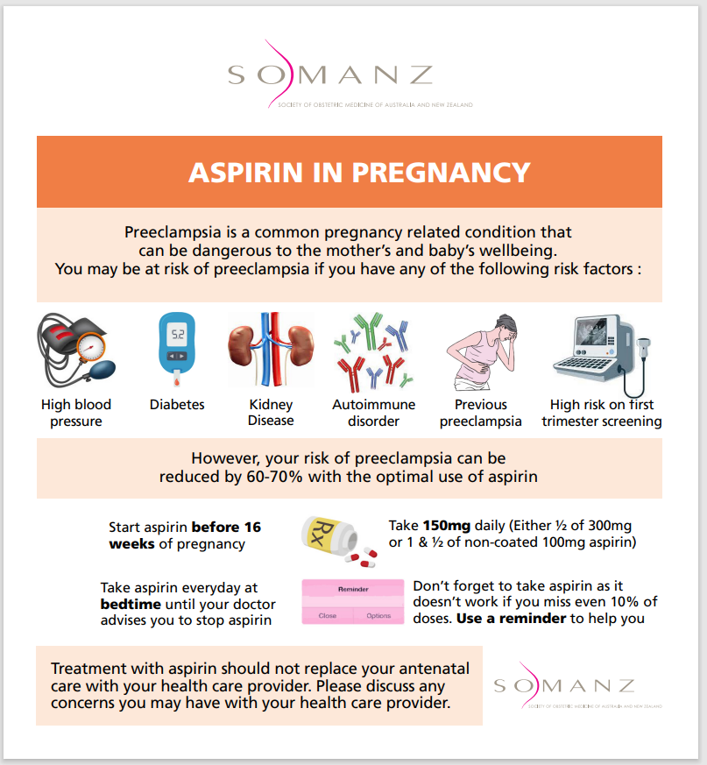

Back to Contents

