Canberra Health Services
Guideline
Care of the Extremely Preterm and Low Birth Weight Neonate

Contents

Contents 1
Guideline Statement 2
Scope 2
Section 1 – Extremely Preterm Early Management (ePREM) bundle 3
1.1 – Retrieval Team Preparation before Delivery 3
1.2 – Admission Team Preparation before Imminent Delivery 6
Section 2 – Care of ePREM and ELBW neonate 8
2.1 - Skin Care 9
2.2 – Thermoregulation (Humidification via Isolette) 10
2.3 – Developmental Care 11
Evaluation 11
Related Policies, Procedures, Guidelines and Legislation 12
References 13
Definition of Terms (if applicable) 14
Search Terms 15
Attachments 15
Attachment 1: Neonatal Resuscitation Checklist 16
Attachment 2: ePREM Flow Chart – Extremely preterm early management Flow Chart 18
Attachment 3: Compliance Checklist for ePREM Flow Chart 20
Attachment 4 : Checklist for ePREM Babies <28 Weeks 22
Attachment 5: How to Set-up Humidification of Neopuff Circuit 23

Guideline Statement

Background
Extremely or low birth weight or preterm neonates -those born before 28 weeks or <1 kg have higher risk of mortality as well as morbidity compared to those born late preterm or at term. The first few hours of life is a critical period of transition requiring multiple adaptations to extrauterine life for which an extremely preterm neonate is ill prepared. The care these vulnerable group of preterm babies receive in this transitional period, therefore has a significant impact on immediate survival and both short and long-term morbidities. In 2016, the Department of Neonatology at Canberra Health Services developed a systematic, evidence based, standardized, scripted, team-based approach to care of the neonate in the critical first hours of life (golden hour and extremely preterm early management ePREM bundle).

Key Objective
The purpose of this document is to outline a care bundle for the admission and ongoing management of extremely preterm (ePREM) neonates born <28 weeks gestational age and extremely low birth weight (ELBW) neonates, born < 1000 grams. The key objective of this guideline is to ensure compliance with the requirements of the care bundle and provide consistency of practice in relation to:
- Extremely Preterm Early Management (ePREM) bundle – Pre-birth Preparation
- Resuscitation at birth and Thermoregulation
- Skin Care and Humidification
- Ongoing care of the Extremely Preterm and Low Birth Weight (LBW) neonate

Back to Table of Contents

Scope

This document pertains to the admission and care of extremely preterm and/or ELBW neonates as described above.

This document is applicable to clinicians who are working within their scope of practice, including:
- Medical Officers
- Registered Nurses (RN) and Registered Midwives (RM)
- Students under direct supervision.

Back to Table of Contents

Section 1 – Extremely Preterm Early Management (ePREM) bundle

Introduction
The components of ePREM bundle include:
- Team preparation: antenatal counselling, interdepartmental and team communication, team briefing
- Delayed cord clamping
- Thermoregulation
- Strategies to establish functional residual capacity (FRC) and gentle ventilation
- Early administration of antibiotics, Total Parenteral Nutrition (TPN) and caffeine
- Early introduction of mothers own expressed breast milk( EBM)
- Prevention of infection through Central Line Associated Blood Stream Infection (CLABSI) bundle
- Developmental Care
- Partnering with Parents

An extremely preterm neonate needs several interventions in the first few minutes to hours of life. We standardised our equipment setup and approach to these intervention via development of resuscitation checklist and ePREM flowchart. The checklist and flow chart ensured that the most appropriately skilled team were present and prepared for resuscitation as well as communicated effectively during resuscitation

1.1 – Retrieval Team Preparation before Delivery

Equipment
- Personal Protective Equipment
- Neonatal Resuscitation Checklist (See Attachment 1)
- ePREM Flow Chart (See Attachment 2)
- Compliance Checklist for ePrem pack (See Attachment 3)
- Small Baby Pack (See Attachment 4 - Checklist for ePrem Babies <28 Weeks )
- Surfactant – Curosurf
- Surfactant Pack (See Attachment 4)
- Ohmeda Giraffe Isolette attached to Shuttle Transport Cot
- Temperature Probe
- Warmed Nest
- Portable Phillips Monitor with Electrocardiogram (ECG) and Oxygen Saturation Leads
- Shuttle Transport Cot fully stocked, charged, and assembled
- Full Oxygen and Air Cylinders
- Baby Pac Ventilator and tubing
- Fisher and Paykel (F&P) Continuous Positive Airway Pressure (CPAP) Circuit
- CPAP bag with equipment (CPAP strapping, 500ml sterile water for irrigation bottle)
- 1000ml Water for Injection (WFI) IV bag
- 2 x F&P Humidifier Bases (one on each side) with yellow grey wires
- Neopuff with attached F&P Neopuff humidifier circuit (connected to one humidifier base)
- 30ml WFI bottle
- Emergency Resuscitation Bag with Resuscitation Equipment
- Panda Resuscitaire (Operation Theatre) or Delivery Suite/Centre Resuscitaire
- Optional: Mefix tape

Procedure
- It is important that the Obstetric Team communicates relevant history and details of impending delivery to the Neonatology Team in a timely manner.
Alert:
Registrar is to request the delay of the caesarean section if a neonatologist is not yet present and if it is safe to do so.

- Ensure the Neonatologist, Neonatology Fellow, Neonatal Intensive Care Unit (NICU) Team Leader (TL) and Retrieval/Access Nurse are informed of the pending delivery. Neonatology Team to be guided by ePREM flow chart (Attachment 2)

- Team Briefing lead by the Neonatologist or Fellow (ePREM Leader) as per Neonatal Resuscitation checklist (Attachment 1)
  - All members of the team are to introduce themselves
  - Discuss the plan, communication, expectations and assign roles to team members
  - Discuss any special considerations
  - Ask for additional personnel or equipment, if required
  - Use closed communication by confirming any orders from the ePREM leader
- Retrieval Nurse and Medical Team to prepare retrieval equipment
  - Warm Curosurf in the isolette
  - Prepare Shuttle Transport Cot
  - Prepare CPAP circuit/Baby Pac Ventilator on Shuttle Transport Cot
  - Attach CPAP prongs to the CPAP circuit and leave in place
  - Retrieve Small Baby Pack and Surfactant Pack (Attachment 4)
  - Obtain Compliance Check list for ePREM Flow Chart (Attachment 3)
- Retrieval Nurse or Medical Officer to transfer or organise transfer of Shuttle Transport Cot to Delivery Suite or Operation Theatre (OT)
- Retrieval Team (RT) to don personal protective equipment( PPE) and go to delivery room to prepare resuscitaire
- RT to check temperature in birthing suite/ operating room is set to 25°C
- Check all equipment on the resuscitaire
- To gather and prepare intubation equipment:
  - Laryngoscopes
  - Endotracheal tubes
  - Mask
  - Pedicap
  - Introducer
- If directed by Neonatologist or Neonatal Fellow, gather and prepare Curosurf and surfactant administration equipment. See Surfactant Therapy for Newborn.
- Switch heating on Resuscitaire to MANUAL and increase to 100% output
- Place polyethylene wrap on top of warmed blankets onto resuscitaire with radiant warmer until ready to use.
  - Radiant heater should remain on but do not allow polyethylene to overheat.
Note:
Do not use conventional plastic wrap as this will melt under the radiant heater

- Use the pre-activated trans-warmer mattress only if there has been insufficient time to warm the birthing room/theatre or resuscitaire or to set up the humidified Neopuff system
- Ensure cardiorespiratory monitor and pulse oximeter are ready for use
- Ensure emergency drugs- adrenaline, normal saline and syringes are available & calculate approximate dose
- Ensure equipment for emergency Umbilical Vein Catheter (UVC) insertion is available.
Note:
Resuscitate neonate as per Neonatal Resuscitation and Airway Management Guideline.

In Delivery Suite:
- Delay cord clamping for 1 minute if possible. Keep neonate securely wrapped and stimulate the neonate until the cord is cut
- Once the cord is cut, receive neonate in warm blankets with polyethylene wrap on top.
  - Immediately wrap the neonate’s entire body in polyethylene wrap, excluding the head and umbilical cord. Do not dry the neonate
  - Transfer the polyethylene wrapped neonate with warmed blankets to resuscitaire as soon as possible
  - Dry the neonate’s head and cover with a beanie or CPAP hat
- Proceed with resuscitation as required
- Retrieval Nurse to apply ECG and Saturation Monitoring to ensure accurate monitoring of the neonate’s heart rate during resuscitation
- Take neonate’s axillary temperature at 10 minutes of age.
- If temperature <36.5⁰C
    - Activate and place the neonate on a trans-warmer mattress (if not already used) wrapped in a dry towel
    - If a trans-warmer mattress is already in place, cover the polyethylene wrapped neonate in new warmed blankets
    - Increase isolette temperature by 0.5⁰C
- If temperature > 37.5⁰C
- Remove pre-activated trans-warmer mattress (if used) before placing neonate into the isolette.
- Reduce isolette temperature by 0.5⁰
- Retrieval Nurse to liaise with Neonatal Intensive Care Unit (NICU) Team Leader (TL) when leaving delivery room. Important information to discuss:
- Estimated Time of Arrival
- Admitting NICU bed space
- Type of respiratory support and corresponding parameters
- Any additional resuscitation requirements
- Prior to leaving delivery room, encourage mother to express Colostrum as soon as able.

In Operating Theatres (OT):
- If neonate is born by caesarean section, the scrubbed nurse/midwife will receive the neonate with a sterile receiver wrap and transfer to resuscitaire following delayed cord clamping
- RT to immediately wrap the neonate’s entire body in polyethylene wrap, excluding the head and umbilical cord. Do not dry the neonate
- Dry the neonate’s head and cover it with a beanie/CPAP hat
- Proceed with resuscitation as required
- Retrieval Nurse to apply ECG and Saturation Monitoring to ensure accurate monitoring of the neonate’s heart rate during resuscitation
- Take neonate’s axillary temperature at 10 minutes of age.
- If temperature <36.5⁰C
    - Activate and place the neonate on a trans-warmer mattress (if not already used) wrapped in a dry towel
    - If a trans-warmer mattress is already in place, cover the polyethylene wrapped neonate in new warmed blankets
    - Increase isolette temperature by 0.5⁰C
- If temperature > 37.5⁰C
- Remove pre-activated trans-warmer mattress (if used) before placing neonate into the isolette.
- Reduce isolette temperature by a 0.5⁰
- Prior to leaving OT retrieve all accountable items from resuscitaire, e.g., grey wire and laryngoscope blades.
- Retrieval Nurse to liaise with NICU TL when leaving OT room. Important information to discuss:
- Estimated Time of Arrival
- Admitting NICU bed space
- Type of respiratory support and corresponding parameters
- Any additional resuscitation requirements
- Prior to leaving OT, encourage mother to express Colostrum as soon as able

1.2 – Admission Team Preparation before Imminent Delivery

Equipment
- Personal Protective Equipment (PPE)
- Alcohol Based Hand Rub
- Admission Bed Set-up
- Neopuff, Wall Suction, Suction Catheters
- 500ml Dextrose 10% Intravenous (IV) Bag
- Starter Preterm Total Parenteral Nutrition (TPN)
- Lipid Emulsion with Vitamins
- IV Antibiotics (Penicillin and Gentamycin)
- Caffeine Citrate IV Medication
- Umbilical Central Line Equipment (UVC/UAC Trolley)
- IV trolley
- Central Line Bundling Equipment
- 500ml Water for Irrigation Bottle – Isolette Humidification
- Large Abdomen Sponge
- Optional: Fully calibrated Leoni Ventilator, Resuscitation Trolley, and equipment as per Retrieval Team requests

Procedure
- Admitting nurse and NICU TL to be guided by ePREM Flow Chart (Attachment 2)
- Admitting nurse to prepare admission space and to gather equipment
- Admitting nurse and/or spare staff member(s) (NICU TL) to prepare IV therapy and IV medications.
- 500ml Dextrose 10% Intravenous (IV) Bag can be prepared via clean procedure or can be done with Aseptic Technique.
- Starter Preterm TPN, Lipids with Vitamins, IV Antibiotics, and Caffeine via Central Line Bundling and Aseptic Technique Procedure. Refer to Venous and Arterial Access and Management Policy and Neonatal Intensive Care Drug Manual.
- Admitting Nurse to set up for sterile umbilical line insertion procedure
- NICU TL or Admitting Nurse to organise patient identification stickers
- NICU TL to liaise with Retrieval Nurse before RT leaving delivery/Operating Theatre OT room. Important information to discuss:
- Estimated Time of Arrival
- Admitting NICU bed space
- Type of respiratory support and corresponding parameters
- Any additional resuscitation requirements

On arrival to the NICU:
- Move neonate into bed space
- If neonate on respiratory support e.g., CPAP or continuous mandatory ventilation (CMV) then transfer patient to prepared bed space respiratory equipment
Alert:
- Do not remove polyethylene wrap on neonate until isolette humidity is commenced
- If commencing patient on Non Invasive Ventilation Neurally adjusted ventilatory assist (NIV NAVA), it is recommended that for patients <1000g, the 6F 49cm Electrical activity of the Diaphragm (EDI) Catheter be used

- Once equipment attached and patient stable, detach Shuttle Transport Cot from isolette and remove from room
- Weigh neonate in isolette, if possible
- Check and record the neonate’s axillary temperature on admission and document
- Follow thermoregulation procedure as per Neonatal Routine Care guideline
- Neonatologist or Neonatal Fellow to insert intravenous cannula and umbilical venous and arterial lines. Refer to Venous and Arterial Access and Management in the Department of Neonatology and Total Parenteral Nutrition in Neonates
- ChloraprepTM is used as a cleaning solution for any sterile procedure
- Once umbilical lines secured and position confirmed via mobile abdominal X-ray, Standard Preterm TPN, Lipids with Vitamins, IV Antibiotics, and IV Caffeine attached aseptically by Neonatologist/Neonatal Fellow
- Admitting Nurse to commence IV fluids as per medical order
- Add sterile water into humidification reservoir of isolette and set humidity on isolette to 85%
- Polyethylene wrap may be removed
- If needed, replace soiled linen with pre-warmed nest.
- Settle neonate and minimally handle the neonate
- Refer to Developmental Care in the Neonatal Intensive Care Unit and Special Care Nursery
- Inform parents of neonate’s progress and re-emphasise the need for early expressed breastmilk (EBM)
- Commence trophic feeds of EBM 1ml every 4 hours as soon as EBM is available or use first EBM for mouth care
- Complete ePREM Compliance Checklist for ePREM Flow Chart. See Attachment 3
- Determine ongoing respiratory requirements and attend to admission observations as per Neonatal Routine Care guideline
- Complete admission paperwork
Alert:
Intravenous Cannula should be attempted prior to umbilical line administration to administer 10% Dextrose IV, IV antibiotics, and IV Caffeine.

Back to Table of Contents

Section 2 – Care of ePREM and ELBW neonate

Extremely premature and low birth weight neonates are at risk of a multitude of pathological issues caused by their overall immaturity and fragility. The care of an extremely preterm and low birth weight neonate is multifactorial and requires vigilant, multidisciplinary, and developmentally appropriate medical and nursing care. Although the clinical care of an ePREM and ELBW is paramount, it’s important to also consider skin care, thermoregulation, and developmental care when attending to procedures.

2.1 - Skin Care
The skin is the largest organ of the body, functioning as a protective and regulatory barrier between the body and external environment. The skin of the ELBW neonate is fragile and transparent due to the thin non- existent stratum corneum. This subsequently increases trans-epidermal water loss (TEWL) causing fluid and electrolyte imbalances, ineffective thermoregulation, increased permeability, and absorption of creams and/or cleaning agents and greater risk of epidermal stripping when using adhesives. These factors lead to an increased risk of infection and delayed healing. The ELBW neonate may not have fully mature skin until 30-32 weeks postconceptional age.

Alert:
The heat from Transcutaneous monitors (TCMs) can burn and TCM adhesive rings can cause epidermal stripping when removed. TCM temperature set to 41⁰C, re-site sensor 2-3 hourly, and observe for erythema or pressure area.

Equipment
- Soft cushioned patient identification bands
- Small chest leads < 1kg
- Mefix ®
- Oxygen Saturation Probe <1kg
- Small saturation wrap
- Cotton wool ball
- Epaderm Cream®
- Cavilon Durable Barrier Cream®
- Cavilon Barrier Wipes
- Niltac Adhesive Remover
- Warm bedding: Nest lined with abdominal sponge
- Sterile water for injection 10mL ampoule
- Chlorhexidine 0.2%
- Tegaderm dressing
- Duoderm dressing
- Optional: 1cm brown tape or 1 inch steri strips

Procedure

Hygiene (Cares)
Note:
- Refer to Neonatal Routine Care guideline on how to attend to neonates’ cares
- Refer to Developmental Care in the Neonatal Intensive Care Unit and Special Care Nursery for skin care
- Use cotton ball soaked with sterile water for injection when cleaning eyes and face
- Use Epaderm Cream when cleaning neonate’s bottom and apply Cavilon Durable Barrier Cream to protect skin
- Only use smooth linen sheets for top of nests to prevent skin abrasions and pressure areas
- To maintain skin integrity, prevent epidermal stripping and infection use a Duoderm as a base between skin and tape when securing feeding tubes and nasal prongs

Monitoring
- Use the soft cushioned patient identification (ID) bands to label patient or alternatively:
- ID band can be attached to isolette or placed on secured intravenous lines or gastric feeding tube.
- Use small chest leads <1kg to monitor the neonate’s cardiorespiratory vital signs.
- Do not use conventional chest leads as it may cause skin damage or tears
- Apply Mefix® on to neonate’s feet or wrists before applying the oxygen saturation probe or alternatively:
- Lightly press a cotton wool ball against the adhesive parts of the oxygen saturation probe and then attach to the neonate’s foot with a small saturation wrap
- All adhesive tape for cannulas should have cotton wool pressed against it prior to applying to the neonate’s skin to reduce the incidence of skin tears
- Avoid the use of adhesives on the ELBW neonate.
- Do not apply a urine bag to collect urine for testing, place cotton wool balls in the nappy

Securing Umbilical catheters
- Prepare the skin prior to application of Tegaderm and Duoderm by applying Cavilon Barrier Wipes
- Apply Tegaderm® or Duoderm to the abdomen around the umbilicus and use this as a base to secure the catheters using the goal post strapping as outlined in the Venous and Arterial Access and Management in the Department of Neonatology
- Tegaderm/Duoderm should be left in place when lines are removed until the neonate is out of humidity
- When removing Tegaderm/Duoderm make sure to apply developmental care principles to minimise painful stimuli. and to use Niltac Adhesive Remover for ease of removal and prevent skin damage

2.2 – Thermoregulation (Humidification via Isolette)
Provision of a high humidity environment limits trans epidermal water loss, improves temperature control and reduces the risk of fluid and electrolyte imbalance.

Equipment
- Ohmeda Giraffe isolette
- Humidity reservoir
- 500ml sterile Water for Irrigation bottle

Procedure
- Ensure humidity reservoir is correctly inserted
- To fill the reservoir, grasp it and push down. The reservoir will tilt open for filling
- Fill to the line on the heater cylinder with sterile water for irrigation and tilt the reservoir back into place
- Do not fill the reservoir past the fill level as this will decrease the level of humidification within the isolette
- Use the LED Humidifier Screen on the graphics display of the isolette to set the desired humidity level
- Commence humidity at 85% from admission for ePREM and ELBW neonates.
- Reduce humidity by 5% daily from Day 7 to 14 as epidermal maturation occurs.
- Humidity is continually weaned until the humidity level reaches 40% when it is then turned off.
- This may take 7-10 days from the commencement of weaning.
- The reduction of humidity may alter the neonate’s thermoregulation
- Therefore, increase cot temperature as needed to maintain neonate’s temperature between 36.5 and 37.5 degrees
- Isolette must be changed weekly, to reduce the potential risk of colonisation of the reservoir water
- Clean all skin creases, neck, ears and underarms every 6-8 hourly or as required.
- Neonate should be nursed on abdominal sponge between skin and bed to absorb any excess moisture.
- Linen should be changed with cares, 6 – 8hrly as it becomes damp
- Ensure that condensation in the isolette does not impair accurate observation of the neonate
Alert:
All neonates born <1250g must be weighed daily for the first 7 postnatal days or until birth weight has been regained or for a longer period as directed by the Neonatologist

2.3 – Developmental Care
Developmental care is an important aspect of the care of a preterm neonate. Information on how to incorporate developmental care in practice, refer to the Developmental Care in the Neonatal Intensive Care Unit and Special Care Nursery.

Back to Table of Contents

Evaluation

Outcomes
- The procedures and protocols highlighted in this document are easily accessible to staff working in NICU and SCN
- The document will assist staff in providing quality and safe care to their patients in NICU and SCN
- This policy will assist in the education and training to clinical staff.

Measures
- All ePREM admissions will be reviewed at 3 monthly ePREM meetings with attention to efficiency, timing and difficulties with process.
- Audit of reported incidences via risk management system (Riskman) related to neonatal respiratory support, physiotherapy, and neonatal lung function assessments.
- Review of case reports via clinical meetings that evaluate patient outcomes and quality and safety.
- Compliance with this guideline will be monitored and communicated by inclusion in relevant clinical area orientation (new staff), relevant health professional level 3 (HP3 staff) providing individual feedback to rotating and weekend staff regarding compliance, and inclusion of this guideline in weekend staff update sessions
Back to Table of Contents

Related Policies, Procedures, Guidelines and Legislation

Policies
- Nursing and Midwifery Continuing Competence Policy
- Informed Consent – Clinical Policy
- Medication Handling Policy

Procedures
- Patient identification and Procedure Matching Procedure
- Infection Prevention and Control – Healthcare Associated Infections Procedure
- Non-Elective Caesarean Section (including classification of urgency)
- Venous and Arterial Access and Management in Neonatal Intensive Care
- Neonatal Routine Care
- Urine Collection in Neonates procedure
- Venepuncture Blood Specimen Collection procedure

Guidelines
- Neonatal Resuscitation and Airway Management Guideline
- Birth Requiring the Presence of a Neonatal Medical Team Member
- Neonatal Hypoglycaemia
- Neonatal Intensive Care Drug Manual
- Developmental Care in the Neonatal Intensive Care Unit and Special Care Nursery
- Preterm Labour
- Preterm birth screening and prevention
- Respiratory Support – Invasive and Non-Invasive (Neonates and Infants)
- Neonatal Emergency Transport Service, Australian Capital Territory (Nets Act) – Back-Transfer, Elective Retrievals, Retrievals & Paediatric Stabilisations

Legislation
- Health Records (Privacy and Access) Act 1997
- Work Health and Safety Act 2011
- Human Rights Act 2004

Other
- Australian Charter of Health Care Rights

Back to Table of Contents

References

- Knoble, R. & Holditch –Davis, D. (2007) Thermoregulation and heat loss prevention after birth and during neonatal intensive care unit stabilization of extremely low birth weight babys. Journal of Obstetric, Gynaecologic and Neonatal Nursing, 36 (3) 280 - 287.
- Allwood, M.(2011) Skin Care Guidelines for Babys Aged 23-30 Weeks' Gestation: A Review of the Literature. Neonatal, Paediatric & Child Health Nursing, 14 (1) 20-27
- Bredemeyer, S. Reid, S. & Wallace, M. (2005) Thermal management for premature births Journal of Advanced Nursing 52(5) 482-489
- Telofski, L.S. Morello, P. Mak-Correa,C and Stamata, G.N (2011) The Baby Skin Barrier: CanWe Preserve, Protect, and Enhance the Barrier? Journal of Perinatology 31, S49–S56;
- A Singh, J Duckett, T Newton1 and M Watkinson, Improving neonatal unit admission temperatures in preterm babies: exothermic mattresses, polythene bags or a traditional approach? Journal of Perinatology (2010) 30, 45–49;
- Neonatal Resusitation: Specific Treatment Recommendations (ILCOR 2015)
- Robin B Knobel RNC, MSN, NNP, John E Wimmer Jr MD and Don Holbert PhD, Heat Loss Prevention for Preterm Babys in the Delivery Room, Journal of Perinatology (2005) 25, 304–308
- Sunita Vohra, MD, MSc, Robin S. Roberts, MSc, Bo Zhang, MPH, Marianne Janes, MHSc, Barbara Schmidt, MD, MSc: Heat Loss Prevention (HeLP) in the delivery room: A randomized controlled trial of polyethylene occlusive skin wrapping in very preterm babys, The Journal of Pediatrics, Volume 145, Issue 6, December 2004, Pages 750–753
- Williams, J. (2004). An investigation into the effect of a polyethylene wrap on the temperature regulation of the very low birth weight and premature baby during transfer to the neonatal intensive care unit: a systematic review. Health Care Reports, 2:(3): 53-78.
- Ashmeade, T. L., Haubner, L., Collins, S., Miladinovic, B., & Fugate, K. (2016). Outcomes of a neonatal golden hour implementation project. American Journal of Medical Quality, 31(1), 73-80.
- Australian Resuscitation Council. (2016, January 1). Guidelines - Australian Resuscitation Council. Retrieved March 15 2017
- Chawla, S., Amaram, A., Gopal, S., & Natarajan, G. (2011). Safety and efficacy of Trans-warmer mattress for preterm neonates: results of a randomized controlled trial. Journal of Perinatology, 31(12), 780-788.
- Doctor, T. N., Foster, J. P., Stewart, A., Tan, K., Todd, D. A., & McGrory, L. (2017). Heated and humidified inspired gas through heated humidifiers in comparison to non-heated and non-humidified gas in hospitalised neonates receiving respiratory support. Cochrane Library.
- Gardner, S. L., & Hernandez, J. A. (2016). Initial nursery care. In S. L. Gardner, B. S. Carter, M. Enzman Hines, & J. A. Hernandez, Merenstein & Gardner's Handbook of neonatal intensive care (8th ed., pp. 71-80). St Louis: Elsevier.
- Kai-Hsiang, H., Ming-Chou, C., Shu-Wen, L., Jainn-Jim, L., Yu-Cheng, W., & Reyin, L. (2015). Thermal blanket to improve thermoregulation in preterm infants: A randomized controlled trial. Pediatric Critical Care Medicine, 16(7), 637-643.
- Kalia, Y.N., Nonato, L.B., Lund, C.H. & Guy, R.H. (1998). Development of skin barrier function in premature infants. Journal of Investigative Dermatology, 111, 320-326.
- Kevat, A. C., Bullen, D. V., Davis, P. G., Omar, C., & Kamlin, F. (2017). A systematic
review of novel technology for monitoring infant and newbornheart rate. ACTA PAEDIATRICA: Nurturing the Child, 106(5), 710-720.
- Lambeth, T. M., Rojas, M. A., Holmes, A. P., & Dail, R. B. (2016). First golden hour of life. Clinical Issues in Neonatal Care, 16(4), 264-272.
- Niermeyer, S., Clarke, S. B., & Hernandez, J. A. (2016). Delivery room care. In S. L. Gardner, B. S. Carter, M. Enzman Hines, & J. A. Hernandez, Merenstein & Gardner's handbook of neonatal intensive care (pp. 47-70). St Louis: Elsevier.
- Omar, C., Kamlin, F., Dawson, J. A., O'Donnell, C. P., Morley, C. J., Donath, S. M., & Sekhon, J. (2008). Accuracy of pulse oximetry measurement of hearth rate of newborn infants in the delivery room. The Journal of Pediatrics, 152(6), 756-769.
- Reynolds, R. D., Pilcher, J., Ring, A., Johnson, R., & McKinley, P. (2009). The golden hour: Care of the LBW infant during the first hour of life one unit's experience . Neonatal Network, 28(4), 211-219.
- van Vonderen, J. J., Hooper, S. B., Kroese, J. K., Roest, A. A., Narayen, I. C., van Zwet, E. W., & te Pas, A. B. (2015). Pulse Oximetry Measures a Lower Heart Rate at Birth Compared with Electrocardiography. The Houral of Pediatrics, 166(1), 49-53.

Back to Table of Contents

Definition of Terms (if applicable)

ABG: Arterial blood gas
CPAP: Continuous Positive Airway Pressure
CRP: C-reactive protein
CXR: Chest X-ray
FBC: Full blood count
Hydrogel products: Gel formed dressing
INSURE: Intubation, surfactant, resuscitation, extubation
Ohmeda Giraffe Incubator: An apparatus used to maintain environmental conditions suitable for a neonate
Stratum corneum: the outer part of the epidermis consisting chiefly of layers of dead flattened nonnucleated cells filled with keratin
ETT- Endotracheal Tube

Back to Table of Contents

Search Terms

Less than 28 weeks gestation, Premature neonate, Premature, Preterm, Extremely low birth weight neonate, ELBW, ePREM, Less than 1000grams, Neonatal Intensive Care, Retrieval, extremely preterm neonate, Golden Hours, ePrem Bundle, Care of the extremely preterm neonate and low birth weight neonate, neonatal, NICU, Neonatal Intensive Care Unit, Prematurity, isolette humidification

Back to Table of Contents

Attachments

Attachment 1: Neonatal Resuscitation Checklist
Attachment 2: ePREM Flow Chart – Extremely preterm early management Flow Chart
Attachment 3: Compliance Checklist for ePREM Flow Chart
Attachment 4 : Checklist for ePREM Babies <28 Weeks
Attachment 5: How to Set-up Humidification of Neopuff Circuit

Back to Table of Contents

Disclaimer: This document has been developed by Canberra Health Services specifically for its own use. Use of this document and any reliance on the information contained therein by any third party is at his or her own risk and Canberra Health Services assumes no responsibility whatsoever.

Policy Team ONLY to complete the following:
Date Amended | Section Amended | Divisional Approval | Final Approval
30 November 2021 | Complete Review | Boon Lim, ED-WY&C | CHS Policy Committee

This document supersedes the following:
Document Number | Document Name
CHHS18/083 | Care of the Extremely Preterm and Low Birth Weight Baby – The Golden Hour

Attachment 1: Neonatal Resuscitation Checklist
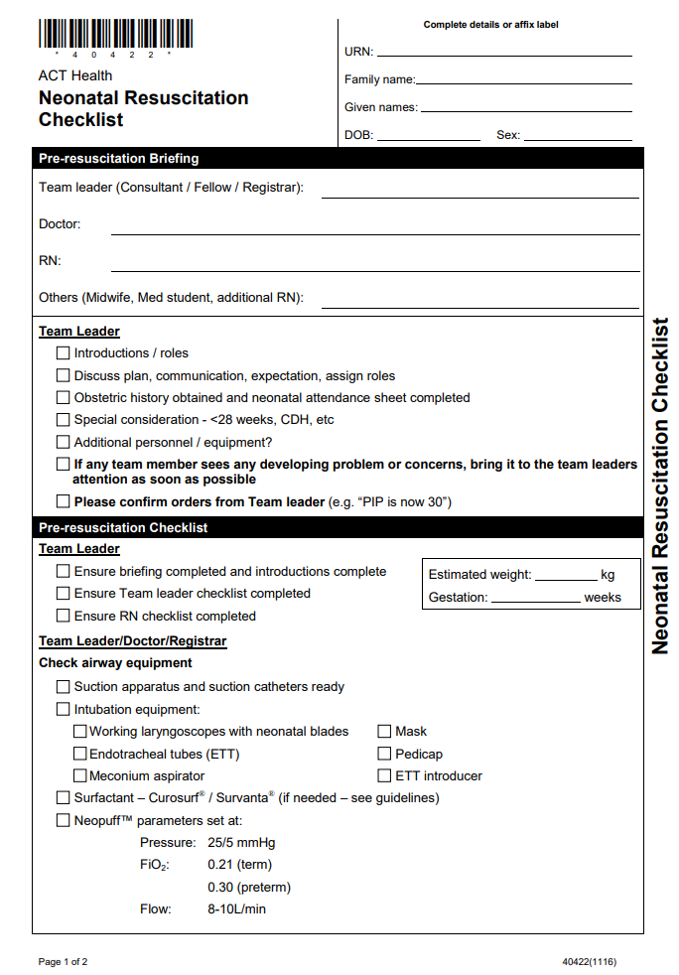
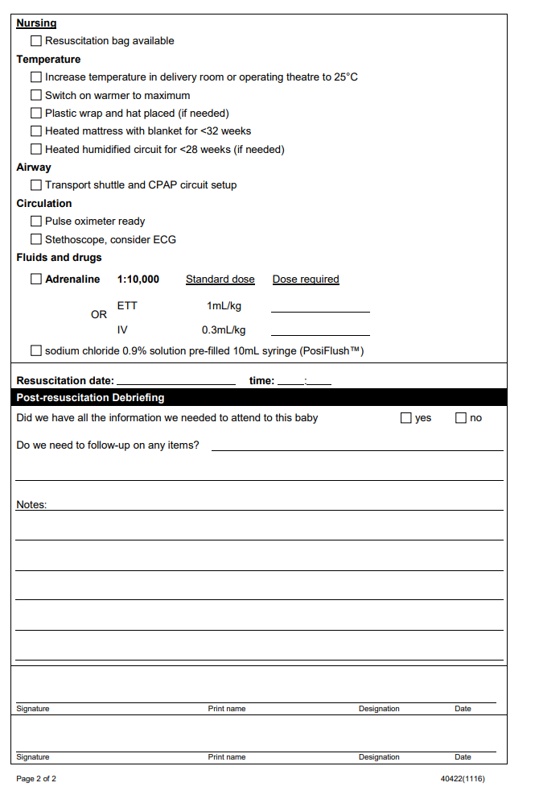

Attachment 2: ePREM Flow Chart – Extremely preterm early management Flow Chart
- The first 72 hours for neonates <28 weeks of gestation and/or ELBW <1000g
- Resuscitation team staff members, duties as below as per colour coding:
- Retrieval nurse (nurse attending delivery)
- Admission Nurse/Team Leader
- Junior doctor attending the delivery
- Consultant attending the delivery

Preparation
- Inform consultant of impending delivery, set Neopuff 25/5 in 30% oxygen, Flow 10L/minute. Request that the caesarean be delayed if the consultant is not yet present and it is reasonable to do so.
- Travel to hospital (if after hours)
- Warm curosurf in isolette and leave this vial of Curosurf in the isolette. Fill the humidifier base of CPAP circuit on transport shuttle with 30 mL of sterile water and switch on. Attach CPAP prongs (smallest size) to the CPAP circuit and leave in place. Prepare and take transport shuttle.
- Switch heating to manual and increase to 100% output on resuscitaire, prepare plastic wrap, hat and heated mattress. Prepare and connect Heated Humidified Circuit.
- Collect equipment for INSURE (if planned). Prepare sterile preterm starter TPN (10%) and lipids 2g/kg/day. Prepare antibiotics and caffeine. Prepare umbilical lines.

Delivery
- Check temperature in OT-request to set it at 25 degrees C
- Encourage delayed cord clamping. Consider ECG monitoring for heart rate.
- Intermittent positive pressure ventilation or CPAP as indicated. ETT as per consultant. Maintain saturations at 80% by 5 minutes and 90-95% by 10 minutes.
- Maintain neonate well wrapped in plastic. Place neonate on heated mattress wrapped with blanket and place hat on head. Pulse oximeter on right hand or wrist. Apply ECG leads (if considered necessary). Listen to heart rate for 6 seconds (tap the heart beat), multiply by 10 and inform medical staff (if ECG not used). Ensure Vitamin K is given and labels are put on neonate or attached to isolette if neonate is too small to wear identification labels. Take temperature prior to transfer.
- If the neonate is ventilated as advised by retrieval nurse, fill humidifier base with water and wet the circuit of ventilator. Order for sticker.
- ETT SURFACTANT AS PER CONSULTANT TEAM TO DEPART RAPIDLY WITHIN 30 MINUTES TO NICU PROVIDED CLINICALLY STABLE. Call ahead to nursery with respiratory support settings.

Attachment 3: Compliance Checklist for ePREM Flow Chart
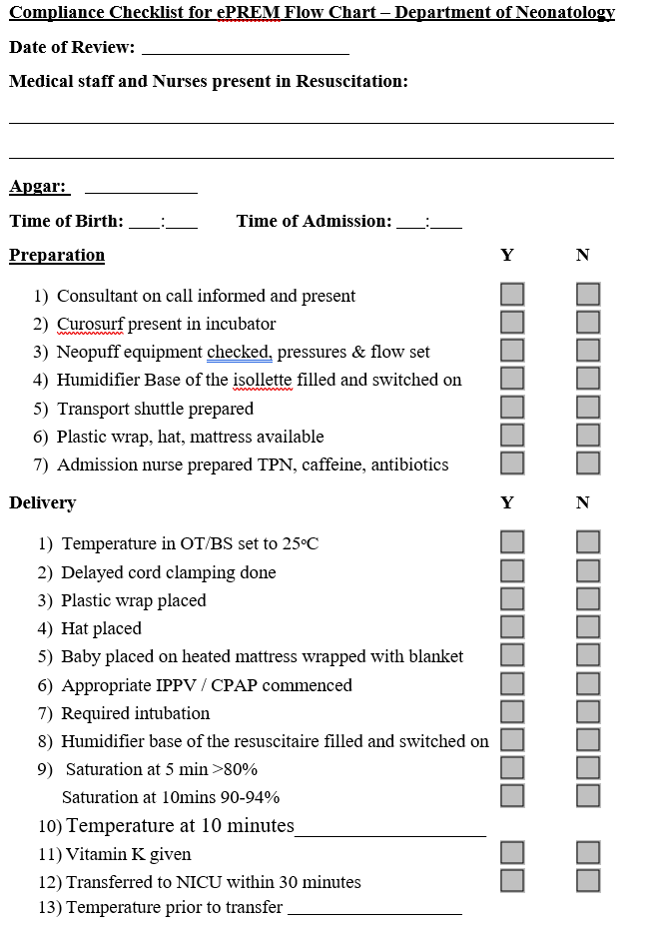
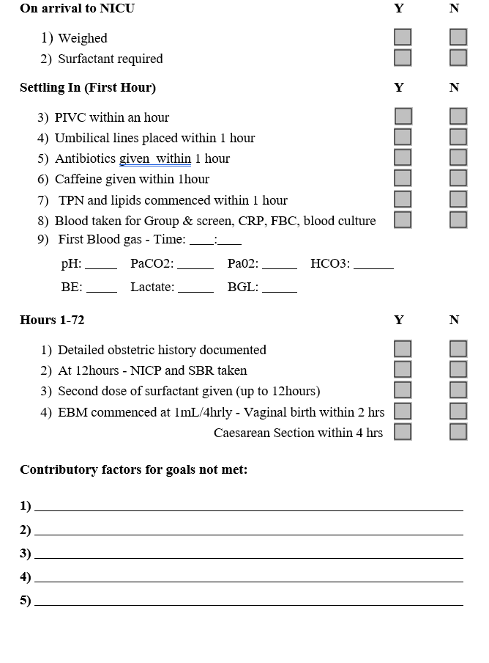

Attachment 4 : Checklist for ePREM Babies <28 Weeks

Thermoregulation
- 1x Trans-warmer mattress
- 1x sheet for trans-warmer mattress
- 1x plastic wrap

Resuscitation
- 1x F&P Humidified neo-puff circuit – Resuscitation T-piece kit
- 1x F&P Humidifier base MR225
- 1x Water for Injection 100mls
- 1x Short Grey Wire for F&P Humidifier Base
- 1x Long Grey Wire for F&P Humidifier Base
- 1x 35mm face mask
- 1x 42mm face mask
- 1x Humidifier adaptor for neo-puff for Panda Resuscitaire
- 1x Bact-trap (white) filter

Monitoring Equipment
- 1x Beanie
- 1x Micro Neo Leads
- 1x <1kg saturation probe
- 1x Yellow Saturation Wrap (prem size)
- 1x Thermometer and plastic covers
- 2x Cavilon wipes
- 1x “00” Blade
- 1x Phillips X2 monitor (from admission bedspace)

Surfactant/Curosurf Pac
- 1x Dressing Pack
- 1x Surfactant Kit (blue syringe)
- 1x Size 16 Gauge Angiocath
- 1x Sterile Scissors
- 1x 10ml, 1x 5ml, 1x3ml syringe
- 2x Blunt Needles
- 2x Prep Pads – 70% Alcohol and 2% Chlorhexidine
- 1x Tape measure
- 1x pair of sterile gloves
- 1x Surfcath

Attachment 5: How to Set-up Humidification of Neopuff Circuit
Resuscitation via Continuous Positive Airway Pressure (CPAP) or intubation using humidified gas in a closed Neopuff circuit assists in the prevention of hypothermia.

Procedure
- Fill neo-puff humidifier base with 30mL sterile water
- Attach CPAP prongs (smallest size) to the CPAP circuit and leave in place
- Turn neopuff settings to Peak Inspiratory Pressure (PIP) 25, Positive End Expiratory Pressure (PEEP) 5
- Ensure the flow of gas through the neopuff is set at 10L/min
- Turn on humidifier base

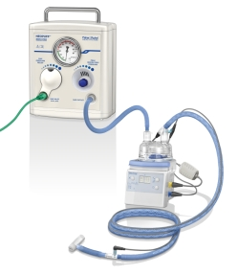
Neopuff set up with humidified base attached

