Canberra Health Services
Procedure
Blood Collection for the Police

Contents

Contents 1
Purpose 2
Scope 2
Alert 2
Section 1 – Compulsory Blood Collection for Police from Patients after an Accident 2
Criteria: 2
Procedure: 3
Section 2 – Blood Collection from Patients Presenting Under Police Custody Drug and/or Alcohol Levels 6
Procedure 6
Evaluation 7
Related Policies, Procedures, Guidelines and Legislation 7
References 8
Definition of Terms 8
Search Terms 8
Attachments 9
Attachment 2: Australian Capital Territory Compulsory Blood Sampling Evidentiary Certificate 9
Attachment 1: Police Bloods Basic Guide (Road Transport (Alcohol and Drugs) Act 1977 10
Attachment 2: Australian Capital Territory Compulsory Blood Sampling Evidentiary Certificate 12

Purpose

The purpose of this procedure is to outline processes and clinician responsibilities for:
- Compulsory blood collection for police from patients after a road related accident
- Blood collection from patients presenting in police custody for the sole purpose of blood collection for drug and/or alcohol levels after an impaired driving matter.

Back to Table of Contents

Scope

This Procedure applies to the following Canberra Hospital (TCH) and North Canberra Hospital (NCH)Emergency Department staff working within their scope of practice:
- Medical Officers (MO)
- Registered Nurses (RN)
- Nurse Practitioners (NP)
Back to Table of Contents

Alert

Exclusions
It is not within the scope of practice for an Enrolled Nurse (EN) or a Registered Midwife (RM) in the Emergency Department to take blood for the purposes outlined in this procedure. Any EN or RM who suspects that this document applies to a patient they are attending should escalate the matter to their team leader.
Back to Table of Contents

Section 1 – Compulsory Blood Collection for Police from Patients after an Accident

Criteria:
- A MO or RN is required to take a sample of the patient’s blood within 2 hours of the patient’s arrival time at the hospital when they attend to a patient who:
  - appears to be over the age of 15
  - attends or is admitted to the hospital for the purpose of examination or treatment as a consequence of an accident (as defined in point 2 below):
    - which occurred no longer than 6 hours before the patient’s arrival at hospital
    - in which the patient was a driver or driver trainer (e.g., Driving instructor), a cyclist, pedestrian (walking, skateboard, scooter, etc), was riding an animal or was driving an animal-drawn vehicle.

- Several important terms are defined in ACT legislation. These include:

  - Accident which is defined in the Road Transport (Alcohol and Drugs) Act 1977 as ‘an accident on a road or road-related area, whether within or outside the ACT, that involves a motor vehicle’.
  - Road which is defined in the Road Transport (General) Act 1999 as an area that is open to or used by the public and is developed for, or has as one of its main uses, the driving or riding of motor vehicles.
  - Road-related area which is defined in the Road Transport (General) Act 1999 as:

    - an area that divides a road (e.g., a median strip); or
    - a footpath or nature strip adjacent to a road; or
an area that is open to the public and is designated for use by cyclists or animals (e.g., a cycle path); or
    - an area that is not a road and this is open to or used by the public for driving, riding, or parking vehicles (e.g., a public carpark); or
    - a shoulder of a road.
- Most accidents involving the use of a vehicle or bicycle will have occurred on a road or road related area. The exception is where the accident occurred on private property in which case there is no obligation to take a sample of the patient’s blood as the provisions of the Act will not apply. This must be documented in the patients DHR file.
- Belief will be formed based on information provided to you by the patient themselves; attending friend or family of the patient; a conveying paramedic; or an attending police officer to name a few. This information is on the blue ‘Blood Collection’ certificate/form and is vital information for legal proceedings.

Procedure:
The process for taking of blood for the police is outlined in the sealed police bloods pack located at resuscitation staff station (see Attachment 1) and describes that the collecting officer must:
- Complete all documentation and procedure steps (a second person must not fill in the form).
- Obtain an unopened Road Transport (Alcohol and Drugs) Act 1977 Blood Sampling Kit stored in resuscitation.
- Ensure the sample container has not passed the expiry date printed on the container.
- Seek the patient’s consent, see below for process if patient does not consent to blood specimen collection.
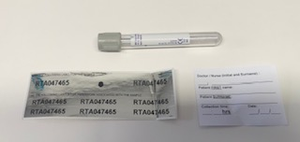
- Obtain a 5mL specimen of blood from the patient. The site must be swabbed with Betadine prior to specimen collection. Alcohol wipes must not be used.

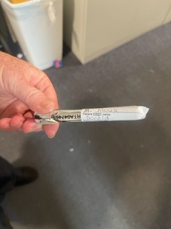
- Seal the sample container using the large, numbered tamper-evident seal (provided in the blood alcohol testing kit), ensuring the serial number affixed to the seal is clearly visible and the label is firmly affixed. Rub your finger over the label to ensure it adheres securely (see picture above – bottom page 3). The ID number printed on the tamper-evident seal must be recorded on the certificate (small sticker applied).
- The collecting clinician must legibly print their first initial and surname, the patient’s first name and surname and the time and date the specimen was obtained on the white patient identification label contained in the Road Transport (Alcohol and Drugs) Act 1977 Blood Sampling Kit to the patient’s blood tube. This label should be attached to the sample, so it does not obscure the serial number on the tamper evident seal.
- Complete all sections of the Australian Capital Territory Compulsory Blood Sampling Evidentiary Certificate – Part 1 - Blood Sample Taken (Attachment 2 - Blue Form).

ALERT:
The patient’s name on the label must exactly match the name written/label applied to the certificate. For example, Mary Jones on certificate can not be M Jones on the sample. If using a patient label and the middle name is included on it, this must appear on the sample label.

- Place the vial in the sealable plastic bag (provided by the blood sampling kit) and seal the bag. Place this into the one-way collection safe in resuscitation.
- Place the Australian Capital Territory Compulsory Blood Sampling Evidentiary Certificate - Blood Sample Taken (Attachment 2 - Blue Form) into the box located on the wall beside the collection safe.
- Document time and collection of blood sample in patient’s DHR, and carefully transcribe the identification number from the small silver sticker to the patient’s DHR (or add a small, numbered silver tamper proof sticker to paper form).

In the case of a blood sample not being obtained:
Medical Reasons/Procedure
- If the blood specimen is not obtained because the MO or RN is of the opinion that taking the sample would be detrimental to the patient’s medical condition, complete the Australian Capital Territory Compulsory Blood Sampling Evidentiary Certificate – Part 2 - Blood Sample Not Taken (Attachment 2 - Blue Form) and place the form into the box located on the wall beside the collection safe.
- This form will be collected as soon as practicable by the Blood and Breath Analysis Officer from ACT Policing.
- Document this in the patient’s DHR.

Patient refused or failed to allow sample to be taken - procedure
- Inform the patient that they are committing an offence if they refuse or fail to provide a sample and allow them to provide a sample upon learning this.
- If the blood specimen is not obtained due to patient refusal, complete the Australian Capital Territory Compulsory Blood Sampling Evidentiary Certificate – Part 3 – If unable to take blood due to fail/refusal (Attachment 2 - Blue Form page 2) and place the form into the box located on the wall beside the collection safe.
- This form will be collected as soon as practicable by the Blood and Breath Analysis Officer from ACT Policing.
- Document that sample has not been obtained in the patient’s DHR.

Note: In the event a sample cannot be collected due to excessive workload in the Emergency Department, this should be documented on the Australian Capital Territory Compulsory Blood Sampling Evidentiary Certificate – Part 2 - Blood Sample Not Taken (Attachment 1 - Blue Form).

Further information is available from the Blood and Breath Analysis Officer deployed at ACT Road Policing Centre. This member can be contacted during business hours on (02) 6256 7777 or alternatively by e-mail at: act-blood-and-breath-analysis@afp.gov.au
Back to Table of Contents

Section 2 – Blood Collection from Patients Presenting Under Police Custody Drug and/or Alcohol Levels

This section applies to patients in the custody of a police officer who present to the ED at TCH or NCH for the purpose of blood collection to assess drug and/or alcohol levels.

This section does not apply to patients who present with the AFP for the purpose of undergoing medical assessment and/or treatment.

Procedure
- Prior to or on arrival to the ED the police officer(s) requesting the blood collection must contact the Forensic Medical Officer (FMO) through switchboard.
- The patient is registered and triaged according to normal procedure. If they have no current need for medical assessment, the presenting problem will be documented as: “Australian Federal Police (AFP) blood collection” and they are to be triaged:
  - at The Canberra Hospital as: Australasian Triage Scale (ATS) 5 in the Australian College of Emergency Medicine Policy on the Australasian Triage Scale and
  - at North Canberra Hospital as per Emergency Triage Education Kit (ETEK), second edition.
- A blood sample must be taken as soon as practicable and within 2 hours of the arrival of the patient at the hospital. In most cases, the FMO will come into ED and collect the blood specimen. In cases where the FMO is unable to present to ED within the legislated time frame, an MO or Nurse will collect the specimen in the presence of the police officer(s) as per Section 1.
- In such cases, the Clinical Coordinator (CC) will identify a suitable MO/RN to obtain the blood specimen.
- During high workloads the Clinical Nurse Consultant (CNC), Clinical Support Nurse (CNS), Clinical Development Nurses (CDN), or After Hours CNC (AHCNC) may all be considered as options to collect the blood specimen.
- A blood sample cannot be taken without appropriate consent from the patient. A patient’s refusal to consent for blood collection under these circumstances may be considered an offence.
- ACT Police will remove the patient from the ED on collection of the sample (or not) unless further medical assessment/treatment is required.

Back to Table of Contents

Evaluation

Outcome
Emergency Department blood sample collection for the police as per this policy

Measures
Police audit of bloods received shows correct procedure is followed and reduction in error rates.
Back to Table of Contents

Related Policies, Procedures, Guidelines and Legislation

Policies
- Nursing and Midwifery Board of Australia Requirements of Practice
- Informed Consent (Clinical) Policy
- Australian College of Emergency Medicine Policy on the Australasian Triage Scale
- Emergency Triage Education Kit (ETEK), second edition

Procedures
- Infection Prevention and Control - Healthcare Associated Infections
- Patient Identification and Procedure Matching Procedure
- Patient Identification – Pathology Specimen Labelling Procedure
- Venepuncture Blood Specimen Collection

Legislation
- Australian Capital Territory Road Transport (Alcohol and Drugs) ACT 1997
- Road Transport (General) Act 1999
- Health Records (Privacy and Access) Act 1997
- Human Rights Act 2004
- Work Health and Safety Act 2011

Other
- Australian Charter of Healthcare Rights

Back to Table of Contents

References

- Australian College of Emergency Medicine Policy on the Australasian Triage Scale. Available from: https://www.acem.org.au
- http://www.legislation.act.gov.au/a/1977-17/default.asp
- WHO Guidelines on Drawing Blood: Best Practices in Phlebotomy. Geneva: World Health Organization; 2010. 2, Best practices in phlebotomy. Available from: https://www.ncbi.nlm.nih.gov/books/NBK138665/
Back to Table of Contents

Definition of Terms

ATS: Australasian Triage Scale.
FMO: Forensic Medical Officer.
DHR: Digital Health Record
Drug: includes; Methylamphetamine, N,αlpha-Dimethyl-3,4 Methylenedioxy) phenylethylamine (MDMA), Delta-9-tetrahydrocannabinol (THC)
Medical Officer: Unconditionally registered medical practitioner under the Health Professional Act 2004.
Nurse Practitioner: Unconditionally registered as a nurse under the Health Professional Act 2004
Registered Nurse: Unconditionally registered as a nurse under the Health Professional Act 2004
Back to Table of Contents

Search Terms

Blood collection, Blood collection for the police, Police, Motor vehicle accident, Drug and alcohol, forensic, accident, AOD, alcohol, blood, Methylamphetamine, TCH, MDMA

Back to Table of Contents

Attachments

Attachment 1 - Documentation in blood collection for the police pack

Attachment 2: Australian Capital Territory Compulsory Blood Sampling Evidentiary Certificate

Disclaimer: This document has been developed by Canberra Health Services specifically for its own use. Use of this document and any reliance on the information contained therein by any third party is at his or her own risk and Canberra Health Services assumes no responsibility whatsoever.

Policy Team ONLY to complete the following:
Date Amended | Section Amended |  | Divisional Approval |  | Final Approval
29 April 2022 | Complete Review |  | Jacqui Taylor, ED-Medicine |  | CHS Policy Committee
31 January 2023 | Updated to include DHR related changes |  | Brendan Docherty, ED, Medicine |  | CHS Policy Team
This document supersedes the following:
Document Number | Document Name
CHHS18/164 | Blood Collection for the Police

Attachment 1: Police Bloods Basic Guide (Road Transport (Alcohol and Drugs) Act 1977

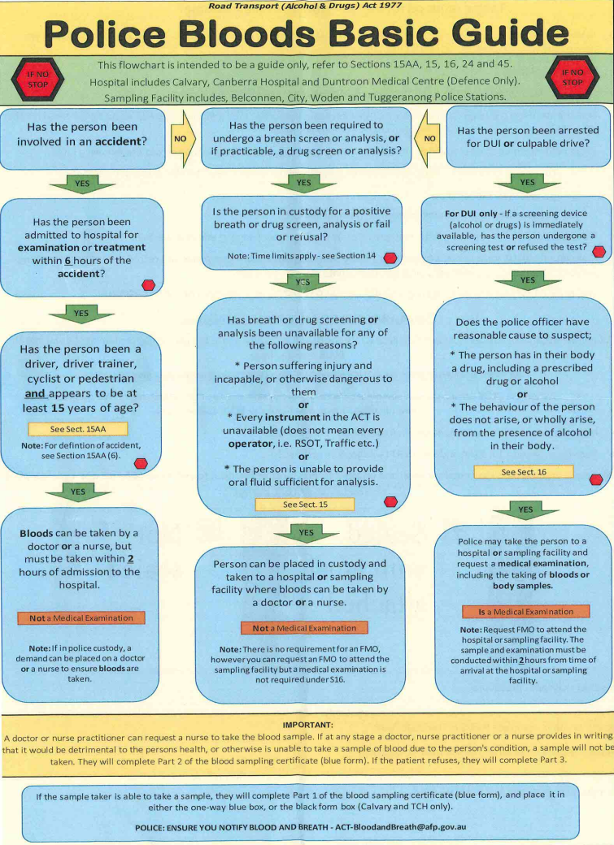
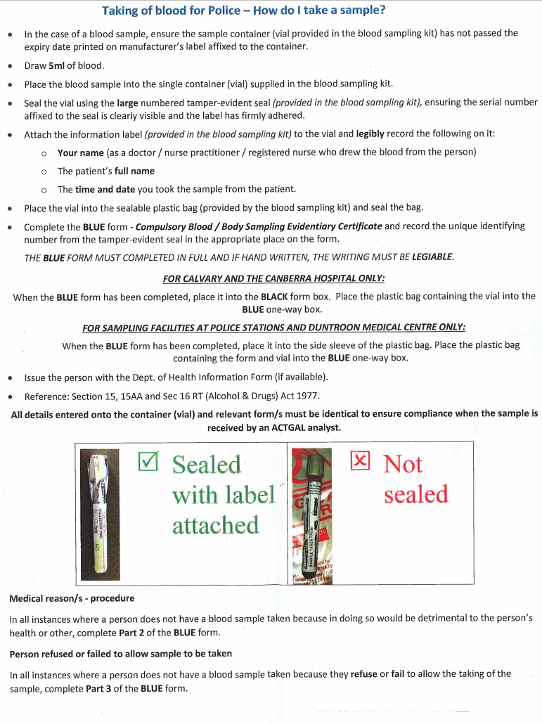

Attachment 2: Australian Capital Territory Compulsory Blood Sampling Evidentiary Certificate
