Procedure | Canberra Health Services

Assessment and Admission Process for Children and Adolescents with Behavioural Concerns – Canberra Hospital
CHS25/216
Contents
Purpose 2
Alerts 2
Scope 3
Section 1 – Emergency Department 3
Section 2 – Bed Manager/Patient Flow 6
Section 3 – Risk Assessment 7
Section 4 – Admission Process 7
Section 5 – Role of Social Work and Collaborative Approach 8
Section 6 – Strategies to Reduce Ongoing Acute Behavioural Disturbance 9
Section 7 – Services in the Community 9
Evaluation 11
Related policies, procedures, guidelines and legislation 11
Definitions 12
Search terms 13
Attachments 13
Attachment 1 - Flow Chart for Child/Adolescent Under 16 Years with Behavioural Presentations 15
Attachment 2 - Flow Chart for Management of Acute Behavioural Disturbance in Child/ Adolescent in the Emergency Department 16
Attachment 3 - Acute Allied Health Social Work (Inpatients) – Clinical Priority Framework 17
Attachment 4 – Referral Form for Therapeutic Support Panel 20

Purpose
The purpose of this document is to assist staff with the management of a child or adolescent presenting to the Emergency Department (ED) with a primary behavioural concern. This could include carer/parent concern, safety issues at home, or escalating behaviour not improving with strategies already implemented at home.
It is acknowledged that hospitals are not best equipped to provide the kind of safety and stability children with behavioural issues require and that hospital staff, although skilled in medical care, may lack specific training and skills required to manage complex behavioural issues. Despite this, parents with a dysregulated child are in a state of crisis, feeling overwhelmed and are unable to manage their child’s behaviour safely, prompting a presentation to the ED as a last resort.
In these cases, Divisions are required to work together to manage the presentation and discharge of the child as soon as possible. More appropriate avenues for children and adolescents with behavioural issues involve community-based services that can offer comprehensive assessment, therapeutic interventions and support for families. Being able to redirect families to a specialised service helps ensure children and adolescents receive the appropriate care in an appropriate setting. Canberra Health Services (CHS) is currently working with the Community Services Directorate to establish a more appropriate service response for these families when in crisis and this procedure is interim process. Refer to Attachment 1 for a flowchart of the process.
This document has been developed to assist the Divisions within Canberra Hospital with a step wise approach for these children. It requires a parallel assessment from various teams to ensure collaborative approach to these families at a time of heightened stress and emotions.
Management of these cases may involve the:
- ED
- Child and Adolescent Mental Health Service (CAMHS) or Mental Health CL (MHCL)
- General paediatricians.
Back to Contents

Alerts
It is important when caring for children and adolescents with behavioural concerns to be aware of strategies that can help during their hospital presentation and stay. These include:
- Low stimulus (turn off monitors if not required, dim lights, quiet space)
- Minimal staff involved in care as is clinically safe (avoid large groups at one time)
- Minimal staff turnover (this helps with building rapport with the patient)
- Communicate in clear and concise way and allow time for the patient to process information. Take into consideration the developmental stage of the patient and their capacity to understand and be involved in decision making.
- Provide supportive boundaries that communicate expectations while allowing for child/youth to express their needs in ways that contribute to decision-making
- Use a timeline for next steps in the patient care
- Use distress minimisation techniques if investigations are required.
Back to Contents

Scope
This document applies to children and adolescents (up to 16 years of age) presenting to Canberra Hospital Emergency Department with a primary behavioural concern.
This document applies to CHS staff working in:
- Canberra Hospital Emergency Department
- CAMHS or Mental MHCL.
This document applies to the following staff working within their scope of practice:
- Medical Officers
- Nurses and Midwives
- Allied Health Professionals
- Students under direct supervision.
Back to Contents

Section 1 – Emergency Department
When patients present to the ED, it is the ED’s role to undertake the initial assessment and management of the case and to exclude any acute medical issues or injuries. Refer to Attachment 2 for Flow Chart for Management of Acute Behavioural Disturbance in Child/ Adolescent in the Emergency Department.
In the ED there are bedspaces that are suitable for a child presenting with acute behavioural issues including:
- Behavioural Assessment Unit (BAU) – The BAU is Pod 7 with capacity for 4 patients at a time and is a low stimulus space. This space may be used if this is the most appropriate place for assessment (with input from the nursing navigator).
- Safe Assessment Room (SAR) -– The SARs are in Pod 4, and there are two single rooms. There is an adjoined ensuite in these rooms. These rooms are low stimulus. These rooms should be used if the most appropriate place for assessment (with input from the nursing navigator).
- Single room in Pod 6 or Pod 5 should be used with minimal stimulus, with input from the clinical care nurse to assist with assessment.
- Sensory room is in Pod 2 and this room should be used when and if the criterion for inclusion is met. Refer to ED Children’s Sensory Room Business rules available on Emergency Department Health Hub page
- The bed spaces in Pod 2 and 3 should be used as the last resort, given the loud noises, unpredictability of the environment and lots of people within a small space.
Note: It is important to have a senior medical officer review the patient early on to help with the assessment and management of these patients and family.
If the child is under an Emergency Apprehension (EA), in addition to emergency staff review a prompt CAMHS or MHCL review is also required. For this to occur, a Digital Health Record (DHR) referral needs to be placed and a phone call via switch.
All these children require an emergency medical assessment to assess the trigger for presentation. This could include:
- acute medical illness
- social/family situation, see definition section for more information
- behavioural issues see definition section for more information
- underlying mental health issue.
The senior emergency medical staff will also assess if admission is required or if the patient can be discharged home with safety planning and follow up.
If senior emergency medical staff determine the patient may have an underlying undiagnosed mental health issue (e.g. psychosis, severe depression), a prompt mental health review is required by the psychiatry registrar and/or consultant.
This situation should be managed with an admission under paediatrics and mental health, given the need for ongoing assessment from both perspectives. For children under 12 years of age the admission will be under a general paediatrician, with a consult and note that the CAMHS consultant is also involved in the care. For children over 12 years of age with a primary mental health issue, admission will be under the CAMHS consultant with a consult to general paediatrics.
Note:
- Primary mental health condition is rare in children under the age of 12 and an acute medical cause needs to be excluded.
- There is no acute mental health bed for patients under 12 years of age, therefore they cannot be admitted to CAMHS Adolescent Unit (CAU) or the Adult Mental Health Unit (AMHU).
For patients on an Emergency Detention 3 (ED3), the ideal location is the swing beds on ward 1A (rooms 7 and 8) under CAU staff, as this will allow close management of these patients.
If following assessment, the ED medical staff and/or CAHMS/MHCL staff believe an admission is necessary, the admission will be facilitated by a prompt and collaborative approach between ED, general paediatricians and CAMHS. Such situations include:
- Inability to safely discharge the patient into care of guardian due to lack of support, safety issues or carer fatigue
- Inpatient admission required to assist with implementing or increasing support in the community (this can start concurrently in the emergency department with the assistance of social worker)
- Inpatient admission required to assist with adjusting/initiation of pharmacological management of acute behavioural disturbance
- Inpatient admission required to assist with further investigations.
An admission for these situations is not in the best interest of the child, however when required it is imperative parents/guardians are included in this initial discussion, as the expectation is a short (ideally less than 48 hours) admission, and need to reaffirm the importance of having the children in a safe place, and not an acute hospital bed due to the ongoing trauma this can cause.
There needs to be:
- a goal for the admission
- clear timeline for discharge
- If appropriate, concurrent escalation to Department of Child, Youth and Family (CYF), Office for Disability (ISRP)and the ACT Office of the Senior Practitioner.
- Referral to social work, and NDIS lead (if appropriate) to assist with safe discharge planning via the DHR.
Note: The admission process to an appropriate bedspace at Canberra Hospital is not delayed while ED contact other services to investigate if they can assist with the care of the child/adolescent. These processes are to happen concurrently.
Emergency staff will need to undertake necessary steps as outlined below, at the same time as bed management are arranging appropriate bedspace for the patient.
- Senior Emergency doctor to call paediatrician on call to discuss admission – direct admission is appropriate to start the process for bed allocation
- Regular medications as well as appropriate prn medications charted (if assistance required, assistance from CAMHS or on call psychiatrist, also can refer to the quick order set in DHR called ‘Paediatric Acute Behavioural Disturbance’)
- Exclusion of acute medical causes (bloods recommended if first presentation and no prior work up in the community, if new medication that has side effect profile impacting electrolytes, risk of infection or concern for toxidrome).
- DHR inpatient consult referral with CAMHS
- DHR inpatient consult referral with social work and call the social worker to assist
- Where there is a risk to parent/guardian safety complete a risk management system (RiskMan) notification – ‘child at risk’ which will log a job number, to facilitate ongoing discharge planning with the CYF
- Nursing special to be ordered in DHR, refer to Increased Patient Care and or Supervision Procedure.
- Wards person and/or security special to be ordered in DHR
- If during business hours consult the Paediatric Behavioural Nurse
- If during business hours and appropriate, please consult Aboriginal Liaison Officer (ALO).
Alert: If EA cannot be revoked or urgent ED3 is required please call the CAMHS psychiatrist if during business hours, or on call psychiatrist if afterhours.
For the patient who is less than 12 years of age and is on an ED3, an admission under both paediatrics and CAMHS is required. The steps will be the same as above, however appropriate documentation needs to be completed on DHR.
For those adolescents (12 to 16 years) who require a mental health admission it is preferred either to Mental Health Short Stay Unit [MHSSU] or Child Adolescent Unit (CAU)...
- Staffing in this case, regardless of location requires one experienced nurse from paediatrics (not casual/relief/agency), one experienced mental health nurse, and with history of prior violent behaviour, or high Occupational Violence (OV) risk, a security guard. .
- A copy of behavioural management plans from the National Disability Insurance Scheme (NDIS), positive behaviour support plan from Office of the Senior Practitioner and any activity programs that may be in place to be documented in the notes, and a hard copy be available on the ward
- NDIS staff usually caring for the patient at home to continue care to ensure home routine is maintained, if in the best interest of the patient. Patients with an NDIS support worker may be able to continue to have support while in hospital, refer to Disability-related health supports available at https://ourguidelines.ndis.gov.au/supports-you-can-access-menu/disability-related-health-supports
- If there is no behavioural management plan, or it needs updating, the nursing staff on ward 1A can create a calming plan (Trigger Action Response Reaction Resolution [TAR3]) for the patient, and this must be readily available for all staff. If during business hours, the acute behavioural care nurse can assist with this.
Back to Contents

Section 2 – Bed Manager/Patient Flow
Patient flow unit (PFU) are responsible for:
- Prioritising bed allocation
- Ensuring risk assessments are completed by the admitting team (see Section 3)
- The step wise allocation of beds, depending on other patient needs and hospital demands.
PFU and After-Hours Nurse Manager (AHNM) will assess a location that includes the context and acuity of other patients within identified areas. To assist with this, PFU and AHNM will engage with Executive on call or Site Operations.
Back to Contents

Section 3 – Risk Assessment
The following risk assessments need to be completed:
- Clinical risk assessment located in DHR – this will be completed by the admitting team, with assistance from CAMHS team (the admitting team may be CAMHS).
- Behaviours of Concern with Bröset located in DHR – this will be completed by the admitting team staff.
Back to Contents

Section 4 – Admission Process
- Children requiring admission for a social or medical condition, and not a primary mental health condition, will be admitted under the paediatric medical team. A consult to CAMHS is also required, for regular input from the team.
- Admitting team must clearly document an escalation plan regarding agitation/sedation management at point of admission.
- Admitting team must clearly document who is responsible to attend the bedside during periods of escalation.
- Staffing for this area, regardless of location will require one (1) experienced/confident nurse from paediatrics (not casual/agency/relief), one (1) experienced mental health nurse and, with history of prior violent behaviour, or high OV risk, one (1).
- A copy of the patient’s (if they have one), behavioural management plans from NDIS or Office of the Senior Practitioner; any activity-based programs that may be in place must be documented in the patient clinical record, scanned into DHR and a hard copy be available on the ward.
- Social worker to assist with implementation of services in the community.
  - If patient is an NDIS recipient, the NDIS lead is key to engage early as they can continue with coordinated response with external organisations such as the Office for Disability, CYF and Office of the Senior Practitioner.
- Play therapist to assist with regulation. A referral is required on DHR.
- Calming plan (TAR3) to be completed and at the bedside, as well as copy for parents.
- Team leader/ Clinical Nurse Consultant (CNC) to concurrently work on escalation steps for services in the community.
- Ongoing input from behavioural care nurse.
Back to Contents

Section 5 – Role of Social Work and Collaborative Approach
Social work are engaged in the care of these children and adolescents via a call from the ED. They are responsible for:
- Conducting a rapid assessment during business hours (Monday to Friday 8:30am to 4:30pm)
- Completing safety planning
- Investigating availability of emergency respite care (see Section 7 for respite places in ACT that will accommodate children)
- The Social Work Department business hours of operation are Monday – Friday, 8.30am – 4.30pm. The After-Hours Social Work Service hours of operation are Monday -Friday 4.30pm – 9.30pm and Saturday, Sunday and Public Holidays 8.30am -9.30pm. Please note our After-Hours Social Work Service is a sole worker.
- Please make referrals to social work via the DHR. If you require a more responsive service, after making a DHR referral please ring 5124 2316 (business hours only) or the ED / After Hours mobile on 0419 210 880.
- Engagement with appropriate teams in community
  - CYF
  - The NDIS lead is available Monday-Friday, 8.30-4.30pm. You can contact the NDIS Lead via Social Work on 5124 2316 or 0466 389 715
  - Integrated Support Response Program (ISRP)
- Completing ISRP application (if the child or adolescent has NDIS funding and is an ACT resident) (see Section 7)
- Working with the multidisciplinary team (MDT) to assess if concern for voluntary relinquish of authority:
  - If CYF will assess priority and if they believe it is high priority then an emergency placement will be arranged
  - If No and parents/guardians express need for additional supports or respite, Social Work will collaborate with MDT, Integrated Operations Centre, Executive as appropriate, to see if emergency respite can be arranged.
- Liaise with CYF to provide ongoing communication regarding status and steps to ensure closed loop communication and timeline, to assist team and family with discharge planning and managing expectations.
Refer to Attachment 3: Acute Allied Health Social Work (Inpatients) – Clinical Priority Framework.
Back to Contents

Section 6 – Strategies to Reduce Ongoing Acute Behavioural Disturbance
- Assess DHR to see if there’s an established TAR3 document that discusses child’s preferences for calming techniques when they are escalated. If this has not been done, the nurses on ward 1A can assist with this.
- Ask the parent/guardian/carer what strategies may work best for their child/young person. If appropriate the patient can be asked what would help them calm.
- Place the child/adolescent in a low stimulus area:
  - Consider offering sensory tools that can help reduce further stimulus (earmuffs, sunglasses).
- Ensure minimal number of staff that is required to deliver safe care is allocated.
- Ensure minimal staff turnover/handover that is required to deliver safe care.
- Communicate in clear and concise way:
  - Allow time for the patient to process the information; many children with behavioural concerns have underlying sensory processing issues.
- Clearly communicate firm and clear boundaries.
- Give the patient a timeline for the next steps, for example:
  - ‘First the team will discuss with you how you are feeling today’
  - ‘Then we will talk about the best place for you to stay tonight’.
- Use distress minimisation techniques/strategies if investigations required:
  - Distraction with iPad/games/smileyscope®/buzzybee®
  - Pharmacological with fentanyl/midazolam/nitrous (for dosing and administration, please refer to the distress minimisation quick order panel on DHR).
- Refer to Attachment 1 and 2 flow charts for management of acute behavioural disturbance in children/adolescents.
- Offer the child/adolescent food and water, as appropriate. Check with patient or family for any food intolerances or allergies.
- Ensure usual mediations are prescribed and given at the usual time.
- If known, behavioural care plan to be at the bedside and available for all staff to review as needed
- Ensure early consultation with Paediatric Behavioural Nurse (Monday to Friday 8:30am to 4pm), play therapist and social worker (after hours social worker: 4:30 to 9:30pm each weekday evening and 8:30am to 9:30pm Saturday, Sundays and Public Holiday).
Back to Contents

Section 7 – Services in the Community

Child, Youth and Family Services (CYF)
Intake Team Number: 1300 556 728
Escalation will be to speak with the team leader or operations manager, and if still needing further escalation, after hours or during business hours to the relevant Executive.
For child protection matters relating to NSW children, the Department of Communities and Justice child protection line can be contacted on 13 21 11.

Integrated Services Response Program (ISRP)
- Short term case coordination to address gaps in mainstream services (under 12 weeks)
- Must have NDIS funding
- Must be ACT resident
- Will help with providing additional supports and at times respite for the child
- Takes time
- Assessment can take up to 14 days, however, will prioritise those presenting to the hospital in acute crisis
- Works closely with National Disability Insurance Agency (NDIA) and CYF
- Application with form available at https://www.act.gov.au/__data/assets/pdf_file/0004/2386516/Integrated-Service-Response-Program-form.pdf including completing Attachment A Consent to provide, release and share information and needs to be signed by parent/guardian
- Social worker assists with application form
Further information is available on the ACT Government website at: https://www.act.gov.au/community/people-with-disability/get-short-term-disability-support-in-a-crisis

Therapeutic Support Panel
- Facilitates access to therapeutic support to children and young people under 18 years who are at risk of or engaged in harmful behaviour or at risk of harm. They are not a crisis response but aim to support unmet needs to address concerning behaviours.
- Panel may be able to help children and young people who exhibit repeated patterns of behaviour that have causes (or present a risk of) significant harm to self or others. The Therapeutic Support Panel can work with police, and Safer Youth Response Service (SYRS) to see if they can help.
- No clear-cut definition/criteria for referral e.g. risk of harmful behaviour, externalising behaviours, putting oneself into a risky position
- Interested in early intervention when the child is on a trajectory of harmful behaviours, and want to divert from that trajectory
- Not a crisis service
- Can get referrals from anyone: consider referral of a child frequently seen in the ED, risk of repeat presentations, as this will help with identifying the gap in the system for many of these children (referral application in Attachment 4)
- Referral will then lead to intake:
  - Weekdays, business hours
  - Referral – will hear in a few days; then within one week for the consent/initial assessment
    - More urgent if patient aged less than 14 years old
    - If no other supports in place will usually be prioritised
  - Need consent from the parents/guardians ideally, as this helps with the referral process
  - Statutory position – can obtain information from education/police/health
  - At Intake will decide the next steps about how they can help (with other supports that are available).
Back to Contents

Evaluation

Outcome
- Children or Adolescents presenting to ED with primary behavioural concerns are managed as per this procedure.

Measures
- 6 month review of 10 clinical records of children and adolescents that present to ED with primary behaviour concerns to identify if the recommended process was followed .
Back to Contents

Related policies, procedures, guidelines and legislation

Policies
- Nursing and Midwifery Board of Australia (NMBA) Requirements for Practice
- Occupational Violence
- Consumer Privacy

Procedures
- Infection Prevention and Control
- Patient Identification and Healthcare Activity Matching
- Emergency Department and Mental Health Interface – Canberra Hospital
- Grey Response for the Emergency Department
- Initial Management, Assessment and Intervention for People Vulnerable to Suicide
- Occupational Violence
- Emergency Department Waiting Room Supervision Canberra Hospital

Guidelines
- Consent for Healthcare Treatment
- Challenging Behaviour

Legislation
- Health Records (Privacy and Access) Act 1997
- Human Rights Act 2004
- Work Health and Safety Act 2011
- Mental Health Act 2015
- Carers Recognition Act 2021
- Children and Young People Act 2008
- Discrimination Act 1991

Other
- Australian Charter of Healthcare Rights
- Australian Disability Strategy
- ACT Office of The Senior Practitioner
Back to Contents

Definitions
Social/family situation:
        - parent/guardian has concern for safety of self or other children in the household, and not safe for patient to be in the household
        - carer burnout, with parent/guardian no longer able to provide care and emergency respite cannot be facilitated in the community
Behaviour of concern:
- physical aggression towards family, including other children
- explosive reactions and inability to re-direct or de-escalate (such as significant change in routine, sensory processing issues)
- inability to keep safe in the home environment, such as history of ongoing absconding and partaking in risky behaviour
- Self injurious behaviour
- destructive behaviour including damage to property

Search terms
ED, behaviour, complex, emergency, respite, child, adolescent, mental health, CAHMS, Canberra
Back to Contents

Attachments

Attachment 1: Flow Chart for Age <16 Years with Behavioural Presentations

Attachment 2: Flow Chart for Management of Acute Behavioural Disturbance in Child/ Adolescent in the Emergency Department

Attachment 3: Acute Allied Health Social Work (Inpatients) – Clinical Priority Framework

Attachment 4: Referral Form for Therapeutic Support Panel
Back to Contents
For Policy Team to complete:
Date amended | Section amended | Divisional approval | Final approval
26/06/2025 | Complete review | Rebekah Ogilvie, ED, Medicine | Policy Document Review Panel
This document supersedes the following:
Document number | Document name
CHS25/053 | Assessment and Admission Process for Children and Adolescents with Behavioral Concerns – Canberra Hospital
Disclaimer
This document has been developed by Canberra Health Services specifically for its own use. Use of this document and any reliance on the information contained therein by any third party is at his or her own risk and Canberra Health Services assumes no responsibility whatsoever.
Back to Contents
Acknowledgement of Country  Canberra Health Services acknowledges the Ngunnawal people as traditional custodians of the ACT and recognises any other people or families with connection to the lands of the ACT and region. We acknowledge and respect their continuing culture and contribution to the life of this region.  © Australian Capital Territory, Canberra 2024 | Accessibility  call (02) 5124 0000   Interpreter call 131 450  canberrahealthservices.act.gov.au/accessibility  

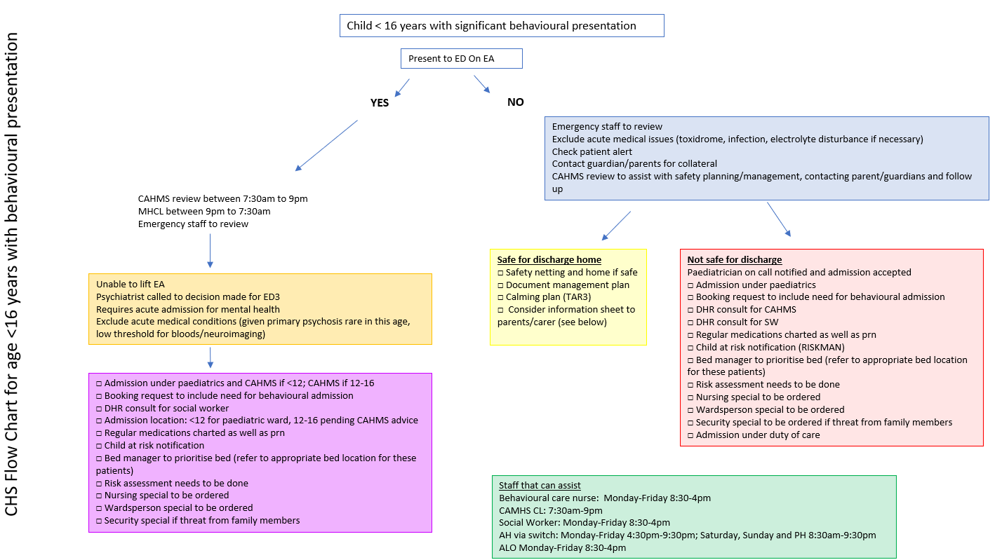
Attachment 1 - Flow Chart for Child/Adolescent Under 16 Years with Behavioural Presentations
Back to Contents

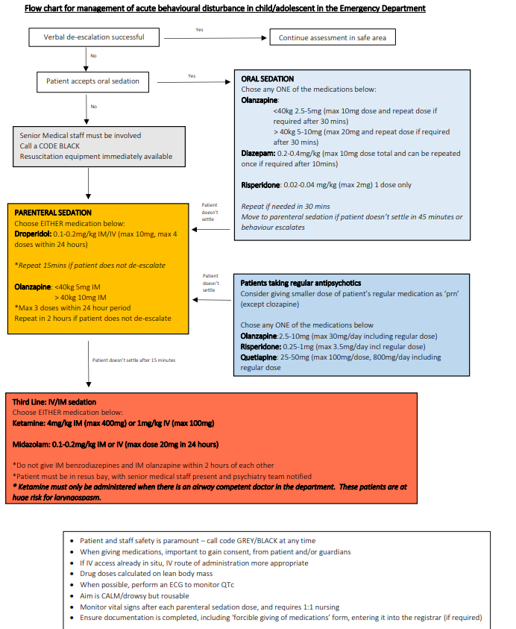
Attachment 2 - Flow Chart for Management of Acute Behavioural Disturbance in Child/ Adolescent in the Emergency Department
Back to Contents

Attachment 3 - Acute Allied Health Social Work (Inpatients) – Clinical Priority Framework
Purpose: To assist staff to manage client workload in terms of response to referral and allocation of social work resources. These indicators are based on assessed risk, impact on psychosocial wellbeing outcomes, client safety and potential to increase length of stay.
 |  | EXEMPTION OR CONSIDERATIONS
Social Work Clinical Indicators | Priority 1 Intervention: Within 4 hours | ADULT TEAMS | MAT PAEDS TEAM
Social Work Clinical Indicators | Crisis Intervention  - Sudden or unexpected death or death expected imminently, including trauma codes  - Acute family or carer stress or conflict, having a major impact on the patient’s safety or care  - Family violence, assault, elder abuse or child at risk, where immediate risk present  - Self-harm or threat of self-harm where Social Work support is required for the family  - Provision of psychological first-aid  Assessment or Complex Discharge Planning – where patient medically fit for immediate discharge  - Intervention required to prevent admission or avoid increasing length of stay and allow safe discharge (EMERGENCY DEPT. ONLY). | Significant carer of family stress: may be a higher priority in ICU/ED settings | Termination of Pregnancy  Traumatic birth  Sudden pregnancy Loss  Sudden transfer of mother and baby
Social Work Clinical Indicators | Priority 2: Within 1 working day | ADULT TEAMS | MAT PAEDS TEAM
Social Work Clinical Indicators | Crisis Intervention  - New diagnosis of life-threatening illness and significant psychosocial distress in patient or family reported  - Seriously unwell newborn/child/young person with significant distress  - Significant level of distress for patient or family re: hospitalisation, sudden deterioration, new diagnosis, treatment or discharge plans  - The patient is the carer of another, and no substitute carer supports are available or confirmed  - Provision of psychological first-aid  Counselling  - Impending expected death or pregnancy loss  - Where patient has disclosed or is suspected to be experiencing family violence, or child at risk concerns, but there is no immediate risk  Assessment or Complex Discharge Planning – Medically Fit for Discharge Within the next 24 HOURS where:  - The discharge plan appears unsafe, or Where the patient has complex discharge needs as defined by:  - Pre-birth alert  - Vulnerable young parent  - Frail aged or person living with a disability or chronic health condition  - Complex health needs, requiring multiple support services on discharge  - Psychosocial vulnerability (alcohol or drug addictions, mental health condition, Aboriginal or Torres Strait Islander or from a culturally diverse background experiencing communication barriers  - The patient is homeless, or their accommodation needs have significantly changed affecting their capacity to be discharged safely.  Advocacy  - Vulnerable young person  - Cognitive impairment or intellectual or physical disability or lack of understanding about their care plan  - Vulnerable Aboriginal or Torres Strait Islander person  - Patients from a culturally and linguistically diverse background who are experiencing communication barriers | Trauma intervention & Psychological first aid may be a higher priority in ED & ICU  All d/c planning within AMU will require P2 triage.  HITH & Outpatient areas: May require different timeframes for response | Bereavement support: death of baby/child  Counselling: Pre-Birth Alert may be a higher or lower priority due to risks present
Priority 3 Intervention: Within 3 working days |  | ADULT TEAMS | MAT PAEDS TEAM
Counselling/psychoeducation  - Palliative care psychosocial assessment and intervention including end of life decisions  - Significant carer or family stress  - Trauma counselling following a traumatic event requiring admission  - Bereavement follow up to family or significant others  Advocacy  - Guardianship application requires initiation  - Discharge planning involving residential aged care and referral to RACLN  - Newly acquired disability requiring NDIS planning  Assessment or complex discharge planning (as above)– medically fit for discharge within the next 48 HOURS |  | Bereavement follow up: Will often be a higher priority in ICU  HITH & Outpatient areas: May require different timeframes for response | Counselling: Pre-Birth Alert may be a higher on lower priority due to risks present.
Priority 4 Intervention: Within 5 working days or more as stated
Counselling  - Chronic or advancing disease causing psychological distress (within 5 working days)  - Very premature baby with no other identified psychosocial issues  - Perinatal counselling  Assessment or complex discharge planning (as above)– expected dates of discharge is 3 WORKING DAYS:  Information and practical assistance  - Access to services and information about entitlement to services (5 days)  - Information about travel and accommodation entitlements (5 days)  - Pt or family require information about EPOA, Wills or Advanced Care Directives (5 days)  - Support documentation required. |  | HITH & Outpatient areas: May require different timeframes for response

Application of Clinical Priority Indicators

For new referrals:
When the clinician is accepting new referrals, consideration should be given to the reason for Social Work referral, the health and psychosocial background information of the patient and/or their significant others, and the patient’s admission timeline (including estimated date of discharge).
With knowledge of all of the above information, the Clinical Priority Indicators are to be used to determine the Priority Rating of the referral.
Priority ratings are used in order to prioritise the workload of the clinician, and to facilitate workload distribution across the team.
In instances where the Priority rating is unclear the clinician should use their clinical judgement to apply a priority, or seek consultation with a Social Work colleague.

For ongoing interventions:
For patients requiring ongoing Social Work intervention during their admission, the Clinical Priority Indicators are to be used to determine the Priority Rating of the required ongoing intervention. The Priority Rating of the ongoing intervention may change in line with changing psychosocial support needs of the patient and/or significant others throughout their admission, or with changes to their estimated health outcomes or discharge dates.
Priority ratings for patients requiring ongoing interventions, are used in order to prioritise the workload of the clinician, to assess the clinician’s capacity to accept new referrals, and to enable fair workload distribution across the team.
The act of assigning Clinical Priorities to both new referrals, and ongoing interventions, is an essential pre-requisite to team Workload Allocation Meetings, in order to ensure fair workload distribution across team, and to ensure that Clinical Priorities can be met across each Division.
Back to Contents

Attachment 4 – Referral Form for Therapeutic Support Panel


Referral Form: Therapeutic Support Panel
Sensitive: Personal
Information in this document is subject to the confidentially provisions of the Children and Young People Act 2008, the Health Records (Privacy and Access) Act 1997 and the Information Privacy Act (ACT) 2014. Further information about the Directorate’s privacy policy is available online at http://www.communityservices.act.gov.au/

The Therapeutic Support Panel works with children, young people, and their families to address unmet therapeutic needs that often-underlie harmful behaviour of children and young people, to divert them from criminal legal responses and systems, and create lasting healthier outcomes.
This form should only be completed if you believe on reasonable grounds that a child or young person:
- Has a genuine need for therapeutic support services; and
- Is at risk of engaging in or has engaged in–
  - Harm to themselves or someone else; or
  - Serious damage to property or the environment or cruelty to an animal; or
  - Any other serious or destructive behaviour
If you or the delegate are unsure about whether to refer a child or young person, or would like to discuss further, please contact the therapeutic support team at:
- (02) 6205 0082
- TSPreferral@act.gov.au.

Date of referral: | DD/MM/YYYY
Name of referrer:
Email Address of referrer:
Phone Number of referrer:
Referring agency (if applicable):
Name of the child or young person:
DOB of Child or young person: | DD/MM/YYYY
Gender:
Cultural identity of child (Aboriginal or Torres Strait Islander, CALD)
Contact details of the child or young person: | Phone:  Email:  Address:
Whereabouts of the child or young person if different to the contact details
Who else is known to reside at this location?
Parent / Carer name(s) of child or young person
Contact information and address of parent/carer | Phone:  Email:  Address:
Have you told the child or young person they will be contacted by a member of the Therapeutic Support Panel? | Yes No
Has the young person agreed to a referral? | Yes No
Have you informed a parent or caregiver of the referral? | Yes No
Have the parent(s)/ carer(s) agreed to a referral? | Yes No
Are there any current orders or legal proceedings in place? (if known) | No Unknown  Yes Details:
REASONS FOR THE REFERRAL:
What are risks of harm to the child/young person and/or others?
What are the behaviours and/or incidents that have raised concern?
What are the vulnerabilities and risk factors for the child or young person?
(e.g. mental health, self-harm, suicidal thoughts, disability or neurodiversity, trauma, drug or alcohol use, harmful sexual behaviour, family violence)
Provide a brief description of your involvement with the child or young person.

What other supports/services are currently in place for the child/young person?

What supports or services have been tried previously for the child or young person and their family or care giver?
(e.g., CYPS, Education, NDIS)

What are the perceived barriers/challenges to positive change?

What are you hoping the Therapeutic Service Program might be able to help with?

Is there anything else you want us to know?
(e.g. best way for us to contact the child/young person, safety concerns, interests of child/young person, strengths, protective factors)

Back to Contents

