Canberra Health Services
Procedure
Canberra Hospital Pulmonary Embolism Response Team (PERT) Pathway – Adult only

Contents

Contents 1
Purpose 2
Alert 2
Scope 2
Section 1 – PE Risk Stratification 3
Section 2 – PERT Activation Criteria and Action 4
Section 3 – PERT Team, Process and Escalation 5
Section 4 – PERT Pathway Management 7
Section 5 – PERT Pathway Therapies 7
Evaluation 11
Related Policies, Procedures, Guidelines and Legislation 11
References 12
Definition of Terms 12
Search Terms 13
Attachments 13
Attachment 1. Canberra Hospital PERT Pathway – Summary 14
Attachment 2. Canberra Hospital PERT Pathway - Flowchart 15
Attachment 3. Pulmonary Embolism Severity Index (PESI) and Simplified PESI (sPESI) 16
Attachment 4. Common Echocardiographic Findings for PE 17
Attachment 5. BOVA Score 18

Purpose

This procedure provides a guidance for Canberra Health Services (CHS) staff on the risk stratification of patients presenting with suspected or confirmed pulmonary embolism (PE), the escalation pathway for those deteriorating or at high risk of deterioration and the timely initiation of appropriate reperfusion and supportive therapies.

Early recognition and multidisciplinary involvement for high-risk (massive) PE and intermediate-high-risk (submassive) PE is critical in reducing mortality and morbidity. A Pulmonary Embolism Response Team (PERT) is urgently required for the patient to achieve this goal.
Back to Table of Contents

Alert

This document is NOT a full guideline for the assessment and management of PE.
Refer to 2019 ESC Guidelines [1] for the areas not covered in this document.

This document is only applicable to patients ≥ 18 years of age – adult only.

PERT pathway is only applicable to Canberra Hospital campus. Patients in North Canberra Hospital or University of Canberra Hospital require transfer before a PERT may be activated at Canberra Hospital.
Back to Table of Contents

Scope

This procedure applies to patients presenting to Canberra Hospital Emergency Department (ED) with symptoms or inpatients developing symptoms of PE, when a diagnosis of PE is confirmed on Computed Tomography Pulmonary Angiogram (CTPA) or Ventilation/Perfusion (V/Q) Scan, OR, is highly suspected when the patient presents in cardiac arrest or imminent cardiac arrest, excluding a CT or Nuclear Medicine imaging.

PERT pathway applies to the following staff working within their scope of practice:
- Canberra Hospital Emergency Department (ED):
- ED Consultant/Senior Registrar (SR)
- ED Registered Nurses (RN)
- Canberra Hospital Respiratory Department:
- Respiratory Consultant/Advanced Trainee (AT) during business hours (BH) (usually primary team)
- Respiratory Consultant on call during after-hours (AH)
- Canberra Hospital Intensive Care Unit:
- ICU Referral Consultant/Registrar (BH)
- ICU Consultant/SR on call and Referral Registrar (AH)
- Extracorporeal membrane oxygenation (ECMO) on call Consultant
- Canberra Hospital Medical Emergency Team (MET):
- As per MET roster
- Canberra Hospital Cardiology Department:
- Cardiology Consultant/AT on call
- Canberra Hospital Medical Imaging Department:
- CT Registrar on call
- Interventional Radiologist (IR) Consultant on call
- Angio Suite Clinical Nurse Consultant (CNC)/RNs
- Canberra Hospital Anaesthetic Department:
- Anaesthetist on call
- Cardiac Anaesthetist on call
- Theatre Flow
- Canberra Hospital Cardiothoracic Department:
- Cardiothoracic Surgeon/Registrar on call
- Canberra Hospital Haematology Department:
- Haematology/AT on call
- Canberra Hospital Switchboard staff
Back to Table of Contents

Section 1 – PE Risk Stratification

PE is stratified to high-risk, intermediate-risk or low-risk PE.

High-risk PE is defined with ANY of the following evidence of haemodynamic instability:
- Cardiac arrest (or imminent cardiac arrest)
- Obstructive shock (SBP <90 mmHg or vasopressors required to achieve SBP ≥ 90 mmHg despite adequate filling status, in combination with end-organ hypoperfusion)
- Persistent hypotension (SBP <90 mmHg or drop ≥40 mmHg from baseline for ≥ 15mins, not caused by new-onset arrhythmia, hypovolaemia or sepsis)

In the absence of any above haemodynamic instability, PE is stratified to intermediate-risk or low-risk PE. Intermediate-risk PE is stratified to intermediate-high-risk or intermediate-low-risk PE.

Intermediate-high-risk PE is defined with evidence of BOTH:
- Right ventricle (RV) dysfunction*
- Myocardial necrosis**

* RV dysfunction is defined with combined evidence on echocardiography (Echo) and CTPA:
- CT RV/LV > 1 (OR 2.5)
- Echo RV/LV ratio > 1 (OR 35.7)
- Echo TAPSE <17mm (OR 27.9)
- ECG consistent with RV strain (adjunct only)
- Elevated BNP (adjunct only)

** Myocardial necrosis is defined with:
- Trop I (hs) > 26ng/L (upper limit normal (ULN))

Intermediate-low-risk PE is defined with the evidence of either.
- RV dysfunction
- Myocardial necrosis

Low-risk PE is defined with simplified pulmonary embolism severity index (sPESI) (see Attachment 3) <1 and/or without evidence of RV dysfunction/myocardial necrosis.

Back to Table of Contents

Section 2 – PERT Activation Criteria and Action

(See Attachment 1: Canberra Hospital PERT Pathway)

PERT can only be activated by medical officers.

For patient with confirmed or suspected PE, PERT is to be activated for high-risk PE and intermediate-high-risk PE.

If the patient is in cardiac arrest or imminent cardiac arrest, PERT is to be activated immediately while advanced life support (ALS) is being carried out. A point of care ultrasound (POCUS) transthoracic echocardiography (TTE) must be performed immediately.

If the patient is haemodynamically unstable (see Section 1 for high-risk PE), PERT is to be activated immediately. POCUS must be performed within 30minutes of initial medical contact.

If the patient’s vital signs do not meet the criteria of haemodynamic instability for high-risk PE, check the following criteria of sPESI:
- SBP <100 mmHg
- HR ≥110/min
- SaO2 <90% RA
Consider:
- Age >80yo
- Cancer

If none (0) of the criteria is met, this is considered low-risk PE, do NOT activate PERT, manage as per Respiratory team.

If ≥ 1 of the criteria is met, perform POCUS within 60minutes of initial medical contact.

If there is evidence of both RV dysfunction on POCUS and myocardial necrosis (Trop I (hs) >26ng/L), this is considered intermediate-high-risk PE, PERT is to be activated.

If there is evidence of only RV dysfunction or only Troponin rise, this is considered intermediate-low-risk PE, do NOT activate PERT, manage as per Respiratory team.

If there is evidence of either severe RV dysfunction or significant Troponin rise, Cardiology input may be required to assess for other cardiac condition.

PE POCUS may be performed by individuals competent in POCUS (for example, Cardiac technicians, Cardiology Consultants/ATs, ICU Consultants/SRs or ED Consultants/SRs etc). The following measurements or signs must be documented using DHR Smartphrase “.PEPOCUS” and the image clips must be uploaded to Echo storage.

Minimum POCUS measurements include:
- Parasternal short axis view:
Intraventricular septum Normal Flattened (D-shaped)
- Apical four chamber view:
RV/LV ratio <1 =1 ≥1
TAPSE ≥17mm <17mm
- Overall:
RV function Normal Mild dysfunction Moderate/Severe dysfunction
Uncertain
- Other signs if present (see ESC Guidelines [1]):
McConnell sign
60/60 sign
Right heart thrombus (“clot-in-transit”)

All PERT activation documentation must use DHR Smartphrase “.PERT”.

Back to Table of Contents

Section 3 – PERT Team, Process and Escalation
PERT consists of:
- ED Consultant/SR (ED patients only)
- ICU Referral Consultant/Registrar (BH) or ICU Consultant/SR on call/Referral Registrar (AH)
- Respiratory Consultant/Registrar on call
- Cardiology Consultant/AT on call (if requested by ICU team)

PERT is available 24 hours 7 days a week.
Any medical officer may activate a PERT by calling switchboard (dialling “2222”), requesting “PERT Activation” and stating patient location.

A page with message “PERT Activated” is sent out to all coded pagers. The following team members are required to present immediately and review the patient.
- ED Registrar (if ED patient)
- ICU Referral Registrar
- Respiratory Registrar (8:00am – 7:00pm weekdays)
During afterhours (7:00pm – 8:00am weekdays and 8:00am – 8:00 am weekends):
- A call is placed to the Respiratory Consultant on-call stating “PERT activated, patient’s location”.

PERT will proceed with appropriate escalation to the specialised teams as follows, activated via ICU team:
Extracorporeal Membrane Oxygenation (ECMO) Team
- ECMO on call Consultant (ICU Consultant Roster)

Catheter-Directed Therapy (CDT) Team
- IR Consultant on call

Surgical Embolectomy (SE) Team
- Cardiothoracic Surgeon on call

Other activations:
MET Team
- As per MET criteria

Cardiology Team
- Cardiology Consultant/AT on call

Anaesthetic Team
(activate via IR or SE teams)
- Anaesthetist and/or Cardiac Anaesthetist on call

Angio Suite (activate via IR Consultant)

Operating Theatre (activate via IR or SE team)

Haematology
- Haematology Consultant/AT on call
Back to Table of Contents

Section 4 – PERT Pathway Management

If patient is in cardiac arrest or imminent cardiac arrest, PERT will make immediate decision to proceed with systemic thrombosis using cardiac arrest regimen (see Section 5.2) unless contraindicated. Canberra Hospital ICU does not provide ECMO-CPR service at this stage, but the ED or ICU team must inform the ECMO on-call Consultant immediately.

When time allows, i.e. patient is haemodynamically stable, PERT will review patient, attend CTPA, Echo and assess the likelihood of death, clinical deterioration, recurrent pulmonary embolism, and bleeding risk, then make multidisciplinary decision to proceed with one or more of the following therapies:
- Anticoagulation (AC) – for ALL patients unless contraindicated
- Systemic Thrombolysis (ST)
- Percutaneous Cather-Directed Therapy (CDT)
- Extracorporeal membrane oxygenation (ECMO)
- Surgical Embolectomy (SE)

ICU team is responsible for the following escalations:
- For CDT, contact IR Consultant on call
- For ECMO, contact ECMO on-call Consultant
- For SE, contact Cardiothoracic Surgeon/Registrar on call

Throughout the management of this extremely high-risk patient group, it is mandatory that decision-making results from direct assessment by and communication between consultants of the relevant specialties.
Back to Table of Contents

Section 5 – PERT Pathway Therapies

Anticoagulation (AC)
In the absence of contraindications, ALL patients with confirmed or suspected PE should be anticoagulated with either unfractionated heparin (UFH) or low molecular weight heparin (LMWH), with the only exception of during systemic thrombolysis.

For patients with high-risk and intermediate-high-risk PE, unfractionated heparin loading followed by continuous infusion may be preferred due to the potential need of invasive procedures (refer to CHS Procedure: Anticoagulation Therapeutic Management (Adults only). Do not delay anticoagulation during risk stratification or considering other advanced therapy.

It is recommended to administer heparin infusion through the heparin library setting of the pump:
- Loading: 60-80kg: 5000 units; <60kg or >80kg: 80 units/kg, max 8000 units
- Continuous infusion: 60-80kg: 1250 units/hr; <60kg or >80kg: 18 units/kg/hr
- Check APTT 6 hours after commencing infusion and then adjust the dose according to APTT nomogram

Systemic Thrombolysis (ST)
Systemic thrombolytic therapy is indicated in suspected/confirmed PE in cardiac arrest or imminent cardiac arrest, confirmed high-risk PE and selected intermediate-high-risk PE. Recombinant tissue-type plasminogen activator (rtPA) Alteplase is used in CHS.

Regimens:
Standard regimen | 65kg and above: Alteplase 100mg over 2 hours  (Administered as a 10mg IV bolus followed by 90mg IV infusion over 2 hours)
Standard regimen | Below 65kg: Alteplase 1.5mg/kg  (Administered as a 10mg IV bolus followed the remainder of the dose as an IV infusion over 2 hours)
Half-dose regimen  (efficacy and safety yet to be confirmed) | Alteplase 50mg* over 2 hours  (Administered as a 10mg IV bolus followed by 40mg IV infusion over 2 hours)  Dose reduction may be considered if body weight <50kg.  * Non-weight-based 50mg is used in most studies, one study uses 0.5mg/kg when body weight <50kg.
Accelerated regimen  (efficacy and safety yet to be confirmed) | Alteplase 0.6mg/kg (maximum 50mg) IV infusion over 15 mins
Cardiac arrest (or imminent cardiac arrest) regimen | Alteplase 50mg IV* bolus  A second dose may be repeated after 15 minutes in the absence of ROSC.  CPR should be continued for at least 60 to 90 minutes prior to terminating resuscitation attempts.  * Intraosseous route can be considered at the same dose when intravenous access cannot be established promptly.

Contraindications:
Absolute contraindications:
- History of haemorrhagic stroke or stroke of unknown origin
- Ischaemic stroke in previous 6 months
- Central nervous system neoplasm
- Major trauma, surgery, or head injury in previous 3 weeks
- Bleeding diathesis
- Active bleeding

Relative contraindications:
- Transient ischaemic attack in previous 6 months
- Oral anticoagulation
- Pregnancy or first post-partum week
- Non-compressible puncture sites
- Traumatic resuscitation
- Refractory hypertension (systolic BP >180 mmHg)
- Advanced liver disease
- Infective endocarditis
- Active peptic ulcer

Percutaneous Catheter-Directed Therapy (CDT)
A mechanical thrombectomy system specifically designed for PE is utilised. Mechanical reperfusion is achieved with insertion of a catheter into the pulmonary arteries via the femoral or jugular route and thrombus removal is enabled with continuous vacuum. Intra-op venogram is recommended for assessment of clot load in the venocaval system. An inferior vena cava filter may be considered at the end of procedure.

Referral:
- Only PERT can refer patient for CDT.

Inclusion Criteria:
- High-risk PE when systemic thrombolysis is contraindicated or failed
- Intermediate-high-risk PE when considered high risk of deterioration
- Failure to improve following 12-24hrs of anticoagulation +/- thrombolysis

Decision Making:
The appropriateness and suitability for CDT must be a joint decision by ED/Respiratory/ICU/IR based on:
- Degree of cardiopulmonary compromise
- Degree of RV strain/dysfunction as per TTE findings and Troponin
- Bova Score [2] for intermediate-risk PE
- Clot burden & location

Pre-operative Requirement:
- Hb > 80
- Platelet > 50
- β-hCG for all child-bearing age female patients, and inform IR consultant if positive

Platelet transfusions are not appropriate in the context of a platelet/endothelial activating thrombotic condition such as heparin-induced thrombocytopenia, thrombotic microangiopathy, catastrophic antiphospholipid syndrome, etc.
Consult Haematologist/AT on call for any complex patients.

Exclusion Criteria:
- Out of hospital cardiac arrest with GCS ≤ 8 without sedation
- Cardiac arrest with ongoing CPR
- Presence of intracardiac thrombus
- Known severe pulmonary hypertension (RVSP > 70mmHg)
- Known anaphylactic sensitivity to radiographic agents
- Pre-existing conditions incompatible with recovery (severe neurologic injury, end-stage malignancy)
- Pre-existing severe multi-organ failure

Process:
- IR consultant on call is responsible to activate Angio Suite.
- Treating team where the patient is located is responsible to place a DHR order “IR Thorax +/- Intervention” and select “Anaesthetics”.
- Treating team where the patient is located is responsible to discuss with Anaesthetist on call regarding peri-operative support.
- If trans-oesophageal echocardiography (TOE) or ECMO is required, Cardiac Anaesthetist on call can be contacted by the Anaesthetist on call or ICU team.

Extracorporeal Membrane Oxygenation (ECMO)
ECMO aims to provide temporary mechanical cardioulmonary support for refractory obstructive shock, RV dysfunction or cardiac arrest. ECMO may be considered as a bridge to recovery or intenventions (CDT or SE).

- ECMO is initiated following ECMO cannulation.
- Cardiohelp system is used in CHS.
- Venoarterial (VA) ECMO is indicated for severe obstructive shock (mostly seen in PE).
- Venovenous (VV) ECMO is indicated for profound hypoxaemia.
- Indications and contraindications (refer to ACI Clinical Practice Guide on ECMO (Adult patients) [3]

ECMO on call Consultant is responsible to activate ECMO team.

Surgical Embolectomy (SE)
Surgical embolectomy may be considered in selected patients at very high risk of death from PE while other reperfusion therapies fail or are contraindicated, or clot-in-transit wedged across a patent foramen ovale (PFO).

Cardiothoracic Surgeon is responsible to activate operating theatre and Cardiac Anaesthetist on call.

Back to Table of Contents

Evaluation

Monitoring
Bi-monthly PERT MDT meetings to discuss all PERT patients, identify opportunities to improve and provide evidence updates

Desired Outcome
- Patients are managed with appropriate reperfusion and supportive therapies in a timely manner.
- The mortality and morbidity of patients with high-risk and intermediate-high-risk PE is improved.

Measurement
- Annual review of 10 clinical records of patients diagnosed/treated for PE to ensure the pathway is followed
- Regular audit on mortality and morbidity of high-risk and intermediate-high-risk PE

Back to Table of Contents

Related Policies, Procedures, Guidelines and Legislation

Policy
- Informed Consent (Clinical)

Procedures
- Patient Identification and Procedure Matching
- Clinical Handover
- Transthoracic Echocardiogram
- Non-invasive Electrocardiography (ECG) in Adults
- Anticoagulation Therapeutic Management

Legislation
- Health Act 1993
- Human Rights Act 2004
- Health Records (Privacy and Access) Act 1997
- Work Health and Safety Act 2011

Other
- Australian Charter of Healthcare Rights

Back to Table of Contents

References

- 2019 ESC Guidelines for the diagnosis and management of acute pulmonary embolism developed in collaboration with the European Respiratory Society (ERS). European Heart Journal (2020) 41: 543-603
- Identification of intermediate-risk patients with acute symptomatic pulmonary embolism. European Respiratory Journal. 2014 Sep; 44(3): 694-703
- ACI Clinical Practice Guide: ECMO (Adult patients)

Back to Table of Contents

Definition of Terms

ACI Agency for Clinical Innovation
AH After-hours
ALS Advanced life support
APTT Activated partial thromboplastin time
BH Business hours
β-hCG β-human chorionic gonadotropin
BNP B-type natriuretic peptide
CDT Catheter-directed therapy
CHS Canberra Health Services
Coag Coagulation profile
CPR Cardiopulmonary resuscitation
CT Computed tomography
CTPA CT pulmonary angiography
ECMO Extracorporeal membrane oxygenation
ED Emergency Department
LMWH Low molecular weight heparin
PE Pulmonary embolism
PERT Pulmonary embolism response team
PESI Pulmonary Embolism Severity Index
POCUS Point of care ultrasound
rtPA Recombinant tissue-type plasminogen activator
SE Surgical embolectomy
sPESI Simplified Pulmonary Embolism Severity Index
ST Systemic thrombolysis
TTE Transthoracic echocardiography
TOE Trans-oesophageal echocardiography
Trop I (hs) High sensitive troponin I
PFO Patent foramen ovale
RV Right ventricle
RVSP Right ventricular systolic pressure
UFH Unfractionated heparin
VA ECMO Veno-arterial ECMO
VV ECMO Veno-venous ECMO
V/Q Ventilation/Perfusion scintigraphy

Back to Table of Contents

Search Terms

Pulmonary Embolism, PE, PERT, PERT activation, thrombolysis, catheter-directed therapies, ECMO, surgical embolectomy, Angio Suite

Back to Table of Contents

Attachments
Attachment 1. Canberra Hospital PERT Pathway – Summary
Attachment 2. Canberra Hospital PERT Pathway – Flowchart
Attachment 3. Pulmonary Embolism Severity Index (PESI) and Simplified PESI (sPESI)
Attachment 4. Common Echocardiographic Findings for PE
Attachment 5. Bova Score

Disclaimer: This document has been developed by Canberra Health Services specifically for its own use. Use of this document and any reliance on the information contained therein by any third party is at his or her own risk and Canberra Health Services assumes no responsibility whatsoever.

Date Amended | Section Amended | Divisional Approval | Final Approval
16/02/2024 | New Document | Lisa Gilmore, Executive Director - Division of Surgery | CHS Policy Committee

This document supersedes the following:
Document Number | Document Name

Attachment 1. Canberra Hospital PERT Pathway – Summary
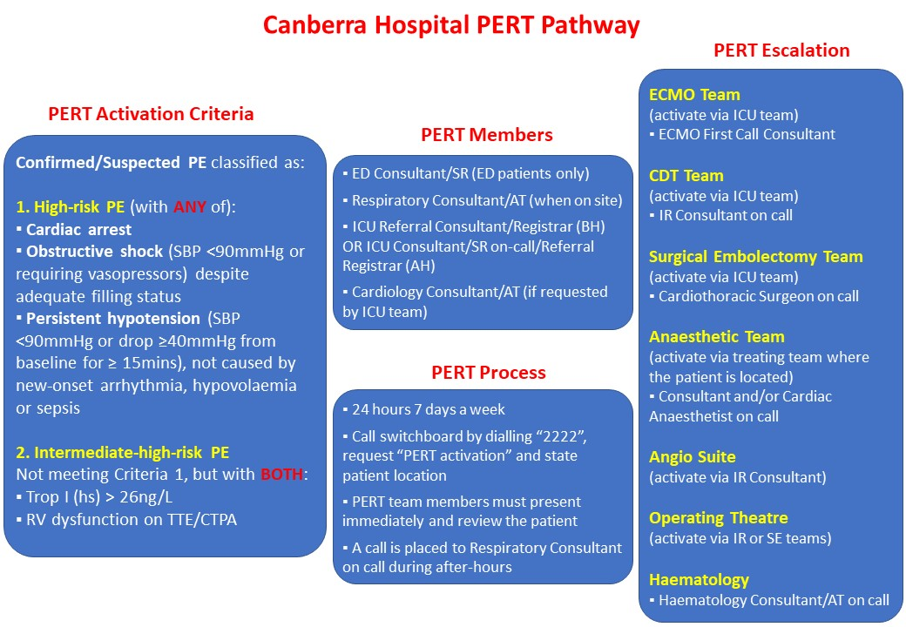

Attachment 2. Canberra Hospital PERT Pathway - Flowchart
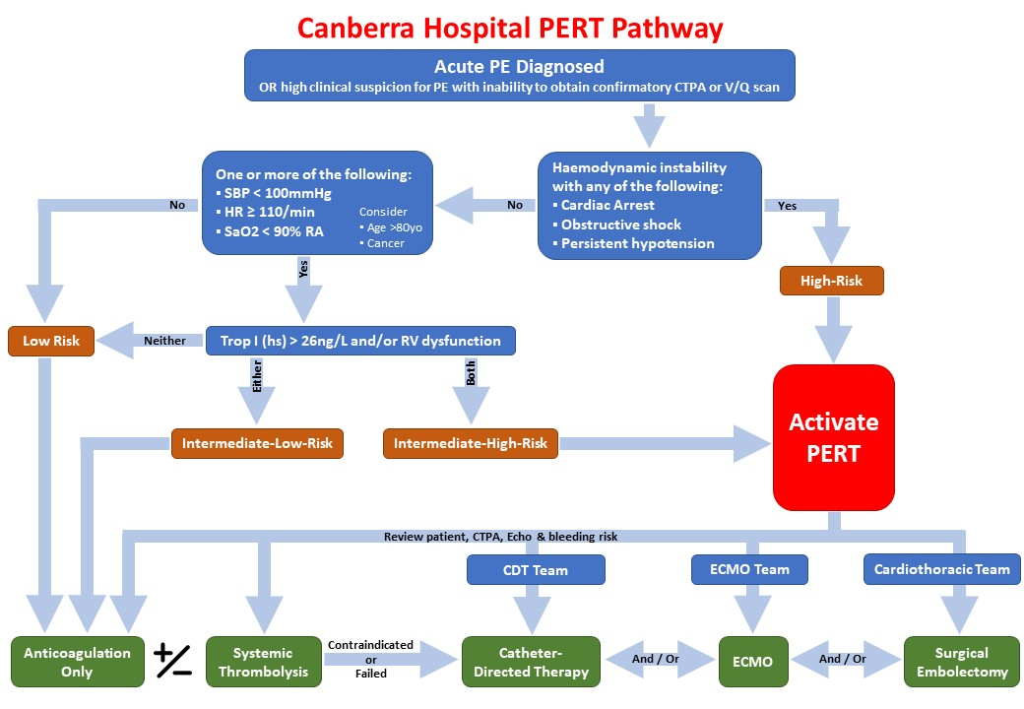

Attachment 3. Pulmonary Embolism Severity Index (PESI) and Simplified PESI (sPESI)
PESI is one of the most extensively validated clinical scores that integrates PE severity and comorbidity. Its strength lies in the reliable identification of patients at low risk for 30-day mortality. sPESI is a simplified version to aid rapid clinical assessment.

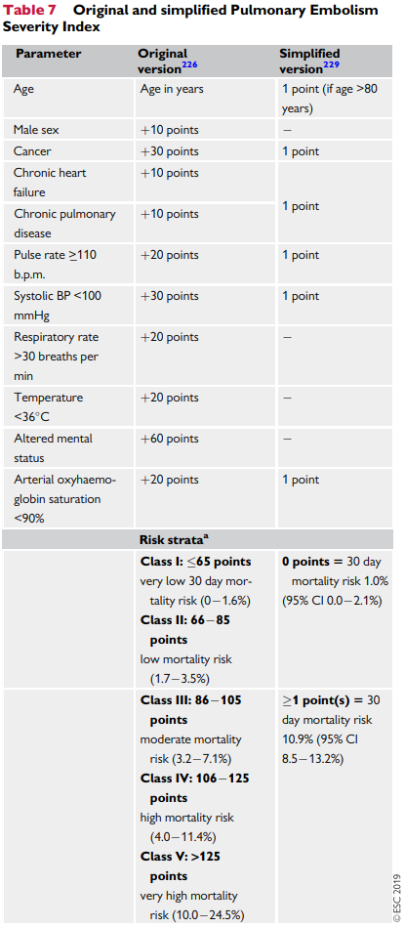

Attachment 4. Common Echocardiographic Findings for PE

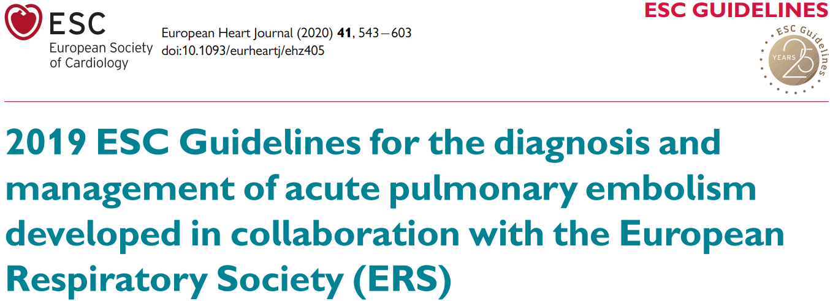

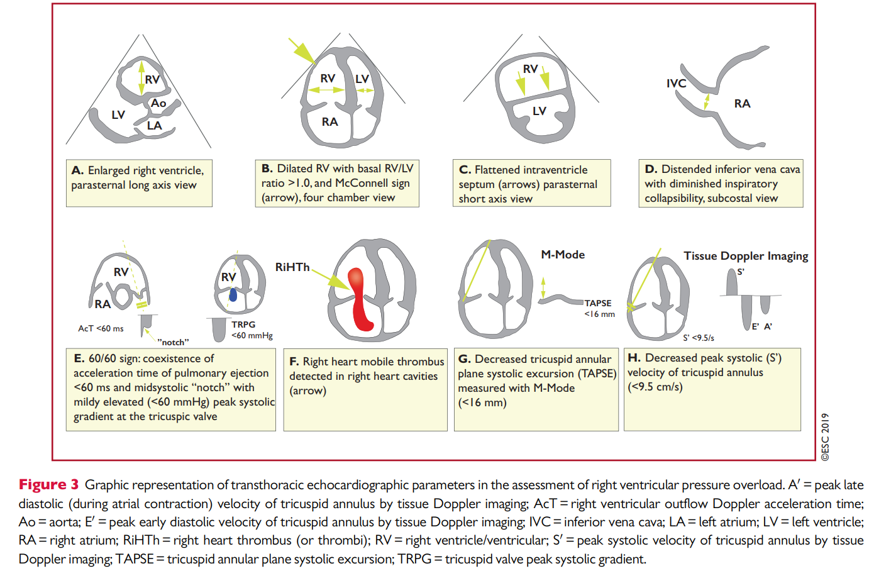

Attachment 5. BOVA Score

