Canberra Health Services
Guideline
Sepsis – Paediatric and Adult (from 28 days of age)

Contents

Contents 1
Guideline Statement 2
Background 2
Key Objective 2
Alerts 2
Scope 3
Section 1 – Roles and Responsibilities 3
Section 2 – Could it be Sepsis? 4
Section 3 – Time Critical Management Bundle 8
Section 4 – Antimicrobial Therapy 12
Section 5 – Comprehensive Care Planning and Clinical Communication 15
Section 6 – Patient and Carer Education and Information 16
Section 7 – Patient’s Digital Health Record (DHR) 16
Evaluation 17
Related Policies, Procedures, Guidelines and Legislation 18
References 18
Definition of Terms 19
Search Terms 20
Attachments 20
Attachment A: Adult Sepsis Clinical Support Tool 21
Attachment B: Maternal Sepsis Clinical Support Tool 23
Attachment C: Paediatric Sepsis Clinical Support Tool 25
Attachment D: Adult First Dose IV Antimicrobial Administration for Sepsis in the ED 27
Attachment E: Paediatric Empiric First Dose Antimicrobial Guidelines for Community Acquired Sepsis 29

Guideline Statement

This document guides Canberra Health Services (CHS) Network team members in the best practice management of sepsis. CHS Network includes the inpatient facilities at Canberra Hospital (CH), Clare Holland House, North Canberra Hospital (NCH), and University of Canberra Hospital (UCH) and community-based services. This guideline outlines key principles to support clinical judgement in the early identification, management, and care of patients with sepsis.

This guideline aligns with CHS systems for recognising and responding to acute deterioration and incorporates key components of the Australian Commission on Safety and Quality in Health Care, Sepsis Clinical Care Standard.

Background
Sepsis is defined as life-threatening organ dysfunction caused by a dysregulated host response to infection¹. While sepsis presents as a spectrum of severity, the potential for rapid and serious deterioration in any patient with sepsis necessitates prompt identification and time critical management whenever sepsis is a possibility.

Sepsis key points
- Sepsis is a medical emergency; early recognition and rapid treatment are critical to improve patient outcomes.
- A diagnosis of sepsis should be considered in any patient with an acute illness or clinical deterioration that may be due to an infection.
- Clinical support tools that include assessment of vital signs and lactate are important to identify possible sepsis early and prompt escalation of care when required.
- Sepsis can affect anyone, although it disproportionately affects the very young, the very old and other high-risk groups, including Aboriginal and Torres Strait Islander people, people with cancer, and people who are immunocompromised.
- Consider sepsis in every child with acute illness or new onset of organ dysfunction, noting that signs and symptoms are often vague and non-specific.
- Early escalation of paediatric cases to critical care (Intensive Care Unit [ICU]/Neonatal Intensive Care Unit [NICU] or via Newborn and Paediatric Emergency Transport Service [NETS]) is essential.

Key Objective
To support CHS team members in identifying patients at risk of sepsis, recognising early the signs and symptoms of sepsis, and to guide coordinated, best-practice and timely care.

Alerts
Please read this document in conjunction with
- Adult (>16 years) haematology and oncology patients - Febrile Neutropenia Management Guideline
- Paediatric (< 16 years) with cancer or a cancer blood disorder - Cancer and Cancer Blood Disorders – Care of Paediatric Patients Guideline

Back to Table of Contents

Scope

This document applies to all CHS team members working within their scope of practice, including:
- Medical Team members
- Registered Nurses and Midwives
- Enrolled Nurses
- Pharmacists
- Allied Health.

This guideline applies to all adult patients and to paediatric patients aged great than 28 days old or if preterm older than 44 weeks corrected gestational age.

For patients aged less than 28 days old or if preterm less than 44 weeks corrected gestational age refer to Neonatal Bacterial Sepsis Guideline.
Back to Table of Contents

Section 1 – Roles and Responsibilities

General Managers (GM)
- Responsible for ensuring operational delivery of the sepsis program at specific CHS Network sites.

Recognising & Responding to Acute Deterioration (RRAD) Committees
- Governance committees responsible for oversight and strategic direction of the Sepsis Program to ensure robust governance and monitoring practices are in place.
- Ensure there is a process for the reporting of Sepsis Program implementation progress, issues, and actions.
- Ensure there is a Network wide process for ongoing routine monitoring of performance against the Sepsis Program indicators and ensure action is taken when performance is outside tolerance ranges.
- Key point of liaison with GM, Chief Operating Officer and other governance committees.

CHS Divisions
- Establish strategies, implement actions and monitoring of sepsis data to ensure exceptional care is delivered.
- Ensure there is a divisional process for ongoing routine monitoring of performance against the Sepsis Program indicators and ensure action is taken when performance is outside tolerance ranges.

Sepsis Program Clinical Lead (time limited implementation role)
- Facilitate the development, implementation and governance of the Sepsis Program and associated guidelines, protocols and management strategies.
- Provide expert advice, direction, and leadership for the Sepsis Program.
- Coordinate and monitor implementation activities, progress and timeline.
- Champion and communicate the Sepsis Program to the clinical workforce.
- Oversee, analyse and monitor hospital-based sepsis indicators to assist with improving clinical care and outcomes for patients.
- Handover, the Sepsis Program to the relevant governance committee when best practice principles are implemented, and clinical indicators are improving and/or meeting or exceeding benchmark levels.
- Note, this position is not responsible for coordination of individual patient care.

Sepsis Network Working Group (time limited)
- Provide expert advice for Sepsis Program delivery, monitoring and support quality improvement.
- Champion and communicate the Sepsis Program to the clinical workforce.
- Escalate risks and issues to the Sepsis Program clinical lead.

Clinicians (medical, nursing, pharmacy and allied health)
- Promote sepsis as a medical emergency, noting that early recognition and rapid treatment are critical to improve patient outcomes.
- Consider a diagnosis of sepsis in any patient with an acute illness or clinical deterioration that may be due to an infection.
- Ensure best practice time critical management of sepsis principles outlined in this guideline are incorporated into clinical decision making.
- Collaborate and promote multidisciplinary care.
- Ensure person-centred, culturally appropriate care remains the focus, and that patients and families participate in decision-making and are informed about their care journey.
- Provide education to patients and families at various stages of care, from the diagnosis of sepsis to discharge.
- Facilitate comprehensive communication and documentation (for example, care plan, medication plan, discharge summary) to clinician(s), patients and families throughout the patient journey.

Back to Table of Contents

Section 2 – Could it be Sepsis?

A diagnosis of sepsis should be considered in any patient with an acute illness or clinical deterioration that may be due to infection. Sepsis screening tools assist clinicians to recognise sepsis early and escalate care when required. They consist of prompts to identify patients with known or suspected infection and clinical trigger criteria which may indicate possible sepsis.

Please see:
- Attachment A: Adult Sepsis Clinical Support Tool
- Attachment B: Maternal Sepsis Clinical Support Tool
- Attachment C: Paediatric Sepsis Clinical Support Tool
Known or Suspected Infection
Risk Factors
Adult, maternal and paediatric risk factors are listed below in Table 1. It is important to acknowledge that an absence of risk factors does not exclude sepsis as a cause of deterioration.

Family and carer concern warrants further investigation and has been included as a significant risk factor. If patients/family/carers are concerned that their medical condition continues to deteriorate and has not been adequately addressed by the clinical team, the CARE for Patient Safety Program enables them to escalate concerns around clinical deterioration. See the Patient & Family Escalation Process - Call and Respond Early (CARE) for Patient Safety Procedure for further information.

Table 1 Risk Factors
Adult Risk Factors
- Re-presentation within 48 hours  - Deterioration despite treatment  - ≥ 65years of age  - Immunocompromised including asplenia  - Aboriginal & Torres Strait Islanders  - Recent surgery / wound / invasive medical device / fall | - Pregnant, birth / termination/ miscarriage in the past 6 weeks  - Risk of intrauterine infection (prolonged rupture of membranes, labor, retained products)  - High level of family/carer concern
Additional Maternal Risk Factors for Maternal Services
- Labour complications (prolonged labour/premature rupture of membranes (PROM)/caesarean/assisted birth/perineal wound)  - Complicated obstetric history (e.g. cervical cerclage/premature birth/ PPH/stillbirth) | - Co-morbidities (e.g. diabetes/obesity)  - Breast infection-mastitis  - History of pelvic infection-STI/ UTI  - Unwell children/household members  - History of group B Strep Colonisation
Paediatric Risk Factors
- Re-presentation within 48 hours  - Deterioration despite treatment  - ≤3 months of age  - Aboriginal & Torres Strait Islanders | - Recent surgery / wound / burn / invasive medical device  - Immunocompromised, including asplenia  - High level of parental concern

Signs and Symptoms
Adult, maternal and paediatric signs and symptoms of infection to be considered are listed below in Table 2. Please note this list is not exhaustive.

Table 2 Signs and Symptoms of Infection
Adult Signs and Symptoms of Infection
- Hypothermia, hyperthermia, rigors  - Neck stiffness, headache, new confusion, change in behaviour or level of consciousness  - Cough, shortness of breath, sputum | - Dysuria, ↑frequency,  - Abdominal pain, distension, peritonism  - Known high or low white blood cell count  - Line associated infection/redness  - Myalgia, back pain, general malaise  - Breast redness, swelling or pain
Additional Maternal Signs and Symptoms of Infection for Maternal Services
- Offensive vaginal bleeding or discharge  Vomiting and diarrhoea | - Cellulitis-epidural site/caesarean or perineal wound/breast
Paediatric Signs and Symptoms of Infection
- Non-blanching rash  - Known high or low white blood cell count  - Line associated infection/redness  - Hypothermia, hyperthermia, rigors  - Decreased urine output | - Signs of toxicity  (Pale or mottled colour; cool peripheries; decreased alertness; arousal or activity; weak cry; grunting; floppiness; apnoea; irritability; bounding pulses; wide pulse pressure)
Clinical Trigger Criteria
Clinical trigger criteria are easily measurable clinical parameters which are used in real time to identify and alert clinicians of patients for further review and assessment. There is wide variation in sensitivity and specificity of sepsis clinical trigger criteria, and debate in the literature is contradictory as to their usefulness. Ultimately, they are an important component of identifying sepsis early for timely intervention, however, are not a replacement for clinical decision making.

These criteria include assessment of vital signs and lactate levels. See Table 3, for specific adult, maternal, and paediatric clinical trigger criteria.

Table 3 Clinical Trigger Criteria
Adult Trigger Criteria
PROBABLE SEPSIS (with organ dysfunction)  ONE of the following  - Lactate ≥ 4mmol/L  - Systolic blood pressure <90mmHg (or a drop >40 from normal) | POSSIBLE SEPSIS  TWO of the following  - Temperature ≥38.5 or ≤35.5  - Heart rate <50 or >120  - Systolic blood pressure <100mmHg (or a drop >40mmHg from their baseline systolic BP  - Respirations <10 or > 25 per minute  - SpO₂ <95% on any oxygen  - Lactate ≥ 2mmol/L  - White cell count <4 or >12 x 10⁹/L  - Clinician ‘worried’
Maternal Trigger Criteria
PROBABLE SEPSIS (with organ dysfunction)  ONE of the following  - Lactate ≥ 4mmol/L  - Systolic blood pressure persistently <90mmHg | POSSIBLE SEPSIS  TWO of the following  - Temperature ≥38 or ≤35.9  - Heart rate <50 or ≥110  - Respirations <9 or > 25 per minute  - Systolic blood pressure <100mmHg  - SpO₂ <95% in RA  - Lactate ≥ 2mmol/L  - White cell count <4 or >15.0 x 10⁹/L  - Clinician ‘worried’
Paediatric Trigger Criteria
PROBABLE SEPSIS (with organ dysfunction)  - Temperature ≥38.5 or ≤36  and ONE of the following  - Lactate ≥ 3mmol/L  - Clinician ‘worried’ | POSSIBLE SEPSIS  - Temperature ≥38.0 or ≤36  and TWO of the following  - Unexplained persistent tachycardia  - Unexplained persistent tachypnoea  - Lactate ≥ 2mmol/L  - White cell count <4 or >12 x 10⁹/L  - Clinician ‘worried’
   | Heart Rate | Resp Rate
  < 3 months | ≥180, ≤70 | ≥70
  3-12months | ≥170, ≤60 | ≥55
  1 to 4 years | ≥160, ≤60 | ≥45
  5 to 11 years | ≥150, ≤60 | ≥40
  12 to 16 years | ≥130, ≤40 | ≥35
   | Heart Rate | Resp Rate
  < 3 months | ≥170, ≤80 | ≥65
  3-12months | ≥160, ≤70 | ≥50
  1 to 5 years | ≥140, ≤70 | ≥40
  5 to 12 years | ≥140, ≤70 | ≥35
  12 to 16 years | ≥110, ≤50 | ≥30

Some of these criteria align with other CHS deterioration and escalation programs. These should not be ignored and include:
- The Vital Signs and Early Warning Scores procedures, which outlines specific EWS escalation processes.
- Code Blue Emergency Management Plan.
- Acutely Unwell and Deteriorating Paediatric Patient Procedure

Please refer to the individual CHS procedures for more detail.

Senior Medical Review
Sepsis is a complex condition which can evolve rapidly. Review by a medical officer who has the appropriate clinical care skills to manage a critically ill patient unsupervised, or until a specialist is available is a key component to ensure timely identification, time critical management and communication and collaboration between all clinicians involved in the patient’s sepsis journey.

Maternal Sepsis
Healthy young women may mask signs of sepsis. Any pregnant person presenting with abnormal vital signs should have appropriate investigations completed to exclude sepsis. Examination, including extensive history and targeted investigations are imperative to determine likely source. In pregnancy, sepsis may be present with or without fever or an obvious source until the time that septic shock presents. Fetal distress may be the first presenting symptom as the uteroplacental circulation is not auto regulated.

Note: Sepsis during pregnancy requires assessment of maternal investigations and fetal/baby well-being unless there has been a perinatal loss by cardiotocograph and/or ultrasound (refer to the Fetal Surveillance guideline, available on the Policy and Guidance Documents register, for gestational indications). Ensure early involvement of Obstetric team for all pregnant people.

Back to Table of Contents

Section 3 – Time Critical Management Bundle

The time critical management bundle consists of interventions required rapidly when sepsis is known or highly likely. Initiation of the time critical bundle should be commenced when a patient:
- has a known or suspected infection,
- meets clinical trigger criteria, and
- the clinician believes sepsis is likely.

Note:
Adapt management/bundle to the patients end of life plan if applicable.

Adult, maternal and paediatric interventions are outlined on the clinical support tool for quick reference and summarised below. Please see:
- Attachment A: Adult Sepsis Clinical Support Tool
- Attachment B: Maternity Sepsis Clinical Support Tool
- Attachment C: Paediatric Sepsis Clinical Support Tool.

- Airway and Breathing
Address airway and breathing compromise and give oxygen as required to maintain oxygen saturation greater than or equal to 95% (88-92% for patients with chronic obstructive pulmonary disease [COPD]). A thorough history including what constitutes normal oxygen levels is required for children with chronic medical conditions.

- Vascular Access
Rapid establishment of intravenous (IV) access is crucial to support fluid resuscitation if clinically indicated, antibiotic administration and resuscitation if required.

Consider gaining access via intraosseous (IO) if IV access is unsuccessful after no more than two attempts.
- Bloods, Blood Cultures and Lactate
Blood Cultures
Blood cultures identify causative pathogens, allowing more effective targeted antibiotic therapy and benefit downstream care. However, if it is not logistically possible to obtain cultures promptly, the risk/benefit ratio favours rapid administration of antimicrobials in critical infections, for example septic shock, meningitis, meningococcal sepsis.

Adult
No central venous access device (CVAD): Take two sets from two separate sites.
CVAD: one set via venepuncture from a peripheral site, as well as one set from the CVAD.

Note: If the CVAD has multiple lumens, collect a third set from a separate lumen (three sets in total).

Paediatric
A single bottle system (aerobic) is used for infant / small child as bacteraemia caused by anaerobic pathogens are less common than aerobic pathogens.

If infant / small child is considered at higher risk of a significant anaerobic infection (immunocompromised, those with head and neck, intra-abdominal or pelvic infection, or sepsis with organ dysfunction), the medical team may request blood culture collection using an Adult Blood Culture Set. This decision should be based on the patient’s clinical presentation and risk factors, with consideration to obtaining adequate sample volume and potential haemodynamic compromise associated with a larger sample volume.

Refer to the Blood Culture Collection Procedure for further details.

Lactate
An increased lactate level may indicate a protective or a maladaptive response to shock, and the association of high lactate levels with mortality in patients with suspected infection and sepsis is well established. Include blood lactate testing routinely and as soon as possible in decision-making for an acutely deteriorating patient or for suspected sepsis.

Note: University of Canberra Hospital (UCH) does not have lactate testing capacity onsite.

Blood Tests
Blood tests: Blood glucose level, FBC, CRP, LFT, coagulation studies (PT, APTT), UEC.

- Antibiotics – see Section 4 – Antimicrobial Therapy

- Fluid therapy
Address sepsis-induced tissue hypoperfusion through timely, effective fluid resuscitation where clinically indicated.

If limited response to fluids, consider vasopressors/inotropes in consultation with senior clinician.

- Other Investigations
Perform an investigation only if the result is likely to alter management. Investigations may include:

Microscopy, Culture, and Sensitivity
- Mid-stream urine (MSU) or catheter specimen of urine (CSU). Note. this should be performed in all children febrile greater than 48hrs.
- Sputum for MCS.
- Wound swab for Microscopy, Culture and Sensitivity (MCS).
- Stool for C. difficile testing (if diarrhoea present).
- Multi resistant organism (MRO) screening if an invasive medical device present.
- Nasopharyngeal /throat swab for respiratory pathogens nucleic acid test (NAT) and SARS-CoV-2 NAT.

Diagnostic Imaging
Conduct a chest X-ray and consider other clinically indicated imaging.

Note: Chest X-ray is most useful if signs of respiratory illness are present, such as cough, tachypnoea, dullness or crackles. If there are no respiratory signs, perform other investigations first.

Note: Clinically indicated radiological imaging investigations should not be withheld in pregnancy due to concerns regarding fetal radiation or maternal breast tissue exposure. It is necessary to balance the risks of the procedure with the maternal benefits in assisting with diagnosis and management.

Lumbar Puncture
Consider lumbar puncture if central nervous system infection is suspected. However, if very unwell, resuscitation and antibiotics take precedence – do not delay.

- Urine Output
Urine output is a key indicator in sepsis. Changes in urine output are closely related to physiological responses, changes in tissue perfusion, severe inflammatory response, renal dysfunction, and clinical treatment.

- The target urine output for adults is a minimum of 0.5 mL/kg/hr.
- The target urine output for infants and children is a minimum of 1 ml/kg/hr.
- Document strict fluid balance chart and consider an indwelling catheter (IDC).

- Monitor and Re-assess
Close monitoring of observations is recommended for patients with suspected or confirmed sepsis due to high risk of clinical deterioration. Repeat observations within 30min or more frequently as clinically indicated or as per EWS Escalation process.
Repeat lactate levels should be taken after each fluid bolus. If fluids are not being administered, repeat in two hours.

Microbiology and antibiotic review within the first 12 hours.

- Escalation / Consultation
Sepsis is a complex and rapidly evolving condition and requires a collaborative approach.
Table 4 highlights key triggers for escalation and consultation.

Table 4 Key triggers for escalation and consultation
Triggers for Escalation / Consultation
Escalation Point | Paediatric | Adult | UCH
Senior Medical | - No improvement or further deterioration  - Clinician concern  - Family / carer concern
Emergency Department | Non-admitted patients  - If ongoing treatment required *  - Direct ward admissions when timely bed access is not available. |  | Non-admitted patients  - If ongoing treatment required *  Inpatients  - Where care is beyond scope of a sub-acute facility *
Paediatrician | Early referral for paediatric patients | N/a
Obstetrician | N/a | Early referral for obstetric patients – ≥20 weeks gestation | N/a
ICU /NICU Referral** | - No improvement after 40 mL/kg fluid  - Vasopressor +/-inotrope requirement  - Requiring respiratory support  - Lactate > 3 mmol/L  - < 1 year of age – NICU  - 1 - 2 years of age – NICU Consider early NETS advice  - ≥ 2 years of age – ICU  Consider early NETS advice | As per MEWS Escalation Table. | N/a
NETS/ Paediatric ICU ** | - Multi system, complex or greater than short-term support required | N/a
Infectious Diseases | Early referral if extensively pre-treated with antimicrobial(s), MRO history, septic shock, unclear source, recent travel history or has not clinically improved or has further deteriorated.
Surgical Team | Early referral if there is evidence of a collection or other infection that would benefit from surgical intervention.
* As per Canberra Hospital and UCH Code Blue Procedure
**As per Acutely Unwell & Deteriorating Paediatric Patient Guideline

Back to Table of Contents

Section 4 – Antimicrobial Therapy

Time Critical Administration
Antimicrobials should be administered as early as possible to a patient with sepsis. A delay to the first dose of antimicrobial therapy is associated with increased mortality.

When signs of infection-related organ dysfunction are present, appropriate antimicrobials should be started within 60 minutes of sepsis recognition. Figure 1 illustrates recommendations on timings of antimicrobial administration based on severity of illness and infection likelihood.

Figure 1 Recommendations on timings of antimicrobial administration²

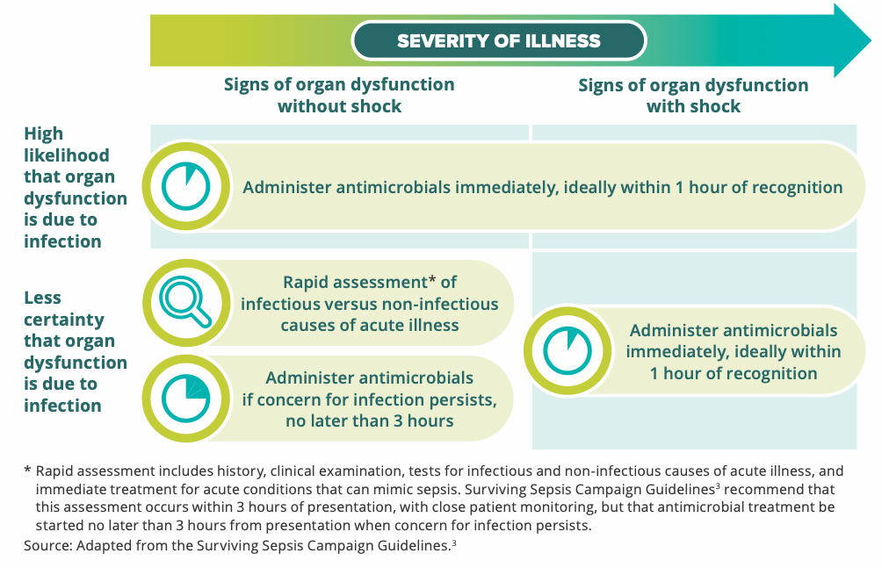

To assist with rapid administration of the initial doses of antimicrobials the following guidance is available:
- Administration sequence of antimicrobials to ensure the highest number of antimicrobials are administered in the shortest possible time. That is, those with the shortest administration time progressing to those with longer administration times.
- If concurrently prescribed antimicrobials have similar administration times, the optimal order of administration of antimicrobials is dependent on the clinical scenario. PATIENT’S CLINICAL RECORDS programming should reflect the preferred order of administration preference where possible for each condition.
- Although the concept of broader to narrower spectrum antimicrobials (see table below) is not a universal concept and is variable dependent on the clinical scenario, in the absence of other guidance the table below may be used to guide administration preference for antimicrobial with similar administration times when all antimicrobials are equally accessible.
- When indicated in prescribing guidelines and all antimicrobials are equally accessible, Ceftriaxone should in most cases be administered first, followed by Gentamicin followed by other antimicrobials. No antimicrobials should be delayed to comply with this order preference; if Ceftriaxone is not ready for administration at the bedside before other antimicrobials.

Broad  (administer first)  Narrow  (administer last) | Piperacillin + Tazobactam; Meropenem; Ceftriaxone; Ceftazidime
Broad  (administer first)  Narrow  (administer last) | Ciprofloxacin; Cefazolin; Trimethoprim/Sulfamethoxazole
Broad  (administer first)  Narrow  (administer last) | Gentamicin; Tobramycin; Clindamycin; Tigecycline; Colistin
Broad  (administer first)  Narrow  (administer last) | Benzylpenicillin; Ampicillin; Flucloxacillin
Broad  (administer first)  Narrow  (administer last) | Azithromycin; Vancomycin, Daptomycin; Linezolid
Broad  (administer first)  Narrow  (administer last) | Metronidazole

- Consideration of intramuscular (IM) injection if delays in obtaining IV/IO access are greater than 15 minutes.

To simplify administration processes and therefore assist with rapid administration of antibiotics Adult First Dose Antimicrobial administration in CH ED times have been standardised to the highest common fluid volume denominator for antimicrobial agents.

Please see CHS Sepsis Antimicrobial Prescribing Guidelines: Attachment C: Adult First Dose Antimicrobial Administration for Sepsis in ED.

Appropriate Antimicrobials
The appropriate empiric antimicrobial for an individual patient will depend on the source of infection, patient factors, local microbiology and CHS antimicrobial formulary.

A CHS local antimicrobial guideline has been developed for paediatric patients:
Attachment E: Paediatric Empiric First Dose Antimicrobial Guidelines for Community Acquired Sepsis.

All other sepsis antimicrobial recommendations follow the CHS Antimicrobial Stewardship (AMS) program endorsed guidelines in the following order:

- CHS formulary see https://healthhub.act.gov.au/governance/chhs-formulary
- Local hospital guidelines which can be found on the CHS Policy Register. These include:
  - Gentamicin - Clinical Guidelines for Dosing and Monitoring of Once Daily Gentamicin in Paediatric Patients
  - Antimicrobial Choice and Administration for Adult Hospital in the Home (HITH)
  - Intravenous Dosing and Monitoring of Aminoglycosides in Adults
  - Cystic Fibrosis - Management and Care of the Patient
  - Peritoneal Dialysis – see Peritoneal Dialysis Peritonitis (PD Peritonitis) Management section
  - Neonatal Bacterial Sepsis
  - Adult (>16 years) haematology and oncology patients - Febrile Neutropenia Management
  - Paediatric (< 16 years) with cancer or a cancer blood disorder - Cancer and Cancer Blood Disorders – Care of Paediatric Patients.
- The current version of the Australian Therapeutic Guidelines: Antibiotic³(eTG) can be found under link “Clinical Apps – Therapeutic Guidelines” on CHS intranet site. (PATIENT’S CLINICAL RECORDS Antimicrobial Panels are consistent with the latest version of this resource).
- Advice from Microbiology, Infectious Diseases or AMS Teams.
Early referral to the Infectious Disease Service is important if the patient has - been extensively pre-treated with antimicrobial(s), MRO history, septic shock, unclear source, recent travel history, has not clinically improved or has further deteriorated.

Antimicrobials should be assessed by the treating team with microbiology results within the first 12 hours and at a minimum of daily thereafter.

Refer to the Antimicrobial Stewardship Procedure for further details.

Back to Table of Contents

Section 5 – Comprehensive Care Planning and Clinical Communication

Care Planning
Critical information must be documented in the patient’s management/care plan and clinical record to support effective routine, structured communication and collaboration between all clinicians involved in the patient’s journey. The care plan should be shared with the patient and family and the relevant clinical team(s).

Sepsis in Pregnancy and timing of birth
In the setting of sepsis in pregnancy, the goal of fetal surveillance is to assess fetal well-being as well as to determine the presence of intrauterine and fetal infection. Ensure early obstetric and neonatal consultation, especially in the case of prematurity, to improve neonatal outcomes associated with premature birth. The timing of delivery will be determined by the presence of intrauterine sepsis (chorioamnionitis), the nature of maternal sepsis, response to initial resuscitation efforts, gestation of the pregnancy, and the fetal status.

Clinical Handover
The purpose of clinical handover is to ensure that relevant, accurate and current information about a patient’s care is transferred to the right person or people, action is taken (when necessary), and continuity of patient care is maintained. See the CHS Clinical Handover Procedure for further information.
Key sepsis specific clinical handover points include:
- Sepsis diagnosis
- Likely source of infection, including relevant microbiology results
- Time of next antibiotic review
- Any further investigation plans
- Frequency of observations and monitoring, including deterioration flags
- Urine output and fluid balance.

Discharge Planning
Comprehensive care planning includes the transition from CHS to home or another service.
Sepsis can have long-lasting effects including new and persisting physical, cognitive and psychological concerns and there is a high risk of readmission to hospital. These risks need to be assessed and discussed with patients and their family prior to discharge and the required follow up arrangements made.

This discussion and these follow-up requirements need to be reflected in the patient’s clinical record and included in the discharge documentation provided to the patient, family and usual doctor. For example:
- Sepsis as a diagnosis including source and microbiology
- Summary of management and investigations
- Medicines list, including duration of antibiotics
- Follow-up appointments and referrals
- Discharging Medical Officer’s name and clinical unit.

See the CHS Discharge Summary Completion – Inpatients Procedure for further information.

Back to Table of Contents

Section 6 – Patient and Carer Education and Information

The patient and their family should be informed about sepsis from the time that it is suspected, throughout their care and at discharge. Information may include risk factors, signs and symptoms, how to escalate care if concerned, the expected treatment and potential short- and long-term health effects of sepsis.

Information will be provided verbally throughout the patient journey and several sepsis consumer health information sheets are available for use at CHS. These are available via the Policy and Guidance Register.
Back to Table of Contents

Section 7 – Patient’s Digital Health Record (DHR)

Several sepsis tools are included in the patient’s EHRs which can be accessed and utilised at any time if you suspect your patient has sepsis or is at risk of developing sepsis. Key components are outlined below.

Best Practice Advisory
The patient’s DHR system has been configured with a sepsis best practice advisory (BPA) that act as an early warning system to detect patients who may meet sepsis clinical trigger criteria, and alert clinicians with a pop-up alert or an alert on the patients’ story board. The BPA is not a replacement for clinical judgement and still allows clinicians to make decisions about the most appropriate management of patients under their care.

A BPA will appear in the patient’s DHRs if the patient meets the predetermined sepsis clinical trigger criteria outline in section 2 – could it be Sepsis?

Please note the BPA will not appear if:
- The sepsis order set has already been initiated.
- Active trauma / ST-elevation myocardial infarction (STEMI) / Sedation has been documented.
- A sepsis review outcome is documented.

Known or Suspected Infection Screening
The known or suspected infection screening outlined in section 2 are present on the patient’s DHRs emergency department triage page to guide early identification, observations, reassessment, and escalation if required.

Additionally, once the Sepsis BPA is triggered, the known or suspected infection screening prompts appear so the clinician can consider these when reviewing the BPA and determining next actions.

Sepsis Order Set
The sepsis order sets guide time critical sepsis management. The order sets are not a replacement for clinical judgement and still allow clinicians to make decisions about the most appropriate management of patients under their care.

The sepsis order sets can be opened through the sepsis BPA, ED quick orders or searched for under general order sets. The order set components are outlined in Section 3 – Time Critical Management Bundle.

Sepsis Navigator
The sepsis navigator page can be opened at any time either by clicking the link in the Sepsis BPA or through the “more menu”. The sepsis navigator page provides an overview of sepsis related observation, reviews and management.
Back to Table of Contents

Evaluation

Outcome
That team members are aware of and incorporate the best practice principles outlined in this guideline into their clinical decision making.

Measures
Routine monitoring of performance against the Sepsis Program clinical indicators outlined below:
- Proportion of blood lactate levels taken ≤ 1 hour from recognition.
- Proportion of patients who were treated according to the locally approved sepsis clinical support tool.
- Proportion of patients who had blood cultures taken before starting antimicrobials.
- Proportion of first dose of an empirical antimicrobial ≤ 1 hour and ≤ 3 hours from recognition.
Back to Table of Contents

Related Policies, Procedures, Guidelines and Legislation

Procedures/Guidelines
- Acutely Unwell and Deteriorating Paediatric Patient
- Antimicrobial Stewardship
- Blood Culture Collection (excluding neonates)
- Cancer and Cancer Blood disorders – Care of Paediatric Patients
- Clinical Handover
- Code Blue Emergency Management Plan, Canberra Hospital
- Code Blue Emergency Management Plan, University of Canberra Hospital
- Code Blue Emergency Management Plan, North Canberra Hospital
- Consent for Treatment
- Discharge Summary Completion – Inpatients
- Early Onset Group B Streptococcus Disease (EOGBSD) Maternity
- Febrile Neutropenic Management
- Infection Prevention and Control
- Neonatal Bacterial Sepsis
- Patient and Family Escalation Process – Call and Respond Early (CARE) for Patient Safety
- Vital Signs and Early Warning Scores – The Canberra Hospital Inpatients
- Vital Signs and Early Warning Scores – University of Canberra Hospital
- Vital Signs & Early Warning Scores - North Canberra Hospital

National Guidelines
- Sepsis Clinical Care Standard

Legislation
- Health Records (Privacy and Access) Act 1997
- Human Rights Act 2004
- Carers Recognition Act 2021
- Medicines, Poisons and Therapeutic Goods Act 2008 (ACT)

Other
- Australian Charter of Healthcare Rights
Back to Table of Contents

References

- Singer M, Deutschman CS, Seymour CW, et al. The Third International Consensus Definitions for Sepsis and Septic Shock (Sepsis-3). JAMA. 2016;315(8):801-810.
- Australian Commission on Safety and Quality in Health Care. Sepsis Clinical Care Standard. Sydney: ACSQHC; 2022.
- Australian Commission on Safety and Quality in Health Care. Antimicrobial Stewardship Clinical Care Standard. Sydney: ACSQHC; 2020.
- Australian Commission on Safety and Quality in Health Care. National Consensus Statement: Essential elements for recognising and responding to acute physiological deterioration (third edition). Sydney: ACSQHC; 2021.
- Bowyer L, Cutts BA, Barett HL, et al. SOMANZ position statement for the investigation and management of sepsis in pregnancy 2023, Aust N Z J Obstet Gynaecol. 2024;1-10.
- Clinical Excellence Queensland – Sepsis, accessed April 2023.
- Evans L, Rhodes A, Alhazzani W, et al. Surviving sepsis campaign: international guidelines for management of sepsis and septic shock 2021. Intensive Care Med. 2021;47(11):1181-1247.
- National Institute for Health and Care Excellence. Sepsis: recognition, diagnosis and early management (update draft consultation). London: NICE; March 2023.
- NSW Clinical Excellence Commission – Sepsis Kills Program, accessed April 2023.
- Bowyer L, Cutts BA, Barett HL, et al. SOMANZ position statement for the investigation and management of sepsis in pregnancy 2023, Aust N Z J Obstet Gynaecol. 2024;1-10.
- Weiss SL, Peters MJ, Alhazzani W, et al. Surviving Sepsis Campaign International Guidelines for the Management of Septic Shock and Sepsis-Associated Organ Dysfunction in Children. Pediatr Crit Care Med. 2020;21(2):e52-e106.

Back to Table of Contents

Definition of Terms

Best Practice Advisory (BPA) | BPAs are an early warning system built into the PATIENT’S CLINICAL RECORDS to detect patients who may meet sepsis clinical trigger criteria. They alert clinicians with a pop up alert or an alert on the patients storey board.
Clinical Support Tool | Is an evidence-based map that supports clinician decision-making and organisation of care and treatment for a well-defined group of patients.
Clinical Trigger Criteria | Clinical trigger criteria are easily measurable clinical parameters which are used in real time to identify and alert clinicians of patients for further review and assessment.
Organ Dysfunction | Physiological imbalances in individual organs, including the lungs, heart and brain. This can be determined by conducting a set of patient observations.
Possible Sepsis | Where sepsis is suspected. However, there may be uncertainty about the infection or the cause of the symptoms.
Senior Medical Officer | A medical officer who has the appropriate clinical care skills to manage a critically ill patient unsupervised, or until a specialist is available.
Sepsis | A life-threatening organ dysfunction caused by a dysregulated host response to infection^{1.}
Sepsis (with organ dysfunction) - Adult | Suspected or known infection with evidence of organ dysfunction including:  - Systolic blood pressure <90mmHg (or a drop >40 from normal)  - Lactate ≥ 4mmol/L
Sepsis (with organ dysfunction) - Paediatric | Suspected or known infection with evidence of organ dysfunction including:  - Temperature ≥38.5 or ≤36  - Unexplained persistent tachycardia  - Unexplained persistent tachypnoea
Back to Table of Contents

Search Terms

Sepsis, Septic Shock, Deterioration, Antimicrobial, AMS, Antibiotic, Lactate.

Back to Table of Contents

Attachments
Attachment A: Adult Sepsis Clinical Support Tool
Attachment B: Maternal Sepsis Clinical Support Tool
Attachment C: Paediatric Sepsis Clinical Support Tool
Attachment D: Adult First Dose Antimicrobial Administration for Sepsis in ED
Attachment E: Paediatric Empiric First Dose Antimicrobial Guidelines for Community Acquired Sepsis

Disclaimer: This document has been developed by Canberra Health Services specifically for its own use. Use of this document and any reliance on the information contained therein by any third party is at his or her own risk and Canberra Health Services assumes no responsibility whatsoever.

Policy Team ONLY to complete the following:
Date Amended | Section Amended | Divisional Approval | Final Approval
30/11/2023 | Reviewed document | Rebekah Ogilvie A/g ED Medicine | CHS Policy Committee
11/12/2024 | Amended to include NCH and additional information on maternity patients | Shakira Spiller, Director Innovation and Improvement | PDRP Chair
16/05/2025 | Updated scope to clarify applicability and direct staff to appropriate guidelines. | Executive Director, Medicine | CHS Policy Team

This document supersedes the following:
Document Number | Document Name
CHS21/680 | ED Adult Sepsis Clinical Pathway
CHS24/078 | Identification and Management of Adult Sepsis- North Canberra Hospital (NCH)
Attachment A: Adult Sepsis Clinical Support Tool 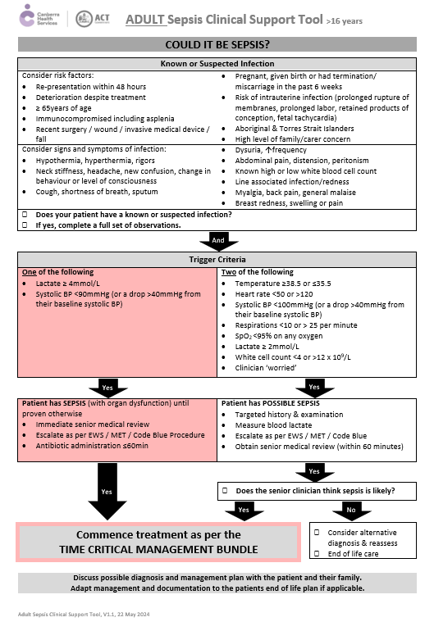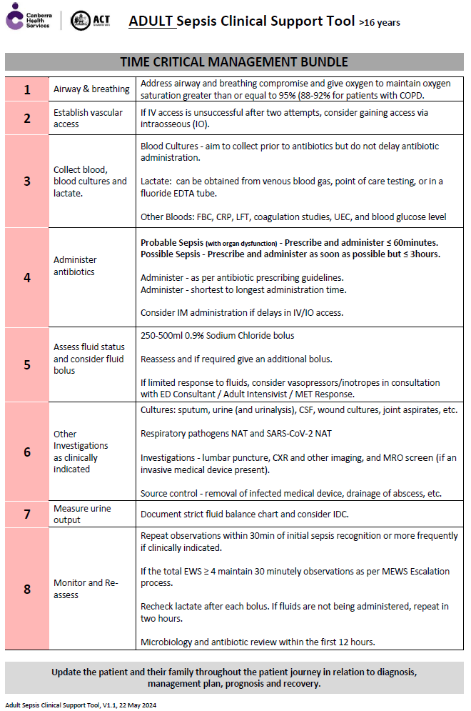

Attachment B: Maternal Sepsis Clinical Support Tool
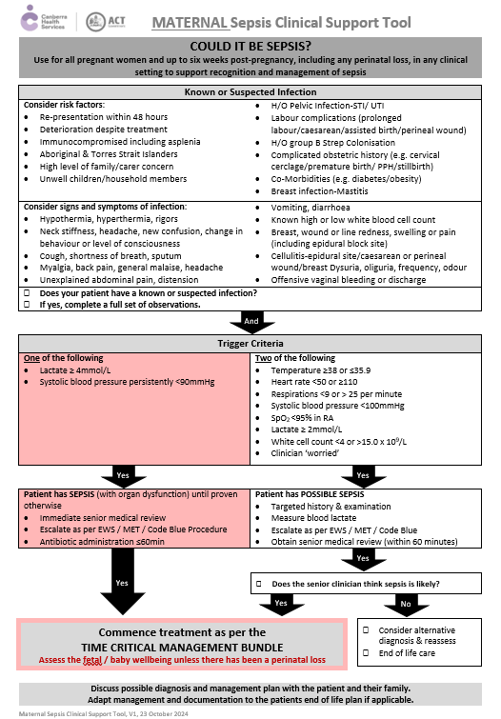

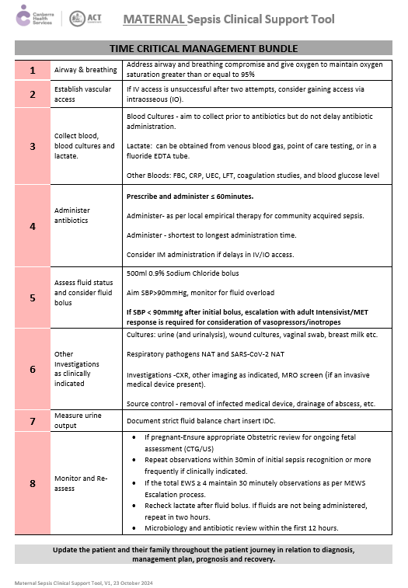

Attachment C: Paediatric Sepsis Clinical Support Tool
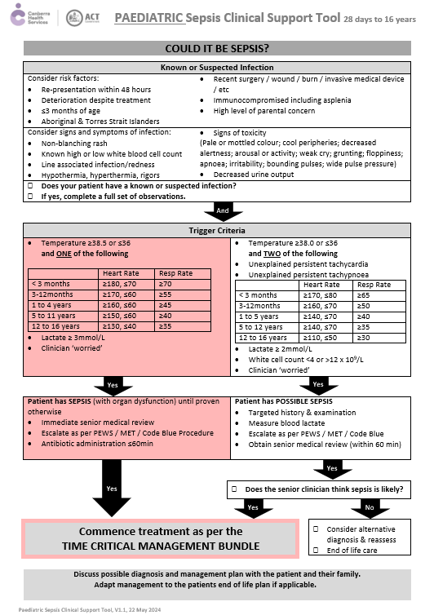
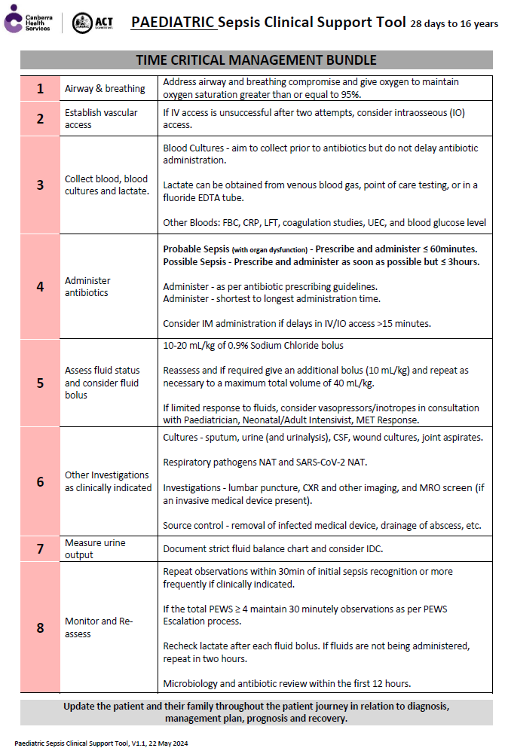

Attachment D: Adult First Dose IV Antimicrobial Administration for Sepsis in the ED
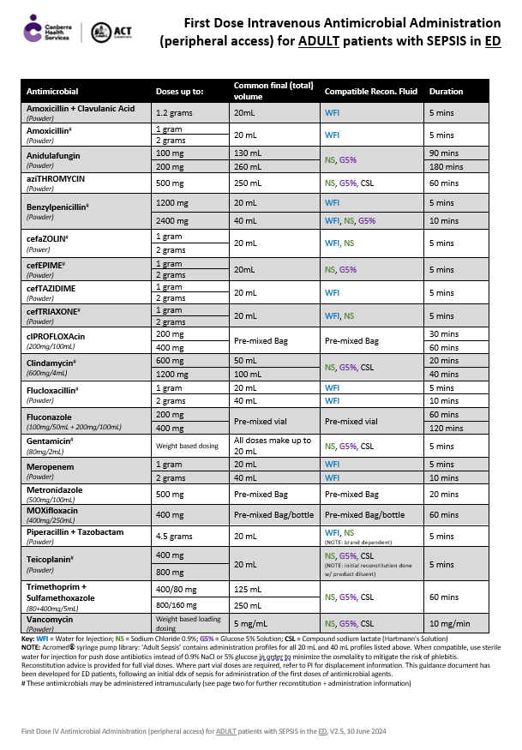
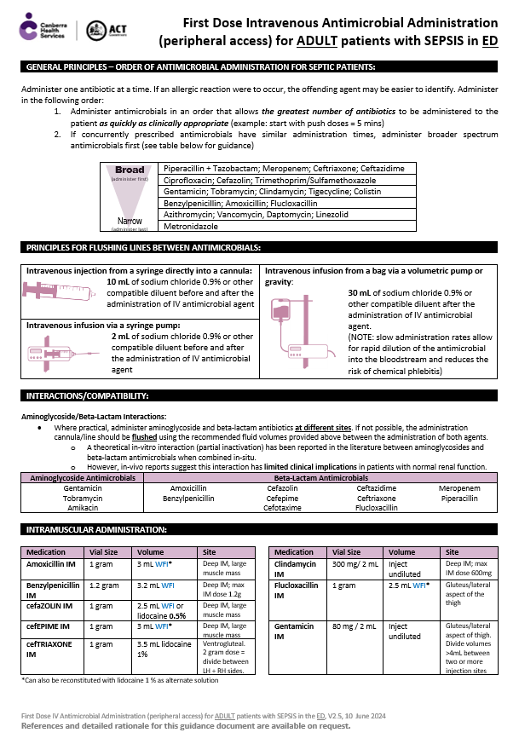

Attachment E: Paediatric Empiric First Dose Antimicrobial Guidelines for Community Acquired Sepsis
