Canberra Health Services
Procedure
Mental Health Court Assessment and Liaison Service Operational Procedure

Contents

Contents 1
Purpose 2
Scope 2
Section 1 – Service Overview 2
Section 2 – Special Population Groups 4
Section 3 – Court Liaison and Triage Assessment 5
Section 4 –Court Liaison: Brief Mental Health Reports 10
Section 5 – Court Liaison: Drug and Alcohol Sentencing List 12
Section 6 –Court Assessment: ACAT Reports 15
Section 7 – Court Assessment: Expert Reports 17
Section 8 – Data Collection 19
Evaluation 19
Related Policies, Procedures, Guidelines and Legislation 20
Search Terms 21
Attachments 21

Purpose

Mental Health Court Assessment and Liaison Services (MHCALS) is a specialist mental health service developed in response to high rates of people with mental illness and disorder in court settings. MHCALS aims to support the ACT Court system and people presenting before the ACT Courts through provision of high-quality consultation and liaison regarding mental health issues in this setting. MHCALS provides a range of services to a number of stakeholders in the criminal justice system. It provides liaison services for the ACT Courts to identify, assess, and where possible divert people with mental illness into appropriate mental health services. It also provides assessment and referral services for people of all ages who may have a mental health condition and require further assessment and treatment.

This Operational Procedure provides processes for the operation of the MHCALS. It is intended to provide procedural instructions and general information required for Canberra Health Services (CHS) health professional working in this service.

Back to Table of Contents

Scope

This procedure applies to Forensic Mental Health Services (FMHS) staff working in the MHCALS and is designed to provide staff with guidance in their engagements with adults (18 years and older) and children and adolescents (under 18yrs). MHCALS Staff may engage with both adults (18-years and older) and children and adolescents (persons under 18-years) who are referred to us via their encounters with the court-system.

The procedure applies to the following staff working within their scope of practice:
- Medical officer
- Registered nurse
- Allied health professional
- Students working under direct supervision.

Section 1 – Service Overview

MHCALS provides two streams of service: the Court Liaison Service and the Court Assessment Service.

Court Liaison Service
The Court Liaison Service screens for and accepts referrals for individuals who may be presenting with mental illness or disorder or concerns regarding their risk of harm to self in the Court. Referrals are received from multiple sources, including for example, the Courts, ACT Corrective Services, the police, and legal practitioners. These referrals are prioritised for assessment through triaging. Advice is provided to the ACT Courts regarding appropriate follow up for those people consenting to assessment, or those displaying a lack of capacity for decision making or significant risk issues. Recommendations to the Court could include the need for immediate treatment and care, or referral options in the event they are remanded in custody or bailed to the community.

The appropriate identification of people with mental illness or disorder allows for suitable treatments and supports to be made available, potentially reducing the individuals’ risk of self-harm or harm from others, increasing their ability to engage with the criminal justice process, and improving the criminal justice system outcomes for people with mental illnesses or disorders.

Services that are provided by the Court Liaison Service include:
- Triage of all people in the court cells who are newly brought into custody, and assessment of people who are identified as potentially experiencing deterioration in mental state and/or at imminent risk of self harm or suicide
- Assess and provide brief mental health reports when requested by the Court to provide information regarding a person’s mental health
- Assess and provide screening assessments and brief mental health reports to inform whether a Drug and Alcohol Sentencing Order is suitable for the person
- Liaison between mental health services and the Court.

The Court Liaison Service does not provide:
- Welfare referrals such as assistance with housing, etc.
- Assistance with discharge planning for people returning to court on s309 assessment order
- Psychosocial support to general members of the public attending court.

Court Assessment Service
The Court Assessment Service provides clinical reports to the ACT Courts, in response to a court request. The Court Assessment Service may also provide reports to the ACT Civil and Administrative Tribunal (ACAT) where there is clinical complexity. The types of reports that are provided by the Court Assessment Service include:
- Opinion regarding mental impairment for serious offences (s334 Crimes Act 1900)
- Reports specific to Verdins sentencing principles for serious offences
- Reports specific to Fitness to Plead criteria
- Reports specific to Criminal Responsibility for serious offences

Back to Table of Contents

Section 2 – Special Population Groups

Specific population groups within the cohort of people who access MHCALS services may have unique mental and physical health care requirements and consideration should be given to these in the planning and provision of care. These special population groups may include the following:

Aboriginal and Torres Strait Islander People
MHCALS acknowledges the Traditional Custodians of the land, the Ngunnawal people, and any other Aboriginal and Torres Strait Islander Persons with connection to this land and region. CHS respects their continuing culture and connections to the land and the unique contributions they make to the life of this area.

CHS is committed to providing culturally safe and sensitive care. As set out in the Aboriginal and Torres Strait Islander Impact Statement and Declaration procedure, CHS is committed to continuously improving the level of service delivered to Aboriginal and Torres Strait Islander people. MHCALS acknowledges the overrepresentation of Aboriginal and Torres Strait Islander Peoples within the criminal justice system and are committed to providing equal access and support during their court matters. Where appropriate, MHCALS will partner with the Mental Health, Justice Health and Alcohol and Drug Service (MHJHADS) Aboriginal and Torres Strait Islander Cultural Specialist Service when delivering services to ensure that services are culturally appropriate and foster a culturally safe environment.

MHCALS acknowledges the importance of providing holistic care to Aboriginal and Torres Strait Islander Peoples, understanding the need for social, emotional, and cultural wellbeing to be considered within all aspects of service provision to ensure overall health and wellbeing of Aboriginal and Torres Strait Islander Peoples.

MHCALS delivers culturally appropriate care by ensuring all clinicians have an understanding of Aboriginal and Torres Strait Islander culture, provide a culturally safe environment, build positive working relationships and involve (where possible) Aboriginal and Torres Strait Islander people as part of the persons health care team.

Carers

As outlined in the Canberra Health Services Partnering for Exceptional Care Framework, CHS is committed to collaborating with carers in the delivery of health services. Under the Mental Health Act 2015, a carer may be a partner, parent, child, relative or guardian of the person receiving care. In addition, the Carers Recognition Act 2021 recognises the role of carers and outlines the requirements for care agencies to uphold and report on compliance with the care relationship principles. It states that a person is in a care relationship if they provide care to another person due to disability, mental illness, or a medical condition.

MHCALS will promote inclusive practices and will facilitate appropriate involvement of carers in the treatment, care or support of the person where that is appropriate. Engagement with carers and family is encouraged, however, it is acknowledged that some people will not consent to involve carers or family members. Where the person is not subject to guardianship or an advanced consent agreement under the Mental Health Act 2015 (ACT) is not in place, any engagement with carers and family should be considered with regard to the Health Records (Privacy and Access) Act (1997).
Back to Table of Contents

Section 3 – Court Liaison and Triage Assessment

Review of ‘Watch House List’
MHCALS clinicians are provided by email with a “Watch House List” (see Attachment 1 for example) that provides the name and date of birth for all persons newly in police custody who are due to present before the ACT Magistrates Court for bail consideration.

Clinicians are required to review CHS patient clinical records using the information provided by the Watch House (or other relevant party) for each person on this list, for the purpose of determining who may require assessment. According to the Clinical Records Management Procedure, a legitimate reason exists for MHCALS Clinicians to access the Electronic Clinical Record (ECR) of these persons to be able to triage and manage the referrals provided by the Watch House or other relevant parties.

A MHCALS Court Liaison assessment would be indicated when the available information suggests that the person may require immediate treatment and/or care for a mental health condition, where there are concerns that the person may be presenting with a deteriorating mental state and/or concerns regarding a person’s risk of harm to self.

Priorities for review would include:
- Australian Federal Police (AFP) requests for s309 assessment order (this would be indicated on the “Watch House List” or via email)
- A person in custody referred by a Magistrate, ACT Correctional Services, Child and Youth Protection Services or AFP due to imminent mental health concerns
- Referrals on the Electronic Clinical Record (ECR) from Access Mental Health Team (AMHT) or Home Assessment and Acute Response Team (HAART) with concerns about someone’s presentation in the Watchhouse
- Aboriginal and Torres Strait Islander clients due to increased risk of harm concerns
- Young people due to increased risks associated with their age group
- Current MHJHADS clients whose file indicates concerns about recent deterioration in mental state. Other reviews will be prioritised depending on clinical judgement, additional collateral that can be obtained and operational considerations.

To aid in determining who may require assessment, clinicians can contact the ACT Corrective Services Court Transport Unit (phone number 02 6207 1827), ACT Watch House (phone number: 02 5126 9131), or Bimberi Control (Ph: phone number 02 6205 9053) to obtain additional information about the person’s behaviour and presentation while in their custody and any available information they may have on the person’s Corrections file. This information is generally provided as a verbal handover to MHCALS and recorded in the persons ECR clinical note regarding the assessment.

Other Referrals
In addition to email contact from the AFP regarding the “Watch House List” or other people who are ‘fresh in custody’ (a term associated with when a person is arrested and placed under police custody), Court Liaison clinicians may review a person who is before the Court where concerns regarding the person’s mental state are raised by their legal representative or the presiding Magistrate. Most frequently referrals of this nature will be received from the Magistrates or Legal Practitioners via phone call to the MHCALS mobile. Court Liaison clinicians will triage the concerns and determine their availability to review the person.

Facilities (interview rooms)
All people that are fresh in custody on a weekday or Saturday morning are transferred by ACT Corrective Services from the Watchhouse to the Court cells to await their matter to be heard before a Magistrate. Any queries about movements of people in custody should be directed to the Court Transport Unit.

All interviews with clients who are in custody are conducted in the non-contact interview rooms located beneath the Courthouse. Clinicians can request to see persons in custody using the intercom on the outside of the door to the cells and provide a list to the Corrections Officer.

For referrals for people who are not in custody, MHCALS clinicians will determine the most suitable location for assessment, based on the referral question, known information regarding the person and information regarding the person’s current behaviour and presentation. Options could include the interview rooms in the MHCALS Court offices (including non-contact option), or alternatively could be in a quiet space near the Court room.

Consent/Confidentiality
The core function of the Court Liaison service is to undertake screening assessments and provide recommendations to the Magistrate regarding a person’s immediate needs. As such, there is a limit to confidentiality in this role, and whilst information handed up to the Magistrate will be brief and purposeful, people being assessed must be made aware that anything they say may be shared with the Court.

When commencing an assessment, the Court Liaison Clinician is expected to:
- Introduce themselves and their role
- Inform the person why they are there (identified through triage or because of s309 request)
- Ensure the person understands that the clinician is not a legal representative
- Ensure that the person understands that the function of the Court Liaison is to inform the Court and provide recommendations in regard to someone’s mental health needs and treatment
- Inform the person that they do not have to participate, and even if they do choose to participate, they can change their minds at any time and exit the assessment
- This information needs to be documented in the person’s clinical record in a file note – see example in Attachment 2.

Where a person does not consent to participate in the screening assessment, the clinician is required to make a clinical judgement with regards to the person’s capacity to provide consent, as well as the current concerns regarding their risk and mental state. Where there are concerns regarding acute symptoms of major mental illness or imminent risk concerns in the absence of consent from the person, the MHCALS clinician may still provide limited information to the Court regarding the person’s immediate needs.

Whilst rare, Magistrates may call upon Court Liaison Clinicians to comment on information they have provided or provide further information to the Court. In these instances, the Court Liaison Clinician should request to speak briefly with the person to gain consent to share further information.

Collateral from Other Sources
Clinicians may request a copy of the Statement of Facts (SOF) regarding the alleged charge for additional information about events leading to the person’s arrest. A copy of the SOF may be obtained for persons in custody from ACT Corrective Services (phone number: 02 6207 1834) where ACT Corrective Services have a copy. The SOF may be provided in electronic format via ACTCS systems, or in hardcopy where available. If provided a hard copy of the SOF, this should be disposed of/destroyed via placing the SOF in a confidentiality bin. Although general details of the SOF may be included in the note as they relate to clinical assessment of the person, as the SOF is not a CHS document, the SOF should not be added as an attachment to the ECR of the person.

The AFP also provide additional information in a Bail Consideration Form and/or an AFP Minute - request for mental health assessment, which is submitted by the AFP to the Director of Public Prosecutions (DPP) and then Legal Aid. Clinicians are able to liaise with the person’s legal representative to review a copy of this form for additional information about events leading to the arrest if required. This form may be referred to within the ECR, though is not generally uploaded.

Other sources of information may include:
- Legal practitioners
- ACT Corrective Services
- Magistrate’s Associate
- Family and or any person in a care relationship with the person
- Friends of the person
- Appointed guardian
- MHJHADS Aboriginal & Torres Strait Islander Cultural Specialist Service

Note: Without the person’s consent, Court Liaison clinicians are unable to share information with the above parties, however they are able to receive any collateral from these parties that may be relevant to informing a clinical judgement. According to the Clinical Records Management Procedure, written consent should be obtained via a standardised form on the ECR on the ‘Forms Register’ and subsequently uploaded to the ECR.

Assessment
The purpose of the assessment in the Court cells is to obtain a brief “snap-shot” of the person’s presentation specifically focusing on whether they are presenting with acute deterioration in mental state or elevated risk issues that prevent any meaningful community safety planning. The focus of the assessment is to determine whether a person’s care can be managed safely in the community (either by AMHT, HAART, their community mental health team, their GP or other identified support services) and to facilitate timely referrals; or to determine if they require further review and immediate care and/or treatment at the Canberra Hospital under an s309 Assessment Order. MHCALS Clinicians should ask Aboriginal and Torres Strait Islander Peoples if they would like to receive support from the MHJHADS Aboriginal and Torres Strait Islander Cultural Specialist Service in the community and/or hospital.

Note: On occasion, there will be s309 assessment requests for people who are not at the ACT Law Courts (e.g., the person was placed under a Section 30 Crimes Act 1900 (ACT) and taken straight to the Alexander Maconochie Centre (AMC), and their matter is being heard via Audio Visual Link). In these instances, MHCALS clinicians are unable to undertake an assessment.

If the person has undertaken an induction to custody mental health assessment, this assessment will be used to determine the need for s309 recommendation. This may require liaison with Custodial Mental Health Services. As consent is not be able to be obtained for information to be provided to the Court, only minimal information based on the induction assessment with Custodial Mental Health Services will be provided (i.e., that the person does or does not require further assessment under s309 order). The Court will be advised that this is due to the person not having had the opportunity to consent to information being shared.

s309 Order
A s309 Assessment Order is a provision under the Crimes Act 1900, whereby a Magistrate may order that a person be taken to an Approved Health Facility (most frequently the Canberra Hospital) for clinical examination for the purpose of deciding whether the person needs immediate treatment and/or care because of mental impairment.

The Magistrate is able to make this order if they have reasonable grounds for believing that a person needs immediate treatment and/or care because of mental impairment. While Court Liaison clinicians can make recommendations about the appropriateness of a s309 Assessment Order, ultimately the decision rests with the presiding Magistrate. Refer to: Management of People Subject to Section 309 of the Crimes Act 1900 Transferred to the Canberra Hospital (MHJHADS) Procedure.

If during the course of a screening assessment a clinician forms an opinion that the person being interviewed may require further review under s309 Assessment Order due to concerns about acute symptoms of major mental illness or imminent risk to self, the clinician is required to:
- If appropriate, advise the person that they are going to recommend a s309 Assessment Order but the presiding Magistrate will decide whether the order is made
- If appropriate, advise the person that they can discuss with their legal representative any concerns they may have about this course
- Contact the MHCALS Consultant Psychiatrist to present the case and discuss whether to recommend a s309
- If after discussion with the MHCALS Consultant Psychiatrist, it is determined that community follow-up can be arranged, ongoing follow-up will be arranged by the clinician as per below
- If it is agreed that the recommendation of a s309 assessment order is appropriate, and it is subsequently ordered by the presiding Magistrate, the clinician is required to contact the Emergency Department Consult Liaison (ED CL phone: 0466 372 195) team and advise them of the Order and any relevant information (e.g., if there are safety concerns)
- Assign the person to MHCALS as an involved service on the ECR, though note MHCALS should not be allocated as the primary treating team due to the consult/liaison role of the MHCALS

Refer also to: Management of People Subject to Section 309 of the Crimes Act 1900 Transferred to the Canberra Hospital (MHJHADS) Procedure.

Community follow-up:
If a s309 Assessment Order is not made but the person is released on bail and requires further mental health support and/or follow-up in the community, clinicians may consider the below options:
- Referral to AMHT via ECR
- Handover to GP (fax cover sheet and copy of assessment note to the GP). Where possible, consent should be obtained from the client to share their information with their GP during the screening assessment
- Notify the person’s current treating team for their ongoing care and follow-up.
Note: if the person is not a current MHJHADS consumer, all referrals for follow-up by MHJHADS must go to AMHT.
- Other referrals such as to Headspace, Everyman Australia, the person’s NDIS supports where appropriate or as indicated
- Where consent was provided, provide an update to the person’s family and/or carer
- Notify the person’s appointed Guardian where appropriate.

Note: if the person is not released on bail and is subsequently remanded in custody they will be assessed on induction by Custodial Mental Health Services for consideration of their ongoing needs.

Note: MHCALS utilises the Mental Health Triage Scales - Use within MHJHADS Procedure to guide triage and assessment.

Documentation
At the completion of the assessment, the Court Liaison Clinician must complete the CHS Consumer Assessment Form (see Attachment 3). This form is then provided to the Associates on #LCMCAssociates@act.gov.au and MCChamberAssociates@courts.act.gov.au on a weekday. To obtain the Court outcome, the Court Liaison Clinician will either contact Court Transport Unit or the Associate. If clinically indicated, the Court Liaison Clinician can also attend court and await court outcomes.

All completed assessments require:
- The Consumer Assessment form to be added to the person’s clinical record in ECR
- A clinical note of the review to be completed on the person’s clinical record in ECR using the Court Liaison Assessment Template (see Attachment 2), including any collateral sought from various sources.

The Court Liaison clinician will complete the CHS approved suicide risk assessment tool on the same day as the assessment.

Back to Table of Contents

Section 4 –Court Liaison: Brief Mental Health Reports

The MHCALS team provide Brief Mental Health Reports to the ACT Law Courts where the Magistrate or Judge has determined that they require more information on the person’s mental health and to inform decision making over the course of the person’s court matters.

When the Court orders a Brief Mental Health Report, Court staff will email the referral form (see Attachment 4), including information regarding the person’s current charges, to chs.mhcals@act.gov.au.

Upon receipt of an email referral, MHCALS will:
- upload the referral to the person’s clinical record on ECR
- assign the person to the MHCALS team on the ECR
- add the person to MHCALS Report Whiteboard (located on Q-drive).

The referral will then be triaged by MHCALS and when appropriate arrange a time to complete the assessment. Should the person be residing in the community, MHCALS will contact the person via phone call or mail or liaise with relevant supports.

Upon offering appointments to persons, MHCALS will ask if Aboriginal and Torres Strait Islander Peoples would like the support of the MHJHADS Aboriginal and Torres Strait Islander Cultural Specialist Service. Should the person be in custody, MHCALS will contact AMC Executive Support via email (amcexecsupport@act.gov.au) to arrange a suitable time.

The person may also be requested by the Court to attend the MHCALS Court Office on the day of referral in order to undertake an assessment. The Court will provide the person with the Brief Mental Health Information sheet (Attachment 5). Should this occur, MHCALS will triage the referral, and if appropriate (i.e. staffing capacity and all relevant information from the Court is received), MHCALS will complete the assessment on the same day.

The MHCALS team require a minimum of five business days from the date of referral to provide a Brief Mental Health Report to the Court.

Where the Court has not provided the minimum 5 days, a return email will be sent to the Court (MCChamberAssociates@courts.act.gov.au for the Magistrates Court or SCAssociates@courts.act.gov.au for the Supreme Court) outlining the minimum requirement of 5 days to complete a report and will also include an anticipated submission date for the report.

Consent
The MHCALS clinicians will need the person’s informed consent to undertake the assessment and provide the report to the Court. The clinician will:
- Correctly identify the person using Patient Identification and Procedure Matching Procedure
- Explain the assessment process and provide the person with an information sheet if needed (see Attachment 5).
- Explain what information is collected
- Ask the person if they feel fully informed and answer any questions they have
- Ask the person if they consent to the assessment
- If the person consents, record that the person has verbally agreed to participate on the report provided to the Court as well as on the person’s clinical record in ECR.

Where a person is subject to a Guardianship Order, MHCALS will seek consent from the appointed guardian. For young people, consent will be sought from parents, those with parental responsibility or guardian where the young person is under 16 years and where the young person is determined to not have sufficient understanding of the assessment and process.

If the person (or their guardian or parent, as relevant) does not consent, a report cannot be completed. The MHCALS clinician will reply via email to the original referral as well as sending an email to either the MCChamberAssociates@courts.act.gov.au for the Magistrates Court or SCAssociates@courts.act.gov.au for the Supreme Court, advising the relevant Court that the person has not consented to the process and the referral will be closed.

Assessment
The assessment for the Brief Mental Health Report will focus on the following items:
- Person’s demographics
- Relevant background details, including previous psychiatric and psychological history, including previous contact with CHS, history of suicide/self-harm, history of mental health orders and relevant psychosocial history. Clinicians will also inquire about people’s cultural background and lived experience of trauma.
- Current presentation, mental state examination, risk considerations, and relevant psychosocial circumstances.

The report will provide an impression regarding any relevant diagnoses and the nature and severity of symptoms, as well as provide recommendations to the Court including options for intervention pathways. See Attachment 6 for the Brief Mental Health Report template.

If it is identified through the assessment that other specialised health-related assessments or referrals are required, the MHCALS clinician will discuss this with the person and make the required referrals (i.e., a referral to Access Mental Health Services due to immediate mental health needs).

Documentation
When the person has been assessed, the MHCALS clinician will add a file note to the person’s clinical record in ECR indicating that consent has been obtained, that an assessment has been undertaken, and note that a report for the Court is pending.

Once the report is completed, the MHCALS team will record the Brief Mental Health Report on the person’s clinical record in ECR.

The MHCALS team will send the report (see Attachment 6) via reply email to the original referral and either the MCChamberAssociates@courts.act.gov.au inbox for the Magistrates Court or SCAssociates@courts.act.gov.au inbox for the Supreme Court by the due date (where five business days for completion were provided). Following submission of the report, the MHCALS team will upload the report onto the ECR and close the person’s referral to MHCALS.
Back to Table of Contents

Section 5 – Court Liaison: Drug and Alcohol Sentencing List

In determining whether a Drug and Alcohol Treatment Order (DATO) is appropriate, the Supreme Court must take into account relevant considerations including the mental health of the defendant. MHCALS conducts screening assessments as part of this process.

Referral
The Drug and Alcohol Sentencing List (DASL) Alcohol and Drug Service (ADS) and MHCALS will receive referrals for a screening Assessment from the Court where the Judge has determined that it is likely the defendant will meet the DASL’s eligibility and exclusion criteria.

Court staff will advise both DASL ADS and MHCALS of the referral via email. MHCALS receives this correspondence from the Court to email address: CHS.MHCALS@act.gov.au . The email referral will include the following paperwork (if available to the Court):
- Bench sheet
- Criminal history
- SOF
- Any previous reports that the court holds.

MHCALS will add the person to the MHCALS Report List Whiteboard (located on the q-drive).

Consent
The MHCALS clinician will not conduct a screening assessment unless the person consents to participate in the assessment and to share information about the assessment. The clinicians will:
- Where able, correctly identify the person using Patient Identification and Procedure Matching Procedure
- Explain the assessment process
- Explain what information is collected
- Explain and document with whom and for what purpose information will be shared
- Ask the person if they feel fully informed and answer any questions they have
- Ask the person if they consent to participate in the screening assessment
- If they consent, record that the defendant has verbally agreed to participate on the “Forensic Mental Health DASL Initial Assessment Form”, which is comparable to the Court Liaison triage assessment (see Attachment 7).
- Should the person not consent, MHCALS will not proceed with the assessment and advise the Court using Attachment 7.

Screening Assessment
The ADS and MHCALS clinicians will interview the person on the day the referral is received within the Court precinct. Ideally, both clinicians will review appropriate clinical records prior to the interview and conduct the screening assessment together. A joint assessment with both ADS and MHCALS clinicians is the preferred assessment pathway, however this will be dependent on operational factors.

The MHCALS clinician will use the “Forensic Mental Health DASL Initial Assessment Form” (see Attachment 7) to document the required clinical information. The information given by the person will be considered in conjunction with any additional information that is obtained from relevant clinical databases.

During the DASL Assessment, clinicians will ask if Aboriginal and Torres Strait Islander Peoples would like the support of the MHJHADS Aboriginal and Torres Strait Islander Cultural Specialist Service, and MHCALS should ensure ADS is aware of the Person’s preferences.

Documentation
The MHCALS team will record the assessment in the person’s clinical record on the ECR and assign the person to the MHCALS team on the ECR.

The MHCALS clinician will provide the completed Forensic Mental Health DASL Initial Assessment Form (see Attachment 7) to the Supreme Court on the same day the assessment was requested and will make a recommendation as to whether the person is considered suitable for progression with a DASL. Should the person present with significant mental health issues during the screening assessment, MHCALS will recommend that a DASL Comprehensive Assessment Report should be requested by the Court.

MHCALS clinician will upload the Initial Assessment Form to the person’s clinical record in ECR.

DASL Comprehensive Assessment Report
Where the DASL and MHCALS team determine that a comprehensive mental health assessment report is required during a Screening Assessment, Court staff will send a copy of the Court Ordered report request to the DASL ADS and MHCALS team by email to CHS.MHCALS@act.gov.au. The following documents are to be provided, if outstanding from the Screening Assessment:
- Bench sheet
- Criminal history
- SOF
- Any previous reports that the court holds.

The Court will adjourn matters for no less than six weeks for persons in the community and no less than four weeks for persons in custody to allow time for the necessary referral and assessments to occur.

Upon receipt of the referral, the MHCALS team will arrange a time to complete the Comprehensive Assessment with the person. The MHCALS clinician will review relevant clinical databases prior to the client interview, so they are informed of any new and relevant health information.

Consent
The, MHCALS clinician will not conduct a comprehensive assessment unless the person consents to participate in the assessment and to share information about the assessment. The clinician will:
- Correctly identify the person using Patient Identification and Procedure Matching Procedure
- Explain the assessment process
- Explain what information is collected
- Explain and document with whom and for what purpose information will be shared
- Ask the person if they feel fully informed and answer any questions they have
- Ask the person if they consent to participate in the comprehensive assessment
- Record that the person has verbally agreed to participate on the “Forensic Mental Health DASL Assessment Report” form (see Attachment 8).

Assessment
The assessment will focus on the following items:
- Person’s demographics
- Relevant background details, including previous psychiatric and psychological history, including previous contact with CHS, history of suicide/self-harm, history of mental health orders and relevant psychosocial history
- Current presentation, mental state examination, risk considerations, and relevant psychosocial circumstances
- Recommendations to the DASL including recommendations for intervention pathways.

Documentation
The MHCALS team will record on the person’s clinical record in ECR that the referral has been received, as well as assign the person to the MHCALS team on the ECR. Additionally, the clinician will add a file note to the person’s clinical record in ECR indicating that an assessment has been undertaken (or date it has been scheduled for) and that a report for the Court is pending.

The MHCALS clinician will provide the completed DASL Comprehensive Assessment Report to the Supreme Court (see Attachment 8), via email to DASL.Coordinator@courts.act.gov.au, Associate.DASL@courts.act.gov.au, and SCAssociates@courts.act.gov.au

This report will provide details on the person’s mental health and will provide a recommendation as to whether the individual’s mental health is likely to significantly impact on their ability to comply with a DATO. Following submission of the report, the MHCALS clinician will upload the report onto the persons clinical record in the ECR and close the person’s referral to the MHCALS.

Back to Table of Contents

Section 6 –Court Assessment: ACAT Reports

When ACAT request a report to be completed by MHCALS, the Tribunal Liaison will email CHS.MHCALS@act.gov.au, requesting an appointment on behalf of the ACAT. This email should include demographics and state the section of the Crimes Act 1900 the person is to be assessed under (e.g., s331 or s334).

Upon receipt of the referral, the MHCALS will triage the referral, allocate a clinician, and as soon as practical allocate a date for the assessment. To book this appointment, the MHCALS team will reply to TribunalLiaison@act.gov.au with the date of the assessment. The ACAT will issue an Assessment Order to the client. Should the person identify as Aboriginal and/or Torres Strait Islander, MHCALS will advise the Tribunal Liaison by email that the MHJHADS Aboriginal and Torres Strait Islander Cultural Specialist Service may be available to support the referred person.

Seven days prior to the assessment, MHCALS will receive a copy from the Tribunal Liaison of the Assessment Order via email to CHS.MHCALS@act.gov.au.

Consent
The MHCALS clinician will not conduct the assessment unless the person consents to participate in the assessment and to have a report provided to ACAT.

The clinician will:
- Correctly identify the person using the Patient Identification and Procedure Matching Procedure
- Explain the assessment process
- Explain what information is collected
- Ask the person if they feel fully informed and answer any questions they have
- Ask the person if they consent to participate in the assessment
- If they consent, record that the person has verbally agreed to participate on the report provided to the ACAT as well as in the person’s clinical record in the ECR.

Where a person is subject to a Guardianship Order, MHCALS will seek consent from the appointed guardian. For young people, consent will be sought from parents, those with parental responsibility or guardian where the young person is under 16 years and where the young person is determined to not have sufficient understanding of the assessment and process.

If the person does not consent the MHCALS clinician will send an email (via reply email to the original referral) advising the ACAT that the person has not consented to the process and the referral will be closed.

Assessment
Areas for assessment may include:
- Person’s demographics
- Relevant background details, including previous psychiatric and psychological history, including previous contact with CHS, history of suicide/self-harm, history of mental health orders and relevant psychosocial history. Clinicians will also inquire about people’s cultural background and lived experience of trauma.
- Current presentation, mental state examination, risk considerations, and relevant psychosocial circumstances
- Treatment Recommendations under the Mental Health Act 2015
- Decision Making Capacity as per the Mental Health Act 2015.

See Attachment 9 for the ACAT report template.

If it is identified through the assessment that other specialised health-related assessments or referrals are required, the MHCALS clinician will discuss this with the person and make the required referrals (e.g., a referral to AMHT due to immediate mental health needs).

Documentation
MHCALS team will record the referral in the person’s clinical record in the ECR as well as assign the person to the MHCALS team in the ECR and add the person to the MHCALS Report Whiteboard (located on Q-drive).

When the assessment has been completed, the assessing clinician will add a file note to the person’s clinical record in ECR indicating that consent has been obtained, an assessment has been undertaken (or date it has been scheduled for) and that a report for the ACAT is pending.

The MHCALS team will provide a report (see Attachment 9 ) via reply email to TribunalLiaison@act.gov.au and acatmentalhealth@act.gov.au no more than seven days after the assessment was completed. Following submission of the report, the MHCALS team will upload the report into the ECR and close the person’s referral to the MHCALS team.

Back to Table of Contents

Section 7 – Court Assessment: Expert Reports

When the Court orders a report in relation to:
- Opinion regarding mental impairment for serious offences
- Fitness to Plead
- Verdins sentencing principles for serious offences attracting significant custodial sentence or complex matters
- Mental Impairment and Criminal Responsibility Report for serious offences attracting significant custodial sentence or complex matters
- Matters referred by the ACAT that have clinical complexity and require specialist assessment.

Court staff will email CHS.MHCALS@act.gov.au with a referral form (see Attachment 4), and attach:
- Bench sheet
- Criminal history
- SOF
- Any previous reports that the court holds.

Should MHCALS not obtain this collateral information prior to the assessment, MHCALS will return email requesting all relevant documentation from the Courts as soon as practical. Without this information, an assessment cannot be completed.

MHCALS requires six to eight weeks, from the date of the referral, to complete this report. Where possible, persons in custody will be prioritised for assessment. Upon receipt of the referral, the MHCALS team will triage the referral and when appropriate arrange a time to complete the assessment with the person via phone call or mail or liaising with relevant supports.

Consent
The, MHCALS clinician will not conduct this assessment unless the person consents to participate in the assessment and to have a report provided to the Court. The clinician will:
- Correctly identify the person using the Patient Identification and Procedure Matching Procedure
- Explain the assessment process
- Explain what information is collected
- Ask the person if they feel fully informed and answer any questions they have
- Ask the person if they consent to participate in the assessment
- If they consent, record that the person has verbally agreed to participate on the report provided to the Court.

Where a person is subject to a Guardianship Order, MHCALS will seek consent from the appointed guardian. For young people, consent will be sought from parents, those with parental responsibility or guardian where the young person is under 16 years and where the young person is determined to not have sufficient understanding of the assessment and process.

If the person does not provide consent, and is assessed to have decision making capacity, to undertake and provide a Report, a report cannot be completed. The MHCALS clinician will send an email (via reply email to the original referral) as well as to the MCChamberAssociates@courts.act.gov.au or SCAssociates@courts.act.gov.au inbox (depending on which Court requested the report), advising the relevant Court that the person has not consented to the process and subsequently the referral will be closed.

Assessment
The information collected in this assessment will be directed by the referral (e.g., Determination of Fitness to Plead as per Crimes Act 1900, s311). In addition to this, assessments will typically also include:
- Person’s demographics
- Relevant background details, including previous psychiatric and psychological history, including previous contact with CHS, history of suicide/self-harm, history of mental health orders and relevant psychosocial history
- Current presentation, mental state examination, risk considerations, and relevant psychosocial circumstances.

Documentation
The MHCALS team will record in the person’s clinical record in the ECR and the MHCALS Report Whiteboard (located on q-drive) that the referral has been received, as well as assign the person to the MHCALS team in the ECR. Additionally, the assessing clinician will add a file note in the person’s clinical record in the ECR indicating that an assessment has been undertaken and that a report for the Court is pending.

The MHCALS team will provide a report (see Attachment 10) via reply email to the referral and the MCChamberAssociates@courts.act.gov.au or SCAssociates@courts.act.gov.au inbox (depending on which Court requested the report), to the relevant Court prior to the due date (where six to eight weeks for completion were provided). After a person’s court date has passed, the MHCALS team will upload the completed report onto the person’s clinical record in the ECR and close the person’s referral to the MHCALS.

Back to Table of Contents

Section 8 – Data Collection

Statistics are collated by MHCALS clinicians on a daily basis for Court Liaison and Court Assessment duties in an Excel worksheet (located in the Mental Health Q drive). Data will include persons triaged and seen through the Court Liaison and Triage Services. Data will also be collected regarding numbers of referrals received for reports, as well as reports completed (Brief Mental Health Reports, DASL Comprehensive Assessment Report, ACAT Reports and Expert Reports).

Data from the Excel Spreadsheets are compiled month to month by the MHCALS Team Leader. This data is also located in the Mental Health Q-drive.

Back to Table of Contents

Evaluation

Outcome:
The ACT Court system and people presenting before the ACT Courts are supported through provision of high-quality consultation and liaison regarding mental health issues through adhering to the below timeframes.

Court Liaison Screening Assessments
All s309 referrals received within MHCALS business hours will be assessed within 2 hours where they are present at the ACT Law Courts

Brief Mental Health Reports
All BMHR reports will be provided by the due date, where the relevant referral period was adhered to (minimum 5 business days)

DASL
- All referrals to DASL will receive a mental health screening assessment by the requested date.
- All eligible DASL referrals will receive a comprehensive mental health assessment (BMHR).

Specialist Reports
All specialist reports will be provided by the due date, where the relevant referral period was adhered to (minimum 6 weeks).

ACAT Reports
All reports provided on behalf of the ACAT will be submitted within 7 days of assessment in line with legislative requirements.

Measures
Monitoring by Team Leaders/Managers of referrals and data collection as per Section 9 using the above timeframes.
Back to Table of Contents

Related Policies, Procedures, Guidelines and Legislation

Policies
- Clinical Governance
- Clinical Records Management
- Communicating for Safety
- Comprehensive Care
- Consumer Privacy
- Informed Consent (Clinical)
- Partnering for Exceptional Care: Partnering with Consumers Framework 2020-2023
- Recovery and Care Planning for MHJHADS

Procedures
- Advance Agreements, Advance Consent Directions, and Nominated Persons under the Mental Health Act 2015
- Assessment of Decision-making Capacity and Supported Decision-making for people being treated under the Mental Health Act 2015
- Care of Persons subject to a Conditional Release Order (CRO)
- Care of Persons subject to Psychiatric Treatment Orders (PTOs) with or without a Restriction Order (RO)
- Drug and Alcohol Sentencing List (DASL)
- Initial Management, Assessment and Intervention for People Vulnerable to Suicide
- Language Services – Interpreters and Translated Materials
- Management of People Subject to Section 309 of the Crimes Act 1900 Transferred to the Canberra Hospital (MHJHADS)
- Mental Health Triage Scales- Use within MHJHADS
- Patient Identification and Procedure Matching

Legislation
- Carers Recognition Act 2021
- Corrections Management Act 2007
- Crimes Act 1900
- Crimes (Sentencing) Act 2005
- Criminal Code 2002
- Health Records (Privacy and Access) Act 1997
- Human Rights Act 2004
- Mental Health Act 2015
- Work Health and Safety Act 2011

Other
- Australian Charter of Healthcare Rights
Back to Table of Contents

Search Terms
S309, Assessment, ACAT, Fitness to Plead, Verdins, Mental Impairment, Suicide, self-harm, Triage, courts, detainee, justice health, JHS, watch house, report
Back to Table of Contents

Attachments
Attachment 1: Example Watch House List
Attachment 2: Court Liaison File Note Template
Attachment 3: Consumer Assessment Form
Attachment 4: Referral for Brief Mental Health Report
Attachment 5: Information Sheet for Brief Mental Heath Report Process
Attachment 6: Brief Mental Health Report Template
Attachment 7: DASL Initial Assessment Template
Attachment 8: DASL Comprehensive Report Template
Attachment 9: ACAT Report
Attachment 10: Specialist Report

Disclaimer: This document has been developed by Canberra Health Services specifically for its own use. Use of this document and any reliance on the information contained therein by any third party is at his or her own risk and Canberra Health Services assumes no responsibility whatsoever.

Policy Team ONLY to complete the following:
Date Amended | Section Amended | Divisional Approval | Final Approval
04/06/2024 | New Document | MHJHADS | CHS Policy Committee

This document supersedes the following:
Document Number | Document Name

Attachment 1: Watch House List
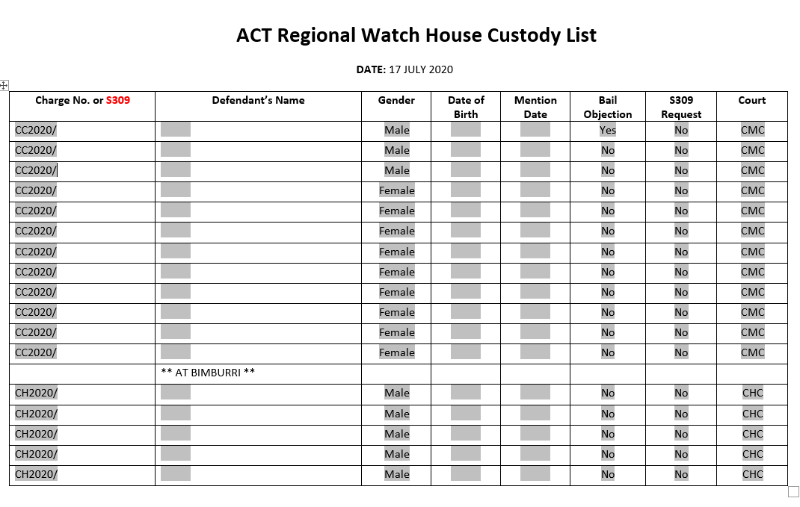
Attachment 2: Court Liaison Notes Template
Attachment 3 – Court Liaison Consumer Assessment Form
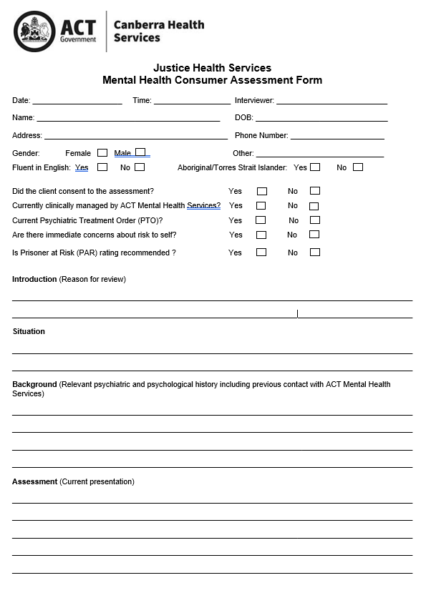

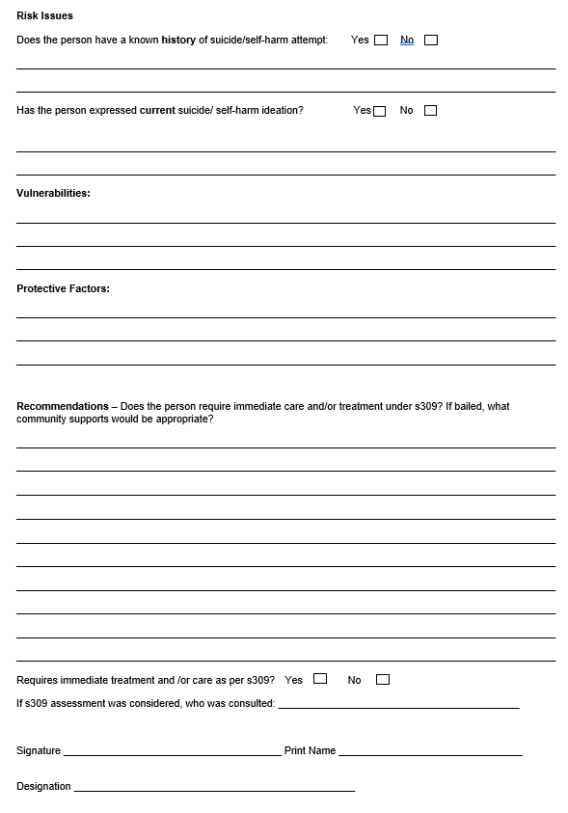
Attachment 4: Referral for Brief Mental Health Report
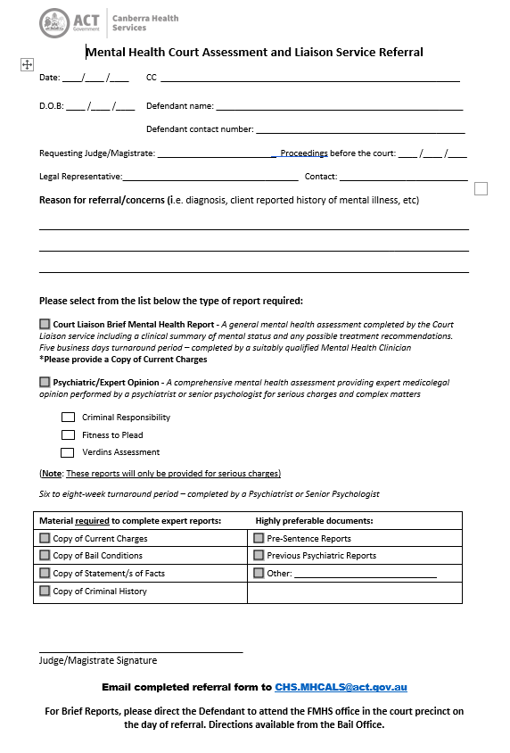
Attachment 5: Information sheet for Brief Mental Health Report
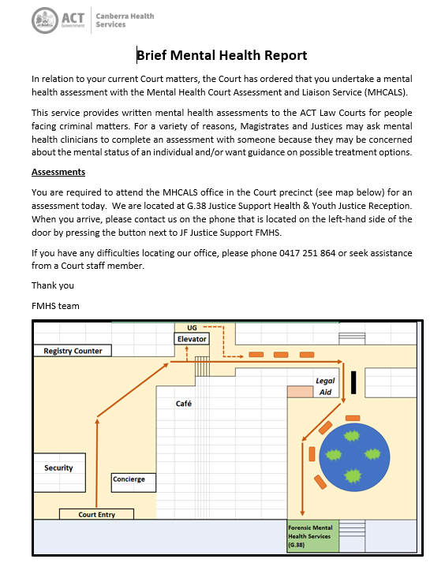

Attachment 6: Brief Mental Health Report Form

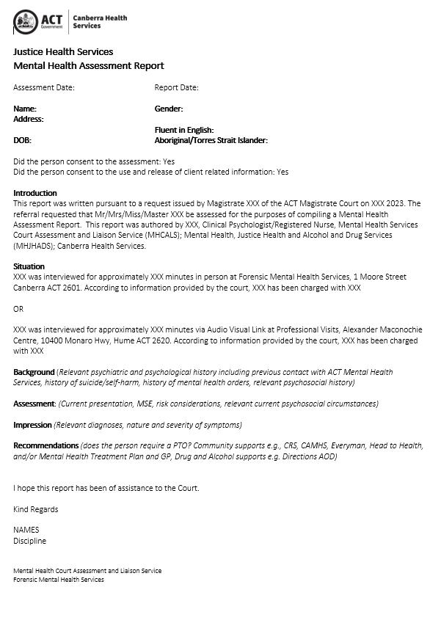
Attachment 7: DASL Initial Assessment Form
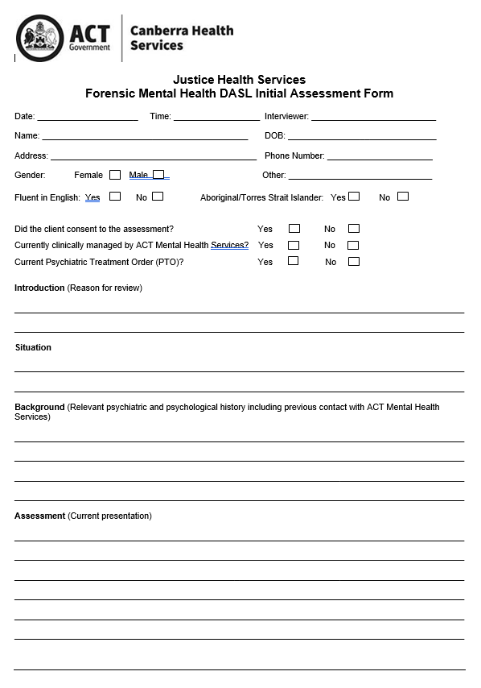

Attachment 8: DASL Assessment Report 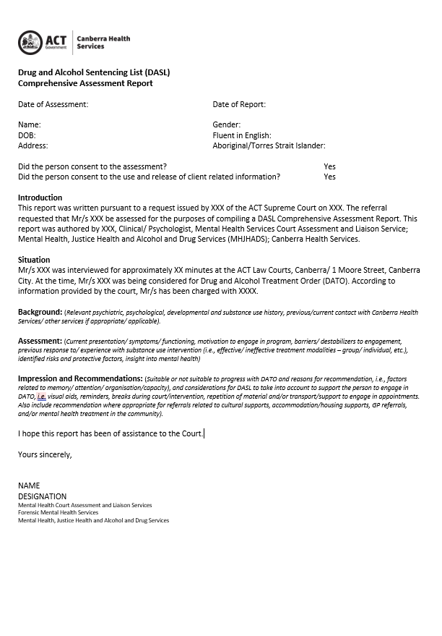
Attachment 9: ACAT Report
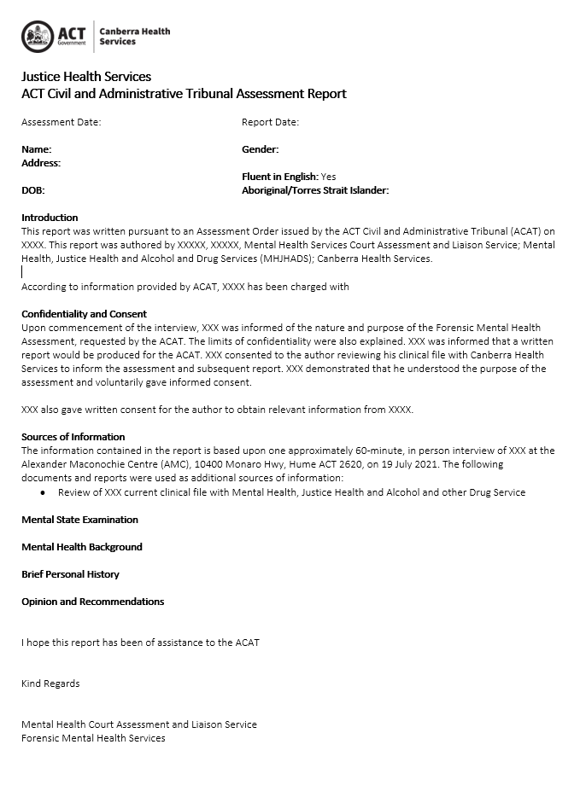

Attachment 10: Specialist Report