Canberra Health Services
Procedure
North Canberra Hospital (NCH) - Identification and Management of Adult Sepsis

Contents

Contents 1
Purpose 2
Alerts 2
Scope 2
Section 1 – Screening for Sepsis 2
Section 2 – Recognition of Sepsis 2
Section 3 – Response to the Identification of Sepsis 4
Section 4 – Resuscitate (Sepsis Bundle) 5
Section 5 – Escalate and Refer 6
Related Policies, Procedures, Guidelines and Legislation 6
References 7
Definition of Terms 7
Search Terms 7
Attachments 7

Purpose

The purpose of this procedure is to provide an over-arching document, describing the Adult Sepsis Clinical Pathway (Attachment 1) for identifying and managing adults with suspected and confirmed sepsis at North Canberra Hospital.

Back to Table of Contents

Alerts

- Absence of risk factors does not exclude sepsis as a cause of deterioration.
- If any staff member is worried, a MET call can be initiated at any time.
- It is important that any investigations do not delay administration of antibiotics.

Back to Table of Contents

Scope

This document applies to all clinicans providing care to adult patients within their scope of practice at North Canberra Hospital (NCH).

See CHS Neonatal Bacterial Sepsis Procedure for guidance around newborns (<28 days or 44 weeks corrected gestational age if preterm) at risk of sepsis or presenting with suspected sepsis.

Back to Table of Contents

Section 1 – Screening for Sepsis

Sepsis is a medical emergency and occurs when the body has a dysregulated host response to infection that results in life-threatening organ dysfunction. Sepsis can develop at any point in a patient’s care journey, therefore any patient who is showing signs of deterioration and/or has the risk factors identified in Section 2 - Recognition of Sepsis must be screened for sepsis. When sepsis is suspected, the Sepsis Pathway Treatment Bundle must immediately be implemented, patients are to be reviewed by a senior clinician and antibiotics are to be administered within 60 minutes.

Back to Table of Contents

Section 2 – Recognition of Sepsis

If the patient has any risk factors for sepsis and/or any new onset of infection plus two or more Sepsis criteria then the patient may have sepsis.

Risk Factors
- Aboriginal and Torres Strait Islander people
- Age >60 years
- Had a fall
- Immunocompromised (including pregnant or asplenic)
- Recent surgery or procedure
- Representation with 48 hours of being discharged from hospital
- Indwelling Medical Device i.e IVC

Signs and Symptoms of Infection
- Fever or rigors
- Dysuria/frequency
- Cough/sputum/breathlessness
- Line associated infection/ redness/swelling/pain
- Abdominal pain/distension/peritonism
- Altered cognition

Sepsis Criteria
- Increasing oxygen requirement
- Respirations ≤ 10 or ≥ 25 per minute
- SPO₂ <95%
- SBP <100 mmHg
- Heart rate ≤ 50 or ≥ 120 per minute
- Decrease in level of consciousness or new onset of confusion
- Temperature <35.5 °C or >38.5 °C
- Lactate ≥ 2 mmol/L
- Blood glucose level <4 mmol/L or >20 mmol/L with a decreased level of consciousness

If the patient has any risk factors for sepsis and/or any new onset of infection plus any Septic Shock criteria then the patient has sepsis or septic shock until proven otherwise.

Septic Shock Criteria
- Any MET Call criteria
- Systolic Blood pressure < 90 mmHg
- Lactate ≥ 2mmol/L
- Base excess < -5.0
- Blood glucose level <4 mmol/L or >20 mmol/L with a decreased level of consciousness.

Back to Table of Contents

Section 3 – Response to the Identification of Sepsis

Emergency Department
If the patient meets any Sepsis Criteria, or is suspicious for sepsis, then the patient is to be triaged a minimum of Australasian Triage Scale (ATS) 3.
If the patient meets any Septic Shock or Sepsis criteria then the patient should be triaged a minimum of ATS 2 and a targeted history and clinical examination conducted by a Senior Medical Officer. These patients once admitted must be connected to continuous monitoring with regular vital sign assessment.

If the patient has any risk factors for sepsis and/or any new onset of infection plus any Septic Shock criteria then the patient has septic shock until proven otherwise and treatment should be commenced per Section 4 - Resuscitate (Sepsis Bundle). In this case, the ED Medical Team Leader must have oversight of the patient’s treatment and the Clinical Manager must be informed.

If the patient has any risk factors for sepsis and/or any new onset of infection plus two or more Sepsis criteria then the patient may have sepsis. If a Senior Medical Officer considers that the patient has sepsis, commence treatment per Section 4 - Resuscitate (Sepsis Bundle).

If sepsis is not suspected, look for other common causes of deterioration and treat, repeat observations within 30 and increase the frequency of observations as indicated on the MEWS chart.

Critical Care Unit
If the patient has any risk factors for sepsis and/or any new onset of infection plus any Septic Shock or Sepsis criteria then a targeted history and clinical examination should be conducted by a Senior Medical Officer.

If the patient has any risk factors for sepsis and/or any new onset of infection plus any Septic Shock criteria then the patient has septic shock until proven otherwise and treatment should be commenced per Section 4 - Resuscitate (Sepsis Bundle). In this case, the ICU registrar must have oversight of the patient’s treatment and the ICU Team Leader must be informed.

If the patient has any risk factors for sepsis and/or any new onset of infection plus two or more Sepsis criteria then the patient may have sepsis. If a Senior Medical Officer considers that the patient has sepsis, commence treatment per Section 4 - Resuscitate (Sepsis Bundle).

If sepsis is not suspected, look for other common causes of deterioration and treat, continue continuous monitoring, with frequent observation and escalate further deterioration to the Senior Medical Officer.

Theatres, Birth Suite, Mental Health, Outpatients and Inpatient Wards, Other Areas otherwise Not Specified
If the patient has any risk factors for sepsis and/or any new onset of infection plus any Septic Shock criteria then the patient has septic shock until proven otherwise. In this case, a MET call must be initiated. Treatment should then be commenced per Section 4 – Resuscitate (Sepsis Bundle).

If the patient has any risk factors for sepsis and/or any new onset of infection plus two or more Sepsis criteria then the patient may have sepsis. In this case, the patient’s Admitting Team must be contacted and the patient reviewed by a Senior Medical Officer within 30 minutes, or as per the MEWS escalation protocol. If a Senior Medical Officer considers that the patient has sepsis, commence treatment Section 4 - Resuscitate (Sepsis Bundle). The area CNC and ICU Liaison nurse (when on shift) should be informed and assist as required.

If sepsis is not suspected, look for other common causes of deterioration and treat, repeat observations within 30 and increase the frequency of observations as indicated on the relevant MEWS chart.

Back to Table of Contents

Section 4 – Resuscitate (Sepsis Bundle)

Investigations
- Collect two Blood Cultures from two different sites. One set should be obtained from the central venous access device if present.
- Serial lactates: > 2 mmol/L is significant after fluid resuscitation.
- FBC, EUC, CRP, LFTs, COAFS, Lipase, Glucose (BGL >7.7 mmol/L in the absence of diabetes may be significant).
- Other swabs, midstream urine and sputum as clinically indicated.

Treatment
- Apply oxygen to maintain oxygen saturations ≥95% (88-92% for a patient with COPD)
- Within 60 minutes, administer antibiotics per the electronic Therapeutic Guidelines: Antibiotic (eTG). Consider allergies prior to choice of antibiotic.
- If hypotensive administer a fluid bolus 20 mL/kg, and repeat if no response. If no improvement in SBP post fluid boluses commencement of vasopressors is indicated. These patients must be referred to the ICU.

Monitoring
- Monitor for signs of pulmonary oedema post fluid resuscitation.
- Check blood glucose level and manage hyper or hypoglycaemia.
- Assess and document level of consciousness and capillary refill.
- In ED and on the wards a full set of vital signs (Respiratory rate, Oxygen Saturations, Heart rate, Blood Pressure, Temperature and Sedation score) should be documented every 30 minutes or more frequently as indicated until the MEWS is <4. In ICU patients sepsis patients are to have continuous cardiac and haemodynamic monitoring and be managed according to the minimum frequency of vital signs procedure.
- Commence a strict fluid balance chart with hourly measures.
- Consider insertion of indwelling urinary catheter if clinically indicated.
- Consider an arterial line to monitor blood pressure (indicated for ICU patients).
- Blood gas assessment as directed by the medical team.

Back to Table of Contents

Section 5 – Escalate and Refer

If after delivering the Sepsis Bundle interventions the patient has any of the following signs of deterioration:
- Respiratory rate >25 breaths per minute
- SPB < 90mmHg
- Decreased or no improvement in level of consciousness
- Urine output <0.5mL/Kg/hour
- Serum lactate level of ≥2mmol/L (or increasing) or no improvement after adequate fluid resuscitation

Then discussion/referral to an Intensivist and an Infectious Diseases physician is to be made.

Back to Table of Contents

Related Policies, Procedures, Guidelines and Legislation

Policies
- Nursing and Midwifery Board of Australia (NMBA) Requirements for Practice
- Informed Consent – Clinical

Procedures
- Adult Vital Signs
- ICU HDU Minimum Frequency of Vital Signs
- Infection Prevention and Control
- Maternity Vital Signs
- Medical Emergency Team
- Oxygen Therapy
- Patient Identification and Procedure Matching
- Neonatal Bacterial Sepsis
- NCH Infection Prevention and Control
- NCH Prevention, Diagnosis and Management of Delirium in the Acute Setting
- NCH Antimicrobial Stewardship

Legislation
- Health Records (Privacy and Access) Act 1997
- Human Rights Act 2004
- Work Health and Safety Act 2011
- Carers Recognition Act 2021

Other
• Australian Charter of Healthcare Rights

Back to Table of Contents

References

- Canberra Health Services (2018) Clinical Procedure: Emergency Department Adult Sepsis Clinical Pathway. CHHS18/215
- NSW Government Clinical Excellence Commission (2021) Sepsis. Online available: https://www.cec.health.nsw.gov.au/keep-patients-safe/deteriorating-patient-program/sepsis Accessed 25-11-21
- Therapeutic Guidelines (2019) Electronic Therapeutic Guidelines. Online available https://tgldcdp.tg.org.au/topicTeaser?guidelinePage=Antibiotic&etgAccess=true Accessed 1-8-19
- UPMC and University of Pittsburgh Schools of the Health Sciences (2016) Quick Sepsis Related Organ Failure Assessment (2016) Online available: http://www.qsofa.org Accessed 1-8-19

Back to Table of Contents

Definition of Terms

Sepsis – is defined as life-threatening organ dysfunction caused by a dysregulated host response to infection.

Back to Table of Contents

Search Terms

Sepsis, pathway, septic, septic shock, deterioration, antimicrobial, AMS, antibiotic, lactate

Back to Table of Contents

Attachments

Attachment 1: Adult Sepsis Pathway

Attachment 1: Adult Sepsis Pathway

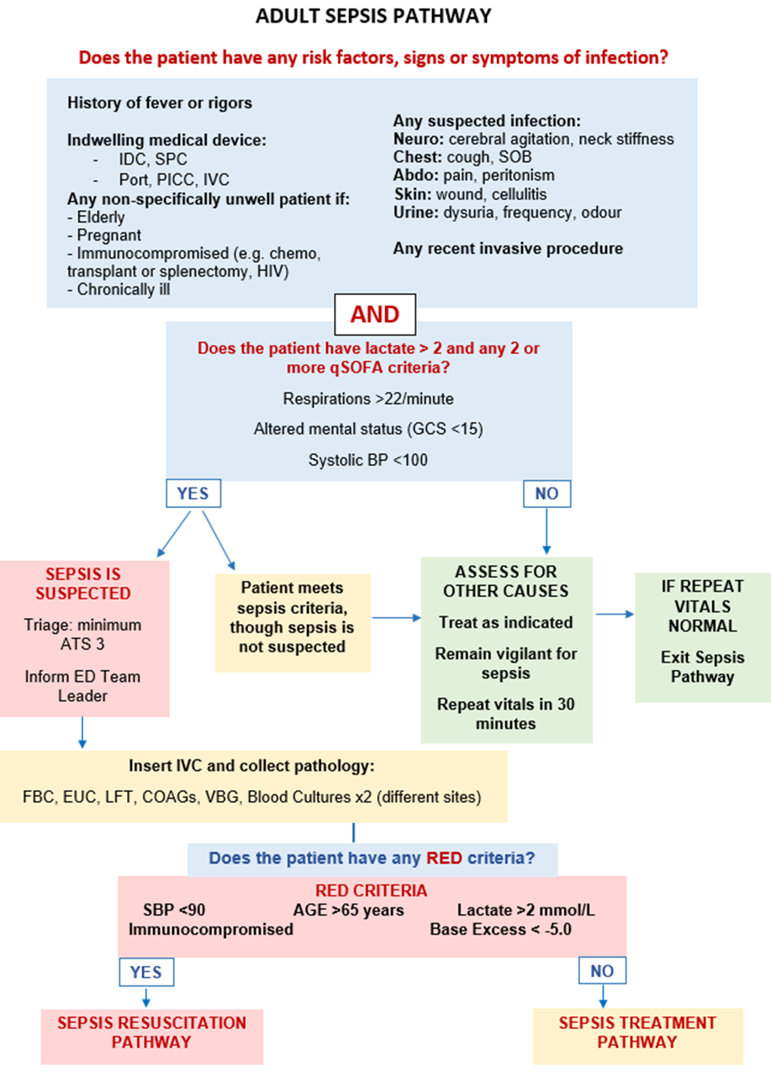

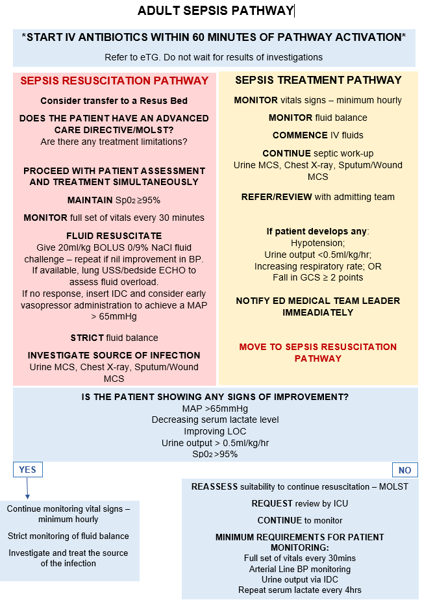

Disclaimer: This document has been developed by Canberra Health Services specifically for its own use. Use of this document and any reliance on the information contained therein by any third party is at his or her own risk and Canberra Health Services assumes no responsibility whatsoever.

Policy Team ONLY to complete the following:
Date Amended | Section Amended | Divisional Approval | Final Approval
26/02/2024 | NCH Transition | Rachel Longhurst A/g ADON ICU/CCU | CHS Policy Team

This document supersedes the following:
Document Number | Document Name

