Canberra Health Services
Procedure
North Canberra Hospital (NCH) - Diagnosis and Management of Diabetes in Pregnancy

Contents

Contents 1
Purpose 2
Alerts 2
Scope 2
Section 1 – Antenatal Testing 3
Section 2 – OGTT and Diagnosis of GDM 4
Section 3 – Ongoing Antenatal Care for Women with Diagnosed GDM 5
Section 4 – Pregnancy Care for GDM not Requiring Medication 5
Section 5 – Pregnancy Care for GDM Requiring Insulin 6
Section 6 – Hypoglycaemia Management 7
Section 7 – Diabetic Ketoacidosis (DKA) 7
Section 8 – Intrapartum Management 8
Section 9 – BGL Monitoring and Medication Management 9
Section 10 – Postnatal 12
Related Policies, Procedures, Guidelines and Legislation 13
References 13
Definition of Terms 15
Search Terms 15
Attachments 15

Purpose

The purpose of this procedure is to provide clinicians at North Canberra Hospital with information on the diagnosis and management of women with Gestational Diabetes Mellitus (GDM).

Back to Table of Contents

Alerts

In hypoglycaemia, if the patient has altered consciousness or seizure initiate a MET (call 2222 from the North Canberra Hospital (NCH) or 0-000 for other locations) and page medical team through switch for an urgent review.

If cBGL is < 4 mmol/L but > 3.5 mmol/L:
- stop the insulin infusion and continue the glucose infusion
- check cBGL every 15 minutes until cBGL is greater than 5mmol/L
- once cBGL is greater than 5 mmol/L restart the insulin infusion at rate as per the table below.

If cBGL is less than 3.5 mmol/L and/or the patient has symptoms of hypoglycaemia
- stop the insulin infusion.
- administer a bolus of glucose by increasing the glucose infusion rate to 300 mL/hour
- check cBGL every 15 minutes until it is greater than 5 mmol/L.
arrange for an urgent endocrine review to plan further management of infusion.

In hyperglycaemia, if cBGL remains greater than 11mmol/L for more than 2 hours and there is no downward trend from previous higher readings, measure blood ketones and seek medical review.

Alert : Urgent medical review is required if:
• blood ketones >0.6 mmol/L
• cBGL is greater than 20mmol/L.

Back to Table of Contents

Scope

This document applies to the following team members working within their scope of practice within NCH:

Gestation Diabetes Mellitus (GDM) is the fastest growing type of diabetes in Australia. GDM affects 15 - 17% of pregnant women. Women who develop diabetes in pregnancy have a greater risk of developing pregnancy related problems affecting the health of the women and her baby. Diabetes in pregnancy usually occurs because of family inherited factors combined with the effect of hormone changes during pregnancy. In 2019 almost 41,000 women in Australia were diagnosed with GDM and 34 percent of women with GDM required insulin therapy (Gestational Diabetes in Australia, 2020).

All women are routinely screened for GDM at 24-28 weeks gestation. Screening includes the Oral Glucose Tolerance Test 75gram fasting (OGTT) which is a two-hour test. Provide all women with the “Screening for Gestational Diabetes in pregnancy” fact sheet before ordering the test.
All women that have 1 or more risk factors for Gestational Diabetes are to have an early HbA1c with their antenatal bloods in the first trimester (or before 20 weeks). If this has not been attended, order it at the booking in visit or prior to 20 weeks gestation. If the early HbA1c is normal, order a repeat OGTT at 24 – 28 weeks as for women with no risk factors.

Flow Chart: Screening and diagnosis of GDM - Refer to Attachment A.

Risk factors for Gestational Diabetes Mellitus for HbA1c testing:
One or more of:
- Previous GDM
- BMI ≥ 25kg/m2
- Family history of diabetes mellitus (DM) - (first degree relative with diabetes or a sister with GDM)
- Maternal age ≥30 years
- Polycystic Ovarian Syndrome
- Hypothyroidism
- History of adverse pregnancy outcomes
- Macrosomia
- Pre-term delivery
- Congenital anomaly
- Stillbirth
- Pregnancy-induced hypertension
- Multiparity.

Risks of Gestational Diabetes Mellitus:
Maternal:
- Pre-eclampsia
- Gestational hypertension
- Polyhydramnios
- Infection
- Induced labour
- Operative birth
- Recurrent GDM in subsequent pregnancies
- Progression to Type 2 Diabetes
- Premature birth/water break
- Trauma to mother and baby at time of delivery.

Newborn:
- Jaundice
- Hypoglycaemia
- Respiratory distress syndrome
- Macrosomia
- Shoulder dystocia
- Fetal hypoxia (especially if glycaemic control has been sub-optimal during pregnancy).

Back to Table of Contents

Section 2 – OGTT and Diagnosis of GDM

Woman with risk factors for GDM (see section 1) should be offered diabetes screening pre-conception or as soon as practicable after confirmation of pregnancy (preferably before 20 weeks completed gestation).

First trimester screening for women with risk factors
- Women with risk factors for GDM in pregnancy should be advised to have an HbA1c measured in the first trimester.
- Women with HbA1c ≥6.5% (≥48 mmol/mol) should be diagnosed and managed as having overt DIP

Early screening for women with a history of GDM or elevated HbA1c
- Prior to 20 weeks’ gestation, and ideally between 10-14 weeks’ gestation, if tolerated, women with a previous history of GDM or an early pregnancy HbA1c ≥6.0 to 6.4% (42-47 mmol/mol) but without diagnosed diabetes, should be advised to undergo a 75 g 2-h POGTT.
- The term “early GDM” refers to GDM detected before 20 weeks’ gestation

GDM diagnosis is made based on the results of the fasting 75 g OGTT.
- A regular diet is to be maintained until 8-12 hours before testing when the woman will be required to FAST.
- During fasting the woman should drink water to prevent dehydration and take her usual medications.
- An OGTT should not be performed within 1 week of maternal steroid administration (unless chronic stable dose).
- If the OGTT is declined a fasting plasma glucose test may be an alternative although this will only give partial information on glucose metabolism.

GDM is diagnosed when the OGTT results show:
- Fasting blood glucose is 5.3 – 6.9 mmol/L
- 1 hour blood glucose is ≥ 10.6 mmol/L
- 2 hour blood glucose is 9.0 – 11.0 mmol/L.

Overt diabetes is diagnosed when the OGTT results show:
- Fasting blood glucose ≥ 7.0 mmol/L
- 2 hour blood glucose ≥ 11.1 mmol/L
- HbA1c ≥6.5%
- Random formal blood glucose level of ≥11.1 mmol/L with other diabetes symptoms.

GDM screening for patients who have had bariatric surgery:
- Patients who have had bariatric surgery may not tolerate the 75-g glucose solution. Alternative screening methods, such as Fasting Plasma Glucose, HbA1c or home glucose monitoring, should be considered in patients who have undergone restrictive/malabsorptive surgery.
Back to Table of Contents

Section 3 – Ongoing Antenatal Care for Women with Diagnosed GDM

- Women diagnosed with GDM are referred for education groups and one on one sessions through DHR with a Diabetes Educator and Dietician. The Diabetes Educator ensures that women are instructed on diabetes, BGL self-monitoring, management plan, risk factors and targets.
- Women diagnosed with overt diabetes in pregnancy are referred to the Centenary Hospital for Women and Children Diabetes Educator and Endocrinologist for follow up asap.
- BGL targets are:
  - Pre-breakfast (fasting) < 5.3mmol/L
  - 2 hours after starting to eat meals < 7.0mmol/L.
Back to Table of Contents

Section 4 – Pregnancy Care for GDM not Requiring Medication

- Routine antenatal care as per pregnancy care guidelines.
- At each antenatal visit, review BGL self-monitoring records to gauge whether GDM is being well controlled by diet. If there are more than three elevated BGLs in 5 days, advise the woman to contact the Diabetes in Pregnancy team and refer the woman to the Diabetes in Pregnancy clinic for review.
- Women with GDM, not requiring insulin, and who are able to be controlled with diet alone will be managed at Antenatal Clinic. While stable, the woman remains within the Continuity of Midwifery Care Service (CMCS) with regular discussion at Collaborative Care meetings.
- If a woman’s BGLs are sub-optimal, their care is transferred to the Diabetes in Pregnancy Clinic for other treatment options.
- Ensure all women with GDM (diet-controlled) are seen by an Obstetric Registrar or Obstetrician at 40 weeks gestation.
- Recommend ultrasound scans for growth and liquor volume at 34-36 weeks if there are concerns about fetal growth or reduced baby movement due to GDM, please ensure earlier review by Obstetric Registrar or Obstetrician.

Note: Estimation of fetal weight by ultrasound scan can have significant margins of error.

Back to Table of Contents

Section 5 – Pregnancy Care for GDM Requiring Insulin

If diet and exercise cannot achieve normoglycaemia in women with GDM, insulin therapy is required; initiation of medication is under the guidance of the diabetes in pregnancy team.

Commencing insulin therapy
- When starting insulin, small doses are prescribed in anticipation that increasing insulin stepwise will be required to achieve blood glucose euglycaemia
- Insulin may not be required with any or all meals
- Insulin resistance increases progressively as pregnancy proceeds. Regular monitoring of BGLs is essential.

Timing and type of insulin
- Decision on which insulin type is required is determined by the time of day when glucose levels are high. Some women will need short and long acting.
- When long-acting insulin is required, consideration of normal sleeping habits should be taken into consideration so insulin is administered at a consistent time e.g., 2130 rather than “Before Bed”.

Table 1 Insulin Therapy Suggested for BGL abnormality
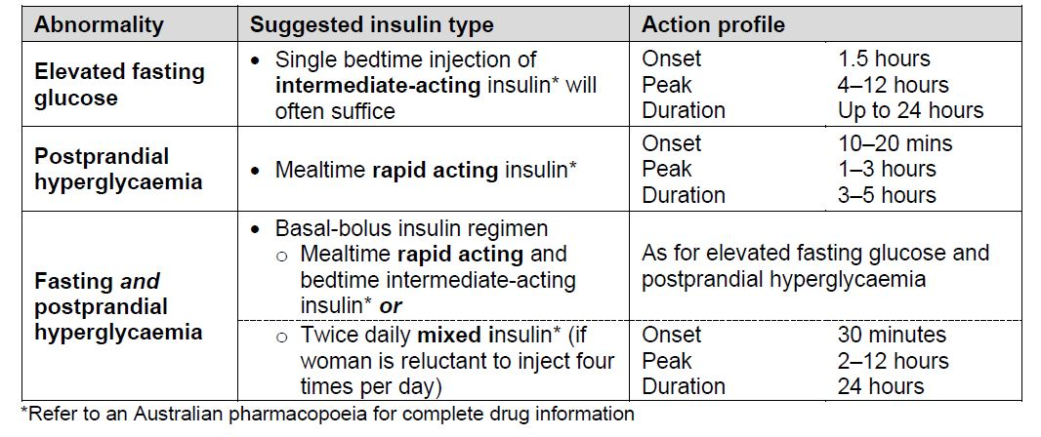
Source Queensland Clinical Guideline: Gestational diabetes mellitus (GDM)

Oral hypoglycaemic agents (OHA’s)
- Most oral hypoglycaemic agents are not currently recommended for use in pregnancy. Clinical trials are continuing to determine if there is any long-term effect on the fetus. These should only be continued in consultation with an endocrinologist
- Oral hypoglycaemic agents other than metformin should not be used during pregnancy
- Oral hypoglycaemic agents may be prescribed for women with GDM under the following circumstances:
- Where the woman has been taking OHA’s prior to and in early pregnancy (e.g. PCOS)
- Where the woman refuses to take insulin injections
- When insulin compliance is sub-optimal
- As a supplement to insulin or when large doses of insulin are required to control cBGLs
Back to Table of Contents

Section 6 – Hypoglycaemia Management
Hypoglycaemia is a condition in which blood glucose levels drop below 4 mmol/L. Delays in recognising or treating hypoglycaemia have the potential to cause serious adverse advents such as injury, unconsciousness, or convulsions. It should be noted that a patient with low blood glucose levels may be asymptomatic.

For management of Hypoglycaemia refer to Attachment B.

Note: Hypoglycaemia treatment items are held in the medication room, these include glucose gel, glucagon and IV glucose solutions.
Consider woman’s own supply of high glucose snacks (e.g., 5-6 jellybeans)

Key points in managing hypoglycaemia:
- Identify and treat the cause of hypoglycaemia
- Do not omit next insulin dose, if the patient is hypoglycaemic when the next dose of insulin is due, delay administration until after correction of the hypoglycaemia.
- If recurrent notify Obstetric team for medical review
- If recurrent notify Endocrinologist or Nurse Practitioner to review insulin regimen
Back to Table of Contents

Section 7 – Diabetic Ketoacidosis (DKA)

If DKA is suspected attend BGL and Ketone testing and contact obstetric and medical registrars for review.
If in DKA, DKA procedure to be followed as per Diabetic Ketoacidosis (DKA) Management in Adults (age 16 years and over) procedure.
Flow Chart: Gestational Diabetes Antenatal Care - Refer to Attachment C.
Back to Table of Contents

Section 8 – Intrapartum Management

Timing and mode of birth is primarily intended to minimise the risk of intrapartum complications associated with Large for Gestational Age (LGA) or macrosomic infants.
- Women with optimal cBGLs and no other complications, who are not receiving pharmacotherapy do not require expedited birth before 40+6 weeks. The decision for expedited birth should be made in consultation with the woman and on an individualised basis.
- Consider awaiting spontaneous labour if cBGLs remain within the target range, there is normal fetal growth, there is not polyhydramnios or other obstetric complications.
- For women with suspected fetal macrosomia or other complications, consider birth from 39 weeks gestation.
- For women with insulin requiring gestational diabetes and optimal cBGL control, normal fetal growth and no other complication of pregnancy (e.g. pre-eclampsia/polyhydramnios/reduced fetal movements) should be offered induction at 39 – 40 weeks
- For women with insulin requiring gestational diabetes and suboptimal cBGL control, reducing insulin requirements, polyhydramnios or oligohydramnios, macrosomia or fetal growth restriction, increased maternal BMI requiring high doses of insulin and development of hypertension/pre-eclampsia should be induced at 38 - 39 weeks.
- All women with insulin requiring GDM will see the endocrinologist and obstetrician at 36 weeks for a plan for peripartum insulin management and timing/mode of birth. The plan will be documented in the woman’s DHR. If a plan is unavailable at time of labour the midwife will contact the Obstetric Registrar.
- CMCS women should be advised that the CMCS midwife will continue to provide care in labour, although recommended that place of labour or birth is Birth Suite (not Birth Centre).
- Continuous external fetal monitoring (CEFM) is indicated in labour if a woman has GDM requiring medication, or sub-optimal cBGL control with or without medication management. Refer to: Fetal Surveillance procedure
Very few women with Gestational Diabetes Mellitus (GDM), whether using insulin or not, require insulin for labour or caesarean section.

Note: All women with IRGDM for IOL or caesarean section will have a plan for their intrapartum and postpartum management discussed with them and documented in their Patients Clinical Records.
Back to Table of Contents

Section 9 – BGL Monitoring and Medication Management

GDM managed by dietary modifications
Continue measurement of BGL at usual times during IOL process and in active labour (i.e. fasting and two hours post- prandial until fasting)
- Monitor BGLs on admission and then four hourly. Increase frequency according to BGL results. If the BGL is > 7.0mmol/L seek Obstetric Registrar or Obstetrician review. If the BGL is < 4.0mmol/l or symptomatic notify Obstetric Registrar or Obstetrician and treat hypoglycaemia. Repeat the BGL in 15 minutes.
- Test each urine specimen for ketones. If any ketones in the urine, test blood ketones.

Insulin requiring GDM
Long-acting/intermediate-acting insulin and BGL monitoring (Morning IOL/night before planned LUSCS)
Confirm management plan in woman’s clinical record from endocrine team
- Measure BGL at usual times i.e. fasting and two hours post- prandial until fasting.
Bedtime insulin
- Reduce night-time long-acting insulin by 1/3 (e.g., Protophane or Humulin NPH)
Oral agents
- Do not give night-time oral hypoglycaemic agents

Short acting insulin and BGL monitoring
Early stages of IOL and pre fasting planned LUSCS
Confirm management plan in woman’s clinical record from endocrine team
- Continue normal meal-time short acting insulin (e.g. Novo Rapid) when eating meals until active labour is confirmed or fasting should commence for surgery
- Check cBGL at usual intervals (i.e. fasting and two hours post prandial) until fasting or in active labour

Active labour/commencement of oxytocin infusion or fasting for caesarean section
For most women insulin is not required during labour or caesarean section.
Confirm management plan in woman’s clinical record from endocrine team
- 2 Hourly cBGLs are required in active labour/commencement of oxytocin infusion/fasting for operative birth
- Anaesthesia (Nitrous Oxide/Epidural or Spinal anesthesia) may mask signs of hypoglycaemia
- If cBGL exceeds 7.0 mmol/L call Obstetric registrar and follow Endocrine management plan in woman’s clinical record, if no plan see table 2 and table 3 for possible subcutaneous insulin doses. 1 small dose of short acting insulin can be given if needed. If cBGL remain above 7.0 mmol/L commence an insulin infusion.

Note: If cBGL drops below 4.0 mmol/L call Obstetric registrar and follow Attachment B for management of Hypoglycaemia

If no birth plan and cBGLs elevated can give some insulin sliding scale
Table 2. Women receiving < 40 units insulin/day
BGL mmol/L | Action
0 – 6.0 | No insulin
6.1 – 8.0 | 2 units rapid-acting insulin
8.1 – 10.0 | 4 units rapid-acting insulin
10.1 – 14.0 | 6 units rapid-acting insulin
>14.0 | 8 units and medical review

Table 3. Women receiving ≥ 40 units insulin/day
BGL mmol/L | Action
0 – 6.0 | No insulin
6.1 – 8.0 | 4 units rapid-acting insulin
8.1 – 10.0 | 6 units rapid-acting insulin
10.1 – 14.0 | 8 units rapid-acting insulin
>14.0 | 10 units and medical review

Fetal Surveillance
- Fetal monitoring during early IOL procedure is as per Induction of Labour Guideline
- Fetal monitoring during labour is per Labour and Birth Care during First, Second, Third and Fourth Stage

Refer to Fetal Surveillance Procedure for intrapartum monitoring recommendations
Continuous external fetal monitoring in active labour is recommended for:
- Women with diabetes where medication was indicated (IRGDM)
- Women who have experienced poorly controlled blood glucose levels
- Women whose baby is macrosomic or small for gestational age

Management of patients requiring insulin infusion
- Insulin infusion requires a separate IV cannula
- Insert 2 IV cannulas
- Target cBGL via insulin adjustments unless the patient is hypoglycaemic.
- Insulin infusion and related fluids are to be charted/prescribed in DHR “order set” Insulin (ACTRAPID) infusion – labour and birth.

Note: All lines and infusions must be labelled according to National Standard for User-applied Labelling of Injectable Medicines, Fluids and Lines.

Aspect | Recommendation
IV Infusion | Administer via infusion pump
Mainline  - 100 units of actrapid insulin in 100 mL of sodium chloride 0.9% (concentration of 1 unit/mL) | - Prime line with insulin solution to connection port  - Commence and adjust insulin infusion according to BGL
Sideline  - 5% glucose or 0.18% sodium chloride and 4% glucose infusion in 1000mls | - Infusion 125mL per hour (8hrly rate)
BGL Monitoring | - hourly while insulin infusion is being administered  - collect blood from the opposite arm to the IV insulin infusion  - • if cBGL > 11mmol/L check for blood ketones.

Insulin Infusion for labour and immediate post birth
 | Intrapartum | Post birth of placenta (if indicated as per table 4)
Blood Glucose Level | mL/Unit per hour | mL/Unit per hour
< 4 | 0.0 | 0.0
4 – 5 | 0.5 | 0.0
5.1 – 7 | 1 | 0.5
7.1 – 9 | 2 | 1
9.1 - 11 | 3 | 1.5
Note: BGL ≥11.1 requires ketone testing. For urgent endocrine review if ketones >0.6 mmol/L or BGL not decreasing after 2 hours of insulin at prescribed rate.
 | Intrapartum | Post birth of placenta (if indicated as per table 4)
Blood Glucose Level | mL/Unit per hour | mL/Unit per hour
11.1 - 13 | 4 | 2
13.1 – 15 | 5 | 2.5
15.1 – 20 | 5.5 | 3
20.1 – 25 | 6 | 4
>25.1 | 6.5 | 5

Table 4 Management of insulin infusion after birth of placenta
 | Post birth of placenta management
Insulin Infusion | Cease IV insulin infusion after birth of placenta unless BGLs elevated
Glucose sideline | Cease when diet is tolerated
BGL monitoring | Monitor for 48 hours fasting and 2hours post  If fasting BGL ≥6.0mmol/L or post-prandial > 10.0 mmol/L, continue BGL monitoring and notify obstetric registrar for management plan

Note: Leave the IV cannula in situ for at least 6 hours after cessation of infusion. When BGLs are stabilised, urine is ketone-free and diet is tolerated the cannula can be removed.

Back to Table of Contents

Section 10 – Postnatal

Maternal:
- If a woman was GDM diet controlled – cease BGL monitoring after birth
- If a woman was GDM insulin requiring – complete a 48 hour BGL profile
  - (Fasting and 2 hours post each meal) prior to discharge
  - If fasting BGL ≥6.0mmol/L or post-prandial > 10.0 mmol/L, continue BGL monitoring and notify obstetric registrar for management plan.
  - If a woman discharged prior to this to self-monitor and record cBGLs and discuss results with midwifery home-visiting services

GDM lifestyle counselling
- Resume a healthy diet
- Order and document in the discharge summary the need for a repeat OGTT at 6 – 12 weeks postpartum (to be ordered and followed up by the GP).
- Referral to post GDM education group
- Recommend lifelong screening for Type 2 diabetes.
- Regular physical activity (30 minutes/day – moderate intensity)
- Weight control management
- Contraception
- Long term follow-up (OGTT screening should be repeated every 2 years)
- Preconception counselling; future pregnancy

Neonate:
- Keep newborn warm and where possible initiate immediate skin-to-skin contact with mother
- Initiate early breastfeed within 30 – 60 minutes of birth
- Support and encourage feeding at least 3 hourly or more frequently as demanded
- Perform BGLs:
  - At 1-2 hours of age
  - Then pre-feed (2nd feed)
If BGL is less than 2.6mmol/L. Refer to Attachment F or CHS Neonatal routine care procedure
- Cease BGL monitoring when the infant has:
- 2 subsequent, pre-feed BGLs greater than or equal to 2.6 mmol/L, and
- The infant is feeding effectively and
- The infant is well and is not requiring intravenous (IV) therapy.
Back to Table of Contents

Related Policies, Procedures, Guidelines and Legislation

Policies
- Nursing and Midwifery Board of Australia (NMBA) Requirements for Practice
- Informed Consent – Clinical

Procedures
- Infection Prevention and Control Procedure
- Patient Identification and Procedure Matching Procedure
- Fetal Surveillance Procedure
- Labour and Birth Care during First, Second, Third and Fourth Stage Procedure
- Neonate Routine Care Procedure
- Antenatal Care and Investigations recommended for Women attending the Antenatal Clinic Procedure

Legislation
- Health Records (Privacy and Access) Act 1997
- Human Rights Act 2004
- Work Health and Safety Act 2011
- Carers Recognition Act 2021

Other
• Australian Charter of Healthcare Rights

Back to Table of Contents

References

- Alberico S, Erenbourg A, Hod M, Yogev Y, Hadar E, Neri F, Ronfani L, Maso G. Immediate delivery, or expectant management in gestational diabetes at term: the GINEXMAL randomised controlled trial. BJOG 2016.
- Biesty LM, Egan AM, Dunne F, Dempsey E, Meskell P, Smith V, et al. Planned birth at or near term for improving health outcomes for pregnant patients with gestational diabetes and their infants. Cochrane Database Systematic Reviews. 2018 [cited 2020 June 22]; Issue 1. Art. No.: CD012910(1): Cd012910. Available from: https://pubmed.ncbi.nlm.nih.gov/29303230/
- Canberra Health Services Guideline: Diabetes in pregnancy – includes pre-existing and gestational diabetes, March 2023
- Crowther, C., Samuel, D., McCowan, L., Edlin, R., Tran, T., and McKinlay, C. Lower versus Higher Glycemic Criteria for Diagnosis of Gestational Diabetes. (2022). New England Journal of Medicine. SP – 587, EP - 598, VL- 387, IS-7. Available from https://www.nejm.org/doi/pdf/10.1056/NEJMoa2204091
- Diabetes Australia. Position statement on Gestational Diabetes in Australia. 2020. Available from: https://www.diabetessociety.com.au/guideline-category/diabetes-gdm-obesity-feet/
- Ley SH, Chavarro JE, Li M, Bao W, Hinkle SN, Wander PL, et al. Lactation duration and long-term risk for incident type 2 diabetes in patients with a history of gestational diabetes mellitus. Diabetes Care 2020;43(4):793-8. Available https://www.ncbi.nlm.nih.gov/pmc/articles/PMC7085808/
- Maso G, Piccoli M, Parolin S, Restaino, S, Alberico S. Diabetes in pregnancy. Timing and mode of delivery. Curr diab Rep 2014; 14(7): 506
- Metcalfe A, Hutcheon J.A, Sabr Y, Lyons J, Burrows J, Donovan L, Joseph K.S. Timing of delivery in women with diabetes: A population- based study. AOGS 2020; 99: 341-349
- Nankervis A, McIntrye HD, Moses R, Ross GP, Callaway L, Porter C et al. Australian Diabetes in Pregnancy Society (ADIPS) Consensus guidelines for the testing and diagnosis of gestational diabetes mellitus in Australia (modified November 2014). Available from https://www.adips.org/downloads/2014ADIPSGDMGuidelinesV18.11.2014_000.pdf
- National Institute for Health and Care Excellence. NICE Guideline. Diabetes in pregnancy: management of diabetes and its complications from preconception to the postnatal period. Published on 25 February 2015. Available from: https://www.nice.org.uk/guidance/ng3
- National Midwifery Guidelines for Consultation and Referral. 4th Edition, 2021. Available from https://midwives.org.au/common/Uploaded%20files/_ADMIN-ACM/National-Midwifery-Guidelines-for-Consultation-and-Referral-4th-Edition-(2021).pdf
- Queensland Clinical Guidelines: Gestational diabetes mellitus, February 2021. https://www.health.qld.gov.au/__data/assets/pdf_file/0022/950503/g-gdm.pdf
- Safer Care Victoria. Gestational diabetes. Available from https://www.safercare.vic.gov.au/clinical-guidance/maternity/gestational-diabetes
- South Australian Perinatal Practice Guideline. Diabetes Mellitus and Gestational Diabetes, April 2019 Available from https://www.sahealth.sa.gov.au/wps/wcm/connect/146238004ee2144cb404bdd150ce4f37/Diabetes+Mellitus+and+Gestational+Diabetes_July2015.pdf?MOD=AJPERES
- Western Australia North Metropolitan Health Service: Obstetrics and gynaecology clinical practice guideline: Diabetes. 2021. Available from https://www.kemh.health.wa.gov.au/~/media/HSPs/NMHS/Hospitals/WNHS/Documents/Clinical-guidelines/Obs-Gyn-Guidelines/Diabetes.pdf?thn=0
Back to Table of Contents

Definition of Terms

Type 1 Diabetes - characterized by a cessation in insulin production and secretion in the pancreatic beta cells, which indicates that these women are reliant on insulin every day.
Type 2 Diabetes - characterized by an insensitivity of target tissues to insulin, combined with a reduced insulin response to glycaemia. This type of diabetes mainly affects adults and is the most common, accounting for 85-90% of diabetic adults.
Gestational Diabetes Mellitus (GDM) - defined as any degree of glucose intolerance with onset or first recognition in pregnancy. This definition applies whether the GDM requires diet or insulin treatment. The incidence is approximately 14-16% of all pregnancies.

Back to Table of Contents

Search Terms

Gestational Diabetes Mellitus, GDM, Diabetes, HbA1C, Pregnancy

Back to Table of Contents

Attachments

Attachment A – Flow Chart: Screening and Diagnosis of GDM
Attachment B – Management of Hypoglycaemia
Attachment C – Flow Chart: Gestational Diabetes Antenatal Care and Visit Plan
Attachment D – Intrapartum Management for Women with GDM requiring Insulin and/or Metformin in Pregnancy
Attachment E – Post-Birth Blood Glucose Management
Attachment F – Neonatal Hypoglycaemia Pathway

Disclaimer: This document has been developed by Canberra Health Services specifically for its own use. Use of this document and any reliance on the information contained therein by any third party is at his or her own risk and Canberra Health Services assumes no responsibility whatsoever.

Policy Team ONLY to complete the following:
Date Amended | Section Amended | Divisional Approval | Final Approval
31/01/2024 | NCH Transition | CHS Policy Team | CHS Policy Team
09/02/2024 | Evaluation section removed | CHS Policy Team | CHS Policy Team
06/08/2025 | Amenments made to Sections 1, 2, and 4, Attachments A & C. | Nicole Le Cornu, Diabetes in Pregnancy Credentialed Diabetes Educator | CHS Policy and Consumer Handouts Team

This document supersedes the following:
Document Number | Document Name
 | NCH – Diagnosis and Management of Diabetes in Pregnancy

Attachment A – Flow Chart: Screening and Diagnosis of GDM
Risk factors for HbA1c testing
- Previous GDM
- BMI ≥ 25kg/m2
- Family history of diabetes mellitus (DM) - (first degree relative with diabetes or a sister with GDM)
- Maternal age ≥30 years
- Polycystic Ovarian Syndrome
- Hypothyroidism
- History of adverse pregnancy outcomes
  - Macrosomia
  - Pre-term delivery
  - Congenital anomaly
  - Stillbirth
  - Pregnancy-induced hypertension
- Multiparity.

Attachment B – Management of Hypoglycaemia
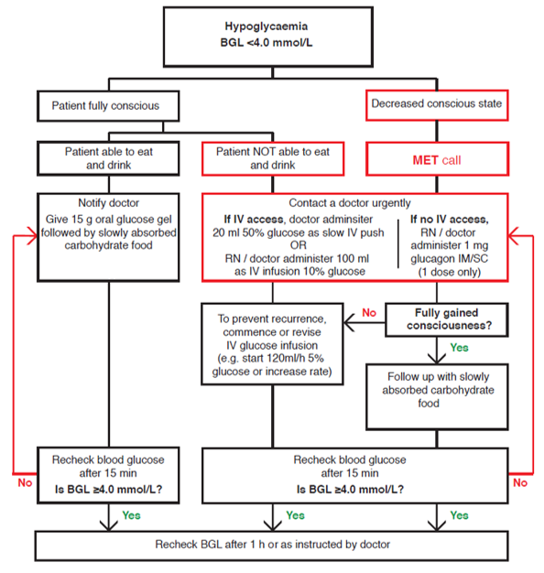

Attachment C – Flow Chart: Gestational Diabetes Antenatal Care and Visit Plan
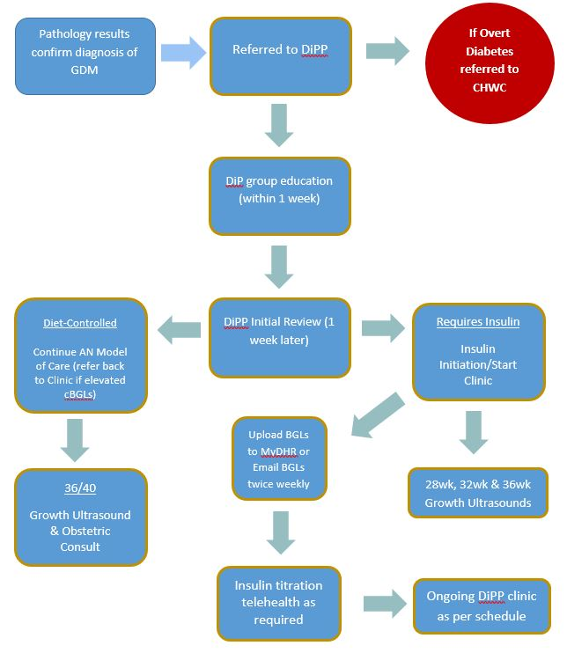

Attachment C – Flow Chart: Gestational Diabetes Antenatal Care and Visit Plan
Insulin Requiring visit plan
Gestation | Clinicians | Tasks
22 weeks | Obstetrician | Review morphology scan
 | Endocrinologist or NP
25 weeks | Midwife | Order 26 week bloods
 | Endocrinologist or NP
28 weeks | Obstetrician | Review 28wk growth Scan
 | Endocrinologist or NP
30 weeks | Midwife | Discuss perineal massage and breastfeeding
 | Endocrinologist or NP
32 weeks | Obstetrician | Review 32wk growth
 | Endocrinologist or NP
34 weeks | Midwife | Discuss perineal massage and breastfeeding & AN EBM
 | Endocrinologist or NP
36 weeks | Obstetrician (not midwife) | Review 36wk growth scan & Plan for birth  Offer GBS screen
 | Endocrinologist (not NP) | Birth plan & PN follow up (Request 6-12 week GTT)
37 weeks | Midwife | Discuss AN EBM & Birth & neonatal Hypoglycaemia
 | Endocrinologist or NP | Confirm birth plan & PN follow up
38 weeks | Obstetrician
 | Endocrinologist or NP

Diet Controlled
Gestation | Clinicians | Tasks
38-39 weeks | Obstetrician | Review 36wk growth scan & Plan for birth  Offer GBS screen

Attachment D – Intrapartum Management for Women with GDM requiring Insulin and/or Metformin in Pregnancy

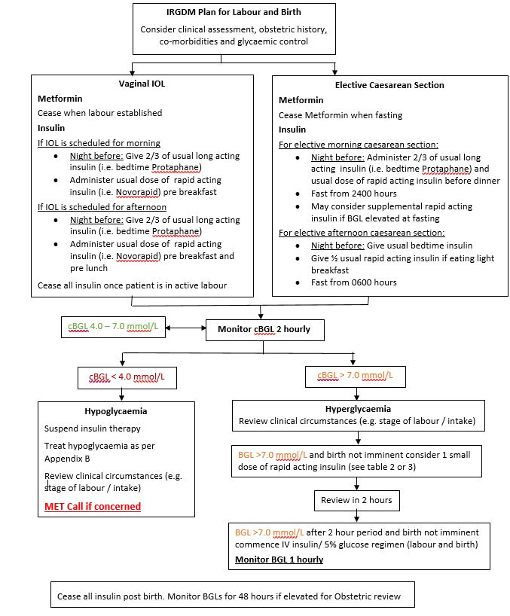

Attachment E – Post-Birth Blood Glucose Management

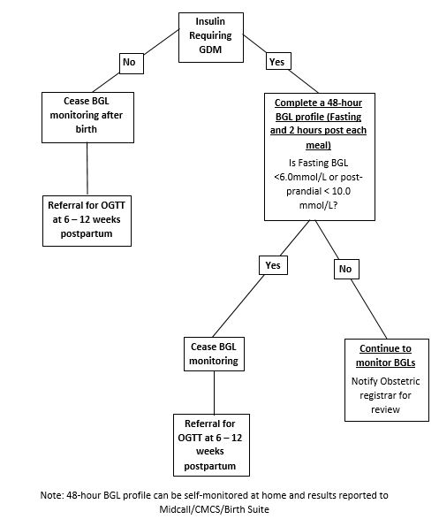

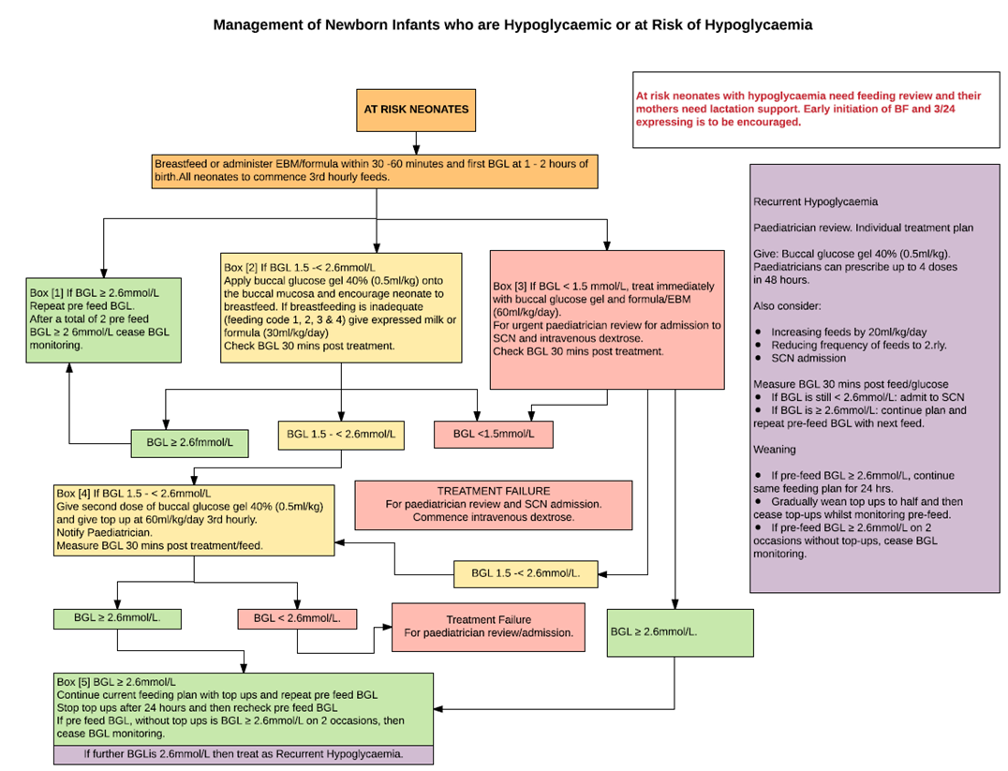
Attachment F – Neonatal Hypoglycaemia Pathway

