Canberra Health Services
Guideline
Management of Paracetamol Toxicity in Adults

Contents

Contents 1
Guideline Statement 2
Scope 3
Section 1 – Clinical presentation 3
Section 2 – Risk assessment 3
Section 3 – Initial Investigations 4
Section 4 – Management: Acute Ingestion of Immediate Release Preparations 5
Section 5 – Management: Acute Ingestion of Modified Release Preparations 9
Section 6 – Management: Repeat Supratherapeutic Ingestions 13
Section 7: Cessation of N-Acetylcysteine 15
Section 8 – When to Consider Discharge 16
Section 9 – Clinical Documentation 16
Evaluation 17
Related Policies, Procedures, Guidelines and Legislation 17
References 18
Search Terms 18
Appendix 1: Dose of N-Acetylcysteine 19

Guideline Statement

Background
Paracetamol poisoning is the most common cause of severe acute liver injury and can result in fatality. Paracetamol is easily accessible to the community and commonly ingested in both intentional and accidental overdose. The most important risk factor for liver damage after acute ingestion is the extent of delay beyond 8 hours to commence N-acetylcysteine. Treatment started within 8 hours of ingestion will prevent serious hepatic injury in almost all patients.

Key Objective
This guideline serves to provide consistency of best clinical practice in the management of adults with paracetamol toxicity across the range of clinical service providers at CHS.

Alerts
- Doses of N-Acetylcysteine should be written in the correct units: mg.
- It is important to distinguish between:
  - immediate and modified release preparations of paracetamol ingestion
  - deliberate or intentional overdose versus ingestion for therapeutic intent
- Advice from the poisons information centre should be sought for:
  - Very large overdoses (immediate or modified release overdoses > 50g or 1g/kg (whichever is less)
  - Those with paracetamol concentrations greater or equal to three times the nomogram line
  - Serial paracetamol concentrations that remain unchanged or increasing
  - Patients with hepatotoxicity (Alanine Aminotransferase (ALT) > 1,000U/L)
  - Intravenous paracetamol errors or overdoses, as the treatment threshold is lower
- Clinical or biochemical evidence of liver injury may not be apparent for up to 24 hours after acute paracetamol overdose.
- Liver transplant unit should be consulted if any of the following criteria are met:
  - International Normalised Ratio (INR) > 3.0 at 48 hours or > 4.5 at any time
  - Oliguria or creatinine > 200micromol/L
  - Persistent acidosis (pH < 7.3) or arterial lactate greater than 3mmol/L
  - Systolic hypotension with Blood Pressure (BP) < 80mmHg despite resuscitation
  - Hypoglycaemia, severe thrombocytopenia or encephalopathy of any degree
  - Any alteration of consciousness (Glasgow Coma Scale (GCS) < 15) not associated with sedative co-ingestants or encephalopathy to any degree (regardless of GCS).

Definitions
Acute ingestion is defined as any intentional/ deliberate paracetamol overdose, including staggered or multiple paracetamol ingestions over more than 2 hours.

Repeated supra-therapeutic ingestion is any ingestion of excessive paracetamol for a therapeutic purpose or ingestion of therapeutic doses of paracetamol with associated symptoms of acute liver injury (abdominal pain, nausea and vomiting).

Back to Table of Contents

Scope

The Clinical Guideline – Management of Paracetamol Toxicity in Adults applies to nursing and medical staff under the clinical governance of Canberra Health Services who are caring for adult patients with intentional or accidental overdose of paracetamol.

Back to Table of Contents

Section 1 – Clinical presentation

In the initial stages of overdose, patients are usually asymptomatic.

Beyond 24 hours, patients with toxic doses of paracetamol develop symptoms including nausea, vomiting, abdominal pain and encephalopathy.

Massive overdoses can cause coma and lactic acidosis and delayed presentations can present with hepatic failure.

Polypharmacy overdoses that include paracetamol can present in varied ways, depending on the agents ingested.

Back to Table of Contents

Section 2 – Risk assessment

History taking should focus on the following:
- Ingestion:
  - Dose
  - Time
  - Preparation: immediate or modified release
  - Co-ingestant (including alcohol and over the counter formulations with paracetamol combined with other medications)
  - Single dose or staggered
  - Deliberate or intentional overdose versus ingestion for therapeutic intent.

  - Symptoms:
  - Abdominal pain
  - Nausea or vomiting.
Table 1: Paracetamol Dosing in Adults that may be associated with Hepatic Injury

Acute single ingestion | ≥ 10g or ≥ 200mg/kg (whichever is less)
Repeated supratherapeutic ingestion# | ≥ 10g or ≥ 200mg/kg (whichever is less) over a single 24-hour period
Repeated supratherapeutic ingestion# | ≥ 12g or ≥ 300mg/kg (whichever is less) over a single 48-hour period
Repeated supratherapeutic ingestion# | Greater than a daily therapeutic dose^ per day for more than 48 hours in symptomatic patients
# These doses are a guide for asymptomatic patients at risk for acute liver injury. All symptomatic patients should be assessed with a paracetamol concentration and ALT.

^ Therapeutic daily dose of paracetamol in adults is a total dose of 60 mg/kg over 24 hours and up to a maximum dose of 4 g/day.
Back to Table of Contents

Section 3 – Initial Investigations

See specific subsections below for investigations required in different circumstances.

Table 2: Initial Investigations for Suspected Paracetamol Toxicity
 | Patient Cohort | Investigations
Deliberate Self-Poisoning | All patients regardless of the stated dose | Serum paracetamol level  ALT  INR (presentation over 24hrs from ingestion)
Repeated Supratherapeutic Ingestion | All symptomatic patients  Asymptomatic patients at risk of acute liver injury (see Table 1) | Serum paracetamol level  ALT

If the ALT is abnormal, add the following and repeat every 12 hours:
- Urea, Electrolytes, Creatinine (UEC)
- Full Liver Function Tests (LFTs)
- International Normalised Ration (INR)
- Blood Sugar Level (BSL)
- Calcium, Magnesium, Phosphate (CMP)
- Venous Blood Gas (VBG) (to evaluate the pH and lactate).

A small proportion of patients develop hepatotoxicity (ALT > 1, 000 U/L or rapidly rising ALT).

Consult the liver transplant unit if any of the following criteria are met:
  - INR greater than 3.0 at 48 hours, or >4.5 at any time
  - Oliguria or creatinine >200micromol/L
  - Persistent acidosis (pH <7.3) or arterial lactate greater than 3mmol/L
  - Systolic hypotension with BP <80mmHg despite resuscitation
  - Hypoglycaemia, severe thrombocytopenia or encephalopathy of any degree
  - Any alteration of consciousness (GCS <15) not associated with sedative co-ingestions or encephalopathy to any degree (regardless of GCS).

Back to Table of Contents

Section 4 – Management: Acute Ingestion of Immediate Release Preparations

- Oral decontamination: activated charcoal

Adult Dose | Indications (Immediate release paracetamol)
50g | In alert, cooperative adults (or intubated) AND  There are NO contraindications to activated charcoal* AND  Within 2 hours of >10g or >200mg/kg (whichever is less) OR  Within 4 hours of ≥30g
* Many patients take polypharmacy overdoses and risk assessment of seizures or respiratory/CNS depression associated with these co-ingestants needs to occur prior to administering activated charcoal.

- Antidote: N-acetylcysteine

Adult Dose | Indications (Immediate release paracetamol)
See Appendix 1 | Known Ingestion Time:  - Single ingestion – treat as per Flowchart 1 and Table 3  - Multiple or staggered ingestions – treat as per Flowchart 1 and Table 3, using the earliest time of ingestion for the nomogram.  - If the first paracetamol concentration was measured within 2 hours of the last ingested paracetamol dose, repeat paracetamol level after 2 hours to ensure there is no ongoing absorption. If either concentration is above the nomogram, start or continue treatment with N-acetylcysteine.  Unknown Ingestion Time/Clinician not confident of Ingestion History:  - Treat as a delayed presentation:  - Follow the >8 hours scenario in Flowchart 1 and Table 3  - If further history becomes available with the time of ingestion and the serum paracetamol concentration can be plotted on the nomogram, use this to guide further treatment.

Figure 1: Treatment Nomogram

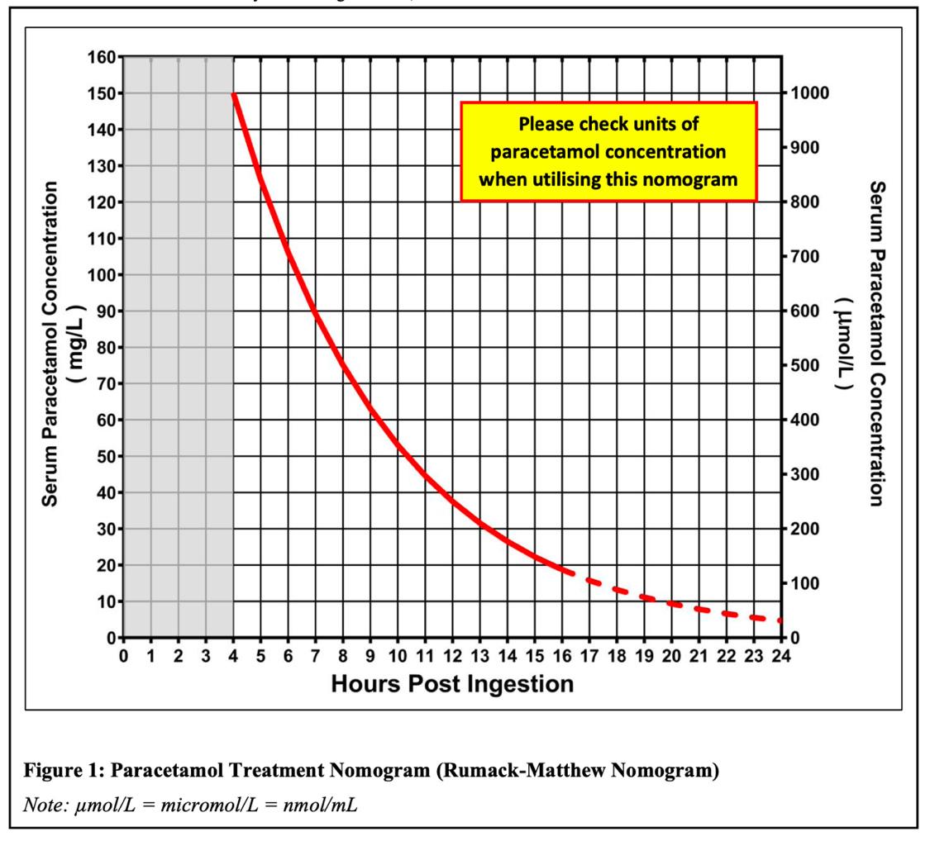

Flowchart 1: Management of Acute Immediate Release Paracetamol Ingestion with Known Ingestion Time
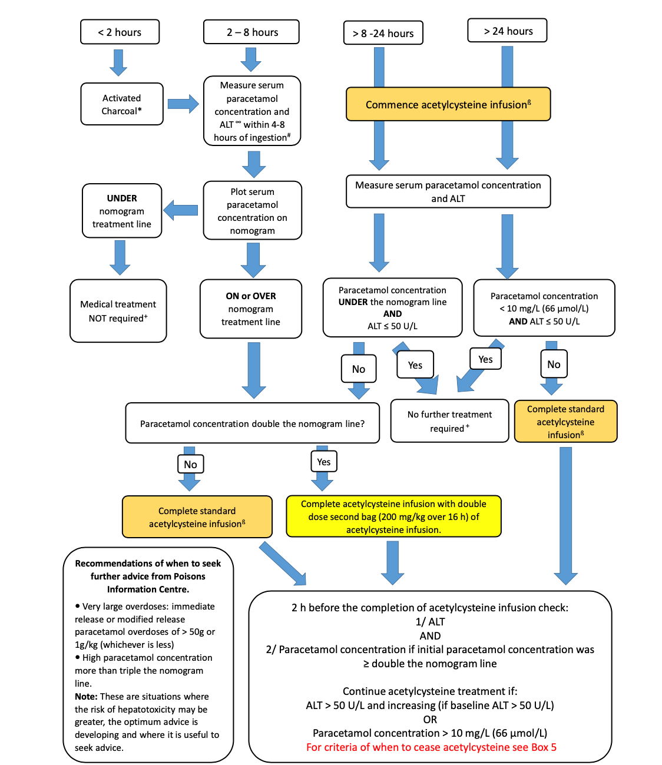
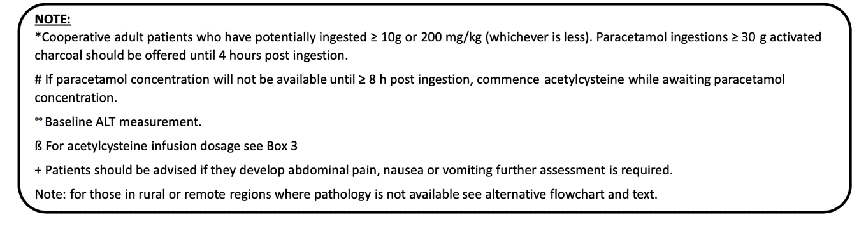
Table 3: Management of Acute Immediate Release Paracetamol Ingestion with Known Ingestion Time

(Note: see Flowchart 1 above for diagrammatic illustration)

Presentation to ED | Investigations | Clinical Situation | Treatment
< 2 hours from ingestion | Measure Serum Paracetamol level and ALT between 4-8hrs post ingestion | Presentation is within:  - 2 hours of ingestion of a toxic dose (≥10g or 200mg/kg) | 50 g activated charcoal if patient is awake and cooperative (or intubated) AND there are no contraindications to activated charcoal (consider co-ingestants)
2 - 4 hours from ingestion | Measure Serum Paracetamol level and ALT between 4-8hrs post ingestion | Presentation is within:  - 4 hours of ingestion of a toxic dose (≥30g) | 50 g activated charcoal if patient is awake and cooperative (or intubated) AND there are no contraindications to activated charcoal (consider co-ingestants)

Time from Ingestion to Paracetamol Level Result |  | Clinical Situation | Treatment
˂ 8 hours  (Serum paracetamol level collected after 4 hours of ingestion with result back within 8 hours of ingestion) |  | Serum paracetamol level is below the nomogram (see Figure 1) | No further medical treatment is required.  Patients should seek medical attention if they develop abdominal pain, nausea or vomiting.
 |  | Serum paracetamol level is on or above the nomogram (see Figure 1) | Treat with N-acetylcysteine infusion:  - Paracetamol concentration is less than double the nomogram line, treat with a standard dose in the second bag (see Appendix 1).  - Paracetamol concentration is greater than double the nomogram line, treat with a double dose in the second bag (see Appendix 1).  - If paracetamol concentration is ≥ triple the nomogram line, discuss with toxicologist regarding need for even higher N-acetylcysteine doses
Between 8-24 hours  (Serum paracetamol level collected after 4 hours of ingestion with result back between 8-24 hours from ingestion) | Commence N-acetylcysteine infusion while waiting for serum paracetamol level and ALT
 | Serum paracetamol level is under the nomogram and ALT ≤ 50 U/L |  | No further treatment with N-acetylcysteine is required.
 | Serum paracetamol level is above the nomogram OR ALT > 50 U/L |  | Continue treatment with N-acetylcysteine:  - Paracetamol concentration is less than double the nomogram line, treat with a standard dose in the second bag (see appendix 1).  - Paracetamol concentration is greater than double the nomogram line, treat with a double dose in the second bag (see Appendix 1)
> 24 hours  (Serum paracetamol level collected after 4 hours of ingestion with result back after 24 hours from ingestion) | Commence N-acetylcysteine infusion at the standard dose while waiting for the serum paracetamol, INR and ALT
 | Serum paracetamol level is <10mg/L AND ALT ≤ 50 U/L |  | No further treatment with N-acetylcysteine is required.
 | Serum paracetamol level is ≥10mg/L OR ALT >50 U/L, |  | Complete standard N-acetylcysteine infusion (see Appendix 1)

When to cease N-acetylcysteine
- 2 hours before the completion of the N-acetylcysteine infusion, check
  - ALT
  - Paracetamol concentration (if the initial paracetamol concentration was ≥ double the nomogram line)
- Continue N-acetylcysteine treatment if any of the following apply:
  - ALT > 50 U/L
  - ALT increasing (if baseline serum ALT was 50 U/L or higher in patients with pre-existing liver biochemical abnormalities)
    - Small fluctuations in ALT (eg ALT ± 20U/L or ± 10%) are common and do not on their own indicate the need for ongoing N-Acetylcystine.
  - Paracetamol concentration >10mg/L (66 micromol/L)
- Refer to Section 7 for advice on patients who require N-acetylcysteine beyond 20 hours.

Back to Table of Contents

Section 5 – Management: Acute Ingestion of Modified Release Preparations

Management is based on the amount of paracetamol ingested.

The nomogram should NOT be used to assess the need for treatment of potentially toxic modified release paracetamol ingestions. Instead, serum paracetamol concentrations are used to determine:
- N-acetylcysteine dosage
- The duration of treatment of N-acetylcysteine
- The need for further decontamination with activated charcoal.

N-Acetylcysteine is often required for much longer durations than for the acute ingestion of immediate release preparations.

- Oral decontamination: activated charcoal

Adult Dose | Indications (Modified release paracetamol)
50g | In alert, cooperative adults (or intubated) AND  There are no contraindications to activated charcoal (consider co-ingestants)* AND  Within 4 hours of ≥10g or ≥200mg/kg (whichever is less) OR  For massive overdoses (≥30g or ≥500mg/kg), absorption may continue up to 24 hours after ingestion and patients may benefit from activated charcoal beyond 4 hours. Seek advice from a clinical toxicologist or poisons information.
* Many patients take polypharmacy overdoses and risk assessment of seizures or respiratory/CNS depression associated with these co-ingestants needs to occur prior to administering activated charcoal.

- Antidote: N-acetylcysteine

Adult Dose | Indications (Modified release paracetamol)
See Appendix 1 | Ingestion of ≥10g or ≥200mg/kg of modified release paracetamol, whichever is less, regardless of serum paracetamol levels – see Flowchart 2 and Table 4  For ingestion doses less than the above of modified release paracetamol, where either the 2 paracetamol concentration levels (taken 4 hours apart) are above the nomogram line – see Flowchart 2 and Table 4

Flowchart 2: Management of Acute Modified Release Paracetamol Ingestion
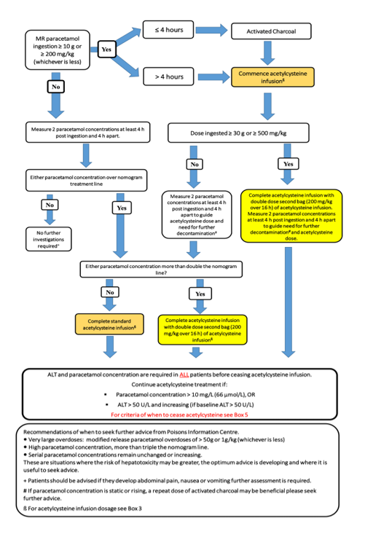
Table 4: Management of Acute Modified Release Paracetamol Ingestion
(Note: see Flowchart 2 for diagrammatic illustration)
Dose of Modified Release Paracetamol Ingested | Clinical Situation | Treatment
Less than 10g or 200mg/kg (whichever is less) | Measure a serum paracetamol concentration and ALT at least 4 hours post ingestion. Repeat a second serum paracetamol level 4 hours after the first was taken.
Less than 10g or 200mg/kg (whichever is less) | Both serum paracetamol concentrations are under the nomogram treatment line | No further medical treatment is required.  Patients should seek medical attention if they develop abdominal pain, nausea or vomiting.
Less than 10g or 200mg/kg (whichever is less) | Either paracetamol concentration is over the nomogram treatment line (but not double it) | Commence N-acetylcysteine (see Appendix 1).
Less than 10g or 200mg/kg (whichever is less) | Either concentration is more than double the nomogram treatment line | Complete N-acetylcysteine infusion with a double dose second bag (see Appendix 1).
More than 10g or 200mg/kg (whichever is less) | Offer 50g activated charcoal up to 4 hours after ingestion.  Immediately commence treatment with N-acetylcysteine and give the full 20-hour course.  Measure a serum paracetamol concentration and ALT at least 4 hours post ingestion.  Repeat a second serum paracetamol level 4 hours after the first was taken.
More than 10g or 200mg/kg (whichever is less) | Either paracetamol concentration is over the nomogram treatment line (but not double it) | Complete the standard N-acetylcysteine infusion (see Appendix 1).
More than 10g or 200mg/kg (whichever is less) | Either concentration is more than double the nomogram treatment line | Complete N-acetylcysteine infusion with a double dose second bag (see Appendix 1).
More than 30g or 500mg/kg (whichever is less) | Patients may benefit from activated charcoal beyond 4 hours.  Commence treatment with N-acetylcysteine, with a double dose second bag (see Appendix 1).  Measure a serum paracetamol concentration and ALT at least 4 hours post ingestion.  Repeat a second serum paracetamol level 4 hours after the first was taken. This is used to guide further decontamination and N-acetylcysteine dose.  If paracetamol concentration is static or rising, a repeat dose of activated charcoal may be beneficial and longer duration of N-acetylcysteine may be required and should be discussed with a toxicologist.

When to cease N-Acetylcysteine
- 2 hours before the completion of the N-Acetylcysteine infusion, check
- ALT
- Paracetamol concentration
- Continue N-acetylcysteine treatment if any of the following apply:
  - ALT > 50 U/L
  - ALT increasing (if baseline serum ALT was 50 U/L or higher in patients with pre-existing liver biochemical abnormalities)
    - Small fluctuations in ALT (eg ALT ± 20U/L or ± 10%) are common and do not on their own indicate the need for ongoing N-Acetylcystine.
  - Paracetamol concentration >10mg/L (66 micromol/L)
- Refer to Section 7 for advice on patients who require N-Acetylcysteine beyond 20 hours

Back to Table of Contents

Section 6 – Management: Repeat Supratherapeutic Ingestions

Repeat supratherapeutic ingestion (RSTI) refers to patients who:
- Ingest excessive paracetamol for a therapeutic purpose OR
- Ingest therapeutic doses of paracetamol and have symptoms of acute liver injury (abdominal pain, nausea and vomiting).

Note: If the supratherapeutic ingestion is deliberate or intentional, they should be managed as per acute intentional ingestion.

Criteria for RSTI
Any of the following that apply:
Over a single 24-hour period | ≥10g or ≥ 200mg/kg (whichever is less)
Over a single 48-hour period | ≥12g or ≥ 300mg/kg (whichever is less)
≥ a daily therapeutic dose per day (total 60mg/kg over 24 hours up to a maximum of 4g/day) for more than 48 hours in those who also have abdominal pain, nausea or vomiting

Note: The criteria for RSTI has been made deliberately low to capture the numerous confounders that increase individual risk of toxicity: age, co-morbidities, alcohol use, nutritional status, genetics and cytochrome p450 induction.

- Antidote: N-acetylcysteine
Adult Dose | Indications (Repeat Supratherapeutic Ingestions)
See Appendix 1 | See Flowchart 3 and Table 5  All patients with an initial ALT >1000U/L should receive at least a full 20-hour course of N-acetylcysteine.

Flowchart 3: Management of Repeat Supratherapeutic Paracetamol Ingestion
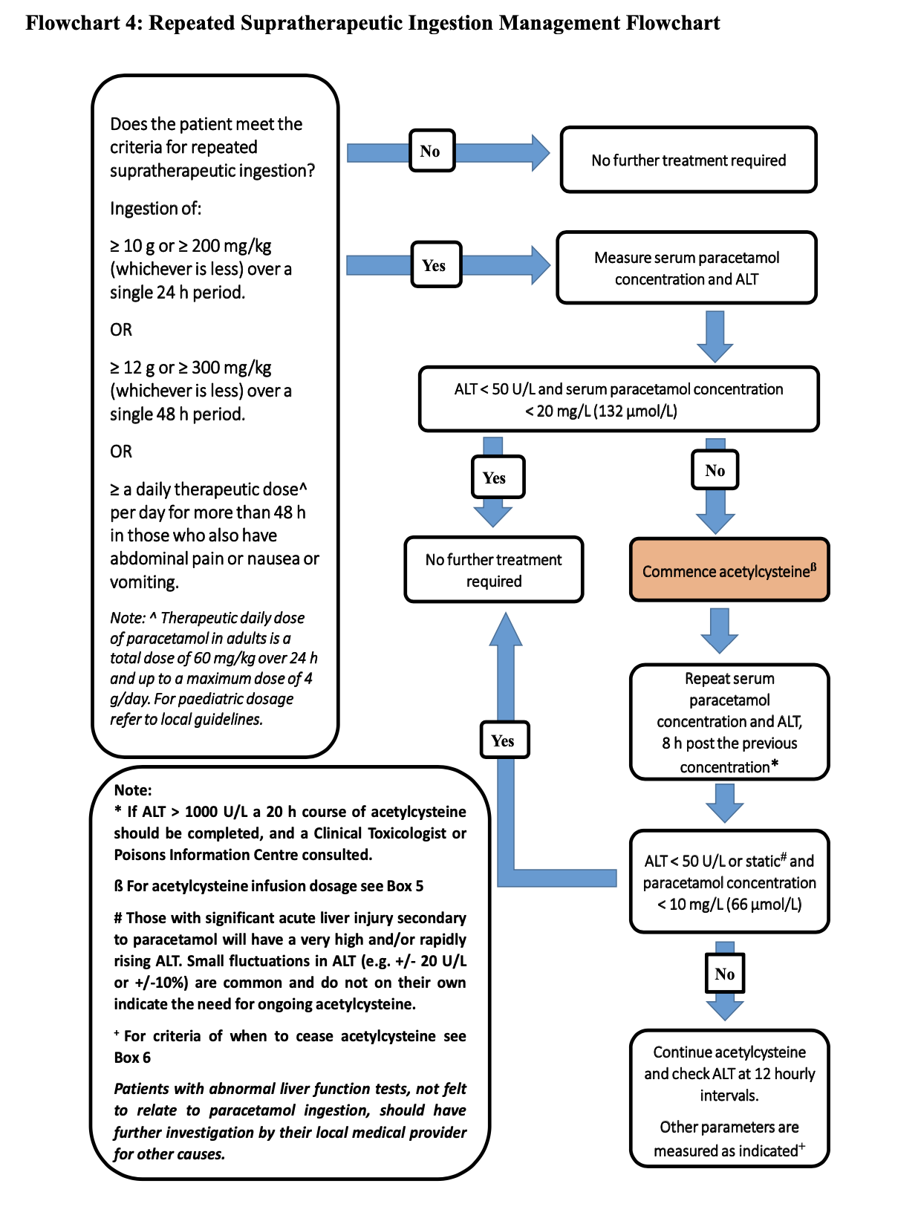

Table 5: Management of Repeat Supratherapeutic Paracetamol Ingestions

Measure serum paracetamol concentration and ALT | ALT < 50 U/L AND serum paracetamol concentration is <20 mg/L | No further treatment is required.
Measure serum paracetamol concentration and ALT | ALT ≥ 50 U/L OR serum paracetamol concentration is ≥20mg/L | Commence N-acetylcysteine at the standard dose  Repeat the serum paracetamol concentration and ALT 8 hours after the previous levels were taken.

8hr repeat serum paracetamol concentration and ALT  (for patients commenced on an N-acetylcysteine infusion) | ALT is <50 U/L or static AND serum paracetamol concentration is <10mg/L | Cease N-Acetylcysteine
 | ALT is > 50 U/L or rising OR serum paracetamol concentration is > 10mg/L | Continue N-Acetylcysteine and check ALT at 12 hourly intervals.

ALERT: All patients with an initial ALT >1,000U/L should receive at least a full 20-hour course of N-Acetylcysteine

Notes:
- Those with acute liver injury will have very high and/or rapidly rising ALT.
- Small fluctuations in ALT (eg, ± 20 U/L or ± 10%) are common and do not on their own indicate the need for ongoing N-acetylcysteine
- For advice about cessation of N-acetylcysteine in patients who require it beyond 20 hours, refer to Section 7.

Back to Table of Contents

Section 7: Cessation of N-Acetylcysteine

- Refer to Section 4 and Section 5 for cessation of N-Acetylcysteine in acute ingestion of immediate or modified release preparations.
- Refer to Section 6 for cessation of N-Acetylcysteine in repeat supratherapeutic ingestion.

Cessation of N-Acetylcysteine in patients who require it beyond 20 hours
Some patients will require ongoing treatment with N-acetylcysteine if they have persistently high paracetamol concentrations greater than 10mg/L or ALT greater than 50 U/L or increasing (if baseline ALT >50 U/L).

Small fluctuations in ALT (+/- 20 U/L or +/- 10%) are common and do not indicate the need for ongoing N-acetylcysteine.

In patients who require N-acetylcysteine beyond 20 hours, regular clinical reviews and 12 hourly paracetamol levels, LFTs and INR are recommended.

Continue treatment until patients meet all the following criteria:
- ALT or AST are decreasing AND
- INR <2.0 AND
- Patient clinically well AND
- Paracetamol concentration <10mg/L for:
- Modified release ingestions
- Patients with initial paracetamol concentration greater than double the nomogram.

Note:
For patients whose ALT > 1,000 U/L OR those with chronic liver disease whose baseline ALT >50 U/L, consider consultation with a gastroenterologist to confirm the timing of cessation of N-Acetylcysteine.

If ongoing N-acetylcysteine is required, continue at the rate of the second infusion (e.g. 100mg/kg over 16 hours). Higher ongoing infusion rates (e.g 200mg/kg over 16 hr) may be required for massive paracetamol ingestions and a clinical toxicologist should be consulted.

Back to Table of Contents

Section 8 – When to Consider Discharge

Patients should be considered medically cleared when the patient has:
- No further N-acetylcysteine requirements AND
- Serum paracetamol concentrations, LFTs and INR within the reference ranges indicated in this document (see Sections 4, 5, 6 and 7).

For deliberate ingestions, a mental health review and risk assessment must be completed prior to discharge and appropriate community follow-up arranged.

Back to Table of Contents

Section 9 – Clinical Documentation

Clinical documentation should include:
- The cause of the ingestion (e.g. accidental or intentional)
- Outcomes of risk assessments, consultations and clinical discussions
- Chronic conditions or comorbidities that may increase the risk of toxicity (e.g. malnutrition)
- Any associated psychiatric diagnoses or mental health symptoms
- For deliberate ingestions, a mental health review and risk assessment must be completed prior to discharge and appropriate community follow-up arranged.
- All manifestations treated as a result of the ingestion/poisoning (e.g. acute liver or kidney failure, encephalopathy, metabolic acidosis)”.

Back to Table of Contents

Evaluation

Outcome
Adult patients will safely receive the appropriate treatment for paracetamol toxicity.

Measures
- Review of clinical incidents relating to the treatment of paracetamol toxicity reported in the incident management system Riskman.
- Audit of paracetamol toxicity management in the Emergency Department, Acute Medical Unit and General Medical Unit within 18 months of the endorsement date of this guideline.

Back to Table of Contents

Related Policies, Procedures, Guidelines and Legislation

Policies
- Informed Consent - Clinical

Procedures
- Infection Prevention and Control Procedure
- Patient Identification and Procedure Matching Procedure

Guidelines
- Management of Anaphylaxis in Adults and Children

Legislation
- Health Records (Privacy and Access) Act 1997
- Human Rights Act 2004
- Work Health and Safety Act 2011

Other
Australian Charter of Healthcare Rights

Back to Table of Contents

References

- Chiew, A., Reith, D., Pomerleau, A., Wong, A., et.al., Updated guidelines for the management of paracetamol poisoning in Australia and New Zealand. MJA. 2020; 212 (4):175-183.
- Agency for Clinical Innovation 2023. Paracetamol Overdose. Emergency Care Institute New South Wales. Viewed at https://aci.health.nsw.gov.au/networks/eci/clinical/clinical-tools/toxicology/paracetamol.
- Dargan, P., Ladhani, S., Jones, A., Measuring plasma paracetamol concentrations in all patients with drug overdose or altered consciousness: Does it change outcome? Emerg Med J. 2001;18:178–182. Viewed at https://emj.bmj.com/content/18/3/178.
- Long, N., Paracetamol Toxicity. Life in the Fast Lane 2023. Nov 2020. Viewed at https://litfl.com/paracetamol-toxicity/.
- The Royal Children's Hospital, Melbourne. Clinical Practice Guidelines. Paracetamol Poisoning. Viewed at https://www.rch.org.au/clinicalguide/guideline_index/Paracetamol_poisoning/
- South Australian Paediatric Clinical Practice Guidelines: Paracetamol Poisoning. Department for Health and Wellbeing, Government of South Australia. Viewed at https://www.sahealth.sa.gov.au/wps/wcm/connect/aade11d3-c856-4d5f-9f35-904d7b30d164/Paracetamol_Poisoning_Paed_v1_0.pdf?MOD=AJPERES&amp;CACHEID=ROOTWORKSPACE-aade11d3-c856-4d5f-9f35-904d7b30d164-nKPo.dv
- Paracetamol Poisoning, Therapeutic Guidelines Ltd (eTG March 2021 edition).
Back to Table of Contents

Search Terms

Paracetamol toxicity, overdose, poisoning, acute liver failure

Back to Table of Contents

Appendix 1: Dose of N-Acetylcysteine

NOTE: Please ensure dosages are written in the correct units – mg.

Dose
Standard treatment | Bag 1: 200mg/kg (max 22g) in 500ml (glucose 5% or sodium chloride 0.9%) IV over 4 hours  Bag 2: 100mg/kg (max 11g) in 1000ml (glucose 5% or sodium chloride 0.9%) IV over 16 hours
Double dose | Bag 1: 200mg/kg (max 22g) in 500ml (glucose 5% or sodium chloride 0.9%) IV over 4 hours  Bag 2: 200mg/kg (max 22g) in 1000ml (glucose 5% or sodium chloride 0.9%) IV over 16 hours

Calculation of N-acetylcysteine doses is based on actual bodyweight rounded up to the nearest 10kg, but with a ceiling weight of 110kg.

If ongoing N-acetylcysteine is required (ie > 20 hours), continue at the rate of the second infusion (e.g. 100mg/kg over 16 hours). Higher ongoing infusion rates (e.g 200mg/kg over 16 hr) may be required for massive paracetamol ingestions and a clinical toxicologist should be consulted.

Anaphylactoid reactions to N-acetylcysteine may occur (wheeze, rash, mild hypotension). Stop the infusion for 30 minutes, give Loratadine 10mg oral, then recommence infusion at half the previous rate. Increase the rate slowly over time until the desired rate is again reached.

Rarely, a more severe reaction can occur. If there are significant cardiovascular changes, respiratory distress or other features of anaphylaxis, review urgently and consider giving adrenaline IM as per standing orders for the emergency management of anaphylaxis (see table below) and hydrocortisone (4mg/kg) IV.

Standing Orders for the Emergency Management of Anaphylaxis:
Adrenaline 1:1000 (1mg/mL) into mid-lateral thigh
Age (years) | Weight (kg) | Adrenaline volume (mL)
Adult | >50 | 0.5 mL
Adrenaline via Epipen
Adult | Epipen 300 | 300 micrograms IM

Disclaimer: This document has been developed by Canberra Health Services specifically for its own use. Use of this document and any reliance on the information contained therein by any third party is at his or her own risk and Canberra Health Services assumes no responsibility whatsoever.

Policy Team ONLY to complete the following:
Date Amended | Section Amended | Divisional Approval | Final Approval
01/12/2023 | New Document | Brendan Docherty ED Medicine | CHS Policy Committee

This document supersedes the following:
Document Number | Document Name

