**Canberra Health Services**

**Guideline**

***Splenic Injury Management Guidelines for Adults***

|  |
| --- |
| Contents |

Contents 1

Guideline Statement 2

Purpose 2

Scope 2

Section 1 – Treatment Algorithm 3

Section 2 – Initial Assessment 4

Section 3 – Use of FAST scan 4

Section 4 – Operative Management 5

Section 5 – Non operative Management following contrast-enhanced CT gradings of splenic injury 5

Section 6 – Mobility vs Bed rest 7

Section 7- Thromboprophylaxis 7

Section 8- Vaccinations 7

Section 9 - Antibiotics 7

Section 10- Follow up Imaging 8

Section 11- Spleen Education and Bracelet 8

Evaluation 8

Related Policies, Procedures, Guidelines and Legislation 9

References 9

Search Terms 10

Attachments 10

|  |
| --- |
| Guideline Statement |

Splenic injury is commonly seen in blunt abdominal trauma. Historically, the management of splenic injuries involved mostly operative interventions because of the high failure rate in nonoperative management (NOM). Over the years, NOM has evolved as the standard of care for haemodynamically stable patients with splenic injury, including that of high grade splenic injuries on Computed Tomography (CT) scan. Treatment of splenic injury success rates have continued to improve with 90% or greater in most centres worldwide.

*Back to Table of Contents*

|  |
| --- |
| Purpose |

The purpose of this guideline is to assist the emergency and trauma team in assessing and managing splenic trauma in adults, 16 years old and above. This guideline is based on existing protocols from various centres. Canberra Health Services (CHS) acknowledge there are controversies in current literature around splenic injury and management and have adapted guidelines to reflect our consensus around best evidence.

*Back to Table of Contents*

|  |
| --- |
| Scope |

This guideline applies to patients presenting to CHS with splenic injury.

This guideline applies to the following CHS staff working within their scope of practice:

* Medical Officers - Emergency physicians, trauma and surgical teams, interventional radiologists
* Nurses
* Allied Health Professionals
* Students under direct supervision.

|  |
| --- |
| Section 1 – Treatment Algorithm |

Figure 1. Treatment Algorithm for Splenic Injury

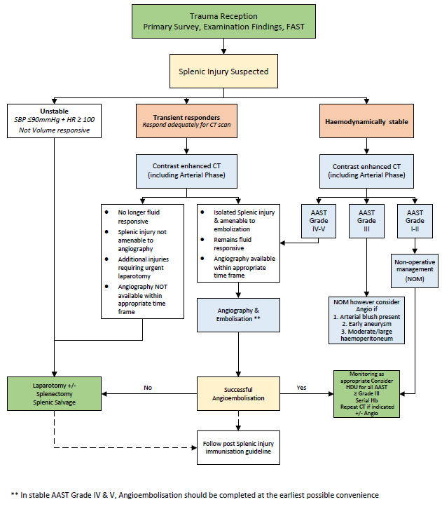

*Back to Table of Contents*

|  |
| --- |
| Section 2 – Initial Assessment |

The initial evaluation of patients with suspected blunt abdominal injuries should follow the principles of Advanced Trauma Life Support (ATLS)/Early Management of Severe Trauma (EMST). The patient’s haemodynamic status is evaluated clinically. There are no clear definitions of haemodynamic stability/instability in the literature. A systolic blood pressure less than 90mmHg should alert the clinician of possible instability in the context of trauma, and thus require early notification to the Senior Emergency Department (ED) Physician and the Trauma Consultant. The patient’s response to fluid or blood product resuscitation should also be used as an assessment of patient’s haemodynamic status.

**Note:** A senior physician’s (Trauma Consultant/Fellow) clinical judgment is imperative to assess the patient’s haemodynamic instability and guide subsequent management.

*Back to Table of Contents*

|  |
| --- |
| Section 3 – Use of FAST scan |

The use of Focused Assessment using Sonography in Trauma (FAST) is an important adjuvant in the initial evaluation of a polytrauma patient, especially in the setting of haemodynamic instability.

Patients with a positive FAST scan and signs of peritonism and haemodynamic instability should be considered for urgent laparotomy and splenectomy in the setting of splenic involvement.

Patients with a positive FAST and haemodynamic instability who respond to initial blood/fluid resuscitation can potentially be transferred to Medical Imaging for CT. The patient should be accompanied by the trauma response team (senior trauma person - consultant or fellow, senior ED physician, Intensive Care Unit (ICU) physician, anaesthetist, and ED nurses). Operating Theatre should be on standby in case of rerouting to theatre, if clinical deterioration of the patient occurs. The Interventional Radiology (IR) team should also be made aware of the patient, to facilitate transfer directly to IR suite if required after CT.

A negative FAST scan does not completely rule out a bleeding/injured spleen. In the haemodynamically unstable patient, a repeat FAST scan should be performed after a period of resuscitation if no improvement noted. Other sites of haemorrhage and other causes of shock should always be considered.

*Back to Table of Contents*

|  |
| --- |
| Section 4 – Operative Management |

Patients with persistent haemodynamic instability with clear signs of abdominal trauma and positive FAST scan should undergo laparotomy. Patients should go direct to operating theatre from the resuscitation bay.

Operative management of splenic injury should be considered for patients with failed NOM and deterioration in haemodynamic status, or significant drop in haemoglobin levels requiring continuous transfusion of blood products.

Operative management of splenic injury is also indicated when there is failed angioembolisation, clinical deterioration and failed NOM in the context of high-grade splenic injuries.

Operating theatre staff will be advised, and nursing staff should prepare for a laparotomy with at least 20 gauze packs opened to facilitate immediate packing of the abdomen.

In theatre the patient will be positioned supine with both arms out. The patient will be prepped from the neck down to upper thigh and draped, only leaving the abdomen exposed. If spleen is the cause of intraabdominal haemorrhage causing haemodynamic instability, splenectomy is warranted. Damage control laparotomy may also be utilised if the patient has multiple injuries with ongoing haemodynamic instability.

The incidence of postoperative bleeding after splenectomy ranged from 1.6-3%, with overall hospital mortality of splenectomy in trauma at near 2%. (Coccolini et al 2017)

*Back to Table of Contents*

|  |
| --- |
| Section 5 – Non operative Management following contrast-enhanced CT gradings of splenic injury |

Nonoperative management (NOM) of splenic injuries include supportive and expectant management and or interventional radiology angioembolisation. NOM is utilised more in most centres in Australia and worldwide because of the availability of intensive care units and interventional radiology

Patients with splenic injury who are haemodynamically stable should have NOM, including patients who were initially haemodynamically unstable but responded to a brief fluid resuscitation. The choice of NOM depends on patient’s grading of splenic injury severity. Patients with high grade splenic injuries (IV or V) or clinical requirement should be admitted to a High Dependency Unit (HDU) for ongoing monitoring. Splenic injury severity is graded on CT scan. (Figure 1)

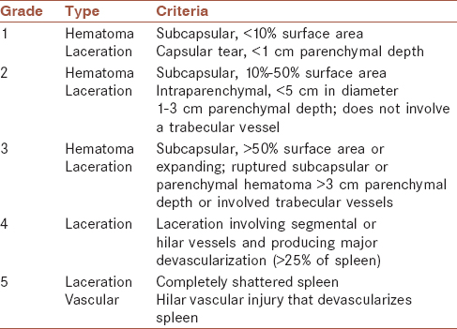

Figure 2. American Association for the Surgery of Trauma (AAST) Grading System of Splenic Injury

Failure rates for NOM (resulting in requirement for angioembolisation or splenectomy) has significant variability. Grades IV and V have significantly high estimated failure rate for observation alone (43.7 and 83.1% respectively). Other clinical factors that can also affect failure of NOM include high Injury Severity Score (ISS) of 25 or higher, and age more than 40.

* 1. **AAST Grade I and II injuries**

NOM should be pursued for patients with Grades I and II injuries, unless there is another indication for trauma laparotomy. The failure rate of NOM for low grade splenic injury is low. It is suggested that if there is a foci of contrast extravasation despite low grade, the decision whether embolization should be pursued will be made in conjunction with IR consultant taking into account other patient factors. In most patients it will not be required.

**4.2 AAST Grade III injuries**

This is still the area of controversy on when to perform angiography. NOM in grade III injuries has success rates of 70-90%. Based on available literature, both observation/expectant management and angiography (+/-) embolization still remain acceptable options. A repeat CT angiogram in 72 hours is recommended to look for development of pseudoaneurysm. Angiography and embolization should be considered if this is associated with large haemoperitoneum on CT scan.

* 1. **AAST Grade IV and V**

In a haemodynamically stable patient, it is recommended to perform angioembolisation even without an obvious foci of bleeding or active contrast extravasation. Regular haemoglobin (Hb) check is recommended twice daily until clinician is satisfied the patient is stable. It is also recommended that patients be admitted in a high dependency unit for haemodynamic monitoring. A repeat contrast enhanced CT imaging is recommended in 72 hours, to monitor development of pseudoaneurysm, or earlier than 72 hours if there are significant concerns re patient’s haemodynamic status or haemoglobin. Repeat angioembolization may be indicated.

*Back to Table of Contents*

|  |
| --- |
| Section 6 – Mobility vs Bed rest |

There is no supporting data around confining patients to bed rest, including those with higher grades injuries. It is recommended for the patient, once considered stable, to be allowed to mobilise even in the intensive care unit/high dependency unit.

*Back to Table of Contents*

|  |
| --- |
| Section 7- Thromboprophylaxis |

Chemical prophylaxis (Low molecular weight heparin (LMWH)-based prophylactic anticoagulation) should be started as early as possible for patients with splenic trauma treated using NOM, without evidence of ongoing bleeding. In patients who are already on oral anticoagulation, the risk-benefit of reversal should be on a case by case basis.

*Back to Table of Contents*

|  |
| --- |
| Section 8- Vaccinations |

It is recommended that patients with absolute or functional asplenia receive vaccination against encapsulated bacteria (*S. pneumoniae, H. influenza, and N. meningitidis*). It is also strongly recommended for the patient to receive seasonal flu vaccination.

Patients who undergo a splenectomy OR splenic artery embolisation (for Grade IV or V splenic injury) should receive vaccinations one week after the procedure. If there is any doubt as to the reliability of access to follow-up, the patient should be vaccinated prior to discharge from hospital.

Patients should be referred to the Infectious Diseases outpatient clinic at 6 – 8 weeks after discharge with a blood film looking for Howell-Jolly bodies prior. Patients should be counselled about asplenia. Refer to *Prevention of Post Splenectomy Sepsis Guidelines*.

*Back to Table of Contents*

|  |
| --- |
| Section 9 - Antibiotics |

Patients should also receive antibiotic prophylaxis on discharge from hospital to last them until follow-up with Infectious Diseases, as per *Prevention of Post Splenectomy Sepsis Guidelines*.

Patients with asplenia are strongly recommended to commence antibiotic therapy at treatment dosages in the event of any onset of unexplained fever, chills, malaise or other flu-like symptoms, especially when medical review is not readily available. Post splenectomy patients should have a prescription available against encapsulated bacteria. Refer to *Prevention of Post Splenectomy Sepsis Guidelines*.

*Back to Table of Contents*

|  |
| --- |
| Section 10- Follow up Imaging |

For high grade splenic injuries, the formation of pseudoaneurysm is a well-recognised complication associated with NOM. A repeat intravenous contrast enhanced CT scan in 48-72 hours for AAST Grade III or higher is recommended. Further repeated imaging should be determined by patient’s clinical status.

For high grade splenic injury patients treated non-operatively (NOM), follow up imaging is controversial but consider a 6-week repeat imaging either via splenic ultrasound or CT.

*Back to Table of Contents*

|  |
| --- |
| Section 11- Spleen Education and Bracelet |

Post splenectomy patients should be given comprehensive post splenectomy education covering the possible implications of having no spleen. This includes discussion about overwhelming post splenectomy infections (OPSI), which although rare, has a high mortality. The discussion should include requirement for vaccinations, antibiotics, and follow up.

The patient should have/arrange to have a post splenectomy bracelet to alert future medical teams/ hospitals about their post splenectomy status.

Similarly, splenic injury patients treated non-operatively, should be well informed of above requirements including vaccinations but also restrictions in activities.

*Back to Table of Contents*

|  |
| --- |
| Evaluation |

**Outcome**

Patients presenting with traumatic splenic injury are managed as per this procedure.

**Measure**

* Annual review of clinical incidents related to splenic trauma
* Annual audit of clinical records of all patients with high grade splenic injury

*Back to Table of Contents*

|  |
| --- |
| Related Policies, Procedures, Guidelines and Legislation |

**Policies**

* Informed Consent (Clinical)
* Medication Handling

**Procedures**

* Clinical handover
* Patient Identification and Procedure Matching
* Interventional Radiology
* Vital Signs and Early Warning Scores
* Post Operative Handover and Observations – Adult Patient (First 24 Hours)
* Infection Prevention and Control
* Aseptic Technique
* Surgical Safety Checklist

**Guidelines**

* Prevention of Post splenectomy Sepsis

**Legislation**

* *Health Records (Privacy and Access) Act 1997*
* *Human Rights Act 2004*
* *Work Health and Safety Act 2011*

**Other**

* Australian Charter of Healthcare Rights

*Back to Table of Contents*

|  |
| --- |
| References |

Rowell, Susan MD, Biffl, Walter MD, Brasel, Karen MD et al. Western Trauma Association Critical Decisions in Trauma: Management of Adult Blunt Splenic Trauma – 2016 Updates.

Zarzaur, Ben, Rozycki, Grace. An Update on Nonoperative management of the spleen in adults. Trauma Surg Acute Care Open. 2017; 2:1-7.

Stassen, Nicole MD, Bhullar, Indermeet MD, Cheng, Julius MD et al. Selective nonoperative management of blunt splenic injury: an Eastern Association for the Surgery of Trauma Practice management guidelines.

Coccolini, Federico, Montori, Guilia, Catena, Fausto et al. Splenic Trauma: WSES Classification and guidelines for adult and paediatric patients. World Journal of Emergency Surgery. 2017;12:40.

Immunisation Recommendations for Functional or Anatomical Asplenia in Adult. Liverpool Hospital Pharmacy Guidelines 2013.

International Association for Trauma Surgery and Intensive Care (IATSIC) Definitive Surgical Trauma Care (DSTC) Course Manual 2017

*Back to Table of Contents*

|  |
| --- |
| Search Terms |

Splenic injury, blunt abdominal injury, FAST scan for abdominal injury, spleen, trauma, splenectomy

*Back to Table of Contents*

|  |
| --- |
| Attachments |

**Disclaimer**: *This document has been developed by Canberra Health Services specifically for its own use. Use of this document and any reliance on the information contained therein by any third party is at his or her own risk and Canberra Health Services assumes no responsibility whatsoever.*

*Policy Team ONLY to complete the following:*

|  |  |  |  |
| --- | --- | --- | --- |
| *Date Amended* | *Section Amended* | *Divisional Approval* | *Final Approval* |
| *29/08/2022* | *New document* | *Lisa Gilmore, ED Surgery* | *CHS Policy Committee* |
|  |  |  |  |

*This document supersedes the following:*

|  |  |
| --- | --- |
| *Document Number* | *Document Name* |
|  |  |
|  |  |