Canberra Health Services
Guideline
Use of Palliative Care Sedation Therapy (Adults)

Contents

Contents 1
Guideline Statement 2
Scope 2
Section 1 – Palliative Sedation Therapy (PST) 2
Section 2 – The intent of PST 4
Section 3 – Patient Assessment for Possible Palliative Sedation 4
Section 4 – Who is Involved in Decision Making? 5
Section 5 – Talking with Patients and Family 5
Section 6 – During Sedation 7
Section 7 – Consent 8
Section 8 – Sedative Medication 9
Section 9 – Monitoring and Outcome 11
Section 10 – Care of Staff 12
Section 11 – Escalation of care 13
Section 12 – Documentation 13
Evaluation 14
Related Policies, Procedures, Guidelines and Legislation 14
References 15
Definition of Terms 16
Search Terms 16
Attachments 17
Attachment 1 - Health Direction 18
Attachment 2 - Advance Care Plan Statement of Choices – Competent Person 20
Attachment 3 - Advance Care Plan Statement of Choices – No Legal Capacity 24

Guideline Statement

Palliative Sedation Therapy (PST) is the monitored use of medications to lower a patient’s awareness in order to provide relief of symptoms that are refractory to usual measures, are distressing and result in considerable suffering if unrelieved (Cherny et al 2009, Morita et al 2005).

- The use of the word ‘terminal’ in this Guideline is not limited to cancer, but appropriate for any end stage disease including dementia.
- This Guideline should empower all medical clinicians, including General Practitioners (GPs), to feel confident that palliative sedation is safe, and a standard care intervention where there is suffering and intractable symptoms.
- The impact of severity and intractable symptom is based on patient assessment rather than clinician assessment.
- The concept of palliative sedation can give rise to a variety of moral questions and emotional distress. It is a complex issue, and this document does not seek to provide all the answers to these concerns, but to provide a clear explanation and guide to its safe use.

Palliative sedation is used only when patients are terminally ill; the precondition for its application, therefore, is in those patients who are predicted to have a very limited expected survival. A decision to use PST is not dependant on nor does it influence other end of life decisions i.e., nutrition support or organ donation.

Back to Table of Contents

Scope

The Clinical Guideline Use of Palliative Sedation Therapy applies to all clinicians working in an inpatient setting under the clinical governance of the Canberra Health Service (CHS).

Paediatric patients are excluded from this guideline. In the rare event that palliative sedation is considered in the paediatric setting the local ACT paediatric palliative care service should be contacted, and the Sydney Children’s Hospitals Network Paediatric Palliative Care Programme (including after hours) should be consulted for medical advice.

Back to Table of Contents

Section 1 – Palliative Sedation Therapy (PST)

The focus of PST is the relief of refractory and distressing symptoms in order to provide patient comfort. PST is:
- A mechanism to achieve patient comfort by reducing the awareness of symptoms through decreasing a patient’s consciousness.
- A management strategy that should be considered in the setting of care for the dying patient to manage severe and refractory symptoms.
- Not an isolated intervention but a symptom control strategy consistent with palliative care provision at the end of life.
- Carried out in a manner that is administered according to standards of best practice and acceptable to the patient, family (refer to Section 5 below) and health-care providers.
- Inclusive of a range of types of sedation (continuous/intermittent, and mild/deep).

PST needs to be distinguished from the more common practice of managing symptoms such as anxiety, restlessness and/or insomnia through use of medicines with sedative properties.

Examples of use of PST:
- Occasionally patients in the Intensive Care Unit (ICU) may be conscious prior to withdrawal of ventilatory support. Examples of such patients would include a ventilator-dependant patient with end-stage motor neuron disease or a ventilator-dependent patient with a high spinal lesion. Optimal care of these patients could involve pre-emptive administration of anaesthetic or sedative drugs to reduce awareness and mitigate suffering during the dying process.
- Potential organ donors in ICU or ED at end of life may require PST. The focus and intent of PST in these cases is the same as for any patient at end of life, namely the relief of refractory and distressing symptoms. PST should not be withheld or limited because a patient is an organ donor.
- Examples outside the ICU context would include people who were suffering significant refractory distress from advanced cancer, or end organ illnesses who were being cared for in an inpatient setting and were thought to be close to dying. These people can request the use of sedation as a therapy for their suffering, symptoms, or distress if other options seem unhelpful or unwanted.

Terminal restlessness may occur as death approaches. A wide range of factors can contribute to terminal restlessness including refractory symptoms, biochemical abnormalities, and unrelieved urinary retention. The recognition and management of these factors is crucial in the care of people experiencing terminal restlessness. Palliative sedation is sometimes required to maintain comfort, particularly with more severe and refractory cases of terminal restlessness.

PST can also be trialled for patients. For example, a patient with refractory distress may decide with clinicians that PST will be utilised for a pre-agreed period prior to the sedation being reduced to allow the clinicians to verify with the patient that they want the therapy to continue.

It may be appropriate to treat psychological symptoms and existential distress with PST in some situations. A robust decision-making process involving the multi-disciplinary team and advice from relevant specialists should be utilised to make decisions to utilise PST in situations when it is considered for use to treat psychological symptoms and existential distress.

Back to Table of Contents

Section 2 – The intent of PST

The intent of PST is to relieve severe and refractory symptoms by lowering the patient’s consciousness (sedation) to the appropriate degree to maintain/achieve comfort as part of optimal palliative care. The precondition for its application is in those patients who are expected to have a very limited survival.

PST, as distinct from euthanasia and assisted dying, is provided to treat symptoms rather than to hasten death. PST is provided in proportion to what is required to relieve symptoms. A decision to use PST is not necessarily counter to other end of life decisions. For instance, it does not necessitate that particular treatments, beyond the PST itself, be started or stopped.

The means used to achieve this outcome are the intentional monitored use of sedative medication in appropriate dosages and combinations, and with the appropriate supervision. Sedation is not the ultimate aim of the intervention but a means to achieve the aim of comfort.

Back to Table of Contents

Section 3 – Patient Assessment for Possible Palliative Sedation

- Terminally ill patients suffering from severe distress should be evaluated urgently.
- The patient must be evaluated by a clinician (ideally a palliative care specialist) with sufficient experience and expertise in palliative care. If the evaluation is carried out by a trainee, it should be corroborated by a specialist team member. One of the team members undertaking an assessment should ideally have an existing relationship with patient where possible.
- The assessment/evaluation should include:
- The patient’s medical history.
- All relevant investigations.
- A physical examination of the patient.
- Current goals of care and potential to achieve goals of care.
- Any psycho-social and environmental factors, including sources of spiritual or existential distress, which may be adversely affecting the level of distress.
- Whether all options to relieve distress e.g., pain management have been considered; and
- Clear determination that this person has entered a terminal phase. Indicators of this might include:
- the extent of disease, as determined by validated prognostic instruments (inpatient setting only)
- the rate of decline in functional status
- the presence or absence of vital organ failure
- the presence or absence of adverse prognostic factors such as very poor performance status (inpatient setting only)
- dyspnoea
- anorexia
- the degree of oral intake
- the presence of delirium and oedema.
  - If uncertainty remains regarding the appropriateness of PST for a patient after clinical assessment, e.g., uncertainty of time until dying, a referral to the Clinical Ethics Committee would be recommended.

Back to Table of Contents

Section 4 – Who is Involved in Decision Making?

- The decision to use palliative sedation should be discussed, unless there is urgent clinical need, among an interdisciplinary team, with input from a senior ward / unit consultant who has experience in palliative care and symptom management i.e., Intensive Care physician in ICU setting. Where possible input from a specialist palliative care team member, a nursing and allied health team member and the patient’s primary physician should also occur.
- PST may happen in an urgent clinical setting where time to discuss a decision is limited. Patients or their substitute decision-makers must be included in decision making to the degree that that is possible. Outside of an urgent and acute clinical situation it would be expected that suitable time and discussion had been provided for the patient or their proxy to make an informed decision about the need for this intervention (see talking with patients and families below). Family members should be informed and included within the process of decision-making to the degree appropriate depending on the context and inclusive of full disclosure of the potential benefits, risks, and alternatives.
- Decision-making should strive for agreement (consensus) between all parties. Where no consensus is reached within 24 hours, a referral to Specialist Palliative Care Services and/or the Clinical Ethics Committee should be made to provide consultation to all members.
- For further information on decision-making in end of life care please refer to the End of Life and Palliative Care intranet page.

Back to Table of Contents

Section 5 – Talking with Patients and Family

Prior to implementing palliative sedation, if there is uncertainty among either family or health care providers, or health care providers are not confident in their skills with palliative sedation, a referral to an experienced clinician or the Specialist Palliative Care team needs to be considered.

What should be discussed with the patient?
- The scope of these discussions should be predicated on the general goals and priorities of care.
- In non-critical situations in the management of patients with decisional capacity, the aims, benefits, and risks of the proposed sedation should be discussed including reference to the following:
- The patient’s general condition including the cause of the intolerable distress, treatments that have been attempted, limitations of other options of care and, if relevant, limited anticipated survival.
- Alternative treatment options, the likelihood that they may relieve distress, and the expected survival associated with each.
- The rationale for the decision that sedation is the only method available for achieving symptom relief within an acceptable time frame.
- The aims of sedation, the distinction between Palliative Sedation and euthanasia and assisted dying.
- The method of sedation, including the depth of planned sedation, patient monitoring, possibility of planned weaning (in some circumstances), with an option to discontinue sedation (in some circumstances).
- The anticipated effects of sedation including degree of reduction in consciousness levels, estimated effects on mental acuity, communication, and oral intake.
- The potential uncommon risks such as paradoxical agitation, delayed or inadequate relief, and the possibility of complications including hastened death.
- Medical treatments and nursing care to be maintained during sedation: treatments and care to maximize patient comfort are continued and the patient’s and their family’s wishes are respected.
- The expected outcomes if sedation is not performed including other treatment options, degree of suffering likely to persist with each option and expected survival with each option; and
- Commitment to the patient’s wellbeing and provision of best possible care irrespective of patient treatment choice of PST.
- Any culturally sensitive care that the patient / family might require

Informing the family
With the permission of the patient, it is generally preferable to conduct this discussion with the participation of significant family members. This approach maximizes communication and often facilitates important meaning-related discussions between patients and their families while the opportunity still exists.

Type of information needed by relatives to inform decision making should typically include:
- Patient, family, and clinician goals of care.
- Patient’s inability to communicate.
- The patient’s symptom distress and treatment.
- The dying process and what can reasonably be anticipated about symptoms, and
- when the patient is expected to die.

Where the patient / family / carer is from a cultural and linguistically diverse (CALD) background it is important to use Translating and Interpreting Service (TIS) and translated information/resources.

For further information on talking with patients and families at end of life please refer to the End of Life and Palliative Care intranet page.

Back to Table of Contents

Section 6 – During Sedation

The patient’s family and loved ones should be allowed and offered the opportunity to be with the patient. Relatives may need to be provided with information once a decision has been made to proceed with PST. They may need:
- Advice to prepare for the patient’s death.
- Advice to tell the patient any important information that they would like to pass on before the start of sedation in case they don’t regain consciousness.
- Knowledge that the maximum efforts for symptom relief have been made and that there were no alternative methods available.
- Information that cares will be provided to ensure that the patient’s comfort is maintained and that the patient’s and family’s wishes are respected.
- Advice to the patient’s family and loved one’s about the dying process, including the likelihood of noisy respiration, peripheral cyanosis, and decreased urinary output.
- Reassurance that other methods have been sufficiently tried and/or carefully considered but were assessed as ineffective, and that sedation is unlikely to shorten the patient’s life and that sedation can be discontinued or reduced if needed.
      - Regular information updates including:
- the patient’s condition
- degree of suffering
- anticipated changes or, when appropriate, notification that death is approaching
- what can be expected in the dying process; and
- Advice on how relatives can be involved in the palliative sedation process, for example, by:
  - spending time with and observing the patient and providing physicians and nurses with information about the patient; and
  - ways to be of help to the patient (e.g., by being with, talking to, and touching the patient, providing mouth care, and managing the atmosphere of the patient’s care e.g., providing the patient’s favourite music, scents, singing favourite songs, saying prayers, or reading to the patient).

The care team must provide supportive care to the members of the patient’s family and/or friends. This includes listening to their concerns, giving attention to grief and physical/psychological burdens, and being aware of any perceived feelings of guilt. Where family and/or friends do not believe they are listened to, they may contact the Specialist Palliative Care team during office hours, place a CARE Call, or contact the After Hours Nursing Coordinator after hours.

Back to Table of Contents

Section 7 – Consent

- The decision to act on palliative sedation relies on obtaining informed consent either from the patient or their substitute decision maker through a Health Direction (Attachment 1), or guidance from either a previously completed Statement of Choices (Attachment 2) or (Attachment 3) Informed consent is outlined in the Informed Consent-Clinical Policy entitled substitute decision makers on the CHS policy register and requires the use of TIS and translated information/resources for those from a CALD background.
- For terminally ill patients who are actively dying, and in severe distress, an opportunity to obtain consent by the patient or their health care proxy may not arise. In the absence of consent, the provision of comfort measures including, if necessary, the use of sedation, PST should be considered as an urgent clinical necessity for care in specific circumstances:
  - death in ICU; and
  - distress in last hours.
This will require clinical judgement and information provision (i.e., not an uninformed decision).
- In situations in which the family members are not readily available as part of the consent process, all efforts should be made and documented, to communicate with next of kin/guardian/enduring power of attorney or nominated carer. Any delays in contacting should not adversely impact or delay patient care. In some cultures, family consent may be deemed necessary or desirable. Where this is the case and family members do not consent to the treatment plan, the care team should:
  - provide enough information to help families better understand the patient’s conditions and suffering.
  - support the patient and their family by talking with each party and finding a solution that is acceptable to both; and
  - provide psychological support to families to relieve them of factors that contribute to conflicts or distress, such as grief and guilt.
- Where consent is to be gained by a health care proxy, those involved should be informed of the information as per the ‘Talking to patients and family’ section. An inclusive discussion will enable the proxy to indicate what the patient would have wanted and the reasoning that leads them to their conclusion.

Documenting consent
- Where the patient is conscious and/or there is a delegated decision maker, in an Enduring Power of Attorney, documentation of the informed consent and the provision of sedation in the clinical record should include the following statements:
              - The patient or Enduring Power of Attorney has been offered information about their condition and the treatment options; and
              - The patient has been provided with all the information that he/she wanted to receive about their condition, the treatment options, and the likelihood of benefit and risks involved.

Back to Table of Contents

Section 8 – Sedative Medication

- The medication chosen should be based on the degree of sedation required i.e., light, or intermittent.
- The administration of the drug(s) is titrated according to the need to relieve symptoms (proportionality rule) and is based on best evidence and individual clinical characteristics.
- Benzodiazepines or a sedating antipsychotic are used most often for palliative sedation and should be the drug of first choice.
- In light or intermittent palliative sedation, medication choices can include lower potency agents (such as lorazepam, which is a benzodiazepine) or lower doses of more sedating agents.
- In deeper palliative sedation, medication choices may require more sedating agents (a benzodiazepine such as midazolam, or sedating antipsychotic such as olanzapine) and at higher doses.
- Different strategies to “induce” the appropriate degree of symptom control through sedation and to “maintain” this control may be required. Both phases of care should be considered, and an appropriate care plan determined.
- Opioids should not be used as the primary agent of sedation but will often still be required for comfort and to support the achievement of sedation in PST.

Palliative Sedation outside of the ICU setting
1st line agent: A benzodiazepine, such as midazolam (other benzodiazepines, such as oral or sublingual lorazepam, may be appropriate if light sedation is required)
- Approach to use of midazolam for palliative sedation
- Give stat doses of 1mg intravenously (IV) or subcutaneously (subcutaneous) every 15-30mins until desired sedation has been reached. Stat doses may need to be increased and a range of 1mg-5mg may be required.
- Continue sedation with a midazolam continuous infusion (subcutaneous or IV) with dosing informed by the dose needed to induce sedation. Doses of between 10mg to 60mg over 24 hours may be required. If midazolam doses of greater than 60mg over 24 hours are needed to maintain palliative sedation outside of the ICU additional pharmacological agents may be required to achieve sedation and a palliative medicine specialist should be contacted for support.
- Prescribe PRN (‘when required’) subcut doses of midazolam for management of breakthrough agitation or alertness every 30minutes. PRN doses of 5mg subcut or more are likely to be required if the patient is on a high dose continuous infusion.

2nd line agent: A sedating antipsychotic
- In cases of severe distress (such as profound delirium), profoundly sedating antipsychotics (such as levomepromazine) may be required in conjunction with benzodiazepines.
- A Palliative Care Specialist must be involved if a person (outside of ICU) requires palliative sedation using multiple agents.
- Approach to using levomepromazine for palliative sedation
- Give stat doses of 12.5mg-25mg subcutaneous or IV every 1 hour until desired sedation has been reached.
- Continue sedation with a levomepromazine infusion (subcutaneous or IV) with dosing informed by the dose needed to induce sedation. Doses of 100mg-300mg per day by infusion (subcutaneous or IV) are usually effective.
- Prescribe PRN doses of levomepromazine 12.5-25mg IV or subcutaneous every 1 hour for management of breakthrough agitation or alertness.

3rd line agent: Alternative sedating agents (barbiturate or propofol)
- The use of propofol or phenobarbital (phenobarbitone) infusion for PST may be appropriate in some situations when other agents are not available or appropriate.
- A Palliative Care Specialist must be involved if a person (outside of ICU) requires palliative sedation using multiple agents, or if phenobarbitone or propofol are thought to be required.
  - Any agents prescribed to achieve sedation prior to the phenobarbital can be continued along with the phenobarbital infusion.
  - The patient’s existing prescribed medications for comfort care should be continued unless they are contraindicated or thought or be ineffective.
  - Approach to using phenobarbital for palliative sedation
- Give a loading dose of 200mg via slow IV push (no faster than 50mg/min) for initial loading. Additional doses of 100mg - 200mg IV can be given hourly to induce required sedation. Subcutaneous bolus injections are generally avoided due to the risk of injection site reactions (e.g., tissue necrosis).
- Continue sedation with 1000mg – 2000mg (IV/subcutaneous) over 24 hours with titration to required effect. Continuous subcutaneous infusion is appropriate and injection site reactions are less common.
Note:
Levomepromazine is not registered in Australia and requires consent and completion of Therapeutic Goods Administration (TGA) Special Access Scheme (SAS) form.

Levomepromazine is on the CHS formulary ‘for use according to Special Access Scheme (SAS) requirements by specialist Palliative Care Consultants’; and requires an Individual Patient Use application if a specialist Palliative Care Consultant is not involved in the care.

Palliative Sedation in the ICU setting
The following medications guidelines are recommended for Palliative Sedation Therapy in the ICU setting.
- The administration of the drug(s) is/are titrated according to the need to relieve symptoms (proportionality rule) and is based on best evidence and individual clinical characteristics, inclusive of sedation requirements during active treatment.
- Benzodiazepines (e.g., midazolam) should be the drug of first choice. Opioids will most often be required for comfort and to support the achievement of sedation in the ICU patient.
- The use of a propofol /barbiturate infusion for PST may be appropriate in some situations in consultation with the palliative care clinician.
- In palliative sedation therapy in ICU/High Dependency Unit for symptom management post trial of therapy where death is expected to take longer than 24 hours it may be appropriate to covert IV to subcutaneous administration and a sedating antipsychotic medication may also be required in addition to benzodiazepines and opioids. These patients should have referrals placed for palliative care involvement especially if discharge to the ward is likely.
- Utilise unit- based drug protocols to guide preparation of and administration of specific drugs noting appropriate approach to dilution and any potential issues with drug admixture compatibility.
- The Richmond Agitation and Sedation Scale (RASS) and Critical Care Pain Observation Tool (CCPOT) should be used as tools to assist in achievement of sedation and comfort.
- The patient’s existing prescribed medications for comfort care should be continued unless they are contraindicated or thought or be ineffective.

Back to Table of Contents

Section 9 – Monitoring and Outcome

An experienced clinician along with the patient (if possible), family and staff should evaluate the below-mentioned parameters.

Patient monitoring
- Both indices of symptom control and depth of sedation should be monitored simultaneously. The required depth of sedation should be at the level, which enable the patient to be able to tolerate the targeted refractory symptom while all other symptoms are controlled.
- The below parameters should be monitored:
  - adverse effects of PST.
  - the severity/relief of suffering; and
  - the patient’s level of consciousness or level of sedation.
- The above-mentioned parameters can be assessed by:
- measuring relief of suffering by verbal comments of the patient, facial expressions, and body movements.
- assessing the level of consciousness by evaluation of the patient’s response to non- painful stimuli; and
- using the eyelash reflex to assess the level of consciousness.
- Scales to help assess distress in patients with lowered consciousness that may be considered for use are:
  - the depth of sedation and agitation: Richmond Agitation Sedation Scale (RASS)
- symptom control: Edmonton Symptom Assessment Scale. This may be completed by caregivers and family members; and
- Critical-Care Pain Observation Tool (CCPOT).
- Initially, the patient should be assessed at least once every 20 minutes to ensure relief of symptoms is achieved, and subsequently at least three times per day after adequate sedation has been achieved.
- The attending physician/nurse practitioner should be informed when the maximum dose range of midazolam has been reached.
- In all cases, the care team must maintain the same level of humane dignified treatment as before sedation. This level of care includes talking to patients and adjustment of the environment. Oral care, eye care, toileting, hygiene, and pressure wound care should be performed based on the patient’s wishes and the estimated risks/harms in terms of the goals of care.

Family Monitoring
- Family should be assessed for psychological and spiritual distress.
- Family should be offered support, encouraged to ask questions and to be allowed an opportunity to grieve.
- Family should be offered social work/psychosocial palliative care or pastoral care as required.

Back to Table of Contents

Section 10 – Care of Staff

- Care of staff involved in PST is needed due to the complex responses that it can engender.
- The care team should recognise the potential for staff distress.
- Staff distress can be mitigated by:
  - fostering a culture of sensitivity to the emotional burdens involved in care
  - participating in the deliberative processes leading up to a treatment decision
  - understanding the rationale for sedation and goals of care
  - sharing information
  - engaging in multidisciplinary discussions both before and after the event that offer the group or individual opportunities to discuss the professional and emotional issues related to such decisions
  - providing information on staff support services i.e., Employee Assistance Program (EAP).
- A staff member may choose to responsibly exercise their right not to provide or participate directly in treatments to which they have a conscientious objection. In such circumstances, staff members must respectfully inform relevant colleagues of their inability to be involved in this manner of care provision, and ensure the patient has alternative care options in place (adapted from Nursing and Midwifery Board Australia, 2018).

Back to Table of Contents

Section 11 – Escalation of care

Where there is concern that a patient may have better quality of care with the introduction of palliative sedation however this has not been provided for in care planning, the concerned staff member should contact the Specialist Palliative Care Consult and Liaison Team Monday to Friday 8:30am – 5:00 pm Ph 0401376949 or the After Hours Nursing Coordinator through SWITCH for advice.

Back to Table of Contents

Section 12 – Documentation

The prescriber or palliative care consultant should ensure that the discussion of the following issues is documented on the health record:
- medical rationale and criteria for recommending sedation.
- decision-making process.
- aims of sedation and the planned depth and duration of sedation.
- patient or their substitutedecision-maker’s consent.
- agreed goals of care amongst the patient, family, and prescribers/health care providers.
- The steps to achieve sedation including initial choices of medications and doses.

Back to Table of Contents

Evaluation

Outcome
- Reduction in consumer complaints.
- Palliative sedation will be implemented in a timely manner.
- There will be no significant incidents related to the use of palliative sedation.

Measure
- Regular reporting to relevant managers of use of palliative sedation and any concerns or feedback regarding palliative sedation.
- Clinical and quality outcomes are evaluated through patient experience questionnaires and CFET Data.
- Incident data will be regularly reviewed by the senior manager.

Back to Table of Contents

Related Policies, Procedures, Guidelines and Legislation

Policies
- Informed Consent- Clinical
- ACT Language Services Policy
- Medication Handling Policy

Procedures
- Infection Prevention and Control-Healthcare Associated Infections Procedure
- Language Services- Interpreters and Translated Materials Procedure
- Goals of Patient Care Plan (Adult and Paediatric not Neonates)
- Optimal Cancer Care Pathway for Lung Cancer Patients (Adults only)
- Subcutaneous Medication Management in the Care of the Palliative Patient-Adults Only
- Patient Identification and Procedure Matching

Guidelines
- Consensus Statement on the use of Palliative Sedation in the ACT
- National Palliative Care Strategy 2018
- ANZSPM Palliative Sedation Therapy Guidance Document.
- ANZICS Statement on Care and Decision-Making at the End of Life for the Critically Ill Edition 1.0 2014
- Nursing and Midwifery Board of Australia Code of Conduct for Nurses 2018
- Australian Medical Association Position Statement on Conscientious Objection 2019

Legislation
- Health Records (Privacy and Access) Act 1997
- Human Rights Act 2004
- Work Health and Safety Act 2011
- Powers of Attorney Act 2006
- Medical Treatment (Health Directions) Act 2006

Other
- Australian Charter of Healthcare Rights

Medication Standing Orders
Palliative care Medication Standing Orders for each division are accessible on the Clinical Forms Register.

Back to Table of Contents

References

- Australian and New Zealand Intensive Care Society. ANZICS Statement on Care and Decision-Making at the End of Life for the Critically Ill (Edition 1.0). Melbourne, ANZICS, 2014.
- Australian and New Zealand Society for Palliative Medicine. ANZSPM Palliative Sedation Therapy Guidance Document ANZSPM 2017.
- Nursing and Midwifery Board Australia (2018) Code of Conduct for Nurses Melbourne
- Cherny, N. I. (2014). ESMO Clinical Practice Guidelines for the management of refractory symptoms at the end of life and the use of palliative sedation. Annals of oncology, 25(suppl_3), iii143-iii152.
- Cherny N, (2017) Palliative Sedation Update.
- Ten Have, H., & Welie, J. V. (2014). Palliative sedation versus euthanasia: an ethical assessment. Journal of pain and symptom management, 47(1), 123-136.
- Abarshi, E., Rietjens, J., Robijn, L., Caraceni, A., Payne, S., Deliens, L., & Van den Block, L. (2017). International variations in clinical practice guidelines for palliative sedation: a systematic review. BMJ supportive & palliative care, 7(3), 223-229.
- Maltoni, M., Scarpi, E., Rosati, M., Derni, S., Fabbri, L., Martini, F., ... & Nanni, O. (2012). Palliative sedation in end-of-life care and survival: a systematic review. Journal of Clinical Oncology, 30(12), 1378-1383.
- Bruinsma, S. M., Rietjens, J. A., Seymour, J. E., Anquinet, L., & van der Heide, A. (2012). The experiences of relatives with the practice of palliative sedation: a systematic review. Journal of pain and symptom management, 44(3), 431-445.
- Dean, M. M., Cellarius, V., Henry, B., Oneschuk, D., & Librach, S. L. (2012). Framework for continuous palliative sedation therapy in Canada. Journal of palliative medicine, 15(8), 870-879.
- Edmonton Zone Palliative Care Program. Palliative Sedation Guideline 2015
- McKinnon M, Azevedo C, Bush SH, Lawlor P, Pereira J. Practice and documentation of palliative sedation: a quality improvement initiative. Current Oncology. 2014 Apr;21(2):100.
- Cherny NI, Radbruch L, Board of the European Association for Palliative Care. European Association for Palliative Care (EAPC) recommended framework for the use of sedation in palliative care. Palliative medicine. 2009 Oct;23(7):581-93.
- Juth N, Lindblad A, Lynöe N, Sjöstrand M, Helgesson G. European Association for Palliative Care (EAPC) framework for palliative sedation: an ethical discussion. BMC Palliative Care. 2010 Dec;9(1):20.
- Schildmann E, Schildmann J. Palliative sedation therapy: a systematic literature review and critical appraisal of available guidance on indication and decision making. Journal of palliative medicine. 2014 May 1;17(5):601-11.
- Patient information and decision making
- Schildmann EK, Schildmann J, Kiesewetter I. Medication and monitoring in palliative sedation therapy: a systematic review and quality assessment of published guidelines. Journal of pain and symptom management. 2015 Apr 1; 49(4):734-46.

Back to Table of Contents

Definition of Terms

Clinician: in an acute inpatient setting this may refer to nursing, medical or allied health staff. In a community setting it may refer to the GP and Registered Nurse. In a Residential Aged Care Facility this may refer to a Registered Nurse, Nurse Practitioner or GP.

Refractory: the intervention is to be used when symptoms are refractory, that is, they cannot be satisfactorily relieved by any other means. The suffering should have been appropriately diagnosed, and treatments for individual symptoms sought and tried, or at least carefully considered and determined to be futile. The ideal approach to determining psychological symptoms as refractory should include:
- Assessment(s) by clinicians, including a psychologist where possible, and the treating team which has established a relationship with the patient and their family; and
- Trials of routine best approaches for anxiety, depression, past trauma and existential distress, and psychological and physical exhaustion.

Terminally ill: this refers to a person who is in the end of life period where death is foreseeable and near.

Back to Table of Contents

Search Terms

Palliative Care, Palliative Care Sedation Therapy, Sedation, PST, ICU, terminally ill

Back to Table of Contents

Attachments

Attachment 1 - Health Direction located on the Intranet, Patient Experience, Advance Care Planning https://healthhub.act.gov.au/patient-care/patient-experience/advance-care-planning
Attachment 2 - Advance Care Plan Statement of Choices – Competent Person Clinical Form 15305
Attachment 3 - Advance Care Plan Statement of Choices – No Legal Capacity Clinical Form 15306

Back to Table of Contents

Disclaimer: This document has been developed by Canberra Health Services specifically for its own use. Use of this document and any reliance on the information contained therein by any third party is at their own risk and Canberra Health Services assumes no responsibility whatsoever.

Policy Team ONLY to complete the following:
Date Amended | Section Amended | Divisional Approval | Final Approval
23 December 2021 | Complete Review | Kath Wakefield, A/g ED-CAS | CHS Policy Committee

This document supersedes the following:
Document Number | Document Name
CHS20/261 | Use of Palliative Care Sedation Therapy (Adults)

Attachment 1 - Health Direction
(located on the Intranet, Patient Experience, Advance Care Planning https://healthhub.act.gov.au/patient-care/patient-experience/advance-care-planning)
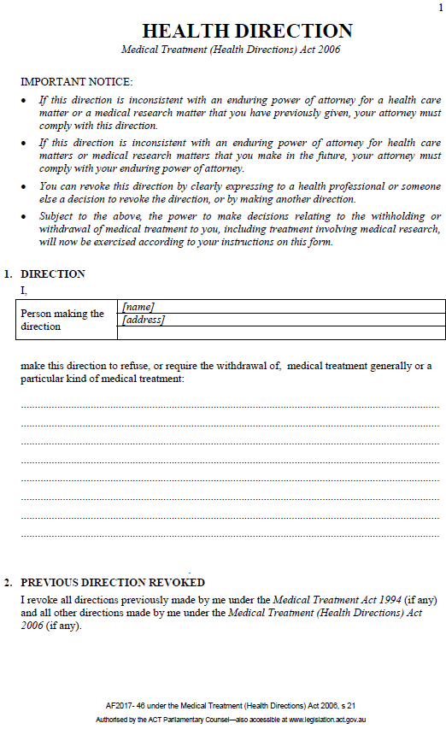
Sample
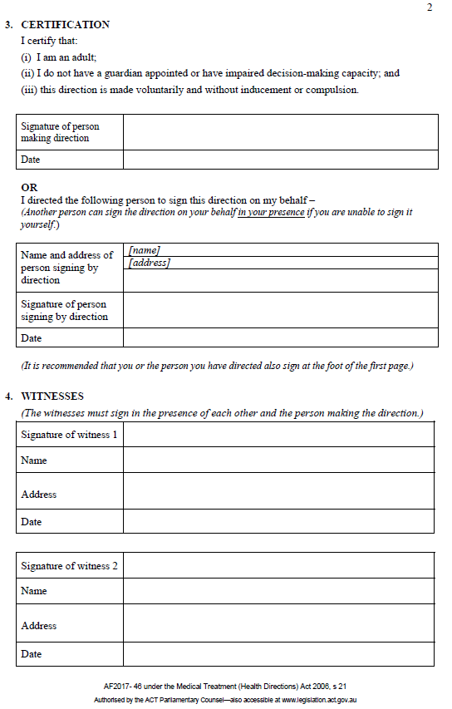
Sample

Attachment 2 - Advance Care Plan Statement of Choices – Competent Person
(Clinical Form No 15305)
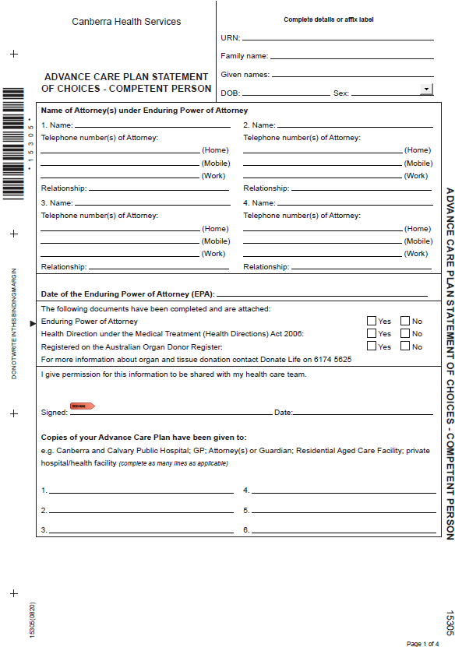
Sample

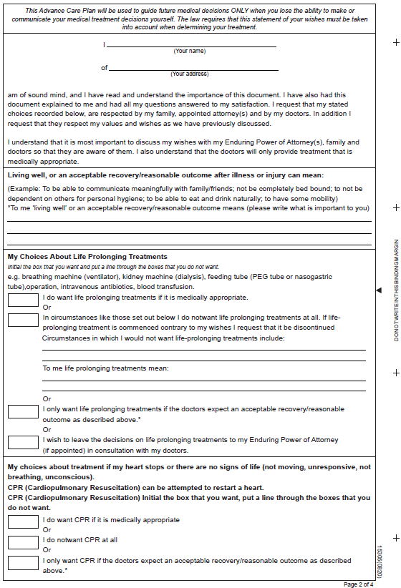
Sample


Sample

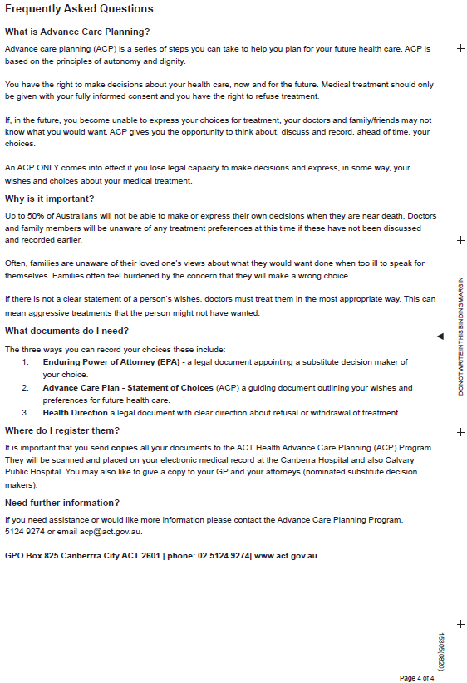
Sample

Attachment 3 - Advance Care Plan Statement of Choices – No Legal Capacity
(Clinical Form No 15306)
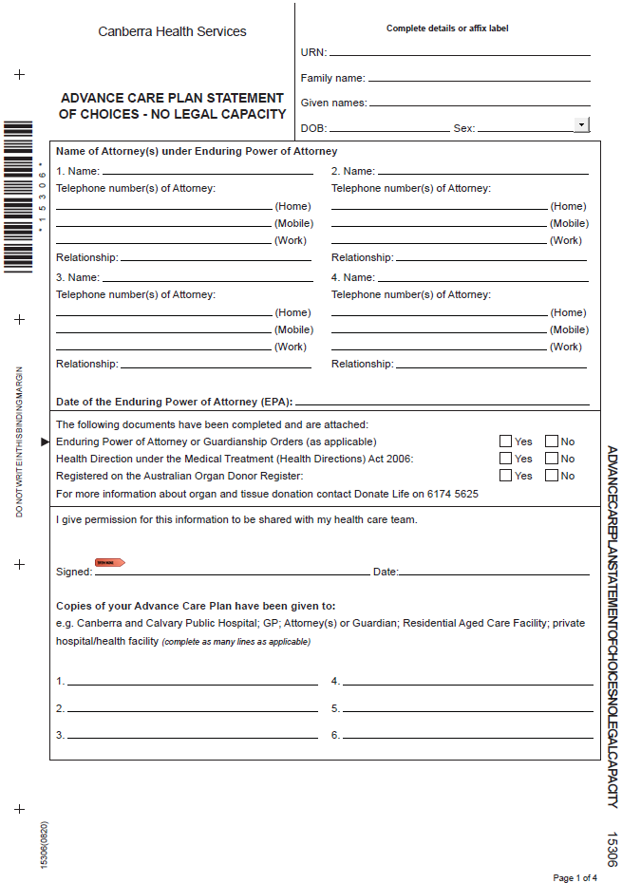
Sample
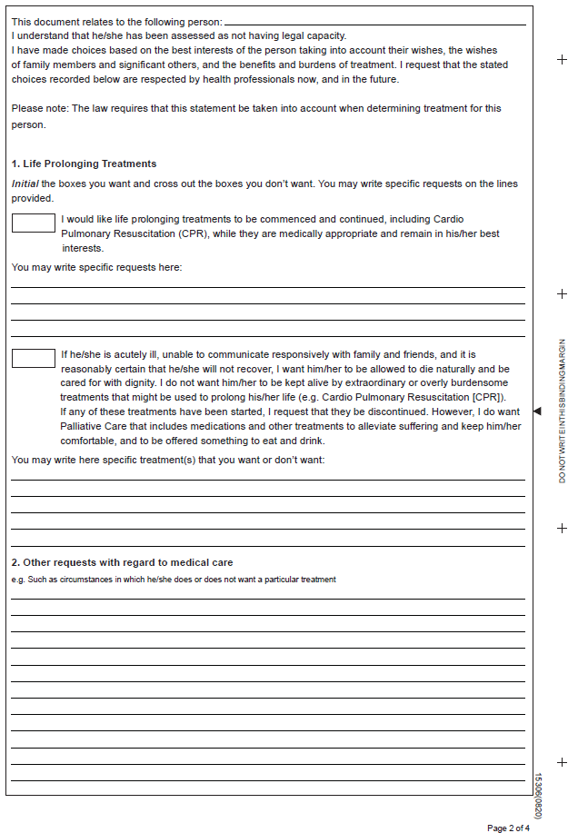
Sample
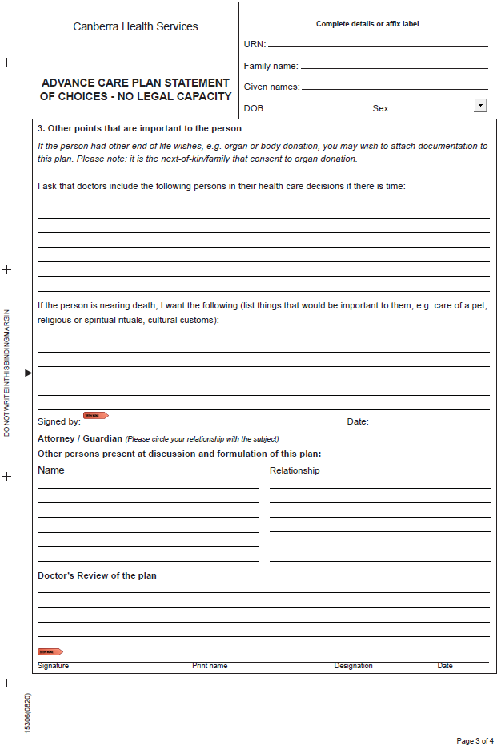
Sample
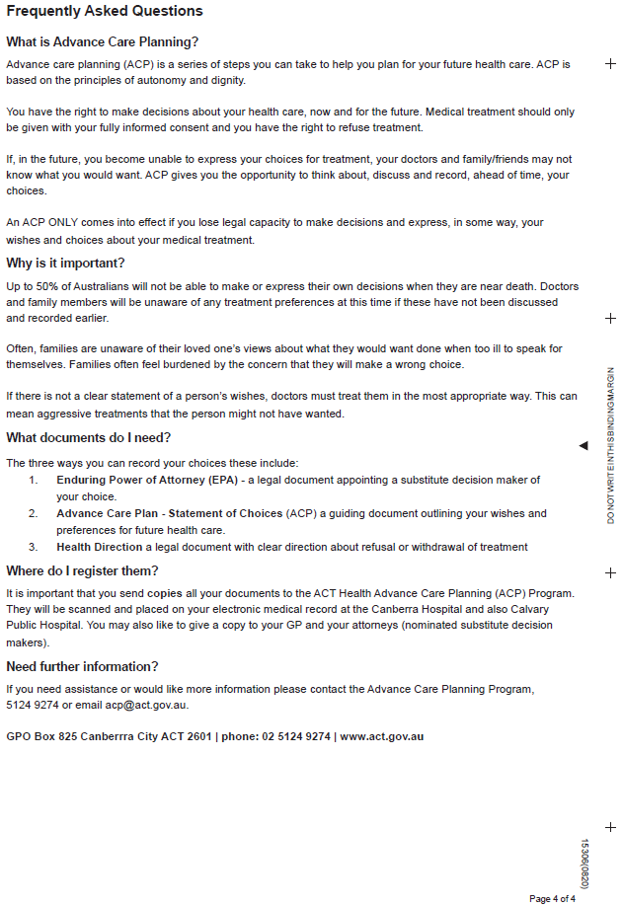
Sample

