Canberra Health Services
Procedure
University of Canberra Hospital
Adult Mental Health Day Service (AMHDS)

Contents

Contents 1
Purpose 5
Scope 5
Background 5
Section 1 – Adult Mental Health Day Service 5
1.1 Definition of Mental Health Rehabilitation 6
Section 2 – Access and Treatment Pathway of the AMHDS 6
2.1 Admission Criteria For AMHDS Referral 6
2.2 Additional Admission Criteria for Specific Programs 7
2.3 Referral 7
2.4 Episode of Care 8
2.5 Multi-Disciplinary Team 9
2.6 AMHDS Workforce 9
Section 3 - Group Therapy Programs 11
3.1 Background 11
3.2 Procedures for Group Therapy Programs 12
3.2.1 Eligibility and Referral to AMHDS Group Therapy Programs 12
3.2.2 AMHDS Rehabilitation Timetable 12
3.2.3 Waiting Lists 13
3.2.4 Maximum Group Numbers 13
3.2.5 Checking in for Group Programs 13
3.2.6 Close Relationships in Group Programs 13
3.2.7 Support People 13
3.2.8 Smoking 14
3.2.9 Group Guidelines 14
3.2.10 Suspension or Discharge from Group Programs 15
3.2.11 Disruptions to Group Programs 15
3.2.12 Responding to a Deteriorating Patient 16
3.2.13 Documentation 16
3.2.14 Non-Attendance at Group Programs 16
3.2.15 Completion of Programs 17
Section 4 – Dialectical Behaviour Therapy Program 17
4.1 Eligibility 17
4.2 Referral 18
4.3 File Review 18
4.4 Assessment and Information Session 18
4.5 Acceptance into the DBT Program 19
4.6 Commencement of DBT Program 19
4.7 Pre-Treatment 19
4.8 Engagement in DBT Program 20
4.9 Closure 20
Section 5 – Duress Alarms 20
5.1 Duress Alarm System 20
5.2 Checking Alarms 21
5.3 Activating and Responding to Duress Alarms 21
5.4 Returning Duress Handsets 22
Section 6 – Emergency Response Codes 22
6.1 Code Blue- HERO 23
6.1.1 HERO Call Procedure 23
6.1.2 Stand Down Code Blue 24
6.1.3 Post-HERO Call 24
6.1.4 Concurrent Code Blue Response 24
6.2 Code Blue- Community Health Centres 25
6.2.1 Procedure for 000 Call 25
6.2.2 Post-Medical Emergency 25
6.3 Code Black 25
6.3.1 De-Escalation Techniques 25
6.3.2 Activation of Code Black 26
6.3.3 Responding to Code Black (aggression) 26
6.4 Door Pressure Sensor Alarms 27
Section 7 – Clozapine treatment in the AMHDS 28
7.1 Adult Mental Health Day Service Clozapine Initiation 28
Section 8 - Treatment guidelines for the initiation, Administration and Monitoring receiving olanzapine Long-Acting Injection (LAI) 28
8.1 Background 28
8.2 Roles and Responsibilities 28
8.3 AMHDS Olanzapine Referral Process 29
8.4 Olanzapine LAI Clinics at UCH 30
8.4.1 Day Prior to UCH Olanzapine LAI Clinic 30
8.4.2 The day of the UCH Olanzapine LAI Clinic 30
8.4.3 UCH Treatment Folder 31
8.5 Olanzapine LAI Clinics in the Communities 31
8.5.1 Resources Required 31
8.5.2 Olanzapine LAI Clinic at City CRS 32
8.5.3 Olanzapine LAI Clinic at Gungahlin Community Recovery Services (GCRS) 32
8.6 Recording Olanzapine LAI Clinic Attendance 32
8.7 Administering Olanzapine LAI 32
8.7.1 Administration 32
8.7.2 Recording Administration 33
8.8 Baseline Observation and Long-term Monitoring for Olanzapine LAI 33
8.8.1 Observations 33
8.8.2 Long-term Monitoring 34
8.9 Non-adherence with 2-hour Monitoring Period 34
8.10 Alcohol or Other Drug Use 35
8.11 Adverse Effects 36
8.11.1 Post-Injection Syndrome and Management (PIS) 36
8.11.2 Precautions to Minimise Risk of Post-injection Sydnrome: 37
8.11.3 Procedures in response to Post-Injection Syndrome 37
Evaluation 37
Related Policies, Procedures, Guidelines and Legislation 38
References 39
Definition of Terms (if applicable) 40
Search Terms 40
Attachments 41
Attachment 1: AMHDS – Recovery-Focused Services Referral Form 42
Attachment 2: Adult Mental Health AMHDS – Self-Management Plan 43
Attachment 3: Adult Mental Health AMHDS – Pre-commencement discussion/assessment template 44
Attachment 4: AMHDS Welcome Pack 45
Attachment 5: AMHDS – Closure Letter Template 47
Attachment 6: Olanzapine Long Acting Injection Initiation Referral Form 48
Attachment 7: Olanzapine Long Acting Injection Observation Form 50
Attachment 8: Adult Mental Health AMHDS – Triage Scale 51
Attachment 9: AMHDS DBT Referral Form 56
Attachment 10: DBT Pre-treatment Guidelines 59
Attachment 11: Dialectical Behaviour Therapy Skills Group & Individual Therapy Agreement 61

Purpose

The Adult Mental Health Day Service (AMHDS) Operational Procedure has been established to promote consistent, best practice processes at the Adult Mental Health Day Service.

Back to Table of Contents

Scope

These operational procedures apply to staff employed by the Adult Mental Health Day Service at the University of Canberra Hospital.

Back to Table of Contents

Background

The Adult Mental Health Day Service (AMHDS) is a program designed to improve access to a range of mental health services for people living in the community and transitioning to the community from an in-patient hospital admission. The AMHDS contributes to the continuum of mental health services provided across the Division of Mental Health Justice Health Alcohol and Drug Services (MHJHADS) through Canberr a Health Services.

The AMHDS assists people in their journey of recovery by offering opportunities in a safe and supportive environment to address challenges and develop the skills and resources to promote successful community living and an enhanced quality of life.

The AMHDS provides treatment and recovery programs to adults aged 18 – 65 years, to meet specific consumer needs. Treatment and recovery programs include pharmacotherapy clinics, psychological group therapies, creative arts therapy group programs, recovery skills/illness self-management group programs and functional skills development groups.

Back to Table of Contents

Section 1 – Adult Mental Health Day Service

The primary function of the AMHDS is to offer a multidisciplinary approach to the biopsychosocial assessment and treatment of people with moderate to severe mental illness in a supportive and recovery oriented environment.

The key functions of the AMHDS are:
- To offer treatment, therapy and support to assist people on their recovery journey in an environment that is flexible and can offer intensive interventions without the need for inpatient admission
- To provide a range of psychological and recovery based programs to support people living with a mental illness to manage their difficulties, cope more effectively and live well in the community
- To offer people who require physical health interventions and monitoring due to medication protocols a supportive and therapeutic environment that allows for adequate supervision and support.

The primary goal of the service is to work collaboratively with people, their treating team, and formal and informal support systems to promote recovery, optimise symptom relief, build capacity for self-management and resilience, and develop skills and resources for living in the community.

The AMHDS complements existing services and enhances available options for intensive treatment, therapy and rehabilitation available through community mental health teams, inpatient units, and the adult mental health rehabilitation unit.

1.1 Definition of Mental Health Rehabilitation
The primary goal of mental health rehabilitation is the enhancement of the person’s quality of life and/or improvement in their psychosocial functioning. This occurs through engagement in a variety of multidisciplinary rehabilitation services to assist the person to develop their capacity to live successfully in the community and build foundations for continued recovery.

“Psychiatric rehabilitation promotes recovery, full community integration, and improved quality of life for persons who have been diagnosed with any mental health condition that seriously impairs their ability to lead meaningful lives. Psychiatric rehabilitation services are collaborative, person directed and individualised. These services are an essential element of the health care and human services spectrum and should be evidence-based. They focus on helping individuals develop skills and access resources needed to increase their capacity to be successful and satisfied in the living, working, learning and social environments of their choice” (PRA, 2007 Retrieved from Psychiatric Rehabilitation Association website: https://www.psychrehabassociation.org/about-pra).

Back to Table of Contents

Section 2 – Access and Treatment Pathway of the AMHDS

2.1 Admission Criteria For AMHDS Referral
- The person is aged between 18 and 65 years. Consumers 17 years of age or above 65 years of age may be admitted following Multidisciplinary Team (MDT) agreement; and
- The person has a primary diagnosis of a moderate to severe mental illness; and
- The person is engaged with a MHJHADS Community Recovery Service or Access Mental Health Comprehensive Team; and
- The person is assessed as suitable, particularly in terms of their current wellbeing and safety; and
- The person (or guardian if relevant) consents and the person is willing to participate in the AMHDS program (note: this does not exclude people who are on a Psychiatric Treatment Order).

2.2 Additional Admission Criteria for Specific Programs
- For the Dialectical Behaviour Therapy program the person is required to have a clinical manager with a Community Recovery Service.
- All group therapy programs will have eligibility criteria in addition to the AMHDS service admission criteria. This information will be provided to referrers with the quarterly rehabilitation timetable. The eligibility criteria will be based on evidence of inclusion and exclusion criteria of what presentations derive therapeutic benefit from the group program.

2.3 Referral
The referral pathway for the AMHDS is described below;
- Access to the AMHDS is by referral completed by an MHJHADS clinician (Attachment 1). Referrals to the AMHDS may be initiated at a number of points in the continuum including:
  - Access Mental Health Comprehensive Team
  - Community Recovery Service (CRS)
  - Adult Mental Health Unit (AMHU) and Calvary Public Hospital Bruce Acacia Unit
- Completed referrals are uploaded on to a person’s MAJICeR file and a message sent to the AMHDS from the referrer advising the team of the referral via MAJICeR.
- Additional referral information is required for the DBT program (see Section 4), Olanzapine Clinic (see Section 8) and Clozapine clinic (see Section 7) referrals.
- AMHDS staff members are allocated responsibility to process referrals from specific CRS team, as well as referrals for people from other teams residing in the CRS catchment area. Where a staff member is on leave it is the team leader’s responsibility to ensure referrals are processed. Upon receipt of referrals the staff member will;
  - Admit the person to the AMHDS team on MAJICeR,
  - Add to the AMHDS Whiteboard,
  - Review the referral information and request any missing information.
- If eligibility criteria are assessed as met upon review of referral information the AMHDS staff member will do a pre-commencement discussion and assessment by MAJICeR file review and phone call with the person and/or the referrer. The staff member may use the pre-commencement discussion/assessment template (attachment 2) to guide their assessment and discussion.
- Where the person is assessed as suitable by the AMHDS clinician they will be offered an orientation to the AMHDS and put on the agenda for Clinical Discussion/MDT.
- Where the AMHDS clinician identifies the referral does not or may not meet the admission criteria for the program/s the person will be discussed at Clinical Discussion/MDT prior to being offered an orientation.
- All new referrals will be presented at AMHDS Clinical Discussion or MDT prior to entering the programs to consider if the entry criteria have been adequately met to accept the referral. For referrals that are not accepted this must be discussed at MDT. If the referral is not accepted, the AMHDS will provide feedback to the referrer and discuss any recommendations regarding accessing supports and/or AMHDS in the future.
- Where AMHDS Clinical Discussion or MDT assess the person is suitable and at risk of behaviours that may be disruptive to the AMHDS program the referrer will be asked to support the person to complete a self-management plan prior to acceptance into the AMHDS program (Attachment 10).
- If the referral is assessed as appropriate, the person and referrer are advised of this and the person is then accepted into the program and provided with an AMHDS Welcome Pack (see attachment 3).

2.4 Episode of Care
The episode of care for the AMHDS is described below;
- Upon acceptance of a referral the person is admitted to the AMHDS as an adjunct episode of care. Their primary episode of care will remain with the treating team.
- During the course of the program and at its completion, each participant’s progress and outcomes will be discussed individually with them, as well as reviewed by the AMHDS Clinical Team/Multidisciplinary Team.
- People’s progress and participation in the AMHDS program will be discussed at a minimum once every 6 months and at the completion of a closed group program. This discussion will include a discussion of the person’s engagement in AMHDS program/s, their progress towards their recovery goals, any other clinical issues and, if relevant, discharge planning. This discussion will be documented on MAJICeR and relevant feedback provided to the treating team and person.
- For group programs 6-12 weeks in length people’s progress should be discussed at the completion or withdrawal from the program, and where there is expressed or observed difficulties engaging in the program (for example, disruptive behaviour, challenges with attention, repeated absences). It is the responsibility of the most senior clinician or peer recovery worker facilitating the group to identify that a person needs to be discussed at clinical discussion due to difficulties engaging in the program, and to put them on the agenda for the next clinical discussion. The AMHDS whiteboard will keep track of the agenda for clinical discussion for regular reviews.
- Subsequent to completion of a closed group program, information will be provided to the person and the referrer regarding the outcomes and achievement of the person’s goals, as well as recommendations for community programs or other AMHDS group programs that may further their recovery goals.
- A person will be discussed for closure from AMHDS at clinical discussion where they have met their recovery goals related to AMHDS engagement, they no longer meet our eligibility criteria, there is non-engagement, they request closure, their treating team requests closure, or they are closed from a primary treating team. Upon closure from the AMHDS participants will be sent a closure letter (attachment 5) summarising their achievements and information on community services with group programs. Except in the case of non-engagement closure will be done in collaboration with the person and their treating team. The treating will be advised via MAJICeR messages of the closure.

2.5 Multi-Disciplinary Team
The Multi-Disciplinary Team (MDT) meeting and Clinical Discussion meeting are the primary clinical forums for a person’s treatment and care to be discussed. The AMHDS holds either an MDT or Clinical Discussion weekly. The meetings provide a structure for the varying disciplines to collaborate effectively to meet the needs of people admitted to the AMHDS and also provides a support function for clinical staff who work in the AMHDS.

The MDT comprises Medical staff and member/s of the Allied Health team and/or Nursing staff. A Clinical Discussion Meeting comprises a senior Health Practitioner HP4 or RN3 and member/s of the allied health team and/or nursing staff.

Functions of the Clinical Discussion and MDT are:
- A regular review of a person’s engagement in the AMHDS and their progress towards recovery goals, and
- A forum for all members of the treating team to provide input.

All clinical discussions conducted in the MDT or Clinical Discussion meetings will be documented in the Mental Health, Alcohol and Drug Services, Integrated Care Electronic Record (MAJICeR) by the designated scribe for that meeting. The MDT utilises a whiteboard that contains clinical information and allows the MDT to track clinical matters and outstanding clinical issues.

2.6 AMHDS Workforce

The AMHDS workforce includes a multidisciplinary team of several clinical disciplines, as well as non-clinical peer recovery workers, to provide holistic treatment and care. Each discipline works within their individual disciplines’ scopes of practice set by the relevant registration body and/or professional association. Peer Recovery Workers work to the standards and guidelines outlined by the document, MHJHADS Peer Recovery Workers: Guidelines and Practice Standards. Allied Health staff work under the supervision, guidance, and direction of the Team Leader. Nursing Staff work under the direction of the Team Leader, with clinical supervision and guidance from the Clinical Nurse Consultant and the Assistant Director of Nursing of the AMHRU. Medical staff work under the guidance and direction of the Clinical Director.

All staff are expected to be an active member of the multidisciplinary team including identifying clinical matters to be raised at MDT/Clinical discussion meetings and contributing discipline specific input into MDT/clinical discussions.

The below outlines the members of the multidisciplinary team and the discipline specific aspects of their role in supporting the AMHDS Model of Care.
Creative Arts Therapist
The creative arts therapist creates, provides and evaluates high quality art therapy programs as well as provides skilled assessment and interventions within the creative arts therapy scope of practice.

Exercise Physiologist
The exercise physiologist provide exercise and education interventions for people to assist in managing mental health and health conditions and to optimise physical function, health and wellness.

Dietitian
The dietitian develops and delivers group programs on nutrition related matters, including both general nutrition and dietetics education and skills, and topics specifically targeted at addressing common nutritional needs for people with mental health issues.

Nurses
Registered nurses provide pharmacological, rehabilitation and educational clinics and group programs at the AMHDS. Key duties include Olanzapine Clinic, Clozapine Commencement Clinics, Metabolic Screening and education, as well as contributing to the development, evaluation and delivery of evidence-based health education and Activities of Daily Living (ADL) skills group programs.

Neuropsychologist
The Neuropsychologist offer evidence-based group and individual programs aimed at improving functioning in areas of cognition known to be impacted by mental health issues including attention, working and long-term memory, and executive functioning.

Occupational Therapist
The AMHDS Occupational therapist/s focus on therapeutic intervention and education programs specifically targeted at promoting a person’s optimal engagement and participation in meaningful activities, as well as addressing functional and occupational issues. They conduct sensory profile assessments and sensory modulation interventions. If appropriately trained they may also contribute to the Dialectical Behavioural Therapy program.

Peer Recovery Workers
Peer recovery workers are people with a lived experience of mental illness who provide peer support to people with mental health issues. AMHDS peer recovery workers facilitate evidence-based peer-led group programs, contribute to service and group program development and co-facilitate group programs with clinicians. Their contributions maximise the experience of people receiving treatment and care at the AMHDS by offering recovery support that breaks down power dynamics and barriers to accessing and engaging in specialist mental health services.

Psychiatrists
The medical team are responsible for the clinical care provided to people attending the AMHDS and provide specialist psychiatry expertise. The medical team provide clinical leadership and oversight of assessment, treatment and care recommendations and multidisciplinary team clinical review. The medical team provide education to the multidisciplinary team to enhance skills, knowledge and evidence-based interventions.

Psychologists
The AMHDS psychologist/s provide evidence-based psychological group interventions that address a person’s identified psychological needs. The AMHDS psychologist/s provide psychological interventions within psychology scope of practice using established techniques and methods, with the aim of increasing an individual’s understanding of their thoughts, feelings, behaviours, and core beliefs, and enhancing coping skills that address interpersonal and emotional needs and goals. The AMHDS psychologists have specialist skills, or undertake specialist training, to provide the Dialectical Behaviour Therapy program at the AMHDS. Within this program they conduct psychological assessment, case formulation, treatment planning and intervention, measurement of symptom change, crisis management and safety planning within the DBT principles and framework.

Social Workers
The AMHDS social worker/s provide evidence-based, strengths-based, group programs to enhance a person’s relationship with and sense of belonging to the broader social system. They promote self-determination, autonomy and development of problem-solving skills. If appropriately trained they provide family intervention and/or contribute to the DBT program and/or other psychologically informed therapies. The social worker provides a key role in contributing a social system perspective to the MDT, service development and treatment planning.

Students and professionals undertaking further training
The AMHDS is a teaching environment so the MDT may also be joined by intern psychologists, transitioning to practice and post graduate nurses, medical students, and allied health students. All student placements will be organised through the relevant CHS placement coordinator for their discipline.

Back to Table of Contents

Section 3 - Group Therapy Programs

3.1 Background
Effective therapy is a vital resource for treating people with severe and persistent mental illness within a community setting. Group therapy is a powerful vehicle for individual growth and change. It provides an environment of trust and safety to help the person build skills to assist in their recovery journey and explore a broad range of personal concerns.

The AMHDS provides group programs aimed at reducing the impact of mental illness within a person’s life as well as increasing skills and overall level of functioning. The group model supports holistic mental health care and the person’s individual recovery journey.

The AMHDS offers both ‘Open’ group programs and ‘Closed’ group programs. Open group programs allow people to join at any point in time of the program, and do not require a commitment of attending every week or doing home practice. Closed group programs are time limited and people are asked to commit to joining in the first 1-2 weeks and attending for a specific period. Closed groups facilitate a greater sense of group cohesion and support, as well as providing more intensive evidence-based group programs. Closed groups often involve scaffolding and building mastery in new skills through repetition and consolidation over several weeks as well as home practice.

Groups delivered at the AMHDS include, but are not limited to, Cognitive Behavioural Therapy (CBT), Dialectical Behaviour Therapy (DBT), Acceptance and Commitment Therapy (ACT), psycho education, Mindfulness, Cognitive Remediation, Living Skills Training, Health Education and Healthy Lifestyle programs and Creative Art Therapies.

The AMHDS aims to create a non-institutional, safe and therapeutic environment where people with mental illness can receive treatment in an atmosphere that promotes autonomy, self-responsibility, care, and connection.

3.2 Procedures for Group Therapy Programs

3.2.1 Eligibility and Referral to AMHDS Group Therapy Programs
The referral and treatment pathway through AMHDS Group Therapy programs is outlined in Section 1.2.

3.2.2 AMHDS Rehabilitation Timetable
It is the responsibility of the AMHDS Team Leader or delegate to develop a quarterly AMHDS rehabilitation timetable. This timetable is based on the model of care and includes group programs that evidence has shown are important to offer as part of outpatient rehabilitation services.

It is the responsibility of the AMHDS Team Leader or delegate to ensure that quarterly timetable is provided to all potential referrers within MHJHADS including all CRS teams, as well as specialty services within MHJAHDS including Forensic Mental Health Services and Specialist Youth Mental Health Outreach Team.

Group programs include occupational therapy, psychological and creative arts intervention group programs such as Cognitive Behavioural Therapy group programs for mood, anxiety and psychosis, Acceptance and Commitment Therapy, Sensory Modulation, Recovery Through Activity and Art Journaling. Physical and mental health group programs include nutrition psychoeducation, cooking skills, walking, physical activity and hydrotherapy programs. Additional group programs include peer-led programs, Family Connections carer’s group program, illness self-management and coping skills programs, youth focussed group programs, social skills, and mindfulness programs.

3.2.3 Waiting Lists
It is the role of the AMHDS team leader to keep a record of waiting lists for each individual group program and provide advice for waiting times and start dates to the referrer and person.

3.2.4 Maximum Group Numbers
The maximum number of participants depends on the nature of the group program and is determined by therapeutic guidelines and clinical judgement regarding maximising the therapeutic benefit of the group. The maximum group numbers within each group is 8 – 16.

3.2.5 Checking in for Group Programs
All consumers attending group programs will check in at UCH Mental Health Reception. Staff will adhere to CHS Patient Identification and Procedure Matching clinical procedure to ensure people are attending for the correct group programs and are registered with the service.

3.2.6 Close Relationships in Group Programs
Where it is identified that group members are part of the same family, are close friends, or in an intimate relationship they will not be able to attend the same therapy group programs. Close relationships may disrupt the therapeutic benefit of the program for the individuals, as well adversely effect the group dynamics. The AMHDS will offer alternative options to the persons involved, in consultation with the person and the treating team, which maintains access to services. Such alternatives may include; being waitlisted for a program and alternative programs while on the waitlist, information on community programs that may address the relevant goal/issue/need, or individual provision of group content by an AMHDS staff member or CRS clinical manager.

3.2.7 Support People
Support people required to support a person’s physical engagement or communication in the group, such as AUSLAN interpreters, may attend group programs. Psycholosical support people such as NDIS support workers and carers are not able to attend closed group programs with consumers. This is to maintain the confidentiality of other group members, as well as promote therapeutic group dynamics. AMHDS is able to support individual plans regarding the accessibility of support people during group programs such as a support person remaining on site to provide support before and after the group program. This plan must be developed and agreed to by all stakeholders prior to the support person attending AMHDS group programs.

An individual plan may be developed in collaboration with the support person, treating team and AMHDS if a person requests that a support person attend AMHDS programs with them. Support people can attend some AMHDS open group programs for a time-limited period where this is part of a collaborative exposure plan to allow the person to commence engagement with AMHDS group programs. This plan must be developed and agreed to by all stakeholders prior to the support person attending AMHDS group programs.

3.2.8 Smoking
The University of Canberra Hospital is a smoke free campus and participants will not be able to leave a group for a cigarette break. Nicotine replacement therapy can be scripted on request for people attending longer groups and people will be provided with a locker where they can store cigarettes, lighters and any other personal property. Refer to Smoke Free Environment Policy and Managing Nicotine Dependence Procedure.

3.2.9 Group Guidelines
The following group guidelines will be provided to participants upon entry into the AMHDS service in the welcome pack and promoted by group facilitators. The group guidelines will also be provided to all open group programs at the beginning of each quarterly timetable, and discussed in week one of all closed group programs, to ensure participants are aware of the guidelines. For closed group programs, during the initial group the suggested group guidelines will be read and agreed to, with inclusions being added by group consent

- Participants are polite and respectful towards other group participants and staff.
- Participants maintain the principles of confidentiality. What is said in group, stays in group.
- Participants are not to be affected by alcohol or other drugs when attending group programs.
- It is anticipated that people attending the closed group programs participate in completing hand-outs, activities and homework.
- Participants attending closed group programs try to attend all sessions and contact the AMHDS on 5124 0150 if they are unable to attend or wish to be discharged.
- Participants are encouraged to speak to facilitators if they are running late, or if they will need to take regular breaks during group.
- Participants maintain pro-social talk during group programs. People do not engage in discussions or behaviours with other group participants that involve self-harm, borrowing money, sharing or exchanging medication, or substance use. Participants are strongly encouraged to speak to AMHDS facilitators if they would like support related to these matters or if they have engaged in self-harm.
- Sexual partnerships between participants who attend the same closed group program is discouraged because it can be highly disruptive to the flow and progress of therapy.
- Actions that may result in suspension or discharge from group programs include; ongoing or persistent unexplained absences, repeated disruptive behaviour within the group, behaviour that could result in criminal charges such as theft, property damage or violence, aggression, violence or threats to staff and bringing alcohol, illicit substances or weapons to the AMHDS.

It is the responsibility of the group facilitators offer hand sanitiser and encourage its use at the beginning of each group program and after group break.

3.2.10 Suspension or Discharge from Group Programs
The following actions may result in suspension or discharge from group programs. Unless immediate suspension is required to ensure the safety of staff and consumers, these actions will be determined after all attempts at altering the behaviour, including a discussion with the person and their clinical manager have taken place. These actions will be managed as per the process outlined in 3.2.11.

- Ongoing or persistent unexplained absences
- Acute hospitalisation
- Repeated disruptive behaviour within the group
- Commencing or continuing a sexual relationship with another participant
- Behaviour that could result in criminal charges such as theft, property damage or violence
- Aggression or violence or threats to staff and
- Bringing alcohol, illicit substances or weapons to the AMHDS.

People who are discharged from a group program can be re-referred at any time.

3.2.11 Disruptions to Group Programs
Where people are identified to be engaging in minor violations of group guidelines the group facilitators are responsible for addressing the behaviour. This will usually involve gently redirecting the person, gently reminding the person or the whole group of the group guidelines, or speaking to the person individually at the end of the session. Group facilitators should be mindful of shame, and possibility of history of trauma in learning environments, in addressing the behaviour. This should be balanced with the importance of immediately addressing behaviours to ensure that all group participants feel safe and comfortable in group programs, and observe that facilitators address inappropriate behaviour.

Where people are engaging in more serious behaviour that is disrupting the therapeutic benefit of group programs for themselves or others, or engaging in action that may result in suspension or discharge from the group programs, it is the responsibility of the most senior clinician or peer recovery worker to manage the behaviour immediately to ensure the welfare and safety of others in the group program. If a group’s facilitators are Peer Recovery Worker’s or HP1’s the assistance of a senior clinician (HP3 or HP4) should be sought as soon as practicable. HP2’s should seek assistance from, or provide feedback to, a senior clinician (HP3 or HP4) as soon as practicable following their management of the situation.

The HP2 or senior clinician should do an assessment of the person’s mental state and risk and provide appropriate follow up based on their assessment and consistent with the triage scale (attachment 14).

The group’s facilitator should put the person on the agenda for the next AMHDS Clinical Discussion/MDT and advise the AMHDS Team Leader of the behaviour.

3.2.12 Responding to a Deteriorating Patient
Group facilitators document observations of mental state at every presentation to the AMHDS. Peer recovery workers are non-clinical staff and will include observations of behaviour that include the extent to which the person appeared settled, appropriate and engaged.

Clinicians will use their clinical judgement to respond to a deterioration in a person’s mental state. Clinicians should be familiar with the persons attending their group and respond to changes in mental state.

It is the responsibility of the most senior clinician or peer recovery worker to respond to observed changes in mental state, or signs of mental state deterioration, to ensure the welfare and safety of the person. If a group’s facilitators are Peer Recovery Workers or HP1’s the assistance of a senior clinician (HP3 or HP4) should be sought as soon as practicable. HP2’s should seek assistance from, or provide feedback to, a senior clinician (HP3 or HP4) as soon as practicable following their management of the situation.

The HP2 or senior clinician should do an assessment of the person’s mental state and risk and provide appropriate follow up based on their assessment and consistent with the triage scale (attachment 14).

The group’s facilitator should put the person on the agenda for the next AMHDS Clinical Discussion/MDT and advise the AMHDS Team Leader of the situation.

3.2.13 Documentation
Attendance and participation in group programs will be documented on MAJICeR by group facilitators, as well as on the AMHDS whiteboard. It is the responsibility of all group facilitators who facilitated the group to ensure that documentation is completed. For programs facilitated by mental health clinicians this documentation will include aspects of the mental state examination that are observable in the group context.

3.2.14 Non-Attendance at Group Programs
A person is considered to have not attended if they did not attend a closed group program they are enrolled in. For open group programs there is not the expectation of reliable attendance.

Clinicians will record all non-attendance at closed group programs on MAJICeR. Only attendance will be recorded for open group programs.

When a person fails to attend a closed group program, and has not contacted AMHDS to advise of their non-attendance, the most senior clinician or Allied Health Assistant facilitating that group will make phone contact with the person as soon as possible after the missed group program to ensure the person’s welfare.

If unable to contact the person by phone the AMHDS clinician will advise the treating team of the person’s non-attendance and their attempted contact and handover follow up to the treating team.

3.2.15 Completion of Programs
People’s progress and engagement with AMHDS will be reviewed regularly as per the episode of care pathway in section 1.4.

Where a decision is made at MDT or clinical discussion to close people from the program a closure letter will be sent which outlines the person’s achievements, and options for community group programs.

Back to Table of Contents

Section 4 – Dialectical Behaviour Therapy Program

DBT is a broad-based cognitive-behavioural treatment originally developed for chronically suicidal individuals diagnosed with borderline personality disorder (BPD). Consisting of a combination of individual psychotherapy, group skills training, telephone coaching, and a therapist consultation team, DBT was the first psychotherapy shown through controlled trials to be effective with BPD (Linehan, 2015). DBT is based on a dialectical and biosocial theory of psychological disorder that emphasises the role of difficulties in regulating emotions and behaviour. Emotion dysregulation has been linked to a variety of mental health problems stemming from patterns of instability in emotion regulation, impulse control, interpersonal relationships, and self-image (Linehan, 2015). DBT skills are aimed directly at these dysfunctional patterns.

4.1 Eligibility
In addition to meeting the admission criteria for the AMHDS, eligibility for the AMHDS DBT program is based on the below inclusion and Exclusion Criteria.

Inclusion Criteria
- Fulfils at least 5 of 9 diagnostic criteria for Borderline Personality Disorder (DSM-5). Lower number of criteria may be considered on an individual basis and accepted based on the merit of the clinical reasoning.
- Person is aware and consents to the referral
- Person has a clinical manager with a MHJHADS CRS
- Person presents as suitable in terms of;
  - DBT case formulation including suitable goals and commitment
  - Adequate self-management skills to commit to intensive therapy
  - Ability to engage in group context
  - Cognitive capacity and current mental state
  - Feasibility of engagement in terms of current life circumstances, supports, social needs and fit with other group participants
Exclusion Criteria
- Psychotic Disorder precluding patient from participation in intensive therapy
- Severe cognitive impairment
- Severe receptive or expressive language disorder
- Significant Substance Dependence
- Eating disorder precluding patient from participation in intensive therapy or requiring treatment prior to DBT engagement

4.2 Referral
- Referring Clinical Managers (CM) are encouraged to contact the DBT team prior to referral to discuss suitability/feasibility of the DBT program.
- Community clinical manager are to to complete the referral form (attachment 8) and upload to MAJICeR. MAJICeR message to be sent to AMHDS team to alert them to the new referral.
- It is the responsibility of the AMHDS clinician allocated to process referrals from that treating team as per section 1.2 of this manual, with the additional step of informing the AMHDS Team leader or delegate that there is a new DBT referral.
- The AMHDS Team Leader or delegate is responsible for ensuring that the DBT referral is allocated to a DBT clinician for follow up as per below.

4.3 File Review
- The allocated DBT clinician will complete a DBT focussed file review to assess whether the person meets inclusion and exclusion criteria
- Where the DBT clinicians assesses the person as suitable based on file review they will offer them a DBT assessment and information session.
- Where the DBT clinician assesses the person as unsuitable based on file review they will present them at DBT consult and document DBT consult’s recommendations on MAJICeR. The DBT clinician will then present them at AMHDS Clinical Discussion/MDT.
- AMHDS Clinical Discussion/MDT will then determine whether to proceed to further assessment and information session or whether to decline the referral.
- If the referral is declined, feedback will be provided to the referrer and person about the clinical reasoning for the decision and recommendations regarding alternative treatment options provided.

4.4 Assessment and Information Session
- Where a DBT referral is assessed as suitable from the file review the person will be offered an information session. The allocated clinician is responsible for contacting the person and arranging an appointment for an assessment and information session.
- The purpose of the information session is to;
- provide an overview of DBT program,
- orient the person to the structure and commitment of the DBT program and the difference between DBT and other therapies that the person may have experienced,
- provide an opportunity for the person to make an informed decision about whether the DBT program is suitable for them,
- assess the person’s goals, expectations, and commitment to the DBT program,
- assess the person’s suitability for the AMHDS DBT program,
- consideration of any feasibility issues.

4.5 Acceptance into the DBT Program
- The allocated DBT clinician will present their DBT case formulation to DBT consult and document consult’s discussion and recommendations regarding the person’s suitability for the program on MAJICeR.
- The allocated DBT clinician will then present the person at AMHDS Clinical Discussion/MDT for final decision as to their suitability for the DBT program.
- If the person is accepted into the program, they will be put on the DBT waitlist.
- If the referral is declined feedback will be provided to the referrer and person about the clinical reasoning for the decision and recommendations regarding alternative treatment options provided.

4.6 Commencement of DBT Program
- It is the responsibility of the AMHDS Team Leader or delegate to keep a DBT waitlist and update referrers and consumers of expected waitlist times.
- When a person is at the top of the DBT waitlist the AMHDS Team Leader or delegate will allocate the person to a DBT clinician to be their individual therapist for the duration of their engagement in the program.
- The allocated clinician will:
- Do a file review to ensure there have been no significant changes in the person’s suitability for the DBT program since being placed on the waitlist. If they assess that the person may no longer be suitable, they will follow the procedure outlined above in section 7.3.4.
- If assessed as remaining suitable they will contact the referrer and advise of the person’s entry into the DBT program.
- They will then contact the person and offer them entry in to the DBT program. If the person accepts, they will organise to commence pre-treatment. If they decline, they will be presented at AMHDS Clinical Discussion/MDT and feedback provided to the referrer.

4.7 Pre-Treatment
- Pre-treatment phase usually take place over a 2-6 week period and involves weekly individual sessions (1 hour duration)
- Sessions are focused on orientation to the program and building commitment to change.
- Clients are gradually shaped into the structure of a DBT individual session over the course of pre-treatment
- Tasks for completion are outlined in ‘Pre Treatment Guidelines (attachment 9) and include signing of the Dialectical Behaviour Therapy Skills Group & Individual Therapy Agreement (attachment 17).

4.8 Engagement in DBT Program
- Once the person has entered into the program and completed pre-treatment they will commence DBT Skills group. The person will then engage in weekly individual therapy sessions, weekly DBT skills group and DBT phone coaching for the duration of their contracted period of 6 months
- At least one month prior to the person completing 6 months in the DBT program it is the individual DBT clinician’s responsibility to present the person for case review at DBT consult for consideration of the benefits of the person completing a second round of DBT skills group. This decision will be made in collaboration with the person and referrer and based on DBT case formulation.
- Throughout the person’s engagement in the DBT program the person’s progress will be discussed regularly with the person and DBT consult as per the guidelines provided in Cognitive-Behavioral Treatment of Borderline Personality Disorder (Linehan, 1993).
- The allocated clinician will provide regular feedback to the clinical manager regarding engagement.
- The allocated clinician with liaise with clinical manager regularly to support the person to engage in DBT.

4.9 Closure
- The person will be offered 4-12 individual therapy sessions after completing the DBT Skills Group for consolidation of DBT skills and transition from the DBT program.
- The individual DBT clinician will discuss discharge/referral options with person and treating team.
- A referral letter with a summary of treatment and relevant handover will be completed for external services/private psychologist/GP if applicable.
- The individual DBT clinician will discuss the closure at DBT Consult and then AMHDS Clinical Discussion/ MDT and closure documentation.

Back to Table of Contents

Section 5 – Duress Alarms

5.1 Duress Alarm System
Personal duress alarms represent one strategy in an overall policy dedicated to the minimisation and management of dangerous situations within AMHDS. They are provided to staff to help safety by ensuring staff are able to request assistance in an emergency. Duress alarms must be worn by staff at all times they are on the unit. Hardwired duress are also located as permanent fixtures in all clinical rooms located in the AMHDS.

Ascom i62 handsets are used in the AMHDS. The handset consists of a duress system with man down capability and can also be used as an internal mobile phone communication device. All staff on duty including medical staff, nursing staff, allied health, students and visiting clinical and professional staff must wear a handset when in the AMHDS. The system does not have the technical scope to function outside of the unit (ie. it does not work in the rest of UCH). Therefore, handsets should not be taken out of the unit.

When a duress alarm is activated, the handsets communicate with each other to alert staff to the location of a staff member who requires assistance. This information is displayed and recorded on the screens of the handsets and on the annunciators located in the unit.

The AMHDS Team Leader will ensure that new staff, visiting staff, students on placement or contractors are trained in the use of the duress alarm and are aware of the duress alarm procedures.

5.2 Checking Alarms
Prior to commencing duty, all staff (including students) must obtain a duress alarm handset from the charging racks in the write-up office. Staff must then record their handset number with the administration staff and secure the handset device to their person. The staff member must check the handset to ensure it is charged and working. Any malfunction or need for battery replacement should be reported to the Allied Health Manager who will also inform the ADON.

Hardwired alarms (i.e. fixed to wall) will be checked by AMHRU staff each week on a weekend. If staff have any concerns regarding the wall alarms, they should advise BGIS through the BGIS helpdesk on x47000 and notify the ADON via Riskman and email.

Duress Alarms need to be tested weekly, with staff waiting until one alarm has been triggered and cancelled before testing the next alarm so as not to overload the system. If the system is overloaded by simultaneous alarms, there is a risk of triggering a Code Yellow.

Hardwired alarms are in the following locations:
- All interview rooms
- Treatment rooms
- Group activity rooms
- Sensory Room
- Art Therapy Room

5.3 Activating and Responding to Duress Alarms
All staff members in the unit (including AMHDS and AMHRU staff) are to respond to the location of the alarm after checking the location of the alarm on the screen in their alarm and then proceed to the identified location. The location will also be displayed on the designated duress alarm computers in the write up space.

The Durasuite alarms are operated through a Wi-Fi system and have the capability of locating the area in which an incident occurred, or a staff member may have deployed the man down button.

Note: This location capability is only accurate within a 3-metre radius in some areas of the unit and it is essential that if an alarm is deployed, AMHRU/AMHDS staff must thoroughly search the immediate vicinity in which the alarm has been activated. Maps of the unit showing the name of each area as designated on the Durasuite system display, are located in each corridor of AMHRU.

Alarms sent via the handset by:
- Local Alarm
- Push pad on top of unit once
- Global alarm
- Push red pad on top of unit twice (x2) in quick succession
- Man Down.

The Man Down function activates when the alarm is horizontal. After 7 seconds the alarm will emit a vibration and tone to indicate to the staff member that the alarm is about to sound. If the alarm is not returned to a vertical position and any button pressed within 7 seconds a local code will be activated. If staff do not respond to the man down within 2 minutes, a global alarm will be activated.

The senior clinician or nurse in attendance will provide instruction to staff as to how the situation is to be managed. Following the resolution of an alarm, the senior clinician is to delegate a staff member to return to the computer and click “concludes” to reset computer.

The most senior AMHDS staff member in attendance is to ensure that a clinical incident report and/or Staff incident report in Riskman is completed on each occasion that the duress alarm system is used in the AMHDS (other than false alarms).

5.4 Returning Duress Handsets
Under no circumstance should the handset be taken from the facility or left sitting on a table unattended.

When leaving the facility on an errand or an excursion, staff must have a mobile telephone with them so that they can contact the unit and be contacted if required. The number that is used to contact those staff must be written on the staff location whiteboard.
Back to Table of Contents

Section 6 – Emergency Response Codes

6.1 Code Blue- HERO
Code Blue relates to a medical condition that has the potential to be life threatening and/or that cannot be managed with the available resources within the AMHDS. It can be activated for any person, visitor, staff members or members of the public within the University of Canberra Hospital (UCH). Staff are to familiarise themselves with the University of Canberra Hospital Vital Signs and and Early Warning Scores procedure that outlines the response to medical emergencies at University of Canberra Hospital.

Hospital Emergency Response Officers (HERO) consist of medical and nursing staff. The equipment the team brings will be sufficient to provide a modified basic life support and airway management. The HERO team will respond to any medical emergency in the first instance and provide basic life support until the arrival of ACT Ambulance Service (if required).

6.1.1 HERO Call Procedure
- Any staff member that identifies that a consumer has a medical emergency will initially activate their personal duress alarm to notify other staff and remain with the person to commence Basic Life Support if necessary.
- Where there is nursing staff present the most senior RN will take the clinical lead of the situation and will also dial 2222 to provide the exact location of the medical emergency. Where no nursing staff are present the senior clinician will take the lead of the situation until a medical or nursing staff member attends.
- The second staff member in attendance will go to AMHRU and collect the emergency trolley and activate a Code Blue (HERO call) by pressing the button located above the trolley.
- Once support people arrive, senior RN will delegate a scribe, and a runner to retrieve glucometer, ECG machine and treatment folder from AMHDS treatment room and notify admin officer. If no RN’s arrive prior to the HERO team staff should use Basic Life Support procedures until the HERO team attend. If sufficient staff are available a member should be asked to notify admin officer.
- Admin officer should:
- Contact doctor (consultant if possible) from AMHDS or AMHRU or Older Person’s Mental Health Team
- If no RN’s in attendance to contact nurse in charge (NIC) or clinical nurse consultant (CNC) to attend immediately
- Contact AMHDS manager / team
- and be prepared to direct the HERO team and ambulance to the location of the emergency
- Whilst waiting for HERO team to arrive, the consumer should have a set of observations completed, including BGL if the code was called due to possible post-injection syndrome, if an RN is present.
- Once the HERO team arrive, senior RN (or clinician lead) will provide an ISBAR handover. HERO team will then assume lead of the situation and others present will provide support as directed by them. Where the person is at AMHDS for Olanzapine clinic the RN will provide a list of current medication as per clinic printout taken from MAJICeR, a list of allergies as per Clinical Portal alerts and known medical conditions.
- If a decision is made by the HERO Team, in collaboration with the consultant psychiatrist, that the consumer requires transfer to an Acute Facility by the ACT Ambulance Service, Senior RN will dial 0-000 to co-ordinate transfer

6.1.2 Stand Down Code Blue
On completion of a Code Blue response the AMHDS nurse will:
- check the contents of the emergency trolley using the emergency trolley check list that is attached to the trolley,
- restock the trolley as required,
- sign as checked in the attached logbook,
- Return the trolley to its standing location in AMHRU,
- The Senior RN (where no RN then Clinician) will contact switchboard to advise the Code Blue has been completed. This will send a code alert to the staff involved notifying them to stand down.

6.1.3 Post-HERO Call
As soon as practical, senior RN (or senior clinician) will:
- notify next of kin of situation occurring and notify them of any transfer to another setting,
- document the adverse event on MAJICer,
- provide a verbal ISBAR outlining the adverse event to the Clinical Manager (CM), if CM not available the Duty Officer (DO) of their treating team. If DO is not available, then the Team Leader (TL) is to be notified. If the Code Blue was called during Olanzapine clinic suggest that Consumer will require a Medical Officer review, prior to re-attending the Olanzapine LAI clinic
- complete a Riskman which is submitted to the AMHDS manager,
- If the Code Blue has occurred due to an adverse drug reaction, as determined by a medical officer, the drug company must be contacted with the batch number and expiry date used for the Consumer (au_drug_safety@lilly.com). The Medical Officer is to notify the Therapeutic Drugs Association and the RN is to put an alert on Clinical Portal stating the person had a verified adverse reaction to Olanzapine LAI.

6.1.4 Concurrent Code Blue Response
If there are two or more Code Blue calls and the first Code Blue has not been stood down, the following applies:
- Second medical officer on the HERO team will respond to the additional Code Blue
- If during business hours, senior nurse coverage to the second HERO response will be by the CNC of the relevant area
- If after hours, then the medical officer and after-hours hospital manager must discuss and make the decision which staff will be released from the initial Code Blue to attend.

6.2 Code Blue- Community Health Centres

6.2.1 Procedure for 000 Call
- An RN who identifies that a person has a medical emergency, will call 000 (0-000 if using an internal phone) and alert surrounding clinicians of the emergency. The RN is to remain with the person to commence Basic Life Support if necessary.
- Once support arrives, the senior RN is to delegate someone to retrieve the AED and the observation machine.
- If possible, the other RN should contact treating team and request further support.
- Prior to ambulance arriving clinicians should complete a set of observations and the second clinician is to prepare provide the list of current medication as per clinic printout taken from MAJICeR, a list of allergies as per Clinical Portal Alerts and known medical conditions to provide to the ambulance officers.

6.2.2 Post-Medical Emergency
- When possible, senior staff member to notify next of kin of situation occurring and notify them of any transfer to hospital
- Senior staff member is to provide a verbal ISBAR outlining the adverse event to the Clinical Manager (CM), if CM not available the Duty Officer (DO) of their treating team. If DO is not available, then the Team Leader (TL) is to be notified. Suggest that consumer will require a Medical Officer review, prior to re-attending the Olanzapine LAI clinic.
- As soon as practical, senior staff member is to document adverse event on MAJICer and complete a Riskman.
- If the Code Blue has occurred due to an adverse drug reaction, as determined by a medical officer, the drug company must be contacted with the batch number and expiry date used for the Consumer (au_drug_safety@lilly.com). The Medical Officer is to notify the Therapeutic Drugs Association and the RN is to put an alert on Clinical Portal stating the person had a verified adverse reaction ot Olanzapine LAI.

6.3 Code Black
A Code Black is an emergency call used when there is assault, verbal abuse, violence or risk of violence that is deemed to be unmanageable and dangerous. Attempts to de-escalate or diffuse the incident should only be made if it is safe to do so. Refer to CHS Guideline Identification, Mitigation and Management of Aggression and Violence for Mental Health Justice Health Alcohol and Drug Services.

6.3.1 De-Escalation Techniques
In situations when a person shows signs of escalating, such as verbal aggression, staff should remain calm, reassure the person they are there to help and use effective communication skills to de-escalate the situation including:
- Respecting personal space
- Appropriate body language using a non-confronting manner
- Establishing appropriate verbal contact to engage with the person
- Communicating in a clear and concise manner, avoiding repetition
- Listening and acknowledging the person’s concerns
- Identifying the person’s needs and feelings
- Setting clear limits and boundaries
- Being respectful
- Expressing an intention to help the person by offering choices that are realistic
- Withdrawing from the situation and providing the person time and space to settle / calm down.

If the situation continues to escalate, seek help from senior staff and/or Allied Health Manager to ensure the appropriate clinical management of the aggressive behaviour and the safety of those involved, including staff themselves. The support of security staff on the UCH campus should be sought. This can be done by activating a Global alarm – press twice on the mobile duress/i62 handset alarm button located on the top of the handset. If the situation continues to escalate Canberra Hospital (CH) security should be involved.

6.3.2 Activation of Code Black
Activation of a Code Black should occur as soon as there is any verbal abuse, threat or physical altercation towards staff, persons or visitors. Staff are to activate the personal duress alarm or the hard-wired alarms that are located in all clinical spaces throughout the unit

6.3.3 Responding to Code Black (aggression)
For the safety of all, it must be assumed that a colleague is in danger and it is crucial that all staff respond efficiently and effectively to each duress alarm.

When a Code Black is called:
- All staff will respond immediately.
- On arrival at the incident the most senior clinician will co-ordinate the response by instructing all staff of the strategy to be used including the action to be taken. If practical and it will not escalate the situation the senior clinician will ask a staff member to inform administration staff, who will advise the Allied Health Manager and CNC of the situation.
- If the situation is life threatening the Senior Clinician is to call the Police on 0-000 and request Australian Federal Police - ACT assistance, clearly stating the location and type of incident.
- All staff will remain as support and backup until instructed by the Senior Clinician to return to their normal duties.
- All persons/visitors in the vicinity of the incident must be guided away from the area immediately.
- Staff are not to attempt to restrain the aggressor unless there is a significant risk to self or others and there are enough AMHRU trained RN staff in attendance to affect a restraint. A voluntary patient cannot be restrained.
- Staff should remove all dangerous articles that they may be wearing (alarms, pens etc.)
- If the police are called, staff are to attempt to contain the situation pending their arrival. Upon their arrival, the Allied Health Manager or most senior clinician will brief the ACT Police Officers on the situation including:
- Individuals involved (person or visitor/family/staff),
- What led to the Code Black being called (possible trigger for the aggressive behaviour),
- Any relevant known history of violence.

- As soon as practical after a code black, the senior clinician will:
- Ensure staff and the environment are safe,
- Ensure other consumers are safe and supported,
- Ensure that the Allied Health Manager is informed,
- Provide an ISBAR handover to the person’s MHJHADS treating team.

- If a staff member has been hurt or is significantly distressed, they are to be relieved of their duties as soon as practicable so they can receive first aid and report the incident to relevant authorities. They must complete a Staff Accident Incident Report.
- If person has been hurt, they should be medically reviewed and debriefed. Any person who has witnessed the incident should be offered support and debriefed.
- The incident is to be fully documented in the person’s Digital Health Record by the staff member who called the Code Black as they are able to articulate fully what the incident was about and how it was handled during and after the code.
- A clinical incident report and staff incident report are both to be entered in Riskman by the person who called the code. If police were involved, the Riskman should include the name of the police officer and the job number.
- The Clinical and Operational Director should be informed.
- If the event occurs after hours the On Call Operational Director for MHJHADS should be contacted and the Allied Health Manager and Clinical and Operational Director should be informed by email.

6.4 Door Pressure Sensor Alarms
Door pressure sensors have been fitted to all AMHDS public toilets. A sensor is triggered when a weight greater than 15 kilograms is exerted on the sensor. A message is sent to all Mental Health i62 Handsets and the security staff handsets. The message is not displayed on annunciators.

AMHDS responders and all staff in the AMHRU are to respond to the activation of a door pressure sensor alarm. The security officer will attend the activation of all door pressure sensors.

The clinical team will test door pressure sensors weekly as part of hardwired duress alarm testing. This activity will be recorded on the associated C-Cure software. Brookfield Global Integrated Systems (BGIS) will undertake a maintenance test on a monthly basis.
Back to Table of Contents

Section 7 – Clozapine treatment in the AMHDS

7.1 Adult Mental Health Day Service Clozapine Initiation
The Adult Mental Health Day Service offers community-based titration of Clozapine. Staff should be familiar with, and remain adherent to, the Clozapine Therapy Guideline. This Guideline outlines the procedures, processes and documentation for Clozapine initiation at the AMHDS.

Back to Table of Contents

Section 8 - Treatment guidelines for the initiation, Administration and Monitoring receiving olanzapine Long-Acting Injection (LAI)

8.1 Background
Medication non-adherence is common and is associated with poorer outcomes for people with schizophrenia. Depot antipsychotic therapy is an option when medication adherence is inadequate despite appropriate psychosocial interventions aimed at improving adherence, and for people who prefer long-acting antipsychotic injections over oral therapy.

Palmoate monohydrate is a long acting injectable or depot form of olanzapine, and is indicated for the maintenance treatment of adults with schizophrenia whose condition has been sufficiently stabilised during acute treatment with oral olanzapine, and who have been assessed as potentially benefiting from receiving injectable medication.

The AMHDS registered nurses provide a clinic for the administration and monitoring of olanzapine long acting injection (LAI). The person is required to provide their own supply of medication to the olanzapine clinic.

8.2 Roles and Responsibilities
- All AMHDS staff involved in the Olanzapine LAI clinic must understand and adhere to the Canberra Health Services Procedure Treatment for the Initiation, Administration and Monitoring of People on Olanzapine Long-Acting Injection.
- Medical Officers are responsible for assessment, treatment planning, prescribing and evaluation.
- Community clinical managers are responsible for coordination, including facilitating any necessary logistical measures to support treatment (eg. ensuring medication charts and medication are transported to AMHDS Olanzapine Clinic, ensuring appropriate transport of consumers to/from appointments).
- The AMHDS registered nurse is responsible for the appropriate administration of medication in accordance with policy and legislation.

8.3 AMHDS Olanzapine Referral Process
- People who are identified as being appropriate for the AMHDS Olanzapine LAI Clinic may be referred by a clinical manager or treating Psychiatrist within MHJHADS.
- All referrals should be completed on an AMHDS Olanzapine LAI referral form located on MAJICeR. The referral form is located via the following pathway on MAJICER: Add Clinical Information > PDF Forms > Mental Health Services > MH – Olanzapine Long Acting Injection Initiation Referral . The referral should include a recent ECG and relevant pathology e.g. glucose, cholesterol, liver, renal and thyroid function (attachment 6).
- Referral forms are to be printed out when completed and kept in the Olanzapine LAI treatment folder. Olanzapine LAI referral forms should be updated every 6 months, when there are changes to medication or when there is a new medical diagnosis. It is the responsibility of the clinical manager/treating team to update the referral every 6 months, update the medication tab in MAJICeR when there is a change of medication, and send a MAJICeR message to the AMHDS to inform them of changes in medication and confirm the prescriber of Olanzapine LAI is aware of these changes and the medication order remains current and valid.
- Nursing staff at the AMHDS are responsible for reviewing MAJICeR messages and processing Olanzapine referrals, including preparing to present them at the next scheduled MDT. The AMHDS nursing staff reviewing the referral will ensure the CM/ referrer has organised supportive transport home from the Olanzapine LAI Clinics as per the CHS Olanzapine LAI policy.
- Once all the necessary information is received, referrals are discussed with the AMHDS consultant during an MDT and documented on MAJICer.
- A MAJICer message in ISBAR + SS format is be sent to the referrer and treating team with the outcome. If the referral is accepted the message should include an outline of the expectations of the consumer when attending AMHDS Olanzapine LAI Clinics. MAJICer message is to be attached to the consumer’s clinical notes.
- Acceptance script:
Hi team,
Please see AMHDS Olanzapine LAI MDT.
In addition, could you please inform consumer of the following;
- Consumer to be reminded of the no smoking policy (if relevant) and the need to remain in the unit/building for the entirety of the 2 hours. Their treating psychiatrist should prescribe NRT to support them with this if indicated. Those coming to UCH should be reminded that the entire campus is strictly non-smoking.
- No drug or alcohol use prior to attending the clinic.
- The requirement to remain for 2 hours post injection. If there is anything, we might do to support their adherence with the observation period please let us know. Consumers attending UCH are welcome to access the open group programs through the day service and may also have access to an iPad.
- Consumers should attend the clinic between 08:30am and 1:30pm.
Please be advised that:
- In accordance with CHS Olanzapine LAI policy consumers must be transported home from the Olanzapine LAI Clinics, it is unsafe for them to drive. Ideally, a responsible adult should accompany the person home.
- MH staff accompanying the consumer to the clinic will be asked to remain at the clinic until the Olanzapine LAI nurse has assessed the person’s suitability for the LAI administration on that day. This usually takes no more than 10-15 minutes.

Olanzapine LAI Clinics at UCH

8.4.1 Day Prior to UCH Olanzapine LAI Clinic
RN to check ECG machine is stocked with tracing paper and ECG dots on the Monday of Olanzapine LAI week.

8.4.2 The day of the UCH Olanzapine LAI Clinic
  - Collect the appropriate amount of linen and a linen skip to cover treatment bed from AMHRU.
  - Place glucometer on the ECG Machine for quick assess in case of an emergency. The senior RN is responsible for ensuring the glucometer is tested in accordance with current biomedical guidelines.
  - Collect duress alarms (Ascom i62 Handsets) from AMHRU and document handset number for administration staff so they can contact RN during clinic and notify when consumers arrive.
  - Inform the CNC and NIC of AMHRU that Olanzapine LAI Clinic is occurring today, and that assistance may be required if any codes are called.
  - Retrieve the UCH Olanzapine LAI treatment folder, observation folder, any Olanzapine LAIs, and breathalyser from black filing cabinet located in the AMHDS treatment room. Key for black filling cabinet located in Adult Mental Health (AMH) reception in white filing cabinet.
  - Collect Olanzapine observation sheets pre-labelled with consumer details in AMHDS in-tray in the AMHDS reception area.
  - All consumers for the UCH Olanzapine LAI clinic are to report to reception. Reception/admin staff will inform the Olanzapine LAI clinic nurse of their arrival.
  - Clinical managers who escort people to the clinic will be asked to wait until the Olanzapine LAI nurse has seen the person to assess their suitability for the LAI administration on that day.
  - Consumer/clinical managers are responsible for bring their LAI medication to the clinic. If a consumer arrives with no medication an LAI cannot be administered. The Clinical manager is to be informed of the situation by MAJICeR message as soon as possible. The person may be offered a place at one of the other community clinics.
  - Olanzapine LAI will not be administered at the AMHDS outside of the allocated clinic times. Should a person be unable to attend this time, the treating community mental health team must make arrangements for administration until the next available clinic.
  - At the end of the day return the duress alarms and dirty linen skip to AMHRU.

8.4.3 UCH Treatment Folder
Consumers from Belconnen Community Recovery Service (BCRS) predominately present to the UCH clinic.

- BCRS will manage and update the treatment folder and sheets.
- BCRS will usually deliver the treatment folder the day prior to the UCH Olanzapine LAI Clinic with any Olanzapine LAIs required for consumers presenting. On the day before UCH clinic, if the RN notices that the treatment folder has not been returned by Belconnen Mental Health (BMH) staff, contact BMH ASAP.
- For consumers attending from other CRSs it is the responsibility of the treating CRS to provide an up to date treatment sheet and printout of current medications.
- All consumers are to have printout of current medication available prior to the administration of the LAI. The RN may print these out on the day before the clinic. The Administering nurse will check the current medication with the consumer prior to administration. Should the person indicate their medication, including over the counter and non-prescription medication has changed, the LAI administration will not proceed until the prescriber has been contacted. If the prescriber is not available the RN should contact the AMHDS consultant, if they are not available the AMHRU consultant and if they are not available the RN should contact the AMHDS manager.
- BCRS is to collect the folder at the end of the day following a UCH Olanzapine LAI Clinic

8.5 Olanzapine LAI Clinics in the Communities

8.5.1 Resources Required
- Ensure a vehicle has been booked the day before. To book a car, RN is to fill in the car booking sheet and speak to AMHDS reception.
- On the day RNs will sign out x2 iPads located in a locked charging station in the AMHDS reception. RNs will also need to collect two clip boards for Olanzapine LAI observations sheets (pre labelled located in AMHDS in-tray), and the required supplies including bandages, alcohol wipes, gloves, antiseptic wipes, blue disposable underpads, milk, tea and coffee, placing all items in the AMHDS travel crate located in the imprest storeroom.
- All consumers are to have printout of current medication available prior to the administration of the LAI. The RN may print these out on the day before the clinic. The administering nurse will check the current medication with the consumer prior to administration. Should the person indicate their medication, including over the counter and non-prescription medication has changed, the LAI administration will not proceed until the prescriber has been contacted. If the prescriber is not available the RN should contact the AMHDS consultant, if they are not available the AMHRU consultant and if they are not available the RN should contact the AMHDS manager.

8.5.2 Olanzapine LAI Clinic at City CRS
On arrival to City Community Recovery Service (CCRS) notify MH reception staff that RNs have arrived for the Olanzapine LAI Clinic.
- There is an office located next to reception for the Olanzapine LAI clinic for the day. Please ask the MH reception to staff for the code if unsure.
- CCRS has a designated treatment room. This treatment room is a shared space between AMHDS and CCRS clinicians. Most CCRS consumers who attend the clinic keep their injections onsite in the locked medication cabinet. Ask CCRS clinicians for assistance to locate key to locked medication cabinet.

8.5.3 Olanzapine LAI Clinic at Gungahlin Community Recovery Services (GCRS)
On arrival to the GCRS notify MH reception staff that RNs have arrived for the Olanzapine LAI Clinic.
- GCRS Olanzapine LAI Clinic is held in the mental health treatment room near ACT pathology. Please note this treatment room is a shared space between AMHDS and GCRS clinicians.
- Treatment sheets are in the medication room at the back of Gungahlin Community Health Centre (GCHC), please ask GCRS clinicians for the code to access the key to locked cupboard if unsure.
- Most consumers who attend the GCRS Olanzapine LAI Clinic bring their Olanzapine LAIs to the clinic. If there are any onsite, they will be in the locked medication cupboard.

8.6 Recording Olanzapine LAI Clinic Attendance
Ensure that consumer attendance in recorded on the appropriate excel spread sheet and kept up to date with the relevant information. The Olanzapine LAI Clinic excel spread sheets can be located; Q:\MH\ACT Wide Mental Health Services\4Adult Mental Health Day Service\Programmes\Service Stream - SPECIALTY SERVICES\Service Stream - PHARMACOTHERAPY\Olanzapine LAI.

8.7 Administering Olanzapine LAI
Staff should be familiar with, and adhere to the Treatment for the Initiation, Administration and Monitoring of People on Olanzapine Long-Acting Injection (LAI) Procedure and Patient Identification and Procedures Matching Procedure.

8.7.1 Administration
Reconstitution and administration of Olanzapine LAI should be attended as per the manufacturer’s recommendations. Key points include:
- Olanzapine LAI is for deep gluteal intramuscular use.
- DO NOT administer into the deltoid muscle.
- DO NOT administer intravenously or subcutaneously.

- It is recommended by the manufacturer that gloves are worn during the reconstitution of Olanzapine LAI as it may be irritating to the skin;
- There is more sterile diluent available in the vial than is required to reconstitute;
- Given that Post-Injection Delirium/Sedation Syndrome (PDSS) is thought to be linked to accidental intravascular injection, the needle must be aspirated for ten seconds to ensure that the bevel is not in contact with a blood supply;
- Z-track technique should be used, and the site should not be massaged post-administration. Staff training on the reconstitution and administration of Olanzapine LAI is available through Eli-Lilly Australia Pty. Limited. Phone (02) 9325 4444.

8.7.2 Recording Administration
- Record the Batch number and expiry date of the drug on the back of each consumer’s Olanzapine LAI observation sheet prior to administering the injection. This is useful information in case of an adverse reaction to send to the Lilly drug safety committee.
- Record this data in MAJICer under the medication tab when recording Olanzapine LAI given.

8.8 Baseline Observation and Long-term Monitoring for Olanzapine LAI

8.8.1 Observations
- Prior to administering Olanzapine LAI staff will check the identity of the patient using the three approved patient identifiers. The following baseline observation and information should be collected as per the Olanzapine Procedure, prior to administration including:
- Bloods pressure- if blood pressure is lower than 100 systolic contact the consumer’s treating psychiatrist, if unavailable the AMHDS/AMHRU consultant.
- Pulse
- Oxygen Saturation (Sa02)
- Weight
- Waist circumference
- Exercise per week
- Nicotine intake
- Drug and alcohol consumption
- Commitment to remain for the 2-hours observation
- Whether supportive transport home has been organised
- Mental State Examination (MSE)
- These baseline observations are important to have in the case of an adverse reaction e.g. Post Injection Syndrome (PIS) (also known as Post-Injection Delirium/Sedation Syndrome (PDSS). Should a consumer refuse to have baseline observations taken, provide education regarding their importance and escalate to AMHDS Manager/Consultant team if required.
- AMHDS staff will document the MSE in the electronic medical record. Any mental state or risk concerns will be managed by mental health staff consistent with the triage scale (attachment 14).
- If the consumer does not intend to remain for the entire 2-hour observation period, the injection will not be administered. If possible, staff will discuss issues around unwillingness to stay and attempt to problem solve. If not possible, the Olanzapine will not be administered and the treating team will be notified.
- Managing 2-hour observation period:
- The person MUST be observed for 2 HOURS after each injection.
- Observation to be conducted by appropriately trained staff.
- Actively monitor person for alertness every 30 minutes to confirm the person is alert, oriented and signs and symptoms of overdose are absent.
- In community mental health clinics, the person is to remain in the clinic during this 2-hour period.
- If an overdose is suspected, close medical supervision and monitoring is recommended until symptoms have resolved.
- For the remainder of the day the person must be vigilant for symptoms of PIS, be able to obtain medical assistance and cannot drive a car or operate machinery.
- Prior to discharge from the clinic a final set of observations is to be taken to ensure the consumer is fit to leave and ensure transport home has been organised as per the policy.

8.8.2 Long-term Monitoring
- Treating teams are also responsible for ongoing monitoring of consumers on Olanzapine LAI. Ongoing monitoring should include 6-monthly pathology (fasting glucose; fasting cholesterol; liver, renal and thyroid function). Treating teams should also consider regular annual ECG monitoring if indicated.
- Primary community teams should be updating referral forms every 6 months, or when comorbidities and/or medication change. The referral form is to be kept with consumer treatment sheets.
- Review of the person’s suitability for Olanzapine LAI must occur where a person repeatedly leaves the clinic prior to the conclusion of the 2 hour observation period.

8.9 Non-adherence with 2-hour Monitoring Period
If a person does not adhere to the 2-hour monitoring period the following process should be followed:
- Attempt to locate and/or make contact
- Attempt to make contact by phone or locate the person by visually inspecting waiting areas/ café close to the clinic.
- If the consumer is located or answers the phone, ensure their immediate welfare, provide them education on risks of post-injection syndrome and encourage them to return to complete the monitoring period. If they return continue with monitoring.

- If the consumer refuses to return for the monitoring period, or was unable to be contacted/located, as per the Olanzapine procedure RN to handover to the treating team for follow up.
- Immediately provide a verbal ISBAR to their Clinical Manager (CM), if CM not available handover to the Duty Officer (DO) of the person’s treating team, if DO not available handover to the treating team’s team leader.
- Document the verbal handover in MAJICer. Ensure you are clear you are handing over care, you will not be providing further follow up for the monitoring period, and that the relevant Clinical Procedure requires the CRS to make a plan with the treating psychiatrist for follow up as there is a risk of post-injection syndrome as per the Olanzapine procedure:

“Should the person leave the clinic prior to the end of the monitoring period or refuse to return to the clinic after leaving, an assessment must be made by the treating Consultant Psychiatrist (or if not available, another Consultant Psychiatrist/Psychiatry Registrar) regarding the follow-up plan required. This includes but is not limited to phone contact with the person or home visiting the person after administration.”

“Review of the person’s suitability for Olanzapine LAI must occur where a person repeatedly leaves the clinic prior to the conclusion of the 2-hour observation period.”

- As soon as practical write a written ISBAR and send MAJICer message to the treating team. In the recommendations/plan make clear that you are handing over care, you will not be providing further follow up for the monitoring period, and that Clinical Procedure requires the CRS to make a plan with the treating psychiatrist for follow up as there is a risk of PIS.
- Community teams can be contacted directly or through the CH switchboard on 4 0000.

8.10 Alcohol or Other Drug Use
If you suspect that a consumer has presented under the influence of alcohol:
- Ask if they have consumed any alcohol prior to attending the clinic. If they admit to consuming alcohol ascertain how much and consider breathalysing them using the AMHDS breathalyser or the AMHRU breathalyser if at UCH. To be able to safely administer Olanzapine LAI, the Blood Alcohol Level (BAL) must be equal to or less than 0.05% (safe driving limit).
- If BAL greater than 0.05% the consumer cannot be given Olanzapine LAI safely. If slightly over, you can ask the consumer to return after 1- 2 hours to see if the BAL comes down to a safe level.
- If consumer refuses to undertake a breathalyser test and appears to be under the influence of alcohol, consider a medical officer (MO) review. If at UCH you may consider asking for direction and review from AMHDS consultant, if not available the AMHRU consultant or registrar, if unavailable contact AMHDS manager. If at the community centre discuss the situation with CM and treating doctors. If unavailable contact AMHDS manager. Do not administer the injection unless directed by a MO.
- If it is decided not to administer the injection, provide a verbal ISBAR to their CM, if CM not available the DO of their treating team, if DO not available the team’s team leader and document on MAJICer. You may suggest the consumer can come to the next available Olanzapine LAI Clinic if it falls within the same week. Otherwise CM and treating teams will need to make other arrangements to administer the medication.
- As soon as practical write a written ISBAR and send MAJICer message to the treating team. In the recommendations/plan make clear you are handing over care.
- If unsure who to contact/how to contact CMs or teams, please contact AMHDS manger or use the CHS address book through outlook or call the CH switchboard on x40000.

If you suspect that a consumer has presented under the influence of recreational or non-prescriptions drugs:
- Ask if they have taken any drugs prior to attending the clinic. If they admit to taking recreational or non-prescriptions drugs ascertain how much and consider a MO review. If at UCH you may consider asking for direction from AMHDS consultant, if not available the AMHRU consultant or registrar. If unavailable contact AMHDS manager. If at the treating team’s community centre discuss the situation with CM and treating consultants. If unavailable contact AMHDS manager. Do not administer the injection unless directed by MO.
- If the consumer denies any drug use but appears to be under the influence of a substance, you should request a review with a MO. Do not administer the injection unless directed by a MO.
- If the outcome of the decision is not to administer the injection, immediately provide a verbal ISBAR to the treating team. Please document this verbal handover in MAJICer. Please make clear you are handing over care; you will not be administering the injection and not providing further follow up. You may also suggest the consumer can come to next available Olanzapine LAI Clinic if it occurs within the same week. Otherwise CM and treating teams will need to make other arrangements to administer the injection.
- As soon as practical write a written ISBAR and send MAJICer message to the treating team. In the recommendations/plan make clear you are handing over care.
- If you’re unsure who to contact/how to contact CMs or teams, please contact AMHDS manger or use the CHS address book through outlook or call the CH switchboard on 40000

8.11 Adverse Effects
Potential inadvertent intravascular injection events have occurred with Olanzapine LAI, leading to symptoms of overdose (referred to as Post-Injection Syndrome). All other adverse effects occurred at a similar incidence as oral Olanzapine.

8.11.1 Post-Injection Syndrome and Management (PIS)
- Appears to occur due to intravascular administration of a portion of the dose.
- Symptoms are consistent with Olanzapine overdose – sedation, dizziness, confusion, slurred speech, altered gait, weakness or unconsciousness.
- Most reports were classified as mild, however rarely it can result in coma.
- PIS has occurred in 0.07% of injections, can occur in a person more than once and with any injection.
- Approximately 80% of events occur within 1 hour of injection; one case was reported to have occurred more than 3 hours after injection.

8.11.2 Precautions to Minimise Risk of Post-injection Sydnrome:
- Prior to administering the injection observe and note if the person is alert and orientated.
- Aspirate the syringe prior to injection – if blood is visible discard syringe and inject in different site.

8.11.3 Procedures in response to Post-Injection Syndrome
- Monitor for hypotension and bradycardia after the IM injection. Patients should remain lying down if dizzy after the injection. A pulse oximeter which displays a pulse waveform and automatic blood pressure monitor should be used for this purpose. It is also advisable to have a means of administering oxygen (Hudson mask), a (full) oxygen cylinder, and a means of providing artificial ventilation of the lungs (Ambu bag and cushioned mask and a Guedel airway) in the vicinity, to help manage an emergency should this occur.
- If a person is adversely affected due to the administration of a medication, implement basic life support, adhering to established ‘Danger, Response, Send for help, Airway, Breathing, Cardiopulmonary resuscitation (CPR) and Defibrillation’ (DRSABCD) Code Blue protocols and Code Blue called as per section 6 of this manual.
- Any adverse drug reaction including confirmed or suspected post-injection syndrome must be reported (once the crisis is managed) as a clinical incident:
- in the Riskman Incident Management System;
- to the MHJHADS Medicines Management and Therapeutics Committee; and
- to the Therapeutic Goods Administration (TGA) as an adverse reaction report.

Back to Table of Contents

Evaluation

Outcome
- AMHDS staff to be appropriately orientated and aware of all AMHDS clinical and operational processes.
- ]AMHDS Referrals to be processed in a timely manner.
- Roles and responsibilities of AMHDS staff are clearly defined.
- AMHDS staff can support clients to achieve identified recovery goals through engagement in AMHDS group programs.
- AMHDS staff providing regular feedback to referrer regarding consumer engagement in AMHDS group programs.
- Appropriate management of significant incidents and knowledge of escalation pathways.

Measure
- 100 % of staff orientated appropriately
- Review of referral processing times by quarterly audit by Team Leader
- Ongoing review of clinical incident RiskMan report data relating to AMHDS
- Review of Consumer Feedback relating to AMHDS
- Review of achievement of recovery goals through MDT process
- Review of outcome measures
- Review of liaison with treating teams via MAJICeR message by quarterly audit by Team Leader

Back to Table of Contents

Related Policies, Procedures, Guidelines and Legislation

Policies
- Smoke Free Environment
- Occupational Violence
- Informed Consent (Clinical)
- Incident Management
- Medication Handling
- Consumer Privacy

Procedures
- Clozapine Therapy Guideline
- Patient Identification and Procedure Matching
- Managing Nicotine Dependence
- Treatment for initiation, Administration and Monitoring of People on Olanzapine Long-Acting Injection (LAI).
- Occupational Violence
- Incident Management
- Infection Prevention and Control – Healthcare Associated Infection
- Clinical Handover
- UCH Vital Signs and Early Warning Scores
- MHJHADS Peer Recovery Workers: Guidelines and Practice Standards
- Identification, Mitigation and Management of Aggression and Violence for Mental Health Justice Health Alcohol and Drug Services
- Challenging Behaviour Guideline

Standards
- National Health Standards for Mental Health Services 2010; and
- National Safety and Quality Health Services Standards 2017; and
- Australian Charter of Healthcare Rights 2020.

Legislation
- Australian Charter of Health Care Rights, 2010;
- Health Practitioner Regulation National Law (ACT,) 2018;
- Health Records (Privacy and Access) Act, 1997;
- ACT Information Privacy Act 2014
- Human Rights Act, 2004;
- Medicines, Poisons, and Therapeutic Goods Act, 2008;
- ACT Medicines, Poisons and Therapeutic Goods Regulation 2008
- ACT Mental Health Act, 2015; and
- Privacy Act, 1988.
- The Poisons Standards 2013.

Back to Table of Contents

References

Goren, J et al. (2013). Antipsychotic Prescribing Pathways, Polypharmacy, and Clozapine Use in the Treatment of Schizophrenia. Psychiatric Services. 64: 6

Novakovic, V et al. (2013). Long- acting injectable antipsychotics and the development of post injection delirium/sedation syndrome (PDSS). Mount Sinai School of Medicine, Manhattan Psychiatric Center.

Eli-Lilly Australia Pty Ltd (2013). Product Information: Zyprexa Relprevv.

Therapeutic Goods Association (2010). Zyprexa Relprevv – Product and Consumer Medicine License. Available at http://www.ebs.tga.gov.au

Zyprexa Relprevv full prescribing information (2011). Indianapolis, IN; Eli-Lilly and Company.

Brazier, J; Tumur, I; Holmes, M; Ferriter, M; Parry, G; Dent-Brown, K and Pailsey, S (2006). Psychological therapies including dialectical behaviour therapy for borderline personality disorder: A systematic review and preliminary economic evaluation. Health Technology Assessment. 10 (35)

Farhall, G & Thomas, N (2013). Cognitive and behavioural therapies for psychosis. Australia and New Zealand Journal of Psychiatry. 47:6: 508 - 511

Goldberg, B & Britnell, B. (2002). The relationship between meaningful activities and quality of life in persons disabled by mental illness. Occupational Therapy in Mental Health. 18: 2

National Health and Medical Research Council (2013). Caring for People with Borderline Personality Disorder: A Reference Guide for Health Professionals. Australian Government.

Stoffers, J; Volllm B, Rucker, G; Timmer, A; Huband, N; and Lieb, K. (2012). Psychological Therapies for People with Borderline Personality Disorder. Cochrane Database of Systematic Reviews. Issue 8

Linehan, M. (1993). Cognitive-behavioral treatment of borderline personality disorder. New York: Guilford Press.

Back to Table of Contents

Definition of Terms (if applicable)

ACTAS – ACT Ambulance Service
AHHM – After Hours hospital managers
AMHDS – Adult Mental Health Day Service
AMHRU – Adult Mental Health Rehabilitation Unit
CHHS – Canberra Hospital Health Service
CRS – Community Recovery Services
DBT – Dialectical Behaviour Therapy
GP – General Practitioner
ISBAR - Acronym adopted by CHHS to facilitate verbal clinical handover: Introduction. Situation. Background. Assessment. Recommendations
MAJICeR - Mental, Alcohol, Justice, Integrated Care – E Record (Electronic Clinical Record)
MHJHADS – Mental Health, Justice Health and Alcohol & Drug Services
Riskman – Hospital Incident Management System
RN – Registered Nurse
UCH – University of Canberra Hospital

Closed group programs – refers to programs that are time limited and people are asked to commit to joining in the first 1-2 weeks and attending for a specific period

HERO - Hospital Emergency Response Officers (HERO) consist of medical and nursing staff. The HERO team will respond to any medical emergency at the University of Canberra Hospital in the first instance and provide basic life support until the arrival of ACT Ambulance Service (if required).

Open group programs – refers to programs that allow people to join at any point in time of the program, and do not require a commitment of attending every week or doing home practice.
Back to Table of Contents

Search Terms

Mental Health, AMHDS, Psychiatry, Admission, Psychiatrist, Mental Health Act 2015, Clozapine, Olanzapine, UCH

Back to Table of Contents

Attachments

Attachment 1: AMHDS – Recovery Focussed Services Referral Form
Attachment 2: AMHDS - Self Management Plan
Attachment 3: AMHDS – Pre-commencement discussion/assessment template
Attachment 4: AMHDS – AMHDS Welcome Pack
Attachment 5: AMHDS – Closure Letter Template
Attachment 6: Olanzapine Long Acting Injection Initiation Referral Form
Attachment 7: Olanzapine Long Acting Injection Observation Form
Attachment 8: Adult Mental Health AMHDS – Triage Scale
Attachment 9: AMHDS DBT Referral Form
Attachment 10: DBT Pre-treatment Guidelines
Attachment 11: Dialectical Behaviour Therapy Skills Group & Individual Therapy Agreement

Disclaimer: This document has been developed by Canberra Health Services specifically for its own use. Use of this document and any reliance on the information contained therein by any third party is at his or her own risk and CHS assumes no responsibility whatsoever.

Policy Team ONLY to complete the following:
Date Amended | Section Amended | Divisional Approval | Final Approval
 | Complete Reivew | Karan Grace, ED, MHJHADS | CHS Policy Committee

This document supersedes the following:
Document Number | Document Name
CHHS18/231 | University of Canberra Hospital Adult Mental Health Day Service (AMHDS)  Archived on 09 June 21 - CHHS18/231 this became overdue prior to 31 December 2019.

Attachment 1: AMHDS – Recovery-Focused Services Referral Form

Adult Mental Health Day Service (AMHDS) Referral Form
For clinical managers to complete for AMHDS Group Program referrals
An up-to-date SVAT has been uploaded to the person’s MAJICeR file: Yes / No
Consumer Details:
Name: | DOB:
Telephone: | Clinical Manager:
Legal Status: | Consumer has consented to referral: Yes / No

Please specify the care plan recovery goal or issue the person is hoping to address by attending groups, and any specific groups they have identified in relation to their goal/s.

Care Plan Recovery Goal / Issue  (e.g. social support, build self-management, healthy eating, weight loss, psychoeducation, skills for community living etc). | Group/s  Please refer to the current AMHDS timetable and specify specific group or type of group (e.g. healthy lifestyle, emotion regulation, psychological therapy, other group therapy, alcohol and other drugs, attention and memory).

Further consumer details:
Diagnosis: ___________________________________________________________________
Primary symptoms: ______________________________________________________________________________________________________________________________________________________________________________________________________________________________________________________
Please provide details of clinically relevant background and behavioural considerations that it would be useful for AMHDS staff to know considering the group program context? (please include history/risk of inappropriate or disruptive behaviour, property damage, verbal aggression, self-harm, dissociation, social anxiety, etc.)
You will be contacted by AMHDS staff if a self-management plan is deemed necessary, and this will need to be completed prior to the consumer’s attendance at groups.
________________________________________________________________________________________________________________________________________________________________________________________________________________________________________________________________________________________________________

Attachment 2: Adult Mental Health AMHDS – Self-Management Plan

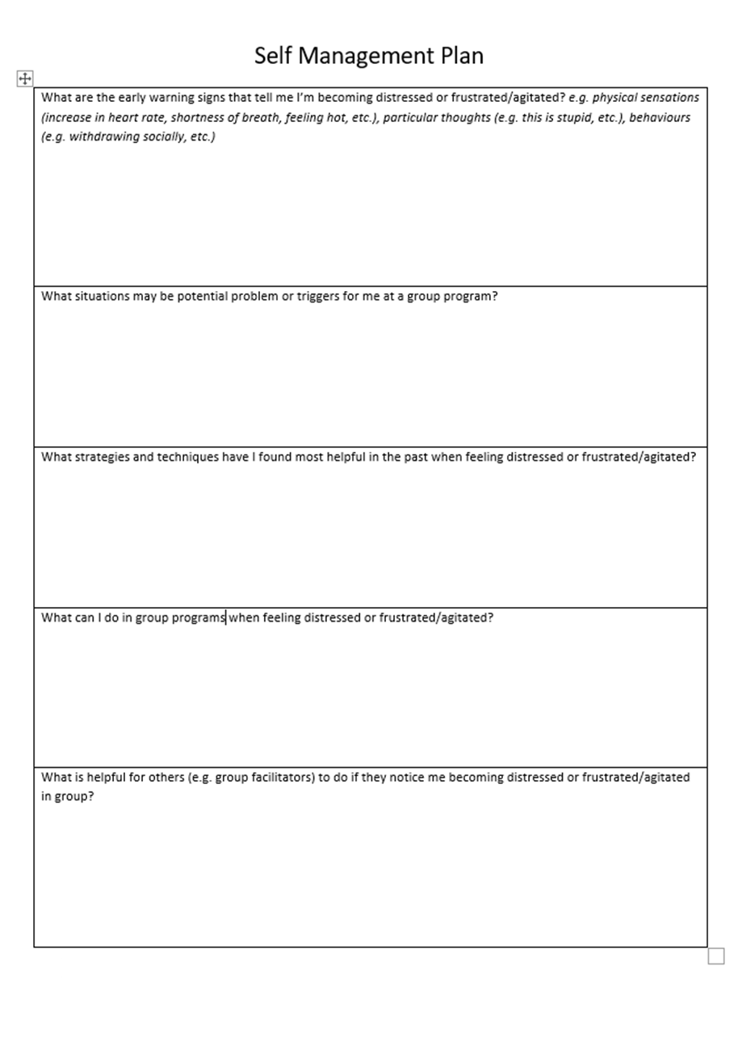

Attachment 3: Adult Mental Health AMHDS – Pre-commencement discussion/assessment template
MAJICER File Review;

☐ The person is aged between 18 and 65. For consumers 17 years of age or above 65 years of age may be admitted following MDT agreement;

☐ The person has a primary diagnosis of moderate to severe mental illness

☐ The person is engaged with a MHJHADS Community Recovery Service or is registered with a mental health team and will remain open for the duration of their engagement with the program/s they are interested in attending

☐The person is assessed as suitable, particularly in terms of their current wellbeing and safety

☐Recent SVAT suggests suitable
☐Review of mental state in recent MAJICeR notes suggests suitable

Contact with Person;
☐Information provided on AMHDS and individual programs as requested

☐Assessment of additional eligibility criteria for specific group program;
Notes:

☐The person (or guardian if relevant, and person assents) consents and the person is willing to participate in the AMHDS program

☐Discussion and information on how person’s goals/issues they hope to address by engagement will be addressed by AMHDS/specific group program
Notes:

MSE:

Plan:
☐Discuss at Clinical Discussion
☐Discuss at MDT
☐Offered Orientation
Date of Orientation:
☐Welcome Pack Posted
☐Other:

Attachment 4: AMHDS Welcome Pack
Welcome to the

Adult Mental Health Day Service

Welcome to the Adult Mental Health Day Service (AMHDS) located at the University of Canberra Hospital (UCH). Please find enclosed important information on engaging with our service. It is expected that you will have read the enclosed information prior to engaging in AMHDS programs. If you would like the information in an alternative format please see the accessibility information provided on the pamphlets.

The following pamphlets are enclosed;

- UCH: Adult Mental Health Day Service
- UCH: Specialty Centre for Rehabilitation, Recovery and Research (includes Getting to the Hospital information)
- ACT Health Smoke Free Health Campus
- Collection and Sharing of Personal Health Information
- ACT Charter of Rights for People Who Experience Mental Health Issues
- Consumer and Carer Feedback Form
- ACCESS Mental Health Team Card

What to Expect

Upon arrival at UCH please check in at Mental Health Reception. For directions to Mental Health Reception please ask at the University of Canberra Hospital Main Reception. Upon check in you will be asked for your full name, date of birth, and address to confirm your identity. A group facilitator will collect you from Mental Health Reception at the time your group commences.

We know that attending group programs can feel daunting for many participants. We welcome participants to come for an orientation to our facilities and to meet their group facilitator prior to the commencement of their program. Please speak with your clinical manager to arrange this.

Group Guidelines

In order to ensure our programs can be offered in a safe and supportive environment we ask that people attending all AMHDS programs adhere to the Group Guidelines. You will have an opportunity to discuss these group guidelines at the commencement of your group program.

- Participants are polite and respectful towards other group participants and staff.
- Participants maintain the principles of confidentiality. What is said in group, stays in group.
- Participants are not to be affected by alcohol or other drugs when attending group programs.
- It is anticipated that people attending the closed group programs participate in completing hand-outs, activities and homework.
- Participants attending closed group programs try to attend all sessions and contact the AMHDS on 5124 0150 if they are unable to attend or wish to be discharged.
- Participants are encouraged to speak to facilitators if they are running late, or if they will need to take regular breaks during group. To reduce disruptions, people attending closed group programs who arrive more than 15 minutes late for group may not be able to participate in that session. Similarly, a person may not be able to return to a group session if they leave without staff consent.
- Participants maintain pro-social talk during group programs. People do not engage in discussions or behaviours with other group participants that involve self-harm, borrowing money, sharing or exchanging medication, or substance use. Participants are strongly encouraged to speak to AMHDS facilitators if they would like support related to these matters or if they have engaged in self-harm.
- Sexual partnerships between participants who attend the same closed group program is discouraged because it can be highly disruptive to the flow and progress of therapy.
- Actions that may result in suspension or discharge from group programs include; ongoing or persistent unexplained absences, repeated disruptive behaviour within the group, behaviour that could result in criminal charges such as theft, property damage or violence, aggression, violence or threats to staff and bringing alcohol, illicit substances or weapons to the AMHDS.

Attachment 5: AMHDS – Closure Letter Template

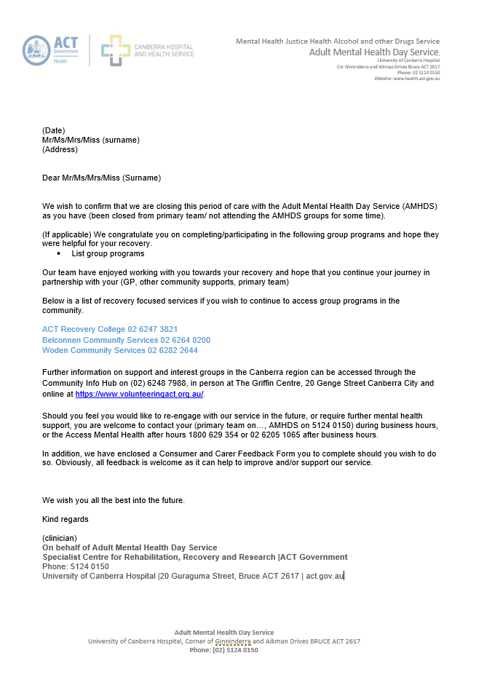

Attachment 6: Olanzapine Long Acting Injection Initiation Referral Form
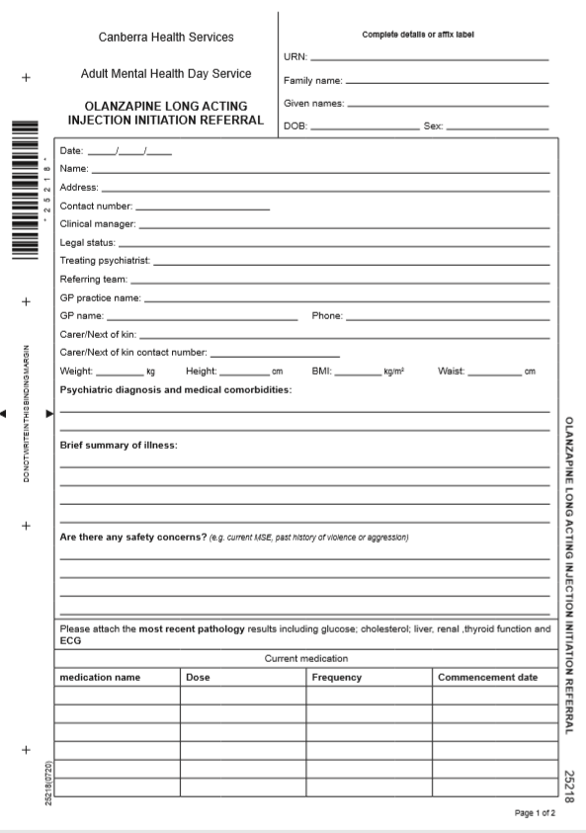

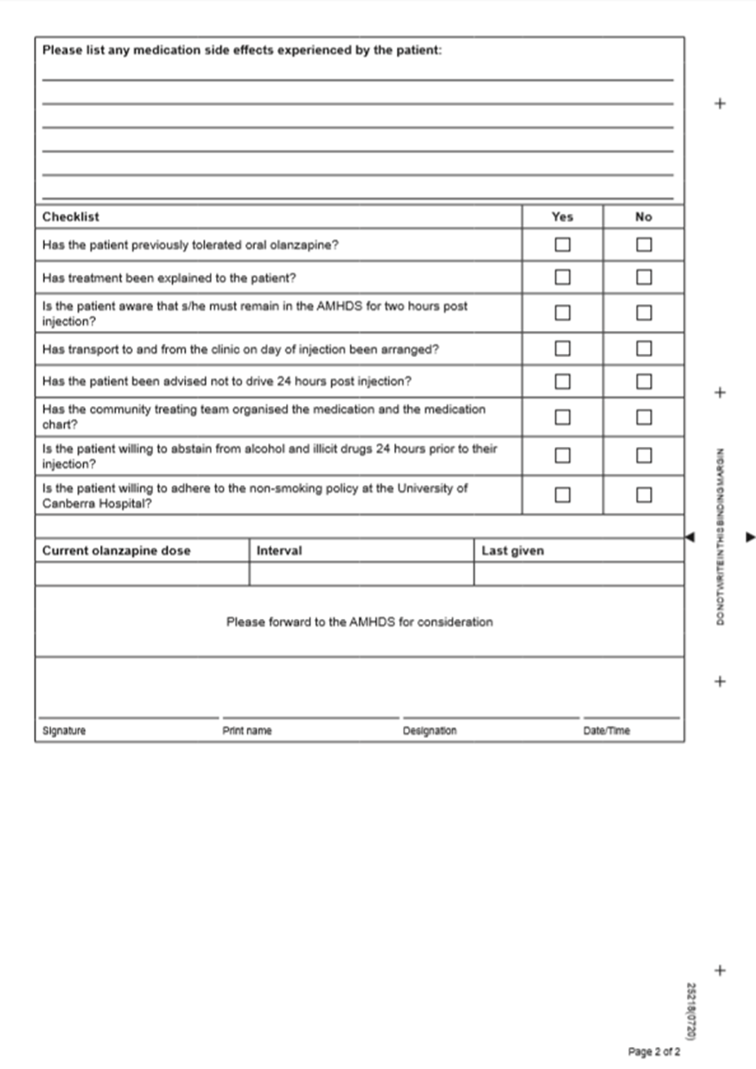

Attachment 7: Olanzapine Long Acting Injection Observation Form
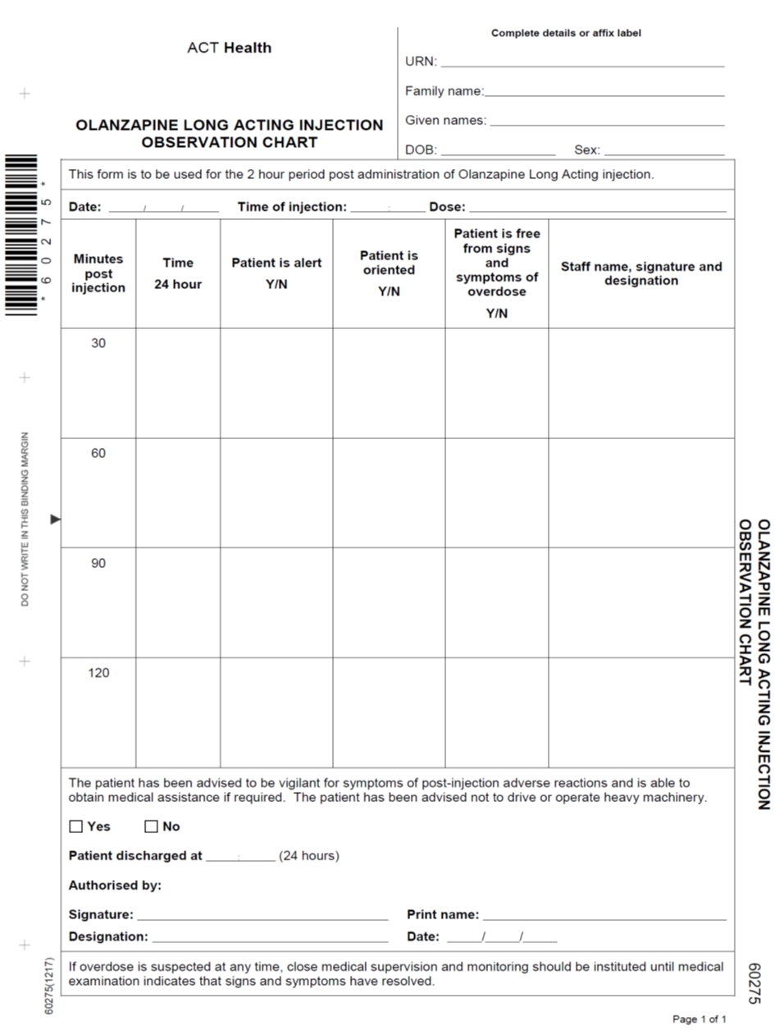

Attachment 8: Adult Mental Health AMHDS – Triage Scale

CODE/  DESCRIPTION | RESPONSE TYPE/TIME TO FACE-TO-FACE CONTACT | TYPICAL PRESENTATIONS | MENTAL HEALTH SERVICE ACTION/RESPONSE | LOCAL AREA ACTIONS
A - EMERGENCY | REFERRAL  IMMEDIATE  REFERRAL  Emergency  service  response | - Time critical  - Overdose  - Other medical emergency  - Siege  - Suicide attempt/serious self-harm in progress  - Violence/threats of violence and possession of weapon  - Delirium | UCH –  Hero Call if Code Blue  Code Black if personal threat  000 | Hero Call if Code Blue  0-000 if in community health centre  If personal threat - call Code Black – ring 2222 (CH Switch)  Ensure safety of staff and consumers  Allied Health Manager by text who will inform OP Director  After Hours: as above plus  Inform MHJHDAS Director on Call.  Inform AHHM x 26741 and security.
B - CRISIS  Very high risk of imminent harm to self or others | WITHIN 2  HOURS | - Acute suicidal ideation or risk of harm to others with plan and/or intent, and/or means and/or history of self-harm or aggression (or collateral information indicating the above).  - Very high risk behaviour associated with perceptual/thought disturbance, dementia, or impaired impulse control  - Collateral information provided that indicates possibility of any of the above and unable to contact person.  - Urgent assessment under Mental Health Act 2015 | Contact AMHRU Psychiatric Registrar or consumer’s treating team psychiatrist if available. If neither available contact AMHDS Consultant Psychiatrist.  Ring 2222 (CH Switch) if code called  ACTAS Transfer  Special Security ie UCH + CH security if required | Contact Psych Reg on Call or treating psychiatrist who will escalate to Clinical Consultant as needed.  Contact Allied Health Manager  Special Security ie UCH + CH security if required  Assess risk re transfer and  Liaise with ACTAS or AFP re transport  Update SVAT  Provide ISBAR handover to other areas as needed  After hours :  Contact AHHM x26741  MHJHADS Director on Call to be notified and Triage scale to be used to request extra staff if required.
C - PRIORITY  High risk of  harm to self  or others  and/or high  distress,  especially in  absence of  capable  supports | WITHIN 24  HOURS | - Information suggesting suicidal ideation or risk to others without plan and/or intent where level of suicide vulnerability or harm to others is unable be assessed.  - Recent (within 30 days) intentional overdose and/or other suicide attempt.  - Required priority assessment to clarify psychiatric needs and/or risk  - Rapidly increasing symptoms of psychosis and/or severe mood disorder  - High risk behaviour associated with perceptual/thought disturbance, dementia, or impaired impulse control  - Due to symptoms of mental illness the person is unable to care for self or dependents or perform activities of daily living.  - Known person requiring urgent intervention to prevent or mitigate relapse of illness. | Contact community Treating Team. Provide ISBAR+SS handover. Hand over care to Community Team. | Contact community Treating Team. Provide verbal ISBAR+SS handover to clinical manager (CM), if CM not available to DO, if DO not available to team leader. Hand over care to Community Team.  Update SVAT and document written ISBAR+SS. Send MAJICeR message to treating team.
D SEMI-URGENT | WITHIN 72  HOURS | - Person with recent suicidal intent who has been seen by, or discussed with a medical officer in the last 24 hours and assessed as not being at on-going elevated risk of suicide but needing follow-up review (excludes recent attempt within 30 days).  Face to face contact within 72 hours  *Where person has previously been seen by, or discussed with a medical officer within the last 24 hours and is reported not to have an elevated vulnerability to suicide, an initial phone follow-up call to assess risk and respond to any fluctuations is permissible.  - Significant person/carer distress associated with serious mental illness (including mood/anxiety disorder) but not suicidal  - Absent insight /early symptoms of psychosis or mental health deterioration  - Known person requiring priority treatment or review. | Contact community Treating Team. Provide ISBAR+SS handover. Hand over care to Community Team. | Contact community treating team. Provide verbal ISBAR+SS handover to clinical manager (CM), if CM not available to DO, if DO not available to team leader. Hand over care to treating team.  Update SVAT if indicated and document written ISBAR+SS. Send MAJICeR message to treating team.
E – NON URGENT | WITHIN 14 DAYS | - Requires specialist mental health assessment but is stable and at low risk of harm in waiting period  - Other service providers able to manage the person until MHS appointment (with or without MHS phone support)  - Known person requiring non-urgent review, treatment or follow-up | Handover care to treating team. | Handover care to treating team. Write ISBAR + SS and send MAJICeR message to treating team. Update SVAT if indicated.
F – REFERRAL | REFERRAL | - Other services (e.g. GPs, private mental health practitioners) more appropriate to person’s current needs  - Symptoms of moderately severe to severe depressive, anxiety, adjustment and/or developmental disorder without complexity or risk, where the symptoms are responding favourably to low intensity interventions and or first line medical treatments.  - Early cognitive changes in an older person | Liaise with treating team. Provide feedback to referrer in timely manner. | Refer to ACCESS team on 1800 629 354  Provide feedback to referrer in timely manner.
G - ADVICE |  | - Person/carer requiring advice or opportunity to talk  - Service provider requiring telephone consultation/advice  - Issue not requiring mental health or other services  - Mental health service awaiting possible further contact  - More information needed to determine whether MHS intervention is required | ALL Teams– provide phone contact number for ACCESS 1800 629 354.  Initiate Majicer file if one does not exist.  Document call.  Follow up with phone call to see if person has made phone call to ACCESS | Inform Allied Health Manager of phone call.  Initiate Majicer file if one does not exist.  Document call.  Follow up phone all to see if person has contacted ACCESS 1800 629 354

Attachment 9: AMHDS DBT Referral Form
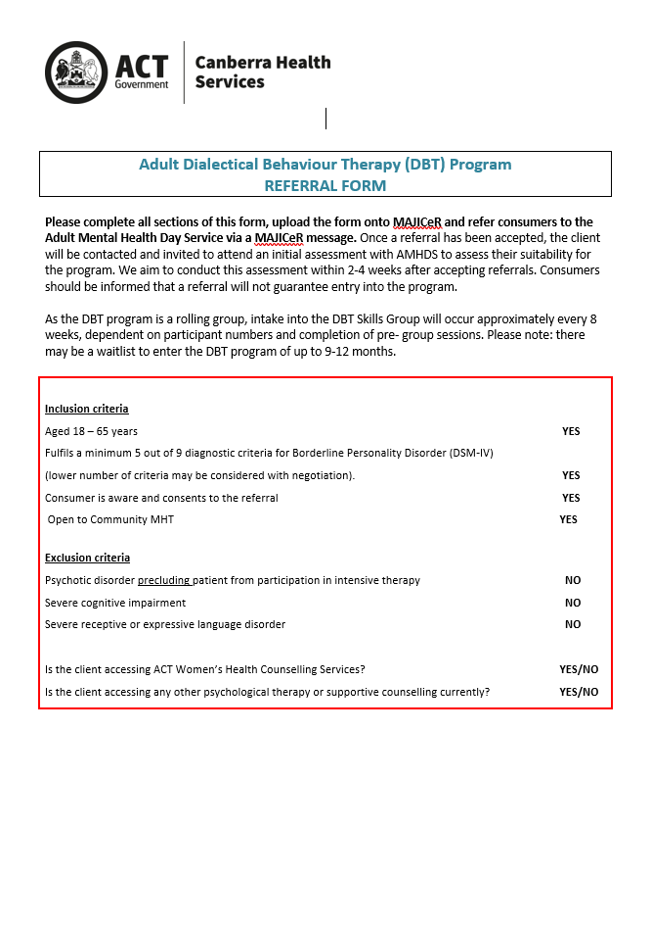

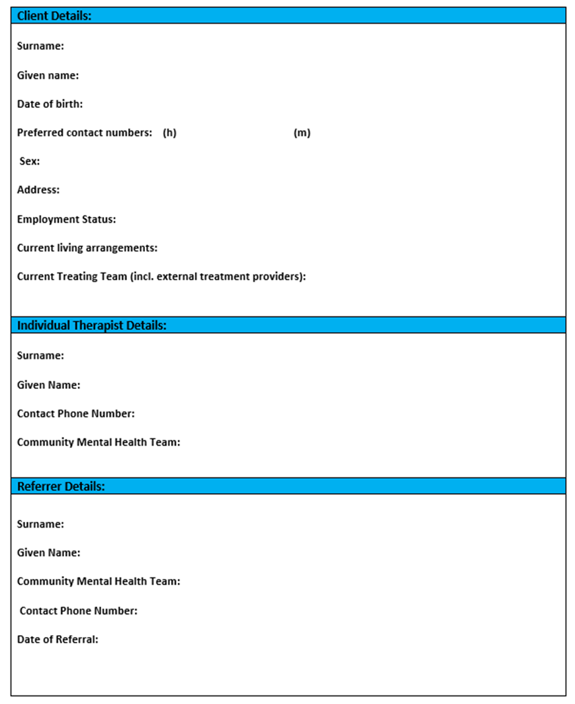

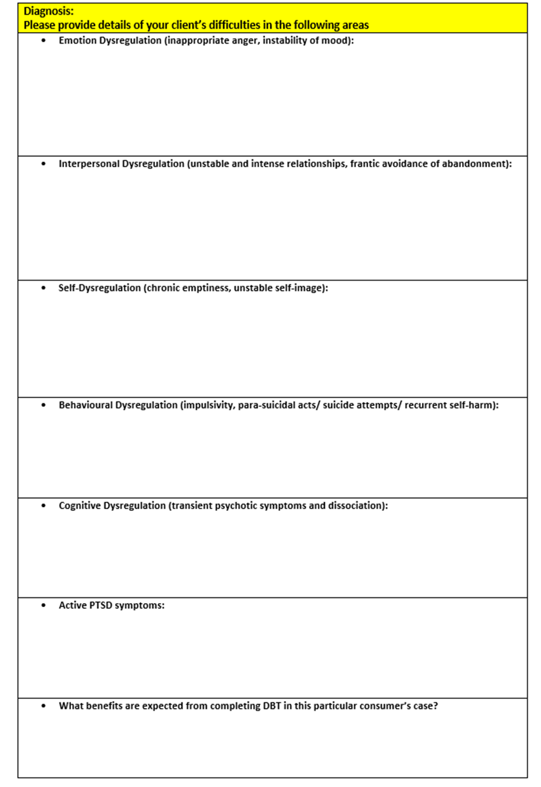

Attachment 10: DBT Pre-treatment Guidelines

Pre-treatment refers to all individual sessions after the assessment process has been completed and before the skills training begins. The therapist presents the progress at consult and a decision is made as to whether the participants can begin skills group based on the level of commitment and completion of the pre-treatment tasks.

Objectives:
- Develop a collaborative commitment between consumer and individual therapist to treatment.
- Orientating the consumer to the specifics of DBT treatment.
- Begin to develop an alliance.
Tasks for completion:
- Orientate to format of the program
  - Describe the structure of DBT modules and the program including consult.
  - Explore past experience of therapy. What has worked/what has not worked.
  - Discuss differences between DBT and other therapies that consumers may have experienced.

- Orientation to guidelines and assumptions of the programme.
  - See DBT Assumptions, Guidelines and Agreements within this document.

- Introduction to Biosocial Theory.
  - Provide explanation of theory.
  - Support the consumer to identify relevant experiences in their life where the model may apply.
  - See General Handout 5: Biosocial Theory (Linehan).

- Develop targets for treatment using treatment hierarchy and overall goals of treatment.
  - Elicit long term goals of consumer.
  - Identify treatment targets using hierarchy. Link to consumer’s long term goals.

- Obtain specific commitment of consumer and therapist to DBT programme a specific period of time.
  - Consider strategies such as Pros and cons, Devil’s advocate.
  - Completion of contract.
  - See Strategies for Obtaining Commitment and ACT Mental Health DBT Skills Group & Individual Therapy Agreement (this document).

- Orienting the network to treatment
  - Help the participant to identify key people in their network. This may include family, friends mental health workers, other health workers etc. Support them to orientate these people to DBT.
- Develop diary card and orientate participant to its use.
  - Customise the card to the individual participant. Consider assessment and hierarchy of treatment targets and consumer’s individual circumstances.
  - Introduce components of the card over time- start with requesting the consumer only complete a portion of the card.
  - See Introducing Diary Cards (this document), How to complete a diary card: Instructions for therapists and clients (University of Washington) and Diary Card template.

- Introduce chain analysis
  - General Handout 7 and 7a: Chain analysis (Linehan).
  - General worksheet 2 and 2a: Chain analysis (Linehan).

Develop and co-sign treatment contract

Attachment 11: Dialectical Behaviour Therapy Skills Group & Individual Therapy Agreement
