Canberra Health Services
Guideline
Triaging of Outpatient Referrals for Consultation with Orthopaedic Specialists

Contents

Contents 1
Guideline Statement 2
Scope 2
Section 1 – Clinical Triaging 3
Section 2 – Referrals for Urgent Review 3
Section 3 – Communicating the Category and Destination Clinic 4
Section 4 – Incorrect Referrals 6
Section 5 – Referrals from Specialist Services 7
Section 6 – Referrals to be Returned to the Referrer 7
Section 7 – Request for Additional Information 9
Section 8 – Duplicate Referrals 10
Section 9 – Updated Referrals 11
Section 10 – Referring on to Surgeons 12
Section 11 – Redirecting to a Face to Face Appointment 13
Evaluation 15
Related Policies, Procedures, Guidelines and Legislation 15
References 16
Search Terms 16

Guideline Statement

Background
Patients referred to Orthopaedic Outpatients for elective procedures are triaged by a team of suitably trained physiotherapists. These physiotherapists make decisions about the urgency of the referral and the most suitable clinic at which the consultation should take place.

The physiotherapists use criteria based on the national definitions for elective surgery urgency categories as outlined by the Australian Institute of Health and Welfare (AIHW, 2008) (Table 1). Their decisions are also based on findings from research conducted in 2010 (Morris et al, 2011). Since this time, there has been a natural evolution of triaging processes, which has led to the development of this guideline.

The triage categories are:
Category | Description
Urgent | Acute conditions which may require urgent surgery
1 | Conditions for which an outpatient review is indicated within 30 days
2 | Conditions for which an outpatient review is indicated within 90 days
3 | Conditions for which an outpatient review is indicated within 365 days
Table 1: Australian Institute of Health and Welfare Orthopaedic Urgency Categories

Key Objective
This guideline has been developed to govern the triaging process for patients referred to Canberra Health Services (CHS) for orthopaedic surgical consultation. It provides comprehensive, standardised and transparent triaging criteria from which clinical prioritisation for orthopaedic consultation can be established. The guideline also details the processes that support the clinical triage decisions, so that the administrative aspects of managing referrals are consistent, efficient and reliable.

Back to Table of Contents

Scope

This guideline applies to all patients referred to the Orthopaedic Outpatient Clinic for elective procedures.

This document applies to the following CHS staff working within their scope of practice:
- All physiotherapy staff undertaking triaging of the orthopaedic outpatient referrals at CHS
- Community Health Intake (CHI) staff.

Back to Table of Contents

Section 1 – Clinical Triaging

Physiotherapists will access referrals to be triaged via Clinical Portal and will refer to this triaging guideline to decide on the triage outcome that best applies to the clinical presentation outlined within the written referral.

Triage outcomes can include:
- Refer the patient directly to the Emergency Department for review
- Redirect the referral to the Orthopaedic Registrar Review Clinic
- Refer directly to a Specialist Orthopaedic Clinic
- Refer to the Orthopaedic Screening Clinic (either face-to-face or telehealth)
- Returning the referral to the referrer for a variety of documented reasons
- Requesting further information from the referrer
- Consulting the supervising orthopaedic surgeon for guidance on most appropriate triaging outcome.

Back to Table of Contents

Section 2 – Referrals for Urgent Review

Any patients referred with a condition requiring urgent review will be redirected to the Emergency Department or Registrar Review Clinic.

Emergency Department
- The physiotherapist will contact the referrer to clarify the need for urgent medical review.
- If the physiotherapist cannot contact the referrer, they should contact the patient or their next of kin directly.
- If clinically appropriate, the physiotherapist will instruct the patient to attend the Emergency Department. Should they not be able to reach the patient, they will instruct the referrer/referrer’s rooms to do so.
- The physiotherapist will contact the Emergency Department Admitting Officer and inform them of the expected presentation.
- Using the ACT Patient Administration System (ACTPAS), the physiotherapist will select the “Cancelled” category from the REFERRAL STATUS drop down box. Refer screenshot below.
- The physiotherapist will select “Urgent” from the REFERRAL CATEGORY drop down box
- The physiotherapist will write “re-directed to Emergency as per phone call to referrer / patient DD/MM/YY” in the BOOKING INSTRUCTIONS.
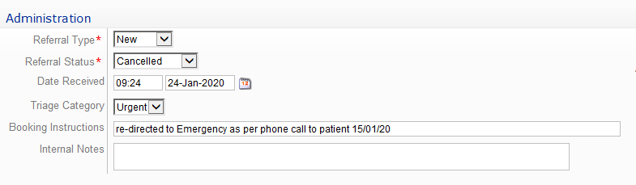

Registrar Review Clinic
- If a referral fits the criteria for intake to the Registrar Review Clinic, the physiotherapist will contact the referrer’s rooms and instruct the referrer/representative to contact the Orthopaedic Registrar On-Call (via CHS Switchboard 5124 0000)
- The physiotherapist will inform the referrer/representative that the referral to the outpatient service will be cancelled
- Using ACTPAS the physiotherapists will select “Cancelled” category from the REFERRAL STATUS drop down box as per the screenshot below.
- The physiotherapists will write “referrer to redirected to registrar review clinic, contacted DD/MM/YY” in the INTERNAL NOTES.

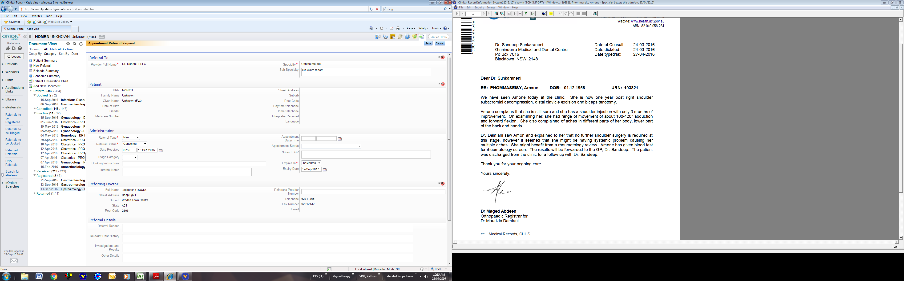


Back to Table of Contents

Section 3 – Communicating the Category and Destination Clinic

Upon reviewing a referral for consultation, the physiotherapist will:
- On ACTPAS select the “Triaged” category from the REFERRAL STATUS drop down box as per screenshot below
- select the appropriate category from the TRIAGE CATEGORY drop down box
- write in the BOOKING INSTRUCTIONS to indicate appropriate destination:

- Orthopaedic Screening clinic (ACTPAS Code MPHYHG) – face-to-face appointment
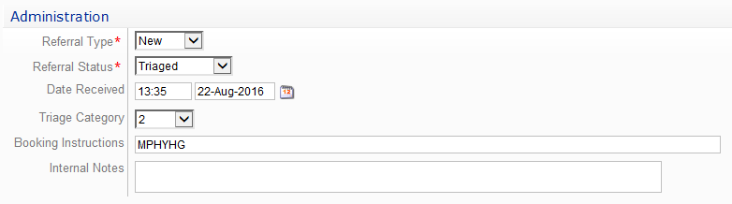
“Face 2 face” written in internal notes

Face 2 face

- Orthopaedic Screening Clinic (ACTPAS Code MPHYHG) – telehealth appointment
“Telehealth” written in internal notes

Telehealth

- In this instance CHI staff will contact the patient to confirm suitability of telehealth.
- If applicable use the “MED PHY Orthopaedic Screen Telehealth” letter from the “outpatient appointment notification” documents as generated in ACTPAS to provide the patient with the appointment details.
- If the patient declines or is unable to access telehealth, the patient will be offered a face-to-face appointment.

- Named Surgeon
The screenshot below from ACTPAS indicates how to enter the name of the orthopaedic surgeon:
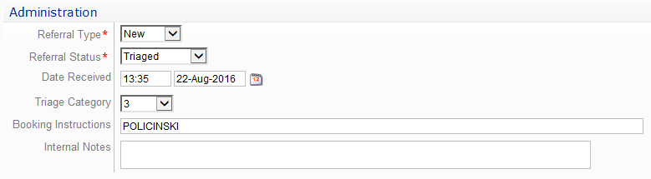
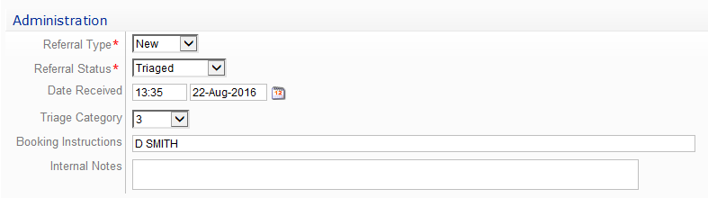
for Doctors with the same surname write
“Initial SURNAME”
(without full stop or comma)

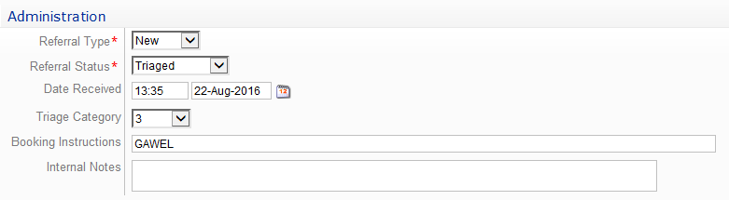
for Dr Kulisiewicz, write “GAWEL”

- Surgical speciality (in the case where a surgeon has not been nominated by the referrer)
- SHOULDER
- HAND (includes wrist and elbow)
- SPINE
- HIP
- KNEE
- FOOT (includes ankle)
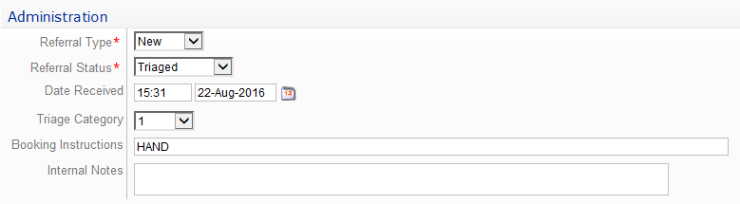

- Write any comments or further instructions within the INTERNAL NOTES.

Back to Table of Contents

Section 4 – Incorrect Referrals

Referrals that are erroneously registered to orthopaedics or registered against the wrong patient should be re-allocated by administration staff. In this case, the physiotherapist will:
- Using ACTPAS Change the REFERRAL STATUS to “Triaged”
- Not enter a TRIAGE CATEGORY. Leave this field blank
- Document the nature of the error within the BOOKING INSTRUCTIONS
(e.g., “this referral is for plastic surgery, not orthopaedics, please re-allocate”, “referral registered under the wrong patient, please amend”).

Please refer to the screenshot below which shows how the ACTPAS entry might look.

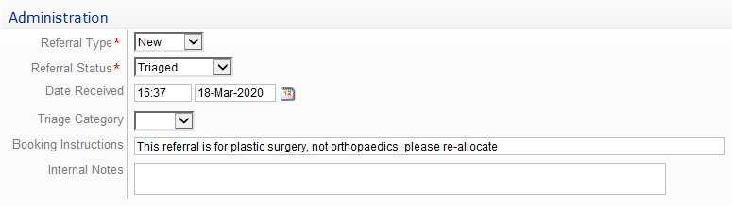

Back to Table of Contents

Section 5 – Referrals from Specialist Services

Referrals received from Consultants or Registrars from the disciplines listed below may be considered appropriate for consultation with an orthopaedic surgeon directly, with a triage category determined by the triaging physiotherapist (i.e. not for review in the Orthopaedic Screening Clinic). They will follow the process outlined in Section 3 – Communicating the Category and Destination Clinic.
- Orthopaedics
- Rheumatology
- Neurosurgery
- Sports Physicians
- Plastic Surgery
- Pain physicians

Referrals from other specialist disciplines will be considered on a case-by-case basis.

Back to Table of Contents

Section 6 – Referrals to be Returned to the Referrer

Referrals can be returned to the referrer for the following reasons:
- There have not been adequate investigations performed or attached
- There is insufficient information provided within the referral to determine the triage categorisation or destination
- The information provided in the referral describes a condition that could be expected to respond to a trial of active non-surgical management, as per current best evidence.
- Any other reason determined by the triaging physiotherapist.

- Inadequate Pre-Requisite Investigations
The Orthopaedic Referral Pathways outline the expected pre-requisite information and investigations a patient should have completed prior to referral for specialist opinion. If a referral is received where these investigations have not been performed or attached, the physiotherapist will request that the referral be returned to the referrer with a letter (generated by ACTPAS), as per the following steps:
- Change the REFERRAL STATUS to “Triaged”
- Leave the TRIAGE CATEGORY blank
- Document “please return to referrer with investigations letter” within the BOOKING INSTRUCTIONS
- CHI staff will select the “MED PHY Orthopaedic Screen more info GP” template from the “Referral acknowledgement - to Patients” documents as generated within ACTPAS. This is to be printed double-sided to allow mailing.

- More Information Required
Should a referral be otherwise registered, and further information or clarification is required to make a clinical decision, the physiotherapist will request that an ACTPAS-generated letter be sent to the referrer as per the following steps:
- Change the REFERRAL STATUS to “Triaged”
- Leave the TRIAGE CATEGORY blank
- Document “rejected - please return to referrer with the adjacent note” within the BOOKING INSTRUCTIONS
- Document the nature of the concern, outlining what information is requested within the NOTES TO GP section
- CHI staff will select the “CHS Referral Returned: Info requested – to GP & Pt” template form the “Referral acknowledgement - to Patients” documents as generated within ACTPAS. They will add the information provided in the NOTES TO GP within clinical portal and “OPORTHTRSIG” optional paragraph.

- Conservative Treatment
As outlined in the Orthopaedic Referral Pathways, there is an expectation that patients with certain conditions undergo a trial of active non-surgical treatment prior to referral for a specialist opinion. Should a referral be submitted outlining such a condition, without reference to a trial of active non-surgical treatment, the physiotherapist can return to the referrer together with a request that this be undertaken.
- On ACTPAS change the REFERRAL STATUS to “Triaged”
- Leave the TRIAGE CATEGORY blank
- Document “please return to referrer with conservative treatment letter” within the BOOKING INSTRUCTIONS
- CHI staff will select the “MED PHY Orthopaedic Screen Conservative Tx GP & Pt” template from the “Referral acknowledgement - to Patient” documents as generated within ACTPAS. These will be forwarded to referrer and to the patient.

Back to Table of Contents

Section 7 – Request for Additional Information

There are circumstances where the referral will be accepted to the Orthopaedic Screening Service, but the triaging physiotherapist will request additional information of the referrer. Upon receipt of the additional information, the triage category may be altered.

Request for Outcome Measures
The Orthopaedic Referral Pathways outline the use of standardised outcome measures to assist triage categorisation of patients. It is expected referrers will request their patient complete the relevant questionnaire and include this with the referral. The results of the questionnaire will be used in conjunction with other referral information to determine the appropriate triage category.

Should the referral not have an outcome measure included, the physiotherapist will triage based on the information available and request that a letter be sent to the referrer encouraging the inclusion of the appropriate outcome measures with future referrals, and that the referrer consider resubmitting the current referral with the relevant completed outcome measure attached.

- On ACTPAS the physiotherapist will document “please send outcome measure letter” in the INTERNAL NOTES
- CHI staff will select the “MED PHY Orthopaedic Screen OM Request GP & Pt” template from the “Placed on Waiting List” documents as generated within ACTPAS. These will be forwarded to referrer and to the patient.

Please refer to the screenshot below which shows how the ACTPAS entry might look.
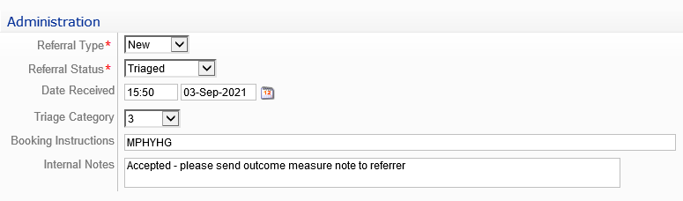

Additional Information Beneficial Prior to the Appointment
If there is enough information to triage the referral, but further information or investigations would be beneficial prior to the appointment, this can be communicated to the CHI Team as per the following steps:
- On ACTPAS the physiotherapist will document “accepted - please return to referrer with the adjacent note” within the BOOKING INSTRUCTIONS
- Document the nature of the concern, outlining what information is requested within the NOTES TO GP section
- CHI staff will select the “CHS WL More Info – GP & Pt” template form the “Placed on Waiting list” documents as generated within ACTPAS.

Please refer to the screenshot below which shows how the ACTPAS entry might look.

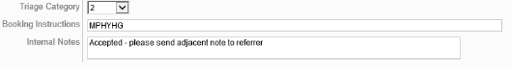
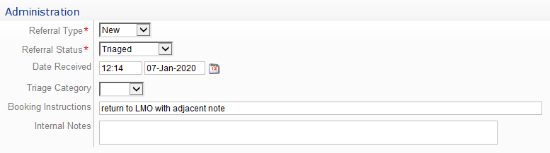
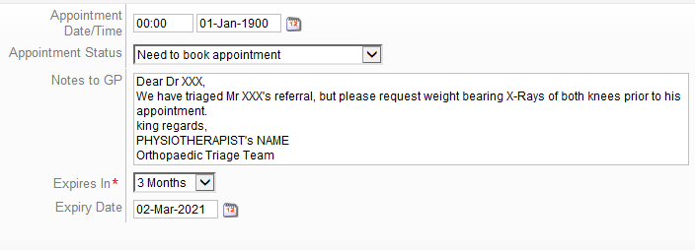

Updating Referrals due to Additional Information
Should an outcome measure or additional investigations be submitted after the original referral, the CHI staff will update the referral on Clinical Portal for consideration by the physiotherapists. See Section 9 regarding update procedures.

Back to Table of Contents

Section 8 – Duplicate Referrals

Any duplicate referrals shall be managed in accordance with the CHS Ambulatory Care eReferrals System Business Rules, as follows:
- Document “DUPLICATE” (in capital letters) in the SUB-SPECIALITY section
- Change the “REFERRAL STATUS” to “Cancelled”, as per the screenshot below:

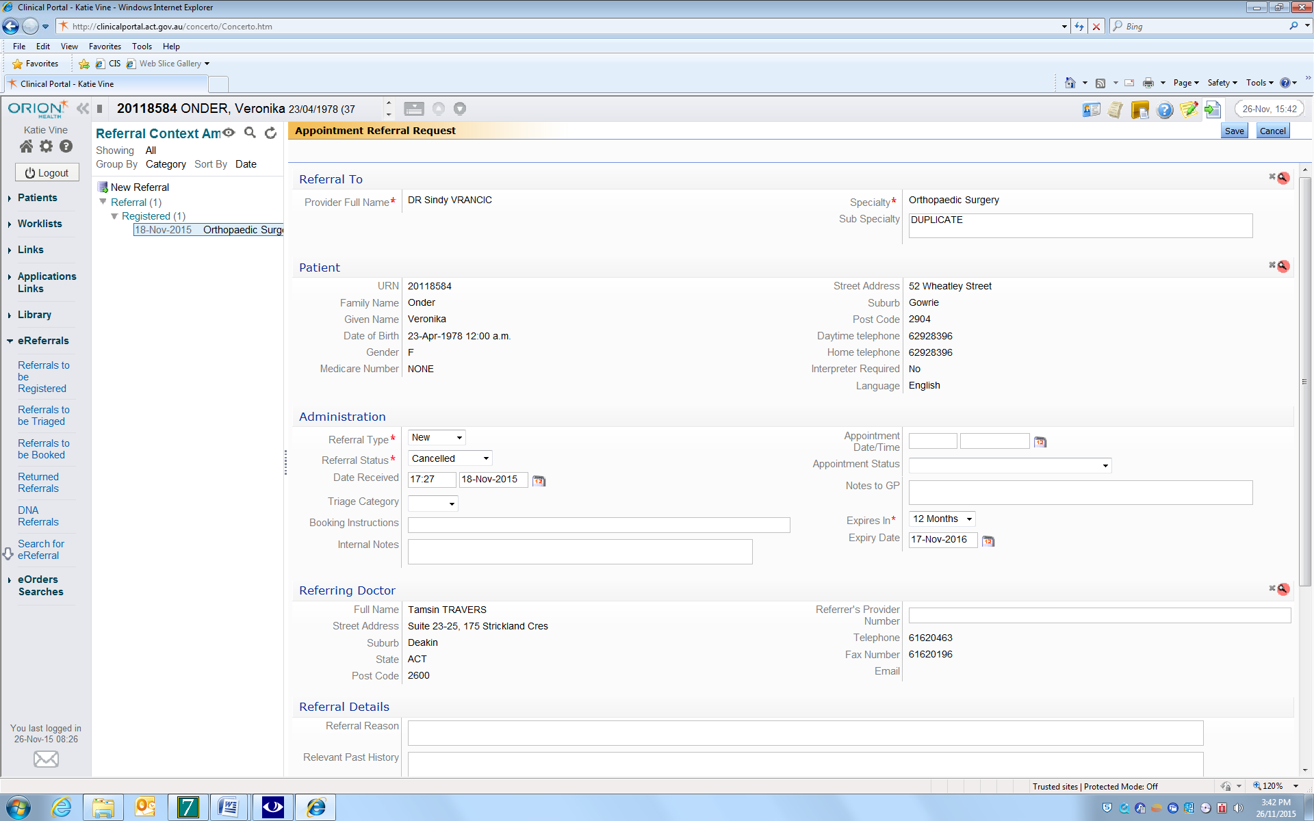

Review appointment
Occasionally, a referral is received for a patient previously seen in a surgeon’s clinic or in the Orthopaedic Screening Clinic ( ACTPAS Code MPHYHG) with a condition that requires review.

In this case:
- The referral type will be changed to “review”
- A “book-by” date will be entered by the physiotherapist in the INTERNAL NOTES. This timeframe will be determined on a case-by-case basis after reviewing the referral and prior medical record as required
- If the review is time-sensitive, the TRIAGE CATEGORY will be changed to “Urgent” and “must meet timeframe” should be documented against the book-by date.

Otherwise, the TRIAGE CATEGORY should be changed to NULL. It this circumstance CHI staff will select the next, appropriate, available appointment.

Back to Table of Contents

Section 9 – Updated Referrals

Referrals may be updated for several reasons, including:
- Updated clinical information from the referrer
- Additional referral for the same condition from an alternate referrer
- New results
- Inclusion of an outcome measure (see Section 7).

In this case:
- CHI staff will upload the new documents to the Clinical Portal, against the original referral
- Change the referral status to “Registered”
- Provide relevant information to the triaging team including:
- The nature of the update – e.g. “updated results” or “outcome measure attached”
- The triage category and clinic destination for the original referral within the INTERNAL NOTES– e.g. Cat 2 BURNS, Cat 3 MPHYHG, Cat 1 HIP, SWL updated referral (whereby “SWL” is surgical wait list).

Back to Table of Contents

Section 10 – Referring on to Surgeons

Following an assessment in the Physiotherapy-Led Orthopaedic Screening Clinic, a physiotherapist can decide to refer the patient on to an orthopaedic surgeon. In this case, the physiotherapist will:
- On ACTPAS change the DATE RECEIVED to today’s date
- Select the “Triaged” category from the REFERRAL STATUS drop down box
- Ensure the appropriate category is selected in the REFERRAL CATEGORY drop down box
- Write in the BOOKING INSTRUCTIONS to indicate appropriate destination
- NAMED SURGEON(s)
Or
- Surgical speciality
- SHOULDER
- HAND (includes wrist and elbow)
- SPINE
- HIP
- KNEE
- FOOT (includes ankle)
Or
- NEXT AVAILABLE SURGEON (surgical speciality in brackets e.g., Shoulder, Hand, Hip, Knee, Spinal)
- If present, delete the appointment time and date from the ADMINISTRATION field
- In the INTERNAL NOTES, write ‘As per MPHYHG, original referral date is DD/MM/YY’, together with any other comments or further instructions as per the screenshots below:


DELETE

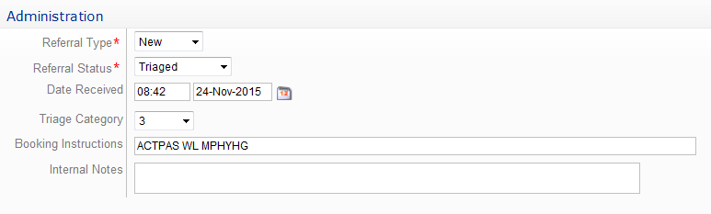
Booked
DELETE

CHANGE to today’s date
ADD Surgeon’s Name or Speciality as above, e.g., KNEE

The CHI staff will add the patient to the relevant ACTPAS Waiting List as per the date of the ORIGINAL REFERRAL.

Back to Table of Contents

Section 11 – Redirecting to a Face to Face Appointment

Following an Orthopaedic Screening Clinic Telehealth appointment, a physiotherapist may decide a face-to-face assessment in the Orthopaedic Screening Clinic is required.
- On ACTPAS change the DATE RECEIVED to today’s date
- Select the “Triaged” category from the REFERRAL STATUS drop down box
- Ensure the appropriate category is selected in the REFERRAL CATEGORY drop down box
- Write MPHYHG in the BOOKING INSTRUCTIONS
- Write ‘face 2 face as per telehealth, original referral date is DD/MM/YY’, in the INTERNAL NOTES
- If present, delete the appointment time and date from the ADMINISTRATION field as per the screenshots below:

DELETE

Booked
DELETE

CHANGE to today’s date
Face to face as per telehealth appointment, original referral date 12/3/2021
MPHYHG
ADD Surgeon’s Name or Speciality as above, e.g., KNEE

The CHI staff will add the patient to the relevant ACTPAS Waiting List as per the date of the ORIGINAL REFERRAL.

Back to Table of Contents

Evaluation

Outcome
Patients on the Orthopaedic Outpatient Specialist Waitlist are triaged, and referrals managed as per this guideline.

Measures
Compliance with this guideline will be audited annually by the Orthopaedic Screening Physiotherapy Team. The target compliance will be 85%.

Back to Table of Contents

Related Policies, Procedures, Guidelines and Legislation

Policies
- Informed Consent (Clinical)
- Medical Specialist Outpatient Referral Acceptance

Procedures
- Patient Identification and Procedure Matching
- Soft Tissue Injuries – Referral Process for Adult Patients who Present to the Emergency Department
- Ambulatory Care Operations Manual
- Credentialling and Scope of Practice for Allied Health

Guideline
- Spinal Pain Service (Adult Outpatients)
- Clinical Supervision for Allied Health Clinicians

Legislation
- Health Records (Privacy and Access) Act 1997
- Human Rights Act 2004
- Work Health and Safety Act 2011

Other
- Australian Charter of Health Care Rights

Back to Table of Contents

References

Morris, J., Grimmer-Somers, K., Kumar, S., Murphy, K., Gilmore, L., Ashman, B., Perera, C., Vine, K. and Coulter, C., 2011. Effectiveness of a physiotherapy-initiated telephone triage of orthopaedic waitlist patients (Doctoral dissertation, Dove Medical).

Health Data Standards Committee. National health data dictionary. Version 14. Canberra: Australian Institute of Health and Welfare, 2008. (AIHW Cat. No. HWI 101.)

Back to Table of Contents

Search Terms

Orthopaedic Surgery, Triage, Outpatients, Ambulatory Services, Extended Scope Physiotherapy, Physiotherapy

Back to Table of Contents

Disclaimer: This document has been developed by Canberra Health Services specifically for its own use. Use of this document and any reliance on the information contained therein by any third party is at his or her own risk and Canberra Health Services assumes no responsibility whatsoever.

Policy Team ONLY to complete the following:
Date Amended | Section Amended | Divisional Approval | Final Approval
04 February 2022 | Complete Review | Jo Morris, ED-AH | CHS Policy Committee

This document supersedes the following:
Document Number | Document Name
CHHS17/044 | Triaging of Outpatient Referrals for Consultation with Ortho Specialists

