Canberra Health Services
Guideline
Retinopathy of Prematurity (ROP) in Neonates: Screening and Treatment

Contents

Contents 1
Guideline Statement 2
Scope 2
Section 1 – Introduction 2
Section 2 – Classification 4
Section 3 – Screening - Eye Examination 6
3.1 - Criteria for Ophthalmology Review - Screening for ROP 6
3.2 - Time of Screening 6
3.3 - Other referrals for ophthalmology review: 6
3.4 - Process 7
3.5 - Follow up 7
3.6 – ROP Screening Procedure 7
3.8 - Use of the Retcam™ 9
3.9 - Transfer to another hospital 9
3.10 - Discharge from hospital 9
Section 4 – Laser Surgery for Retinopathy of Prematurity (ROP) 10
Section 5 – Vascular Endothelial Growth Factor (VEGF) Inhibitor Treatment 13
Evaluation 14
Related Policies, Procedures, Guidelines and Legislation 15
References 15
Definition of Terms 16
Search Terms 16
Attachments 16
Attachment 1: Retinopathy of Prematurity Screening form 18
Attachment 2: Laser Surgery Check List 19

Guideline Statement

Background
Retinopathy of prematurity (ROP) is a condition that affects the developing retina of preterm infants, which can potentially lead to poor visual outcome.

Key Objective
The purpose of this document is to provide the best practice guide for the screening and prompt treatment of Retinopathy of Prematurity.

Alerts
- Compress lacrimal sac at medial canthus during and for 1 min following instillation of eye drops to reduce systemic absorption.
- Observe for bradycardia during instillation.
- Observe infant for active bowel sounds as Cyclopentolate is an anticholinergic drug and can cause a paralytic ileus.
- Bright lighting should be avoided for 2 hours post dilation as the pupils will be dilated.
- Some infants who are not already monitored may require monitoring for up to 2 hours post procedure.

Back to Table of Contents

Scope

The document pertains to neonates nursed in the Canberra Health Services (CHS) network, including the inpatient facilities at Canberra Hospital, Clare Holland House, North Canberra Hospital, and University of Canberra and community-based services.

This document applies to CHS network staff who are involved in the screening and treatment of Retinopathy of Prematurity in neonates and working within their scope of practice.

- Medical Officers.
- Nurses and Midwives who are working within their scope of practice.
- Students under direct supervision.

Back to Table of Contents

Section 1 – Introduction

Retinopathy of prematurity (ROP) is a condition that affects the immature vascularity of the retina of premature infants. Despite improvements in neonatal care and management guidelines, ROP remains a leading cause of childhood blindness worldwide. Premature infants born <31 weeks of gestational age are the group mostly affected, therefore screening programs usually focus on this population.

Screening for ROP is a standard procedure in the Neonatal Intensive Care Unit that aims to identify the infants who are at high risk of ROP and will benefit from early diagnosis and treatment.

There are different stages of the disease (see Section 2 - Classification) and severe ROP may need invasive treatment with laser surgery and/or intraocular injection of VEGF inhibitor, to prevent progression of the eye disease and to improve visual outcome.

The prevalence of ROP varies among different countries. In 2019, The Australian and New Zealand Neonatal Network (ANZNN) reported that 8.4% of infants <31 weeks/<1250 grams of birth weight were diagnosed with severe ROP (Stage 3 or 4). The rate of severe ROP at the neonatal unit at The Canberra Hospital for the same population in 2019 was 13%.

The risk factors associated with ROP include:
- Prematurity
- IUGR condition
- Hyperoxia
- Hyperglycaemia
- Infections (early and late onset sepsis)
- Prolonged invasive respiratory support
- Blood transfusions
- Poor growth
- High levels of Insulin-like growth factors (IGF-1).

The development of the retina is incomplete in premature infants and the extent of immaturity is higher at lower gestational ages. In the human fetus, the retinal vascularity develops by vasculogenesis (de novo synthesis of blood vessels) and angiogenesis (formation of blood vessels from pre-existing vessels). Retinal vasculogenesis starts at 12 weeks of gestation and is usually completed by 22 weeks of gestation. Retinal angiogenesis starts at 16 weeks of gestation and is usually completed between 36 to 40 weeks of gestation. This process occurs physiologically in utero at an oxygen partial pressure of around 50 mmHg and depends on different oxygen-regulated growth factors that stimulate the retinal vascular development. When infants are born prematurely, they are exposed to a higher partial pressure of oxygen (oxygen saturations >90%) and this “hyperoxia” affects the levels of oxygen-regulated growth factors and subsequently the retinal vascular development causing ROP.

The disease has two phases:
- The first is a hyperoxic phase and it is characterized by inhibition of the retinal vascularisation. The “hyperoxia” after a premature birth (especially <31 weeks), the loss of nutrients (given previously through the placenta), and the loss of growth factors in the retina, produce a “blood-vessel growth stop”. The retina will continue its maturation and growth, increasing its metabolic demand without sufficient blood perfusion, leading to the second phase of the disease.
- The second phase is a hypoxic phase. The hypoxic retina stimulates the exaggerated expression of oxygen-regulated growth factors, which stimulates a dysregulated retinal neovascularisation. These abnormal vessels can grow out of the plane of the retina into the vitreous cavity; and this can progress to retinal detachment and blindness.

The transition between Phase 1 and Phase 2 usually occurs between 31 to 33 weeks of corrected gestational age. In most preterm infants ROP regresses spontaneously and the retina vascularises fairly normally. In infants that develop severe ROP, the greatest severity is usually noted between 35 to 38 weeks of corrected gestational age.

Understanding these two phases of the disease allows early identification of infants at risk of developing ROP. Taking in consideration the physiopathology of the disease, the screening for ROP at the CHHS occurs at 32 weeks of corrected age or 28 days of postnatal (chronological) age, whichever comes later.

Back to Table of Contents

Section 2 – Classification

ROP is described using 3 concepts: location, stage and “plus disease” using the international classification of retinopathy of prematurity grading system. This is important for the standardisation of treatment practices.

Location: The retina is divided into three zones (as per the diagram below) which allow the examiner to define the location and extent of the disease. By convention these are labelled using Roman numerals.
- Zone I is a circle centred on the optic nerve, radius twice the disc-macular distance.
- Zone II is an annulus surrounding Zone I which just reaches the nasal edge of the retina (the ora serrata).
- Zone III is the remaining temporal crescent of retina
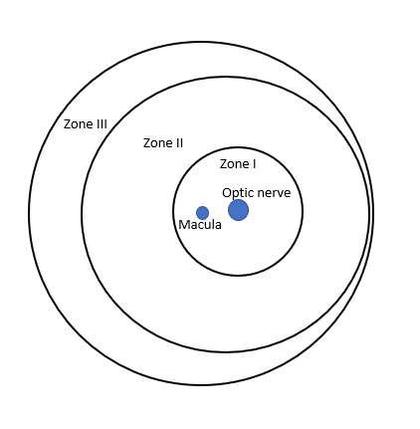
Figure 1. Zones of the retina

Stage: There are 5 stages of disease (labelled using Arabic numerals). These stages are (from less to more severe):
- Stage 1: is characterised by a thin demarcation line between vascularised on non-vascularised retina
- Stage 2: there is a ridge that arises in the region of the demarcation line, has height and width, and extends above the plane of the retina
- Stage 3: there is extraretinal fibrovascular proliferation (or neovascularisation) that extends from the ridge into the vitreous
- Stage 4: partial retinal detachment
- Stage 5: total retinal detachment

Plus disease: Refers to venous dilation and increased arteriolar tortuosity of the posterior retinal vessels. Plus disease is either present or absent. At times there may be increased dilation or tortuosity of the retinal vessels which does not meet the definition of plus disease, and this may be referred to as pre-plus disease.

Back to Table of Contents

Section 3 – Screening - Eye Examination

The aim of the eye screening/examination is the early identification of ROP in premature infants at high risk, which has the potential to reach severe stages of the disease which may need treatment.

3.1 - Criteria for Ophthalmology Review - Screening for ROP
Screening by the ophthalmologist will occur for infants in any of the following cases:
- < 31 weeks of gestation at birth.
- Birth weight <1250gms (any gestation).
- Infants outside the above criteria and <34 weeks of gestation at birth that require oxygen at 4 weeks of chronological age.

3.2 - Time of Screening
All infants who fit the above criteria should have their first eye check at 32 weeks corrected gestational age or at 28 days of chronological age whichever comes later.

3.3 - Other referrals for ophthalmology review:
There are other clinical reasons for ophthalmological examination of the eye in a neonate. For example, in cases of congenital infections (TORCH infections), in cases of early and late onset sepsis (for example in infection by fungal agents), genetic conditions, etc. The neonatologist on service will consider referral for eye examination in these or other conditions.

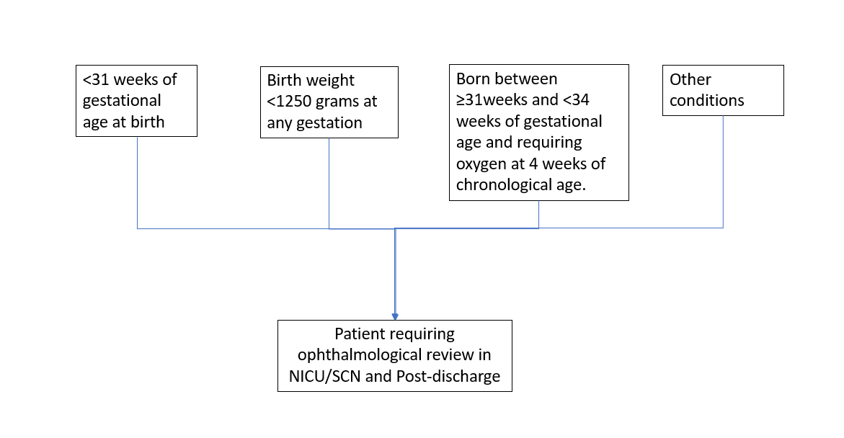
FIGURE 2. REFERRALS FOR OPHTALMOLOGY REVIEW IN THE NICU/SCN

3.4 - Process
- The Neonatal Intensive Care Unit (NICU)/ Special Care Nursery (SCN) medical team will identify the neonates that require an ophthalmological eye review.
- The NICU/SCN team leader (TL) will enter the identified neonates to the eye screening book/list.
- ROP screening is conducted at the bedside by ophthalmologist.
- All infants who meet the screening criteria will have regular reviews by an ophthalmologist.
  - The frequency of these reviews will be determined by the ophthalmologist based on the clinical appearance of the retina.
  - Screening ends when the retina has vascularised into Zone III or following treatment for ROP when it is clear that the ROP has resolved.
- The ophthalmologist rostered on for the day of the examination will communicate to the NICU team the time that the examinations will take place. This will enable the NICU/SCN team to organise instillation of eye drops for the neonates who will undergo eye examination.
- The eye drops, Cyclomydril®, are under Special Access Scheme (SAS) and are stored in the medication room. The SAS form needs to be completed by the neonatal medical team and returned to the pharmacy so stock can be replaced.
  - The Cyclomydril eye drops can be stored between 8-25 °C and it is good for use for 28 days from opening. Each bottle should only be used for one patient.
- Parents must be informed about the need for eye review and the results of the screening. The NICU/SCN team or ophthalmologist will inform the parents about the result of the review and the follow up/treatment required.

3.5 - Follow up
- The frequency of the follow up will be determined by the ophthalmologist on the basis of retinal findings (classified according to the international classification of ROP).
- Usually, the follow up will occur every 1 to 2 weeks in cases with high risk of progression or every 2 to 3 weeks if there is low risk of progression.
- The follow up is usually ceased when the retina is completely vascularised.

3.6 – ROP Screening Procedure

Equipment
- Alcohol based hand rub (ABHR)
- Resuscitation equipment available and on standby
- Sucrose
- Eye drops as ordered on the medication chart (Cyclomydril eye drops)
- Local anaesthetic drops (Oxybuprocaine 0.4% eye drops)
- Neutral detergent wipes
- Sterile eye tray containing lid retractor
- Indirect ophthalmoscope and lens
Procedure
- Collect the equipment listed above.
- Attend hand hygiene before touching the infant by either hand washing or using ABHR.
- Swaddle tightly and reposition the infant so the head is easily accessible.
- Consider oral sucrose prior to the administration of eye drops (Refer to the Neonatal Intensive Care Drug Manual).
- Instil the eye drops at the times ordered on the medication chart (Refer to the Neonatal Intensive Care Drug Manual).
- Gently open eye lid and instil drops into the junction of bulbar and palbebral conjunctiva of the lower lid (see Image 1).
  - Ensure the drops are instilled onto the eye and not just the eyelid.
  - In neonates with significant lid oedema it may be necessary to open the eye using cotton buds with the help of an assistant.
  - Note: If the eye drops are not instilled adequately the eyes cannot be examined. Do not exceed recommended dosage as systemic effects can occur.
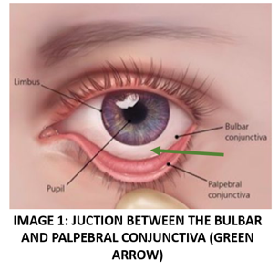
- Avoid touching the conjunctiva with the tip of the dispenser.
- Repeat procedure for the other eye.
- After one minute gently wipe excess drop from eyelid and surrounding tissues.
- Monitor infant’ vital signs. Observe for bradycardia, hypotension, desaturation and signs of ileus.
- The eye drops take between 30 and 60 minutes to work (and the pupils will remain dilated for 1-4 hours).
- Immediately prior to examination, the ophthalmologist will instil local anaesthetic eye drops into the eyes to be examined.
- The ophthalmologist will insert an eyelid speculum and perform indirect ophthalmoscopy. Nursing staff assist by positioning the baby on their back and keeping the baby’s head still during the examination. CPAP device does not usually need to be removed for the examination.
- It is the responsibility of the nurse to alert the doctor if the baby is becoming unstable during the examination (for example with desaturation and/or bradycardia) in which case the examination should be paused, and the eyelid speculum removed.
- The ophthalmologist will record the findings of the eye examination and the time frame for the next eye review on the Retinopathy of Prematurity Screening form (available on the Clinical Forms Register number 60620 (see Attachment 1).
- The ophthalmologist may document the findings in the medical record notes of the patient if the eye review was requested for other clinical indications (different than ROP). The ophthalmologist will also document the time frame for the next eye review/follow up.
- When the procedure is completed, settle the infant in a comfortable position.
- Monitor infant as per Neonatal Routine Care Guideline.
- Place eye examination equipment in pre-rinse tub for sterilising in ward assistant area.
- The procedure is to be documented on the observation chart, problem sheet and in the progress notes of the infant.

3.8 - Use of the Retcam™
Retcam™ is a bed-side imaging system that takes digital photographs of the retina by utilizing a microscope with high-quality camera. Retinal images can be electronically transferred, so they can be reviewed and reported remotely by an ophthalmologist. Images may also be recorded to provide evidence of clinical findings e.g. in cases of non-accidental injury, or in eyes requiring treatment. The process of using Retcam™ is as follows:

Procedure
- Pupil dilation is necessary (per the above protocol).
- At the time of examination one drop of polygel is to be applied to the lens of the Retcam™.
- Local anaesthetic eye drops are instilled, and an eyelid speculum is necessary.
- Retcam™ images will be obtained by the ophthalmologist.
- Clean the Retcam™ lens between each infant with an alcohol swab.
- Wipe over the Retcam™ with a tuffi wipe.
- The digital images are reviewed, and subsequent screening is determined by the ophthalmologist on the day of screening.

3.9 - Transfer to another hospital
- If a neonate is transferred to another hospital, details of eye examination, digital images and recommendations for further examinations must be included in transfer letter.
- The transfer letter should specify the stage of ROP (if present) and the zone to which the retina is vascularised.

3.10 - Discharge from hospital
- Some babies may still require ongoing eye reviews at the time of discharge. It is important that these follow-up appointments are organised prior to discharge to avoid delays in care.
- Follow up will usually be in the paediatrics outpatient department, in the paediatric ophthalmology clinic. Neonatal staff should send a referral, contact the clinic and schedule the appointment (if possible) in the appropriate timeframe and with the appropriate clinician, as determined by the ophthalmologist.
- A similar procedure should be followed if the baby is being followed up privately.
- Ensure the parents are aware of the appointment.

Back to Table of Contents

Section 4 – Laser Surgery for Retinopathy of Prematurity (ROP)
This section outlines the procedure for the pre- and post-operative care of infants undergoing laser surgery for ROP. The surgery will usually be performed in the procedure/theatre room in the NICU.

Diode laser retinal ablation is a surgical treatment for severe stages of ROP. The aim of the treatment is to prevent further abnormal vessel proliferation in the retina, prevent detachment, and promote regression of abnormal vessel development.

Note: Laser Surgery for neonates should ideally be undertaken in the NICU Operating Theatre (OT) Procedure Room

Equipment
- Consent form signed.
- Laser surgery check list available (see Attachment 2).
- Laser Surgery for Retinopathy of Prematurity (ROP) observation chart (available in Clinical Forms Register number 45315).
- Infant’s progress notes and access to images (if appropriate).
- Retinopathy of Prematurity Screening Form (in notes).
- Open care centre warmed.
- Laser on trolley.
- Eye examination pack.
- Towel under head to absorb normal saline used for eye irrigation.
- Warm, sterile normal saline for irrigation.
- Pre and post procedure eye drops as prescribed:
- Pre-surgery: Cyclomydril® (before surgery)
- Oxybuprocaine 0.4% eye drops (just prior to commencing surgery)
- Post-surgery: Dexamethasone 0.1% every 6 hours for 5 days (after surgery)
- Morphine (and Midazolam) intravenous infusions as per medical prescription.
- Vecuronium and Fentanyl intravenous bolus doses as per medical prescription.
- Mechanical ventilator turned on and set as per neonatologist’s instructions (Refer to Respiratory Support – Invasive and Non-invasive (Neonates and Infants) Clinical Guideline).
- Prepare pre-intubation medications (Morphine, Atropine, Suxamethonium) and intubation equipment (refer to Neonatal Resuscitation and Airway Management Guideline).
- Heart rate, respiratory rate, oxygen saturation and blood pressure monitoring equipment.
- Safety Equipment:
- Safety laser goggles
- Non reflective instruments
- Blinds closed on windows and door closed
- Fire extinguisher outside door
- Towels to wet if necessary
- Service manual

Procedure

Pre-Operative Care
- Confirm infant identification with 3 patient identifiers as per Patient Identification and Procedure Matching Clinical Procedure.
- Medical officer to ensure the parents have signed the consent form and have been notified of the reason and time of surgery (this should ideally have been done 24-48 hours before the day of the procedure).
- Ensure the eye for surgery is clearly identified on the consent form. If the surgery is unilateral ensure that the eye that needs the intervention is clearly identified.
- Check that the consent form has been completed as per the Informed Consent (clinical) Policy.
- Infant should be fasted for four hours prior to surgery and the stomach aspirated via nasogastric tube.
- Arrange for an intravenous access when fasting commences and start intravenous fluids.
- Withhold any oral medications unless directed otherwise.
- Prepare drugs for intubation (Morphine, Atropine, Suxamethonium), equipment for intubation and invasive ventilation (refer to Neonatal Resuscitation and Airway Management Guideline).
- Prepare Morphine/Fentanyl (and Midazolam) infusions as per prescription (Refer to the Neonatal Intensive Care Drug Manual).
- Prepare Morphine/Fentanyl and Vecuronium boluses as per prescription (Refer to the Neonatal Intensive Care Drug Manual).
- Set up the NICU OT procedure room. Use Laser surgery check list (Attachment 2) for guidance:
  - Laser warning sign on door
  - Blinds closed
  - Temperature set
  - Check ventilator
  - Check infusions pumps
- Collect ophthalmology equipment (see equipment list).
- Position infant on an open care centre with head easily accessible and full monitoring in situ (ECG electrodes, oxygen saturation monitoring, and blood pressure cuff).
- Ensure infant is normothermic. Put thermometer probe on infant to monitor temperature throughout the procedure.
- Perform pre-surgery procedures including intubation, commencement of invasive ventilation (Refer to Respiratory Support – Invasive and Non-invasive. Neonates and Infants. Clinical Guideline) and sedation.
- Give eye drops as prescribed:
  - Cyclomydril eye drops. First dose 1 hour before the surgery and second dose 30 minutes prior to the surgery.
  - Oxybuprocaine 0.4% eye drops just prior to the surgery.
- Check all equipment is working and ready to be used and ophthalmologist nearby, prior to anaesthetising the infant.
- When infant is intubated, ventilated, sedated, and the clinical condition is stable, the procedure is ready to begin.
- Neonatologist/Neonatal Advanced Trainee, Ophthalmologist and NICU nurse to be present in the procedure room prior and during the surgery.

During the Procedure
- Perform team time-out immediately prior to commencement of procedure.
- During the procedure ensure that all safety practices are adhered to:
  - Door into theatre must be always closed
  - Blinds on windows must be closed and ensure there are no gaps.
  - All persons in and entering room wear protective safety goggles.
- During the procedure the neonatal nurse will irrigate the infant’s eyeball with warm normal saline as directed by the ophthalmologist to keep the cornea moist. Further dilating drops may be instilled as requested by the ophthalmologist.
- Continuous monitoring of heart rate, respiratory rate, oxygen saturations and blood pressure.
- Record vital signs every five minutes throughout the procedure on the Laser Surgery for ROP form (Clinical Forms Register number 45315).
- Ensure adequate analgesia and muscle relaxation with Fentanyl/Morphine boluses, and Vecuronium boluses.
- At the end of the procedure instil post procedure eye drops:
  - Dexamethasone 0.1% immediately post-surgery (to be continued for 5 days)
- Place all bar codes from sterile equipment in the infant’s case notes.
- Parents should be informed that the procedure is completed, the outcome and the follow-up details.

Post-Operative Care
- Pain management:
  - Attend to pain scoring - expect moderate pain for first 24hrs.
  - Maintain pain relief according to infant pain scores with Paracetamol (oral/IV) regularly or PR as prescribed (refer to Neonatal Routine Care Clinical Guideline for Pain Assessment and Management in Neonates).
- The infant will require instillation of Dexamethasone 0.1% eye drops for 5 days post-surgery.
- Instil normal saline eye drops 2-4 hourly for 24 hours.
- Continuous monitoring of heart rate, respiratory rate, oxygen saturations and blood pressure hourly until extubation or for a minimum of 4 hours if extubated immediately post-surgery.
- Wean ventilation according to respiratory effort and blood gases.
- Extubate infant as per neonatologist instructions.
- Continuous monitoring of heart rate, respiratory rate, and oxygen saturations for at least 24 hours following extubation.
- Assess infant’s eye(s) for signs of infection, swelling or discharge 4-6hrly.
- Position comfortably in a quiet environment with dim lighting.
- Introduce feeds as per neonatologist instructions.
- Parents should be encouraged to visit and provide care as infant’s condition allows.
- Document care provided in:
  - Progress notes
  - Nursing observation flow chart
  - Laser surgery/ophthalmic record chart

Prior to Discharge
- Ensure follow-up has been arranged with the ophthalmologist.

Back to Table of Contents

Section 5 – Vascular Endothelial Growth Factor (VEGF) Inhibitor Treatment
Anti-VEGF drugs inhibit the production of VEGF, which is produced by the avascular retina in infants with ROP. This factor is the driver for abnormal growth of blood vessels in the developing retina.

The use of anti-VEGF in cases of ROP is recommended in the following cases:
- ROP failed to respond to adequate laser treatment.
- Laser treatment was not possible (in cases of poor view of the retina, or when the infant was too unwell to tolerate the surgery).
- Aggressive posterior ROP.
- ROP in Zone I or posterior Zone II.

Becacizumab (Avastin®) and Ranibizumad (Lucentis®) are anti-VEGF that can be used for the treatment of ROP. At CHHS these medications are used as per the advice of the ophthalmologist. These drugs are injected into the eye. The long-term effects of anti-VEGF treatment in premature infants are unknown.

Equipment
- Eye trolley
- Procedure trolley
- Dressing pack (from the eye clinic). Contains
- Sterile cotton tips
- Sterile cotton balls
- Calliper and rule
- Sterile field
- Sterile gauze
- Normal Saline
- Sucrose
- Eye speculum from eye trolley
- BD Microlance 3, 30G needle
- VEGF inhibitor (Avastin® or Lucentis®)

Procedure
- Confirm infant identification with 3 patient identifiers as per Patient Identification and Procedure Matching Clinical Procedure.
- Ensure the parents have signed the consent form and have been notified of the reason and time of the procedure.
- Medication must be ordered from pharmacy or eye clinic 24 hours before the procedure.
- Position infant supine, securely swaddle and consider oral sucrose for comfort (Refer to the Neonatal Intensive Care Drug Manual).
- Bedside nurse to securely hold the infant. The infant must be still for the procedure. Actively sucking a dummy with sucrose could be beneficial during the procedure.
- The procedure is conducted by the ophthalmologist only, under strict aseptic technique.
  - Ocular area is cleaned with Betadine.
  - Speculum is inserted by ophthalmologist.
  - The procedure involves injecting the medication into the vitreous space under aseptic conditions.
- All infants requiring treatment with VEGF inhibitors will require ongoing follow up as inpatients and post-discharge.
Back to Table of Contents

Evaluation

Outcome
- Screening for ROP in all infants with high risk of developing ROP.
- Early detection and treatment of severe ROP.

Measures
- Audit of ROP incidence and need for treatment through ANZNN collection data.
- Audit of data regarding severe ROP that needed treatment in neonatal mortality and morbidity meetings.
- Monitoring of long-term visual outcomes of neonates who had had laser treatment and/or anti VEGF therapy.

Back to Table of Contents

Related Policies, Procedures, Guidelines and Legislation

Policies
- Nursing and Midwifery Requirements for Practice
- Informed Consent (Clinical)

Procedures
- Infection Prevention and Control
- Patient Identification and Procedure Matching

Guidelines
- Fasting Guidelines for Patients undergoing Sedation or Anaesthesia
- Infection Control – Cleaning (Shared) Patient Care Equipment
- Respiratory Support – Invasive and Non-invasive (Neonates and Infants) Clinical
- Neonatal Resuscitation and Airway Management
- Neonatal Routine Care

Legislation
- Health Records (Privacy and Access) Act 1997
- Human Rights Act 2004
- Work Health and Safety Act 2011
- Carers Recognition Act 2021

Other
• Australian Charter of Healthcare Rights

Forms
- Laser Surgery for Retinopathy of Prematurity (ROP) observation chart
- Retinopathy of Prematurity Screening

Back to Table of Contents

References

- Hellstrom A, Smith L, Dammann O. Retinopathy of Prematurity. Lancet 2013; 382: 1445-1457.
- Fierson W. Screening examination of Premature Infants for Retinopathy of Prematurity. American Academy of Pediatrics. Pediatrics 2018; 142 (6): e20183061.
- Chow S.S.W, Creighton P, Chambers G, Lui K. Report of the Australian and New Zealand Neonatal Network 2019, accessed from: https://anznn.net/annualreports
- International Committee for the classification of Retinopathy of Prematurity. The international classification of retinopathy of prematurity revisited. Arch Ophthalmology 2005; 123 (7): 991-999.
- Raghuveer T, Zachula M. Strategies to Prevent Severe Retinopathy of Prematurity: A 2020 Update and Meta-analysis. Neoreview 2020; 21 (4); e249-263.
- Hartnett E. Penn J. Mechanism and management of retiinopathy of prematurity. New England Journal of Medicine 2012; 367 ( 26): 2515-2526.
- Higgins R. Oxygen Saturation ans Retinopathy of Prematurity. Clin Perinatol 2019; 46: 593-599.
- Kim S et al. Retinopathy of Prematurity: a review of risk factors and their clinical significance. Survey of Ophthalmology 2018; 63; 618-637.
- Wallace D at al. Current and future trends in treatment of severe retinopathy of prematurity. Clin Perinatology 2013; 40: 297-310.
- Sternberg P, Durrani A. Evolving concepts in the management of retinopathy of prematurity. American Journal of Ophtalmology 2018; 186:23-32.
- Quinn G. Challenges and future directions in the detection and treatment of retinopathy of prematurity. Neoreviews 2017; 18 (2): e91-99.
- Sharma M. Identification and treatment of retinopathy of prematurity: update 2017. Neoreviews 2017; 18 (2): e84-90.
- Bashinsky A. Retinopathy of Prematurity. N C Med J 2017; 78 (2): 124-128.

Back to Table of Contents

Definition of Terms

NICU: Neonatal Intensive Care Unit
ROP: Retinopathy of prematurity
VEGF: Vascular Endothelial Growth Factor

Back to Table of Contents

Search Terms

Retinopathy of prematurity, ROP, Laser eye surgery, Eye drops, Eye examination, Screening for ROP, NICU, anti-VEGF, Avastin.

Back to Table of Contents

Attachments
Attachment 1: Retinopathy of Prematurity Screening form
Attachment 2: Laser Surgery Check List

Policy Team ONLY to complete the following:
Date Amended | Section Amended | Divisional Approval | Final Approval
31/10/2022 | Full review | Susan Freiburg ED WYC | CHS Policy Committee

This document supersedes the following:
Document Number | Document Name
CHHS16/248 | Retinopathy of Prematurity (ROP) in Neonates

Attachment 1: Retinopathy of Prematurity Screening form
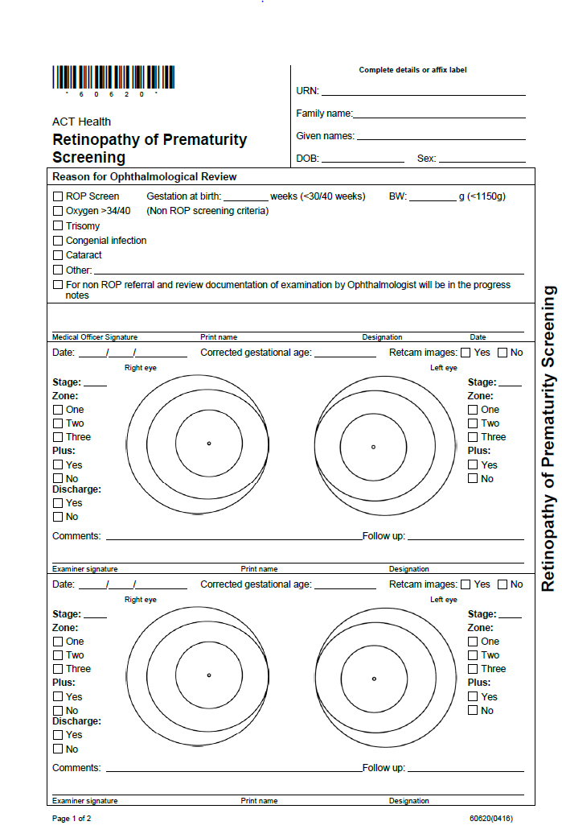
Sample

Attachment 2: Laser Surgery Check List

Laser surgery check list

DAY BEFORE TO SURGERY |  | Done
Eye drops ordered on medication chart.  Chart faxed to pharmacy if required. | Cyclomydril  1 hour and 30 min prior to surgery
 | Oxybuprocaine 0.4% - just prior to surgery
 | Dexamethasone 0.1% after surgery
Infusions +/- boluses for procedure charted | As per consultant/medical staff  (Fentanyl and Vecuronium boluses and Morphine or Fentanyl/ Midazolam infusions)
Intubation medications charted as per intubation protocol | Morphine, Atropine, Suxamethonium
DAY OF SURGERY |  | Done
4 hours prior to surgery
Fasting commenced
PIVC sited and IV fluids commenced (Dextrose 10% N/4 at TFI 120ml/kg/day)
Infusions +/- boluses prepared
Intubation drugs and equipment prepared
3 hours prior to surgery
Set up procedure room | Laser warning sign on door
Set up procedure room | Blinds closed
Set up procedure room | Temperature set
Set up procedure room | Ventilator set up
Set up procedure room | Pumps set up
Collect ophthalmology equipment | Laser
Collect ophthalmology equipment | RET cam (if applies)
Collect ophthalmology equipment | Eye tray, cotton buds (“q-tips” style), normal saline, gauze
Collect ophthalmology equipment | Head ring
Collect ophthalmology equipment | Laser surgery observation chart
Collect ophthalmology equipment | Safety laser goggles x 6 pairs
Intubation drugs and equipment prepared

2 hours prior to surgery
Infant moved into procedure room
Intubation
Ventilation
Sedation
1 hour prior to surgery
First dose of Cyclomydril eye drops
Paracetamol if charted
30 min prior to surgery
Second dose of Cyclomydril eye drops
Just prior to surgery
Oxybuprocaine 0.4% eye drops

DURING SURGERY |  | Done
Nurse and medical officer present (neonatologist/advanced trainee)
Full respiratory and cardiovascular monitoring
15 minutely monitoring of infant’s vital signs, oxygen saturation level, blood pressure and ventilation parameters until end of procedure
Documentation of observations on Laser surgery observation chart
Sedation, analgesia and muscle relaxant as per consultant/fellow medical staff
Nurse/medical officer to assist with Normal Saline drops
AFTER SURGERY |  | Done
Pain management | PO/IV Paracetamol PRN charted
Eye drops | Dexamethasone 0.1% eye drops for 5 days post surgery
 | Normal saline eye drops 2-4hourly as required for 24 hours
Monitoring | Hourly until extubation or for a minimum of 4 hours if extubated immediately post-procedure
 | Continuous monitoring of heart rate, respiratory rate and O₂ saturations for at least 24 hours following extubation
Follow-up | Parents aware of follow-up appointment

SUGGESTED DOSES | Stat dose | Infusion
Fentantyl | 1-2microgram/Kg/dose | 1-5 microgram/kg/hour
Morphine | 100-200 microgram/kg/dose | 10-30 microgram/kg/hour
Midazolam | 50-150 microgram/kg/dose
Vecuronium | Initial dose 100 microgram/kg/dose  Subsequent doses 30-150 microgram/kg.

Check list completed by:
Designation:
Date:
Time:

