Canberra Health Services
Procedure
Prosthetic Orthotic Service Client Management

Contents

Contents 1
Purpose 2
Alerts 2
Scope 2
Section 1 – Aim of Prosthetic and Orthotic Service Provision 2
Section 2 – Scope of service provision 3
Section 3 – Client eligibility and exclusion criteria 3
Section 4 –Referral and triage processes 4
Section 5 – Client consent 4
Section 6 – Goal Setting and Care Planning 5
Section 7 – Assessment Protocols 5
Section 8 – Information Management 6
Section 9 – Clients Rights and Responsibilities 6
Section 10 – Service Location and Hours of Service 6
Evaluation 6
Related Policies, Procedures, Guidelines and Legislation 7
References 7
Definition of Terms 7
Search Terms 8
Attachments 8
Attachment 1: Prosthetic and Orthotic Service Flow Chart 9
Attachment 2: Summary of Prosthetic and Orthotic Service Funding Models 10
Attachment 3: Prosthetic and Orthotic Service Priority Criteria 12

Purpose

The purpose of this procedure is to ensure Prosthetic, Orthotic and Medical Grade Footwear Services are managed appropriately within the Clinical Technology Services Area.

Back to Table of Contents

Alerts

All services are subject to funding approval. Please refer to funding models outlined within this document.

Back to Table of Contents

Scope

This procedure applies to all clinical, technical and administrative support staff working within the Clinical Technology Services area and to referrers and clients accessing Prosthetic, Orthotic and Medical Grade Footwear services.

This procedure will be used by Community Health Intake (CHI) to direct management of referrals they receive for the Prosthetic and Orthotic Service, using the clinical record system workflows.

Back to Table of Contents

Section 1 – Aim of Prosthetic and Orthotic Service Provision

The Prosthetic and Orthotic Service provides prostheses to people with amputations, orthoses to people with musculoskeletal weakness, injuries or neurological disorders and medical grade footwear to people with foot pathologies or pressure relief issues.

Prosthetic and orthotic services include assessment and advisory services, and the design, prescription, manufacture, fitting, supply, maintenance and repair of prostheses, orthoses and medical grade footwear.

The aim of the Prosthetic and Orthotic Service is to provide a specialised clinical service for clients who have a medical condition that requires a prosthetic, orthotic or medical grade footwear device to support the body to enable them to perform functional activities of daily living.

The aim of prosthetic and orthotic intervention is to maximise client independence, function and comfort by providing the most appropriate treatment/equipment to meet the individual client’s needs.

Back to Table of Contents

Section 2 – Scope of service provision

Prosthetic, orthotic and medical grade footwear services are provided by health professionals employed by CHS who are credentialed and operating within their scope of clinical practice, as defined by the Credentialing and Defining Scope of Clinical Practice for Allied Health Professionals procedure and the Australian Orthotic and Prosthetic Association (AOPA) guidance documents.⁽¹⁾

Prosthetic, orthotic and medical grade footwear services are supported by technical officers employed by CHS who perform fabrication, repair and maintenance of prosthetic, orthotic and medical grade footwear devices in accordance with clinical specifications and component manufacturers’ recommendations.

Prosthetic, orthotic and medical grade footwear services are supported by CHI, who provide first point of contact and process referrals using the clinical record system workflows. They are also supported by CHS Village Creek administrative officers, who manage clinic scheduling, process correspondence, co-ordinate facility bookings, book interpreter services, respond to clinical record system work queue instructions and provide onsite first point of contact.

Prosthetic Orthotic Service processes are outlined in Attachment 1: Prosthetic Orthotic Service flow chart.

Back to Table of Contents

Section 3 – Client eligibility and exclusion criteria

An eligible client is any person who resides within the ACT and has a medical condition that requires a prosthetic, orthotic or medical grade footwear device to support the body to enable them to perform functional activities of daily living.

Eligible clients include people with amputation, congenital limb deficiency, neuromuscular impairment (paralysis, weakness, and pain), musculoskeletal injury (deformity, fracture, soft tissue injury) or pressure relief issues.

Eligibility for interstate prosthetic clients is as per the ACT Artificial Limb Scheme (ACTALS) – Adults and Children procedure.

Orthotic and medical grade footwear clients from the surrounding region, who need to access the ACT Prosthetic and Orthotic Service due to limited regional capacity, may be provided a service at full cost recovery for their device.

Eligibility for service provision is subject to funding approval. Prosthetic and Orthotic Service charges are stipulated in the annual Health (Fees) Determination notifiable instrument (available at https://www.legislation.act.gov.au/ ).

A summary of Prosthetic and Orthotic Service funding models is outlined in Attachment 2.

Back to Table of Contents

Section 4 –Referral and triage processes

Referrals
All referrals to the Prosthetic and Orthotic service will be through CHI, who will process the referral via the clinical records system to the Prosthetic Orthotic Service work queue.

CHI will ensure referrals meet the listed eligibility criteria and seek further information related to incomplete referrals.

Triage of referrals
A Prosthetic and Orthotic Health Professional Officer level 3 or 4 will review the Prosthetic Orthotic Service work queue and arrange appropriate and timely follow up of referrals by:
- ensuring all referrals are triaged within 1 working day of receipt
- ensuring incomplete or inappropriate referrals are redirected to CHI for action within two working days of receipt
- ensuring all referrals are designated the appropriate level of priority, as per Prosthetic and Orthotic Service Priority Criteria (Attachment 3) and are routed via the clinical records system to the Village Creek Administration work queue for appointment booking or to the Prosthetic Orthotic Service wait list pool.

Back to Table of Contents

Section 5 – Client consent

Client consent for treatment, audio-visual recording and sharing of information is to be managed in accordance with the following CHS policies and procedures:
- Informed Consent (Clinical)
- Photo, Video and Audio: Capture, Storage, Disposal and Use
- Clinical Records Management.
Back to Table of Contents

Section 6 – Goal Setting and Care Planning

At the initial appointment/assessment, goal setting and care planning will occur in response to the referral information provided and in consultation with the client, the service provider and the client’s family, carer and advocate (as required). The consultation and agreed care plan will be documented in the client’s clinical record.

Consultation and agreement will be sought from the referrer if the proposed care plan varies from the original referral request.

Prosthetic and Orthotic Service care plans will include:
- clinical assessment
- aim of intervention
- method of intervention
- details of equipment to be provided
- timelines for intervention
- funding agreement.

Back to Table of Contents

Section 7 – Assessment Protocols

The Prosthetic and Orthotic Service clinicians will follow the ISOAP (identification, subjective information, objective information, analysis/action/advice and plan) method of recording assessments in the client’s clinical record using relevant notes and assessment templates:
- Introduction – the clinician identifies themselves, confirms client identification details of Name, Unit Record Number (URN) and date of birth and gains verbal consent for an intervention session.
- Subjective assessment – the client self-reports issues and reasons for seeking the service. The clinician records this information and asks questions to clarify information.
- Objective assessment– the clinician undertakes and records an objective assessment of the client, including (where relevant):
- analysis of gait defects
- joint range of motion measures
- muscle strength measures
- sensation testing
- skin integrity
- review of referral information (x-ray, imaging, neurological tests, drug history).
- Analysis, Advice, Action – subjective and objective information is interpreted and treatment recommendations, education and/or advice is provided. In consultation and with consent of the client, treatment may commence.
- Plan - the agreed treatment plan is developed and documented.

Clinical documentation should be completed in the client’s clinical record at the time of intervention. If this is not possible, documentation must be completed before the end of the shift in which the intervention occurred.

Back to Table of Contents

Section 8 – Information Management

The Prosthetic Orthotic Service clinicians and administration support staff will comply with CHS requirements on the use of the clinical record system, and any supporting paper documents are scanned to the clinical record system on receipt.

Back to Table of Contents

Section 9 – Clients Rights and Responsibilities

The Prosthetic Orthotic Service clinicians will advise clients of their rights and responsibilities as per The Australian Charter of Healthcare Rights ⁽²⁾. Provision of this information will be documented in the client’s clinical record.

Back to Table of Contents

Section 10 – Service Location and Hours of Service

The Prosthetic Orthotic Service is located at the Village Creek Centre, 37 Kingsmill St, Kambah, ACT 2902. The service operates between 8.30am - 5.00 pm Monday to Friday.

The Prosthetic Orthotic Service provides in-reach services to the Canberra Hospital and University of Canberra Hospital (UCH) on a sessional basis. Service provision to other public and private facilities may be coordinated on a case by case basis, with consideration of service capacity and clinical need.

Drop in services are not available. All appointments must be booked following referral via CHI and triage via the clinical records system Prosthetic Orthotic Service work queue.

Back to Table of Contents

Evaluation

Outcome
Prosthetic, Orthotic and Medical Grade Footwear Services will be managed appropriately within the Clinical Technology Services Area.

Measure
Service delivery in accordance with this procedure is reported via the clinical records system.
Consumer feedback related to the service will be reviewed.

Back to Table of Contents

Related Policies, Procedures, Guidelines and Legislation

Policies
- Informed Consent (Clinical)

Procedures
- ACT Artificial Limb Scheme (ACTALS) – Adults & Children
- Credentialing and Defining Scope of Clinical Practice for Allied Health Professionals
- Photo, Video and Audio: Capture, Storage, Disposal and Use
- Clinical Records Management

Legislation
- Health Records (Privacy and Access) Act 1997
- Privacy Act 1988 (Commonwealth)
- Human Rights Act 2004
- Work Health and Safety Act 2011
- Health Act 1993
- Carers Recognition Act 2021

Other
- Australian Charter of Healthcare Rights

Back to Table of Contents

References

- Australian Orthotic and Prosthetic Association (AOPA) Competency standards and scope of practice (available at: https://www.aopa.org.au/publications/aopa-standards-codes )
- The Australian Charter of Healthcare Rights (2nd edition) (available at :Australian Charter of Healthcare Rights )
Back to Table of Contents

Definition of Terms

Device – term used interchangeably to refer to prosthetic, orthotic, medical grade footwear and assistive technology equipment.

Medical Grade Footwear – applies to footwear specifically designed to accommodate and support foot pathologies. Also referred to as extra depth, extra width, custom, orthopaedic or bespoke footwear.

Orthosis/Orthoses – term applied to a device(s) to support a body part(s) in a position to prevent, limit or assist movement in a given function. These are also referred to as Orthotic, Brace, Splint, Appliance or Calliper.

Prosthesis/Prostheses – term applied to a device(s) to replace a limb(s). These are also referred to as Artificial Limb(s).

Acronyms:
P&O: Prosthetics and Orthotics
RACS: Rehabilitation, Aged and Community Service

Back to Table of Contents

Search Terms

Prosthetic, Orthotic, Medical Grade Footwear, Client Management, Village creek

Back to Table of Contents

Attachments

Attachment 1: Prosthetic Orthotic Service flow chart
Attachment 2: Summary of Prosthetic and Orthotic Service funding models
Attachment 3: Priority Allocation Criteria

Disclaimer: This document has been developed by Canberra Health Services specifically for its own use. Use of this document and any reliance on the information contained therein by any third party is at his or her own risk and Canberra Health Services assumes no responsibility whatsoever.

Date Amended | Section Amended | Divisional Approval | Final Approval
23/12/2022 | Complete Review | Maria Harman, A/g ED RACS | CHS Policy Committee

This document supersedes the following:
Document Number | Document Name
CHHS17/307 | Prosthetic Orthotic Service Client Management

Attachment 1: Prosthetic and Orthotic Service Flow Chart

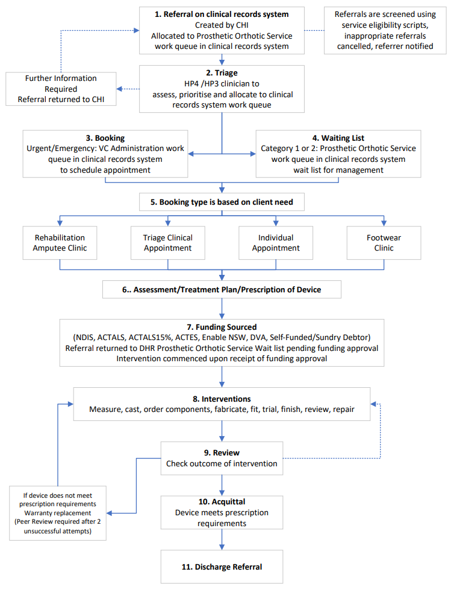

Attachment 2: Summary of Prosthetic and Orthotic Service Funding Models

Prosthetic and Orthotic Services are subject to funding criteria. Different funding providers have distinct eligibility criteria, application processes and funding models.

The Prosthetic and Orthotic Service will assess client information to determine the appropriate funder for services at the initial consultation and support the client to access funding for planned services. Where external funding is required the Prosthetic and Orthotic Service intervention will not commence until written funding approval is received.

Prosthetic and Orthotic Service charges are stipulated in the current annual Health (Fees) Determination notifiable instrument.

Funding Models:
National Disability Insurance Scheme (NDIS): provides funding for assistive technology, including prosthetics, orthotics and medical grade footwear. To be eligible for NDIS assistance clients need to:
- have a permanent disability which results in substantially reduced ability to undertake regular daily activities
- be aged less than 65 years when making an access request
- be an Australian citizen, a permanent resident or a New Zealand citizen who holds a Protected Special Category Visa.

Clients need to apply directly to NDIS for access approval and once approved undertake planning with a local area coordinator to establish their individual care and support needs.

ACT Artificial Limb Scheme (ACTALS): provides funding for prosthetic devices for clients residing in the ACT and surrounding NSW region over the age of 65 years. Current funding categories are:
- ACTALS Exempt – Persons holding a valid Centrelink Pensioner Concession Card, Health Care Card or Commonwealth Seniors Health Card are entitled to free prosthetic services and are exempt from payment for prosthetic devices when using components on the approved component list. Full cost must be paid by the client for prosthesis or componentry not covered by the funding scheme.
- ACTALS Billable - Persons not holding a valid Centrelink card are required to pay 15% of the scheduled cost of the provision, maintenance and repair of their prostheses, for prosthetics and componentry funded under ACTALS, up to a maximum per financial year as per the annual Health (Fees) Determination notifiable instrument. Full cost must be paid by the client for prosthesis or componentry not covered by the funding scheme.
- Department of Veterans’ Affairs (DVA) – eligible veterans are not funded by ACTALS. Funding for prosthetic services for eligible veterans is under contract between CHS and DVA.
- Compensation – Clients pending settlement of compensation claims may have their prosthetic costs covered on a “without prejudice” basis by the ACTALS. ACTALS retain the right to recoup these costs upon settlement.

ACT Equipment Scheme (ACTES): provides funding for eligible ACT residents for a range of equipment including orthotics and footwear. Clients under 65 years must apply for NDIS support initially. If deemed ineligible for NDIS they are required to provide written evidence of this decline to become eligible to apply for ACTES. Application forms are available on the Clinical Forms Register (forms 15001 and 15002).

ENABLE NSW: provides funding for NSW residents for a range of equipment including orthotics and footwear.
Eligibility and financial criteria and instructions how to submit an application are available online at: https://www.enable.health.nsw.gov.au/for_individuals/applying-to-EnableNSW.

DVA: provides funding for eligible veterans for a range of equipment including prosthetics, orthotics and footwear. DVA eligibility criteria and details of equipment services which are funded are available online at: https://www.dva.gov.au/.

Private clients: are not funded for prosthetic, orthotic or footwear services and are subject to full service fees as stipulated in the annual Health (Fees) Determination notifiable instrument.

Insurance: funding for prosthetic, orthotic and footwear services varies between insurance bodies and individual client policies. Clients are directed to contact their insurer for details of their level of funding coverage and the insurer’s preferred method of approval for service provision.

Compensation: funding under compensation settlements varies.
- Settled Claim, Client Granted Full Payout: Clients who receive full payout of their claim are deemed as private clients of the Prosthetic and Orthotic Service (see above).
- Settled Claim, Claims Manager nominated: Clients who are allocated a claims manager to coordinate ongoing costs are subject to the terms of settlement. Clients are required to provide details of their Claims Manager for funding of prosthetic, orthotic and footwear services to be negotiated.
- Unsettled claim, Clients who have an unsettled claim are deemed as private clients of the Prosthetic and Orthotic Service for orthotic and footwear services. Clients requiring prosthetic services may be funded by the ACTALS (see above).

Attachment 3: Prosthetic and Orthotic Service Priority Criteria
Referrals to the Prosthetic and Orthotic Service are triaged based upon the following classifications. Timeframes for management of clients within these priority classifications are included.

Emergency / Urgent – Same day triage, treatment within 2 business days
Clients in this category are referred to the Prosthetic and Orthotic Service for one of the following:
- initial consultation with a client pending amputation
- issues with the client/device interface where skin integrity is being compromised by the fit or function of an existing device and the client is dependent on that device to function normally
- a device that a client depends on to function normally has broken and is failing to function in a safe manner.

The P&O Service does not provide wound management services. New clients with skin integrity issues should be directed to an appropriate primary care services (GP, Emergency department, podiatry, wound management clinic).

Category 1 – treatment within 30 days
Clients in this category are referred to the Prosthetic and Orthotic Service for one of the following:
- initial assessment, with clinical indicators for urgency of intervention, including:
- initial assessment with a client following amputation
- high falls risk or history of falls within last 3 months
- intervention within acute care management e.g.
- high risk foot care in consultation with podiatry / wound management services
- fracture management
- stroke management
- the client is dependent upon an existing device to function normally and:
- there are issues with the client / device interface resulting in increased pain
- skin integrity is affected by the fit or function of the device and client self-management actions cannot overcome the issue
- the device has worn components that pose an imminent risk of failure to function in a safe manner, and the client is dependent on the device to function normally.

Clients in category 1 can function at their normal level but may lose that function without professional intervention.

Category 2 – treatment within 90 days
Clients in this category are referred to the Prosthetic and Orthotic Service for one of the following:
- initial assessment, with no clinical indicators of urgency for intervention
- issues with the client / device interface resulting in discomfort or effecting the fit or function of an existing device and client self-management can temporarily alleviate the issue
- a device has wear and tear of components that pose a low risk of failure to function in a safe manner
- the client and/ or device is due for scheduled review.

Clients in category 2 can function normally and are in no imminent danger of loss of that function.

