Canberra Health Services
Procedure
Physiotherapy – Respiratory Management (Adults and Children)

Contents

Contents 1
Purpose 3
Scope 3
Section 1 – Cough Assist Machine 3
Section 2 – Inspiratory Muscle Training 8
Section 3 – Hyperinflation 14
Section 4 – Induced Sputum Collection 20
Evaluation 25
Related Policies, Procedures, Guidelines and Legislation 25
References 26
Definition of Terms 29
Search Terms 29
Attachments 29
Attachment 1 – Assessing peak cough flow 31
Attachment 2 – Assembly of Cough Assist Machine 33
Attachment 3 – Modifying Cough Assist Machine settings 34
Attachment 4- Cough Assist Machine Competency Assessment 36
Attachment 5: Inspiratory Muscle Training Skills Assessment 39
Attachment 6 : Measuring Negative Inspiratory Force (NIF) on GE Carescape Ventilator 40
Attachment 7: Hyperinflation Competency Assessment 41
Attachment 8: Ventilation Competency Assessment 44
Attachment 9: VHI Procedure for the Marquet Servo - U 47
Attachment 10: VHI Procedure for GE Ventilator 48
Attachment 11: Negative Pressure Rooms at October 2021 49
Attachment 12 – Induced Sputum mouthpiece components and equipment assembly 50
Attachment 13: Equipment Ordering - CAM, IMT and Induced Sputum. 51
Attachment 14: Induced Sputum Sign 53

Purpose

This procedure outlines respiratory interventions performed by physiotherapists at Canberra Health Services (CHS).

Background
This document has been developed to guide physiotherapists who utilise cough assist, inspiratory muscle training, manual and ventilator hyperinflation and who perform induced sputum procedures.

Key Objective
To ensure the delivery of safe, evidence-based, best-practice respiratory management in adult and paediatric patients by acute care physiotherapists.

Back to Table of Contents

Scope

This document applies to adult and children patients referred to CHS physiotherapists for repiratory management.

This document applies to the following staff working within their scope of practice:
- Physiotherapists
- Nursing staff
- Physiotherapy students under direct supervision
- Carers trained or under instruction/prescription by physiotherapists.

Back to Table of Contents

Section 1 – Cough Assist Machine

Background
Coughing is an essential reflex which clears excess secretions and foreign matter from the airway. The essential components include deep inspiration, closure of the glottis and forceful expiration^{1,2}. In order for a cough to be effective, an adequate expiratory flow must be generated. A normal peak cough flow (PCF) is in the range of 360-840L/min^{1,2}. The minimum PCF required to sufficiently clear secretions is ≥160-200L/min^{1,2}. There is insufficient evidence to determine age-adjusted PCFs for children under the age of 12 years¹. Cough strength can be reduced in patients with inspiratory and expiratory muscle weakness, particularly during periods of acute infection, leading to low lung volumes and difficulty clearing secretions¹ . Mechanical insufflation-exsufflation (in-exsufflation) via a cough assist machine (CAM) can assist in the removal of pulmonary secretions and maximise lung volumes without the need for more invasive techniques².

Mechanical in-exsufflation consists of insufflating the lungs with positive pressure, followed by a quick change to negative pressure exsufflation. This creates a peak and sustained flow high enough to mimic a cough and thereby to loosen and move secretions toward the oropharynx for suctioning or expectoration². Pressures reported to be clinically effective include ranges of +15 to +40cmH₂O for insufflation and -15 to -40cmH₂O for exsufflation^{2,3}. This range of pressures has also been reported to be safe and comfortable in children¹. Higher pressures of up to +50cmH2O insufflation and -50cmH2O exsufflation may be required in the presence of an artificial airway, due to increased airway resistance².

Indications, Precautions and Contraindications^{4,5}
Indications
Any patient who is at risk or has evidence of retained secretions with an ineffective cough or reduced lung volumes. This can include, but is not limited to, patients with:
- Neuromuscular deficits (e.g. muscular dystrophy, myasthenia gravis, motor neurone disease, spinal cord injury, brain injury, spina bifida, cerebral palsy, etc.)
- Intrinsic lung disease such as chronic obstructive pulmonary disease (COPD), cystic fibrosis or bronchiectasis.

Precautions
- Ribs fractures.
- Patients with cardiac compromise as positive pressure can reduce cardiac output.
- Facial fractures, facial trauma or sinus surgery. In this case a mouthpiece may be used as opposed to the facemask in consultation with senior physiotherapist/medical staff.
- Acutely unwell/deteriorating patients likely requiring intubation.
- Reduced Glascow Coma Scale (GCS), increased drowsiness or inability to consistently follow commands in adult populations.
- Patients with significant oxygen or ventilation requirements. This is due to risk associated with disconnecting from other interfaces to complete CAM therapy.

Contraindications
- Undrained pneumothorax or the presence of an intercostal catheter (ICC) with continuous leak.
- Unstable cardiovascular system such as unstable arrhythmias, mean arterial pressure (MAP) <65mmHg, the presence of an Intra-Aortic Balloon Pump (IABP), increasing inotropic or vasopressor support.
- Large lung abscess or bullae.
- Recent barotrauma.
- Patients ventilated on lung protective strategy, e.g. Acute respiratory distress syndrome (ARDS)
- Acute bronchospasm.

Outcome measures
- Peak cough flow (refer to Attachment 1)
- Vital capacity via spirometry
- Oxygen saturations (SpO2)
- Chest radiograph (CXR)
- Auscultation
- Palpation
- Cough quality
- Volume/consistency of sputum

Equipment and Assembly
Equipment
- Emerson CA-3200 Cough Assist machine or Phillips Respironics Cough Assist E70
- Patient circuit
- Bacterial/viral filter
- Breathing hose
- Connector
- Patient interface (face mask, mouthpiece, or tracheostomy adapter)
- Pulse oximeter
- Tissues or wall suction for sputum clearance
- Mask/eye protection for staff member if indicated (infection or multi-resistant organism)

Assembly
- Connect the machine to power and position it within easy reach.
- Connect the patient circuit to the machine (see Attachment 2).

Procedure
- Physiotherapists performing CAM need to have completed the competency assessment (Attachment 4). All components do not have to be completed to perform CAM; physiotherapists should work within their scope of training.
- Identify indications for use of CAM and any precautions or contraindications. If precautions exist, discuss with senior physiotherapist and medical staff prior to initiating cough assist.
- Select patient interface and assemble circuit (Attachment 2).
- Perform hand hygiene, apply personal protective equipment (PPE) and observe any other relevant precautions.
- Gain informed consent from the patient, as per Informed Consent (Clinical) Policy on the CHS Policy and Guidance Documents Register.
- Pause any feeds the patient is receiving and complete nebulisers (if required), in consultation with nursing staff.
- Assess appropriate outcome measures.
- If assessing peak cough flow refer to Attachment 1 or Clinical Guideline: Physiotherapy - Adult Patient with a Spinal Cord Injury found on the CHS Policy and Guidance Documents Register.
- Appropriately position the patient to maximise ventilation.
- On the user interface, select the mode (manual, automatic or advanced-automatic) and pressures desired for treatment. Titrate pressures to minimum required for therapeutic response. Higher difference between insufflation and exsufflation pressures is associated with improved sputum clearance².
- Determine and inform patient of the dosage of therapy. Instruct patient to cough on exsufflations.
- Apply interface patient. You may remove oxygen if preventing adequate seal or alternatively oxygen can be run through the circuit of the Phillips Respironics Cough Assist E70.

Alert: Tracheostomy/Endotracheal tube (ETT)
If using a tracheostomy interface either:
- Inflate cuff and perform treatment via tracheostomy.
- Deflate cuff, place speaking valve/cap over tracheostomy and perform therapy via mouth.

- Complete therapy. Consider use of adjuct techniques as required such as percussions, vibrations or and manual assisted cough² (see Clinical Guideline: Physiotherapy – Adult Patient with a Spinal Cord Injury; Attachment 5, on the CHS Policy and Guidance Documents Register, for details on how to perform Manual Assisted Cough).
- Be sure to disconnect the CAM from the patient immediately after the cough cycle and allow adequate rest.
- Clear secretions as indicated following every cycle.
- Repeat sets until re-assessment indicates treatment has had desired effect. Cease treatment in presence of adverse side effects (e.g. patient fatigue, complaint of pain, hypotension) and notify treating team.
- Ensure to complete treatment session with an insufflation to leave appropriate functional vital capacity (FVC)^{1,2}.
- Perform hand hygiene and doffing procedures.
- Document therapy including patient position, mode of delivery, pressures, dosage, length of insufflation/pause, outcome measures and ongoing management plan in the patient’s clinical record.

Modes and Settings^{4,5}
Manual
Manual mode requires the therapist to manually cycle between insufflation and exsufflation including length of breaths and pause time. This is controlled by the use of the manual lever or foot pedal. It is appropriate for acutely unwell patients where the cough assist is used as a new treatment modality or for titrating settings for long-term use.

Automatic
Automatic mode will automatically deliver insufflation and cycle to exsufflation instead of manually moving the switch. Therapy will commence as per the set pressures and length of insufflation/exsufflation once the machine is in therapy mode. Automatic mode will only deliver one insufflation prior to exsufflation. Automatic mode is appropriate for established treatment regimes and carer use⁶.

Advanced Automatic
Advanced Automatic mode will deliver a set number of insufflations prior to an exsufflation. Similar to Automatic mode, therapy will commence as per the set pressures, length of insufflation/exsufflation and pause time, once the machine is in therapy mode. Advanced Automatic mode does not require use of the lever or foot pedal to deliver breaths. The set cycle will be repeated up to 10 times with the option to cease at any time. Advanced Automatic mode is appropriate for established treatment regimes and carer use⁶.

Alert: Cough-Trak may be used in Automatic and Advance Automatic modes. This setting will commence insufflation when it detects the patient initiating a breath. As a result, the pause time is determined by the patient trigger.

Considerations for Paediatric Population
- Paediatric patients are at high risk of blocking airway with secretions due to small airways and high airway resistance. Ensure suction equipment is prepared prior to CAM to clear blockages immediately.
- Ensure feeds are paused prior to CAM to reduce risk of aspiration. Ensure to liaise with nurses and senior paediatric physiotherapist.
- Pause gastrostomy (PEG) and nasogastric (NG) feeds 1 hour prior to treatment.
- Jejunal (PEJ) feeds do not have to paused.
- Paediatric patients often have faster respiratory rates than adults. For this reason, consider:
- Shorter pause times between breaths.
- Shorter insufflation time guided by chest wall expansion.
- Close monitoring of shortness of breath.
- Ensure longer rest periods between sets, due to higher risk of muscle fatigue².
- Ensure to end treatment session with an insufflation breath to leave adequate FVC².

Home Usage and Training ^{2,6,7}
- Physiotherapists may only utilise CAM as part of physiotherapy treatment once they have completed the CAM competency package with an appropriately trained physiotherapist as outlined in Attachment 4.
- CAM should be prescribed by a trained physiotherapist.
- Any changes to the prescription of CAM should be made by a trained physiotherapist.
- CAM is safe and effective for use in the home environment.
- Appropriate carer education and training is required to ensure effective transition of CAM to the home environment. Training should ensure carers are familiar with the machine and have instruction for safe and effective use.
- Carers who have received appropriate training are permitted to use CAM during a patient admission.
- It is recommended that physiotherapy review is completed for long-term CAM users during hospital admission to ensure effective airway clearance.
- Physiotherapy staff may complete routine CAM treatments for patients if usual carers are unavaible or if carer application is ineffective.

Cleaning and Maintenance
The Emerson CA-3200 Cough Assist machine or Phillips Respironics Cough Assist E70 external surfaces are to be cleaned with detergent wipes, mild detergent and water or bactericidal cleaning solution such as 70% isopropyl alcohol between patients.

The mask, tubing and bacterial filters are single patient use and cannot be sterilised. Replace the mask, tubing and filter when there are obvious signs of wear and tear, or if it is no longer possible to get a good mask seal. After final use by the patient the circuit should be disposed of.

Daily Cleaning:
- Wipe down the machine and interface with a clean detergent wipe, daily with single patient use. If the circuit is visibly soiled (for example, with sputum), wash the tubing as per the instructions below.

Weekly Cleaning:
- Wash the tubing and mask in warm soapy water and allow to air-dry. The mask can be left to dry in the patient’s room on a clean towel. The tubing should be left to dry in a hanging position and must be completely dry before re-use.

If the CAM is to be used by more than one patient concurrently, the machine is to be cleaned as above. The circuit including the tubing, mask, adapters and bacterial/viral filter must be replaced between patients to prevent cross-contamination.

The CAM should be clearly identified as clean or dirty with provided labels.

Please refer to Attachment 13 for ordering of equipment.

Back to Table of Contents

Section 2 – Inspiratory Muscle Training

Background
Inspiratory muscle training (IMT) is relevant (but not exclusive) to three main groups of patients including Chronic Obstructive Pulmonary Disease (COPD), Chronic Heart Failure (CHF) and Intensive Care Unit (ICU) patients who have been mechanically ventilated for > 7 days.

Inspiratory muscle weakness manifests as breathlessness with minimal exertion, such as sitting in a chair, as well as during exercise⁸. This weakness may reduce patients' ability to return to normal activities and thus contribute to the poor quality of life reported for ICU survivors up to 5 years following ICU discharge^{9,10}.

IMT is specific strength training for respiratory muscles where patients inhale against resistance to build muscle strength. IMT has been shown to improve inspiratory muscle strength and is associated with reduced duration of ventilation ¹¹, decreased ICU and hospital length of stay¹², as well as improved quality of life in ICU survivors who were ventilated > 7 days¹³. It has also been shown to improve respiratory muscle strength, endurance, exercise performance, quality of life, and reduce dyspnoea in patients with reduced respiratory muscle strength and poor exercise tolerance (for example COPD¹⁴, CHF¹⁵ and Chronic Kidney Disease¹⁶).

Literature suggests that high-intensity, interval-type IMT programs are ideal for improving inspiratory muscle strength in just a few weeks. This is referred to as the ‘acute’ IMT protocol described in this guideline^{17,18}. The ‘chronic’ IMT protocol is based on evidence in stable community-dwelling patients with chronic COPD and is more suitable in a pulmonary rehabilitation context. The chronic approach can also be applied to patients with stable congestive heart failure.

Indications, Precautions and Contraindications
Acute indications
Patients who are:
- Ventilated in ICU (> 7 days) that are alert and able to actively participate with training but have failed to wean from mechanical ventilation by usual strategies (e.g. decreasing pressure support or t-piece trials)
- In ICU recently weaned from mechanical ventilation > 7 days who are breathing spontaneously
- Admitted to the acute wards with an acute exacerbation of COPD, where a goal is long-term management of dyspnoea

Chronic indications
- Patients with stable COPD who have inspiratory muscle weakness
  - Particularly those unable to participate in a weight-bearing exercise program like Pulmonary Rehabilitation
  - Particularly those who have made minimal improvements following completion of a Pulmonary Rehabilitation program
  - In patients with COPD, consider switching to chronic IMT approach after 6-8 weeks for maintenance
- Patients with stable CHF
- Stable neuromuscular conditions

Precautions
- Risk of rib fractures (i.e. history of rib fractures)
- Acute exacerbation COPD (within first 4-5 days)

Contraindications
Patients are not suitable for IMT if the patient:
- Has an undrained pneumothorax or is at risk of spontaneous pneumothorax (e.g. history of same)
- Has large or excessive bullae on chest x-ray
- Has had lung surgery within the last 12 months
- Is pregnant
- Shows signs of unstable cardiovascular or neurological systems
- Requires excessive ventilatory support (e.g. positive end expiratory pressure (PEEP) > 10 cm H₂0 or fraction of inspired oxygen (FiO₂) > 0.6 or are critically PEEP-dependent
- Has severe dyspnoea at rest
- Has frank haemoptysis
- Is ventilated and the medical or physiotherapy staff deem the risks of brief disconnection from ventilation to be unacceptable for any reason

Selecting Starting Resistance

Option 1 – Maximal Inspiratory Pressure (MIP) on Powerbreathe:
- Using MIP device – Follow instructions for use in instruction manual
- Method is repeated until there is less than 20% variability across 3 tests
- Starting resistance is calculated at a minimum of 50% of MIP

Option 2 – Negative Inspiratory Force (NIF) on ventilator:
- Some ventilators have capacity to measure MIP
- Follow instructions in user manual for ventilators to complete NIF measurement (Attachment 6)
- Starting resistance is calculated at a minimum of 50% of MIP

Option 3 – nil MIF/MIP available:
- If no method of calculating the MIP is available commence at the lowest resistance available
- If patient is able to hold valve open for greater than 1 second on all 6 breaths, resistance to be increased by one increment each set until patient is just able to open valve in all 6 breaths

Monitoring
Patients’ clinical parameters and response during training should be monitored if ventilator- dependent. This includes:
- Blood pressure
- Heart rate
- Respiratory Rate
- Peripheral capillary oxygen saturation
- BORG

Parameters to cease IMT
IMT training should be ceased if patient develops:
- Pulse Oximetry Saturation decrease >5% from baseline
- Subjective signs of distress or severe sharp pain on inspiration
- Cardiac arrhythmias
- Signs and symptoms of secretion retention in patient’s on ventilation – provide suction if indicated.

Progression of therapy
- Continue training with the acute approach until patients have reached goal inspiratory muscle strength (e.g. MIP of 80 – 100 in previously well patient). This may include independent IMT at home following discharge from hospital.
- In patients with COPD, consider switching to chronic IMT approach after 6-8 weeks for maintenance.

ACUTE Inspiratory Muscle Training Procedure
- Threshold IMT
- Electronic IMT (E-IMT)

Threshold IMT
Equipment
- Threshold Inspiratory Muscle Trainer device (Phillips Respironics): allows incrementally adjusted training pressures from 9cmH₂O up to 41cmH₂O
- Flexible connector for patients with an ETT or tracheostomy

Procedure
- Gain informed consent from the patient, as per Informed Consent (Clinical) Policy on the CHS Policy and Guidance Documents Register.
- Perform hand hygiene.
- Physiotherapist performing IMT on patients with artificial airways are required to complete the IMT skills assessment (Attachment 5) with an appropriately trained physiotherapist.
- Training should be conducted with the patient in high sitting position, preferably in a chair.
- For a patient who is spontaneously breathing, attach the mouthpiece to the IMT device and apply the nose peg if the patient tends to breathe through their nose (optional). For a patient who is ventilator-dependent, attach the flexible tubing to the Threshold IMT. This will allow the Threshold IMT to attach directly to the tracheostomy/ETT (no mouthpiece required) (Figure 1).

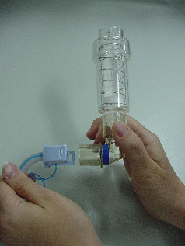
Figure 1: Attaching IMT device to ETT/ Tracheostomy

- The patient inhales through the device to generate an inspiratory pressure greater than the indicated threshold pressure setting to compress the spring and open the poppet valve.
- The inspiratory pressure should be maintained for at least 1 second, with respiratory rate < 30 bpm. Audible air flow indicates a successful breath.
- The patient exhales through the training device via a low resistance one-way valve.
- Training sessions consist of 5 sets of 6 training breaths for a total of 30 training breaths per day, 5 days per week.
- If ventilator-dependent, patients are returned to mechanical ventilation for rest between training as needed. If spontaneously breathing, allow rests between sets as required (typically < 1 minute).

ELECTRONIC IMT (E-IMT)
Equipment
- PowerBreathe® electronic IMT device
- Bacterial filter (if using Powerbreathe®) or Powerbreathe® TrySafe™ Filter
- Flexible connector for patients with an ETT or tracheostomy

Procedure
- Gain informed consent from the patient, as per Informed Consent (Clinical) Policy on the CHS Policy and Guidance Documents Register.
- Perform hand hygiene.
- Training should be conducted with the patient in high sitting position, preferably in a chair.
- For a patient who is spontaneously breathing, attach the mouthpiece to the E-IMT device and apply the nose peg if the patient tends to breathe through their nose (optional). For a patient who is ventilator-dependent, attach the flexible tubing and filter to the E-IMT. This will allow the Threshold IMT to attach directly to the tracheostomy/ETT (Figure 2).

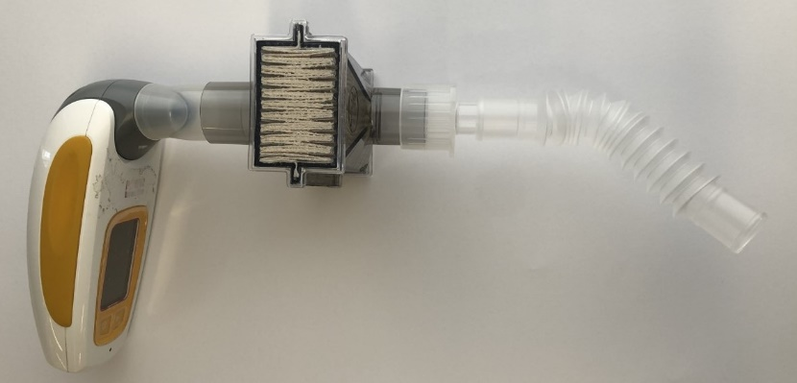
Figure 2: Attaching E-IMT to ETT/Tracheostomy

- The patient inhales through the device to generate inspiratory pressure for 1 second with respiratory rate < 30bpm. Patient exhales through device.
- You will know if the breath has been successful when you rest after full set as remaining breath count is depicted on the screen of the device.
- Training sessions consist of 5 sets of 6 training breaths for a total of 30 training breaths per day, 5 days per week.
- If ventilator-dependent, patients are returned to mechanical ventilation for rest between training as needed. If spontaneously breathing, allow rests between sets as required (typically < 1 minute).

CHRONIC Inspiratory Muscle Training Procedure¹⁸
Equipment
- Threshold IMT device (Phillips Respironics): allows incrementally adjusted training pressures from 9cmH₂O up to 41cmH₂O.

Procedure
- Gain informed consent from the patient, as per Informed Consent (Clinical) Policy on the CHS Policy and Guidance Documents Register.
- Training should be conducted with the patient in high sitting position, preferably in a chair with upper limbs supported.
- Adjusting intensity: intensity (target load) should be titrated to 30% of MIP to begin with. To adjust the pressure indicator to the setting prescribed, align the red edge of the pressure indicator by turning the control knob at the bottom of the Threshold IMT.
- Attach the mouthpiece to the IMT device and apply the nose peg.
- The patient inhales through the device to generate an inspiratory pressure greater than the indicated threshold pressure setting to compress the spring and open the poppet valve. Audible air flow indicates a successful breath.
- Training should follow the pattern of 7 lots of 2 minute cycles, where target training equals 30% of MIP, and the warm-up load is 15% of MIP. Intensity should be increased as tolerated to maintain an RPE of 13-14 / 20 (or 4/10).
- IMT should be performed 3 days a week for a minimum of 8 weeks, and then continued indefinitely at 2 days a week for maintenance.

Monitoring/Progression Measures
- Recommend monitoring SpO₂ and RR during initial training session
- Reassess MIP after 8 weeks of training – if no changes, cease IMT. If patient has improved, continue with maintenance program for life (2 sessions/week)
- Cease immediately if patient reports sudden sharp pain on inspiration (refer for medical review, due to risk of pneumothorax)

Documentation
All documentation should follow the Clinical Records Management Procedure. However with respect to IMT, the following should be specifically mentioned:
- Informed consent, see Informed Consent (Clinical) Policy on the CHS Policy and Guidance Documents Register
- Training parameters used (resistance, sets, breaths)
- Response to treatment (any adverse outcomes).

Cleaning and Maintenance
- Threshold device
  - Single-patient use only and disposable, therefore no cleaning or sterilising is required
  - Should be stored in the patient’s bedside trolley with the patient’s sticker on it and can be used following discharge should the patient wish to
- Electronic device
  - Must be wiped down with a detergent wipe before and after each patient use. Mouthpiece and filter is single-patient use and disposable, therefore no cleaning or sterilising is required.

Back to Table of Contents

Section 3 – Hyperinflation

Background
Hyperinflation is the delivery of a slow, deep inspiration greater than baseline tidal volume up to a peak inspiratory pressure (PIP) of 40cm H₂O, followed by an inspiratory hold of up to three seconds, and a quick, unobstructed expiration to patients with an artificial airway¹⁹. The slow deep inspiration to 35-40cm H₂O re-expands areas of atelectasis²⁰; the inspiratory hold recruits lung segments via collateral channels, allows for gas exchange and mobilises secretions; while the quick release increases expiratory flow rates, allows for annular two phase gas liquid flow, and mimics a huff and/or cough, mobilising pulmonary secretions from distal to proximal lung segments²¹. Hyperinflation has been shown to be an effective technique for mobilising sputum²²⁻²⁴, reversing atelectasis^{25, 26},improving oxygenation and pulmonary compliance^{22,27}.

Traditionally, hyperinflation has been delivered to patient on mechanically ventilation by disconnecting them from the ventilator and connecting them to a manual resuscitation circuit and is known as manual hyperinflation (MHI). At CHS, the technique is delivered via the Laerdal Silicone Resuscitator bag (Figure 3). Disadvantages of this technique include loss of PEEP, de-recruitment of lung segments, and poor tolerance or dyssynchrony with the technique by patients who are agitated. When completed manually, substantial clinical experience is required to deliver the technique consistently and to prevent barotrauma or volutrauma²⁸.

Ventilator Hyperinflation (VHI) is the delivery of hyperinflation breaths via adjustments of ventilator settings and when compared to MHI, VHI has been shown to be as effective in mobilising secretions, improving lung compliance, oxygenation and restoring lung volumes²⁹⁻³². It requires no disconnection from mechanical ventilation, so there is no loss of PEEP and it is synchronous with patient breaths. Volumes are delivered consistently and PIP and volume are controlled by the ventilator, thus reducing the risk of barotrauma or volutrauma in appropriately selected patients.

In clinical practice, VHI is utilised in patients currently undergoing mechanical ventilation while MHI is mainly utilised in patients no longer requiring mechanical ventilation.

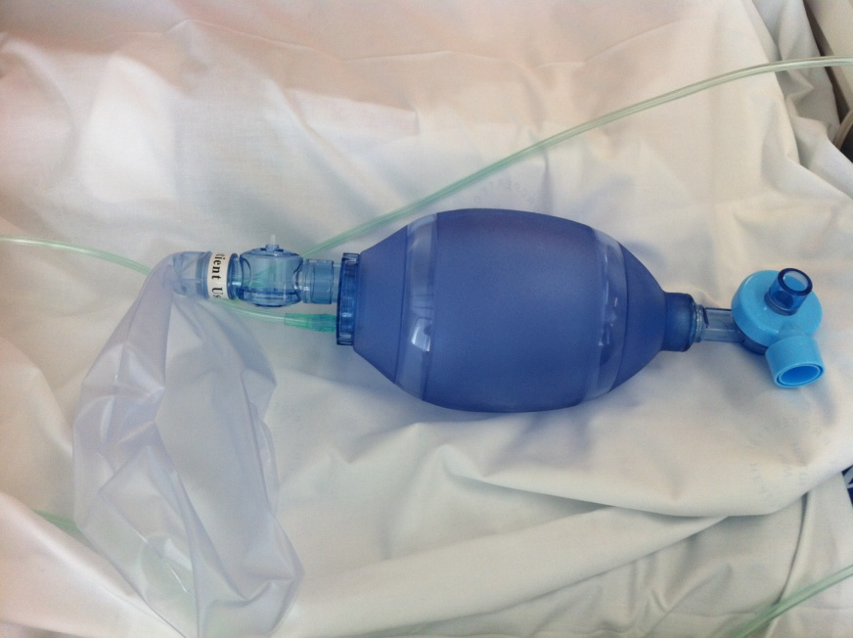
Figure 3. Laerdal Silicone Resuscitator bag

Indications for Hyperinflation³³
- Evidence of retained secretions
- Evidence of collapse or loss of volume
- Poor lung compliance
- Decreased oxygenation caused by one of the above.

Outcome Measures
- Arterial blood gases
- Oxygen saturations
- Chest Radiograph (CXR)
- Volume/consistency of sputum suctioned
- Tidal Volumes (V_{t})
- Vital Capacity
- Peak Inspiratory Pressure (PIP)
- Ventilator Wave Forms
- Static Compliance (C_{stat}=V_{T}/P_{plat}-PEEP)
- Auscultation
- Palpation (chest wall movement/fremitus).

Alert:
All paediatric cases where hyperinflation is indicated must be discussed with a senior physiotherapist and the treating consultant. Consideration for seeking advice from paediatric specialty centres in the clinical reasoning process for complex cases is recommended.

Precautions for Hyperinflation³⁴
- Unstable cardiovascular system such as unstable arrhythmias, mean arterial pressure (MAP) <65mmHg, MAP swing >5mmHg between inspiration and expiration, the presence of an IABP; increasing inotropic or vasopressor support (as high intra-thoracic pressures may compromise venous return).
- Partial pressure of oxygen (PaO2)/FiO2 Ratio <200mmHg
- PIP >35cmH₂0
- Airway pressure release ventilation (APRV)
- Intracranial pressure (ICP) >15mmHg
- Florid acute pulmonary oedema (APO)
- Restrictive or obstructive lung disease
- Significant pulmonary hypertension or evidence of right ventricular dysfunction

Alert:
In the presence of precautions to hyperinflation, treatment should proceed with caution after direct consultation with a senior physiotherapist, senior registrar or consultant.

Contraindications for Hyperinflation³⁴
- Undrained pneumothorax or the presence of an ICC with continuous leak
- Bronchopulmonary fistula
- Thoracic surgery with lung resection
- Patients ventilated on lung protective strategy for ARDS, severe pneumonia, pulmonary contusions
- Acute bronchospasm
- Patients ventilated for an exacerbation of COPD with elevated intrinsic PEEP or other conditions where hyperinflation would be detrimental.
- Patients under the age of 3 years, as lack of collateral channels increases risk of pneumothorax.

Performing MHI
Equipment
- Appropriate size Laerdel Silicone Resuscitator Bag (adult/paediatric)
- Heat Moist Exchange (HME) Filter
- Mouthpiece or interface.

In addition, patients on ventilation require:
- PEEP Valve
- Test lung

Procedure for MHI
- Physiotherapists may only perform MHI once they have completed the Hyperinflation Competency package with the appropriately trained physiotherapist (Attachment 7).
- Identify indications for MHI and any precautions or contraindications. If precautions exist, discuss with appropriate senior physiotherapy staff and treating Consultant/Senior Registrar prior to initiating MHI.
- Ensure appropriate number of staff are available to carry out the treatment. Physiotherapists with less clinical experience or who have not performed the technique recently should consider a second staff member (nurse or physiotherapist) to be available to suction and place the ventilator on standby in the more unstable patient. For patients on vasoactive infusions or who have ICP monitoring, MHI should be carried out with the bedside nurse present as titration of infusions may be required during treatment. A second physiotherapist is required if manual techniques are indicated as an adjunct to MHI.
- Gain informed consent from the patient, as per Informed Consent (Clinical) Policy on the CHS Policy and Guidance Documents Register.
- Appropriately position the patient to maximise ventilation and perfusion (V/Q) matching and to drain secretions.
- To set up the MHI circuit (Figure 4), attach a HME filter to the Laerdel bag. For patient’s on ventilation, ensure a PEEP valve set at the patient’s baseline PEEP setting is incorporated into the circuit.

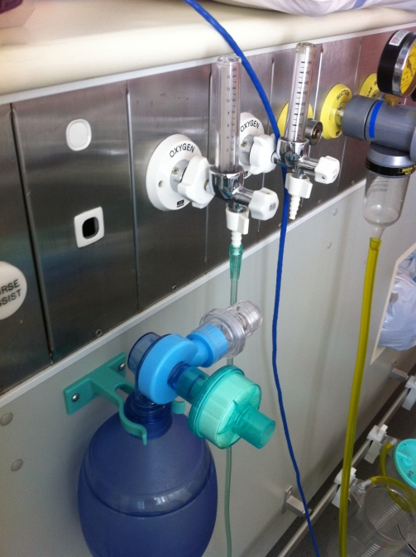
Figure 4. Circuit set up for patient on ventilation

- Attach the oxygen tubing to the oxygen outlet and turn the oxygen flow to 15 litres/minute. Ensure the reservoir bag is not split and is filling with gas. A manometer is not required to be used as the Laerdel circuit has a safety valve that prevents PIP from exceeding 35cm H₂O²³.
- For the patient on ventilation, silence the ventilator, disconnect the ventilator from junction of the Bennet’s connector and connect the Laerdel circuit to the patient. For a patient who is self-ventilating with a tracheostomy, disconnect oxygen and attach the Laerdel circuit to the tracheostomy via the flexible connector only (Figure 5).
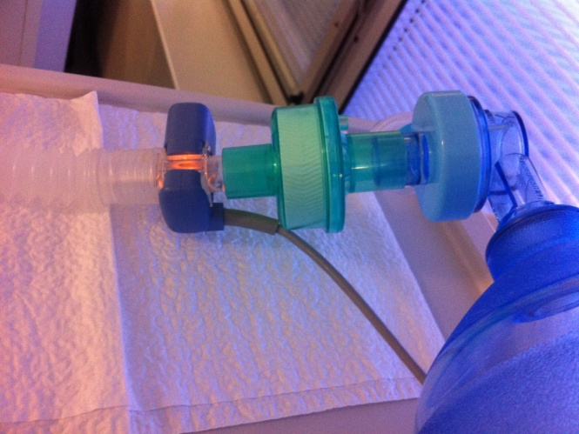
Ladel Bag
Flexible tubing
Figure 5. Circuit connection for the patient on ventilation

- Commence providing bag ventilation for the patient at the same rate and volume as baseline. Once satisfied that the patient is being ventilated via bag ventilation, place the ventilator in standby mode as per Physiotherapy Ventilator Assessment Tool (Attachment 8) and attach the ventilator to the test lung.
- Commence MHI with a two handed technique, delivering a larger than baseline tidal volume, an inspiratory hold and a quick release. The literature recommends 6 sets of 6 MHI breaths to treat atelectasis and compliance^{29, 34}. For sputum clearance, continue MHI if patient is stable until outcome measures indicate that sputum has been cleared.
- For all patients, monitor HR and SpO₂ throughout. If available, monitor MAP, electrocardiogram (ECG), ICP and Cerebral perfusion pressure (CPP). ICP should remain below target, and CPP should remain >60mmHg (CPP=MAP-ICP). Monitor MAP swing for anything >5mmHg between inspiration and expiration. Modify or cease treatment as appropriate.
- Suction the patient’s airway as indicated. Consider completing additional MHI breaths post-suction to recruit collapsed lung segments³⁵.
- Once treatment is complete, for patients on ventilation restart the ventilator before reconnecting the patient and ensure the patient is ventilating at baseline or appropriate respiratory rate and with adequate tidal volumes and End Tidal Carbon Dioxide (ETCO₂) prior to putting the Laerdal bag away. For ward patients, return patient to previous oxygen circuit e.g. humidified or Swedish nose.
- Reassess outcome measures and reposition patient appropriately.
- Document patient position, level of PEEP (if applicable), duration of MHI, appropriate outcome measures and any adverse events

Performing VHI
- Physiotherapists may only perform VHI once they have completed the Hyperinflation Competency package and ventilator training package with the appropriately trained physiotherapist (Attachments 7 and 8). The bedside nurse must be present during VHI.
- Identify indications for VHI, most appropriate mode of ventilation to deliver. hyperinflation for the specific patient, and any precautions or contraindications. If precautions exist, discuss with appropriate senior physiotherapy staff and treating Consultant/Senior Registrar prior to initiating VHI.

Alert:
VHI can only be performed in SIMV Pressure Control on the GE Carescape Ventilator.

- Explain the treatment and gain consent from the patient/carer and inform the bed side nurse.
- Appropriately position the patient to maximise ventilation and perfusion (V/Q) matching and to drain secretions.
- Adjust ventilator alarm limits.
- Adjust ventilator settings to achieve hyperinflation breaths, refer to VHI flow chart for relevant ventlitor (Attachment 9 and 10).

Note: Consider utilising pressure/volume curve to assess over-distention point and titrate volumes accordingly to reduce risk of barotrauma/volutrauma³⁶.

- Titrate settings during treatment as required to maintain PIP at 35-40cmH₂O.
- Once target PIP is reached, manual techniques (i.e. percussion or vibration) may be incorporated if indicated.
- Monitor HR, MAP, ECG and ETCO₂ throughout. If measured, ICP should remain below target, and cerebral perfusion pressure should remain >60mmHg (CPP=MAP-ICP). Monitor MAP swing for anything >5mmHg between inspiration and expiration. Modify or cease treatment as appropriate.
- For patients who may require breaks during treatment due to intolerance of the technique or to prevent haemodynamic instability, return them to their baseline settings in that mode of ventilation. When resuming hyperinflation breaths, the determined values required to reach PIP of 40cmH₂O can be resumed without the gradual increase in settings.
- Suction the patient’s airway as required. Consider completing additional VHI breaths post-suction to recruit collapsed lung segments³⁵.
- Dosage - The literature recommends 6 sets of 6 VHI breaths to treat atelectasis and improve compliance^{29,30,34}. For sputum clearance, continue VHI if patient is stable until outcome measures indicate that sputum has been cleared.
- Once treatment is completed, return ventilator settings to baseline return patient to previous mode of ventilation and return alarm settings to previous limits. Inform the bedside nurse that alarm limits and ventilator settings are at baseline. Ensure patient is ventilating at adequate rate, V_{t} and ETCO₂ prior to reassessing outcome measures and repositioning the patient as required.
- Document the patient position, mode of ventilation, RR, PIP reached, V_{t} reached, duration of treatment and any adverse events.

Back to Table of Contents

Section 4 – Induced Sputum Collection

This section outlines the processes for receipt and management of referral and safe collection of an induced sputum sample through inhalation of hypertonic saline.

Background
Induced sputum is a diagnostic procedure used for patients who are unable to provide a sputum sample spontaneously. It involves the patient inhaling hypertonic saline via an ultrasonic nebuliser, followed by coughing and expectoration of airway secretions³⁷. Hypertonic saline works both as a mucolytic and an expectorant³⁸. It disrupts the ionic bonds within the sputum, osmotically draws additional water onto the airway epithelial surface reducing the viscosity of secretions and triggers a cough aiding in sputum expectoration³⁸. Hypertonic saline has a dose-response relationship, and therefore the effects on sputum viscosity increase as the concentration of saline increases³⁸.

At CHS, induced sputum is used in the diagnosis of pulmonary Tuberculosis (TB) and Pneumocystis Jirovecii Pneumonia (PJP), formally known as Pneumocystis Carinii Pneumonia (PCP)³⁹. Current guidelines suggest that for PJP a single sample needs to be induced for testing. For TB, three samples on consecutive days are required to increase sensitivity of the test^{40, 41}. In TB, a spontaneous sputum sample provides similar diagnostic yield to an induced sample, and therefore if patients can expectorate spontaneously, this should be tested first⁴². Induced sputum has been shown to have an equal or greater diagnostic yield than bronchoscopic sampling, is less expensive and has fewer risks in patients with suspected TB and therefore should be completed prior to a bronchoscopy⁴⁴.

Indications
- Suspected Tuberculosis (TB)
- Suspected Pneumocystis Jirovecii Pneumonia (PJP)

Precautions/Contraindications^{37,45,46}
- Inability to follow instructions
- Inadequate respiratory reserve or acute respiratory distress
- FiO2 >50%
- FEV₁ <1.0 Litre
- Asthma/ COPD *see alert
- Pneumothorax
- Pulmonary emboli
- Haemoptysis of unknown origin
- Unstable cardiovascular system such as unstable arrhythmias, mean arterial pressure (MAP) <65mmHg
- Thoracic, abdominal, or cerebral aneurysm

Alert:Since saline inhalation may cause bronchoconstriction, safety measures should be undertaken before performing the procedure. In patients with moderate to severe COPD or asthma, spirometry pre-treatment with salbutamol should be undertaken^{37,46}.

Referrals - general
- Referral for inpatient induced sputum collection will be accepted from a Medical Specialist/VMO from Intensive Care, Respiratory, Oncology, Haematology, or Infectious Diseases only.
- For inpatients, referral must be documented in the patient’s clinical file, including the purpose for collection. The medical team is to contact the ward physiotherapist via pager to alert them to the referral as soon as possible.
- Requests are accepted during standard business hours (excluding special circumstances). Refer to “Weekends/out of business hours” for details.
- If induced sputum is requested for conditions other than TB and PJP, this must be discussed by the treating consultant with a senior physiotherapist.

Weekends/out of business hours
- Microbiology is unable to routinely process an induced sputum sample on weekends or public holidays. If the testing is urgent the requesting medical team will contact the Microbiologist on-call to ensure availability of laboratory staff prior to referral to the physiotherapist for collection.
- PJP collection requests made over a weekend/Public Holiday will be collected within 48 hours and sent to Microbiology, even if they are unable to be processed over the weekend, to allow for higher diagnostic yield.
- Requests made for collection after 3:00pm will be delayed until the following business day due to the time taken to collect and process.
- The physiotherapy evening service (5pm-9pm) will not routinely perform induced sputum collection.
- Induced sputum collection on the weekend will be clinical reasoned in relation to staff capacity, appropriate room availability and AAHS Physiotherapy Priority Tool.

Safety - Infection Control
To minimise the risk of transmission of airborne disease:
- All induced sputum collections are to be completed in a negative pressure room. Refer to Attachment 11 for list of appropriate rooms.
- PPE is compulsory during collection including gown, gloves, goggles and P2/N95 respirator.
- Ensure PPE don and doff steps are followed closely.
- All staff performing a TB collection are required to have a baseline Mantoux test or Tuberculin Skin Test (TST) wit 3h CHS Department of Respiratory and Sleep Medicine (DRSM), which requires five yearly updates/reviews.
- The physiotherapist conducting the procedure will remain with the patient throughout the procedure.
- Should the patient be required to leave the ward for collection then a nurse escort may be required at the discretion of the Clinical Nurse Consultant (CNC) (depending on the patient’s acuity). Refer to Patient Escort and Transport within Canberra Hospital Campus Procedure.

Preparation
On referral for an induced sputum, the following preparation is required:

Referring medical team:
- Inform ward CNC of the need for the patient to be in a negative pressure room
- Contact microbiology if outside normal business hours to ensure the sample can be processed
- Chart 6% hypertonic saline
- Chart bronchodilators and anti-emetics if required.
- Complete a paper pathology form for each sample required and place in the patient’s file

The ward CNC/Team Leader:
- Ensure that a negative pressure room is available on the treating ward
- If a negative pressure room cannot be organised on the treating ward, liaise with Patient Flow Unit to source a negative pressure room on another ward. Refer to Attachment 11 for a list of appropriate rooms.

Physiotherapist:
- Ensure all equipment required is available and clean

Alert:
Morning sample collection is preferable as they are more sensitive for detecting TB⁴²

Equipment
- Suchatzki Ultrasonic nebuliser
- One-way mouthpiece (small and medium sizes available)
- Disposable items:
- bacterial filter
- medicine cup
- dust filter
- 6% hypertonic saline solution (in premix 10ml sachet) ^{47, 48, 49}
- Oxygen available and/or administered
- PPE including gown, gloves, goggles and P2/ N95 respirator
- Sterile sputum specimen jar
- Box of tissues
- Vomit bag
- Sterile water
- Pulse oximeter
- Bronchodilator and anti-emetics (if indicated) *see alert

Alert:
It is recommended that bronchodilators and anti-emetics are charted prior to commencing sputum induction due to risk of bronchospasm and nausea.

Procedure
- Gain informed consent from the patient, as per Informed Consent (Clinical) Policy on the CHS Policy and Guidance Documents Register.
- Assemble and check the equipment (see Appendix 12).
- Access negative pressure room for collection. If using the room solely for collection purposes, drape a sheet where the patient will be sitting. Ensure the negative pressure setting is turned on and signage on door (Appendix 14)
- Administer bronchodilators, anti-nausea medication and supplemental oxygen if indicated.
  - Perform a spirometry in high risk patients (mod-severe respiratory conditions). If FEV1< 1.0L, consult the medical team before continuing³⁷.
- Perform hand hygiene and don PPE.
- Explain the procedure to the patient and what to expect, including possible side effects (coughing, dry mouth, nausea, wheeze).
- Ensure patient is seated comfortably and in a sustainable position.
- Perform baseline observations (SpO₂, RR and auscultation), establish continuous SpO₂ for high risk patients and those requiring oxygen therapy.
- Prepare nebuliser with 10ml hypertonic saline solution in disposable cup, and sterile water in the main water chamber up to the recommended marked ‘fill’ line. (Refer to Appendix 12 for machine setup).
- Turn on the machine (a fine mist should appear)
- Instruct patient to put the mouthpiece into their mouth and breathe slowly and deeply. You should see a fine mist in the clear T-piece. The patient should experience a salty taste.
- After 5 minutes of inhalation, if no spontaneous cough has occurred, instruct patient to cough. Repeat at 5 minute intervals until a sample is produced^{47,49}.
- Continue to monitor the patient throughout procedure. The procedure should be stopped:
  - Once the patient has produced an adequate sample
  - If the patient complains of dyspnoea, chest tightness, wheeze or decrease in Sp0₂ >5%. Immediately take observations, administer bronchodilator (if indicated), and notify medical team.
- After 15 minutes if no sample is obtained, cease the procedure, and inform medical team.
- Repeat observations and ensure patient is stable.
- If successful, place the patients identification sticker on the specimen container, write on the sticker the time and date of the procedure, and ensure ‘Induced Sputum’ labelled on specimen jar. Fill out the ‘collection’ part of the pathology form and send to Microbiology via a pathology chute. Ensure ‘Induced Sputum’ is written in the ‘sample type’ box.
- If used, place any draped sheets into the linen skip.
- Dispose of consumables in yellow bin inside the room.
- Remove gloves and gown and discard in yellow bin inside the room. Tie bag up.
- Remove goggles and P2/N95 respirator once outside the room.
- Document result of collection attempt in the patient’s clinical record.
- The room requires cleaning before use by another patient. Leave the room vacant for one hour and then contact the cleaning service to complete an infectious clean.
- Clean the machine as below.

Alert: Evidence suggests that airway clearance techniques such as percussion and vibrations have no additional benefit during an inducing sputum procedure and are not routinely performed⁴³.

Cleaning and Maintenance
Cleaning
- Wipe down outside of ultrasonic nebuliser machine with detergent wipes before and after each patient use.
- After use the ultrasonic nebuliser is split into multiple components for disinfection and sterilisation – tubing and water chamber; mouthpiece and one way valve; and disposables. Ensure PPE is worn for the cleaning and separating of the used equipment.
- Tubing and water chamber are sent to Department of Respiratory and Sleep Medicine (DRSM) for thermal disinfection and air dried. Items need to be separated into individual components and emptied of any liquid.
- Mouthpiece and one way valve are sent to Gastroenterology & Hepatology Unit for sterilisation. Mouthpiece needs to be separated into individual components for cleaning.
- Filters and the medicine cup are disposable after each test.
- Items to be clearly identified as clean or dirty with provided labels.

Maintenance
- If any of the equipment if faulty or broken, it is taken to Biomed for assessment.
- The AHA is responsible for taking and collecting equipment from Biomed.
- If new and replacement parts are required, they are ordered via PICS. Please refer to Attachment 13 for ordering information and codes.
Back to Table of Contents

Evaluation

Outcome
Relevant staff will be aware of the Physiotherapy- Respiratory Management Procedure to guide evidence based practice and ensure continuity of care for patients when utilising the above interventions. All relevant staff will complete competency and skills based assessments related to their clinical role and operate within their scope of practice.

Measures
- Inclusion in relevant clinical orientation.
- Monitoring through peer review, documentation audits and clinical practice audits.
- Staff completion of competency and skills assessments.

Back to Table of Contents

Related Policies, Procedures, Guidelines and Legislation
Policies
- Clinical Records Management
- Informed Consent (Clinical)
- Work Health and Safety

Procedures
- Infection Prevention and Control - Healthcare Associated Infections
- Patient Identification and Procedure Matching
- Adult Nebulisation Therapy
- Clinical Record Management
- Patient Identification - Pathology Specimen Labelling
- Pathology Specimen Handling
- Patient Escort and Transport within Canberra Hospital Campus

Guidelines
- Physiotherapy – Adult Patient with a Spinal Cord Injury
- Tracheostomy Management - Adult Patients
- Clinical Supervision for Allied Health Clinicians
- Credentialing and Defining the Scope of Clinical Practice for Allied Health Professionals
- Infection Control - Cleaning (Shared) Patient Care Equipment
- Oxygen Therapy and or Non-Invasive Ventilation (Paediatrics 0-16yrs)

Legislation
- Health Records (Privacy and Access) Act 1997
- Human Rights Act 2004
- Work Health and Safety Act 2011

Other
- Australian Charter of Healthcare Rights

Back to Table of Contents

References
- Hull J, Aniapravan R, Chan E, Chatwin M, Forton J, Gallagher J, Gibson N, Gordon J, Hughes I, McCulloch R, Russell RR, Simonds A. British Thoracic Society guideline for respiratory management of children with neuromuscular weakness. Thorax. 2012 Jul;67 Suppl 1:i1-40. doi: 10.1136/thoraxjnl-2012-201964. PMID: 22730428.
- Chatwin M, Toussaint M, Gonçalves MR, Sheers N, Mellies U, Gonzales-Bermejo J, Sancho J, Fauroux B, Andersen T, Hov B, Nygren-Bonnier M, Lacombe M, Pernet K, Kampelmacher M, Devaux C, Kinnett K, Sheehan D, Rao F, Villanova M, Berlowitz D, Morrow BM. Airway clearance techniques in neuromuscular disorders: A state of the art review. Respir Med. 2018 Mar;136:98-110. doi: 10.1016/j.rmed.2018.01.012. Epub 2018 Feb 6. PMID: 29501255.
- Lachal R, Louis B, Subtil F, Guérin C. Bench Assessment of the Effect of a Collapsible Tube on the Efficiency of a Mechanical Insufflation-Exsufflation Device. Respir Care. 2019 Jul;64(7):752-759. doi: 10.4187/respcare.06478. Epub 2019 Mar 12. PMID: 30862688.
- Emerson CA-3200 User Manual
- Phillips Respironics CoughAssist 70 Series User Manual
- Moran FC, Spittle A, Delany C, Robertson CF, Massie J. Effect of home mechanical in-exsufflation on hospitalisation and life-style in neuromuscular disease: a pilot study. J Paediatr Child Health. 2013 Mar;49(3):233-7. doi: 10.1111/jpc.12111. Epub 2013 Feb 26. PMID: 23438093.
- Dale CM, McKim D, Amin R, Carbone S, Fisher T, Goldstein R, Katz S, Gershon A, Leasa D, Nonoyama M, Pizutti R, Tandon A, Rose L. Education Experiences of Adult Subjects and Caregivers for Mechanical Insufflation-Exsufflation at Home. Respir Care. 2020 Dec;65(12):1889-1896. doi: 10.4187/respcare.07534. Epub 2020 Jun 30. PMID: 32606074.
- Bissett B, Leditschke IA, Neeman T, et al. Weaned but weary: one third of adult intensive care patients mechanically ventilated for 7 days or more have impaired inspiratory muscle endurance after successful weaning. Heart Lung 2015;44(1):15-20.
- Herridge MS, Tansey CM, Matte A, et al. Functional disability 5 years after acute respiratory distress syndrome. N Engl J Med 2011;364(14):1293-304.
- Cuthbertson BH, Roughton S, Jenkinson D, et al. Quality of life in the five years after intensive care: a cohort study. Crit Care 2010;14(1):R6.
- Vorona S, Sabatini U, Al-Maqbali S, et al. Inspiratory Muscle Rehabilitation in Critically Ill Adults: A Systematic Review and Meta-Analysis. Ann Am Thorac Soc 2018.
- Elkins M, Dentice R. Inspiratory muscle training facilitates weaning from mechanical ventilation among patients in the intensive care unit: a systematic review. Journal of Physiotherapy, 2015; 61:125-134
- Bissett BM, Leditschke IA, Neeman T, et al. Inspiratory muscle training to enhance recovery from mechanical ventilation: a randomised trial. Thorax 2016;71(9):812-9.
- Shoemaker MJ, Donker S, Lapoe A. Inspiratory muscle training in patients with chronic obstructive pulmonary disease: the state of the evidence. Cardiopulm Phys Ther J 2009;20(3):5- 15.
- Dall'Ago P, Chiappa GR, Guths H, Stein R, Ribeiro JP. Inspiratory muscle training in patients with heart failure and inspiratory muscle weakness: a randomized trial. J Am Coll Cardiol 2006;47(4):757-63
- Elkins M, Dentice R. Inspiratory muscle training facilitates weaning from mechanical ventilation among patients in the intensive care unit: a systematic review. Journal of Physiotherapy, 2015; 61:125-134
- Hill K, Jenkins SC, Philippe DL, et al. High-intensity inspiratory muscle training in COPD. Eur Respir J. 2006;27(6):1119-1128.
- Hill K, Cecins NM, Eastwood PR, Jenkins SC. Inspiratory muscle training for patients with chronic obstructive pulmonary disease: a practical guide for clinicians. Arch Phys Med Rehabil. 2010;91(9):1466-1470
- McCarren B, Chow CM. Manual hyperinflation: a description of the technique. Aust J Physiother. 1996;42(3):203-208.
- Rothen HU, Sporre B, Engberg G, Wegenius G, Hedenstierna G. Re-expansion of atelectasis during general anaesthesia: a computed tomography study. Br J Anaesth. 1993;71(6):788-795.
- Maxwell L, Ellis E. Secretion clearance by manual hyperinflation. Possible mechanisms. Physiotherapy Theory and Practice. 1998;14:189-197.
- Hodgson C, Denehy L, Ntoumenopoulos G, Santamaria J, Carroll S. An investigation of the early effects of manual lung hyperinflation in critically ill patients. Anaesth Intensive Care. 2000;28(3):255-261.
- Hodgson C, Ntoumenopoulos G, Dawson H, Paratz J. The Mapleson C circuit clears more secretions than the Laerdal circuit during manual hyperinflation in mechanically-ventilated patients: a randomised cross-over trial. Aust J Physiother. 2007;53(1):33-38.
- Berney S, Denehy L, Pretto J. Head-down tilt and manual hyperinflation enhance sputum clearance in patients who are intubated and ventilated. Aust J Physiother. 2004;50(1):9-14.
- Stiller K, Geake T, Taylor J, Grant R, Hall B. Acute lobar atelectasis. A comparison of two chest physiotherapy regimens. Chest. 1990;98(6):1336-1340.
- Maa SH, Hung TJ, Hsu KH, et al. Manual hyperinflation improves alveolar recruitment in difficult-to-wean patients. Chest. 2005;128(4):2714-2721.
- Ntoumenopoulos G, Gild A, Cooper DJ. The effect of manual lung hyperinflation and postural drainage on pulmonary complications in mechanically ventilated trauma patients. Anaesth Intensive Care. 1998;26(5):492-496.
- Rusterholz B, Ellis E. The effect of lung compliance and experience on manual hyperinflation. Aust J Physiother. 1998;44(1):23-28.
- Berney S, Denehy L. A comparison of the effects of manual and ventilator hyperinflation on static lung compliance and sputum production in intubated and ventilated intensive care patients. Physiother Res Int. 2002;7(2):100-108.
- Savian C, Chan P, Paratz J. The effect of positive end-expiratory pressure level on peak expiratory flow during manual hyperinflation. Anesth Analg. 2005;100(4):1112-1116.
- Ahmed F, Shafeeq AM, Moiz JA, Geelani MA. Comparison of effects of manual versus ventilator hyperinflation on respiratory compliance and arterial blood gases in patients undergoing mitral valve replacement. Heart Lung. 2010;39(5):437-443.
- Dennis DM, Jacob WJ, Samuel FD. A survey of the use of ventilator hyperinflation in Australian tertiary intensive care units. Crit Care Resusc. 2010;12(4):262-268.
- Hanekom S, Berney S, Morrow B, et al. The validation of a clinical algorithm for the prevention and management of pulmonary dysfunction in intubated adults--a synthesis of evidence and expert opinion. J Eval Clin Pract. 2011;17(4):801-810.
- Dennis D, Jacob W, Budgeon C. Ventilator versus manual hyperinflation in clearing sputum in ventilated intensive care unit patients. Anaesth Intensive Care. 2012;40(1):142-149.
- Corley A, Spooner AJ, Barnett AG, Caruana LR, Hammond NE, Fraser JF. End-expiratory lung volume recovers more slowly after closed endotracheal suctioning than after open suctioning: A randomized crossover study. J Crit Care. 2012 Dec 01; 27(6): 1-7.
- Poulton, A. Physiotherapists Use of SIMV for Ventilator Hyperinflation (VHI) for patients in Wollongong Hospital Intensive Care Unit [Internet]. 1st version. Wollongong, NSW: Illawarra Shoalhaven Local Health District, 2016 Nov. Ventilator hyperinflation application; [cited 2021 Oct 22); [1 page]. Available from https://www.islhd.health.nsw.gov.au/
- Weiszhar Z & Horvath I. Induced Sputum Analysis: Step by Step. Breathe. 2013,9(4):301-306
- Elkins MR, Bye PT. Mechanisms and applications of hypertonic saline. J R Soc Med. 2011;104 Suppl 1(Suppl 1):S2-S5.
- Paggiaro PL, Chanez P, Holz O, et al. Sputum induction. Eur Respir J Suppl. 2002;37:3s-8s.
- Al Zahrani K, Al Jahdali H, Poirier L, Rene P, Menzies D. Yield of smear, culture and amplification tests from repeated sputum induction for the diagnosis of pulmonary tuberculosis. Int J Tuberc Lung Dis. 2001;5(9):855-860.
- McWilliams T, Wells AU, Harrison AC, Lindstrom S, Cameron RJ, Foskin E. Induced sputum and bronchoscopy in the diagnosis of pulmonary tuberculosis. Thorax. 2002;57(12):1010-1014.
- Schoch OD, Rieder P, Tueller C, et al. Diagnostic yield of sputum, induced sputum, and bronchoscopy after radiologic tuberculosis screening. Am J Respir Crit Care Med. 2007;175(1):80-86.
- Elkins MR, Lane T, Goldberg H, et al. Effect of airway clearance techniques on the efficacy of the sputum induction procedure. Eur Respir J. 2005;26(5):904-908.
- Lewinsohn DM, Leonard MK, LoBue PA, et al. Official American Thoracic Society/Infectious Diseases Society of America/Centers for Disease control and Prevention Clinical Practice Guidelines: Diagnosis of Tuberculosis in Adults and Children. Clinical Infectious Diseases. 2016;1-35
- http://www1.health.nsw.gov.au/pds/ActivePDSDocuments/GL2009_006.pdf
- Pizzichini E, Leigh R, Djukanovic et al. Safety of Sputum Induction. European Respiratory Journal. 2002;20(37):9s-18s
- Fahy JV, Boushey HA, Lazarus SC, et al. Safety and reproducibility of sputum induction in asthmatic subjects in a multicenter study. Am J Respir Crit Care Med. 2001;163(6):1470-1475.
- Kelly MG, Brown V, Martin SL, Ennis M, Elborn JS. Comparison of sputum induction using high-output and low-output ultrasonic nebulizers in normal subjects and patients with COPD. Chest. 2002;122(3):955-959.
- Popov TA, Pizzichini MM, Pizzichini E, et al. Some technical factors influencing the induction of sputum for cell analysis. Eur Respir J. 1995;8(4):559-565.

Back to Table of Contents

Definition of Terms

PaO₂/FiO₂ Ratio - the ratio of partial pressure of oxygen (PaO2) to fraction of inspired oxygen (FiO₂), also known as the PF ratio¹⁹.

Peak Inspiratory Pressure (PIP) - point of maximal airway pressure on inspiration, measured in centimetres of water¹⁹

Back to Table of Contents

Search Terms

CAM, Cough assist, Cough assist machine, Physiotherapy, Physio, Respiratory Physiotherapy, Airway clearance, Sputum clearance, Inspiratory Muscle Training, IMT, Intensive Care, Critical Care, VHI, Ventilator Hyperinflation, Hyperinflation, Mechanical ventilation, MHI, Respiratory management, Atelectasis, Manual Hyperinflation, Induced Sputum Collection, Sputum Induction.
Back to Table of Contents

Attachments

Attachment 1 – Assessing peak cough flow
Attachment 2 – Assembly of Cough Assist Machine
Attachment 3 – Modifying Cough Assist Machine settings
Attachment 4 – Cough Assist Machine Competency Assessment for Physiotherapists
Attachment 5 – Inspiratory muscle training skills assessment
Attachment 6 – Measuring Negative Inspiratory Force (NIF) on GE Carescape Ventilator
Attachment 7 – Hyperinflation Competency Assessment for Physiotherapists
Attachment 8 – Ventilator Competency Assessment for Marquet Servo-U and GE
Attachment 9 – VHI Procedure Flow Chart for Servo-U ventilator
Attachment 10 – VHI procedure Flow Chart for GE ventilator
Attachment 11 – Negative Pressure Rooms
Attachment 12 – Induced Sputum mouthpiece components and equipment assembly

Disclaimer: This document has been developed by Canberra Health Services specifically for its own use. Use of this document and any reliance on the information contained therein by any third party is at his or her own risk and Canberra Health Services assumes no responsibility whatsoever.

Policy Team ONLY to complete the following:
Date Amended | Section Amended | Divisional Approval | Final Approval
18/02/2022 | Complete review | Jo Morris ED Allied Health | CHS Policy Committee

This document supersedes the following:
Document Number | Document Name
CHS18/069 | Physiotherapy- Respiratory Management

Attachment 1 – Assessing peak cough flow

Peak Cough Flow (PCF) can be assessed using the Peak Flow Meter or Phillips Respironics Cough Assist E70. For further information on interpretation of peak cough values see the Appendix 3 in the Physiotherapy – Adult Patient with a Spinal Cord Injury clinical guideline on the CHS Policy and Guidance Documents Register.

Assessing PCF with Peak Flow Meter:
- Remove device from packaging and attach bacterial filter and mask/mouthpiece as indicated.
- Move the marker to the bottom of the numbered scale.
- Position patient. For a patient with SCI, place them supine to maximise vital capacity.
- Apply interface to patient. Ensure the patient does not obstruct the holes on either end of the meter.
- Have the patient take a deep breath and cough.
- The marker will indicate the peak cough flow for that attempt.
- Repeat 3 times, record highest value of attempts.
Note: This is the preferred and more reliable method of obtaining PCF.

Alert:
Peak Cough Flow can be assessed reliably in children 8 years old and over.
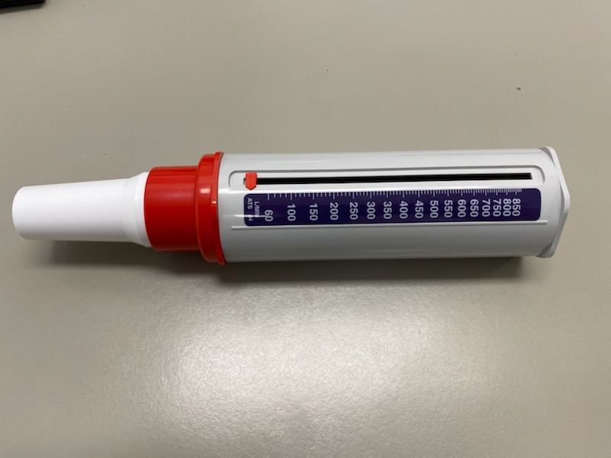

Assessing PCF with Phillips Respironics Cough Assist E70:
- Set up pre-set to be in manual mode, inhale pressure 0cmH₂O and exhale pressure 0cmH₂O.
- Position patient. For a patient with SCI, place them supine to maximise vital capacity.
- Select Therapy from the Standby screen.
- Apply the interface to the patient.
- Ask the patient to take a deep breath and cough.
- While the patient is taking the deep breath turn the manual control lever to inhale.
- When the patient commences coughing, quickly turn the manual control lever to exhale.
- Remove the interface and record the baseline peak cough flow. Ensure ‘Detailed View’ is shown on the screen (as seen in Figure 1).

Figure 1: Detailed view off Figure 2: Detailed view on
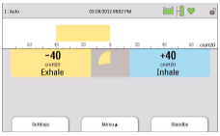
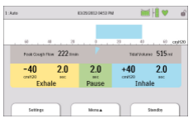

Attachment 2 – Assembly of Cough Assist Machine

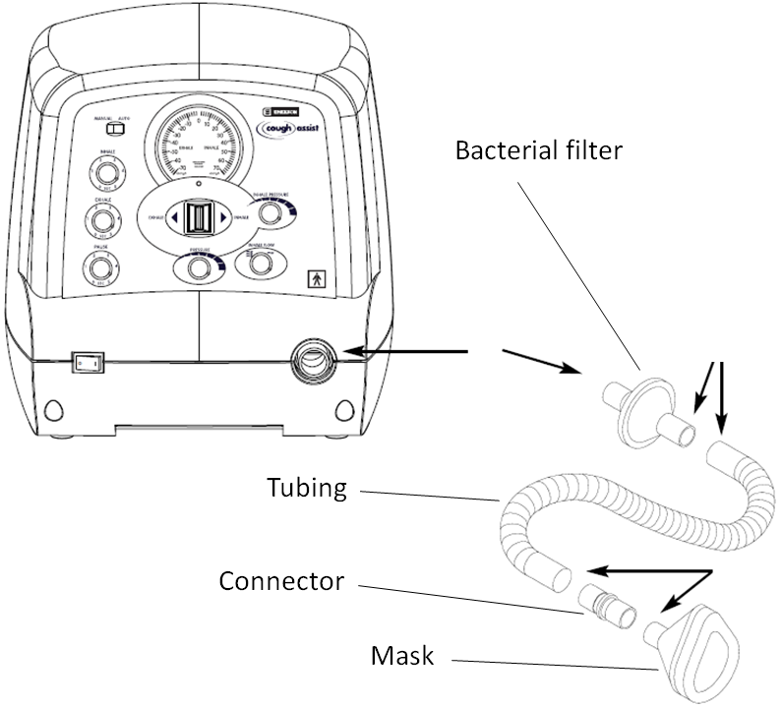
Emerson CA-3200 Cough Assist

Phillips Respironics Cough Assist E70

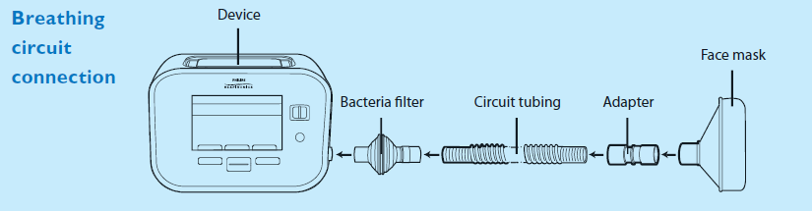

Attachment 3 – Modifying Cough Assist Machine settings

Phillips Respironics Cough Assist E70⁵

Navigating the standby screen:
- When the machine is turned on the standby screen will appear.
- Detailed view will either be turned on or off. To turn detailed view on or off enter the Menu and select Options. Then scroll to Detailed View and toggle between on/off.

Changing between full access and limited access
To change patient settings full access needs to be enabled. Once the machine has been configured, the access should be returned to limited access in order to prevent the settings being changed by someone that is not trained to do so.

To turn on full access:
- From the standby screen press the down button and hold the manual control lever to the right (inhale). The unlocked graphic in the top right hand corner of the screen indicates that the machine is in full access mode.
To turn on limited access:
- From the standby screen select Menu > Options > Menu Access. Press the Modify key and toggle to Limited Access.
Adjusting patient settings:
- Ensure ‘full access’ has been enabled.
- Press the left key (under the word ‘settings’ on the screen).
- The screen below will appear.
- Use the up/down and modify keys to change the settings for each pre-set.
- To return to the standby screen select Finish by using the left key.

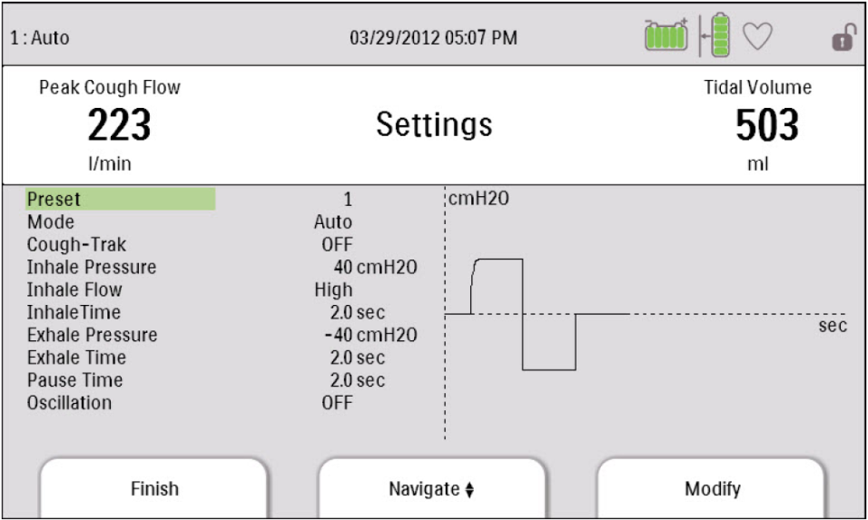

Emerson CA-3200 cough assist⁴

Pressure adjustment:
- Perform hand hygiene.
- Turn on the power switch.
- Select inhale flow to full or reduced.
- Block the mask end of the breathing hose with your hand.
- Set the manual/auto switch to manual.
- Push the manual control lever to the exhalation phase (to the left). Observe the pressure gauge on the device and adjust the maximum negative pressure by using the pressure knob to achieve the correct reading on the gauge.
- Shift the manual control lever to the inhalation phase (push to the right). Adjust the pressure reading by turning the inhale pressure knob to achieve the desired reading on the pressure gauge.
- Cycle the manual control lever from inhale to exhale and back a few times to ensure that the pressure and suction readings are correct.
- On release of the manual control lever check that the pressure returns to 0cmH₂O.

Attachment 4- Cough Assist Machine Competency Assessment
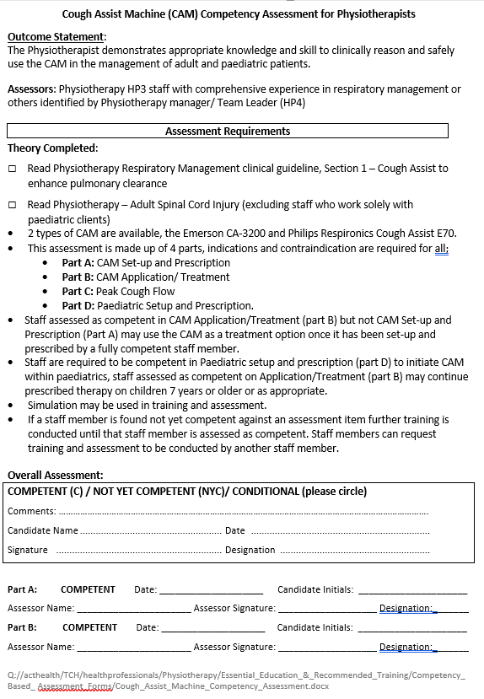
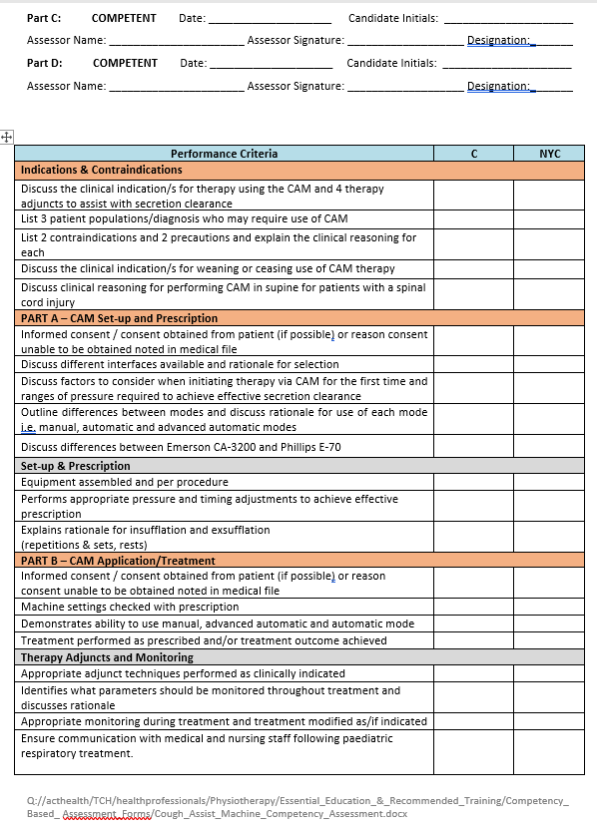
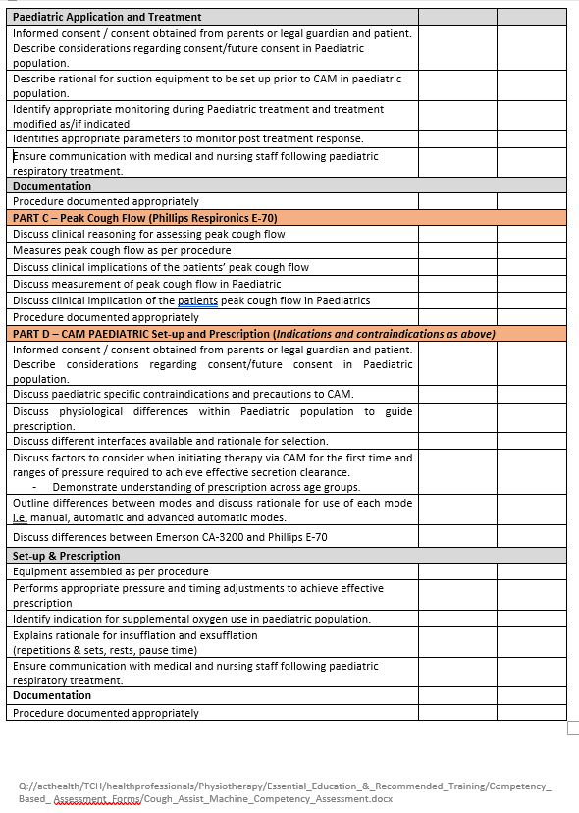

Attachment 5: Inspiratory Muscle Training Skills Assessment
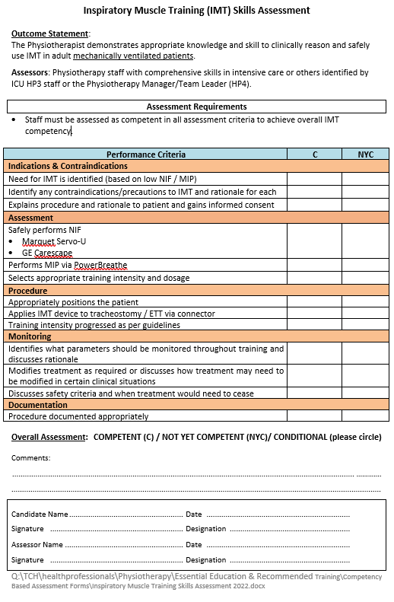

Attachment 6 : Measuring Negative Inspiratory Force (NIF) on GE Carescape Ventilator

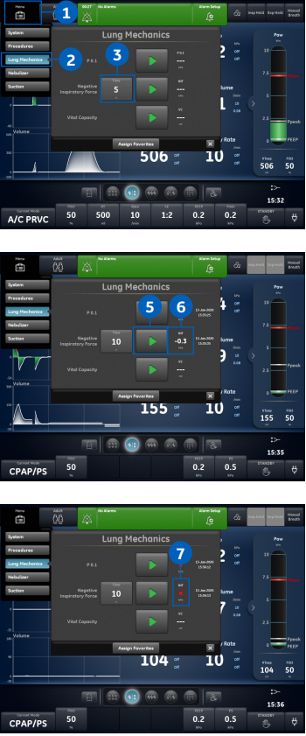
Taking a NIF Measurement
- Select Menu

- Select Lung Mechanics

- Select NIF Time
                - Use Trim knob to select a NIF time, usually up to 10 seconds

- Instruct the patient to fully exhale

- Select Start (triangle play button) and then instruct patient to fully inhale

- The most negative airway pressure is recorded and displayed along with the timestamp of test

- The procedure will end when the set time has elapsed or when Stop is selected. If the measure was not available or unable to register an X will be displayed.

Attachment 7: Hyperinflation Competency Assessment
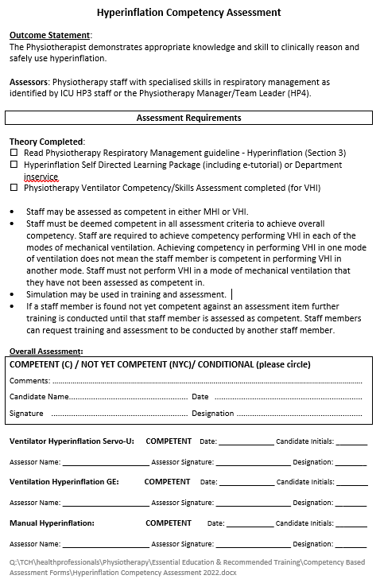
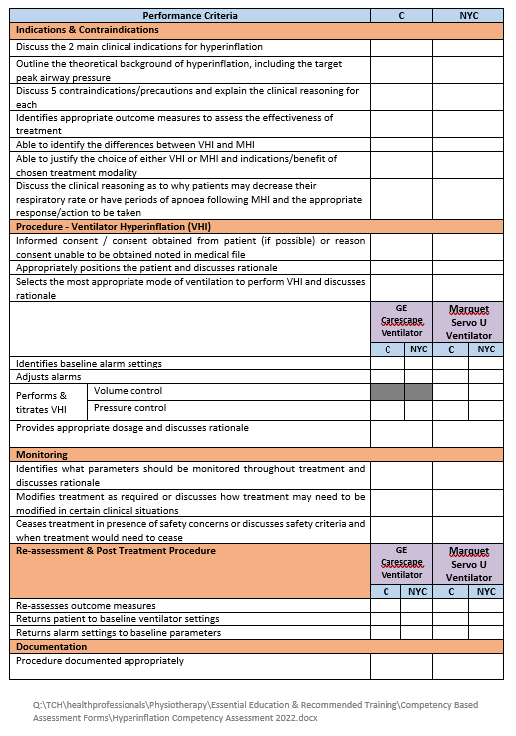
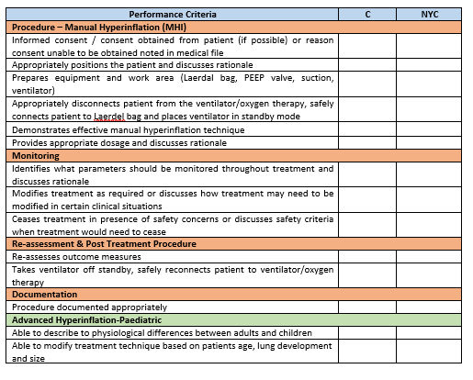

Attachment 8: Ventilation Competency Assessment
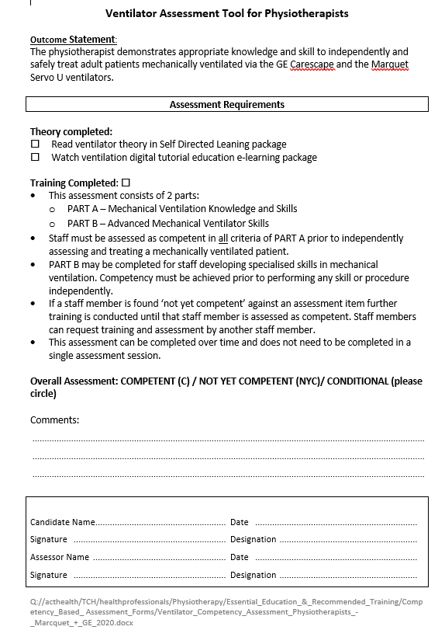
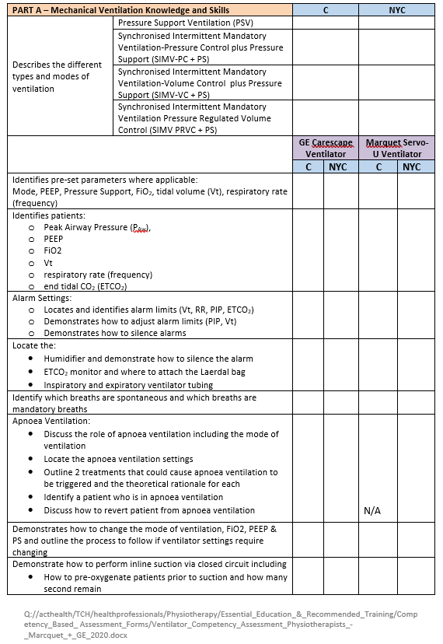
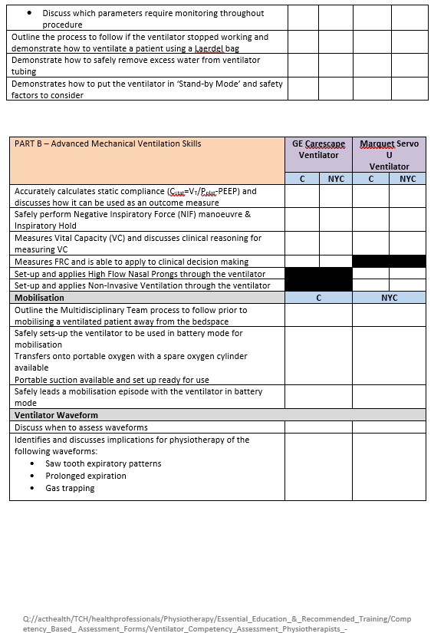
Attachment 9: VHI Procedure for the Marquet Servo - U

Attachment 10: VHI Procedure for GE Ventilator

Attachment 11: Negative Pressure Rooms at October 2021

Building | Ward | Negative Pressure Rooms
1 | Ward 8A | 2
1 | Ward 8B | 2
1 | Ward 7A | 2
1 | Ward 7B | 1
1 | Ward 6A | 2
1 | Ward 5A | 1
1 | Ward 5B | 1
12 | Intensive Care Unit (ICU) | 4
12 | Emergency Department (ED) | 4
12 | Peri-Operative Theatres | 1
11 | Ante-Natal | 1
11 | Post Natal | 1
11 | Neonatal ICU (NICU) | 1
11 | Special Care Nursery (SCN) | 1
11 | Paeds High Dependency Unit | 5
11 | Paeds Adolescent | 2
11 | Paeds Medical Unit | 6
11 | Paeds Surgical Unit | 1
11 | Birthing Suite | 1
UCH | University of Canberra Hospital (UCH) | 1
 | Total | 40

Attachment 12 – Induced Sputum mouthpiece components and equipment assembly

Deconstructed view showing all components
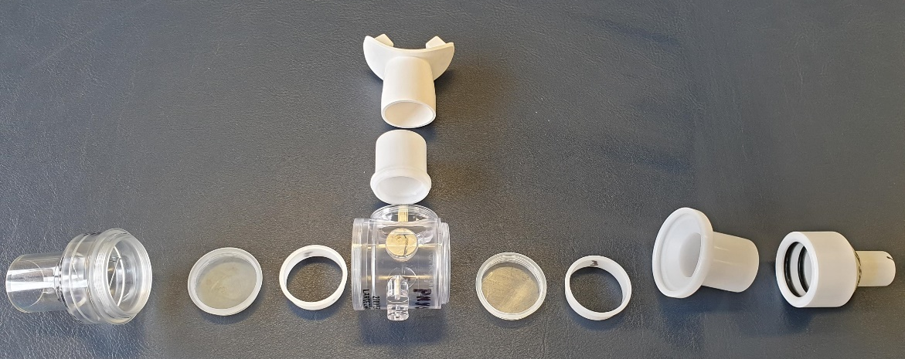

Mouthpiece assembled
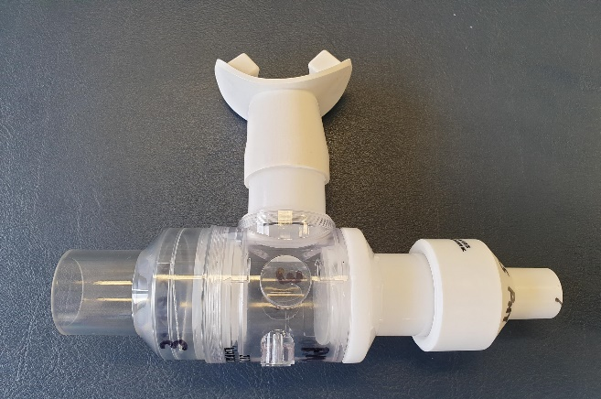
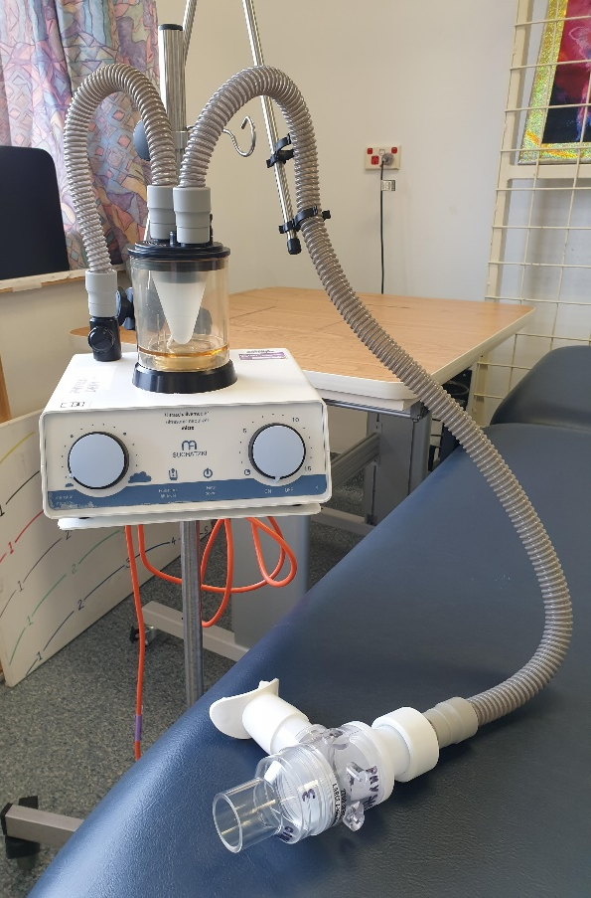
Fill line
Control flow rate
Induced Sputum Circuit fully assembled
Mouthpiece assembled
Chamber and medicine cup
Long Tubing

Start and Timer
Small Tubing

Attachment 13: Equipment Ordering - CAM, IMT and Induced Sputum.
- Equipment is ordered on PICs unless stated otherwise.
- Equipment is stocked in the level 9 storeroom and should be checked prior to further orders being placed.

Cough Assist Machine
 | PICs
Philips Cough assist unit – CA E70 INTL | 105424
Philips Cough assist CA E70 series Foot pedal | 105427
Cough assist stand 1m high with storage basket | 81472
Cough assist circuit adult MED 6ft CA70 E70 Series | 104113*
Note:
*Cough assist circuits are single patient use and disposed of after use.

Inspiratory Muscle Training
 | PICs Code
Threshold IMT- Inspiratory muscle strength and endurance trainer | 31119 *
Note:
*Equipment is single patient use and disposable.
In addition to stock in the Level 9 storeroom they are also located in ICU.
IMT stock is ordered by the neuro AHA as part of routine weekly ordering as stock levels require.

Induced Sputum

Ultrasonic nebuliser and chamber
 | PICs Code
Nebulising Chamber SUCHATZKI (entire unit) | 33696
Nebulising chamber replacement oscillator module | 140990
Nebuliser SUCHATZKI with portable stand | 82486
(Long) Tube SUCHATZKI Autoclavable 100cm * | 33702
(Short) Tube SUCHATZKI Autoclavable 45cm * | 33705
Medication cup SUCHATZKI (single use) | 82487 **
Bacterial filter SUCHATZKI (single use) | 82489**
Note:
* Both the long and short tube are required to complete the circuit.
** The medication cup and filter are ordered by the neuro AHA with the scanner as part of routine weekly ordering.

Mouthpiece
 | PICs Code
Large 2700 two-way non-rebreathing t-shape valve | 86101
Diaphragm replacement for 2700-series valve diaphragm large spiral | 144232
Mouth port for 2700 valve with outlet port of 28.6mmod/22mmid | 95298
Mouth port for 2700 valve with outlet port of 22mmod/15mmid | 95297
Adapter to 2700 or 2730 two-way NRBV & 7450 | 95298
Reusable mouthpiece – white medium | 173693 – cat code: 758300-001- $592.43
7000 Series, O-ring slip seal connector/reducer.  (Box of 50- stock in level 9 storeroom) | Oring SSF connector - 86102

Attachment 14: Induced Sputum Sign
