Canberra Health Services
Procedure
Occupational Assessment, Screening and Vaccination
New and existing staff members

Contents

Contents 1
Purpose 3
Scope 3
Section 1 – Roles and Responsibilities 3
1.1 Chief Executive Officer (CEO) 3
1.2 Executive Directors/Executive Group Managers/Executive Branch Managers 3
1.3 Managers / Supervisors 3
1.4 People and Culture and the Medical Officer Support Credentialling Education and Training Unit (MOSCETU) 4
1.5 ACT Health Clinical Placement Office 4
1.6 Occupational Medicine Unit 4
1.7 Department of Respiratory and Sleep Medicine 5
1.8 Expert Risk Assessment Panel 6
1.9 CHS staff 6
Section 2 – Risk Assessment, Screening and Vaccination 6
2.1 Risk Categorisation 6
2.2 Screening and Vaccination Requirements 8
2.3 Volunteers 10
2.4 Students (including non-CHS employees) on clinical placement 11
2.5 Contracted Staff (e.g., cleaning services, agency staff) 12
Section 3 - Temporary Compliance and Unprotected Staff 12
3.1 HBV- Temporary Compliance 12
3.2 Management of staff with a contraindication 14
Section 4– Exceptional circumstances to permit employment of a Category A applicant without OMU processes 15
Evaluation 16
Related Policies, Procedures, Guidelines and Legislation 16
References 17
Definition of Terms 17
Search Terms 18
Attachments 18
Attachment A – Form 1: Category A Health Care Workers/Students 19
Attachment B – Information Sheet 3: Specified Infectious Diseases: Risks, Consequences of Exposure and Protective Measures 23
Attachment C – Information Sheet 2: Checklist of Required Evidence of Protection 26
Attachment D – New Volunteer Categories 30
Attachment F – Volunteer Certificate of Compliance 33
Attachment G – Form 2: Vaccine Non-Responders and Staff with a Medical Contraindication to a Vaccine 34
Attachment H – Risk Management Plan for Unprotected Staff – Category A 35
Attachment I – Executive Waiver 37

Purpose

The purpose of this document is to detail the mandatory requirements for occupational assessment, screening and vaccination (OASV) for Canberra Health Services (CHS) staff and students to minimise the risk of transmission of specified diseases.

These diseases include SARS-CoV-2 (COVID-19), diphtheria, tetanus, pertussis, hepatitis B, measles, mumps, rubella, varicella and tuberculosis (TB).

Back to Table of Contents

Scope

This procedure applies to existing and prospective Category A CHS staff (see Section 2) including salaried and non-salaried employees, contracted staff, students on clinical placement and volunteers.

Back to Table of Contents

Section 1 – Roles and Responsibilities

1.1 Chief Executive Officer (CEO)
The CEO has overall responsibility for the OASV procedure. The CEO:
- provides resources to enable the Occupational Medicine Unit (OMU) to assess, screen and vaccinate staff.
- provides resources to enable Department of Respiratory and Sleep Medicine (DRSM) to screen and clinically assess staff.

1.2 Executive Directors/Executive Group Managers/Executive Branch Managers
Executive Directors, Executive Group Managers and Executive Branch Managers will be responsible for:
- ensuring that all staff members participate in this procedure.
- granting permission for exceptional circumstances to be applied to individual ‘unprotected’ cases as per this procedure (see Sections 3 and 4).

1.3 Managers / Supervisors
Managers and supervisors provide People and Culture (as necessary) with the risk categorisation for position(s) when recruiting. This includes whether the position performs exposure prone procedures (EPP). Managers and supervisors will be responsible for:
- ensuring that staff members are aware of this procedure.
- ensuring that new staff who commence work before any vaccine course complete the course and that the staff member presents the evidence to OMU within the agreed time frames.
- ensuring that staff with a temporary medical contraindication or exemption present to OMU for reassessment at the conclusion of the temporary exemption (see Section 3).

1.4 People and Culture and the Medical Officer Support Credentialling Education and Training Unit (MOSCETU)
The Division of People and Culture and MOSCETU will be responsible for:
- ensuring this procedure is incorporated into all staff recruitment processes.
- ensuring all staff position descriptions are risk categorised according to the risk of occupational exposure to the specified infectious diseases (Category A or B) and requirement for exposure prone procedures (Category A-EPP), with the category included in position description at the time of advertisement
- ensuring all job advertisements and all information kits for applicants include reference to this procedure and indicate the risk category of the position
- ensuring all job advertisements for positions that involve EPP include reference to the following:
- Healthcare Workers Living with Blood Borne Viruses or Performing Exposure Prone Procedures and at Risk of Exposure to Blood Borne Viruses Procedure (available on the Policy and Guidance Documents Register)
- the Australian National Guidelines for the Management of Healthcare Workers Living With Blood Borne Viruses and Healthcare Workers Who Perform Exposure Prone Procedures at Risk of Exposure to Blood Borne Viruses (the National Guidelines) ¹
- ensuring information kits for Category A applicants include all required OMU forms and Information Sheets
- ensuring that new recruits are only accepted for appointment if they comply with the requirements of this procedure
- ensuring whenever there has been a break in service, a new certificate of compliance is attained.

1.5 ACT Health Clinical Placement Office
The ACT Health Clinical Placement Office will be responsible for:
- ensuring students (including post graduate clinicians on clinical rotations) who commence placement before completing their hepatitis B virus (HBV) vaccination course complete the course, present the serology testing to their educational institution and add the information to the Student Placement Online database
- ensuring orientation to CHS includes the student’s responsibility to follow this procedure
- managing exceptional circumstances as they arise (e.g., students with medical contraindications and vaccine non-responders)
- advising students about risks, preventative measures and appropriate procedures in exceptional circumstances.

1.6 Occupational Medicine Unit
OMU staff will be responsible for:
- assessing the evidence provided for all Category A staff member’s protection against the specified infectious diseases (see Section 2)
- in the CHS onboarding portal, identify staff that meet the requirements of this procedure as being compliant, or where applicable mark individuals as unprotected or temporarily compliant
- promoting awareness of the National Guidelines amongst staff who perform EPPs (for example at orientation, infection control training and regularly at staff meetings).
- referring staff to attend for TB screening with DRSM if required
- providing a catch-up vaccination plan for existing staff giving priority to those working with high-risk groups or high-risk areas
- managing exceptional circumstances as they arise, such as workers with medical contraindications, vaccine non-responders and abstaining staff, including referral to the Expert Risk Assessment Panel
- maintaining a confidential staff ‘Immunisation Register’ which is accessible by authorised personnel only
- providing quarterly reports regarding workforce immunisation rates to the Peak Work Health Safety committee, as well as the Infection Prevention Control Clinical Response Committee.

OMU compliance assessors may be registered nurses, registered midwives or enrolled nurses who are appropriately trained in this procedure and in the interpretation of immunological test results, vaccination schedules, TB assessment and/or TB screening.

Assessors who have been found to have the required experience and knowledge in immunisation may perform assessments and refer difficult/uncertain results/assessments to an Authorised Nurse Immuniser, OMU CNC or doctor for advice.

1.7 Department of Respiratory and Sleep Medicine
DRSM staff will be responsible for:
- co-ordinating screening and clinical review of staff in relation to TB screening, follow up and clinical assessment
- recording staff assessed for TB and the required periodic testing on the ‘Tuberculosis Register’
- providing clearance forms for staff screened for TB who are able to commence/continue work
- providing clearance forms for staff who are cleared for work at the completion of TB treatment.

The clearance form will advise staff of general requirements for TB periodic screening based on best knowledge of primary work area and informs staff if they move to a high-risk area their screening requirement will increase accordingly.

1.8 Expert Risk Assessment Panel
The Expert Risk Assessment Panel assists OMU compliance assessors in assessing risk and developing risk management plans for unprotected staff (for example those with a contraindication) or those on temporary compliance. The panel includes an Infectious Diseases Consultant, OMU Clinical Nurse Coordinator (CNC), the candidate/staff member and/or their direct line manager.

1.9 CHS staff
It is the responsibility of CHS staff to be aware of and adhere to the requirements of this procedure. Staff are to present for re-screening or vaccination as indicated in this procedure and/or on their certificate of compliance. If a staff member acquires an illness that impairs immunity after receiving initial compliance, it is their responsibility to present to OMU for reassessment of their compliance with this procedure.

Back to Table of Contents

Section 2 – Risk Assessment, Screening and Vaccination

2.1 Risk Categorisation
CHS staff are categorised according to their risk of acquisition and/or transmission of specified vaccine preventable diseases. This risk is divided into Category A and Category B (see Figure 1). All Position Descriptions when advertised must include the designated risk category of the position.

Figure 1: Categories of Risk
Category A
Contact with patients and/or blood, body substances or infectious materials, including non-clinical staff working in ward or outpatient areas. | - Direct contact with, or potential exposure to:  - patients/clients  - deceased persons or body parts  - blood, body substances, infectious material  - surfaces or equipment that might contain blood, body substances or infectious material, for example soiled linen, surgical equipment, syringes.  - Other contact that would allow the acquisition or transmission of diseases that are spread by respiratory means, including:  - frequent or prolonged face-to-face contact with patients or clients (e.g., interviewing or counselling individual clients or small groups, performing reception duties in an emergency/outpatient’s department)  - work in clinical areas such as wards, the emergency department, outpatient clinics (e.g., ward clerks and patient transport officers)  - frequent attendance in clinical areas (e.g., food services staff who deliver meals).  Examples include but are not limited to: dentists, doctors, contracted domestic and environmental staff, nurses, mortuary technicians, laboratory scientists, allied health practitioners, tertiary students, personal care assistants, clerical personnel on wards, maintenance engineers who service equipment, sterilising service personnel, personnel responsible for the decontamination and disposal of contaminated materials, laundry personnel, waste facility personnel (e.g. Sterilising Services).
Category B
NO contact with patients or blood, body substances or infectious materials. |  | - Do not have contact with, or potential exposure to:  - patients/clients  - deceased persons or body parts  - blood, body substances, infectious material  - surfaces or equipment that might contain blood, body substances or infectious material, for example soiled linen, surgical equipment, syringes.  - Do not have other contact that would allow the acquisition or transmission of diseases that are spread by respiratory means.  - Normal work location is not in a clinical area e.g., administrative positions not in a ward, food services personnel in kitchens.  - Only attend clinical areas infrequently and for short periods of time e.g., maintenance contractor undertaking work in clinical area.
 |  | Examples include but are not limited to administration and clerical personnel in non-clinical work settings, some secondary students, stores personnel, kitchen personnel.

2.1.2 Exposure Prone Procedures (EPPs)
EPPs are invasive procedures where there is potential for direct contact between the skin of the staff member and sharp objects (surgical instruments, needles, sharp tissues, spicules of bone or teeth) in poorly visualised or confined body sites or cavities, including the mouth of the patient. This is regardless of whether the hands are gloved or not. Procedures where there is potential for contact with a sharp instrument, needles or sharp tissues in open view, for example cannulation or venepuncture, are not considered EPPs. During EPPs, there is an increased risk of transmitting Blood Borne Viruses (BBVs) between staff and patients. Healthcare workers who perform EPP’s must know their BBV status at commencement of employment and undergo testing for HBV, HCV and HIV (see Definition of Terms) at least once every three years as set out in the National Guidelines.
Category A staff who are required to perform EPPs as part of their role are sub-classified as Category A-EPP.

Professions that perform EPPs include, but are not restricted to:
- medical practitioners (including junior medical officers, interns and resident medical officers) in particular:
- surgeons and surgical assistants
- emergency/trauma physicians (e.g., insertion of chest drains/multiple fractures)
- obstetricians
- nurses and midwives, including surgical assistants and trauma nurses
- dentists and dental assistants
- students (dental, medical, perioperative [scrub nurse] nursing and midwifery).

Each year, healthcare workers who perform EPPs make a declaration to the Australian Health Practitioner Regulation Agency (AHPRA) at the time of annual registration renewal, stating that they are compliant with the National Guidelines. For more information refer to the Healthcare Workers Living with Blood Borne Viruses or Performing Exposure Prone Procedures and at Risk of Exposure to Blood Borne Viruses Procedure.

2.2 Screening and Vaccination Requirements
Category A staff are required to provide evidence of their protection against the infectious diseases listed in Table 1 to the OMU via the CHS onboarding portal, prior to being issued a compliance certificate from an OMU assessor (see Section 5). On receipt of all required documentation the OMU will aim to issue a compliance certificate within five business days.

Category B staff are managed directly through their recruitment channel.

Table 1: Vaccination/assessment requirements for Specified Infectious Diseases

Specified Infectious Diseases | Cat A | Cat B | Evidence Required
SARS-Cov-2 (COVID-19) 2 doses | Required | Required | Therapeutic Goods Administration (TGA) approved or recognised COVID-19 vaccine (in accordance with the Australian Technical Advisory Group on Immunisation (ATAGI) minimum intervals)
SARS-Cov-2 (COVID-19) 3 doses | Recommended | Recommended | TGA approved or recognised COVID-19 vaccine (in accordance with the ATAGI minimum intervals)
Diphtheria | Required | Recommended | One adult dose of diphtheria/tetanus/pertussis vaccine (dTpa) within the past 10 years.
Pertussis (Whooping cough) | Required | Recommended
Tetanus | Required | Recommended
Measles | Required | Recommended | Two doses of measles/mumps/rubella vaccine (MMR) 4 weeks apart or  positive IgG for measles, mumps and rubella or  birth date before 1966
Mumps | Required | Recommended
Rubella (German Measles) | Required | Recommended
Varicella (Chicken Pox) | Required | Recommended | Two doses of varicella vaccine 4 weeks apart (only one dose required if immunised at less than 14 years of age) or  positive IgG for varicella-zoster virus (VZV) or  VZV PCR positive chickenpox or shingles infection
Influenza (Flu) (season dependent) | Recommended | Recommended | Annual seasonal influenza vaccine
TB | Required | Recommended | Negative TST or TB IGRA (see Section 2.2.2)
Hepatitis B (immunity) | Required | Recommended | Age-appropriate course of HBV vaccination and anti-HBs ³10IU/ml or  anti-HBc and/or HBs antigen detected

Further information about specified infectious diseases is provided in Information Sheet 3: Specified Infectious Diseases: Risks, Consequences of Exposure and Protective Measures (see Attachment B).

2.2.1 Appropriate evidence of protection against infectious diseases
Acceptable evidence of protection includes:
- a written record of vaccination signed and dated by a medical practitioner or immunisation clinic nurse
- serological confirmation of protection
- a certificate from the Australian Immunisation Register (AIR) maintained by Medicare
- other stamped/signed and dated evidence e.g., confirmation of a staff member’s status from a confidential immunisation register such as:
- the OMU’s Immunisation Register
- the Calvary Health Care Bruce Staff Health Department’s Staffvax Database
- an immunisation database maintained by an Australian state or territory Department of Health.

Further detail is provided in Information Sheet 2: Checklist of Required Evidence of Protection (see Attachment C).

Evidence of COVID-19 vaccination is only accepted in the form of an AIR immunisation history statement or AIR COVID-19 digital certificate (evidence of COVID-19 vaccination). For non-Australian citizens or residents who have received a COVID-19 vaccine overseas, please refer to the TGA’s list of international COVID-19 vaccines recognised by Australia (available at: https://www.tga.gov.au/products/covid-19/covid-19-vaccines/international-covid-19-vaccines-recognised-australia).

The OMU assessor must be satisfied that the evidence is from a legitimate source. Should a staff member present a vaccination record in a foreign language, it may be translated to English using the free translating service website provided by the Department of Home Affairs (https://translating.homeaffairs.gov.au/en) or the applicant may be asked to have it translated.

2.2.2 TB Assessment and Screening
The purpose of TB screening and assessment is to identify evidence of latent or active TB infection. All new Category A staff must submit a negative TST or TB IGRA (TB QuantiFERON) (see Definition of Terms) within the last 36 months as part of our broad-spectrum screening program.

The OMU will review the blood results submitted by the applicant and determine whether further screening is required by the DRSM or an appropriately accredited respiratory clinic (for a list of appropriately accredited chest clinics contact the OMU or DRSM). It will be the applicant’s responsibility to attend a clinic and obtain a ‘clearance to work’ certificate/letter before the OMU can update the individual’s status to compliant in the CHS onboarding portal. If the applicant lives in the ACT, the OMU will refer the applicant to the DRSM.

2.2.3 Overseas applicants and TB
In July 2022, The Australian Government Department of Home Affairs amended the health examinations required for VISA applications to include chest-x-rays for anyone applying >15 years of age, and latent TB screening required for any person from a high risk country (see https://immi.homeaffairs.gov.au/help-support/meeting-our-requirements/health/what-health-examinations-you-need ). This means if a candidate has applied for a Category A position and has gone through this VISA process, they have satisfied the screening requirements already and do not need to repeat it for the purpose of their employment. Candidates in this situation should still complete the TB assessment tool to rule out active TB.

These candidates will need to present to the DRSM within 2 months of commencing their employment with CHS for follow-up assessment and consultation. The OMU assessor will note this in the CHS onboarding portal and notify the DRSM.

2.3 Volunteers
In 2022, the Volunteer Programs were recategorised into Category A and Category B (see Attachment D- New Volunteer Categories). The requirements for a Category A volunteer were also reviewed and their mandatory vaccination and screening requirements, including TB assessment, were amended. The required evidence of protection against the nominated infectious diseases for Category A volunteers is listed in Table 2.

It is the responsibility of the Volunteer Service Coordinators to forward the completed Form 1: Volunteers (Category A) (see Attachment E) to OMU. OMU will assess the documents and send all correspondence to the Volunteer Service. The OMU will issue a Volunteer Certificate of Compliance (Attachment F) to the volunteer service coordinator on completion of the assessment. The OMU will not cover any costs for vaccination or serology for volunteer services.

Table 2: Vaccination/risk assessment required for Category A volunteers
Specified Infectious Diseases | Cat A | Evidence Required
SARS-Cov-2 (COVID-19) 2 doses | Required | TGA approved or recognised COVID-19 vaccine (in accordance with the ATAGI minimum intervals)
SARS-Cov-2 (COVID-19) 3 doses | Recommended | TGA approved or recognised COVID-19 vaccine (in accordance with the ATAGI minimum intervals)
Diphtheria | *Required | *One adult dose of dTpa within the past 10 years only for volunteers working in the division of Women, Youth and Children  (dTpa recommended for all other volunteers)
Pertussis (Whooping cough) | *Required
Tetanus | *Required
Measles | Required | Two doses of MMR vaccine 4 weeks apart or  positive IgG for measles, mumps and rubella or  birth date before 1966
Mumps | Required
Rubella (German Measles) | Required
Varicella (Chicken Pox) | Required | Two doses of varicella vaccine 4 weeks apart (only one dose required if immunised at less than 14 years of age) or  positive IgG for varicella-zoster or  VZV PCR positive chickenpox or shingles infection
TB | Required | Risk assessment required (see Attachment E). For review by DRSM if at risk.
Influenza (Flu) (season dependent) | Recommended | Annual seasonal influenza vaccine
Hepatitis B (immunity) | Recommended | Age-appropriate course of HBV vaccination and anti-HBs 10IU/ml or  anti-HBc and/or HBs antigen detected

2.4 Students (including non-CHS employees) on clinical placement
Students undertaking a clinical placement with CHS are considered to be new staff for the purpose of this procedure and therefore must complete the requirements in Section 2.2. A completed Form 1: Category A Health Care Workers/Students (see Attachment A) and evidence of protection against the specified diseases are to be submitted to the student’s educational institution. Students who do not consent to participate in the assessment, screening and vaccination process will not be permitted to attend clinical placement.

Dental, medical, perioperative (scrub nurse) nursing and midwifery students are classed as Category A-EPP staff as they may be required to perform or assist with EPPs during their clinical placement and must provide information about their BBV status. These students will need to comply with EPP requirements as stipulated in Section 2.1.2. Students cannot request approval to abstain from the procedure.

The educational institution must:
- inform all students of the requirements of this procedure
- ensure that all students have completed all forms and have provided evidence of protection against the specified diseases
- indicate on the Student Placement Online database that the student has completed the requirements of this procedure
- if requested, provide the required status according to OASV requirements as outlined in Information Sheet 2 (Attachment C) to OMU
- ensure the students do not commence clinical placements if they do not comply with the requirements of this procedure
- have a mechanism to provide further assessment and counselling for students who are unable to complete the requirements of this procedure.

2.5 Contracted Staff (e.g., cleaning services, agency staff)
It is the responsibility of the contracted company to ensure that all contracted staff in a Category A position comply with the mandatory screening and vaccination requirements set out in Table 1. Contracted staff cannot request approval to abstain from these requirements. CHS contracts will reflect this requirement.

The CHS staff member who has oversight of the contract must ensure the contracted company:
- informs all contracted staff of the requirements of this procedure
- ensures contracted staff do not work at CHS if they do not comply with the requirements of this procedure.

Back to Table of Contents

Section 3 - Temporary Compliance and Unprotected Staff

If a staff member is not able to provide evidence of immunity or age-appropriate vaccination history to the specified infectious diseases, they are considered not compliant. They will be issued either an unprotected or temporary compliance certificate.

3.1 HBV- Temporary Compliance
The full adult-formulation hepatitis B vaccine is given in a 3-dose schedule. Post-vaccination serological testing is required 4-8 weeks after completing the vaccination course. This means that the minimum time to complete a course of HBV vaccine and serological testing can take up to five months. This is in accordance with recommendations in the current edition of The Australian Immunisation Handbook. ²

It is recognised that it may not be possible for some new staff (including students and non-CHS staff on clinical placement) to complete the HBV vaccination requirements prior to the commencement of their employment or first clinical placement. These new staff will be granted a ‘Temporary Compliance – Vaccination Incomplete’. They are only to commence employment/placement if they have:
- completed all other vaccination requirements and consent to being managed as an unprotected staff member
- provided documented evidence that they have received at least the first dose of HBV vaccine
- agreed to complete the HBV vaccine course within the minimum possible timeframe and provide a post-vaccination serology result within 6 weeks of having completed the HBV vaccine course.

It is the staff member’s responsibility to ensure they complete the vaccination course and have the serology testing conducted within the above time. CHS staff are eligible to have this completed in OMU but can choose to do this with their own healthcare provider.

A student’s failure to complete the HBV vaccine course and provide a post-vaccination serology result within 6 weeks may result in suspension from attending further clinical placements in CHS facilities.

Educational institutions are responsible for advising students about the risks, preventative measures and appropriate procedures if they are exposed to blood or body fluids on clinical placement prior to having received a full course of HBV vaccine. See the Management of Occupational Blood and Body Fluid Exposures Procedure for more information.

3.1.1 HBV non-responders:
An HBV non-responder is a person who:
- is not infected with the virus
- has a documented history of an age-appropriate course of HBV vaccine
- has a current level of antibody to HBV surface antigen (anti-HBs) of <10 mIU per mL.

Persistent HBV non-responders must include in their evidence of protection documentation that they:
- are unprotected for HBV
- will minimise exposure to blood and body fluids
- understand the management in the event of exposure (including hepatitis B immunoglobulin with 72 hours of parenteral or mucosal exposure to HBV).

3.1.2 Temporary compliance for other specified infectious diseases (measles, mumps, rubella and varicella)
Whilst every effort should be made for all staff to meet all requirements, due to vaccine spacing requirement (e.g., any live vaccine requires 1 month in between doses) it is recognised that some hiring managers may require the staff member to commence employment sooner than the completion date of a vaccination course.
If a new recruit requires a vaccination for any other specified infectious disease in order to reach compliance against this procedure (e.g. MMR) and where there is a time required between completing a course (e.g. MMR-II vaccine requires at least 28 days between doses), the OMU assessor will undertake a risk assessment and if required, consult with the expert risk panel. If there is found to be minimal to no risk, the recruit will be provided with temporary compliance until the vaccination course is complete. This will be on a case-by-case basis.
In this instance:
- CHS recruitment will advise OMU that the staff member is required to commence before the vaccination course is complete.
- The staff member should only commence once they have received their first dose.
- It must be communicated to the hiring manager, CHS recruitment, OMU and the recruit when the vaccination course will be completed.
- The staff member will provide the evidence of completion to OMU.

3.2 Management of staff with a contraindication
A medical contraindication to vaccination is a medical condition or risk factor in a worker that makes receiving a specific vaccine potentially harmful, as assessed by a suitably qualified medical practitioner. Staff who are unable to be vaccinated due to a temporary or permanent medical condition are required to provide evidence of their circumstances, for example a medical certificate or AIR Immunisation Medical Exemption Form (available at https://www.servicesaustralia.gov.au/im011) from their doctor. They must also fill out Form 2: Vaccine Non-responders and Staff with a Medical Contraindication to Vaccination (see Attachment G).

The Expert Risk Assessment Panel may need to be consulted in certain circumstances along with appropriate decision makers such as the Executive Director. Each case will be assessed individually based on the role of the staff member and the nature of their clinical work. The hiring manager, recruitment officer and Executive Director will perform a risk assessment and complete a Risk Management Plan for Unprotected Staff (Attachment H) to issue an unprotected compliance certificate on a case-by-case basis.

3.2.1 Contraindication to the HBV vaccine
New recruits with a medical contraindication to the HBV vaccine may be employed in Category A positions, however they must:
- be directed to the Management of Occupational Blood and Bodily Fluid Exposures Procedure (available on the Policy and Guidance Documents Register)
- be provided with information regarding the risk and the consequences of HBV infection available on Information Sheet 3 (Attachment B)
- provide evidence of the medical contraindication (e.g., letter from a doctor) and a signed Form 2: Vaccine Non-responders and Staff with a Medical Contraindication to Vaccination (Attachment G).

3.2.2 Contraindication to vaccines for diptheria, tetanus and pertussis (dTpa), measles, mumps and rubella (MMR), varicella-zoster virus (VZV) or COVID-19.
New staff (including students) applying for a Category A position/clinical placement who have a medical contraindication and cannot demonstrate dTpa, MMR, VZV or COVID-19 vaccination or proof of immunity must not be employed in a Category A position or attend a clinical placement until a risk assessment has been undertaken by the Expert Risk Assessment Panel and/or the Executive Director, and a Risk Management Plan for Unprotected Staff developed (see Attachment H).

Back to Table of Contents

Section 4– Exceptional circumstances to permit employment of a Category A applicant without OMU processes

Exceptional circumstances may permit the commencement of employment of a Category A job applicant before they have met all the requirements of this procedure. Exceptional circumstances are limited to situations in which:
- the Category A job applicant delivers highly specialised work and there is a current workforce shortage in their area of expertise
- failure to employ the Category A job applicant would pose a genuine and serious risk to service delivery which is considered greater than the risk posed of not having met the requirements of this procedure.

Any such employment must only proceed with the written approval of the relevant Executive Director/Executive Group Manager/Executive Branch Manager (see Attachment I: Executive Waiver). Employment must only proceed within the framework of an individual risk management plan developed by the hiring manager and Executive in consultation with OMU and the Expert Risk Assessment Panel (if indicated or required), to protect the applicant, staff and consumers. The completed Risk Management Plan for Unprotected Staff (see Attachment H) must be forwarded to OMU.

It should be noted that granting this approval should be provided on the basis that all necessary efforts will then be made to meet all the requirements of this procedure as soon as possible.

Back to Table of Contents

Evaluation

Outcome
CHS staff will meet the mandatory requirements for occupational assessment, screening and vaccination.

Measure
Staff compliance with vaccination requirements will be reviewed annually.

Back to Table of Contents

Related Policies, Procedures, Guidelines and Legislation

Policies
- Nursing and Midwifery Board of Australia (NMBA) Requirements for Practice
- Work Health and Safety
- Recruitment

Procedures
- Infection Prevention and Control
- Healthcare Workers Living with Blood Borne Viruses or Performing Exposure Prone Procedures and at Risk of Exposure to Blood Borne Viruses
- Control of Tuberculosis
- Department of Respiratory and Sleep Medicine Registered Nurse Initiated X Rays (NIX) for Adults and Children
- Recruitment
- Patient Identification and Procedure Matching
- Management of Occupational Blood and Body Fluid Exposures

Legislation
- Work Health and Safety Act 2011
- Health Records (Privacy and Access) Act 1997
- Medicines, Poisons and Therapeutic Goods Act 2008
- Public Health Act 1997
- Human Rights Act 2004

Other
- Australian Charter of Healthcare Rights

Back to Table of Contents

References

- Australian National Guidelines for the Management of Healthcare Workers Living With Blood Borne Viruses and Healthcare Workers Who Perform Exposure Prone Procedures at Risk of Exposure to Blood Borne Viruses (2018). Communicable Diseases Network Australia. https://www.safetyandquality.gov.au/sites/default/files/2019-06/nat-guidelines-work-bbv.pdf)

- Australian Immunisation Handbook (2018). National Health and Medical Research Council. https://immunisationhandbook.health.gov.au/

- Australian Guidelines for the Prevention and Control of Infection in Healthcare (2010). National Health and Medical Research Council. http://www.nhmrc.gov.au/guidelines-publications/cd33

Back to Table of Contents

Definition of Terms

Expert Advisory Panel A committee that determines the ability of a BBV infected staff members to perform all duties of their position and work in high-risk clinical areas.
HBV non-responder A non-responder is a person without HBV infection who has a documented history of age-appropriate primary course of HBV vaccine, but with a current anti-HBs level <10mIU/mL.
HCV Hepatitis C Virus
HIV Human Immunodeficiency Virus
IgG Immunoglobulin G
IGRA Interferon gamma release immunoassay, a laboratory blood test used to identify people infected with TB. This test does not distinguish between LTBI and TB disease.
LTBI Latent TB infection. This is the presence of TB infection without TB disease.
PCR Polymerase Chain Reaction
TB Tuberculosis, an infection primarily caused by Mycobacterium tuberculosis.
TST Tuberculin Skin Test, a diagnostic tool used to identify people infected with TB. TST is not a test for immunity and does not distinguish between LTBI and TB disease.

Back to Table of Contents

Search Terms

Vaccine, immunisation, screening, EPP, BBV, Hepatitis, vaccination, chickenpox, measles, mumps, pertussis, whooping cough, HIV, Rubella, Tuberculosis, blood borne virus, meningococcal, recruitment, staff, OMU

Back to Table of Contents

Attachments

Attachment A – Form 1: Category A Health Care Workers/Students
Attachment B – Information Sheet 3: Specified Infectious Diseases: Risks, Consequences of Exposure and Protective Measures
Attachment C – Information Sheet 2: Checklist of Required Evidence of Protection
Attachment D – New Volunteer Categories
Attachment E – Form 1: Volunteers (Category A)
Attachment F – Volunteer Certificate of Compliance
Attachment G – Form 2: Vaccine Non-Responders and Staff with a Medical Contraindication to a Vaccine
Attachment H – Risk Management Plan for Unprotected Staff – Category A
Attachment I – Executive Waiver

Disclaimer: This document has been developed by Canberra Health Services specifically for its own use. Use of this document and any reliance on the information contained therein by any third party is at his or her own risk and Canberra Health Services assumes no responsibility whatsoever.

Policy Team ONLY to complete the following:
Date Amended | Section Amended | Divisional Approval | Final Approval
01/03/2023 | Complete review | Kellie Lang, ED of NMPSS | CHS Policy Committee
23/03/2023 | Amended to include new CHS onboarding portal | Leanne Muir, ADON NMPSS | CHS Policy Team
31/03/2023 | Section 3.1 amended to meet updated AIH handbook | Leanne Muir, ADON NMPSS | CHS Policy Team
15/05/2023 | Section 2.2.2 amended to reflect slight change to screening procedure | Leanne Muir, ADON NMPSS | CHS Policy Team
17/07/2023 | Updated to include the term Health Worker and new Attachment A replaced existing Attachment A | Leanne Muir, ADON, NMPSS | CHS Policy Team

This document supersedes the following:
Document Number | Document Name
CHHS17/233 | Occupational Screening Assessment and Vaccination

Attachment A – Form 1: Category A Health Care Workers/Students

Attachment B – Information Sheet 3: Specified Infectious Diseases: Risks, Consequences of Exposure and Protective Measures
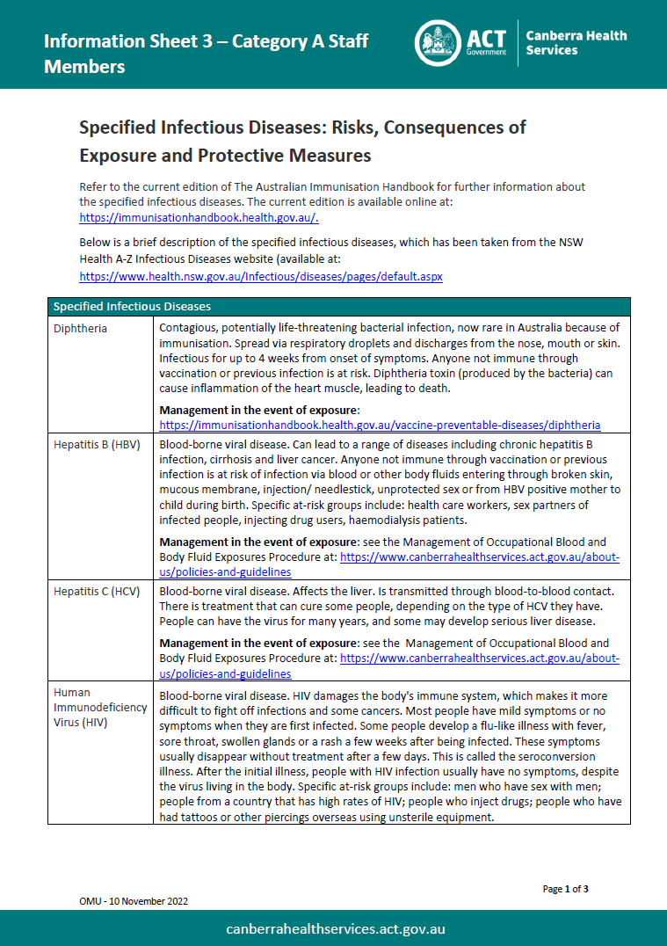
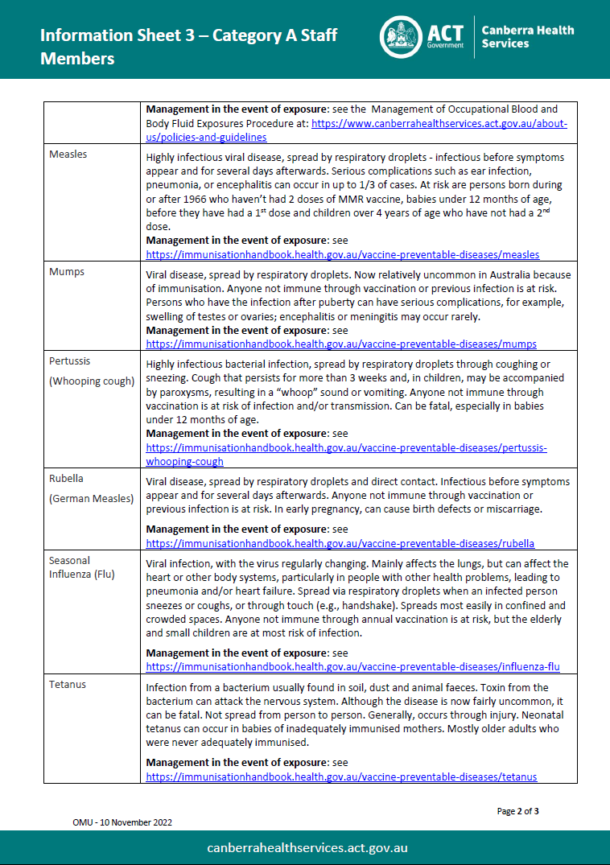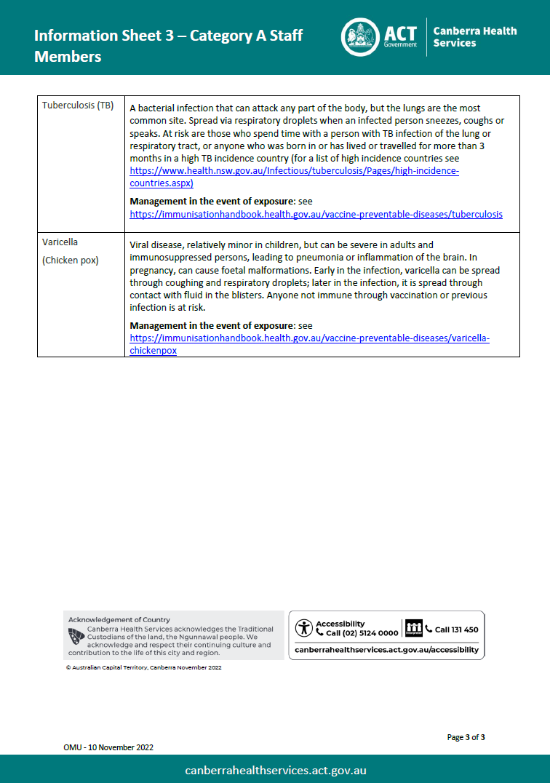

Attachment C – Information Sheet 2: Checklist of Required Evidence of Protection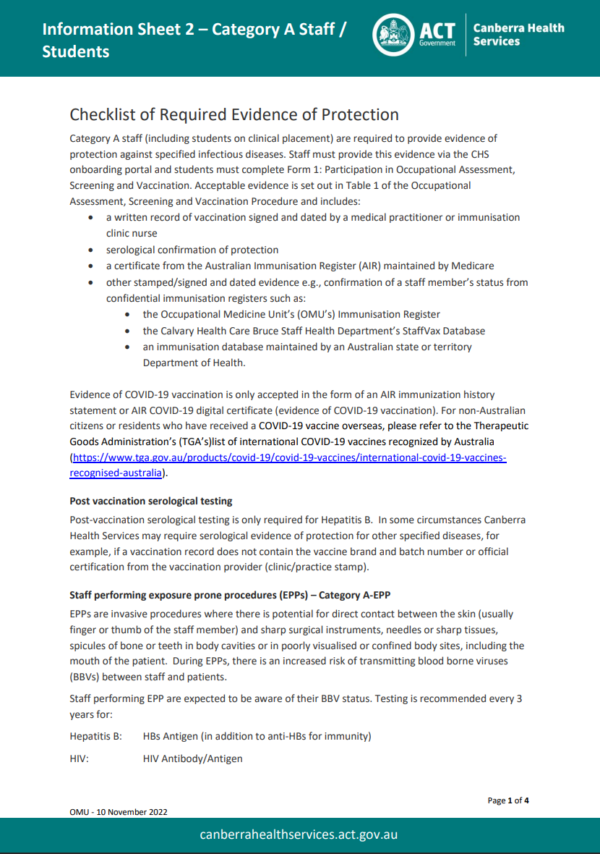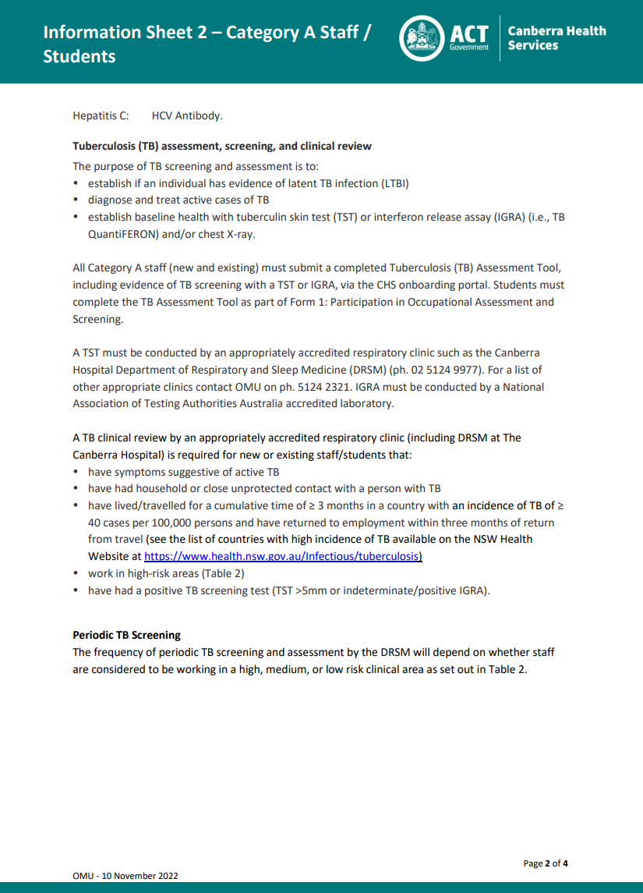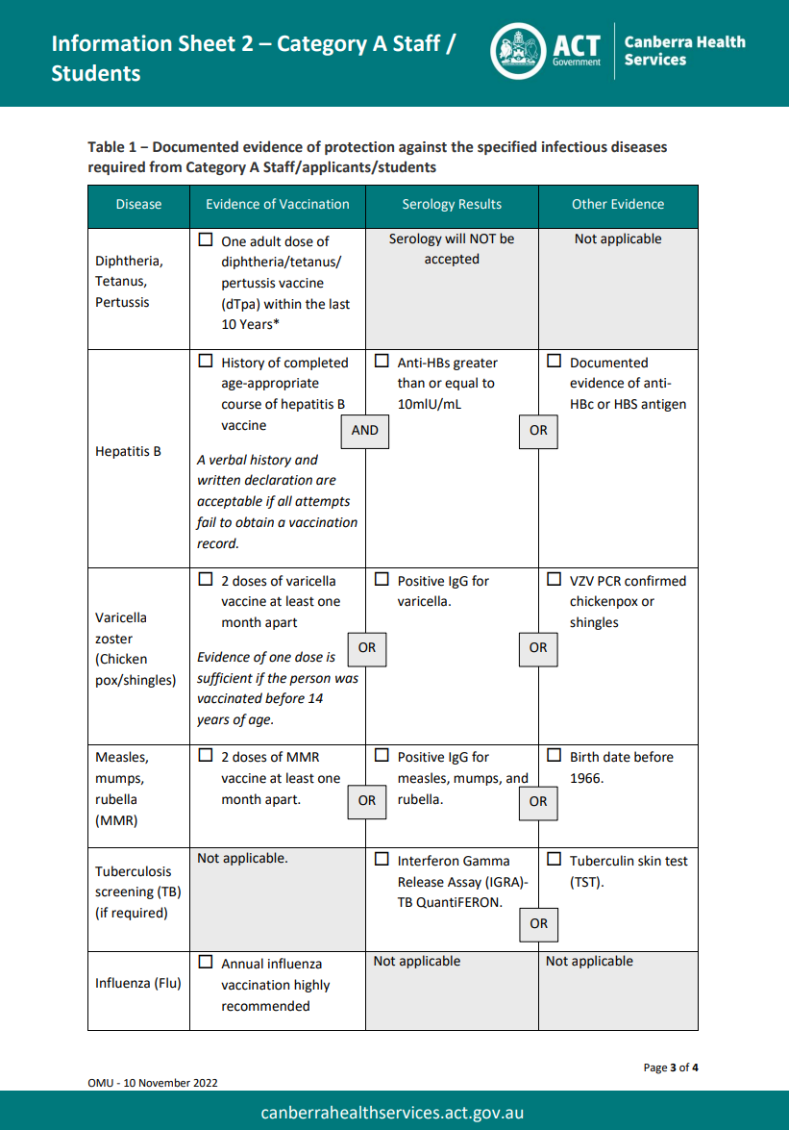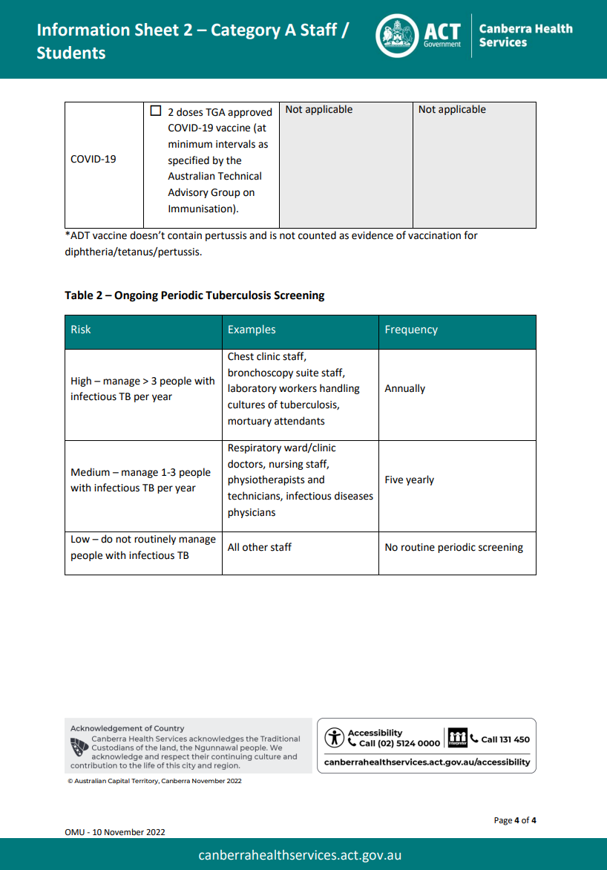

Attachment D – New Volunteer Categories
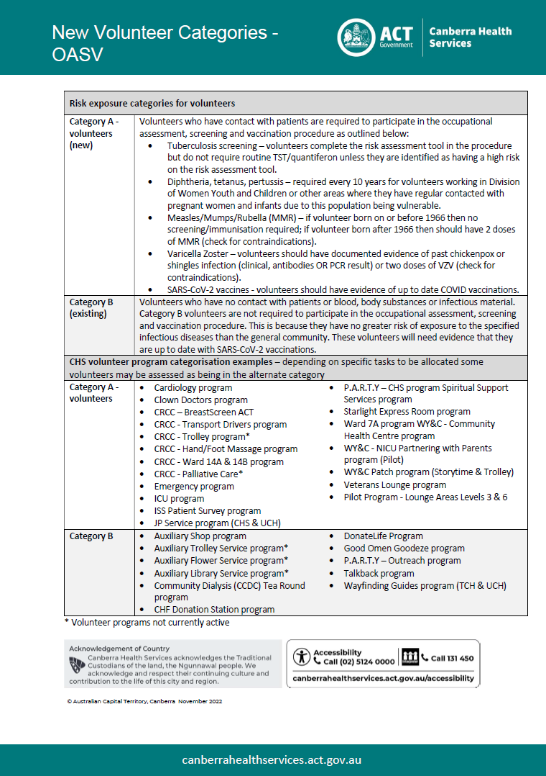
Attachment E – Form 1: Volunteers (Category A)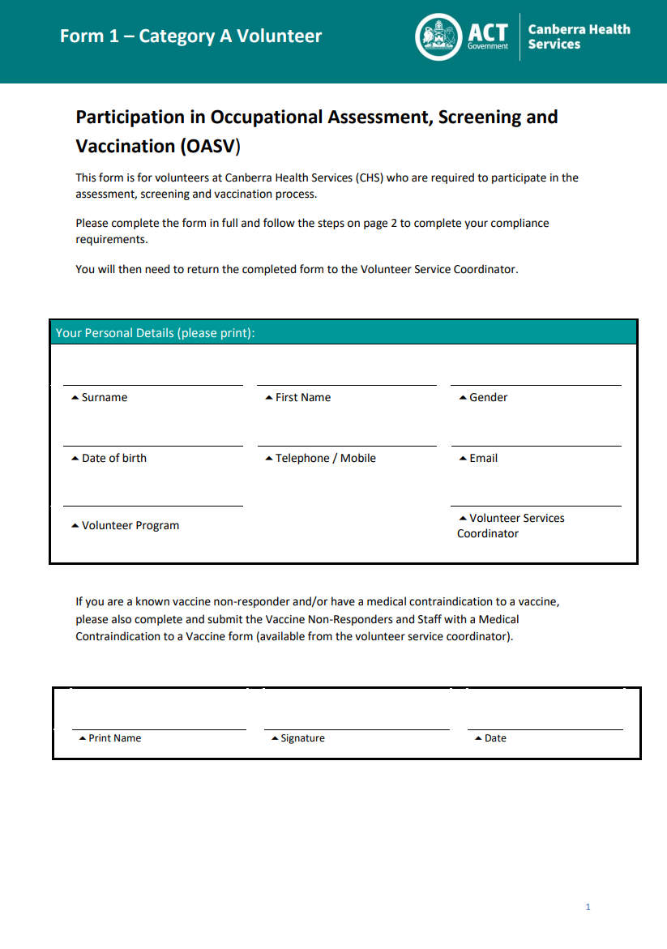 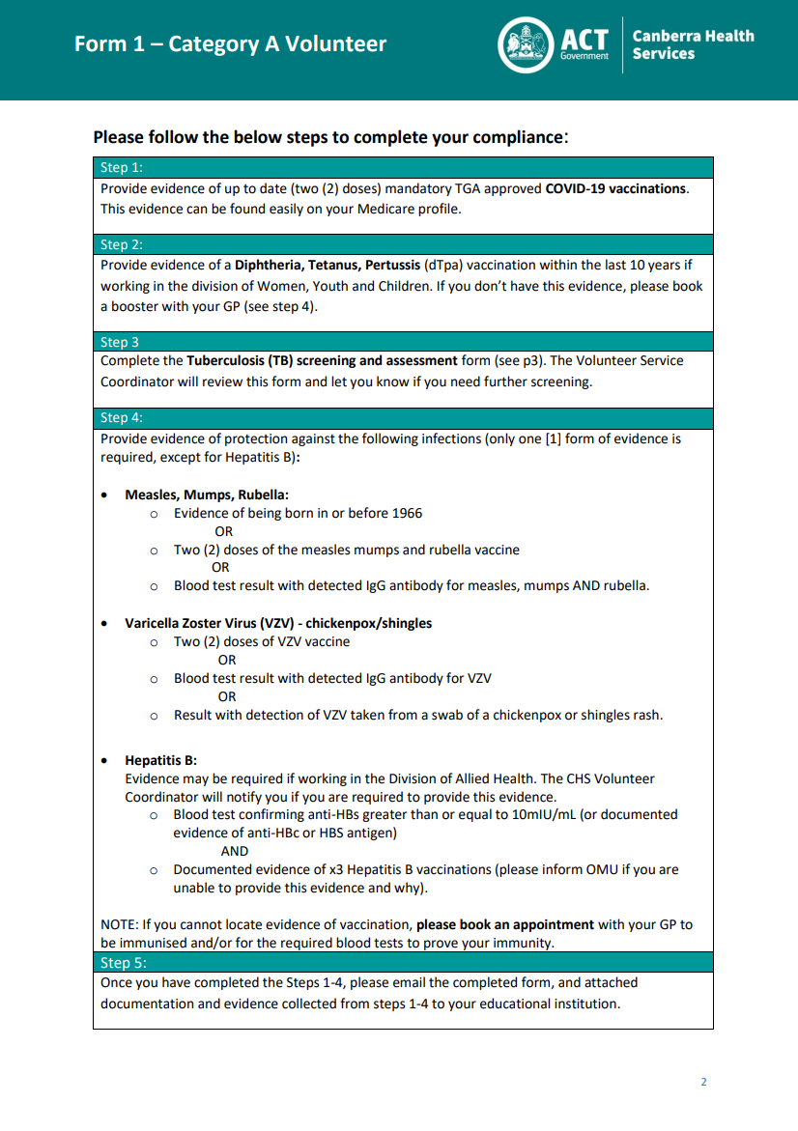

Attachment F – Volunteer Certificate of Compliance
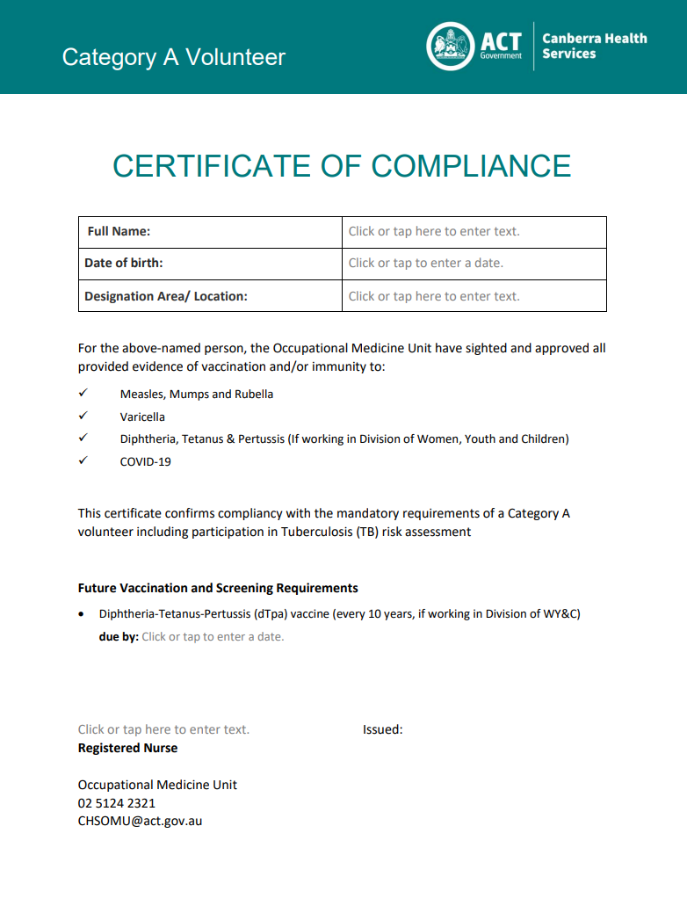

Attachment G – Form 2: Vaccine Non-Responders and Staff with a Medical Contraindication to a Vaccine
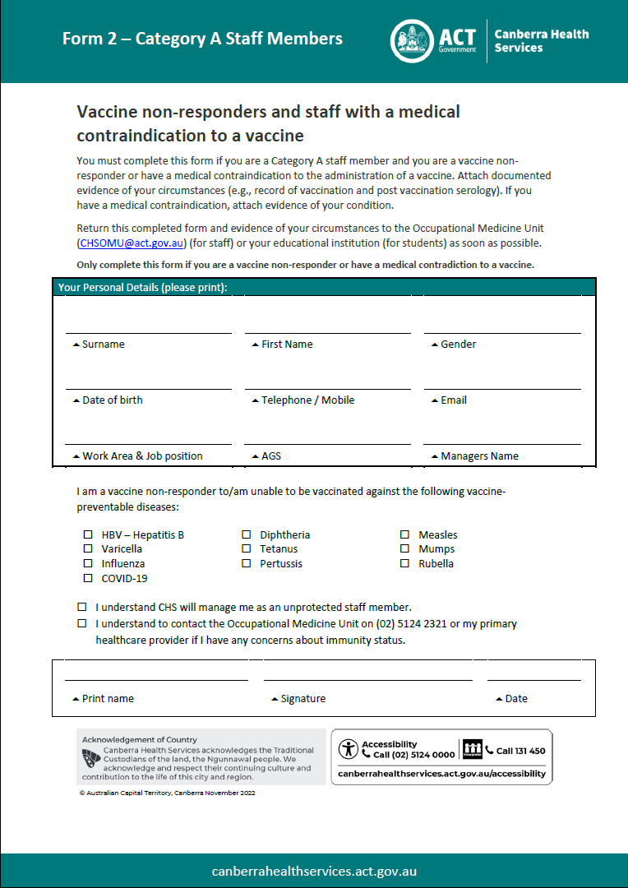
Attachment H – Risk Management Plan for Unprotected Staff – Category A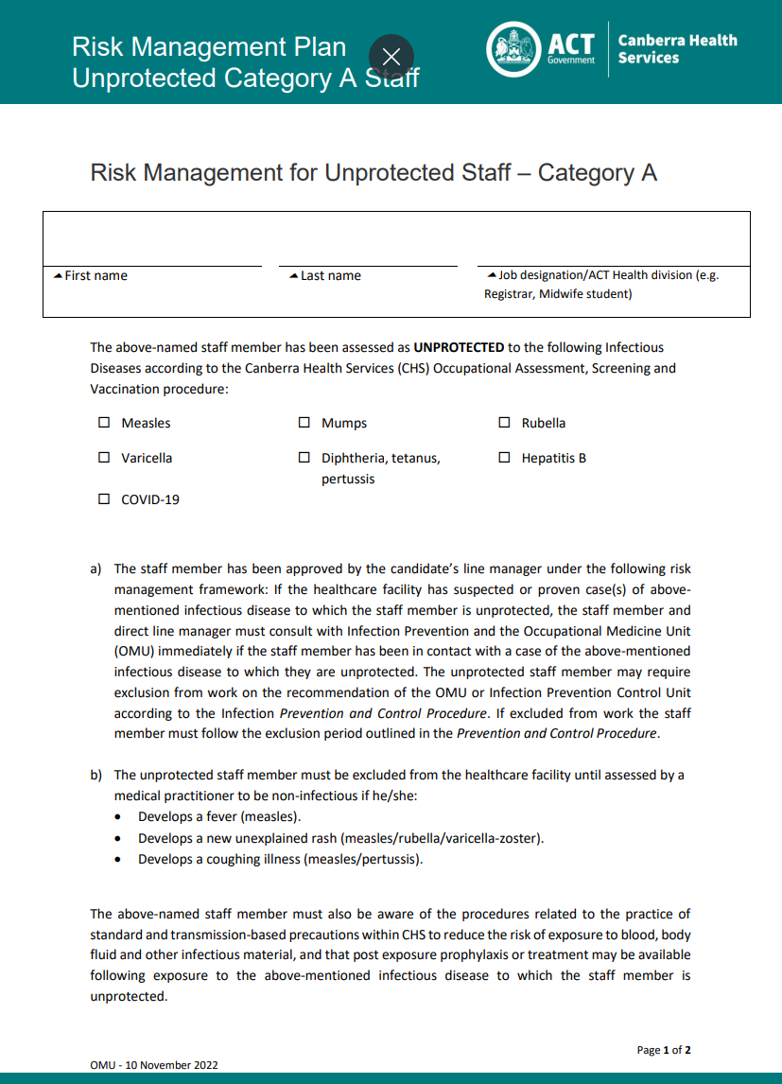 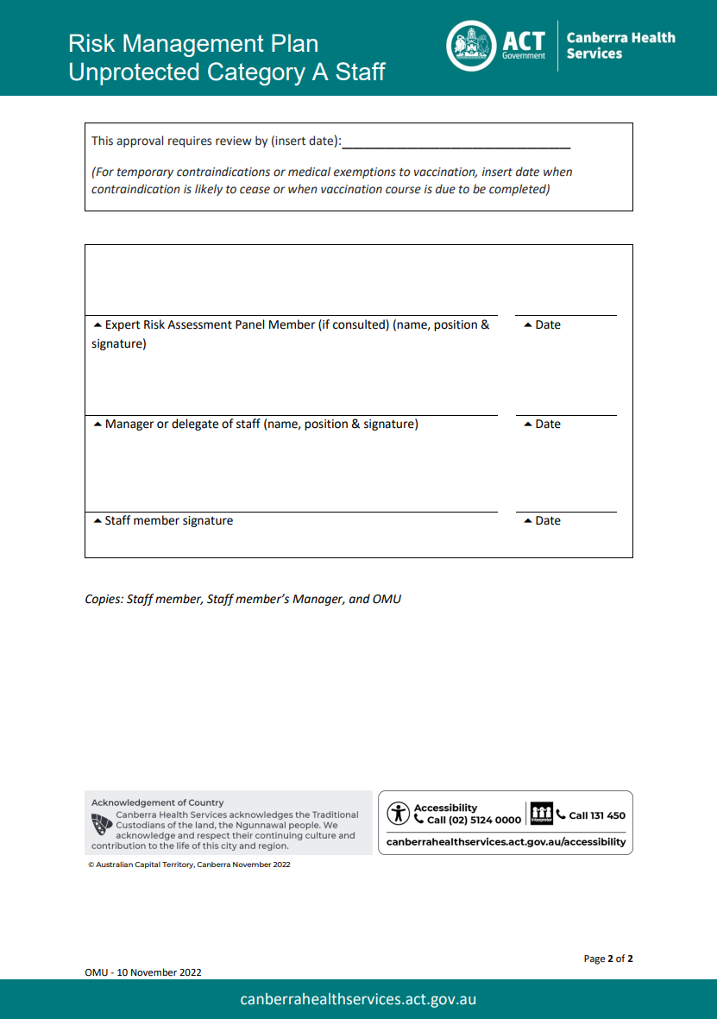

Attachment I – Executive Waiver
