Canberra Health Services
Guideline
Junior Medical Officer Relocation Reimbursement

Contents

Contents 1
Guideline Statement 2
Scope 2
Section 1 – Roles and Responsibilities 4
Section 2 – Reimbursement Process 4
Section 3 – Cessation of employment 5
Section 4 – Salary packaging 5
Evaluation 6
Related Policies, Procedures, Guidelines and Legislation 6
Definition of Terms 6
Search Terms 7
Attachments 7

Guideline Statement

Background
Canberra Health Services (CHS) Network offers a relocation reimbursement payment to eligible Junior Medical Officers (JMO) in accordance with the Relocation Subsidy Reimbursement Guideline – JMOs as stated in the relevant ACT Public Service Medical Practitioners Enterprise Agreement (MPEA).

Key Objective
This document is to provide JMOs with information on how to apply for relocation reimbursement when relocating to Canberra to commence employment with the CHS Network.
Back to Table of Contents

Scope

This guideline applies across all of the CHS Network, including the inpatient facilities at Canberra Hospital, Clare Holland House, North Canberra Hospital (NCH), and University of Canberra and community-based services. It pertains to all JMOs. JMO means Interns, Resident Medical Officers (RMO), Senior RMOs (SRMO), Junior Registrars, Registrars, Senior Registrars and Postgraduate Fellows employed by CHS who have had to relocate to work in the ACT.

Seconded medical officers are subject to other arrangements and are therefore excluded from the terms of this policy. This procedure does not include additional payments for family or other dependants.

In order to claim the relocation reimbursement, a JMO must hold a CHS Network contract of one year minimum in length. If the employee ceases employment with CHS Network prior to their initial one-year contract end date, recovery of money paid will be made in accordance with the Relocation Support clause in the MPEA. The Chief Executive Officer (CEO) or their Delegate (the Senior Director of Medical Officer Support Credentialing Education and Training Unit (MOSCETU)/ Medical Administration NCH) may, in exceptional circumstances, consider not seeking reimbursement of the relocation allowance.

Prior approval from the Delegate is required for relocation subsidy reimbursement. Up to AU$5,500 is available to approved applicants. All applications will be reviewed on an individual basis. The relocation reimbursement will be paid within three months of the finalised claim being submitted for payment.

The set amounts for relocation subsidy reimbursement will be reviewed by the CEO with each new Fair Work Australia endorsed MPEA.
Back to Table of Contents

Section 1 – Roles and Responsibilities

The Delegate (Senior Director MOSCETU/Medical Administration Manager NCH) will be responsible for:
- considering the merit of the application
- providing the rationale for the decision if the application is not approved.
- advising MOSCETU/Medical Administration NCH of decision.

The MOSCETU/ Medical Administration NCH will:
- assist the JMO with claim process
- collate the paperwork for Delegate
- advise the JMO of the outcome of application
- notify the relevant Executive Director of approval
- forward the approved claim to CHS Finance or the NCH Finance Department for processing
- advise CHS Finance Team or the NCH Finance Department when monies are to be recouped from final monies
- update this Guideline.

CHS or NCH Finance Manager/Department will:
- check all relevant documentation has been provided
- complete and attach an accounts payable cover sheet
- forward to the relevant Financial Delegation for approval
- send to Shared Services/NCH Payroll for payment.

The JMO will be responsible for:
- providing the original receipts for claims made
- completing the required paperwork
- lodging the claim within twelve months of the date of commencement
- providing further information/supporting documentation as requested.
Back to Table of Contents

Section 2 – Reimbursement Process

- The JMO provides the original receipts with the completed Relocation Reimbursement Form (Attachment A/D) and Temporary accommodation relating to relocation declaration (Attachment B) to MOSCETU/ Medical Administration NCH. MOSCETU/ Medical Administration NCH staff will record the date of receipt of the JMO application. Claims can be provided in hardcopy to MOSCETU/ Medical Administration NCH or emailed to MOSCETU chstchmosu@act.gov.au ; Medical Administration NCH CHSNCH.MedAdmin@act.gov.au These documents are sent to the JMO in their New Starter Pack, or are available upon request from MOSCETU/ Medical Administration NCH.
- The JMO Manager reviews the claim submitted, verifies JMO’s employment status then submits documentation to the Senior Director of MOSCETU/ Medical Administration Manager NCH, (the Delegate) for consideration.
- The Delegate decides on the claim for relocation reimbursement and returns all documentation to JMO Manager.
- If the Delegate approves the claim, or any part thereof, the amount (in AUD) that has been approved must be clearly stated on relevant documentation.
- If the Delegate does not approve the claim, or any part thereof, they will provide the JMO Manager with the reasons for this.
- The JMO Manager will notify the JMO of the outcome, of their application. If an application has not been approved, the JMO will be given reasons to allow the JMO to present further information, if required.
- The documentation is then forwarded to CHS Finance and Business Intelligence Team/ NCH Finance Department. The Finance Manager, Processing Team checks and if required, documentation is forwarded to the relevant Financial Delegate for approval.
- When approval is received, Finance Manager, Processing Team forwards documentation to Shared Services/NCH Payroll to process payment for the JMO.
Back to Table of Contents

Section 3 – Cessation of employment

If the employee terminates their employment with CHS Network prior to the end of their contract as stated in the EA, a refund of the allowance may be sought and calculated at the 100% if the employee resigns before six (6) months or 50% after six (6) months employment. In exceptional circumstances, consideration may be given to not seeking reimbursement of the relocation allowance. If the employee does not provide a requested refund before leaving CHS Network, all monies will be taken from any accrued leave entitlements.
Back to Table of Contents

Section 4 – Salary packaging

Relocation costs which are not reimbursed by CHS Network may be able to be salary packaged by the employee. Employees can find more information about salary packaging on the HealthHub/NCH Intranet.
Back to Table of Contents

Evaluation

Measures
- Monthly reporting of claims to the Delegate, including timeliness of processing and payments.

Outcome
- All relocation reimbursement will be paid within three months of the finalised claim being submitted for payment.
Back to Table of Contents

Related Policies, Procedures, Guidelines and Legislation

Agreements
- ACT Public Service Medical Practitioners Enterprise Agreement

Legislation
- Public Sector Management Act 1994
- Financial Management Act 1996
Back to Table of Contents

Definition of Terms

Employees - for the purposes of this policy are permanent and long term temporary employees of the CHS Network who are eligible for this provision in relation to the relevant EA. Long term temporary employees are defined in all EAs as persons who are engaged on a temporary basis for a period greater than 12 months but not exceeding 5 years on a full or part time basis.
Employment conditions – employees of the CHS Network are employed under the provisions of the ACT Public Service's Enterprise Agreements, the Public Sector Management Act 1994 (ACT) and Public Sector Management Standards 2006 (ACT).
Junior Medical Officer – includes Interns, Resident Medical Officers (RMO), Senior RMOs (SRMO), Registrars, Senior Registrars and Postgraduate Fellows.
Required documentation - includes original receipts, copy of leasing arrangement, sign
ed statutory declaration, where considered acceptable by the Delegate.
Back to Table of Contents

Search Terms

Relocation, reimbursement, Junior Medical Officer, accommodation, rent, removal, travel
Back to Table of Contents

Attachments

Attachment A – Relocation Reimbursement Form
Attachment B – Temporary Reimbursement Form
Attachment C – List of Items Claimable for Relocation Reimbursement
Attachment D – NCH Relocation Reimbursement Form

Disclaimer: This document has been developed by Canberra Health Services/North Canberra Hospital specifically for its own use. Use of this document and any reliance on the information contained therein by any third party is at his or her own risk and Canberra Health Services assumes no responsibility whatsoever.

Policy Team ONLY to complete the following:
Date Amended | Section Amended | Divisional Approval | Final Approval
27/07/2023 | Complete Review | Suzanne Smallbane, ED Medical Services Group | CHS Policy Committee

This document supersedes the following:
Document Number | Document Name
CHS20/187 | JMO Relocation Reimbursement

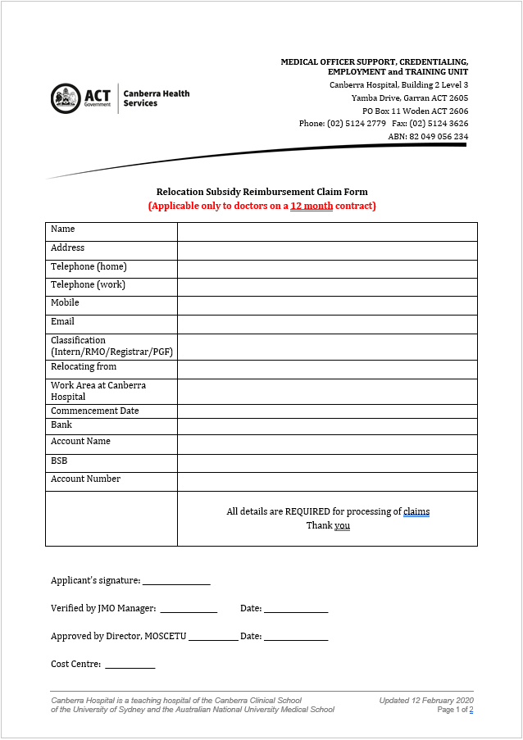
Attachment A – Relocation Reimbursement Form
Sample
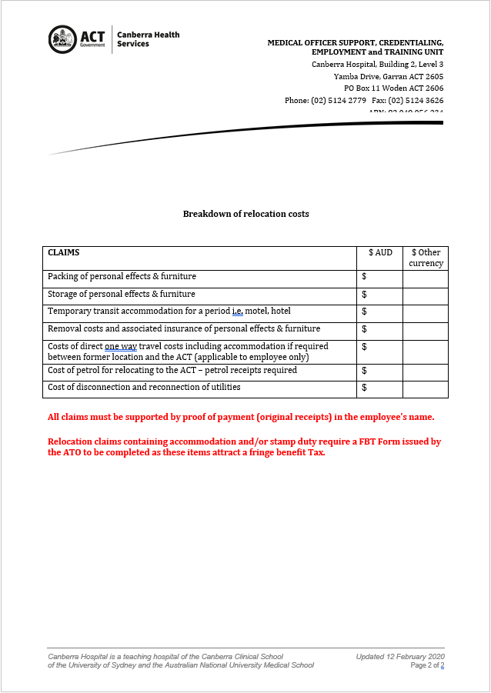
Sample

Attachment B – Temporary accommodation relating to relocation declaration
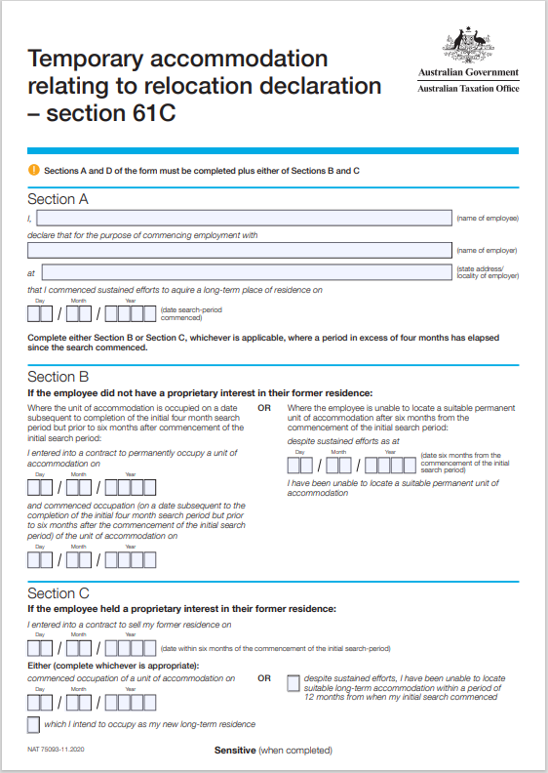
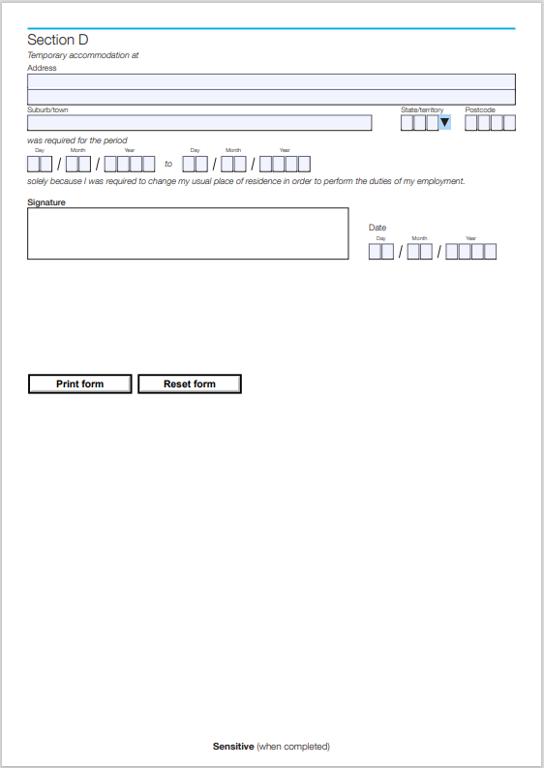
Sample
Sample

Attachment C – List of Items claimable for relocation reimbursement.

The items listed below are neither prescriptive nor exhaustive and the Delegate will use appropriate judgement when determining the reasonableness of each item being claimed by the Junior Medical Officer (JMO) for Relocation Reimbursement.

- Packing and storage of personal effects and furniture.
- Temporary rental accommodation for a period.
- Removal costs and associated insurance of personal effects and furniture.
- Costs of direct one-way travel including accommodation if required between former location and the ACT.
- Cost of petrol for relocating to the ACT as per advice from the Public Sector Management Standards.
- Cost of disconnection and reconnection of utilities.

Attachment D – NCH Relocation Reimbursement Form

Relocation Subsidy Claim Form
(Applicable for doctors on a 12 month contract)

Commencement date: _____________________________________________________________

Personal Details
Name

Postal Address
Telephone (work
Telephone (mobile)
Email Address
Relocating from
Occupation / Classification
Eg: Nurse, Dr, HP
Cost centre / Area of Work
Hiring Manager
Payment Method: Cheque or EFT
Bank
Account Holders Name
BSB
Account Number

Applicant Signature: __________________________________________________________

NCH Claim Category Summary
To enable your claim to be processed efficiently please number your receipts in bottom left hand corner. If more than one receipt is being claimed for the same claim category (i.e. 3 receipts pertaining to rental accommodation) group within the same number.

Receipt Number(s) | Claims category | $ AUD  Total of receipt | Other Currency | Manager’s  Initials
 | Packing of personal effects and furniture
 | Storage of personal effects and furniture
 | Removal costs and associated insurance of personal effects and furniture
 | Unpacking of personal Effects & Furniture
 | Direct one-way travel costs including accommodation when required between the former location and the ACT and/or surrounding districts
Temporary accommodation for up to 6 months until a rental property secured or property purchased.
(Temporary – this term refers to hotel/serviced apartment or similar type of accommodation – it does not imply place of residence and this is limited by the determined ceiling)
 | Disconnection and reconnection of utilities
 | Stamp Duty, legal and professional services associated with sale of the residence at the former location and purchase of a residence or lease on a block of land in the ACT & surrounding districts

Please note the above items are the only claimable relocation expenses.

NCH Endorsement of Claim for Reimbursement

Hiring Manager Recommendation

Total pre-approved agreed amount claimable for all relocation cost as per employment agreement for above staff member $__________

All items and receipts in the claim summary have been reviewed and meet the requirements outlined in the Certified Agreement Guide for Relocation Subsidy Reimbursement.
(All receipts included in claim must be complete including total paid & GST ( GST if applicable))

Total of this Claim $___________

Final Claim YES / NO

_____________________________ _________________________
Supervisor Signature Date

Authorisation of Claim for Reimbursement

Prepared by |  |  | Amount
Entity | Cost Centre | Account | Int trading | Project
600 |  | 713806 | 99 | 9999
Description

Tax Code |  |  | Phone
Payment Approved
Delegates Name |  | Signature
Position Number |  | Date

Please forward all claims for Processing to NCH Finance: APINVOICES@act.gov.au

