Canberra Health Services
Guideline
Care of the Adult Post-Operative Cardiothoracic Patient

Contents

Contents 1
Guideline Statement 2
Scope 2
Section 1 – Preparation of Bed and Bed Area 2
Section 2 – Standard Medications and Infusion Concentrations 4
Section 3 – Assessment and Immediate Post-Operative Care – Handover and Role Allocation 5
Section 4 – Management First 4 Hours Post-Operatively 8
Section 5 – Supportive and Ongoing Care 12
Section 6 – Weaning and Extubation Guidelines 14
Section 7 – Management of Cardiac Arrest in Post-Cardiac Surgery Patients 15
Section 8 – Chest Reopening 22
Evaluation 24
Related Policies, Procedures, Guidelines and Legislation 24
References 25
Definition of Terms 25
Search Terms 26

Guideline Statement

Background
Cardiothoracic surgery includes all surgical procedures that involve the heart, lungs and great vessels. Canberra Hospital performs approximately 200 cardiothoracic surgeries each year, including mechanical and tissue valve replacement or repair, Coronary Artery Bypass Grafts, lobectomies, and aortic repair. The post-operative management and care of patients undergoing cardiothoracic surgery has significant implications on their recovery.
This clinical guideline has been developed in accordance with recent recommendations from American and European Cardiothoracic surgery societies and covers the initial handover, assessment, and immediate care of a post-operative cardiothoracic patient in Intensive Care, as well as their follow up care on the ward.

Key Objective
The purpose of this Guideline is to outline the safe and effective care of patients in Intensive Care after cardiac surgery. The introduction of this guideline will promote a standardised approach to the medical and nursing care of a post-operative cardiothoracic patient in Intensive Care. It does not replace expert medical orders or interventions.

Back to Table of Contents

Scope

The guideline pertains to the nursing staff that have been deemed competent to work in the cardiac bay (i.e. Dark Green coloured step according to ICU nursing pathway) and the treating medical team. Nursing or medical staff not yet competent in the care of post-operative cardiothoracic patient must be directly supervised by a competent practitioner.

This guideline is only for the care of the adult patient following cardiac surgery at Canberra Health Services.

Back to Table of Contents

Section 1 – Preparation of Bed and Bed Area

The cardiac bay bed areas must always be kept ready to accept a patient at short notice.
Bed preparation checklist
Back of the bed:
- Airway basket
- Yankauer sucker and Y-suction catheter (12)
- Guedel airway (size 2, 3, 4)
- Air Cushion Mask (S, M, L)
- PEEP valve
- Eye Protection
- Hudson mask with O2 tubing
- Nasal Prongs
- Arm Board.
- Detergent wipes, Teri wipes and Redi wipes.
- Ensure the ‘patient card’ is on the back wall.
- Check that the Activated Clotting Time (ACT) machine is on and remove old sample tube if present.

Monitor:
- If patient details are available, enter them into the monitor.
- MMS (Multi Measurement Module).
- 3 x pressure cables.
- ECG cable and ECG dots.
- SpO2 cable and finger probe.
- NIBP cuff and cable.
- Temperature cable and probe.

Ventilator:
- Servo ventilator pre-checked with dry circuit, HME filter, closed suction system, sterile water 500mL. Set up on the left side of the patient.
- ETCO2 cable and cuvette.
- Settings: SIMV, FiO2 50%, tidal volume 500mL, rate 12. Leave ventilator in standby mode. Settings will be adjusted at handover.
- Set appropriate alarm settings (adjusted at the time of the handover).
- On top of the ventilator the following items must be placed to allow for easy access for accepting nurse to complete his/her head-to-toe assessment:
- Cuff manometer
- Pre-cut Blenderm tape to secure ICC’s and pacemaker wires
- Gauze
- Neuro torch
- Stethoscope
- Bladder Syringe and Spigot

IV Therapy:
- 2 x IV poles.
- IV Pole No 1: B-Braun syringe pumps x4 /Volumetric pumps x4.
- IV Pole No 2: With PCA, transducer manifold and Tubigrip stocking for pacemaker
- PCA giving set and 50mL syringe.
- Maintenance fluid + additives (5% Dextrose 500mL with 30mmols KCL + 20mmols MgSO4) burette and infusion set.
- Propofol 1g/100mL infusion primed and ready.
- Noradrenaline 6mg/100mL in 5% dextrose, primed and entered into Braun pump. Place Noradrenaline at the top of the tower for easy visualisation.
- Plasmalyte 1000 mL X 2 bags available in bedside trolley.
- Rapid infuser drip set in bedside trolley.
- 4% Albumin X 2 (to be ordered by Pod 3 medical team pre-arrival of patient).
- PCA Fentanyl primed and ready to go.

Suction:
- High wall suction x3 attached to canisters and suction tubing
- High wall suction x1 connected directly to extra-long 3m suction tubing
- Howard Kelly clamps x2.

Bedside trolley:
- To be restocked according to ICU trolley checklist.
- New appropriate battery (AA for Medtronic 5392, 9V for Medtronic 5388) for pacemaker box (spare pacemaker – red boxes in cardiac bay). Ensure that it is not close to a magnet.
- Pathology bag: blood tubes, ABG syringe, ACT tube and 20mL syringe.
- Cardiac hug pillow.
- Slide sheets.
- Bair hugger.

Back to Table of Contents

Section 2 – Standard Medications and Infusion Concentrations

Drug name | Preparation
Glyceryl trinitrate (GTN) | 100mg in 500mL 5% dextrose
Sodium nitroprusside (SNiP) | 100mg in 500mL 5% dextrose
Adrenaline | 6mg in 100mL 5% dextrose
Noradrenaline | 6mg in 100mL 5% dextrose
Dobutamine | 1g in 250mL 5% dextrose
Metaraminol | 40mg in 100mL 0.9% sodium chloride
Milrinone | 10mg in 100mL 0.9% sodium chloride
Levosimendan | 12.5mg in 250mL 5% dextrose
Vasopressin | 20IU in 50mL 0.9% sodium chloride
Insulin (actrapid) | 50IU in 50mL 0.9% sodium chloride

Intravenous Fluid
- 5% Dextrose 500mL with KCl 30mmols and MgSO4 20mmols
- 4% Dextrose 1/5 0.9% sodium chloride 1000mL with KCl 30mmols
- 4% Dextrose 1/5 0.9% sodium chloride 1000mL
- 4% Albumin 500mL x2 (with medical review)
- Plasmalyte 1000 mL bag X 2

Back to Table of Contents

Section 3 – Assessment and Immediate Post-Operative Care – Handover and Role Allocation

- There should always be two nurses, an ICU specialist/senior registrar, Anaesthetist and Cardiothoracic surgeon at the bedside for a full clinical handover of the patient. At least one nurse must be competent in caring for post-operative cardiothoracic patients.
- ‘Hands off handover’ must occur immediately after the patient has been connected to the ICU bedside monitor and the ICU ventilator. Below is a printable template outlining a suggested checklist for handover.

- Ideally, the second nurse should be available for the first hour of stabilisation of the post-op patient.
- When reviewing the role of the accepting nurse and the assisting nurse, keep in mind that a suggested format is for one nurse (the accepting nurse) to attend to the patients’ needs on the right side (i.e. the ventilator side) and one (the assisting nurse) on the left side (i.e. connecting up to monitoring etc).

Role of the ICU Nurses
Accepting Nurse
- Check patient ID.
- Take ventilator off standby and confirm settings with anaesthetist and ICU doctor.
- Connect patient to ventilator.
- Ensure adequate ventilation and ETCO2 trace.
- Receive “hands off” handover from the theatre nurse, anaesthetist and the surgical team. Confirm all infusions co-signed.
- Assess patient airway, ensure ETT secure, check position and cuff pressure.
- Assess patient’s breathing, auscultate chest.
- Secure ICC connections with pre-cut Blenderm tape, drains and ICC tubing.
- Inspect graft harvest site – check peripheral pulses.
- Don gloves and check epicardial pacemaker details:
- Check pacing wires are secured in the connector block and the lead pins are tight in the pacemaker.
- Secure pacing wires to the patients’ chest using gauze and tape (see below).

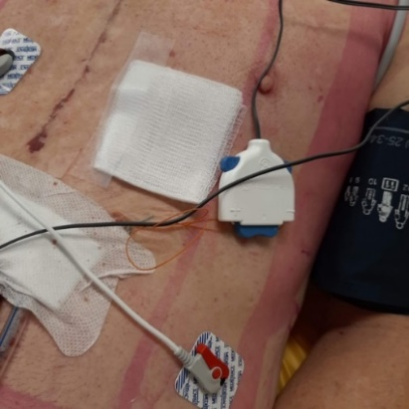 | 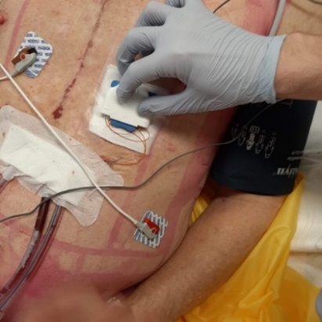 | 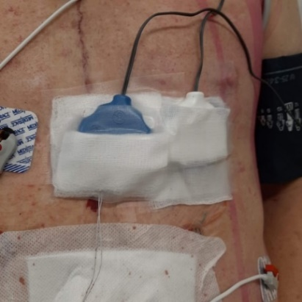

- Check correct polarity of lead pins, blue to blue and white to white.
- Check that the leads are connected to the correct chamber, atrial to right of the patient’s sternum, ventricular to left of the patient’s sternum.
- Note the original epicardial pacemaker settings from the anaesthetist and optimise the settings in accordance with ICU medical team. Usual settings:
- DDD mode
- Rate at 70-90bpm
- AV delay at 170 mS (default – based on rate set on pacemaker)
- Atrial sensitivity at 0.4 – 10mV. Adjusted according to patients’ sensing threshold
- Atrial output at 5-10 mA
- Ventricular sensitivity at 0.8-2.0mV
- Ventricular output at 5-10 mA
- Other common modes used in ICU are DDD, AAI and VVI. Pacing modes must only be changed after consulting with ICU specialist or senior registrar.
- Threshold testing to be done later if the patient is haemodynamically stable (see Temporary Epicardial Pacemaker Clinical Procedure).
- Check Battery icon and ensure spare new battery available.
- For details of epicardial pacing management and troubleshooting, please refer to Clinical Procedure: Management of a patient with Temporary Epicardial Pacing.
- If the patient does not require pacing, perform 12 lead ECG 12/24.
- Check with medical team as to regularity of Cardiac output studies.
- Aspirate nasogastric tube and spigot. Aspirate 4/24.
- Complete full head to toe assessment of patient and document all observations.

Assisting nurse
- Attach ICC and UWSD to suction and turn the suction on to prescribed amount
(-20cmH2O or -10cmH20). Note volume in drain.
- Receive ‘hands off handover’ from anaesthetist and theatre nurse.
- Connect ECG, ART, CVP, PAP and SpO2 modules and cables to bedside monitor. Ensure patient admitted and ‘6-waves ICU’ selected on monitor and pacing ON in ECG.
- Zero and level pressure transducers and modules.
- Remove OT monitoring from patient.
- Check drainage from ICC and document. Ensure admitting nurse and ICU team aware of output.
- Connects pre-made Noradrenaline and maintenance fluid and PCA.
- Check UWSD for swing, bubbling and drainage (volume and drainage) and document all observations.
- Check Pulmonary artery (PA) catheter
- Check position of PA catheter as per black markings at insertion site (usually between 50-60 cm) and record on MetaVision.
- Ensure wedging syringe is unlocked, has no air and is secured to patient’s chest.
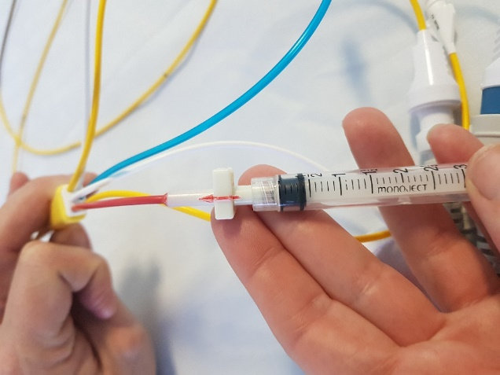
- Check that PA trace on monitor is a pulmonary artery trace.
- If required, connect PA to HaemoSphere monitoring.
- Check R cubital fossa cannula patent and resuscitation fluid attached. Used as needed.
- Apply warming device (e.g. Bair hugger) if temperature is less than 35oC.
- Attend to pathology - ABG, UEC, LFT, CMP, FBC, COAG.
- Performs bedside ACT and communicates results to accepting nurse and the medical team to determine if additional Protamine is required.
- Check alarms are on and appropriate limits are set.
- Check all infusions are correctly labelled, ordered and running via appropriate lumens at desired rates. Move Braun pumps being used to the station on patient’s right side. Discard infusions that are not required. Ensure all lines are tidy and labelled correctly
- Empty IDC bag (do not include in total fluid output), record hourly urine outputs thereafter.
- CXR: check with ICU medical officer that CXR has been requested via Clinical Portal and that radiology has been paged, confirm position of all lines after CXR done.
- Document all observations on MetaVision.
- Bring the accompanying family in to visit when appropriate.

Role of The ICU Registrar
- Fill the Albumin order and PCA charts before patient’ arrival.
- Receive ‘hands off handover’ of the patient along with ICU specialist/ senior registrar and nursing staff.
- Assess patient according to the TCH ICU post-operative cardiothoracic management pathway.
- Admit the patient to MetaVision. Order all required medications and infusions and document management plan according to ICU specialist.
- Order chest X-Ray and pathology requests (FBE, UEC, Ca, Mg, PO4, LFT, Coagulation profile) and additional tests when appropriate.
- Review chest X-Ray once done. Confirm and document line positions (ETT, lines, NGT position).
- Monitor the progress of the patient meticulously and assist bedside nurses with troubleshooting.
- Look for early post -operative complications such as shock, cardiac tamponade, severe coagulopathy and high drainage output.
- Escalate concerns to the ICU specialist/ senior registrar.

Back to Table of Contents

Section 4 – Management First 4 Hours Post-Operatively

Aim for hemodynamic stability and work towards wake, wean and extubate.

Airway and Breathing
- Assess and document position of ETT at teeth and on CXR.
- Check cuff pressure each shift and more regularly if required.
- Assess patient ventilator settings which are routinely set at:
- Mode: SIMV PRVC
- FIO2: 50%
- TV: 6-8 mL/Kg
- RR: 12 per min
- PEEP: 5 cmH2O
- PS: 10 cmH2O
- I Time: 1.2 Sec
- Flow trigger: 1.6 L/min
- Check and set all ventilator alarms.
- Airway pressure limit – 10cmH2O above patient’s airway pressure to a maximum of 35 cmH2O.
- Respiratory rate – 10 bpm above patient’s respiratory rate to a maximum of 35 per minute.
- Apnoea – alarm on, set at 20secs.
- Aim to wean FiO2 and change from PRVC to Pressure Support when appropriate.
- Check ABG on return from OT, then hourly for 4 hrs and when clinically indicated.
- Perform suctioning as clinically indicated.
- All patients that are haemodynamically stable with no bleeding can be considered for extubation in the first 6 hours of ICU admission.

Circulation:
- All observations documented hourly and any concerns must be communicated to ICU medical staff immediately.
- Limb observations of the graft site limb should be performed and documented hourly for 4 hours and then 4th hourly.
- Aim MAP 65-75 mmHg or any targets suggested by ICU medical staff or cardiothoracic surgical team. Common targets include the following:
- Post CABGs aim MAP 70-80
- Post valve surgery aim Systolic pressure 100-110
- Fluid resuscitation with Plasmalyte or 4 % albumin as required.
- Commence vasopressors (Noradrenaline) after adequate optimisation of preload and discussion with ICU medical staff.
- All the cardiac output study results to be discussed with ICU medical staff for interpretation and commencement of vasopressors/inotropes.
- Check ICC drainage 15 minutely for first hour then hourly. Inform ICU Registrar and Cardiothoracic Registrar if drainage volume is >200mls in the first hour or >100mls per hour for two consecutive hours thereafter.
- Routine ABG/formal bloods:
- ABG’s – 1 hourly for first 4 hours then PRN
- Formal bloods on admission, 6 hours post admission then AM

Pulmonary Artery Catheter (PAC):
- Check position of PA catheter at insertion site and on CXR (1-2cm left of mediastinal border) and document length in MetaVision.
- PA alarms always on: set systolic and diastolic alarms 10mmHg above patient’s pulmonary artery systolic and diastolic to detect inadvertent catheter wedging.
- Normal pulmonary pressures may differ between patients and must be maintained depending on their condition. Those with stenosis, pulmonary disease or post valve surgery may have elevated pulmonary pressures.
- Use Pulmonary Artery Diastolic Pressure (PADP) as a measure for preload rather than Pulmonary Capillary Wedge Pressure (PCWP).
- Wedging syringe must be emptied of air and remain attached and unlocked. PCWP to be performed only by the ICU specialist. Nurses are not to wedge.
- Perform cardiac output studies on return from OT as instructed by the treating medical team. Please refer to PAC Guideline for further clarification.
- A mixed venous blood gas, obtained from PAC, may also be requested alongside cardiac output studies.
- Repeat as requested by ICU specialist or when there is a change in clinical status, inotropic requirements or fluid status to assess contractility, systemic vascular resistance and stroke volume.
- Regularly observe trace to ensure the catheter has not migrated and become wedged.
- If trace indicates spontaneous wedging or will not wedge, only appropriately accredited staff are able to “float” PAC into position. A wedged PAC is an emergency and requires immediate intervention by ICU specialist.
- THE PULMONARY ARTERY CATHETER MUST BE TRANSDUCED AND MONITORED AT ALL TIMES.

Other supportive measures:
- Position patient to 30 degrees upright
- Sedate as required with IV Propofol and boluses as required until patient stable, allow patient to wake to assess neurological status.
- Assess pain level; commence Fentanyl PCA (over-ride bolus if required to control pain and maintain BP parameters) remembering that pain is often under-treated in the post-operative cardiac patient.
- Commence PRN antiemetic alongside analgesia.
- Commence IV maintenance according to body weight (documented on perfusionist’s chart.
- Actively warm patient to 36 degrees with Bair Hugger.
- Monitor and replace K+ as per ICU protocol. K+ target is 4.5 – 5mmol/L (prescribed on MetaVision under PRN medications).
- If creatinine >150umol/L remove K+ from maintenance fluid.
- Hourly ABGs for first 4 hours, adjust ventilation accordingly and wean to Pressure Support ventilation as soon as possible.
- Check all medications and infusions have been prescribed and signed by the ICU medical team.
- Extubate according to Cardiothoracic extubation criteria (see Section 6).
- Complete pressure area care 2nd hourly and document repositioning on MetaVision.

Heart Rate:
- 12-lead ECG post op, when rhythm changes or when ST segment alarms sound. Once stable, ECGs are to be done daily at 0600, unless patient being paced.
- Maintain heart rate 70 - 90 bpm or as stipulated by the medical team.
- Check ST segment settings daily and ensure ST alarms are turned on.
- Monitor electrolytes and replace as indicated keeping MgS04 >1.0mmol/L and K+ 4.5 to 5.0mmol/L.
- If patient is paced, check connections, rate, mode, AV delay, and sensitivity and output thresholds. Document settings on pacemaker observation chart. See Epicardial Pacing Guideline for further information. If patient is paced and haemodynamically stable, an ECG can be done by turning the rate on the pacemaker down slowly then doing a 12 lead ECG to determine the patient’s underlying rhythm. Ensure medical team are notified of this plan in advance. To check patients underlying rhythm, please refer to CHS Clinical Procedure: Management of a patient with Epicardial Pacing.
- If pacing wires not in use, wrap in gauze and secure. For more information see CHS Clinical Procedure: Management of a patient with Epicardial Pacing.

Neurological status:
- Assess GCS and document.
- Report any changes from pre-operative status to ICU medical team immediately. Incidence of embolic stroke after cardiac surgery is increased in older patients and those with multiple comorbidities.
- Patients presenting post-operatively with new confusion, agitation, delirium, post-pump psychosis or combativeness should be assessed by the ICU medical team.

Limb Observations:
- Hourly circulation observations on legs and/or arms graft sites.
- Document limb colour, warmth, movement, strength, capillary return and sensation MetaVision.

Chest Drains:
- Mediastinal drains should be secured to the patient and all connections secured with clear Blenderm tape.
- Connect the chest drains to the Under Water Seal Drain with suction of -10cmH2O–20cmH20 (as prescribed).
- Observe for oscillation, bubbling and drainage. Document findings in MetaVision.
- If drainage exceeds 100mL/hr, inform ICU and Cardiothoracic teams.
- Monitor chest drains for any significant decrease in output and/or presence of clots. Accompanied by haemodynamic instability, this could be a sign of cardiac tamponade, which is an emergency situation.
- Chest drains can be removed on day 1 provided drainage is less than 100mls over 4 hours. Removal must be documented on MetaVision by the Cardiothoracic team.
- Drains must be removed with 2 RNs - one pulling out the drain, the other assisting with pinching the wound shut and applying steri strips. An occlusive dressing is applied to site. Refer to CHS procedure Intercostal Catheter Management.
- CXRs must be performed immediately post ICC removal and reviewed by the Medical Officer.

Fluid Input
- Maintenance fluid at 1mL/kg/hr of:
- 5% Dextrose with 30mmol KCL & 20Mmol MgSO4
- 4% Glucose & 0.18% Sodium Chloride with 30mmol KCL
- 4% glucose & 0.18% Sodium Chloride solution
- Fentanyl PCA for analgesia. Clinician override bolus to be used to treat pain until the patient is able to cooperate and respond. Document boluses on pain management tab on MetaVision.
- Propofol infusion, decrease rate on return from OT, aiming for extubation within 4-6 hours.
- Administration of fluid boluses is based upon on patients’ clinical condition and hemodynamic parameters and end organ perfusion.

Fluid Output
- Measure and document hourly urine output. Maintain at 0.5mL/kg/hr to 1.5mL/kg/hr. Notify ICU medical team if urine output drops.
- NGT on free drainage, removed on extubation.
- Hourly ICC output.
- Monitor fluid balance hourly.

Analgesia
- Assess patient’s pain and sedation score and aim for score of 0-1 (RASS scale) to wake, wean and extubate.
- The Numerical Rating Scale (NRS) (1 to 10) can be used for the awake patients in ICU who can self-report their pain.
- Administer adequate analgesia to keep patient comfortable and to enable adequate deep breathing and coughing.

Back to Table of Contents

Section 5 – Supportive and Ongoing Care

Diet
- NBM till extubated then ice to suck 4 hours post extubation.
- Day 1 patient commenced on light diet.
- Day 2 commenced on regular diet as tolerated.

Positioning
- Position patient head up at least 30 degrees after CXR.
- Patient may be turned post op if stable and no bleeding.
- Pressure area care 2nd hourly, including heels.
- Once normothermic, patient to have a post op wash.
- Patient must support sternal wound when moving or coughing by folding arms across chest and limit arm movements to maintain sternal stability.

Wound Care
- Sternal wound and graft sites dressed with hydrocolloid dressing. Dressing to remain intact. If wound oozing, reinforce existing dressing, do not remove unless directed by cardiothoracic team.
- Bandages and drains on leg graft sites removed day 1 and where prescribed. Limb observations must be performed and documented.
- All line dressings to remain dry and intact.

Intravenous Lines
- All lines to remain dry and intact. Dressings to be changed as per unit policy.
- Arterial line: remove prior to transfer to ward (day 1 or day 2) if ABGs are satisfactory and after all routine bloods have been taken.
- Pulmonary Artery Catheter and protective sheath/shield are removed Day 1 if no longer required. Cap introducer sheath.
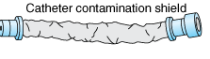
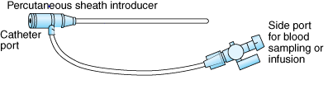
- The introducer sheath to be removed when it is not required within 12 hours of removal of PA catheter.
- Central Venous Catheter: to be removed before day 5.
- Peripheral lines: not to be used for more than 72 hours as it increases significant risk of superficial thrombophlebitis.
- All line removal requests must be documented.

Physiotherapy
- PRN suctioning.
- Patients who are haemodynamically stable and have no bleeding can be considered for extubation 4-6 hrs post-operatively.
- Once extubated, encourage deep breathing and coughing 2nd hourly to re-expand the lungs and prevent atelectasis.
- Always encourage patient to splint sternum with towel when coughing and moving to prevent sternal breakdown.
- Provide patient education on mobilising to protect sternal wound (i.e, not using arms to move themselves).
- Patient to sit out of bed and mobilise at 0500 on day 1 in preparation for morning ICU and cardiothoracic ward round. If patient remains intubated/sedated/unstable, reassess mobility requirements.

Back to Table of Contents

Section 6 – Weaning and Extubation Guidelines

- Aim to wake, wean and extubate within 6 hours of admission to ICU.
- If patient not for early extubation, cardiothoracic or ICU team to document this and handover to nursing staff. Reasons for delayed extubation include difficult or prolonged surgery or haemodynamic instability.
- All extubation decisions to be made by ICU senior registrar/ ICU specialist and documented in MetaVision.

RN checklist for readiness to wean:
- Patient is reversed from neuromuscular blockade and anaesthetic agents. Must be able to:
- Rouse easily
- Obey commands – mobilise all limbs as applicable
- Lift head off bed for at least 5 seconds.
- Analgesia is optimised to achieve adequate deep breathing and spontaneous cough.
- Patient is hemodynamically stable
- HR and BP are within ordered parameters
- Bleeding is controlled (drain output <100 mL/Hr)
- Stable perfusing rhythm (intrinsic or paced).
- Temperature: >36.2° and < 38.2°.
- Respiratory parameters and mechanics:
- RR<20 per min
- SPO2 ≥ 92% on FIO2 ≤ 30%
- P/F ratio ≥150 on ABG
- PaCO2 30-50 mmHg
- Minimal ventilatory pressure support – 5-8cmH20 and PEEP 5-10cmH20 (note: morbidly obese patients may require higher PEEP until extubation).
- Strong spontaneous cough.
- CXR noted.
- Acid base status: pH>7.30, BE ≥ -5.

If above criteria are met, RN to notify ICU medical team and decision to extubate is led by ICU senior registrar/ICU specialist.

Signs and symptoms of failure to wean
- RR< 7 or >30 per minute.
- SPO2<92% OR PaO2<60 mmHg on 35% FIO2.
- Marked use of accessory muscles, paradoxical breathing.
- Increase in HR and BP.
- Marked distress, subjective dyspnoea, agitation and sweating.
- Significant ECG changes (ischaemia, dysrhythmia), chest pain.

Contraindications to early extubation
- Inability to wean per protocol.
- SPO2, ABG and RR outside the set parameters.
- Change in patient’s neurological condition.
- Haemodynamic instability.
- Clinical condition necessitates increase or change in type of ventilatory settings.

Back to Table of Contents

Section 7 – Management of Cardiac Arrest in Post-Cardiac Surgery Patients

- Identification of cardiac arrest:
- ECG shows Ventricular Fibrillation, Ventricular Tachycardia or asystole
- For PEA and pulseless VT: Pulseless arterial, central and pulmonary pressure waveforms, loss of ETCO2

Alert:
Call cardiac arrest immediately and follow cardiac life support algorithm below.

- PEA may appear as sinus rhythm on the ECG. Loss of output is indicated by absence of arterial pressure trace. In the absence of a pulse, call cardiac arrest immediately and follow below algorithm.
- The first responder should immediately call for help and initiate the cardiac arrest protocol.
- In order to minimise delay to reopening in the event that initial attempts to restore spontaneous circulation are unsuccessful, preparation for re-sternotomy should ideally commence immediately in the event of confirmed circulatory arrest, or as soon as personnel are available to do so.
- Emergency re-sternotomy should form an integral part of the cardiac arrest protocol up to the 10th post-operative day.
- Beyond the 10th post-operative day, a senior clinician should decide whether emergency re-sternotomy is to be performed.
- An emergency re-sternotomy should be completed within 5 minutes from the time of the cardiac arrest.
- In deteriorating patients with suspected or proven pericardial tamponade, a re-sternotomy should be considered prior to transporting to the operating theatre.

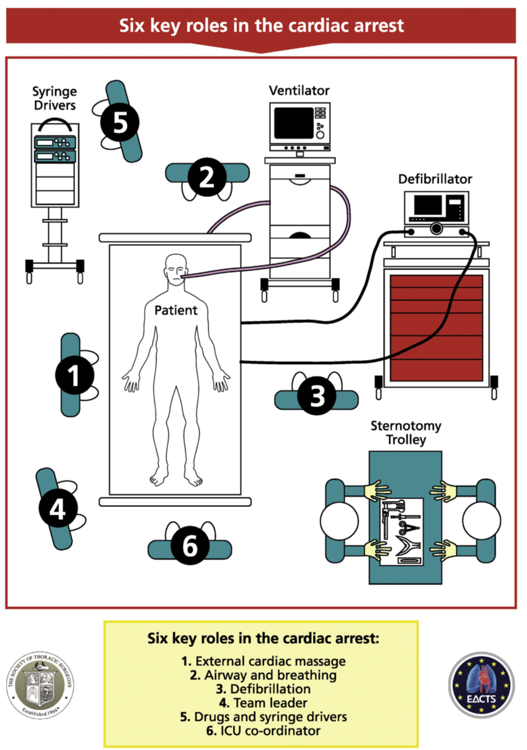

6 Key Roles in the Cardiac Arrest

Note:
These roles are allocated at the beginning of each shift.
Nursing staff should be familiar with the expectations of each role and be competent in performing all relevant skills.

Requirement to be allocated a CALS role:
- Current ALS
- Light Green, Dark Green or Blue coloured step.

Role 1: External Cardiac Massage (ECM)
Role 2: Airway and Breathing
Role 3: Defibrillation
Role 4: Team Leader
Role 5: Drugs and Syringe Driver
Role 6: ICU Nurse Coordinator

Role 1 External cardiac massage (ECM) (Chest Compressions)
 | External Cardiac Massage (ECM)
Check | - Rhythm:  - VF or pulseless VT: Delay ECM up to 1 min for defibrillation.  - Asystole or severe bradycardia: Delay ECM up to 1 min for epicardial pacing (DDD at 80-100 per min with maximum output).  - Communicate with the team leader before commencing ECM.
Perform | - Chest compressions at a rate of 100-120 beats/min.  - Perform ECM at the middle of the sternum with your arms straight.  - Aim for the systolic blood pressure (SBP) > 60 mmHg.
Notify | - To the team if you are unable to achieve SBP>60 mmHg.

Alert:
External cardiac massage may be ineffective in patients with pericardial tamponade, tension pneumothorax and massive haemorrhage.
Automated external compression devices should not be used on cardiac surgical patients.

Role 2 Airway and Breathing
 | Airway and Breathing
Check | - Position of the Endotracheal tube and its patency.  - Palpate trachea for any deviation.  - Look for bilateral chest expansion and bilateral breath sounds.  - ETCO2 trace and levels (will be low in cardiac arrest).
Perform | - Increase FIO2 to 100%, Reduce PEEP to 5 cmH2O.  - Change to Bag/Valve Ventilation with 15 Lit/Min O2 with PEEP valve dialled to 5 cmH2O.  - Assess for lung compliance.  - Return back to ventilator if no concerns identified on Bag/Valve ventilation.  - End-tidal waveform capnography should be used to confirm correct position of the endotracheal tube.  - If a tension pneumothorax is suspected, a needle decompression or finger thoracostomy is to be performed immediately, followed by a chest drain.  - Endotracheal intubation should not delay attempts to address reversible causes nor chest reopening.
Notify | - Team of any concerns.

ROLE 3 Defibrillation
 | Defibrillation
Check | - Connect the external defibrillator pads immediately and check/confirm the rhythm.  - Check availability of Internal pads and its connector (bottom drawer in chest re-opening trolley).
Perform | - In ventricular fibrillation or pulseless ventricular tachycardia 3 sequential shocks should be given without intervening CPR.  - During emergency sternotomy, connect the internal pads to the defibrillator via a connector.  - Use 20J-40J for defibrillation with internal pads.
Notify | - Inform the team for check and charge for the rhythm check.

Role 4 Team Leader
 | Team Leader
Check | - Check if ICU specialist and cardiothoracic surgeon is contacted immediately.  - Availability of the chest re-opening trolley, defibrillator and medications.  - Check availability of internal pads and its connector (bottom drawer).  - Check the rhythm.
Perform | - Allocate a person to each 5 other roles.  - Ensure the protocol is being followed (attached with Team leader card).  - In ventricular fibrillation or pulseless ventricular tachycardia  - 3 sequential shocks should be given without intervening CPR  - Advice for emergency re-sternotomy 3 failed attempts at defibrillation.  - Start external cardiac compressions as per ARC ACLS protocol.  - Give Amiodarone 300 mg in 20 ml Syringe.  - Continue external cardiac compressions until re-sternotomy.  - In Asystole or severe bradycardia  - Check the epicardial pacing wires and setting.  - Set to DDD at 90 bpm at the maximum atrial and ventricular output voltages.  - If no output, advise for emergency sternotomy.  - Start external cardiac compressions as per ARC ACLS protocol.  - Consider Atropine 3 mg via a central line, Adrenaline 50 micrograms.  - Continue external cardiac compressions until re-sternotomy.  - In Pulseless electrical activity  - Check the epicardial pacing wires and setting.  - If the pacemaker is connected and functioning, then briefly turn the pacemaker off to exclude underlying ventricular fibrillation.  - Advice for emergency re-sternotomy 3 failed attempts at defibrillation.  - Start external cardiac compressions as per ARC ACLS protocol.  - In cardiac arrest with an IABP in place, it should be set to pressure trigger  - Do not delay external cardiac compressions for more than 1 minute for defibrillation or pacing.
Notify | - Inform the team for check and charge for the rhythm check.

ROLE 5 Drugs and Syringe Driver
 | Drugs and Syringe Driver
Check | - Check the security and position of the central line.  - Identify free central venous line access (preferred over peripheral).  - Check all the infusions running in the patient.
PERFORM | - Stop all unnecessary infusions (in discussion with the team leader).  - If there is concern about patient’s awareness then it is acceptable to continue the sedative infusions.  - Other infusions can be restarted as required by the clinical situation.  - Prepare  - Adrenaline 100 micrograms/ ml  - Amiodarone 300 mg in in 20 ml Syringe  - 1L of 0.9% normal saline/Plasmalyte primed through a rapid infusion set
NOTIFY | - Team of any medications administered and any concerns.

Alert:
- Adrenaline is not to be given during the cardiac arrest unless directed by a clinician experienced in cardiothoracic advanced life support (CALS).
- For patients with asystole, atropine is not recommended as a routine part of the protocol.
- After 3 failed attempts at defibrillation for VF/pulseless VT, a bolus of 300mg of intravenous amiodarone should be given.

ROLE 6 ICU Co-ordinator
 | ICU Nurse Co-ordinator
Check | - Check if ICU specialist and cardiothoracic surgeon is contacted immediately.  - Availability of the chest re-opening trolley, defibrillator and medications.  - Check availability of internal pads and its connector (chest reopening trolley).
Perform | - Recruit and allocate medical and nursing staff as per need (discussing with the team leader).  - Preparing for potential re-sternotomy as soon as an arrest is called:  - Remove the Sternotomy tray from chest reopening trolley drawer.  - At least 3 sets of sterile gown and gloves to be opened and kept ready for use.  - Two staff members to be made available to assist.  - Once decision is made for re-sternotomy, assist in opening the sternotomy tray and sterile internal defibrillator pads.  - Call for expert assistance and other services if not immediately available.
Notify | - Continue to report progress to the team leader.

Back to Table of Contents

Section 8 – Chest Reopening

In addition to the 6 key roles outlined above, a re-sternotomy team must be established at the beginning of the arrest consisting of at least 1 doctor and 1 nurse.

Scrub Doctor (to take over from the doctor performing BLS once patient is draped)
Scrub Nurse A
Scrub Nurse B (ideally a theatre scrub nurse)

All members of this team must immediately scrub and don sterile gowns and gloves in preparation for emergency re-sternotomy within 5 minutes of cardiac arrest.
Scout Nurse/CALS Nurse Coordinator (Role 6 from CALS pathway) - does not need to scrub.

The chest reopening trolley is located in the cardiac bay, bedspaces 30 and 31 of ICU. The trolley contains two sets of shelves. The left-hand side is for ICU nurses/doctors performing the re-sternotomy, and the right-hand side contains equipment for theatre nurses.

The left hand-side contains 5 packs clearly labelled 1-5.
- Pack 1 – Poole sucker, suction tubing, yellow tray, sponges, breather bag, table drape, scalpel, yankauer.
- Pack 2 – Instrument tray: wire cutters, heavy needle holder, retractor, artery forceps (see Image 1).
- Pack 3 – Patient drape.
- Pack 4 – Sterile suction, yankauers and Betadine.
- Pack 5 – Internal cardiac defibrillators.
- Sterile gloves and gowns and masks and goggles are stored alongside re-sternotomy trolley.

While external cardiac massage (ECG) is underway, re-sternotomy team should prepare the trolley and patient.

Scrub Nurse A
- Open Pack 1. Open trolley drape over chest reopening trolley. Ensure drape does not cover shelves of trolley. The doors of the trolley shelves should be opposite to the bed of the patient and the patient side should ideally be covered with drape.
- Open Pack 2. Arrange instrument tray on trolley.
- Open Pack 3. With assistance from Cardiothoracic doctor (or second scrub nurse) apply patient drape preferably after applying skin prep. Doctor will take over ECM.
- Open Pack 4.
- Pack 5 does not need to be open unless required.

Cardiothoracic Doctor (or ICU doctor in an unlikely event of Cardiothoracic doctor being unavailable)
- Assist Scrub Nurse to open and arrange Packs 1-4.
- Open pack 3 with Scrub Nurse. If possible, apply skin prep. Drape patient.
- Take over ECM. This change-over from non-sterile to sterile ECM should ideally take no more than 10 seconds.
- When equipment is ready, cease ECM and use the scalpel or scissors to reopen the sternotomy incision, including all sutures deeply down to the sternal wires.
- Cut all sternal wires with the wire cutters and pull them out with the heavy needle holder. The sternal edges will separate, and a tamponade may be relieved at this point if present. This is significantly faster if one person cuts the wires with the wire cutter and a second assistant (Scrub nurse A or B) removes the wires with the heavy needle holder.
- Use sterile suction to clear excessive blood or clot.
- Place the retractor between the sternal edges and open the sternum. If cardiac output is restored, one has successfully treated the cardiac arrest and should wait for expert assistance from cardiothoracic surgical team.

CALS and re-sternotomy participants should prepare to transport patient back to theatre for washout and closure.

Resternotomy Tray 2
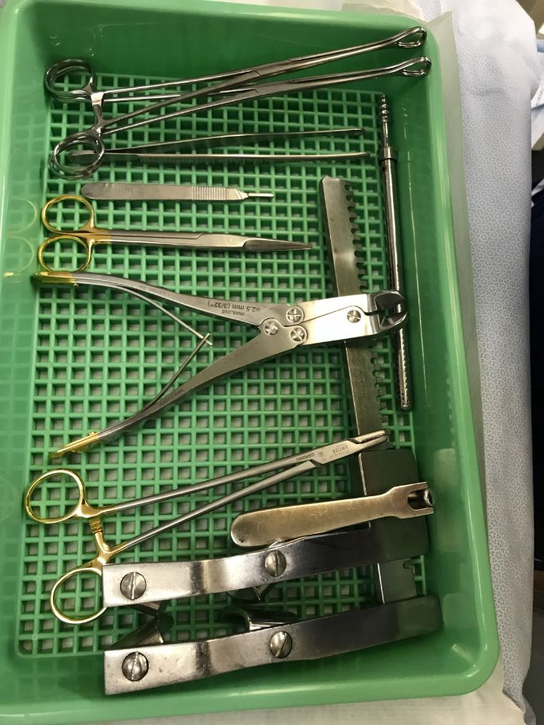

Scrub Nurse B (Theatre Nurse/Medical Assistant)
- Assist Scrub A to open packs 1-4.
- Assist surgeon to open chest – removal of wires.

Scout/ICU Nurse Coordinator
- Assist Scrub doctor and nurses to scrub up.
- Hold open trolley packs for contents to be removed aseptically.
- Connect sterile suction to wall.
- Coordinate transfer of patient back to theatre when indicated.

Back to Table of Contents

Evaluation

Outcome Measures
- The outcome measures for post-operative cardiothoracic patients are to be considered in terms of improved performance in the domains of safe practice and prevention/reduction of potential complications.
This includes:
- >95% Compliance with Clinical Procedural guidelines.
- Reduced complications related to post-operative cardiothoracic patients.
- Improved Benchmarking performance against similarly delineated facilities.

Method
- Clinical Audits of compliance against Clinical procedural guidelines as conducted by Clinical Support/Development Nurses (CDNs) and reported on at Staff Unit Meetings.
- Any mechanical patient incidence or complication related to post-operative cardiothoracic patients as reported via incident management system.

Back to Table of Contents

Related Policies, Procedures, Guidelines and Legislation

Policies
- Nursing and Midwifery Continuing Competence Policy
- Informed Consent (Clinical)
- Clinical Supervision Policy
- Incident Management Policy

Procedures
- Radial and Femoral Arterial Sheaths Removal Following Cardiac Catheterisation Management and Care of Adult Patients
- Infection Prevention and Control – Healthcare Associated Infections
- Aseptic Technique
- Central Venous Access Device (CVAD) Management – Children, Adolescents and Adults (NOT Neonates)
- Patient Identification and Procedure Matching
- Non-Invasive Electrocardiography (ECG) in Adults
- Arterial Line

Legislation
- Health Records (Privacy and Access) Act 1997
- Human Rights Act 2004
- Work Health and Safety Act 2011
- Charter of Healthcare Rights

Back to Table of Contents

References

- Engelman, D., Ben Ali, W., Williams, J., Perrault, L., Reddy, V., Arora, R., Roselli, E., Khoynezhad, A., Gerdisch, M., Levy, J., Lobdell, K., Fletcher, N., Kirsch, M., Nelson, G. Engelman, R., Gregory A., Boule, E. Guidelines for Perioperative Care in Cardiac Surgery Enhance Recovery after Surgery Society Recommendations. JAMA Surgery. 2019; vole 154, no. 8, pp 775-766.
- Sanson, G., Khlopenyuk, Y., Milocco, S., Massimiliano, S., Dreas, L., Fabiani, A. Delirium after cardiac surgery. Incidence, phenotypes, predisposing and precipitating risk factors and effects. The Journal of Acute and Critical Care. 2018. Volume 47, issue 4 pp408-417.
- Silvestry, F. Postoperative complications among patients undergoing cardiac surgery. UpToDate. 2019. Available at: https://www.uptodate.com/contents/postoperative-complications-among-patients-undergoing-cardiac-surgery?search=nursing%20care%20post%20op%20cardiac%20patients&source=search_result&selectedTitle=6~150&usage_type=default&display_rank=6
[accessed 24/8/2020]
- Barbeito, A., JohnBull,E. Anesthesia for cardiac surgery: General Principles. UpToDate. 2020. Available at: https://www.uptodate.com/contents/anesthesia-for-cardiac-surgery-general-principles?search=fast%20tracking%20cardiac%20surgery&source=search_result&selectedTitle=1~150&usage_type=default&display_rank=1
[accessed 24/8/2020]
- Ghadimi, K., Welsby., I. Reversal of anticoagulation and management of bleeding after cardiopulmonary bypass. UpToDate 2020. Available at: https://www.uptodate.com/contents/reversal-of-anticoagulation-and-management-of-bleeding-after-cardiopulmonary-bypass?search=post%20op%20cardiac%20patients&topicRef=94297&source=see_link
[Accessed 24/8/2020]
- Ref: Annals of Thoracic Surgery, 2017-03-01, Volume 103, Issue 3, Pages 1005-1020, Copyright © 2017 The Society of Thoracic Surgeons

Back to Table of Contents

Definition of Terms

ABG – Arterial Blood Gas
ACT – Activated Clotting Time
ART – Arterial line
Ca – Calcium
CMP – Calcium, Magnesium, Phosphate – blood test
COAG – Coagulation Studies
CVC – Central Venous Catheter
CXR – Chest X-Ray
ECG – Electrocardiograph
ECM – External Cardiac Massage
ETCO2 – End Tidal Carbon Dioxide
ETT – Endotracheal Tube
FBC – Full Blood Count
FiO2 – Fraction of inspired oxygen
HME – Humidified Moisture exchange filter
IABP – Intra Aortic Balloon Pump
ICC – Intercostal Catheter
IDC – Indwelling Catheter
IV - Intravenous
K – Potassium
LFT – Liver Function Test
MAP – Mean Arterial Pressure
Mg – Magnesium
NG – Nasogastric Tube
NiBP – Non-Invasive Blood Pressure
O2 – Oxygen
PADP – Pulmonary Artery Diastolic Pressure
PAP – Pulmonary Artery Pressure
PCA – Patient Controlled Analgesia
PCWP – Pulmonary Capillary Wedge Pressure
PEEP – Positive End Expiratory Pressure
PO4 – Phosphate
PRVC – Mode of ventilation Pressure Regulated Volume Control
PS – Mode of ventilation Pressure Support
SIMV – Mode of ventilation Synchronized Intermittent-Mandatory Ventilation
SpO2 – Oxygen Saturation
TEDS – Thromboembolic Deterrent Stockings
UEC – Urea and electrolyte count
UWSD – Under Water Seal Drain
VT – Ventricular tachycardia

Back to Table of Contents

Search Terms

Cardiothoracic, CABG, valve, valves, Cardiac, Cardiac output studies, CICU

Back to Table of Contents

Disclaimer: This document has been developed by Canberra Health Services specifically for its own use. Use of this document and any reliance on the information contained therein by any third party is at his or her own risk and Canberra Health Services assumes no responsibility whatsoever.

Policy Team ONLY to complete the following:
Date Amended | Section Amended | Divisional Approval | Final Approval
9 June 2021 | Complete Review | Jillian Davis, A/g ED, Surgery | CHS Policy Committee

This document supersedes the following:
Document Number | Document Name

