Canberra Health Services
Procedure
Intracranial Surgery Management of the Adult Patient

Contents

Contents 1
Purpose 2
Alerts 2
Scope 3
Section 1 – Crainotomy, Craniectomy and Crainoplasty 3
Section 2 – Burrhole Management 6
Section 3 – Brain Abscess, Extradural Abscess and Subdural Empyema 7
Section 4 – Raised Intracranial Pressure 9
Section 5 – Transsphenoidal Resection of Pituatury or Skull Base Lesions 30
Section 6 – Fluid and Electrolyte Monitoring 32
Evaluation 35
Related Policies, Procedures, Guidelines and Legislation 35
Definition of Terms 36
Search Terms 37
Attachments 37

Purpose

The purpose of this Procedure is to outline the process for optimal care and management of intracranial injuries and disorders in adult patients (16 years and older) of Canberra Health Services (CHS).

This procedure provides information for all clinicians who care for patients with an intracranial injury or disorder requiring surgery in the acute hospital setting.

Standardisation of practice means delivery of best practice, continuity of care and optimal clinical outcomes for the patients of CHS.

Back to Table of Contents

Alerts

Clinicians should always be conscious of the risk of sudden neurological deterioration in patients who have been admitted following intracranial injury or disorder, both in the pre and post-operative stages.

- Neurlogical observations should be attended at least every 4 hours. Frequency of observations can only be moved to 4 hourly or greater time frame in consultation with the Neurosurgical team, nursing team leader or in accordance with post operative guidelines of this procedure.
Note:Patients 16 years to 17 years and 11months a Paediatric Observation Profile (12-17years) should be used.
- Benzodiazepines and high dose opioids should be avoided in patients at risk of neurological deterioration. The sedative and respiratory depressive effects of these medications can mask a decreasing Glascow Coma Scale (GCS) score and signs of rising intracranial pressure. Nurses must only administer these medications to patients with intracranial injury or disorder when prescribed by a neurosurgical or intensive care registrar/consultant.
- The recommended position for patients with intracranial injury or disorder (unless otherwise specified by treating team - i.e. post-operative burrhole procedure) is SEMI HIGH FOWLERS position (head of bed raised 30°-45°). This position provides balance between minimising intracranial pressure and optimising cerebral perfusion. The TRENDELBERG position is generally contraindicated in neurosurgical patients as it increases intracranial pressure.
- Admission to the Neurosurgical Acute Care Unit (NACU) on ward 9B is indicated for adult patients post-operative from intracranial surgeries/procedures for the first 24 hours and then dependent on clinical need at the discretion of the 9B Nursing team leader and the Neurosurgery registrar/consultant.
- Intracranial hypertension is a serious and potentially life-threatening emergency; it must be addressed immediately.

Back to Table of Contents

Scope

This procedure applies to all CHS adult patients who have presented with a suspected intracranial injury or disorder inlcuding those who have had radiological confirmation of an intracranial injury or disorder and patients admitted for elective surgical management of an intracranial disorder.

This document applies to the following staff working within their scope of practice:
- Medical Officers
- Nurses and Midwives
- Allied Health Professionals
- Students under direct supervision.

Back to Table of Contents

Section 1 – Crainotomy, Craniectomy and Crainoplasty

1.1 Definition
A craniotomy, craniectomy and cranioplasty are procedures performed in the operating theatre by a neurosurgeon.

A craniotomy is performed via a surgical opening through the skull to gain access to portions of the central nervous system inside the cranium. After the procedure has been performed the dura is closed, the bone flap replaced and scalp closed. The procedure is used for, but not limited to, the following:
- clipping of aneurysm;
- excision of arteriovenous malformation (AVM
- removal or debulking of tumour
- evacuation of large subdural haematoma (SDH), extradural haematoma (EDH)
- drainage of abscess
- elevation of depressed skull fracture
- trigeminal nerve decompression
- repair of dural tear or cerebrospinal fluid (CSF) leak.

A craniectomy is similar to a craniotomy in that a portion of bone flap is removed to access into the cranium; except in a craniectomy the bone flap is not returned, the dura remains open and only the skin/scalp is closed. This procedure is performed:
- to decompress/reduce intracranial pressure (ICP) in the case of cerebral swelling secondary to trauma.
- in the instance of infection or damage involving the bone flap.

A cranioplasty is the surgical replacement of a bone flap following a prescribed timeframe after a craniectomy. This can be autologous (using the patient’s own bone flap which was originally removed), a titanium mesh or a 3D printed synthetic. A cranioplasty is indicated when:
- cerebral swelling reduces and ICPs normalise following trauma.
- the prescribed course of intravenous antibiotics has been completed and risk of further infection reduced
- replacement of bone flap is required following severe skull fractures.

1.2 Nursing Pre-Operative Procedure
- Explain the procedure to the patient and/or patient’s family.
- Complete the Surgical Safety Checklist according to Surgical Safety Checklist Policy.
- Ensure the following pathology has been collected and that the results are available prior to the patient going to operating theatres (refer to Venepuncture Blood Specimen Collection Procedure):
- FBC, UEC's, BGL, Coags, Group & Hold
- ECG for all patients over 50 years of age or those with significant cardiac history.
- Check neurological observations and record as directed in the Neurological Observations procedure. It is imperative to have a baseline for comparative measures post operatively and also if there is deterioration prior to surgery.
- If the patient is prescribed dexamethasone, check and document blood glucose levels daily.
6. Fast the patient according to the Fasting Guideline for Patients Requiring Sedation or Anaesthesia.
7. Measure the patient for TEDs and assist the patient in putting them on prior to going to operating theatres.
8. Administer the patient’s routine medications as appropriate (seizure prophylaxis should never be withheld). If prophylactic subcutaneous heparin is prescribed, confirm with the neurosurgical team whether to administer pre-operatively (dependant on Consultant).
9. Notify the CNC or Team Leader when the patient is called to operating theatres in order to have NACU bed available for their post-operative return.

1.3 Nursing Post-operative Procedure
- Receive handover from Post Anaesthetic Care Unit (PACU) staff in accordance with the Clinical Handover Procedure and Post Operative Handover and Observations – Adult patients (First 24hours) Procedure.
- Inform the patient/and or their family of post-operative procedures and gain consent.
- Attend Neurological and Vital sign Observations on return to the ward/unit and then:
- 30minutes for the first 2 hours post operatively
- hourly for following 12 hours if neurologically stable and MEWS <4
- every two hours for a further 12 hours if neurologically stable and MEWS <4
- every four hours thereafter if neurologically stable and MEWS <4 until advised otherwise by the Neurosurgical registrar or Nursing Team Leader
- In the Intensive Care Unit(ICU), the patient is continuously monitored.
- Monitor for signs and symptoms of acute cerebral bleed/raised intracranial pressure (ICP) see below. If the patient shows signs of acute cerebral bleed/raised ICP provide the patient with analgesia and anitemtics as required, escalate to the neurosurgical team and increase frequency of observations to every 30 minutes until medical review.

Signs of Raised Intracranial Pressure
- Headache & nausea (particularly a sudden increase in headache with associated nausea).
- Irritability/agitation
- Drop in Glasgow Coma Scale (GCS)

- Hypertension, usually associated with widening pulse pressure
- Bradycardia Cushing’s Triad
- Irregular respiratory pattern

- If applicable, attend External Ventricular Drain (EVD) observations and record ICP hourly as per Section 4.
- Maintain the head of the bed elevated to 30-45 degrees.
- For the sedated patient in the ICU maintain head in midline position, even when side lying and avoid flexing the neck. Keep endotracheal tube ties and any cervical collars secure but loose enough to prevent compression of the jugular veins. Consider sandbags for heavily sedated ICU patients instead of a cervical collar, ensuring the collar is reapplied for any repositioning.
- Ensure adequate oxygenation (maintain SpO2 > 95%), Cerebral Perfusion Pressure (CPP) > 60mmHg as well as maintaining blood pressure within optimal limits (SBP 120-160 mmHg unless otherwise specified by registrar).
- If the patient is heavily sedated, monitor the respiratory rate together with arterial blood gas levels, minimum 4 hourly or as directed by ICU Medical Officer. Depressed respirations compromise ventilation and oxygen exchange thereforemaintain PCO2, PaO2, SaO2 within normal ranges and where possible avoid regular endotracheal or tracheostomy suctioning.
- Control the patient’s temperature – treat temperature elevation > 38˚C promptly with antipyretic medication and report to the neurosurgical or Intensivist team – attend septic screen if required (urine MC&S, Blood Culture collection (Refer to Blood Culture Collection (excluding neonates) Procedure) and clarify if cerebro-spinal fluid (CSF) sample is indicated for patients with an EVD insitu).
- Continue to monitor for signs of central nervous system (CNS) infection such as fever, nuchal rigidity (neck stiffness), photophobia, irritability.
- Regularly assess pain and provide analgesia as prescribed, noting there are specific medications that are generally contraindicated in these patients; see ALERTS section. Cranioplasty wounds can be very painful due to pulling pressure on the scalp flap; ensure adequate analgesia is prescribed and available.
- Maintain a strict fluid balance for first 24 hours post operatively. Monitor the patient’s oral intake and assess the need for intravenous fluids (IVF).
- Check patency and indication of peripheral intravenous cannulas (PIVC) or central venous access devices (CVADs). Ensure date of insertion is clearly marked on the dressing and remove PIVCs as per the Peripheral Intravenous Cannula, Adults and Children (Not neonates) procedure.
- Check blood results daily for electrolyte balance; specifically monitor for hyponatraemia.

Note: If the patient’s sodium levels are outside the normal range (135-145 mmol/L), consider obtaining paired urine-serum osmolarity for more definitive diagnosis. Report levels outside normal range to the neurosurgical team.

- Surgical Drain:
- Check patency of the drain and medical orders regarding suction when taking over care of the patient.
- Ascertain level that the drain should be, i.e. at head level or below patient’s head level.
- Indicate volume of drainage at the end of the shift/handover by applying tape on the bag and marking level in pen. Ensure to also document this on fluid balance chart.
- Report any excessive drainage immediately to MO.
- Nurses can remove subgaleal drain as per orders from the neurosurgical team, complying with the Drain Management Procedure.
Note: Subdural drains must only be removed by a trained Medical Officer.
- Patient will generally return post-operatively with a head bundle(bandage on head):
- If substantial exudate on head bundle then reinforce it, otherwise leave until removed by the Neurosurgical team.
- If minimal or no head shave, generally the wound is left open to air. Refer to individual dressing orders by medical officer in the patient’s clinical record.
- Observe dressing and site for signs of infection or CSF leak.
- Consider topical medihoney to surgical wound, depending on Consultant preference (this is documented in the neurosurgical team plan/orders in the patient’s clinical record) to prevent infection.
- Measure and apply TEDs to patient if not already insitu. Apply sequential compression devices (SCDs) for the first 24 hours postoperatively; continue to reassess mobility and keep insitu as required to reduce risk of deep vein thrombosis (DVTs).
- Mobilise only as instructed by Neurosurgeon. If the patient is immobile, ensure 2-3 hourly pressure area care. Continue to reassess every shift for risk (using Waterlow tool) and observe skin.
- Observe the patient for dysphagia, if signs evident - keep nil by mouth (NBM) and refer for assessment by Speech Pathology. Provide regular mouth care.
- Check if post-operative imaging is required (ordered) and escort the patient according to the Patient Escort and Transport within Canberra Hospital Campus procedure.
- Allow hairwashing as specified by neurosurgeon.
- Sutures/staples – usually removed by nurse on Day 7 post operative unless following a re-do procedure which will stay in for 14 days.
- If the patient is admitted for a newly diagnosed cerebral tumour, ensure referrals to the ‘Gynaecology/Brain and Central Nervous System (CNS) Cancer Nurse Care Coordinator’ and ‘Social Work’Work are completed.
- Ensure falls risk has been assessed accurately and continues to be reassessed daily with any management strategies implemented in a timely fashion to limit risk.
Note: for patients following craniectomy, a fall without protection from the skull can be catastrophic.
- For patients being discharged without a bone flap following craniectomy – a helmet may be required to protect the site in the community, this will be decided on a case by case basis and be guided by the neurosurgical consultant and CNC. Referrals can be made through Prosthetics & Orthotics Department.

Back to Table of Contents

Section 2 – Burrhole Management

2.1 Definition
A burrhole is the formation of a small opening into the skull. Burrholes may be performed to remove extradural and subdural haematomas, biopsy a brain tumour, or to aspirate and treat a brain abscess. A burrhole is also performed in the process of Ventriculoperitoneal / Ventriculopleural Shunt insertion and to insert intracranial pressure monitoring devices.

2.2 Nursing Pre-Operative Procedure
- All pre-operative care and management as per Section 1.2 ..
- Withhold anti-coagulants pre-operatively for duration specified by the Neurosurgical team.

2.3 Post-operative Procedure
All post-operative care and management as per Section 1.3 except:
- Patients who have undergone burrhole drainage of acute subdural haematomas(SDH) should be able to mobilise post operatively as able, confirm documentation on Operation Record, form number 45320.
- Patients who have undergone burrhole drainage of chronic subdural haematomas will often be prescribed a period of bed rest with the head of the bed to remain flat for 24-48 hours and until post-operative CT and drain removal. This is to prevent possible re-bleed or pneumocephalus in the space of the SDH as the brain re-expands. Only mobilise or increase the head of the bed after neurosurgery review and documentation of orders.
- Drains should only be gravity fed – no suction. Keep drains at head level (resting on mattress next to head). Management otherwise as per Section 1.3.
- Restart prophylactic (and regularly prescribed) anti-coagulants only after specified by the neurosurgical registrar.

Back to Table of Contents

Section 3 – Brain Abscess, Extradural Abscess and Subdural Empyema

3.1 Definition
Infective processes that occur around the meninges can be classified as parameningeal infections. This includes three main diagnoses –
- Brain abscess - A brain abscess is an area of either free or encapsulated pus in the brain parenchyma; occurring as a single lesion or multiple lesions. A brain abscess is usually caused by an organism reaching the brain from infections of the middle ear, mastoid or sinuses. Some abscesses occur as a result of penetrating cerebral trauma, neurosurgical procedures or oral surgery. An infectious organism can be carried in the blood from other sites, such as lung infections, acute bacterial endocarditis and skin infections. In some cases, no focal cause of infection is identified. Acute clinical manifestations of brain abscess may include headache, chills and fever, malaise, some focal signs such as sensory and motor impairment, seizure activity and speech disorders. Clinical manifestations during the stage of enlargement are those caused by mass lesion: headache, signs of increased intracranial pressure, localised deficits, nausea and vomiting, confusion and drowsiness. Fever may be absent. The sudden drop of GCS with elevated white cell count (WCC) in the CSF, may indicate the rupture of an abscess into the ventricles.
- Infected extradural collections - An infected extradural collection between the dura and skull is called empyema. With extradural empyema, symptoms can include neck stiffness and focal seizures.
- Subdural empyema - A subdural empyema or abscess develops over the convexity of the cerebral hemispheres within the subdural space. Nursing staff must be vigilant in monitoring and reporting seizure activity.

3.2 Nursing Management
Nursing management of the patient depends on whether the abscess is single or multiple, the age and location of the abscess and the medical/surgical management instigated.
- Neurological and vital sign observations every hour or as per Medical Officers (MO) orders.
- Control the patient’s temperature – treat temperature elevation > 38˚C promptly with antipyretic medication and report to the neurosurgical team – attend septic screen if required (urine MC&S, Blood Culture collection, CSF sample if external ventricular (EVD) or lumbar drain insitu).
- Continue to monitor the patient for increasing signs of CNS infection – fever, nuchal rigidity, photophobia, irritability.
- Nurse the patient in semi-high fowlers position unless otherwise ordered by MO.
- Provide analgesia as required.
- Strict fluid balance for the first 24 hours. Monitor oral intake and assess the need for IVF.
- Check patency and indication of PIVCs or CVADs. Ensure the date of insertion is clearly marked on the dressing and remove PIVCs as per the Peripheral Intravenous Cannula, Adults and Children (Not neonates) Procedure.
- Administer intravenous antibiotic therapy as prescribed and consider advocating for a Peripherally Inserted Central Catheter (PICC) line if long-term intravenous antibiotics are indicated.
- Measure and apply TEDs if not already insitu. Apply SCDs if decreased mobility and continue to reassess as per Patient Care and Accountability Plan.
- Continue to reassess pressure injury risk every shift (Waterlow score) as per Patient Care and Accountability Plan. Implement strategies as suitable.
- Monitor patient for signs and symptoms of raised ICP (see section 1.3).
- If further diagnostic examinations are required, prepare the patient and assist the MO in performing neuro-diagnostic studies, such as lumbar puncture.
- Observe for and manage any seizure activity as per treating team orders.

  - Nursing Pre-Operative Procedure
If required, prepare the patient for surgery as outlined in Section 1.2.

3.4 Nursing Post-operative Procedure
Post-operative procedure for craniotomy and evacuation of abscess as per Section 1.2.
Post-operative procedure for burrhole drainage of abscess as per Section 2.2.

Back to Table of Contents

Section 4 – Raised Intracranial Pressure

Alert: ICP measurement is affected by the height of the drip chamber relative to the patient. It is important that neither the drip chamber nor the patient be raised or lowered accidently. If either is raised or lowered, it is imperative to re-level the drainage system.

4.1 Definition
ICP is the pressure exerted by the combined total volume of the three components of the skull; brain tissue, blood and cerebrospinal fluid. ICP is measured in millimeters of mercury (mmHg) at rest is normally 5–15 mmHg for a supine adult.
The pressure-volume relationship between ICP, volume of CSF, blood, brain tissue and cerebral perfusion pressure (CPP) is known as the Monro-Kellie doctrine or the Monro-Kellie hypothesis.

Modified Monro-Kellie Hypothesis
The skull is a rigid structure surrounding blood, CSF and brain matter. Any change in volume of one of these components requires a change in one or more other components in order to maintain a constant volume. If the status quo is not maintained, the intracranial pressure (ICP) will increase.

Intracranial hypertension, or raised ICP, is the elevation of the pressure within the cranium. ICP is normally 5–15 mmHg; at 20mmHg treatment to reduce ICP is required, as autoregulation and compensation fails when ICP rises above 35mmHg and CPP falls below 40mmHg.

CPP, defined as the difference between mean arterial pressure (MAP) and ICP, is the driving force responsible for adequate brain perfusion and oxygenation. Following a significant ICP increase, CPP decreases, resulting in an inadequate brain tissue perfusion and oxygenation. The consequent ischemia will induce further cytotoxic oedema resulting in even higher ICP.

Formulas
CPP = MAP – ICP
MAP = (Systolic BP + (Diastolic BP x2)) ÷ 3

There are 2 ways to maintain target CPP: manage the ICP to normal range and control MAP.

4.2 External Ventricular Drains (EVD)
The EVD is a catheter which is most commonly inserted into the anterior horn of the lateral ventricle on the non-dominant side and used to drain CSF when intracranial pressure is too high.
An EVD functions on the principle of pressure assisted by gravity. CSF drainage (and consequently ICP) is controlled by the height of the drip chamber relative to the patient. Drainage occurs when the ICP rises above the pressure of the reference point, commonly the patient’s external auditory meatus/ foramen of Monro (tragus).

Alerts:
- The medical team/neurosurgeon should be notified urgently if: the EVD stops draining or becomes blocked; sudden change of CSF colour; new neurological changes; increased ICP; MAP changes, evidence of leakage from any point of the EVD.
- EVD tubing must not be irrigated, changed or manipulated in any way other than by the Neurosurgeon or trained delegate.
- Always keep the ‘Zero point’ of EVD drain chamber at the same level as the patient’s foramen of Monro (Tragus) to prevent erroneous ICP readings and avoid under or over drainage of CSF.
- Always close the patient line stopcock or clamp the patient line before the patient’s position is changed (e.g.,when performing pressure area care, sitting the patient out of bed, transporting the patient), re-level the drainage system after position change, and turn the patient line stopcock to “drainage only” position and unclamp the patient line afterwards.

The purpose of an EVD is to:
- provide a means of monitoring ICP (measurement in cmH2O)
- allow drainage and measurement (mL) of CSF
- easily obtain CSF specimens for pathology/biochemistry purposes.

Indications for an EVD
Acute onset hydrocephalus as a result of excess production, malabsorption or blockage of the flow of CSF. This can be from:
- Meningitis and encephalitis which may result in malabsorption or CSF through the arachnoid granulations.
- Tumours located around the third or fourth ventricle which cause compression and blockage of the flow of CSF.
- Closed head injury which results in raised intracranial pressure.
- Subarachnoid haemorrhage which may result in malabsorption of CSF.

Nursing Care of the Patient with an EVD
- When accepting care of the patient with an EVD (either at shift change or post-operatively) check the orders from the neurosurgeon regarding the reference point (i.e how many cmH2O above tragus) and whether ICP monitoring is requested together with drainage.
- Ensure the dressing is intact and the site is clean, dry and free from signs of wound infection.
- Neurological and vital sign observations are attended hourly for at least the first 48 hours post insertion and then every 2 hours at the discretion of the neurosurgeon.
- For Intensive Care Patients, neurological and vital sign observations should be attended hourly with any ICP monitoring system.
- ICP and drain volume measures remain hourly for the duration of the EVD and document on the External Ventricular Drain and Lumbar Drain Observation Chart at Attachment 1.
- Observe and document the colour of the CSF to provide a baseline to which any change can be measured.
- Extended clamping/closing of the EVD is strictly contraindicated. Drainage should be clamped off ONLY for patient repositioning, transportation, ICP measurement, zero-ing the ICP or if ordered and documented by the neurosurgery registrar or Consultant (i.e., in preparation for removal).
- Assess and support patients that may be unable to follow instructions or have disruptive behaviour, as this may affect EVD with constant disruption to the insertion site and a dislodgement of EVD which can leave the patient at high risk for cerebral infection. Consider assistant in nursing special if the patient is at high risk of interfering with device. Physical restraints should be avoided in already agitated patients due to the risk of further increasing ICPs. Refer to Increased Patient Care and/or Supervisions Procedure and Restrictive Practices for people NOT detained under the Mental Health Act 2015 Procedure.

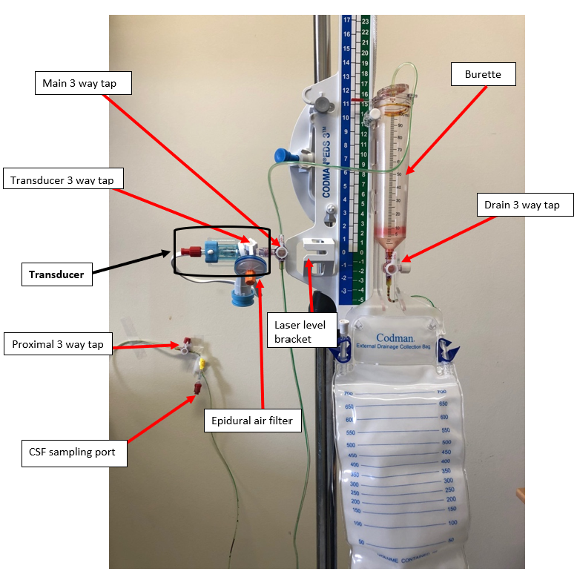
Figure 1. EVD

4.2.1 Levelling of the EVD
The EVD is a pressure-fed drain, therefore it requires levelling to ensure that it does not:
- over drain CSF, introducing the risk of collapsing the ventricles and, in extreme cases rupturing, the small bridging capillaries around the dura leading to the formation of subdural haematomas; or
- under drain CSF – contraindicating the purpose of the system.
The pressure transducer of the EVD must be maintained at the same horizontal level as the ventricles to ensure reliable interpretation of its value.

The levelling point is the patient’s external auditory meatus (tragus), measured by using the laser device in bracket and should be performed at; handover (shift to shift or between clinical areas), whenever the patient repositions, hourly as part of EVD observations or when troubleshooting small or large drainage volumes.

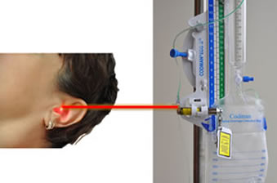

- Attend hand hygiene.
- Explain the procedure to patient and/or family and gain consent.
- Ensure the spirit level on the laser is horizontal.
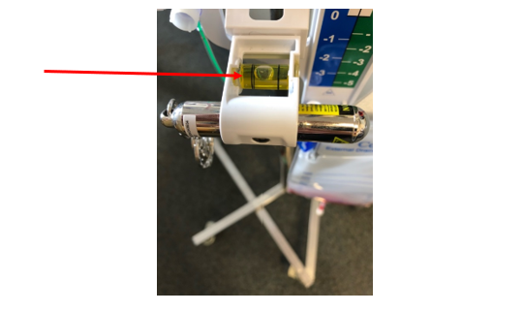

- If not the spirit level on the laser is not horizontal, alter the angle of the system by loosening the grey screw clamp until the spirit level is centered.
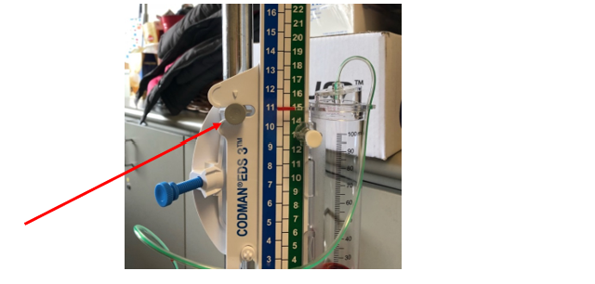
- Turn on the laser by pressing the button exposed through the plastic case whilstprotecting the patients eyes from the laser.
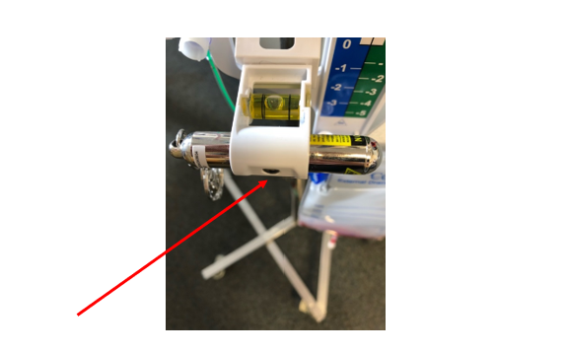

- Ensure the main 3 way tap is OFF to patient.
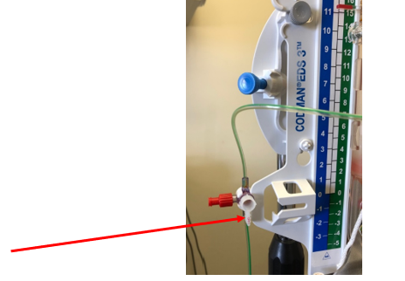
- Alter the height of the entire EVD system if required by loosening the blue clamp to bring the transducer laser horizontal with the patient’s tragus.
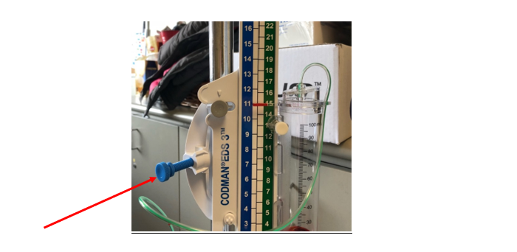

- Ensure the EVD is reopened to drainage (main 3 way tap OFF to transducer).

4.2.2 Priming Transducer and Connection of EVD to Monitor

The procedure outlined below is followed in cases where the patient arrives to the clinical area without a transducer already attached to the EVD. The procedure needs to be undertaken using sterile no touch technique.

Alert: Never connect high pressure flush bag to the ICP transducer

Equipment
- Sterile gown/drape
- Sterile gloves
- Goggles
- Basic dressing pack
- Epidural filter
- Single transducer set
- 5ml syringe
- 10ml normal saline
- Chlorhexidine 0.5% in alcohol 70%
- Clean dressing trolley

Procedure
- Attend hand hygiene...
- Clean the procedure trolley.
- Attend hand hygiene, don clean gloves and open all equipment onto the sterile dressing pack for use using aseptic no touch technique.
- Remove gloves and attend procedural hand wash.
- Don goggles, sterile gloves and sterile gown.
- Draw up saline into syringe.
- The transducer has three ports. Two of the ports are attached to clear lines. The third port is occluded with an orange/ red coloured bung. Port A is the “monitor end” of the transducer (there is also a white monitor cable attached to this end of the transducer). Port B is the “EVD connection end” of the transducer. Port C has the orange/ red bung attached and is the “epidural filter” port.
  - Completely remove (and discard) the two clear lines from Port A and Port B as these are not required for EVD/ICP monitoring.
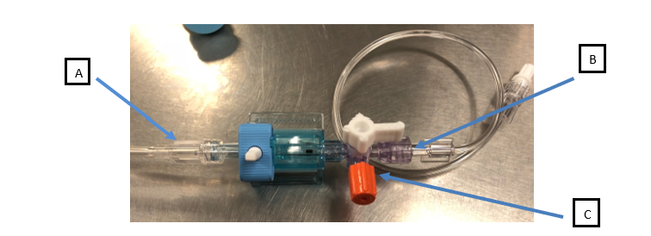

  - Place the yellow bung from the packaging over Port A.

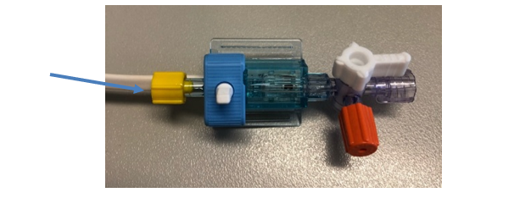
- Using the syringe, prime the transducer with normal saline. This is done in two stages.
  - Firstly, remove the orange/ red bung from Port C (but DO NOT discard).
  - Connect syringe to Port C.
  - Ensure the transducer 3 way tap is OFF to Port B (EVD connection port).
  - Loosen the bung on Port A, gently squeeze either side of the blue valve or pull the white toggle to allow flow and prime with saline, release the blue valve/toggle and tighten the yellow bung again.
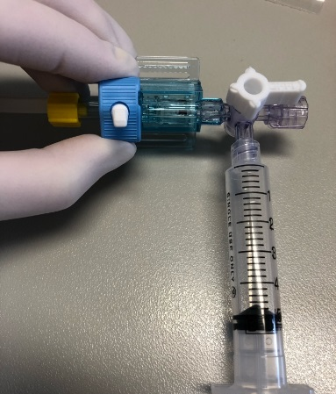

- Secondly, turn the transducer 3 way tap OFF to Port A (transducer end) and prime with saline, turn transducer 3 way tap OFF to Part B (drain) again.

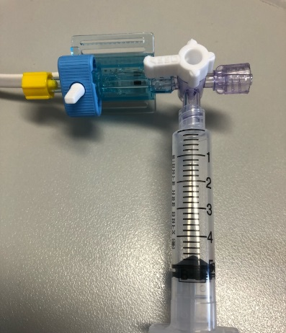

- Remove the syringe from Port C and connect the epidural filter to this same port. Place the orange bung over the epidural filter port.
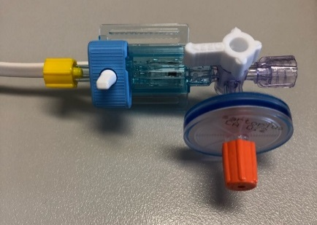

- Next, the transducer needs to be attached to the EVD. Generally, the EVD system has a red bung over the drainage port at the end of the drainage system.
- Turn the main 3 way tap OFF to the patient.

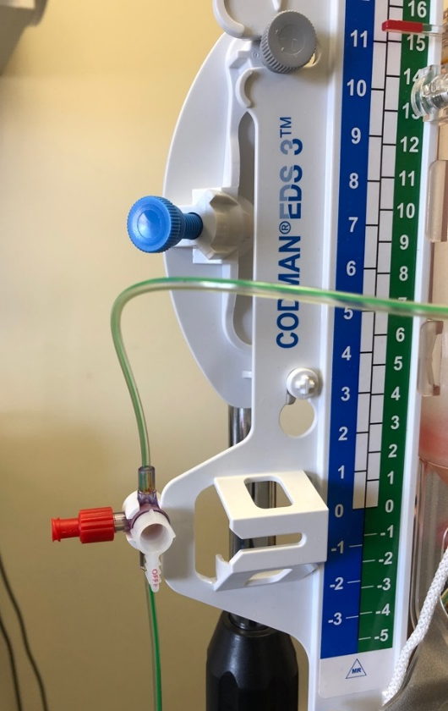

- Remove the red stopper.
- Clean the site three times with Chlorhexidine 0.5% in alcohol 70% soaked gauze allowing time to dry in between.
- Connect the transducer, ensuring it is secure.
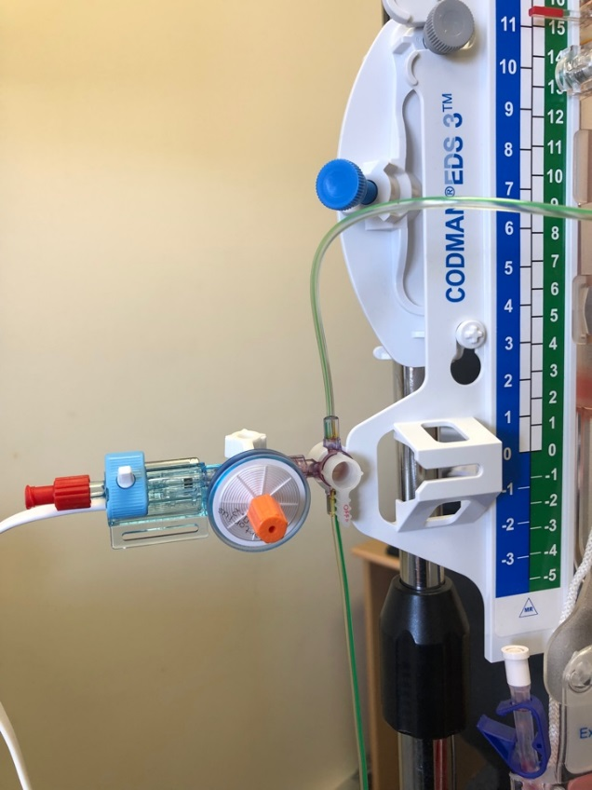

- Remove the blue plug at the end of the white transducer cable and connect to the ICP monitor lead.
- Zero the transducer as per Section 4.2.3 below.

4.2.3 Zero-ing the Transducer
The transducer should be zeroed on the monitor; at least once at the commencement of shift, when it has been clamped/closed, when the ICP is reading high or as a negative and when you suspect equipment error.

Procedure
- Attend hand hygiene.
- Check the EVD is level to the tragus (see Section 4.1).
- Turn the main 3 way tap OFF to patient.
- Using the white toggle, lower the burette to ‘zero’.

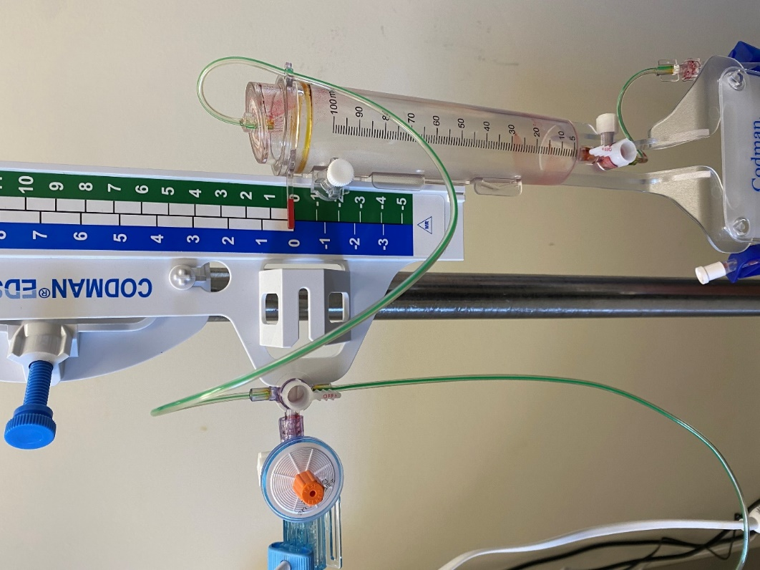

- Ensure the Phillips monitor is programmed to display ICP, Press “ZERO”
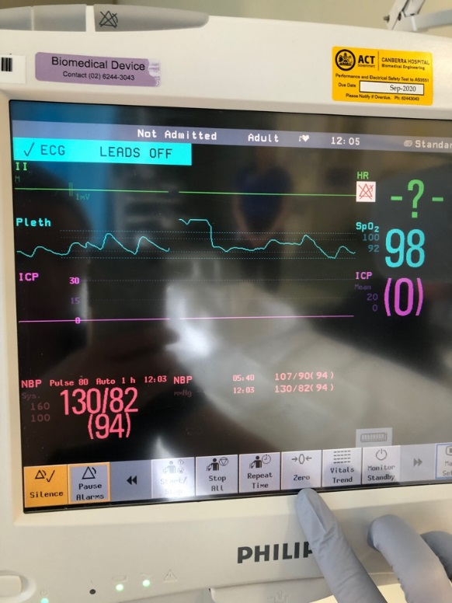

Then press “ZERO ICP” on the Phillips monitor and wait for a beep.

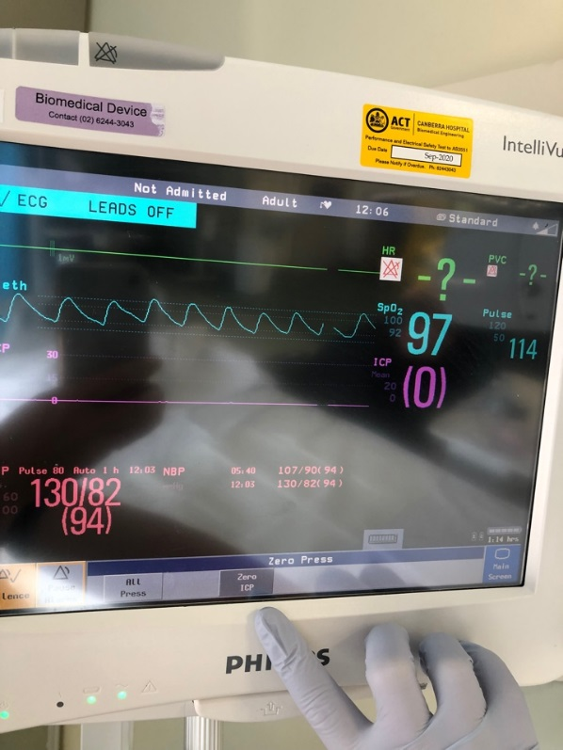

- The monitor screen will then beep again and ICP measure will display ‘0’
- Using the white toggle, raise the burette back to the prescribed height.
- Turn the main 3 way tap OFF to drain (ensuring an accurate pressure reading from the patient).

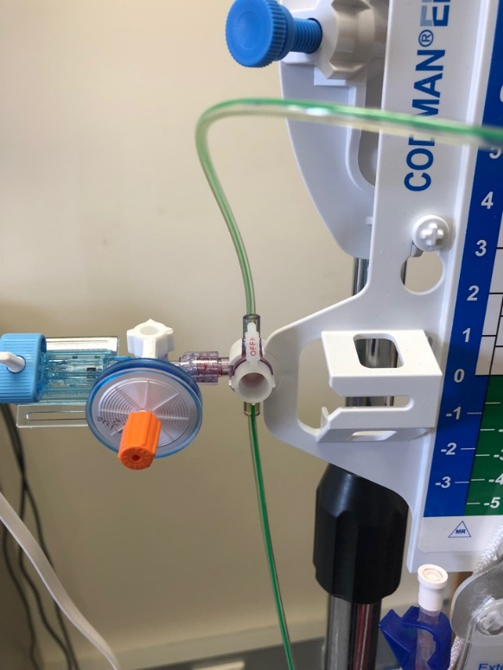
- Wait 30 seconds for waveform to stabilise. If the ICP reading is a negative reading or the ICP waveform displayed is inaccurate, start again from the beginning of the process and re-zero.
- When completed, turn the EVD back open to drain (main 3 way tap is OFF to the transducer) and ensure patency by observing for ‘swing’.
- Attend hand hygiene.
- Record ICP pressure on ‘External Ventricular Drain and Lumbar Drain Observation Chart’ (Attachment 1), including ‘zeroed’ in the comments section.
- For patients in the Intensive Care Unit - confirm accurate ICP measurement on MetaVision.

4.2.4 Changing the EVD/Lumbar Drain Drainage bag
Change the drainage bag when 75% full using aseptic technique.

Equipment
- Sterile gloves
- Goggles
- General dressing pack
- Sterile gauze squares
- Dressing trolley
- New sterile drainage bag
- Chlorhexidine 0.5% in alcohol 70%

Procedure
- Explain the procedure to the patient and gain consent.
- Attend hand hygiene.
- Turn the drainage 3 way tap (between CSF chamber and drainage bag) OFF to bag.
- Ensure the blue clamp between the chamber and drainage bag is clamped off.
- Don goggles and sterile gloves.
- Maintaining sterile non touch technique, disconnect the drainage bag.
- Clean the connection site with chlorhexidine 0.5% and alcohol 70% three times, remembering to let dry for 30 seconds in between.
- Attach the new bag whilst maintaining non touch technique.
- Open the blue clamp.
- Dispose of waste appropriately.
- Clean the dressing trolley.
- Document the procedure in patient’s clinical record.

4.2.5 CSF Sampling from EVD/Lumbar Drain (LD)
Sampling of CSF should only be attended when ordered by the treating team and only completed by a Medical Officer or Registered Nurse who has been assessed as competent to do so by a Neurosurgical Clinical Development Nurse or ICU Educator.

Alert:
- Never aspirate CSF directly from the ventricular system.
- Strict asepsis must be maintained to prevent possible life-threatening complication of ventriculitis. Surgical aseptic non touch technique (surgical ANTT) is to be applied when sampling CSF from an EVD/LD.

Equipment
- Sterile gown
- Sterile gloves
- Goggles
- General dressing pack
- Sterile gauze
- Dressing trolley
- Chlorhexidine 0.5% in alcohol 70%
- CSF specimen tubes
- 3mL luer lock syringe

Procedure
- Explain the procedure to the patient and gain consent.
- Confirm patient identification by using 3 core identifiers: name, date of birth and UR number as per the Patient Identification - Pathology Specimen Labelling Procedure.
- Attend hand hygiene.
- Turn the proximal 3 way tap OFF to patient.
- Attend procedural hand wash.
- Don goggles and sterile gown/gloves.
- Clean the luer lock sampling site with chlorhexidine 0.5% and alcohol 70% three times, remembering to allow 30 seconds in between to dry.
- Place a sterile drape under the sampling port.
- Remove the plunger from 3mL luer lock syringe leaving only the open syringe.
- Attach the syringe (with plunger removed) to luer lock sampling port.
- Place the CSF specimen tube underneath the end of the syringe.
- Turn the stop cock proximal to the patient OPEN to patient allowing flow of CSF.
- Allow CSF to passively drip from luer sampling port through the syringe and into specimen tube. DO NOT ASPIRATE.
- When the specimen tube is approximately one quarter full, or to the marking on tube, turn the stop cock back OFF to patient.
- Place the specimen tube safely back onto sterile field.
- Remove the syringe from sampling port.
- Apply the black CSF specimen tube lid.
- Remove personal protective equipment (PPE).
- Turn the proximal stop cock OPEN to patient (unless EVD is not to be draining) and ensure swing before leaving patient.
- Label the specimen tubes at the bedside in accordance with the Patient Identification - Pathology Specimen Labelling Procedure.
- Send specimens to pathology using the correct procedure. Refer to the Pathology Specimen Handling Procedure.
- Dispose of waste appropriately.
- Clean dressing trolley.
- Document procedure in patient’s clinical record.

4.2.6 Interhospital Transportation of Patients with an EVD or Lumbar Drain
In addition to the requirements of the Patient Escort and Transport within Canberra Hospital Campus Procedure, patients with an EVD being transferred throughout the hospital must be accompanied by a Registered Nurse on Medical Officer competent in the management of EVD’s as assessed by Neurosurical Clinical Development Nurse or ICU Educator.

- Explain the procedure to patient and gain consent if appropriate.
- Turn the main 3 way tap OFF to patient.
- Turn the proximal 3 way tap OFF to patient.
- If a transducer is attached, disconnect the monitor at the grey-white connection.
- Remove the drainage system from the IV pole and lay it securely on the mattress next to the patient, ensuring it is not in a position to fall through the bedrails.
- At the discretion of the Neurosurgeon, drainage may be required to continue during transport/transfer. If drainage is to continue, once the patient is settled on the trolley/ transport bed, level the EVD as per 4.2.1, ensure it is securely clamped to the bed IV pole and turn the proximal and main 3 way taps OPEN to patient to allow continuation of drainage.

NOTE All reasonable efforts should be made to limit the time the drain is clamped. If stationary for extended period of time during patient transfer, the EVD should be levelled as per 4.2.1 and allowed to continue drainage.

MRI Compatibility
The Codman EVD system – compatible.
Codman laser level device - NOT MRI compatible and therefore must be removed.
Codman Microsensor Transducer and Truwave Pressure Transducer – MRI ‘conditional’ and should be clarified with MRI team prior to patient transfer.

4.2.7 Disconnection or EVD Tubing Fault
As an EVD is a closed and sterile system, every effort should be made to protect the EVD tubing from exposure through damage or accidental disconnection.
In the event of a disconnection between the ventricular catheter and the EVD system, the ventricular catheter (patient end) should be clamped with rubber ended forceps and a neurosurgery registrar should be contacted immediately to prime and attach a new EVD system using aseptic non touch technique.
Should the ventricular catheter be damaged or compromised, clamp with rubber ended forceps and notify the neurosurgery registrar immediately.
Should the catheter and ventricular system be dislodged completely, cover the insertion site with sterile dressing and notify the Neurosurgery registrar immediately.

4.3 Lumbar Drain Management

4.3.1 A lumbar drain (LD) is a small, flexible drain placed in the lumbar spine to drain cerebrospinal fluid. A spinal needle is inserted before an epidural catheter is advanced through the needle to approximately the T12-L1 interspace. The needle is then withdrawn and a sterile closed drainage system is attached to the catheter. The catheter is then secured with a transparent adhesive dressing to maintain sterility of the insertion site.

Lumbar drains are used for, but not limited to, the following:
- management of CSF leaks
- in the diagnostic process of normal pressure hydrocephalus
- prevention of neurological deficits during/after Thoracoabdominal Aortic Aneurysm (TAA) repair
- access for intrathecal medication administration and/or CSF sampling.

Alert
- The medical team/neurosurgeon should be notified urgently if: the LD stops draining or becomes blocked; sudden changes of CSF color; new neurological changes; increased ICP; evidence of leakage from any point of the LD.
- LD tubing must not be irrigated, changed or manipulated in any way other than by Neurosurgeon or trained delegate.

4.3.2 Nursing Management
The Neurosurgical team will document the indication and the specific management required in the clinical record. The indication for insertion of a LD drain should be clearly understood as they are managed according to their indication.

If inserted for the diagnosis of normal pressure hydrocephalus (NPH), the volume of hourly drainage will be prescribed by the Neurosurgeon and the level of the drainage chamber to insertion site should be titrated to achieve the prescribed drainage. If the volume being drained exceeds the Neurosurgeons specific hourly target range, the collection chamber should be raised. Conversely if the volume of CSF drained is less than required, the collection system should be lowered in order to produce a sufficient gradient to facilitate drainage.

If inserted for the management of a CSF leak, the drainage chamber should be maintained level with the insertion site to prevent over or under drainage.

Regardless of the indication, the volume of CSF drainage should be measured and documented hourly together with patency of the drain/swing:
- Ensure the proximal and main 3 way taps are OPEN to patient and there is swing present (ensuring patency of drain).
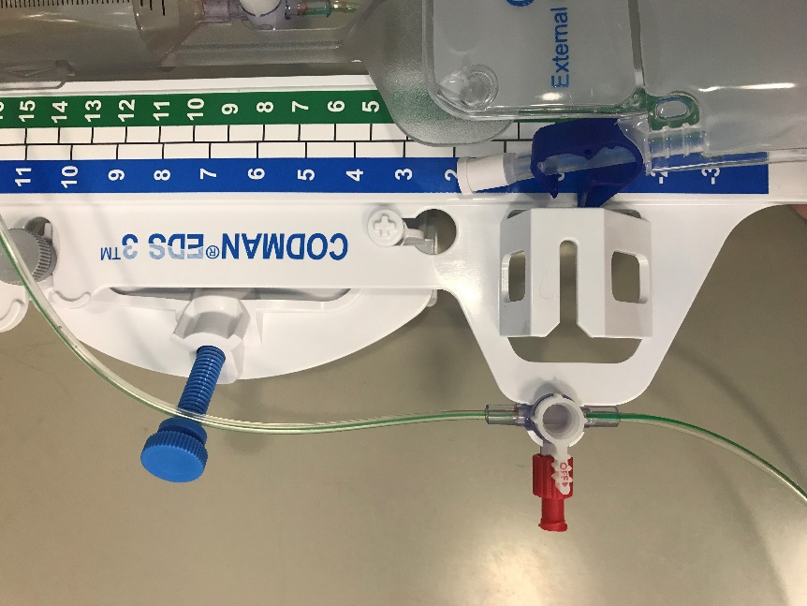

- Observe the volume of drainage over the hour and, if titrating to achieve prescribed drainage, alter the level of the drainage system. This can be achieved by lowering the burette via the white nozzle below.
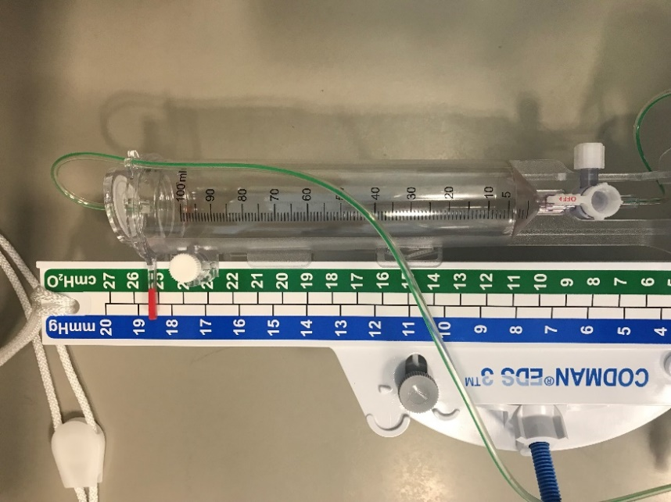

Or by lowering the entire the system via the blue toggle/clamp and white rope.

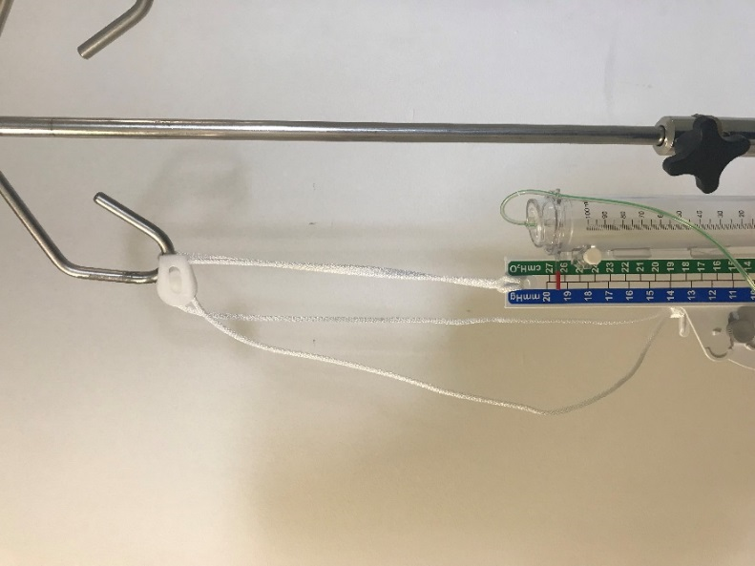

- At the end of the first hour, empty the drainage chamber into the collection bag by turning the drainage 3 way tap OPEN to the drainage bag as pictured below.
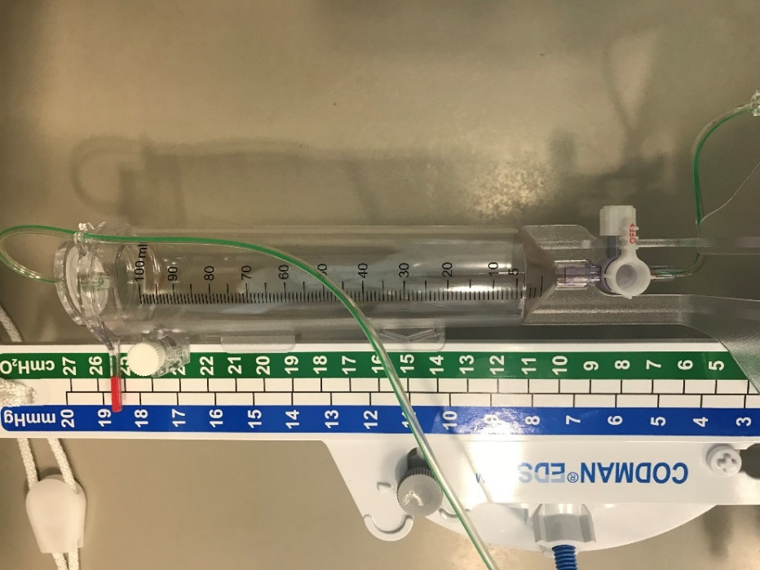

- When the CSF burette is emptied into the bag, ensure the drainage 3 way tap is OFF to chamber as shown below.
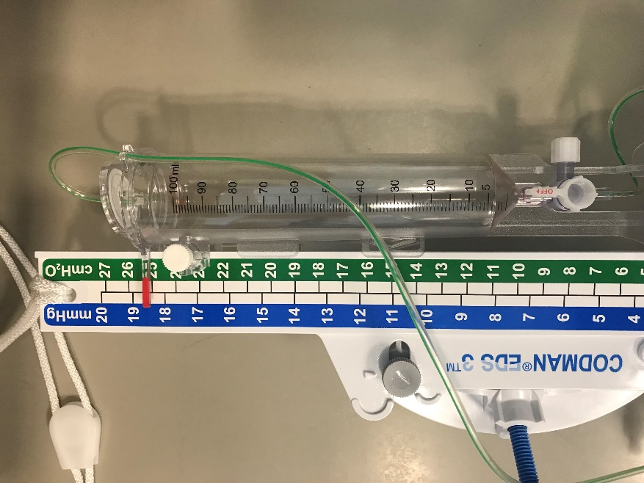

- Document the CSF hourly total on the ‘External Ventricular Drain and Lumbar Drain’ form.
- Ensure the main 3 way tap is turned back ON to the patient to facilitate drainage and check for swing/patency before leaving patient.
- If the patient requires re-positioning or if mobilising, the main 3 way tap should be turned OFF to the patient to prevent CSF syphoning. Patients with lumbar drains should only have toilet privileges to prevent the system from being clamped for extended periods of time.

4.4 Codman ICP Monitoring

4.4.1 Connecting Codman to Bedside Phillip monitoring
- The red end connects to the pressure module of Bedside monitor.
- The black end connects to the back of the Codman Express.
- When prompted (on the Codman ExpressTM screen), press the “Zero” button to zero ICP on the Bedside monitor.
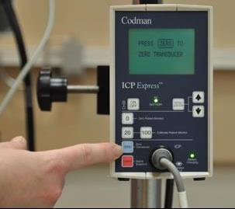

- When prompted (on the Codman ExpressTM screen), press the “MENU/ENTER” button after bedside monitor is Zeroed.
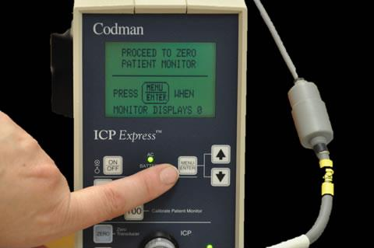

- When prompted to choose the calibration signal, select the “20” button.
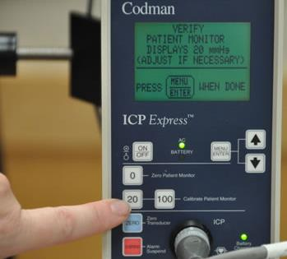

- Confirm that the bedside monitor has a reference line at 20 mmHg and then press the “MENU/ENTER” to start monitoring.
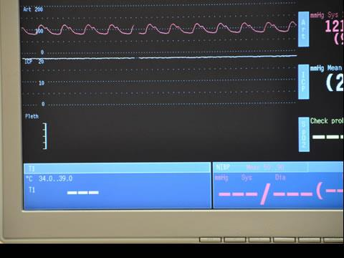

If the value “-99” appears when zeroing the ICP Express monitor, this means the grey cable that connects to the front of the ICP Express monitor needs to be replaced.

If a zero reference number appears before zeroing, turn the ICP Express off and restart.

    - Disconnection and Reconnection of Codman Monitor
- Disconnect the catheter from the grey cable attached to ICP Express.
- When reconnecting catheter to ICP Express, the reference number on the monitor must match the number written on the catheter. Either accept the displayed reference number (if they match) or adjust. Go to menu/enter and use the arrow key to choose the correct reference number.
- Alarms are automatically off when ICP express is turned on. To activate alarms, go to menu/enter button, choose on/off alarm limits option and the activate alarm option by arrowing up or down for required limits.

4.5 Ventriculoperitoneal and Ventriculopleural Shunt Management

4.5.1 Definition
A ventricular peritoneal shunt consists primarily of a catheter, a reservoir and a terminal catheter. It is surgically implanted to facilitate drainage of excessive CSF from the ventricles to prevent hydrocephalus. The primary catheter is implanted into the lateral ventricle through a burrhole and the catheter is pulled through to the reservoir. The CSF flows from the ventricles through the catheter into the reservoir where it collects. The terminal catheter is pulled under the skin to the terminal point in the peritoneum or pleural space, which is then secured into position.

4.5.2 Nursing Pre-Operative
All pre-operative care and management as per Section 1.2.

4.5.3 Nursing Post-Operative
All post-operative care and management as per Section 1.3 except:
- Monitor closely for signs of raised intracranial pressure (as described in section 1.3) due to:
- shunt failure
- intracerebral haemorrhage or haematoma (due to trauma during passage of the ventricular catheter).
- Monitor for bowel sounds and bowel movements over the next 48 hours if the shunt terminates in the peritoneum.
- Monitor SaO2, work of breathing and respiratory rate closely if the shunt terminates in the pleural space.

Back to Table of Contents

Section 5 – Transsphenoidal Resection of Pituatury or Skull Base Lesions

  - Definition
Transsphenoidal resection is an endoscopic surgery which is performed through the nose and sphenoid sinus and is used in most cases to remove lesions from the pituitary gland and base of skull. Neurosurgeons in conjunction with Ear, Nose and Throat (ENT) surgeons perform this procedure. An endoscope with a camera and light are inserted through the sphenoid sinus, sella and finally piercing the dura to reach the pituitary gland. The lesion is removed through the same passage and, in some cases, a fat graft from the abdomen and a septal flap is created to patch the sella.

Some common types of pituitary lesions include:
- Pituitary Macroadenomas: a tumor that is greater than 10mm in size and grows from the pituitary gland; may be hormone-secreting or non-functioning
- Craniopharyngioma: a benign tumor that grows from cells near the pituitary stalk; can invade the third ventricle (may need Craniotomy approach).
- Rathke’s cleft cyst: a benign cyst, or fluid-filled sac, between the anterior and posterior lobes of the pituitary gland.
- Meningioma: a tumor that grows from the meninges, the membrane that
surrounds the brain and spinal cord.
- Chordoma: a malignant bone tumor that grows from embryonic notochord remnants located at the base of the skull.
5.2 Nursing Pre-Operative
All pre-operative care and management as per Section 1.2 except:
- If not already collected in pre-admission or Endocrine clinic, ensure the following pathology has been collected and that the results are available prior to the patient going to operating theatres (refer to the Venepuncture Blood Specimen Collection Procedure):
- Specific Endocrine Blood screening: including TSH, fT4, ACTH, and cortisol (to be collected 0600-0800), IGF-1, Prolactin, LH, FSH. For males: testosterone; for females: may require oestradiol and progesterone.
- Routine blood tests, including baseline EUC, LFTs, FBE and APTT/INR, are usually ordered pre-operatively.
2. Pre-Operative pituitary tumour patients will require full visual field testing by an Ophthalmologist for a baseline result.
3. A pre-op MRI with and without contrast.
4. A nasal examination by the surgical team or ENT team to ensure the transsphenoidal approach is suitable.

5.3 Nursing Post- Operative
PRECAUTIONS
Due to the surgical approach during transsphanoidal procedures being through the nares, piercing the sella and dura, nasal precautions are required in the post-operative period.
- The insertion of a Nasogastric Tube (NGT) is to only be performed after all alternatives have been considered. The NGT then should only ever be inserted by an ENT surgeon with the assistance of a nasendoscope and after consultation with the neurosurgery consultant.
- For 6 weeks post-operatively:
- no noseblowing
- no nasal packs for epistaxis (unless inserted by ENT surgeon)
- no Continuous Positive Airway Pressure (CPAP)
- splints and nasal packing should only be removed by the ENT surgeon, usually at two weeks post operatively.
- The prescription of desmopressin (DDAVP) and hypertonic saline (1.8% and 3%) for neurosurgical patients in the management of hypo and hypernatraemia should only occur after consultation with the Endocrine and Neurosurgical Consultant.

The major complications associated with trans-sphenoidal resection include CSF leak (rhinorrhoea), diabetes insipidus (DI), syndrome of inappropriate secretion of antidiruretic hormone (SIADH), sinusitis, epistaxis and meningitis.

All post-operative care as per section 1.3 except:
  - The patient may have internal nasal splints or packing insitu, which will remain until ENT review at approximately two weeks post-surgery. On return to the ward, a nasal bolster will be insitu over the nares, this should be changed by nursing staff PRN with the frequency and volume documented in the clinical records.
  - Monitor exudate for haemoserous ooze or for suspicion of a CSF leak (clear rhinorrhoea, often metallic taste) and notify neurosurgical and ENT teams immediately if CSF leak is suspected. Clear nasal discharge may be sent to pathology for B2transferin testing. Antibiotics should be considered if CSF leak thought likely.
  - Advise the patient to report any salty taste or sensation of “dripping” in the back of their throat, as it could also indicate a CSF leak.
  - Perform patient education on the nasal precautions outlined in Section 5.1.
  - An IDC will be inserted intraoperatively and strict hourly urine output measurements post operatively are required to monitor for DI. This includes monitoring of input for a strict FBC. Hourly urine output measures should be continued until specified by the Neurosurigcal team.
Note: If urine output exceeds 300mL/hour for three consecutive hours, a paired serum and urine osmolarity should be attended, the Endocrine team contacted and desmopressin (DDAVP) considered. DDAVP is a synthetic version of the naturally produced anti-diuretic hormone (ADH), a hormone produced by the posterior pituitary gland and if disturbed or damaged intraoperatively can cause polyuria and consequent electrolyte imbalances. The prescription of DDAVP may only be decided by a Neurosurgical or Endocrine consultant.
  - Patients should have EUC, FBC and morning cortisol (0600-0800) taken day 1 post operatively. Bloods should be attended between these times for peak serum cortisol level prior to administration of any prescribed glucocorticoids. Do not withhold Glucocorticoids until results from blood test, administer as prescribed and adjustments can be made for the next prescribed dose if required.

Back to Table of Contents

Section 6 – Fluid and Electrolyte Monitoring

Alert: Intravenous Dextrose/Glucose is generally contraindicated in patients with a neurological injury or disorder. Intravenous dextrose solutions can lower plasma osmolality and drive water across the blood brain barrier, increasing cerebral water content and intracranial pressure. Clarify any prescribed intravenous fluid which contain dextrose/glucose with the Neurosurgical Registrar or nursing Team Leader.

Sodium disturbances are common in patients with brain injury being either from trauma, tumour/metastasis or acute haemorrhage, due to the major role that the central nervous system plays in the regulation of sodium and water homeostasis. In turn, treatment of the injured brain can cause metabolic and electrolyte derangements.

Central Pontine Myelinosis (CPM)
Treatment of hyponatraemia must be a gradual process and strictly monitored by regular UECs. Rapid correction of hyponatraemia can result in central pontine myelinolysis (also known as osmotic demyelination syndrome (ODS) and devastating neurologic sequelae).
The rate of rise in plasma sodium concentration in patients with hyponatremia should be <8 mmol/L per 24hours and even lower in patients at higher risk.
High Risk Factors for development of ODS:
- Hyponatraemic for >48hours
- History of alcoholism
- Cirrhosis
- Malnutrition

6.1 Syndrome Of Inappropriate Secretion Of Antidiuretic Hormone (SIADH)
SIADH is defined by hyponatremia and serum hypo-osmolality. This results from inappropriate, continued secretion or action of the antidiuretic hormone (ADH) despite normal or increased plasma volume, causing impaired water excretion. Hyponatremia is caused by an excess of water rather than a deficiency of sodium.
    - Diagnosis and Monitoring
- Paired blood and urine osmolarity:
- Hyponatraemia sNA<135meq/L
- High urinary sodium (salt wasting) > 40mEq/L
- Low serum osmolarity < 270 mOsm/L
- Normal renal function (BUN and creatinine) Urea and creatinine may be lower than usual from increased intravascular volume
- Normal adrenal function (no hypotension, no hyperkalaemia)
- Euvolaemia (No signs of dehydration or fluid overload )

- Fluid Balance
- Observe for Oliguria

    - Management
All treatment should be driven by the Endocrinology or Neurosurgical consultant or registrar and no standing orders apply, however will generally consist of:
- Ensuring the cause of hyponatremia is not due to cerebral salt wasting (CSW), the defining characteristic being euvolaemia (in SIADH) over hypovolaemia as would be the case in CSW. Remembering that CSW is rare in adults.
- Fluid restricting and limiting the intake of plain water based on the degree of hyponatremia, to be determined and documented by the treating team or consulting Endocrine team. Usual fluid restriction would be 1.2-2.0L/day.
- In severe cases of SIADH, 1.8% or 3% sodium chloride infusions (no greater concentration than 1.8% to be given in NACU) should be considered at a slow rate with regular monitoring of bloods to mitigate the risk of CPM (see alert page 32).
- Regular EUC checks (usually 4-12hourly) depending on severity of hyponatraemia and clinical scenario are warranted

  - Cranial Diabetes Insipidus (DI)
Cranial diabetes insipidus (DI) is a condition of decreased secretion of Antidiuretic hormone (ADH) leading to the inability to concentrate urine and subsequent polyuria/polydipsia. The patients are at a high risk for fluid and electrolyte imbalances and dehydration. The most common clinical situation leading to DI is in the post-operative period after pituitary surgery
    - Monitoring and Diagnosis
      - Paired blood and urine
- osmolarity <300 mOsm/L
- Normal or high serum sodium

    - Fluid Balance
- Urine output > 300mL/ hr for 3 consecutive hours
- Diluted urine

    - Management
All treatment should be driven by the Endocrinology or Neurosurgical consultant or registrar and no standing orders apply, however will generally consist of:
    - Once the DI diagnosis is confirmed by a neurosurgical/endocrine consultant, desmopressin (DDAVP) will be required to be administered. The usual starting dose is 0.5-1.0mcg IV. Ongoing doses should only be prescribed on re-emergence of polyuria. Desmopressin can be converted to an oral dose if the condition persists past 24-48hrs.
    - Fluid replacement is an important aspect of DI management, especially if hypernatraemia has developed. Patients with intact thirst (no hypothalamic dysfunction, normal cognitive and conscious state) and who are able to tolerate large amounts of oral fluids, can replace their urinary losses as oral fluids, although some patients will require intravenous fluid replacement. For patients who cannot tolerate oral intake and IV dextrose is contraindicated, a NGT can be used to replace fluid losses (refer to ‘Precautions’, Section 5.3).
    - Maintain a strict hourly input and output fluid balance chart and report high urine outputs to the treating team.
    - Monitoring of EUC should occur 4-6 hours after commencement of DDAVP and at least daily if DDAVP therapy is to continue.

6.3 Cerebral Salt Wasting (CSW)
Cerebral salt wasting is characterised by the loss of sodium in the renal system resulting in polyuria (high volume urine output), hyponatremia and hypovolemia. It is predominantly associated with subarachnoid haemorrhage (SAH) and traumatic brain injury (TBI) but can occur less commonly with tumours, ischaemic strokes and meningitis. It is most often diagnosed in the first 14 days from injury. The vast majority of neurosurgical patients with hyponatraemia will have SIADH, though it is important to rule out CSW (see Section 6.1) by observing for polyuria and hypovolaemia.
    - Monitoring and Diagnosis
      - Paired blood and urine osmolarity
- Low serum sodium < 135mEq/L
- Urine sodium > 40 mEq/L
- Serum osmolality <270 mOsm/kg
      - Strict Fluid Balance
- Observe for Polyuria

    - Management
All treatment should be driven by the Endocrinology or Neurosurgical consultant or registrar and no standing orders apply, however will generally consist of:
- Fluid replacement
Sodium replacement with either oral salt supplements or 1.8% sodium chloride intravenously in severe cases (see Alert in Section 6).

Back to Table of Contents

Evaluation

Outcome
Patients requiring intracranial surgery or with acute intracranial injuries and disorders at CHS will be managed as per this procedure.

Measures
- Annual review of clinical incident reports related to intracranial surgery
- Annual review of consumer feedback related to intracranial surgery care
- Regular audit of staff competencies related to clinical skills required for intracranial surgical care.

Back to Table of Contents

Related Policies, Procedures, Guidelines and Legislation

Policies
- Nursing and Midwifery Board of Australia (NMBA) Requirements for Practice
- Informed Consent – Clinical

Procedures
- Infection Prevention and Control
- Patient Identification and Procedure Matching
- Patient Identification – Specimen Labelling
- Pathology Specimen Handling
- Patient Escort and Transport within Canberra Hospital
- Medical Imaging
- Venepuncture Blood Specimen Collection
- Post Operative Handover and Observations – Adult Patients (First 24 hours)
- Clinical Handover
- Surgical Safety Checklist
- Neurological Observations
- Peripheral Intravenous Cannula (PIVC) and Midline Catheters – the insertion and management of Adults and Children
- Central Venous Access Device (CVAD) Management – Children, Adolescents and Adults

Guidelines
- Fasting Guidelines – For patients requiring Sedation and Anaesthesia

Legislation
- Health Records (Privacy and Access) Act 1997
- Human Rights Act 2004
- Work Health and Safety Act 2011
- Carers Recognition Act 2021

Other
- Australian Charter of Healthcare Rights
Back to Table of Contents

Definition of Terms
Antidiuretic hormone (ADH) - A relatively small (peptide) molecule that is released by the pituitary gland at the base of the brain after being made in the hypothalamus. ADH has an antidiuretic action that prevents the production of dilute urine (and so is antidiuretic).
AVM - a tightly tangled collection of abnormal appearing, dilated blood vessels that directly shunt arterial blood into the venous system without the usual connecting capillary network. The vessels of an AVM are thin-walled, tortuous (winding, twisted), and lack the normal characteristics of arteries and veins. As a result of the absence of the capillary network, the blood flow is accelerated, and the pressure is elevated within the fragile vessels of the AVM. These conditions predispose the lesion to haemorrhage.
Central Nervous System (CNS) – Is part of the nervous system which refers to the brain and spinal cord.
Cerebral Salt Wasting (CSW) - is a rare endocrine condition featuring a low blood sodium concentration and dehydration in response to trauma/injury or the presence of tumours in or surrounding the brain.
Cerebrospinal fluid (CSF)- A clear watery fluid which fills the space between the arachnoid membrane and pia mater.
Desmopressin (DDAVP) - is a man-made form of vasopressin and is used to replace a low level of vasopressin. This medication helps to control increased thirst and too much urination due to these conditions, and helps prevent dehydration.
Diabetes Insipidus (DI) – is a condition of decreased secretion of antidiuretic hormone (ADH). Affected patients void large amounts of dilute urine daily and are at high risk for fluid and electrolyte imbalances.
Electrocardiogram (ECG)- Electrocardiography is the process of recording the electrical activity of the heart over a period of time using electrodes placed on the skin.
Extradural haematoma or Epidural haematoma (EDH)- refers to bleeding between the tough outer membrane of the brain (dura mater) and the skull.
External Ventricular Drain (EVD) – a temporary system that allows drainage of CSF from the ventricles to an external closed chamber.
Intracerebral haemorrhage (ICH)- Refers to bleeding into the cerebral parenchyma.
Intracranial pressure (ICP) – Refers to the pressure inside the cranium normally exerted by the CSF that circulates around the brain and spinal cord within the cerebral ventricles.
Magnetic resonance imaging (MRI) - uses a powerful magnetic field, radio frequency pulses and a computer to produce detailed pictures of organs, soft tissues, bone and virtually all other internal body structures.
Sequential Compression Device (SCDs) – Is a machine device used in deep vein thrombosis (DVT) prophylaxis. It is a machine that alternates air in the legs to prevent the formation of clots in immobile patients.
Subdural haematoma (SDH)- Refers to bleeding between the dura mater and arachnoid or pial layer.
Surgical drain – a closed drainage system placed near surgical incisions post operatively to remove bodily fluids and prevent them accumulating at the surgical site.
Syndrome of inappropriate antidiuretic hormone (SIADH) - is defined by the hyponatremia and hypo-osmolality resulting from inappropriate, continued secretion or action of the antidiuretic hormone arginine vasopressin (AVP) despite normal or increased plasma volume, which results in impaired water excretion.
Traumatic Brain Injury (TBI) - is an injury to the brain caused by a blow to the head or other external force, which causes rapid movement of the brain inside the skull.
Ventricular Peritoneal Shunt (VP) - ventricular peritoneal shunting is the procedure to treat excess CSF in the ventricles usually caused by hydrocephalus. A shunt is inserted into the ventricles and drains the excess CSF in to the peritoneum.
Back to Table of Contents

Search Terms

Craniotomy, Craniectomy, Cranioplasty, Burrholes, EVD, Lumbar drain, Hydrocephalus, Brain injury, subdural, Abcess, Empyema, ICP, Intracranial, VP shunt, Transsphenoidal, Pituitary, Neurosurgery, Brain, Sodium, Hyponatraemia, Brain tumour, Meningioma, glioblastoma, Adenoma, Tumour, Diabetes insipidus, Cerebral salt wasting, SIADH, NGT, Nasogastric
Back to Table of Contents

Attachments

Disclaimer: This document has been developed by Canberra Health Services specifically for its own use. Use of this document and any reliance on the information contained therein by any third party is at his or her own risk and Canberra Health Services assumes no responsibility whatsoever.

Policy Team ONLY to complete the following:
Date Amended | Section Amended | Divisional Approval | Final Approval
12/08/2022 | New document | Lisa Gilmore ED Surgery | CHS Policy Committee

This document supersedes the following:
Document Number | Document Name

