Canberra Health Services
Guideline
RACS Client Management for NDIS Funded Services

Contents

Contents 1
Guideline Statement 2
Scope 3
Section 1 – NDIS Funded RACS Supports 3
Section 2 – Standard NDIS Participant Intake and Client Management 3
Section 3 – Identification of Funding Issues 8
Section 4 – Risk Assessment Process 10
Section 5 – Escalation Process 11
Section 6 – Additional Service Requirements as an NDIS Registered Provider 12
Evaluation 14
Related Policies, Procedures, Guidelines and Legislation 15
References 15
Definition of Terms (if applicable) 16
Search Terms 16
Attachments 16

Guideline Statement

This guideline provides an operational framework for decision making related to the provision of National Disability Insurance Scheme (NDIS) funded supports by Rehabilitation Aged and Community Services (RACS) services to individual clients. This guideline should be applied to identify and manage clients who should potentially receive these supports via funding from the NDIS.

Background
RACS provides a range of services that support clients with disabilities. With the introduction of the NDIS in the ACT as a trial on 1st July 2014, RACS became an in-kind provider of these services to ACT residents eligible for the NDIS. On the 1st July 2019, RACS became a fee for service provider for NDIS supports.

As NDIS participants are funded by the Commonwealth for required services under the National Disability Insurance Scheme Act 2013, they are deemed as no longer eligible to receive these services through other public funding sources via Canberra Health Service (CHS).

Key Objective
Where a client is receiving services that should be provided under NDIS funding, CHS will seek to ensure that all billable services are funded from a participant’s NDIS plan.

Alerts:
RACS provides the same services for NDIS participants and non-participants. Funding of required supports needs to be appropriately identified. It is important where possible to ensure NDIS funding is claimed for all eligible clients.

This guideline applies to clients who are NDIS participants, and to clients who are identified as likely to meet NDIS eligibility criteria. Information regarding eligibility can be found at the NDIS website www.ndis.gov.au

Note:
Whilst the NDIS eligibility criteria identifies that a person must have permanent and significant disability and be under the age of 65, this does not mean that people over 65 cannot be NDIS participants. People can remain on the NDIS after the age of 65 as long as they submitted an access request prior to turning 65.
Back to Table of Contents

Scope

This operational guideline applies to:

- All staff within CHS and external agencies working on behalf of CHS in relation to the provision of services which should be NDIS funded.
- Clients with a permanent condition which potentially makes them eligible for funding of support services by the NDIS and who are within the eligible age range for NDIS funding.

Back to Table of Contents

Section 1 – NDIS Funded RACS Supports

The main objective of the NDIS is to provide all Australians who acquire a permanent disability before the age of 65 which substantially impacts how they manage everyday activities with the reasonable and necessary supports they need to live an ordinary life.

RACS is an NDIS registered provider and provides a range of these supports and services through existing mainstream health services including, but not limited to:
- Community Care Nursing
- Community Care Nutrition
- Community Care Occupational Therapy (including Specialised Wheelchair and Posture Seating Service)
- Community Care Podiatry
- Clinical Technology Workshop (CTW)– Equipment Repairs and Maintenance
- Prosthetics and Orthotics (P&O)
- Brindabella Day and Ambulatory Rehabilitation Services (BRS)

Details regarding what health-related services or supports should be funded by the NDIS are stored at Attachment 1: NDIS Funded Supports

Back to Table of Contents

Section 2 – Standard NDIS Participant Intake and Client Management

For a visual guide to the Client Management Process, please refer to Attachment 2: NDIS Client Management Flowchart.

- Client Intake via Central Health Intake (CHI)

Intake for all RACS services occur as per standard area procedures. Please refer to relevant operational procedures as listed in the Related Policies, Procedures, Guidelines and Legislation section of these guidelines. For greater details, refer to Attachment 3: Individual Services Steps for NDIS Client Intake documents. See Step 1. Intake.
Referrals for the majority of RACS services are managed via the Central Health Intake (CHI). While CTW, P&O and BRS referrals accept referrals from alternate services, they do also receive some referrals via CHI.
When a referral is received, CHI will:
- Identify if the client is an NDIS participant. This will include checking the details tab of ACTPAS and/or asking the referrer.
- Check if the referrer is expecting that the services being requested will be funded under NDIS funding. If the referrer is unsure, CHI will identify from the provided information if it is a possibility that the service will need to be NDIS funded.
- If the referrer has been able to provide NDIS plan details, this will be forwarded with the referral.

ACTPAS Processes for CHI:
When there is a possibility, the services may need to be NDIS funded, CHI will:

1. Check NDIS details on ACTPAS. Add the NDIS number if missing.

- Request the following information and enter this into the Present Issue field of a referral:
- that the referred client is a NDIS participant.
- the best contact person for funding matters. If the referrer does not know, this should be noted.
- additional details regarding plan dates and client funding that the referrer has been able to provide.

- For services that CHI book initial appointments for, they will book the appointment on ACTPAS with the administration category (ADCAT) ‘Medicare Shared’ and a note will be placed in Dependent Resources ‘NDIS Participant’.

Note: BRS do not have their referrals actioned by CHI and therefore undertake the above NDIS related referral and ACTPAS management.

- Client Intake – Service specific triaging

If a client is referred to a service for supports that are deemed as the funding responsibility of the NDIS, and the client is eligible for NDIS funding, then CHS should only provide these services under NDIS funding. Details regarding NDIS funded health-related services or supports that RACS provides are stored at Attachment 1: NDIS Funded Supports.

For details of the process for completion of intake, and the Identified Officer responsible for these steps, refer to Attachment 3: Individual Services Steps for NDIS Client Intake documents. See Step 1. Intake.

If the referred client is identified by CHI / Administration Staff or the Identified Officer as being eligible for required services under NDIS funding, then they will need to:
- Ensure the referrer and client have been informed of this fact.
- Ensure required plan information has been provided or identify to the client that they will need to bring a copy of the plan or relevant details to their first appointment.
- Identify to the referrer and/or client that NDIS funded services cannot be provided without written confirmation that the client has the required funding available in their participant’s plan and that a service agreement needs to be completed
- Book the initial client appointment as per standard area processes.
Note:
For one-off supports such as equipment repair or pre-approved device provision by Clinical Technology Services of CTW and P&O, a service agreement does not have to be completed if declined by the client. Evidence of funding approval will however need to be provided. See Clinical Technology Workshop Client Equipment Repairs and Maintenance Procedure and Prosthetic Orthotic Service Client Management Procedure for details.

During the triage process or at the first appointment, the following funding issues may be identified that will impact upon the management of the referral:

- Client referred does not identify as an NDIS participant.
- It is identified that the client may not have sufficient funding within their plan to cover the supports that are being requested. This can include:
- Requested services were not considered during planning, or the client’s needs have changed since the plan was established.
- The referrer or client are unsure if there is sufficient funding for requested supports.
- There are insufficient funds within a participant’s plan for requested supports.

- An NDIS participant is unwilling to agree to funding of services under NDIS funding, or to provide required confirmation that they have funding for supports within their NDIS plan.
For management of clients with an identified funding issues please refer to Section 3 – Funding Issue Identification.

3. Confirming service level need and funding availability

Confirming of service required can vary significantly between different services. For details please refer to Attachment 3: Individual Services Steps for NDIS Client Intake documents. See Step 2. ‘Confirm service level need and funding availability’.

For details of the process for confirming funding availability, and the Identified Officer responsible for steps, refer to Attachment 3: Individual Services Steps for NDIS Client Intake documents. See Step 2. ‘Confirm service level need and funding availability’ or ‘Confirm Funding’.

There are several options whereby required funding details can be confirmed for a client’s current NDIS plan:

- For a recurring client, or a client already accessing other NDIS funded services through CHS:
- Where a client has an existing referral open to a service, information regarding the funding contact person, funding and/or plan dates can initially be sourced from data stored on ACTPAS.
- Alternately, where a client has previously provided a copy of their plan to CHS, or if they have forwarded it to RACS upon referral, then the plan should be available via Clinical Patient Folder (CPF) as document 90092 NDIS Plan.
- As appropriate, staff should utilise existing information and then confirm with the client or their identified delegate to reduce the need for repetitive queries regarding funding (i.e. confirm rather than ask for full information details).

- For a new client where the client or a delegate has been identified upon referral for contact in relation to funding:
- The client or their preferred funding contact, should be contacted by the Identified Officer to confirm funding availability within their plan for required services, and necessary details required to enable the establishment of a service agreement as required.

- For a client where it has not been identified who the primary contact for funding is:
- In the first instance, contact the client directly to identify if they are the primary contact for confirming funding availability, unless there is an indication upon referral that they are managed under a guardian.
- If the client is unable to confirm who the most appropriate contact person is for confirming funding, review ‘Next of Kin/Parent/Guardian’ field the Patient Details, Personal Contacts tab.
- If alternate contact details are not available from ACTPAS, contact the referrer to ascertain most appropriate contact person for funding management.
- If consent to communicate with NDIS is attained, contact the Local Area Coordinator for information, or see step 6 below. Consent can be gained by arranging for the client to sign a NDIS Consent form as stored at Q:\RACC\Common\NDIS Fee for Service\Admin templates.

Funding details needed:
The following details are needed to complete the required tab on the ACTPAS system and establish a service agreement:
- Plan dates
- Plan goals relevant to requested treatment
- Fund management for support to be utilised (e.g. Self, plan or agency managed)
- Support category or code to be used for coding / service agreement / billing
- Debtor details

This information can be provided in any of the following ways as best meets the needs of the client and/or their identified delegate:
- By provision of a client’s plan, or relevant sections of a client’s plan, prior to initial occasion of service.
- Provision in writing via email or letter prior to initial occasion of service.
- Verbal provision of details prior to initial occasion of service and then written confirmation via a service agreement at commencement of service.
- Provision of client’s plan, relevant sections of a client’s plan, or relevant details in writing at the initial occasion of service.
- Provision of a written consent by the client or their guardian at the initial occasion of service for RACS to contact their support coordinator, plan manager, Local Area Coordinator (LAC) or the National Disability Insurance Agency (NDIA) to gain information regarding their planning and funds available.
- A phone call to the LAC with the client present. Following identification of the client they can provide one off verbal consent for information from their NDIS plan to be provided to RACS directly.

Note:
A client’s funding confirmation should be provided at or before their first contact or appointment. If there is a delay accessing the required NDIS plan and funding information, a follow up appointment should not be booked until this is established. For exceptions to this process refer to Section 3: Identification of Funding Issues.

- Establishing a Service / Funding Agreement

Service Agreements should be completed for all eligible NDIS clients. Templates for Service Agreements are stored at Q:\RACC\Common\NDIS Fee for Service in individual service area folders. For details of the process for confirming funding availability, and the Identified Officer responsible for steps, refer to Attachment 3: Individual Services Steps for NDIS Client Intake documents. See Step 3. ‘Establish Service/Funding Agreement’.

Where possible and appropriate, details regarding the service to be provided will have been established prior to the commencement of service provision and the service agreement completed and confirmed.

When completing a service agreement, the Identified Officers should:
- Complete the Service Care Plan at the front of the service agreement.
- Complete the Agreement details on the next page.
- Ensure the NDIS participant, or delegate signing on their behalf, has had an opportunity to review and confirm they are comfortable with the Service Care Plan and Operative Provisions of the document.
- Following the signing of the Service Agreement by the participant or their delegate, complete the signature section at the end of the document.
- Ensure a copy of the Service Agreement has been provided to the participant, and that a copy has been uploaded to the client’s clinical record in the Clinical Patient Folder (CPF).

Note:
A client cannot be charged as an NDIS funded participant until confirmation has been received that they have funding available in their plan and consent has been gained for the services to be provided as NDIS funded.

- Provision of Care

Booking of first appointments or contacts and subsequent service provision will occur as per standard area procedures. Please refer to relevant operational procedures as listed in the Related Policies, Procedures, Guidelines and Legislation section of these guidelines. For details of the process for commencing service provision, and the Identified Officer responsible for these steps, refer to Attachment 3: Individual Services Steps for NDIS Client Intake documents. See Step 4. ‘Commence Service Provision’.

- Change of plan process

As plans have a limited time frame, and/or clients care needs change resulting in a client needing an unscheduled review of their plan, a change of plan process will need to be followed if clients need/want to continue to receive services from CHS. For details of the process, refer to Attachment 4: Individual Services Change of NDIS Plan Process documents.

Note:
If a client’s care needs change, or a client’s plan is extended for a short period of up to three months, care can continue to be provided against the existing service agreement with documented agreement from the client or their delegate.

Back to Table of Contents

Section 3 – Identification of Funding Issues

At any stage during the intake and client management process, issues may be identified where funding for required services is not available. Possible scenarios include:

- Client does not identify as a NDIS participant

If the triaging officer identifies the client is likely to be eligible for NDIS funding but the client reports they are not an NDIS participant, then the referrer should be advised:
- The client may be eligible to become an NDIS participant and they should be encouraged to apply to the NDIS for funding.
- That if the client has applied and has been declined by the NDIA, written evidence may be requested prior to accessing services under alternate funding options.

A risk assessment of the risk to client or carer health and well-being if service is not provided will need to be completed using Attachment 5: Risk Assessment Matrix. See Risk Assessment Process in Section 4. The client and/or referrer will be advised of the outcome of the risk assessment and the availability of services under alternate funding.

- Supports requested not covered on a valid NDIS plan

If the triaging officer identifies that the requested services should be NDIS funded but the client or their delegate identify the client does not have sufficient funding for required supports in their plan, then the triaging officer will need to identify appropriate action for management. Issues can include:
- Requested services were not considered during planning, or the client’s needs have changed since the plan was established.
- The referrer or client are unsure if there is sufficient funding for requested supports.
- There are insufficient funds within a participant’s plan for requested supports.

The client or their delegate should be provided with the information available on the Accessing NDIS Supports through Canberra Health Services Information for referrers Information sheet which can be accessed at www.health.act.gov.au/services/rehabilitation.

If service need is urgent, services can be commenced using existing funds in a client plan while they undergo a Change of Circumstance with the client / delegates approval.
If a client identifies they are unable to commence services from funding within their NDIS plan, a risk assessment of the risk to client or carer health and well-being if service is not provided will need to be completed using Attachment 5: Risk Assessment Matrix. See Risk Assessment Process in Section 4.

- NDIS participant is unwilling or unable to confirm they have funding for needed supports in their NDIS plan

If a referral is received for an NDIS funded service, but the client is unable or unwilling to confirm that they have funding for required supports in their NDIS plan then:
- The referrer and/or client will be informed by the triaging officer that services cannot be provided without confirmation of funding availability.
- Signed consent will be requested for CHS to liaise with the support coordinator, plan manager, LAC or NDIA. This can be done on a CHS Consent form or on NDIS consent forms.

If the referrer and/or client refuses to provide required evidence of supports but continues to request support, then a risk assessment of the risk to client or carer health and well-being if service is not provided will need to be completed using Attachment 5: Risk Assessment Matrix. See Risk Assessment Process in Section 4.

- Required supports are not included in a participant’s plan due to change of circumstance after initial planning conversation, or NDIS not accepting need for funding as meeting requirements.

If a client is receiving NDIS funded services through RACS and a change of circumstance occurs, then their care will need to be proactively managed. Possible scenarios could include:
- A client does not have a valid plan (i.e., They are a new NDIS participant and an NDIS funded plan has not yet been established).
- Insufficient funds were allocated in a client’s plan for their care needs.
- There has been a significant change in client function or situation resulting in a need for changed services.
- There is a risk of deterioration in client / carer function or situation that is not accounted for in their plan.

In these scenarios the treating clinician should:
- If the change of service provision needs occurs after a service agreement has been established, and the client or their identified delegate identifies that there is sufficient funding within their existing plan, written confirmation should be requested and uploaded onto CPF.
- If the client has insufficient funding and has recently been issued with a new plan, advise the client or carer to lodge a review request via their Support Coordinator or the LAC to arrange for required funds to be added to their plan as required.
- If the client has an established plan which will require review, advise the client or carer to talk to their Support Coordinator or LAC regarding lodging a Section 48 Change of Circumstance application. Advise that CHS services can provide planning advice if required, for supports that our services provide.
- Follow the Risk Assessment Process as per Section 4 below.

Back to Table of Contents

Section 4 – Risk Assessment Process

When a client is requesting supports to be provided that have been deemed as eligible for NDIS funding, but CHS staff are unable to establish an appropriate funding/service agreement, a Risk Assessment should be completed. See Attachment 5: Risk Assessment Matrix. This tool needs to be utilised to ensure that a full assessment of the risk to a client’s or carer’s health and well-being if the service is not provided is properly ascertained.

If the Risk Assessment determines that a client is at low to medium risk, the assessing officer must:
- Direct the client to follow up with their Support Coordinator or LAC and follow the required steps to to access funding for the services they require as per NDIS processes.
- Inform the client that the referral will be closed.
- Document in the client’s clinical record the result of the Risk Assessment, the information provided to the client and referrer, and the plan to discharge the referral.
- Close the client referral as per standard process.

If the Risk Assessment determines that a client is at a high to extreme risk, the assessing officer must:
- Direct the client to follow up with their Support Coordinator or LAC and follow the required steps to access funding for services they require as per NDIS processes.
- Identify to the referrer and client that their case will be escalated within CHS management for consideration.
- Escalation process should then be completed as identified in Section 5.
- Document in the client’s clinical record the result of the Risk Assessment and steps followed as part of the escalation process.

Back to Table of Contents

Section 5 – Escalation Process

If an NDIS funding issue arises that impacts on a client’s access to requested supports, then a risk assessment will need to be completed as per Attachment 5: Risk Assessment Matrix. If it is identified that the risk to the client or carer health and well-being in not providing requested services is high to extreme, then an escalation process will occur.

The escalation steps should be addressed in the following order:

- Triaging officer / treating clinician will raise or review the clinical need with the responsible service manager to confirm escalation is appropriate. Attachment 6: NDIS Funding Difficulties Escalation Form will be completed with relevant details completed.

- The NDIS Funding Difficulties Escalation Form must have been sighted, reviewed and signed off by the Senior Service Manager before progressing to the consideration of the area Director within 2 working days. If there is an immediate risk to client safety, this should occur as soon as possible.

- The NDIS Funding Difficulties Escalation Form must have been sighted, reviewed and signed off by the Director before progressing to the RACS Executive Director for their awareness within 2 working days. Where cost of projected care is less than $20,000, approval can occur at the Director level. Where the potential cost for the required support is over $20,000 this will need to be approved by the RACS Executive Director before action can occur.
- The Director will then forward the NDIS Funding Difficulties Escalation Form to the RACS Executive Director for consideration where required.

- If at any stage during the escalation process it is assessed that the case is not considered as high to extreme risk, or it is identified the case should not be accepted for management as non-funded NDIS case, this will be documented on the NDIS Funding Difficulties Escalation Form and feedback provided to the relevant management level down. If this occurs:
- the form will be provided to the relevant level down the escalation chain
- the person at this level will ensure that appropriate feedback is provided to the client / referrer both verbally and in writing
the escalation form will be uploaded to client’s clinical record. Emailed is sent to HIS to update client’s clinical record.

- If the Director or Executive Director of RACS agree to manage the case and provide the required services as “non-NDIS funded activity:
- form will be returned to service manager to follow up with treating clinician
- service manager will ensure appropriate feedback is provided to client /referrer both verbally and in writing
- escalation form will be uploaded to client’s clinical record
- client’s referral will have the Admin Category marked as ‘NDIS not funded’ to enable tracking of amount and cost of unfunded activity. Occasions of service will have the Admin Category marked as Medicare Shared.

- Data from ACTPAS will be gathered annually to identify number and cost of care provided that is ‘NDIS not funded’.
Back to Table of Contents

Section 6 – Additional Service Requirements as an NDIS Registered Provider

- Background – The NDIS Quality and Safeguards Commission
The NDIS Quality and Safeguards Commission is an independent agency established to improve the quality and safety of NDIS supports and services. They regulate NDIS providers, provide national consistency, promote safety and quality services, resolve problems and identify areas for improvement. CHS is registered as a provider with the NDIS Quality and Safeguards Commission.

- Our responsibilities as a registered NDIS Provider
Currently, providers must be registered to provide supports to participants who have support funding directly managed by the NDIA. CHS is only able to provide services as a registered provider against the standards for which we are registered.

Currently CHS is registered against the following Registration Groups:
0135 | Custom Prosthetics
0128 | Therapeutic Supports
0115 | Daily Tasks/Shared Living
0114 | Community Nursing Care
0112 | Assistive Equipment-Recreation
0107 | Assist – Personal Activities
0105 | Personal Mobility Equipment
0104 | Assist Personal Activities High
0103 | Assist Prod-Pers Care/Safety
In addition, we are seeking in our re-registration the addition of the following Registration Group
0126 | Ex Phys Pers Training

In addition, CHS is required to:
- Ensure we have an effective complaints management and resolution arrangement. This is currently in place as the Consumer Feedback Management Procedure.
- Notify, investigate and respond to the following reportable incidents, as well as report them to the commission:
- Death
- Serious Injury
- Abuse and Neglect
- Sexual or Physical Assault
- Unauthorised use of Restrictive Practices.
- Ensure appropriate worker screening and valid clearance for staff who have more than incidental contact with NDIS participants. This is further defined below.

- Staff responsibilities as NDIS Workers
Under the NDIS Code of Conduct, all staff who work with NDIS participants more than incidentally are required to:
- Have undergone appropriate worker screening to work with NDIS participants. As all staff who provide direct client care provide services deemed by the NDIS Quality and Safeguards Commission as a specified service or support, this screening requires the person to be registered to engage in a regulated activity under the Working with Vulnerable People (Background Checking) ACT 2011 (ACT). This currently occurs as part of CHS standard recruitment processes, or via registration with the Australian Health Practitioner Regulation Agency for registered health professionals. Renewal of registration occurs in line Working with Vulnerable People (Background checking) Act 2011 and services ensure compliance for all staff.
- Complete the NDIS Quality and Safeguards Commission Worker’s Orientation Module as mandatory training and provide evidence of completed training to their direct supervisor or manager.
- Be aware of, and adhere to, the NDIS Code of Conduct.
- In addition to following standard incident reporting mechanisms as per CHS Policy and Procedure Incident Management, ensure they raise to their direct supervisor / manager that the client was an NDIS participant. This should be noted in the Riskman entry made. The manager will ensure that the incident is raised to the NDIS Project Officer for coordination of reporting to the NDIS Quality and Safeguards Commission.

Back to Table of Contents

Evaluation

Outcome
- 90% of NDIS eligible clients will have their CHS service funded through the NDIA.

- RACS service providers adhere to the guideline which will lead to recoup cost generated through NDIS billing.

- Valid NDIS client service agreements in place 80% of the time for NDIS funded services. Identification of funding issues to occur within one month of a service agreement expiring as picked up in monthly ACTPAS audit reporting.

- Less than 10% errors are made by Service Providers in the health centres as a result of the “Individual Service Steps for NDIS Client Intake as picked up in monthly ACTPAS audit reporting.

- Less than 10% errors are made by administration staff and ensure funding information is entered onto NDIS approval tab as picked up in monthly ACTPAS audit reporting.

Measures
- Report on NDIS revenue generated by RACS service providers measured through Patient Account Report.

- Tracking of NDIS client service agreements with RACS services measured through NDIS Approval tab and Service Agreement Tracking Report generated monthly

- Reduction in errors made by Service Providers in the health centres for NDIS Client Intake measured through weekly NDIS Activity report sent to all staff teams for auditing

- Reduction in errors made by administration staff and ensure funding information is entered onto NDIS approval tab monitored weekly NDIS OOS reports sent to clinical areas for auditing and correction to enable billing

Back to Table of Contents

Related Policies, Procedures, Guidelines and Legislation

Policies
- Incident Management
- Clinical Records Management

Procedures
- NDIS Invoicing and Debt Management Procedure
- Community Care Program Referral Management Operational Procedure
- Continence Assessment and Management Clinical Procedure
- Prosthetic Orthotic Service Client Management Operational Procedure
- Clinical Technology Workshop Client Equipment Repairs and Maintenance Operational Procedure
- Specialised Wheelchair and Posture Seating (SWAPS) Clinical Services Operational Procedure
- Consumer Feedback Management Procedure
- University of Canberra Hospital (UCH) - Eligibility, Prioritisation and Referral Management to Brindabella Rehabilitation Service
- Incident management.
- Clinical Records Management

Guidelines
- NDIS Quality and Safeguards Framework https://www.dss.gov.au/ndisqualitysafeguards

Legislation
- National Disability Insurance Scheme Act 2013
- Health Records (Privacy and Access) Act 1997
- Human Rights Act 2004
- Work Health and Safety Act 2011
- Privacy Act 1988
- Discrimination Act 1991
- Working with Vulnerable People (Background Checking) Act 2011
- Charter of Health Care Rights
Back to Table of Contents

References

- National Disability Insurance Scheme website
National Disability Insurance Scheme (NDIS)
- National Disability Insurance Scheme: Corporate Plan (2018-2022)
Corporate Plan | NDIS
- NDIS Operational Guidelines
Operational Guidelines | NDIS
- NDIS Rules
Legislation, rules and policies | NDIS Quality and Safeguards Commission (ndiscommission.gov.au)
- NDIS Principles to Determine Responsibilities and Other Service
ndis-principles-determine-responsibilities-ndis-and-other-service-1.pdf (dss.gov.au)

Back to Table of Contents

Definition of Terms (if applicable)

NDIA’s processes- Processes as identified by the National Disability Insurance Agency.

Triaging Officer- Identified staff member from each team responsible for reviewing referrals and identifying priority, service and funding needs.

Treating Clinician- Staff member seeing client in an appointment.

Senior Service Manager- Manager of Allied Health for Community Care Allied Health Services, Director of Client Support Services for Clinical Technology Services, Manager of Brindabella Day Therapy Services for Brindabella Day Therapy Services.

Identified Officer- Refers to the staff member responsible for following up the administrative processes for intake of a client. This can vary depending on the service. Identified Officers for each service are indicated on the individual service flowcharts for NDIS Client Intake at Attachment 3: Individual Services Steps for NDIS Client Intake Documents

Back to Table of Contents

Search Terms

NDIS, NDIS participant, NDIS funded services, NDIS funding, NDIS plan, client management, community care, National Disability Insurance Scheme, disability

Back to Table of Contents

Attachments

Attachment 1: NDIS Funded Supports
Attachment 2: NDIS Client Management Flow Chart
Attachment 3: Individual Services Steps for NDIS Client Intake documents
Attachment 4: Individual Services Change of NDIS Plan Process documents.
Attachment 5: Risk Assessment Matrix
Attachment 6: NDIS Funding Difficulties Escalation form

Back to Table of Contents

Disclaimer: This document has been developed by Canberra Health Services specifically for its own use. Use of this document and any reliance on the information contained therein by any third party is at his or her own risk and Canberra Health Services assumes no responsibility whatsoever.

Policy Team ONLY to complete the following:
Date Amended | Section Amended | Divisional Approval | Final Approval
22 April 2022 | New Document | Jo Morris, A/g ED-RACS | CHS Policy Committee

This document supersedes the following:
Document Number | Document Name

Attachment 1: NDIS Funded Supports

The following Canberra Health Services supports are funded under NDIS funding versus CHS / alternate funding for NDIS eligible participants. These supports are provided to clients under RACS eligibility criteria.
NDIS Funded | CHS or alternate funding
The following supports are assumed eligible for NDIS funding when:  - A client requires the support due to their NDIS recognised disability, or  - Are unable to manage their support needs due to their NDIS recognised disability.  - Are unable to have their support needs met by alternate carers or support workers | The following supports are assumed not to be NDIS funded when:  - The clients need for a support is not related to their NDIS recognised disability and  - Their ability to manage the support needs are not impacted upon by their NDIS recognised disability.  - The need for care is resultant of an acute condition/intervention or is not directly related to their NDIS recognised disability.

Community Care Nursing
Nutrition related supports
PEG feed education, maintenance and support
Nursing support for Total Parenteral Nutrition (TPN) care
Nursing support for long term / permanent jejunostomy tube (J-tube)
Continence Supports
Continence aids assessment, education and support
Catheter changes, flushes, related supports
Stoma care - education and management for ongoing stoma support.
Medication supports
Insulin administration
Administration of medication, or support for client self-administration of medication if required in relation to the clients recognised disability.
Administration of other medications when a client is unable to do it for themselves due to their NDIS recognised disability and other supports are unable to provide the required support.
Respiratory supports
Tracheostomy care and maintenance including tube changes
Ventilator settings, monitoring and management
Wound care
Tube site checks (skin integrity)
Skin integrity, wound and pressure care assessment and monitoring.
Wound care for pressure injuries directly resultant of the impact of a client’s NDIS recognised disability that have arisen in a non-health setting. This includes newly forming, recurring or long term injuries.
Wound care for clients with lymphoedema and/or leg ulcers where the support need directly correlates with a client’s disability but is not solely due to their disability (eg. Client’s with reduce mobility experiencing leg ulcers or lymphoedema which then further reduces their mobility).
AINs
Personal care, meal preparation, domestic assistance, transport of patients, bowel care, delivery of medication and skin integrity check, maintenance of ventilation
Clinical Nurse Consultants and Nurse Practitioner input
Clinical Nurse Consultant and Nurse Practitioner input for complex care, continence, wound and stoma care as directly required due to the persons NDIS recognised disability.

Community Care Nutrition
Assessment and advice for management of enteral feed regime that relates to the disability.
Assessment and advice for management of general nutrition conditions for people with a disability eg: malnutrition, poor appetite, dysphagia, gastrointestinal disorders. This includes people requiring a texture modified diet or oral nutrition supplements.
Obesity and weight management dietetic support where the support need directly correlates with a client’s disability but is not solely due to their disability eg. Psychosocial condition contributes to inadequate nutrition or obesity. Dietary intervention can include: meal planning education, motivational interviewing. Failure to manage nutrition issue results in deterioration in psychosocial condition. Identification of appropriateness to occur on a case by case basis.
Training of NDIS funded support staff or carers in relation to nutrition management of an individual NDIS participant eg: correct consistency of food and fluids based on Speech Pathology recommendations, high protein high energy diets, food skills (menu planning, shopping, cooking).
Avoidant Restrictive Food Intake Disorder (ARFID).

Community Care Occupational Therapy
OT assessment, trials, recommendation, prescription, report writing, training and acquittal for assistive technology and home modifications which relate to safety and independence specific to the disability eg: activities of daily living; access/egress; pressure care management.
Education of NDIS funded support staff in relation to an individual NDIS participant and their prescribed assistive technology.

Specialised Wheelchair and Posture Seating (SWAPS)
Tertiary level consultancy for the assessment of posture and wheelchair seating needs for participants with complex needs in addition to input provided by primary assessing and prescribing therapist.
Clinical costs for coordinating equipment trials, modifications, completing required reporting of recommendations, following up trials.
Assessment related to pressure management and completion of pressure mapping sessions to assist in managing pressure care and injuries and return to seating plans related to long term condition.

Community Care Podiatry
Biomechanical assessment directly related to disability.
Low risk foot care with an Allied Health Assistant. Annual foot health assessment with a Podiatrist (or as required)
High risk foot care by a Podiatrist. Annual foot health assessment with a Podiatrist (or as required).
Assessment, prescription, and review for medical grade footwear and/or orthotics – as required.
Skin integrity and wound care where directly related or correlated to the client’s identified disability.
Note: This can be intermittent or unplanned dependent on client need and history.

Clinical Technology Workshop
Assessment, quoting and repair of client’s personal equipment (primarily mobility equipment including wheelchairs and some walking devices).
Maintenance of client’s personal equipment.
Assessment and manufacture of customisations to wheelchairs and / or seating systems which occur under the direction of a clients treating therapist.

Prosthetics and Orthotics
Assessment, manufacture, fitting of prosthetics (post-interim prosthetic)
Review and alterations to prosthetics and/or orthotics to ensure appropriate fitting and comfort.
Funding for provision of prosthetic consumables including socks and liners.
Assessment, manufacture and fitting of orthotics
Assessment, manufacture and fitting of medical grade footwear or custom medical grade footwear to meet client needs.

Attachment 2: NDIS Client Management Flowchart
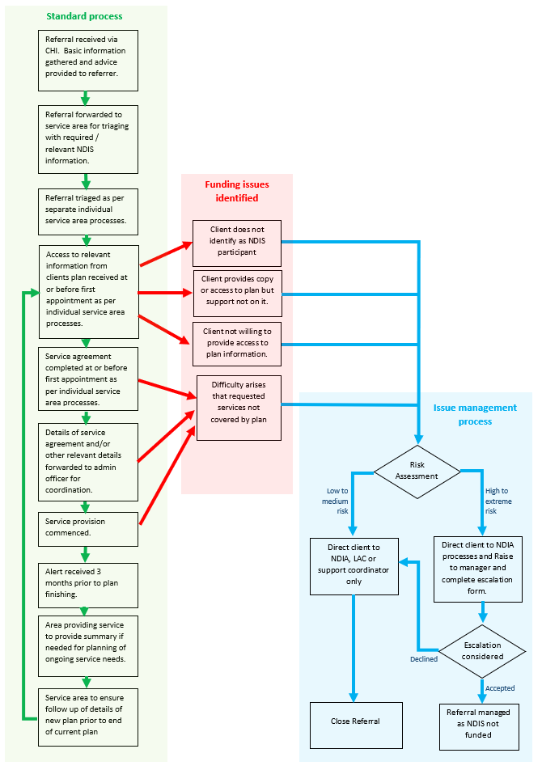

Attachment 3: Individual Services Steps for NDIS Client Intake Documents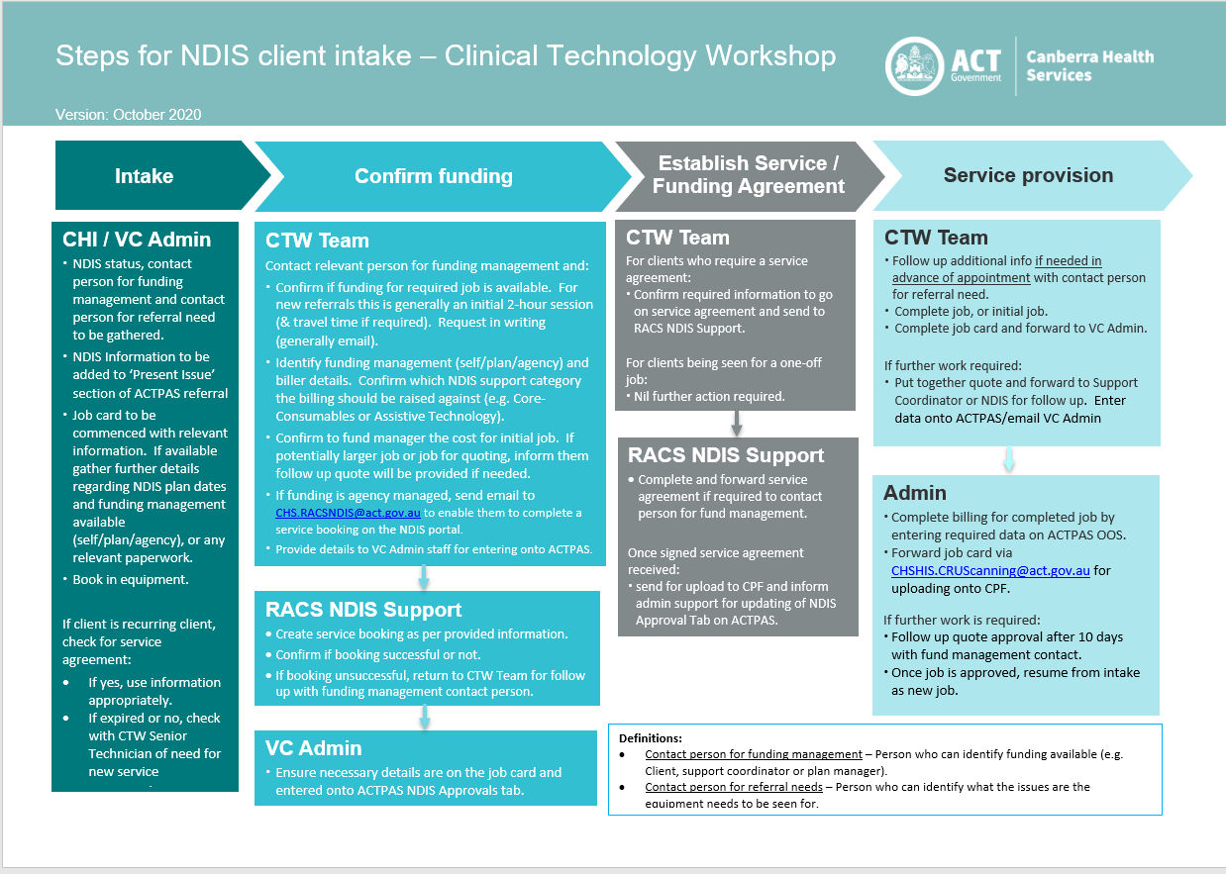
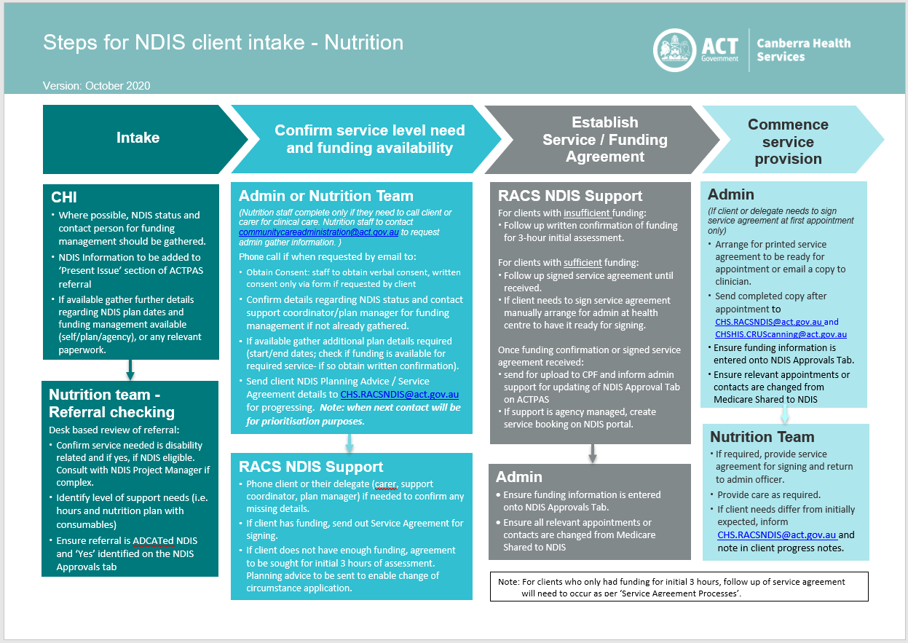
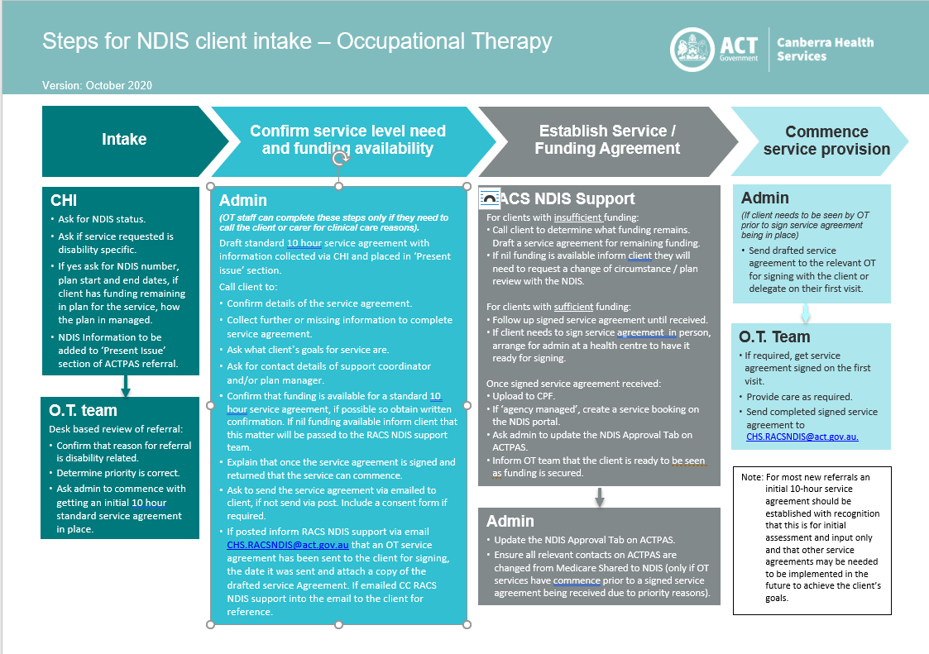
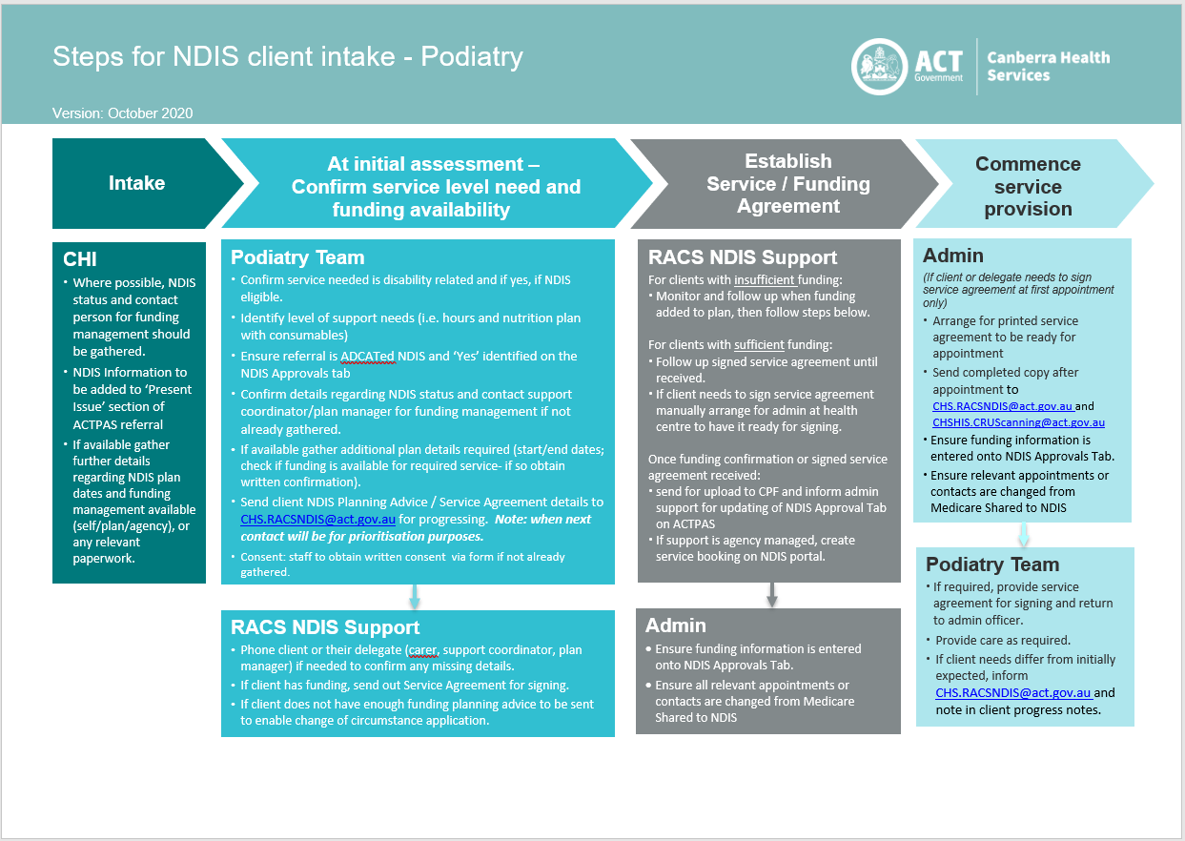
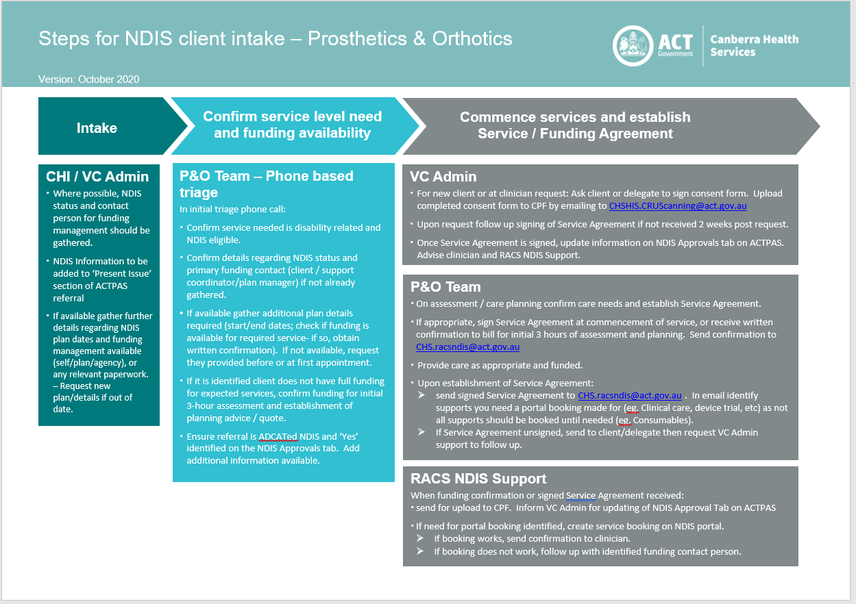

Attachment 4: Individual Services Change of NDIS Plan Process Documents

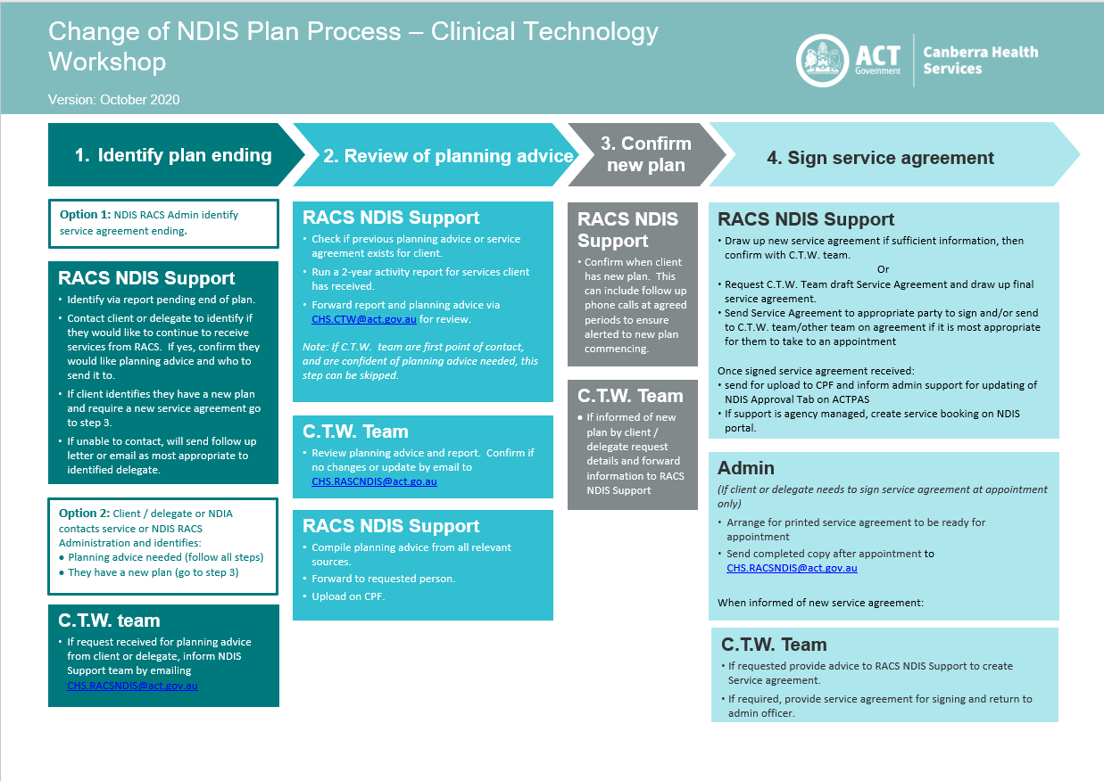
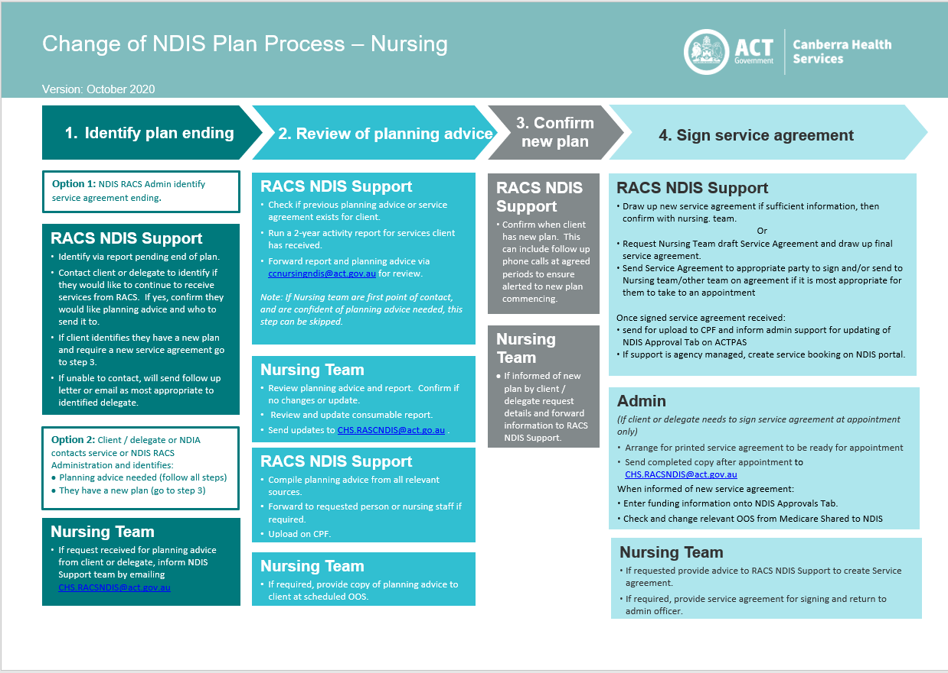
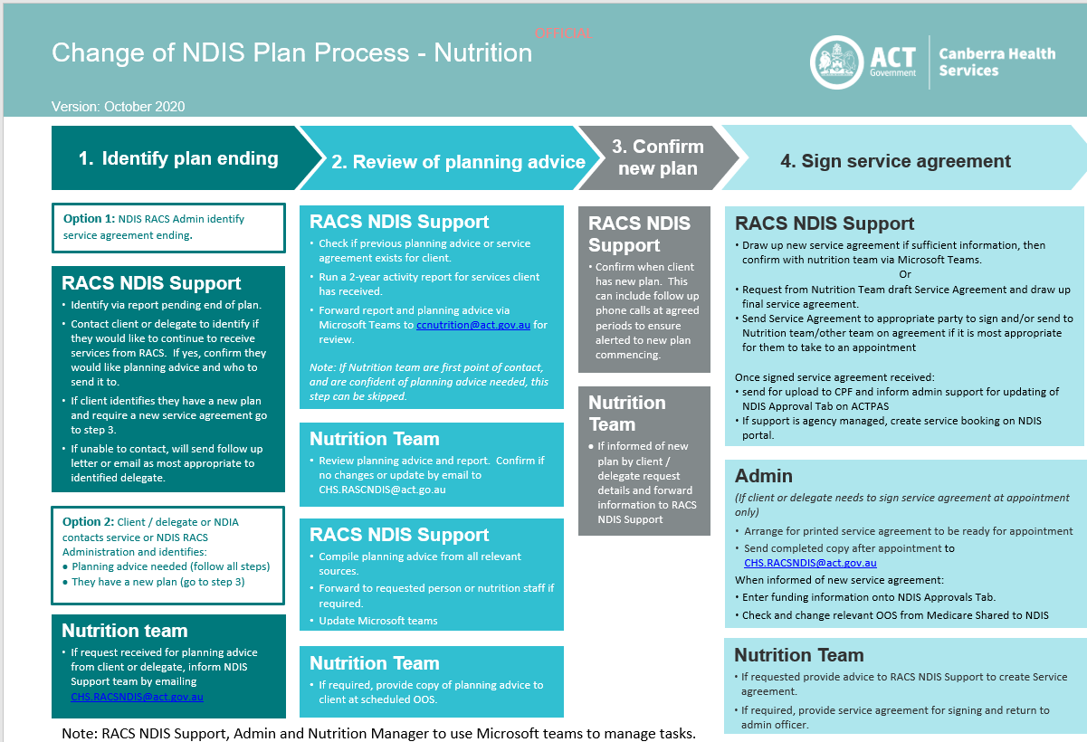
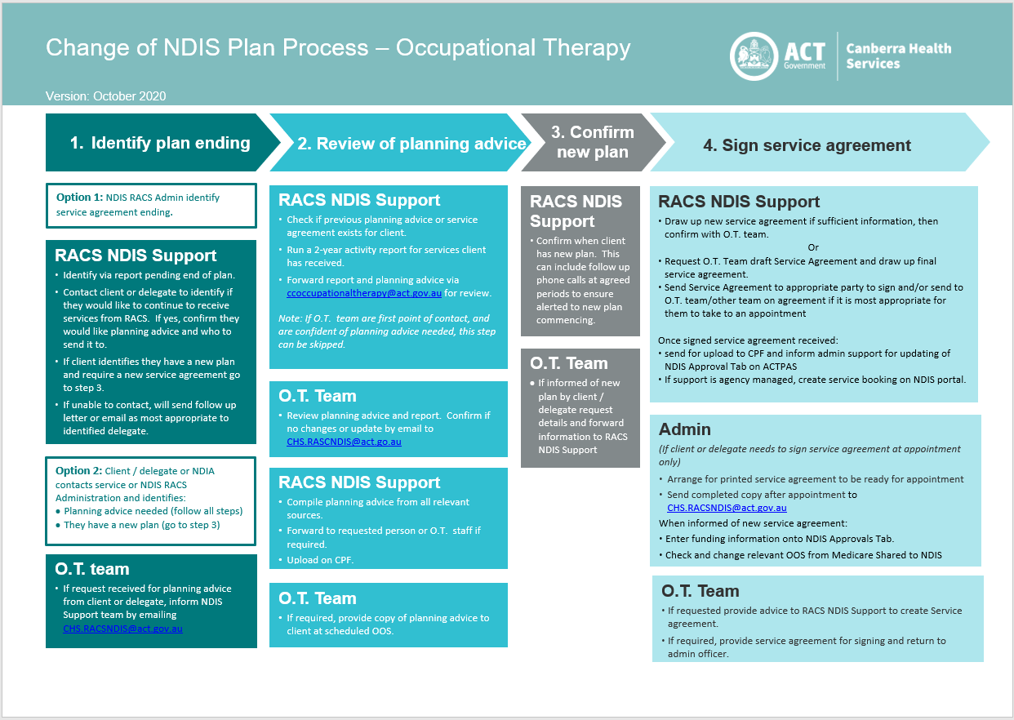
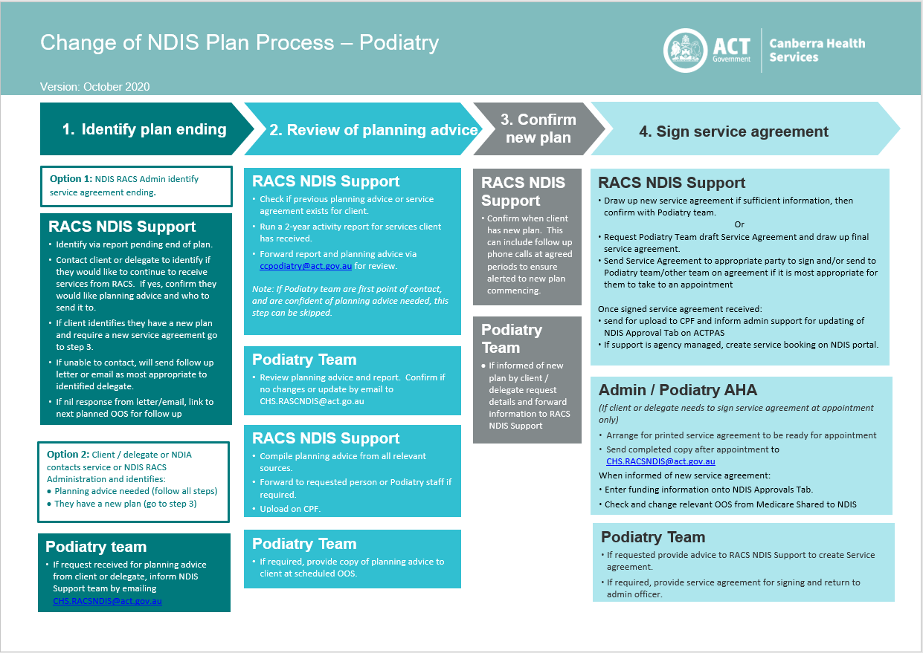
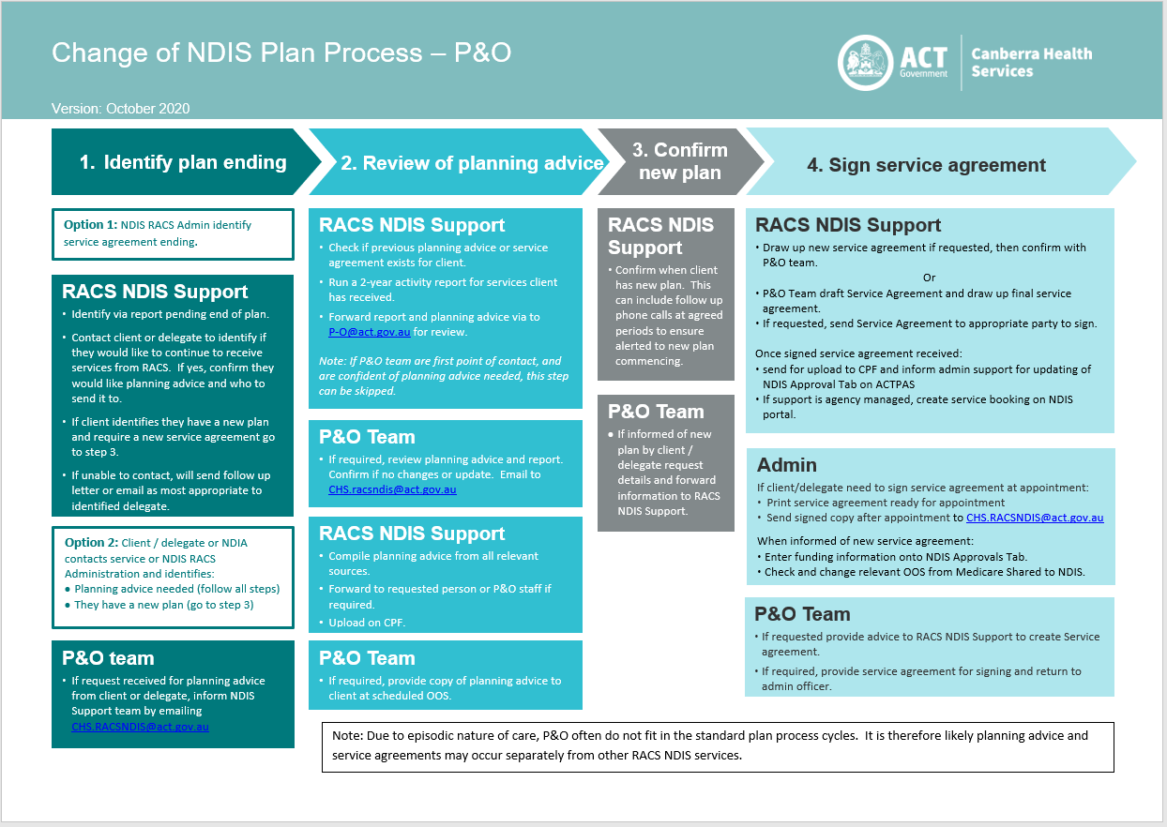

Attachment 5: Risk Assessment Matrix

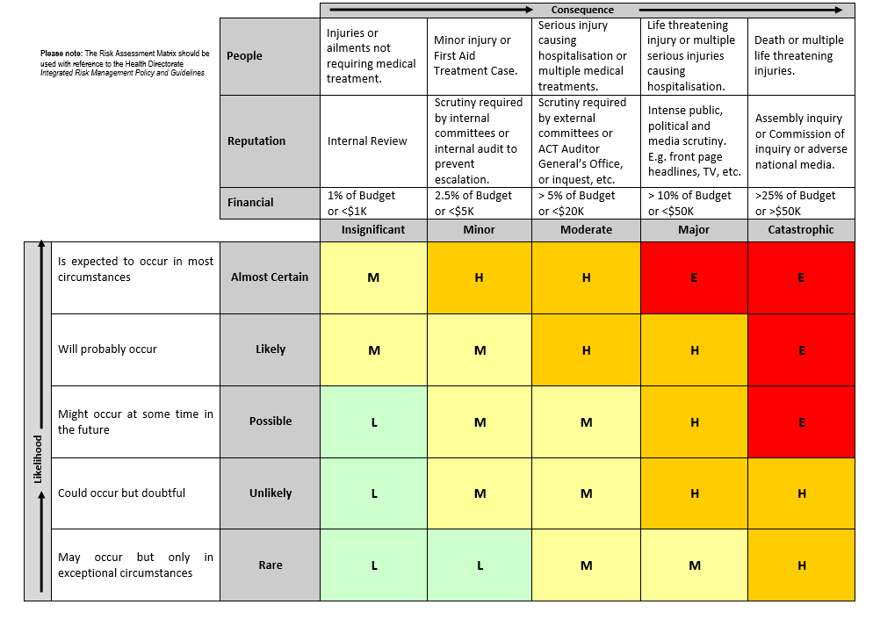

Attachment 6: NDIS Funding Difficulties Escalation Form
