Canberra Health Services
Procedure
Surgical Safety Checklist

Contents

Contents 1
Purpose 2
Alerts 3
Scope 3
Section 1 – Surgical Safety Checklist Pre-operative Process 4
Section 2 – Roles and Responsibilities – Surgical Safety Checklist Steps 4
Section 2 – Steps of the Surgical Safety Checklist 5
Section 3 – Completing the Surgical Safety Checklist 6
Section 4 – Process for discrepancies and non-compliance with the Surgical Safety Checklist 6
Evaluation 7
Related Policies, Procedures, Guidelines and Legislation 8
References 8
Search Terms 9
Attachments 9

Purpose

The Surgical Safety Checklist (SSC) was developed by the World Health Organisation (WHO) to improve surgical safety, reduce mortality rates and the incidence of surgical complications¹. The goals of the SSC are to ensure that staff have a consistent system and follow a uniform approach to minimise the most common and avoidable risks endangering the lives and well-being of surgical patients.

The WHO SSC identifies three phases of an operation, each corresponding to a specific period in the normal flow of a procedure:
- Step 1 “sign in”- before the induction of anaesthesia
- Step 2 “time out”- before the incision of the skin
- Step 3 “sign out”- before the patient leaves the operating room.

The SSC is a best practice patient safety initiative (endorsed by Australian Health Ministers, the Royal Australasian College of Surgeons², and the Australian and New Zealand College of Anaesthetists). The SCC is required under the National Safety and Quality Health Services Standards Version 2, Communicating for Safety, Action 6.06 Correct identification and procedure matching³.

Canberra Health Services (CHS) implemented the SSC on 1 February 2011. The three steps associated with the WHO SSC have been formalised into three distinct phases in CHS, each corresponding to a specific period in the normal flow of a surgical procedure (Attachment 1):

- Step 1 “Check-in”- incorporating the “sign in” step of the WHO SSC (completed before the induction of anaesthesia).
- Step 2 “Team Time Out”- incorporating the “time out” step of the WHO SSC (performed in the operating room and prior to skin incision or commencement of operative procedure).
- Step 3 “Check Out”- incorporating the “sign out” step of the WHO SSC. All steps are to occur prior to the patient leaving the operating room.

The purpose of this Clinical Procedure is to address patient safety and clinical risks associated with surgical procedures to ensure all CHS staff adhere to the correct process for completing the CHS SSC.

The completion of the SSC ensures:
- surgical safety and reduces both the mortality rates and the incidence of surgical complications through correct patient identification. This will prevent procedures being performed on the wrong patient or body part resulting in death or major permanent loss of function.
- matching of the correct patient to the correct procedure, communication within the surgical team and between the patient and the surgical team.
- Governance which clearly outlines staff roles and responsibilities in the process.

Back to Table of Contents

Alerts

Alert 1
In the following emergency situations, full completion of the SSC is at the discretion of the lead Medical Officer responsible for the operating team (Surgeon 1):
- Category 1 – Life threatening <1 hour
- Category A – Caesarean, delivery within 30 mins

In these categories only, Surgeon 1 is responsible for the care of the patient and should decide the most appropriate course of action based on clinical urgency. Surgeon 1 must document the decision to modify or delay the completion of the SSC must be documented in the clinical record.

Alert 2
The SSC is not considered complete unless all fields in the SSC in Clinical Portal have been completed. The SSC must be completed at the time of the procedure. The SSC should not be retrospectively completed, completed all at the same time, nor completed in advance or conclusion of the procedure.

Back to Table of Contents

Scope

This Clinical Procedure applies to all invasive and non-invasive surgical procedures where an electronic SSC is completed. This includes surgical procedures that are scheduled on the CHS Operating Room List “Theatre List” (excluding the Minor Procedure Room and Theatre 1B).

This document applies to the following CHS staff working within their scope of practice:
- surgical and anaesthetic medical staff
- nursing and midwifery staff
- students under direct supervision, and
- all other staff employed in the operating room environment e.g., wardsperson, radiographers.

For surgical procedures outsourced to the private sector (e.g., as part of a waiting list initiative), the private provider must provide a performance report to CHS which indicates their compliance with the three steps of the Surgical Safety Checklist. This will be reviewed at the time the service contract, Service Level Agreement or Memorandum of Understanding is renewed and is reported quarterly at meetings with CHS and private providers.

Back to Table of Contents

Section 1 – Surgical Safety Checklist Pre-operative Process

The process starts when the patient is being prepared for a surgical procedure and this includes the commencement of the Pre-operative Checklist (clinical form 45220) on admission to one of the areas listed below:
- Emergency Department
- Inpatient ward
- Day Surgery Admissions Unit
- Extended Day Surgery Unit

The patient’s identity, planned procedure and consent must be confirmed as per the Informed Consent Policy and Patient Identification and Procedure Matching Procedure prior to transfer from the admission area to the operating suite or procedure room. If the admission area staff member has any concern about the responses, the patient remains in the admission area until the concern is addressed (“if a box is ticked ‘no’ the patient does not go”).

The paper copy of the Pre-operative Checklist must be completed by the operating room nursing staff in Admissions or in the Holding Bay. This clinical handover of the patient, prior to transfer into the anaesthetic bay should include the patient, if present Enduring Power of Attorney (EPOA) or Health Attorney or legal guardian in the discussion where possible.

As stated in the Patient Identification and Procedure Matching Procedure marking of the surgical site (when appropriate) must take place in the inpatient area, admissions area, or Holding Bay. It is performed by a member of the surgical team who will be involved in the procedure:
- an arrow is placed at or near the surgical site with an indelible pen and initialled by the surgical team member
Note: any obscuring bandage/cast or other dressing must be removed from the operative site prior to site marking
- the marking should be placed so that it remains visible after draping
- when operating on the phalanges of the hands or feet, the site of the incision must be marked.

Back to Table of Contents

Section 2 – Roles and Responsibilities – Surgical Safety Checklist Steps

All members of the operating team have a role in ensuring the safety and success of an operation. The operating team is responsible for participating in and performing the SSC.
The operating team comprises of:
- surgeon and surgical assistants
- anaesthetists/anaesthetic registrar
- scrub and scout nurses
- anaesthetic nurses

The surgeon or medical officer performing the surgery is Surgeon 1. Surgeon 1 has ultimate responsibility for completing the SSC. Consultants are accountable for ensuring Registrars are aware of their responsibility to complete the SSC.

The medical officer is responsible for:
- initiating and leading SSC briefings while the patient is in the operating room
- reading aloud discussion points on the SSC form
- providing a verbal response to discussion points raised relevant to the role
- completion of the SSC form by checking a tick box relevant to each discussion point

Back to Table of Contents

Section 2 – Steps of the Surgical Safety Checklist

Step 1 Check-in
The check-in process must be undertaken by the anaesthetic nurse and/or anaesthetist in the anaesthetic bay, or procedure room, before the induction of anaesthesia, where they:
- confirm the patient’s identity, procedure, surgical site, and consent with the patient
- confirm the anaesthesia safety check and attach pulse oximetry if pulse oximetry monitoring is required/clinically indicated
- consider and confirm difficult airway/aspiration risk
- check for drug allergies
- assess risk of major bleeding (risk of >500mL in adults or 7mL/kg in paediatrics)
- check that the surgical site is correctly marked and bring it to the attention of Surgeon 1 if not marked correctly. It is Surgeon 1’s responsibility to ensure that the surgical site is correctly marked.

Check In must be documented on the pre-op checklist and included in the patient’s clinical notes.

Step 2 Team Time Out (documented electronically in the operating room)
This must occur prior to skin incision or commencement of operative procedure. As part of the Team Time Out the availability of all imaging requested by the surgical team is checked. Team Time Out must be performed by Surgeon 1 or their delegate.

During the SSC briefings, all team members must pause, listen, and participate by providing a verbal response to other team members. However, it is the surgeon or medical officer performing the surgery that leads the discussion and is responsible for confirming that the team has completed each task before safe surgery commences.

Attachment 1 outlines the process to complete Step 2 Team Time Out.
Step 3: Check Out (documented electronically in the operating room)
This step must occur following the procedure before the patient leaves the operating room. Check Out must be performed by Surgeon 1 or their delegate.

Attachment 1 outlines the process for completing Step 3 Check Out.

Back to Table of Contents

Section 3 – Completing the Surgical Safety Checklist

The SSC must be completed electronically within Clinical Portal (Attachment 1). On completion the electronic SSC is sent to Clinical Patient Folder.

Some responses in both steps of the electronic SCC may prompt additional information in a free text response. For example, if “yes” is ticked in the anaesthetic concerns, a box drops down so specific concerns in relation to anesthetising the patient can be documented e.g., identifying potential difficulty in intubating the patient.

Back to Table of Contents

Section 4 – Process for discrepancies and non-compliance with the Surgical Safety Checklist

Non-compliance with completing the electronic SSC may be identified immediately or later via compliance reports.

At the time of surgery, if any staff member has a concern that the surgical safety checklist is not being followed or there is a discrepancy, they must in the first instance voice their concerns to the other members of the operating team and the surgery must not proceed. Using the Speaking Up for Safety (SUFS) CODE is recommended.

If surgery proceeds, as outlined above non-compliance must also be documented in the clinical record and reported as soon as it is practical. Nursing staff must report the incident to the Clinical Nurse Consultant/Nursing Team Leader who will escalate to the Peri-operative Assistant Director of Nursing (ADON), who is responsible for investigating the incident.

Medical staff must report the incident to their Unit Director and/or Clinical Director of Surgery directly or to the Peri-operative ADON.

A clinical incident report (completed RiskMan) is to be completed by the staff member witnessing the incident of non-compliance with the SSC. This clinical incident will be reviewed by the staff members supervisor and/or line manager.

If a clinician is identified as having repeatedly breached this clinical procedure, the following process for non-compliance is to be followed:
- Surgical staff will have a meeting scheduled with their Supervisor of Training, Unit Director, or Clinical Director. A plan will be developed to address non-compliance.
- If a medical officer continues not to comply with clinical procedure, further action will be taken in accordance with the current ACT Public Sector Medical Practitioners Enterprise Agreement or the Visiting Medical Officers Service Contract.

Assessment for compliance against several defined categories is designed to ensure compliance with the correct process and to ensure patient safety.

Note:
As stated in the Patient Identification and Procedure Matching Procedure

Discrepancies: All team members must agree on the resolution of the discrepancy and the resolution must be documented in the clinical record and a RiskMan incident report completed by a member of the perioperative team.

A wrong patient, wrong site, wrong procedure incident is a mandatory reportable event.
Refer to Incident Management Policy and Procedure for further information.

Back to Table of Contents

Evaluation

Outcome
Patients having a surgical procedure at CHS will have a surgical safety checklist completed.

SSC completion is reported to the Division of Surgery and monitored via:
- Electronic SSC compliance reports informed by data from Clinical Portal (Attachment 1).
- Observational audits (20 per month) using the SSC audit tool.

Measures
The compliance target for the electronic SSC is 95% to account for potential data entry discrepancies. The goal is for all (100%) of patients to have an electronic SSC completed.

Compliance and observational data is reported monthly to the Division of Surgery by the ADON of Peri-operatives Services and is reported in the quality and safety data bundle provided by the Quality Safety Innovation and Improvement Division. Data for clinical units outside of the Division of Surgery is reported through the appropriate Division.

Data is monitored against the compliance target and improvement initiatives may be developed to improve compliance.

Clinical incident reports related to non-compliance with the SSC are reviewed and actioned by supervisors and/or line managers as outlined in Section 4.

Back to Table of Contents

Related Policies, Procedures, Guidelines and Legislation

Policies
- Nursing and Midwifery Board of Australian (NMBA) Requirements for
- Informed Consent (Clinical)
- Incident Management (Clinical)

Procedures
- Infection Prevention and Control Healthcare Associated Infections Clinical
- Patient Identification and Procedure Matching
- Incident Management (Clinical)

Guidelines
- Fasting Guidelines – Elective and Emergency Surgery

Legislation
- Health Records (Privacy and Access) Act 1997
- Human Rights Act 2004
- Work Health and Safety Act 2011

Other
- Australian Charter of Health Care Rights

Back to Table of Contents

References

- World Health Organization. Surgical Safety Checklist [Internet]. 2009 [cited 2022 May 24]. Available from: http://apps.who.int/iris/bitstream/handle/10665/44186/9789241598590_eng_Checklist.pdf;jsessionid=40D234432F883F4BF352BA9042AAFA9D?sequence=2

- Royal Australasian College of Surgeons. Surgical Safety Checklist (Australia and New Zealand). October 2009 [cited 2022 May 24] Available from: https://www.surgeons.org/-/media/Project/RACS/surgeons-org/files/member-benefits/lst_2009_surgical_safety_check_list_-australia_and_new_zealand-.pdf?rev=1bc12bd84b9944af8249055988581b0d&hash=0BC3BC836F92086751ADC838AF4A1765

- Australian Commission on Safety and Quality in Health Care. Surgical Safety Checklist. 2022 [cited 2022 May 24]. Available from: https://www.safetyandquality.gov.au/our-work/communicating-safety/patient-identification/patient-procedure-matching-protocols/surgical-safety-checklist

Back to Table of Contents

Search Terms

Surgical Safety Checklist, SSC, Electronic, eSSC, Peri operative, operating theatre, OT, Operating Room, OR.

Back to Table of Contents

Attachments

Attachment 1 – CHS Surgical Safety Checklist

Disclaimer: This document has been developed by Canberra Health Services specifically for its own use. Use of this document and any reliance on the information contained therein by any third party is at his or her own risk and Canberra Health Services assumes no responsibility whatsoever.

Policy Team ONLY to complete the following:
Date Amended | Section Amended | Divisional Approval | Final Approval
26 June 2022 | Complete Review | Lisa Gilmore, ED-Surgery | CHS Policy Committee

This document supersedes the following:
Document Number | Document Name
CHHS17/170 | Surgical Safety Checklist Policy

Attachment 1 – CHS Surgical Safety Checklist

Step 2 – Team Time Out

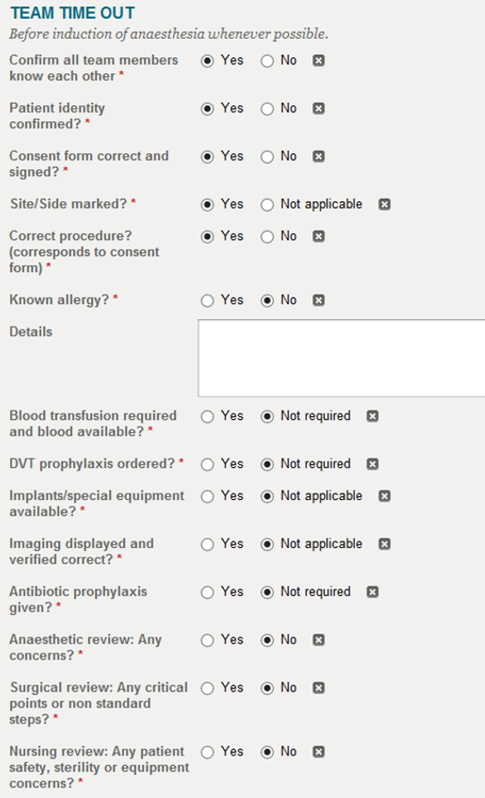

Step 3 – Check Out
