Guideline | Canberra Health Services

Resuscitative Thoracotomy
CHS26/077
Contents
Guideline statement 2
Scope 2
Section 1 – Resuscitative Thoracotomy Algorithm 3
Section 2 – Indications for Pericardial Decompression via Resuscitative Thoracotomy in either Blunt and/or Penetrating Trauma 4
Section 3 – Contraindications for Pericardial Decompression via Resuscitative Thoracotomy 4
Section 4 – Urgent Thoracotomy 5
Section 5 – Equipment and Method 5
Section 6 – Pericardiotomy Procedure 8
Section 7 – Post Procedure Care 9
Section 8 – Cessation of Resuscitation 9
Evaluation 9
Related policies, procedures, guidelines and legislation 10
References 10
Definition of terms 11
Search terms 12

Guideline statement

Background
Thoracic trauma is one of the leading causes of death worldwide in all age groups and accounts for 20-50% of all traumatic injuries.
Rapid response times and improved paramedical treatment at the scene have resulted in increasing numbers of patients arriving at the Emergency Department in extremis. Salvage of these patients requires immediate resuscitation, achieved by focusing on the correction of reversible causes of shock: haemorrhage, obstruction (due to tension pneumothorax or pericardial tamponade) and hypoxia. As part of the initial resuscitation, a small subset of patient’s may require a Resuscitative Thoracotomy (RT) to decompress their pericardium.
Survival rates following RT for penetrating thoracic trauma are 9-12% and up to 38% in those with signs of life; whereas for blunt trauma survival rates are 1-2% and up to 5% in those with signs of life.
Resuscitative Thoracotomy is also commonly and interchangeably called Emergency Department Thoracotomy (EDT).

Key Objective
The primary aim of a Resuscitative Thoracotomy is to alleviate cardiac tamponade which is causing refractory obstructive shock.
In the presence of senior surgical staff, secondary aims to consider are:
- Haemorrhage control
- Performing open cardiac massage
- Cross clamping the descending thoracic aorta to prevent exsanguination from catastrophic intraabdominal bleeding.
Back to Contents

Scope
This guideline applies to resuscitation teams receiving trauma patients in the Emergency Department of Canberra Hospital.
Clinicians should work within their scope of practice and only perform procedures for which they have sufficient training. Thoracotomy is a highly invasive procedure and the risk to staff and the patient from an inappropriate or incorrectly performed procedure may be greater than not attempting such a procedure. The decision to proceed with a Resuscitative Thoracotomy is a Consultant level decision.

This guideline applies to adult patients in cardiac arrest or peri-arrest due to physical trauma. It excludes patients who have injuries incompatible with life and patients who have had no signs of life in the last 10 minutes.
Back to Contents

Section 1 – Resuscitative Thoracotomy Algorithm

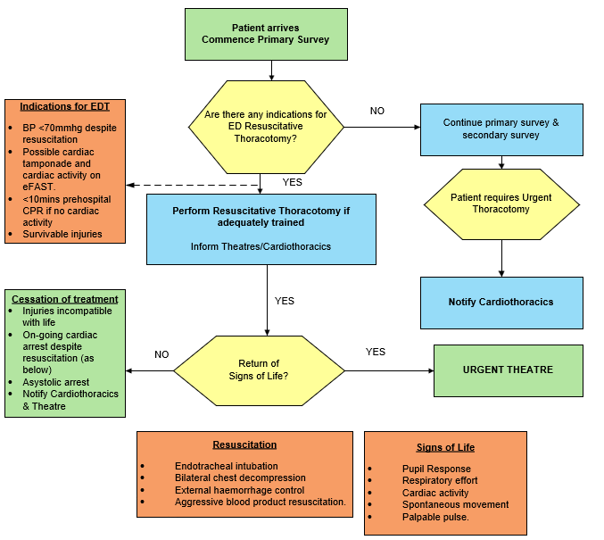
** Consultant decision to perform Resuscitative Thoracotomy is required**

Back to Contents

Section 2 – Indications for Pericardial Decompression via Resuscitative Thoracotomy in either Blunt and/or Penetrating Trauma
Indications for pericardial decompression via RT in either blunt or penetrating trauma include:
- All of the following:
  - Refractory shock with Systolic Blood Pressure (BP) less than 70mmHg despite intubation, bilateral chest decompression, external haemorrhage control and aggressive blood product resuscitation
  - Possible Cardiac Tamponade on eFAST
  - Possible Cardiac Activity on eFAST
- Or both of the following:
  - Witnessed cardiac arrest in ED or pre-hospital (less than 10 minutes) in an undifferentiated trauma patient
  - Possible Cardiac Tamponade on eFAST.
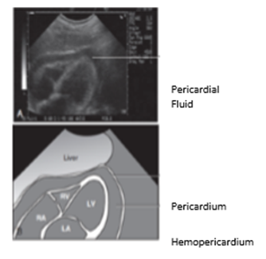
Figure 1: Image of pericardium displaying both pericardial fluid and hemopericardium
Back to Contents

Section 3 – Contraindications for Pericardial Decompression via Resuscitative Thoracotomy
Contraindications for pericardial decompression via RT include:
- Cardiopulmonary resuscitation (CPR) of greater than 10 minutes in the context of traumatic arrest
- Injuries that are not compatible with life (including non-survivable head injuries)
- Lack of training in the procedure
- The patient’s age and pre-existing co-morbidities mean that successful resuscitation is highly unlikely.
Back to Contents

Section 4 – Urgent Thoracotomy
Time critical patients who are not in extremis, and who do not meet the indications above, are best managed in the operating room by the cardiothoracic team. The patients should have rapid transport to theatre.
If the cardiothoracic team is delayed and not immediately available in theatre at the time of the patient’s arrival, the thoracotomy should be commenced by the general surgeon. The approach should be as outlined in Section 5 using the left lateral thoracotomy, which can then be extended/converted to clamshell if required. Lateral decubitus positions (left or right) are not recommended in a critical trauma situation.
Back to Contents

Section 5 – Equipment and Method

Personal Protective Equipment (PPE)
Full PPE should be worn by all clinicians involved in the procedure due to the high risk of blood and body product contamination; this includes (but isn’t limited to) gloves/waterproof gown/mask/ full face protection and shoe covers.

Equipment
- Resuscitative Thoracotomy Tray
- 1 Large Bowl
- 20 Large surgical packs
- An additional suction (either wall or portable)

Resuscitative Thoracotomy Equipment
There are two surgical trays available: a standard Cardiothoracic Tray and a Resuscitative Thoracotomy tray.
Resuscitative Thoracotomy Tray contents:
- Skin Prep (Chlorhexidine)
- Drapes x 2
- Scalpel (size 22)
- Metzenbaum Dissecting Scissors
- Rib Shears
- Assembled Finochietto Retractors
- Lung Retractor
- Debakey Forceps
- Mayo Curved scissors
- Satinsky Vascular Clamp
- Suture 3/0 Prolene
- Needle holder
- Skin stapler
- Roberts Curved Forceps
- Artery Forceps x 2
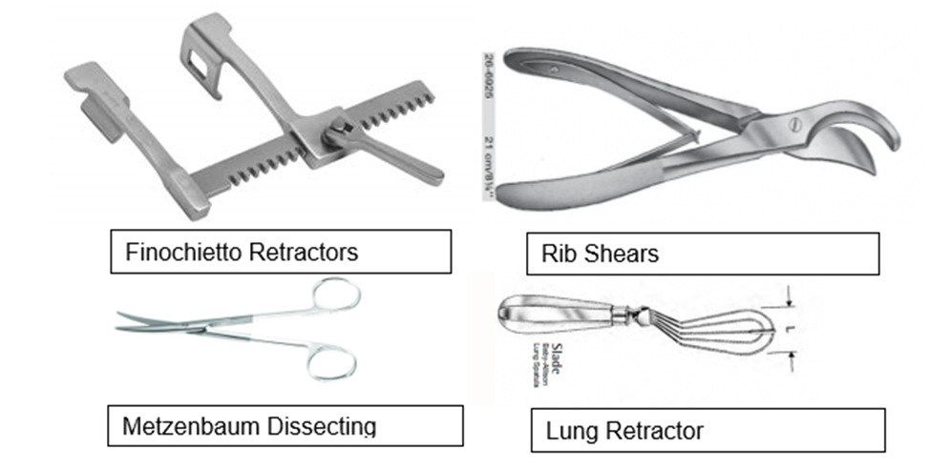
Figure 3: Some of the components of a Resuscitative Thoracotomy Tray

The approach
The left anterolateral approach is frequently utilised (see Figure 2) for RT due to the advantages of:
- Rapid access with simple instrumentation in the supine patient
- Easy extension to the contra lateral hemi-thorax (clamshell).
The right anterolateral approach may be selected in cases where there is a penetrating injury to the right side of the chest.

Method
Although surgical draping is not essential, large waterproof, disposable sterile paper drapes are included in the Resuscitative Thoracotomy tray. The patient is positioned supine with both arms abducted at right angles, and the left side of the chest and hip partly elevated (folded towels, pillow, or sandbags). Several large surgical packs should be available as well as suction.
Rapidly prepping and draping of the entire area is suggested prior to the skin incision being made. The skin incision should be below the nipple, in the infra-mammary fold and should target the fifth intercostal space (see image 1 in Figure 2), extending through the soft tissues of the chest wall following the curve of the rib. In women, the breast should be retracted. If a finger thoracostomy has been performed in the fifth intercostal space, the incision should be extended as per the above description.
Entry into the pleural cavity should be on the superior margin of the sixth rib to avoid the intercostal neurovascular bundle. Muscle, periosteum and parietal pleura are divided in one layer with scissors and blunt dissection. Chest wall bleeding is generally minimal.
To spread the ribs once the incision is completed (see image 4 in Figure 2) and the pleural cavity exposed, a suitable retractor (Finochietto comes assembled on the Resuscitative Thoracotomy Tray) should be inserted with the handle pointing towards the axilla. Additional exposure can be achieved by incising the superior and inferior costal cartilages of the opened interspaces, or by bisecting the sternum (rib shears) to convert to a clamshell thoracotomy.
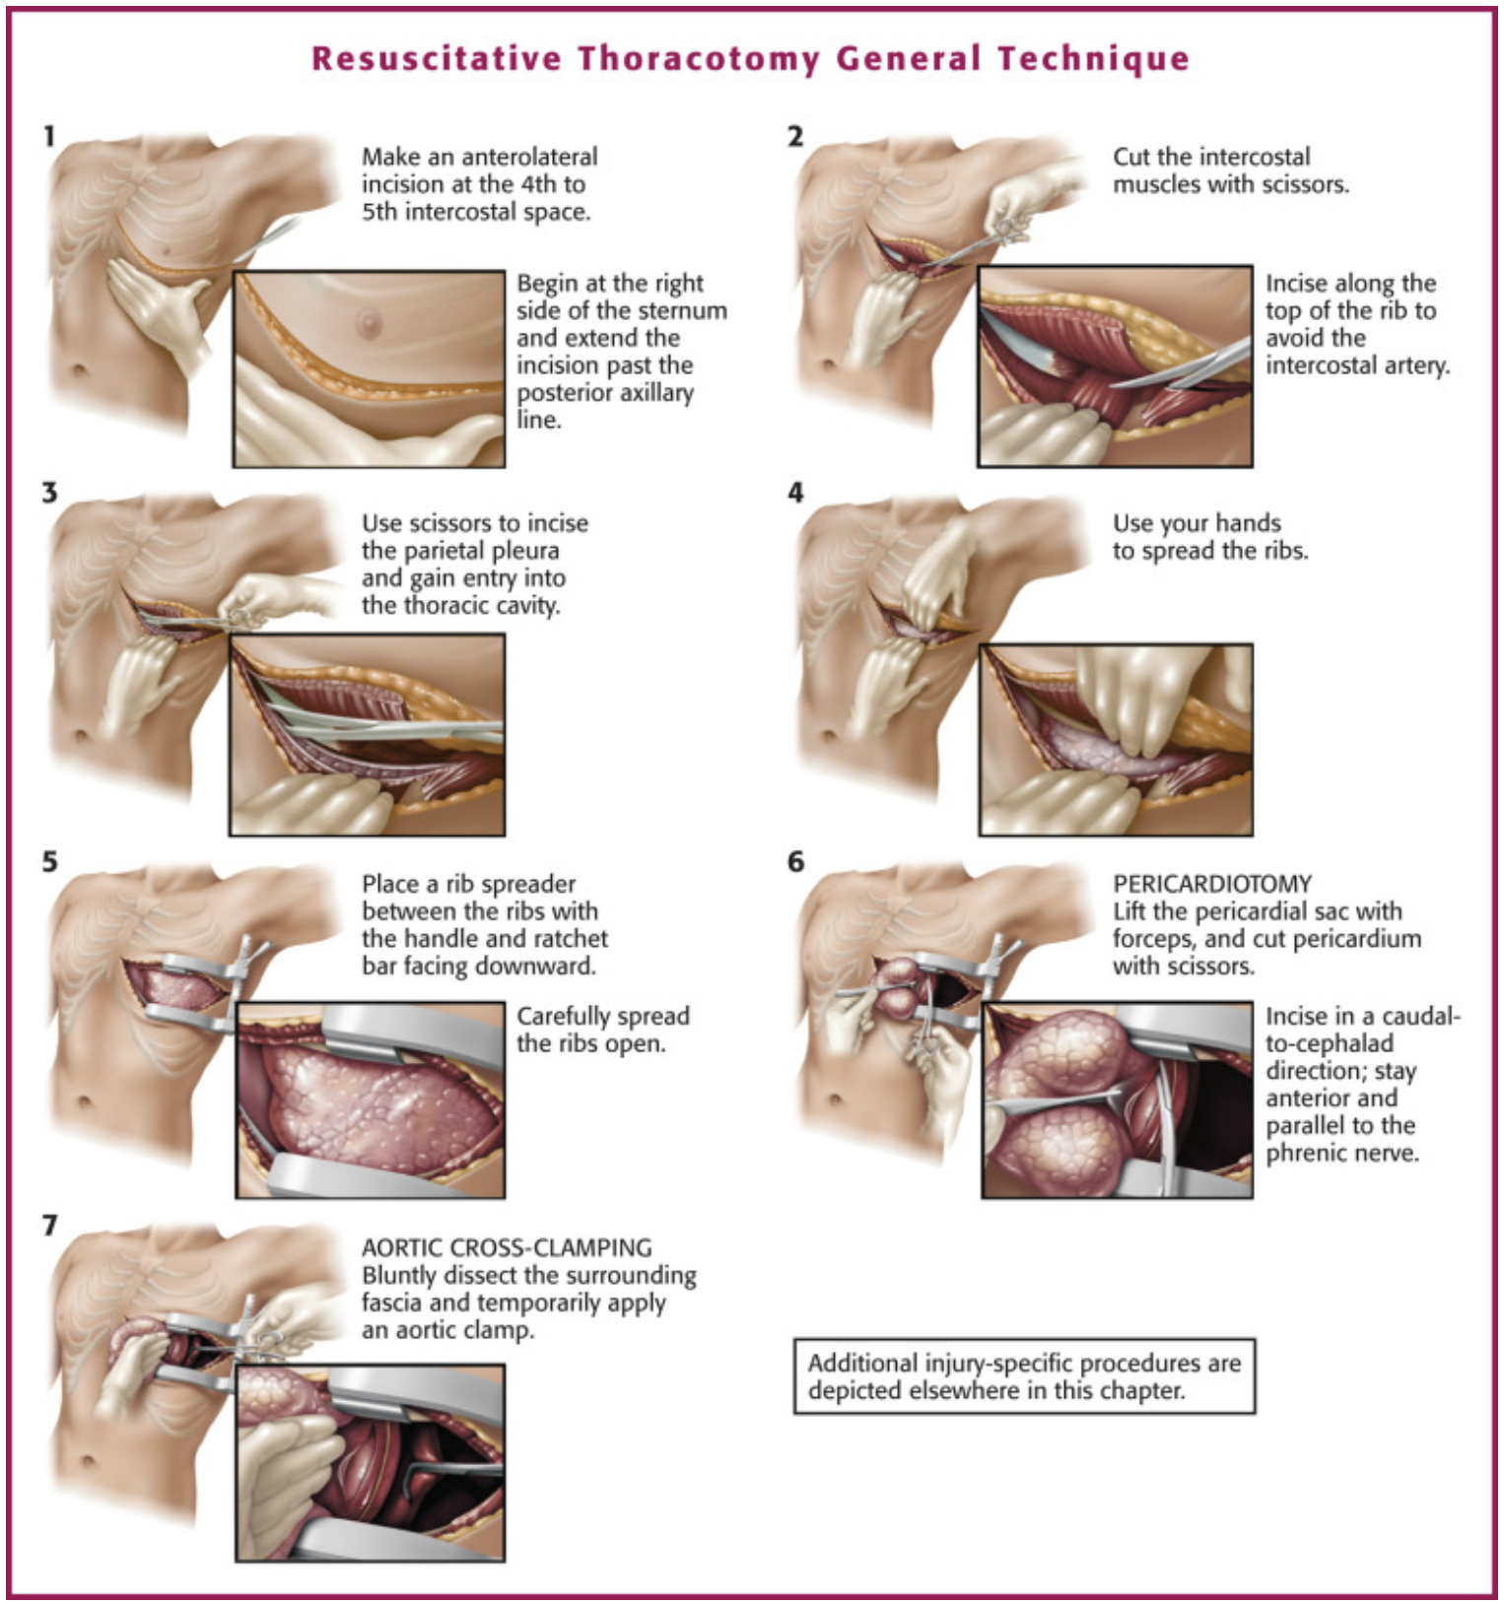
Figure 2: Resuscitative thoracotomy, general technique. (From Jones & Rivers 2019, Chapter 18 Resuscitative Thoracotomy. [Custalow CB: Color atlas of emergency department procedures. Philadelphia, 2005, Saunders]).

Section 6 – Pericardiotomy Procedure

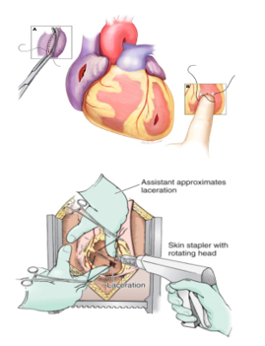
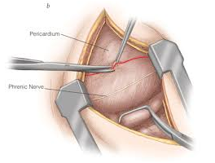
Pericardiotomy to relieve cardiac tamponade
The pericardiotomy should be made with at least 1cm anterior scissors and parallel to the phrenic nerve.
Any blood should be evacuated.
In the beating heart, digital pressure on bleeding sites should be maintained until the patient is resuscitated.
If the heart is fibrillating, suture control of the bleeding points should be performed after defibrillation.
The pericardium may appear normal despite the presence of tamponade. It must always be opened.

Initially, use digital pressure on bleeding sites. If unsuccessful, consider:
Satinsky clamp for atrial wounds.
Skin stapling device for temporary control of bleeding from the myocardium (larger wounds).
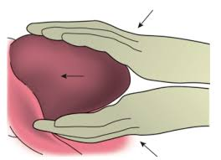
Cardiac massage should begin immediately if there is true cardiac arrest.
This can be done using two hands with a hinged clapping motion - i.e. two cupped hands opposed at the wrist and avoiding thumb pressure.
Internal cardiac massage should not be the only indication for RT as external compressions have been shown to be equally effective.
Defibrillation for ventricular fibrillation by closing the chest and using external defibrillation pads at 200 Joules.
Back to Contents

Section 7 – Post Procedure Care
Once cardiac output has returned, the patient requires rapid transport to the operating theatre for definitive care. Hypotensive resuscitation principles (aiming for systolic BP of approximately 90mmHg) should be employed to maintain perfusion but minimise haemorrhage. Refer to the Critical Bleeding Massive Transfusion Procedure, available on the Policy and Guidance Documents Register.
Back to Contents

Section 8 – Cessation of Resuscitation
Cessation of resuscitation requires careful consideration, and should be considered where there is:
- On-going cardiac arrest despite intubation, external haemorrhage control, aggressive blood product resuscitation and pericardiotomy
- Asystolic arrest
- Injuries that are incompatible with life.
Back to Contents

Evaluation

Outcome
- Patients presenting to the Emergency Department with physical trauma are treated according to this guideline.

Measures
- Review of documentation as part of data collection and analysis for the Australian Trauma Registry by the Trauma Service.
- The Trauma Service will be responsible for auditing compliance and storing all identified issues on the Australian Trauma Registry, reporting bimonthly to the ACT Trauma Committee.
- Current Key Performance Indicators:
  - Trauma team activation (According to activation criteria)
  - Trauma team response - volume per minute of fluid resuscitation
  - Emergency surgery in < 40 minutes from arrival
  - Emergency catheter angiography in < 60 minutes from arrival.
Back to Contents

Related policies, procedures, guidelines and legislation

Procedures
- Aseptic Technique
- Infection Prevention and Control
- Patient Identification and Health Care Activity Matching
- Fresh Blood Products Administration (Adults, Paediatrics and Neonates)
- Trauma Team Activation and Roles and Responsibilities
- Massive Transfusion Protocol
- Surgical Safety Checklist

Guidelines
- Consent for Healthcare Treatment
- Traumatic Cardiac Arrest

Legislation
- Health Records (Privacy and Access) Act 1997
- Human Rights Act 2004
- Work Health and Safety Act 2011

Other
- Australian Charter of Healthcare Rights
Back to Contents

References
- Seamon MJ, Haut ER, Van Arendonk K, et al. An evidence-based approach to patient selection for emergency department thoracotomy: A practice management guideline from the Eastern Association for the Surgery of Trauma. Journal of Trauma and Acute Care Surgery. 2015;79(1):159-173.
- Fransman R, Efron D. Emergency Department Resuscitative Thoracotomy In: Cameron J, Cameron A, eds. Current Surgical Therapy 13th ed: Elsevier; 2020: 1139-11452
- Raja A. Thoracic Trauma In: Walls R, Hockberger R, Gausche-Hill M, eds. Rosen's Emergency Medicine; concepts and clinical practice 9th ed: Elsevier; 2018: 382-403.
- Gumm K, Liersch K, Judson r, et al. TRM04.02 Emergency Department Thoracotomy Guideline Melbourne: The Royal Melbourne Hospital; June 2015
- Marmor G. Traumatic Cardiac Arrest Guideline Canberra: Canberra Health Services Clinical Guideline. Canberra Hospital; May 2020
- Jones R, Rivers E. Resuscitative Thoracotomy. In: Roberts I, Hedges J, eds. Roberts and Hedges Clinical Procedures in Emergency Medicine and Acute Care Elsevier; 2019: 338-352. e332.
- ANZCOR. Management of Cardiac Arrest due to Trauma; ANZCOR Guideline 11.10.1: Australian and New Zealand Council of Resuscitation April 2016.
- Boddart G, Hornez E, De Lesquen H, et al. Resuscitation thoracotomy. Journal of Visceral Surgery. December 2017;154:S35-S41.
- Lesquen H, Beranger F, Natale C, Boddaert B, Acaro J. Resuscitation thoracotomy-technical aspects. Journal of Visceral Surgery. 2017;154:S61-S67
- Moore H, Moore E, Burlew C, et al. Establishing Benchmarks for Resuscitation of Traumatic Circulatory Arrest: Success-to-Rescue and Survival among 1,708 Patients. Journal of the American College of Surgeons. 2016 223(1):42-50.
- Fitzgerald M, Newton-Brown E, Tan G, Martin K. Emergency & Trauma Centre Resuscitative Thoracotomy and Pericardial Decompression Handbook. 3rd ed. The Alfred 2015
- Custalow C. Resuscitative thoracotomy, general technique. In: 18.4 F, ed. Color atlas of emergency department procedures. Philadelphia Saunders 2005.
- Godbole M, Olafson S, Cohen RB, Ward CL, Sailes S, Sharlin M, Parsikia A, Moran BJ, Leung PSP. Eastern Association for the Surgery of Trauma (EAST) vs Western Trauma Association (WTA): How a Level 1 Trauma Center Splits the Difference in Resuscitative Thoracotomy. Cureus. 2024 Mar 20;16(3):e56521. doi: 10.7759/cureus.56521. PMID: 38646323; PMCID: PMC11026983.
- Radulovic N, Wu R, Nolan B. Predictors of survival in trauma patients requiring resuscitative thoracotomy: A scoping review. Trauma. 2023;26(2):95-100. doi:10.1177/14604086231156265
- Perkins, Zane B., Robert Greenhalgh, Ewoud Ter Avest, Shadman Aziz, Andrew Whitehouse, Steve Read, Liz Foster et al. "Prehospital resuscitative thoracotomy for traumatic cardiac arrest." JAMA surgery 160, no. 4 (2025): 432-440.
Back to Contents

Definition of terms

Resuscitative Thoracotomy (RT)
Occurring in the emergency department as an integral part of the initial resuscitation process immediately after presentation.

Signs of Life
- Pupillary response to light
- Respiratory effort
- Cardiac activity/ contractility on eFAST
- Spontaneous movement
- Palpable pulse

Urgent Thoracotomy
Thoracotomy performed in the operating theatre.
Back to Contents

Search terms
Trauma, Arrest, Cardiac, Traumatic, Thoracotomy, Resuscitation, Tamponade
Back to Contents

For Policy Team to complete:
Date amended | Section amended | Divisional approval | Final approval
26/03/2026 | Complete Review | Deborah Plant Executive Director, Division of Surgery | CHS Policy Committee
This document supersedes the following:
Document number | Document name
CHS22/348 | Resuscitative Thoracotomy
Disclaimer
This document has been developed by Canberra Health Services specifically for its own use. Use of this document and any reliance on the information contained therein by any third party is at his or her own risk and Canberra Health Services assumes no responsibility whatsoever.
Back to Contents

Acknowledgement of Country  Canberra Health Services acknowledges the Ngunnawal people as traditional custodians of the ACT and recognises any other people or families with connection to the lands of the ACT and region. We acknowledge and respect their continuing culture and contribution to the life of this region.  © Australian Capital Territory, Canberra 2024 | Accessibility  call (02) 5124 0000   Interpreter call 131 450  canberrahealthservices.act.gov.au/accessibility  

