Guideline | Canberra Health Services

Physiotherapy – Adult Patient with a Spinal Cord Injury
CHS25/031
Contents
Guideline statement 2
Scope 2
Section 1 - Physiotherapy Management 3
Evaluation 8
Related policies, procedures, guidelines and legislation 9
References 10
Definition of terms 13
Search terms 15
Attachments 15
Attachment 1 - ACUTE SUPPORT PHYSIOTHERAPY PRIORITY TOOL – Inpatients & Emergency Department (secondary contact) 17
Attachment 2 - ASIA Scale²² 19
Attachment 3 - How to test forced vital capacity 21
Attachment 4 - How to assess peak cough flow 23
Attachment 5 - Expected Vital Capacity for SCI ^{(adapted from 16)} 24
Attachment 6 - How to perform a manually assisted cough²³ 25
Attachment 7 - Outcome Measures for Impairment and Activity Management²⁴ 28
Attachment 8 - Optimal Functional Outcome for Patients following Complete Spinal Cord Injury²² 30

Guideline statement
Key Objective
The purpose of this document is to standardise physiotherapy management of adult spinal cord injury (SCI) patients in the acute, sub-acute and community setting. This document can be applied to adult patients (16 years or older) with complete or incomplete SCIs.

Alerts
All physiotherapists involved in the management of a patient with SCI should be aware of and know the management for autonomic dysreflexia (refer to Definition of Terms section for symptoms and management).
Back to Contents

Scope
This clinical guideline applies to the following Canberra Health Service (CHS) Network staff members working within their scope of practice managing adult patients (16 years or older) who have a SCI:
- Physiotherapists
- Physiotherapy students
- Allied Health Assistants
- Students under direct supervision
The CHS Network includes the inpatient facilities and outpatient services at Canberra Hospital, Clare Holland House (CHH), North Canberra Hospital (NCH), University of Canberra Hospital (UCH) and community-based services.
This guideline does not cover SCI associated with cancerous lesions. These patients require further clinical reasoning and consultation with a senior physiotherapist and medical team to determine appropriate management.
Physiotherapy staff managing adult patients with a SCI have the following roles and responsibilities:
- To make themselves aware of this clinical guideline and all relevant associated policies, guidelines and procedures.
- To make their supervisor/manager aware of these patients, to ensure management is in scope of practice and appropriate training and relevant credentialing has been completed prior to initiating interventions.
- Health Professional Level (HP) 3 and HP4 Physiotherapists are responsible for liaising with physiotherapists with the appropriate skills to manage a patient with SCI. If there is no such person available within CHS, then direct consultation should be made with physiotherapists from a specialist SCI unit.
- To conduct a clinical risk assessment, determine appropriate manual handling requirements, and abide by infection control policies.
It should be noted that:
- All patients with a newly confirmed or suspected SCI or lesion at or above T12 admitted to the Emergency Department (ED), Intensive Care Unit (ICU) or acute wards are a blanket referral and will be assessed by a physiotherapist as a Priority 1 (refer to Attachment 1 for Workload Prioritisation Tools) from time of referral. Referral will be accepted from medical, nursing or other allied health via the Digital Health Record (DHR) or via pager. Physiotherapist may also self-refer to ensure timely review.
- All patients with an acute SCI at or below L1 or patients with a non-acute SCI admitted to inpatient units and community-based services will be assessed as per eligibility criteria of the relevant service.

Back to Contents

Section 1 - Physiotherapy Management
Alert: There is no dedicated spinal unit within CHS, patients with newly acquired SCI should be referred for transfer of care by a medical team member to a spinal unit within 48 hours of admission.
In addition to standard subjective history and appropriate patient consent, gather and document information in the patient’s clinical record:
- Level of injury and American Spinal Injury Association (ASIA) scale where available (Attachment 2)
- Complete or incomplete lesion
- Date of injury
- Stability of associated spinal fractures
- Timing of and type of surgical fixation
- Spinal immobilisation (Refer to Spinal Injury Management of the Adult Patient Procedure available on the Policy and Guidance Documents Register for more information on indications for use and fitting of cervical spine collars and other braces)
- Other associated injuries and their management plan
- Presence of spinal shock.

Respiratory Management
Note: Liaise with medical team regarding frequency of vital capacity (VC) measurement. Any non-ventilated patient with a VC less than or equal to1 Litre requires medical review.

Assessment (for patients with an injury at or above T12)¹:
Complete on admission, prior to extubation and pre and post physiotherapy respiratory management.
- VC (Attachment 3)
- Cough
- Peak cough flow (Attachment 4)
- Work of breathing and presence of paradoxical abdominal use
- Chest X-Ray (CXR)
- Arterial Blood Gas (ABG)
- Auscultation
- Respiratory rate
- Regular regime for airway clearance or volume restoration therapy e.g. cough assist, Non-Invasive Ventilation (NIV), and tracheostomy management
- Ventilation settings, tidal volume and peak inspiratory pressure.
Note: Patients ability to perform spirometry may be affected post operatively due to pain, and therefore effect their VC result.

Note: Cough assist machines should not be used to measure peak cough flow, as they are unable to compensate for tubing dead space. Accurate peak cough flow should be performed as per Attachment 3. Peak cough flow as measured with a cough assist machine may be used during treatment to guide titration of settings.

Management

Acute
- Patients with cervical or thoracic spine injuries with evidence of spinal shock should receive volume restoration therapy or airway clearance techniques, as listed below in the ‘management choices’ section, 4 to 6 hourly during Physiotherapy service hours². Patients who are unable to maintain respiratory status or who will deteriorate without physiotherapy management outside these hours may require additional overnight management. If this is unavailable, patient may be transferred to a suitable service. These patients should be discussed with the relevant HP4 and manager to establish a management plan for transfer.
- Management choice should be based on a thorough respiratory assessment.
- Consider patients functional ability to ensure the most active management is provided as an adjunct to focal respiratory managment³.
- Refer to Attachment 5 for acceptable VC and when to notify medical team for reductions in VC. Management choice should consider the patient’s associated injuries and haemodynamics.

Non-Acute
- Ensure any regular respiratory management plan continues and modify if clinically indicated.
- Education of the patient’s family and carers regarding any modification to regular respiratory management plan.
Intervention choices can include⁴:
- Ventilator or manual hyperinflation (VHI or MHI)
- Non-invasive ventilation (NIV)
- Continuous positive airway pressure (CPAP)
- Insufflation/exsufflation with cough assist machine (CAM)
- Intermittent positive pressure ventilation (IPPV)
- Intrapulmonary Percussive Ventilation (IPV)
- Deep breathing
- Active cycle of breathing (ACBT)
- Manually assisted cough (refer to Attachment 6)
- Manual techniques
- Abdominal binder (refer to Definition of terms)
- Postural drainage
- Positioning
- Inspiratory muscle training. ^{5,6}
Note: When considering management choices for the patient note the optimal position for the patient may be supine (dependent on level of injury).

Note: Consider heated humidification for all patients requiring respiratory intervention at flows greater than 25 litres/minute with or without oxygen support.

Note: Consider peak cough flow and goals of intervention(e.g. volume restoration versus airway clearance) for the patient when deciding on the most appropriate modality. Refer to Table 1 for intervention guidelines.
- Interpretation of Peak Cough Flow values and suggested modalities for volume restoration or airway clearance
Peak Cough Flow Rate | Volume restoration | Airway clearance
Greater than 360 Litres/min | Volume restoration likely not indicated | Mobilisation (if possible)  Active Cycle Breathing Techniques (ACBT)
260 to 360 Litres/min | Mobilisation (if possible)  Supine positioning (in tetraplegic patients)  Deep breathing exercises | As above if able  Supine positioning (in tetraplegic patients)  ACBT  Manual techniques  Manual assisted cough
160 to 260 Litres/min | VHI/MHI  CAM – Insufflations only  IPPV  NIV  Positioning | As above if able  VHI/MHI  CAM – insufflations/  IPPV  IPV  NIV  Suction
Less than 160 Litres/min | As above  Consider increasing frequency of intervention | As above  Consider increasing frequency of intervention

Considerations:
Direct clearance from the patient’s Neurosurgery consultant is required for patients with non-surgically fixed spinal fractures prior to implementing manual techniques or manually assisted cough. NCH staff will contact CHS Neurosurgery medical officers for clearance.
Patients with non-surgically fixed cervical spine fractures may require a head hold for CAM or a manually assisted cough. This requires discussion with an appropriate HP3/4 physiotherapist and/or the neurosurgery team.
Positioning must be consistent with documented spinal precautions in the patients’ clinical record.
Positive Expiratory Pressure (PEP) therapy for patients with SCI and no underlying lung disease is not supported².

Impairment and Activity Management¹⁸

Assess the patient for:
- Strength
- Muscle length
- Spasticity using the Tardieu scale
- Sensation
- Pain
- Musculoskeletal
- Function e.g. transfers, bed mobility, wheelchair skills and upper limb function as appropriate
- Outcome measures used should be appropriate for SCI (refer to Attachment 7).

Management
Management should be focused on managing primary impairments, mitigation of secondary complications and the reintegration of the patient into the community. At all stages the patient and family or carer/s should be appropriately educated in the rehabilitation provided and involved in setting goals.

Management options include:
- Strength Training
  - Follow progressive resistive exercise training principles.
  - Consider:
    - Target muscles required for function (fully and partially innervated).
    - Task specific strengthening.
    - Power and endurance.
    - Requirements of new functional activities.
- Sensation Management
  - Skin integrity education.
  - Pressure care management in collaboration with the multidisciplinary team (MDT).
- Muscle Tone Management
  - Spasticity:
    - Consider referral to neurology for inpatient management.
    - Consider referral to the Brindabella Day and Ambulatory Rehabilitation Service - Spasticity Clinic, located at the University of Canberra Hospital, if indicated.
    - Referrals to the Spasticity Clinic need to be accompanied by a general practitioner (GP)/medical referral as it is a Rehabilitation Medicine clinic. The desired method of referral is a Central Health Intake (CHI) referral completed by the treating physiotherapist with all relevant clinical information, accompanied by a GP/medical referral from the treating team.
  - Length:
    - Target those muscles susceptible to shortening due to immobility or spasticity with functional implications.
    - Consider increasing muscle length as appropriate for new function – e.g. hamstrings to allow long sitting.
    - Consider decreasing muscle length as appropriate for new function – e.g. wrist and finger flexors to allow for a tenodesis grip.
    - Consider serial casting if indicated.
- Functional Training
  - Trained tasks should be appropriate to the individual and their Specific, Measurable, Achievable, Relevant and Time-based (SMART) goals.
  - Allow sufficient practice time for learning new skills.
  - Include training of new skills as appropriate:
    - Bed mobility
    - Supine to side lying
    - Supine to sitting
    - Bed to wheelchair transfers
    - Floor to wheelchair transfers
    - Wheelchair skills
  - For patients with incomplete SCI consider retraining of normal functional tasks.
  - Consider compensatory strategies to increase function.
  - Consider community reintegration including access and group participation.
  - Staff should be familiar with the optimal functional outcomes for patients with complete SCI for appropriate goal setting (refer to Attachment 8).
- Pain Management
  - Monitor medical management of the patient’s pain.
  - Provide education to the patient on posture and pain management strategies.
  - Consider referral of the patient to chronic pain team.
- Lifestyle Modification
  - Cardiovascular conditioning
    - Medical clearance from the treating team is required prior to commencing cardiovascular conditioning for patients with:
      - Known cardiovascular instability
      - Autonomic dysfunction
  - Musculoskeletal/overuse injury education, prevention and management.
- Multidisciplinary Team Referrals
  - Medical and Nursing for bladder and bowel, skin and pressure care and sexuality.
  - Occupational Therapy or Specialised Wheelchair and Posture Seating service (SWAPS) for wheelchair and seating, adaptive equipment, environmental modifications and driver and vocational rehabilitation.
  - Social Work.
  - Psychology.
  - Nutrition.
  - Exercise Physiology for addressing general conditioning.
  - Consider referral to prosthetics and orthotics for lower limb orthotic prescription if client performing transfers or walking.
  - Other team members as appropriate.

Discharge
Patients will be discharged from physiotherapy when:
- Discussions have been had with the patient and carer regarding progress and achievement of SMART goals.
- When functional gains have plateaued despite ongoing physiotherapy targeting the patient’s SMART goals.
All patients with a new SCI should be referred to a SCI Review Clinic at a specialist SCI unit closest to where they reside on discharge from rehabilitation (medical and allied health referrals accepted).
Back to Contents

Evaluation

Outcome
All physiotherapy staff in the acute, sub-acute and community settings will utilise this document to inform clinical decision making and provide a standardised approach to care using evidence based best practice when managing adult patients with SCI.

Measures
Review and audit of all clinical records for SCI patients receiving physiotherapy management will be conducted every 12 months by the relevant HP4/Manager to ensure the guideline is being followed. Appropriate prioritisation and time to action referral will be audited as part of regular prioritisation audits.
Back to Contents

Related policies, procedures, guidelines and legislation

Policies
- Clinical Records Management
- Preventing and Controlling Healthcare Associated Infection
- Health Practitioner Credentialling and Scope of Practice
- Recognising and Responding to Acute Deterioration

Procedures
- Infection Prevention and Control
- Patient Identification and Healthcare Activity Matching
- Autonomic Dysreflexia
- Spinal Injury Management of the Adult Patient
- Tracheostomy Management - Adult Patients
- Physiotherapy – Respiratory management (Adults and Children)
- Non-invasive ventilation management for adult patients outside the ICU HDU Pressure Injury Prevention and Management – Adults, Children and Neonates
- Urinary Catheter Insertion and Management for Adults, Children and Infants (not Neonates)
- Respiratory Support (including invasive and non-invasive ventilation) in Critical Care – North Canberra Hospital
- High Flow Nasal Therapy and Oxygen Therapy Management – North Canberra Hospital
- Credentialling and Defining the Scope of Practice for Allied Health – North Canberra Hospital
- Physiotherapy Eligibility and Referrals – North Canberra Hospital
- Insertion of and suction with oropharyngeal or nasopharyngeal airway for adult patients – North Canberra Hospital
- Bowel Assessment and Management (Adults and Children)

Guidelines
- Consent for Healthcare Treatment

Legislation
- Health Records (Privacy and Access) Act 1997
- Human Rights Act 2004
- Work Health and Safety Act 2011
- Carers Recognition Act 2021

Other
- Australian Charter of Healthcare Rights

Relevant educational documents
- Cardiovascular Fitness in Training for Patients with Neurological Conditions
- Chest Care and Maintenance for Ventilator Dependent Tetraplegic People Living in the Community with HD support Pkg Funding
- Guideline for the Therapeutic Management of the Upper Limb in Patients with Neurological Conditions
- Electrical Stimulation SOP
- Management of Muscle Length in Patients with Neurological Injury
- Safe operational guidelines for a Gait Harness, use of a Treadmill, and use of a tilt table.
- Safe management of Physiotherapy Groups
- Serial Casting to prevent contractures
- Strength Training with Patients with Neurological Condition
- Cough assist machine (Nippy) Inservice and competency – North Canberra Hospital
Back to Contents

References
- Harvey L. Management of Spinal Cord Injuries – A guide for physiotherapists. Elsevier: Edinburgh; 2008.
- Berney S, Bragge P, Granger C, Opdam H, Denehy L. The acute management of cervical cord injury in the first six weeks after injury: a systematic review. Spinal Cord Injury. 2011; 49: 17-29.
- Glinsky JV, Harvey LA and the Australian and New Zealand Physiotherapy Clinical Practice Guidelines consortium. Australian and New Zealand Clinical Practice Guideline for the physiotherapy management of people with spinal cord injury. 2022
- Enriquez A.S, Peterson M, Lansford B. Respiratory treatment of the adult patient with spinal cord injury. Physical Therapy. 1981; 61: 1737-1745.
- Gundogdu I, Ozturk EA, Umay E, Karaahmet OZ, Unlu E, Cakci A. Implementation of a respiratory rehabilitation protocol: weaning from the ventilator and tracheostomy in difficult-to-wean patients with spinal cord injury. Disability and rehabilitation. 2017 Jun 5;39(12):1162-70.
- Donnachie J, Seenan C, Simms K. Effects of IMT on pulmonary function and health-related quality of life in adults with spinal cord injury: a systematic review. Physiotherapy. 2019 Jan 1;105:e207-8.
- Bott J, Blumenthal S, Buxton M. Guidelines for the physiotherapy management of the adult, medical, spontaneously breathing patient. Thorax. 2009; 64: i1-i52
- Pe J, Hasnan N. Benefit of triple-strap abdominal binder on voluntary cough in patients with spinal cord injury. Spinal Cord. 2011; 49(11): 1138-1142.
- Dumont R, Okonkwo D, Verma S, Hulbert J, Boulos P, Ellegala D, Dumont A. Acute spinal cord injury, part 1: Pathophysiologic mechanisms. Clinical Neuropharmacology. 2001; 24(5): 254-264.
- Pillastrini P, Bordini S, Bazzochi G, Belloni G, Menarini M. Study of the effectiveness of bronchial clearance in subjects with spinal cord injuries, examination of a rehabilitation programme involving mechanical insufflations and exsufflation. Spinal Cord. 2006; 44: 614-616
- Fornasa E, Ajcevic M, Accardo A. Characterization of the mechanical behavior of intrapulmonary percussive ventilation. Physiol Meas 2013; 34: 1583–1592.
- Deney L, Berney S. The use of positive pressure devices by physiotherapists. Eur Resp J. 2001; 821-829.
- Kumar N, Pieri-Davies S, Chowdhury JR, Osman A, El Masri W. Evidence-based respiratory management strategies required to prevent complications and improve outcome in acute spinal cord injury patients. Trauma. 2017 Oct;19(1_suppl):23-9.
- Harris K, Ward T, Pryor J, Prasad S. Spinal Cord Injury in Physiotherapy for respiratory and cardiac problems: Adults and Paediatrics. 4th ed. Edinburgh: Churchill Livingston; 2008
- American Spinal Injury Association. International Standards for Neurological Classifications of Spinal Cord Injury. (revised 3rd ed). American Spinal Injury Association, Chicago. 2000; 1-23
- Benditt J, Boitano L. Pulmonary issues in patients with chronic neuromuscular disease. American Journal of Critical Care Medicine. 2013; 187(10): 1046-1055.
- Berly M, Shem K. Respiratory management during the first five days after spinal cord injury. Journal of Spinal Cord Medicine. 2007; 30(4): 309-318.
- Schilero GJ, Bauman WA, Radulovic M. Traumatic spinal cord injury: pulmonary physiologic principles and management. Clinics in chest medicine. 2018 Jun 1;39(2):411-25.
- Berlowitz DJ, Wadsworth B, Ross J. Respiratory problems and management in people with spinal cord injury. Breathe. 2016 Dec 1;12(4):328-40.
- Morris, S. (2002). Ashworth and Tardieu Scales: Their clinical relevance for measuring spasticity in adult and paediatric neurological populations. Physical Therapy Reviews, 7, 53-62.
- Miller M.R, Hankinson J, Brusasco V, et al. Standardisation of spirometry. European Respiratory Journal. 2005; 26: 319-338.
- American Spinal Injury Association. Reference manual for international standards for neurological classification of spinal cord injury. Chicago: ASIA; 2002.
- Physiotherapy Management of People with Spinal Cord Injury and Similar Neurological conditions. Rehabilitation Studies Unit: The University of Sydney.
- Curt A, Bruehimeir M, Leenders K.L, Roeicke U, Dietz V. Differential effect of spinal cord injury and functional impairment on human brain activation. Journal of Neurotrauma. 2002; 19: 43-51.
- Ben M, Harvey L, Denis S, Glinsky J, Goehl G, Chee S, Herbert R.D. Does 12 weeks of regular standing prevent loss of ankle mobility and bone mineral density in people with recent spinal cord injuries? Australian Journal of Physiotherapy. 2005; 51: 251-256.
- Cramer S.C, Orr E.L, Cohen M.J, Lacourse M.G. Effects of motor imagery training after chronic, complete spinal cord injury. Experimental Brain Research. 2007; 177: 233-42.
- Crowe J, Mackay-Lyons M, Morris H. A multi- centre randomized controlled trial of the effectiveness of positioning on quadriplegic shoulder pain. Physiotherapy Canada. 2000; 52: 266-273.
- Davis G, Glaser R.M. Cardiorespiratory fitness following spinal cord injury. Key issues in neurological physiotherapy. In Ada L, Canning C eds. Oxford: Butterworth-Heinemann; 1990. 155-196.
- Green J.B, Sora E, Bialy Y, Ricamato A, Thatcher R.W. Cortical sensorimotor reorganization after spinal cord injury an electroencephalographic study. Neurology. 1998; 50(4): 1115- 1121.
- Harris K, Ward T, Pryor J, Prasad S. Spinal Cord Injury in Physiotherapy for respiratory and cardiac problems: Adults and Paediatrics. 4th ed. Edinburgh: Churchill Livingston; 2008.
- Harvey L.A, Batty J, Crosbie J, Poulter S, Herbert R.D. A randomized trial assessing the effects of daily stretching on ankle mobility in patients with spinal cord injuries. Archives of Physical Medicine and Rehabilitation. 2000; 81: 1340-1347.
- Harvey L.A, Byak A.J, Ostrovskaya M et al. Randomised trial of the effect of four weeks of daily stretch on extensibility of hamstring muscles in people with spinal cord injuries. Australian Journal of Physiotherapy. 2003; 49: 176-181.
- Harvey L.A, de Jong I, Geohl G, Simpson D, Perinello D. Twelve weeks of extensibility of the flexor pollicus longus muscle in people with tetraplegia? Physiotherapy Research International. 2006. 12: 5-13.
- Hill K, Denisenko S, Miller K, Clements T, Batchelor F. Clinical Outcome Measurement in Adult Neurological Physiotherapy. 3rd ed. Australian Physiotherapy Association National Neurology Group; 2005.
- Hoffmann L.F, Field-Fote E.C. Cortical reorganisation following bimanual training and somatosensory stimulation in cervical spinal cord injury: a case report. Physical Therapy. 2007; 87: 208-223.
Back to Contents

Definition of terms
Abdominal Binder: Elasticated binder applied around the abdomen. The device provides support to the abdominal contents, decreasing abdominal compliance and improving the length tension of the diaphragm, improving vital capacity, decreasing work of breathing, and improving expiratory flow ⁸. Abdominal binders should be applied when patients with SCI are high sitting in bed or sitting out of bed to maximise respiratory mechanics.
Autonomic Dysreflexia (AD)⁹: Also known as hyperreflexia, refers to the over activity of the Autonomic Nervous System normally occurring in patients with lesions at or above T5. The result is an abrupt onset of excessively high blood pressure. AD can develop suddenly and is potentially life threatening and is considered a medical emergency. If not treated promptly and correctly, it may lead to seizures, stroke, and even death.
AD occurs when an irritating stimulus is introduced to the body below the level of spinal cord lesion. Common causes include kinking of catheter tubing; constipation; pressure areas; skin lesions; and fractures. The noxious message is blocked, activating increased sympathetic activity and resulting spasm and vasoconstriction of blood vessels and hypertension. Common symptoms include pounding headache; nausea; goose bumps; sweating above the level of injury; clammy skin below the level of the lesion; nasal congestion; bradycardia, blotchy or flushing of the skin; and restlessness.
AD is a medical emergency. Patients with SCI who develop the above symptoms should remain upright and the cause of the noxious stimulus reversed e.g. un-kinking catheter, performing pressure area care. If symptoms do not improve immediately or no source of noxious stimulus is found, urgent medical review is required.
For more information refer to Autonomic Dysreflexia – Clinical Procedure on the CHS Policy and Guidance Documents Register.
Cough Assist: The delivery of a positive inspiratory pressure and a negative expiratory pressure that mimics the mechanics of coughing. The technique is delivered via an insufflator/exsufflator machine through a mouthpiece or face mask. This technique has been shown to increase FVC and peak expiratory flow in patients with SCI¹⁰.
Intrapulmonary Percussive Ventilation (IPV)¹¹: The delivery of mini bursts of sub-tidal positive pressure breaths at high frequency (60–400 cycles/min), which is superimposed on patients breathing cycle. These positive pressure breaths are known to restore or maintain lung volumes and improve alveolar ventilation, whereas the asymmetrical pattern of the flow waves assists in mobilising pulmonary secretions toward the central airway
Intermittent Positive Pressure Breathing¹²: Delivery of larger than baseline pressure supported breaths via a face mask or mouth piece. Breaths are patient triggered and augment tidal volume to restore lung volumes and assist in mobilising pulmonary secretions towards the central airways.
Manually Assisted Cough: The application of a compressive force delivered inwards and upwards against the thorax, mimicking the contraction of the diaphragm and the effect of the abdominals and internal intercostals during coughing. Caution should be taken in performing the technique in the patient who has concurrent abdominal or thoracic injuries, or intact sensation¹³.
Paradoxical Breathing: As a result of intercostal and abdominal muscle paralysis, during the inspiratory phase of breathing, there is a paradoxical inward motion of the chest wall and outward motion of the abdomen. This occurs as the flaccid intercostals cannot counterbalance the negative intrapleural pressure which drives inspiration, causing the chest wall to collapse in on inspiration. Paralysis to the abdominal muscles creates a hypercompliant abdomen causing it to move out on inspiration^{14,15}.
Peak Cough Flow: The velocity of gas flow from the lungs during a cough¹⁶. Refer to Attachment 4 for how to perform and decision making from results.
Spinal Cord Injury (SCI)¹⁷: Is an insult to the spinal cord resulting in a change, either temporary or permanent, in its normal motor, sensory, or autonomic function. Tetraplegia (also known as quadriplegia) is injury to the spinal cord in the cervical region, with associated loss of muscle strength in all 4 extremities. Paraplegia is injury in the spinal cord in the thoracic, lumbar, or sacral segments, including the cauda equina and conus medullaris. The extent of a SCI is measured using the American Spinal Injury Association (ASIA) impairment scale (Attachment 2).
Spinal Cord Injury Review Clinic: Refer to the clinic via Community Health Intake (CHI). The clinic is attended by a Rehabilitation Doctor, Rehabilitation Nurse Practitioner, Complex Care Clinical Nurse Consultant, Specialised Wheelchair and Posture Seating (SWAPS) Therapist, Occupational Therapist, Physiotherapist and Social Worker.
Spinal Shock: Is a phenomenon resulting in significant cardiovascular and respiratory sequelae. Inflammation or trauma to the spinal cord causes disruption to vasomotor input causing bradycardia, hypotension and decreased cardiac output. Loss of sympathetic control and unopposed vagal activity results in hypersecretion of pulmonary secretions¹⁸.
Supine Positioning: In a tetraplegic patient, FVC and FEV₁ are higher in the supine position than the upright position. This occurs as the weight of the abdominal contents forces the diaphragm into a higher resting position. In this position, the muscle fibres of the diaphragm are operating at a more favourable length-tension relationship, resulting in a greater downward excursion of the diaphragm and increased lung volumes ¹⁹.
Tardieu scale: is a clinical measure of muscle spasticity in patients with neurological conditions. The Tardieu Scale quantifies spasticity by assessing the muscle’s response to stretch applied at given velocities. The quality of the muscle reaction at specified velocities and the angle at which the muscle reaction occurs are incorporated into the measurement of spasticity²⁰.
Vital Capacity (VC): The volume change at the mouth between the position of full inspiration and complete expiration, expressed in litres ²¹.
Back to Contents

Search terms
Physiotherapy, Spinal Cord Injury, Paraplegia, Quadriplegia, Tetraplegia, Respiratory Management Rehabilitation, Vital Capacity, Cough Assist Machine, Positive Expiratory Pressure (PEP), ASIA Scale, North, University, Canberra, Community.
Back to Contents

Attachments

Attachment 1 - ACUTE SUPPORT PHYSIOTHERAPY PRIORITY TOOL – Inpatients & Emergency Department (secondary contact)

Attachment 2 - ASIA Scale

Attachment 3 - How to test forced vital capacity

Attachment 4 - How to assess peak cough flow

Attachment 5 - Expected Vital Capacity for SCI

Attachment 6 - How to perform a manually assisted cough²³

Attachment 7 - Outcome Measures for Impairment and Activity Management

Attachment 8 - Optimal Functional Outcome for Patients following Complete Spinal Cord Injury
Back to Contents
For Policy Team to complete:

Date amended | Section amended | Divisional approval | Final approval
22/01/2025 | New Document Added | Jo Morris, ED, Allied Health | Policy Document Review Panel
This document supersedes the following:
Document number | Document name
CHS20/296 | Physiotherapy - Adult Patient with a Spinal Cord Injury
Disclaimer
This document has been developed by Canberra Health Services specifically for its own use. Use of this document and any reliance on the information contained therein by any third party is at his or her own risk and Canberra Health Services assumes no responsibility whatsoever.
Back to Contents

Acknowledgement of Country  Canberra Health Services acknowledges the Ngunnawal people as traditional custodians of the ACT and recognises any other people or families with connection to the lands of the ACT and region. We acknowledge and respect their continuing culture and contribution to the life of this region.  © Australian Capital Territory, Canberra 2024 | Accessibility  call (02) 5124 0000   Interpreter call 131 450  canberrahealthservices.act.gov.au/accessibility  

Attachment 1 - ACUTE SUPPORT PHYSIOTHERAPY PRIORITY TOOL – Inpatients & Emergency Department (secondary contact)

PHYSIO | Priority 1 | Priority 2 | Priority 3 | Priority 4 | Not indicated for intervention
Response Time to Assessment | That morning/that afternoon | That Day | That day/next day | Within next 2 to 3 days | Intervention will not be provided
Frequency of review | 2 to 3 times per day (more as indicated) | 1 to 2 times per day | Daily / 3 to 5 times per week | 1 to 2 times per week
 | Respiratory  Severe respiratory conditions where there is evidence of retained secretions and reduced lung volumes where physiotherapy intervention is likely to prevent deterioration:  - Reduce likelihood of ICU admission / readmission  - Reduce likelihood of intubation / facilitate extubation  - NICU patient (respiratory)  - Neurological conditions including neuromuscular weakness with a high risk of clinical deterioration e.g. patients with bulbar dysfunction and/or spinal cord injury  Functional  To facilitate immediate discharge or prevent hospital admission, i.e. that day  - ED/EMU/EDSU/AMU patients  - Safety for discharge including equipment, braces, collars, mobilisation (if competency for same)  Other  - Serial cast applied by physiotherapy requiring urgent review e.g. slippage, pressure area or neurovascular compromise. | Respiratory  Moderate to severe conditions with high risk of developing respiratory complications where physiotherapy intervention is likely to prevent deterioration:  - New chest referrals  - Major upper abdominal surgery  - Open cardiothoracic surgery  - Chest trauma/CHIP  - Underlying lung condition admitted for secondary issues (e.g. CF, bronchiectasis)  - CF – airway clearance & exercise  Functional  Patients with complex issues that require early review to limit deterioration and facilitate recovery, for example, but not limited to:  - Initial stroke assessment  - Early stroke rehabilitation within first 7 days*  - Elective Joint Replacements Day 1 to 5  - Hip Fracture patients as per pathway Day 1 to 6  - Initial fitting of collars, braces and harnesses (if competency for same)  - Complex postnatal review (Mon to Fri) e.g. Obstetric Anal Sphincter Injury, Urinary Retention  - Bariatric (morbid obesity BMI > 40) - selected ongoing Rx as clinically reasoned  - New falls Assessment (inpatient & reason for admission)  - Mastitis (7 days)  Priority 3 patients not seen in previous 2 days | Respiratory (daily)  Conditions where physiotherapy intervention supports stability of respiratory function:  - Exacerbation of COPD  Functional (3 to 5 times/week)  Conditions where physiotherapy supports functional improvement to achieve patient goals or limits deterioration:  - Progression of mobility  - Facilitate discharge  - Falls screening and prevention strategies  - Awaiting rehab with ongoing functional goals  - Neonatal neurological assessment and treatment  - New mobility Ax without resp issues  - Pre-existing neurological condition without respiratory concerns  Physiotherapy intervention to assist with diagnosis  - Induced sputum  - Neonatal Orthopaedic Review  Priority 4 patients not seen for a week. | Patients who will achieve functional goals with treatment frequency of 1 to 2 sessions per week.  Patients requiring periodic monitoring to prevent deterioration e.g. SCI, patients on bed rest orders, long term AHA pts – as clinically reasoned | Routine pre-operative assessment in low risk patients.  Treatment for pre-existing conditions (e.g. rotator cuff injury) not related to admission, and not impacting on the patient’s progress or discharge.  Patients who have plateaued against their functional SMART goals in discussion with their family and the treating team.
*7-day stroke service: INCLUSION CRITERIA - Patients with diagnosis of stroke (radiologically or clinically) within first 7 days - Alert and able to follow instructions - At least 2/5 strength in affected LL OR 1x min assist dynamic sitting balance -Physiotherapy related impairments and goals
RACs Inpatients (e.g. 11A/B) weekend and after hours service delivery - refer to Acute Support Physiotherapy - Priority Tool (Inpatients Secondary Contact ED) RACS 2024.docx
North Canberra Hospital priority tool refer to local document.

Back to Contents

Attachment 2 - ASIA Scale²²
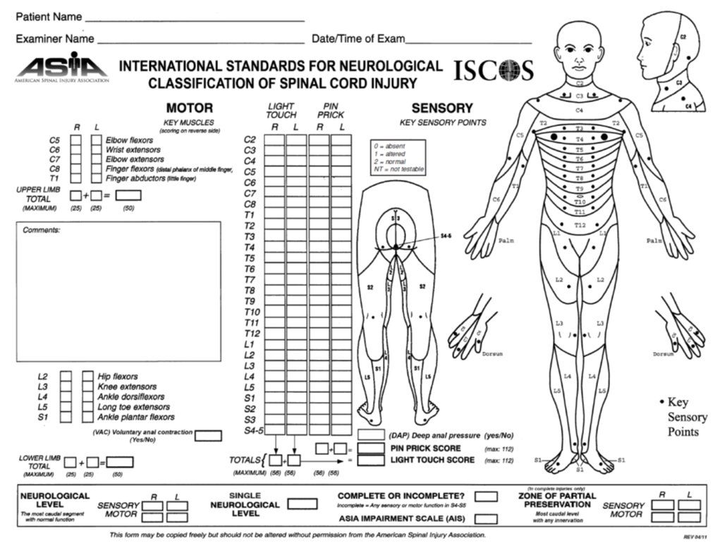

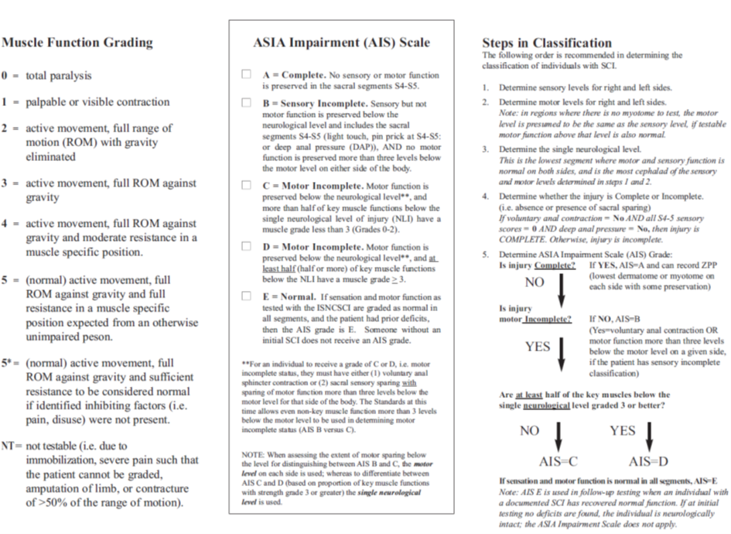

Back to Contents

Attachment 3 - How to test forced vital capacity
Spirometry instructions sourced from EasyOneTM Spirometer operations manual (Canberra Hospital and North Canberra Hospital).

Measuring the Forced Vital Capacity (FVC)
- Choose “Perform Test” in the main menu and then NEW. Confirm with ENTER. The instrument will now allow you to enter the patient data.
- Enter the corresponding patient data line by line. Use the keys as described in Chapter 4.3. Confirm with ENTER each time.
- After entering the patient data, you then move on to the "Test selection" menu. Choose the FVC test and confirm with ENTER.
- Insert a spirette into the instrument. Ensure that the arrow on the spirette is lined up with the arrow on the instrument.
- Once again briefly prepare the patient for the test. When the patient is ready, press ENTER. You will now hear the sensor buzzing.
- The instrument now prompts you to avoid air flow in the spirette since it is setting the baseline. It is advisable to block off the spirette on one end in order to ensure that the baseline is set precisely even if the room is draughty. An audible signal will sound when the baseline has been set. You will see prompt "Blast out" on the screen.
- Hand the instrument to the patient. Ask the patient to breathe in deeply, insert the spirette correctly into their mouth. Now ask the patient to exhale as firmly and as quickly as possible and continue exhaling until all air has been exhaled.
- At the end of the maneuver, you will see a message on the display indicating whether the maneuver was acceptable. At least three acceptable maneuvers must have been performed before you see message "Session complete".
- Using keys (>) and (<) you can view the result on the screen. In order to print the result, choose the PRINT field and press ENTER. Then place the instrument into the base unit. The report is then printed.
Spirometry instructions sourced from SpiroLabTM Spirometer user manual (North Canberra Hospital).

Measuring FVC
- Create a new patient profile, or check for existing patients in the archives (data required to create a patient profile is: name, surname, sex)
- Slide the turbine fully into position in the MiniFlowmeter then turn it clockwise until it clicks into place.
- Connect the MiniFlowmeter to Spirolab.
- Slide the mouthpiece at least 0.5 cm along the groove on the turbine.
- Fit the nose clamp over the patient's nostrils to prevent air from escaping.
- Take the MiniFlowmeter with both hands or, alternatively, hold it as you would a mobile phone.
- Introduce the mouthpiece into the mouth behind the teeth, making sure that air does not escape from the sides of the mouth.
- Select the FVC icon
- Ask the patient to: insert the spirette correctly into their mouth and breathe in deeply. Now ask the patient to exhale as firmly and as quickly as possible and continue exhaling until all air has been exhaled.
- At the end of the maneuver, you will see the quality grade (A highest quality, F poorest quality). Complete at least three high quality maneuvers before ending the session.
- Select the “Print” icon, then “Internal”. This will print a receipt from the device detailing the session.
Note: Optimal position to perform spirometry may be supine, depending on level of SCI. Ensure position that spirometry is performed is accurately documented.
Back to Contents

Attachment 4 - How to assess peak cough flow
Assessing PCF with Peak Flow Meter:
- Remove device from packaging and attach bacterial filter and mask/mouthpiece as indicated.
- Move the marker to the bottom of the numbered scale.
- Position patient. For a patient with SCI, place them supine to maximise vital capacity.
- Apply interface to patient. Ensure the patient does not obstruct the holes on either end of the meter.
- Have the patient take a deep breath and cough.
- The marker will indicate the peak cough flow for that attempt.
- Repeat 3 times, record highest value of attempts.
Note: This is the preferred and more reliable method of obtaining PCF.
Alert: Peak Cough Flow can be assessed reliably in children 8 years old and over.
Figure 1
Peak Flow Meter
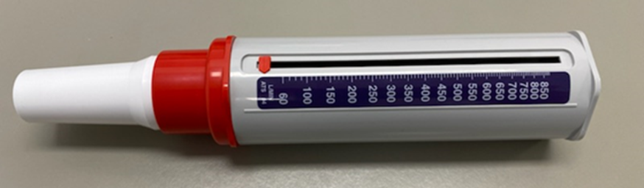
Note: North Canberra Hospital assessment of peak flow can be completed with the SpiroLab.
Back to Contents

Attachment 5 - Expected Vital Capacity for SCI ^{(adapted from 16)}
Level of Injury | Expected Vital Capacity (%of normal) * | Measured Vital Capacity (% of normal predicted) requiring volume restoration/airway clearance therapy**
C2 | 40% | 25%
C3-4 | 60% | 35%
C5-6 | 80% | 50%
C7-T4 | 90% | 70%
T5-T10 | 95% | 80%
T11-L5 | 100% | 80%
*Refer to link for normal values chart (http://www.dls.org/ourpages/auto/2010/4/12/41442062/Vital%20Capacity%20Chart.pdf)
**If measured vital capacity is below this value, commence physiotherapy treatment. The patient requires urgent medical review and recommend commencement of ventilation (either invasive or non-invasive).
Note: All non-ventilated patients whose VC is measured at <1L consider involvement of ICU outreach.
Back to Contents

Attachment 6 - How to perform a manually assisted cough²³

Abdominal Thrust
- Position the patient in supine to maximise VC.
- Perform volume restoration or airway clearance techniques as indicated.
- Place the palms of both hands below the sternum (Figure 2)
- Instruct the patient to take a maximal inspiration (augment tidal volume with manual insufflation, mechanical insufflations, manual hyperinflation or NIV as required).
- Instruct the patient to cough. As the patient initiates a cough, thrust firmly down and up (pushing diaphragm into thoracic cavity).
- Clear secretions from oropharynx as required.
- Continue until sputum cleared.
- Alternatively, the technique may be performed seated (Figure 3).
Precautions/considerations:
- Unstable spinal fractures
- Abdominal injuries/trauma
- Surgical wounds
- Intact sensation
- Pregnancy
- High abdominal pressures
- PEG feeds

Figure 2

Supine manually assisted cough (abdominal thrust)

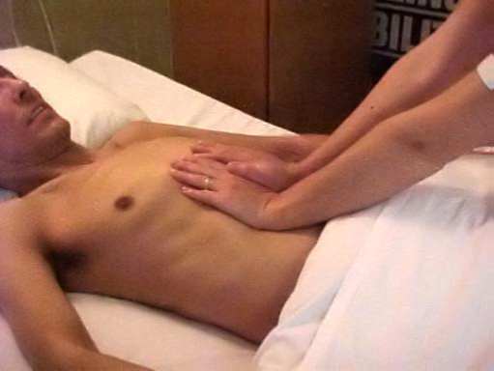

Figure 3

Seated manually assisted cough (abdominal thrust)

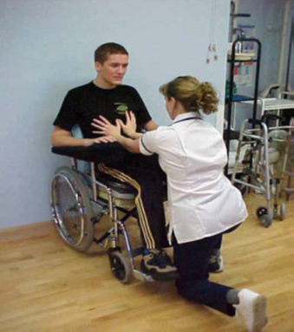

Thoracic Compression
- Position the patient in supine or full side lie to maximise VC.
- Perform volume restoration or airway clearance techniques as indicated.
- For the patient in supine, place hands on either side of chest wall (Figure 4). For the patient in side lie, place hands anteriorly and posteriorly on the lower half of the rib cage.
- Instruct the patient to take a maximal inspiration (augment tidal volume with manual insufflation, mechanical insufflations, manual hyperinflation or NIV as required).
- Instruct the patient to cough. As the patient initiates a cough, firmly compress the rib cage and thrust up.
- Clear secretions from oropharynx as required
- Continue until sputum cleared
Precautions/contraindications:
- Unstable spinal fractures
- Rib fractures or thoracic surgery

Figure 4

How to perform a manually assisted cough (thoracic compression)

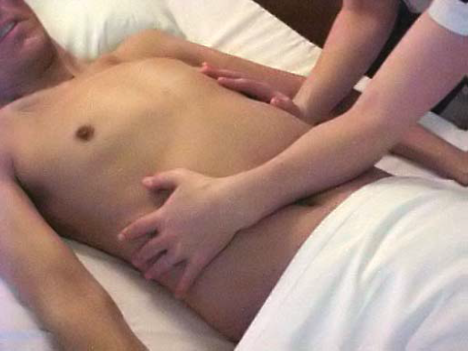

Back to Contents

Attachment 7 - Outcome Measures for Impairment and Activity Management²⁴

Measurement:
Outcome Measure | Types/ Details
ASIA Assessment of Strength and Sensation | ASIA Assessment of strength and sensation (see Attachment 1)
Specific SCI Assessment Tools (activity and participation measures) | Functional Independence Measure (FIM)  Spinal Cord Independence Function (SCIM)  Quadriplegic Independence Function (QIF)  Clinical Outcomes Variable Scale (COVS)  Quebec users’ evaluation of satisfaction with assistive technology (QUEST)  Wheelchair skills test (WST)  Wheelchair User Shoulder Pain Index (WUSPI)  Walking Index for Spinal Cord Injury (WISCI)  - No consensus on the most appropriate measure post SCI  - Include measurements of impairment, activity limitations, and participation limitations
Functional Measures | Balance: Step test and Berg Balance Scale  Mobility: 10m walk, 6 minute walk, Timed Up and Go, 6 minute push test  - Measures should be compared with normative scores
Strength | Muscle strength can be measured using manual muscle testing (such as Oxford scale below) for grading of upper limb and lower limb muscle groups  - no contraction palpated  - muscle flicker  - complete range of motion with gravity eliminated  - complete range of motion against gravity  - complete range of motion against gravity with some (moderate) resistance  - complete range of motion against gravity with maximal resistance  - A dynamometer can also be used to quantify strength
Range of Motion (ROM) | Use a goniometer with standardised positioning

Outcome Measure | Types/ Details
Spasticity | Must be measured using the Tardieu scale as it differentiates between spasticity and contracture  Assess at two velocities:  - as slow as possible  - as fast as possible (faster than the rate of the natural drop of the limb segment under gravity)  Measure:  The angle of muscle reaction (Y)  The quality of the muscle reaction (X):  - no resistance throughout the course of the passive movement  - slight resistance throughout the course of the passive movement, with no clear catch at a precise angle  - clear catch at a precise angle, interrupting the passive movement, followed by release  - fatigable clonus (< 10 seconds when maintaining pressure)  - non-fatigable clonus (> 10 seconds when maintaining pressure)
Kinaesthetic Sensation | Kinaesthetic Sensation can be measured using various measurement tools such as the modified Nottingham sensory assessment:  - absent  - appreciation of movement taking place  - direction of movement sense  - joint position sense  - unable to test

Back to Contents

Attachment 8 - Optimal Functional Outcome for Patients following Complete Spinal Cord Injury²²
Level of Injury | Details of Muscle Activity | Details of Overall Possible Function
C2 | Patients will have activity of:  - facial, pharyngeal and laryngeal muscles (supplied by unaffected cranial nerves)  - neck extensors above the level of the lesion and some sternocleidomastoid  - trapezius, but not diaphragm | C2 – C3  Ventilator Dependent  C2 – C4  Independent wheelchair propulsion using electric wheelchair activated by motions of head, chin or mouth; function is determined by what can be done with their head using modern technology
C3 | Patients will have activity of:  - some diaphragm (innervated C3-5) but not sufficient for independent breathing
C4 | Patients will have activity of:  - sufficient diaphragm function to be ventilator independent  - full trapezius and some rhomboids and supraspinatus, but this is of little function significance
C5 | Patients will have activity of:  - biceps and deltoid make independent eating, shaving, combing hair possible with adaptive equipment  - usually cannot roll or transfer  - usual method of propulsion is hand controlled electric wheelchair, though most can propel a manual wheelchair on flat terrain  - some C5 quads can drive a car (but cannot transfer independently into or out of a car)

Level of Injury | Details of Muscle Activity | Details of Overall Possible Function
C6 | Patients will have activity of:  - wrist extensors, serratus anterior, pectorals and latissimus dorsi which mean that C6 quads can be totally independent and live alone.  - Lat dorsi and serratus anterior activity enables the person to lift his/her body weight and transfer with shoulders in external rotation and elbows passively (no triceps) locked in extension so that the ground reaction force is behind the elbow  - Manual wheelchair over level surfaces, minor obstacles and slightly uneven terrain | C6 – C7  Patient uses tenodesis grip, i.e., in the presence of innervated wrist extensors and no finger flexors  The therapist promotes shortening of the finger flexors so the patient can grasp by extending the wrist and release by flexing the wrist
C7 | Patients will have activity of:  - triceps, so don't need to lock elbows in extension to transfer
C8 | Patients will have activity of:  - finger flexors, so don't need tenodesis grip, making it easier to use the hands
T1- T4 | Patients will have:  - no abdominals, erector spinae above level of lesion T1 to T4 | T1 to L2  Ambulation requires knee-ankle-foot orthosis (KAFO's) and crutches and is a real challenge even on level surfaces, and therefore unlikely to be functional  L3 downward  Walking becomes potentially more functional with varying levels of orthotic support
T5 and below | Patients will have:  - Progressively easier balance in sitting, due to rectus abdominus beginning to be innervated at T5

Back to Contents

