Canberra Health Services
Policy
Medication Reconciliation and Medication Review for Adult and Paediatric Patients

Contents

Contents 1
Policy Statement 2
Purpose 2
Scope 3
Roles & Responsibilities 3
Related Policies, Procedures, Guidelines and Legislation 5
Definition of Terms 6
References 7
Search Terms 7
Attachments 7
Attachment 1 – Flowchart for Medication Reconciliation on Admission 8
Attachment 2 - Meds on Admission tab in MedChart 9
Attachment 3 – Medication Reconciliation Form 10
Attachment 4 – Pre-operative Medication Plan 12
Attachment 5 – Electronic Discharge Summary 13

Policy Statement

Hospital executive, nursing and midwifery staff, pharmacists and prescribers each have a role to play in ensuring the continuity of medication management in our health service. This policy outlines the roles and responsibilities of each staff member in providing this continuity of care.

Medication Reconciliation is a structured process to ensure that patients receiving care in our service receive all medicines that they are intended to and that accurate, current and comprehensive medicines information, including changes to their medication regimen follows them at all transfers of care¹.

Medication Reconciliation is a four-step process¹ (Attachment 1):
- Documenting a complete medication history following interview with the patient or their carer
- Verifying the accuracy of this history with at least one additional source of information to create a Best Possible Medication History (BPMH)
- Reconcile the BPMH against the medicines prescribed for the patient at CHS to identify discrepancies, work to resolve discrepancies and document the plan for rectifying the discrepancies
- Provide an accurate list of prescribed medicines to the patient and next care provider at each transfer of care

Medication Review optimises prescribed pharmacotherapy by conducting evidence-based reviews on existing and newly prescribed medicines in the context of the patient’s clinical condition and treatment goals². While every patient should have medication reviews conducted, prioritising patients deemed at highest potential risk of experiencing medication-related harm is a practical method of distributing limited resources to ensure these patients benefit from this activity.

Staff are expected to complete these processes in accordance with their responsibilities outlined below.

Back to Table of Contents

Purpose

This policy specifies the groups of people within Canberra Health Service who are responsible for continuity of medication management through completion of Medication Reconciliation and Medication Review for the patients of our service. This policy should be read in conjunction with the Medication Reconciliation and Medication review Procedure for Adult and Paediatric Patients.

Back to Table of Contents

Scope

This policy applies to adult and paediatric patients admitted to CHS.

This Operational Policy applies to the following CHS staff working within their scope of practice:
- hospital executives
- pharmacists
- prescribers
- nurses and midwives
- other healthcare professionals who have received appropriate training.

Back to Table of Contents

Roles & Responsibilities

Responsible Group 1: Hospital Executive Directors
- Hospital Executives are responsible for CHS’s approach to medication management, encouraging the importance of partnering with patients, carers and their families; and working with clinicians to build collaborative medication reviews into existing work practices to ensure consistent and effective medication reconciliation.
- Hospital Executives are responsible for endorsing a formal process for medication reconciliation at transfers of care as part of a key strategy to improve the safe use of medicines and reduce preventable harm caused by medicines.

Responsible Group 2: Pharmacists
- Pharmacists are responsible for engaging patients in the process of obtaining a Best Possible Medication History (BPMH).
- Pharmacists working directly in clinical care areas are responsible for obtaining a patient’s BPMH and documenting this on admission in the ‘Medications on Admission’ section of MedChart (Attachment 2) or on the Medication Reconciliation Form (MRF) (Attachment 3) in areas that do not use MedChart, with priority given to patients deemed to be at highest potential risk of experiencing medication-related harm.
- Pharmacists working directly in clinical care areas are also responsible for documenting in MedChart or on the MRF the plan for the management of patient's regular medications once they are admitted. This plan may be based on the treating team's documentation and the pharmacist's discretion and clinical judgement or recommendations.
- Pharmacists working directly in clinical care areas are responsible for medication review of prescribed medicines in the context of the patient’s clinical condition, treatment goals and using documented treatment plans from prescribers, with priority given to patients deemed to be at highest potential risk of experiencing medication-related harm.

Responsible Group 3: Prescribers
- Prescribers are responsible for engaging patients in the process of obtaining a Best Possible Medication History (BPMH).
- Prescribers admitting a patient to CHS are responsible for discussing medicines taken prior to admission, documenting this as a BPMH (including medicine name, dose, frequency and route of administration) in the progress notes (or equivalent electronic system such as Metavision). Included in this must be a plan for each of the patient’s medicines in the context of their presentation to the health service. The prescriber who documents this initial BPMH in the progress notes or equivalent electronic system, must explicitly state the sources used to compile the list and a confidence rating of how complete it is, with specific concerns that require follow up from their colleagues. This must form part of clinical handover to the next clinician taking over care of the patient.
- Prescribers are responsible for reviewing the BPMH documented in the ‘Meds on Admission’ tab of MedChart and ‘Activate Plan’ taking into consideration recommendations made by the pharmacist.
- Where a BPMH has not been documented in the ‘Meds on Admission’ tab of MedChart, the prescriber is responsible for obtaining a BPMH using the process outlined in Attachment 1 and documenting this in the ‘Meds on Admission’ tab of MedChart before charting regular or new medicines in the ‘Scheduled’ medicines tab of MedChart.
- If a prescriber cannot compile a BPMH for a patient considered at high-risk of medication related problems, prescribers are responsible for requesting assistance from a pharmacist.
- Anaesthetists are responsible for discussing and documenting a patient’s medication history and a plan for their medications in the pre-admission setting on the Pre-operative Medication Plan (Attachment 4). The BPMH must include medicine name, dose, frequency and route of administration.
- Prescribers are responsible for referring to the BPMH for an accurate medication history, for reconciling medications on admission with those on discharge when preparing a discharge summary, and for following up any medication related issues identified by the pharmacist or other clinician.
- Prescribers are responsible for communicating any changes made to patient’s medicines during a health care encounter (such as an admission or outpatient appointment) to the patient and to their primary community health care provider (generally their GP). Prescribers are also responsible for documenting these changes in the progress notes or equivalent electronic system and indicating on the discharge summary that medicines have been discussed with the patient (see Attachment 5).
- Prescribers are responsible for regularly reviewing medicines for their patient to ensure use of medicines is optimised and meets the patient’s changing needs and goals of care.

Responsible Group 4: Nursing and Midwifery Staff
- Nursing and Midwifery staff are responsible for safe and secure storage of Patient’s Own Medicines (POMs) in the patient care area which might have been brought into hospital with the patient and could be used as a second source of information in confirming a patient’s medication history. If a patient has brought their own medicines with them, the nurse or midwife admitting the patient is encouraged to request a family member takes the medicines home. If this is not possible, the nurse is responsible for retrieving these from the patient and placing them in the clear green plastic clip lock bag marked ‘Patient’s Own Medicines’, affixing a patient addressograph to the bag and storing them according to the CHS Medication Handling Policy.
- Nursing Staff in the pre-admission clinic are responsible for documenting a patient’s BPMH on the Pre-operative Medication Plan as part of nurse-led pre-operative instructions. The BPMH must include medicine name, dose, frequency and route of administration.
- Nursing and Midwifery staff are responsible for medication order review, as part of adhering to the 5 Rights of Medication Administration prior to administering a medication. Any concerns found during a medication order review should be raised with the relevant clinician.

Back to Table of Contents

Related Policies, Procedures, Guidelines and Legislation

Policies
- Medication Reconciliation and Medication Review Operational Procedure
- Medication Handling
- High Risk Medicines

Procedures
- Admission to Discharge
- Admissions from the Emergency Department to Ward
- Clinical Handover
- Discharge Summary Completion
- Clinical Handover – Mental Health, Justice Health and Alcohol Drug Services (MHJHADS)
- Clinical Records Management

Guidelines
- Clinical Guideline Pre-admission Clinic – Adult Elective Surgery Peri-operative Medication
- Australian Commission on Safety and Quality in Health Care. Medicine Reconciliation
- Clinical Excellence Commission, 2014. Continuity of Medication Management: Medication Reconciliation Toolkit, December 2014
- The Society of Hospital Pharmacists of Australia. SHPA Standards of practice for the provision of medication reconciliation

Legislation
- Medicines, Poisons and Therapeutic Goods Act 2008
- Medicines, Poisons and Therapeutic Goods Regulation 2008
- Health Practitioner Regulation National Law Act 2010
- Health Records (Privacy and Access) Act 1997
- Human Rights Act 2004
- Work Health and Safety Act 2011
Back to Table of Contents

Definition of Terms

Addressograph
Patient sticky label containing the patient’s full name, address, date of birth, medical record number and other identifiers.

Best Possible Medication History (BPMH)
A snapshot of the patient’s actual medication use which might be different from information in their healthcare record, or medicine list held by GP or patient or dispensing history from a pharmacy. The BPMH should be compiled from an interview with the patient or the patient’s carer, whenever possible, and confirmed with at least one other source of medicines information.

MedChart
The Electronic Medication Management System in use at Canberra Health Service.

Medication Management Plan
National standard paper form for documenting Best Possible Medication History and recording the key steps of medication reconciliation.

Medication Review
Review of medicines prescribed to a patient to ensure safe and quality use of medicines in the context of the patient’s clinical condition and their goals of care.

Medication Reconciliation Form
Canberra Health Services local paper form for documenting a patient’s Best Possible Medication History and documenting reconciliation of this with their prescribed medicines.

Patient Own Medicines (POMs)
Medicines that belong to a patient which have been used by the patient prior to admission at home.

Back to Table of Contents

References

- Clinical Excellence Commission. (n.d.). Continuity of Medication Management. Retrieved September, 4, 2020, from http://cec.health.nsw.gov.au/keep-patients-safe/medication-safety-and-quality/continuity-of-medication-management
- Australian Commission on Safety and Quality in Health Care. National Safety and Quality Health Service Standards guide for hospitals. Sydney: ACSQHC; 2017

Back to Table of Contents

Search Terms

Medication Reconciliation, Medication, Reconciliation, Review, Medicines, BPMH, Best Possible Medication History, Medication Management, Continuity, Continuity of Medication Management, Admission, Discharge, Transfer, Poms

Back to Table of Contents

Attachments

Attachment 1 – Flowchart for Medication Reconciliation on Admission
Attachment 2 – Meds on Admission tab in MedChart
Attachment 3 – Medication Reconciliation Form
Attachment 4 – Pre-operative Medication Plan
Attachment 5 – Electronic Discharge Summary

Disclaimer: This document has been developed by Canberra Health Services specifically for its own use. Use of this document and any reliance on the information contained therein by any third party is at his or her own risk and Canberra Health Services assumes no responsibility whatsoever.

Policy Team ONLY to complete the following:
Date Amended | Section Amended | Divisional Approval | Final Approval

This document supersedes the following:
Document Number | Document Name

Attachment 1 – Flowchart for Medication Reconciliation on Admission
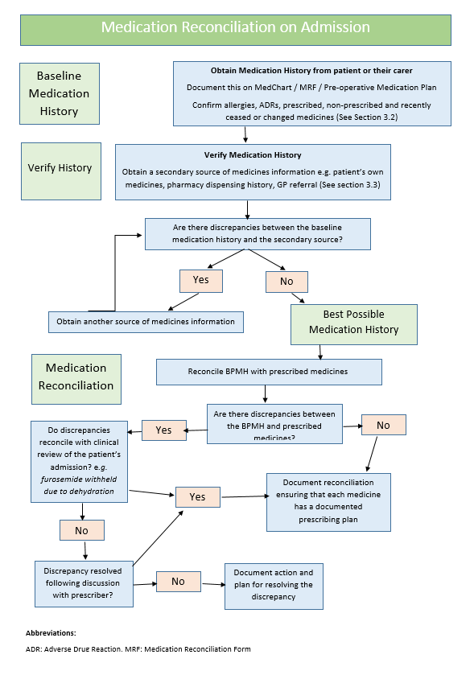

Attachment 2 - Meds on Admission tab in MedChart
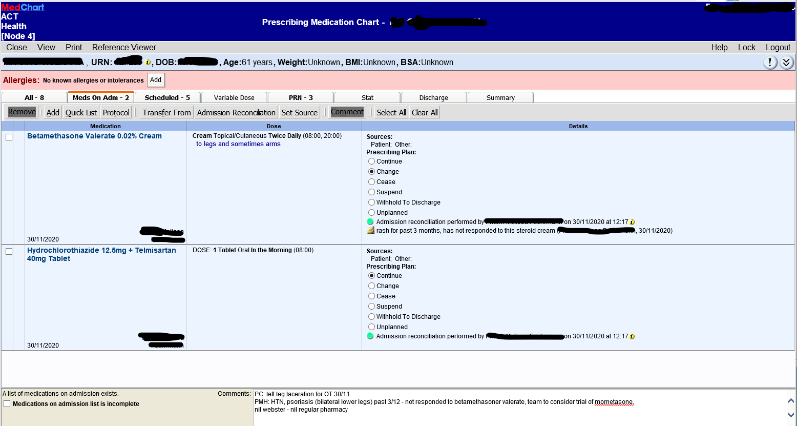

Attachment 3 – Medication Reconciliation Form

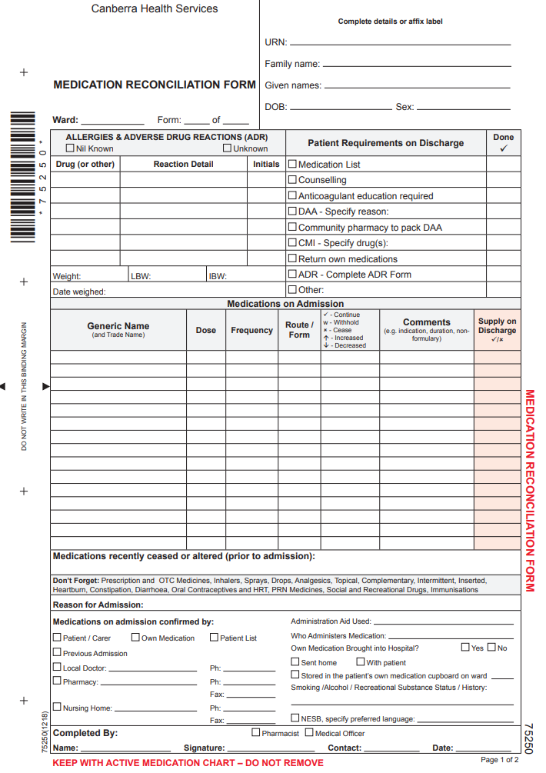
Sample
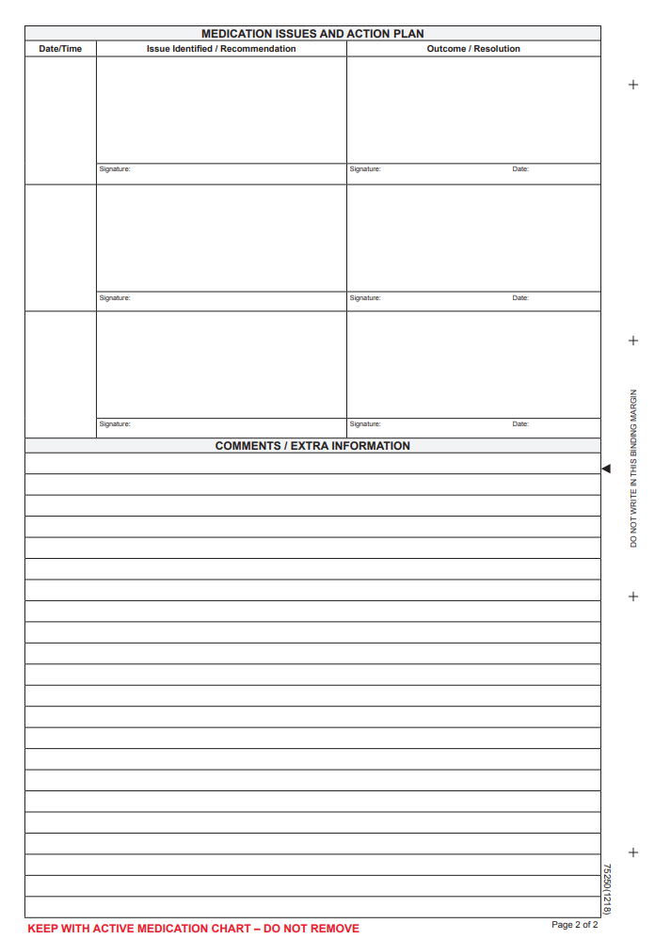
Sample

Attachment 4 – Pre-operative Medication Plan
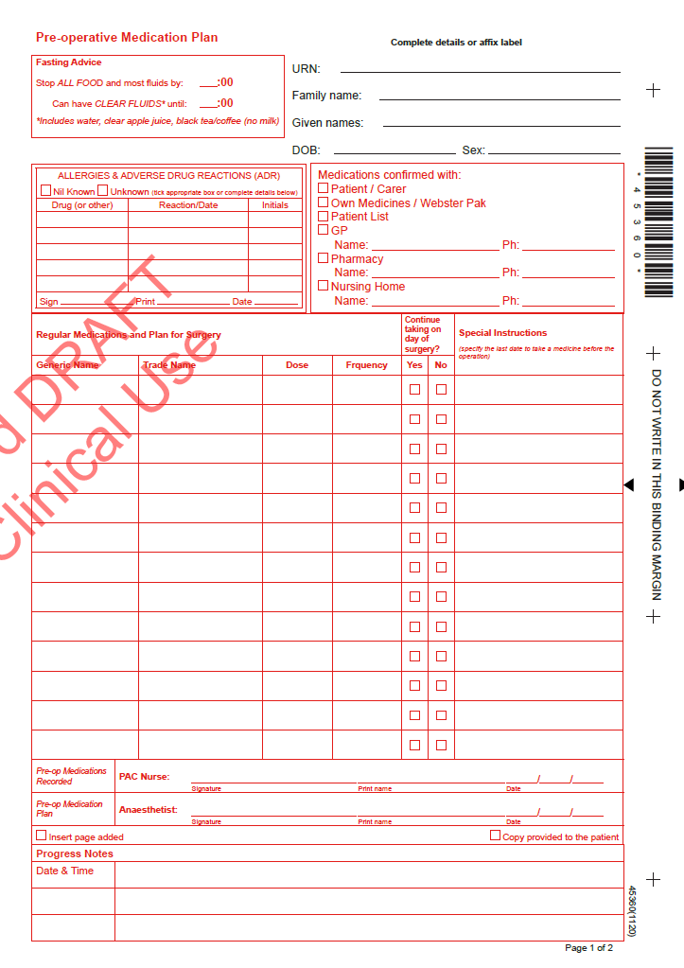
Sample
Attachment 5 – Electronic Discharge Summary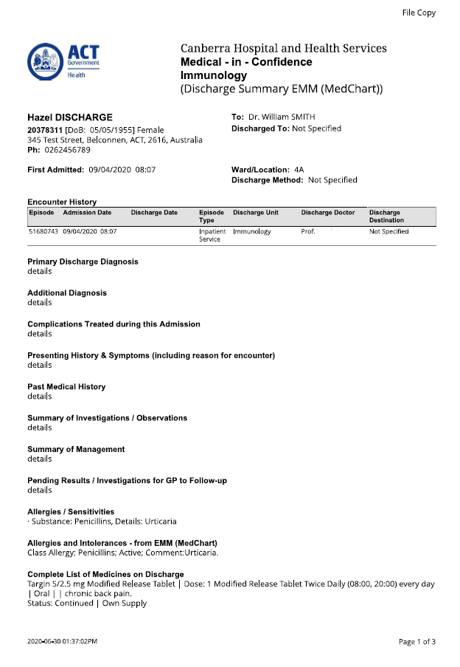
Sample
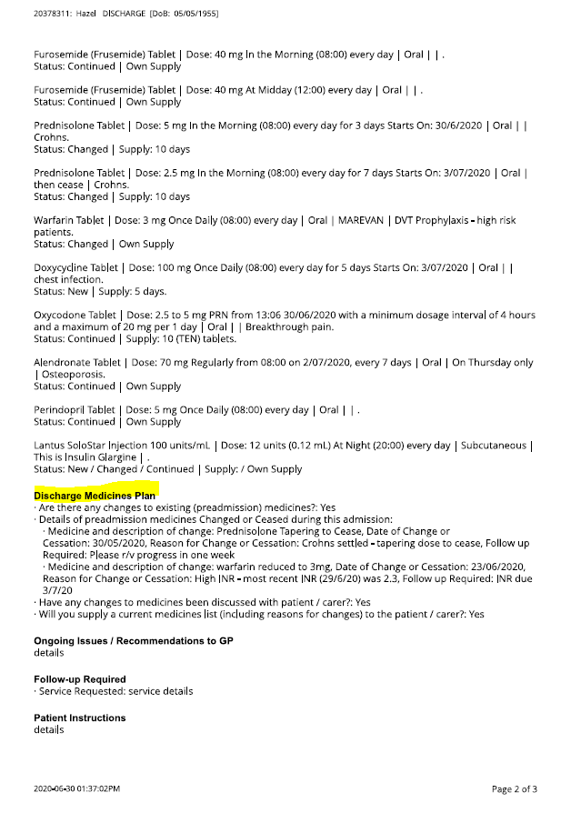
Sample
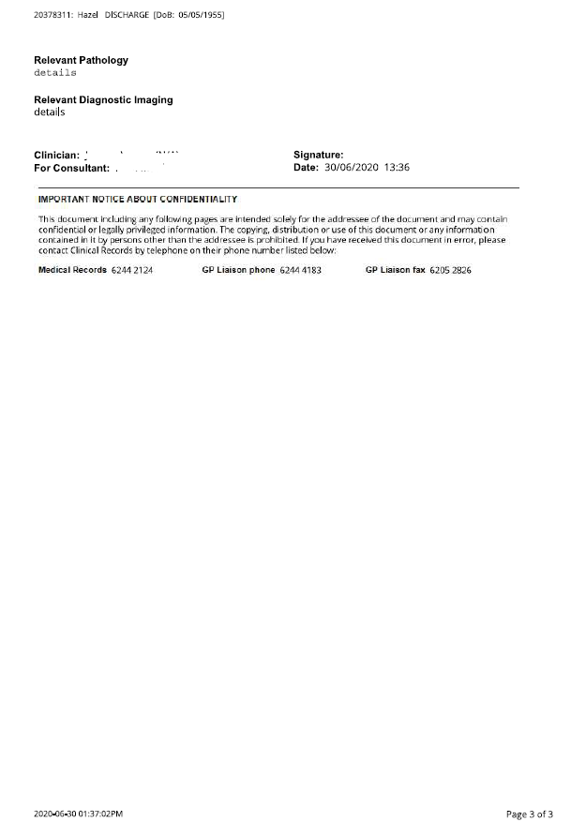
Sample

