Canberra Health Services
Procedure
Intrauterine Device (IUD) Insertion, Replacement, Removal and Care

Contents

Contents 1
Purpose 2
Scope 2
Section 1 – Training/Competency 2
Section 2 – IUD Consultation & Counselling 2
Section 3 – IUD Insertion 3
Section 5 – IUD Removal/Replacement 6
Section 6 – IUD Post Insertion Care 6
Section 7 – Management of Vasovagal Collapse / Cervical Shock 7
Evaluation 8
Related Policies, Procedures, Guidelines and Legislation 8
References 9
Definition of Terms 9
Search Terms 9
Attachments 9

Purpose

The purpose of this procedure is to provide clinicians with information on the safe and effective insertion of an intrauterine device (IUD) in the hospital and the community setting.

This procedure provides clinicians with best practice information for assessment and management of patients interested in an IUD and for educating and supporting patients and their carers.

Back to Table of Contents

Scope

This document pertains to patients aged 14 years and older.

This document applies to the following staff working within their scope of practice:
- Medical Officers
- Nurse Practitioners
- Registered Nurses
Back to Table of Contents

Section 1 – Training/Competency

Clinicians who insert IUDs are responsible for ensuring that they are appropriately trained and maintain their clinical competence. Clinicians should aim for greater than twelve IUD insertions in conscious women undertaken per year, as a guide, to maintain skill and practice.

Clinicians who insert IUDs should attend regular updates in dealing with emergencies, including vasovagal shock.

Appropriately trained registered nurses should assist and be present during the procedure and support post-procedure observation and care.
Back to Table of Contents

Section 2 – IUD Consultation & Counselling

Equipment:
- IUD product information(s)
- Sample IUD devices / educational resources

Procedure
- Discuss with the patient the different types of IUDs, their efficacy, actions, advantages, and disadvantages
- Obtain a full medical history, ensuring no contraindications to IUD insertion or use. History should include
- fainting/vasovagal reaction with cervical instrumentation
- menstrual and vaginal bleeding history
- sexual history
- obstetric and gynaecological history
- cervical screening test history
- cancer history
- current medications and allergies
- Prescribe the agreed upon IUD and advise the patient to bring the IUD to their insertion appointment. Advise the patient to eat prior to their appointment and be well-hydrated to reduce the risk of a vasovagal episode. They can also take basic analgesia such as a Non-steroidal Anti-inflammatory Drug (NSAID) or Paracetamol to assist with post-insertion cramping
- Provide appropriate information, written information about the IUD if available, and a copy of the patient consent form, for the patient to take home
- Ensure there is a plan in place for interim contraception
- If there is to be a changeover of an IUD, ask whether the patient has been checking for the strings, if not then it is appropriate to undertake a speculum examination to identify they are visible for removal. If strings have not been checked and cannot be seen, organise a pelvic ultrasound.

Back to Table of Contents

Section 3 – IUD Insertion

Equipment (all equipment used for insertion should be sterile)
- Vaginal speculum
- Lubricant
- Uterine sound
- Sponge forceps
- Tenaculum or vulsellum
- Long handled curved scissors
- Gloves
- Antiseptic solution
- Gauze swabs
- Cervical dilators (if indicated)
- Local anaesthetic (without adrenaline) injection or spray, syringe, drawing up needle and spinal needle for injection (depending on clinician and patient preference)
- Silver Nitrate Sticks
- Sphygmomanometer
- Emergency Equipment and Medicines:
  - Pulse oximeter
  - Oxygen with face mask
  - Algorithm for management of cervical shock
  - IV starter kit
  - Atropine injection 600 µg in 1 mL x 3
  - Sodium chloride injection 0.9% (90 mg in 10 mL) x 3
  - Sodium chloride 0.9% intravenous fluid 500 mL x 2

Preparation
- Emergency equipment and documented procedure should be available
- Informed Consent should be discussed and signed (refer to Informed Consent (Clinical) Policy
- Pulse rate and blood pressure (BP) should be documented pre- and post-IUD insertion
- A wedge may be placed underneath patient buttocks to angle the pelvis to increase ease of speculum use
- A no touch aseptic technique should be used when sounding the uterus and inserting an IUD
- Ensure pre-treatment of any infection such as chlamydia and gonorrhoea
- There is little evidence on the use of oral analgesia or topical or intracervical anaesthesia with IUD insertion. Discuss local anaesthetic with the patient and provide if appropriate or requested.
- Exclude possible early pregnancy before IUD insertion:
  - Complete urine pregnancy test
  - On the day of insertion, confirm the last period was not an implantation bleed by asking if the period was on time, of normal duration and heaviness, and associated with normal premenstrual and period symptoms
  - If changeover of IUD, ask about date of last unprotected sexual intercourse.

Procedure
- Attend Hand Hygiene
- Identify the correct patient using the three core patient identifiers
- A bimanual examination can be performed to assess uterine position, size, shape, and mobility, as well as to exclude pathology. Ascertaining whether the uterus is anteverted or retroverted can reduce the risk of perforation
- Cleanse at vulva using antiseptic solution
- Using a sterile technique, apply lubricant to speculum, and then insert speculum to visualise cervix
- Thoroughly cleanse cervix and proximal vagina with suitable antiseptic solution. Inject local anaesthetic if previously consented to by patient. This should be done with a paracervical block, or directly into the cervix depending on the operator’s preference and experience. Paracervical block is highly effective analgesia and avoids cervical bleeding which can obscure the view during insertion.
- Grasp lip of cervix with tenaculum or vulsellum and apply gentle traction to align the cervical canal with the uterine cavity
  - In a retroverted uterus, it may be better to grasp the posterior lip of the cervix
  - Gentle counter traction, using the tenaculum, should be maintained during the procedure
- Gently insert the uterine sound to determine the depth of the uterine cavity, confirm its direction, and exclude the presence of uterine anomaly or previously inserted IUD which has not been removed
- If unable to pass the uterine sound through the internal cervical os, consider performing a local anaesthetic block if not already done, and use cervical dilators. Do not force the uterine sound as this increases risk of perforation
  - If unable to insert the sound, trial use of cervical dilators. Do not force a sound or dilator as this increases the risk of perforation. If the internal os cannot be dilated appropriately or if the sound depth indicates suspicion of not reaching the fundus, abort the procedure and refer on for this to be done under sedation
  - Practice point: the risk of perforation is greater for finer gauge instruments such as the sound. Do not exert force when attempting to pass the sound through the internal cervical os
- Once uterine length is determined by the sound, IUD to be opened from packet
- Pick up IUD device and place slider to insertion position (note that this may be different for various products; ensure you are familiar with all products you insert)
- Set upper edge of flange to measurement of uterine sounding
- Continue to hold slider with thumb in insertion position
- Maintain gentle traction of cervix, gently advance the insertion tube through cervix. Do not force inserter, if necessary, dilate cervical canal
- Continue until flange is 1.5 – 2 cm from the cervix, to allow space for the arms of the IUD to open when released in the uterine cavity; move the slider to mark position (enabling the arms of the IUD to be released)
- Wait 5-10 seconds, and then advance the device to the uterine fundus until the flange touches cervix
- Pull slider all the way down to release the IUD
- Pull inserter out
- Remove the tenaculum or vulsellum
- Cut the threads so that 2-3 cms is visible outside cervix
- Ensure there are no signs of active bleeding, and remove the speculum. Should you suspect the IUD is not in correct placement, organise a pelvic ultrasound
- If there is excessive bleeding from the tenacullum or vulsellum site, apply pressure with gauze or utilise silver nitrate sticks for haemostasis.

Back to Table of Contents

Section 5 – IUD Removal/Replacement

Equipment:
- Vaginal speculum
- Lubricant
- Sponge forceps / 23 cm Spencer wells forceps
- Gloves

Procedure
- Apply lubricant to speculum, and then insert speculum to visualise cervix and identify the strings
- Using forceps, apply gentle traction to threads, with breath expiration or a cough, pull to remove the IUD
- If the strings cannot be identified, the forceps can be used to try to grab strings not visible within the cervical os
- Other effective options are to use a cervical screening cytobrush in the cervix to catch on strings that might be coiled in the cervical canal
- A Pelican IUD thread retriever can also be used to attempt to local IUD strings within the cervix

A new IUD can be replaced immediately. Follow Section 1 procedure

Back to Table of Contents

Section 6 – IUD Post Insertion Care

Equipment:
- Sphygmomanometer

Procedure
- Documentation in clinical record should include pre- and post-insertion counselling and specifically: last normal menstrual period, urine pregnancy test result, pre- and post- blood pressure and pulse readings, length of uterine cavity on sounding, degree of insertion difficulty, length to which the threads were cut, absence of active bleeding, batch number of device, expiry date of device, sterile pack number and expiry date. Where used: dilation, anaesthesia and management of complications should also be documented.
- Observe for at least 15 to 20 minutes after insertion
- Adhere to low threshold for early ultrasound to check device placement if any insertion difficulties or excessive pain experienced by woman during insertion
- Advise the patient when the IUD will become effective for contraception and if a barrier method should be used
- Provide advice on when to seek medical advice, including signs of pelvic infection and pregnancy
- Provide post-insertion handout including expected symptoms and use of analgesia
- Advise nothing to be inserted into vagina for 48-72 hours (including penetrative intercourse, tampons, swimming, or baths)
- Teach how to check the IUD threads after menstruation or once a month
- Advise additional use of condoms if risk of sexually transmitted infections

Back to Table of Contents

Section 7 – Management of Vasovagal Collapse / Cervical Shock

Preparation
- Consider vasovagal collapse / cervical shock with the following symptoms: feeling lightheaded, nauseated, unwell or agitated
- Consider vasovagal collapse / cervical shock with the following signs: pale and sweaty, thready slow pulse, hypotension, loss of consciousness, may have tonic clonic movements

Equipment:
- Sphygmomanometer
- Emergency equipment and medicines:
  - Pulse oximeter
  - Oxygen with face mask
  - Algorithm for management of cervical shock
  - IV starter kit
  - Atropine injection 600 µg in 1 mL x 3
  - Sodium chloride injection 0.9% (90 mg in 10 mL) x 3
  - Sodium chloride 0.9% intravenous fluid 500 ml x 2

Procedure
- Remove stimulus from cervix. Remove IUD if partially inserted. Leave IUD in-situ if fully in uterus. Consider removing IUD depending on vital sign observations
- Lie flat and elevate legs
- Give oxygen and attach pulse oximeter
- Check airway, breathing and circulation:
  - A - chat and reassure patient
  - B – check breathing, loosen tight clothes around neck
  - C – check pulse and BP; compare to pre-procedure observations
- Observation management:
  - Pulse > 60 bpm, sBP > 90: observe, discharge home when recovered
  - Pulse < 60, sBP < 90, PLUS signs of shock: keep lying flat, elevate legs, provide O2 with mask, monitor, recovery usually takes 20-30 minutes
  - Pulse < 40, sBP < 90, PLUS signs of shock: insert IV line, administer atropine 600 mcg / 1 mL, 1 mL IV followed by 10 mL saline flush (atropine 500 mcg IM may be given if IV access not possible). Call 000. May be repeated every 3-5 minutes, to a maximum of 3 mg (5 doses). Consider bolus fluids 500 – 1000 mL. Transfer to ED (Emergency Department).
- Consider use of adrenaline for management of anaphylaxis
- Automated external defibrillator (AED) should be available
- Arrange ambulance transfer if there is no swift improvement

Back to Table of Contents

Evaluation

This procedure will be evaluated in line with the review date unless clinically indicated earlier. This will be achieved by discussion with staff using the document and ongoing review of updated clinical practice guidelines for IUD insertion.

Outcome

- There should be no clinical incidents relating to IUD insertion, replacement, or removal and post care management.
- Positive feedback received from women who used the service in CHS hospital or community setting.

Measures
- Incidents data from Riskman will be reported and reviewed regularly by Operational Managers and Director; and reviewed at Women Youth and Children Quality and Safety meetings.
- Consumer feedback reviewed at Quality and Safety meeting

Back to Table of Contents

Related Policies, Procedures, Guidelines and Legislation

Policies
- Informed Consent (Clinical)

Procedures
- Infection Prevention and Control-Healthcare Associated Infections
- Patient Identification and Procedure Matching Procedure

Legislation
- Health Records (Privacy and Access) Act 1997
- Human Rights Act 2004
- Work Health and Safety Act 2011

Other
- Australian Charter of Health Care Rights
Back to Table of Contents

References

- Faculty of Sexual & Reproductive Healthcare (FSRH). Intrauterine contraception. FSRH, amended September 2019.
- Family Planning NSW (New South Wales), Queensland, Victoria. Contraception: An Australian clinical practice handbook. 2012.
- Willacy, H., & Jarvis, S. (2019). Patient Fertility and Reproduction: Intrauterine contraceptives (IUCD and IUS) – Management. Patient online: Intrauterine Contraceptives (IUCD and IUS) - Management | Patient

Back to Table of Contents

Definition of Terms

- IUD – Intrauterine Device. This may refer to a non-hormonal (Copper) or hormonal (Kyleena or Mirena) device.
- Uterine sound: a graduated sound used to measure the depth of the uterine cavity.
- Cervical os means cervical opening.

Back to Table of Contents

Search Terms

Intrauterine device; IUD, IUD insertion; IUD replacement; IUD removal; Mirena IUD; Kyleena IUD; Copper IUD

Back to Table of Contents

Attachments

Attachment 1 – Algorithm for management of cervical shock
Attachment 2 – IUD consent checklist

Disclaimer: This document has been developed by Canberra Health Services specifically for its own use. Use of this document and any reliance on the information contained therein by any third party is at his or her own risk and Canberra Health Services assumes no responsibility whatsoever.

Policy Team ONLY to complete the following:
Date Amended | Section Amended | Divisional Approval | Final Approval
16/02/2022 | New document | Boon Lim- A/g ED-WY&C | CHS Policy Committee

This document supersedes the following:
Document Number | Document Name

Attachment 1
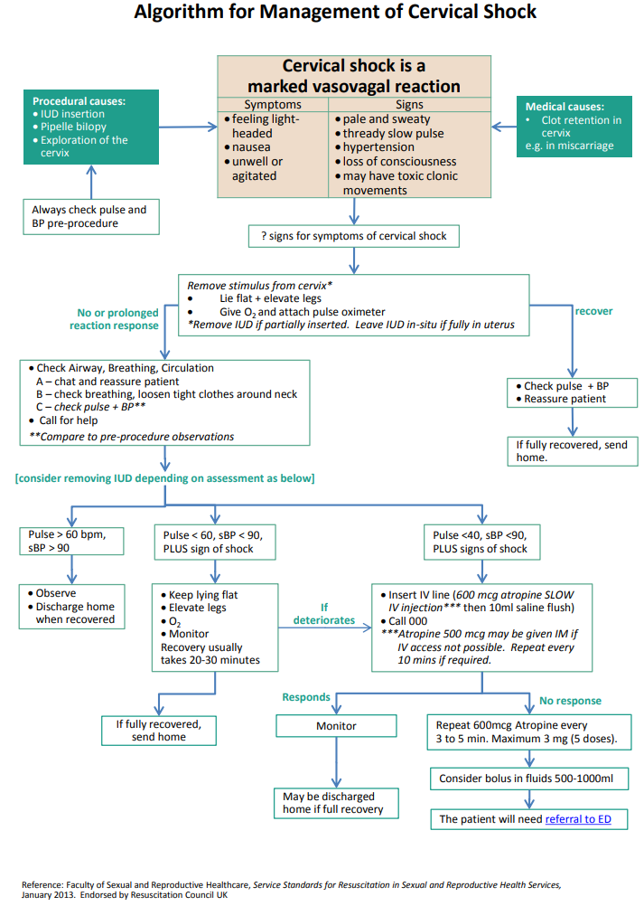

Attachment 2 – IUD consent checklist
To be used by clinician to aid process of completing CHS Informed Consent to Treatment form.

It may not be possible to insert the IUD on the day of the appointment.
There is a risk of fainting during or after the procedure. If this happens, you may need to stay longer until staff are sure you are well enough to leave.
There is a less than 1% chance that the IUD will not prevent pregnancy.
If you fall pregnant while using the IUD, there is a high risk of miscarriage or preterm birth, and that the IUD cannot be removed.
If you fall pregnant while using the IUD, there is an increased risk of ectopic pregnancy (0.2% risk).
There will be changes in your menstrual bleeding pattern while the IUD is in place.
There is a risk of expulsion of the IUD (5%-8% risk).
There is an increased risk of pelvic infection following IUD insertion (1% risk in the first 20 days).
Do not place anything in your vagina, including having sex, using menstrual cup, swimming/taking a bath, for the first 3 days after IUD insertion to reduce the risk of infection.
There is a risk of the IUD perforating the uterus. If this happens, you will need to see a gynaecologist to discuss having surgery to remove the IUD (0.07% risk).
Hormonal IUDs confer a risk of developing ovarian cysts (10% in the first year). And acne
The IUD must be removed /replaced in keeping with it’s approved duration of efficacy – 5 years for Kyleena/Mirena/Multiload (copper), 10 years for Copper T (TT380).
If left in place for longer the IUD may not be effective at preventing pregnancy.
It is important to ensure you are not pregnant at the time of the IUD insertion. This may involved performing a urine pregnancy test on the day of insertion.
A hormonal IUD may not be effective immediately. Do not have unprotected sex for seven days if you do not fall into one of the following categories:
- Inserted on day 1 to 5 of normal period
- Inserted within 21 days of giving birth
- Inserted within 5 days of a termination of pregnancy
- Replacing another hormonal IUD (Mirena or Kyleena)
- Replacing a copper IUD on day 1 to 5 of normal period
- Switching from Implanon or Depo progresterone.
Check for your IUD strings after each period. Try to remember to feel for your IUD strings a few times a year if you don’t get a period.

