Canberra Health Services
Procedure
HIV Non-Occupational Post-Exposure Prophylaxis (PEP)

Contents

Contents 1
Purpose 2
Scope 2
Section 1 – HIV Non-Occupational Post-Exposure Prophylaxis (PEP) 2
Evaluation 4
Related Policies, Procedures, Guidelines and Legislation 5
References 5
Definition of Terms 6
Search Terms 6
Attachments 6

Purpose

To outline the procedure for patients presenting to the Canberra Health Services (CHS) Emergency Department for HIV Post Exposure Prophylaxis (PEP) following possible HIV exposure.

Back to Table of Contents

Scope

This document applies to adult, adolescent or paediatric patients that present for HIV Post Exposure Prophylaxis (PEP) at CHS.

This document applies to the following CHS staff working within their scope of practice:
- Medical Officers
- Registered Nurses and Midwives
- Students working under supervision

Back to Table of Contents

Section 1 – HIV Non-Occupational Post-Exposure Prophylaxis (PEP)

- Triage:

If patient presents within 72 hours of exposure, access to HIV PEP is time critical. HIV PEP should be commenced as soon as possible after an actual or potential exposure to HIV, and at the latest within 72 hours.

- Obtain history:
- History of exposure:
- Time and date of exposure; calculate time since exposure
- Nature of exposure
- receptive anal intercourse - with or without ejaculation
- insertive anal intercourse - uncircumcised or circumcised
- receptive or insertive vaginal intercourse
- receptive or insertive oral intercourse
- needlestick injury or other sharps exposure
- shared needles and other injecting equipment
- mucous membrane and non-intact skin exposure

- HIV status of source individual if known.

Note:

PEP commencement should not be delayed even in circumstances where the source cannot be contacted immediately

If the source is known and can be contacted:
- If source is known to be HIV positive, check their:
- current HIV medication and most recent HIV viral load. Undetectable viral load = <50 copies/mL.
- prior anti-HIV medications and resistance assays

- If source is known to be taking pre-exposure prophylaxis (PrEP), check adherence
- PEP is generally not required but should be considered if there are concerns about source non-adherence to PrEP.

- If source choses not to disclose their HIV status or have an HIV test
- assume for the purposes of PEP prescription that they are HIV positive.

- If the source cannot be contacted, try to establish from the patient if they have any of the following risks:
- men who have sex with other men
- injecting drug use
- coming from country of higher HIV prevalence (in particular, sub-Saharan Africa or South East Asia)

- Assess HIV status and medical history of exposed person:
- Current illnesses, medications, allergies
- Hepatitis B vaccination or infection status
- Hepatitis C infection status
- Pregnancy or pregnancy risk – all women presenting for PEP should have a pregnancy test and be offered emergency contraception if appropriate
- Prior HIV testing

- Phone the Infectious Diseases (ID) Physician on-call with the above history in order to confirm that HIV PEP is appropriate for the exposure (HIV PEP indications are available via link in Attachment A) and to clarify potential drug-drug interactions (see Attachment B).

Decisions about whether or not to commence HIV PEP can be complex. Staff should clearly present patient concerns to the ID physician on call so that the decision to prescribe or not to prescribe PEP can be more easily communicated to the patient.

In the ED, patients are provided with a 2 drug (tenofovir and emtricitabine) starter pack (7 day initial supply) if PEP is indicated. There will be a minority in whom dolutegravir will also be indicated – there is a separate 7 day starter pack to be added in if indicated.

Note: If the patient is a child (less than 16 years old), provide ID physician with their age and weight. If PEP is indicated, medications and dosages may require modification.

- Inform patient/caregiver that PEP is a 28 day course of medication, which reduces but does not remove the risk of HIV seroconversion. Baseline HIV testing is required with follow-up HIV testing at 6 weeks and 3 months. There is a PEP information sheet for consumers on the policy register, and a consumer handout for HIV testing.

Alert:

Educate patient that until final follow-up tests are confirmed as negative they must avoid risks of transmission of HIV through sexual contact or sharing of blood or other body fluids.

- Obtain consent from the patient with appropriate pre-test discussion and collect the following baseline serology tests: HIV, Hepatitis B Virus (HBV), Hepatitis C Virus (HCV) and syphilis, plus electrolytes, urea, creatinine (EUC), liver function tests (LFT), and pregnancy test if appropriate.

Results will be provided at Canberra Sexual Health Centre (CSHC) when attending PEP follow-up.

- Provide PEP starter pack and go through PEP medication consumer handout. Inform patient/caregiver that they will be required to attend CSHC within 7 days to receive follow-up and the remainder of their medication.

- Other medical care:
- Consider need for Hepatitis B prophylaxis vaccination as per Australian Immunisation Handbook
- If the patient has any contaminated wounds or abrasions, assess need for tetanus vaccination as per Australian Immunisation Handbook.

Back to Table of Contents

Evaluation

Outcome:
Patient’s presenting to CHS ED with suspected HIV exposure within 72hours will be managed as per this procedure.

Measures:
- Review of 10 patient clinical records of patient’s presenting for HIV PEP when this procedure is reviewed.
- Review of consumer feedback related to HIV PEP.
Back to Table of Contents

Related Policies, Procedures, Guidelines and Legislation

Policies
- Commencement of Clinical Care
- Nursing and Midwifery Continuing Competence
- Informed Consent (Clinical)
- Medication Handling

Procedures
- Infection Prevention and Control - Healthcare Associated Infections
- Patient Identification and Pathology Specimen Labelling
- Patient Identification and Procedure Matching
- Canberra Sexual Health Centre
- Venepuncture Blood Specimen Collection
- Pathology Specimen Handling
- Australian Sexually Trasmitted Infections Management Guidelines
- Management of People with Human Immunodeficiency Virus (HIV) who place others at risk
- Blood Borne Virus (BBV) Testing in Adults
- Australian Immunisation Handbook

Consumer Handouts
- HIV Post-exposure Prophylaxis (PEP) Medication
- HIV Post-Exposure Prophylaxis (PEP)
- HIV and AIDS

Legislation
- Health Records (Privacy and Access) Act 1997
- Medicines, Poisons and Therapeutic Goods Act 2008
- Australian Charter of Healthcare Rights
- Work Health and Safety Act 2011
- Human Rights Act 2004

Back to Table of Contents

References

- ASHM, Australian National Guidelines for Post-Exposure Prophylaxis after Non-Occupational and Occupational Exposure to HIV (Second edition) http://www.pep.guidelines.org.au/ accessed 7/6/21
- Australian Technical Advisory Group on Immunisation (ATAGI). Australian Immunisation Handbook, Australian Government Department of Health, Canberra, 2018, The Australian Immunisation Handbook (health.gov.au)
- Topic | Therapeutic Guidelines (tg.org.au)

Back to Table of Contents

Definition of Terms

CSHC Canberra Sexual Health Centre
ED Emergency Department
HBV Hepatitis B Virus
HCV Hepatitis C Virus
HIV Human Immunodeficiency Virus
HSV Herpes Simplex Virus
IDU Injecting Drug Use
PEP Post Exposure Prophylaxis
STI Sexually Transmissible Infection

Back to Table of Contents

Search Terms

Non occupational exposure, HIV, PEP, sexual health, ED, emergency, post, exposure, prophylaxis

Back to Table of Contents

Attachments

Attachment A – Indications for HIV PEP
Attachment B – PEP Medications and cautions

Disclaimer: This document has been developed by Canberra Health Services specifically for its own use. Use of this document and any reliance on the information contained therein by any third party is at his or her own risk and Canberra Health Services assumes no responsibility whatsoever.

Policy Team ONLY to complete the following:
Date Amended | Section Amended | Divisional Approval | Final Approval
11/08/2021 | Complete Review | Jacqui Taylor, ED Medicine

This document supersedes the following:
Document Number | Document Name
CHHS17/241 | HIV Non-Occupational Post Exposure Prophylaxis (PEP)

Attachment A – Indications for HIV PEP

See ASHM, National Guidelines for Post-Exposure Prophylaxis after Non-Occupational and Occupational Exposure to HIV (Second edition), 2020
When to Prescribe PEP - PEP Guidelines

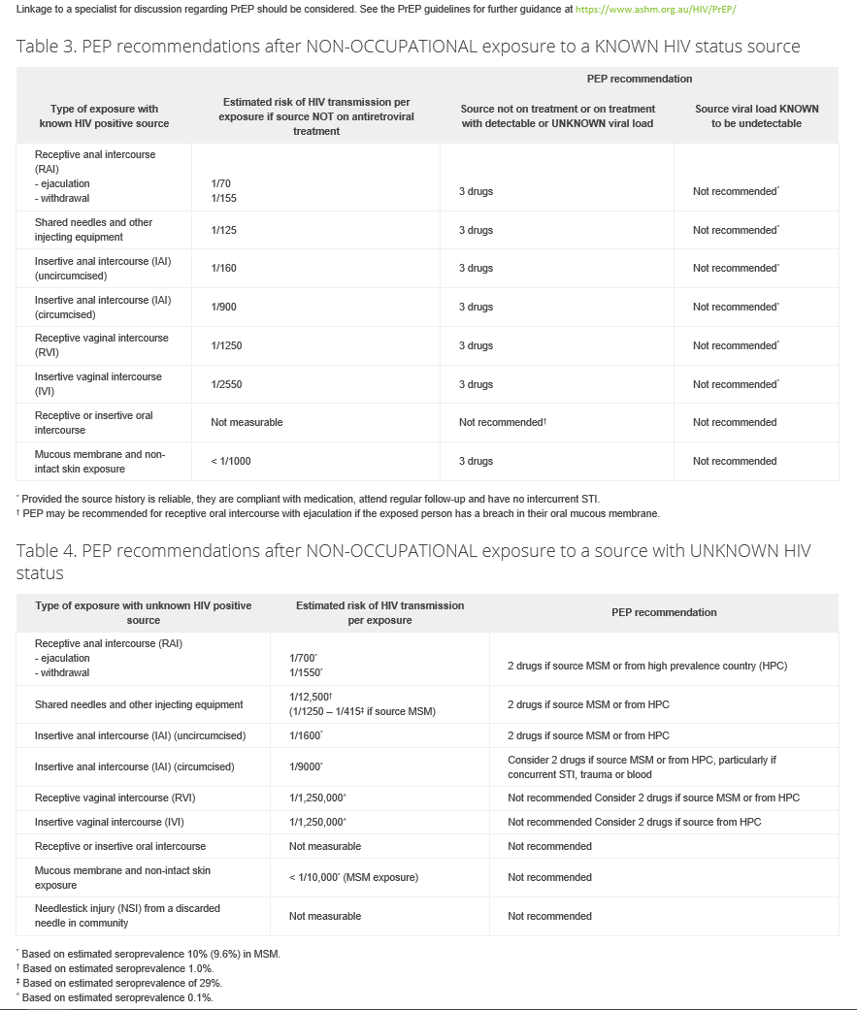

Attachment B – PEP Medications and cautions

Tenofovir and Emtricitabine
- Generally well tolerated
- Mild to moderate gastrointestinal side effects of nausea, vomiting, diarrhoea; tiredness, headache
- Use with caution or avoid if renal impairment eGFR <60ml/min
- Requires dose reduction if eGFR < 50 ml/min

Dolutegravir
- Generally well tolerated
- Drugs that are contraindicated
- Dofetilide (not available in Australia)
- Drugs that should be used with caution
- Phenytoin, phenobarbital, rifampicin, St John’s Wort, carbamazepine - increase dolutegravir dose to 50mg BD or stop St. John’s Wort.
- Antacids containing polyvalent cations e.g. Mg or Al – use at least 2 hours before or 6 hours after the dolutegravir dose.
- Products containing calcium or iron – use at least 2 hours before or 6 hours after the dolutegravir dose OR dose concomitantly with food.
- Metformin – increase monitoring of glycaemic control, adjustment in metformin dose may be required.

A full drug interaction check can be made on the Liverpool HIV Drug Interactions site http://www.hiv-druginteractions.org/

