Canberra Health Services
Procedure
Fresh Blood Products Administration – Adults, Paediatrics, and Neonates

Contents

Contents 1
Purpose 2
Alerts 2
Scope 4
Section 1 – Advice to Prescribers 5
Section 2 – Consent, refusal of Consent and Patient Information 6
Section 3 – Collecting the Pre-transfusion Sample and Positive Patient Identification 10
Section 4 – Requesting Fresh Blood Components, RBC, FFP, Platelets, Cryoprecipitate 12
Section 5 – Transportation and Storage of Fresh Blood Components 13
Section 6 – Generic Administration requirements Adults, Paediatrics, Neonates 14
Section 7 –Auto transfusion. Administration of blood obtained through Intraoperative Cell Salvage (ICS) 20
Section 8 – University of Canberra Public Hospital (UCH) 21
Section 9 – Paediatric Transfusions 22
Section 10 – Neonatal inpatients in NICU 25
Section 11 – Partial Exchange Transfusions – Neonates 30
Section 12 – Double Volume Exchange Transfusion (Neonates) 32
Section 13– Transfusion During Haemodialysis 40
Section 14 – Apheresis Procedures 41
Section 15 – Transfusion Reactions 43
Evaluation 48
Related Policies, Procedures, Guidelines and Legislation 48
References 49
Search Terms 50

Purpose

This document provides clear direction for nursing and medical staff in relation to administration of fresh blood products (Red Cells, Platelets, Fresh Frozen Plasma, and Cryoprecipitate) to Adult, Paediatric and Neonatal patients both within the Canberra Hospital and in the retrieval services environment.

Back to Table of Contents

Alerts

Risk
- Administration of Blood and Blood Products has the potential to be hazardous. Blood transfusions should only be given if the potential clinical benefits outweigh the potential risks to the patient.
- During the past three decades, there has been tremendous improvement in blood transfusion safety, largely owing to a decline in infectious hazards; however, blood transfusion still has the potential risks of morbidity and mortality.

Note: The most avoidable risk for patients is receiving the wrong blood resulting from misidentification of patient, or from procedural errors.

Positive Patient Identification (PPID)
The majority of transfusion-associated mortality is due to patients receiving the wrong blood product, or blood intended for another person. The independent double bedside check is a vital step in preventing serious transfusion error. Checking to ensure the right blood is given to the right patient is mandatory.

A bedside check between the patient’s ID wristband and the label on the blood component is essential to prevent component administration errors. Any other checking or signing of documentation is secondary and does not substitute the patient ID check.

No Band, No Blood
All patients receiving a transfusion must be wearing a patient Identification band regardless of whether they are in an outpatient or inpatient setting.

Zero Tolerance
ANY Transfusion specimen must comply with the following criteria. Otherwise the specimen will be rejected and a recollect will be required:
The patient’s Surname and First Name must be identical on the specimen
and request form
The Unique Record Number (URN) and Date of Birth (DOB) must be identical on the specimen and request
A Medical Officer must sign and date the request form and print their name
Time and date of collection must be recorded on both the form and the specimen
The specimen must be initialled by the collecting officer; and
The Transfusion Request Form must be signed by both the collecting officer and a witness to the collection to verify the positive patient identification and labelling process
eOrders identification stickers on the specimen will also be rejected for processing.

When specimens and /or their request forms do not meet the labelling requirements identified above for transfusion samples, the sample will be rejected and will require recollection with a new request form - in line with section 8 - zero tolerance of the Patient Identification – Pathology Specimen labelling Procedure. All major labelling errors will be documented on the incident management system (Riskman) and incident management processes will be followed.

Storage
Blood can only be stored in a fridge that is compliant with the Australian standard AS3864 (i.e. Blood must not be stored in a ward fridge – fridge stickers to this effect are available from the Transfusion CNC ext. 44092).

NO Consent, NO Transfusion
The informed consent process (verbal or written) must be documented in the clinical record. Otherwise, transfusion of blood or blood products must not commence or continue until the informed consent process is documented.

Note:
In the event of a lifesaving emergency transfusion when no authorised patient advocate is available the transfusion may be administered. This decision must be documented in the clinical record.

Acute Haemolytic Transfusion Reactions
Transfusion reactions are most likely to occur within the first 15 to 30 minutes of the commencement of transfusion of blood product. The correct observation protocol must always be used. See section 15 for more information on Transfusion Reactions.

Paediatric
Children experiencing transfusion reactions may be less able to verbalise their feelings and/or explain their symptoms but may suddenly develop overwhelming anxiety and complain of discomfort or pain.

Overnight Transfusions
Patients will not be routinely transfused overnight (between 2000hrs and 0700hrs) unless they are actively bleeding or are needing an urgent Blood Transfusion.

Back to Table of Contents

Scope

For the purposes of this procedure:
Paediatrics patients are defined as aged less than 18 years
Infants are defined as aged less than 1 year
Neonates are defined as aged less than 28 days
Mature Minor - In determining whether a child or young person is capable of providing consent, health professionals need to consider whether they have sufficient capacity to:
- Comprehend the medical advice being given, including the nature consequences and implications of the proposed examination, treatment, or procedure
- Comprehend the potential risks to health with or without the examination, treatment, or procedure and
- Manage the emotional impact of either accepting or rejecting the advised examination, treatment, or procedure.

Documentation should clearly include the clinician’s determination of Gillick competence, refer to Informed Consent (Clinical) policy for more information.

Alert:
Administration of fresh blood products must only be performed by registered nurses, registered midwives or medical officers with appropriate skills and training.

Canberra Health Services (CHS) highly recommends all clinicians involved in clinical aspects of transfusion complete the relevant Blood Safe Australia eLearning course to increase their knowledge of safe and appropriate transfusion practice. These courses are available via Capabiliti or at www.bloodsafelearning.org.au. See figure 1 below for a summary of courses.

Managers are responsible for ensuring that their staff have the appropriate skills and training to deliver safe transfusion practices and that compliance with completion of these courses is documented in the learning management system Capabiliti.

The CHS Blood Management Committee highly recommends the completion of the following course by relevant staff. (i.e. Staff who order, participate in administration or transportation of blood/blood products or any staff collecting pretransfusion samples).

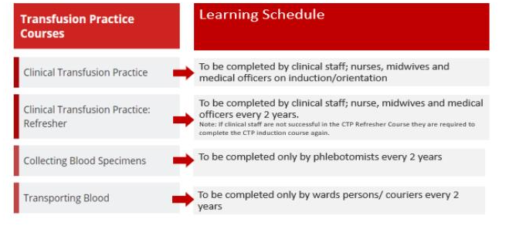
Figure 1: BloodSafe eLearning minimum requirements

Back to Table of Contents

Section 1 – Advice to Prescribers

The decision to administer blood products, and the consideration of other blood management strategies, must be based on a thorough clinical assessment of the patient and of that person’s individual needs.

CHS supports the National Blood Authority / National Health and Medical Research Council Patient Blood Management Guidelines. Decisions to transfuse blood products should be consistent with these nationally endorsed guidelines.

These guidelines acknowledge the principle that efforts should be made to maintain a patient’s own blood, especially with emerging evidence that transfusion is frequently not beneficial and may in fact lead to harm, including increased mortality rates.

Efforts to maintain an individual’s own blood should include preoperative optimisation of the haemoglobin and iron stores, the use of haematinic replacement therapy rather than transfusion in asymptomatic or mildly symptomatic anaemic patients and improved measures to enhance haemostasis, such as the use of antifibrinolytics.

Key recommendations from the Guidelines include:
RBC transfusion should not be dictated by a haemoglobin ‘trigger’ alone but should be based on assessment of the patient’s clinical status. In the absence of acute myocardial or cerebrovascular ischaemia, postoperative transfusion may be inappropriate for patients with a haemoglobin level of >80 g/L.
Patients (excluding neonates) should not receive a transfusion when the haemoglobin level is ≥100 g/L. In postoperative patients with acute myocardial or cerebrovascular ischaemia and a haemoglobin level of 70–100 g/L, transfusion of a single unit of RBC, followed by reassessment of clinical efficacy, is appropriate.
In patients (excluding neonates) with a Hb 70-100g/L, transfusion is not associated with reduced mortality, but may be indicated to relieve symptoms of anaemia. Transfusion of a single unit of red cells should be considered, with a reassessment of the clinical efficacy.
Transfusion to correct a Hb<70g/L is likely to be appropriate, but may not always be necessary, particularly if there is specific therapy available or patients are well compensated.
Where red cell transfusion is being considered in stable postoperative patients (excluding neonates) without evidence of ischaemia, it is likely to be inappropriate when the Hb is greater than 80g/L.
Transfusion of red cells has been associated with increased mortality in acute coronary syndrome when the Hb is >100g/L.
In general, invasive procedures can be undertaken in patients with INR≤ 2 or platelets >50 x10^9/L (excluding intracranial, neuraxial or intraocular procedures).

Further recommendations relating to specific situations including paediatrics and neonates are available. These can be found at http://www.blood.gov.au/pbm-guidelines

Back to Table of Contents

Section 2 – Consent, refusal of Consent and Patient Information
Consent for receipt of identified blood and/or blood products (including intra-operative cell salvage), as part of their treatment or procedure, must be sought from the patient prior to administration of the blood product. Documented consent for Blood and Blood Products is required under the Blood Management National Safety and Quality Health Service Standard.

Capacity:
Legally, capacity to provide consent exists if the patient is able to understand the nature, effect and consequences of the decision to be made, rationally weigh up the options, understand the implications of his or her decision and communicate the decision. The clinician needs to take into consideration individual circumstances, cultural or religious considerations, illness, and treatment.

A patient has capacity to make a decision if they can, with assistance if needed, demonstrate all of the following elements:
understand when a decision about need for treatment, care or support needs to be made
understand the facts related to that decision including the risks and benefits
understand the main choices available in relation to the decision
weigh up the consequences of the main choices
understand how the consequences of the main choices affect them
on the basis of the above elements, make the decision, and
communicate the decision they make in whatever way they can.

Significant risks, benefits and other alternative blood management strategies, including the patient’s right to decline the transfusion must be discussed with the patient and documented on the Blood and Blood Product Prescription and Checklist and/or the Consent to treatment form available on the CHS Clinical Forms register, or electronic equivalent.

Valid, informed consent for transfusion means that a documented dialogue has occurred between the patient and a clinician that includes:
the reason for the proposed blood product transfusion
the proposed blood product for transfusion
the risks and benefits of the blood product, and the risks or consequences of not receiving the product
The patient has the opportunity to ask questions and have those questions answered
Refusal of consent for blood components
Alert-Refusal of Consent
A patient’s/carers decision to refuse or withdraw consent to blood and/or blood products, and any known reasons, is to be documented in the clinical record by the treating health professional and confirmed in writing by a second health professional.
Patients/carers who refuse treatment with blood transfusion or other blood products should document this decision in a Health Care Directive.
Where a patient refuses consent for the transfusion of specific blood products, both the acceptable and unacceptable products for transfusion should be clearly documented.
People refusing blood transfusion therapy may carry an advanced medical directive with them in regard to blood and blood products, these may outline which products are acceptable for this individual.
Frequency of consent
Acute patients: patients who are receiving a single transfusion associated with surgery or other medical condition should give consent prior to this episode of transfusion.
Chronic patients (including neonates): Patients undergoing regular/frequent transfusions typically in the outpatient or day-stay setting over a period of months to years and covering multiple episodes of care should give consent (for children, consent should be provided by a person with parental responsibility or their delegate) at the commencement of their treatment or as their condition evolves and the indication for transfusion changes. This consent will remain valid for 12 months unless there is a significant change in the indication or risk profile of transfusion.

NO Consent NO Transfusion

Alert-No Consent
If the informed consent process is not documented in the clinical record transfusion of blood or blood products must not commence or continue until the informed consent process is appropriately documented.

Alert - Lifesaving emergency transfusion
In the event of a lifesaving emergency transfusion when no authorised substitute decision maker is available or legal directive/s present, the transfusion may be administered if the treating medical officer believes that immediate action is necessary to resolve the medical emergency. This decision must be documented in the clinical record retrospectively and is made with the best information available at that time.
The circumstances that comprise the emergency and the consumer’s lack of capacity to consent must be documented in the patient’s clinical record

Alert Lifesaving emergency transfusion
Blood and blood products can be given in an emergency when through a lack of capacity, no consent has been given, provided:
- The treatment is a necessity;
- There is no written advance directive by the consumer/carer to the contrary;
- Consent cannot be sought from a substitute decision maker if treatment is required immediately; and
- The clinical decision to transfuse without consent is documented in the clinical record. (i.e. The circumstances that comprise the emergency and the consumer’s lack of capacity to consent)

Alert – Telephone Consent Child or Young Person
Where a child or young person requires treatment that is not a medical emergency, telephone consent may be obtained from the parent or authorised patient advocate. Another health professional must listen to the consent conversation and must document in the clinical record that valid informed consent has been obtained.

Blood transfusions without parental consent
Pursuant to section 23 of the Transplantation and Anatomy Act 1978, where a parent of a child refuses to consent to a blood transfusion for a child in a life-threatening emergency (under the age of 18 years) or it is not practicable to delay the administration of a blood transfusion until consent of the parent is obtained, a blood transfusion for a child may be administered without parental consent provided:
at least two medical officers are of the opinion that the child is in danger of dying and that the administration of a blood transfusion to the child is the best means of preventing the death of the child, and
the medical officer is satisfied that the blood to be transfused is compatible with the blood of the child.
If a blood transfusion is administered to a child without parental consent, the medical officers involved must clearly and thoroughly document:
the reasons for their view that the child was in danger of dying
the reasons for their view that the blood transfusion was the best means of preventing the death of the child
that the blood to be transfused is compatible with the blood of the child
if the parent refused to provide consent, the discussion which occurred with the parent including all questions asked of the parent and their responses, steps taken to ascertain why the parent refused to consent and the discussion regarding the risks and benefits of the transfusion, and
if it is not practicable to delay the administration of the blood transfusion until consent can be obtained, the reason why it is not practicable to delay.

As per the Informed Consent Policy: If a blood transfusion (not life-threatening event) is refused by a parent, and the clinician believes on reasonable grounds that this is not in the best interests of the child, they must contact the Public Trustee and Guardian.

Consent can be obtained by contacting the Office of the Public Trustee and Guardian during business hours (0900-1630) to apply for an emergency guardianship order. If consent is required outside of business hours, a procedure or treatment may only proceed if it is an emergency, otherwise the procedure or treatment must not proceed until the emergency guardianship order is in place.

The Office of the Public Trustee and Guardian contact is: 02 6207 9800.
Equipment
Blood and Blood Product Prescription and Checklist
Consumer information

Procedure
- Patients and/or authorised patient advocate must be routinely provided with information prior to commencement of the transfusion, unless in an emergency life treating situation
- Discuss indication for transfusion with patient and/ or authorised patient advocate
- Discuss risks, benefits, and any patient blood management strategies available
- Provide written information
- Consider patients cultural/religious beliefs and values, arrange interpreter if required and document the name of the interpreter on the Blood Product Prescription and Checklist.
- Provide an opportunity for the patient / authorised patient advocate to ask questions
- Document informed consent process in the clinical records on the Blood Product Prescription and Check List and /or the Consent to Treatment form
- For patients who cannot give valid or informed consent refer to the Informed Consent (Clinical)Policy
- Ongoing consent should be verbally obtained from the patient/parent/guardian prior to administration of each Blood Product and documented in the patient’s notes.

Back to Table of Contents

Section 3 – Collecting the Pre-transfusion Sample and Positive Patient Identification

Pretransfusion sample collection must include positive patient identification processes and labelling of specimens in the presence of the patient/i.e.in the sample collection circle.

ALERT - eOrders
Transfusion – related pathology orders cannot be ordered through eOrders.
All requests for transfusion – related pathology must be documented on the Blood Transfusion Form (pink)
These include:
Group & Screen (G&S)
Antenatal samples (G&S pregnancy)
DCT (DAT)
CORD testing (Group & Direct coombs Test)
Group only
Antigen typing
Red cell phenotype

eOrders generated patient identification labels must not be used to label transfusion- specimens. Any transfusion specimens labelled with the eOrder label will be rejected under transfusion zero tolerance and will require recollection.

In line with the CHS Patient Identification: Pathology Specimen Labelling Procedure, the patient’s identity MUST be positively confirmed at the time of sample collection, and the tube labelled immediately after being filled before leaving the patient’s bedside/sample circle.

Ensure all documentation is complete including:
Full name, DOB, MRN
Declaration is signed by both the collector and the witness
Date and time of collection on the request form and the sample tube
The sample tube is signed by the collector
Indication for transfusion and transfusion history
Date transfusion is required/ scheduled
Special requirements if indicated e.g. irradiation, CMV negative
Request form signed by medical officer.

For neonatal patients, the mother’s details, including full name, DOB and hospital MRN (where available) should be documented in the clinical history or the relevant section on the Transfusion Request Form.

Alert-Zero Tolerance
CHS has zero tolerance for incorrectly labelled transfusion samples. If all the mandatory requirements are not clearly documented and correct the sample will be rejected and will need to be recollected.

All major mislabelling errors (Including Wrong Blood in Tube, Unlabelled samples and/or forms, where the three core identifiers on the form do not match the sample) will be entered into clinical incident management system and an incident management review will be required

Equipment
- Alcohol based hand rub
- EDTA Tube (pink)
- Vacutainer and needle
- Heel lance device or blood collection 24G needle (neonates)
- Sharps bin
- Skin wipe
- PPE – Gloves and Goggles
- Fully completed request form

Procedure for Adults (see Section 9 – Paediatric Transfusions for paediatrics and Section 10 – Neonatal inpatients in NICU)

- Ensure consistent practice with the 5 moments of Hand Hygiene
- Positive Patient Identification
- The patient’s identification must be confirmed by asking the patient to state their first and last names and their DOB. If there is any likelihood of confusion or ambiguity regarding the patient’s name or its spelling, the patient must also be asked to spell their name, comparing the patient’s answers with:
- Patient identification details on the patient’s identification wristband
- Patient identification details on the Pathology Request Form
- Patient identification details on any pre-printed self-adhesive specimen labels that are available.
- For those patients not able to give verbal confirmation of correct identification, identification must be confirmed by a relative, medical or nursing staff, who must then witness the specimen collection and independently witness the correct labelling of the tube and the associated documents
- Ensure that a suitable witness is available to watch specimen collection and confirm patient identification
- Select suitable venous access
- Collect sample
- Label sample with:
- Three core identifiers (full name, DOB, URN)
- Date and time of collection
- Collector’s initials.
- Complete documentation:
- Ensure all core identifiers on the form completely match the core identifiers on the specimen and the patient’s Identification Band, where possible the patient must be shown the labels on the specimens collected from them and asked to read aloud the full name and date of birth on them and to confirm that the specimens are correctly labelled with their identification details
- Collector’s signature, printed name and designation on declaration
- Witness signature, printed name and designation on declaration
- Time and date of collection.
- Place specimen and request form in biohazard bag and place in pathology chute.

Back to Table of Contents

Section 4 – Requesting Fresh Blood Components, RBC, FFP, Platelets, Cryoprecipitate

All requests for a group and screen, or a cross match must be written on a Blood Transfusion request form and cannot be requested in eOrders. Documentation must be legible.

Equipment
Blood Transfusion Request form

Procedure - as per Patient identification and specimen labelling procedure
Complete documentation and include all of the following:
Patient surname, full given name, DOB and hospital MRN
Gender
Patient Address (only mandatory for patients who are not required to wear an identification (ID) band and therefore do not have an MRN as the third core identifier)
Ward or unit
Name (Legible, printed) and signature of requesting doctor
Date request written
Product to be transfused, including any special requests e.g. irradiated, CMV negative
Date and time of product required
Relevant clinical history including diagnosis and indication for transfusion, known red cell antibodies, any previous transfusion adverse events, current/recent pregnancy, medications
For neonatal patients, maternal details (including full name, DOB, and URN) must be included in the clinical history where available

Alert
The Transfusion Laboratory does not action request forms for blood components until a phone call is made by a member of the treating team. The lab must be notified by phone on x 44239 before products will be delivered.

Alert
The Transfusion Laboratory should be kept informed of the transfusion schedule of long-term transfusion dependent patients (e.g. patients with thalassemia or sickle cell disease). Notification of appointment dates should be emailed to TCHTransfusion@act.gov.au so that appropriate units can be obtained ahead of time. Units often need to be ordered from Lifeblood Sydney which can cause delays of >24 hours in the provision of blood products.

Back to Table of Contents

Section 5 – Transportation and Storage of Fresh Blood Components

Alert
Blood components are transported in dedicated and validated insulated containers.
Blood components must never be transported via the pneumatic tube system.
Only one unit of red cells is delivered at a time for each patient, except in emergency situations.
Blood components must never be stored in a ward fridge.

Alert – Massive Transfusion Shipper
Blood and blood products for Massive Transfusion may be sent in a sealed shipper or esky.
DO NOT Open until ready to administer.
The contents of the Shipper will be clearly marked on the top of the shipper.
Once the shipper is opened the 30 minutes/4-hour rule applies.
Please contact the transfusion lab x44239 if you are unsure.
Return any unused products to the lab as early as possible.

Equipment
- Blood Component
- Validated insulated container
- ARCBS cold pack-(cold pack that has bubble wrap coverage on one side.) Packs are available from the transfusion laboratory.

Procedure
- Ensure consistent practice with 5 moments of Hand Hygiene
- Confirm with the Transfusion scientist which blood components are to be delivered
- Select appropriate blood component from fridge
- Record time of removal from approved storage using “bundy” clock in transfusion laboratory
- Transport component is dependent on cold chain requirements:
  - Red Cells and FFP should be transported with a cold pack in an insulated shipper
  - Platelets and cryoprecipitate must be kept at room temperature, i.e. NO cold pack is required

Note: Platelets must not be transported in the same container as those products requiring a cold pack

- Take blood component to ward area and must be handed to nursing, midwifery, or medical staff in the clinical area. (i.e. Blood and Blood Products MUST Not be left unattended on desks/benches)

Back to Table of Contents

Section 6 – Generic Administration requirements Adults, Paediatrics, Neonates

Blood Products will be given where resuscitation equipment is available, in an area where the patient can be easily observed and monitored.

Alert Patients will not be routinely transfused overnight (between 2000hrs and 0700hrs) unless actively bleeding or needing an urgent Blood Transfusion.

Staff will request the Blood Product only when preparation of the patient has been completed and appropriate and patent IV access is in-situ.

All Fresh Blood Products will be administered as soon as they are received, and transfusion must be completed within four hours of commencement and no longer than four and a half hours following release of the product from controlled storage.

Single units of red blood cells are issued unless alternative arrangements have been made with the laboratory.

Alert
The majority of transfusion-associated mortality is due to patients receiving the wrong blood product, or blood intended for another person. The identity check between patient and blood component is the crucial final opportunity to avoid potentially fatal mis transfusion. The double independent bedside check is a vital step in preventing serious transfusion error. Two staff members independently checking positive patient identification should ensure that the right blood is given to the right patient. This double independent checking process is mandatory. Noting that that Transition to Practice (TTP) and Enrolled Nurses (EN) must check with a registered Nurse / registered midwife / medical officer. (i.e., Two(2) TTP/ENs cannot check blood products on their own.

Alert
The patient identification process is one procedure that must occur at the patient’s bedside. A double independent bedside check between the patient’s ID wristband and the identification label on the blood component is essential to prevent component administration errors. Any other checking or signing of documentation is secondary and does not substitute the patient ID check.

Equipment
- Appropriate IV access
- Appropriate IV giving set with inline 170 –200-micron filter (to filter any debris collected during storage)
- Three-way tap, extension tubing and 30/ 50mL syringe (neonates only)
- Blood and Blood Product Prescription and Checklist
- Fluid Balance Sheet (if required)
- Personal Protective Equipment
- Alcohol wipes
- Blood Warmer if applicable (Massive Transfusion, Exchange Transfusion for Neonates or if recommended by transfusion laboratory).

Procedure
- Check for documented consent
- Ensure consistent practice with 5 moments of Hand Hygiene
- Collect equipment
- Confirm that the correct blood product type has been delivered. (e.g. pRBC, Platelets, Plasma, or Cryoprecipitate)
- Complete the double independent Positive Patient Identification check with second authorised staff member (i.e. Medical Officers, Registered Nurses or Midwives, anaesthetic technicians or Enrolled Nurses who have successfully completed Clinical Transfusion Practice education via BloodSafe and have been deemed competent)

Alert
The patients full name (family and given name) DOB, and MRN must be
independently and separately checked by two staff members conducting the bedside check. These three core identifiers must be identical on the patient’s identification band and the compatibility label attached to the blood product

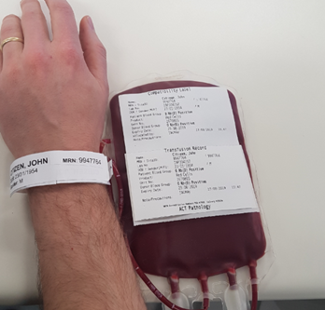

- Remove the lower section of the compatibility label and check that the blood group and the blood unit number on the compatibility label matches the manufacturer’s sticker on the unit

Alert
The blood group and unit /donation number and expiry date on the compatibility label must be independently and separately checked by both staff members conducting the bedside check to verify they match the manufacturer’s sticker on the unit

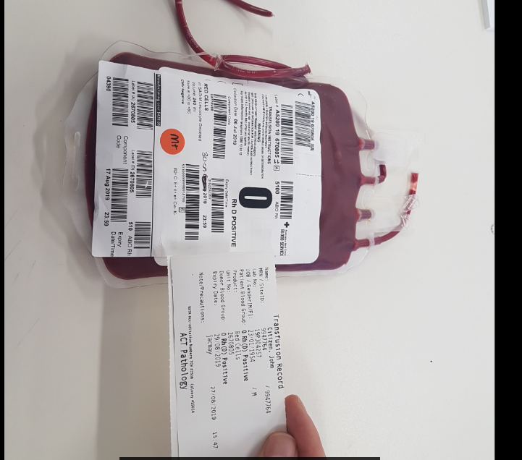
- Check that the blood group, unit number and expiry date on the compatibility label match the manufacturers label
- Check the Blood and Blood Product Blood Prescription and Checklist / precautions section for special transfusion instructions (e.g. CMV negative, irradiated)

Where to find product type, donation number and expiry
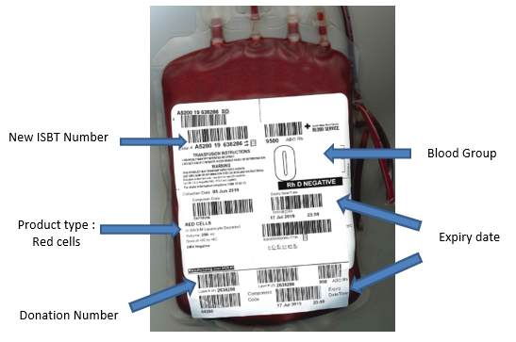

- Inspect the pack for:
- Leaks at the ports and seams
- Evidence of haemolysis in the plasma or at the interface between red cells and plasma
- Evidence of unusual discoloration or turbidity
- Check for the presence of large clots.

Alert
If there is evidence of any abnormality of the above, call Blood Transfusion Laboratory and return the pack to the lab.

- At completion of independent double checks by both staff members (where both staff members agree that the correct product has been issued to the correct patient) both staff must sign the Blood and Blood Products Prescription and Check List and place the Transfusion Record Sticker in the medical records
- The second independent checker spikes the unit and primes the giving set with either the blood component or 0.9% Sodium Chloride
- Connect giving set to infusion pump (and blood warmer if required)
- Program infusion pump
- Attach line to IV access device
- Record base line observations in appropriate profile in Patientrack (where available):
- Temperature
- Heart Rate
- Respiratory Rate
- Blood Pressure
- SpO₂
- Level of consciousness (LOC)
- Start infusion.

Infusion Rates Adults (See section 10 for neonates and section 9 for Paediatrics):
The infusion rate for blood products depends on the clinical context, age, and cardiac status of the patient. For patients at risk of circulatory overload e.g. cardiac failure, it usually necessary to transfuse more slowly. Concomitant use of diuretics should also be considered.
Blood product | Rate for adults | Storage
Red Blood Cells | Start at no more than 5mL/min  for the first 15 minutes, unless an emergency | Stored at 2-6 º C in a validated blood fridge
Platelets | Platelets are administered at a rate of approximately 15- 30 minutes per bag | Platelets cannot be refrigerated or frozen they must be stored at room temperature and used within five days of being donated
FFP/ELP | Administer at a rate of 10 -20mL/kg/hr | These products are issued thawed. Thawing conditions are controlled by and are the responsibility of the Transfusion Laboratory.  The process can take up to 20 minutes
Cryoprecipitate | Administer at a rate of 10 -20mL/kg/hr

Note: See section 9 for rates for paediatrics and section, 10 11 and 12 for neonates.

Alert
Do not give platelets via a giving set that has been used for the Transfusion of Blood or other Blood Products.

- Complete documentation on the Blood and Blood Products Prescription and Checklist Transfusion sheet and fluid balance sheet (if required)
- Observe patient based on Observation Protocol 1 or 2. Record observations in the appropriate transfusion profile in Patientrack.

Alert – Transfusion Observation Profiles:
Transfusion observations must be documented using the appropriate “transfusion profile: in Patientrack in all areas where Patientrack is available.

Observation Protocols Fresh Blood Products
Observation Protocol 1  (Profile 1 Patientrack) | Observation Protocol 2  (Profile 2 Patientrack)
If the patient is alert and orientated and able to participate in their care, initiate observation Protocol 1 | For all other patients including paediatrics, neonates, patients with “Transfuse with Care” alerts on the transfusion record and all overnight transfusions, use this protocol (which includes 1/2hrly observations throughout transfusion)
Explain the symptoms of Adverse Transfusion Reaction to the patient before starting the Blood Transfusion. Instruct the patient to immediately report the following:
Shivering
Rashes
Flushing
Shortness of breath
Pain in the extremities or in the loins.
Base Line Observations (within 60 minutes of commencing infusion)  Temperature (Temp)  Heart Rate (HR)  Respiratory Rate (RR)  Blood Pressure (BP)  SpO₂  Level of consciousness (LOC) | Base Line Observations (within 60 minutes of commencing infusion)  Temperature (Temp)  Heart Rate (HR)  Respiratory Rate (RR)  Blood Pressure (BP)  SpO₂  Level of consciousness (LOC)
15 Minute observations  Monitor (physically check) patient for first 15 minutes of transfusion  Monitor and record observations 15 minutes after commencement | 15 Minute observations  Monitor (physically check) patient for first 15 minutes of transfusion  Monitor and record observations 15 minutes after commencement
30-minute Observations
Continue to monitor and record observations
EVERY 30 minutes until infusion complete.
Completion Observations
Monitor and record final observations once unit completed

- Ensure the following is documented in the clinical record.
- Indication for transfusion
- Patient observations and outcomes (including adverse events)
- Product administration start and finish times
- Volume and type of product administered
- Unique donation / batch number of product
- Names and signatures of both persons checking the product
- Any equipment used e.g. pumps / blood warmers.

Back to Table of Contents

Section 7 –Auto transfusion. Administration of blood obtained through Intraoperative Cell Salvage (ICS)

The responsible clinician should prescribe salvaged blood for re-infusion in the same manner as for allogeneic blood and document the transfusion in the standard anaesthetic documentation.

All salvaged blood must be labelled with a label which includes:
- Patient’s full name
- Date of birth
- Hospital number
- Collection start date and time
- Expiry date and time
- Type of autologous blood (intra-op/washed)
- Name of the autotransfusionist involved in the case
- Volume of blood collected to be re-infused.

Alert: Intraoperative Cell Salvage products must only be administered to the patient from whom the blood was collected. The re infusion bag must be kept at the patient’s bedside at all times.

When not immediately re-infused in theatre there must be double independent checking of the salvaged blood against the patients Identification. i.e. when the blood is separated from the cell salvage machine, before connecting the re-infusion bag to the patient.

Alert
Salvaged blood must only be transfused in the theatre, PACU/or intensive-care unit (ICU), and not be transferred to any outside areas in the hospital i.e. Patients must stay in PACU/ICU until re-infusion with Intraoperative Cell Salvage blood is completed.

Blood must be transfused within four hours of collection.

Blood observation protocols apply.

A leukocyte depletion filter may be indicated for reinfusion.

Any adverse events associated with ICS should be documented and reported in clinical incident system (Riskman) and to the Transfusion CNC X 44092.

More information about the process for collection of intra operative salvaged blood is available at Intra operative Cell Salvage Guideline available on the Policy and Guidance Documents Register.

Back to Table of Contents

Section 8 – University of Canberra Public Hospital (UCH)

At the University of Canberra Public Hospital, the following processes for ordering and supply of blood products apply.

Alert
The provision of therapeutic products will be agreed upon on a case-by-case basis between the UCH treating team and the clinical director of haematology or the chief scientist of haematology at ACT Pathology.

Requesting Blood Products for UCH
- A valid Group and Screen is required before blood products can be issued.
- Requests for blood products must be received by the transfusion laboratory at least 24hrs prior to issue.
- Requests for products must be sent during ACT Pathology business hours
07:00hrs to 17:00hrs Monday to Friday.
- UCH will send a completed request form requesting one unit of RBC and call the transfusion laboratory ph: 62016274 (Calvary) to request the unit.
- On receipt of the request, ACT Pathology will fax the ward a Transfusion Information Check Sheet for ward staff to check and confirm all patient identification details are correct prior to the unit being transported.
- UCH will confirm full name, date of birth and medial record number on the Transfusion Information Check Sheet match identically to the intended patient.

Note:
The UCH Information Check Sheet does not replace the positive patient identification check on administration, but it is to confirm demographics prior to transport.

- UPCH will fax completed, signed and dated Transfusion Information Check Sheet
To ACT Pathology transfusion laboratory Calvary Fax: 62016078
- ACT Pathology will package blood with appropriate Australian Red Cross Blood Service shipper requirements and arrange transport to UCH

Receiving Blood Products
- On receipt of blood products UPCH staff must check transportation sticker on shipper for Pack Time and Unpack by time to ensure that these does not exceed 2hours 40 mins.
- If there are any issues, please contact transfusion laboratory issuing the unit immediately.
- Blood Products must be transfused immediately upon receipt and completed within
4 hours.
- Blood must not be stored in the shipper, ward fridge, or any other fridge that is not compliant to Australian Standard AS864.

Note: For assistance in blood administration at UCH please Call the nurse educator

Administration
Administration of blood product must comply with all steps in Section 6.

Back to Table of Contents

Section 9 – Paediatric Transfusions

Alert:
In neonatal and paediatric patients with critical bleeding requiring massive transfusion, use the Critical Bleeding/Massive Transfusion protocol

Children require specific consideration of the following:
The volume to be infused. Children less than 20kg should have the volume prescribed in mL
The volume should be calculated on the child’s weight and the desired haemoglobin to prevent transfusion associated overload (TACO).
In most paediatric patients over 20 kg, transfusion of a single unit of RBC, followed by clinical reassessment to determine the need for further transfusion, is appropriate. This reassessment will also guide the decision on whether to retest the Hb level.

Alert:
In neonatal and paediatric surgical patients in whom substantial blood loss is anticipated
preoperative anaemia and iron deficiency should be identified evaluated and managed to minimise RBC transfusion. Where preoperative anaemia is identified, it is important to determine its aetiology, so that appropriate therapy can be given.

Transfusion Volume calculation
In calculating transfusion volume for infants and small children (<20kg):
the dose or transfusion volume of blood components for, infants and children should be carefully calculated and prescribed in mL (not in ‘units’), with a specified transfusion rate an administration rate of up to 6 mL/kg/hour (for a 20 mL/kg transfusion) or 5 mL/kg/hour (for a 15 mL/kg transfusion) will allow proper checking procedures and completion of the transfusion within the 4 hours that RBCs can be out of a blood refrigerator. Transfusion volume can be calculated using the following formula:

Transfusion volume (mL) = patient’s weight x EBV × (desired Hb – patient’s Hb) / Hb of donor unit

where:
- weight is in kg
- the patient’s estimated blood volume (EBV) is in mL/kg – this decreases with age, from 100–120 mL/kg in extremely preterm infants, to 80–85 mL/kg in term infants and about 70 mL/kg in older infants and children
- desired Hb and patient’s Hb is in g/L
- haematocrit (HCT) can be substituted for Hb in the formula, provided it is used throughout; Hb can be estimated from HCT using the formula

Hb = HCT× 1000/3.

Cell Type | HCT+/- SD (range)
Paediatric RBCs leucocyte depleted | 0.63 ± 0.03 [0.5–0.7]
RBCs leucocyte depleted | 0.59 ± 0.03 [0.5–0.7]
HCT, haematocrit; RBC, red blood cell; SD, standard deviation
Source: Australian Red Cross Blood Service data (1 July 2013 to 30 June 2014)

Special requirements:
- Consider whether special requirements, such as irradiation or CMV negative units are required.

Consumer information:
An information brochure on blood transfusions should be provided for the parent/guardian, such as Children receiving a blood transfusion - A Parent’s guide

Positive Identification of Children:
- Identification bands must be in place and the parent/guardian/carer (if present) should positively identify the child prior to commencing the transfusion.

Rate of infusion:
- Clinical indication and fluid volumes appropriate for weight must be considered by the medical officer when determining the rate of transfusion; and
- Administration must not exceed four (4) hours.

A child’s cognitive ability to report or partake in care:
- Infants and young children will not be able to communicate adverse effects of transfusion and must be closely monitored.

Consideration of child’s activities:
- Transfusion should be planned for a time when the child is in a supported clinical area, allowing close observation.

Alert
Children experiencing transfusion reactions may be less able to verbalise their feelings and explain their symptoms due to their developmental stage but may suddenly develop overwhelming anxiety and complain of discomfort or pain.

Equipment
- Appropriate IV access
- Appropriate IV giving set with inline 170 –200-micron filter (to filter any debris collected during storage)
- Three-way tap, extension tubing and 30/ 50mL syringe (neonates)
- Blood and Blood Product Prescription and Checklist
- Fluid Balance Chart
- Personal Protective Equipment
- Alcohol wipes
- Blood Warmer if applicable (Massive Transfusion, Neonates).

Procedure
- Product and Identification checking procedure as per adult transfusion see Section 6 ( 1-17)
- Special considerations for Paediatrics
Blood product | Formula for calculating  transfusion volume | Pack sizes | Rate
Red Blood Cells | See Transfusion Calculation | 250-300mL/pack;  50 -60 mL/Pedi pack | up to  6 mL/kg/hour (for a 20 mL/kg transfusion) or  5 mL/kg/hour (for a 15 mL/kg transfusion)
Platelets | 5 - 20 mL/kg  (5 - 10 mL/kg will raise platelet count by 50 - 100x 10⁹ /L) | Paediatric <40kg  - Paediatric (single donor) 40 - 60 mL  - Apheresis (single donor) split into 4 - 8 x 40 - 60 mL packs  Paediatric > 40kg  - Apheresis (single donor) >200mL or split into 2 x > 100mL packs  - Pooled from 4 donors - >160mL | Platelets are usually administered at 5-10mL/kg over at least a 1/2-hour period or as specified by the Medical Officer.  In patients undergoing chemotherapy and haematopoietic stem cell transplantation, the recommended strategy for prophylactic use of platelets is transfusion at a platelet count of <10x10⁹/L in the absence of risk factors, and at of <20x10⁹/L in the presence of risk factors (e.g. fever, minor bleeding)
Fresh Frozen Plasma (FFP) | 10 - 20 mL/Kg | 300mL/pack  50mL/pack (for neonatal use) | Start at no more than 5mL/min.
Cryoprecipitate | 5-10 mL/kg | 30-40 mL/pack | Start at no more than 5mL/min.

Back to Table of Contents

Section 10 – Neonatal inpatients in NICU

Red Blood Cell (pRBC) transfusions in neonates are indicated to:
- Correct acute blood loss and hypovolaemia in preterm and term babies.
- Treat anaemia commonly associated with prematurity, anaemia haemolytic disease of newborn.

Red Cell Requirements:
- Group O Rh (D) negative is usually provided to neonates (Group O and RhD compatible with infant's group). If infant group identical red cells are used, these must be compatible with any circulating maternal antibody.
- Leucocyte depleted. All red cell products are leucocyte depleted by ARCBS.
- Irradiated to reduce the risk of associated graft versus host disease (Ta-GVHD) ( Irradiated blood products for babies must be used within 24 hours of irradiation)
- CMV negative/ Safe

Transfusion Volume calculation for neonates
In calculating transfusion volume for neonates:
- the dose or transfusion volume of blood components for neonates should be carefully calculated and prescribed in mL (not in ‘units’), with a specified transfusion rate.

Neonatal indications:
For premature neonates, the following haemoglobin thresholds are used for a transfusion of pRBC

Note: low threshold is recommended unless symptomatic or comorbid conditions necessitate using high threshold

Transfusion Threshold Haemoglobin (g/L)

Period | Respiratory Support | No Support
Week 1 | 110 | 100
Week 2 | 100 | 85
Weeks >=3 | 85 | 70
Reference: Kirpalani H, Bell EF, Hintz SR et al. Higher or Lower Hemoglobin Transfusion Thresholds for Preterm Infants. N Engl J Med 2020; 383:2639-2651

The values given for Week 3 and later, will be used as transfusion thresholds until postmenstrual age 36 weeks or hospital discharge, whichever occurs first
Respiratory support is defined as:
- Mechanical ventilation
- NIPPV/NIV NAVA
- CPAP/High Flow
- Low flow oxygen with FiO2 >0.35

Fresh Frozen Plasma (FFP) is indicated in neonates for
- Treatment of DIC
- Coagulopathy

FFP is usually administered at 10-20mL/kg over at least a 1/2-hour period or as specified by the Medical Officer.

Platelets are indicated for
- treatment of thrombocytopenia or
- Platelet dysfunction.

Thrombocytopenia is a relatively common problem that occurs in 0.5 to 6% of all neonates and 25% of neonates admitted to the NICU.

Causes of early onset thrombocytopenia include maternal preeclampsia, peri natal asphyxia, immune-mediated thrombocytopenia (isoimmune or autoimmune), growth restriction and early-onset sepsis. Causes of late-onset thrombocytopenia include sepsis and necrotizing enterocolitis (NEC).

Platelets are usually administered at 5-10mL/kg over at least a 1/2-hour period or as specified by the Medical Officer.

Blood product | Rate for Neonates | Storage
Red Blood Cells | 20 ml/kg given over 2-4 hours | Stored at 2-6 º C in a validated blood fridge
Platelets | 10-20 ml/kg given over 30 minutes | Platelets cannot be refrigerated or frozen they must be stored at room temperature and used within five days of being donated
FFP | FFP: 15 ml/kg given over 1-2 hours | These products are issued thawed. Thawing conditions are controlled by and are the responsibility of the Transfusion Laboratory;  The process can take up to 20 minutes
Cryoprecipitate | Cryoprecipitate: 5-10ml/kg over 1 hour

Neonatal Cross Matching
Cord blood samples are not used as pre-transfusion samples in neonates. For the few babies that will require transfusion a peripheral blood sample must be used (this can be obtained either by venepuncture or heel prick). This sample must be accompanied by a transfusion request form and conform to the labelling requirements as described in Section 3.
In addition to the neonate’s sample, a maternal sample is also required. The maternal sample must be collected a maximum of 72hrs before delivery or within 14 days after delivery.

Alert
The neonatal protocol extends for the first four (4) months of life. The neonatal cross match protocol is available for all babies less than four months of age, not just those babies born at CHS. If the infant is discharged then re-hospitalised within the four-month period, a new pre-transfusion sample must be received.

Alert
It is recognised that in the first four months of life it is very uncommon to develop antibodies to red cell antigens. Consequently, it is not necessary to repeatedly collect crossmatch specimens prior to blood transfusions during the first 4 months of life, unless an antibody had been detected in maternal or baby’s blood, in which case antigen negative units should be selected until the antibody is no longer detectable. The transfusion laboratory will notify the unit if further cross match specimens are required during this period.

Alert
Collect a Newborn Screen Test (NBST) prior to the transfusion if the baby is less than 48 hours of age and the NST has not been collected previously.
Collect a second sample at 48hrs post transfusion; and
Collect a third sample 3 weeks post transfusion.
Refer to Newborn Bloodspot Screening Test Clinical Procedure

Alert
ACT pathology do not always stock Paediatric packs; however, these can be requested on a patient specific basis to reduce donor exposure when babies may require more than one transfusion. The potential need for ongoing transfusion should be discussed with the transfusion laboratory.

Alert
All fresh blood products will be administered as soon as they are received and completed or ceased within four (4) hours of leaving the Transfusion Laboratory refrigerator.

Alert
Blood products for neonates may be infused through umbilical catheters but never through a Peripheral central catheter (PICC line), (as PICC line has increased chance of clotting due to its small calibre.)

Alert:
If blood product is to be administered through a central line (excluding PICC lines), central line bundling and aseptic technique must be maintained during this procedure. Refer to the Venous and Arterial Access and Management in Neonatal Intensive Care Clinical Guideline for further information on Central Line Bundling.

Equipment
- Alcohol based hand rub
- A standard blood filter giving set is used for all fresh blood products
- PPE, Gloves, Goggles
- T-piece
- IV infusion pump
- Newborn Screen Test (NBST) card
- Neonatal Intensive Care Observation Chart
- Blood and Blood Products Prescription and Check List.
- Optional:
  - 30/50mL syringe
  - Extension tubing
  - Central line bundling and aseptic procedure equipment, if infusing blood product via central line (excluding PICC). Refer to Venous and Arterial Access and Management in Neonatal Intensive Care Clinical Guideline.

Procedure
- Obtain consent from parents/guardians.
- Medical officer (MO) to discuss and document consent with parent or authorised patient advocate on the Blood and Blood Products Prescription and Checklist
- If blood transfusion to be given <48 hours of age, MO or Nurse/Midwife to obtain parent/guardian consent for Newborn Bloodspot Screening Test. Refer to Newborn Bloodspot Screening (NBST) Clinical Procedure
  - If consent received, staff to obtain sample and follow NBST procedure
  - If parent/guardian refuses, follow Refusal of Test procedure
- Medical Officer to document order:
- Amount volume of RBC/ FFP/ Platelets to be transfused in mL/kg
- Duration of RBC/ FFP/ Platelets to be transfused
- Blood Transfusion order sent to Pathology and nurse to contact Blood Bank when ready to administer blood. Refer to Section 4 and 5
- Product and Identification checking procedure as per adult transfusion, see Section 6

Alert:
There is evidence that red blood transfusions are associated with Necrotising Enterocolitis (NEC) in babies who are < 34 weeks Corrected Gestational Age (CGA) and/or < 1800g Current Weight.

- Risk of NEC will be mitigated by the following feeding protocol during RBC transfusions:
  - Feeds should be withheld 4 hours before, during, and after transfusion (total of 12 hours)
  - Before and after blood transfusion:
- If a neonate is on Parenteral Nutrition (not on full feeds), continue the TPN through central or peripheral line as per medical order
- If on full feeds, withhold oral feeds and commence Sodium Chloride 0.22% and 10% dextrose or 10% dextrose through peripheral IV
Alert:
Blood products must be administered through a separate intravenous line.

  - Stop the TPN or Dextrose IV infusion during the RBC transfusion (to avoid risk of fluid overload and haemolysis of RBC)
    - Infants receiving TPN through central or PICC lines may have TPN running at 1 ml/hr
    - Packed cells have dextrose monohydrate (0.95g) as part of the additive solution which should be enough to avoid hypoglycaemia during transfusion
    - If patient is at risk ( e.g., severe Intrauterine Growth Restriction (IUGR) neonate or hyperinsulinemia) for hypoglycaemia, perform a Blood Glucose Level test midway during transfusion at 2-hour mark
  - If the patient is on full feeds and has a primary IV cannula for blood transfusion, there is no need for a second IV cannula as the IV fluids will be ceased during transfusion (Please ensure the line is flushed with 0.9% Saline prior to commencing blood transfusion)
- Ensure consistent practice with 5 Moments of Hand Hygiene

Alert:
If blood product is to be administered through a central line (excluding PICC lines), central line bundling and aseptic technique must be maintained during this procedure. Refer to the Venous and Arterial Access and Management in Neonatal Intensive Care Clinical Guideline for further information on Central Line Bundling

- Prime Blood Filter Giving Set giving set with blood/platelet/FFP or draw up prescribed volume of blood product into a syringe
- Zero infusion pump and set the rate and volume to be infused, using the drug library checking with another staff member
- Remove any IV filters from IV cannula/umbilical catheter
- Check umbilical catheter position or IV site for swelling or redness before commencing transfusion
- Connect line to the IV cannula/umbilical catheter and commence infusion
- Record the time that the infusion is commenced
- Observe infant carefully in the first 15 minutes of transfusion commencing
  - Follow Protocol 2 blood administration observations and document on the appropriate observation chart
  - Observe the intravenous insertion site for redness or swelling every 30 minutes
  - Observe for any signs of reaction to the transfusion- e.g., skin rash, vomiting or fever
- Administer Frusemide, if medically prescribed
- When the blood transfusion is complete, check BGL if TPN has been ceased during transfusion
- Flush the T-piece and cannula with 1-2mL 0.9% Sodium Chloride when transfusion complete
- Recommence intravenous fluids at prescribed rate if it has been reduced during transfusion
- Remove cannula if medical staff confirm it is no longer needed
- Record time the blood transfused was completed.

Back to Table of Contents

Section 11 – Partial Exchange Transfusions – Neonates

A partial exchange transfusion is a procedure to correct polycythaemia using a two-catheter technique.

Polycythaemia is used as a measure for hyper viscosity and is defined by a central venous haematocrit (HCT) of greater than 65%.

Symptoms can include thrombocytopaenia, hyperbilirubinaemia and hypoglycaemia.
Treatment is generally based upon the presence of signs and symptoms such as respiratory distress, renal failure or cardiac failure. The aim is to decrease the haematocrit by removing red cells and simultaneously replacing the volume with equal amounts of 4% albumin or 0.9% Sodium Chloride.

Calculate the volume required for exchange:
Volume Sodium chloride 0.9% /Albumin 4% = Total blood volume x (observed PCV – Desired PCV [0.55])
Observed PCV
Example:
For 1kg baby: Haematocrit = 0.75
(for babies <32 weeks use 100ml/kg as total blood volume, for babies > 32 weeks, use 80ml/kg as total blood volume)

Blood Volume = 100mL/kg x 1kg = 100mL
Volume fluid = 100 x (0.75 – 0.55) / 0.75
= 100 x 0.2/0.75
= 20/0.75
= 27mL of Sodium chloride 0.9% /Albumin 4% replacing same amount of blood of patient (withdrawn)

Equipment
Alcohol Based Hand Rub (ABHR)
Resuscitation equipment
Observation chart
Monitoring equipment
Exchange pack and vascular tray
Extra syringes and needles
Infusion pump and giving sets
Sterile gown and gloves
Unsterile gloves for assistant
Saline or colloid
FBC tube for post HCT.

Procedure
- Product and Identification checking procedure as per adult transfusion see Section 6
- Medical officer to discuss and document consent with parent or authorised patient advocate (in line with CHS Consent procedure) on the Blood and Blood Products Prescription and Checklist
- Ensure consistent practice with 5 Moments of Hand Hygiene
- Positive patient identification of neonate
- Provide appropriate warm environment
- Medical Officer to document fluids to be used and amount of blood to be removed
- Record baseline observations and attach to monitoring equipment
- Prepare equipment
- Prime giving set
- Use either umbilical venous catheter or peripheral arterial/venous line
- Take blood for a Newborn Screening Test before the partial exchange transfusion

Alert
Peripheral arterial lines are preferred due to risk of Necrotising Enterocolitis (NEC) in blood transfusion of premature neonates

- Insert a 5 FG umbilical catheter to a level that allows free flowing withdrawal of blood.
- The preferred method is the isovolumetric or simultaneous exchange where access is via an umbilical venous catheter (Sodium chloride 0.9% /Albumin 4% in) and an umbilical or peripheral arterial catheter (blood out)
- If either umbilical vessel is not available then the RBCs can be withdrawn via a peripheral arterial cannula and donor RBCs / FFP infused through a venous cannula
- Using this method, the RBCs are slowly withdrawn from the umbilical arterial catheter (or peripheral arterial line) in pre-determined aliquots with simultaneous replacement of donor RBCs / FFP through the umbilical venous catheter (or peripheral venous line) using the same aliquot size
- The process should not be hurried and should take a minimum of 1 hour or more depending on the volume of the exchange
- Push pull method:
When using the same catheter RBCs / FFP are pushed in and pulled out through the same umbilical venous catheter. The minimum time for this procedure is 1 hour or more depending on the volume of blood to be exchanged
- Record transfusion observations during procedure and assess access sites
- Record amount of blood withdrawn, and fluids replaced on fluid balance sheet and document in notes
- Partial Exchange transfusion to be done over 1-2 hours
- Check vital signs and sites post transfusion every 30 minutes for 6 hours
- Recommence IV fluids or oral feeds and remove cannula/ catheter as directed by medical staff
- Check full blood count and blood glucose level post exchange
- Position baby comfortably
- Dispose of equipment according to WHS guidelines.
- Notify parents that the procedure has been completed and their infant is comfortable.

Back to Table of Contents

Section 12 – Double Volume Exchange Transfusion (Neonates)

Double volume exchange transfusion is used for the management of hyperbilirubinaemia and haemolytic disease of the newborn when other methods of treatment such as early and intensive use of phototherapy has been ineffective.

Alert
Liaise with the obstetric team and notify blood bank of a potential exchange transfusion before the delivery of an RhD- affected foetus (Haemolytic disease of the newborn), as blood suitable for exchange of neonates is not routinely stocked at ACT Pathology. Red cell units must be ordered from Sydney and can take up to 24 hours to arrive.

Red cells for transfusion must be compatible with the mother and infant, and selected in accordance with ANZSBT Guidelines for Transfusion and Immunohaematology Practice.

Alert
FFP or 4% albumin may be used for dilution purposes (Albumin may help to further bind bilirubin).

Double Volume Exchange volume is 160-200mL/kg
Single Volume Exchange volume is 80-100mL/kg

Alert
Safety for a hydropic baby whose weight is increased but blood volume not increased - use 50th centile or medically estimated “working weight”.

Note: (for babies <32 weeks use 100mL/kg as total blood volume, for babies > 32 weeks, use 80mL/kg as total blood volume)

Example: Calculate the volume required for double exchange transfusion: in a 3.5kg infant > 32weeks
Blood Volume to be transfused calculation: 80mL x 3.5k.g (infant’s weight) = 280mL pRBC

Volume To transfuse for double exchange: 280mL pRBC x2 = 560 mL pRBC (i.e. 2x80mL/kg)

What to transfuse: FFP: 10% of pRBC to be transfused (i.e.560mL) = 56 mL of FFP and
Packed Cells: 560mL minus 56mL= 504 mL Packed cells

Isovolumetric exchange
- The preferred method is the isovolumetric or simultaneous exchange where access is via an umbilical venous catheter (Sodium chloride 0.9% /Albumin 4% in) and an umbilical or peripheral arterial catheter (blood out).
- If either umbilical vessel is not available then the RBCs can be withdrawn via a peripheral arterial cannula and donor RBCs / FFP infused through a venous cannula.
- Using this method, the RBCs are slowly withdrawn from the umbilical arterial catheter (or peripheral arterial line) in pre-determined aliquots with simultaneous replacement of donor RBCs / FFP through the umbilical venous catheter (or peripheral venous line) using the same aliquot size.
- The process should not be hurried and should take a minimum of 1 hour or more depending on the volume of the exchange.
- Push pull method:
- When using the same catheter RBCs / FFP are pushed in and pulled out through the same umbilical venous catheter. The minimum time for this procedure is 1 hour or more depending on the volume of blood to be exchanged.

Alert
Extreme care must be taken when using 3 ways taps to prevent air entering the line and ensure blood is injected to right direction (waste blood to waste bag etc).

Equipment
- Emergency equipment
- Check Neopuff® & suction equipment (8/10Fg catheter)
- Emergency trolley is checked, stocked and in close proximity
- The infant will require cardiorespiratory and saturation monitoring – set alarm limits
- Temperature probe in situ – set alarm limits
- NIBP & cuff for blood pressure recording (if arterial line not insitu)
- Have oral sucrose & pacifier available to settle infant if needed
- Set up for Umbilical Arterial Catheter/Umbilical Venous Catheter or peripheral arterial line and intravenous line
- Evacuate gastric contents through a 8FG feeding tube and leave on free drainage. Maintain “nil by mouth” (no enteral feeds)
- Pathology tubes, neonatal intensive care profile (NICP), full blood count (FBC), blood glucose level (BGL), Serum Bilirubin (SBR) Neonatal Screen x1. Blood gas syringe
- Pathology request forms
- Phototherapy using the Biliblanket (Ohmeda) should be continued during procedure
- Blood administration set including burette
- Giving set
- Basic dressing set
- Gauze squares
- 10mL syringes
- 3 way tap x2
- Alcohol solution
- Masks, sterile gloves, gown and warm drapes (if baby cold)
- Blood/fluid warmer and fluid warming set
- Blood waste set, (urine drainage bag and extension set)
- Infusion pump
- Exchange Transfusion recording sheet
- Resuscitation trolley
- Cardio-respiratory monitor (e.g. ECG, pulse oximetry and blood pressure monitor)

Procedure
- Medical officer to discuss and document consent with parent or authorised patient advocate on the Blood and Blood Products Prescription and Check list
- Independently confirm infant identification with the medical officer performing the procedure
- Independent double Blood Product and patient identification checks As per adult transfusion see Section 6
- Collect and send pre-transfusion blood tests, Neonatal Intensive Care Profile (NICP), Full Blood Count (FBC), Serum Bilirubin (SBR), and Neonatal Screen (NNS) to pathology. Neonatal screen must be done prior to infusion regardless of age. It should then be repeated 48 hours after the exchange transfusion is complete
- If chromosome, metabolic or haematological screening tests are required these should be performed prior to the transfusion with the first blood withdrawn
- Set up equipment on sterile field
- Set up blood warmer and turn on
- The Hotline blood warmer operates at a temperature of 41 to 42 degrees Celsius
- Prime lines through intravenous pump and blood warmer
- See Diagram A for set up of giving and withdrawing blood (NB peripheral vein and radial artery may be used)
- Maintain a neutral thermal environment
- Ensure baby remains comfortable throughout procedure
- Aspirate stomach and maintain gastric decompression and prevent aspiration
- Ensure 2 care providers are present at all times; one to perform the procedure and one to record infusion and withdrawal of blood, monitor vital signs and clinical status every 15 minutes
- Perform surgical scrub and don sterile gown and gloves
- Load the blood in burette with 135 mL of RBCs and 15 mL of FFP that is a 10% dilution and prime the lines. Re-load the burette with a 10% dilution when necessary – that is add 126mL RBCs and 14mL FFP to the 10mL residual volume in the burette. This is to ensure the HCT of infused red cells is consistent throughout procedure

Example:
Volume and burettes required for double exchange transfusion in a 3.5kg infant > 32weeks
1st loading of burette: pRBC 135 mL plus FFP/4% albumin 15mL = 150mL (10% dilution)

Subsequent loading of burette: PRBC 126mL plus FFP14 mL to last 10mL = 150mL (10% dilution)

I.e. 560 mL total volume requires 4x filling of burette

- Rate of exchange
A suggested rate is 30 aliquots over 2 hours that is, 4 minutes each cycle.
(This is irrespective of whether the isovolumetric or push-pull method is used).

Aliquot volume for double volume exchange:
Aliquot volume (mL) = estimated blood volume x 2 x infant weight (kg) ÷ number of aliquots in 2 hours = 80ml x 2 x weight (kg) ÷ 30. Example

Example: Aliquots for double exchange transfusion in a 3.5kg infant > 32weeks
estimated blood volume x 2 x infant weight (kg) ÷ number of aliquots in 2 hours
= 80ml x 2 x weight (kg) ÷ 30

80ml x 2 x 3.5kg ÷ 30 = 19.8 ml every 4 minutes over 2 hours OR 9.9ml every 4 minutes over 4 hours

- Each aliquot of blood being withdrawn from the baby is replaced with the same amount of transfusion product
- Each exchange aliquot should take approximately 5 minutes
- Each exchange aliquot should be recorded as it is completed
- The RN should report the cumulative volumes every 100 mL
- Vital signs must be recorded at 15minute intervals from baseline, including:
- heart rate & rhythm
- oxygen saturation
- skin temperature
- respirations (rate and effort)
- Blood pressure
- infants’ colour, tone & behaviour
- document blood warmer temperature – maintain at 37degrees C

- Simultaneous Exchange (see Figure 1 and 2):
- Both clinicians (MO and RN) are to wear gloves and protective goggles.
- Withdraw first aliquot slowly; announce volume (x-mL) ‘out’, the RN records volume and uses this waste sample to take FBC, creatinine, sodium, potassium, magnesium, calcium, glucose, SBR, ABGs and NBST (if not already taken).
- At the same time as the aliquot is being withdrawn, the medical officer, having drawn the aliquot volume from the burette into the syringe, pushes blood into the umbilical venous catheter and announces volume (x-mL) ‘in’.
- The RN records both volume out and volume in, including running totals
- Repeat the sequence, at all times ensuring that volume being removed is kept at the same rate as volume being given.
- The RN should report the cumulative volumes every 100 mL
- Gently rotate both the RBC pack and the burette every 10 minutes to ensure an even mix of plasma and RBCs.
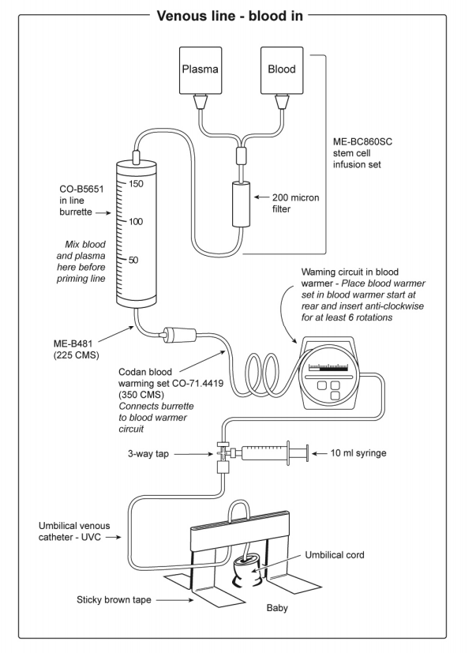
Figure 1: venous access (blood infusion)
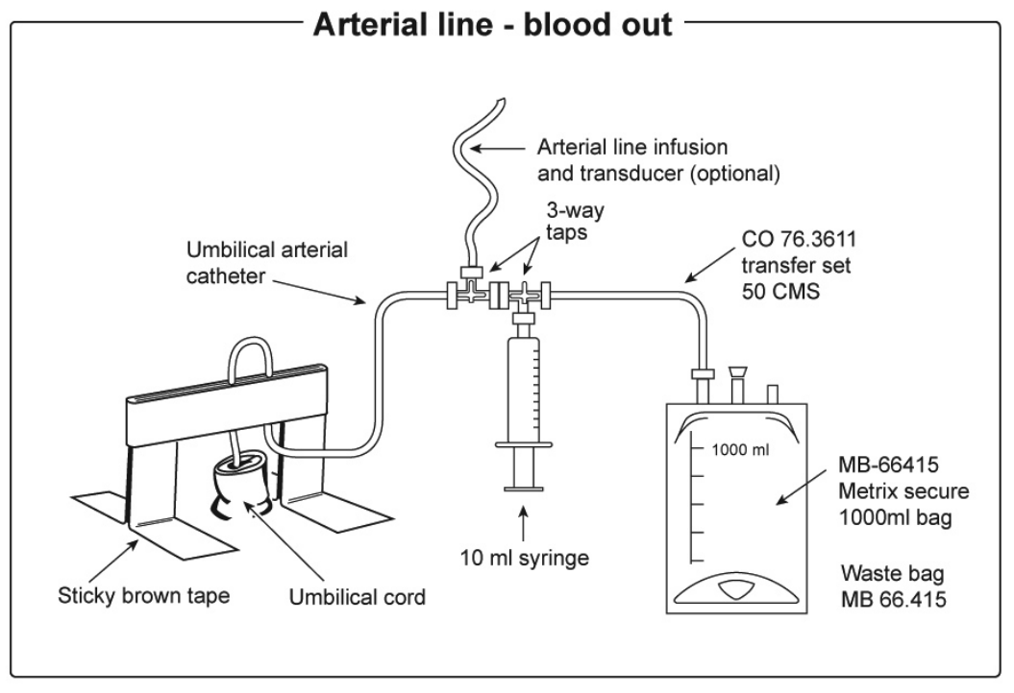
Figure 2: arterial access – blood removal

- Push and pull method (see Figure 3):
- Both clinicians (MO and RN) are to wear gloves and protective goggles.
- Withdraw first aliquot slowly; announce volume (x-mL) ‘out’, the RN records volume and uses this waste sample to take FBC, creatinine, sodium, potassium, magnesium, calcium, glucose, SBR, ABGs and NBST (if not already taken).
- After the first aliquot is being withdrawn, the medical officer, having drawn the aliquot volume from the burette into the syringe, pushes blood into the umbilical venous catheter and announces volume (x-mL) ‘in’
- The RN records both volume out and volume in, including running totals
- Repeat the sequence, at all times ensuring an even pace – the procedure may have to be slowed if not well tolerated.
- The RN should report the cumulative volumes every 100 mL
- Gently rotate both the RBC pack and the burette every 10 minutes to ensure an even mix of plasma and RBCs.
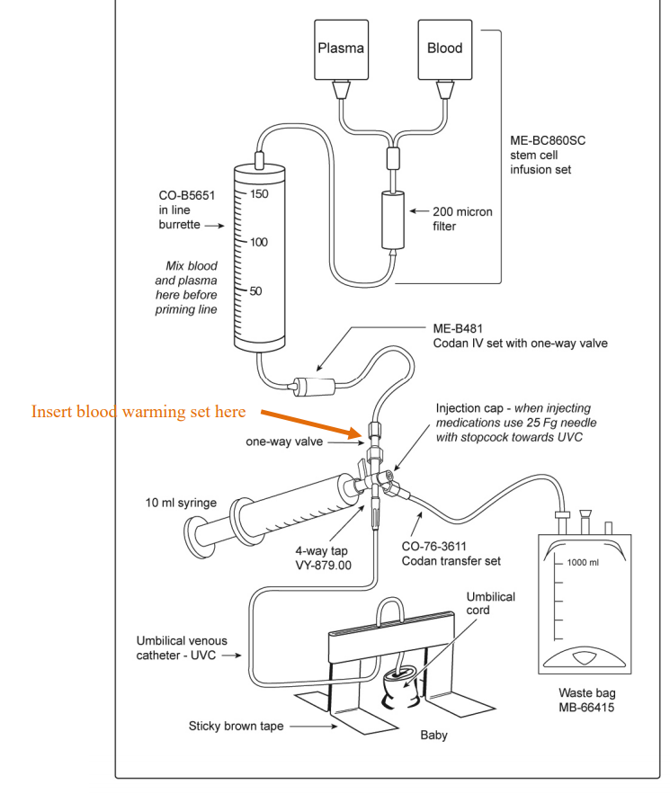
Figure 3 - Push Pull Method

- The total exchange should be completed within 2-4 hours
- After half of the transfusion product has been exchanged, check NICP, SBR, ABG, and BSL. Ensure baby’s calcium levels are checked and if low consider 1 mL of 10% of calcium gluconate
- At the end of the exchange transfusion with the last withdrawal aliquot recheck NICP, ABG, LFT and ABG.

Post Exchange Care
- Remove the exchange circuit and prime new intravenous infusion set
- Commence intravenous / arterial fluids as ordered
- Ensure all intravenous and arterial connections are secure, the infusion pump is zeroed and alerts are set
- Check all infusions, volumes and rates with a second RN and document
- Ensure infant is clean and dry and repeat all observations
- Notify parents that the procedure has been completed and their infant is comfortable.
- Perform blood glucose levels and ABGs (if indicated) 30 minutes after exchange and as appropriate to keep BGLs > 2.5mmol/l and to stabilise respiratory / metabolic condition.
- Repeat FBC, creatinine, sodium, potassium, magnesium, calcium, glucose and SBR as indicated post exchange. Consider repeating Coags.
- Monitor infant for abnormal signs and possible complications including thrombocytopenia, bleeding, signs of infection, feed intolerance or abdominal distension.
- High intensity phototherapy needs to be continued and reviewed in relation to SBR results

Waste Blood Setup
- The UAC is attached to the 3 way tap then the extension set is connected from the 3 way tap to the waste bag
- Attach 10 mL syringe to the side port of the 3 way tap.

Back to Table of Contents

Section 13– Transfusion During Haemodialysis

All patients who are haemodialysis dependent should have blood transfusions whilst on dialysis to allow for immediate removal of the extra vascular volume and potassium from the blood transfusion.

Equipment
- Infusion Pump
- Infusion line with inline 170 –200-micron filter (to filter any debris collected during storage)
- Blood Product

Procedure
- Product and Identification checking procedure as per adult transfusion, see Section 6
- Ensure consistent practice with 5 moments of Hand Hygiene
- Prime Infusion line with blood and attach to infusion pump
- Program rate and volume to be infused on infusion pump depending on the following:
- “transfuse with care” alert for Packed Red Blood cells” give over 60 minutes
- No alerts give over 30-60 minutes
- Unclamp infusion line, press start button on infusion pump to commence transfusion
- Complete documentation on the Blood and Blood Products Prescription and Check list Transfusion sheet and fluid balance sheet (if required)
- Observe patient based on Observation Protocol 1 or 2.
- Ensure the following is documented in the clinical record.
- Indication for transfusion
- Patient observations and outcomes (including adverse events)
- Product administration start and finish times
- Volume and type of product administered
- Unique donation / batch number of product
- Names and signatures of both persons checking the product.

Back to Table of Contents

Section 14 – Apheresis Procedures

The Apheresis staff of Haematology Outpatients perform a number of specialised procedures using fresh blood products such as packed red blood cells for a Red Cell Exchange (to treat Sickle Cell Disease) and Cryoprecipitate for Therapeutic Plasma Exchanges (to treat Thrombotic Thrombocytopenic Purpura).
The type of product and volume of product is determined by the treating Haematologist and is based on the patient’s height, weight, and Haematocrit.
Apheresis procedures are performed using centrifugation. A disease provoking component of a person’s blood is removed (for example plasma) and retained, and the remainder of their blood is returned to the circulation. A replacement product is then infused at the same time. These procedures can be done to improve disease symptoms if a patient is in “crisis” from their disease and can also be done to maintain their disease at a manageable level.
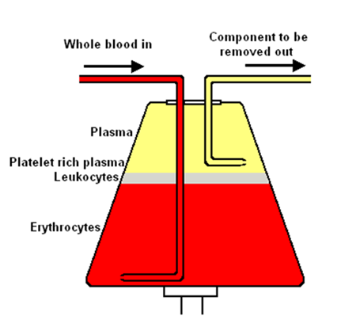
Patients are monitored closely during these procedures, with vital sign monitoring and verbal checks happening at least every 20 minutes. Patients are monitored for transfusion reactions, as well as citrate toxicity from the anticoagulant used in the procedure.

Adult Exchange Transfusion for Sickle cell disease
Exchange transfusion for sickle cell disease should be based on clinical judgement of individual cases, considering the indication for transfusion, the need to avoid hyperviscosity and minimise alloimmunisation, maintenance of iron balance, venous access issues and available resources.

Indications for emergency exchange transfusion for Sickle cell disease
a complicated sickle cell crisis, such as a stroke
a chest crisis – sickling in the lungs causing breathing problems

Indications for routine or planned exchange transfusion for Sickle cell
stroke, repeated exchange transfusions can help reduce the risk of further strokes happening.
Severe disease, repeated exchange transfusions can help reduce the number of crises
Pregnancy. An exchange transfusion may prevent complications to the patient of the baby
major operations such as a hip replacement, a single exchange transfusion reduces the risk of complications from the general anaesthetic and surgery.
leg ulcers exchange transfusions may aid healing.
exchange transfusion may help in cases of severe priapism (painful erections) that have not responded to other forms of treatment or surgery.

Appropriate IV access is required. If the patient has appropriate peripheral access the procedure may be performed using a 16gauge fistula needle for “inlet” and a 16 gauge Peripherally Inserted Venous Catheter for “return”. Venous access is a problem in a substantial number of adult patients with SCD and may be particularly problematic for automated exchange where good vascular access is essential to maintain flow rates. In this case, a long term Central Venous Access Device should be considered, such as a Vascath or fistula.
.
Blood provided for SCD patients should be HbS negative and, where possible, should be <7 days old for exchange transfusion but older blood may be given if the presence of red cell antibodies makes the provision of blood difficult.

Alert
The Transfusion Laboratory must be notified as soon as possible of the intention to transfuse SCD patients. Appropriate units must be ordered from ARCLB Sydney which can cause delays in the provision of blood products.

Note:
Each patient's baseline Hb and reticulocyte count should be documented in their clinical record. Changes in reticulocyte level reflect amounts of haemolysis and red cell production, which may be helpful in identifying the cause of worsening anaemia.
A transfusion history should be obtained in all SCD patients requiring transfusion, whether elective or emergency. This includes details of the patient's red cell phenotype and any red cell antibodies (current and historical).

Only nurses competent in apheresis should perform Apheresis procedures. Refer to After Hours Apheresis procedure for details.

Back to Table of Contents

Section 15 – Transfusion Reactions

Alert
Transfusion Reactions are most likely to occur within the first 15 to 30 minutes of the commencement of transfusion of blood product. Transfusion reaction can be: fever, rash, pruritus, pain, rigors, chills, nausea/vomiting or signs of shock (hypotension, tachycardia, tachypnoea)

Transfusion reactions may be defined as any adverse outcome associated with the infusion of blood or blood components. If a mild reaction is suspected, it is up to the physician to determine whether investigation by the laboratory is required/appropriate. If a request is received by the laboratory to investigate a suspected transfusion reaction, further blood units will NOT be issued for the patient until serological investigation has been completed and the laboratory can confirm that the reaction was not haemolytic and was not caused by red cell incompatibility.

Mild transfusion reactions
Examples of mild reaction include:
- Isolated Temperature rise < 39º C without tachycardia, hypotension or respiratory compromise
- Localised rash
- Pruritus.
If a mild reaction is suspected (<1.5 ⁰ C above base line) the transfusion may be continued with caution (revert to observation protocol 2), with the support of antipyretics or antihistamines, at the discretion of the physician. If the signs or symptoms persist, develop or deteriorate subsequently, stop the transfusion and manage as per a severe transfusion reaction
Document reaction and management in clinical records
Report to Riskman.

Severe transfusion reactions
Examples of severe reactions:
Temperature ≥39º C or 1.5 º C above base line
Hypotension/shock
Tachycardia, tachypnoea, hypertension
Rigors or chills
Nausea, vomiting
Pain: localised (i.e., cannula site), chest, back.

If a severe reaction is suspected:
Stop the Transfusion immediately
Seek urgent medical advice - consider calling Medical Emergency Team (MET)
Monitor and record patients’ vital signs
Maintain IV access, do not flush the existing giving set – use a new IV giving set
Immediately repeat identification checking procedure to ensure the right unit has been given to the right patient
Alert the transfusion laboratory
Properly label and send to the laboratory the following post-transfusion samples, (blood samples to be taken preferably from the arm not used for the transfusion):
- Two EDTA tubes for repeat group and screen, with an accompanying pink Transfusion Request Form (with clinical notes ‘investigation of suspected transfusion reaction)
- Citrate (blue) tube for coagulation studies and XDP’S (D-dimer)
- Heparin (green) tube for electrolytes, creatinine, LDH and haptoglobin
- A photocopy of the Blood product prescription and checklist (side 2)
- A photocopy of the patient’s observation chart (e.g., PEWS/MEWS)
- Unit of blood to which the patient has reacted, with capped IV giving set attached. Blood units must not be returned to the laboratory via the pneumatic tube system.
Maintain a fluid balance chart
The medical officer should order the type of intravenous fluid required to maintain the patency of the intravenous line
Document reaction and management in clinical records and on page 2 of Blood and Blood Product Prescription and Check list
All adverse events related to blood product administration must be reported to Riskman.

Procedure
If a Transfusion Reaction is suspected:
Stop the Transfusion immediately
Check and document the patient’s vital signs
Repeat checking procedure to ensure the right unit has been given to the right patient
Contact medical staff immediately for further management and investigation.

Alert
Further management including subsequent transfusions will depend on the type and severity of the reaction and results of associated investigations. Further transfusions should not be commenced without the advice of the haematology specialist/registrar in consultation with the managing clinician.

Symptom | Possible Diagnosis | Investigations | Action
Fever>1.5°C over base line or 38°C Chills and rigors | Bacterial Contamination | Blood & Bag cultures | Stop Transfusion and Assess  IV antibiotics if Sepsis  (Blood cultures to be collected prior to administration of any antibiotics)  Send Riskman  Notify Transfusion Lab
 | Febrile Non-Haemolytic | Exclude other causes | Stop Transfusion and Assess  Anti-pyretics (may continue transfusion at slower rate if all other diagnosis have been eliminated. (must observe and document vital signs using protocol 2 if transfusion recommenced)
Rash, hives, wheeze, Dyspnoea, hypotension | Allergy | Exclude other causes | Stop Transfusion and Assess  Recommence Slowly  Antihistamines  Send Riskman  Notify Transfusion Lab
 | Anaphylaxis | Patient IgA level  Anti-IgA antibodies | Stop Transfusion  Call code Blue/MET  ABC resuscitation  Send Riskman  Notify Transfusion Lab
Chills, hypotension, back pain, Haemoglobinuria, ooze from IV sites | ABO incompatibility | Check ABO type DAT IAT | Stop Transfusion  Call code Blue/MET  Recheck ABO Compatibility  Send Riskman  Notify Transfusion Lab
 | Haemolysis | UEC, Full Coagulation Profile (FCP), Hb, Haemolysis tests LDH, Haptoglobin, DCT | Stop Transfusion  Maintain BP and renal function
 | Bacterial Contamination | Blood & Bag cultures | Stop Transfusion  IV antibiotics if sepsis  (Blood cultures to be collected prior to administration of any antibiotics)  Send Riskman  Notify Transfusion Lab
Dyspnoea, productive cough, pink frothy sputum, pulmonary oedema, hypotension with  Transfusion Related Acute Lung Injury (TRALI) | Circulatory Overload | Clinical  FBC  Chest X ray | Stop Transfusion  Call code Blue/MET  Oxygen, diuretics, sit High Fowlers position  Send Riskman  Notify Transfusion Lab
 | TRALI occurs within 6hrs of Transfusion | HLA granulocyte antibody tests  Chest X ray | Stop Transfusion  Call code Blue/MET  Oxygen, diuretics, sit High Fowlers position  Send Riskman  Notify Transfusion Lab

Comparison of TRALI and TACO (Adapted from BCSH Guideline on the Investigation and Management of Acute Transfusion Reactions 2012 by kind permission of British Committee for Standards in Haematology)
 | TRALI | TACO
Patient Characteristics | ? More common in haematology and surgery patients | Most common in age >70 but can occur at any age
Implicated Blood Components | Usually plasma and platelets | Any
Onset | Up to 6 hours from transfusion (usually within 2 hours) | Within 6 hours of transfusion
Oxygen Saturation | Reduced | reduced
Blood Pressure | Often low | Often high
Jugular venous pressure | Normal or low | Elevated
Temperature | Often raised | Normal
Chest X-ray | Bilateral peri-hilar and nodular shadowing or ‘white out’, heart size normal | Enlarged heart and characteristics of pulmonary odema
Echocardiogram | Normal | Abnormal
Pulmonary artery wedge pressure | Normal | Elevated
Blood count | Fall in neutrophils and monocytes followed by neutrophil leucocytosis | No specific changes
Fluid Challenge | Improves | worsens
Response to diuretics | Worsens | Improves

Back to Table of Contents

Evaluation

Outcome
Informed decision making for the administration of blood and blood products
Safe, appropriate, evidence-based transfusion practice

Measures
Review of Transfusion associated clinical incident reports
Monthly blood administration audit

Back to Table of Contents

Related Policies, Procedures, Guidelines and Legislation

Policies
- Nursing and Midwifery Board of Australia (NMBA) Requirements for Practice
- Informed Consent (Clinical)
- Blood Management

Procedures
Critical Bleeding Massive Transfusion - Adults Procedure
Patient Identification: Pathology Specimen Labelling Procedure
Patient Identification and Procedure Matching Procedure
Infection Prevention and Control Healthcare Associated Infections Procedure
Venepuncture Blood Specimen Collection
Specimen Handling
After Hours Apheresis
Vital Signs and Modified Early Warning Score
Peripheral Intravenous Cannula (Adults and Children)
Central Venous Access Device (CVAD) management (Children Adolescents and Adults)
Blood Collection using Heel Lance Device (Neonates)
Venous and Arterial Access and Management in Neonatal Intensive Care
Newborn Bloodspot Screening Test

Guidelines
- Fasting Guidelines – Elective and Emergency Surgery
Intraoperative Cell Salvage
- Australian New Zealand Society of Blood Transfusion

Legislation
- Health Records (Privacy and Access) Act 1997
- Human Rights Act 2004
- Work Health and Safety Act 2011
- Australian Charter of Healthcare Rights

Back to Table of Contents

References

- National Safety and Quality Health Service (NSQHS) Standard 7 Australian Commission on Safety and Quality in Health Care, National Safety and Quality Health Service Standards (September 2012). Sydney. ACSQHC, 2012. Available at: https://www.safetyandquality.gov.au/wp-content/uploads/2011/09/NSQHS-Standards-Sept-2012.pdf
- Australian and New Zealand Society of Blood Transfusion Ltd Royal College of Nursing Australia Guidelines for the Administration of Blood Products 2011, Australian and New Zealand Society of Blood Transfusion 2nd edition , December. Available at: http://www.anzsbt.org.au/publications/documents/ANZSBT_Guidelines_Administration_Blood_Products_2ndEd_Dec_2011_Hyperlinks.pdf
- Australian and New Zealand Society of Blood Transfusion Guidelines For Transfusion And Immunohaematology Laboratory Practice, Australian and New Zealand Society of Blood Transfusion1st Edition, November 2016. Available at: https://www.anzsbt.org.au/data/documents/guidlines/GuidelinesforTransfusionandImmunohaematologyLaboratoryPractice_1ed_Nov20_.pdf
- Label and Component Information Australian Red Cross Blood Service Version 5.5, Effective January 2016. Available at:

- http://resources.transfusion.com.au/cdm/ref/collection/p16691coll1/id/808
Royal Children’s Hospital Melbourne Clinical Guidelines – Blood Administration, The Royal Children's Hospital Melbourne Victoria 2017. Available at: http://www.rch.org.au/bloodtrans/blood_administration/Blood_administration/
- Patient Blood Management Guidelines: Module 1 Critical Bleeding Massive Transfusion National Blood Authority, 2011. Available at: https://www.blood.gov.au/pbm-module-1
- Patient Blood Management Guidelines: Module 2 - Perioperative National Blood Authority, 2012. Available at: https://www.blood.gov.au/pbm-module-2
- Patient Blood Management Guidelines: Module 3 Medical, National Blood Authority, 2013. Available at: https://www.blood.gov.au/pbm-module-3
- Patient Blood Management Guidelines: Module 4 Critical Care, National Blood Authority, 2012. Available at: https://www.blood.gov.au/pbm-module-4
- Patient Blood Management Guidelines: Module 5 Obstetrics and Maternity, National Blood Authority, 2015. Available at: https://www.blood.gov.au/pbm-module-5
- Patient Blood Management Guidelines: Module 6 - Neonatal and Paediatrics, National Blood Authority, 2016. Available at: https://www.blood.gov.au/pbm-module-6
- Brodsky, D., & Martin, C. (2003). Hemotology, Oncology and Bilirubin. In Brodsky, D., & Martin, C. (Eds.) Neonatology Review. Philadelphia: Hanley & Belfus, Inc.
- Cloherty, J P., Eichenwald, E. C. & Stark A.R. (2008) Manual of Neonatal Care. 6th Ed Philadelphia, Wolters Kluwer.
- Gibson, B.E.S., Todd, A., Roberts, I., Pamphilon, D., Rodeck, C., Bolton-Maggs, P., Durbin, G., Duguid, J., Boulton, F., Cohen, H., Smith, N., McClelland, D.B.L., Rowley, M., & Turner, G. (2004). Transfusion guidelines for neonates and older children. British Journal of Haematology 124, 433-453
- Risson, D.C., Davies, M. W. & Williams, B.A. (2012) Review of alloimmune thrombocytopenia. Journal of Paediatrics and Child Health 48: 9 816-822
- Murray, N.A. Evaluation and treatment of thrombocytopenia in the neonatal intensive care unit. Acta Paediatric Supplement 2002; 91 (438): 74−81
- Roberts, I.A. & Murray, N,A. Thrombocytopenia in the newborn. Current Opinion Pediatrics 2003; 15 (1): 17−23.
- Kirpalani H et al. The premature infants in need of transfusion (PINT) study. Journal of Pediatrics 2006;149:301-7
- Australian Red Cross Lifeblood, 2022. Products. [online] Australian Red Cross Lifeblood. Available at: <https://www.lifeblood.com.au/health-professionals/products> [Accessed 19 May 2022].
Back to Table of Contents

Search Terms

Blood, Transfusion, Neonates, Paediatrics, Exchange Transfusion, Partial Exchange Transfusion, Platelets, Patient Identification, Cross match, Transfusion Reactions, Consent for transfusion, Apheresis, Intra operative cell salvage.

Back to Table of Contents

Disclaimer: This document has been developed by Canberra Health Services specifically for its own use. Use of this document and any reliance on the information contained therein by any third party is at his or her own risk and Canberra Health Services assumes no responsibility whatsoever.

Policy Team ONLY to complete the following:
Date Amended | Section Amended | Divisional Approval | Final Approval
09 June 2021 | Complete Review | Nicholas Coatsworth, ED, Surgery, | CHS Policy Committee
27/05/2022 | Neonatal information updated | Maria Burgess Clinical Nurse Consultant Nurse Consultant Transfusion | CHS Policy Committee

This document supersedes the following:
Document Number | Document Name
CHHS17/296 | Fresh Blood Products Administration – Adults, Paediatrics (Including Mature Minors), Infants and Neonates

